3GPP TSG-S4 Meeting#133-e S4-251336

Online, 18th–25th July 2025
CR-Form-v12.2
PSEUDO CHANGE REQUEST
 | 26.265 | CR | pseudo | rev | - | Current version: | 1.2.0
For HELP on using this form: comprehensive instructions can be found at
http://www.3gpp.org/Change-Requests.

Proposed change affects: | UICC apps |  | ME | X | Radio Access Network |  | Core Network | X

Title: | [VOPS] On Multiview features
Source to WG: | Apple Inc.
Source to TSG:
Work item code: | VOPS |  |  |  |  |  | Date: |  |  | 2025-07-10
Category: | B |  |  |  |  |  | Release: |  |  | Rel-19
 | Use one of the following categories:  F (correction)  A (mirror corresponding to a change in an earlier release)  B (addition of feature),  C (functional modification of feature)  D (editorial modification)  Detailed explanations of the above categories can  be found in 3GPP TR 21.900. |  |  |  |  |  |  |  | Use one of the following releases:  Rel-8 (Release 8)  Rel-9 (Release 9)  Rel-10 (Release 10)  Rel-11 (Release 11)  …  Rel-16 (Release 16)  Rel-17 (Release 17)  Rel-18 (Release 18)  Rel-19 (Release 19)
Reason for change: |  | There are remaining EN’s on missing features like 3D reference info SEI which needs to be implemented.
Summary of change: |  | Add recommendation for 3D reference info SEI.
Consequences if not approved: |  | Several key features will remain missing.
Clauses affected: |  | 6.3.6
 |  | Y | N
Other specs |  |  | X | Other core specifications |  |  |  | TS/TR ... CR ...
affected: |  |  | X | Test specifications |  |  |  | TS/TR ... CR ...
(show related CRs) |  |  | X | O&M Specifications |  |  |  | TS/TR ... CR ...
Other comments:
This CR's revision history:

* * * First Change * * * *

6.3.6 3GPP MV-HEVC Stereo

6.3.6.1 Introduction
The MV-HEVC Stereo Operation Point permits consistent distribution of stereoscopic content using MV-HEVC. The remainder of this clause 6.3.6 defines the Bitstream and Receiver requirements for the 3GPP-MV-HEVC-Stereo receiver.

6.3.6.2 Bitstream Requirements

A 3GPP-MV-HEVC-Stereo Bitstream shall conform to the following requirements
- the Representation Format included in the Bitstream shall conform to the 3GPP Stereoscopic format as defined in clause 4.4.3.4.
- The bitstream shall conform to the constraints specified in the MV-HEVC-UHD decoding capabilities as defined in clause 5.3.2.
- the Bitstream shall be decodable by
- a decoder with HEVC-UHD-Dec decoding capabilities as defined in clause 5.3.2.
- a decoder with MV-HEVC-UHD decoding capabilities as defined in clause 5.3.2.
- The chroma sub-sampling shall be 4:2:0 and the value of chroma_format_idc shall be set to 1.
- The vps_numlayers_minus1 value shall be set to 2.
- vps_auxiliary[lId] shall be equal to 0 in the VPS extension for the sub-bitstream with nuh_layer_id != 0. If
NOTE: This implies that the second also carries primary video.
- The vps_num_direct_ref_layers[1] may be present, and if present,
- it shall be set to 1.
- the vps_direct_ref_layer_id[1][0] shall be set to 0.
NOTE: This implies, that layer-dependency is possible, but not needed. The two layers may be independent, or the second layer depend on the base layer.

- The aspect_ratio_idc value shall be set to 1, indicating a square pixel format.
- In the VUI, either
- the values of colour_primaries, transfer_characteristics and matrix_coeffs each shall be set to 1.
- The value of chroma_sample_loc_type_top_field shall be set to 0.
- or
- the values of colour_primaries and matrix_coeffs each shall be set to 9, and the value of transfer_characteristics shall be set to one of the following values: 14 (for SDR with WCG), 16 (for PQ) and 18 (for HLG).
- The value of the chroma_sample_loc_type_top_field shall be set to 2.
The timing information may be present.
- If the timing information is present, i.e. the value of vui_timing_info_present_flag is set to 1, then the values of vui_num_units_in_tick and vui_time_scale shall be set according to the frame rates allowed for each operation point. The timing information present in the video Bitstream should be consistent with the timing information signalled at the system level.
- The frame rate shall not change between two RAPs. fixed_pic_rate_general_flag value, if present, shall be set to 1.
Bitstreams not required to be associated with frame packing information for all coded video sequences. It is also possible that such information, when present, may differ from one coded video sequence to another.
The HEVCDecoderConfigurationRecord 'hvcC' should include the three_dimensional_reference_displays_info SEI message as specified in Recommendation ITU-T H.265 / ISO/IEC 23008-2 [h265].
SEI Message Name | Purpose | Key Fields / Parameters
three_dimensional_reference_displays_info | Describes reference display geometry for 3D rendering | Display width/height, aspect ratio, viewing distance, screen center, baseline, depth range
depth_representation_info | Specifies depth value representation | Depth range (near/far), quantization, linearity
multiview_scene_info | Describes scene structure across multiple views | Number of views, view IDs, camera parameters
multiview_acquisition_info | Provides camera acquisition details | Intrinsic/extrinsic camera parameters, baseline distances
depth_timing | Synchronizes depth and texture layers | Timing offsets, synchronization flags
view_position | Specifies spatial position of each view | View index, 3D coordinates
view_dependency_structure | Describes inter-view dependencies | View hierarchy, reference relationships

6.3.6.3 Receiver Requirements
Receivers conforming to this Operation Point 3GPP-MV-HEVC-Stereo shall support decoding and rendering Bitstreams with the restrictions defined in clause 6.3.6.2.
NOTE 1: Rendering includes adherence to the parameters signalled in the bitstream to characterize the distributed Representation format.
There are no requirements on output timing conformance for H.265/HEVC decoding (Annex C of [6]). The Hypothetical Reference Decoder (HRD) parameters, if present, should be ignored by the Receiver.

Also checked how the SEI messages interact with rendering
How 3D SEI Messages Interact in Rendering
1. Scene and Acquisition Understanding
- multiview_scene_info and multiview_acquisition_info provide the camera setup and scene structure:
  - Number of views
  - Camera positions and orientations
  - Baseline distances
- These are used to reconstruct the 3D geometry of the scene and determine how views relate spatially.

2. Depth Interpretation
- depth_representation_info tells the renderer how to map depth values (e.g., from 0–255) to real-world distances.
- This is essential for accurate depth-based rendering and view synthesis.

3. Display Calibration
- three_dimensional_reference_displays_info defines the target display geometry:
  - Screen size, viewing distance, eye separation
- This ensures that the rendered 3D effect appears correctly on the intended display.

4. View Positioning and Dependencies
- view_position specifies where each view is located in 3D space.
- view_dependency_structure tells the decoder which views depend on others, guiding decoding order and prediction structure.

5. Temporal Synchronization
- depth_timing ensures that depth maps and texture video are synchronized in time.
- This prevents visual artifacts due to misaligned frames.

Rendering Pipeline Overview
Here’s a simplified flow of how these SEI messages are used:
- Decode SEI messages → extract scene, depth, and display info.
- Reconstruct 3D scene using camera and depth data.
- Map depth to screen space using display parameters.
- Synthesize intermediate views or render stereo pairs.
- Display on 3D screen with correct parallax and depth cues.
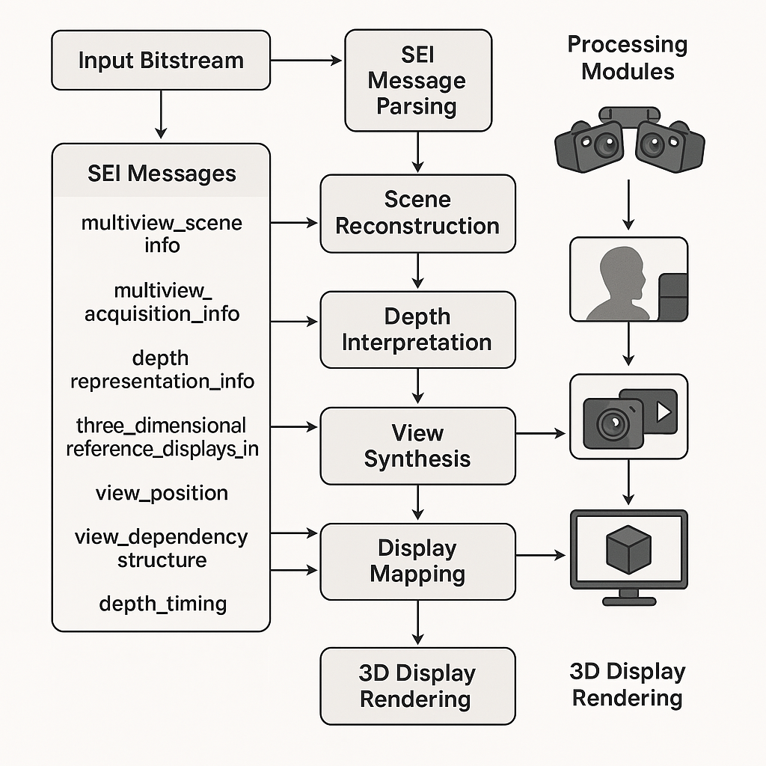
* * * End of Changes * * * *

