**3GPP TSG-SA WG4 Meeting #132S4-250860rev1(1071)**

**Fukuoka, Japan, 19 – 23 May 2025**

**Source: Tencent**

**Title: [FS_ARSpatial] pCR on Call flow for spatial computing**

**Agenda item: 9.8**

**Document for: Agreement**

**1. Introduction**

The present contribution proposes to clarify the negotiation responsibilities when establishing a spatial computing session.

Currently, section 7.3 indicates the following:

* Media Application Function (Media AF): This function is responsible for the negotiation of the spatial computing service session between the Media AS and the Media Client.

Whereas the call flow in clause 7.4 indicates in step 1 and 2:

1. The Media Client discovers Media AS and sets up a connection to it. It provides information about the spatial computing capabilities of the UE to configure the Spatial Computing Functions in the Media AS.

2. In response to step 1, the Media AS creates and transmits a description of the XR Spatial Description format, the configuration data and the input it expects to receive from the Spatial Computing Client to the Media Client.

The workflow is also misleading as it includes the Media Access Function as part of the Media Client. It is proposed to relocate the Media AF in the network and rely on the Media Session Handler for control plane communications and Media Access function to support the spatial computing functions as described in clause 7.3.

The following call flow is meant to fix this inconsistency.

**2. Proposal**

It is proposed to agree the following changes to the 3GPP draft TR 26.819 v0.4.0

* * * First Change * * *

## 7.4 Call flow for spatial computing session setup and operation

The spatial computing operation can be described by the call flow in Figure 7.4.1.

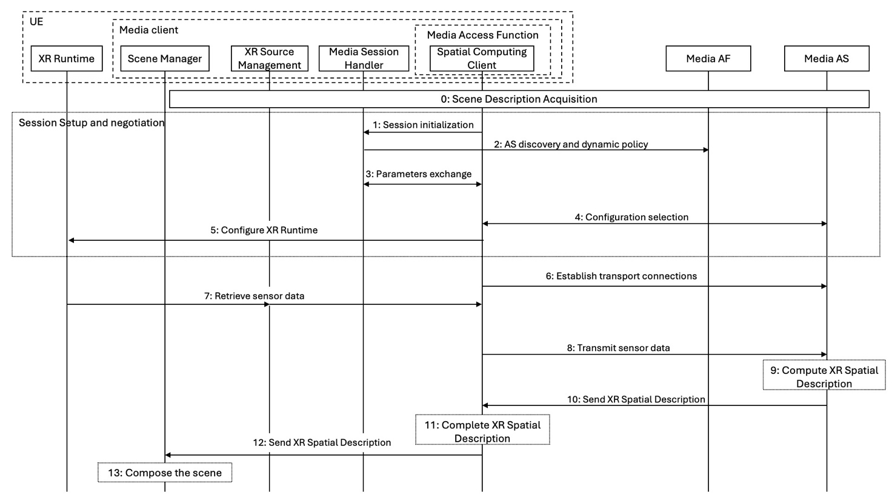

Figure 7.4.1 - High-level call flow for spatial computing session setup and operation.

The steps are:

0. The Scene Manager acquires the scene description information and discovers the needed spatial computing functions for the XR experience.

1. The Spatial Computing Client initiates a session by contacting the Media Session Handler, which acts as the control plane interface.

2. The Media Session Handler communicates with the Media AF for the discovery of the AS (in the case of edge computing) and the configuration of quality-of-service parameters.

3. The Media Session Handler passes the information configured in step 2 to the Media Access Function via the interfaces M6/M11.

4. The Spatial Computing Client inside Media Access Function establishes the session with the Media AS.

5. The XR runtime is configured. This configuration aims to provide sensor data needed for the Spatial Computing functions configured in the Media AS in step 1.

6. The Spatial Computing Client requests the instantiation of pipelines for XR Spatial Description from the Media Access Function, which in turn establishes a connection to the Media AS.

7. The Source Manager retrieves sensor data from the XR runtime and provides them to the Media Access Function.

8. The Media Access Function sends sensor data to the Media AS.

9. The Media AS uses that data to invoke the spatial computing functions and compute the XR Spatial Description.

10. The Media AS transmits the generated XR Spatial Description to the Media Access Function.

11. Spatial Computing Client may complete XR Spatial Description using local sensor data.

12. Spatial Computing Client provides the XR Spatial Description to the Scene Manager.

13. The Scene Manager composes the scene using the XR Spatial Description.

* * * Second Change * * *

* * * End of Changes * * *