**3GPP TSG-SA4 Meeting #132 *S4-250869***

**Fukuoka, Japan, 19th May 2025 - 23rd May 2025**

|  |  |  |  |  |  |  |  |  |
| --- | --- | --- | --- | --- | --- | --- | --- | --- |
| *CR-Form-v12.3* | | | | | | | | |
| **CHANGE REQUEST** | | | | | | | | |
|  | | | | | | | | |
|  | **26.264** | **CR** | **0004** | **rev** | **-** | **Current version:** | **18.2.0** |  |
|  | | | | | | | | |
| *For* [***HELP***](http://www.3gpp.org/3G_Specs/CRs.htm#_blank)*on using this form: comprehensive instructions can be found at* [*http://www.3gpp.org/Change-Requests*](http://www.3gpp.org/Change-Requests)*.* | | | | | | | | |
|  | | | | | | | | |

|  |  |  |  |  |  |  |  |  |
| --- | --- | --- | --- | --- | --- | --- | --- | --- |
| ***Proposed change affects:*** | UICC apps |  | ME | **X** | Radio Access Network |  | Core Network | **X** |

|  |  |  |  |  |  |  |  |  |  |  |
| --- | --- | --- | --- | --- | --- | --- | --- | --- | --- | --- |
|  | | | | | | | | | | |
| ***Title:*** | CR to TS 26.264v18.2 for alignment with SR_IMS | | | | | | | | | |
|  |  | | | | | | | | | |
| ***Source to WG:*** | Nokia | | | | | | | | | |
| ***Source to TSG:*** | S4 | | | | | | | | | |
|  |  | | | | | | | | | |
| ***Work item code:*** | SR_IMS | | | | |  | ***Date:*** | | | 2025-05-13 |
|  |  | | | |  | |  | | |  |
| ***Category:*** | **F** |  | | | | | ***Release:*** | | | Rel-19 |
|  | *Use one of the following categories:* ***F*** *(correction)* ***A*** *(mirror corresponding to a change in an earlier release)* ***B*** *(addition of feature),* ***C*** *(functional modification of feature)* ***D*** *(editorial modification)*  Detailed explanations of the above categories can be found in 3GPP [TR 21.900](http://www.3gpp.org/ftp/Specs/html-info/21900.htm). | | | | | | | | *Use one of the following releases: Rel-8 (Release 8) Rel-9 (Release 9) Rel-10 (Release 10) Rel-11 (Release 11) … Rel-17 (Release 17) Rel-18 (Release 18) Rel-19 (Release 19)  Rel-20 (Release 20)* | |
|  |  | | | | | | | | | |
| ***Reason for change:*** | | SR_IMS has the objectives to define split rendering over IMS with the following objective: **“**   1. ***Define protocols, procedures, and codecs for delivery of split-rendered media and metadata for support of split rendered content including uplink (e.g., pose), and downlink (e.g., rendered pose) as part of a new specification.***   ***Note1: For objectives 3, some of the work is done for AR services as part of Rel-18 WI IBACS, therefore, where possible, references to TS26.114, TS 26.264, TS 26.119, TS 26.522 and TS 26.565 will be added for metadata and codec capabilities. The procedures covered in TS 26.264 can be appropriately migrated to the new specification or referenced. “***  The SR_IMS WID further includes TS 26.264 as an impacted spec with the expected change: “Move some of the split rendering related text to new specification with appropriate references.” | | | | | | | | |
|  | |  | | | | | | | | |
| ***Summary of change:*** | | As all expected procedures are now comprehensively defined in TS 26.567 in conformance with IMS DC architecture specified in TS 23.228 v19.2, this CR removes the split rendering normative aspects from TS 26.264 and replaces them with a reference to TS 26.567. | | | | | | | | |
|  | |  | | | | | | | | |
| ***Consequences if not approved:*** | | Rel-19 will have two specifications with split rendering over IMS that have not been fully checked and aligned. | | | | | | | | |
|  | |  | | | | | | | | |
| ***Clauses affected:*** | | 2, 3.1, 4.2, 6.5, 7.2, 8.2, 8.3, A.1.1, A.1.3, A.1.5 | | | | | | | | |
|  | |  | | | | | | | | |
|  | | **Y** | **N** |  | | | |  | | |
| ***Other specs*** | |  | **X** | Other core specifications | | | | TS/TR ... CR ... | | |
| ***affected:*** | |  | **X** | Test specifications | | | | TS/TR ... CR ... | | |
| ***(show related CRs)*** | |  | **X** | O&M Specifications | | | | TS/TR ... CR ... | | |
|  | |  | | | | | | | | |
| ***Other comments:*** | |  | | | | | | | | |
|  | |  | | | | | | | | |
| ***This CR's revision history:*** | |  | | | | | | | | |

* * * First Change * * * *

2 References

The following documents contain provisions which, through reference in this text, constitute provisions of the present document.

- References are either specific (identified by date of publication, edition number, version number, etc.) or non‑specific.

- For a specific reference, subsequent revisions do not apply.

- For a non-specific reference, the latest version applies. In the case of a reference to a 3GPP document (including a GSM document), a non-specific reference implicitly refers to the latest version of that document *in the same Release as the present document*.

[1] 3GPP TR 21.905: "Vocabulary for 3GPP Specifications".

[2] 3GPP TS 26.114: "IP Multimedia Subsystem (IMS); Multimedia telephony; Media handling and interaction".

[3] 3GPP TS 26.119: "Media Capabilities for Augmented Reality".

[4] 3GPP TS 23.228: "IP Multimedia Subsystem (IMS); Stage 2".

[5] 3GPP TS 24.229: "IP multimedia call control protocol based on Session Initiation Protocol (SIP) and Session Description Protocol (SDP); Stage 3".

[6] 3GPP TS 26.565: "Split Rendering Media Service Enabler".

[7] ISO/IEC 23090-14 AMD 2, Information technology — Coded representation of immersive media — Part 14: Scene description — Amendment 2: Support for haptics, augmented reality, avatars, Interactivity, MPEG-I audio, and lighting

[8] 3GPP TS 26.522: "5G Real-time Media Transport Protocol Configurations".

[9] 3GPP TS 26.567: "Split rendering over IMS"

# 3 Definitions of terms, symbols and abbreviations

## 3.1 Terms

For the purposes of the present document, the terms given in TR 21.905 [1] and the following apply. A term defined in the present document takes precedence over the definition of the same term, if any, in TR 21.905 [1].

**AR data:** Collection of information to be exchanged among participants in a call with AR experience. It includes AR media and AR metadata.

**AR media:** Media (e.g., audio, video, text or image) that will be rendered by the AR-MTSI client as an overlay over the user’s real perception. This includes traditional 2D media (e.g., a 2D audio stream rendered to be perceived by the user to originate from their left side) and 3D media (e.g., spatial audio and volumetric video).

**AR metadata:** Data that provides information on AR media and its rendering. This includes pose, spatial descriptions and scene descriptions.

**AR-MTSI client:** A DCMTSI client supporting AR capabilities as defined by this specification.

**AR MF:** An AR-MTSI client implemented by functionality included in the MF.

**AR-MTSI client in terminal:** An AR-MTSI client that is implemented in a terminal or UE. The term "AR-MTSI client in terminal" is used in this document when entities such as AR MF/MRF is excluded.

## 3.2 Symbols

Void

## 3.3 Abbreviations

For the purposes of the present document, the abbreviations given in TR 21.905 [1] and the following apply. An abbreviation defined in the present document takes precedence over the definition of the same abbreviation, if any, in TR 21.905 [1].

ADC Application Data Channel

BDC Bootstrap Data Channel

AS Application Server

DC Data Channel

DCSF Data Channel Signalling Function

I‑CSCF Interrogating‑CSCF

IMS IP Multimedia Core Network Subsystem

MF Media Function

P‑CSCF Proxy‑CSCF

S‑CSCF Serving‑CSCF

# 4 System description

## 4.1 General

Typical conversational AR scenarios as envisioned in this document consist of an immersive AR call that may include the following conversational components:

- Real-time speech/audio that can comprise mono, stereo, and/or spatial audio.

- Real-time 2D video or 360-degree video that can be rendered as rectangular or spherical overlay in the AR experience.

- A real-time volumetric video of the user or an object that can be rendered in AR or MR.

In addition to the above conversational media, non-real-time objects may be exchanged over the data channel as well.

Both two-party and multiparty calls are possible. The AR experience may be unidirectional, i.e., only one party receives AR media and renders it, or it may be bidirectional, i.e., both parties receive and transmit AR media. The term AR-MTSI client includes both:

- an AR-MTSI client in terminal which is an AR device as defined in TS 26.119 [3] e.g., AR glasses, phone, Head Mounted Display (HMD) that has an XR Runtime for rendering an AR experience.

- AR MF/ that provides support for AR conversational services.

As an AR-MTSI client in terminal is a DCMTSI client in terminal with additional features for AR communication, the following requirements for a MTSI client terminal also apply for an AR-MTSI client in terminal:

- the interworking requirements in clause 12 of TS 26.114 [2],

- the jitter buffer management requirements in clause 8 of TS 26.114 [2],

- the packet loss handling requirements in clause 9 of TS 26.114 [2],

- the media and rate adaptation requirements in clause 10 and 17 of TS 26.114 [2], and

- the network preference management object in clause 15 of TS 26.114 [2],

NOTE: If an AR-MTSI client in terminal supports functionalities for MSMTSI client in terminal as specified in Annex S of TS 26.114 [2], the media and rate adaptation requirements in Annex S.8 of TS 26.114 [2] also apply for an AR-MTSI client in terminal.

## 4.2 Terminal architecture

The detailed XR client architecture is not in the scope of this specification. The XR baseline client architecture can be found in TS 26.119 [3]. The pre/post-processor component in terminal provides AR capabilities for processing output of peripherals and the input/output of encoders/decoders, which may include:

- XR runtime

- Scene manager

- Presentation engine

- XR source management

The AR-MTSI client has XR Runtime capabilities for rendering AR experience, e.g., spatial localization and mapping, etc., and can support local AR rendering and network-assisted split rendering based on client’s capabilities as defined in TS 26.567 [9]. A UE may support multiple microphones, cameras or sensors.

An AR-MTSI client supports the protocol stack of a basic MTSI client as described in clause 4.2 of TS 26.114 [2]. For the specific AR communication instance, AR-MTSI client can select different IMS media channel to deliver AR data to IMS network or peer UE. In general, AR media components with real-time characteristics are transported via RTP session and AR metadata is transported via data channel or RTP session with AR media.

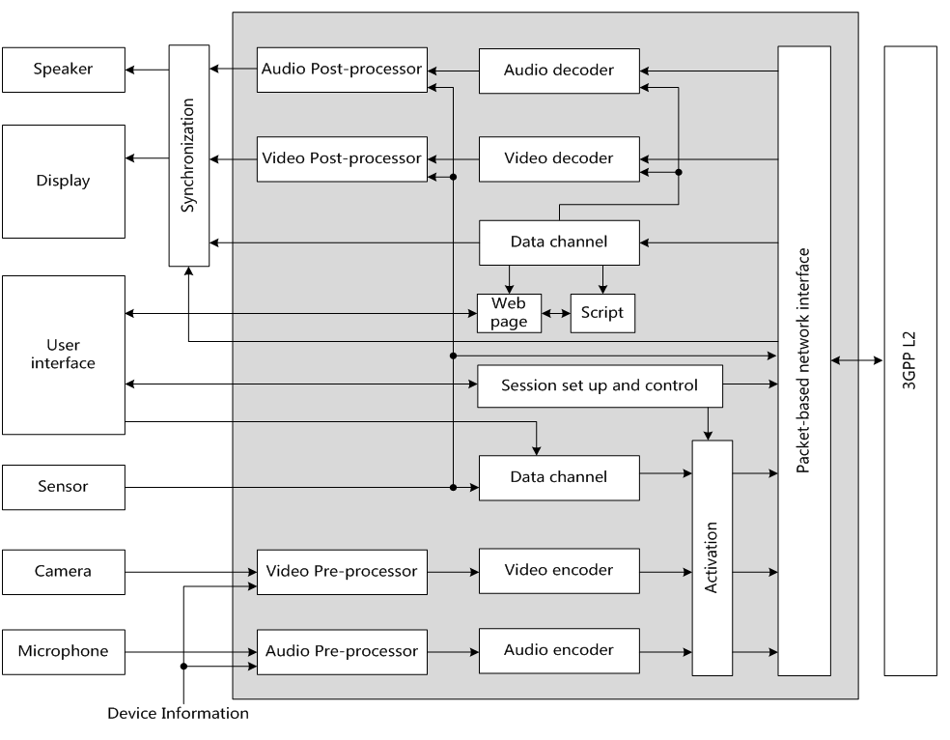

Figure 4.2.1: Functional components of an AR-MTSI client in terminal

## 4.3 End-to-End Reference Architecture

The end-to-end architecture to support AR communication over IMS can be found in TS 23.228 Annex AC [4]. The following Figure 4.3.1 is a simplified version showing the media functions within the scope of this specification.

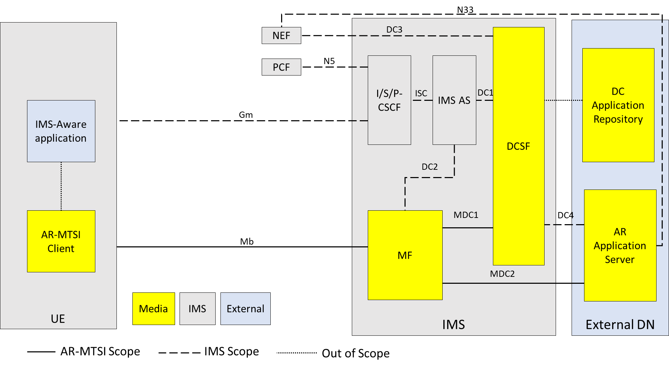

Figure 4.3.1: Generalized IMS DC Architecture to support AR communication

NOTE 1: General control-related elements over Gm interface, such as SIP signalling (TS 24.229 [5]), fall outside the scope of this specification, albeit parts of the session setup handling and session control for AR conversational media at Gm reference point, such as the usage of SDP and setup and control of the individual media streams between clients, are defined in this specification.

NOTE 2: DC Application Repository may be in external DN but can also be in operator domain. The DC Application Repository holds the application(s) that can be used in AR communication sessions and is out of scope of 3GPP.

AR Application Server (AR AS):

- AR Application Server is responsible for AR service control related to AR communication, including AR session media control and AR media capability negotiation with the UE.

NOTE 3: AR Application Server is a specific DC Application Server and is out of scope of 3GPP.

NOTE 4: The UE can download the AR metadata from AR AS through application data channel.

DCSF:

- The DCSF receives event reports from the IMS AS, and decides whether AR communication service is allowed to be provided during the IMS session. Additionally, the DCSF interacts with the AR AS for DC resource control.

MF:

- Support AR conversational service by providing transcoding for terminals with limited capabilities. Additionally, the MF may collect spatial and media descriptions from UEs and create scene descriptions for symmetrical AR call experiences.

- Provide remote rendering for AR-MTSI clients in terminals with limited capabilities based on rendering negotiation. For remote rendering the AR-MTSI client provides AR metadata, e.g., pose data, as defined in clause 6 of this specification.

IMS AS:

- The IMS AS receives the media control instructions from the DCSF and accordingly interacts with the UE for connecting the UE's audio/video media termination to the MF [4], and interacts with MF for data channel media resource management for AR media processing.

# 5 Immersive AR Media

## 5.1 General

An AR-MTSI client supports simultaneous transfer of multiple media components with real-time characteristics. An AR-MTSI client supports the core media components in TS 26.114 [2] for a conversational AR scenario including text, image, video and speech (also referred to as audio).

## 5.2 Speech

AR-MTSI client in terminal offering speech communication shall follow clause 5.2.1 in TS 26.114 [2]. In order to support minimum service interoperability, an AR-MTSI client in terminal shall implement the UE codec and media handling requirements as specified in TS 26.114 [2].

## 5.3 Video

AR-MTSI client in terminal offering video communication shall follow clause 5.2.2 in TS 26.114 [2] and may render it as based on AR metadata (in clause 6) and media configuration (in clause 7). In order to support minimum service interoperability, an AR-MTSI client in terminal shall implement the UE codec and media handling requirements as specified in TS 26.114 [2].

Specifically, the AR-MTSI client in terminal may support Overlays and Scene Description-Based Overlays (as described in TS 26.114 [2] in clause Y.6.4 and Y.6.9) to render video elements in parts of the AR environment. This may result into rendering the video stream (or parts of the video stream) in a sub-area of the display device. Further, the UE may negotiate a stream characteristic most suitable for the sub-area and may renegotiate the stream characteristics in case the sub-area changes.

## 5.4 Real-time text

AR-MTSI client in terminal offering real-time text shall follow clause 5.2.3 in TS 26.114 [2] and may render it as defined in the AR metadata (in clause 6).

## 5.5 Still images

AR-MTSI client in terminal supporting still images shall follow clause 5.2.4 in TS 26.114 [2] and may render it as defined in the AR metadata (in clause 6).

# 6 AR Metadata

## 6.1 General

Real-time scene creation for an AR conference with two or more participants may be done by the MF to create a symmetric experience for all participants. For an MF to create a scene, it may request the following information from the UEs:

- spatial description of the space surrounding the UE e.g., the occlusion-free space around the user in which the AR media will be rendered.

- media properties indicating the AR media that the UE will be sending, and thus have to be incorporated in the scene.

- receiving media capabilities of the UEs, which may include

- UE media decoding capabilities

- UE hardware capabilities (e.g., the display resolution)

- information based on detecting the location, orientation, and capabilities of physical world devices, eligible for usage in an audio-visual communications session

Based on this information the MF creates a scene which includes:

- defining the placement of the user and the AR media in that scene, including e.g., the position, size, depth from the user, anchor type, and recommended resolution (or quality)

- specific rendering properties for the AR media, e.g., for a 2D object to be rendered with a billboarding effect

The MF can then share the scene with the participant UEs using a supported scene description format. This scene description may be different for different UEs.

NOTE: The scene as sent by the MF allows the UE to 1) select and request any related media (for example, in a quality and bitrate based on the rendering characteristics or network connection), 2) render the complete scene on a (virtual) display device, and 3) update the rendering and requested media dynamically (e.g., according to the movement and view orientation of the user).

## 6.2 Metadata data channel message format

For the carriage of metadata defined in this clause the AR-MTSI clients shall use the data channel. The data channel sub-protocol shall be identified as “3gpp-ar-metadata”, which shall be included in the dcmap attribute of the SDP.

The transmission order for the data channel shall be set to in-order and the transmission reliability shall be set to reliable.

The metadata message format shall be set to text-based and the messages shall be UTF-8 encoded JSON messages.

A data channel message may carry one or more AR metadata messages as defined in Table 6.2-1.

Table 6.2-1 AR Metadata Messages Format

|  |  |  |  |
| --- | --- | --- | --- |
| **Name** | **Type** | **Cardinality** | **Description** |
| messages | Array(Message) | 1..n | A list of AR metadata messages. Each message shall be formatted according to the Message data type as defined in Table 6.2-2. |

Each metadata message shall follow the format specified in Table 6.2-2.

Table 6.2-2 AR Metadata Message Data Type

|  |  |  |  |
| --- | --- | --- | --- |
| **Name** | **Type** | **Cardinality** | **Description** |
| id | string | 1..1 | A unique identifier of the message in the scope of the data channel session. |
| type | string | 1..1 | A URN that identifies the message type. |
| payload | object | 1..1 | The message payload depends on the message type. |
| sendingAtTime | number | 0..1 | The wall clock time when the AR metadata message is transmitted. (clause 9.3.2.1 in TS 26.565 [6]) |

## 6.3 Spatial descriptions

### 6.3.1 Spatial description format

#### 6.3.1.1 General

A spatial description format is used for defining the physical space around a UE or trackable in which virtual content can be inserted. This clause includes the supported formats and the method for exchanging the information between AR-MTSI clients.

#### 6.3.1.2 Available visualization space

An AR-MTSI client in terminal may send available visualization space, user position and other trackable poses to AR MF for scene creation and update.

The available visualization space defines an occlusion-free space around the user for rendering the AR scene as a geometric primitive. The format for available visualization space is defined in clause 12.4 of TS 26.119 [3]. The type of the message containing visualization space as a payload shall be “**urn:3gpp:ar:v1:visualization-space**”. The availableVisualizationSpace object [3] shall contain a xrSpaceId. The xrSpaceId is used for determining the local coordinate axis of the visualization space. The xrSpaceId shall be a unique identifier for an XR space of one AR-MTSI client in terminal. If the visualization space is sent, then initial user pose shall be sent. The user pose and visualization space are in reference to the same xrSpaceId.

If the visualization space is anchored to another trackable (instead of the user) not anchored around the user or if the viewer is not the centre of the visualization space, an initial pose for a trackable as defined in clause 6.3.1.3 may be used.

#### 6.3.1.3 Initial Pose

Trackable is a real-world object (e.g., the UE, floor, controllers, table etc.) that the UE can detect, which can be used as a reference to anchor virtual objects to the real world.

The AR-MTSI client in terminal that sends the available visualization space may also send at least one pose for a trackable within the visualization space. The AR-MTSI client in terminal may send additional poses for anchoring virtual objects. The poses shall be sent using the format defined in clause 12.2 of TS 26.119 [3]. The poseInfo (as defined in Table 12.2-1 of TS 26.119 [3]) shall contain an xrSpaceId that is the same as the one used for visualization space. The poses may additionally contain a label string to identify the type of anchor. The labels are application-dependent, but for example, user, floor, left controller etc., can be used as labels. The type of the message for a pose sent for scene creation shall be set to “**urn:3gpp:ar:v1:initial-pose**”.

## 6.4 Scene descriptions

An AR-MTSI client in terminal that is a compliant device type of TS 26.119 [3] shall support the capabilities requirements for scene description as described in clause 10 of TS 26.119 [3] for its respective device type.

When used in an AR call, the scene description should be the entry point to the AR session (after establishment of a regular call/conference) and shall be exchanged over the data channel as described in TS 26.114 [2]. The Scene Description is exchanged over a stream with a stream id in the range 1 to 1000 and shall be provided by the AR AS through the MF to the AR-MTSI client in terminal. In this case, no web application needs to be downloaded in this case.

Based on the information in the Scene Description, the UE may decide to add additional media streams through a re-INVITE. However, at least the RTP session for the voice of every participant should be present and should be linked to an audio source in the scene description.

NOTE: Support for advanced audio codecs, such as IVAS, in scene description is for further study.

Each participant should be associated with their own camera node, identified through the node name, which is also provided as part of the SDP through the “sd-nodes” attribute of media session of the data channel that carries the Scene Description.

The “sd-nodes” attribute shall conform to the following ABNF syntax:

att-field = "sd-nodes"

att-value = participant-label SP node-name *("," node-name)

participant-label = char-val ; char-val is defined in RFC 7405

node-name = char-val ; char-val is defined in RFC 7405

The AR MF should apply pose updates from the received pose information of each participant to their respective camera nodes, as negotiated by the SDP sd-nodes attribute.

A scene description of an AR session may be sent from the AR MF/MRF to the AR-MTSI clients in terminal.

An AR MF that supports scene description shall support:

- The capability to generate a scene description file that conforms to the SD-Rendering-glTF-Core capability as defined in TS 26.119 [3].

- The capability to generate and update a scene description file that conforms to the SD-Rendering-glTF-Ext1 as specified in TS 26.119 [3].

An AR MF that supports scene description may additionally support the generation of scene description files and updates that conform to the **SD-Rendering-glTF-Ext2** capabilities as defined in TS 26.119 [3].

An AR MF that supports scene description may additionally support the generation of scene description files and updates that conform to the **SD-Rendering-glTF-Interactive** capabilities as defined in TS 26.119 [3].

In addition, an AR MF that supports scene description shall support the referencing of RTP streams in the scene description through the MPEG_media extension as defined in ISO/IEC 23090-14 AMD 2 [7]. The external media shall be RTP media streams supported by an AR-MTSI client and signalled in the SDP.

When scene description is not used as the entry point, the scene description shall be sent by the AR MF/MRF to the AR-MTSI client in terminal over the application data channel. The type of the message containing the scene description shall be set to “**urn:3gpp:ar:v1:sd**”.

An AR MF that supports scene descriptions should create and distribute the scene for an AR call with audio and video streams based on the visualization space, viewer position and AR media properties. The AR MF should create the scene description for each participant (AR-MTSI client in terminal) such that the shared experience is symmetrical for the different users in the call, e.g., to maintain relative position of users and objects.

6.5 Split rendering

### 6.5.1 General

in terminal supporting split rendering (of AR Media objects or 3D scenes) as defined in TS 26.567 and shall conform to the procedures and capabilities defined in TS 26.567 for split rendering [9]. .

NOTE: In case split rendering is used, AR Media objects or 3D scenes are rendered in a split rendering server (AR AS) based on the XR pose information and actions of the AR-MTSI client in terminal. The split rendering server renders a view of the scene (or object) based on the viewing angles and XR pose, provided by the AR-MTSI client in terminal. The resulting images are sent as video streams from the split rendering server to the AR-MTSI client in terminal, which renders the videos at their respective position in AR.

### 6.5.2 Pose Format

When the split rendering is activated, the AR-MTSI client in terminal periodically transmits a set of pose predictions to the AR AS or MF as defined in [9]. .

### 6.5.3 Action Format

The AR-MTSI client in terminal reports any changes to action state as it occurs by sending updated actions to the AR AS or MF after the split rendering is activated as defined in TS 26.567 [9].

# 7 Media configurations

7.1 General

The media configuration requirements for MTSI clients in terminals specified in TS 26.114 [2], clause 6, also apply for AR-MTSI client in terminal.

An SDP framework for AR data exchange for AR communication is presented to negotiate codec support for AR media, AR metadata, as well as RTP/RTCP signalling necessary for AR media rendering processing.

AR-MTSI client in terminal shall use RTP for the real-time transport of AR media for AR communication. Any AR media as an overlay may refer to the overlay configuration described in clause Y.6.4.3 of TS 26.114 [2]*.*

AR-MTSI client in terminal shall use data channels for exchange of AR metadata and rendering negotiation. The SDP attribute “*3gpp_armetadata_types*”should be used to indicate the types of AR metadata which defined in clause 6 (e.g. pose, action and scene description) within the data channel.

The syntax for the SDP attribute is:

att-field = "3gpp_armetadata_types"

att-value = message_type *("," message_type)

message_type = char-val

; URN identifying the message type of AR metadata

; char-val is defined in RFC 7405

Poses as part of AR metadata may be transmitted via RTP session in a RTP header extension as specified in clause 4.3 of TS 26.522 [8].

7.2 Split rendering media configuration

The AR-MTSI client in terminal shall indicate its support for AR calls by including the “webrtc-datachannel” in the “+sip.sub-type” Contact header field.

A new Contact header field parameter, “+sip.3gpp-ar-support” is used to indicate the level of support for AR calls. The possible values for the “3gpp-ar-support” parameter are:

- “**ar-capable**”: indicates that the terminal is fully capable of receiving and rendering AR media as described by the capabilities in [2] clause 9.2.

- “**ar-assisted**”: indicates that the terminal is capable of transmitting AR metadata on the uplink. However, the UE has no support for processing and rendering a 3D scene. The participation in an AR call requires the deployment of split rendering. The rendered view(s) are controlled by the pose information that is shared by the terminal.

In the absence of the “+sip.3gpp-ar-support”, it shall be assumed that the terminal has no support for AR calls. In this case, the MTSI client can only participate in the AR call if split rendering is offered.

An AR-MTSI terminal that intends to participate in an AR call shall register with the “**ar-capable**” value for the “+sip.3gpp-ar-support” parameter and shall offer/answer an SDP that includes a data channel with the sub-protocol “mpeg-sd”. Any updates that the AR-MTSI terminal intends to share, including pose updates, will be sent as scene updates to the AR AS. An AR-MTSI terminal that intends to participate in an AR call with the support for split rendering shall register with the “**ar-assisted**” value for the “+sip.3gpp-ar-support” parameter and shall offer/answer an SDP that includes a data channel with the sub-protocol “3gpp-sr-metadata” as defined in [6]. Pose updates that are to be used for the rendering are shared as pose predictions with the MF.

As specified in Annex AC.9 of TS 23.228 [4], the AR application server may provide network assisted rendering using split rendering over IMS as defined in TS 26.567 [9]. An AR-MTSI client in terminal can decide to request split rendering based on user selection and its status such as power, signal, computing power, internal storage, etc. The AR-MTSI client in terminal shall complete an AR media rendering negotiation with the AR AS before it initiates subsequent procedures to activate the split rendering.

An **AR-assisted** terminal that intends to deploy split rendering for AR media rendering, shall use the negotiation processes between the AR-MTSI client in terminal and the AR AS or MF to determine the split rendering configuration. The split rendering configuration shall be as specified in TS 26.567 [9]. The exchange of the configuration information shall take place using the established application data channel between an AR-DCMTSI client and the MF/AR AS.

For a terminal that does not support AR calls, the IMS AS may trigger split-rendering on behalf of the terminal upon receiving an (re)INVITE for an AR call. The output format for the rendered media shall be conformant to clauses 10.4.3 and 10.4.4 of TS 26.119 [3]. The MF that performs the remote rendering shall select a suitable rendering viewpoint for the session, e.g. a selected viewpoint in the scene or the initial viewpoint for the participant as assigned by the AR AS in the scene description. In case no split rendering can be setup, the IMS AS should reject the call.

The IMS AS detects support for AR capabilities based on the presence or absence of the “+sip.3gpp-ar-support” parameter of the Contact Header Field in the REGISTER message.

# 8 AR Data Transport

## 8.1 General

The data transport requirements for MTSI clients in terminals specified in TS 26.114 [2], clause 7, also apply for AR-MTSI clients in terminals.

## 8.2 RTP transport

In addition to the requirements specified in TS 26.114 [2], clause 7, the RTP Header Extension for PDU Set Marking (clause 4.2) and RTP Header Extension for XR Pose (clause 4.3) specified in TS 26.522 [8] also apply for AR-MTSI clients in terminals.

## 8.3 RTCP usage

In addition to the requirements specified in TS 26.114 [2], clause 7, the Transmission of timing information data for QoE measurements specified in TS 26.522 [8], clause 5.2, also applies for AR-MTSI clients in terminals.

# 9 Quality of Experience

## 9.1 General

Quality of Experience (QoE) requirements for MTSI clients in terminals specified in TS 26.114 also apply for terminals to be specified by this specification. Further, extensions to those QoE requirements are for future studies (and expected once extensions are made to the AR media formats).

Annex A (normative):  
Call flows for IBACS

# A.1 IMS AR communication Call Flows

## A.1.1 General

Figure A.1.1-1 illustrates a high-level call flow for AR communication.

Figure A.1.1-1: High-level call flow for AR communication

The following steps are performed:

A. AR Call Session Setup: UE1 initiates an AR call, and the AR call session is established between UE1 and UE2, data channels along with audio and video channels are established between UE and network

B. Split Rendering Negotiation: When the UE has poor rendering capability which is not able to satisfy the requirements of AR communication, the split rendering negotiation is involved between the UE and IMS. The split may be adjustable during a session. This split rendering negotiation step can be executed/re-executed during the session when the UE’s status changed and/or user selection. Split rendering support over IMS is defined in TS 26.567 [9].

C. Scene Description Processing: Prepare and generate scene description updates for the AR call session, this procedure can be done either on UE or IMS network.

D. AR Media Processing: AR media & Metadata transmission and AR media rendering for the AR call session, if split rendering is enabled, this procedure can be done by both UE and IMS network.

## A.1.2 AR Call Session Setup

The AR call session procedure shall be followed as specified in clause AC.7 of TS 23.228 [4].

## A.1.3 Split Rendering Negotiation

Split rendering procedures are defined in TS 26.567[9].

## A.1.4 Scene Description Processing

Figure A.1.4-1 illustrates a detailed call flow for scene description processing procedure.



Figure A.1.4-1: Call Flow for Scene Description Processing

The steps are as follows:

1. The UE1 initiates an AR communication session and establishes audio and video session connections with the UE2. Then the bootstrap and application data channels are established for the UE1 and UE2.

2. The split rendering negotiation procedure has been finished.

3. MF prepares the scene description based on media descriptions and assets for the call.

4. MF delivers the scene description to the UEs.

5. A UE may trigger a scene update e.g., when a new object is added/removed in the scene, or a spatial information update is sent or UE capabilities change. The figure shows the update is triggered by UE1, but this can be either UE.

6. The MF will process the new information and creates a scene description update. It is also possible for the MF to initiate an update without an update from the UEs, for example if link conditions change.

7. MF distributes scene description update to all UEs.

NOTE: Spatial data related updates may be required for collaborative AR calls, e.g., when multiple users are physically collocated and also part of the same AR experience. The type of spatial description updates is for further study.

8. Subsequent procedures continue.

## A.1.5 AR Media Processing

Figure A.1.5-1 illustrates a detailed call flow for AR media processing procedure.



Figure A.1.5-1: Call Flow for AR Media Processing

The steps are as follows:

1. The UE1 initiates an AR communication session and establishes audio and video session connections with the UE2. Then the bootstrap and application data channels are established for the UE1 and UE2.

2. The split rendering negotiation procedure has been finished. Split rendering procedures, protocols, signalling and formats shall be compliant with TS 26.567 [9].

3. The scene description processing has been finished.

4a. The UE1 captures the AR metadata, performs AR media rendering locally and then encodes rendered AR media, e.g., as audio/video media stream.

5a. The UE1 sends the rendered AR media and/or AR metadata to the peer through the established media connection(s).

6a. The UE1 receives the AR media and/or AR metadata from the peer through established media connection(s).

7a. The UE1 decodes the AR metadata and performs AR media rendering locally and displays it on its screen.

Network Centric Procedure:

4b. The UE1 retrieves AR metadata such as pose and user input locally, and renders the part of AR objects that should be done in the UE1 according to the result in step 2.

5b. The UE1 sends AR media to the MF, the AR media can include the audio/video media stream rendered by the UE1, and the AR metadata which is used for the AR objects rendering that should be done in the IMS network.

6b. The UE2 may also send AR media and/or AR metadata to the MF/MRF, e.g., the viewport.

7b. The MF renders the part of AR objects based on the AR metadata received. Then the MF decodes the audio/video media stream received from the UE1, and combines with the AR media rendered by the MF.

8b. The MF sends the rendered audio/video media stream to UE2.

9b. The MF sends the rendered audio/video media stream to the UE1.

10. A UE may trigger a scene update as described in clause 9.1.3. for example, if objects are added/removed from the scene or if UE capabilities change and it can no longer render some AR objects as negotiated in step 2.

11. The MF processes the new information and creates a scene description update. It is also possible for the MF to initiate an update without an update from the UEs, for example if network conditions change.

12. The MF distributes the scene description update to all UEs.