3GPP TSG-SA WG4 Meeting #131 S4-250240

Geneva, Switzerland, 17 – 21 February 2025

Source: InterDigital Canada
Title: [FS_AVATAR] Scene Management for Multi-party Avatar-based Communication
Agenda item: 9.7
Document for: Discussion and Agreement

1. Introduction
For multi-participant AR calls that offer a shared experience. A shared 3D scene is required. The Scene Manager is responsible for the creation and update of the scene based on input and actions from all participants in the session.
In this contribution, we describe the procedure by which an Avatar communication session is established and how the scene management for such an immersive session is performed.

2. Scene Management in Multi-party Avatar Calls
Figure X demonstrates the call flow for setting up and managing a shared scene for shared space AR calls where participants are represented by their avatars.
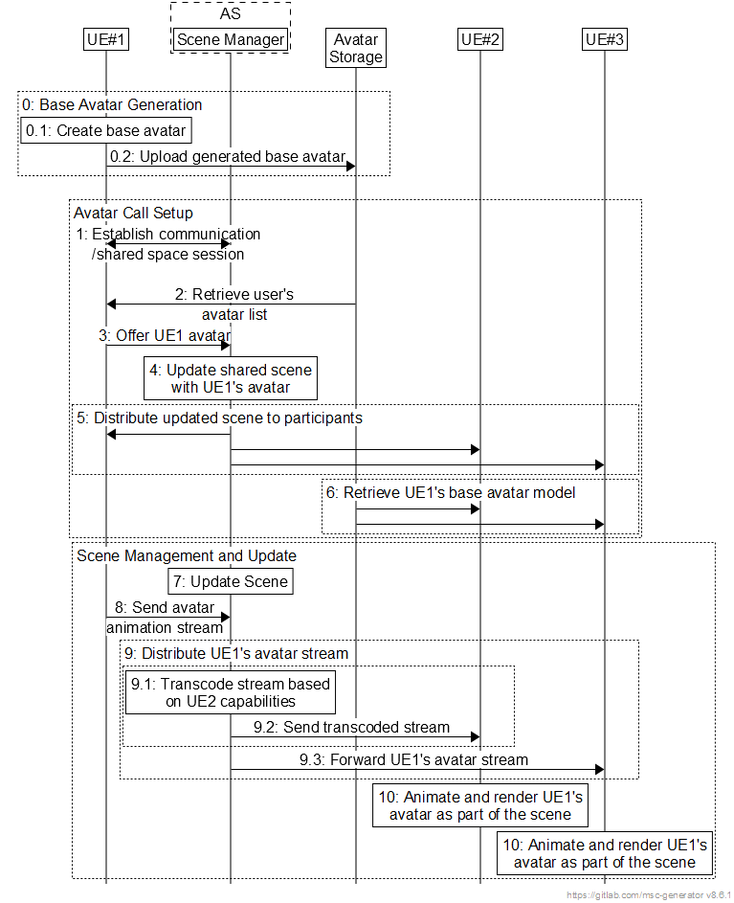
Figure X – Call flow for multi-party avatar call.
The following describes the steps in a multi-party avatar-based call:
Prerequisite
UE1 generates the personalized base avatar, possibly using a reference avatar format. The generated base avatar is then uploaded to an Avatar Storage network function. This request shall be encrypted and unique for each UE.
Avatar Call Setup
- UE1 establishes or joins a communication/shared space session with the AS. As part of the session establishment process, UE1 may provide the AS with a set of avatar-related capabilities that it supports (e.g., supported avatar representation and animation formats and supported animation features). If UE1 is the first to join the session, the Scene Manger in the AS generates a new shared scene.
- UE1 retrieves a list of avatars associated with the user from the Avatar Storage.
- UE1 offers the user’s base avatar model, based on the user’s selected avatar from the retrieved avatar list, to the Scene Manager for use in the session. The selection process may also make use of metadata associated with each avatar in the list.
- The Scene Manger updates the shared scene to include the avatar offered by UE1 as a node in the scene. The newly added node contains a description of how UE1’s avatar can be reconstructed and animated by other participants in the session. The Scene Manager locally assigns the ownership of this node(s) to user of UE1, thus only allowing UE1 to update the status of these nodes.
- The AS sends a scene description document for the shared scene to UE1 and scene updates to any existing participants.
- Each participant (e.g., UE2) downloads UE1’s base avatar model from the Avatar Storage network function, based on the information provided in the scene description document and in accordance with the granted level of access. The access may for instance be limited to a predetermined level of detail or to a subset of the digital assets that are stored as part of the base avatar model.
Scene Management and Update
- During the session, the Scene Manager may update the scene based on changes requested by the participant UEs (e.g., the user wants to change their avatar, or other participants joining the session). These updates are then sent by the AS to all the session participants either as complete scene updates or as scene patches.
- UE1 generates an animation data stream for the user’s avatar (e.g., based on tracking sensor data, such as a camera capturing the user’s face, or based on user interaction) and sends the stream to the AS over an established data channel that is part of the session.
- Upon receiving the animation data, the AS distributes the animation stream of UE1 to other participants in the communication session. The AS may perform a processing step (e.g., transcoding or conversion) on the data via the Media Function prior to forwarding the stream to other participants (e.g., based on the participant’s supported avatar animation capabilities and features).
- Each participant uses the downloaded base avatar model and the received animation streams for UE1 to reconstruct and animate the avatar of UE1. The avatar is then rendered as part of the scene.

3. Proposal
We propose to agree the content of section 2 into the TR under a new section on session management for AR calls with avatars.

