**3GPP TSG- Meeting #**

**, , - revision of S4-250026**

|  |  |  |  |  |  |  |  |  |
| --- | --- | --- | --- | --- | --- | --- | --- | --- |
| *CR-Form-v12.3* | | | | | | | | |
| **CHANGE REQUEST** | | | | | | | | |
|  | | | | | | | | |
|  |  | **CR** |  | **rev** |  | **Current version:** |  |  |
|  | | | | | | | | |
| *For* [***HE******LP***](http://www.3gpp.org/3G_Specs/CRs.htm#_blank)*on using this form: comprehensive instructions can be found at* [*http://www.3gpp.org/Change-Requests*](http://www.3gpp.org/Change-Requests)*.* | | | | | | | | |
|  | | | | | | | | |

|  |  |  |  |  |  |  |  |  |
| --- | --- | --- | --- | --- | --- | --- | --- | --- |
| ***Proposed change affects:*** | UICC apps |  | ME | **X** | Radio Access Network |  | Core Network | **X** |

|  |  |  |  |  |  |  |  |  |  |  |
| --- | --- | --- | --- | --- | --- | --- | --- | --- | --- | --- |
|  | | | | | | | | | | |
| ***Title:*** |  | | | | | | | | | |
|  |  | | | | | | | | | |
| ***Source to WG:*** |  | | | | | | | | | |
| ***Source to TSG:*** |  | | | | | | | | | |
|  |  | | | | | | | | | |
| ***Work item code:*** |  | | | | |  | ***Date:*** | | |  |
|  |  | | | |  | |  | | |  |
| ***Category:*** |  |  | | | | | ***Release:*** | | |  |
|  | *Use one of the following categories:* ***F*** *(correction)* ***A*** *(mirror corresponding to a change in an earlier release)* ***B*** *(addition of feature),* ***C*** *(functional modification of feature)* ***D*** *(editorial modification)*  Detailed explanations of the above categories can be found in 3GPP [TR 21.900](http://www.3gpp.org/ftp/Specs/html-info/21900.htm). | | | | | | | | *Use one of the following releases: Rel-8 (Release 8) Rel-9 (Release 9) Rel-10 (Release 10) Rel-11 (Release 11) … Rel-17 (Release 17) Rel-18 (Release 18) Rel-19 (Release 19)  Rel-20 (Release 20)* | |
|  |  | | | | | | | | | |
| ***Reason for change:*** | | **In-session Unicast Repair for MBS Object Distribution**: For live and low-latency live services using the Object Distribution Method in MBS, in certain cases the transmission of an object is not successful. In this case, unicast repair for individual MBS Clients can improve the service quality. However, the timing of such requests needs to be carefully studied in order to avoid network overloads or significant latencies in the delivery. A study to extend MBS User Services and object streaming to address in-session repair is of relevance. For details refer to TR 26.802.  In TR 26.802, *In-session unicast repair for MBS Object Distribution* as introduced in clause 5.9 and based on the conclusions in clause 5.9.7 to address Gap#1 in clause 5.9.5 by the candidate solution in clause 5.9.6 has been motivated. | | | | | | | | |
|  | |  | | | | | | | | |
| ***Summary of change:*** | | *In-session unicast repair for MBS Object Distribution* as introduced in clause 5.9 of TR 26.802:  i. Define a new reference point in TS 26.502 between the MBSTF and the MBS AS.  ii. Document call flows and procedures for both post-session and in-session unicast repair. | | | | | | | | |
|  | |  | | | | | | | | |
| ***Consequences if not approved:*** | | Feature not supported | | | | | | | | |
|  | |  | | | | | | | | |
| ***Clauses affected:*** | | 1, 2, 4.2.2, 4.2.6, 4.3.1, 4.3.3.1, 4.3.3.2, 4.3.4, 4.4.1, 4.5.2, 4.5.5, 4.5.6, 4.9, 5.2, 5.3, 5.6, 5.6.1 (new), 5.6.2 (new), 5.6.3 (new) | | | | | | | | |
|  | |  | | | | | | | | |
|  | | **Y** | **N** |  | | | |  | | |
| ***Other specs*** | |  | **X** | Other core specifications | | | | TS/TR ... CR ... | | |
| ***affected:*** | |  | **X** | Test specifications | | | | TS/TR ... CR ... | | |
| ***(show related CRs)*** | |  | **X** | O&M Specifications | | | | TS/TR ... CR ... | | |
|  | |  | | | | | | | | |
| ***Other comments:*** | |  | | | | | | | | |
|  | |  | | | | | | | | |
| ***This CR's revision history:*** | | |  |  |  |  | | --- | --- | --- | --- | | [**S4-250026**](https://www.3gpp.org/ftp/tsg_sa/WG4_CODEC/TSGS4_131_Geneva/Docs/S4-250026.zip) | [AMD-ARCH-MED] In-session Unicast Repair for MBS Object Distribution | Qualcomm Germany, BBC | Thomas Stockhammer |   **Revisions**: none  **Presenter**: Thomas Stockhammer  **Online Discussion**:   * Richard: We might need to merge.   + Thomas: Yes. * Thomas: There are comments to be removed and I need to fix the release.   **Decision**: Revised to remove comments and fix release. The revision will be agreed without presentation  [S4-250026](https://www.3gpp.org/ftp/tsg_sa/WG4_CODEC/TSGS4_131_Geneva/Docs/S4-250026.zip) is **revised to S4-250271**. | | | | | | | | |

## ===== CHANGE =====

# 1 Scope

The present document defines an architecture and high-level procedures for User Services conveyed using the 5G multicast–broadcast capabilities of the 5G System defined in TS 23.501 [2], TS 23.502 [3] and TS 23.247 [5].

The design of the system is primarily motivated by the conclusions of TR 26.802 [20].

## ===== CHANGE =====

# 2 References

The following documents contain provisions which, through reference in this text, constitute provisions of the present document.

- References are either specific (identified by date of publication, edition number, version number, etc.) or non‑specific.

- For a specific reference, subsequent revisions do not apply.

- For a non-specific reference, the latest version applies. In the case of a reference to a 3GPP document (including a GSM document), a non-specific reference implicitly refers to the latest version of that document *in the same Release as the present document*.

[1] 3GPP TR 21.905: "Vocabulary for 3GPP Specifications".

[2] 3GPP TS 23.501: "System architecture for the 5G System (5GS)".

[3] 3GPP TS 23.502: "Procedures for the 5G System (5GS)".

[4] 3GPP TS 23.503: "Policy and charging control framework for the 5G System (5GS); Stage 2".

[5] 3GPP TS 23.247: "Architectural enhancements for 5G multicast-broadcast services; Stage 2".

[6] 3GPP TS 26.348: "Northbound Application Programming Interface (API) for Multimedia Broadcast/Multicast Service (MBMS) at the xMB reference point".

[7] 3GPP TS 26.501: "5G Media Streaming (5GMS); General description and architecture".

[8] IETF RFC 3550: "RTP: A Transport Protocol for Real-Time Applications".

[9] IETF RFC 2250: "RTP Payload Format for MPEG1/MPEG2 Video".

[10] 3GPP TS 26.247: "Transparent end-to-end Packet-switched Streaming Service (PSS); Progressive Download and Dynamic Adaptive Streaming over HTTP (3GP-DASH)".

[11] 3GPP TS 26.531: "Data Collection and Reporting; General Description and Architecture".

[12] 3GPP TS 23.468: "Group Communication System Enablers for LTE (GCSE\_LTE)".

[13] Void.

[14] 3GPP TS 23.468: "Group Communication System Enablers for LTE (GCSE\_LTE)".

[15] 3GPP TS 29.522: "5G System; Network Exposure Function Northbound APIs; Stage 3".

[16] OMA: "OMNA BCAST Service Class Registry", <https://technical.openmobilealliance.org/OMNA/bcast/bcast-service-class-registry.html>.

[17] IANA: "Reliable Multicast Transport (RMT) FEC Encoding IDs and FEC Instance IDs", <https://www.iana.org/assignments/rmt-fec-parameters/rmt-fec-parameters.xhtml#rmt-fec-parameters-1>.

[18] 3GPP TS 33.501: "Security architecture and procedures for 5G system".

[19] 3GPP TS 33.246: "Security of Multimedia Broadcast/Multicast Service (MBMS)".

[20] 3GPP TR 26.802: "Multicast Architecture Enhancement for 5G Media Streaming".

## ===== CHANGE =====

### 4.2.2 User Services network architecture

MBS User Services enable high-level applications to make use of the low-level features of the MBS System. An MBS User Service is provided by the MBSF and MBSTF working in combination to support configuration option 2 and configuration option 3 defined in annex A of TS 23.247 [5]. In addition to the Network Functions defined in [5]:

- The *MBS AF* provides unicast User Service Announcements to the MBSF Client in the user plane and to the MBSTF.

- The *MBS AS* provides unicast services such as Object Repair to the MBSTF and MBSTF Client.

- The *MBSSF* supports the User Plane security procedure according to clause W.4.1.3 of TS 33.501 [18] and provides a user plane authentication service to the MBSF Client.

Together, these functions enable a complete service offering to an end-user, via a set of APIs that allows the MBS Client to activate or deactivate reception of MBS User Services.

The MBS User Services architecture depicted in figure 4.2.2-1 shows the MBS-related entities involved in providing MBS User Services delivery and control. These are described in the following clauses. The MBS Application Provider plays the role of the AF/AS.

****

Figure 4.2.2-1: MBS User Services network architecture

## ===== CHANGE =====

### 4.2.6 Object Repair

When using the Object Distribution Method, Object Repair procedures may be provisioned by the MBS Application Provider. This feature allows an MBS Client to retrieve from the MBS AS (via reference point MBS‑4‑UC) missing portions of objects not received intact from the MBSTF at reference point MBS‑4‑MC.

The following Object Repair procedures are defined in clause 5.6 of the present document:

- *In-session Object Repair* during the MBS Distribution Session, including the ability to repair objects in streaming distribution.

- *Post-session Object Repair* after the completion of the MBS Distribution Session, including a randomized back-off period for different MBS Clients in order to avoid overloading the MBS AS.

The functions of the MBS AS are defined in clause 4.3.4.

## ===== CHANGE =====

### 4.3.1 General

The MBSF and MBSTF offer service layer functionality for sending data via MBS Sessions. The MBSF (clause 4.3.2) offers control plane functionality while the MBSTF (clause 4.3.3) offers user plane functionality. The MBSTF acts as a User Plane anchor when it sources IP multicast traffic. Reference point Nmb2 provides the means for the MBSF to configure the delivery methods in the MBSTF, and also supports push-based ingest of object manifests. Reference point MBS‑11 supports pull-based ingest by the MBSTF of object manifests and pull-based ingest of User Service Announcement objects for delivery to the MBS Client via reference point MBS‑4‑MC (as described in clause 4.2.4).

Figure 4.3.1-1 shows the complete set of functional entities involved in supporting MBS User Services when the MBS Application Provider is deployed in the Trusted DN, including client functions in the UE.



NOTE: When the MBS Application Provider is deployed outside the Trusted DN, it interacts with the MBSF via the NEF at reference point N33, as shown in figure 4.2.2‑1, instead of via Nmb10.

Figure 4.3.1-1 MBS User Service reference architecture

In the above architecture, MBS-specific functions such as the MBS AS and MBSF are shown as independent and standalone. In deployments, they may be co-located on physical devices with other functions. As an example, the MBS AS may be hosted in the MBS Application Provider domain, or it may be hosted in a 5GMS AS.

## ===== CHANGE =====

#### 4.3.3.1 General

The functionality of the MBSTF is defined in clause 5.3.2.12 of TS 23.247 [5]. It receives User Plane data traffic at reference point Nmb8 and sends MBS data packets to the MB‑UPF via reference point Nmb9.

NOTE: The MBSTF may not be present in all deployments of the MBS System. However, the MBSTF is an integral and necessary component of MBS User Services, and the present document is not concerned with deployments in which it is absent.

The present document defines additional User Plane functionalities of the MBSTF to support MBS User Services as follows:

1. Receiving MBS Distribution Session configurations from the MBSF at reference point Nmb2.

2. Sending notification events to the MBSF, e.g., data ingest failure, session terminated, delivery started via reference point Nmb2.

3. Based on the MBS Distribution Session configuration:

a) MBS delivery of ingested objects or sequences of objects to the MBS Client using the Object Distribution Method (see clause 6.1). This may be used to support real-time distribution of media segments (as special objects) including CMAF segments.

b) MBS delivery of ingested packet streams to the MBS Client using the Packet Distribution Method (see clause 6.2).

c) Delivery of MBS User Service Announcement information (including updates as necessary) within the MBS Session.

4. In the case of 3a), potentially forwarding ingested objects to the MBS AS to support Object Repair.

## ===== CHANGE =====

#### 4.3.3.2 MBSTF subfunctions to support Object Distribution Method

The MBSTF subfunctions supporting the Object Distribution Method are depicted in figure 4.3.3.2-1 below.



Figure 4.3.3.2-1: MBSTF architecture overview for Object Distribution Method

The *Object ingest* subfunction supports:

- *Pull-based ingest at reference point MBS‑11:* The Object ingest subfunction in this case fetches one or more objects from the MBS AF using HTTPS for inclusion in the MBS User Service Announcement Channel. (The set of objects to be included is listed in an object manifest previously fetched from the MBS AF at the same reference point.)

- *Push-based ingest at reference point Nmb2:* The Object ingest subfunction receives an object manifest from the MBSF that describes a set of objects for inclusion in the MBS User Service Announcement Channel. The MBSTF goes on to fetch the objects listed in the object manifest from the MBS AF via reference point MBS‑11.

- *Pull-based ingest at reference point Nmb8:* The Object ingest subfunction in this case fetches one or more objects from the MBS Application Provider (AF/AS).

- *Push-based ingest at reference point Nmb8:* The Object ingest subfunction receives one or more objects from the MBS Application Provider (AF/AS).

- *Pull-based egest at reference point MBS-12:* To support object repair, the Object ingest subfunction provides a content server from which the MBS AS may be configured to fetch one or more objects that have been ingested from the MBS Application Provider (AF/AS).- *Push-based egest at reference point MBS-12:* To support object repair, the Object ingest subfunction may be configured to forward one or more objects that it has ingested from the MBS Application Provider (AF/AS) to the MBS AS.

Object ingest procedures at reference point Nmb2 and MBS‑11 shall be a subset of those at reference point Nmb8.

The *Object segmentation subfunction* supports the partitioning of an object into payload units suitable for MBS transmission.

The optional *Application Layer FEC* subfunction supports object recovery when some packets are not received by the MBMS Client.

The *Packetisation* subfunction places the payload units (and, optionally, the FEC data) into Nmb9 transmission packets according to clause 6.1.

The *Packet scheduling* subfunction schedules the outgoing packet stream according to target bit rate configuration.

The *Control* subfunction offers support for MBSTF service configuration, status query and notifications at reference point Nmb2.

## ===== CHANGE =====

### 4.3.4 MBS AS

The MBS AS is an optional entity that performs the following functions to support MBS User Services:

- Providing a byte-range Object Repair service to the MBSTF Client (via reference point MBS‑4‑UC) for use with the Object Distribution Method.

The MBS AS is configured by the MBSF at reference point MBS‑9. This interaction is not further defined in this document.

To support Object Repair by the MBSTF Client at reference point MBS‑4‑UC (see clause 4.3.5), the MBS AS may be configured separately for each MBS Distribution Session to ingest content from the MBSTF via reference point MBS-12 by one of the two following methods:.

- *Pull-based ingest at reference point MBS-12:* The MBS AS fetches one or more objects from the MBSTF. The MBSTF endpoint from which objects are fetched is included in the MBS AS configuration provided at reference point MBS‑9. In this mode of operation, the MBS AS behaves as a reverse proxy and may cache the objects for reasons of scalability and efficiency.

- *Push-based ingest at reference point MBS-12:* The MBSTF publishes one or more objects to the MBS AS. The MBS AS ingest endpoint is included in the configuration provided to the MBSTF at reference point Nmb2.

The MBS AS may be deployed as a standalone entity, or its functions may be co-located with other Network Functions such as the MBSTF (see clause 4.3.3) or the 5GMS AS defined in TS 26.501 [7].

## ===== CHANGE =====

### 4.4.1 Overview

The following reference points defined in clause 5.1 of TS 23.247 [5] are relevant to MBS User Services architecture: Nmb1, Nmb2, Nmb5, Nmb8, Nmb9, Nmb10 and Nmb12.

The following additional reference points are defined by the present document:

**- MBS-3:** Used by the MBSF to configure the MBS AF and to publish User Service Announcements to it. This reference point is not described further in the present document.

**- MBS-4-MC:** Unidirectional multicast distribution of content from the MBSTF to the MBS Client.

**- MBS-4-UC:** User Plane interactions between the MBSTF Client and the MBS AS for the purpose of file-based unicast repair.

**- MBS-5:** User Plane interactions between the MBSF Client and the MBS AF for the purpose of MBS control plane and service handling.

**- MBS-6:** API exposed by the MBSF Client and used by the MBS-Aware Application to manage and control MBS User Services.

**- MBS-7:** API exposed by the MBSTF Client and used by the MBS-Aware Application to receive user data information distributed using MBS User Services.

**- MBS-8:** Announcement of MBS User Services to the MBS-Aware Application by the MBS Application Provider. The procedures at this reference point are beyond the scope of 3GPP specification.

**- MBS-9:** Used by the MBSF to configure the MBS AS. This reference point is not described further in the present document.

**- MBS-10:** User Plane interactions between the MBSF Client and the MBSSF for the purpose of authorising access to security-protected MBS data by means of the User Plane security procedure specified in clause W.4.1.3 of TS 33.501 [18].

**- MBS-11:** Used by the MBSTF to retrieve object manifests and User Service Announcements listed in object manifests from the MBS AF.

**-** **MBS-12**: Used by the MBS AS to ingest objects from the MBSTF to support unicast Object Repair.

In addition, the following reference points are defined inside the MBS Client function:

- **MBS‑6′:** API exposed by the MBSTF Client and used by the MBSF Client to (de)activate reception of an MBS Session by the MBSTF. The reception parameters are supplied by the MBSF Client.

This reference point is outside the scope of MBS User Services and is not described further in the present document.

- **MBS‑7′:** API exposed by the MSTF Client and used by the MBSTF to supply MBS Session configuration information that has been received from reference point MBS‑4‑MC.

This reference point is outside the scope of MBS User Services and is not described further in the present document.

## ===== CHANGE =====

4.5.2 Static information model

Figure 4.5.2‑1 shows how the different service and session concepts depicted in figure 4.5.1‑1 above relate to each other. In this figure:

1. The MBS Application Provider provisions the parameters of a new MBS User Service by invoking the *Nmbsf* service either directly, or via the NEF. This specifies which of the *Service announcement modes* are to be used to advertise the MBS User Service, as well as descriptive metadata for inclusion in the MBS User Service Announcement.

2. The MBS Application Provider provisions a number of time-bound MBS User Data Ingest Sessions within the scope of the MBS User Service by invoking the *Nmbsf* service either directly, or via an equivalent *Nnef* service provided by the NEF. Each MBS User Data Ingest Session includes the details of one or more MBS Distribution Sessions.

- To indicate that it has a restricted MBS service area (i.e. corresponding to a local MBS Service, as defined in clause 6.2.2 of TS 23.247 [5]), an MBS Distribution Session may specify one or more *Target service areas*. In line with [5], MBS data is not transmitted outside the MBS service area derived from the indicated *Target service areas*.

- To provision location-dependent variants of an MBS User Service (see clause 6.2.3 of TS 23.247 [5]), a number of MBS Distribution Sessions conveying different MBS data may be provisioned within the scope of the same MBS User Service by setting the *Location-dependent service flag* on the MBS Distribution Sessions of each variant. Location-dependent MBS Distribution Session variants shall have the same *MBS Session Identifier*, but they shall have disjoint *Target service areas*.

- When the *Multiplexed service flag* is set on the MBS Distribution Session, all MBS Distribution Sessions with an identical (or empty) set of *Target service areas* shall be multiplexed onto the same MBS Session. The *MBS Session Identifier* shall be the same for all MBS Distribution Sessions within the multiplex. This feature may be combined with the *Location-dependent service flag*, in which case each location-dependent multiplex of MBS Distribution Sessions is mapped into a separate MBS Session.

- The MBS Application Provider may set the *Transport security protection* flagto indicate that transport security protection (as specified in annex W of TS 33.501 [18]) is required for the MBS Distribution Session. When the flag is set, the MBSSF chooses between the control plane or user plane security procedure.

- The MBS Application Provider may indicate in *Target UE classes* whether a broadcast MBS Distribution Session is intended for consumption by UEs of reduced capability ("NR RedCap UE" as defined in clause 6.19 of TS 23.247 [5]), by reduced capability UEs and full capability UEs, or by full capability UEs only.

The MBSF provisions additional MBS Distribution Session parameters (denoted in table 4.5.6‑1 as assigned by the MBSF) and exposes some of them back to the MBS Application Provider (as indicated by NOTE 1 to table 4.5.6‑1).

NOTE 1: The MBSF typically allocates an *MBS Session Identifier*, such as a Temporary Mobile Group Identity (TMGI) for each MBS Distribution session (see step 4 below) as a side-effect of provisioning, but it is also possible for the *Nmbsf* service invoker to nominate a particular value during this provisioning step if TMGI allocations are managed externally to the MBSF.

3. The MBS Application Provider may additionally provision an MBS Consumption Reporting Configuration within the scope of the MBS User Service by invoking the *Nmbsf* service either directly, or via the NEF.

NOTE 2: Reception reporting for MBS User Services is for future study.

Shortly before the current time enters the time window of a provisioned MBS User Data Ingest Session:

4. The MBSF provisions an MBS Session in the MBS System by invoking the *Nmbsmf* service on the MB‑SMF (see clause 9 of TS 23.247 [5]) to allocate a TMGI (if one has not already been allocated) for each MBS Distribution Session and to create an MBS Session Context for each one. The parameters of the MBS Session Context shall be populated as specified in clause 4.5.9. In response, the MB-SMF provides the MB-UPF ingest information (specifically, the MB‑UPF tunnel endpoint address and traffic flow information to be used by the MBSTF) to the MBSF.

5. The MBSF provisions an MBS Distribution Session in the MBSTF by invoking the *Nmbstf* service at reference point Nmb2 using the parameters from the newly created MBS Session Context.

6. Using the parameters from the MBS Distribution Session and from the newly created MBS Session Context, the MBSF compiles an MBS User Service Announcement to advertise the availability of the MBS User Service and makes this service access information available by one or more of the *Service announcement modes* provisioned in the MBS User Service.



NOTE 1 Square brackets after a parameter name indicate multiplicity; parameter names rendered in italics with parentheses are optional. See the following clauses for details.

NOTE 2: Parameters and entities not exposed to the MBS Application Provider via the *Nmbsf* service at reference point Nmb10 are annotated with the dagger symbol †.

NOTE 3: MBS Session Identifier is defined by clause 6.5.1 of TS 23.247 [5] as a Temporary Mobile Group Identity (TMGI) or a Source-Specific Multicast (SSM) IP address.

**Figure 4.5.2-1: MBS User Services static information model**

## ===== CHANGE =====

4.5.5 MBS User Data Ingest Session parameters

This entity models an MBS User Data Ingest Session, as provisioned by the MBS Application Provider and as managed by the MBSF. The baseline parameters for an MBS User Data Ingest Session are listed in table 4.5.5‑1 below.

NOTE: A linkage from the MBS User Data Ingest Session to its parent MBS User Service is additionally required at stage 3. The *User Service identifier* defined in table 4.5.3‑1 serves this purpose.

The set of active periods may be updated by the MBS Application Provider at any time. The state of constituent MBS Distribution Sessions (and their corresponding MBS Distribution Session Announcements) may need to change as a consequence.

**Table 4.5.5‑1: Baseline parameters of MBS User Data Ingest Session entity**

|  |  |  |  |
| --- | --- | --- | --- |
| **Parameter** | **Cardinality** | **Assigner** | **Description** |
| User Data Ingest Session Identifier | 1..1 | MBSF | An identifier for this MBS User Data Ingest Session that is unique in the scope of the parent MBS User Service (see clause 4.5.3). |
| MBS User Service Announcement | 0..1 |  | The MBS User Service Announcement (see clause 4.5.7) currently associated with this MBS User Data Ingest Session.  Present only if all constituent MBS Distribution Sessions are in the *ESTABLISHED* or *ACTIVE* state. |
| Active periods | 0..\* | MBS Application Provider | Periods of time during which the MBS User Data Ingest Session, and all its subordinate MBS Distribution Sessions, are active in the MBS System.  If omitted, the MBS User Data Ingest Session and all its subordinate MBS Distribution Sessions are intended to be active until further notice. |

The MBS User Data Ingest Session is composed of one or more MBS Distribution Sessions (see clause 4.5.6 below) and these shall be provisioned in the same operation as the enclosing MBS User Data Ingest Session. It is not valid for an MBS User Data Ingest Session to have no MBS Distribution Sessions defined.

MBS Distribution Sessions may be added to or removed from an MBS User Data Ingest Session by the MBS Application Provider at any time, subject to the minimum number specified above. The MBS User Service Announcement may need to change as a consequence to refer to a revised set of corresponding MBS Distribution Session Announcements.

## ===== CHANGE =====

4.5.6 MBS Distribution Session parameters

This entity models an MBS Distribution Session, as provisioned by the MBS Application Provider and as managed by the MBSF. This MBSF subsequently uses this information to provision a corresponding MBS Distribution Session in the MBSTF.

The following parameters assigned by the MBS Application Provider may be updated by the MBS Application Provider at any time:

- Target service areas,

- MBS Frequency Selection Area (FSA) Identifier (applicable only to broadcast Service type),

- QoS information,

- Target UE classes as defined in clause 6.19 of TS 23.247 [5].

With the exception of the *MBS Session Identifier* (which is immutable after initial assignment) and the *Location-dependent service flag* (which is immutable after creation), all other parameters assigned by the MBS Application Provider may be updated by the MBS Application Provider when the MBS Distribution Session is in the *INACTIVE* state.

The baseline parameters for an MBS Distribution Session that are common to all distribution methods are listed in table 4.5.6‑1 below. All parameters are exposed to the MBS Application Provider except where noted otherwise.

**Table 4.5.6‑1: Common baseline parameters of MBS Distribution Session entity**

|  |  |  |  |
| --- | --- | --- | --- |
| **Parameter** | **Cardinality** | **Assigner** | **Description** |
| Distribution Session Identifier | 1..1 | MBSF | An identifier for this MBS Distribution Session that is unique within the scope of the MBS User Service (see clause 4.5.3). |
| State | 1..1 |  | The current state of the MBS Distribution Session: *INACTIVE*, *ESTABLISHED*, *ACTIVE* or *DEACTIVATING* (see clause 4.6.1). |
| MBS Session Context | 1..\* |  | As defined in clause 6.9 of TS 23.247 [5] (see NOTE 1).  There shall be one MBS Session Context associated with the MBS Distribution Session unless multiple *Target service areas* are specified (see below). |
| MB‑UPF tunnel endpoint address | 0..1 |  | The tunnel endpoint address of the MB‑UPF that supports this MBS Distribution Session at reference point Nmb9 (see NOTE 1, NOTE 4). |
| MBMS GW tunnel endpoint address | 0..1 |  | The tunnel endpoint address of the MBMS GW that supports this MBS Distribution Session at reference point SGi‑mb (see NOTE 1, NOTE 4). |
| User Plane traffic flow information | 0..1 |  | Details of the MBS-4-MC User Plane traffic flow to be used by the MBSTF for this MBS Distribution Session, including the multicast group destination address and port number to be used inside the unicast tunnel at reference point Nmb9 (see NOTE 1).  This parameter is mandatory except in the case of Packet Distribution Method operating in Forward-only mode, in which case multicast-addressed packets ingested at reference point Nmb8 are relayed to Nmb9 without changing their address. |
| MBS Session Identifier | 0..1 | MBSF or MBS Application Provider | The Temporary Mobile Group Identity (TMGI) or Source-Specific Multicast (SSM) IP address of the MBS Session supporting this MBS Distribution Session (see NOTE 2).  Multiple MBS Distribution Sessions within the scope of the same MBS User Service may share the same value if they are location-dependent MBS Services, as defined in clause 6.2.3 of TS 23.247[5].  TMGI values are allocated by the MBSF in conjunction with the MB‑SMF unless supplied by the MBS Application Provider at the time of provisioning. |
| Target service areas | 0..\* | MBS Application Provider | The set of regions comprising the MBS service area in which this MBS Distribution Session is to be made available (see NOTE 2).  The provided set of regions shall be disjoint with that of every other MBS Distribution Session sharing the same MBS Session Identifier.  A unique MBS Session Context shall be associated with the MBS Distribution Session for each declared service area, distinguishable by its Area Session Identifier. |
| MBS Frequency Selection Area (FSA) Identifier | 0..1 |  | (Applicable only to broadcast *Service type*.) Identifies a preconfigured area within which, and in proximity to, the cell(s) announce the MBS FSA ID and the associated frequency corresponding to this MBS Distribution Session (see NOTE 3). |
| Target UE classes | 0..\* |  | Indicates whether this MBS Distribution Session is suitable for consumption by NR RedCap UEs and/or non-NR RedCap UEs as defined in clause 6.19 of TS 23.247 [5]. |
| Location-dependent service flag | 0..1 |  | An indication that this MBS Distribution Session corresponds to a location-dependent MBS Session.  If the flag is unset or omitted, the MBS Distribution Session is not location-dependent. |
| Multiplexed service flag | 0..1 |  | If set, all MBS Distribution Sessions in the scope of the same parent MBS User Data Ingest Session with identical or empty sets of *Target service areas* shall be multiplexed onto the same MBS Session.  All MBS Distribution Sessions in the multiplex shall be assigned the same MBS Session Identifier. |
| Restricted membership flag | 0..1 |  | (Applicable only to multicast *Service type*.) An indication that this MBS Distribution Session is restricted to a set of UEs according to their current subscription status in the MBS System.  If the flag is set, only UEs in the restricted set are permitted to join this MBS Distribution Session; otherwise, any UE is permitted to join. |
| QoS information | 0..1 |  | A 5G QoS Identifier (5QI) [2] to be applied to the traffic flow for this MBS Distribution Session (see NOTE 2).  The 5QI information is used by the MBSF to set the Quality of Service for the MBS Session by interacting with the PCF at reference point Nmb12. |
| Maximum content bit rate | 1..1 |  | The maximum bit rate for content in this MBS Distribution Session. |
| Maximum content delay | 0..1 |  | The maximum end-to-end content distribution delay that is tolerated for this MBS Distribution Session by the MBS Application Provider. |
| Distribution method | 1..1 |  | The distribution method for this MBS Distribution Session, as defined in clause 6. |
| Operating mode | 0..1 |  | The operating mode in the case where multiple modes are defined in clause 6 for the indicated distribution method. |
| FEC configuration | 0..1 |  | Configuration for Application Layer FEC (AL-FEC) information added by the MBSTF to protect this MBS Distribution Session.  The AL‑FEC scheme shall be identified using a term from the Reliable Multicast Transport (RMT) controlled vocabulary of FEC Encoding IDs [17] expressed as a fully-qualified URI, e.g. *urn:ietf:rmt:fec:encoding:0*.  The overhead of AL‑FEC protection shall be specified as a proportion of the (unprotected) MBS data, e.g. 1.1 for 10% overhead.  Additional scheme-specific parameters may be signalled in the form of uncontrolled name–value pairs. |
| Transport security protection | 1..1 |  | A flag indicating whether transport security protection is required by the MBS Application Provider for this MBS Distribution Session.  The MBSSF determines whether the control plane security procedure (see NOTE 5) or the user plane security procedure is selected. (See annex W of TS 33.501 [18] for details of these procedures.) |
| Traffic marking information | 0..1 | MBS Application Provider or MBSF | Information (e.g. a Differentiated Services Code Point) used by the MBSTF to mark the multicast packets that it conveys to the MB‑UPF at reference point Nmb9. |
| NOTE 1: Internal parameter not exposed to the MBS Application Provider.  NOTE 2: Parameter not relevant to the MBSTF.  NOTE 3: Used to guide frequency selection by the UE for a broadcast MBS Session.  NOTE 4: At least one of *MB‑UPF tunnel endpoint address* or *MBMS GW tunnel endpoint address* shall be present.  NOTE 5: The control plane security procedure (see clause W.4.1.2 of TS 33.501 [18]) is applicable only to Multicast MBS Session(s). | | | |

An MBS Distribution Session Announcement (see clause 4.5.8 below) shall be associated with an MBS Distribution Session when the latter is in the *ESTABLISHED* or *ACTIVE* state.

The following MBS Distribution Session parameters are additionally relevant when the distribution method is the Object Distribution Method:

**Table 4.5.6‑2: Additional MBS Distribution Session parameters for Object Distribution Method**

|  |  |  |  |
| --- | --- | --- | --- |
| **Parameter** | **Cardinality** | **Assigner** | **Description** |
| Object acquisition method | 1..1 | MBS Application Provider | Indicates whether the objects(s) to be acquired and possibly distributed as part of the corresponding MBS User Data Ingest Session are to be pushed into the MBSTF by the MBS Application Provider or whether they are to be pulled from the MBS Application Provider by the MBSTF.  In the latter case, the *Object acquisition method* indicates whether the object(s) are to be retrieved once from the MBS Application Provider at the start of each active period of the corresponding MBS User Data Ingest Session, or whether the MBSTF is required to check their validity periodically, for example once per rotation of an object carousel.  When a reference to an object manifest is provided as the *Object acquisition identifiers*, it is the responsibility of the MBSTF to check for updates to the object manifest itself in an efficient manner. |
| Object acquisition identifiers | 0..\* | MBS Application Provider | Directly or indirectly identifies the object(s) to be ingested and distributed by the MBSTF during this MBS Distribution Session.  This could be the ingest URL of the object, the ingest URL of a manifest describing a set of objects or the ingest URL of an Application Service Entry Point document.  For both pull- and push-based object acquisition, values are expressed as URL paths to be resolved relative to the *Object ingest base URL*.  Constraints on this parameter are specified in table 6.1-1. In particular, when referencing an object manifest, exactly one object acquisition identifier shall be present. |
| Object ingest base URL | 0..1 | MBS Application Provider or MBSF | In the case of push-based object acquisition, a URL indicating the host part and base path on the MBSTF to which objects are published. In this case, the value shall be nominated by the MBSF and shall be unique for all MBS Distribution Sessions within the MBS System.  In the case of pull-based object acquisition, a URL indicating a host part and base path on the MBS Application Provider's origin server (or, in the case of the User Service Announcement Channel, on the MBS AF) relative to which objects lacking an absolute URL are acquired. In this case, the value shall be nominated by the MBS Application Provider (or, in the case of the User Service Announcement Channel, by the MBSF) and need not be unique.  When present, this URL prefix is replaced by the MBSTF with the *Object distribution base URL* prior to distribution of ingested objects.  If omitted, nothing is substituted in the content ingest URL when forming the object distribution URL |
| Object distribution base URL | 0..1 | MBS Application Provider | A URL prefix substituted by the MBSTF in place of the *Object ingest base URL* prior to distribution of ingested objects.  If present, the optional *Object ingest base URL* shall also be present.  If omitted, the object distribution URL is the same as the object ingest URL. |
| Object repair base URL | 0..1 | MBSF | A URL prefix substituted by the MBSTF Client in place of the *Object distribution base URL* when repairing objects not received completely intact from this MBS Distribution Session (see NOTE 1). The value shall point to the MBS AS.  Present only when object repair is provisioned for this MBS Distribution Session. |
| Object repair exposure base URL | 0..1 | MBSTF | An endpoint on the MBSTF from which objects are additionally made available to the MBS AS at reference point MBS‑12 (NOTE 2).  Present only when object repair is provisioned for this MBS Distribution Session with pull-based ingest by the MBS AS. This parameter is therefore mutually exclusive with *Object repair ingest base URL*. |
| Object repair ingest base URL | 0..1 | MBSF | An endpoint on the MBS AS to which objects ingested by the MBSTF are additionally pushed (NOTE 2).  Present only when object repair is provisioned for this MBS Distribution Session with push-based ingest by the MBS AS. This parameter is therefore mutually exclusive with *Object repair exposure base URL*. |
| NOTE 1: Parameter not relevant to the MBSTF.  NOTE 2: Internal parameter not exposed to the MBS Application Provider. | | | |

The following MBS distribution session are additionally relevant when the distribution method is the Packet Distribution Method:

**Table 4.5.6‑3: Additional MBS Distribution Session parameters for Packet Distribution Method**

|  |  |  |  |
| --- | --- | --- | --- |
| **Parameter** | **Cardinality** | **Assigner** | **Description** |
| Packet ingest method | 1..1 | MBS Application Provider | Indicates whether packets are to be ingested using multicast ingest or unicast ingest.  Multicast ingest is valid for Proxy mode only. In this case, the MBSTF shall join a Source-Specific Multicast (SSM) group indicated in *MBSTF ingest endpoint addresses* parameter.  Unicast ingest is valid for Proxy mode and Forward-only mode. In this case, the MBSTF shall allocate a listening IP address and port number for packet ingest and shall return it to the MBSF in the *MBSTF ingest endpoint addresses* parameter below. |
| MBSTF ingest endpoint addresses | 1..1 | MBS Application Provider, MBSF, MBSTF | The endpoint addresses used by the MBS Application Provider and MBSTF to establish a connection at reference point Nmb8 prior to the commencement of this MBS User Data Ingest Session.  In the case of Proxy mode, this shall be the Source-Specific Multicast (SSM) endpoint addresses (including the source IP address, destination multicast group address and destination UDP port) nominated by the MBS Application Provider or else by the MBSF.  In the case of Forward-only mode, this shall be the IP addresses and UDP port numbers at the source and destination ends of the content ingest tunnel, nominated respectively by the MBS Application Provider and the MBSTF. |

## ===== CHANGE =====

## 4.9 Interworking with eMBMS

Interworking between MBS and eMBMS is described in clause 5.2 of TS 23.247 [5] and applies at the service layer in cases where the same Multicast/Broadcast service is provided simultaneously via eMBMS and MBS. Figure 4.9‑1 depicts a combined network architecture based on figure 4.2.1-1 in the present document and figure 5.2-1 in TS 23.247 [5].



Figure 4.9‑1: MBS–eMBMS interworking system architecture

To support MBS-eMBMS interworking according to the description in clause 5.2 of TS 23.247 [5], the MBS User Services architecture supports the following functionality:

1. MBS User Services are provisioned in the MBSF via reference point Nmb10 per the present document. eMBMS User Services are separately provisioned in the MBSF at reference point xMB-C per TS 26.348 [6] or at reference point MB2-C per TS 23.468 [12]. A common TMGI is used in the MBS System and in the eMBMS System. The two User Services should be provisioned to ingest the same content if service continuity between the MBS System and the eMBMS System is required.

2. Signalling from the MBSF to the MBS Client is present in the MBS User Service Announcement indicating that the equivalent User Service is also available via eMBMS. By this, a UE that implements both an MBS Client and an eMBMS Client may choose to receive the service from either network, and may dynamically switch between them according to varying reception conditions. Such an architecture is shown in figure 4.9‑2.

3. Content for the provisioned MBS User Service is ingested logically by the MBTSF at reference point Nmb8 per the present document. Content for the provisioned eMBMS User Service is ingested logically by the MBSTF at reference point xMB-U per TS 26.348 [6] or at reference point MB-2 per TS 23.468 [12]. If these reference points are compatible, the content is ingested once to satisfy both logical ingests.

4. MBS User Services distribution methods are compatible with eMBMS delivery methods such that the same ingested content can be delivered to an MBS Client and to an eMBMS Client. UEs supporting only eMBMS are served by this architecture as well.



Figure 4.9‑2: MBS–eMBMS interworking reference architecture

## ===== CHANGE =====

## 5.2 High-level baseline procedures

The high-level baseline procedures for MBS User Services are shown in figure 5.2-1.

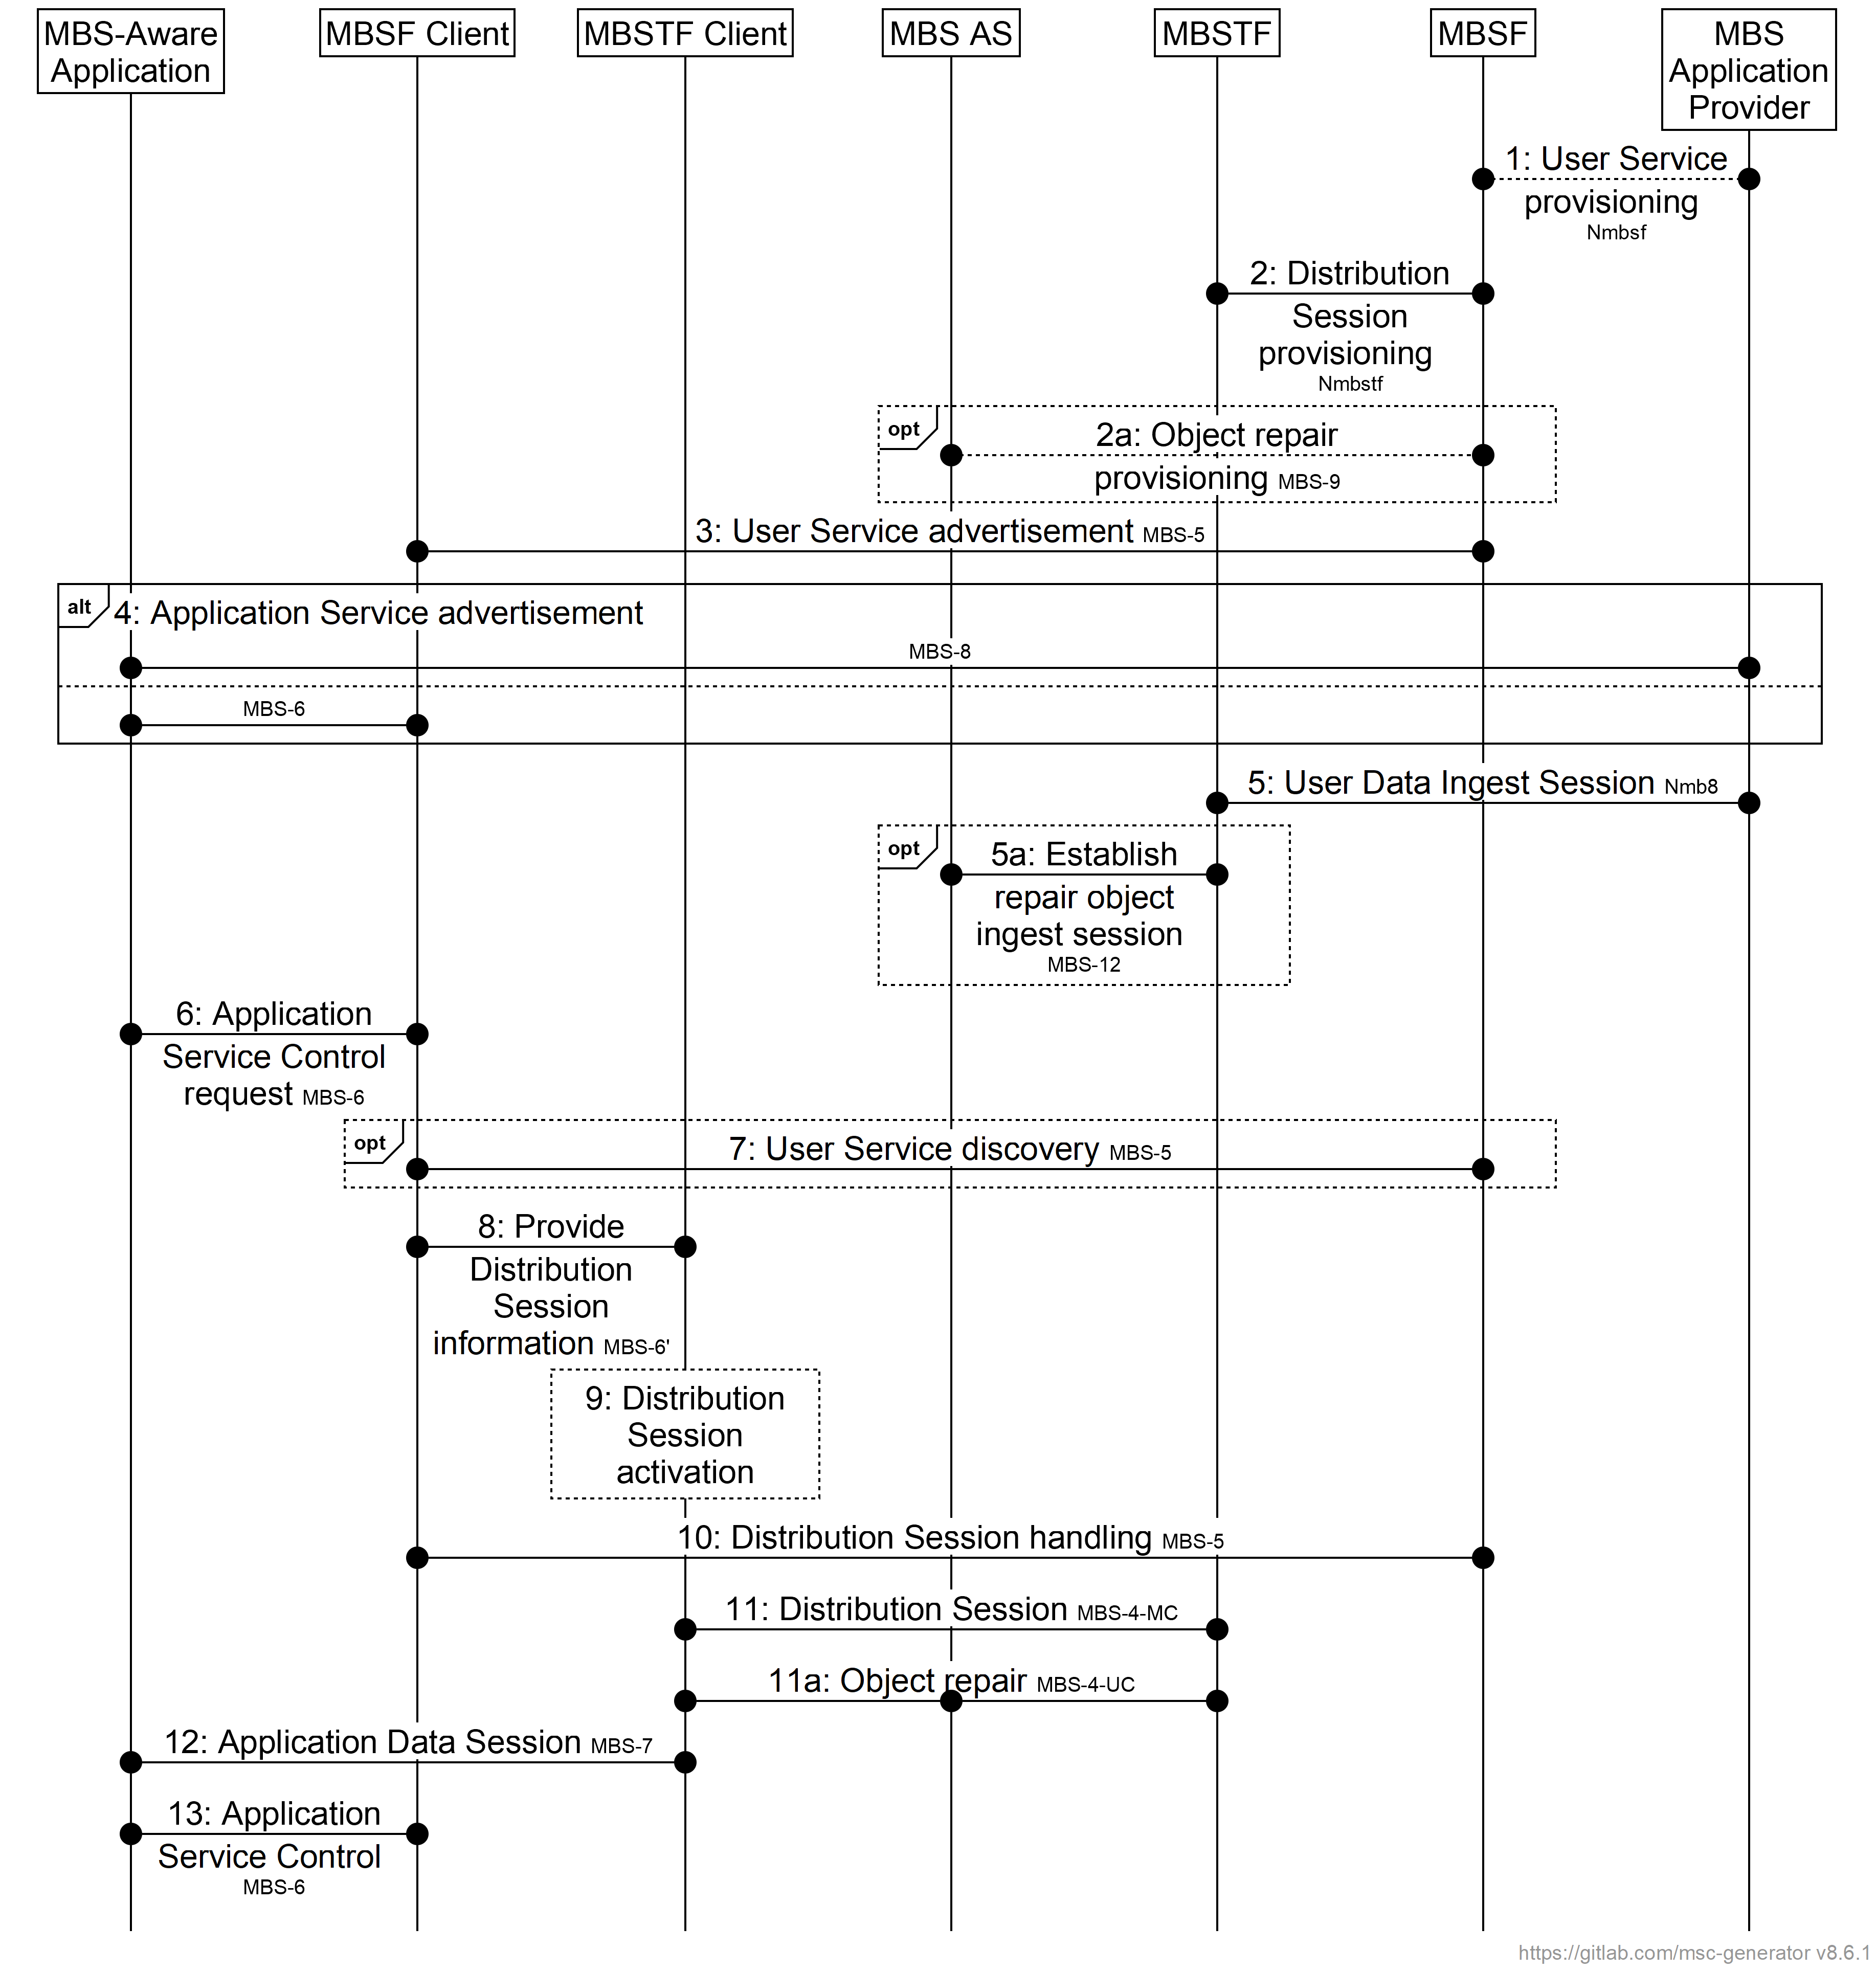

NOTE: In the interests of brevity, the prefix MBS is omitted from the numbered steps in the figure.

Figure 5.2-1: MBS User Service high-level baseline procedures

The basic procedures are as follows:

1. The MBS Application Provider provisions an Application Service as an MBS User Service by invoking the Nmbsf service on the MBSF via reference point Nmb10.

2. The MBSF provisions one or more MBS Distribution Session by invoking the Nmbstf service on the MBSTF via reference point Nmb2. The configuration may include parameters to establish an Object Repair ingest session with the MBS AS.

2a. Optionally, the MBSF configures the Object Repair feature for the MBS Distribution Session on the MBS AS via reference point MBS-9. This interaction is not further defined in this release.

3. The MBSF provides an MBS User Service Announcement document that may be accessed by the MBS Client of interested UEs.

4. The MBS Application Provider informs the MBS-Aware Application via MBS-8 that the specific Application Service can be accessed via an MBS User Service by means of an Application Service Announcement.

[Alternatively, the MBSF Client synthesises the Application Service Announcement from the User Service Announcement received in step 3 and informs the MBS-Aware Application via MBS‑6 that the Application Service can be accessed via an MBS User Service.]

5. The MBS Application Provider creates an MBS User Data Ingest Session with the MBSTF (via the MBSF) and the latter ingests the user data via Nmb8.

5a. Optionally, if Object Repair is provisioned, the MBSTF establishes an Object Repair ingest session with the MBS AS, and the latter ingests the relevant user data via reference point MBS-12.

6. The MBS-Aware Application requests the MBS Client to access a specific MBS User Service by invoking procedures at MBS-6.

7. Optional: If it has not already been received in step 3 above, the MBSF Client may discover additional access information about this MBS User Service by querying the MBSF via MBS-5.

8. The MBSF Client provides the MBS Distribution Session information acquired as part of the User Service Announcement information to the MBSTF Client via MBS-6′.

9. The MBSTF Client activates reception of the MBS Distribution Session.

10. The MBSF Client continuously handles the MBS Distribution Session data based on updates received via MBS‑5.

11. The MBSTF Client receives MBS Distribution Session data via MBS-4‑MC as part of the MBS Distribution Session.

11a. If unicast repair is provisioned, then the MBSTF Client may use reference point MBS-4-UC to accomplish post-session or in-session Object Repair as part of the MBS Distribution Session.

12. The MBSTF provides the MBS Distribution Session data to the MBS-Aware Application via MBS-7 in an MBS Application Data Session.

13. The MBS-Aware Application controls the MBS User Service by invoking MBS Application Service Control procedures on the MBSF Client via MBS-6.

## ===== CHANGE =====

## 5.3 Procedures for User Service provisioning

The procedure begins with the MBS Application Provider provisioning an MBS User Service and, within its scope, a set of MBS User Data Ingest Sessions, as shown in figures 5.3‑1 and 5.3.‑2 below.

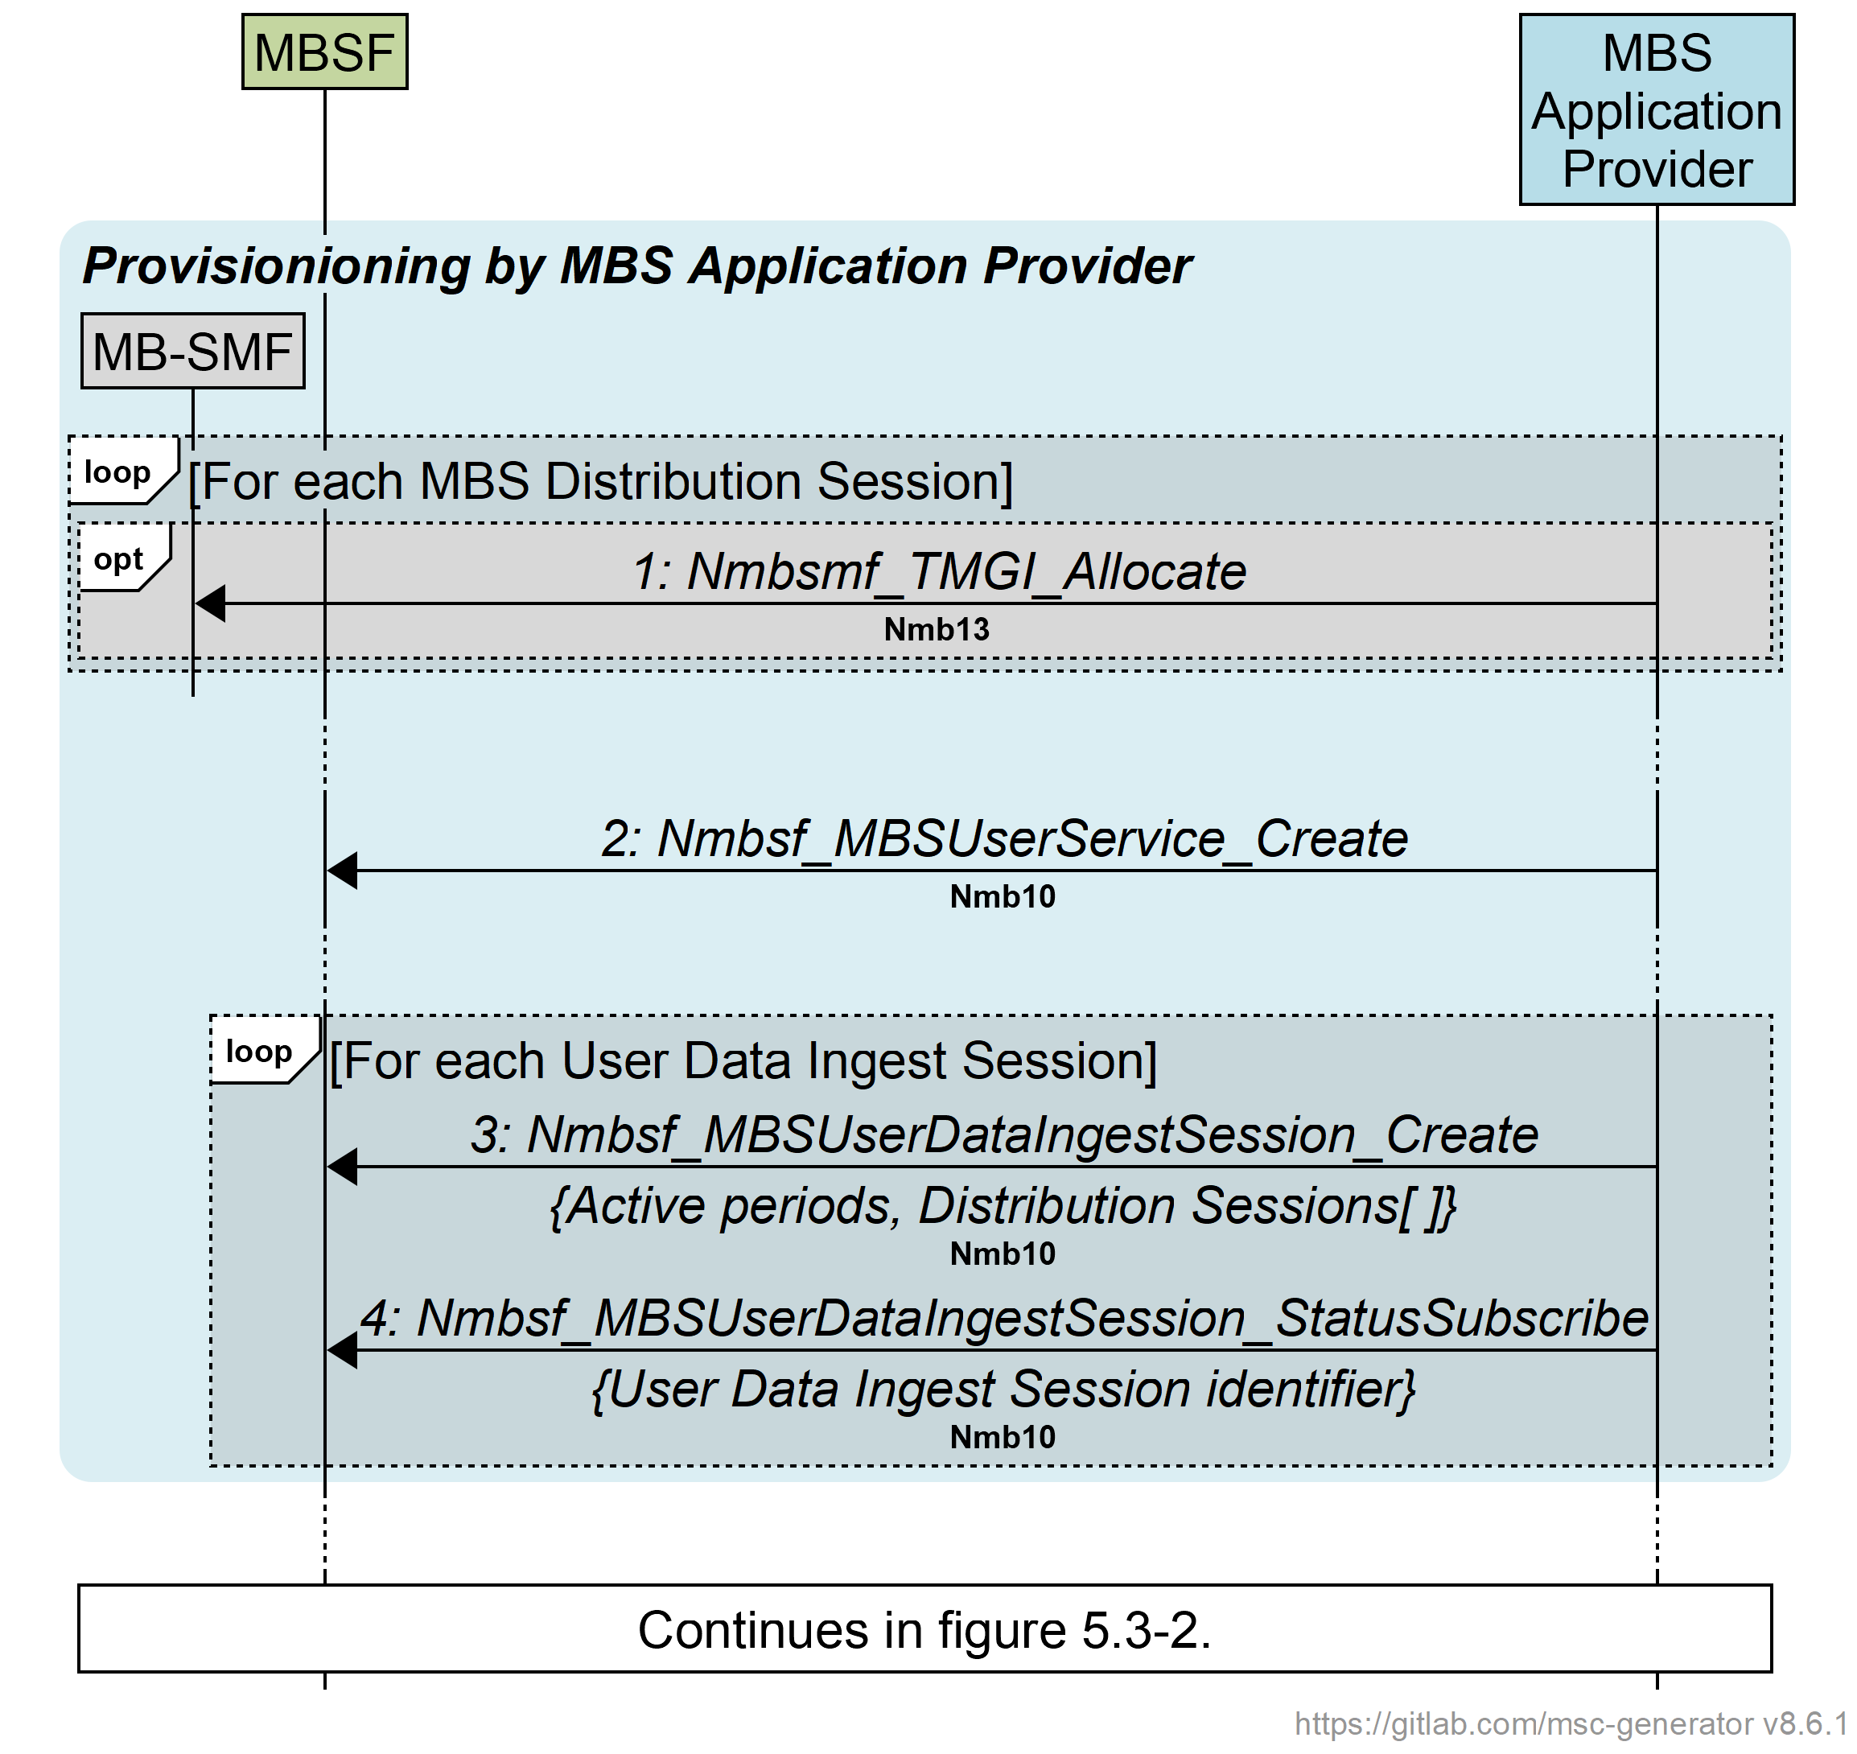

Figure 5.3‑1: Call flow for MBS User Service provisioning by MBS Application Provider

First, the MBS Application Provider provisions a new MBS User Service Session in the MBS System:

1. To support Use Cases (e.g. Group Communication) where there is a requirement for TMGI allocation to be managed outside the MBS System, the MBS Application Provider may pre-allocate a TMGI for some or all of the MBS Distribution Sessions declared in step 3 below by invoking the Nmbsmf\_TMGI\_Allocate service operation on the MB‑SMF at reference point Nmb13 (or N33+N29mb, if invoked via the NEF), as specified in clause 9.1.2.2 of TS 23.247 [5].

2. The MBS Application Provider invokes the Nmbsf\_MBSUserService\_Create service operation at reference point Nmb10 (or N33+Nmb5 if invoking via the NEF) to create a new MBS User Service, as defined in clause 4.5.3.

Immediately, or at some later time, the MBS Application Provider creates at least one MBS User Data Ingest Session (as defined in clause 4.5.5) within the scope of the MBS User Service created in step 2 above:

3. The MBS Application Provider creates an MBS User Data Ingest Session by invoking the Nmbsf\_MBSUserDataIngestSession\_Create service operation at reference point Nmb10 (or N33+Nmb5, if invoked via the NEF).

The MBS User Data Ingest Session optionally includes a schedule of start and end times referred to as *active periods*.

The MBS User Data Ingest Session comprises the details of one or more MBS Distribution Session(s), as defined in clause 4.5.6. Each such MBS Distribution Session fully specifies one of the distribution methods defined in clause 6 and may optionally nominate a TMGI to be used if one was pre-allocated in step 1 above.

4. The MBS Application Provider subscribes to status events from the MBSF relating to the MBS User Data Ingest Session just created by invoking Nmbsf\_MBSUserDataIngestSession\_StatusSubscribe service operation at reference point Nmb10 (or N33+Nmb5, if invoked via the NEF).

5. Void.

Shortly before a provisioned MBS User Data Ingest session is scheduled to become active (see clause 4.5.5), or immediately if no schedule of active periods is provisioned, the MBSF establishes in the MBSTF all MBS Distribution Sessions comprising that MBS User Data Ingest Session as shown in figure 5.3‑2 below.

Msc-generator~|version=8.6.1~|lang=signalling~|size=977x1611~|text=# Richard Bradbury, BBC Research ~@ Development~n# ~lrichard.bradbury@bbc.co.uk~g~nhscale = auto;~nnumbering=yes;~ndefcolor CoreColour=216,216,216;~ndefcolor MnScolour=112,48,160;~ndefcolor APcolour=183,221,232;~ndefcolor MScolour=255,255,0;~ndefcolor clientColour=255,255,204;~ndefcolor ECcolour=245,157,86;~ndefcolor EVEXcolour=229,185,181;~ndefcolor MBScolour=196,214,160;~n~ndefstyle oos [line.color=gray, text.color=gray, arrow.color=gray];~n~n#UE [large=~qyes~q, fill.color=lgray] {~n#~4hide App[fill.color=APcolour]: ~qMBS-Aware\nApplication~q;~n#~4hide MBSFC[fill.color=MBScolour]: ~qMBSF Client~q;~n#~4hide MBSTFC[fill.color=MBScolour]: ~qMBSTF Client~q;~n#};~nMBSTF[fill.color=MBScolour]: ~qMBSTF~q;~nhide MBSAS[fill.color=MBScolour]: ~qMBS AS~q;~nhide MBSMF[fill.color=CoreColour]: ~qMB-SMF~q;~nMBSF[fill.color=MBScolour]: ~qMBSF~q;~nAP[fill.color=APcolour]: ~qMBS\nApplication\nProvider~q;~n~n~nbox [number=no]: ~qContinued from figure 5.3-1.~q;~n...;~nvspace 5;~nbox .. [fill.color=MBScolour,0.5, line.corner=round, line.color=none, number=no]: ~q\i\bInternal MBS Distribution Session provisioning\b\i~q {~n~4.. [tag=~qloop~q, number=no, fill.color=gray,0.2]: ~q\[For each MBS Distribution Session of the activated MBS User Data Ingest Session\]~q {~n~8show MBSMF;~n~8vspace 7;~n~8.. [tag=~qopt~q, fill.color=CoreColour] {~n~9~3MBSF-~gMBSMF [number=6]: \iNmbsmf_TMGI_Allocate\i\n\_\bNmb1\b\_;~n~8};~n~8MBSF-~gMBSMF: \iNmbsmf_MBSSession_Create\n\{TMGI\}\i\n\_\bNmb1\b\_;~n~8.. [tag=~q~q, fill.color=CoreColour, number=no]: ~q\[Broadcast MBS Session\]~q {~n~9~3MBSMF-~gMBSF: \iNmbsmf_MBSSession_StatusNotify\n\{TMGI\}\i\n\_\bNmb1\b\_ ;~n~8MBSF-~gAP: \iNmbsf_MBSUserDataIngestSession_StatusNotify\nSession started\i event\n\_\bNmb10\b\_;~n~8};~n~8hide MBSMF;~n~n~8vspace 5;~n~8-- [tag=~qalt~q, fill.color=gray,0.2, number=no]: \[Object Repair enabled by MBSF\] {~n~9~3show MBSAS;~n~9~3vspace 7;~n~9~3-- [tag=~qalt~q, fill.color=gray,0.2, number=no]: \[Push-based object ingest at MBS-12\] {~n~9~7MBSF-~gMBSAS [number=no, oos]: 9a: Configure Object Repair\n\_\bMBS-9\b\_;~n~9~7MBSAS-~gMBSF [number=no, oos]: \I\{Push endpoint for Object Repair\};~n~9~7vspace 5;~n~9~7MBSF-~gMBSTF [number=10]: \iNmbstf_MBSDistributionSession_Create\n\{Push endpoint for Object Repair\}\i\n\_\bNmb2\b\_;~n~9~3} -- [tag=~q~q, fill.color=gray,0.2, number=no]: \[Pull-based object ingest at MBS-12\] {~n~9~7MBSF-~gMBSTF [number=10]: \iNmbstf_MBSDistributionSession_Create\i\n\_\bNmb2\b\_;~n~9~7MBSTF-~gMBSF [number=no]: \I\{Pull endpoint for Object Repair\};~n~9~7MBSF-~gMBSAS [number=no, oos]: 10a: Configure Object Repair\n\i\{Pull endpoint for Object Repair\}\i\n\_\bMBS-9\b\_;~n~9~3};~n~9~3MBSAS~l=~gMBSTF [number=no]: 10b: Establish\nObject Repair\ningest session\n\_\bMBS-12\b\_;~n~9~3MBSAS-~gMBSF [number=no, oos]: 10c: Object Repair ingest session established\n\_\bMBS-9\b\_;~n~9~3hide MBSAS;~n~8} -- [tag=~q~q, fill.color=gray,0.2, number=no]: \[Object Repair disabled by MBSF\] {~n~9~3MBSF-~gMBSTF [number=10]: \iNmbstf_MBSDistributionSession_Create\i\n\_\bNmb2\b\_;~n~8};~n~n~8vspace 7;~n~8MBSF-~gAP: \iNmbsf_MBSUserDataIngestSession_StatusNotify\nDistribution Session starting\i event\n\i\{Distribution Session identifier\}\i\n\_\bNmb10\b\_;~n~8MBSF-~gMBSTF: \iNmbstf_MBSDistributionSession_StatusSubscribe\n\{Distribution Session identifier\}\i\n\_\bNmb2\b\_;~n~n~8vspace 7;~n~8.. [tag=~qopt~q, fill.color=gray,0.2, number=no]: ~q\[Packet Distribution Method\] \ior\i \[Object Distribution Method with pull-based content ingest\]~q {~n~9~3vspace 7;~n~9~3MBSTF~l=~gAP: Establish content ingest\n\_\bNmb8\b\_;~n~9~3MBSTF-~gMBSF: \iNmbstf_MBSDistributionSession_StatusNotify\nUser Data Ingest Session established\i event\n\{\iDistribution Session established\i\}\i\n\_\bNmb2\b\_;~n~9~3hide MBSTF;~n~8};~n~n~8vspace 5;~n~8MBSF-~gAP: \iNmbsf_MBSUserDataIngestSession_StatusNotify\nDistribution Session established\i event\n\i\{Distribution Session identifier\}\i\nor \iDistribution Session establishment failure\i event\i\n\_\bNmb10\b\_;~n~8box MBSF..MBSF: Compile\nMBS Distribution Session Announcement;~n~4};~n~4vspace 5;~n~4MBSF-~gAP: \iNmbsf_MBSUserDataIngestSession_StatusNotify\nUser Data Ingest Session established\i event\n\i\{Distribution Sessions\[\]\}\i\nor \iUser data ingest failure\i event\i\n\_\bNmb10\b\_;~n};~n~|

NOTE: Interactions depicted in grey are not further defined in this release.

Figure 5.3‑2: Call flow for MBS User Service internal provisioning

For each such MBS Distribution Session of a parent MBS User Data Ingest session:

6. If no MBS Session ID was nominated by the MBS Application Provider in step 1 above, the MBSF may allocate a TMGI for it at this point by invoking the Nmbsmf\_TMGI\_Allocate service operation on the MB‑SMF at reference point Nmb1, as specified in clause 9.1.2.2 of TS 23.247 [5].

7. The MBSF creates an MBS Session to reserve resources in the MBS System for the MBS Distribution Session by invoking the Nmbsmf\_MBSSession\_Create service operation on the MB‑SMF at reference point Nmb1, as specified in clause 9.1.3.6 of TS 23.247 [5]). The MBS Session ID provided for the MBS Distribution Session in step 1 or reserved in step 6 above is provided as an input parameter, if available. If needed, the MB‑SMF allocates a TMGI as a side-effect of this operation. The MBSF determines the other input parameters as specified in clause 4.5.9.

8. For MBS Distribution Sessions of *Service type* broadcast, the MB-SMF notifies the MBSF upon successful establishment of the corresponding MBS Session(s).

9. Once it is satisfied that the Broadcast MBS Session has been successfully established, the MBSF notifies the MBS Application Provider about the successful establishment of the Broadcast MBS Session(s) corresponding to the MBS Distribution Session using one or more *Session started* events.

The following steps do not need to wait for the completion of step 8:

9a: To enable push-based ingest of objects by the MBS AS at reference point MBS‑12 in the case of the Object Distribution Method, the MBSF configures the Object Repair feature for the MBS Distribution Session in the MBS AS via reference point MBS‑9. In its response, the MBS AS nominates an endpoint to which ingested objects are to be pushed by the MBSTF (see *Object repair ingest base URL* in table 4.5.6‑2). This interaction is not further defined in this release.

10. The MBSF creates the MBS Distribution Session in the MBSTF by invoking the Nmbstf\_‌MBS‌Distribution‌Session\_‌Create service operation at reference point Nmb2. This is a mirror of the entity in the MBSF (see clause 4.5.6).

- In the case of the Object Distribution Method with push-based ingest of objects by the MBS AS at reference point MBS‑12 (i.e., step 9a above), the parameters of the request include an MBS AS endpoint to which objects ingested by the MBSTF are to be pushed.

- In the case of the Object Distribution Method with push-based ingest of objects by the MBS AS at reference point MBS‑12 (i.e., step 10a below), the response includes an endpoint nominated by the MBSTF from which objects it has ingested may be pulled by the MBS AS.

- In the case of the Object Distribution Method with push-based *Object acquisition method*, the response includes additional content ingest parameters chosen by the MBSTF for this MBS Distribution Session (see *Object ingest base URL* in table 4.5.6‑2).

- In the case of the Packet Distribution Method, the response includes additional content ingest parameters chosen by the MBSTF for this MBS Distribution Session (see *MBSTF ingest endpoint addresses* in table 4.5.6‑3).

10a: To enable pull-based ingest of objects by the MBS AS at reference point MBS‑12 in the case of the Object Distribution Method, the MBSF configures the Object Repair feature for the MBS Distribution Session in the MBS AS via reference point MBS‑9. In this case, the parameters of the request include the MBSTF endpoint from which objects ingested by the MBSTF may be pulled by the MBS AS (see *Object repair exposure base URL* in table 4.5.6‑2). This interaction is not further defined in this release.

If Object Repair feature is configured in the MBS AS per step 9a or step 10a above:

10b: The MBSTF and the MBS AS establish an Object Repair ingest session for push- or pull-based ingest of objects at reference point MBS‑12 according to the Object Repair configuration.

10c: The MBS AS informs the MBSF via reference point MBS-9 that it has successfully created an Object Repair ingest session with the MBSTF. This interaction is not further defined in this release.

Then:

11. The MBSF invokes the Nmbsf\_MBSUserDataIngestSession\_‌StatusNotify service operation at reference point Nmb10 (or Nmb5+N33, if invoked via the NEF) to inform the MBS Application Provider of the content ingest parameters that have been chosen for this MBS Distribution Session using the *Distribution Session starting* event (see *MBSTF ingest endpoint addresses* in table 4.5.6‑3).

12. The MBSF subscribes to status events from the MBSTF relating to the MBS Distribution Session just created by invoking the Nmbstf\_MBSDistributionSessionStatusSubscribe service operation at reference point Nmb2.

13. In the case of the Packet Distribution Method and pull-based content ingest using the Object Distribution Method, the MBSTF attempts to establish content ingest from the MBS Application Provider at reference point Nmb8 according to the ingest parameters and distribution method provisioned for the MBS Distribution Session in question (see table 4.5.6‑1).

On success, the state of the MBS Distribution Session in the MBSTF becomes ESTABLISHED; on failure, it remains INACTIVE (see step 2 in clause 4.6.1).

NOTE 2: Success of this step varies according to the provisioned distribution method and its configuration. Success may, for example, be defined as establishing a network association with the MBS Application Provider (using the additional parameters defined in table 4.5.6‑3), or it may require successful ingest of an initial object from the MBS Application Provider (using the additional parameters defined in table 4.5.6‑2).

14. The MBSTF invokes the Nmbstf\_MBSDistributionSession\_StatusNotify callback service operation at reference point Nmb2 to inform the MBSF of the (un)successful establishment of content ingest using the *Distribution Session established* event.

On success, the state of the MBS Distribution Session in the MBSF becomes ESTABLISHED; on failure, it remains INACTIVE (see step 2 in clause 4.6.1).

15. The MBSF invokes the Nmbsf\_MBSUserDataIngestSession\_StatusNotify callback service operation at reference point Nmb10 (or Nmb5+N33, if invoked via the NEF) to inform the MBS Application Provider of the (un)successful establishment of content ingest for the MBS Distribution Session in the context of its parent MBS User Data Ingest Session using either the *Distribution Session established* event or *Distribution Session establishment failure* event, as appropriate.

16. If content ingest was established successfully in step 11 above, the MBSF compiles the metadata relating to this MBS Distribution Session into an MBS Distribution Session Announcement, as defined in clause 4.5.8.

When the MBSF has completed its attempt to configure all MBS Distribution Sessions required by the parent MBS User Data Ingest Session:

17. The MBSF invokes the Nmbsf\_MBSUserDataIngestSession\_StatusNotify callback service operation at reference point Nmb10 (or Nmb5+N33, if invoked via the NEF) to inform the MBS Application Provider of the (un)successful establishment of all MBS Distribution Sessions of the parent MBS User Data Ingest Session using either the *User Data Ingest Session established* event or *User data ingest failure* event, as appropriate.

## ===== CHANGE =====

## 5.6 Procedure for User Service data repair

### 5.6.1 General

In the case of the Object Distribution Method (as defined in clause 6.1), the MBSTF Client may collaborate with the MBS AS at reference point MBS‑4‑UC to recover lost portions of content corresponding to MBS data that was not successfully received by the MBSTF Client at reference point MBS‑4‑MC (see step 9 in clause 5.5).

The high-level procedure for data repair is illustrated in figure 5.6.1‑1 below:

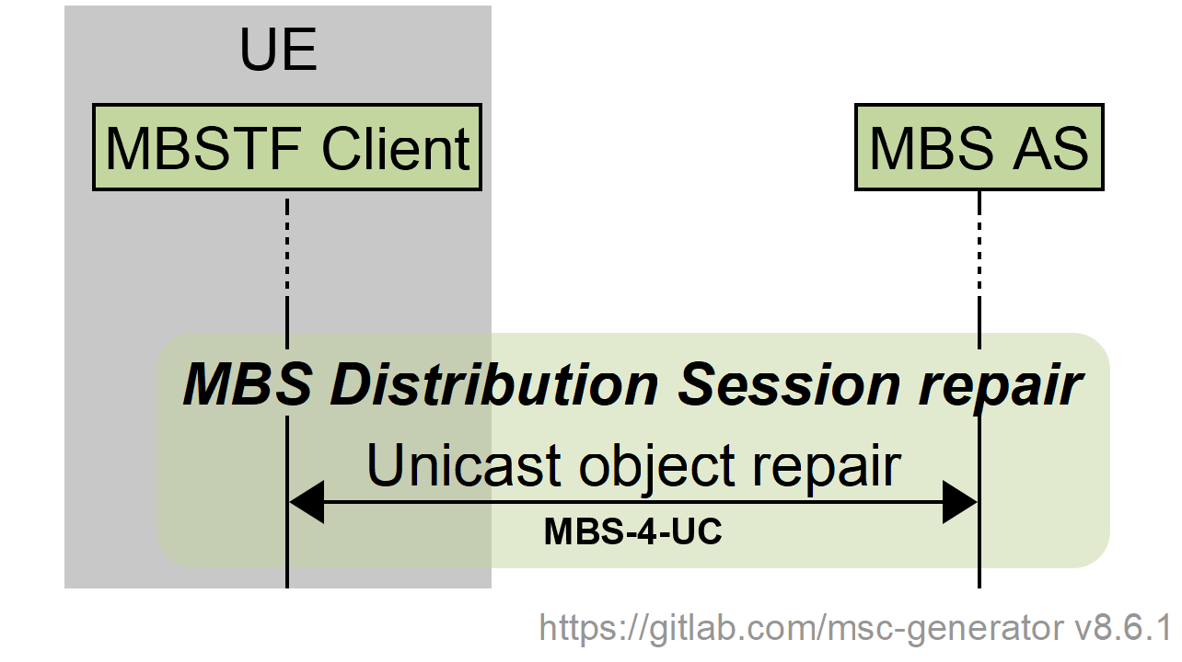

Figure 5.6.1-1: High-level call flow for MBS User Service data repair

In the following clauses, more detailed procedures are provided for:

- *In-session Object Repair* during the MBS Distribution Session, including the ability to repair objects in streaming distribution, defined in clause 5.6.2.

- *Post-session Object Repair after the completion of the MBS Distribution Session* defined in clause 5.6.3.

### 5.6.2 In-session Object Repair

The procedures in clause 5.5 are extended as shown in figure 5.6.2-1 to support in-session object repair. In particular, after the steps described in clause 5.5.2 and figure 5.5-2, in case in-session object repair is configured for the MBS Client, the following steps are carried out.

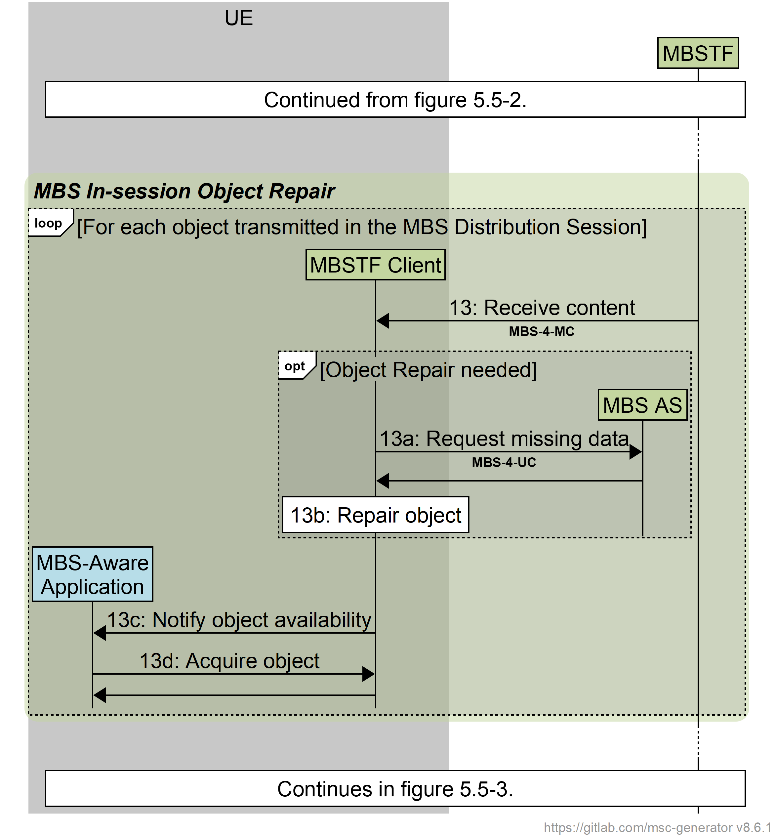

Figure 5.6.2‑1: Call flow for in-session Object Repair

Having received object data from the MBSTF (step 13 in clause 5.5.2):

If the MBSTF Client detects that the received object data is incomplete, and that Object Repair is therefore needed:

13a: The MBSTF Client requests sufficient data from the MBS AS via reference point MBS‑4‑UC in order to repair the object and the requested data is returned by the MBS AS.

13b: The MBSTF Client repairs the object by applying the data provided in the previous step to the incomplete object data received in step 13.

Then, in all cases:

13c: The MBSTF Client informs the MBS-Aware Application that the object is available for retrieval.

13d: The MBS-Aware Application retrieves the object from the MBSTF Client.

In practice, multiple objects may be received in parallel, and the steps of the call flow are interleaved for each one.

### 5.6.3 Post-session Object Repair

The procedures in clause 5.5 are extended as shown in figure 5.6.3-1 to support post-session object repair. In particular, after the steps described in clause 5.5.3 and figure 5.5.3-1, in case post-session Object Repair is configured for the MBS Client, the following steps are carried out.

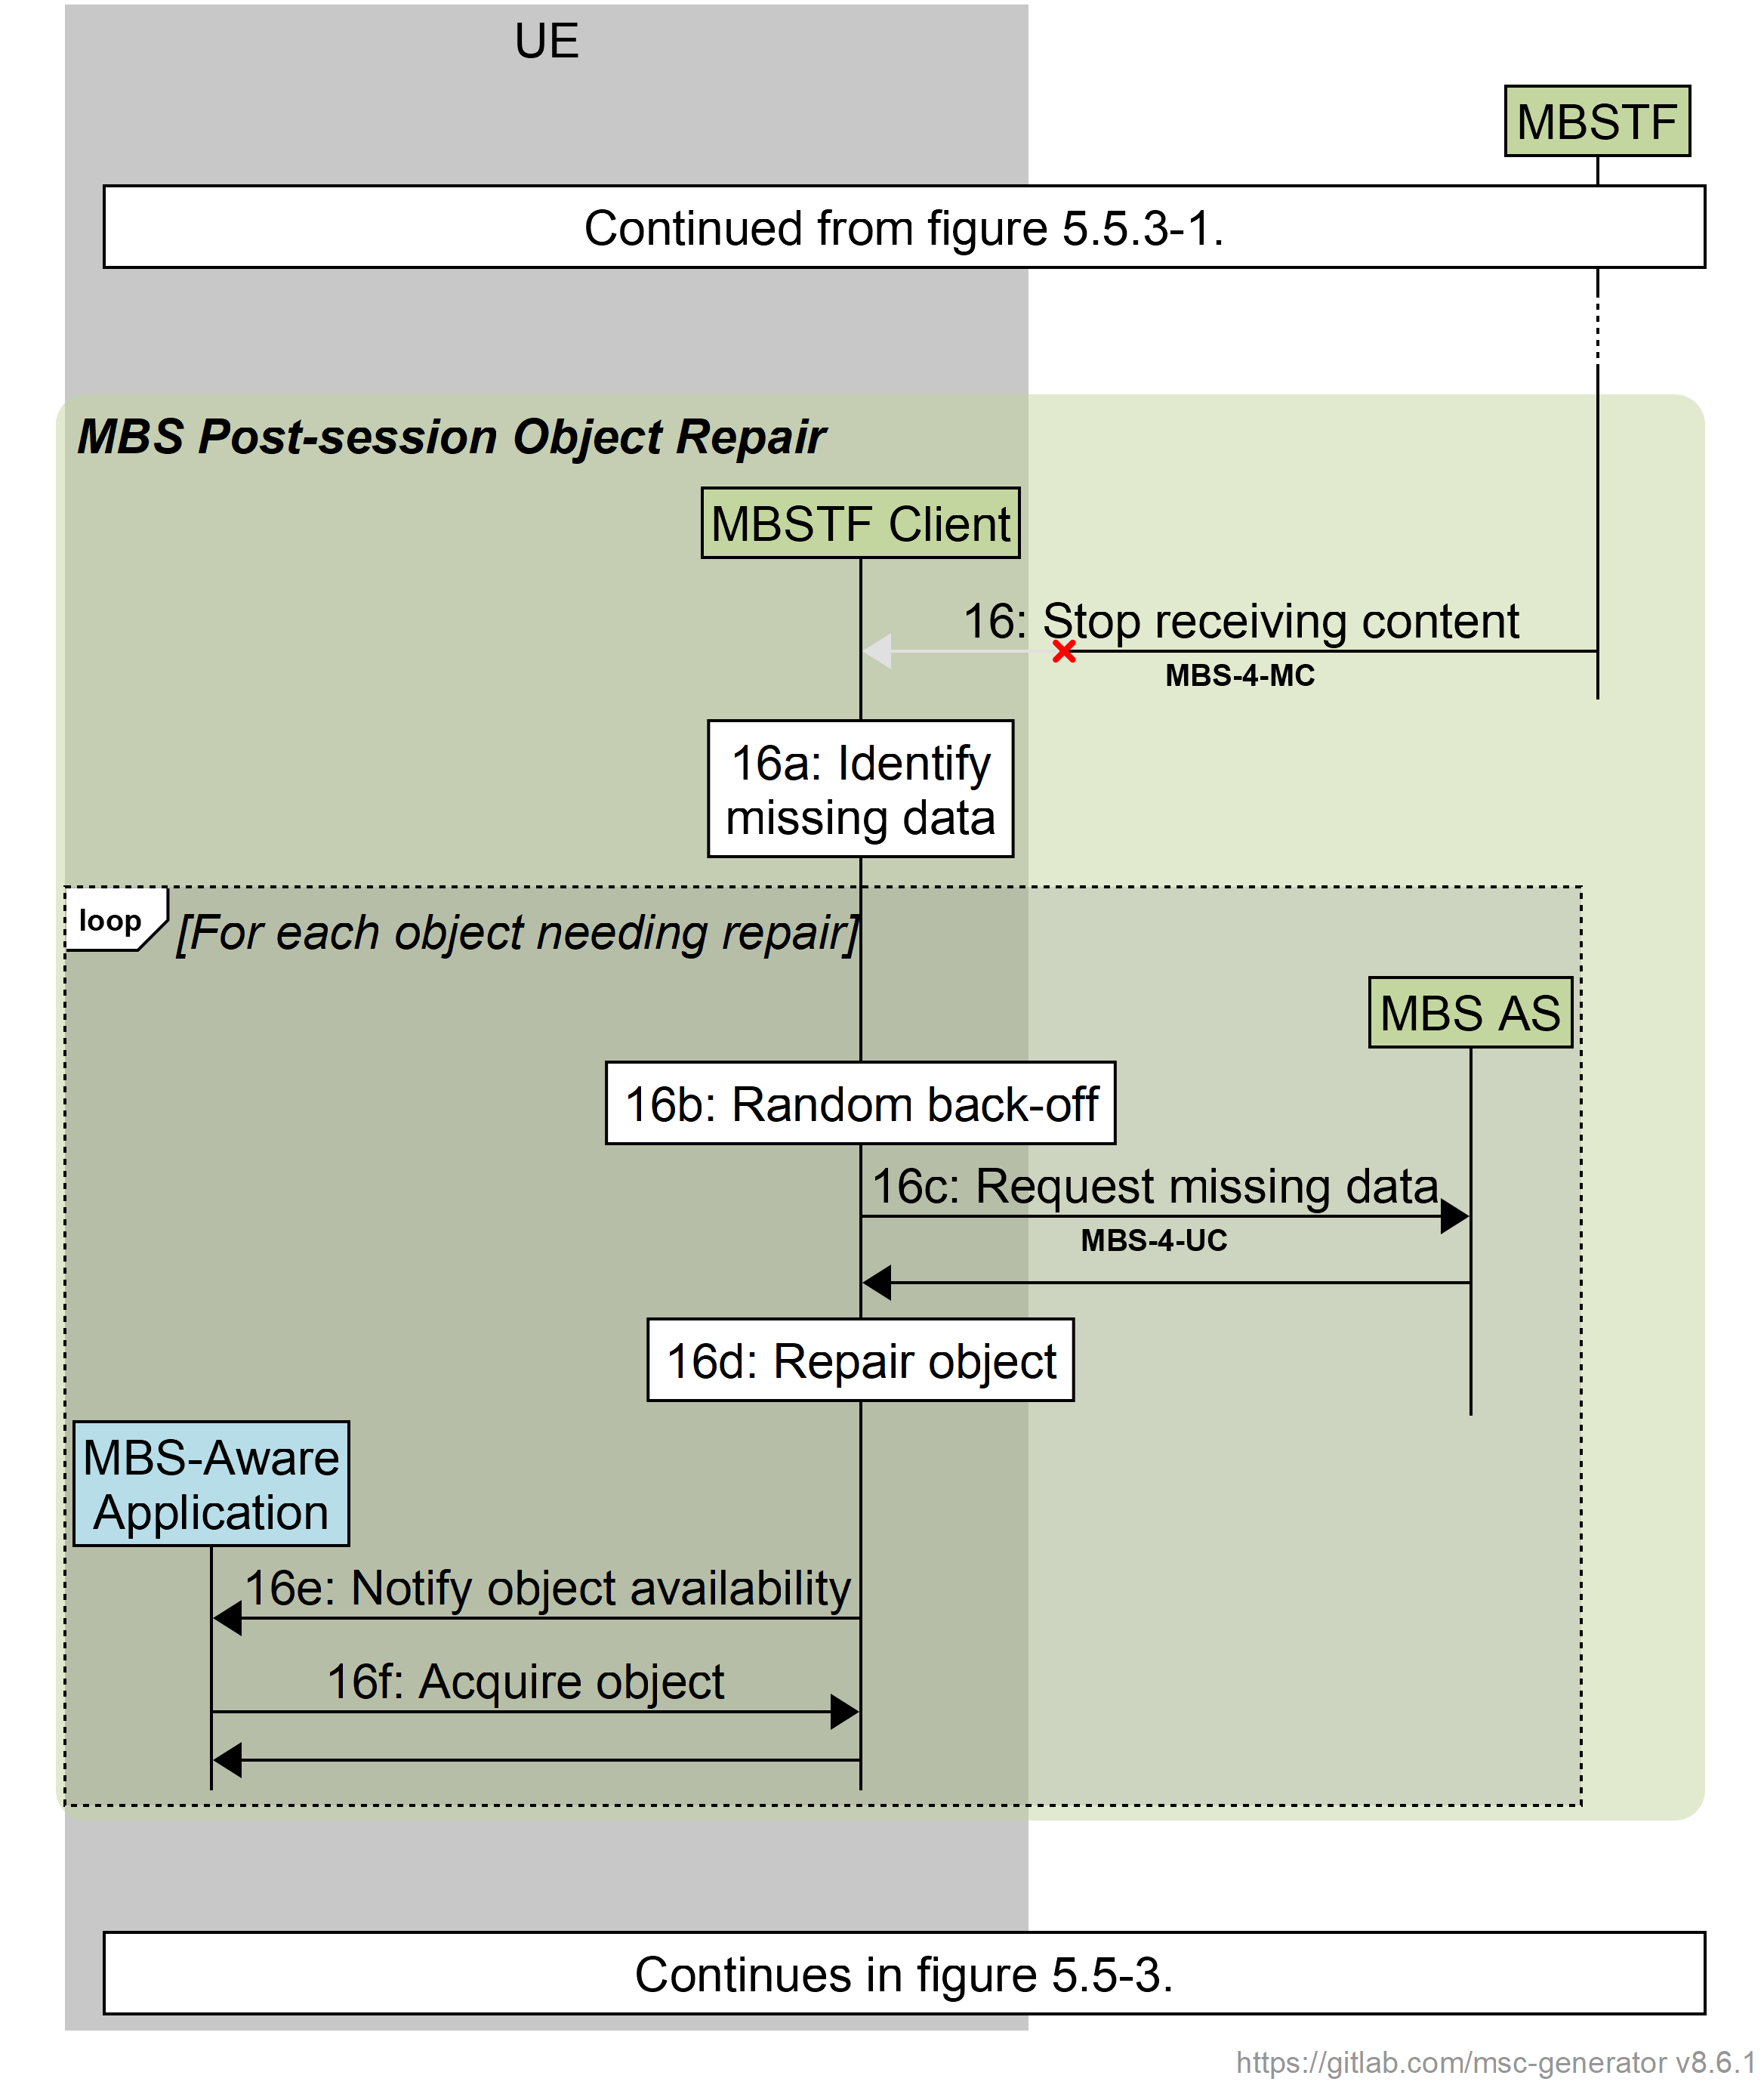

Figure 5.6.3‑1: Call flow for Post-session Object Repair

When the MBSF Client deactivates an MBS Distribution Session (step 15 in clause 5.5.3) and the MBSTF Client stops receiving content (step 16 in clause 5.5.3):

16a: The MBSTF Client determines whether any data is missing.

Then, for each object that was received during the MBS Distribution Session needing repair:

16b: If there is missing data, the MBSTF waits for some random back-off time period.

16c: After the back-off time period has elapsed, the MBSTF requests missing data from the MBS AS.

16d: The MBSTF Client applies the data provided in the previous step to the incompletely received object data.

16e: The MBSTF Client informs the MBS-Aware application that the object is available for retrieval.

16f: the MBS-Aware Application retrieves the object from the MBSTF Client.