3GPP TSG-SA WG4 Meeting #131 S4-250302
Geneva, Switzerland, 17th February–21st February 2025 revision of S4-250208

Title: [FS_MediaEnergyGREEN]: Clarifications and additions to Solution #5 on exposure of energy related information
Agenda Item: 8.8
Source: Samsung Electronics Co Ltd., BBC

Introduction
Document S4aI250043 was agreed during the SA4-e (AH) MBS SWG Post 130 meeting that proposed a solution to KI 1 related to exposure of energy information from the UE, network, and other entities to the application in the UE. Based on this agreed tdoc, a draft is being prepared for review during the upcoming SA4#131 meeting (draft TR 26942-102). This contribution proposes some clarifications to the text proposal in the above draft based on agreed text in parent specification TS 23.501.
Background and motivation
Document S4aI250043 described generic reference architecture for collection and expose of Energy information, and instantiation of the above in 5G Media Streaming architecture and the generalized media delivery architecture. A TR draft 26942-102 is being prepared with the above solution for formal review during the upcoming SA4#131 meeting. This contribution proposes an update to the text proposal in the above draft because of the following:
- Clause 5.51 of parent specification TS 23.501 describes support of energy efficiency and energy savings in 5G System. In sub-clause 5.51.2.3 of this clause in TS 23.501, it is specified that upon receiving energy related information from gNB, OAM, and UPF, the EIF calculates Energy Consumption information of different granularities (UE, PDU Session and/or QoS flow). This information is shared with authorized consumers such as AF/NEF or other 5GC NF (clause 5.51.2.1 of TS 23.501). Because of this specification text, Energy Consumption of different granularities is available with the Energy Information AF, and therefore is able to be shared with the Energy Information Collector, as described in document S4aI250043. The present contribution updates the agreements in S4aI250043 with this additional information.
- The Key Issue #1 description in clause 6.1.1 of TR 26942 on the topic of Energy-related Information exposure proposes that the analysis by this Key Issue should consider 4 problems. One of the problems that is not well addressed so far in the candidate solutions related to this Key Issue is the following:

3. Would it be useful to expose energy-related information of the network to the Media Session Handler to help it optimize its media session in an energy-efficient way?

There is not much text in the solutions related to this Key Issue in the TR 26942 to describe how the energy information exposed from the network will help the Media Session Handler optimize its media session in an energy-efficient way.

Clause 5.51.4 of TS 23.501 describes Background Data Transfer based on network energy related information and specifies the following:

5.51.4 BDT based on network energy related information
5GS supports BDT (background data transfer) policy selection and re-negotiation process by introducing energy related information. The PCF may make policy decisions based on energy related information. The PCF may also trigger the re-negotiation of BDT policy with the AF.

Background Data Transfer using dynamic policy invocation procedures for downlink and uplink in 5G Media Streaming are described in clauses 5.7.8 and 6.9.7 respectively in TS 26.501. Based on high level specification in TS 23.501, the BDT procedures in TS 26.501 may be enhanced as well. So, in current contribution, the following note is proposed to be added (in step-9 of call flow in clause 7.6.3.1) in the generic high-level procedures for collection and exposure of Energy Information:
NOTE 1: Based on the received Energy Information report, the Media Session Handler may perform selection of appropriate Background Data Transfer Policy during the Downlink Background Data Transfer using dynamic policy invocation procedure described in clause 5.7.8 of TS 26.501 [23] and Uplink Background Data Transfer using dynamic policy invocation procedure described in clause 6.9.7 of TS 26.501 [23].

Text proposal
Below is the proposal with clarifications and additions described above to the TR 26.942

* * * * First change * * * *

3.1 Terms
NF Energy Information: energy-related information collected from Network Functions and exposed by the EIF.
AS Energy Information: energy-related information collected and exposed by Application Servers.
Network Energy Information: NF Energy Information and/or AS Energy Information.
UE Energy Information: energy-related information collected by the UE.

* * * * Next change * * * *

7.6 Solution #5: Energy-related information from the network and other Service Provider entities provided to a UE application and Application Service Provider

7.6.1 Key Issue mapping
This Candidate Solution addresses Key Issue #1 (Energy-related Information exposure) described in clause 6.1.

7.6.2 Functional description

7.6.2.1 Introduction
This Candidate Solution addresses how energy-related information from the device, the network and other components of the content delivery system can be provided to a UE application during media consumption for exposure to the user.

7.6.2.2 Generic reference architecture for collection and exposure of energy-related information
Figure 7.6.2.2-1 depicts a reference architecture that realises this candidate solution in the general (i.e., non-media-specific) case.
Figure 7.6.2.2-1: Generic reference architecture for collection and exposure
of energy-related information
The following functions are defined in this generic reference architecture:
- The Energy Information AF is an Application Function in the Data Network with some or all of the following responsibilities, depending on its current provisioning state:
- Subscribes to and consumes NF Energy Information from the Energy Information Function as defined in TS 23.501 [72]).

- Subscribes to and consumes AS Energy Information from the Application Server.
- Collates and exposes the above Network Energy Information to the Energy Information Collector in the UE via the data plane.
- The Energy Information Collector is a UE function with some or all of the following responsibilities, depending on its current configuration:
- Acquires an Energy Information collection configuration from the Energy Information AF. The Energy Information collection configuration may direct the Energy Information Collector to collect energy information from the UE at different granularities, e.g. UE, PDU Session and/or QoS flow, as described in clause 5.51.2.3 of TS 23.501 [72] and/or for individual applications.
- Subscribes to and consumes Network Energy Information from the Energy Information AF according to the Energy Information collection configuration.
- Collects UE Energy Information from other UE functions and about itself according to the Energy Information collection configuration.
- Collates and exposes collected energy-related information to the UE Application via a client API.
The following reference points are defined in this generic reference architecture:
E1 Network API used by the Application Service Provider to provision the Energy Information AF. This determines whether and which NF Energy Information and/or AS Energy Information is collected by the Energy Information AF, and which UEs are entitled to consume it.
E12 NF Energy Information exposed by the Energy Information Function (as defined in TS 23.501 [72]) is consumed by the Energy Information AF using a Network API according to the latter’s provisioning state.
Editor’s Note: Definition of the Energy Information Function in TS 23.501 [72] is a work in progress at the time of writing.
E3 AS Energy Information exposed by the Application Server is consumed by the Energy Information AF using a Network API according to the latter’s provisioning state.
Editor’s Note: Subject to the final design of the Energy Information Function in TS 23.501 [72], reference point E3 is not required if AS Energy Information falls within the scope of reference point E12.
E5 Network API used by the Energy Information Collector in the UE to subscribe to and receive Network Energy Information from the Energy Information AF.
E6 Client API used by the UE Application to subscribe to energy-related information notifications from the Energy Information Collector.
E8 Network API used by the Application Service Provider to receive energy-related information from the UE Application. This reference point is beyond the scope of 3GPP standardisation.

7.6.2.3 Instantiation in 5G Media Streaming architecture
Figure 7.6.2.3-1 illustrates how the generic reference architecture for collecting and exposing energy-related information could be instantiated in the 5G Media Streaming architecture defined in TS 26.501 [23].
Figure 7.6.2.3-1: Instantiation of generic reference architecture for collection and exposure
of energy-related information in the 5GMS System
The following functions are defined in this instantiation of the generic reference architecture:
- The Energy Information AF is instantiated in the 5GMS AF and has some or all of the following responsibilities, depending on its current provisioning state obtained from the 5GMS AF:
- Subscribes to and consumes NF Energy Information from the Energy Information Function (as defined in TS 23.501 [72]).
- Subscribes to and consumes AS Energy Information from the Application Server.
- Collates and exposes the above Network Energy Information to the Energy Information Collector in the UE via the data plane.
- The Energy Information Collector is instantiated in the Media Session Handler of the 5GMS Client and has some or all of the following responsibilities, depending on its current configuration:
- Acquires an Energy Information collection configuration from the Energy Information AF embedded in Service Access Information obtained from the 5GMS AF by the Media Session Handler. The Energy Information collection configuration may include configuration directing the Energy Information Collector to collect energy consumption information from the UE at different granularities, e.g. UE, PDU Session and/or QoS flow, as described in clause 5.51.2.3 of TS 23.501 [72] and/or for individual applications.
- Subscribes to and consumes Network Energy Information from the Energy Information AF according to the Energy Information collection configuration.
- Collects UE Energy Information from the Media Stream Handler and from the Media Session Handler according to the Energy Information collection configuration.
- Collates and exposes collected energy-related information to the 5GMS-Aware Application via a client API.
The following reference points are defined in this instantiation of the generic reference architecture:
E1 This reference point is not instantiated: the Energy Information AF is instead provisioned via reference point M1.
M1 Network API used by the Media Application Provider to provision the Energy Information AF via the 5GMS AF. This determines whether and which NF Energy Information and/or AS Energy Information pertaining to the 5GMS AS is collected by the Energy Information AF, and which UEs are entitled to consume it.
NOTE 1: The service API at reference point M1 may be similar to that at reference point E1 in the generic reference architecture described in clause 7.6.2.2.
E12 This reference point is used per clause 7.6.2.2 of the present document.
M3 After configuration of the Content Hosting and/or Content Publishing and/or Content Preparation, features by the 5GMS AF, the 5GMS AS obtains a media-specific Energy Information collection configuration from the Energy Information AF instantiated in the 5GMS AF. The configuration information is embedded in Service Access Information.
E3 This reference point is used per clause 7.6.2.2 of the present document. In this instantiation, the entity exposing AS Energy Information to the Energy Information AF is the Media AS and the AS Energy Information may include the media delivery session identifier.
Editor’s Note: Subject to the final design of the Energy Information Function in TS 23.501 [72], reference point E3 is not required if AS Energy Information falls within the scope of reference point E12.
M5 Network API used by the Media Session Handler to obtain a media-specific Energy Information collection configuration from the Energy Information AF instantiated in the 5GMS AF. The configuration information is embedded in Service Access Information.
NOTE 2: The Energy Information collection configuration may be similar to that exposed at reference point E5 in the generic reference architecture described in clause 7.6.2.2.
E5 This reference point is used per clause 7.6.2.2 of the present document. The Energy Information Collector is instantiated in the Media Session Handler and the media-specific Energy Information collection configuration is instead acquired in Service Access Information via reference point M5 (see above). Media-specific energy-related information exposed to the Media Session Handler relates to a specific media delivery session.
M11 Client API used by the Energy Information Collector to collect UE Energy Information from the Media Access Client.
E6 This reference point is not instantiated: the energy-related information is instead exposed to applications via reference point M6.
M6 Client API used by the Media-aware Application to subscribe to energy-related information notifications from the Energy Information Collector. Notifications correlate UE Energy Information collected from the Media Access Client, AS Energy Information collected from the Media AS and NF Energy Information collected from relevant 5G Core Network Functions with individual media delivery sessions.
NOTE 3: The client API at reference point M6 may be similar to that at reference point E6 in the generic reference architecture described in clause 7.6.2.2.
E8 This reference point is not instantiated: the energy-related information is instead exposed via reference point M8.
M8 Network API used by the Media Application Provider to receive energy-related information from the Media-aware Application. This reference point is beyond the scope of 3GPP standardisation.

7.6.2.4 Instantiation in generalised Media Delivery architecture
Figure 7.6.2.4-1 illustrates how the generic reference architecture for collecting and exposing energy-related information could be instantiated in the generalised Media Delivery architecture defined in TS 26.501 [23] and TS 26.506 [59].
Figure 7.6.2.4-1: Instantiation of generic reference architecture for collection and exposure
of energy-related information in the generalised Media Delivery System
Details of the functions and reference points are similar to those described in clause 7.6.2.3.

7.6.3 Procedures

7.6.3.1 Generic high-level procedures for collection and exposure of energy-related information
Figure 7.6.3.1-1 below details the different steps for energy-related information collection and reporting in the system outlined in clause 7.6.2.2.
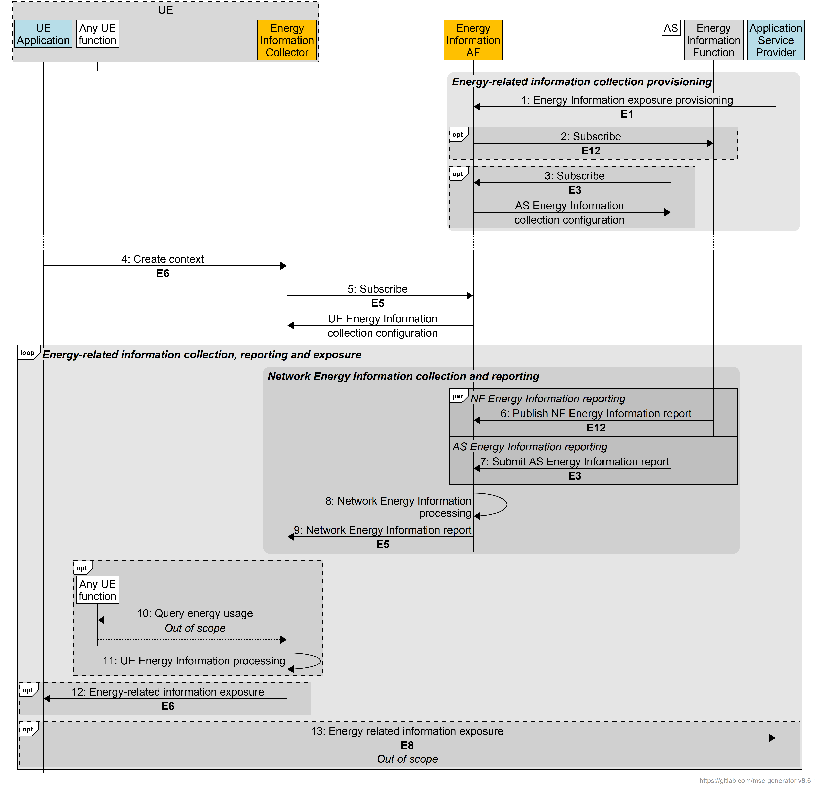
Figure 7.6.3.1-1: Procedures for energy-related information collection and reporting
A first step is required to provision Energy Information Collection:
1. The Application Service Provider provisions the Energy Information AF with the Energy Information exposure configuration via reference point E1. The Energy Information exposure configuration may identify application(s) that fall within its scope.
2. The Energy Information AF subscribes to receive Network Energy Information reporting from the Energy Information Function via reference point E12, if relevant.
3. The AS obtains an AS Energy Information collection configuration from the Energy Information AF via reference point E3, if relevant. This includes a callback endpoint on the Energy Information AF for submitting AS Energy Information reports.
Editor’s Note: This step requires further discussion. What stimulates the subscription, c.f. step 5 below.
At some later point:
4. The UE Application creates an Energy Information collection and reporting context with the Energy Information Collector via reference point E6.
5. The Energy Information Collector subscribes to Network Energy Information reporting from Energy Information AF via reference point E5, if relevant, and receives in response a UE Energy Information collection configuration.
After this initialisation phase, reporting can be done:
6. The Energy Information Function may submit an Network Energy Information report to the Energy Information AF via reference point E12. The Network Energy Information report may include energy consumption information of different granularities, e.g. UE, PDU Session and/or QoS Flow, as described in clause 5.51.2.3 of TS 23.501 [72].
7. The AS may submit an AS Energy Information report to the Energy Information AF via reference point E3 using the callback endpoint supplied in step 3. The AS Energy Information report may include energy consumption information of different granularities, e.g. UE, PDU Session and/or QoS Flow, as described in clause 5.51.2.3 of TS 23.501 [72].
8. The Energy Information AF processes the energy-related information report(s) it has received.
9. The Energy Information AF exposes a processed Network Energy Information report about the UE to the Energy Information Collector subscriber via reference point E5. The Network Energy Information report may include energy consumption information of different granularities, e.g. PDU Session and/or QoS Flow, as described in clause 5.51.2.3 of TS 23.501 [72].
10. The Energy Information Collector may collect additional UE Energy Information from any UE function using methods beyond the scope of 3GPP standardisation.
11. The Energy Information Collector processes the UE Energy Information it has obtained in the previous step.
12. The Energy Information Collector exposes energy-related information to the subscribed UE Application via reference point E6. Based on the UE Energy Information collection configuration obtained in step 5, the energy-related information report may include energy consumption information of different granularities, e.g. PDU Session and/or QoS Flow, as described in clause 5.51.2.3 of TS 23.501 [72] and/or for individual applications.
13. The UE Application may expose the received energy-related information to the Application Service Provider via reference point E8 using methods beyond the scope of 3GPP standardisation.

7.6.3.2 5GMS high-level procedures for collection and exposure of energy-related information

Figure 7.6.3.2-1 below details the different steps for energy-related information collection and reporting in the context of the 5GMS System defined in TS 26.501 [23] and as extended in clause 7.6.2.3 of the present document.
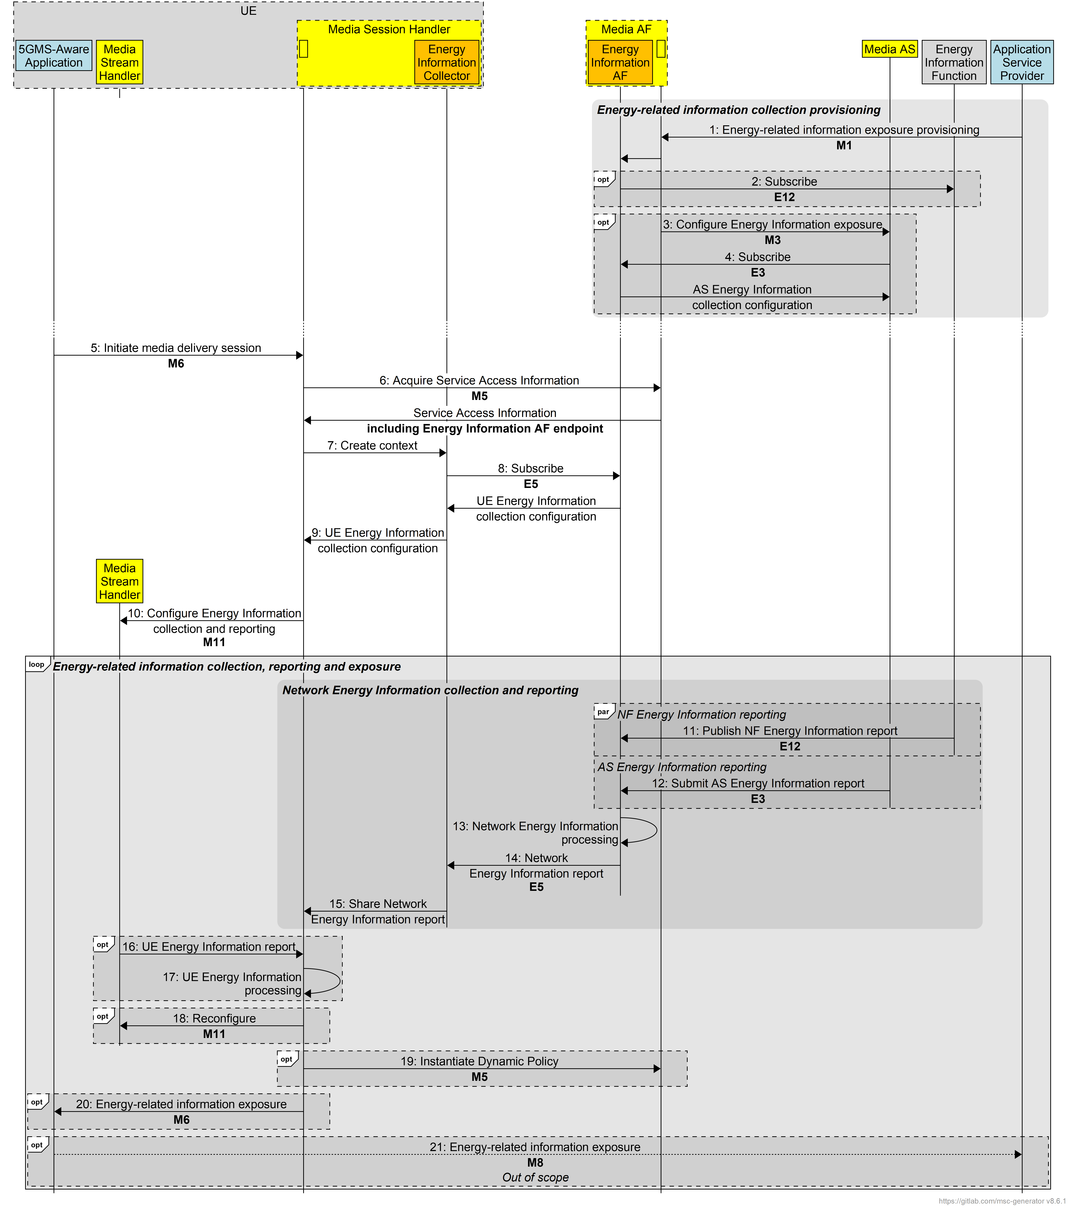
Figure 7.6.3.2-1: Procedures for energy-related information collection and reporting
in the 5GMS System
A first step is required to provision Energy Information Collection:
1. The 5GMS Application Provider provisions the 5GMS AF via reference point M1, including an Energy Information exposure configuration intended for the Energy Information AF instantiated in the 5GMS AF. The Energy Information exposure configuration may identify application(s) that fall within its scope.
2. The Energy Information AF subscribes to receive NF Energy Information reporting from the Energy Information Function via reference point E12, if relevant.
3. The 5GMS AF configures the 5GMS AS via reference point M3, including details of the Energy Information AF instantiated in the 5GMS AF.
4. Based on configuration received from the 5GMS AF in the previous step, the 5GMS AS obtains an AS Energy Information collection configuration from the Energy Information AF via reference point E3, if relevant. This includes a callback endpoint on the Energy Information AF for submitting AS Energy Information reports.
At some later point:
5. The 5GMS-Aware Application initiates a new media delivery session with the Media Session Handler via reference point M6, including a request to enable energy-related information collection and reporting.
6. The Media Session Handler obtains Service Access Information from the 5GMS AF, including access details of the Energy Information AF.
7. As a consequence of the previous step, the Media Session Handler creates a new energy-related information collection and reporting context with the Energy Information Collector instantiated in it.
8. The Energy Information Collector subscribes to Network Energy Information reporting from Energy Information AF via reference point E5, if relevant, and receives in response a UE Energy Information collection configuration.
9. The Energy Information Collector shares the UE Energy Information collection configuration with the Media Session Handler.
10. Based on the UE Energy Information collection configuration received in the previous step, the Media Session Handler configures UE Energy Information collection and reporting in the Media Stream Handler via reference point M11.
After this initialisation phase, reporting can be done:
11. The Energy Information Function may submit an NF Energy Information report to the Energy Information AF via reference point E12. The NF Energy Information report may include energy consumption information of different granularities, e.g. UE, PDU Session and/or QoS Flow, as described in clause 5.51.2.3 of TS 23.501 [72].
12. The 5GMS AS may submit an AS Energy Information report to the Energy Information AF via reference point E3 using the callback endpoint supplied in step 4. The AS Energy Information report may include energy consumption information of different granularities, e.g. UE, PDU Session and/or QoS Flow, as described in clause 5.51.2.3 of TS 23.501 [72].
13. The Energy Information AF processes the energy information report(s) it has received.
14. The Energy Information AF exposes a processed Network Energy Information report about the UE to the Energy Information Collector subscriber established in step 5 via reference point E5. The Network Energy Information report may include energy consumption information of different granularities, e.g. PDU Session and/or QoS Flow, as described in clause 5.51.2.3 of TS 23.501 [72].
15. The Energy Information Collector shares the report received in the previous step with the Media Session Handler.
16. The Media Session Handler may collect additional UE Energy Information about the media delivery session from the Media Stream Handler via reference point M11. Based on the UE Energy Information collection configuration obtained in step 6, the UE Energy Information report may include energy consumption information of different granularities, e.g. PDU Session and/or QoS Flow, as described in clause 5.51.2.3 of TS 23.501 [72].
16. The Media Session Handler processes the UE Energy Information it has obtained in the previous step.
17. The energy-related information received by the Energy Information Collector is shared with the enclosing Media Session Handler.
18. Based on the energy-related information received in step 17, the Media Session Handler may reconfigure the Media Stream Handler to change its streaming behaviour (e.g. change its streaming bit rate).
NOTE 1: Details of Media Stream Handler reconfiguration in response to energy-related information are for further study.
19. Based on the Energy Information received in step 17, the Media Session Handler may instantiate a Dynamic Policy with a different energy usage profile.
NOTE 2: Details of Dynamic Policy changes in response to energy-related information are for further study.
20. The Media Session Handler exposes energy-related information to the subscribed 5GMS-Aware Application via reference point M6. Based on the UE Energy Information collection configuration obtained in step 6, the energy-related information may include energy consumption information of different granularities, e.g. PDU Session and/or QoS flow, as described in clause 5.51.2.3 of TS 23.501 [72] and/or for individual media delivery sessions.
21. The 5GMS-Aware Application may expose the received energy-related information to the Application Service Provider via reference point M8 using methods beyond the scope of 3GPP standardisation.

7.6.4 Summary
This Candidate Solution describes how energy-related information from the device, the network and other components of the Media Delivery system can be provided to a UE application during media consumption for exposure to the user and/or to the Application Service Provider.
This solution is based on Network Energy Information available from the Energy Information Function as well as the definition of two new entities, with their associated reference points, allowing the Network Energy Information to be complemented and delivered to the UE application:
- The Energy Information AF has some or all of the following responsibilities, depending on its current provisioning state:
- Subscribes to and consumes NF Energy Information from the Energy Information Function.
- Receives AS Energy Information reports from the Application Server.
- Collates and exposes the above Network Energy Information to the Energy Information Collector in the UE via the data plane.
- The Energy Information Collector, is a UE function with some or all of the following responsibilities, depending on its current configuration:
- Acquires an Energy Information collection configuration from the Energy Information AF.
- Subscribes to and consumes Network Energy Information from the Energy Information AF according to the Energy Information collection configuration.
- Collects UE Energy Information from other UE functions and about itself according to the Energy Information collection configuration.
- Collates and exposes collected Energy Information to the UE Application via a client API.

* * * * End changes * * * *

