**3GPPSA4 131-bis-e MeetingS4-250596**

Online, 11 – 17 April 2025

**Source: China Mobile**

**Title: [FS_Beyond2D] Clause 4.1 Introduction to Beyond 2D Video Formats**

**Agenda item: 9.6**

**Document for: Agreement**

**1. Introduction**

This document provides an introduction section to Claus 4, Beyond 2D Video Formats.

**2. Proposal**

It is proposed to agree the following changes to the 3GPP draft TR 26.926 V0.3.0

* * * First Change * * *

## 4.1 Introduction

This section provides an overview of the Beyond 2D Video formats that are avalaible in the market, generated from established and emerging capturing systems (including cameras for spatial video capturing), contribution, and usable on display technologies (smartphones, VR HMDs, AR glasses, autostereoscopic and multiscopic displays). These include: stereoscopic 3D video, Multi-view plus Depth, dense dynamic point clouds, dynamic meshes, and emerging formats such as Neural Radiance Fields (NeRF), light fields, and 3D Gaussian Splatting (3DGS). Table 4.1-1 summarizes the Beyond 2D Video formats documented in this study, highlighting their representation principles, advantages, challenges and compression technologies.

**Table 4.1-1 Summary of Beyond 2D Video Formats**

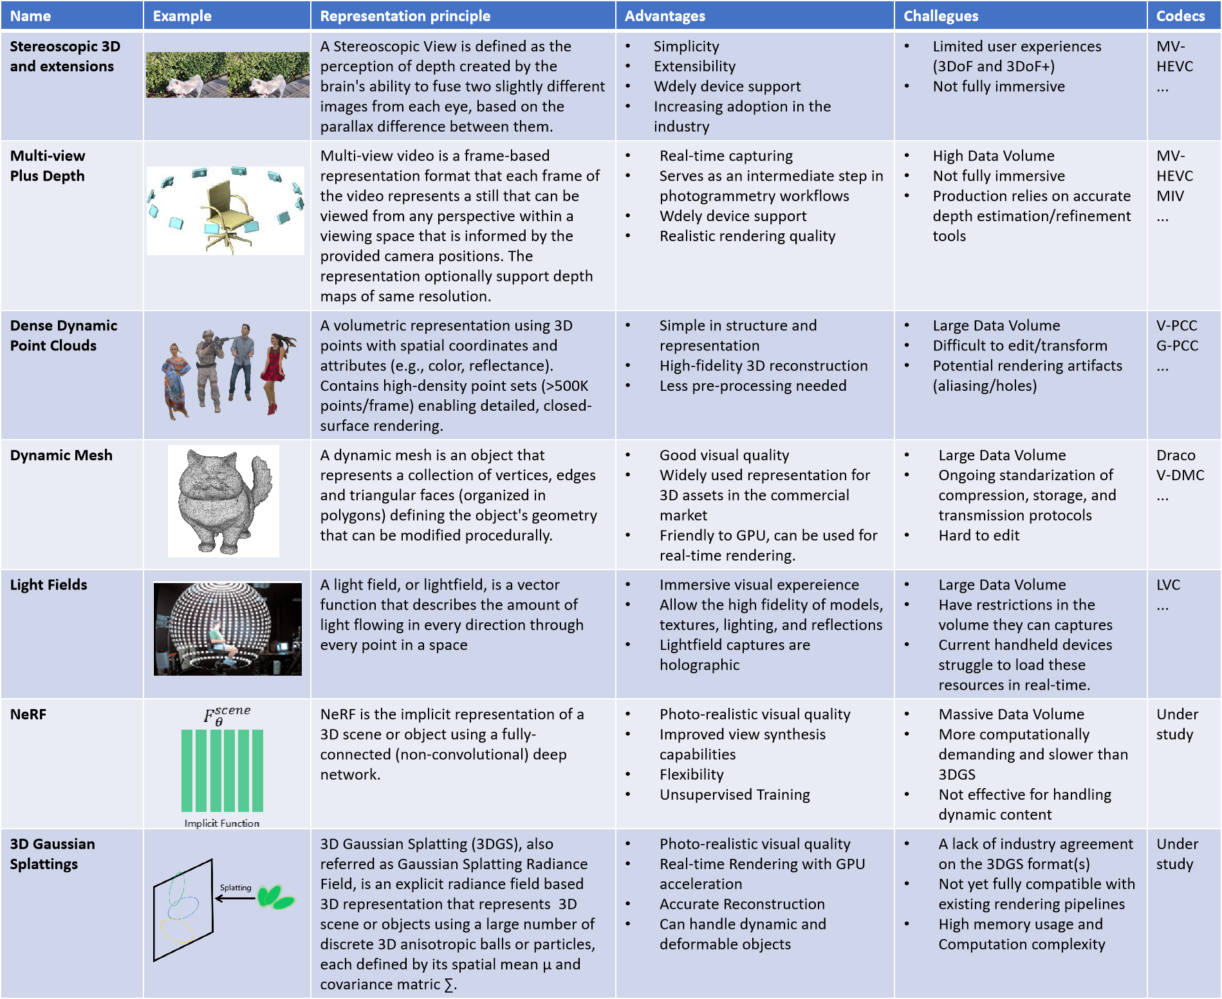

* * * End of Changes * * *