**3GPPSA4 131-bis-e MeetingS4-250570**

Online, 11 – 17 April 2025

**Source: China Mobile**

**Title: [FS_Beyond2D] pCR on Annex C.2.12 – Test Sequences for Dynamic Mesh**

**Agenda item: 9.7**

**Document for: Agreement**

**1. Introduction**

This document provides test sequences for Dynamic Mesh.

**2. Proposal**

It is proposed to agree the following changes to the 3GPP draft TR 26.956 V0.3.0

* * * First Change * * *

### C.2.12 Exercise test sequence

#### C.2.12.1 Description

The sequence is captured by a lightweight capture system, equipped with 4 Azure KinectTM depth cameras and proprietary 3D reconstruction algorithms, is capable of capturing and reconstructing dynamic mesh sequences. It can reconstruct 29.9695 frames per second, with each dynamic human mesh containing more than 50K triangles. The texture maps have resolutions ranging from 1K to 8K (depends on the settings).

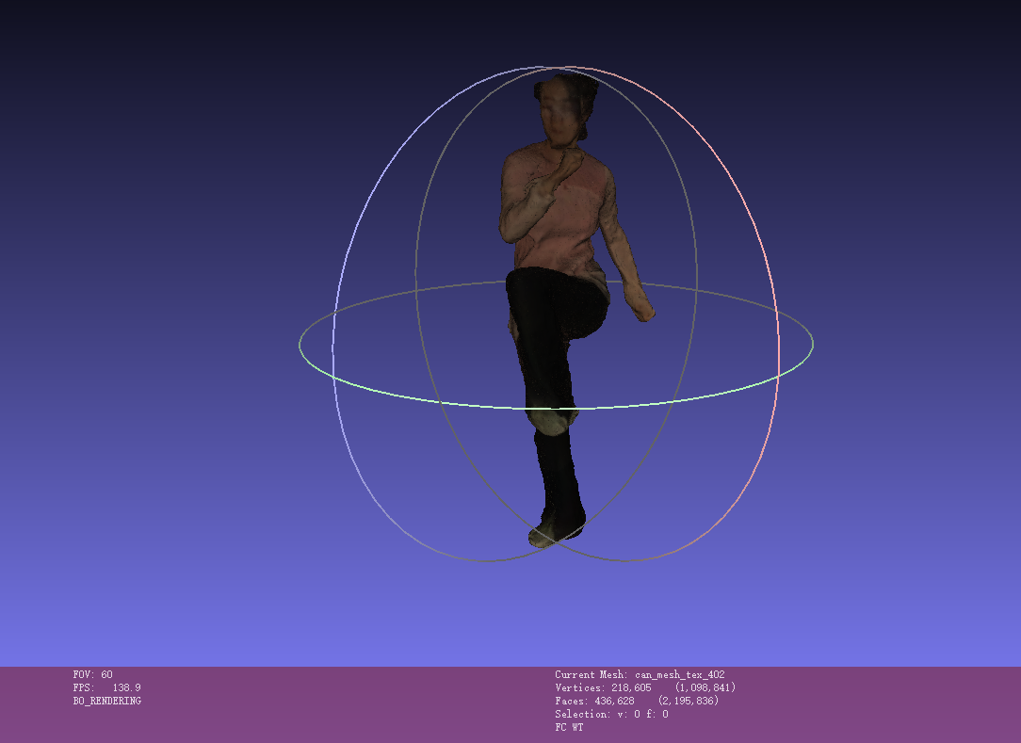

Figure X9 Exercise’s Sequence

#### C.2.12.2 Sequence properties

The sequence can be downloaded as dynamic mesh. The dynamic human mesh containing more than 50K triangles. The texture maps have resolution of 8K (depends on the settings).

**Table Y16 Exercise sequence properties dynamic mesh**

|  |  |  |  |  |  |  |
| --- | --- | --- | --- | --- | --- | --- |
| **Test material dataset filename** | **#Frames** | **#Vertices** | **#Faces** | **Geometry Precision** | **Texture Coord. Precision** | **Texture Map Size** |
| live_model_guangboticao_8192 | 200 | 40k | 80k | 12 bits | 13 bits | 8192*8192 |

The dataset contain one PNG file representing texture, one MTL representing material, and one OBJ file representing geometry for each mesh frame.

The sequences can be accessed: https://www.dropbox.com/scl/fi/rkbw1sb2i8nbcm69po00m/live_model_guangboticao_8192.zip?rlkey=qza774eses1p1jfiybe50c1j2&st=gabk43hw&dl=0

3GPP members can request the password by contacting xujiayi@chinamobile.com.

#### C.2.12.3 Copyright and license information

Exercise © 2025 by XU is licensed under CC BY-ND 4.0. To view a copy of this license, visit https://creativecommons.org/licenses/by-nd/4.0/

* * * End of Changes * * *