**3GPPSA4 131-bis-e MeetingS4-250569**

Online, 11 – 17 April 2025

**Source: China Mobile**

**Title: [FS_Beyond2D] Test Sequences for UE-to-UE Stereoscopic Video Live Streaming**

**Agenda item: 9.7**

**Document for: Agreement**

**1. Introduction**

This document provides test sequences for UE-to-UE Stereoscopic Video Live Streaming Scenario.

**2. Proposal**

It is proposed to agree the following changes to the 3GPP draft TR 26.926 V0.3.0

* * * First Change * * *

##### 7.2.7.1.3 Self-Converted Sequences

The AI-based conversion of existing 2D images and Video to stereo3D is proving commercially viable and fulfills the growing need for high quality stereoscopic images. This approach is particularly effective when creating content for the new generation of autostereoscopic displays that require multiple stereo images.Various open-source algorithms and platforms use deep neural networks to perform real-time end-to-end conversion of 2D videos and images to stereoscopic 3D video format.

As 2D-to-Stereo3D conversion algorithms usually take RGB video format, the Python scripts can be found in Annex D.2.2 to convert between YUV and RGB formats.

The test sequences use the left view of the stereoscopic videos collected in Section 7.2.7.1.2 as input, and generate the right view through AI algorithms to synthesize side-by-side stereoscopic videos. The sequences can be found in Annex C.3.5, C.3.6, and C.3.7.

* * * Second Change* * *

##### 7.2.7.1.2 Self-Captured Sequences

A dual-lens camera can be used to directly capture stereo 3D video. There are many mobile devices on the market with this capability. For example, SpatialLabs EyesTM provided by Acer is a stereoscopic camera capable of capturing up to 8-MP (4K) per eye at 30 fps or 2K per eye at 60 fps. Or the ZTE Nubia Pad 3D IITM can capture stereo 3D video with the specifications in Table 7.2.7.1.2.1:

The main camera setup is the dual-camera systems includes two identical 13 MP lenses. These cameras capture slightly different perspectives of the same scene, mimicking the way human eyes perceive depth. The AI then processes these images to produced a coherent 3D representation. The selfie camera setup features two lenses positioned near the center of the top bezel when the tablet is oriented horizontally (with the longer side on the top).

**Table 7.2.7.1.2-1 Specification of Capturing Device**

|  |  |
| --- | --- |
| **Rear Camera** | **Specification** |
| Number of Cameras | 2 (Dual) |
| Resolution | 13 MP (wide); 13 MP (wide) |
| Autofocus | AF, AF |
| Video Recording | 1200 @ 30 fps |
| Others | LED Flash, panorama, HDR, Stereoscopic AI-powered 3D capture |
| **Front Camera** | **Specification** |
| Number of Cameras | 2 (Dual) |
| Resolution | 8 MP (ultra wide); 8 MP (ultra wide) |
| Aperture | f/2.2, f/2.2 |
| Field of View | 105°, 105° |
| Video Recording | 1200 @ 30 fps |

The captured videos (in mp4 file) need further processing (e.g., reading the right/left views and concatenate them into one video frame) the scripts can be found in Annex D.2.3. An FFmpeg command described in Annex D.2.4 can be used to save each frame into a proper test sequence,

The test sequences captured from ZTE Nubia Pad 3D IITM main camera and post-processed by the above tools can be found in Annex C.3.2, C.3.3, and C.3.4.

* * * Third Change (all new text)* * *

## C.3 Test Sequences for UE-to-UE Stereoscopic Video Live Streaming

### C.3.1 Overview

This annex presents candidate test sequences that are available for testing. Some sequences have been made freely available to 3GPP under license agreement but cannot be made publicly available. Some sequences are free and publicly available for download by respecting the license.

### C.3.2 Street View - captured test sequence

#### C.3.2.1 Description

Real-time street view capture using stereoscopic cameras, combining moving pedestrians, vehicles, and static background elements in a single 3D scene.

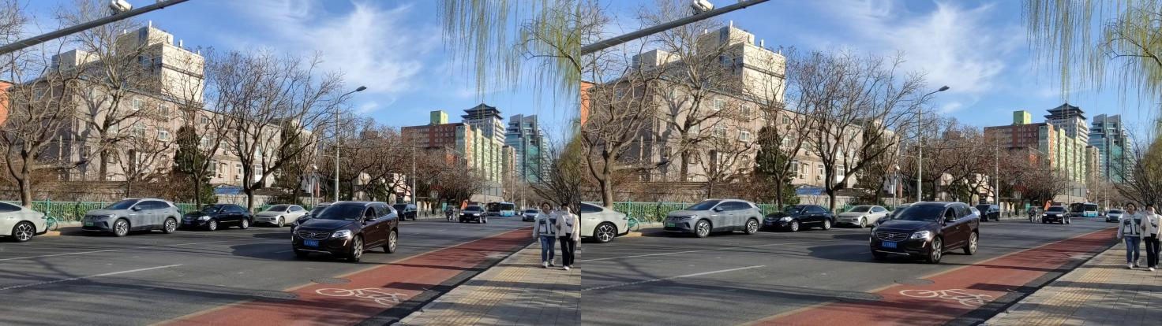

Figure X1 StreetView - captured

#### C.3.2.2 Sequence properties

The tables Y1 summarizes the properties of the StreetView captured sequence

|  |  |
| --- | --- |
| Parameter | Value |
| Resolution | 1920 ×1080 (Per Eye) |
| Frame Rate | 30 |
| Bit Depth | 8 |
| Length | 344 |
| YUV format | 4:2:0 |
| Color Component | Y’CbCr |
| Color Space | ITU-R.BT2020 |

Table Y1 StreetView - captured sequence properties

The sequence can be accessed: https://pan.baidu.com/s/18ZQXrdm3LTTvV4JDE0sr2A?

3GPP members can request the password by contacting xujiayi@chinamobile.com.

#### C.3.2.3 Copyright and license information

sbs_streatView_data © 2025 by Jie Li is licensed under CC BY-ND 4.0. To view a copy of this license, visit https://creativecommons.org/licenses/by-nd/4.0/

### C.3.3 Cute Dog - Captured test sequence

#### C.3.3.1 Description

A cute dog plays in the road. The scene is dynamic, with lively movements and detailed fur textures.

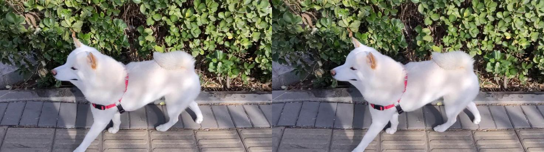

Figure X1 Cute Dog - Captured

#### C.3.3.2 Sequence properties

The tables Y1 summarizes the properties of the Cute Dog - Captured sequence

|  |  |
| --- | --- |
| Parameter | Value |
| Resolution | 1920 ×1080 (Per Eye) |
| Frame Rate | 30 |
| Bit Depth | 8 |
| Length | 505 |
| YUV format | 4:2:0 |
| Color Component | Y’CbCr |
| Color Space | ITU-R.BT2020 |

Table Y1Cute Dog - Captured sequence properties

The sequence can be accessed: https://pan.baidu.com/s/1DgjHpQJ8I-jay75PjCj3NQ?

3GPP members can request the password by contacting xujiayi@chinamobile.com.

#### C.3.3.3 Copyright and license information

sbs_Cute_Dog © 2025 by Jie Li is licensed under CC BY-ND 4.0. To view a copy of this license, visit <https://creativecommons.org/licenses/by-nd/4.0/>

### C.3.4 Moving Girl - Captured test sequence

#### C.3.4.1 Description

The girl presents a doll and a signboard to the audience, with particularly strong 3D depth effects visible especially when she extends the objects toward the camera.

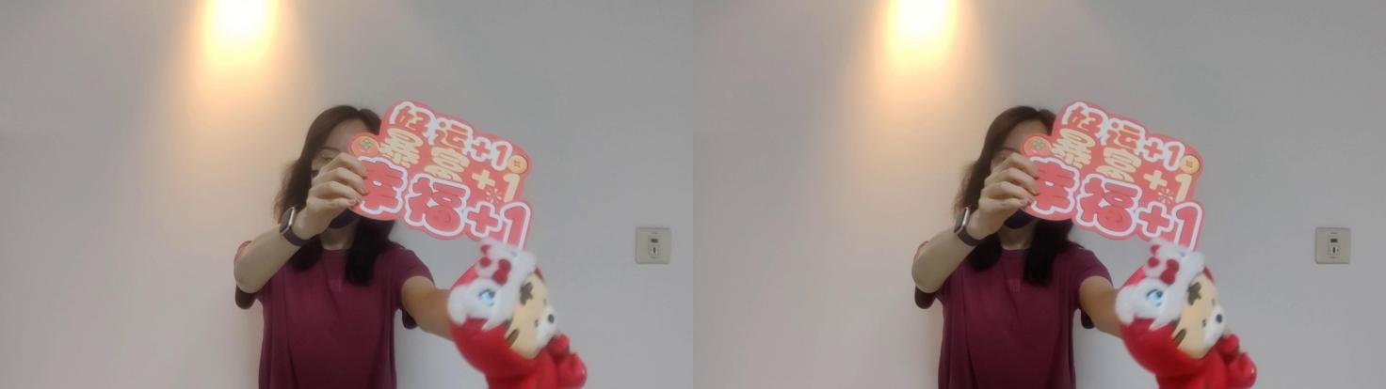

Figure X1 MovingGirl-Captured

#### C.3.4.2 Sequence properties

The tables Y1 summarizes the properties of the MovingGirl-Captured sequence

|  |  |
| --- | --- |
| Parameter | Value |
| Resolution | 1920 ×1080 (Per Eye) |
| Frame Rate | 30 |
| Bit Depth | 8 |
| Length | 312 |
| YUV format | 4:2:0 |
| Color Component | Y’CbCr |
| Color Space | ITU-R.BT2020 |

Table Y1 MovingGirl-Capture properties

The sequence can be accessed: https://pan.baidu.com/s/1rpdbtxs7TrLGla8sYAvC8w?

3GPP members can request the password by contacting xujiayi@chinamobile.com.

#### C.3.4.3 Copyright and license information

TestSequence_JuneXie_2 © 2025-03-26 by June Xie is licensed under CC BY-ND 4.0. To view a copy of this license, visit https://creativecommons.org/licenses/by-nd/4.0/

### C.3.5 Street View - Generated test sequence

#### C.3.5.1 Description

The sequence uses the left view of the stereoscopic videos collected in Annex C.3.2 as input, and generate the right view through AI algorithms to synthesize side-by-side stereoscopic videos.

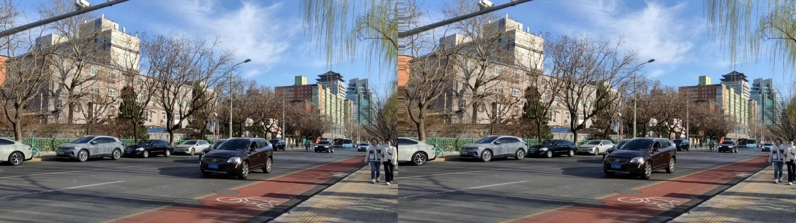

Table Y1 StreetView - generated sequence properties

#### C.3.5.2 Sequence properties

The StreetView - generated sequence has same properties as defined in C 3.2.2, it can be accessed: https://pan.baidu.com/s/16tKuVdLWMfyrtm8JbA4QVw

3GPP members can request the password by contacting xujiayi@chinamobile.com.

#### C.3.5.3 Copyright and license information

Streetview_lina_generated © 2025 by Lina is licensed under CC BY-ND 4.0. To view a copy of this license, visit https://creativecommons.org/licenses/by-nd/4.0/

### C.3.6 Cute Dog - Generated test sequence

#### C.3.6.1 Description

The sequence uses the left view of the stereoscopic videos collected in Annex C.3.3 as input, and generate the right view through AI algorithms to synthesize side-by-side stereoscopic videos.

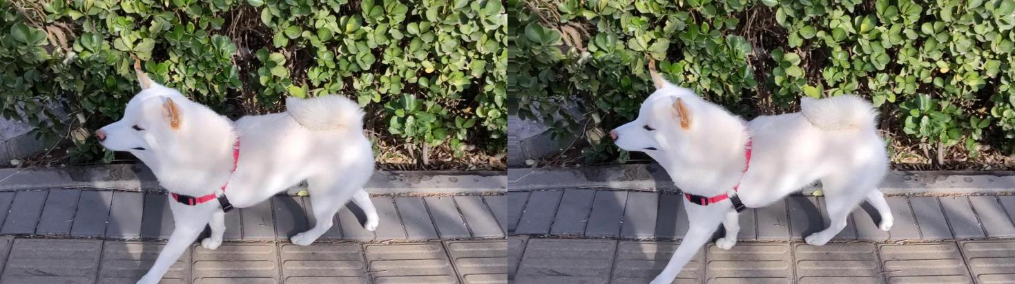

Figure X1 Cute Dog -Generated

#### C.3.6.2 Sequence properties

The Cute Dog - generated sequence has same properties as defined in C 3.3.2, it can be accessed: https://pan.baidu.com/s/1TVTtsHriJMeXflrd3CweFQ

3GPP members can request the password by contacting xujiayi@chinamobile.com.

#### C.3.6.3 Copyright and license information

Dog_lina_generated © 2025 by Lina is licensed under CC BY-ND 4.0. To view a copy of this license, visit <https://creativecommons.org/licenses/by-nd/4.0/>

### C.3.7 Moving Girl - Generated test sequence

#### C.3.7.1 Description

The sequence uses the left view of the stereoscopic videos collected in Annex C.3.4 as input, and generate the right view through AI algorithms to synthesize side-by-side stereoscopic videos.

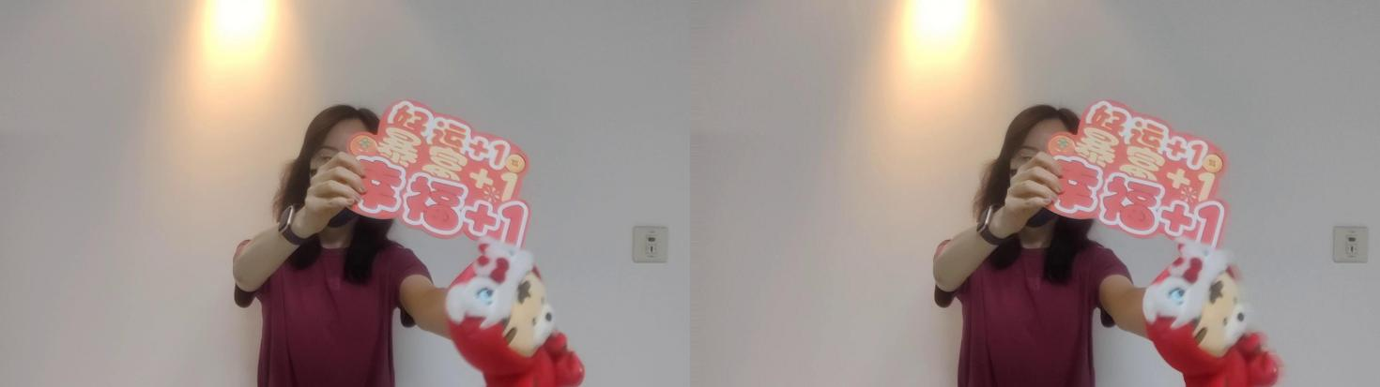

Figure X1 Moving Girl -Generated

#### C.3.7.2 Sequence properties

The Moving Girl - generated sequence has same properties as defined in C 3.4.2, it can be accessed: https://pan.baidu.com/s/1aduJg1C_6j3tq3_-3p7aIw?

3GPP members can request the password by contacting xujiayi@chinamobile.com.

#### C.3.7.3 Copyright and license information

TestSequence_JuneXie_1 © 2025-03-26 by June Xie is licensed under CC BY-ND 4.0. To view a copy of this license, visit https://creativecommons.org/licenses/by-nd/4.0/

* * * End of Changes * * *