**3GPP TSG-SA SA4#131-bis-eS4-250445r1**

**Online, 11 – 17 April 2025**

|  |  |  |  |  |  |  |  |  |
| --- | --- | --- | --- | --- | --- | --- | --- | --- |
| *CR-Form-v12.2* | | | | | | | | |
| **CHANGE REQUEST** | | | | | | | | |
|  | | | | | | | | |
|  |  | **CR** |  | **rev** |  | **Current version:** | **0.3.0** |  |
|  | | | | | | | | |
| *For* [***HE******LP***](http://www.3gpp.org/3G_Specs/CRs.htm#_blank)*on using this form: comprehensive instructions can be found at* [*http://www.3gpp.org/Change-Requests*](http://www.3gpp.org/Change-Requests)*.* | | | | | | | | |
|  | | | | | | | | |

|  |  |  |  |  |  |  |  |  |
| --- | --- | --- | --- | --- | --- | --- | --- | --- |
| ***Proposed change affects:*** | UICC apps |  | ME |  | Radio Access Network |  | Core Network |  |

|  |  |  |  |  |  |  |  |  |
| --- | --- | --- | --- | --- | --- | --- | --- | --- |
|  | | | | | | | | |
| ***Title:*** | pCR on include 3D background models in new annex X | | | | | | | |
|  |  | | | | | | | |
| ***Source to WG:*** | InterDigital, Sony, Samsung, Nokia, Philips, Deutsche Telekom, Fraunhofer HHI, KDDI, Sony Group Corporation, Huawei | | | | | | | |
| ***Source to TSG:*** |  | | | | | | | |
|  |  | | | | | | | |
| ***Work item code:*** |  | | |  | ***Date:*** | | | 2025-15-04 |
|  |  | | |  |  | | |  |
| ***Category:*** | B |  | | | ***Release:*** | | | Rel-19 |
|  | *Use one of the following categories:* ***F*** *(correction)* ***A*** *(mirror corresponding to a change in an earlier release)* ***B*** *(addition of feature),* ***C*** *(functional modification of feature)* ***D*** *(editorial modification)*  Detailed explanations of the above categories can be found in 3GPP [TR 21.900](http://www.3gpp.org/ftp/Specs/html-info/21900.htm). | | | | | | *Use one of the following releases: Rel-8 (Release 8) Rel-9 (Release 9) Rel-10 (Release 10) Rel-11 (Release 11) … Rel-16 (Release 16) Rel-17 (Release 17) Rel-18 (Release 18) Rel-19 (Release 19)* | |
|  |  | | | | | | | |
| ***Reason for change:*** | | Test sequences for scenario 2 will be rendered on neutral background and on backgrounds based on 3D models. This change includes three 3D background models in a new annex X | | | | | | |
|  | |  | | | | | | |
| ***Summary of change:*** | | Adds 3D backgroud models to annex X | | | | | | |
|  | |  | | | | | | |
| ***Consequences if not approved:*** | | Interference of test sequence and a realistic background could not be evaluated | | | | | | |
|  | |  | | | | | | |
| ***Clauses affected:*** | |  | | | | | | |
|  | |  | | | | | | |
|  | | **Y** | **N** |  | |  | | |
| ***Other specs*** | |  |  | Other core specifications | | TS/TR ... CR ... | | |
| ***affected:*** | |  |  | Test specifications | | TS/TR ... CR ... | | |
| ***(show related CRs)*** | |  |  | O&M Specifications | | TS/TR ... CR ... | | |
|  | |  | | | | | | |
| ***Other comments:*** | | Changes are tracked starting from TR V0.3.0 | | | | | | |
|  | |  | | | | | | |
| ***This CR's revision history:*** | |  | | | | | | |

**== CHANGE 1 (all new) ===**

# Annex X: Testing support material

## X.1 3D background models for scenario 2 tests

## X.1 Introduction

Volumetric Video test sequences presented in annex C.2 contain the single asset without background. For subjective tests for scenario 2 representation formats, videos using a camera path are generated using a neutral background neutral and a 3D background model. The purpose of the 3D background model is to enable the evaluation of interference between a test sequence and a background. For example artefacts of the borderline of a test sequence may be less visible in front of a background model than on a neutral background (see also Figure 7.3.4.3-1). Focus of a subjective evaluation is always the test sequence itself and not the background, the background is only a support.

This chapter presents three 3D background models that are free of charge and publicly available under license.

## X.2 Crouch End Station 3D background model

#### X.2.1 Description

This model presents the remains of the Crouch End Station in London.

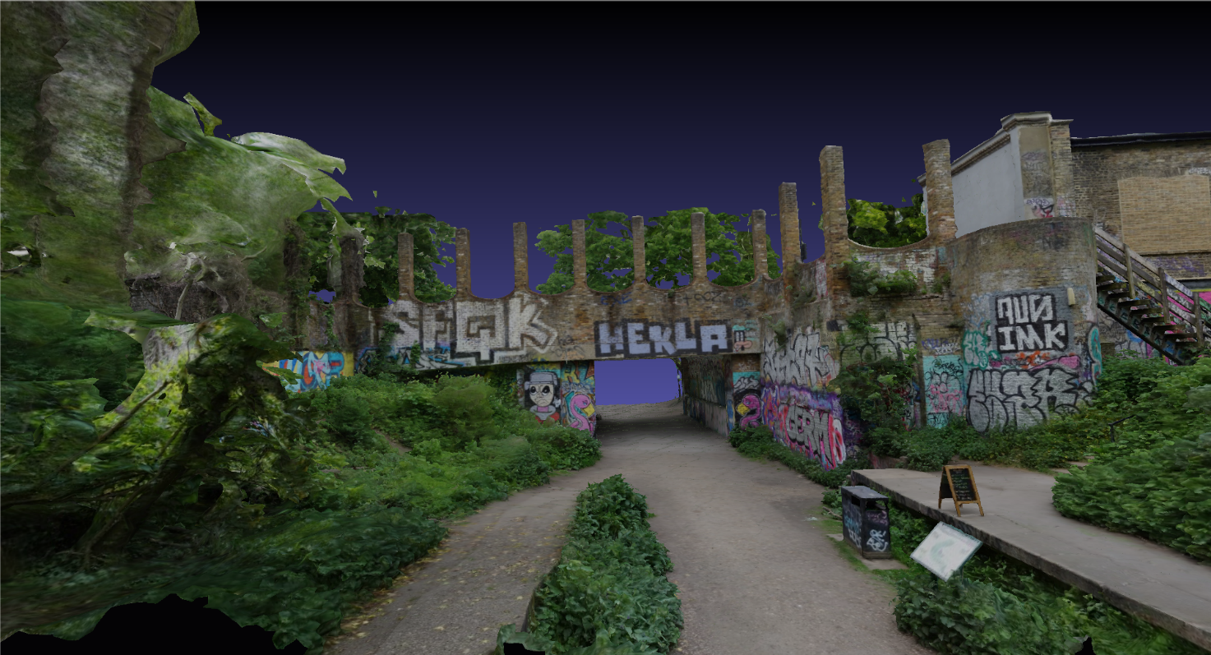

Figure Z1 Remains Crouch End Station – content courtesy artfletch / Sketchfab

This background model can be publicly accessed: <https://sketchfab.com/3d-models/crouch-end-station-d2651a5550f34d80b0dba6e971f3a1ae>

#### X.2.2 Copyright and license information

The Remains Crouch End Station 3D background model is available under the Creative Commons license: <https://creativecommons.org/licenses/by/4.0/>

This model is free of charge and publicly available.

## X.3 Great Drawing Room 3D background model

#### X.3.1 Description

This model represents the Great Drawing Room of the Hallwyl Museum in Stockholm/Schweden. The room is inspired by the baroque style of the 17th century.

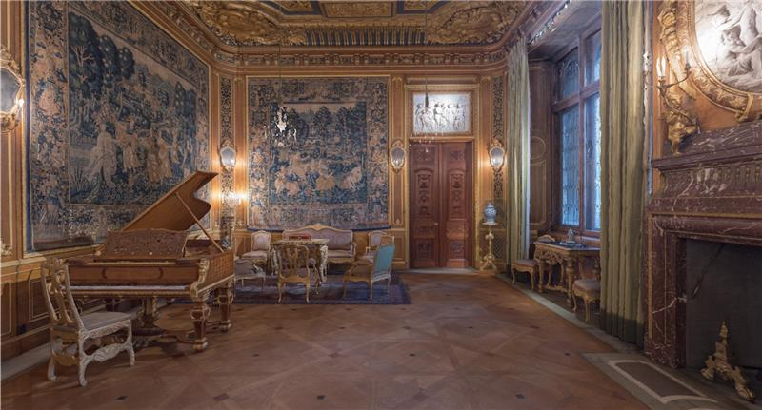

Figure Z2 Great Drawing Room – content courtesy The Hallwyl Museum / Sketchfab

This background model can be publicly accessed: <https://sketchfab.com/3d-models/the-great-drawing-room-feb9ad17e042418c8e759b81e3b2e5d7>

#### X.3.2 Copyright and license information

The Great Drawing Room 3D background model is available under the Creative Commons license: <https://creativecommons.org/licenses/by/4.0/>

This model is free of charge and publicly available.

## X.4 Southbank Undercroft Skatepark 3D background model

#### X.4.1 Description

This model represents a skate park in the Underscoft neneath Queen Elizabeth Hall on the Southbank, London.

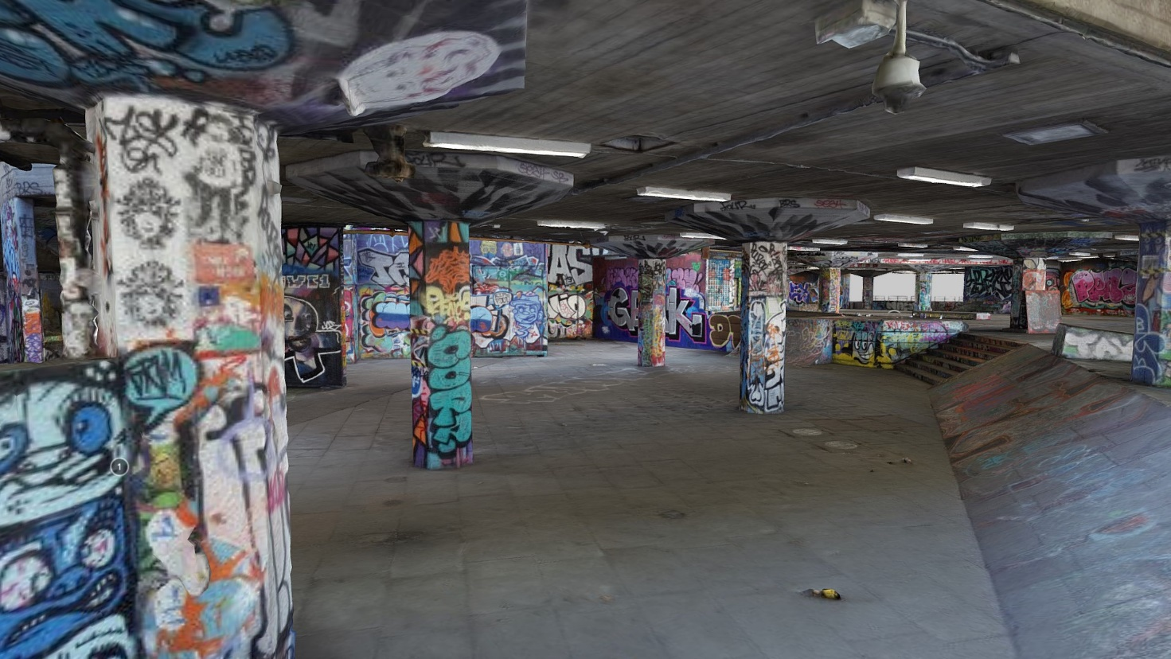

Figure Z3 Southbank Undercroft Skatepark – content courtesy artfletch / Sketchfab

The background model can be publicly accessed: <https://sketchfab.com/3d-models/southbank-undercroft-skatepark-add37d5dc6a2456eb0d7607c6fbd884d>

#### X.4.2 Copyright and license information

The Southbank Undercroft Skatepark background model is available under the Creative Commons license: <https://creativecommons.org/licenses/by/4.0/>

This model is free of charge and publicly available.