**3GPP TSG-SA SA4#131-bis-eS4-250445**

**Online, 11 – 17 April 2025**

|  |  |  |  |  |  |  |  |  |
| --- | --- | --- | --- | --- | --- | --- | --- | --- |
| *CR-Form-v12.2* | | | | | | | | |
| **CHANGE REQUEST** | | | | | | | | |
|  | | | | | | | | |
|  |  | **CR** |  | **rev** |  | **Current version:** | **0.3.0** |  |
|  | | | | | | | | |
| *For* [***HE******LP***](http://www.3gpp.org/3G_Specs/CRs.htm#_blank)*on using this form: comprehensive instructions can be found at* [*http://www.3gpp.org/Change-Requests*](http://www.3gpp.org/Change-Requests)*.* | | | | | | | | |
|  | | | | | | | | |

|  |  |  |  |  |  |  |  |  |
| --- | --- | --- | --- | --- | --- | --- | --- | --- |
| ***Proposed change affects:*** | UICC apps |  | ME |  | Radio Access Network |  | Core Network |  |

|  |  |  |  |  |  |  |  |  |
| --- | --- | --- | --- | --- | --- | --- | --- | --- |
|  | | | | | | | | |
| ***Title:*** | pCR on include 3D background models in annex C | | | | | | | |
|  |  | | | | | | | |
| ***Source to WG:*** | InterDigital, Sony, Samsung, Nokia, Philips, Deutsche Telekom, Fraunhofer HHI, KDDI, Sony Group Corporation, Huawei | | | | | | | |
| ***Source to TSG:*** |  | | | | | | | |
|  |  | | | | | | | |
| ***Work item code:*** |  | | |  | ***Date:*** | | | 2025-06-04 |
|  |  | | |  |  | | |  |
| ***Category:*** | B |  | | | ***Release:*** | | | Rel-19 |
|  | *Use one of the following categories:* ***F*** *(correction)* ***A*** *(mirror corresponding to a change in an earlier release)* ***B*** *(addition of feature),* ***C*** *(functional modification of feature)* ***D*** *(editorial modification)*  Detailed explanations of the above categories can be found in 3GPP [TR 21.900](http://www.3gpp.org/ftp/Specs/html-info/21900.htm). | | | | | | *Use one of the following releases: Rel-8 (Release 8) Rel-9 (Release 9) Rel-10 (Release 10) Rel-11 (Release 11) … Rel-16 (Release 16) Rel-17 (Release 17) Rel-18 (Release 18) Rel-19 (Release 19)* | |
|  |  | | | | | | | |
| ***Reason for change:*** | | Test sequences for scenario 2 will be rendered on neutral background and on backgrounds based on 3D models. This change includes three 3D background models in annex C | | | | | | |
|  | |  | | | | | | |
| ***Summary of change:*** | | Adds 3D backgroud models to annex C | | | | | | |
|  | |  | | | | | | |
| ***Consequences if not approved:*** | | Test sequences could only be rendered on neural background, which is less realistic. Interference of test sequence and a realistic background could not be evaluated | | | | | | |
|  | |  | | | | | | |
| ***Clauses affected:*** | |  | | | | | | |
|  | |  | | | | | | |
|  | | **Y** | **N** |  | |  | | |
| ***Other specs*** | |  |  | Other core specifications | | TS/TR ... CR ... | | |
| ***affected:*** | |  |  | Test specifications | | TS/TR ... CR ... | | |
| ***(show related CRs)*** | |  |  | O&M Specifications | | TS/TR ... CR ... | | |
|  | |  | | | | | | |
| ***Other comments:*** | | Changes are tracked starting from TR V0.3.0 | | | | | | |
|  | |  | | | | | | |
| ***This CR's revision history:*** | |  | | | | | | |

**== CHANGE 1 (all new) ===**

# Annex C: Reference Sequences

## C.X 3D background models

## C.X.1 Overview

Volumetric Video test sequences presented in annex C.2 contain a single asset without background. As background, a neutral color, an AR scene from a camera or a 3D background model can be used. This chapter presents three 3D background models that are used in the tests related to scenario 2. All presented 3D background models are free and publicly available under license.

## C.X.2 Crouch End Station 3D background model

#### C.X.2.1 Description

This model presents the remains of the Crouch End Station in London.

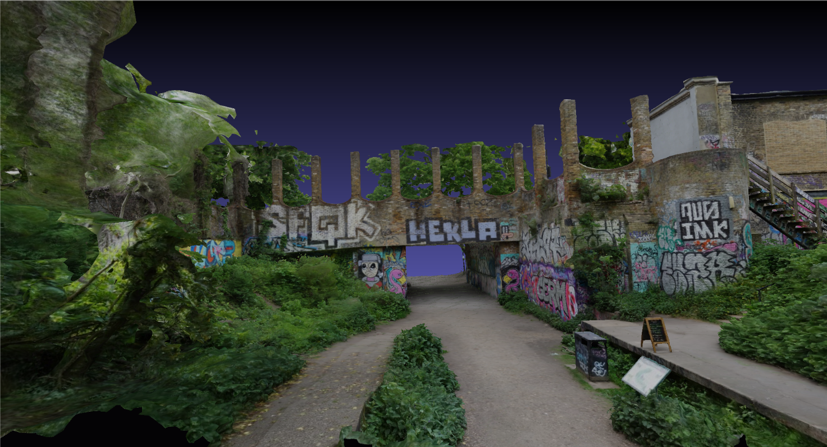

Figure Z1 Remains Crouch End Station – content courtesy artfletch / Sketchfab

#### C.X.2.2 Sequence Properties

Table Y1 summarizses the principal properties of the 3D background model.

|  |  |
| --- | --- |
| Parameter | Value |
| #of triangles | 1.9M |
| #of vertices | 956.7k |

Table Y1 Remains Crouch End Station 3D background properties

The background model can be publicly accessed: <https://sketchfab.com/3d-models/crouch-end-station-d2651a5550f34d80b0dba6e971f3a1ae>

#### C.X.2.3 Copyright and license information

The Remains Crouch End Station 3D background model is available under the Creative Commons license: <https://creativecommons.org/licenses/by/4.0/>

This model is free and publicly available.

## C.X.3 Great Drawing Room 3D background model

#### C.X.3.1 Description

This model represents the Great Drawing Room of the Hallwyl Museum in Stockholm/Schweden. The room is inspired by the baroque style of the 17th century.

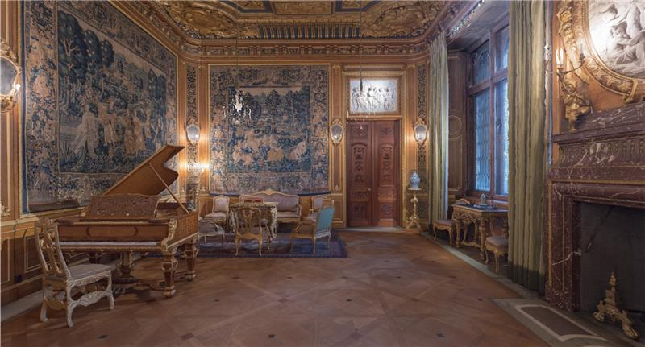

Figure Z2 Great Drawing Room – content courtesy The Hallwyl Museum / Sketchfab

#### C.X.3.2 Sequence Properties

Table Y2 summarizses the principal properties of the 3D background model.

|  |  |
| --- | --- |
| Parameter | Value |
| #of triangles | 1M |
| #of vertices | 507.7k |

Table Y2 Great Drawing Room 3D background properties

The background model can be publicly accessed: <https://sketchfab.com/3d-models/the-great-drawing-room-feb9ad17e042418c8e759b81e3b2e5d7>

#### C.X.3.3 Copyright and license information

The Great Drawing Room 3D background model is available under the Creative Commons license: <https://creativecommons.org/licenses/by/4.0/>

This model is free and publicly available.

## C.X.4 Southbank Undercroft Skatepark 3D background model

#### C.X.4.1 Description

This model represents a skate park in the Underscoft neneath Queen Elizabeth Hall on the Southbank, London.

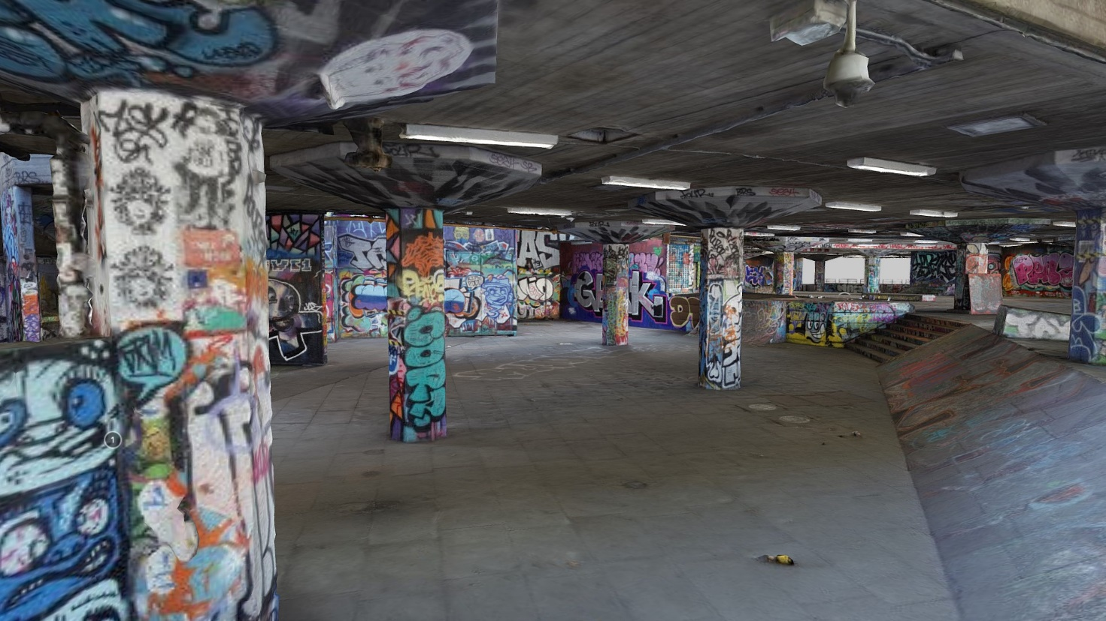

Figure Z3 Southbank Undercroft Skatepark – content courtesy artfletch / Sketchfab

#### C.X.4.2 Sequence Properties

Table Y3 summarizes the principal properties of the 3D background model.

|  |  |
| --- | --- |
| Parameter | Value |
| #of triangles | 1.8M |
| #of vertices | 910.8k |

Table Y3 Southbank Undercroft Skatepark 3D background properties

The background model can be publicly accessed: <https://sketchfab.com/3d-models/southbank-undercroft-skatepark-add37d5dc6a2456eb0d7607c6fbd884d>

#### C.X.4.3 Copyright and license information

The Southbank Undercroft Skatepark background model is available under the Creative Commons license: <https://creativecommons.org/licenses/by/4.0/>

This model is free and publicly available.