**Agenda item:** 10.6

**Source:** Qualcomm Inc.

**Title: [5G_RTP_Ph2] On updating the data burst size indication**

**Document for** Discussion andAgreement

# Introduction

SA4 has been specifying the signaling of data burst size (BSSize). Due to the low-latency requirement of XR applications, the constituent PDUs of a data burst may increase as seen in the RTP sender after the data burst indication has been sent, making the indicated data burst size (BSSize) obsolete.

This is illustrated in the example below. For simplicity, each PDU is assumed to be 1000 bytes. At time T1, the BSSize of a burst consisting of blue PDUs #1, #2 and #3 is determined and sent in blue PDU #1. Between time T2 and T3, a new group of PDUs (green PDUs) for a new application data unit (ADU) with higher priority than the blue data burst are generated and the green PDU #1 is transmitted at time T3 to avoid delaying the transmission of the new ADU, and the blue PDU #3 is delay after all the green PDUs. Therefore, the initial data burst (consisting of the three blue PDUs) grows to a new data burst that includes the 3 blue PDUs and the 4 green PDUs. This change in the constituent PDUs of a data burst makes the previously indicated BSSize obsolete, and the BSSize needs to be updated (to 7000 bytes).

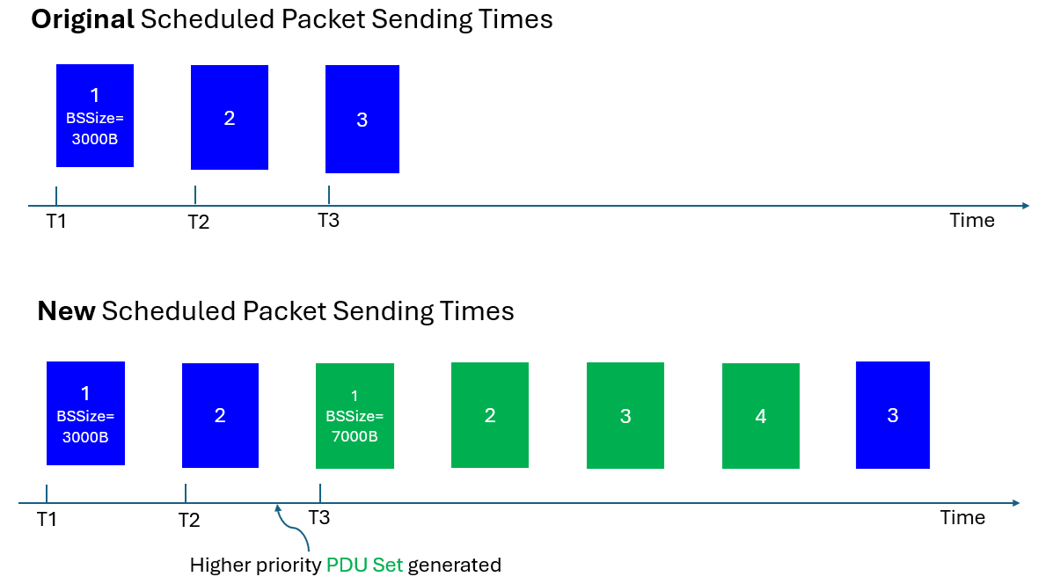

Figure 1: the transmission of a green PDU #1 for a new application data unit before the last PDU of the current data burst makes the earlier indicated BSSize obsolete.

To update the BSSize, the green PDU #1 can carry the updated BSSize and indicate that the BSSize is an update via a reserved bit in the RTP header extension for dynamically changing traffic characteristics.

# Proposal

Agree the following proposal:

**Proposal:** when the constituent PDUs of a data burst change, the traffic source updates the data burst size (BSSize) in the first new constituent PDU and indicates that the BSSize is an update of a previous PSSize via a reserved bit (e.g., the first reserved bit being set to 1 instead of 0) in the RTP header extension for dynamically changing traffic characteristics.