3GPP TSG-SA WG4 Meeting #131-bis-e S4-250544
Online, 11 – 17 April 2025

Source: Nokia
Title: [SR_IMS] pCR Foveated optimizations for Split Rendering
Spec: 3GPP TR 26.567 v1.0.0
Agenda item: 10.5
Document for: Discussion and agreement

- Introduction
XR devices are increasingly capable of gaze tracking, which can be used for interaction and visual optimizations. Foveated rendering and foveated video encoding, which leverage non uniform visual acuity (foveated vision) are two such optimizations which are relevant for split rendering scenarios. Foveated rendering techniques, when rendering a frame, assign rendering resources in a spatially varying manner such that the area where the user is looking, i.e. where the user gaze is tracked, is rendered with the highest quality. Foveated encoding techniques apply the same paradigm to video encoding, assigning highest bit budget in a frame to the gaze location. Typically, this is achieved by using so called importance maps which divide a frame into different zones with different importance to allocation different rendering or encoding resource budgets differentially. As an example, NVIDIA dynamic foveated rendering, used via the Variable Shading Rate API feature, by default divides the frame into three zones: High quality, medium quality and low quality. For easy usage, the size of these zones and the quality levels are saved as presets or profiles.
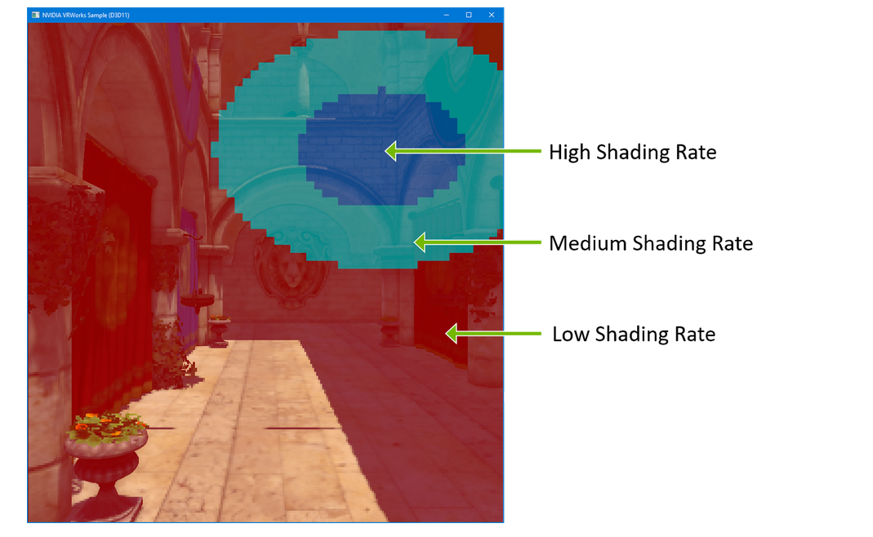
Figure 1 NVIDA VRS based foveated rendering illustration. Source: Easy VRS Integration with Eye Tracking
In split rendering use cases, when gaze data is available from a UE, it can be sent to the MF to be used for foveated rendering and foveated encoding. For a given perceptual quality, these optimizations may help in reducing server rendering resource usage and downstream channel capacity usage.
Devices with eye tracking functionality may provide gaze data via an API to an XR runtime which exposes it to the application. For example, OpenXR provides gaze data via the extension XR_EXT_eye_gaze_interaction. The gaze data is available as eye pose which includes orientation and position of the tracked eyes in an XR space. The available gaze data, if it is predicted for a future frame render time, may also contain information about the confidence in prediction of the (pose of) gaze sample.
- Reason for Change
To enable gaze-based optimizations in rendering and encoding processes in SR_IMS.
- Proposal
It is proposed to agree the following changes to TR 26.567 v.1.0.0.

* * * First Change All new text * * * *
A.2.X Foveated optimizations.
Gaze based optimizations like foveated rendering and foveated encoding reduce resource usage and improve user experience for a given resource usage. When gaze data is available and the SR-DCMTSI client and MF or DC-AS agree to use gaze data for gaze-based optimizations in rendering and encoding. For gaze-based optimizations in rendering and encoding, the SR-DCMTSI client and the MF agree on an optimization profile during session negotiation from a selection of appropriate profiles. An optimization profile provides importance maps based on the gaze position for foveated rendering and encoding. An importance map provides quality information for different regions of a frame, their size and location with reference to a gaze point.
During a split rendering session, the optimization profile being used may need to be adapted or a switch to a different profile may be desired based on, for example, user preference, network conditions, monitored QoE etc

A.2.X.1 Configuration format
To use gaze-based optimizations of rendering and encoding, the split rendering configuration shall indicate the gaze-based optimization profile used in the extra configurations field of the split rendering configuration format specified in clause 5.4.2.4 and illustrated in Annex A.1.3. The configuration shall be JSON formatted and conform to the format in Table A.2.X.1-1. A gaze-based optimization profile contains importance maps for the rendering and encoding a frame according to varying qualities based on the reported gaze location.
Table A.2.X.1-1 Configuration format for gaze-based optimization profile
Name | Type | Cardinality | Description
gazeOptProfile | Object | 1..N | An object corresponding to a gaze-based profile. It may be only an identifier such as a URI/N or it may comprise all information needed to use the profile

A.2.X.2 Metadata format
Adapting gaze-based optimization being in use in a split rendering session shall follow the general network procedures specified in clause 7.3.1. The metadata message to adapt the gaze-based optimization profile shall conform to the format specified in clause 5.4.3 and shall have the type indicated as “urn:3gpp:split-rendering:v1:asrp:gaze_opt_adapt”. Depending on the implementation and the adaptation needed, the payload may indicate a switch to a new gaze optimization profile or modification of parameters of the current profile. The message shall conform to the format in Table A.2.X.2-1
Table A.2.X.2-1 Metadata message format for gaze-based optimization adaptation
Name | Type | Cardinality | Description
id | string | 1..1 | A unique identifier of the message in the scope of the data channel session.
type | string | 1..1 | urn:3gpp:split-rendering:v1:asrp::asrp:gaze_opt_adapt
message | Object | 1..1 | Message content
subtype | string | 1..1 | An identifier of the subtype of the message, it may indicate a switch in optimization profile (SwitchOptProf) or a change in parameters of the optimization profile (ModOptProf)
gazeOptProfile | Object | 1..1 | An object corresponding to a gaze-based profile. It may be only an identifier such as a URI/N or it may comprise all information needed to use the profile. If the message subtype is to switch a profile, this contains or points to the gazeOptProf to switch to. If the message subtype is ModOptProfile, this contains or points to a modified version of the current optimization profile.

* * * End Changes * * * *

