3GPP TSG-SA4 Meeting #131-bis-e S4-250469

Online, , 11th Apr 2025 - 17th Apr 2025
CR-Form-v12.3
CHANGE REQUEST
 | 26.802 | CR | 0007 | rev | 3 | Current version: | 19.1.0
For HELP on using this form: comprehensive instructions can be found at
http://www.3gpp.org/Change-Requests.

Proposed change affects: | UICC apps |  | ME |  | Radio Access Network |  | Core Network

Title: | [FS_AMD] Combined MBS and Unicast Services
Source to WG: | Qualcomm Germany
Source to TSG:
Work item code: | FS_AMD |  |  |  |  |  | Date: |  |  | 2025-04-07
Category: | C |  |  |  |  |  | Release: |  |  | Rel-19
 | Use one of the following categories:  F (correction)  A (mirror corresponding to a change in an earlier release)  B (addition of feature),  C (functional modification of feature)  D (editorial modification)  Detailed explanations of the above categories can  be found in 3GPP TR 21.900. |  |  |  |  |  |  |  | Use one of the following releases:  Rel-8 (Release 8)  Rel-9 (Release 9)  Rel-10 (Release 10)  Rel-11 (Release 11)  …  Rel-17 (Release 17)  Rel-18 (Release 18)  Rel-19 (Release 19)  Rel-20 (Release 20)
Reason for change:
Summary of change:
Consequences if not approved:
Clauses affected:
 |  | Y | N
Other specs |  |  |  | Other core specifications |  |  |  | TS/TR ... CR ...
affected: |  |  |  | Test specifications |  |  |  | TS/TR ... CR ...
(show related CRs) |  |  |  | O&M Specifications |  |  |  | TS/TR ... CR ...
Other comments:
This CR's revision history:

===== CHANGE =====

2 References
The following documents contain provisions which, through reference in this text, constitute provisions of the present document.
- References are either specific (identified by date of publication, edition number, version number, etc.) or non-specific.
- For a specific reference, subsequent revisions do not apply.
- For a non-specific reference, the latest version applies. In the case of a reference to a 3GPP document (including a GSM document), a non-specific reference implicitly refers to the latest version of that document in the same Release as the present document.
[A331] ATSC A/331, "Signaling, Delivery, Synchronization, and Error Protection".
[103972] ETSI TR 103 972: "Deployment Guidelines for DVB-I services over 5G Systems".
[26804] 3GPP TR 26.804: " Study on 5G media streaming extensions"
[AWS-WM] Kevin Yao, "Combining dynamic ad insertion and A/B watermarking", 22 FEB 2023 in AWS Elemental MediaTailor, Direct-to-Consumer & Streaming, Media & Entertainment, Media Services, available here: https://aws.amazon.com/blogs/media/combining-dynamic-ad-insertion-and-a-b-watermarking/
[104002] ETSI TS 104 002: " Publicly Available Specification (PAS); DASH-IF Forensic A/B Watermarking An interoperable watermarking integration schema".
[DSS-2023] DASH-IF Special Session: "A/B Watermarking", February 2023, slides available here: https://github.com/Dash-Industry-Forum/Dash-Industry-Forum.github.io/files/10720660/DASH-IF_ServerSideWM_2023.pdf
[CTA5007] CTA 5007-A: "Web Application Video Ecosystem - Common Access Token"
[WM-API] DASH-IF Candidate Specification, "Watermarking Encoder API", Community Review version available here https://dashif.org/news/cr-watermarking-api/
[103998] ETSI TS 103 998, "Content Steering for DASH".

===== CHANGE =====

5.11.4 Summary and conclusions
It is recommended to address the following functionalities that are available in MBMS for MBS User Services:
1. The generic Application Service as defined in clause 7.6 of TS 26.346 [16] based on the discussion in clause 5.11.3.2. A detailed discussion in provided in clause 5.12.
2. Partial file handling as defined in clause 7.9 of TS 26.346 [16] based on the discussion in clause 5.11.3.3,
3. Reporting of metrics based on the discussion in clause 5.11.3.4. A detailed discussion in provided in clause 5.12.
4. Time Synchronization as defined in TS 26.346 [16] in clause 4.6 based on the discussion in clause 5.11.3.6.
Other aspects identified in clause 5.11.2 for aligning MBS and MBMS are for further study.

===== CHANGE =====

5.12 Key Issue #11: Combined MBS multicast and unicast

5.12.1 Description

5.12.1.1 Background and examples
In several deployment scenarios and specifications, the distribution of unicast streaming content such as DASH/HLS/CMAF content over a broadcast/multicast system is considered. Examples include, but are not limited to:
- 5GMS via eMBMS (see TS 26.501 [9], clause 4.9 and 5.10).
- 5GMS via MBS (see TS 26.501 [9], clause 4.11 and 5.12).
- DVB ABR Multicast in ETSI TS 103 769 [12].
- ATSC3.0 specification in A/331 [A331].
- ETSI TS 103 720 [31] for 5G Broadcast.
- ETSI TR 103 972 [103972] for DVB-I over 5G Broadcast.
Hybrid service concepts are well established, and examples include alternative languages requested over unicast, targeted ad insertion, coverage extensions, and several others.
In study, several cases for potential hybrid services have been identified, and are only partially addressed:
- In-session unicast repair as documented in clause 5.9 of the present document,
- Application Services including hybrid services, as documented in clause 5.11.3.2 of the present document,
- Reporting and metrics as documented in clause 5.11.3.4 of the present document,
- Support for DRM in clause 5.10 of TR 26.804 [26804], in particular as mentioned in clause 5.10.4: "The mapping to 5GMS via MBS/MBMS is for further study",
- Common Media Client Data as introduced in clause 5.16 of TR 26.804 [26804], in particular as mentioned in clause 6.16, it is recommended "to further study the usage of CMCD when 5GMS is deployed over MBS and/or MBMS.
Other potential functionalities for hybrid services include:
- Targeted Ad Insertion: ISO/IEC 23009-1 6th edition addresses details of this functionality for DASH as Alternative MPD Events and is aligned with HLS interstitials
- Fast Start-up using unicast: ISO/IEC 23009-1 6th edition addresses details of this functionality for DASH using Segment Sequences.
- A/B Watermarking: In order to also provide a more recent mapping not even discussed yet for 5G Media Streaming, a mapping of A/B Watermarking (WM) to Multicast Broadcast. As an example, A/B Watermarking is specified in DASH-IF ETSI TS 104 002 [104002]. For more background, there was also a DASH-IF Special session in February 2023 with information available here [DSS-2023].
This clause addresses the above aspects generalizes the architectural and procedural aspects when combining unicast and broadcast. This aspect also allows to add new functionalities that require selective unicast requests.
In hybrid media cases, the Media Player may simultaneously request and consume resources from a unicast server (CDN) and a local Media Server, attached to the UE. In the example shown in figure 5.12.1-1 taken ETSI TR 103 972 [103972], three options are considered, how the combination of unicast and multicast are carried out to support hybrid services.
1. The broadcast receiver accesses unicast network.
2. The DASH client selects content from different networks.
3. The application (in this case DVB-I client) selects content from different networks.
Figure 5.12.1-1: Different options to combine multicast/broadcast with unicast
(from ETSI TR 103 972 [103972])
Many streaming services and experiences nowadays have a certain amount of personalization. In this case, two aspects are of importance:
- Requests from the Media Player may include personalized information such as identifiers for the user, specific tokens, device identifiers, tracking data or other client metadata such as defined in CMCD.
- Responses to requests may be customized by the CDN or some edge server based on information included in requests.
Prominent examples are provided in table 5.12.1-1.
Table 5.12.1-1: Examples for personalized unicast requests and responses
Customized requests | Customized responses
Ad tracking and beaconing | Monetization incentives, ad skipping possible
DRM and License keys requests | License keys
Common Media Client Data | —
Identifiers used by Ad Decision systems | Targeted dynamic ad content
Tokens used by A/B Watermarking schemes | Variants of A/B watermarking

5.12.1.2 High-level solutions
Two high-level solutions may be considered to address the handling unicast requests.
- Solution 1: Media Player handles unicast requests
- The manifest discriminates requests to the local media server (fed by broadcast/multicast) and the unicast requests by creating different service locations and typically different URLs
- The Media Player handles the unicast requests directly to the network and deals with request issues
- Generally, this is the preferred option for several use cases (alternative language requests, handoff to unicast for coverage extensions, etc.), but there are limitations
- If the request to a broadcast resource is bundled with unicast related data, the information terminates in the local Media Server (CMCD, Tokens, etc.)
- If the differentiated request needs to be obfuscated to the client and the response logic is provided be a network server, instead of done by the client.
- Scalability, too many requests may go to unicast, so only subset needs to be addressed through unicast.
- Solution 2: MBS/MBMS/5G Broadcast client handles unicast request
- In this case, the Media Player sends conditioned requests to the local or gateway server
- The local/gateway server not only serves the requested resource, but also processes the additional information provided with the request and potentially issues unicast requests based on the resources.
- The requested resource may be served from the broadcast distribution, or it may be served by issuing a unicast request or, as in the case of unicast repair, it may even be a combination of the two.
Solution 1 is well established in MBMS using the generic application service. A more detailed discussion is provided in clause 5.13 in a new key issue. For high-level solution 2, no mechanism is yet provided. The remainder of this clause addresses a mapping of the solution 2 to MBS/MBMS architectures. The solution may be combined with 5G Media Streaming, or may support third-party media streaming services.

5.12.1.3 MBMS Generic Application Service
The Generic Application service specified in clause 7.6 of TS 26.346 [16] is described as follows on a high level:
- The User service announcement contains an explicit Application Service Description, for example a DASH MPD or a HLS M3U8, or both. In this case, all resources that are directly or indirectly referenced in the Application Service Entry Point document instance of this metadata fragment, and are expected to be retrieved by HTTP GET, are delivered as an MBMS User Service. However, the User Service may use MMBS broadcast, or it may use unicast.
- In order to support generic application services in MBMS, the User Service Description contains an Application Service Description which describes the service, including a content-type parameter to describe the information.
- Now if the User Service Description contains a reference to an Application Service Entry document containing broadcast-delivered objects, then:
1) The MBMS User Service is a download delivery service using FLUTE.
2) The MBMS download session delivers objects that are directly or indirectly referenced by the service entry document.
3) If an object is delivered as a FLUTE object with an availability time defined by service is delivered then the MBMS download session delivers the objects such that the last packet of the delivered object is available at the UE latest at its availability time as announced in the application service document and the Content-Location element in the FDT for the delivered object matches the URL in the Application Service document.
4) If an update to the Application Service document is delivered as a FLUTE object then the Content-Location element in the FDT for the delivered object matches the URI of the appropriate referenced Application Service document
For any Application Service which is not a DASH-over-MBMS service, a) its service definition and any specialized handling for service delivery over MBMS, and b) the content format with the exception that it is an HTML5 document, management and hosting of the associated Application Service Description are outside the scope of this specification.
In clause 7.6 of TS 26.346 [16], more details on use cases are discussed. As conveyed by the application service document, an Application Service belonging to a MBMS User Service and carried by the MBMS download delivery method may be made available such that the resources are partly available on broadcast and are partly available in unicast.
Two main use cases are considered in this context:
1) Unicast fallback reception should the UE move outside the MBMS coverage area of the corresponding User Service. Subsequently, should the UE move back into MBMS coverage, it may be required by network operator policy that only broadcast reception of the User Service is permitted (network policy and the means for its delivery and execution is outside the scope of this specification). It may also be desired by the MBMS service provider that reception of individual broadcast resources is restricted by MBMS service areas.
2) Unicast-supplemented service offerings, for which certain resources are only available on unicast and these resources provide an additional user experience and therefore should be accessible by the application, regardless of whether the MBMS Client is in the coverage for broadcast reception or not.

5.12.2.2 Techniques for switching between service locations in the MBMS Client

5.12.2.2.1 General
An example addressing both Unicast fallback reception and Unicast-supplemented service offerings is provided in the DASH MPD in listing 5.12.2.2.1-1,
Listing 5.12.2.2.1-1: Extended example from TS 26.347 for an MPD with multiple service locations
<MPD
xmlns:xsi="http://www.w3.org/2001/XMLSchema-instance"
xmlns="urn:mpeg:dash:schema:mpd:2011"
type="dynamic" minimumUpdatePeriod="PT10s"
timeShiftBufferDepth="PT600S"
minBufferTime="PT2S"
profiles="urn:3GPP:PSS:profile:DASH10"
publishTime="2014-10-17T17:17:05Z"
availabilityStartTime="2014-10-17T17:17:05Z">
<Location>http://www.example.com/MPD2.mpd</Location>
<Period id="1" start="PT0S">
<SegmentTemplate media="./$RepresentationID$/$Number$.m4s" initialization="$RepresentationID$-init.mp4"/>
<!–- Video 720p>
<AdaptationSet mimeType="video/mp4" codecs="hvc1.1.2.L93.B0" startWithSAP="1" maxWidth="1280" maxHeight="720" frameRate="30" profile="urn:3GPP:video:op:h265-720p-HD">
<BaseURL serviceLocation="fallback">http://example.com/uc</BaseURL>
<SegmentTemplate timescale="30" duration="60"/>
<Representation id="v2048" bandwidth="2048000">
<BaseURL serviceLocation="broadcast">http://example.com/bc</BaseURL>
</Representation>
<Representation id="v1024" bandwidth="1024000"/>
<Representation id="v512" bandwidth="512000"/>
<Representation id="v128" bandwidth="128000"/>
</AdaptationSet>
<!–- Video HDR>
<AdaptationSet mimeType="video/mp4" codecs="hvc1.2.4.L113.B0" startWithSAP="1" maxWidth="1920" maxHeight="1080" frameRate="30" profile="urn:3GPP:video:op:h265-Full-HD-HDR">
<BaseURL serviceLocation="unicast">http://example.com/suc</BaseURL>
<EssentialDescriptor schemeIdUri="urn:mpeg:mpegB:cicp:MatrixCoefficients" value="9"/>
<EssentialDescriptor schemeIdUri="urn:mpeg:mpegB:cicp:TransferCharacteristics" value="16"/>
<EssentialDescriptor schemeIdUri="urn:mpeg:mpegB:cicp:ColourPrimaries" value="9"/>
<SegmentTemplate timescale="30" duration="60"/>
<Representation id="8M" bandwidth="8192000">
<Representation id="6M" bandwidth="6144000"/>
<Representation id="4M" bandwidth="4096000"/>
<Representation id="2M" bandwidth="2048000"/>
</AdaptationSet>
<!–- Audio English>
<AdaptationSet mimeType="audio/mp4" codecs="mp4a.40.2" segmentAlignment="true" startWithSAP="1" language="en">
<BaseURL serviceLocation="fallback"> http://example.com/uc</BaseURL>
<SegmentTemplate timescale="20" duration="40"/>
<Representation id="a128" bandwidth="128000">
<BaseURL serviceLocation="broadcast"> http://example.com/bc</BaseURL>
</Representation>
<Representation id="a64" bandwidth="64000">
</AdaptationSet>
<!–- Audio Spanish>
<AdaptationSet mimeType="audio/mp4" codecs="mp4a.40.2" segmentAlignment="true" startWithSAP="1" language="es">
<BaseURL serviceLocation="unicast"> http://example.com/suc</BaseURL>
<SegmentTemplate timescale="20" duration="40"/>
<Representation id="a128" bandwidth="128000">
<Representation id="a64" bandwidth="64000">
</AdaptationSet>
</Period>
</MPD>

5.12.2.2.2 Switching service locations using SAND4M
If such the MPD in listing 5.13.1.2.1-1 is provided to the DASH client, then the use of SAND4M as defined in TS 26.247 [26247] permits signalling from the MBS Client to the MBS-Aware Application (e.g. an MBS-aware DASH client).
Also assume that in the MBMS User Service Bundle Description, a generic application service is signalled as follows:
Listing 5.12.2.2.2-1: Example generic application service
as signalled in MBMS User Service Description
<r12:broadcastAppService>
<r12:basePattern>http://example.com/bc</r12:basePattern>
</r12:broadcastAppService>
<r12:unicastAppService>
<r12:basePattern>http://example.com/uc</r12:basePattern>
</r12:unicastAppService>
<r15:supplementaryUnicastAppService>
<r15:basePattern>http://example.com/suc</r15:basePattern>
</r15:supplemenaryUnicastAppService>

In MBMS signal coverage, the following SAND message would be provided indicating that only a service location for the MBMS User Servie is available, and the supplementary unicast for HDR video and the Spanish language are available via unicast:
Listing 5.12.2.2.2-2: Example SAND message indicating availability of MBMS User Service
<SAND>
<Status baseURL="http://localhost/">
<ResourceStatus status="cached"/>
</Status>
<Status baseURL="http://example.com/uc">
<ResourceStatus status="unavailable"/>
</Status>
<Status baseURL="http://example.com/suc">
<ResourceStatus status="available"/>
</Status>
</SAND>

In case the MBMS Client is out of signal coverage, the MBMS User Service becoming unavailable is signalled by:
Listing 5.12.2.2.2-3: Example SAND message indicating non-availability of MBMS User Service
<SAND>
<Status baseURL="http://localhost/">
<ResourceStatus status="unavailable"/>
</Status>
<Status baseURL="http://example.com/uc">
<ResourceStatus status="available"/>
</Status>
<Status baseURL="http://example.com/suc">
<ResourceStatus status="available"/>
</Status>
</SAND>

5.12.2.2.3 Switching service locations using DASH-IF Content Steering
An alternative solution more broadly supported by clients is Content Steering as defined in ETSI TS 103 998 [103998].
An equivalent MBMS User Service Description would be provided, with a generic application service signalled as follows:
Listing 5.12.2.2.3-1: Example generic application service
as signalled in MBMS User Service Description
<r12:broadcastAppService>
<r12:basePattern>http://example.com/bc</r12:basePattern>
</r12:broadcastAppService>
<r12:unicastAppService>
<r12:basePattern>http://example.com/uc</r12:basePattern>
</r12:unicastAppService>
<r15:supplementaryUnicastAppService>
<r15:basePattern>http://example.com/suc</r15:basePattern>
</r15:supplemenaryUnicastAppService>

In MBMS signal coverage, the following Content Steering message message would be provided indicating that only the MBMS User Service service location is available, as well as the supplementary unicast for HDR video and the Spanish language:
Listing 5.12.2.2.3-2: Example Content Steering document
indicating availability of MBMS User Service
{
"VERSION": 1,
"TTL": 5,
"RELOAD-URI": "http://localhost/mbms/steering"
"PATHWAY-PRIORITY": ["broadcast","unicast"]
}

In case the MBMS Client is out of signal coverage, the MBMS User Service becoming unavailable is signalled by:
Listing 5.12.2.2.3-2: Example Content Steering document
indicating non-availability of MBMS User Service
{
"VERSION": 1,
"TTL": 5,
"RELOAD-URI": "http://localhost/mbms/steering"
"PATHWAY-PRIORITY": ["fallback","unicast"]
}

Signalling of the information for the Content Steering server itself may be in the MPD, or it may be provided by other means, for example in CMSD headers.

5.12.2.2.4 Presentation manifest rewriting
Editor’s Note: TODO.
Listing 5.12.2.2.4-1: Extended example from TS 26.347 for an MPD with multiple service locations
Before rewriting | After rewriting
<MPD
xmlns:xsi="http://www.w3.org/2001/XMLSchema-instance"
xmlns="urn:mpeg:dash:schema:mpd:2011"
type="dynamic" minimumUpdatePeriod="PT10s"
timeShiftBufferDepth="PT600S"
minBufferTime="PT2S"
profiles="urn:3GPP:PSS:profile:DASH10"
publishTime="2014-10-17T17:17:05Z"
availabilityStartTime="2014-10-17T17:17:05Z">
<Location>http://www.example.com/MPD2.mpd</Location>
<Period id="1" start="PT0S">
<SegmentTemplate media="./$RepresentationID$/$Number$.m4s" initialization="$RepresentationID$-init.mp4"/>
<!–- Video 720p>
<AdaptationSet mimeType="video/mp4" codecs="hvc1.1.2.L93.B0" startWithSAP="1" maxWidth="1280" maxHeight="720" frameRate="30" profile="urn:3GPP:video:op:h265-720p-HD">
<BaseURL serviceLocation="fallback">http://example.com/uc</BaseURL>
<SegmentTemplate timescale="30" duration="60"/>
<Representation id="v2048" bandwidth="2048000">
<BaseURL serviceLocation="broadcast">http://example.com/bc</BaseURL>
</Representation>
<Representation id="v1024" bandwidth="1024000"/>
<Representation id="v512" bandwidth="512000"/>
<Representation id="v128" bandwidth="128000"/>
</AdaptationSet>
<!–- Video HDR>
<AdaptationSet mimeType="video/mp4" codecs="hvc1.2.4.L113.B0" startWithSAP="1" maxWidth="1920" maxHeight="1080" frameRate="30" profile="urn:3GPP:video:op:h265-Full-HD-HDR">
<BaseURL serviceLocation="unicast">http://example.com/suc</BaseURL>
<EssentialDescriptor schemeIdUri="urn:mpeg:mpegB:cicp:MatrixCoefficients" value="9"/>
<EssentialDescriptor schemeIdUri="urn:mpeg:mpegB:cicp:TransferCharacteristics" value="16"/>
<EssentialDescriptor schemeIdUri="urn:mpeg:mpegB:cicp:ColourPrimaries" value="9"/>
<SegmentTemplate timescale="30" duration="60"/>
<Representation id="8M" bandwidth="8192000">
<Representation id="6M" bandwidth="6144000"/>
<Representation id="4M" bandwidth="4096000"/>
<Representation id="2M" bandwidth="2048000"/>
</AdaptationSet>
<!–- Audio English>
<AdaptationSet mimeType="audio/mp4" codecs="mp4a.40.2" segmentAlignment="true" startWithSAP="1" language="en">
<BaseURL serviceLocation="fallback"> http://example.com/uc</BaseURL>
<SegmentTemplate timescale="20" duration="40"/>
<Representation id="a128" bandwidth="128000">
<BaseURL serviceLocation="broadcast"> http://example.com/bc</BaseURL>
</Representation>
<Representation id="a64" bandwidth="64000">
</AdaptationSet>
<!–- Audio Spanish>
<AdaptationSet mimeType="audio/mp4" codecs="mp4a.40.2" segmentAlignment="true" startWithSAP="1" language="es">
<BaseURL serviceLocation="unicast"> http://example.com/suc</BaseURL>
<SegmentTemplate timescale="20" duration="40"/>
<Representation id="a128" bandwidth="128000">
<Representation id="a64" bandwidth="64000">
</AdaptationSet>
</Period>
</MPD>

5.12.2 Collaboration scenarios

In order to address the functionality of handling a combination of requests from media players to unicast and broadcast, a new function in the Multicast Broadcast client is added that operates based on a policy to steer the client to specific service locations. The application service document is typically requested through the Media Service on the client, i.e. form service location 1. This allows the application of different policy enforcing mechanisms such SAND4M, manifest rewriting or content steering. Figure 5.12.2-1 provides a basic overview of the architecture considered, initially independent of a specific implementation for MBS or MBMS.
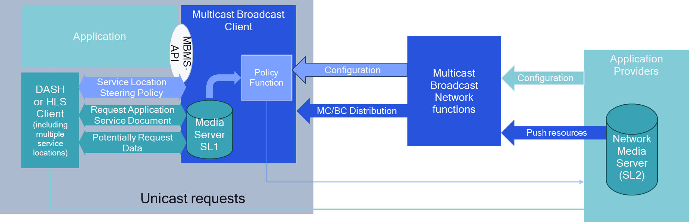
Figure 5.12.2-1: Extension to Multicast Broadcast client to support generic application service
Examples include alternative languages requested over unicast, targeted ad insertion, coverage extensions, and several others.
In order to address the functionality of handling a combination of personalized requests from media players, a new function in the Multicast/Broadcast Client is added that collects information and may communicate with the unicast Application Provider. Figure 5.12.2-2 provides a basic overview of the considered architecture, initially independent of a specific implementation for MBS or MBMS.
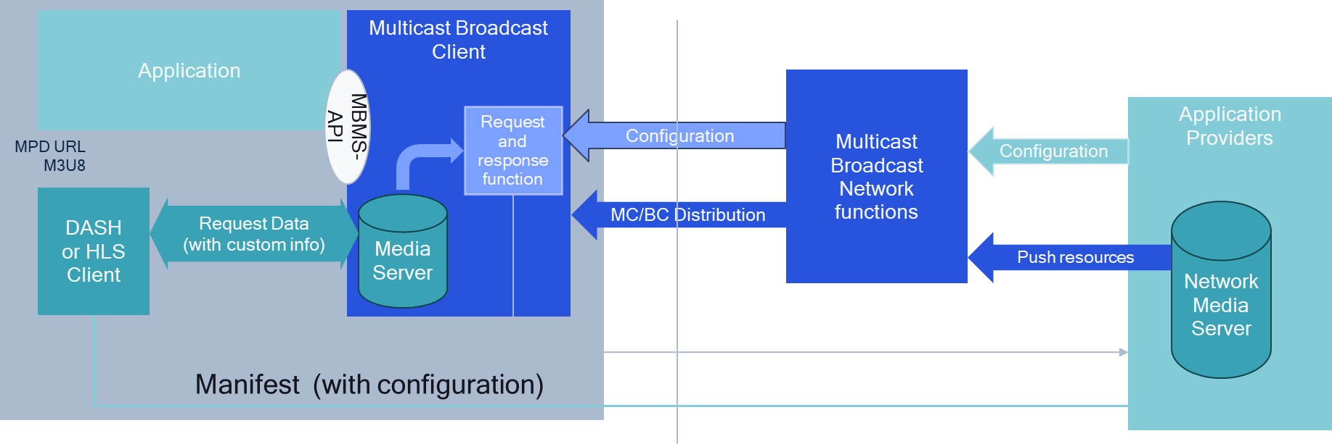
Figure 5.12.2-2: Extension to Multicast Broadcast client to support selected unicast requests
In this case, the application provider configures the Multicast/Broadcast Network Function for distribution. In addition, it provides a configuration instruction, such that Multicast/Broadcast Clients can be configured to manage personalized requests and responses from the Media Clients. This configuration information is provided to the Multicast/Broadcast Client in a service announcement. The Multicast/Broadcast Client uses the request information, possibly adapts the responses and possibly selectively requests information from the unicast server.

5.12.3 Architecture mappings and call flows

5.12.3.1 Introduction
This clause considers different ways in which the collaboration scenarios outlined in clause 5.12.2 can be mapped into the MBS User Services architecture define in TS 26.502 [29] and outlines high-level call flows for procedures between the relevant system actors.

5.12.3.2 Mapping to MBS User Services using MBS AS
The MBS AS is already defined in TS 26.502 [29], but at this stage only has a single functionality, namely object repair. In order to support generic application services, the MBS AS is extended to host content not only for object repair.
NOTE: The logical MBS AS may be co-located with a unicast server that is also used for regular unicast communication.
Figure 5.13.2.2-1 now extends the scope of the MBS AS to support generic application services using the content hosting function.
Figure 5.12.3.2-1: Extensions to MBS User Services network architecture:
Generic application unicast functionality in MBS AS
The above extension does not yet include the proposed extensions in considered in clause 5.9, namely definition of the reference point between MBSTF and MBS AS. However, it is considered a generalization of the discussion in clause 5.9. In addition, the client architecture may stay primarily unmodified, but some of the extensions are provided.
Figure 5.12.3.2-2: Extensions to MBS User Services reference architecture:
Generic Application Service
Figure 5.12.3.2-2 shows how the MBS User Services reference architecture is extended also in the MBSTF Client to support a steering policy for service locations. In this case, the MBSF Client may configure the logic for steering via MBS-6', and the Media Server in the MBSTF Client may also provide a configuration API, for example which requests are served via unicast or which ones are served via MBS-4-MC. While it is expected that the MBS-Aware Application can issue requests to unicast service locations, the requests are virtually proxied through the Media Server of the MBSTF Client.
The extensions for the high-level baseline procedures in TS 26.502 [29] are a generalization to the procedure extensions in clause 5.9 for generic application service and are provided in figure 5.12.3.2-3 in bold.
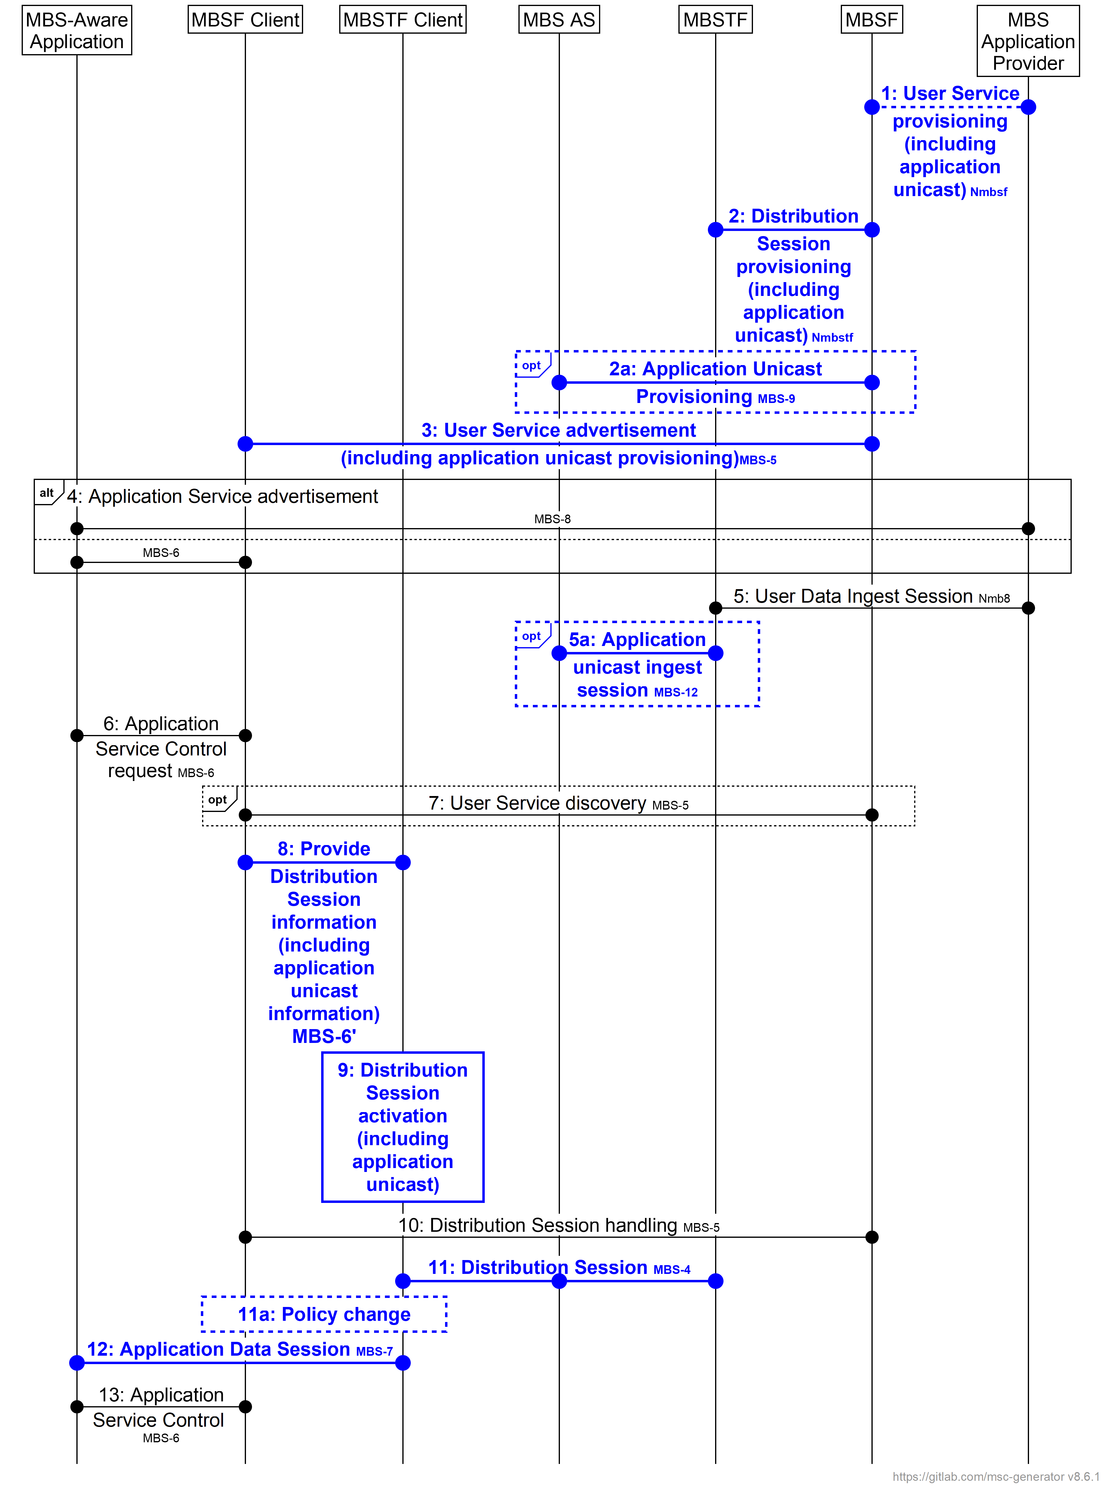
NOTE: In the interests of brevity, the prefix MBS is omitted from the numbered steps in the figure.

Figure 5.12.3.4-3: Extended MBS User Service high-level baseline procedures
The following steps are updated or extended compared to the original high-level call flow:
1. The user service provisioning includes application unicast provisioning.
2. The distribution session provisioning includes application unicast provisioning.
2a. The MBSF provisions application unicast ingest in the MBS AS via reference point MBS-9.
3. The user service announcement is extended to include instructions for application unicast.
5a. The MBS AS ingests application unicast content from the MBSTF.
8. Configuration of the MBSTF Client by the MBSF Client at reference point MBS-6′ is extended to configure a content steering policy for service locations exposed by the Media Server.
9. Activation of the Distribution Session in the MBSTF Client is extended to include activation of the content steering policy for service locations configured in the previous step.
11.The Distribution Session also uses the MBS AS selectively for unicast requests.
11a. Changes to the content steering policy are made by the MBSF or autonomously by the MBSTF, for example due to non-availability of the MBS User Service. Based on this, use of the Distribution Session by the MBSTF in the previous step may toggle between being multicast at reference point MBS-4-MC with unicast fallback at reference point MBS-4-UC, and being exclusively unicast at reference point MBS-4-UC.
12. Requests from the MBS-Aware Application to the Media Server of the MBSTF Client at reference point MBS-7 may include different service locations.

5.12.3.3 Mapping to MBS User Services using an external unicast server
This aspect is for further study.

5.12.3.4 Selective unicast requests from MBS Client
This aspect is for further study.

5.12.4 Gap analysis and requirements

5.12.4.1 General
This is to be completed.

5.12.4.2 Mapping to MBS User Services using MBS AS
The following aspects are identified to be missing:
1. Formal definition of a named reference point between the MBSTF and the MBS AS in order to publish ingested objects to the MBS AS for the purpose of supporting application unicast requests.
2. MBS User Service provisioning parameters at reference point Nmb10 describing the content steering policy to support application unicast requests.
3. MBS Distribution Session provisioning of MBSTF at reference point Nmb2 to support application unicast requests.
4. Provisioning of the MBS AS at reference point MBS-9 in order to support application unicast requests.
5. MBS User Service Announcement parameters to support provisioning for application unicast requests for different purposes.
6. Unicast ingest session to support ingest of unicast content into the MBS AS.
7. Functional extension of the MBSTF Client to support switching service locations.
8. Support for differentiated requests from the MBS-Aware Application to the Media Server of the MBSTF Client (and either forwarding these requests to the MBS AS or serving them from local cache, as dictated by the content steering policy currently in force).
9. Support for application unicast requests from the MBSTF Client to the MBS AS via reference point MBS-4-UC.

5.12.4.3 Mapping to MBS User Services using an external unicast server
This aspect is for further study.

5.12.4.4 Selective Unicast Requests from MBS Client
This aspect is for further study.

5.12.5 Candidate solutions

5.12.5.1 General
This aspect is for further study.

5.12.5.2 Mapping to MBS User Services using MBS AS
In order to address the gaps identified in clause 5.12.3, the following solutions may be considered:
1. Formal definition of a named reference point between the MBSTF and the MBS AS in order to publish ingested objects to the MBS AS for the purpose of supporting application unicast requests.
- The same reference point as defined for object repair in clause 5.9 is expected to be used.
2. MBS User Service provisioning parameters at reference point Nmb10 describing the content steering policy to support application unicast requests.
- The provisioning may be supported by URL mapping templates such as those used to configure a proxy/edge server.
3. MBS Distribution Session provisioning of MBSTF at reference point Nmb2 to support application unicast requests.
- This can be addressed by a generalisation to what is needed for object repair in clause 5.9.
4. Provisioning of the MBS AS at reference point MBS-9 in order to support application unicast requests.
- This can be addressed by a generalisation to what is needed for object repair in clause 5.9.
5. MBS User Service Announcement parameters to support provisioning for application unicast requests for different purposes.
- The provisioning may be supported by inclusion of the URL mapping template described under point 2 above in the MBS User Service Announcement.
6. Unicast ingest session to support ingest of unicast content into the MBS AS.
- This can be addressed by a generalisation to what is needed for object repair in clause 5.9.
7. Functional extension of the MBSTF Client to support switching service locations.
- Options include SAND4M (see clause 5.13.1.2.2), presentation manifest rewrite and DASH-IF Content Steering (see clause 5.13.1.2.3).
8. Support for differentiated requests from the MBS-Aware Application to the Media Server of the MBSTF Client (and either forwarding these requests to the MBS AS or serving them from local cache, as dictated by the content steering policy currently in force).
- No specific extensions are needed for typical clients.
9. Support for application unicast requests from the MBSTF Client to the MBS AS via reference point MBS-4-UC.
- No specific extensions are needed except for parameters that are processed, including http header parameters, query parameters or other parts of HTTP requests.

5.12.5.3 Mapping to MBS User Services using an external unicast server
This aspect is for further study.

5.12.5.4 Selective Unicast Requests from MBS Client
This aspect is for further study.

5.12.6 Summary and conclusions
For combined MBS multicast and unicast, additional study is recommended to discuss different candidate solutions.

===== CHANGE =====

8.4.2 Recommendations for stage 2 normative work arising from version 19
It is recommended to provide relevant extensions to TS 26.502 [29] to extend the MBS User Service architecture based on the updated conclusions in clause 5. Candidates for these extensions are:
1. For Key Issue #8: In-session unicast repair for MBS Object Distribution as introduced in clause 5.9 and based on the conclusions in clause 5.9.7:
- Address Gap #1 identified in clause 5.9.5 by the candidate solution described in clause 5.9.6:
i. Define a new reference point in TS 26.502 [29] between the MBSTF and the MBS AS.
ii. Document call flows and procedures for both post-session and in-session unicast repair.
2. For Key Issue #9: MBS User Service and Delivery Protocols for eMBMS as introduced in clause 5.10 and based on the conclusions in clause 5.10.6:
a. Fully specify support for the Joint BM-SC and MBSF Functionality. For this purpose, the gap identified in clause 5.10.4.1 of the present document needs to be addressed by documenting additional procedures and baseline parameters as required in TS 26.502 [29] and permitting the signalling of MBMS sessions.
b. Document in an informative annex to TS 26.502 [29] the deployment architectures, client architectures and high-level call flows in clauses 5.10.2.3 and 5.10.2.4.
3. For Key Issue #10: Selected MBMS Functionalities not supported in MBS as introduced in clause 5.11 and based on the conclusions in clause 5.11.4:

a. Add the necessary functional extensions and call flows to support time Synchronization as defined in TS 26.346 [16] in clause 4.6 based on the discussion in clause 5.11.3.6.

===== CHANGE =====

8.4.3 Recommendations for stage 3 normative work arising from version 19
It is recommended to provide relevant extensions to MBS User service protocols and formats specified in TS 26.517 [30] based on the conclusions in clause 5 and the stage-2 extensions above, if applicable. Candidates for these extensions are:
1. For Key Issue #8: In-session unicast repair for MBS Object Distribution as introduced in clause 5.9 and based on the conclusions in clause 5.9.7:
- Address Gaps #2, #3, #4, and #5 in clause 5.9.5 by the candidate solution in clause 5.9.6:
i. On gap #2 identified in clause 5.9.5, both of the following signalling options are expected to be supported:
- Using FDT parameters to signal the time when repairs can be requested using the Expires attribute).
- Using LCT header information to signal the time when repairs can be requested using the B-Flag.
ii. On Gap #3 identified in clause 5.9.5, the following signalling options exist in the FLUTE File Delivery Table (FDT):
- Defining a new FDT extensions parameter to signal the availability time when the object needs to be released.
iii. On gap #4 identified in clause 5.9.5, the execution of MBS object delivery and in-session unicast repair can run in parallel in the MBS Client. However, this should be validated if there are cases this is not the case and whether these cases need to be explicitly stated, for example reduced capability (RedCaP) UEs.
iv. On gap #5 identified in clause 5.9.5, time synchronization can reuse functionalities defined in TS 26.346 [16], but tighter synchronization that 1 second. This work is aligned with the findings and work in clause 5.11.3.6.
2. for Key Issue #9: MBS User Service and Delivery Protocols for eMBMS as introduced in clause 5.10 and based on the conclusions in clause 5.10.6:
- Address the relevant stage-3 aspects based on stage-2 work.
3. For Key Issue #10: Selected MBMS Functionalities not supported in MBS as introduced in clause 5.11 and based on the conclusions in clause 5.11.4:

a. Adapt time synchronization as defined in clause 4.6 of TS 26.346 [16] to MBS User Services.

===== CHANGE =====

8.4.4 Recommendations for further study arising from version 19
It is recommended to continue the study of additional extensions to MBS User Services. Candidate topics based on the present document are:
1. For Key Issue #9: MBS User Service and Delivery Protocols for eMBMS as introduced in clause 5.10 and based on the conclusions in clause 5.10.6:
a. Validate the approaches by implementation, for example in 5G-MAG Reference Tools, and identify if the functionality is fully supported or any further specification updates are needed.
b. Going forward, ensure that enhancements to the MBSTF and delivery methods in MBS can also be leveraged and deployed for eMBMS.
2. For Key Issue #10: Selected MBMS Functionalities not supported in MBS as introduced in clause 5.11 based on the conclusions in clause 5.11.4:
- Further study MBMS features that are not yet supported in based on the analysis in clause 5.11.2.
3. For Key Issue #11: Combined broadcast and unicast as introduced in clause 5.12 and based on the conclusions in clause 5.12.6:
- Progress candidate solutions.
- Further study the combination with deployed media players.

===== CHANGE =====

8.4.5 Recommendations for coordination arising from version 19
It is recommended to coordinate work with other working groups and organizations as follows:
1. For Key Issue #9: MBS User Service and Delivery Protocols for eMBMS as introduced in clause 5.10 and based on the conclusions in clause 5.10.6:
a. Validate the approaches by implementation, for example in 5G-MAG Reference Tools.
b. Validate with other working groups whether the TMGI allocation in the MBS User Service Announcement is achievable via MB-SMF.
2. For Key Issue #10: Selected MBMS Functionalities not supported in MBS as introduced in clause 5.11 and based on the conclusions in clause 5.11.4:
- Validate the approaches by implementation, for example in 5G-MAG Reference Tools.
3. For Key Issue #11: Combined Unicast and Broadcasts as introduced in clause 5.12 and based on the conclusions in clause 5.12.4:
- Validate the approaches by implementation, for example in 5G-MAG Reference Tools.

