3GPP TSG-SA WG4 Meeting #131-bis-e S4-250592
Online, 11 – 17 April 2025

Source: vivo
Title: Channel characteristics retrieval
Spec: 3GPP TR 26.940 v0.0.1
Agenda item: 7.9
Document for: Agreement

1. Introduction
At the recent SA#107 plenary meeting, the “Study on Ultra Low Bitrate Speech Codec” has been approved. According to the WID description [1], the primary focus of this study is to develop design constraints and performance requirements for a codec supporting use cases like IMS Voice Call over GEO and the resulting transmission parameters. One main objective is to study “GEO channel characteristics and derive service-related dependencies, e.g. bitrates, mouth-to-ear delay or loss/delay/jitter profiles”. This contribution mainly focuses on the methodology to obtain delay-error profiles.
It is evident that the delay-error profile methodology has been previously employed by SA4, particularly during the development of the EVS codec, as detailed in Annex E of TS 26.132 [2]. The resulting profiles from that work are included as attachments in the TS 26.132 [2] ZIP files. This pCR proposes to adopt a similar approach and generate comparable profiles.
Given that the GEO channel represents a new scenario compared to the LTE end-to-end reference access used in Annex E, the input parameters for the simulation model need to be newly proposed and analyzed. In this context, RAN1, RAN2, and SA2 are expected to:
- Option#1: Confirm both the methodology and the input parameters assumed by SA4
- Option#2: Confirm the methodology and provide their own assumptions on input parameters
This pCR recommends adopting Option 1, and proposes sending LS to the relevant working groups to support the collection of channel characteristics..
2. Reason for Change
The present document provides how to obtain delay-error profiles based on the methodology defined in Annex E in TS 26.132 [2] and delay-error profile as defined in clause 8.2.2.3 in TS 26.114 [3].
4. Proposal
It is proposed to agree the following changes to 3GPP TR 26.940 [4].

* * * First Change * * * *

5 Channel characteristics and service-related dependencies

5.1 Introduction
This clause introduces the methodology of obtaining channel characteristics and results for developing design constraints and performance requirements for a codec supporting use cases of IMS Voice Call over GEO.

5.2 Delay error profiles
The delay-error profile is a model used to describe the network impairments—particularly delay and packet loss—that can impact real-time conversational services such as IMS voice call. Such profile typically reveals the GEO satellite channel characteristics and will be used to evaluate codec robustness, guide jitter buffer design and ensure a fair and comparable testing. Generally, there are 4 kinds of profiles defined in SA4 so far and different profiles serves different purpose:
- Initial profiles attached to TS 26.114 [3] (i.e. the profiles 1 to 6 attached to TS 26.114)
- Extra profiles attached to EVS-7c [7], used for EVS characterization testing (i.e. profiles 7 to 10 in dly_error_profiles.zip attached to EVS-7c [7])
- Profiles used for delay tests as defined in Annex E.3 in TS 26.132 [2]
- Profile used for simulating VoLTE as defined in Annex F in TS 26.132 for JBM tests (i.e. the profile "dly_profile_volte.dat")
Generally there are 3 ways to obtain delay-error profile as listed below, considering the restrictions on commercially availability and requirements for cross-check, the methodology described in this study mainly focus on the simulation way.
- field measurement, to capture real-world network conditions, however, even though it can reflect the real-network conditions, it is not applicable since there is no commercialized 3GPP-based GEO voice.
- prototype testing, to use early-state hardware implementations with custom development, even though it is more real than simulation, the custom development needs longer period and hard to cross-check by different companies.
- simulation, to model network behaviour in a controlled environment, where scripts can be open source and easier for cross-check.

5.2.1 Simulation model for generating packet delay and loss profiles
The intention of this methodology is to reuse the simulation model defined in Annex E.2 of TS 26.132 [2] to produce the delay error profile.
As described in Annex E.2 of TS 26.132 [2], the simulation model is initially derived for the purpose of testing the UE delay for MTSI-based speech with LTE access and used to generate packet arrival time variations and packet loss at the receiving UE for MTSI-based speech over end-to-end LTE access will serve as the baseline. This reference LTE access scenario is illustrated in Figure 5.2.1.1-1. Building on the main scenario defined in Clause 4.2.1, the candidate end-to-end GEO access scenario is shown in Figure 5.2.1.1-2. The primary distinction between the reference LTE scenario and the GEO voice main scenario lies in the introduction of the “new GEO channel”.
Fig.5.2.1.1-1: End-to-end channel of VoLTE using LTE access
Fig.5.2.1.1-2: End-to-end channel of main scenario for IMS voice call using NB-IoT (GEO) satellite access
Based on the functional description in Table E.1 of TS 26.132, the following input parameters are required to implement the simulation model:
- % BLER_tx : The block error rate in uplink.
- % BLER_rx : The block error rate in downlink.
- % max_tx : The maximum number of transmission attempts in uplink.
- % max_rx : The maximum number of transmission attempts in downlink.
- % drx_cycle_length : The length of the DRX cycle
- % mis_eNB1_eNB2 : Scheduling time mis-alignment between eNB1 and eNB2
- % max_net_delay : The maximum network delay between eNB1 to eNB2
- % min_net_delay : The minimum network delay between eNB1 to eNB2
- % nFrames : The number of frames for the simulation

Editor’s Note: Assumptions regarding these input parameters are subject to confirmation by RAN1, RAN2, and SA2.
BLER_tx / BLER_rx:
These parameters are required to simulate block error rates in both uplink and downlink. There are 2 ways to consider:
Case I: BLER IID to channel. In the LTE access scenario, the simulation model assumes that BLER is Independent and Identically Distributed (IID). Although GEO channels typically assumed to exhibit more complex error patterns (e.g., burst errors or correlation), the IID assumption is also applied to the "new GEO channel" based on the NTN TDL-C channel model, as described in Annex A.
Case II: BLER relevance to GEO channel
Editor’s Note: the demonstration of error pattern has relationship with GEO channel is FFS and could be demonstrated by RAN1
max_tx / max_rx:
These define the maximum number of HARQ retransmissions for uplink and downlink respectively, which fall under RAN2 scope. As per 3GPP Release 18 specifications [5], NB-IoT supports two HARQ processes, which face constraints in high-latency GEO satellite scenarios. For IoT-NTN (GEO), HARQ feedback is supported to be disabled per the standard.
drx_cycle_length:
This parameter represents the duration of the DRX (Discontinuous Reception) cycle in milliseconds. It determines how frequently the device wakes up to check for incoming transmissions. In the simulation context Annex E.2 of TS 26.132 [2], this parameter affects packet scheduling and transmission timing. While the original model uses values of 20-40ms for terrestrial LTE, appropriate values for GEO scenarios should be confirmed with RAN2.
mis_eNB1_eNB2:
This parameter represents the scheduling offset between uplink and downlink transmissions. In GEO scenarios, it indicates how long packets wait in the buffer before the next transmission opportunity. This should be determined primarily by RAN2 (responsible for scheduling/SPS, Semi-Persistent Scheduling) with possible input from RAN1 for physical layer timing aspects.
max_net_delay / min_net_delay:
These represent the delay range between eNB1 and eNB2. For GEO voice, they are considered similar to the LTE scenario, and legacy parameter values can be reused.
nFrames:
In the reference LTE scenario, one IP packet corresponds to 20 ms of speech. In contrast, the GEO voice scenario introduces additional considerations due to the propagation delay from GEO satellite altitude. Therefore:
- Speech sequence (frame length): For GEO, a longer frame length may be used. A maximum frame length of 80 ms, as defined by 3GPP, is assumed in this simulation. Final confirmation is expected from SA4.
- IP packet size: This depends on the protocol overhead as illustrated in Figure 5.2.1.1-3 for the reference LTE access scenario and Figure 5.2.1.1-4 for the GEO voice main scenario. The exact overhead depends on the transport path of the VoIP RTP packet—user plane or control plane—and must be confirmed by RAN2 and SA2. For simulation purposes, the assumed range is as follows:
- Lower bound: ~7 bytes. Assuming user plane with ROHC (3 bytes) and NB-IoT protocol layers: PDCP (1 byte), RLC (1 byte), MAC (2 bytes);
- Upper bound: ~52 bytes. Assuming control plane with IPv4/UDP/RTP (20/8/12 = 40 bytes), NAS reduction (7 bytes, optimized by CT1), and NB-IoT layers: RRC (2 bytes), RLC (2 bytes), MAC (1 byte);

Fig. 5.2.1.1-3: VoIP RTP packet in reference LTE access scenario
Fig.5.2.1.1-4: Example of VoIP RTP packet in GEO voice main scenario
- RTP Payload Size: This is computed as the product of frame length and codec bit rate.
Editor’s Note: whether the size of RTP payload affects the delay-error profile is FFS.

5.2.2 Results
Editor’s Note: the results are FFS

5.3 Transmission data rate
Editor’s Note: the SA1 determined [1-3] kbps transmission data rate for uplink and downlink is to be verified by RAN1.
* * * Second Change * * * *

Annex A Proof of GEO channel IID characteristic

A.1 Introduction
This annex offers the proof of the BLER is Independent and Identically Distributed (IID) via a simulation method.

A.2 Methodology
PHY-layer simulations to collect statistics on error packet distribution is conducted. Simulations were performed for two voice packet bundling scenarios:
- 80ms bundling voice packet (I_TBS=4, I_RU=1, TBS=120, QPSK, 12Tone NPUSCH with 32 repetitions)
- 160ms bundling voice packet (I_TBS=3, I_RU=4, TBS=256, QPSK, 12Tone NPUSCH with 16 repetitions)
The simulation setup used the NTN TDL-C channel model with a K-factor of 10.224 dB as specified in TR38.811 for elevation α_model=50°. Target BLER was set at 2% for both configurations, and over 10,000 packets were simulated to ensure statistical significance. For each error packet, the distance to the next error packet was recorded to analyse error patterns.
The detailed simulation assumptions are listed in Table A.2-1, Table A.2-2, Table A.2-3 and Table A.2-4:
Table A.2-1. Simulation assumptions for system configuration
Parameter | Values
Carrier frequency | 2GHz (S-band)
System bandwidth | 180kHz
SCS | 15kHz
Channel bandwidth | DL: 180 kHz  UL: 180/90/45/15kHz
Target elevation angle | 50° for GEO
Channel model | NTN TDL-C
Delay Spread | 30ns

Table A.2-2. Simulation assumptions for GEO satellite
Parameter | Values
Satellite Orbit | GEO，Set-2
Satellite altitude | 35786km
Satellite antenna polarization | Circular polarization
Satellite EIRP density | 53.5dBW/MHz (46.05dBW/180kHz)
Satellite Tx max Gain | 45.5 dBi
G/T | 14 dB/K
Satellite Rx max Gain | 45.5 dBi

Table A.2-3. Simulation assumptions for GEO satellite
Parameter | Values
Antenna polarization | Linear polarization
Antenna configuration | 1Tx, 2Rx
Tx transmit power | 200mW (23dBm)
Tx antenna gain | 0dBi
Antenna temperature | 290K
Noise figure | 7 dB
Rx antenna gain | 0dBi

Table A.2-4. Simulation configuration for 80ms and 160ms bundling voice packet
Parameter | Values for 80ms bundling | Values for 160ms bundling
Number of sub-carriers | 12Tone | 12Tone
Physical transmit channel | NPUSCH | NPUSCH
Modulation | QPSK | QPSK
TBS index(I_TBS) | 4 | 3
RU number index(I_RU) | 1 | 4
TBS | 120bits (for 0.8kbps codec) | 256bits (for 1.2kbps codec)
Target BLER | 2% | 2%

A.3 Simulation results
The simulations collected error packet statistics to identify patterns in error occurrences. The results were analyzed to determine:
- Whether errors occur in random patterns or in bursts
- The probability of consecutive packet errors
Figures 1 and 2 show the Cumulative Distribution Function (CDF) of the adjacent error packet ID difference for both test configurations:
The CDF plots reveal several important characteristics:
- Low probability of consecutive errors: Both CDFs show that the probability of adjacent error packet ID difference equal to 1 (consecutive packet errors) is relatively low, approximately 5-7% of all error cases.
- Widespread distribution of errors: The gradual slope of the CDF curves indicates that errors are distributed over a wide range of packet intervals, rather than occurring in concentrated bursts.
- Similar patterns across configurations: Both the 80ms and 160ms voice packet configurations show comparable error distribution patterns, suggesting that this behavior is consistent regardless of the specific parameters.
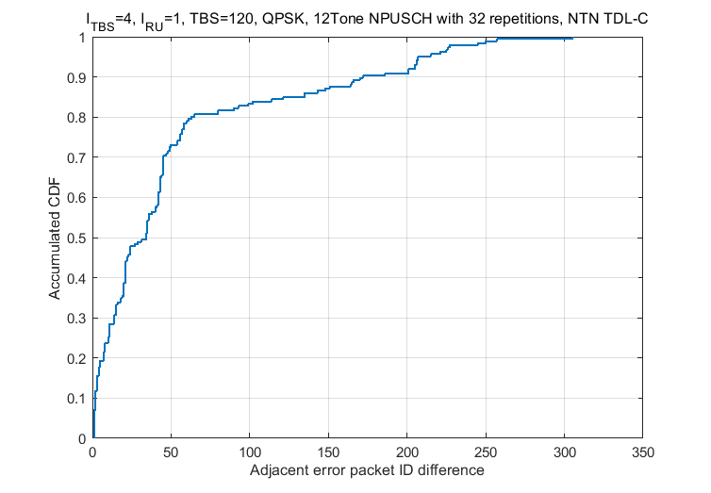
Fig. A.3-1: CDF of Adjacent Error Packet ID Difference for 80ms Voice Packets
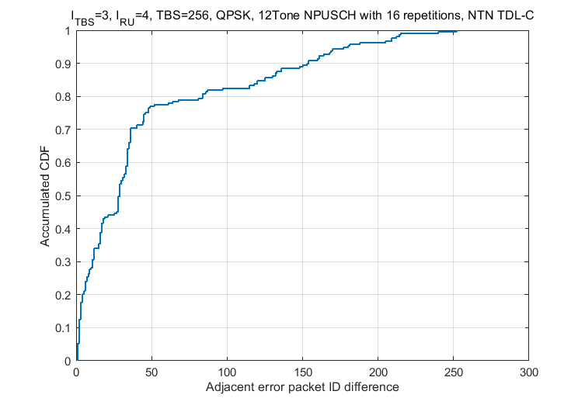
Fig. A.3-2: CDF of Adjacent Error Packet ID Difference for 160ms Voice Packets
It can be observed that the BLER exhibits random occurrence patterns and the adjacent error packet ID difference equal to 1 with low probability, i.e. two consecutive packets occur to error.
These observations strongly support the conclusion that error occurrences in the simulated GEO voice transmission scenarios follow a random pattern rather than a bursty one, which aligns with the characteristics of the NTN TDL-C channel model with its high K-factor and limited multipath components. The block error rate (BLER) in GEO voice transmission exhibits random occurrence patterns, with low probability of consecutive packet errors.
* * * End of Changes * * * *
[1] 3GPP Tdoc SP-250378, "Study on Ultra Low Bitrate Speech Codec"
[2] 3GPP TR 26.132, "Speech and video telephony terminal acoustic test "
[3] 3GPP TS 26.114, "Media handling and interaction"
[4] 3GPP TR 26.940, "Study on Ultra Low Bitrate Speech Codecs"
[5] 3GPP TR 36.321, "Evolved Universal Terrestrial Radio Access (E-UTRA); Medium Access Control (MAC) protocol specification"
[6] 3GPP TS 36.331, "Evolved Universal Terrestrial Radio Access (E-UTRA); Radio Resource Control (RRC); Protocol specification"
[7] https://www.3gpp.org/ftp/TSG_SA/WG4_CODEC/EVS_Permanent_Documents/EVS-7c_S4-141392.zip

