3GPP TSG-SA4 Meeting #130 S4-242260r01

Orlando, United States, 18th Nov 2024 - 22nd Nov 2024 revision of S4-242260
CR-Form-v12.3
CHANGE REQUEST
 | 26.804 | CR | 0024 | rev | 1 | Current version: | 18.1.0
For HELP on using this form: comprehensive instructions can be found at
http://www.3gpp.org/Change-Requests.

Proposed change affects: | UICC apps |  | ME | X | Radio Access Network |  | Core Network | X

Title: | [FS_AMD] Advanced Media Delivery Features for 5G Media Streaming
Source to WG: | Qualcomm Incorporated, BBC, Dolby France SAS, Huawei Technologies Co Ltd., Xiaomi, Comcast, Orange, XGN, Ericsson LM, Tencent, ATEME, Samsung Electronics Co. Ltd.
Source to TSG: | S4
Work item code: | FS_AMD |  |  |  |  |  | Date: |  |  | 2024-11-26
Category: | B |  |  |  |  |  | Release: |  |  | Rel-19
 | Use one of the following categories:  F (correction)  A (mirror corresponding to a change in an earlier release)  B (addition of feature),  C (functional modification of feature)  D (editorial modification)  Detailed explanations of the above categories can  be found in 3GPP TR 21.900. |  |  |  |  |  |  |  | Use one of the following releases:  Rel-8 (Release 8)  Rel-9 (Release 9)  Rel-10 (Release 10)  Rel-11 (Release 11)  …  Rel-17 (Release 17)  Rel-18 (Release 18)  Rel-19 (Release 19)  Rel-20 (Release 20)
Reason for change: |  | - Common Client Metadata: While 3GPP and MPEG in DASH support DASH metrics, the reporting is not common to any player, for example all DASH players as well as HLS players. As an example, CTA WAVE has developed: CTA-5004: Web Application Video Ecosystem Common-Media-Client-Data (CMCD) with an excellent overview here: https://ottverse.com/common-media-client-data-cmcd/. It is worthwhile to study the benefits of integrating commonly supported metrics and client data reporting in 5GMS workflows. The focus is the integration of already defined metrics rather than developing new metrics. Examples of study include support of specific metric keys, player APIs, sending options from client to server (user plane, M5 reference point, EVEX), M3 reference point impact, as well as usage of the data in operations. A study of creating a common harmonized reporting framework and studying the interaction of different frameworks may be included. For details see S4-242156, 26804-0015rev9  - Common Server-and Network-Assisted Streaming: MPEG-DASH supports Server and Network Assisted DASH (SAND). Certain profiles of SAND were adopted in TS 26.247, but the industry has generalized the concepts in SAND in efforts such as Content Steering (see ETSI TS 103 998), Web Application Video Ecosystem (WAVE) specification for Common Media Server Data (CMSD), or Addressable Resource Index (ARI) Tracks in MPEG. The study and integration of these technologies into the Media Delivery System and MBS/MBMS workflows is of significant interest, in particular also in combination with existing QoS mechanisms. For details see S4-242168, 26804-0009rev6  - Multi-CDN and Multi-Access Media Delivery: Content distributors often use multiple Content Delivery Networks (CDNs) to distribute their content to tend-users. As an example, they may upload a copy of their catalogue to each CDN, or more commonly have all CDNs pull the content from a common origin. In advanced deployments, technologies such as Coded Multisource Media Format (CMMF) use Application Layer FEC techniques to stripe different subsets of content across multiple CDNs. Different client implementations may then beneficially use the content on multiple CDNs, potentially guided by the service or network provider. In addition, formats and techniques for generating content for multiple CDN delivery such as MPEG-DASH Part 9 (ReAP) may be taken into account. Further extensions include the ability for a client to use multiple access networks at the same time to support media delivery. Study of integration of different technologies into the Media Delivery System is of relevance to address content provisioning, content hosting, impacts on user plane reference points M2 and M4, and on media session handling at reference point M5 as well as potential benefits in terms of quality and resource usage. For details see S4-242235, 26804-0006rev24 and S4-242242, 26804-0013rev10  - Modem Usage Optimized Media Streaming: In Rel-18, basic support for Background Data Transfer is added. UE power resources are constrained, and media delivery typically also results in power consumption if the radio is always connected. In order to better support streaming services, requests and access to the modem and the resources should be well balanced. Enhancements to Background Data Transfer to support preload as well as functionality of what is defined in W3C Managed Media Source Extension to minimize active network connections are relevant topics to study with the aim of limiting battery consumption in the UE resulting from media delivery. For details see S4-242167, 26804-0010rev6  - DRM and Conditional Access: DRM and Conditional Access are commonly used by third-party streaming services. However, in case streaming is done through MBS or MBMS, a more careful management of the keys needs to be checked. Scalability of key delivery is an issue. The support for -encrypted content in Unicast/Multicast and Broadcast is relevant. Integration of Content Protection interfaces in the provisioning, for example using CPIX back-end interfaces is of high relevance for the industry and should accordingly be studied. The impacts of these on media plane (reference points M2 and M4) as well as the media session handling APIs (reference points M3, M5) should also be studied. For details see S4-242228, 26804-0016rev9  - DASH/HLS Interoperability: DASH/HLS interoperability is a key issue to support highly scalable distribution systems for CDN-based distribution as well as for MBS/MBMS distribution. Offering common CMAF segments that can be consumed by both DASH and HLS media players promises to address these issues. However, detailed nuances need to be identified to ensure optimized delivery and CTA WAVE has provided detailed guidelines in CTA-5005-A to support this matter. Studying these guidelines and understanding the impacts on the 5GMS System as well as MBS/MBMS distribution is of relevance. In addition, formats and techniques supporting DASH/HLS interoperability such as MPEG-DASH part 9 (ReAP) may be taken into account. For details see S4-242166, 26804-0011rev7  - Improved QoS support: In Rel-18, SA2 has defined a number of new features in the 5G System, especially in the PCF, from which media delivery may benefit. Examples documented in TS 23.501 include the use of Explicit Congestion Notification (ECN) to support Low Latency, Low Loss, Scalable Throughput (L4S) services (clause 5.37.3), PDU Set handling (clause 5.37.5) and QoS Monitoring (clause 5.45), and there are likely others. The impact and usefulness of selected features is preferably studied. The functions identified in this context may be studied in one or more of the above work topicsS4-242241, 26804-0007rev11  - Impacts and opportunities of QUIC for segmented content delivery: Since the finalisation of the QUIC protocol by the IETF in May 2021, there has been significant deployments of QUIC driven by the usage of HTTP/3 for streaming services. In the IETF, the working group on Media Over QUIC (MOQ) is working towards an extensible protocol for publishing media for ingest and distribution. While QUIC is mostly used today as the underlying protocol of HTTP/3, there is still open questions as to how media segments are delivered over QUIC streams when using HTTP/3 but also considering other QUIC-based protocols such as MOQ. Considering different types of media application, e.g. multi-stream use cases, will be of interest. Studying the various strategies for delivering segmented content over QUIC streams will also bring insights for the network management aspects. For instance, findings in this domain may be relevant to WT#2.1 in the ongoing study in SA2 called FS_XRM_Ph2 (SP-231671) whose deliverable is available as TR 23.700-70. For details see S4-242171, 26804-0012rev3 and S4-242163, 26804-0019rev8  - Dynamic Content Generation from multiple sources: Introduce the key issue of dynamic content generation in redundant workflows that is common in the media industry. There are some benefits in deploying this closer to the user in the mobile network. For details see S4-242214, 26804-0017rev5  - An LS from 5G-MAG was received on potential future study topics related to usage of uplink streaming for media production and contribution in S4-242056.  - Conclusions are needed to identify normative work. For details see S4-242131, 26804-0022rev1  - Editorial Updates and corrections
Summary of change: |  | Addresses the work item objectives for this key issue  - Documents the key issue in more detail, in particular how they relate to the 3GPP Media Delivery architecture and/or the MBS User Service architecture  - Studies collaboration scenarios between the Application Service Provider and the 5G System and for each of the key topics.  - Based on existing architectures, provides one or more deployment architectures that address the key topics and the collaboration models.  - Maps the key topics to basic functions and develop high-level call flows.  - Identifies the issues that need to be solved.  - Provides candidate solutions including call flows, protocols and APIs for each of the identified issues.  Identifies gaps and recommend potential normative work for stage-2 and stage-3, including which existing specifications would be impacted and/or if any new specifications would preferably be developed.
Consequences if not approved:
Clauses affected: |  | 2, 3.3, 5.2.4.1, 5.2.5, 5.2.6.2, 5.2.7.2, 5.4, 5.4.1.1, 5.4.2.3, 5.4.3.4, 5.4.5.2, 5.4.5.4, 5.4.5.5, 5.4.6.1, 5.5.2, 5.5.2.7, 5.5.3, 5.5.4.4, 5.5.5.2.4, 5.5.6a (new), 5.5.7, 5.7.3, 5.7.4, 5.7.5, 5.7.6, 5.9.4, 5.9.5, 5.9.6.3, 5.10, 5.10.1, 5.10.2, 5.10.3, 5.10.4, 5.10.5, 5.10.6, 5.12.1.2, 5.12.2, 5.12.3, 5.12.4, 5.15 (new), 5.16 (new), 5.17 (new), 5.18 (new), 5.19 (new), 5.20 (new), 5.21 (new), 5.22 (new) 5.23 (new), 5.24 (new), 5.25 (new), 5.26 (new), 6.1, 6.4, 6.5, 6.8, 6.10, 6.15 (new), 6.16 (new), 6.17 (new), 6.18 (new), 6.19 (new), 6.20 (new), 6.21 (new), 6.22 (new) 6.23 (new), 6.24 (new), 6.25 (new), 6.26 (new), 7, 7.1, 7.2, 7.3 (new), A.1, A.1.0, A.1.1, A.1.2, Annex B (new)
 |  | Y | N
Other specs |  |  | X | Other core specifications |  |  |  | TS/TR ... CR ...
affected: |  |  | X | Test specifications |  |  |  | TS/TR ... CR ...
(show related CRs) |  |  | X | O&M Specifications |  |  |  | TS/TR ... CR ...
Other comments: |  | This CR merges the agreed CRs  - S4-242156, 26804-0015rev9  - S4-242168, 26804-0009rev6  - S4-242235, 26804-0006rev24  - S4-242242, 26804-0013rev10  - S4-242167, 26804-0010rev6  - S4-242228, 26804-0016rev9  - S4-242166, 26804-0011rev7  - S4-242241, 26804-0007rev11  - S4-242171, 26804-0012rev3  - S4-242163, 26804-0019rev8  - S4-242214, 26804-0017rev5  - S4-242131, 26804-0022rev1  - [S4-241884, 26804-0017rev3]  - [S4-242153 (pp) 26501-0098rev3]
This CR's revision history:

===== CHANGE =====

===== CHANGE =====

2 References
The following documents contain provisions which, through reference in this text, constitute provisions of the present document.
- References are either specific (identified by date of publication, edition number, version number, etc.) or non-specific.
- For a specific reference, subsequent revisions do not apply.
- For a non-specific reference, the latest version applies. In the case of a reference to a 3GPP document (including a GSM document), a non-specific reference implicitly refers to the latest version of that document in the same Release as the present document.
[1] 3GPP TR 21.905: "Vocabulary for 3GPP Specifications".
[2] Akamai Blog, “A QUICk Introduction to HTTP/3”, April 2020, https://www.akamai.com/blog/developers/a-quick-introduction-http3

[3] IETF RFC 9112: "HTTP/1.1", June 2022.
[4] IETF RFC 9113: "HTTP/2", June 2022.
[5] IETF RFC 9114: "HTTP/3", June 2022.
[6] D. Bhat, A. Rizk, and M. Zink, "Not so QUIC: A Performance Study of DASH over QUIC," NOSSDAV'17: Proceedings of the 27th Workshop on Network and Operating Systems Support for Digital Audio and VideoJune 2017 Pages 13–18 https://doi.org/10.1145/3083165.3083175
[7] AWS: "Achieving Great Video Quality Without Breaking the Bank", Streaming Media June 2019, https://pages.awscloud.com/rs/112-TZM-766/images/GEN elemental-wp-achieving-great-video-quality-without-breaking-the-bank.pdf
[8] Netflix, "Optimized shot-based encodes: Now Streaming!", Netflix Blog, May 2018, https://netflixtechblog.com/optimized-shot-based-encodes-now-streaming-4b9464204830
[9] DASH-IF/DVB: "Report on Low-Latency Live Service with DASH", July 2017, available here: https://dash-industry-forum.github.io/docs/Report%20on%20Low%20Latency%20DASH.pdf
[10] DASH-IF: "IOP Guidelines v5, Low-latency Modes for DASH", available here: https://dash-industry-forum.github.io/docs/CR-Low-Latency-Live-r8.pdf
[11] ISO/IEC 23009-1: "Information technology — Dynamic adaptive streaming over HTTP (DASH) — Part 1: Media presentation description and segment formats".
[12] IETF RFC 8673: "HTTP Random Access and Live Content".
[13] 3GPP TR 26.939: "Guidelines on the Framework for Live Uplink Streaming (FLUS)".
[14] 3GPP TS 26.238: "Uplink Streaming".
[15] 3GPP TS 26.501: "5G Media Streaming (5GMS); General description and architecture".
[16] 3GPP TS 26.512: "5G Media Streaming (5GMS); Protocols".
[17] ISO/IEC 13818-1:2019: "Information technology — Generic coding of moving pictures and associated audio information — Part 1: Systems".
[18] SCTE 35 2020: "Digital Program Insertion Cueing Message", https://www.scte.org/pdf-redirect/?url=https://scte-cms-resource-storage.s3.amazonaws.com/SCTE-35-2020_notice-1609861286512.pdf
[19] ISO/IEC 23000-19: "Information technology — Multimedia application format (MPEG-A) —Part 19: Common media application format (CMAF) for segmented media".
[20] ISO/IEC 23009-1:2019/DAMD1: "Information technology — Dynamic adaptive streaming over HTTP (DASH) — Part 1: Media presentation description and segment formats — Amendment 1: CMAF support, events processing model and other extensions".
[21] VSF TR-06-01:2020, "RIST Simple Profile", https://vsf.tv/download/technical_recommendations/VSF_TR-06-1_2020_06_25.pdf
[22] VSF TR-06-02: "RIST Main Profile", https://www.videoservicesforum.org/download/technical_recommendations/VSF_TR-06-2_2020_03_24.pdf
[23] 3GPP TS 23.501: "System architecture for the 5G System (5GS)".
[24] 3GPP TS 23.502: "Procedures for the 5G System (5GS)".
[25] 3GPP TS 29.517: "5G System; Application Function Event Exposure Service; Stage 3".
[26] 3GPP TS 29.244: "Interface between the Control Plane and the User Plane nodes; Stage 3".
[27] IETF RFC 6733: "Diameter Base Protocol".
[28] 3GPP TS 29.514: "5G System; Policy and Charging Control over Rx reference point; Stage 3".
[29] IETF RFC 7657: "Differentiated Services (Diffserv) and Real-Time Communication", November 1995.
[30] IETF RFC 3168: "The Addition of Explicit Congestion Notification (ECN) to IP", September 2001.
[31] IETF RFC 9204: "QPACK: Field Compression for HTTP/3", June 2022.
[32] IETF RFC 9000: "QUIC: A UDP-Based Multiplexed and Secure Transport", May 2021.
[33] IETF RFC 9001: "Using TLS to Secure QUIC", May 2021.
[34] IETF RFC 9002: "QUIC Loss Detection and Congestion Control", May 2021.
[35] IETF RFC 5681: "TCP Congestion Control", September 2009.
[36] M. Kuehlewind and B. Trammell, draft-ietf-quic-manageability-11, "Manageability of the QUIC Transport Protocol", Work in Progress, Internet-Draft, 30 June 2021.
[37] N. Cardwell et. al. "BBR Updates: Internal Deployment, Code, Draft Plans", 9 March 2021, https://datatracker.ietf.org/meeting/110/materials/slides-110-iccrg-bbr-updates-00.pdf
[38] ETSI TS 103 799: "Publicly Available Specification (PAS); DASH-IF Content Protection Information Exchange Format".
[39] ISO/IEC JTC1/SC29/WG11/N19062 23090-8 FDIS: "MPEG-I: Network-based Media Processing — Network-Based Media Processing Specification".
[40] 3GPP TS 26.247: "Transparent end-to-end Packet-switched Streaming Service (PSS); Progressive Download and Dynamic Adaptive Streaming over HTTP (3GP-DASH)".[41] 3GPP TS 23.503: "Policy and charging control framework for the 5G System (5GS); Stage 2".
[42] 3GPP TS 29.514: "5G System; Policy Authorization Service; Stage 3".
[43] 3GPP TS 29.522: "5G System; Network Exposure Function Northbound APIs; Stage 3".
[44] 3GPP TS 29.122: "T8 reference point for Northbound APIs".
[45] 3GPP TS 29.512: "5G System; Session Management Policy Control Service; Stage 3".
[46] 3GPP TS 26.803: "5G Media Streaming (5GMS); Architecture extensions".
[47] 3GPP TS 23.558: "Architecture for enabling Edge Applications (EA)".
[48] 3GPP TS 23.288: "Architecture enhancements for 5G System (5GS) to support network data analytics services".
[49] Tdoc S4-210723: "Generic architecture for data collection and reporting", submission from BBC, Dolby Laboratories Inc., LM Ericsson and Qualcomm Incorporated to SA4#114-e, May 19-28, 2021.
[50] Tdoc S2-2103267: "Extension of Naf_EventExposure for observed service experience data collection from UEs", CR from InterDigital to SA2#144e, Apr 12-16, 2021.
[51] 3GPP TS 26.114: "IP Multimedia Subsystem (IMS); Multimedia telephony; Media handling and interaction".
[52] Tdoc S2-2104496: "Extension of Naf_EventExposure for observed service experience data collection from UEs", CR from Qualcomm Incorporated to SA2#145e, May 17-28, 2021.
[53] 3GPP TS 26.118: "Virtual Reality (VR) profiles for streaming applications".
[54] 3GPP TS 26.346: "Multimedia Broadcast/Multicast Service (MBMS); Protocols and codecs".
[55] 3GPP TS 29.554: "Background Data Transfer Policy Control Service; Stage 3".
[56] 3GPP TS 28.530: "Management and orchestration; Concepts, use cases and requirements".
[57] 3GPP TS 28.531: "Management and orchestration; Provisioning".
[58] 3GPP TS 28.532: "Management and orchestration; Generic management services".
[59] 3GPP TS 28.533: "Management and orchestration; Architecture framework".
[60] 3GPP TS 28.540: "Management and orchestration; 5G Network Resource Model (NRM); Stage 1".
[61] 3GPP TS 28.541: "Management and orchestration; 5G Network Resource Model (NRM); Stage 2 and stage 3".
[62] 3GPP TS 28.542: "Management and orchestration of networks and network slicing; 5G Core Network (5GC) Network Resource Model (NRM); Stage 1".
[63] 3GPP TS 28.543: "Management and orchestration of networks and network slicing; 5G Core Network (5GC) Network Resource Model (NRM); Stage 2 and stage 3".
[64] 3GPP TS 28.545: "Management and orchestration; Fault Supervision (FS)".
[65] 3GPP TS 28.546: "Management and orchestration of networks and network slicing; Fault Supervision (FS); Stage 2 and stage 3".
[66] 3GPP TS 28.552: "Management and orchestration; 5G performance measurements".
[67] 3GPP TS 28.554: "Management and orchestration; 5G end to end Key Performance Indicators (KPI)".
[68] 3GPP TS 23.434: " Service Enabler Architecture Layer for Verticals (SEAL); Functional architecture and information flows ".
[69] 3GPP TS 23.700-99: " Study in Network slice capability exposure for application layer enablement (NSCALE)".
[70] 3GPP TS 29.520: " 5G System; Network Data Analytics Services; Stage 3".
[71] 3GPP TR 23.700-40: "Study on enhancement of network slicing; Phase 2".
[72] 3GPP TS 26.531: “Data Collection and Reporting; General Description and Architecture”.
[73] 3GPP TR 26.802: "Multicast Architecture Enhancement for 5G Media Streaming".
[74] IETF RFC 822: "STANDARD FOR THE FORMAT OF ARPA INTERNET TEXT MESSAGES", August 13, 1982.
[75] IETF RFC 1521: "MIME (Multipurpose Internet Mail Extensions)", September 1993.
[76] IETF RFC 2474: "Definition of the Differentiated Services Field (DS Field) in the IPv4 and IPv6 Headers", December 1998.
[77] IETF RFC 2475: "An Architecture for Differentiated Services", December 1998.
[78] IETF RFC 3246: "An Expedited Forwarding PHB (Per-Hop Behavior)", March 2002.
[79] IETF RFC 2597: "Assured Forwarding PHB Group", June 1999.
[80] S. Hurst, draft-hurst-quic-rtp-tunnelling: "QRT: QUIC RTP Tunnelling", Internet-Draft, Work in Progress.
[81] J. Ott and M. Engelbart, draft-engelbart-rtp-over-quic: "RTP over QUIC", Internet-Draft, Work in Progress.
[82] SRT Alliance, “Secure Reliable Transport (SRT) Protocol”, https://github.com/Haivision/srt
[83] M.P. Sharabayko and M.A. Sharabayko, draft-sharabayko-srt-over-quic-00 ,“Tunnelling SRT over QUIC”, Internet-Draft, Work in Progress, 28 July 2021.
[84] Robin Marx, Luca Niccolini, Marten Seemann, Lucas Pardue, draft-ietf-quic-qlog-main-schema-09, "Main logging schema for qlog", Internet-Draft, Work in Progress, 8 July 2024.
[85] Robin Marx, Luca Niccolini, Marten Seemann, Lucas Pardue, draft-ietf-quic-qlog-h3-events-08, "HTTP/3 and QPACK event definitions for qlog", Internet-Draft, Work in Progress, 8 July 2024.
[86] Robin Marx, Luca Niccolini, Marten Seemann, Lucas Pardue, draft-ietf-quic-qlog-quic-events-08, "QUIC event definitions for qlog", Internet-Draft, Work in Progress, 8 July 2024.
[87] Roger Pantos and William May, Jr., "HTTP Live Streaming", RFC 8216, August 2017.
[88] 3GPP TR 26.925: "Typical traffic characteristics of media services on 3GPP networks".
[89] 3GPP TR 26.917: "Multimedia Broadcast Multicast Services (MBMS) and Packet-switchedStreaming Service (PSS) enhancements to support television services".
[90] "DASH-IF WebRTC-based Streaming", https://dashif.org/news/webrtc/
[91] IETF RFC 6749: "The OAuth 2.0 Authorization Framework".
[92] IETF RFC 6750: "The OAuth 2.0 Authorization Framework: Bearer Token Usage".
[93] 3GPP TS 33.501: "Security architecture and procedures for 5G System".
[94] 3GPP TS 26.531: "Data Collection and Reporting; General Description and Architecture".
[95] 3GPP TS 26.532: "Data Collection and Reporting; Protocols and Formats".
[96] 3GPP TS 26.511: "5G Media Streaming (5GMS); Profiles, codecs and formats".
[97] ETSI TS 103 770: "Digital Video Broadcasting (DVB); Service Discovery and Programme Metadata for DVB-I".
[98] Android Developer Documentation: "Handling Android App Links",
https://developer.android.com/training/app-links
[99] 3GPP TS 26.347: "Multimedia Broadcast/Multicast Service (MBMS); Application Programming Interface and URL".
[100] ETSI TS 103 769: "Digital Video Broadcasting (DVB); Adaptive media streaming over IP multicast".
[101] 3GPP TS 23.247: "Architectural enhancements for 5G multicast-broadcast services".
[102] 3GPP TS 29.558: "Enabling Edge Applications; Application Programming Interface (API) specification; Stage 3".
[103] IETF RFC 2045: "Multipurpose Internet Mail Extensions Part One: Format of Internet Message Bodies".
[104] IETF RFC 3986: "Uniform Resource Identifier (URI): Generic Syntax", January 2005.
[105] Consumer Technology Association Specification CTA-5004: "Web Application Video Ecosystem – Common Media Client Data", September 2020.
[106] 3GPP TS 26.531: "Data Collection and Reporting; General Description and Architecture".
[107] 3GPP TS 26.532: "Data Collection and Reporting; Protocols and Formats".
[108] 3GPP TS 26.510: "Media delivery: Interactions and APIs for provisioning and media session handling (Release 18)".
[109] 3GPP TS 26.247: "Transparent end-to-end Packet-switched Streaming Service (PSS); Progressive Download and Dynamic Adaptive Streaming over HTTP (3GP-DASH)".
[110] 3GPP TS 29.591: "Network Exposure Function Southbound Services; Stage 3 (Release 18)".
[111] ETSI TS 103 998: "DASH-IF: Content steering for DASH".
[112] Draft Text of ISO/IEC FDIS 23009-9: "Information technology - Dynamic adaptive streaming over HTTP (DASH) – Part 9: Redundant Encoding and Packaging for segmented live media (REaP)", ISO/IEC JTC 1/SC 29/WG 3 NO 1165, Jan. 26, 2024. [Online]. Available: https://www.mpeg.org/standards/MPEG-DASH/9/
[113] Emma Roth, "A popular open-source content delivery network went down for hours", The Verge, Apr. 12, 2024. [Online]. Available: https://www.theverge.com/2024/4/12/24128276/open-source-unpkg-cdn-down (accessed May 9, 2024).
[114] Sebastian Moss, "Cloudflare recovers from service outage after power failure at core North American data center", Data Center Dynamics, Nov. 3, 2023. [Online]. Available: https://www.datacenterdynamics.com/en/news/cloudflare-recovers-from-service-outage-after-power-failure-at-core-north-american-data-center/ (accessed May 9, 2024).
[115] Brian Barrett, "How an Obscure Company Took Down Big Chunks of the Internet", Wired, Jun. 8, 2021. [Online]. Available: https://www.wired.com/story/fastly-cdn-internet-outages-2021/ (accessed May 9, 2024).
[116] Josh Fomon, "CDN Provider Akamai Takes Down Popular Internet Services During Outage", Ookla, Jul. 22, 2021. [Online]. Available: https://www.ookla.com/articles/akamai-outage-july-22-2021 (accessed May 9, 2024).
[117] Charlotte Trueman, "Cloudflare outage brings hundreds of sites, services temporarily offline", Computer World, Jun. 21, 2022. [Online]. Available: https://www.computerworld.com/article/1627967/cloudflare-outage-brings-hundreds-of-sites-services-temporarily-offline.html (accessed May 9, 2024).
[118] Jim Salter, "The Internet broke today: Facebook, Verizon, and more see major outages", Ars Technica, Jul. 3, 2019. [Online]. Available: https://arstechnica.com/information-technology/2019/07/facebook-cloudflare-microsoft-and-twitter-suffer-outages/ (accessed May 9, 2024).
[119] Marc Hoppner, "A content owner, a CDN and a player walk into a bar", (Jan. 6, 2023). Accessed: May 9, 2024. [Online Video]. Available: https://www.youtube.com/watch?v=S9EdoQFOQ9I&list
=PLkyaYNWEKcOf98lZxnCcL6y7ZIVU3oSYO&index=12
[120] Guillaume du Pantavice, "Improving streaming experience with Bayesian optimization, from AB to AZ test", (Dec. 25, 2021). Accessed: May 9, 2024. [Online Video]. Available: https://www.youtube.com/
watch?v=t4nRrLygVwo&list=PLkyaYNWEKcOfD1GYFxFbZXDP03XM-cZPg&index=19
[121] E. Ghabashneh and S. Rao, "Exploring the interplay between CDN caching and video streaming performance", IEEE INFOCOM 2020 – IEEE Conference on Computer Communications, Toronto, ON, Canada, 2020, pp. 516-525.
[122] K. Vermeulen, L. Salamatian, S. H. Kim, M. Calder, and E. Katz-Bassett, "The central problem with distributed content: common CDN deployments centralize traffic in a risky way", In Proceedings of the 22nd ACM Workshop on Hot Topics in Networks (HotNets ’23). Association for Computing Machinery, New York, NY, USA, 70-78.
[123] A. Bentaleb, R. Farahani, F. Tashtarian, C. Timmerer, H. Hellwagner, and R. Zimmermann, "Which CDN to Download From? A Client and Server Strategies", (Jan. 6, 2024). Accessed: May 9, 2024. [Online Video]. Available: https://www.youtube.com/watch?v=xCZmCnWgQRE
[124] Will Law, "Content steering with MPEG DASH", (May 4, 2023). Accessed: May 9, 2024. [Online Video]. Available: https://www.youtube.com/watch?v=o9Pa5y-Usxw
[125] W. Law and Y. Reznik, "DASH content steering at scale", Media Web Symposium (MWS’23), June 2023.
[126] ETSI TS 103 973: "Coded multisource media format (CMMF) for content distribution and delivery".
[127] IETF RFC 6330: "RaptorQ forward error correction scheme for object delivery", August 2011.
[128] IETF RFC 5110: "Reed-Solomon forward error correction (FEC) schemes", April 2009.
[129] ETSI TS 103 285: "Digital Video Broadcasting (DVB); MPEG-DASH Profile for Transport of ISO BMFF Based DVB Services over IP Based Networks".
[130] ISO/IEC 26090-8:2020: "Information technology – Coded representation of immersive media, Part 8: Network based media processing".
[131] IETF RFC 5052: "Forward Error Correction (FEC) Building Block", August 2007.
[132] IETF RFC 5053: "Raptor Forward Error Correction Scheme for Object Delivery", October 2007.
[133] IETF RFC 6726: "FLUTE - File Delivery over Unidirectional Transport," November 2012.
[134] : "TCP Extensions for Multipath Operation with Multiple Addresses", March 2022.
[135] 3GPP TS 26.502: "5G multicast-broadcast services; User service architecture (Release 18)".
[136] Q. De Coninck, O. Bonaventure, C. Huitema, M. Kuehlewind, draft-ietf-quic-multipath-10, "Multipath Extension for QUIC", July 2024.
[137] IETF RFC 6897: "Multipath TCP (MPTCP) Application Interface Considerations", March 2013
[138] IETF Draft: "Multipath Extension for QUIC", draft-ietf-quic-multipath-10, July 2024
[139] Media Source Extension, W3C Working Draft 01, April 2024,
https://www.w3.org/TR/media-source-2/
[140] Movie labs: "Specification for Enhanced Content Protection", available at: https://movielabs.com/ngvideo/MovieLabs_ECP_v1.4.pdf.
[141] W3C: "Encrypted Media Extensions", available at: https://www.w3.org/TR/encrypted-media-2/
[142] Akamai: "Welcome to Adaptive Media Delivery", in Adaptive Media Delivery Implementation Guide, available at: https://learn.akamai.com/en-us/webhelp/adaptive-media-delivery/adaptive-media-delivery-implementation-guide/GUID-3F89E64C-415D-452D-9541-BB650CD783B9.html
[143] ETSI TS 103 799: "Content Protection Information Exchange Format (CPIX)".
[144] DASH-IF: "Interoperability Points; Part6-v5.0.0: Content protection and security".
[145] ETSI TS 104 002: "DASH-IF Forensic A/B Watermarking".
[146] DASH Industry Forum: "DASH-IF Live Media Ingest Protocol v1.2", February 2024,
https://dashif-documents.azurewebsites.net/Ingest/master/DASH-IF-Ingest.pdf
[147] Consumer Technology Association CTA-5005-A: "Web Application Video Ecosystem – DASH-HLS Interoperability Specification",
https://shop.cta.tech/products/web-application-video-ecosystem-dash-hls-interoperability-specification-cta-5005-a
[148] ISO/IEC 23001-7: "Information technology — MPEG systems technologies Part 7: Common encryption in ISO base media file format files".
[149] IETF RFC 9330:"Low Latency, Low Loss, Scalable Throughput (L4S) Internet Service: Architecture".
[150] IETF RFC 9331: "Explicit Congestion Notification (ECN) Protocol for Very Low Queuing Delay (L4S)", January 2023.
[151] IETF RFC 9332: "Dual-Queue Coupled Active Queue Management (AQM) for Low Latency, Low Loss, and Scalable Throughput (L4S)", January 2023.
[152] 3GPP TS 38.300: "NR; NR and NG-RAN Overall Description".
[153] 3GPP TS 26.522: "5G Real-time Media Transport Protocol Configurations".
[154] Apple Developer Documentation, nw_ip_metadata_get_ecn_flag(_:) | Apple Developer Documentation
[155] IETF RFC 3168: "The Addition of Explicit Congestion Notification (ECN) to IP".
[156] 3GPP TS 29.122: "T8 reference point for Northbound APIs".

[157] Belson, D. and Pardue L.: "Examining HTTP/3 usage one year on", June 2023
https://blog.cloudflare.com/http3-usage-one-year-on
[158] IETF RFC 5321: “Simple Mail Transfer Protocol”, October 2008.
[159] HTTP Archive: State of the Web, https://httparchive.org/reports/state-of-the-web#h3
[160] W3C Working Draft: "WebTransport", May 2024, https://www.w3.org/TR/webtransport
[161] A. Frindell, E. Kinnear, V. Vasiliev: "WebTransport over HTTP/3", Work In Progress, Internet Draft, draft-ietf-webtrans-http3, https://datatracker.ietf.org/doc/html/draft-ietf-webtrans-http3/
[162] IETF RFC 9297: "HTTP Datagrams and the Capsule Protocol", August 2022.
[163] IETF RFC 9221: "An Unreliable Datagram Extension to QUIC", March 2022.
[164] IETF RFC 9218: "Extensible Prioritization Scheme for HTTP", June 2022.
[165] ISO/IEC 23009-6: "Information technology — Dynamic adaptive streaming over HTTP (DASH) — Part 6: DASH with server push and WebSockets".
[166] L. Curly, K. Pugin, S. Nandakumar, V. Vasiliev, I. Swett: "Media over QUIC Transport", Work In Progress, Internet Draft, draft-ietf-moq-transport, https://datatracker.ietf.org/doc/draft-ietf-moq-transport/07/
[167] S. Nandakumar, W. Law, M. Zanaty: "Common Catalog Format for moq-transport", Work In Progress, Internet Draft, draft-ietf-moq-catalogformat, https://datatracker.ietf.org/doc/draft-ietf-moq-catalogformat/01/
[168] Zhang, X., Jin, S., He, Y., Hassan, A., Mao, Z. M., Qian, F., & Zhang, Z. L., "QUIC is not Quick Enough over Fast Internet", in Proceedings of the ACM on Web Conference 2024 (pp. 2713–2722), May 2024.
[169] Nguyen, M., Nys, P., Pham, S., Silhavy, D., Arbanowski, S., & Steglich, S., "Toward WebTransport Support in HTTP Adaptive Streaming", in Tenth International Conference on Communications and Electronics 2024 (ICCE) (pp. 96–101), IEEE, July 2024.
[170] Roberto Ramos-Chavez, Espen Braastad, Jamie Fletcher, and Arjen Wagenaar. 2024. Standards based OTT A/B Watermarking at Scale. In Proceedings of the 3rd Mile-High Video Conference (MHV '24). Association for Computing Machinery, New York, NY, USA, 94. https://doi.org/10.1145/3638036.3640251
[171] 3GPP TS 26.506: "5g Real-time Media Communication Architecture (Stage 2)".
[172] Media Source Extension, W3C Editor's Draft 26, October 2023,
https://jyavenard.github.io/media-source/media-source-respec.html#dfn-endstreaming
[173] 5G-MAG Report: "Uplink media delivery: Architectures & Features", available in https://www.5g-mag.com/post/uplink-media-delivery-architectures-features
[174] 3GPP TS 26.113: "Real-Time Media Communication; Protocols and APIs".
[175] Chaudhary, Sapna, Mukulika Maity, Sandip Chakraborty, and Naval Shukla. "A dataset for analyzing streaming media performance over HTTP/3 browsers."Advances in Neural Information Processing Systems 36 (2024)
[176] Chaudhary, Sapna, et al. "Managing Connections by QUIC-TCP Racing: A First Look of Streaming Media Performance Over Popular HTTP/3 Browsers." IEEE Transactions on Network and Service Management (2024).
[177] Kazuho Oku, Lucas Pardue Robin Marx, Luca Niccolini, Marten Seemann, draft-kazuho-httpbis-http3-on-streams-00, "HTTP/3 on Streams", Expired Internet-Draft, 19 August 2024.
[178] Chellappa, Sindhu, and Radim Bartos. "Is QUIC Quicker with HTTP/3? An Empirical Analysis of Quality of Experience with DASH Video Streaming."2022 IEEE International Conference on Advanced Networks and Telecommunications Systems (ANTS). IEEE, 2022.

[179] Herbots, Joris, et al. "Cross that boundary: Investigating the feasibility of cross-layer information sharing for enhancing ABR decision logic over QUIC."Proceedings of the 33rd Workshop on Network and Operating System Support for Digital Audio and Video. 2023.

===== CHANGE =====

3.3 Abbreviations
For the purposes of the present document, the abbreviations given in 3GPP TR 21.905 [1] and the following apply. An abbreviation defined in the present document takes precedence over the definition of the same abbreviation, if any, in 3GPP TR 21.905 [1].

ABR Adaptive Bit Rate
ACK ACKnowledgment
ACM Association for Computing Machinery
ALPN Application-Layer Protocol Negotiation
AMF Access and Mobility Management Function
ANBR Access Network Bitrate Recommendation
ANTS Advanced Network Technologies Symposium
API Application Programming Interface
AQM Active Queue Management
ARPA Advanced Research Projects Agency
ARQ Automatic Repeat reQuest
ASP Application Service Provider
ATSSS Access Traffic Steering, Switching, and Splitting
AUS AUthentication Server
AVC Advanced Video Coding
AWS Amazon Web Services
BBC British Broadcasting Corporation
BBR Bottleneck Bandwidth and Round-trip propagation time
BDT Background Data Transfer
BMFF Base Media File Format
BMSC Broadcast/Multicast Service Center
CAE Content-Aware Encoding
CBR Constant Bit Rate
CCF Call Control Function
CDF Cumulative Distribution Function
CDN Content Delivery Network
CDP Content Delivery Protocol
CERN European Organization for Nuclear Research
CIRR Carrier-Independent Routing Registry
CMAF Common Media Application Format
CMAS Commercial Mobile Alert System
CMCD Common Media Client Data
CMMF Coded Multisource Media Format
CMSD Content Media Server Data

CPI Content Protection Information
CPIX Content Protection Information Exchange
CPT Content Preparation Template
CRUD Create, Read, Update, Delete
CTA Consumer Technology Association
CWR Congestion Window Reduced
DANE DASH-Aware Network Element
DASH Dynamic Adaptive Streaming over HTTP
DCSM Data Collection and Storage Management

DNS Domain Name System
DRM Digital Rights Management
DSCP Differentiated Services Code Point
DTT Digital Terrestrial Television
DVB Digital Video Broadcasting
DVR Digital Video Recorder
EAS Edge Application Server
ECE Explicit Congestion Notification
ECN Explicit Congestion Notification
ECP Enhanced Content Protection
ECT Explicit Congestion Notification-Capable Transport
EDGE Enhanced Data rates for GSM Evolution
EDL Enhanced Data Link
EEC Edge-Enabled Client
EEL End-to-End Latency
EES Edge Enabler Server
EFDT Enhanced File Delivery Table
EME Encrypted Media Extensions
ENP Enhanced Network Performance
EPS Evolved Packet System
EPT Enhanced Packet Transport
EVEX EVent EXposure

FAR Forward Action Rule
FDIS Final Draft International Standard
FDT File Delivery Table
FEC Forward Error Correction
FHD Full High Definition
FLUS Framework for Live Uplink Streaming
FLUTE File Delivery over Unidirectional Transport

FQDN Fully Qualified Domain Name
GBR Guaranteed Bit Rate
GRO Generic Receive Offload
GSO Geostationary Satellite Orbit
GTP GPRS Tunneling Protocol
GUID Globally Unique Identifier
HDR High Dynamic Range
HEVC High Efficiency Video Coding
HLS HTTP Live Streaming

HTTP Hypertext Transfer Protocol
HTTPS Hypertext Transfer Protocol Secure
IANA Internet Assigned Numbers Authority
ICCE International Conference on Consumer Electronics
IEC International Electrotechnical Commission
IEEE Institute of Electrical and Electronics Engineers
IETF Internet Engineering Task Force
IMS IP Multimedia Subsystem

IOP Interoperability Points
IPC Inter-Process Communication
IPTV Internet Protocol Television
ISO International Organization for Standardization
JSON JavaScript Object Notation
JTC Joint Technical Committee
KID Key IDentifier
KPI Key Performance Indicator
LPT Low-Power Transceiver
LSD Low-Speed Data
LTE Long-Term Evolution
MABR Multicast Adaptive Bit Rate
MANO Management and Orchestration
MAR Multi-Access Rule

MBMS Multimedia Broadcast Multicast Service
MBS Multicast Broadcast Service
MBSF Multicast Broadcast Service Function
MBSTF Multicast Broadcast Service Transport Function
MHV Mile-High Video
MIME Multipurpose Internet Mail Extensions
MNO Mobile Network Operator
MoQ Media over QUIC
MPD Media Presentation Description
MPEG Moving Picture Experts Group
MPQUIC Multipath QUIC
MPTCP Multipath TCP
MQTT Message Queuing Telemetry Transport
MSE Media Source Extensions

MTSI Multimedia Telephony Service for IMS
NAT Network Address Translation
NBMP Network-Based Media Processing
NEF Network Exposure Function
NFV Network Functions Virtualization
NRF Network Repository Function
NRM Network Resource Model
NSACF Network Slice Admission Control Function
NSCALE Network Slice Capability Exposure
NSSAI Network Slice Selection Assistance Information
NWDAF Network Data Analytics Function
OAM Operations, Administration, and Maintenance
OMA Open Mobile Alliance
OTI Object Transmission Information
OTT Over-The-Top
PAS Publicly Available Specification
PCC Policy and Charging Control
PCF Policy Control Function
PDF Portable Document Format
PDR Packet Detection Rule
PDU Protocol Data Unit
PFCP Packet Forwarding Control Protocol

PFD Packet Flow Description
PFDF Packet Flow Description Function
PFS Packet Flow Set
PHB Per-Hop Behaviour
PING Packet Internet Groper
PLMN Public Land Mobile Network
PSA Public Service Announcement
PSDB Packet Set Delay Budget
PSER Packet Set Error Rate
PSIHI Packet Set Integrated Information
PSNR Peak Signal-to-Noise Ratio
PSS Packet-Switched Streaming
QER QoS Enforcement Rule
QFI QoS Flow Identifier
QLOG QUIC Logging
QoS (Network) Quality of Service
QPACK QUIC Header Compression
QRT QUIC RTP Tunnelling
QUIC Quick UDP Internet Connections
RAN Radio Access Network

RFC Request for Comments
RIST Reliable Internet Stream Transport
RLC Radio Link Control
ROM Receive-Only Mode
RSFEC Reed-Solomon Forward Error Correction
RTC Real-Time Communication
RTCP Real-Time Control Protocol
RTMP Real-Time Messaging Protocol
RTP Real-Time Protocol
RTT (Network) Round-Trip Time
SAND Server and Network Assisted DASH
SAP Service Access Point
SBI Service-Based Interface

SCTE Society of Cable Telecommunications Engineers
SDAP Service Data Adaptation Protocol
SDF Service Data Flow
SEAL Service Enabler Architecture Layer
SEI Supplemental Enhancement Information
SIB System Information Block
SIM Subscriber Identity Module
SLA Service Level Agreement
SMF Session Management Function
SMS Short Message Service
SMTP Simple Mail Transfer Protocol
SRT Secure Reliable Transport

SSD Seek Start-up Delay
SST Slice Selection Type
STS Secure Token Service
SVC Scalable Video Coding
SVTA Streaming Video Technology Alliance

TBD To Be Determined
TCP Transmission Control Protocol
TEE Trusted Execution Environment
TEID Tunnel Endpoint Identifier
TLS Transport Layer Security
TMGI Temporary Mobile Group Identity
TOI Transmission Object Identifier
TSG Technical Specification Group
TSI Transport Stream Identifier

TZM Time Zone Management
UDP User Datagram Protocol
UDR Unified Data Repository
UHD Ultra-High Definition
UMTS Universal Mobile Telecommunications System
UPF User Plane Function
URI Uniform Resource Identifier
URL Uniform Resource Locator
URN Uniform Resource Name
URR Usage Reporting Rule
USIM Universal Subscriber Identity Module
UTC Coordinated Universal Time
UUID Universally Unique Identifier
VBR Variable Bit Rate
VSF Video Services Forum
WAVE Web Application Video Environment
WDD Workflow Description Document
XML Extensible Markup Language

ZSM Zero-touch network and Service Management

===== CHANGE =====

5.2.4.1 Content preparation before downlink streaming
In this collaboration, the 5GMSd Application Provider requests content preparation for its stream before distribution. Figure 5.2.4.1-1 shows such a scenario.
UE
5GMSd
Client
5GMSd
Aware Application
5GMSd AS
External DN
5GMSd
Application Provider
M1d
M2d
Trusted DN
M4d
5GMSd AF
M5d
PCF
M8d
N5
Figure 5.2.4.1-1: Content preparation before downlink streaming
In this case:
1. The Application Provider defines the required content preparation and requests the 5GMSd AF to create the process using the Content Preparation Template (CPT) through M1d.
2. The 5GMSd AF configures the 5GMSd AS according to the media transformation(s) specified in the Content Preparation Template (M3d) and responds to the Application Provider (M1d).
3. The media is streamed from Application Provider to 5GMSd AS (M2d).
4. The content is transformed by 5GMSd AS according to the Content Preparation Template and provided for distributions (M4d).
5. The Application Provider may update, retrieve, or destroy the Content Preparation Template using M1d.
NOTE: How does DistributionConfiguration relate to CPT? Does the CPT define the initial/generic formats (such as HLS and DASH) and DistributionConfiguration defines a subset of it for distribution?

===== CHANGE =====

5.2.5 Deployment architectures

This aspect is for further study.

===== CHANGE =====

5.2.6.2 Call flow for content preparation after uplink streaming
The call flow is shown in Figure 5.2.6.2-1.
Figure 5.2.6.2-1: Call flow for content preparation after uplink streaming
Steps:
1. The 5GMSu Application Provider creates a Provisioning Session with the 5GMSu AF (M1u).
2. The 5GMSu Application Provider creates one or more Content Preparation Templates defining instructions for content preparation, as well as the required output format(s) (M1u).
3. The 5GMSu AF, based on the received Content Preparation Templates requests the 5GMSu AS to verify availability of content preparation and contribution resources, e.g. to allocate 5GMSu content ingest and contribution egest resources. (M3u, procedures not specified):
a. Syntax checking of Content Preparation Template.
b. Semantic validation of Content Preparation Template.
c. Basic assessment of 5GMSu AS resource availability implied by the Content Preparation Template.
4. The 5GMSu AF acknowledges to the 5GMSu Application Provider the successful creation of Content Preparation Templates, as well as successful provisioning of content preparation (M1u).
5. The 5GMSu Application Provider optionally provides the service access information to the 5GMSu-Aware Application (M8u, out of scope)
If needed, steps 6–10 may optionally be executed.
6. The 5GMSu-Aware Application requests the 5GMSu Application Provider to support impending reception of uplink streaming content (M8u)
7. The 5GMSu Application Provider provides the 5GMSu AF with updated Content Preparation Template(s) (M1u).
8. The 5GMSu AF, based on the modified Content Preparation Templates, requests an updated confirmation of uplink streaming resource availability (M3u).
9. The 5GMSu AF acknowledges to the 5GMSu Application Provider that the Content Preparation Templates have been successfully updated (M1u).
10. The 5GMSu Application Provider acknowledges to the 5GMSu AF the use of the service (M8u).
The rest of the call flow concerns the 5GMS uplink streaming process:
11. The 5GMSu-Aware Application request the 5GMSu Client to start an uplink streaming session (M6/7u).
12. If Service Access Information was not provided in Step 5, the 5GMSu Client requests this information from the 5GSMu AF (M5u).
13. The 5GMSu Client requests start of the uplink streaming session from the 5GSMu AF (M5u).
NOTE 1: Although the above step is defined by the stage 2 design in TS 26.501 [15], it is not realised in Release 16 by stage 3 procedures defined in TS 26.512 [16].
14. The 5GMSd AF requests instantiation of the content preparation process (M3u).
15. The 5GMSd AS instantiate the media preparation process if it has not started before (M3u).
16. The 5GMSd AF acknowledges the instantiation of the content preparation process (M3u).
Steps 14–16 may not be needed if the content preparation process has been instantiated during earlier steps in the call flow (such as between 3 and 8).
17. Uplink media streaming from the 5GMSu Client to the 5GMSu AS commences (M4u).
18. Media streaming egest from the 5GMSu AS to the 5GMSu Application Provider (M2u) commences.
Finally:
19. The 5GMSu AS releases its resources after observing a period of interactivity. Note that this is implementation dependent.
NOTE 2: The 5GMSu Application Provider also sets up the M2u configuration during the provisioning section. The details of such set-up are not shown in the above call flow.
NOTE 3: The M2u configuration process is the subject of the uplink streaming topic of this study.

===== CHANGE =====

5.2.7.2 Open issues in collaboration scenario 2: content preparation after uplink streaming
In addition of the above issues of collaboration scenario 1, the following issues may be considered.
In this case, the content is delivered to the 5GMSu Application Provider through M2u.
Open issue 4: Egest protocols
TS 26.512 [16] Table 8.1-1 defines the ingest protocols at M2d. But the egest protocols for M2u are not defined. One possibility is use already defined ingest protocols also as possible egest protocols. However, it must be investigated whether the current definitions of these protocols are adequate for egest.
NOTE: This issue is addressed in uplink streaming Key Issue, see clause 5.5.
Open issue 5: Egest Configuration
TS 26.512 [16] Content Hosting Configuration resource defines an Ingest Configuration. It is not clear whether the same resource can be used for Egest configuration and whether the parameters are adequate.
NOTE: This issue is addressed in uplink streaming Key Issue, see clause 5.5.

===== CHANGE =====

5.4 Use of HTTP/3 in the Media Delivery System

===== CHANGE =====

5.4.1.1 General
Media streaming applications are continued to use HTTP-based distribution protocols, but newer versions of HTTP such as HTTP/2 or HTTP/3 are introduced, see for example also TR 26.925 [88], clause 6.1.4. The architectural and performance impacts of such protocols for 5G-based media distribution is unclear and requires study. The study also considers how Media Players may use functionalities existing in new transport protocols, and also investigate the impact of new transport protocols on 5GMS usage and traffic identification (e.g. Service Data Flow Descriptions).
Based on SMTP (Simple Mail Transport Protocol) [158] and reusing MIME (Multipurpose Internet Mail Extensions) notation [74][75], HTTP protocol (also known as web protocol), powers most websites, mobile apps, and videos. It was created by Tim Berners-Lee at CERN in 1989 and has been enhanced over the years to keep up with the ever-changing World Wide Web. Currently, the web is a mixture of HTTP/1.1 as specified in RFC 9112 [3] and HTTP/2 as specified in RFC 9113 [4] adoption. Most well-known websites are running HTTP/2, while smaller websites and late adopters plan to migrate to HTTP/2 in the near future as it is relatively easy to implement. In 2021, HTTP/2 was used by about 45% of websites and supported by all major web browsers while HTTP/3 was only used by about 5% of websites and was not then well-supported by web browsers. However, significant HTTP/3 deployments emerged which boosted the deployment of HTTP/3. For example, YouTube™ had for a long time been offering a pre-RFC draft version to any client that wanted to use it, especially the Chrome™ browser. Other browsers, including Mozilla Firefox, Microsoft Edge and Apple Safari™ followed soon after waiting for the QUIC [32] and HTTP/3 [5] RFCs to be published before mainlining that feature.
According to an analysis done by the CDN provider Cloudflare published in mid-2023 [157], "mobile devices are responsible for over half of request volume to Cloudflare, with Chrome Mobile generating more than 25% of all requests, and Mobile Safari more than 10%". Table 5.4.1.1-1 summarises the breakdown of traffic to Cloudflare endpoints per HTTP version for different web browser types during the month of March 2023.
Table 5.4.1.1-1: Breakdown by browser type of HTTP version usage
against Cloudflare endpoints (March 2023)
User Agent | HTTP/3 | HTTP/2 | HTTP/1.1
Mobile Chrome | ~40% | ~35% | ~5%
Mobile Safari | ~20% | ~75% | ~5%
All User Agents | ~28% | ~63% | ~9%
NOTE: Data is for generic HTTP traffic and
is not limited to streaming services.

Well-known video streaming services have deployed the delivery of segmented content via HTTP/3 as shown in clause A.1.2. However, no public information from those services could be found as of May 2024 detailing the percentage of HTTP/3 usage compared to previous HTTP versions on their services.
In the span of two years (2021–2023), the increase of HTTP/3 usage by web browser User Agents has been significant. According to a report published by the HTTP Archive [159], the percentage of websites supporting HTTP/3 has also been increasing during the same period. Table 5.4.1.1-2 presents the percentage of web sites supporting HTTP/3 for December 2021 and March 2024 using Chrome on mobile and desktop platforms to collect the data.
Table 5.4.1.1-2: Percentage of web sites supporting HTTP/3
as surveyed by the HTTPArchive
Web Browser | Percentage of websites  supporting HTTP/3
 | December 2021 | March 2024
Mobile Chrome | 12.6% | 28.4%
Desktop Chrome | 12.2% | 27.0%

HTTP/2 introduces the "Streams" concept at HTTP level and each stream can have different priorities. All objects can from a web-page can be multiplexed in single long-lived TCP connection. Also, HTTP/uses header compression (HPACK) to avoid verbose/clear text. Also, HTTP/2 pseudo-mandates TLS to prevent “middle boxes” from messing up with the content. However, HTTP/2 does not remove the drawbacks of TCP’s head-of-line blocking - packet loss on one stream will block all other streams until recovery even if packets for all other streams are correctly received.
HTTP/2 testing shows [2] that the delivery of large objects over HTTP/2 can be slower than over HTTP/1.1 when there is packet loss. This is because HTTP/2 uses a single TCP connection, versus about six connections which most web browsers open over HTTP/1.1. In addition, the TCP congestion control algorithms reduce the TCP congestion window size, resulting in fewer bytes sent over the wire when using just one TCP connection.
HTTP/2 provides on average a 5% to 15% performance improvement on page load times over HTTP/1.1 [2]. HTTP/1.1 allows persistent TCP connections, but requests still had to be serialized, resulting in the well-known "HTTP head of queue blocking". In order to improve downloads, many TCP flows still needed to be parallelized to speed up delivery.
The solution to this problem is to use HTTP/2 over a different transport protocol that provides more efficient congestion control. One option would be to upgrade and modify TCP, but modifying TCP implementations is viewed as an impossible task. For example, middle boxes such as NAT, Firewalls, and Load balancers are problematic, because they get rarely upgraded which prevents any updates to TCP. TCP is also hard to evolve as it is almost always implemented as part of operating system kernels, requiring an updated operating system as part of TCP updates. Hence, it was considered easier to introduce a new transport protocol on top of UDP, that can be implemented outside the operating system kernel, in the user space. This new transport protocol is referred to as QUIC.
That, in essence, is what HTTP/3 [5] is: HTTP/2 over User Datagram Protocol (UDP) based on IETF QUIC. HTTP/3 is a thin layer on top of QUIC [32] including QPACK header compression [31]. The main QUIC functions are connection and stream multiplexing [32], fast startup[32], loss recovery, in-order delivery (within stream) [32], flow control [32]. TLS1.3 (handshake) [33], loss recovery and congestion control [34].
HTTP/3 always uses the QUIC protocol as its transport layer, although QUIC may also be used to carry other application-level protocols. For 5MBS, the term “HTTP/3” will always be used to refer to “HTTP/3 over QUIC”, unless the text refers specifically to QUIC in explaining its effect on HTTP/3.By multiplexing multiple concurrent logical streams over a single UDP-based transport association, and by giving each stream its own independent byte offset numbering space, packet loss in one stream does not block progress on other logical streams in the same QUIC connection. (However, the affected stream will still block when packets are lost, so as to guarantee in-order delivery of payloads to the application.).
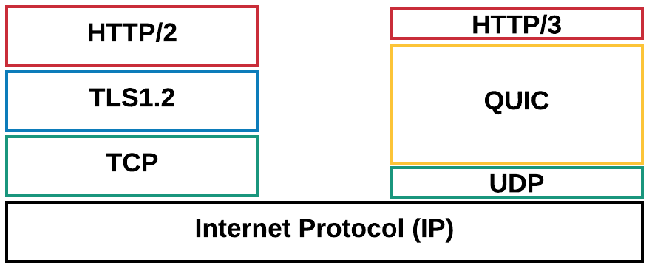
Figure 5.4.1.1-1: HTTP/2 and HTTP/3 protocol stacks
For an entertaining introduction to QUIC and HTTP/3, please check https://www.youtube.com/watch?v=B1SQFjIXJtc.
However, using HTTP/3 over QUIC for adaptive streaming still requires study as under certain circumstances, the quality using QUIC may even degrade for DASH-based streaming than it would increase [6]. The evaluation results show that using the unmodified DASH algorithms on top of QUIC may not provide the anticipated performance boost when compared to the standard DASH over TCP.
The main expected benefit of QUIC is being able to multiplex requests for all Adaptation Sets onto the same transport association, and then to manage the network QoS on that aggregate connection. This has a valuable operational benefit to a CDN operator (including the 5GMS AS) in reducing the number of UDP ports that a server needs to keep open. Another benefit is being able to migrate connections from one IP address to another with minimal interruption to either client or server. This is useful when the client moves, but it is also useful when the server changes (e.g. in edge computing relocation Use Cases).
Because HTTP/3 and IETF QUIC are new protocols, there are several questions about performance and management that need to be investigated during this study.

===== CHANGE =====

5.4.2.3 Collaboration for uplink media streaming using HTTP/3
For this key topic, the discussion will focus on a media plane only collaboration scenario where the 5GMSu AS is deployed in the trusted domain. This collaboration scenario is described in clause 5.5.2.2 and illustrated in figure 5.5.2.2-1.
- If HTTP/3 is used as the uplink application protocol at reference point M4u, the uplink media is streamed from the Media Streamer subfunction of an HTTP/3-enabled 5GMSu Client to an HTTP/3-enabled 5GMSu AS.
- If HTTP/3 is used as the media egest application protocol at reference point M2u, the egest media is sent from an HTTP/3-enabled 5GMSu AS to an HTTP/3-enabled 5GMSu Application Provider.
NOTE 1: Clause 5.5.2.7, describing a "hybrid, i.e. end-to-end form of collaboration across uplink media streaming and downlink media streaming services", and clause 5.2.4.3 on "Content preparation between uplink ingest and downlink streaming", is consider useful to cover in clause 5.4 as well in future versions.
NOTE 2: Uplink ingest formats are also a key topic, and clause 5.2.1 names several existing uplink ingest formats to be studied. Even for the formats not routinely carried over HTTP (e.g. RTP-based RIST [21][22] and SRT [82]), discussions are underway in the Internet Engineering Task Force to specify direct mappings onto QUIC (for instance, [80] and [81] for RTP and [83] for SRT).The impact of encapsulating these non-HTTP protocols in QUIC is encouraged to be considered in future versions of the present document.

===== CHANGE =====

5.4.3.4 Usage of HTTP/3 at reference point M5

This aspect is for future study.

===== CHANGE =====

5.4.5.2 Streaming Protocols taking advantage of HTTP/3 capabilities
Because so many media providers have used HTTP-based transport mechanisms, they have been forced to provide “workarounds” to overcome the TCP-related deficiencies that HTTP implementations were forced to deal with. Confirming with the predominant implementors of HLS, MPEG-DASH, SRT, and even RTP what their timeframes are for versions of these protocols that take advantage of HTTP/3 capabilities would be useful, but these versions are already starting to appear. Preliminary proposals for "Tunnelling SRT over QUIC" are described in [83], and multiple proposals for RTP over HTTP/3, or even directly over QUIC, have been submitted to the IETF.

===== CHANGE =====

5.4.5.4 Adaptive Streaming clients operating on top of HTTP/3 capabilities
Adaptive streaming clients are implemented to overcome the TCP-related deficiencies that HTTP implementations were forced to deal with. Today’s adaptive streaming clients are typically not aware that they are operating on top of HTTP/3 and QUIC instead of HTTP/1.1 and TCP. To establish an HTTP/3 connection as quickly as possible, some clients optimistically initialize both a TCP and a QUIC connection at the same time, a "connection racing" strategy that is often inadequate in providing the optimal solution [176]. Moreover, according to [175] and [176], in current browser implementations there can be a switch to/from TCP and UDP during a session, resulting in a non-standards-compliant behaviour of using HTTP/3 over TCP (presumably in a manner similar to [177]), having a negative impact in performance. A DASH client as documented in clause 13 of TS 26.512 [16] includes some typical functions that may be impacted by operation on top of HTTP/3, in particular:
NOTE: Further study of the behaviour mentioned in the paragraph above regarding the switching to/from TCP/UDP is encouraged.
- Throughput estimation: An estimate of the network throughput from the 5GMSd Application Server, which is typically computed as the object size divided by the download time where the download time is the time difference between the first and the last bytes received for that object. According to [178], measuring the throughput of multiplexed audio and video streams over a single UDP socket results in additional response latency for the (much smaller) audio segments, whose individual throughput is not captured during the calculation of channel throughput. HTTP/3-specific algorithm selection methodologies exist [178] [179] that consider the underlying QUIC connection.
- Request Scheduling: The adaptive streaming client schedules requests under the assumption of TCP operation. It typically operates for example audio and video on two HTTP sessions with separate sockets, and each of the sockets maintains its own independent socket buffer. By contrast, requests for audio and video are typically multiplexed onto a single HTTP/3 session on a single UDP socket with a single socket buffer. Therefore, the HTTP responses from both the streams interfere, and a higher response rate for one stream affects the queuing delay for the responses on the other stream.
Based on these operations, it is important that the adaptive streaming client:
1. Is aware that it is operating on top of HTTP/3.
2. Adapts its operation based on HTTP/3 properties
Details are for further study.

===== CHANGE =====

5.4.5.5 5GMS Operation taking advantage of HTTP/3 capabilities
5G Media Streaming provides the ability to support regular OTT media streaming by providing additional and auxiliary information between the Media Session Handler and the 5GMSd AF. Supported functions in Rel-16 include telco CDN, network assistance and for example metrics reporting. It would be appropriate to adjust 5GMS function to HTTP/3 based delivery. As an example, certain DASH metrics are designed for TCP based streaming and would preferably be updated to account for HTTP/3 based delivery. Additionally, novel ABR algorithms designed for HTTP/3 delivery [156] take into consideration QLOG metrics [84] [85] [86] in their bit rate selection logic (see also clause 5.4.6.1).
NOTE: Identify the impact of including QLOG events on 5GMS metrics reporting.

===== CHANGE =====

5.4.6 Candidate solutions

This aspect is for further study.

===== CHANGE =====

5.4.6.1 Metrics reporting using qlog events
NOTE: Contribution pending.

===== CHANGE =====

5.5.1.5 5G-MAG analysis of uplink streaming for media production and contribution

5.5.1.5.1 Overall description
5G-MAG has published a report [173] in late 2024 covering the following:
- Identification of systems and features enabling enhancements for uplink media delivery and traffic management in the content of media production and contribution applications.
- Description of architectures, reference points and relevant procedures in the context of uplink media delivery using 3GPP technology.
- Feasibility analysis of the status of the technology and its potential applicability based on 3GPP Release 17 and Release 18 specifications.
- Identification of possible gaps in existing specifications to support their application for uplink media delivery.
As part of the analysis, the following findings are identified for potential consideration in future improvements of the 5GMSu and RTC architectures.

5.5.1.5.2 Network Assistance
The Network Assistance feature is found key for interrogating and manipulating QoS for a given media delivery session. Uplink media delivery sessions may be handled in a device alongside other media delivery session or application-related traffic.
AF-based Network Assistance may be complemented with ANBR-based Network Assistance in use cases where performance at the radio layer is considered critical and therefore a tighter signalling interaction between the RAN and the UE modem would be beneficial. Granularity to apply ANBR-based Network Assistance for specific media flows would be beneficial but is currently lacking support in 3GPP specifications.

5.5.1.5.3 QoE metrics reporting
QoE metrics reporting is specified up to and including in Release 18 for DASH-based downlink media streaming. Such a framework may not be entirely suitable for uplink media streaming applications using protocols and packaging other than segmented media. Moreover, 3GPP does not in Release 18 specify QoE metrics reporting for uplink media delivery sessions based on 5GMSu.
Although the RTC architecture has a fully specified metrics reporting scheme, the metrics are all expressed from the perspective of the RTC session receiver, even though WebRTC can be bidirectional. Most of the metrics available only apply to an RTC endpoint receiving media with no mechanisms to report metrics to the sender via RTCP messages other than lost RTP packets and session RTT.
One potential solution that could be specified within this constraint would be for the 5GMSu AS to provide QoE metrics reports about uplink media streaming sessions to the 5GMSu AF via reference point M3u. (This is analogous to the RTC AS providing QoE metrics reports to the RTC AF via reference point RTC-3, as specified by TS 26.113 [174] in Release 18.)

5.5.1.5.4 Consumption reporting
Although Release 18 specifies the data types and APIs for submitting consumption reports in TS 26.510 [108], TS 26.113 [174] does not yet specify how to populate consumption reports for RTC sessions.

5.5.1.5.5 Traffic steering and multipath
Traffic steering and multipath delivery mechanisms are today commonly employed in content production and contribution scenarios by bonding multiple cellular access networks together. Advanced network assistance mechanisms may be useful to better drive the bit rate allocation across multiple links and avoid retransmission quality degradation.
Among others, exposure of the following information to the Media Client would be helpful:
- Initial recommended uplink throughput with associated latency in aggregate and/or for each path separately, as appropriate.
- Notification of predicted upcoming uplink network conditions in aggregate and/or for each path separately, as appropriate.
- Notification of upcoming cell handover.

===== CHANGE =====

5.5.7 Conclusion
This key issue has explored five collaboration scenarios for uplink streaming in the 5G Media Streaming architecture. For each scenario, a high-level call flow has been developed. Several gaps were identified during this process. Additionally, the uplink steaming features of TS 26.501 [15] and TS 26.512 [16] were compared with both TS 26.238 [14] as well as the download streaming features of TS 26.501 and TS 26.512, and the missing features are identified.
As this study shows, uplink streaming is severely underspecified in TS 26.501 and TS 26.512 in Release 16, and the following gaps are identified:
1. Collaboration scenarios and their associated call flows described in clauses 5.5.2 and 5.5.3.
2. Protocol(s) for egesting uplink streaming to the 5GMSu Application Provider through M2.
3. Content Publishing Configuration API to enable a 5GMSu Application Provider to create, update, retrieve and delete a publishing template through M1.
4. Content Publishing Template to describe the publishing configuration from the 5GMSu AS to the 5GMSu Application Provider, including content preparation prior to egest.
5. Entry point for the UE’s uplink media streaming to the 5GMSu AS that is obtained by the UE through M5.
In an updated version it is further recommended to study the application of uplink 5G Media Streaming for media production and contribution in more detail based on the information from 5G-MAG in clause 5.5.1.5. Specific topics are:
- Network Assistance as elaborated in clause 5.5.1.5.2,
- QoE metrics reporting as elaborated in clause 5.5.1.5.3,
- Consumption reporting as elaborated in clause 5.5.1.5.4,
- Traffic steering and multipath as elaborated in clause 5.5.1.5.5.

===== CHANGE =====

5.7.3 Deployment architectures

This aspect is for further study.

===== CHANGE =====

5.7.4 Mapping to 5G Media Streaming and high-level call flows

This aspect is for further study.

===== CHANGE =====

5.7.5 Potential open issues

This aspect is for further study.

===== CHANGE =====

5.7.6 Candidate solutions

This aspect is for further study.

===== CHANGE =====

5.9.4 Mapping to 5G Media Streaming and high-level call flows

This aspect is for further study.

===== CHANGE =====

5.9.5 Potential open issues

This aspect is for further study.

===== CHANGE =====

5.9.6.3 Solution 2: Time-limited authorization token provisioning
In order to reduce the number of callbacks, tokens with a limited validity duration may be provisioned with the 5GMS AF and the 5GMS-Aware Applications.
In this solution the 5GMSd Application Provider provisions a set of valid authorization tokens, including expiry time, in the 5GMS AF in advance via M1.
As in Solution 1, the Media Session Handler passes an authorization token when invoking the 5GMS AF at M5. The 5GMA AF authorizes the Media Session Handler’s request based on this token.
Since the token validity is time-limited, the 5GMS Application Provider must periodically update the set of valid authorization tokens provisioned at the 5GMS AF and the 5GMS-Aware Application is responsible for refreshing the token used by the Media Session Handler. For example, the application may be configured to periodically fetch a new token from the 5GMS Application Provider.
Figure 5.9.6.3-1: Usage of time-limited tokens for policy activation authorization
The steps are as follows:
1. The 5GMS Application Provider provisions tokens on the 5GMS AF before any 5GMS-Aware Application tries to activate any Dyanmic Policy. The token is provisioned together with the Policy Template definitions.
2. When a user (and the 5GMS-Aware Application) successfully authenticates with the 5GMS Application Provider, the 5GMS-Aware Application receives a time-limited authorization token. The 5GMS-Aware Application typically stores the token.
The difference with Solution 1 is the use of the token by the 5GMS AF:
3. When a 5GMS-Aware Application wishes to activate a Dynamic Policy, it provides the authorization token to the 5GMS AF. The 5GMS AF then validates the token using a simple lookup against it list of currently valid tokens without reference to the 5GMS Application Provider.

===== CHANGE =====

5.10 Support for distributing DRM-protected, encrypted and high-value content

===== CHANGE =====

5.10.1 Description
Content is increasingly encrypted for distribution for different reasons, e.g. Content Protection, Conditional Access, or integrity of playback. The management of keys for different use cases is a prime concern. Examples include scalable access to keys, secure storage of keys, key availabilities. It is envisioned that an MNO can provide key management and/or key distribution services for content providers. In particular, providing scalable and secure key management within 5GMS for multiple different devices needs further study.
Examples of secure media requirements are, for example, captured in the MovieLabs ECP specification [140] and elsewhere by other content providers
. In a specific example, a live sports service provider wants to offer a live stream. Examples include where the content needs to be delivered with low latency (typically encoder to glass in 3–10 seconds) in order to be on par with regular TV distribution means, and whether it is made available for replay and seeking in a certain time window. Other services may also be considered.
The service may require different tools and functionalities levels of security:
1. Conditional access supported by DRM management. As an example, to support key rotation, users need to get a master key for decrypting the secondary level keys.
2. Key rotation. As an example, content decryption keys are changed periodically but protected by the master key.
3. Multi-DRM and multi-key management to ensure playback rules, for example to avoid that clients attempting early playback of the content too early and have advantages in betting/wagering, skipping content, etc. In many cases, multiple DRM Systems need to be supported to target different device types. In addition, multi-key can enable distinct keys to support different qualities such as UHD and HD, which is a common industry requirement.
4. Watermarking. The content is distributed and a unique signature is added at the latest possible time (in the device, at the Edge). An example of such approach can be found in [142].
5. Content encryption. This makes sure content cannot be used by users that are not in possession of the required decryption key. The encryption is usually applied on the content atat the point of packaging or encoding.
6. A secure implementation. The client implements a Trusted Execution Environment (TEE), such as Secure Media Path.
In addition, DASH-IF has defined workflows for managing protected content as follows:
- Content Protection Information Exchange Format (CPIX) as specified in ETSI TS 103 799 [143].
- DASH-IF Interoperability Points; Part6-v5.0.0: Content protection and security [144].
- DASH-IF Forensic A/B Watermarking as specified in ETSI TS 104 002 [145].
Integration of Content Protection interfaces in the provisioning, for example using CPIX back-end interfaces, is of high relevance for the industry and should accordingly be studied. The impacts of these on the media plane (reference points M2 and M4) as well as on the media session handling APIs (reference points M3, M5) should also be studied.
In addition, W3C has developed the Encrypted Media Extensions API [141], enabling browser platforms to support secure encrypted media playback using different DRM solutions.

===== CHANGE =====

5.10.2 Collaboration scenarios
It is assumed that the content provider provides DRM protections for the content. However, beyond this different collaboration models between the content provider and 5G System operator/MNO exist.
As examples, the MNO provides infrastructure to the content service provider in order to support security related functions.
- The service provider may want to provide scalable access to the content and in particular the key distribution. Hence it uses 5G Media streaming servers to support secure key distribution.
- The streaming service provider wants to rule playback, for example to avoid that the situation whereby users can see the streamed content too early while at the same time, the streaming service provider does not want to delay the distribution artificially either and want to give the clients the ability to download the main content (without buffer underruns).
- The service provider asks for fairness in the client, but the client cannot be trusted to act fairly. Hacked clients are possible. Clients may have DRM systems that the service providers will use.
- The service provider asks for a watermarking solution from the MNO.
- The service provider wants the 5GMS System to re-encrypt content using the Content Preparation feature.
Encryption (as already defined in TS 26.511 [96]) and secure keys may be used for other purposes, for example for conditional access or DRM systems. In some cases, keys are also provided in hierarchically, depending on business rules, security levels and deployment scenarios.
In an extension of the above use case, the content is distributed via multiple operators’ network. In this case, the encryption may be done by the service provider and the service provider provides the keys to the MNO. In another case, the service is offered by the MNO and the MNO does encryption and key management. In another context, DRM-protected encrypted content may also be distributed when using 5G Media Streaming over MBMS or MBS as documented in clauses 4.6 and 4.9 respectively in TS 26.501 [15].

===== CHANGE =====

5.10.3 Deployment architectures

The core components of a DRM workflow are provided in figure 5.10.3-1 based on Part 6 of the DASH-IF Interoperability Points specification [144]. Similar workflows apply also for other streaming technologies, but DASH is used in the below analysis for illustrative purposes.
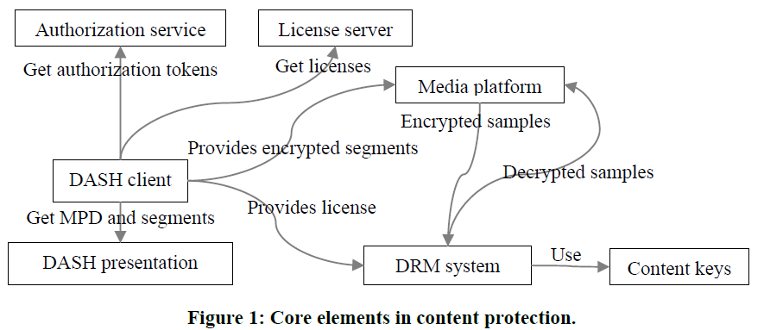
Figure 5.10.3-1: Core elements in content protection according to DASH-IF IOP Part 6 [144]
The definition of the functions is as follows:
- Authorization Server: provides authorization tokens that may be required for requesting a license from a license server.
- DASH client: a function using the Media platform and the DRM system to playback encrypted content.
- DASH Presentation: A server hosting DASH resources, i.e. MPDs and Segments primarily, and includes information on the used DRM System.
- License Server: A license server provides licenses that are data structures in a DRM system specific format that contains one or more content keys and associates them with a policy that governs the usage of the content keys (e.g. expiration time).
- Media Platform: enables playback of encrypted content while protecting the decrypted samples and content keys against potential attacks.
- DRM System: an implementation of content keys management cooperating with the device’s media platform to enable playback of encrypted content while protecting the decrypted samples and content keys against potential attacks, consisting of two main components: a license server and a DRM client.
- DRM Client: processes licenses and enforcing the associated policies. Either the DRM client handles the decryption of samples, or the DRM client interacts with the hardware elements that address the decryption.
A DRM system cooperates with the device’s media platform to enable playback of encrypted content while protecting the decrypted samples and content keys against potential attacks. The same encrypted DASH presentation can be decrypted by different DRM systems if a DASH client is provided the DRM system configuration for each DRM system, either in the MPD or at runtime. A content key is a key used by a DRM system to make content available for playback. A content key and its identifier can be shared between all DRM systems, whereas the mechanisms used for key acquisition and content protection are largely DRM system specific. DASH adaptation sets are often protected by different content keys. The encapsulated content keys are typically encrypted and only readable by the DRM system.
A more detailed DRM workflow is provided in figure 5.10.3-2 based on the Content Protection Information Exchange Format (CPIX) as specified in ETSI TS 103 799 [143]. It complements Part 6 of the DASH-IF Interoperability Points specification [144] by putting more emphasis on the back-end aspects. The following additional functions are defined:
- Content Provider: A publisher who provides the rights and rules for delivering protected media, also possibly source media (mezzanine format, for transcoding), asset identifiers, key identifiers (KID), content key values, encoding instructions, and content description metadata.
- Encoder: A function that encodes media in a specified set of formats with different bitrates and resolutions etc., possibly determined by the publisher.
- Packager/Encryptor: A function that who encrypts and packages media, inserting DRM signalling and metadata into the media files.
- Manifest Creator: A function that generates the media manifests which group the various media files into a coherent presentation. These manifest files may contain DRM signalling information.
- DRM Client: Obtains information from different sources: media manifest files, media files, and DRM licenses.
An example architecture is provided in figure 5.10.3-2.
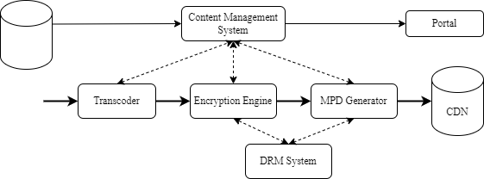
Figure 5.10.3-2: Example backend architecture and workflow for encrypted live content
based on ETSI TS 103 799 [143]
In this case, content is continuously received, transcoded in the desired format and encrypted if any type of protection is required. One or multiple content keys can be used regardless of whether key rotation is used or not. Keys are generated by the encryption engine or the DRM system and are available to all DRM systems and encryption engines to support multi-DRM with a shared key The MPD Generator requests to the DRM systems their specific signalling, if any, to be added in the MPD. Encrypted segments and the media manifest can be uploaded on a CDN making it available to users.
Figure 5.10.3-3 illustrates the usage of the encrypted content in a realistic workflow comprising multiple cooperating components. In ETSI TS 103 799 [143], a standardised data format for content protection information exchange is defined, collected in a document that can be signed.
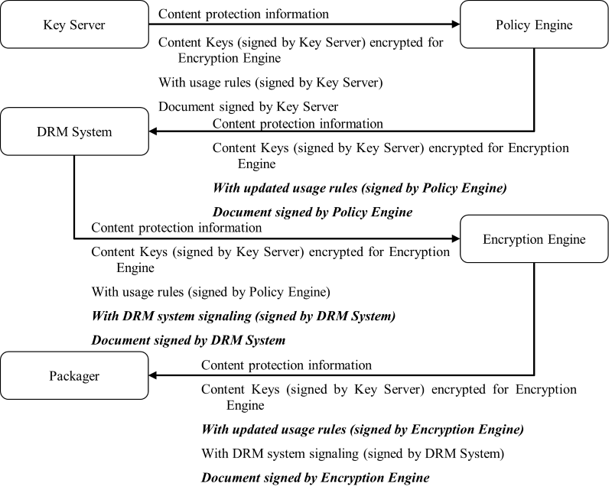
Figure 5.10.3-3: Incremental update and extension of the document based on ETSI TS 103 799 [143]
Also, in ETSI TS 103 799 [143] a workflow for use with CPIX is presented for which multiple producers are included. This workflow is shown in figure 5.10.3-4.
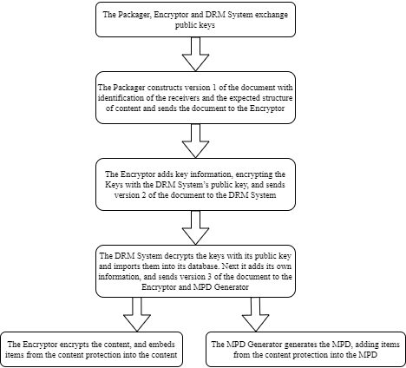
Figure 5.10.3-4: Multiple producer example steps based on ETSI TS 103 799 [143]
A typical example workflow of encrypted content is shown in figure 5.10.3-5.
Figure 5.10.3-5 Typical workflow for generating, distributing and playing back encrypted content
The following call flow is provided:
Initialization:
1. The Encryptor/Packager (ENP), License Server (LS), and Authorization Server (AUS) exchange public keys.
Content Protection Information construction:
2. The Packager constructs content protection information.
3. The Encryptor retrieves keys and adds them to the content protection information.
Content Protection Information distribution:
4a. The Encryptor/Packager sends the content protection information to the License Server
4b. The License Server sends the content protection information to the Authorization Server.
5. The Authorization Server decrypts the keys and adds data to the content protection information.
6. The Authorization Server sends the updated content protection information to the License Server.
7. The License Server decrypts the keys and adds data to the content protection information.
8. The License Server sends the updated content protection information to the Encryptor/Packager and the Manifest Creator.
Presentation manifest and segment generation:
9. The Manifest Creator generates the presentation manifest (e.g. DASH MPD) and adds the content protection information.
10. The Manifest Creator uploads the presentation manifest to the Content Hosting.
11. The Encryptor/Packager generates encrypted segments and adds the content protection information.
12. The Manifest Creator uploads the encrypted segments to the Content Hosting.
Client requests and authorisation:
13. The DASH Client requests the presentation manifest from the Content Hosting.
14. The DASH Client requests authorisation tokens from the Authorization Server.
15. The DASH Client requests a license from the License Server, possibly using the authorisation tokens.
16. The DASH Client provides the license to the DRM Client.
Content delivery and decryption:
17. The DASH Client requests encrypted segments from the Content Hosting.
18. The DASH Client provides the encrypted segments to the Media Platform.
19. The Media Platform provides the encrypted samples to the DRM Client.
20. The DRM System decrypts the samples using the license and content keys.
21. The DRM System provides the decrypted samples to the Media Platform.

===== CHANGE =====

5.10.4 Mapping to high-level call flows

Based on the generalised Media Delivery architecture from TS 26.501 [15], as reproduced in figure 5.15.1-1 below, different mapping options of the components of the above DRM architecture to the downlinkdownlink media streaming architecture are provided in table 5.10.4-1.
NOTE Since this Key Issue deals only with downlink media streaming, figure 4.2.1-2 from TS 26.501 may be applicable as well, with "5GMSd" instead of "Media" throughout.
Figure 5.10.4-1 Media Delivery architecture as defined in figure 4.1.2.2-1 of TS 26.501 [15]
Table 5.10.4-1 provides different deployment options on how the DRM network functions are mapped to the downlink media streaming functions.
Table 5.10.4-1 Possible deployment options to map DRM network functions
to downlink media streaming functions
DRM Function | 5GMSd Application Provider | 5GMSd AS | 5GMSd AF | Media Player | Media Session Handler
Authorization Server | 1, 3, 4 | 2 | 5, 6
License Server | 1, 3, 4 | 2 | 5, 6
Encoder | 1, 4, 6 | 2, 3, 5
Encryptor/packager | 1, 4, 6 | 2, 3, 5
Manifest Creator | 1, 6 | 2, 3, 4, 5
Content Hosting |  | 1, 2, 3, 5, 6
DRM Client |  |  |  | 1, 2, 3, 4, 5, 6
DASH Client |  |  |  | 1, 2, 3, 4, 5, 6
Media Platform |  |  |  | 1, 2, 3, 4, 5, 6

The following different deployment options are discussed:
Option 1: The 5GMSd Application Provider runs all DRM and packaging related functions, and the 5GMSd AS only caches the DASH Presentation as a CDN. For DRM acquisition, the UE contacts the 5GMSd Application Provider.
NOTE: This option corresponds to downlink media streaming in Release 18 in which DRM is external to the 5GMSd AS. Other options address the internalization of certain DRM-related functions.
Option 2: The 5GMSd System runs a DRM and packaging service, including a License Server, on the 5GMSd AS. Content is ingested by the 5GMSd AS and all functions of licence hosting, content encoding, content encryption and so on run in the 5GMSd AS.
Option 3: The 5GMSd System runs a content encoding and packaging service, but the License Server is external in the 5GMSd Application Provider. The 5GMSd AS needs to communicate with the License Server for content encoding and packaging.
Option 4: The 5GMSd System generates the presentation manifest, but content encoding, content packaging and content encryption are external in the 5GMSd Application Provider. The 5GMSd AS needs to acquire relevant information for presentation manifest generation.
Option 5: This is similar to Option 2 but, being quite specific in operation, the License Server is handed to the 5GMSd AF alongside the Authorization Server. The main communication is between 5GMSd AS and 5GMSd AF at reference point M3d.
Option 6: This is similar to option 5, but only the License Server is offered by the 5GMSd System, hosted in the 5GMSd AF. Similar to option 4, content encoding, content packaging and content encryption are external in the Media Application Provider. The main communication is between the 5GMSd Provider and the 5GMsd AF at reference point M1d for the exchange of Content Protection Information.
Based on current deployments, licence acquisition is a user plane communication and no APIs in the media access client exist to delegate the licence acquisition to a third-party function, such as the Media Access Function (e.g. Media Player). Hence, options 5 and 6 are not further discussed.
Now, for the different options 1-4, table 5.10.4-2 maps the steps in figure 5.10.3-5 to components and/or interfaces defined in the media delivery architecture as shown in figure 5.10.4-1.
Table 5.10.4-2: Mapping of steps in figure 5.10.3-5 to components and/or interfaces defined in the media delivery architecture as shown in Figure 5.10.4-1
Steps | Option 1  (External DRM and packaging) | Option 2  (Internal DRM and packaging) | Option 3  (Internal packaging, external DRM) | Option 4  (only manifest internal)
1 | 5GMSd AP | 5GMSd AS | M2d (CPI) | 5GMSd AP
2 | 5GMSd AP | 5GMSd AS | 5GMSd AP | 5GMSd AP
3 | 5GMSd AP | 5GMSd AS | 5GMSd AP | 5GMSd AP
4 | 5GMSd AP | 5GMSd AS | 5GMSd AP | 5GMSd AP
5 | 5GMSd AP | 5GMSd AS | 5GMSd AP | 5GMSd AP
6 | 5GMSd AP | 5GMSd AS | 5GMSd AP | 5GMSd AP
7 | 5GMSd AP | 5GMSd AS | 5GMSd AP | 5GMSd AP
8 | 5GMSd AP | 5GMSd AS | M2d (CPI) | M2d (CPI)
9 | 5GMSd AP | 5GMSd AS | 5GMSd AS | 5GMSd AS
10 | M2 (Ingest) | 5GMSd AS | 5GMSd AS | 5GMSd AS
11 | 5GMSd AP | 5GMSd AS | 5GMSd AS | 5GMSd AP
12 | M2 (Ingest) | 5GMSd AS | 5GMSd AS | M2d (ingest)
13 | M4d | M4d | M4d | M4d
14 | M8d | M4d | M8d | M8d
15 | M8d | M4d | M8d | M8d
16 | Media Player | Media Player | Media Player | Media Player
17 | M4d | M4d | M4d | M4d
18 | Media Player | Media Player | Media Player | Media Player
19 | Media Player | Media Player | Media Player | Media Player
20 | Media Player | Media Player | Media Player | Media Player
21 | Media Player | Media Player | Media Player | Media Player

Of the options documented in table 5.10.4-2, Option 1 is most prominent because it is the default option for downlink media streaming in Release 18. Of the remaining options:
- In particular Option 3 is expected to be of interest for 5G Media Streaming deployments, because it addresses the scenario for which a specific encoding or transcoding for 5G Media Streaming is carried out by the Application Server.
- Option 4 is a subset of Option 3, and hence not discussed explicitly.
- We also exclude option 2 for now, as DRM servers are generally handled outside MNO networks.
NOTE: The mapping to 5GMS via MBS/MBMS is for further study

===== CHANGE =====

5.10.5 Potential open issues

Based on the analysis in table 5.10.4-2, for different deployment options, functional updates to the 5GMSd AS and Media Player would be needed, and additional information may be exchanged through reference points M2d, M4d and M8d. Based on the discussion in clause 5.10.4, Option 3 is considered in more detail, and the following open issues are identified:
1. Support for public key exchange between the Encryptor/Packager (ENP) on the 5GMSd AS, as well as the external License Server (LS), and Authorization Server (AUS) via reference point M2d.
2. Support for the delivery of updated content protection information (for example new key information) from an external entity to the Encryptor/Packager and the Manifest Creator deployed in the 5GMSd AS via reference point M2d.
3. The delivery of modified content protection information in the presentation manifest and the content via reference point M4d.
4. Explicit support for encrypted sample entries 'encv' etc, in 3GPP TS 26.511 [96] to support encrypted media formats.
An additional question arises whether encryption needs to be part of the content preparation template and configuration via in the 5GMSd AS via reference point M3d is needed. This aspect is not included in the call flow, but should be considered as a potential open issue.

===== CHANGE =====

5.10.6 Candidate solutions

In order to address the open issues documented in clause 5.10.5, the following aspects address a solution to the topics:
- Support for Content Protection Information Exchange Format (CPIX) as specified in ETSI TS 103 799 [143] at reference point M2d addresses open issues 1 and 2 identified in clause 5.10.5.
- Support for the DASH-IF Interoperability Points; Part 6 [144] at reference point M4d addresses open issue 3 identified in clause 5.10.5 for both DASH and HLS.
- Support for decryption and (re-)encryption tasks in the content preparation template tasks in the 5GMSd AS, specified using a Content Preparation Template provisioned in the 5GMSd AF via M1d and configuration in the 5GMSd AS via reference point M3d.

===== CHANGE =====

5.11.1.5 Target latency constraints
Based on a report developed jointly between DVB and DASH-IF on Low-Latency DASH [9], this clause defines details on how to support consistent latency in DASH for linear TV services. In [9], several definitions had been introduced, repeated here for consistency.
- End-to-End Latency (EEL): The latency for an action that is captured by the camera until its visibility on the remote screen.
- Encoder-Display Latency (EDL): The latency of the linear playout output (which typically serves as input to distribution encoder(s)) to the screen.
- Packager-Display Latency: The latency after the output of the distribution encoder to the screen.
- CDN latency: The delay caused by the CDN delivery from CDN input to CDN output.
- Live Edge Start-up Delay (LSD): The time between a user action (service access or service join) and the time until the first media sample of the service is perceived by the user when joining at the live edge. Typically also the channel change time.
- Seek Start-up Delay (SSD): The time between a user action (service access or service join) and the time until the first media sample of the service is perceived by the user when seeking to a time shift buffer.
Those two categories, latency and delay are subject to be controllable by the service provider for a consistent service offering. In the remainder, primarily the Encoder-Display Latency (EDL) and the Live Edge Start-up Delay are considered, but for some use cases also the End-to-End Latency (EEL) may be relevant. Figure 5.11.1-1 provides a schematic overview of the different latencies.
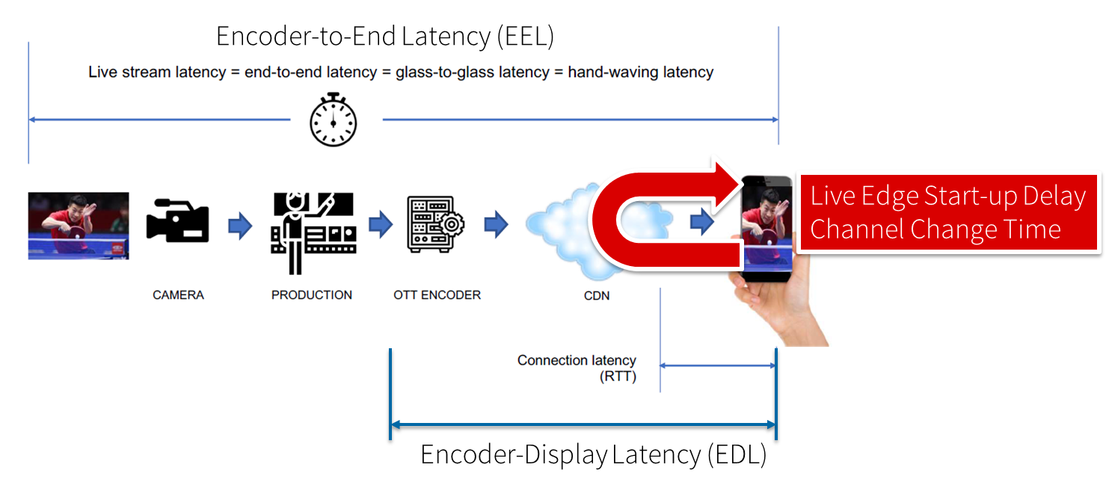
Figure 5.11.1-1: Different latencies and delays relevant for low-latency distribution
The Low Latency DASH scenario is a variant of the Live Services recommended approach focused on ensuring that the Encoder-Display Latency of the DASH Media Presentation is comparable to the latency when distributing over terrestrial, cable or satellite broadcast. Latency in broadcast is not a unique universal value, as it is influenced by many factors such as the duration of the broadcast encoding pipeline, the latency of the transport channel which can slightly differ per type (satellite, cable, IPTV or, DTT...), or the artificial delays introduced by local content moderation regulations. However, most of the measurements converge on a 3 - 10 seconds latency between the moment where the source signal is acquired for encoding and the moment when it's played back on the TVs, i.e the EDL. Start-up delay requirements are typically in the range of 1-2 seconds. For details refer to [9].
Low-latency mode are supported to minimize the architectural impacts on existing workflows. Figure 5.11.1-2 provides a basic flow of information for operating a low-latency DASH service as defined in DASH-IF’s Low-latency Modes for DASH [10]. The DASH packager gets information on the general description of the service as well as the encoder configuration. The encoder produces CMAF chunks and fragments. The chunks are mapped by the MPD packager onto Segments and provided to the network in incremental fashion using HTTP/1.1 chunked transfer.
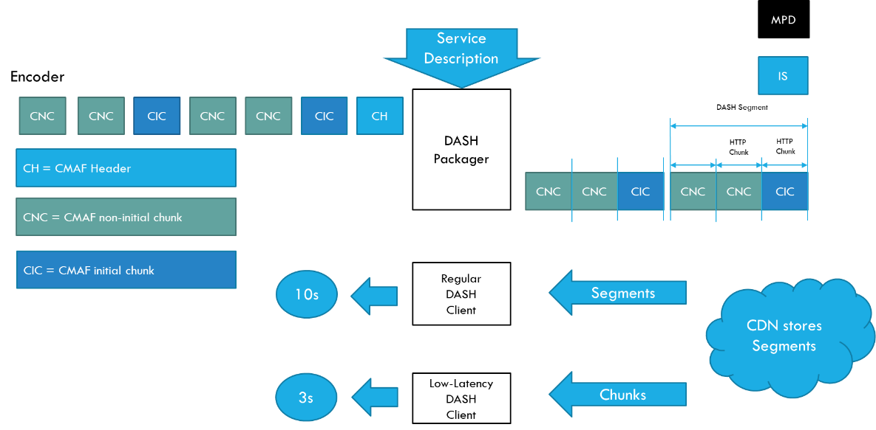
Figure 5.11.1-2 Basic operation flow Low-Latency DASH
HTTP chunked transfer coding needs to be supported up from the ingest into the packager up to the CDN edge, whereas the last mile delivery is expected happen using HTTP chunked transfer coding or HTTP in regular mode. If HTTP chunked transfer coding is supported by the DASH player, it basically means that a media segment carrying the latest moment of the program (also known as the "live edge time" as defined in clause 4 of this document) could be consumed on the player while it's still being produced by the encoder and the packager.
In case chunked segments are used, clients may want to access partially available Segments for example for fast random access, see ISO/IEC 23009-1 [11]. However, requesting available byte ranges of a partially available Segment, i.e., Segments still being produced, is not consistently supported in CDNs, but solutions are provided in RFC 8673 [12]. This functionality may also be needed to support common segment handling for low-latency DASH and low-latency HLS.
Key aspects for low-latency live distribution include:
- Consistent support for chunked transfer from ingest to client.
- Support for partial access to non-complete resources.
- End-to-end optimizations to support the latency requirements.

===== CHANGE =====

5.12.1.2 Network Slicing Extensions in SA4
Though the 3GPP SA4 technical specifications related to 5G Media Streaming have touched upon network slicing, the standards could be significantly enhanced with further study and specification related to network slicing aspects. Some of the items currently being worked in SA4 that can be enhanced to incorporate network slicing based specification are presented below. Table 5.12.1.2-1 lists the Release 16 architecture items that can benefit from further specification on network slicing.
Table 5.12.1.2-1: Release-16 Items for further Network Slicing related specification
Work Items | Aspects for study related to network slicing
5G Media Streaming | TS 26.501 [15] and TS 26.512 [16] have added specification text for dynamic policy. However, aspects related to network slicing and dynamic policy are not adequately addressed. TS 26.501 [15] briefly discusses dynamic policy based on network slicing for downlink streaming. Dynamic policy aspects for other use cases (media processing, uplink streaming etc.) can be studied.  Provisioning aspects on M1d interface with respect to network slicing. Study integration/interworking of management API with provisioning aspects of media services with network slicing  Aspects related to management of QoS for network slices of media services. How does QoS work with network slicing?  Aspects related to realization of media services with multiple network slices, and multi-network slice scenarios.  Realization of use cases with network slicing.

Table 5.12.1.2-2 lists candidate list of Release-17 items that can benefit with further specification on network slicing related aspects.
Table 5.12.1.2-2: Release-17 Items for further Network Slicing related specification
Work Items | Aspects for study related to network slicing
5GMS_EDGE | There is minimal specification in TR 26.803 [46] related to network slicing. The TR can greatly benefit from identifying and specifying network slicing aspects related to edge computing such as below:  Use cases: Realization of current edge use cases using network slicing keeping in view the control and management aspects of network slicing architecture as standardized in 3GPP SA2 and SA5.  EAS relocation in relation to network slicing impact, architecture, and procedures for supporting EAS relocation with network slicing.
EVEX | SA4 has started standardization of a reference architecture for data collection and reporting in TS 26.531 [72]. The TR can benefit from incorporating network slicing related data collection:  Study information elements and procedures related to data collection about network slices e.g., from NWDAF as specified in TS 29.520 [70] and TS 28.541 [61].  Slice optimization: Study optimizing network slice parameters for SA4 media services using metrics (analytics) collected using above method.  NOTE: Possible study directions include study of how slice related data from NWDAF could be useful, who is the customer of such data, and any required API support to retrieve such data.
5MBUSA | TR 26.802 [73] describes aspects related to multicast. Study can be performed to identify the relationship between 5G multicast and network slicing and answer questions such as below:  5G multicast media service using network slicing: How to realize 5G multicast and broadcast services using network slicing.  Hybrid Services: Study network slicing impact on the hybrid services key issue described in TR 26.802 [73]. Investigate whether different network slices can be used with different delivery systems for hybrid services.
NOTE: The scope of the EVEX Work Item does not currently include consuming analytics data from the NWDAF.

NOTE 1: Study to include aspects related to network slice usage e.g., how application/OS/UE can map different application traffic to network slices.
NOTE 2: In general, all the items in tables 5.12.1.2-1 and 5.12.1.2-2 are listed here to present areas for further study on aspects related to network slicing. The current scope of each of these work items may not include study of network slicing aspects.
The scope of the study proposed in the above tables is not exhaustive or final. More study topics can be identified in different work areas being discussed in SA4. The study can include how existing and new use cases can benefit with the network slicing specification. However, such a study in SA4 cannot be done in isolation. Multiple study/work items are currently underway in different SA groups. It is recommended that SA4 study consider such studies and work in other groups while specifying media service level network slicing standardization. The following are some of the study/work items in other groups that may be relevant to study in SA4:
- [3GPP SA2] TR 23.700-40 [71]: Study on enhancement of network slicing; Phase 2.
- [3GPP SA6] TS 23.434 [68]: Service Enabler Architecture Layer for Verticals (SEAL); Functional architecture and information flows.
- [3GPP SA6] TR 23.700-99 [69]: Study in Network slice capability exposure for application layer enablement (NSCALE).
NOTE: For maintaining alignment with the specifications in other groups, it is recommended that correspondence with those groups is done using standard 3GPP liaison procedures.

===== CHANGE =====

5.12.2 Collaboration Scenarios

This aspect is for future study.

===== CHANGE =====

5.12.3 Deployment Architectures

This aspect is for future study.

===== CHANGE =====

5.12.4 Mapping to 5G Media Streaming and High-Level Call Flows

This aspect is for future study.

===== CHANGE =====

5.15 Media Delivery specification
The specification structure for stage-2 and stage-3 is for further study.

===== CHANGE =====

5.16 Common Media Client Data (CMCD)

5.16.1 Description

5.16.1.1 Introduction
While 3GPP and MPEG in DASH support DASH metrics, the reporting is not common to any player, for example all DASH players as well as HLS players. As an example, CTA WAVE has developed: CTA-5004: Web Application Video Ecosystem Common Media Client Data (CMCD) [105]. It is worthwhile to study the benefits of integrating commonly supported metrics and client data reporting in 5GMS workflows. The focus is the integration of already defined metrics rather than developing new metrics. Examples of study include support of specific metric keys, player APIs, sending options from client to server (user plane, M5 reference point, as specified in TS 26.510 [108], Data collection and reporting as defined in TS 26.531 [106] and as specified in TS 26.532 [107]), M3 reference point impact), as well as usage of the data in operations. A study of creating a common harmonized reporting framework and studying the interaction of different frameworks may be included.
CMCD defines a set of media client data, structured as key/value pairs, that allows a media player to communicate mutually beneficial media-related information to a CDN via either (i) a set of custom headers, (ii) a URL request query string, or (iii) a JSON object. Common is used because the same data structure can be used across all players and all CDNs.
NOTE: CTA WAVE is currently extending its specification [105], and a new version is expected to be published by the middle of 2025.
A player may be instructed through a configuration API, for example defined in dash.js, on how to exactly report. In addition, in the 6th edition of MPEG-DASH in ISO/IEC 23009-1 [11], a configuration API and an MPD-based configuration signalling mechanism is specified in order for the DASH client to be instructed to enable CMCD information collection and reporting.
A basic overview of CMCD is provided in figure 5.16.1-1 illustrating option (i) in green and option (ii) in red. With every HTTP request, typically and primarily for the request of a media segment, some custom data is sent either as HTTP header or as query string appended to the segment request URL. In a third mode that is not widely implemented, corresponding to option (iii) above, the media client may also provide the information in a JSON object to the application out of band of media segment requests.
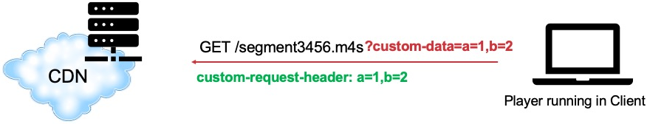
Figure 5.16.1-1: Basic CMCD concept – Media client sends key–value pairs to CDN in-band with requests

5.16.1.2 Use cases
The use cases which CMCD enables are broad – including robust pre-fetching of content, analytics solutions, forensic debugging, CDN delivery optimisation, alerting and monitoring systems, low latency optimisations, server-side switching, research analytics and content steering decision-making.
In the context of 5G Media Streaming, the CMCD information may be used for several purposes that are elaborated further in the remainder of this clause:
1) Operational optimisation of the 5GMSd AS: The Application Server uses CMCD information to optimise its operation. For example, the 5GMSd AS may choose to pre-fetch content from the 5GMSd Application Provider based on the value of the CMCD Next object request key signalled by the Media Player.
2) Operational optimisation of the 5GMSd AF and 5G Media Streaming: The Application Function uses CMCD information in order to configure the 5G System for optimised media delivery across the User Plane. For example, the 5GMSd AF may invoke service operations on the PCF in order to effect a delivery boost if the CMCD Buffer starvation flag is set by the Media Player.
3) UE data collection on media playback and 5GMS reception, reporting and event exposure by 5GMS System: The Application Function uses the data collection and reporting framework to provide CMCD information to the 5G System or to external 5GMS Application Providers. This could, for example, take the form of a time series event log for audit purposes. Such data could, for example, be useful to determine the quality of reception and to identify anomalies or errors that can occur on players.

5.16.1.3 Comparison of CMCD information with 5GMS reporting mechanisms
As part of this study, it is relevant to analyse CMCD [105] in comparison with existing client metadata reporting mechanisms already defined by the 5G Media Streaming architecture in TS 26.501 [15], namely:
- QoE metrics reporting, as described in clause 4.0.9 of [15]. For DASH streaming using downlink media streaming:
- TS 26.512 [16] specifies the use of the QM10 quality metrics reporting scheme for DASH and the "HSD" quality reporting protocol as specified in clause 10 of TS 26.247 [109].
- The operations for provisioning QoE metrics reporting are specified in clause 5.2.11 of TS 26.510 [108].
- The operations for QoE metrics reporting are specified in clause 5.3.5 of TS 26.510 [108].
- Consumption reporting, as described in clause 4.0.8 of [15]. For downlink media streaming:
- The format for consumption reports is specified in clause 11.3.3 of TS 26.512 [16].
- The operations for provisioning consumption reporting are specified in clause 5.2.12 of TS 26.510 [108].
- The operations for consumption reporting are specified in clause 5.3.6 of TS 26.510 [108].
One potential consideration for study is whether CMCD could potentially subsume or obsolete either or both of the above mechanisms. To that end, it is instructive to directly compare the information that can be conveyed using the three mechanisms in order to identify overlaps and/or gaps between them.
Table B-1 shows CMCD information in the left-hand columns, QoE reporting metrics in the central columns and consumption reporting data types in the right-hand columns. The comparison reveals that there is minimal overlap between the existing 5GMS reporting mechanisms and CMCD as specified in [105]. Further updates to [105] may increase the overlap.

5.16.2 Collaboration scenarios
In the context of the collaboration scenarios in annex A of TS 26.501 [15], the following collaboration scenarios are considered relevant:
Scenario 1 The 5GMSd AS is deployed in an external Data Network (OTT) as documented in clause A.1 of [15].
In this case, a third-party service provider logs data from clients about operational performance. The 5GMSd Application Provider may use the data in order to optimise its overall service including clients served through a 5G System.
Scenario 2 Both the 5GMSd AF and the 5GMSd AS are deployed in the trusted Data Network as documented in clause A.2 of [15].
In this case, the reported CMCD information can be further processed by the receiving 5GMSd AF in order to drive media delivery optimisations. Many use cases may be considered, for example network assistance, policy updates, etc.
In a similar fashion, when the 5GMSd AS and 5GMSd AF are external per clause A.2 of [15], such considerations may be taken into account, and also in the case where the 5GMSd AS is internal and the 5GMSd AF is external, as documented in clause A.6 of [15].
Scenario 3 5GMSd AF is deployed in the trusted Data Network and the 5GMSd AS deployed in an external Data Network as documented in clause A.4 of [15]. In this case, provisioning updates may be done by the 5GMSd Application Provider in response to received CMCD information.
Similar aspects apply for the collaboration document in clause A.4 of [15].
Scenario 2 is the core scenario for collaboration, namely the case that the 5GMSd AS collects information which is shared with the 5GMSd AF for further actions. The remaining discussion in this clause considers the case in which both the 5GMSd AS and the 5GMSd AF are both deployed in the Trusted DN. However, it is generally also possible for a third-party provided in a non-trusted environment to use CMCD information according to the following scenarios.
In the context of the above collaboration scenarios, the three different use cases introduced in clause 5.16.1.2 may also be considered:
1) Operational optimisation of the 5GMSd AS: If the Application Server is deployed externally, the CMCD information may be considered as information describing the media delivery session.
2) Operational optimisation of the 5GMSd AF and 5G Media Streaming: If the Application Function is deployed externally, NEF-based access to 5G System functionalities may be employed to optimise the delivery based on CMCD information, for example by applying network assistance or dynamic policy updates.
3) UE data collection on media playback and 5GMS reception, reporting and event exposure by 5GMS System: The Data Collection AF instantiated in the 5GMSd AF exposes CMCD information collected in the operational service as events. The Event consumer may be external and/or the Data Collection AF may provide information to the NWDAF for further processing in the operator’s network.

5.16.3 Architecture mappings

5.16.3.1 In-band reporting of CMCD information via reference point M4d and M3d
In the case where CMCD information is reported in-band with media requests at reference point M4d, no changes are required to the reference architecture for downlink media streaming defined in clause 4.1.1 of TS 26.501 [15] or to the generalised media delivery architecture defined in clause 4.1.2.1 of [15]. Furthermore, the instantiation of UE data collection, reporting and event exposure in the 5G Media Streaming architecture defined in clause 4.7 of [15] is also applicable unmodified.
Figure 5.16.3.1-1: Reference architecture for data collection and reporting when
the 5GMS AS is delegated to collect in-band CMCD information from the Media Player
and 5GMS AS reports CMCD information to the 5GMS AF via M3d
In this architectural mapping, the functionality of the system functions is extended as shown in figure 5.16.3.1-1 (with extensions depicted in red) and as follows:
- The Media Stream Handler (Media Player) additionally collects CMCD information and reports it to the 5GMSd AS via reference point M4d according to configuration previously received from the Media Session Handler via reference point M1d and from the 5GMSd AF via reference point M5d.
- The 5GMSd AS additionally collects and reformats CMCD information received in band from the Media Stream Handler at reference point M4d and shares it using an appropriate format with the 5GMSd AF via reference point M3d according to configuration previously received from the 5GMSd AF via reference point M3d.
- The CMCD information may be processed in the Data Collection AF, and the Data Collection AF exposes the information to the NWDAF via reference point R5 and/or to an external Event Consumer via reference point R6.

5.16.3.2 In-band reporting of CMCD information via reference point M4d and R4
In a variant of the architectural mapping described in clause 5.16.3.1, the CMCD information is instead reported by the 5GMSd AS to the Data Collection AF via reference point R4, as depicted in figure 5.16.3.2-1.
Figure 5.16.3.2-1: Reference architecture for data collection and reporting when
the 5GMS AS is delegated to collect in-band CMCD information from the Media Player
and 5GMS AS reports CMCD information to the 5GMS AF via R4
In this architectural mapping, the functionality of the system functions is extended as follows:
- The Media Stream Handler (Media Player) additionally collects CMCD information and reports it to the 5GMSd AS via reference point M4d according to configuration previously received from the Media Session Handler via reference point M11d and from the 5GMSd AF via reference point M5d.
- The 5GMSd AS additionally collects and reformats CMCD information received in band from the Media Stream Handler at reference point M4d and shares it using an appropriate format with the Data Collection AF instantiated in the 5GMSd AF via reference point R4 according to configuration for the CMCD data domain previously received from the Data Collection AF via reference point R4.
- The Data Collection AF additionally makes the CMCD information available to the 5GMSd AF that instantiated it in order to drive media delivery optimisations.
- Exposure of events to the NWDAF via reference point R5 and/or to external Event Consumers via reference point R6, is identical to clause 5.15.3.1.

5.16.3.3 Out-of-band reporting of CMCD information at M11d and M5d
In the case where CMCD information is reported out of band, no changes are required to the reference architecture for downlink media streaming defined in clause 4.1.1 of TS 26.501 [15] or to the generalised media delivery architecture defined in clause 4.1.2.1 of [15]. Furthermore, the instantiation of UE data collection, reporting and event exposure in the 5G Media Streaming architecture defined in clause 4.7 of [15] is also applicable unmodified.
Figure 5.16.3.3-1: Reference architecture for data collection and reporting when
the Media Session Handler reports CMCD information to the 5GMS AF out of band via M5d
In this architectural mapping, the functionality of the system functions is extended as shown in figure 5.16.3.3-1 and as follows:
- The Media Stream Handler (Media Player) additionally collects CMCD information according to configuration previously received from the Media Session Handler via reference point M11d and from the 5GMSd AF via reference point M5d.
- The Media Session Handler additionally obtains CMCD information from the Media Stream Handler (Media Player) via reference point M11d.
- The Media Session Handler additionally reports the CMCD information to the 5GMSd AF out of band at reference point M5d.
- Exposure of events to the NWDAF via reference point R5 and/or to external Event Consumers via reference point R6, is identical to clause 5.15.3.1.

5.16.4 High-level call flows

5.16.4.1 In-band reporting of CMCD information via reference point M4d and M3d
The focus of the call flow is on Scenario 2 as defined in clause 5.16.2.1 above, for which the CMCD information is initially sent to the 5GMSd AS via reference point M4d, and then provided to the 5GMSd AF at reference point M3d. The call flow is aligned with QoE metrics collection and reporting as defined in clause 5.5 of TS 26.501 [15], but addresses the user plane aspects.
Figure 5.16.4.1-1 illustrates a scenario where CMCD collection and reporting by the 5GMSd AS is configured by the 5GMSd AF via reference point M3d. In this example, it is assumed that the CMCD collection information provided by the 5GMSd AF comprises instructions/rules regarding CMCD reporting. It is further assumed that the 5GMSd AF is required to deliver CMCD reports to separate destination entities, upon optionally having performed post-processing the collected report information. The 5GMSd AF and 5GMSd AS can be either trusted or untrusted.
Figure 5.16.4.1-1: CMCD-based data collection in 5GMSd reported in-band via M4d and M3d
The message sequence steps are described below. Potential gaps are highlighted in bold for the purpose of identifying new requirements.
1: The 5GMSd AF is provisioned at reference point M1d with CMCD reporting configuration information pertaining to CMCD information collection by the Media Player and reporting of it to the 5GMSd AF via the 5GMSd AS. The 5GMSd AF is provisioned with different CMCD collection, reporting and processing information regarding required post-processing functionality and subsequent and separate delivery of processed CMCD information to the 5GMSd Application Provider and/or to the NWDAF. The 5GMSd AF also configures the 5GMSd AS to collect CMCD information and report it to the 5GMSd AF. Finally, the 5GMSd Application Provider subscribes to receive events containing CMCD information.
2: The 5GMSd-Aware Application triggers the Service Announcement and Content Discovery procedure at reference point M8d. The Service Announcement may include the whole Service Access Information that includes a CMCD collection and reporting configuration to be used by the Media Player.
3: Time passes until the 5GMSd Client initiates session establishment and media playback.
4: Streaming Session and media playback is established.
4a: The 5GMSd-Aware Application informs the Media Player of impending media playback by invoking a suitable method at reference point M7d.
4b: The Media Player requests the establishment of a streaming session by invoking a suitable method at reference point M11d on the Media Session Handler, which acknowledges the request.
4c: The Media Session Handler requests may acquire whole Service Access Information from the 5GMSd AF via reference point M5d if did not already receive this in step 2 above.
4d: The Media Session Handler informs the Media Player about the successful set-up of the streaming session by means of a suitable notification at reference point M11d.
4e: The media playback pipeline is set up between the Media Player, the 5GMSd AS at reference point M4d and with the 5GMSd Application Provider at reference point M2d.
5: Using a suitable interaction at reference point M11d, the Media Session Handler interrogates the Media Player on its capability to perform in-band CMCD collection and reporting at reference point M4d and instructs the player to enable CMCD collection and reporting, including a session identifier.
6: The Media Player acknowledges its support for the collection of the required CMCD information at reference point M11d.
During the course of media playback, steps 7a to 7f below may be repeated, depending on the duration of the playback.
7a: The Media Player requests media content from the 5GMSd AS via reference point M4d and includes configured CMCD information in the request, either as an additional query parameter in the request URL or else as additional HTTP request headers, according to the configuration obtained in step 5 above.
7b: The 5GMSd AS extracts and processes CMCD information from this request.
7c: In the case of a live streaming service, media content may have already been published by the 5GMSd Application Provider to the 5GMSd AS at reference point M2d. However, in this case it is considered that the 5GMSd AS ingests media from the 5GMSd Application Provider in pull mode. The 5GMSd AS checks if the requested data is already cached and if not, requests the data from the upstream 5GMSd Application Provider. The 5GMSd AS may also use information in the CMCD information to request future segments in advance of a request at reference point M4d.
NOTE: CMCD information does not currently include a timestamp when the future media data would be available.
7d: The 5GMSd AS delivers the requested media data to the Media Player at reference point M4d.
7e: The Media Player starts playback and informs the Media Session Handler by means of a suitable notification at reference point M11d.
7f: The 5GMSd AS provides the requested CMCD information to the 5GMSd AF via reference point M3d.
7g: The 5GMSd AF extracts the relevant CMCD information and processes the data.
7h: Based on CMCD information the 5GMSd AF may decide to communicate with the 5G System to initiate media handling functions such as network assistance.
8: In accordance with its CMCD reporting configuration as provisioned in step 1, the 5GMSd AF performs separate post-processing in accordance with the received types of CMCD reports.
9: The Data Collection AF instantiated in the 5GMSd AF exposes an event containing processed CMCD information to the 5GMSd Application Provider at reference point R6 in accordance with the Event Data Processing Configuration provisioned in step 1.
10: The Data Collection AF instantiated in the 5GMSd AF exposes an event containing processed CMCD information to the NWDAF at reference point R6 in accordance with the Event Data Processing Configuration provisioned in step 1.
NOTE: Although not explicitly shown or described in figure 5.16.3-1, should the 5GMSd AF represent an untrusted network entity and the NWDAF represent a trusted network entity, the NWDAF’s subscription to receive processed CMCD reports from the 5GMSd AF is mediated in the southbound direction by the NEF (Network Exposure Function) through the Nnef_EventExposure service as specified in TS 29.591 [110] to enable event notifications as described in step 10.

5.16.4.2 In-band reporting of CMCD information via reference point M4d and R4
In reference to the architectural mapping in clause 5.16.3.2, figure 5.16.4.2-1 illustrates a scenario where the CMCD information initially sent to the 5GMSd AS via reference point M4d is subsequently reported to the 5GMSd AF via reference point R4 according to TS 26.531 [106], TS 26.532 [107] and TS 26.512 [16].
To enable this, CMCD collection and reporting by the 5GMSd AS is first configured by creating a Data Reporting Session with the Data Collection AF instantiated in the 5GMSd AF via reference point R4. In this example, it is assumed that the CMCD collection information provided by the Data Collection AF comprises instructions/rules regarding CMCD reporting. It is further assumed that the 5GMSd AF is required to deliver CMCD reports to separate destination entities, upon optionally having performed post-processing the collected report information. The 5GMSd AF and 5GMSd AS can be either trusted or untrusted.
Figure 5.16.4.2-1: CMCD-based data collection in 5GMSd reported in-band via M4d and R4
The message sequence steps are the same as those in clause 5.16.4.1 with the following exceptions. Potential gaps are highlighted in bold for the purpose of identifying new requirements.
1: The 5GMSd AF is provisioned at reference point M1d with CMCD reporting configuration information, pertaining to CMCD information collection by the Media Player and reporting of it to the 5GMSd AF via the 5GMSd AS. The 5GMSd AF is provisioned with different CMCD collection, reporting and processing information regarding required post-processing functionality and subsequent and separate delivery of processed CMCD information to the 5GMSd Application Provider and/or to the NWDAF. The 5GMSd AF passes this configuration to the Data Collection AF instantiated in it. The 5GMSd AS creates a Data Rreporting Session at reference point R4 and receives a configuration including parameters for collecting CMCD information and reporting it to the Data Collection AF. Finally, the 5GMSd Application Provider subscribes to receive events containing CMCD information.
7f: The 5GMSd AS provides the requested CMCD information to the Data Collection AF via reference point R4 and this information is passed internally to the enclosing 5GMSd AF.

5.16.4.3 Out-of-band reporting of CMCD information via reference point M11d and M5d
In reference to the architectural mapping in clause 5.16.3.3, figure 5.16.4.3-1 illustrates a scenario where the CMCD information initially sent to the Media Session Handler via reference point M11d is subsequently reported to the 5GMSd AF via reference point M5d using the existing out-of-band reporting mechanisms defined in TS 26.501 [15].
To enable this, CMCD collection and reporting by the Media Session Handler is first configured via Service Access Information obtained from the 5GMSd AF at reference point M5d. In this example, it is assumed that the Service Access Information includes instructions/rules regarding CMCD reporting. It is further assumed that the 5GMSd AF is required to deliver CMCD reports to separate destination entities, upon optionally having performed post-processing the collected report information. The 5GMSd AF and 5GMSd AS can be either trusted or untrusted.
Figure 5.16.4.3-1: CMCD-based data collection in 5GMSd reported in-band via M11d and M5d
The message sequence steps are the same as those in clause 5.16.4.1 with the following exceptions. Potential gaps are highlighted in bold for the purpose of identifying new requirements.
1: The 5GMSd AF is provisioned at reference point M1d with CMCD reporting configuration information pertaining to CMCD information collection by the Media Player and reporting of it to the 5GMSd AF via the Media Session Handler. The 5GMSd AF is provisioned with different CMCD collection, reporting and processing information regarding required post-processing functionality and subsequent and separate delivery of processed CMCD information to the 5GMSd Application Provider and/or to the NWDAF.
2: The 5GMSd-Aware Application triggers the Service Announcement and Content Discovery procedure at reference point M8d. The Service Announcement may include the whole Service Access Information that includes a CMCD collection and reporting configuration to be used by the Media Session Handler, and hence by the Media Player.
7a: The Media Player requests media content from the 5GMSd AS via reference point M4d.
7b: In the case of a live streaming service, media content may have already been published by the 5GMSd Application Provider to the 5GMSd AS at reference point M2d. However, in this case it is considered that the 5GMSd AS ingests media from the 5GMSd Application Provider in pull mode. The 5GMSd AS checks if the requested data is already cached and if not, requests the data from the upstream 5GMSd Application Provider.
7c: The 5GMSd AS delivers the requested media data to the Media Player at reference point M4d.
7d: The Media Player starts playback and informs the Media Session Handler by means of a suitable notification at reference point M11d.
7e: The Media Player generates CMCD information for this request.
7f: The Media Player provides the requested CMCD information to the Media Session Handler via reference point M11d.
7g: The Media Session Handler provides the requested CMCD information to the 5GMSd AF via reference point M5d.
7h: The 5GMSd AF extracts the relevant CMCD information and processes the data.
7i: Based on certain information, for example buffer levels, etc., the 5GMSd AF may decide to communicate with the 5G System to initiate media handling functions such as network assistance.

5.16.5 Gap analysis and requirements

5.16.5.1 In-band reporting of CMCD information via reference points M4d and M3d
Based on the call flow in clause 5.16.4.1, the following gaps are identified:
1) Lack of provisioning information at reference point M1d in step 1 to configure CMCD reporting, including subsequent exposure to the 5GMSd Application Provider [and to the OAM Server].
2) Lack of configuration signalling at reference point M3d in steps 1a and 1b for the 5GMSd AS to collect CMCD information for specific sessions or all clients.
3) Lack of a CMCD client reporting configuration in Service Access Information at reference point M5d in step 2.
4) Lack of Media Player configuration API at reference point M11d in steps 5 and 6 to configure CMCD collection and reporting, including acknowledgement of the Media Player's capabilities.
5) Missing functionalities in the Media Player in step 7c to report CMCD information as part of media requests at reference point M4d. If the next segment request is included, then CMCD information needs to be extended to add the timestamp when the next media object is available.
6) Missing functionalities in the 5GMSd AS in step 7a to extract and process CMCD information received from the Media Player via reference point M4d and:
a. To proactively request media segments according to the received CMCD information per step 7c, if this optional feature is supported.
b. To provide the CMCD information to the 5GMSd AF at reference point M3d per step 7f.
7) Missing functionalities in the 5GMSd AF to process CMCD information received from the 5GMSd AS via reference point M3d, and to use this information to initiate and re-configure media session handling as needed in the 5G Core, and to aggregate the information for delivery to the 5GMSd Application Provider and/or to the NWDAF per steps 8, 9 and 10.

5.16.5.2 In-band reporting of CMCD information via reference points M4d and R4
Based on the call flow in clause 5.16.4.2, the following gaps are identified. Differences from the gaps identified in clause 5.16.5.1 are highlighted in bold.
1) Lack of provisioning information at reference point M1d in step 1 to configure CMCD reporting, including subsequent exposure to the 5GMSd Application Provider [and to the OAM Server].
2) Lack of configuration signalling at reference point R4 in steps 1a and 1b for the 5GMSd AS to collect CMCD information for specific applications.
3) Lack of a CMCD client reporting configuration in Service Access Information at reference point M5d in step 2.
4) Lack of Media Player configuration API at reference point M11d in steps 5 and 6 to configure CMCD collection and reporting, including acknowledgement of the Media Player's capabilities.
5) Missing functionalities in the Media Player in step 7c to report CMCD information as part of media requests at reference point M4d. If the next segment request is included, then CMCD information needs to be extended to add the timestamp when the next media object is available.
6) Missing functionalities in the 5GMSd AS in step 7a to extract and process CMCD information received from the Media Player via reference point M4d and:
a. To proactively request media segments according to the received CMCD information per step 7c, if this optional feature is supported.
b. To provide the CMCD information to the Data Collection AF instantiated in the 5GMSd AF at reference point R4 per step 7f.
7) Missing functionalities in 5GMSd AF to process CMCD information received from the Data Collection AF, and to use this information to initiate and re-configure media session handling as needed in the 5G Core, and to aggregate the information for delivery to the 5GMSd Application Provider and/or to the NWDAF per steps 8, 9 and 10.

5.16.5.3 Out-of-band reporting of CMCD information via reference point M5d
Based on the call flow in clause 5.16.4.3, the following gaps are identified. Differences from the gaps identified in clause 5.16.5.1 are highlighted in bold.
1) Lack of provisioning information at reference point M1d in step 1 to configure CMCD reporting, including subsequent exposure to the 5GMSd Application Provider [and to the OAM Server].
2) Lack of a CMCD client reporting configuration in Service Access Information at reference point M5d in step 2.
3) Lack of Media Player configuration API at reference point M11d in steps 5 and 6 to configure CMCD collection and reporting, including acknowledgement of the Media Player's capabilities.
4) Missing functionalities in the Media Player in step 7f to report CMCD information to the Media Session Handler at reference point M11d.
5) Missing functionalities in the Media Session Handler in step 7g to report CMCD information to the 5GMSd AF at reference point M5d.
NOTE: It is impractical for the Media Player to signal the next segment request to the 5GMSd AF using out-of-band signalling at reference point M5 and to pass this information on to the 5GMSd AS at reference point M3 for the purposes of pre-fetching media segments.
6) Missing functionalities in the 5GMSd AF to process CMCD information received from the Media Session Handler via reference point M5d, and to use this information to initiate and re-configure media session handling as needed in the 5G Core, and to aggregate the information for delivery to the 5GMSd Application Provider and/or to the NWDAF per steps 8, 9 and 10.

5.16.6 Candidate solutions

5.16.6.1 In-band reporting of CMCD information via reference points M4d and M3d

5.16.6.1.1 Provisioning information at reference point M1d
Provisioning information is needed at reference point M1d to configure CMCD reporting, including delivery to the 5GMSd Application Provider [and to the OAM Server]. For this purpose, the following is a suitable solution:
- To support provisioning information to configure CMCD reporting, the metrics reporting provisioning procedures specified in clause 5.2.11 of TS 26.510 [108] may be reused at reference point M1d with the controlled vocabulary of metrics reporting schemes specified in clause 7.8 of TS 26.512 [16] extended to describe the different forms of CMCD.
- To support delivery of this information to the 5GMSd Application Provider, the Event Data Processing Configuration may be reused at reference point M1d per clause 5.2.13 of TS 26.510 [108] with the following enhancements needed to provision exposure of CMCD information as a distinct new type of event:
- A new enumerated value of AfEvent specified in TS 29.517 [25] used to signal a CMCD event when one is exposed by the Data Collection AF instantiated in the 5GMSd AF.
- New collection and record data types specified in TS 26.512 [16] used by the Data Collection AF instantiated in the 5GMSd AF to expose CMCD information in events.
- A new DataDomain enumerated value specified in TS 26.532 [107] to specify data exposure restrictions for CMCD information.
NOTE: Analysis of which data aggregation functions (count, mean, maximum, minimum, etc.) are appropriate to provision for CMCD information in the abovementioned data exposure restrictions is for further study.- Delivery of this information to the NWDAF is for further study.

5.16.6.1.2 Configuration signalling at reference point M3d
Configuration signalling at reference point M3d for the 5GMSd AS to collect CMCD information for specific sessions or all clients. To support this functionality, the following solution may be considered:
- Reuse client metrics reporting configuration in Service Access Information exposed by the 5GMSd AF to the 5GMSd AS at reference point M3d. A new metrics reporting scheme representing the CMCD JSON format is specified in clauses 4.7.5, 7.8.1 and 11.4.1 of TS 26.512 [16] and is always indicated regardless of which metrics reporting scheme has been provisioned at reference point M1d.
- In order to support this, the 5GMSd AS configuration provided by the 5GMSd AF at reference point M3d as specified in clause 8.8 (and, for symmetry with uplink media streaming, clause 8.9) of TS 26.510 [108] needs to be enhanced to tell the 5GMSd AS which set of Service Access Information it needs to retrieve to obtain the correct client metrics reporting configuration. The external application identifier of the parent Provisioning Session needs to be additionally passed at reference point M3d. This may be achieved by enhancing the data model specified in clause 9.4.3 (and, for symmetry with uplink media streaming, clause 9.5.3) of TS 26.510 [108].

5.16.6.1.3 Configuration signalling at reference point M5d
Provide CMCD configuration information to the Media Session Handler at reference point M5din order to configure collection and reporting of CMCD information by the 5GMSd Client. To support this functionality, the following solution may be considered:
- Reuse client metrics reporting configuration in Service Access Information exposed by the 5GMSd AF to the 5GMSd AS at reference point M5d. A new metrics reporting scheme representing the CMCD query parameter or CMCD request header is specified in clauses 4.7.5, 7.8.1 and 11.4.1 of TS 26.512 [16] and is always indicated.

5.16.6.1.4 Media Player configuration API at reference point M11d
Media Player configuration API at reference point M11d to configure CMCD data collection and reporting, including the acknowledgement of the Media Player's capabilities.

5.16.6.1.5 Data reporting at reference point M4d
The Media Player reports CMCD information at reference point M4d as part of media requests using either a CMCD query parameter or CMCD request headers as specified in CTA-5004 [105]. The CMCD information conveys the media delivery session identifier chosen by the Media Session Handler.
If the next segment request is included, then CMCD needs to be extended to add the timestamp when the segment or media object is available.

5.16.6.1.6 Data reporting at reference point M3d
The 5GMSd AS provides CMCD information to the 5GMSd AF at reference point M3d. To support this functionality, the following solution may be considered:
- Based on CMCD information conveyed using a CMCD query parameter or CMCD request headers in M4d requests, the 5GMSd AS submits a QoE metrics report to the 5GMSd AF using the CMCD JSON format specified in CTA-5004 [105].

5.16.6.1.7 Event exposure at reference point R5 and R6
The Data Collection AF instantiated in the 5GMSd AF exposes events to the Event Consumer AF of the 5GMSd Application Provider. To support this functionality, the following solution may be considered:
- Reuse event exposure mechanism per clause 4.7.4 of TS 26.501 [15] and clause 18 of TS 26.512 [16]. A new collection data type and record data type need to be specified by the latter. Individual CMCD records are expressed using the JSON representation specified in CTA-5004 [105]. In addition, clause 5.6.2.6 of TS 29.517 [25] needs to be extended by CT3 to allow exposure of events containing this new type of record in an AfEventNotification.

5.16.6.1.8 Functional changes to 5GMSd AF
Functionalities in the 5GMSd AF to process received CMCD information received, to use this information to initiate and re-configure media session handling functions in the 5G Core as needed, and to aggregate the information for delivery to the 5GMSd Application Provider [and/or to the OAM Server]. To support this functionality, the following solution may be considered:
- Data processing and event exposure for CMCD information per clauses 4.7.3 and 4.7.4 of TS 26.501 [15] and clause 18 of TS 26.512 [16] respectively.
NOTE: How data aggregation functions (count, mean, maximum, minimum, etc.) are applied to reported CMCD information is for further study.

5.16.6.1.9 Functional changes to 5GMSd AS
Functionalities in the 5GMSd AS to extract and process CMCD information received from the Media Player via reference point M4d and:
1. Reformat it into the CMCD JSON format specified in CTA-5004 [105] and report it to the 5GMSd AF via reference point M3d.
2. Proactively request media segments from the 5GMSd Application Provider at reference point M2d, if this optional feature is supported.

5.16.6.1.10 Functional changes to Media Player
Functionalities in the Media Player to report CMCD information to the 5GMSd AS at reference point M4d as part of media requests.
The CMCD specification [105] may need to be extended to add the timestamp when the next media object is available in order to fully support the pre-fetch optimisation described in step 7c of clause 5.16.4.

5.16.6.1.11 Functional changes to Media Session Handler
Functionalities in the Media Session Handler to process CMCD configuration information and to instruct the Media Player via reference point M11d to initiate CMCD collection and reporting.

5.16.6.2 In-band reporting of CMCD information via reference points M4d and R4

5.16.6.2.1 Provisioning information at reference point M1d
Same as clause 5.16.6.1.1.

5.16.6.2.2 Configuration signalling at reference point R4
Configuration signalling at reference point R4 instructing the 5GMSd AS to collect CMCD information for specific applications. To support this functionality, the following solution may be considered:
- Reuse data reporting configuration exposed by the Data Collection AF to the 5GMSd AS at reference point R4 as part of a DataReportingSession. The new data domain required by clause 5.16.6.2.1 is used in this configuration for the additional purpose of signalling the need for the 5GMSd AS to collect and report CMCD information.

5.16.6.2.3 Configuration signalling at reference point M5d
Same as clause 5.16.6.1.3.

5.16.6.2.4 Media Player configuration API at reference point M7d
Same as clause 5.16.6.1.4.

5.16.6.2.5 CMCD reporting at reference point M4d
Same as clause 5.16.6.1.5.

5.16.6.2.6 Data reporting at reference point R4
The 5GMSd AS provides CMCD information to the Data Collection AF instantiated in the 5GMSd AF at reference point R4. To support this functionality, the following solution may be considered:
- The 5GMSd AS creates a data reporting session with the Data Collection AF instantiated in the 5GMSd AF.
- Based on CMCD information conveyed using a CMCD query parameter or CMCD request headers in M4d requests, the 5GMSd AS submits data reports to the Data Collection AF instantiated in the 5GMSd AF. The format of the data report is a new record data type defined in clause 4.7.2 of TS 26.501 [15] and specified in clause 17 of TS 26.512 [16] based on the CMCD JSON document format specified in CTA-5004 [105]. Clause 7.3.2.3 of TS 26.532 [107] needs to be extended to allow records of this new type to be reported to the Data Collection AF in a DataReport.

5.16.6.2.7 Event exposure at reference point R5 and R6
Same as clause 5.16.6.1.7.

5.16.6.2.8 Functional changes to 5GMSd AF
Same as clause 5.16.6.1.8.

5.16.6.2.9 Functional changes to 5GMSd AS
Functionalities in the 5GMSd AS to extract and process CMCD information received from the Media Player via reference point M4d and:
1. Report it to the Data Collection AF instantiated in the 5GMSd AF via reference point R4.
2. Proactively request media segments from the 5GMSd Application Provider at reference point M2d, if this optional feature is supported.

5.16.6.2.10 Functional changes to Media Player
Same as clause 5.16.6.1.10.

5.16.6.2.11 Functional changes to Media Session Handler
Same as clause 5.16.6.1.11.

5.16.6.3 Out-of-band reporting of CMCD information via reference point M11d and M5d

5.16.6.3.1 Provisioning information at reference point M1d
Same as clause 5.16.6.1.1

5.16.6.2.2 Configuration signalling at reference point M3d/R4
Not relevant to this solution.

5.16.6.3.3 Configuration signalling at reference point M5d
Same as clause 5.16.6.1.3.

5.16.6.3.4 Media Player configuration API at reference point M11d
Same as clause 5.16.6.1.4.

5.16.6.3.5 CMCD reporting at reference point M11d
The Media Player reports CMCD information to the Media Session Handler at reference point M11d. To support this functionality, the following solution may be considered:
- Reuse the mechanism for exposing QoE metrics to the Media Session Handler specified in clause 13.2.5 and 13.2.6 of TS 26.512 [16].

5.16.6.3.6 CMCD reporting at reference point M5d
The Media Session Handler reports CMCD information to the 5GMSd AF at reference point M5d. To support this functionality, the following solution may be considered:
- Reuse the QoE metrics reporting mechanism specified in clause 11.4 of TS 26.512 [16] with the set of report formats extended to include CMCD JSON documents as specified in CTA-5004 [105]. The CMCD JSON document conveys the media delivery session identifier chosen by the Media Session Handler.

5.16.6.3.7 Event exposure at reference point R5 and R6
Same as clause 5.16.6.1.7.

5.16.6.3.8 Functional changes to 5GMSd AF
Same as clause 5.16.6.1.8.

5.16.6.3.9 Functional changes to 5GMSd AS
Not relevant to this solution.
NOTE: Pre-fetching of media segments by the 5GMSd AS is not supported by this solution.

5.16.6.3.10 Functional changes to Media Player
Functionalities in the Media Player to report CMCD information to the Media Session Handler at reference point M11d.
NOTE: Pre-fetching of media segments by the 5GMSd AS is not supported by this solution.

5.16.6.3.11 Functional changes to Media Session Handler
Functionalities in the Media Session Handler to process CMCD configuration information and to instruct the Media Player via reference point M11d to initiate CMCD collection reporting.
Functionalities in the Media Session Handler to reformat the CMCD information into the JSON format specified in CTA-5004 [105] and to submit it to the 5GMSd AF as a QoE metrics report per clause 5.16.6.3.6.

5.16.7 Summary and conclusions
The analysis in clause 5.16.1.3 and annex B indicates minimal overlap between CMCD information [105] and existing reporting mechanisms for 5G Media Streaming (QoE metrics reporting and consumption reporting). Based on this, it is recommended that CMCD be considered as a supplementary reporting mechanism for media client data at this point, operating alongside QoE metrics reporting and consumption reporting.
The operational optimisations of the the 5GMSd AS envisaged in point 1 of clause 5.16.1.2 cannot be realised with the out-of-band reporting solution outlined in clauses 5.16.3.3, 5.16.4.3 and 5.16.5.3. For this reason, this is not a preferred solution.
The preferred solution is Option 1 "In-band reporting of CMCD information via reference points M4d and M3d", for the following reasons:
- In-band reporting reference point M4d is broadly implemented in common media clients nowadays.
- In-band reporting permits operational optimizations by the 5GMSd AS, which is not the case with Option 3 Out-of-band reporting of CMCD information via reference points M11d and M5d. Solely on the basis of this issue, Option 1 and Option 2 would remain valid candidates.
- Passing the CMCD information to the 5GMS AF at reference point M3d (Option 1) permits operational optimisations by the 5GMSd AF, which is not the case with Option 2 In-band reporting of CMCD information via reference points M5d and R4 where the CMCD information is handed directly to the Data Collection AF instantiated in the 5GMS AF, but is not visible to the latter.
- All envisaged use cases can be supported by Option 1.
Hence, it is recommended to implement the solution defined in clause 5.16.6.1 in the relevant 3GPP specifications.
Furthermore, there is a preference to provide deployment choices to the 5GMSd Service Provider to select the use of reporting scheme using either the CMCD query parameter or CMCD request headers.

===== CHANGE =====

5.17 Common server-and network-assisted streaming

5.17.1 Description
The clause describes common server- and network-assisted streaming scenarios that leverage content steering mechanisms for efficient content delivery. These scenarios address both internal and external collaboration models, emphasizing optimized delivery paths, latency reduction, and bandwidth efficiency. The references include ETSI TS 103 998 [111] for content steering in DASH environments, ensuring alignment with industry standards.

5.17.2 Collaboration Scenarios

5.17.2.1 Content steering and distribution inside the trusted domain
In this collaboration, content steering is provided by the Mobile Network Operator between various distributions provided by the 5GMSd AS. The content steering server also exists inside the trusted DN. Figure 5.17.2.1-1 shows such a scenario.

UE
5GMSd
Client
5GMSd-Aware Application
5GMSd AS

External DN
5GMSd
Application Provider
M1d
M2d
Trusted DN
M4d
5GMSd AF
M5d
PCF
M8d
N5
Steering Server
Distribution #1
Distribution #2
Figure 5.17.2.1-1: Content steering inside Trusted DN
In this case:
1 The MNO provides multiple 5GMSd AS instances to deliver the content to/from the UE at reference point M4d.
2 The MNO also provides a content steering server as part of the 5GMSd AS.
3 The presentation manifest published by the 5GMSd Application Provider at reference point M2d does not include any content steering information. The 5GMS System manipulates the manifest by adding Base URLs, as well as the steering server information, before providing it the 5GMSd Client at reference point M2d.
4 During streaming, the UE makes requests to the content steering server based on the information provided. The content steering operation is internal to the MNO’s 5GMS System and opaque to the 5GMSd Application Provider.

5.17.2.2 Content steering outside the trusted domain with mixed content delivery inside and outside
In this collaboration, content steering is provided by an outside entity in the external DN which steers the UE to get the content among multiple delivery networks, one of which is the MNO’s 5G System. Figure 5.17.2.2-1 shows such a scenario.
UE
5GMSd
Client
5GMSd-Aware Application
5GMSd AS

External DN
5GMSd
Application Provider
M1d
M2d
Trusted DN
M4d
5GMSd AF
M5d
PCF
M8d
N5
External Steering Server
Distribution #1
External Distribution Server
Figure 5.17.2.2-1: Content steering outside Trusted DN
In this case:
1 The MNO provides a 5GMSd AS for delivering the content to/from the UE. The same content is also available from other distribution networks outside the MNO’s trusted DN. The 5GMSd Application Provider has the information of the external distribution networks. The existence and nature of these networks are not necessarily known to the MNO.
2 The content steering server is also located in the external DN.
3 The 5GMSd Application Provider provides a presentation manifest at reference point M2d that contains Base URLs for the MNO’s 5GMSd AS as well as the external distribution networks and also information regarding the content steering service.
4 The 5GMSd Client may use the MNO’s 5GMSd AS at reference point M4d, or an external network depending on the content steering server’s responses.

5.17.2.3 Content steering outside and content delivery inside trusted domain
In this collaboration, content steering provided by an outside entity in the external DN steers the UE to retrieve content from multiple 5GMSd AS instances, all of which are deployed in the Trusted DN of the MNO. Figure 5.17.2.3-1 shows such a scenario.
UE
5GMSd
Client
5GMSd-Aware Application
5GMSd AS

External DN
5GMSd
Application Provider
M1d
M2d
Trusted DN
M4d
5GMSd AF
M5d
PCF
M8
N5
Content Steering Server
Distribution #1
Distribution #2
Figure 5.17.2.3-1: Content steering outside of Trusted DN while distribution networks inside Trusted DN
In this case:
1 The MNO provides 5GMSd AS instances for delivering the content to/from the UE.
2 The 5GMSd Application Provider has the information about the MNO 5GMSd AS instances.
3 The content steering server is located in the external DN.
4 The Application Provider provides a presentation manifest at reference point M2d that contains Base URLs for the MNO’s 5GMSd AS instances, as well as the information regarding the external content steering service.
5 The 5GMSd Client uses one of the MNO’s 5GMSd AS instances at reference point M4d depending on the content steering server’s responses.

5.17.2.4 Content steering inside and content delivery insider and outside of the trusted domain
In this collaboration, content steering is provided by the MNO. But at least one of distribution networks exists outside of the Trusted DN. Figure 5.17.2.4-1 shows such a scenario.
UE
5GMSd
Client
5GMSd-Aware Application
5GMSd AS

External DN
5GMSd
Application Provider
M1d
M2d
Trusted DN
M4d
5GMSd AF
M5d
PCF
M8d
N5
External Distribution Server
Distribution #1
Steering Server
Figure 5.17.2.4-1: Content steering inside Trusted DN while one distribution server outside of Trusted DN
In this case:
1 The MNO provides some of 5GMSd AS instances for delivering the content to/from the UE.
2 The 5GMSd Application Provider has the information of the MNO 5GMSd AS instances.
3 The content steering server is provided by MNO.
4 The Application Provider provides a presentation manifest at reference point M2d that contains Base URLs for the MNO’s 5GMSd AS instances as well as the external content servers’ Base URLs.
5 The 5GMSd Client selects one of the content servers at reference point M4d or the external content server(s) depending on the content steering server’s responses.

5.17.3 Architecture mappings
Figures 5.17.2.1-1, 5.17.2.2-1, 5.17.2.3-1 and 5.17.2.4-1 depict the mapping to existing 5G frameworks with enhancements to support content steering across different scenarios:
- Trusted domain only: Within the MNO's trusted domain, the architecture includes multiple 5GMSd AS service locations/endpoints interconnected via reference points M4d and M8d. The content steering server dynamically assigns delivery paths. Steering is accomplished by having the DASH client periodically access a content steering server to retrieve a steering manifest, which instructs the player as to the availability and priority of the service locations/endpoints.
- Hybrid trusted and external domains: For scenarios where delivery spans both trusted and external domains, the 5GMSd Client interacts with the steering server via interfaces outside the scope of 3GPP. Inter-domain metadata exchange ensures proper selection between trusted 5GMSd AS endpoints/locations and external CDNs based on factors such as load balancing, geolocation, and service-level agreements.

5.17.4 High-level call flows
The high-level call flow involves multiple stages:
- Content discovery and manifest retrieval: The 5GMSd Application Provider publishes a presentation manifest at M2d, which is augmented by the MNO to include steering metadata (e.g., base URLs, steering logic).
- Steering decision and content request: The 5GMSd Client queries the steering server (via reference point M4d) for an optimal delivery path. The decision incorporates real-time factors, such as network congestion, content cache location, and user QoS profiles.
- Content delivery: Based on the steering server's response, the 5GMSd Client retrieves content from the selected 5GMSd AS endpoint/location (reference point M4d) or external CDN.
- Adaptation and monitoring: The delivery adapts dynamically to changing conditions, ensuring uninterrupted playback and meeting the KPIs for latency and throughput.
The detailed description if for further study.

5.17.5 Gap analysis and requirements
A solution for manifest manipulation and metadata exchange between MNOs and external CDNs may be required, including security aspects to ensure that steering decisions from the external domain are safe.
The complete gap analysis is for further study.

5.17.6 Candidate solutions
Candidate solutions may include Dynamic Content Steering using the DASH Content Steering Manifest (DCSM) as defined in ETSI TS 103 998 [111].
A comprehensive analysis of candidate solutions and their applicability is for further study.

5.17.7 Summary and conclusions
The collaboration scenarios documented in clause 5.17.2 are intended to address the challenges of integrating server- and network-assisted streaming in hybrid environments, leveraging content steering to optimize delivery paths across trusted and external networks.
The Key Issue on media delivery from multiple service endpoints/locations in clause 5.19 addresses the majority of considerations to add Content Steering to 5G Media Streaming.
For Common Media Server Data (CMSD), further study is needed.

===== CHANGE =====

5.18 Multi-access media delivery

5.18.1 Description

5.18.1.0 Introduction
Media streaming applications traditionally obtain content from a single source over a single path within a network. This imposes several limitations:
1. Performance is constrained to that of the source and path chosen. Any limits on network bandwidth and latency between the client and that source are directly translated to the client’s achievable Quality of Service (QoS) and Quality of Experience (QoE).
2 Disruptions or degraded performance caused by the source in use or on any of the network links between the client and source can lead to poor user experience, often in the form of lower playback quality, rebuffering, or complete playback failure.
This Key Issue considers integration of different technologies into the 5G Media Streaming System that addresses these, and similar, issues by allowing media streaming applications to efficiently access content across multiple access networks. Different client implementations may then beneficially use the content on these multiple access networks either serially or concurrently, potentially guided by the service or network provider. Study of integration of different technologies into the 5G Media Streaming System is of relevance to address content provisioning, content hosting, impacts on user plane reference points M2 and M4, and on media session handling at reference point M5 as well as potential benefits in terms of quality and resource usage.
Challenges that multi-access architectures aim to address may include:
1. Disruptions to QoS and QoE resulting from degraded performance or loss of availability of one or more network interfaces/access networks. An example is disruption such as significant delays and loss of throughput caused during the process of switching from one access network to another as transport layer connections are migrated to new endpoint addresses on a different access network, or are destroyed and need to be re-established.
2. Inability to efficiently utilise multiple network interfaces/access networks concurrently to achieve a target QoS or QoE. An example is the inability of a UE to effectively utilise its connection with a secondary, reliable but high-cost 5G access network in support of the primary, unreliable but inexpensive, access network using Wi-Fi.

5.18.1.1 Multi-access using more than one USIM
A UE contains at most one USIM. Multiple UEs may be combined in a single device to form a composite terminal that is able to access more than one access network concurrently.
Common scenario in media production where 5G modem units provide multiple SIM card slots intended for concurrent use. (Smartphone UEs with multiple slots aren't typically able to use more than one at the same time.) This Key Issue should also study what (if any) changes to the 5GMS System are needed to take advantage of this. However, this is unlikely to be transparent to the 5GMS Client, requiring the use of multipath transport protocols, or applications specifically written to work with multiple paths.

5.18.1.2 Non-ATSSS multi-access using upper layer approaches under application control
UEs connected to multiple access networks (whether they be a 3GPP or non-3GPP network, multiple disjoint 3GPP networks, etc.) inherently have the capability to deploy and utilise multi-access techniques without lower-layer support such as ATSSS.
- The use of a multipath transport protocols such as MPTCP [134] or MPQUIC [136] is one approach to enable multi-access media delivery. However, this approach requires implementation of the protocol(s) on both the UE and on the Application Server.
- Another method to enable multi-access media delivery is to use an application layer approach similar to that described in clause 5.19.1.3 whereby CMMF [126] is employed to enable efficient simultaneous use of the available access networks. The benefit of this approach is that the Application Server can remain agnostic of the UEs’ use of multiple access networks.
In either case, traffic steering and routing across the appropriate network is performed using existing functionality in both the UE and network. Multiple TCP and/or QUIC connections are set up where each is bound to a different UE network interface (each with an assigned IP address appropriate to its interface’s network). An Application Server may transmit media over one access network or another via the appropriate TCP and/or QUIC connection.

5.18.1.3 Multi-access using ATSSS

5.18.1.3.1 Background Specification for ATSSS architecture
Clause 5.32 of TS 23.501 [23] describes ATSSS (Access Traffic Steering, Switching, and Splitting) an optional feature supported by the UE and 5G Core network for multi-access. Some of the key principles this feature defines that are relevant for our study are:
1. The ATSSS feature enables a Multi-Access PDU Connectivity Service allowing for the exchange of PDUs between the UE and a Data Network by simultaneously using one 3GPP access network and one non-3GPP access network via two independent N3/N9 tunnels between a PDU Session Anchor UPF (PSA UPF) and the RAN/AN.
NOTE 1: The limits on the number and type of access network refer to Release 18 and may differ in subsequent releases.
2. The Multi-Access PDU Connectivity Service is facilitated by a Multi-Access PDU (MA PDU) Session that may have User Plane resources on two access networks. In the context of the generalised media delivery architecture specified in TS 26.501 [15]:
- If conveyed over an MA PDU Session, the application flow between the Media Session Handler and the Media AF (e.g., 5GMS AF) at reference point M5 may use two different access networks.
- If conveyed over an MA PDU Session, the application flow between the Media Access Client (e.g., Media Player or Media Streamer) and the Media AS (e.g., 5GMS AS) at reference point M4 may use two different access networks.
3. The UE is supplied with policy rules ("ATSSS rules") by the network for deciding how to distribute uplink traffic across multiple access networks. Similarly, the UPF anchor is supplied with policy rules ("N4 rules") by the network for deciding how to distribute downlink traffic across the two N3/N9 tunnels and the two access networks. The network entity configuring ATSSS rules and N4 rules is the SMF. The SMF may map PCC rules from the PCF to create these ATSSS and N4 rules.
4. The UE indicates its support for ATSSS (steering functionalities and steering modes) in the PDU Session Establishment Request that is sent to request a new MA PDU Session.
5. If the UE requests a network slice instance, the same S-NSSAI is allowed to span both access networks.
NOTE 2: Support for QoS when PDUs are conveyed over a PDU Session belonging to a network slice that spans non-3GPP access network is unknown.
6. For QoS support, the same 5G QoS model used for conventional PDU Sessions also applies to MA PDU Sessions, i.e. QoS Flow is the finest granularity of QoS differentiation. However, QoS Flow is access-agnostic: the same network QoS applies to each of the different access network comprising the MA PDU Session, i.e. the same QoS is available across two different paths in different access networks. The network (SMF) may provide QoS rules to the UE via one access network that are used for both the 3GPP access network and non-3GPP access network.
- In the context of the generalised media delivery architecture, application flows at reference point M5 and/or M4 using a MA PDU Session may have similar network QoS as when they are transmitted via the 3GPP access network alone.
NOTE 3: Support for PDU Session QoS when PDUs are conveyed over a non-3GPP access network is unknown.
7. The network may provide Measurement Assistance Information to the UE and/or UPF to assist them in determining which measurements (packet round-trip time measurements, packet loss rate measurements) are to be performed before deciding how to distribute traffic across the two access networks.
8. The ATSSS rules provided to the UE by the network contain information about the type of steering to be used to distribute traffic across multiple access networks. This allows traffic to be steered, switched and split across multiple access networks. From clause 5.32.8 of TS 23.501 [23], the supported steering mechanism defined in this release are:
- Higher-layer MPTCP (Multipath TCP) functionality – The UPF provides MPTCP proxy functionality. Corresponding MPTCP functionality in the UE may communicate with the MPTCP proxy in the UPF to distribute and aggregate traffic across multiple access networks.
- Higher-layer MPQUIC (Multipath-enabled QUIC) functionality – The UPF provides MPQUIC proxy functionality. The corresponding MPQUIC functionality in the UE may communicate with the MPQUIC proxy in the UPF to distribute and aggregate traffic across multiple access networks.
- ATSSS-LL (ATSSS Low-Layer) functionality – The UPF allows steering, switching, and splitting of traffic across two access networks based on information from the IP layer and below.
9. The ATSSS rules provided to the UE by the network indicate which steering mode is to be applied to matching traffic for each Service Data Flow (SDF). The steering mode determines how the matching traffic is to be distributed across 3GPP and non-3GPP access networks. Supported steering modes in Release 18 include:
- Active-Standby: Used to steer matching SDF packets onto one access network (the "Active access") when this is available, and onto another (the "Standby access") when the Active access is unavailable.
- Smallest Delay: Matching SDF packets are steered to the access network with smallest packet round-trip time.
- Load-Balancing: Used to split the delivery of SDF packets between both the access networks if both of them are available.
- Priority-based: Used to steer SDF packets onto an access network with a higher priority.
- Redundant: Used to duplicate SDF packets on both access networks if both of them are available.
Figure 5.18.1.3-1 illustrates the traffic steering mechanisms defined in this release by TS 23.501 [23] and their respective functionalities.
Figure 5.18.1.3-1: Traffic steering mechanisms and their functionalities
in an illustrative UE model specified in TS 23.501 [23]
For access traffic steering, switching, and splitting procedures, the UE may be provided with up to five different IP addresses by the network:
- one IP address/prefix for the Multi-Access PDU session (allocated regardless of type of steering functionality).
- two IP addresses/prefixes, one bound to each access network, called the "MPTCP link-specific multipath" addresses (if UE and network agree on using MPTCP steering functionality).
- two IP addresses/prefixes, one bound to each access network, called the "MPQUIC link-specific multipath" addresses (if UE and network agree on using MPQUIC steering functionality).
NOTE 1: The MPTCP link-specific multipath addresses and the MPQUIC link-specific multipath addresses may not be routable via N6.
NOTE 2: The "MPTCP link-specific multipath" addresses/prefixes can be the same as the "MPQUIC link-specific multipath" addresses/prefixes.
To support the operation of media delivery services specified in TS 26.501 [15], TS 26.506 [171], and TS 26.502 [135] with multi-access, there is a need to first document clear potential issues to split, steer, and switch the M4 application flows of these media delivery services based on methods specified in ATSSS architecture.

5.18.1.3.2 Application considerations for multipath TCP
RFC 6897 [137] specifies two classes of application:
- Legacy Applications: These applications are unaware of MPTCP, and therefore use the existing TCP sockets API to interface with the MPTCP layer. This is the default case.
- MPTCP-aware applications: These applications are aware of MPTCP functionality, and use an enhanced MPTCP API to interact with the MPTCP layer.
RFC 6897 [137] describes a basic API that is a simple extension of TCP’s interface for MPTCP-aware applications. Following are some of the application interface capabilities with the basic API for an MPTCP-aware application while using MPTCP.
- The application may be able to request to turn on or turn off the usage of MPTCP.
- The application may restrict MPTCP to bind to a given set of IP addresses. The application possesses the capabilities to add a set of new local addresses to an existing MPTCP connection, or to remove a local address from an existing MPTCP connection.
- The application may be able to obtain information on the pairs of addresses used by the MPTCP subflows.
- The application may explicitly configure send and receive buffer sizes via the sockets API (SO_SNDBUF, SO_RCVBUF). These socket options can be used with MPTCP to affect the buffer sizes of the MPTCP connection.
- The application may be able to retrieve the local connection identifier for the MPTCP connection.
[137] also describes requirements on an advanced MPTCP API in its annex, including design considerations, MPTCP usage scenarios and application requirements. Following are some of the potential requirements on an advanced API beyond the features of the basic API listed above available to the application to interface with the MPTCP layer.
- The application may obtain usage information and statistics about all subflows (e.g., the ratio of traffic sent via this subflow).
- The application may request a change in the number of subflows in use, thus triggering removal or addition of subflows. Requesting establishment of a specific subflow to a provided destination, or a request for termination of specific existing subflow may be possible.
- The application may be able to inform the MPTCP implementation about its high-level performance requirements, e.g., in the form or a profile.
- The application may be able to indicate the communication characteristics of the connection (e.g., expected amount and data rate to be sent over MPTCP connection, expected duration of connection etc.). Similar heuristics may be used by the application to manage (create new, or terminate existing) MPTCP subflows.
- The application may be able to specify preferable subflows or subflow usage policies. This could change the behaviour of MPTCP scheduler.
- The application may be able to specify redundancy levels (e.g., specify whether TCP segments are to be sent on one path or more than one path in parallel).
- The application may be able to register for callbacks to be informed when there are changes to subflows of the MPTCP connection.
RFC 6897 [137] also discusses performance improvements for applications resulting from the use of MPTCP. The obvious performance improvement is throughput because the applications is able to pool more than one path between two MPTCP endpoints. Another obvious improvement is application resilience because if one path fails, the other paths are able to carry all the traffic, and if necessary any lost packets on a path may be retransmitted over one or more of the other available paths. However [137] also discusses two potential problems for applications using MPTCP, especially if they are applications with real-time requirements:
- If the delays of different MPTCP subflows of an MPTCP connection differ, the jitter perceivable to an application may appear higher as the data is spread across multiple subflows. Although MPTCP ensures in-order delivery to the application, the data delivery could be more bursty than with a single-path TCP connection.
- Some middleboxes may refuse to pass MPTCP data segments due to the presence of TCP options, or they may strip TCP options. In this case, MPTCP falls back to regular TCP operation. Although this is not a problem (because the corresponding application session is still ultimately usable for data exchange), there may be additional delays when the first handshake fails.

5.18.1.3.3 Application considerations for multipath QUIC
[138] specifies a multipath extension for QUIC version 1 to enable simultaneous usage of multiple paths for a single QUIC connection. [138] also specifies the capabilities of an MPQUIC-aware application to interface with the MPQUIC implementation on the host/device.
- The application using the QUIC multipath extension may use algorithms to define and handle the number of active paths and how they are used to send QUIC packets.
- The application using the QUIC multipath extension may handle the IP addresses and the actual decision process to set up or tear down paths.
- The application using the QUIC multipath extension may specify the maximum number of paths for a QUIC connection by setting the initial_max_path_id parameter or by sending a MAX_PATH_ID frame. The application may later revise the maximum number of paths for a QUIC connection.
- The application using the QUIC multipath extension may define strategies to keep one or more paths alive by sending PING frames on those paths before the idle timeout expires.
- The application using the QUIC multipath extension may use the capabilities of the MPQUIC implementation to maintain separate congestion state for each path to avoid sending more data on a given path than congestion control for that path indicates.
According to [138], an MPQUIC endpoint may use multiple IP addresses simultaneously for a connection. The multipath extension for QUIC supports the following scenarios:
- The client uses multiple IP addresses, and the server listens on only one IP address.
- The client uses only one IP address, and the server listens on multiple IP addresses.
- The client uses multiple IP addresses, and the server listens on multiple IP addresses.
- The client uses only one IP address, and the server listens on only one IP address.

5.18.1.4 Dynamic Policies in 5G Media Streaming
TS 26.501 [15] and TS 26.510 [108] specify the stage-2 procedures and stage-3 data model definitions for the Dynamic Policy feature in 5G Media Streaming. Specified as part of a high-level procedure for service provisioning in clause 5.3.2 of TS 26.501 [15], when the dynamic policy feature is offered and selected, the 5GMSd Application Provider specifies a set of policies which can be invoked for the media streaming session. The data model for the PolicyTemplate resource in specified in clause 8.7.3 of TS 26.510 [108]. The Media Session Handler becomes aware of the selected policies in the form of a list of valid Policy Template Ids listed in the Service Access Information it obtains from the 5GMS AF at reference point M5 or by private means via reference point M8.
When the Media Session Handler intends to activate a Dynamic Policy for a media streaming session, the Media Session Handler sends a Dynamic Policy API request to the 5GMS AF. As specified in clause 5.7.3 of TS 26.501 [15], the request includes at least the Provisioning Session identifier, the Service Data Flow Description(s) of the relevant application flow(s) and the Policy Template identifier to be applied to the described application flow(s). The details of the Dynamic Policy API are specified in clause 9.3 of TS 26.510 [108], and the data model for the DynamicPolicy resource is specified in clause 9.3.3 of TS 26.510 [108].
The applicationFlowBindings property in the DynamicPolicy data model specifies the bindings between application flows at reference point M4 managed within the scope of the Dynamic Policy Instance and their network QoS requirements. The ApplicationFlowBinding object referenced by this property includes three sub-properties that allow for specification of the application flows to which the dynamic policy QoS specification is to be applied:
- componentIdentifier that references a particular service component in the Policy Template
- applicationFlowDescription which provides a specification of an application flow to be used by the 5G Core for application traffic identification purposes.
- qosSpefication that provides network QoS requirements for the application flow(s) described by applicationFlowDescription.
The ApplicationFlowDescription type referenced by the applicationFlowDescription property is specified in clause 7.3.3.2 of TS 26.510 [108] and includes the following sub-properties:
- filterMethod of type SdfMethod (specified in clause 7.3.4.2 of TS 26.510 [108]) provides details about how to identify packets belonging to this application flow.
- packetFilter of type IPPacketFilterSet (specified in clause 7.3.3.1 of TS 26.510 [108]) provides the details about the application flow in terms of packet header values.
- domainName describes the application flow in terms of the FQDN of a Media AS.
- mediaType describes the type of media carried by this application flow.
- mediaTransportParameters of type ProtocolDescription (specified in clause 5.5.4.13 of TS 29.571 [29571]) describes the set of media transport protocol parameters to be used by the 5G Core for the purpose of PDU Set identification and/or end of data burst detection on this application flow.

5.18.1.5 Key Issue objectives
When the UE and the network agree to use a Multi-Access PDU Session (as described in clause 5.18.1.2.1 of the present document) for a 5G Media Streaming session, it is not clear how the Dynamic Policy feature specified in TS 26.501 [15] and TS 26.510 [108] is activated and implemented for application flows over multiple access networks.
Specifically, the following issues need to be studied:
- If M4 application flows are carried over two access networks, what does "activate dynamic policy with QoS requirements" mean – whether the requested network QoS is applicable to one, or more, or all access paths.
- Is it feasible to request QoS for a subset of access paths over specific access networks?
- Are any enhancements to the ApplicationFlowDescription type described in TS 26510 [108] needed to support identification of M4 application flows over multiple access networks?

5.18.2 Collaboration scenarios

5.18.2.0 Introduction
The following collaboration scenarios correspond to annex A in TS 26.501 [15] in which a 5GMS Client is connected to one more 5GMS AS instances via multiple access networks (e.g., a 3GPP Access and a non-3GPP Access, such as Wi-Fi). The 5GMS AS instances may be deployed in the Trusted DN or in an external DN. Where a 5GMS AS instance is deployed in a Trusted DN, connectivity between it and the 5GMS Client via the non-3GPP Access is still achieved via the UPF.

5.18.2.1 Multi-access media delivery without using ATSSS
In this scenario, based on the description in clause 5.18.1.2, the Media Stream Handler in the 5GMS Client is connected (either directly or via functions within the UE) to multiple access networks (e.g., an unmanaged Wi-Fi network and the 5G network). The 5GMS Client performs media delivery at reference point M4 with one or more 5GMS AS instances. The 5GMS Client may choose to switch between access networks or use multiple simultaneously. To do this, a 5GMS Client binds each HTTP connection to a specific UE network interface, allowing it to deterministically request and receive content over the appropriate access network(s)). This allows the client to distribute network load across access networks, optimise costs, as well as improve QoS.
The 5GMS Client’s Media Session Handler discovers the URL of each Application Server from Media Entry Points provided in Service Access Information, acquired either from the 5GMS Application Function (AF) at reference point M5, or else obtained from the 5GMS Application Provider via reference point M8.
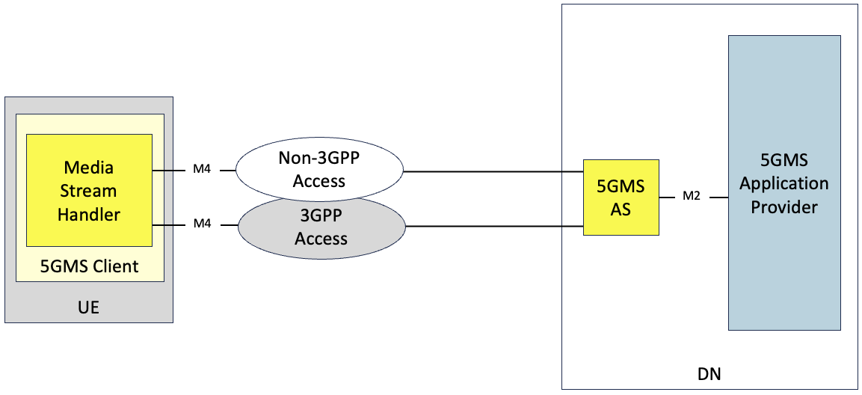
Figure 5.18.2.1-1: Multi-access media delivery without using ATSSS
Figure 5.18.2.1-1 shows the Media Stream Handler communicating with a single 5GMS AS instance through different access networks. Neither access network has direct communication with its peers. The 5GMS AS communicates (minimally) with the Application Provider at reference point M2 and with the 5GMS AF (not depicted) via reference point M3. In some scenarios, the 5GMS Client and 5GMS AS may use lower-layer functionality and/or functions to manage multi-access media delivery. In these cases, a single reference point M4 may be split among multiple access networks. In the particular case of multipath TCP as specified in RFC 8684 [134], where multipath handling is typically a built-in kernel function, the 5GMS Client and 5GMS AS can be largely unaware of the use of multi-access delivery after creating an MPTCP socket.

5.18.2.2 Multi-Access media delivery using ATSSS
Figure 5.18.2.2-1 shows the collaboration scenario for multi-access media delivery using ATSSS. In this scenario, the multi-access delivery is supported by ATSSS functionalities deployed in both the UE and the UPF, as described in clause 5.18.1.3 of the present document. These are responsible for steering, switching, and splitting of M4 application flows. Depending on the ATSSS mechanism selected, the 5GMS Client and the 5GMS AS may be unaware of multi-access media delivery.
Figure 5.18.2.2-1: Multi-access media delivery using ATSSS

5.18.3 Architecture mapping

5.18.3.1 Multi-access downlink media streaming using CMMF
Integration of CMMF within the 5GMS architecture is discussed in detail within clause 5.19. This clause discusses the differences for the collaboration scenario presented in clause 5.18.2.1.

5.18.3.2 ATSSS mapping into 5GMS architecture
Figure 5.18.3.1-1 shows the detailed collaboration scenario for multi-access media delivery using different ATSSS steering functionalities described in clause 5.18.1.3 of the present document.
Figure 5.18.3.1-1: Multi-access media delivery using different ATSSS steering mechanisms
In figure 5.18.3.1-2, the UE and the network may negotiate the use of one or more ATSSS steering mechanisms:
1. If the UE and the network agree on using the low-layer steering mechanism (ATSSS-LL) as specified in clause 5.32 of TS 23.501 [23]:
a. The 5GMS Client and the 5GMS AS are unaware of multi-access media delivery.
b. Traffic steering, switching, and splitting decisions at the UE and UPF are based on information at IP the layer and below.
c. A data switching function in the UE decides how to steer, switch, and split M4 flows across the 3GPP and non-3GPP accesses based on provisioned ATSSS rules and local conditions (e.g., signal loss conditions).
d. Any type of traffic, including the TCP traffic, UDP traffic, Ethernet traffic, etc. from the 5GMS Client may be steered, switched, or split.
2. If the UE and the network agree on using the high-layer MPTCP Steering mechanism as specified in clause 5.32.6.2.1 of TS 23.501 [23]:
a. The 5GMS Client and the 5GMS AS may be unaware of multi-access media delivery.
b. Traffic steering, switching, and splitting decisions at the UE and UPF are based on information at the IP layer and above.
c. The network enables an MPTCP proxy in the UPF for the multi-access PDU Session.
d. The network allocates three IP addresses/prefixes to the UE – one for the multi-access PDU Session and two additional IP addresses/prefixes called “MPTCP link-specific multipath” addresses associated with each of the 3GPP and non-3GPP Accesses. The “MPTCP link-specific multipath” addresses may not be routable via N6.
e. TCP application flows at reference point M4 from the Media Stream Handler of the 5GMS Client in a UE allowed to use MPTCP functionality are sent to the MPTCP proxy over the two access networks using the two link-specific multipath addresses, and the MPTCP proxy functionality in the UPF uses the multi-access PDU Session IP address/prefix to communicate with the 5GMS AS in the DN.
f. Any non-MPTCP traffic from the 5GMS Client is routed over either the 3GPP Access or the non-3GPP Access based on a received ATSSS rule for non-MPTCP traffic as specified in clause 5.32.2 of TS 23.501 [23].
3. If the UE and the network agree on using the high-layer MPQUIC Steering mechanism as specified in clause 5.32.6.2.2 of TS 23.501 [23].
a. The 5GMS Client and the 5GMS AS may be unaware of multi-access media delivery.
b. Traffic steering, switching, and splitting decisions at the UE and UPF are based on information at the IP layer and above.
c. The network enables an MPQUIC proxy in the UPF for the multi-access PDU Session.
d. The network allocates three IP addresses/prefixes to the UE – one IP for the multi-access PDU Session and two additional IP addresses/prefixes called “MPQUIC link-specific multipath” addresses associated with each of the 3GPP and non-3GPP Accesses. The “MPQUIC link-specific multipath” addresses may not be routable via N6.
e. A QoS Flow selection and steering mode selection component in the Media Stream Handler of the 5GMS Client determines the number of multipath QUIC connections to be set up for the application flows at reference point M4. Each QUIC connection carries one QoS flow (based on QoS rules) i.e. each multipath QUIC connection carries the UDP traffic mapped to a single QoS flow
f. QUIC-based UDP application flows at reference point M4 from the Media Stream Handler of a 5GMS Client are sent over the two access networks to the MPQUIC proxy using the two link-specific multipath addresses with multiple QUIC paths, and the MPQUIC proxy functionality in the UPF uses the multi-access PDU Session IP address/prefix to communicate with the 5GMS AS in the DN.
Table 5.18.3.2-1 provides a description of whether the 5GMS Client and/or 5GMS-Aware Application is aware of multi-access media delivery for each of the steering functionalities supported in this release.
Table 5.18.3.2-1: Application awareness of UE steering functionalities
Steering functionality | Application awareness | Application transparency
ATSSS-LL | No | Yes
MPTCP | Yes. 5GMS Client or 5GMS-Aware Application may use API as described in clause 5.18.1.3.2 to control MPTCP behaviour. | Yes. 5GMS Client or 5GMS-Aware Application may use just the standard TCP sockets API as described in clause 5.18.1.3.2 to be transparent with MPTCP functionality.
MPQUIC | Yes. 5GMS Client or 5GMS-Aware Application may use API as described in clause 5.18.1.3.3 to control MPQUIC behaviour. | TBD

5.18.4 High-level call flow

5.18.4.1 Multi-access downlink media streaming using CMMF

5.18.4.2 Multi-Access media delivery using ATSSS
From clause 5.32 of TS 23.501 [23] and clause 4.22.3 of TS 23.502 [24], a Multi-access PDU Session may be set up in one of three different ways:
1. The UE may set up a Single Access PDU Session over one access network, and then register over another access network and request a Multi-access PDU Session to be set up using both the access networks.
2. The UE may indicate its capability for ATSSS, and request the setting up of a Multi-access PDU Session to begin with.
3. The UE may request to set up a Single-Access PDU Session, but the network may transparently set up a Multi-access PDU Session instead.
For simplicity, for the high-level call flows for 5G Media Streaming with multi-access media delivery, the first option above is used. Figure 5.18.4.2-1 shows a high-level call flow for a 5G Media Streaming session over a Multi-access PDU Session that uses two different access networks: a 3GPP access and a non-3GPP access.
Assumptions:
- The 5GMS Client is unaware of the UE ATSSS steering functionality.
- 5G Media Streaming session is set up over 3GPP access first before the UE switches to a Multi-Access PDU Session to use both the access networks.
Figure 5.18.4.2-1: 5G Media Streaming session with multi-access media delivery
The steps are as follows:
1. The UE sets up a Single-Access PDU Session over the 3GPP access using the PDU Session establishment procedure specified in clause 4.3.2 of TS 23.502 [24]. The 5GMS entities on the UE set up a 5G Media Streaming session over the Single-Access PDU Session as specified in clause 5.2 of TS 26.501 [15].
2. The Media Stream Handler in the 5GMS Client of the UE interacts with the 5GMS AS for M4 media streaming over 3GPP access.
3. UE requests setting up a Multi-Access PDU Session spanning both the 3GPP access network and the non-3GPP access network with the SMF as specified in claue 5.32 of TS 23.501 [23]. This request includes UE capabilities for ATSSS multi-access delivery and the UE’s preferred steering functionalities.
4. A decision is made by the SMF to switch the Single-Access PDU Session of the UE to a Multi-Access PDU Session. (The SMF may interact with the PCF to make this decision.)
5. The SMF sends updated ATSSS rules to the UE as specified in clause 5.32 of TS 23.501 [23].
6. The SMF updates the forwarding behaviour of the UPF for the Multi-Access PDU Session by sending updated N4 rules for multi-access delivery to the UPF. Based on the the received N4 rules, the UPF activates the required steering functionality.
7. The UE OS processing the received ATSSS rules activates the UE ATSSS Steering Functionality in the UE.
8. If the highest priority rule in the received ATSSS rules indicates steering of traffic towards a specific access nework (e.g., 3GPP access), then:
- In the uplink direction, the M4 media flows from the Media Stream Handler are sent to the UE ATSSS Steering Functionality, which then forwards the media flows to the UPF over the 3GPP access network, and the UPF forwards the media flows to the 5GMS AS.
- In downlink direction, the M4 media flows from the 5GMS AS are sent to the UPF, which then forwards them to the UE ATSSS Steering Functionality over the 3GPP access network, which then forwards them to the Media Stream Handler in 5GMS Client.
9. If the high priority rule in the received ATSSS rules indicates switching of traffic towards a specific access network (e.g., from 3GPP access to non-3GPP access), then:
- In the uplink direction, the M4 media flows from the Media Stream Handler are sent to the UE ATSSS Steering Functionality, which then forwards the media flows to the UPF over the non-3GPP access, and the UPF forwards the media flows to the 5GMS AS.
- In the downlink direction, the M4 media flows from the 5GMS AS are sent to the UPF, which then forwards the media flows to the UE ATSSS Steering Functionality over the non-3GPP access network, which then forwards them to the Media Stream Handler in 5GMS Client.
10. If the highest priority rule in the received ATSSS rules indicates splitting of traffic between two access networks (e.g., 3GPP access and non-3GPP access), then:
- In the uplink direction, the M4 media flows from the Media Stream Handler are sent to the UE ATSSS Functionality. The UE ATSSS Steering Functionality then splits the M4 media flow traffic according to the criteria defined in the ATSSS rules and distributes it between both the 3GPP access and the non-3GPP access networks when forwarding it to the UPF. The split M4 flows arrive at the UPF where the ATSSS Steering Functionality in the UPF aggregates the split M4 traffic, and then forwards the aggregated M4 flows to the 5GMS AS.
- In the downlink direction, the M4 media flows from the 5GMS AS are sent to the ATSSS Steering Functionality in the UPF. The ATSSS Steering Functionality in the UPF then splits the M4 media flow traffic according to the criteria defined in the N4 rules and distributes it between both the 3GPP access and non-3GPP access networks when forwarding it to the UE. The split M4 flows arrive at the UE. The UE ATSSS Steering Functionality aggregates the split M4 traffic, and then forwards the aggregated M4 flows to the Media Stream Handler in the 5GMS Client of the UE.
Figure 5.18.4.2-2 shows a high-level call flow for a 5G Media Streaming session over a Multi-access PDU Session that uses two different access networks: a 3GPP access and a non-3GPP access, when the 5GMS-Aware Application is aware of ATSSS Functionality in the UE.
Figure 5.18.4.2-2: 5G Media Streaming session with multi-access media delivery when the 5GMS-Aware Application is aware of ATSSS Functionality in the UE
The steps are as follows:
1. A 5G Media Streaming session over a Multi-Access PDU Session is set up as described in steps 1–7 of figure 5.18.4.2-1 of the present document. This includes setting up ATSSS Functionality in the UE for multi-access media delivery.
2. The 5GMS-Aware Application receives information from the UE ATSSS Steering Functionality that multi-access delivery is being activated. The UE ATSSS Steering Functionality may provide information to the 5GMS-Aware Application about the multipath connection and associated subflows/paths.
3. The 5GMS-Aware Application configures the UE ATSSS Steering Functionality. The configuration information is based on the application configuration information described in clause 5.18.1.3.2 of the present document.
4. The Media Stream Handler in the 5GMS Client interacts with the 5GMS AS using multiple access networks as described in steps 8–10 of figure 5.18.4.2-1 of the present document.
Figure 5.18.4.2-3 shows a high-level call flow of the Dynamic Policy procedure for 5G Media Streaming before and after activation of multi-access media delivery.
Figure 5.18.4.2-3: Dynamic Policy Procedure for a 5G Media Streaming Session with multi-access delivery
The steps are as follows:
1. A 5G Media Streaming session over a Multi-Access PDU Session is set up, and M4 media flows are exchanged by the Media Stream Handler in the UE and 5GMS AS over an access network (e.g., 3GPP access) as described in steps 1–2 of figure 5.18.4.2-1 of the present document.
2. The Media Session Handler in the UE 5GMS Client instantiates a Dynamic Policy in the 5GMS AF to be applied to 5G Media Streaming session as described in clause 5.7.4 of TS 26.501 [15]. In some cases, a QoS specification may be provided which contains the desired QoS information.
3. The 5GMS AF interacts with the PCF on behalf of the 5GMS Client (directly if the 5GMS AF is deployed in the Trusted DN, or via the NEF if 5GMS AF is in the external Data Network) to facilitate the application of the requested Dynamic Policy.
4. The M4 media flows are transferred between the Media Stream Handler and 5GMS AS over 3GPP access with the requested dynamic policy.
5. A multi-access media delivery session is set up using 3GPP access and non-3GPP access networks as described in steps 3–7 of figure 5.18.4.2-1 and steps 2–3 of figure 5.18.4.2-2 of the present document. The 5GMS-Aware Application may or may not be aware of multi-access media delivery.
6. M4 media flows are transferred over the 3GPP accesss and non-3GPP access, as described in steps 8–10 of figure 5.18.4.2-1.
7. The Media Session Handler interacts with the 5GMS AF to modify the Dynamic Policy as described in clause 5.7.4 of TS 26.501 [15] so that it applies to the multi-access 5G Media Streaming session.
- If the M4 media flows are exchanged by the Media Stream Handler in the UE and 5GMS AS exclusively over the 3GPP access (as a result of using the high priority rule in the received ATSSS rules reflecting either a traffic steering or traffic switching decision to the 3GPP access), the requested QoS specified in the Dynamic Policy instance may be succesfully applied.
- If the M4 media flows are exchanged by the Media Stream Handler in the UE and 5GMS AS exclusively over the non-3GPP access (as a result of using the high priority rule in the received ATSSS rules reflecting either a traffic steering or traffic switching decision to non-3GPP access), the requested QoS specified in the Dynamic Policy instance may be succesfully applied if the non-3GPP access can guarantee and provide the required policy treatment.
- If the M4 media flows are exchanged by the Media Stream Handler in the UE and 5GMS AS over both the 3GPP access and the Non-3GPP access (as a result of using the high priority rule in the received ATSSS rules reflecting a traffic splitting decision to both 3GPP access and non-3GPP access), the requested QoS specified in the Dynamic Policy instance may be succesfully applied if the non-3GPP access can guarantee and provide the required policy treatment to the traffic it carries.

5.18.5 Gap analysis and requirements

5.18.5.1 Multi-access downlink media streaming using CMMF

5.18.5.2 Multi-Access media delivery using ATSSS
The following potential open issues are identified in the specific case where multipath delivery is not transparent to the 5GMS-Aware Application:
- There is no specification related to informing the 5GMS-Aware Application of multiple paths when the UE is using ATSSS-based multipath media delivery.
- There is no specification related to configuration of multiple paths by 5GMS-Aware Application when the UE is using ATSSS-based multipath media delivery.
In addition, the existing procedures for Dynamic Policies do not allow the 5GMS Client to request policy treatment over a specifc access network if the M4 flows are exchanged using multiple access networks. This is due to the fact that the currently specified data model parameters for dynamic policy procedures (as described in clause 5.18.1.4 of the present document) do not allow for identification of specific paths if multiple paths are possible between the UE and the 5GMS AS. Specifically, the sourceAddress and destinationAddress parameters of IPPacketFilterSet used in the Application‌Flow‌Description type (as described in clause 5.18.1.4 of this present document) both use the IP addresses of the Multi-Access PDU Session (as described in clause 5.18.1.3.1 of present document) assigned to the UE and UPF Steering Functionalities.
For identification of specific path, it is required that either the MPTCP link-specific multipath addresses or the MPQUIC link-specific multipath addresses be used, but these addresses are not routable via N6 (see clause 5.18.1.3.1 of present document), so these IP addresses are not candidates for use during the Dynamic Policy instantiation request that is to be sent to the 5GMS AF over N6.
This is an issue if one of the paths is a problematic path in a multipath environment as described in clause 5.18.1.3.2 of the present document. However, according to clause 5.32.4 of TS 23.501 [23], traffic splitting for GBR QoS Flows is not supported. So, if M4 media flows are transported as GBR QoS Flows, then traffic splitting of M4 media flows using ATSSS is not supported in this release, and the study needs to be revisited in a future release.
NOTE: The Rel-18 ATSSS specification does not support traffic splitting for GBR QoS Flows between 3GPP and Non-3GPP accesses. The ATSSS specification work in future releases is to be monitored, and referenced here when there is an update.

5.18.6 Candidate solutions

5.18.6.1 Multi-access downlink media streaming using CMMF
This candidate solution includes approaches where a 5GMSd Client accesses and downloads, via reference point M4d, CMMF-encoded media objects [126], and possibly original source media (e.g., MPEG-DASH or HLS media segments), over multiple access networks simultaneously from a single 5GMSd AS. CMMF (discussed in detail within clause 5.19.6.3) enables multi-access capabilities through application-layer implementations of the 5GMSd Client without requiring lower-layer (e.g., network, transport, etc.) multi-access integrations.
In this solution, multiple different CMMF-encoded bitstreams/objects (or representations) of the source media are stored/cached within a single logical 5GMSd AS. A CMMF-enabled 5GMSd Client requests and downloads a different CMMF-encoded representation (stripe) of the required original source media over each of the access networks available to it. These (potentially partially) received CMMF bitstreams/objects are decoded by a CMMF decoder in the 5GMSd Client yielding the required original source content once enough information has been received over all of the available access networks.
Unlike other multi-access technologies such as MPTCP, MPQUIC, ATSSS, etc., the responsibility to set up, request, and steer the delivery of content across each available access network rests with the application layer (e.g., Media Player) in this solution. For example, a Media Player sets up multiple HTTP connections in parallel, each one bound to a different network interface (each assigned with an IP address appropriate to that network). Requests to a single 5GMSd AS for different CMMF-encoded representations (stripes) of the original source media are sent from each of the HTTP connections over the different access networks. The HTTP response from the 5GMSd AS to each of these requests is routed appropriately over the appropriate access network, following standard network-layer/IP routing rules and procedures.
As mentioned above, traffic steering over each access network may be performed by the application layer (e.g., Media Player); and multiple policies can be defined/implemented based on the desired outcome. For example, a best-effort policy may evolve downloading as much CMMF-encoded content from each available access network until the CMMF decoder can successfully decode the required media. Networks that have lower latency, higher bandwidth, etc. will naturally contribute more to the download than those with higher latency, lower bandwidth, etc. Another policy may preference delivery of content from one access network over another. In this case, a schedular may be implemented so that requests of CMMF-encoded content made to the Application Server can be throttled over one access network so that the majority of the download is completed on the other(s).
Integration of CMMF within the 5GMS System is discussed in detail within clause 5.19.6.3.

5.18.6.2 Multi-Access media delivery using ATSSS
To address the gaps identified in clause 5.18.5.2, it is proposed to extend the media stream handling client API exposed by the Media Stream Handler to the 5GMS-Aware Application at reference point M6 and to the Media Session Handler at reference point M11 as follows:
1. For the 5GMS-Aware Application to configure the following multipath delivery parameters:
- Enable/disable multipath media delivery.
- The number of MPQUIC paths or MPTCP subflows in the multipath delivery connection.
- Add new or remove existing MPQUIC path or MPTCP subflows to/from an existing multipath delivery connection.
- Which media application flows are mapped onto which MPQUIC path or MPTCP subflow.
These objectives are achieved by enhancing the parameters to the Configurations and settings API specified in clause 13.2.4 of TS 26.512 [16] as follows:
- Add new properties indicating, for each target service location/endpoint at reference point M4, the minimum and maximum number of MPQUIC paths or MPTCP subflows that the Media Player should use, and which multipath transport protocol (MPQUIC and/or MPTCP) the Media Player is permitted to use for each such service location/endpoint. If the minimum and maximum number are both set to zero, multipath operation is disabled for that service location/endpoint.
2. For the 5GMS-Aware Application to be informed of the following:
- Connection endpoint information to each of the MPQUIC path or MPTCP subflow.
- Status information of multipath delivery connection.
These objectives are achieved by enhancing the Dynamic Status Information specified in clause 13.2.6 of TS 26.512 [16] as follows:
- Add a new property (e.g., multipathDeliveryStatus of type string) to expose status information about the multipath delivery connection to the 5GMS-Aware Application.
NOTE: Detailed formats of the above information are to be developed in conjunction with study progress documented in clause 5.24 of present document.

5.18.7 Summary and conclusions
Multi-access media delivery enables media streaming applications to efficiently access content over multiple access networks. This Key Issue has examined existing specification relating to the ATSSS (Access Trafffic Steering Switching and Splitting) architecture in TS 23.501 [23] and TS 23.502 [24] to identify its impact on 5GMS. Topics relating to application awareness and influence on multi-access delivery, potential enhancements to dynamic policy feature of 5GMS to support multiple access paths, and network assistance with multi-access delivery have been studied. The Key Issue has documented collaboration scenarios and the mapping of the ATSSS architecture into the 5GMS architecture.
The MPTCP and MPQUIC link-specific multipath IP addresses are not routable via N6 as of current release, and therefore identification of specific paths for any 5G Media Streaming procedures is not supported. Further, traffic splitting for GBR QoS Flows is not supported. If M4 media flows are transported as GBR QoS Flows, then traffic splitting of M4 media flows using ATSSS is not supported in this release, and the study is to be revisited in a future release.
It is recommended that:
1. An informative annex is added to TS 26.501 [23] documenting:
a. A brief description of multi-access media delivery, based on clause 5.18.1 of the present document.
b. The mapping of the ATSSS architecture into the 5GMS architecture, as described in clause 5.18.3.2 of the present document.
2. Changes to the Configuration Settings API and to the Dynamic Status Information API as described in clause 5.18.6.2 of the present document are implemented in TS 26.510 [108] to allow for application configuration and status information exchange for multi-access media delivery.

===== CHANGE =====

5.19 Media delivery from multiple service endpoints/locations

5.19.1 Description

5.19.1.1 Introduction
Media streaming applications conventionally obtain content from a single source or endpoint over a single path within a network. Each source, or endpoint, may consist of a single server located within the network or an entire network of servers (e.g., a Content Distribution Network (CDN)). Operating in this manner imposes several limitations:
1. Performance is constrained to that of the source/endpoint and path chosen. Whatever the limits on network bandwidth and latency between the client and that source/endpoint are directly translated to the client’s achievable Quality of Service (QoS) and Quality of Experience (QoE).
2 Disruptions or degraded performance caused by the source/endpoint in use or on any of the network links between the client and source/endpoint can lead to poor user experience, often in the form of lower playback quality, rebuffering, or complete playback failure.
This study considers integration of different technologies into the 5G Media Streaming System that addresses these, and similar, issues by allowing media streaming applications to efficiently access content across multiple sources/endpoints and/or multiple access networks. Different client implementations may then beneficially use the content on these multiple sources or networks concurrently, potentially guided by service or network provider. In addition, formats and techniques for generating content for multiple sources/endpoints or multiple access network delivery such as MPEG-DASH Part 9 (ReAP) [112] may be considered. Further extensions include the ability for a client to use multiple access networks at the same time to support media delivery. Study of integration of different technologies into the 5G Media Streaming System is of relevance to address content provisioning, content hosting, impacts on user plane reference points M2 and M4, and on media session handling at reference point M5 as well as potential benefits in terms of quality and resource usage.
A multi-CDN or multiple service location/endpoint content offering generally provides content in a redundant manner at locations that can be differentiated by the client. The locations typically differentiate in one or multiple Quality-of-Service criteria. For example, every service location/endpoint may have different access bit rates, reliability and/or availability, distribution costs, etc. When implemented by a commercial Content Delivery Network (CDN), this is sometimes referred to as multi-CDN, but the concept is more general and may preferably be named multiple service locations/endpoints.
In one embodiment, identical content is offered at multiple service locations. In another embodiment, different subsets of content are offered on one or the other service location/endpoint (e.g., these may be CMMF-coded redundant versions). Decisions on which location to use at which time may be made by the client only, by instruction from the network or service provider, or by a combination of the two. Multiple service location/endpoint approaches may also be considered in broadcast/multicast/unicast scenarios.
For the purposes of this study, the terms "CDN", "source", "endpoint", and "service location" are used interchangeably. They each refer to a single entity within the network consisting of one or more physical hosts where content is made accessible to streaming media clients. Each individual entity may be distinguishable from the others through differences in configuration (e.g., different domain names, hosting configuration, etc.).

5.19.1.2 Challenges Multi-CDN deployments aim to address
CDNs are often used by content distributors to globally scale delivery of their content to end-users. These networks consist of a number of Points of Presence (PoPs) located at various locations around the networks’ edge. These PoPs help load-balance delivery of content as well as improve Quality of Service (QoS) by reducing the distance/latency between every client and the content they are accessing. In many cases, content distributors employ multiple CDNs to leverage the strengths of one CDN over another in every location those CDNs have a PoP. For example, a client experiencing degraded performance while using one CDN may switch to another that is offering better performance at that time and location. As another example, a content distributor may prefer one CDN over another at a given time to reduce delivery costs and/or meet monthly contractual commitments. These multi-CDN deployments aim to solve content delivery issues that exist when only one CDN is used; but the benefits they provide may not be fully realized because of the various challenges experienced and underlying methods used to stream content to every client.
Challenges multi-CDN deployments and architectures aim to address may include:
1. Sustained CDN-/network-wide service disruptions where network access, connectivity or QoS is severely degraded. Examples may include cases where an entire CDN’s network is degraded because of a network-wide misconfiguration or power failure. The duration of these events may last minutes to hours and affect a majority of the client population. Examples of recorded instances can be found in [113], [114], [115], [116], [117], and [118].
2. Intermittent or short-term disruptions affecting QoS for an individual or small group of clients. Examples include short periods of congestion within the network, isolated HTTP request/response failures or delays caused by application server congestion, etc. The following discusses these in greater detail: [119], [120], [121], [122], [123], [124], and [125]
3. Augmentation of one CDN's performance with that of another to achieve a level of performance that neither can provide on its own. An example is a peer-to-peer CDN where each peer has limited uplink capacity and is unable to satisfactorily service client demand on its own.
The following clauses summarize some of the approaches that can be used to enable multi-CDN or multi-source/endpoint delivery to mitigate the challenges described above. Some of these solutions may be implemented over the top of the 5GMS System in such a way that content hosted within the 5GMS System is treated as a single CDN/source/endpoint, while others exist outside of the 5GMS System (e.g., commercial CDNs, etc.).

5.19.1.3 Media delivery with DNS-based switching

5.19.1.3.1 Functional description of DNS-based switching
Multi-CDN delivery using a DNS server to perform switching between CDNs is a popular way to improve the delivery of services. In this solution, an Application Provider selects the source, or endpoint, media players stream from by updating Domain Name System (DNS) records with pointers to the appropriate content source/endpoint. This approach is convenient since it is transparent to the media player.
In this case the media player does the following:
1. Segment or MPD request: The media player selects a Media Presentation Description (MPD) or a media segment to download, along with its associated URL. The domain name contained within this URL is typically generic to the Application Provider’s service, rather than to a specific CDN or content source/endpoint. Furthermore, this domain name is typically an alias to a canonical domain that can be resolved by obtaining the associated CNAME record within DNS.
2. DNS resolution: The media player first initiates a DNS lookup to resolve the domain name contained within the URL selected in step 1. This process ultimately returns with the IP address(es) required to establish the appropriate transport session(s) needed to request and download the MPD or media segment. The media player sends a DNS query to a DNS resolver (typically located within the ISP’s network). Depending on the status of the DNS resolver’s cache, the resolver may forward this query to an authoritative DNS server. In the case where a CNAME record is obtained by the DNS resolver, the canonical domain name contained in the CNAME record is resolved. This process continues until the appropriate A (IPv4 address) or AAAA (IPv6 address) DNS record is obtained. The DNS resolver finally responds to the media player’s DNS query with the resolved IP address(es) associated with the domain name contained within the original URL.
3. The media player establishes a transport session (e.g., TCP session) with the server associated with the IP address(es) returned by the DNS resolver. In the case where multiple IP addresses are returned in response to the prior DNS query, establishment of a transport session to the first IP address listed in the DNS query response is attempted. If unsuccessful, an attempt to establish a transport session with the second IP address listed in the DNS query response is attempted. This process continues until establishment of a transport session is successful or all attempts to each of the returned IP address have failed.
4. HTTP request and content delivery: The media player requests and obtains the MPD or media segment from the remote endpoint of the established transport session via HTTP.
The process, outlined above, which the media player follows is no different than what it would normally do to request and stream content. However, the functionality to switch sources, or endpoints, in this multi-CDN approach is implemented by changing the DNS records used to resolve the DNS queries in step 2 above. As mentioned above, the domain name of the URL used by the media player is typically setup as an alias in a DNS CNAME record where the canonical domain name contained in this record points to the location where the content should be streamed. An Application Service may change this DNS CNAME record so that the canonical domain name points to a different location (e.g., a different CDN, source, or endpoint). Determination of the canonical name used in the DNS CNAME record may be based on criteria such as performance (e.g., latency, bit rate, etc.), cost, geographic location, etc.

5.19.1.3.2 DNS-based switching requirements on multi-CDN delivery
Evaluating DNS-based switching requirements on multi-CDN delivery is left for further study.

5.19.1.3.3 DNS-based switching performance
Evaluating DNS-based switching performance for the purposes of enabling multi-source delivery is left for further study.

5.19.1.4 Media delivery with DASH-based client-side switching

5.19.1.4.1 Functional description of DASH-based client-side switching
In the specific case of MPEG-DASH, the same steps as in clause 5.19.1.3.1 may be applied, but some preceding steps can be implemented to select CDN or URL in the DASH Media Presentation Description.
The usage of multiple base URLs and consistent resolution is also described in the 3GPP DASH profile specified in clause 8.6 of TS 26.247 [40]. In DASH, it is possible to use a relative base URL to point to files on a relative path, or one could use an absolute base URL that contain the full base path to be used. For multi-CDN usage the absolute base URL path is typically used.
The Media Presentation Description can contain different BaseURL elements that enable fetching segments from different locations. In this case the media player (DASH client) can apply some additional logic, such as based on its historical data or assigned priorities in the Media Presentation Description to select a base URL. This base URL can then be combined with the relative path for the media segment’s full URL. This way, the media player can, by interpreting the media presentation description, decide on the URL to use for the request for the media segment or Media Presentation Description. After this step, the steps in clause 5.19.1.3.1 are followed.
To summarize, the following steps may be followed by the media player for media segment requests using the base URL in the Media Presentation Description before the step of multi-CDN delivery with a DNS server in clause 5.19.1.3.1.
1. Check the different base URLs in the Media Presentation Description that apply to the segment.
2. Check which base URL has the highest priority for usage, based on internal logic of the media player. In case a previous request has failed, another base URL may be selected, as before.
3. Combine the base URL with the relative path obtained for the media segment.
4. Apply the steps as described in clause 5.19.1.3.1.
This approach is applied in profiles for DASH used in the industry, such as DVB-DASH [129].
An example of handling error responses and using multiple base URLs is shown in figure 5.19.1.1.4.1-1.
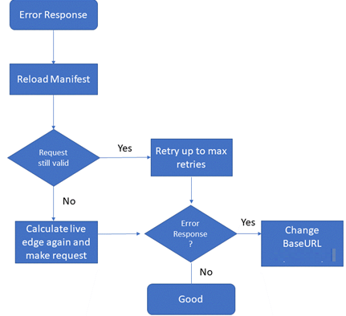
Figure 5.19.1.4.1-1: A media player combining baseURL changes,
MPD update and live edge calculation as in [129]
In this case, the step may include reloading the Media Presentation description and recalculating the live edge (in case a DASH dynamic media presentation is used) to obtain again the relative request URL and make sure it is valid.
The media segment is requested again, and in this case there should not be an error response.
In case of an error response the process may be repeated.

5.19.1.4.2 DASH-based client-side switching requirements on multi-CDN delivery
Evaluating DASH-based client-side switching requirements on multi-CDN delivery is left for further study.

5.19.1.4.3 DASH-based client-side switching performance
Evaluating DASH-based client-side switching performance for the purposes of enabling multi-source delivery is left for further study.

5.19.1.5 Media delivery using a Content Steering Server

5.19.1.5.1 Functional description of multi-CDN delivery using a Content Steering Server
There is no equivalent base URL feature available when using HTTP Live Streaming (HLS) [87] for media delivery. Instead, a mechanism known as HLS Content Steering was developed by Apple to support downloads from different pathways.
This feature uses an external Content Steering server to provide server paths to HLS clients allowing them to change the path of the requests. An HLS playlist may contain a tag to indicate information about the content steering server location (e.g. the tag #EXT-X-CONTENT-STEERING with SERVER-URI attribute indicates the steering server URI using this tag). An HLS client can then use this URI to request the steering manifest that includes information about the different pathway URIs (CDN paths) and suggested priority.
This approach has recently also been considered for use with MPEG-DASH by the DASH Industry Forum’s content steering architecture [111], so it is potentially applicable to DASH as well as HLS.
Figure 5.19.1.5.2-1 shows the basic architecture for Content Steering based on ETSI TS 103 998 [111]. Content steering provides a deterministic capability for a content distributor to switch the content source that a media player uses, either at start-up or at any point during the presentation, by means of a remote steering service.
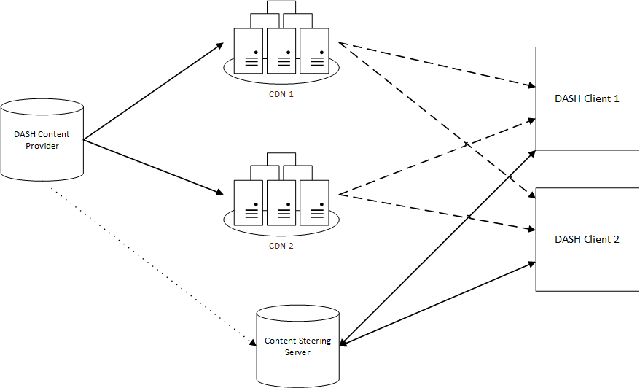
Figure 5.19.1.5.2-1: Content Steering architecture according to ETSI TS 103 998 [111]
Steering is accomplished by having the DASH client periodically access a Content Steering Server to retrieve a steering manifest, which instructs the player as to the availability and priority of content sources.
The typical procedures followed when content steering is in use are shown in figure 5.19.1.5.2-2 for the case when the content is provided on two CDNs.
Figure 5.19.1.5.2-2: Typical procedures for Content Steering according to ETSI TS 103 998
The DASH content provider generates an MPD that includes Base URLs to CDN1 and CDN2, as well as an address where the DASH clients can access the Content Steering Server.
3. The provider also uploads the MPD and the content segments to both CDNs.
6. At the start of playback, the DASH client requests the MPD from one CDN, in this case from CDN2. It finds the content steering server URL, and it may find information that instructs it to contact the content steering server prior to the first segment request versus the default behaviour of making the request once its starting buffer is full.
7. The DASH player then makes a request to the Content Steering Server.
8. The content server responds with a content steering manifest and the DASH client uses the information within to select the segment source, in this case from CDN2.
10. After some time, the content provider may collect operational information from the participating clients, for example by using Common Media Client Data (CMCD) as defined in CTA-5004 [105]. Based on this information, the content provider may update the Content Steering Server, and based on this updated information, the content steering manifest may change.
11. When the client requests an update to the content steering manifest, new information may be provided that instructs the DASH client to request media segments from CDN1 instead of CDN2.
13. The DASH client then switches smoothly, at a segment boundary, to download the next media segments from CDN1 instead of CDN2. The steering server response can also be used to steer the DASH client between alternate sources for DASH manifest refreshes, via service descriptors contained within the MPD.

5.19.1.5.2 Content Steering Server requirements on multi-CDN delivery
Evaluating Content Steering Server requirements on multi-CDN delivery is left for further study.

5.19.1.5.3 Content Steering Server performance
Evaluating Content Steering Server performance for the purposes of enabling multi-source delivery is left for further study.

5.19.1.6 Media delivery using SAND4M

5.19.1.6.1 Functional description of multi-CDN delivery using SAND4M
3GPP DASH as specified in clause 13.10 of TS 26.247 [40], defines the Server-Assisted Network Delivery (SAND) functionality that enabling SAND for Multi-Network support (SAND4M). The primary use case for SAND for Multi-Network Access resulted from the distribution of DASH content over MBMS or other networks, for which the MBMS Client acts as a DASH server or DASH-Aware Network Element (DANE) in order to provide DASH formats to the DASH client in a manner compatible with TS 26.247 [40].
Clause 13.10 of TS 26.247 [40] specifies required and recommended functions for both a DANE and a DASH client. Despite the requirements of this mode having been designed to fulfill the SAND functionalities, it is not restricted to this use case: this mode may also be used in other contexts, in particular when using multiple networks for distribution and dynamic steering across the network. Specifically, the following cases are considered potentially relevant to the topic of multi-CDN delivery:
- Not all resources announced in the presentation manifest (e.g. MPEG-DASH MPD) are always accessible on all networks, e.g. broadcast resource is unavailable when the UE is outside broadcast coverage.
- Not all resources are available on all networks all the time.
- Networks may have different availability times.
- Networks go down dynamically and may re-appear.
- The DANE may issue preferences for one network.
- The information may be established via in-band and out-of-band channels.

5.19.1.6.2 SAND4M requirements on multi-CDN delivery
Evaluating SAND4M requirements on multi-CDN delivery is left for further study.

5.19.1.6.3 SAND4M performance
Evaluating SAND4M performance for the purposes of enabling multi-source delivery is left for further study.

5.19.1.7 Media delivery using Coded Multi-source Media Format (CMMF)

5.19.1.7.1 Functional description of CMMF
Coded Multi-source Media Format (CMMF) [126] is an extensible container format designed to facilitate the management and interchange of audio-visual media and metadata in one or more coded representations (e.g., encoded with application-layer, forward error correction (FEC), linear, network, or channel codes). The coded media representations supported by CMMF enable the efficient use of multi-source, multi-path, and multi-access connectivity for network-delivered media applications. The use of CMMF does not replace the basic media streaming architectures and procedures already defined. Rather, it is intended to supplement them to provide additional capabilities.
A typical Video-on-Demand (VoD) MPEG-DASH HTTP adaptive streaming system is set up similarly to the non-shaded blocks shown in figure 5.19.1.3.6.1-1. Source media (e.g. audio/video elementary streams) are segmented and encoded into multiple representations, each with a different quality and bit rate. These segments are packaged together using MPEG-DASH (or HLS) and stored on an origin server located within the network. One or more CDNs are set up to distribute and deliver this content to an OTT service provider’s customer base. These CDNs obtain every requested MPEG-DASH (or HLS) segment from an origin server, caches these segments at their respective network edges, and deliver these segments to clients.
Enabling multisource delivery using CMMF within this existing delivery architecture can be accomplished through the addition of a CMMF Bitstream Generator/Source before segments are delivered to the CDNs, and a CMMF Receiver on each client, as illustrated by the shaded boxes in figure 5.19.1.7.1-1.
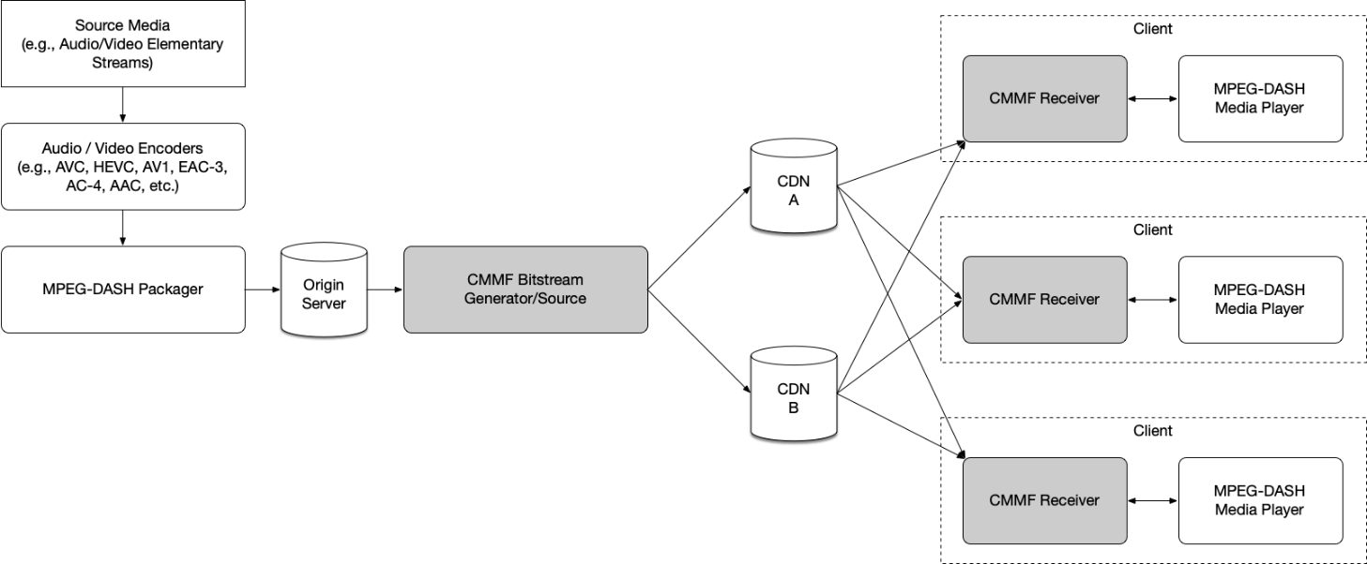
Figure 5.19.1.7.1-1: MPEG-DASH with CMMF Delivery System Example
While figure 5.19.1.7.1-1 shows the CMMF Bitstream Generator/Source between the Origin Server and the CDNs (i.e., CMMF bitstreams are created on demand), the CMMF Bitstream Generator/Source can just as easily be located between the MPEG-DASH Packager and the Origin Server. In the former case, the original MPEG-DASH segments are stored on the Origin Server and CMMF representations of those segments are cached on each CDN. In the latter case, the CMMF Bitstream Generator/Source creates multiple CMMF representations of each segment produced by the MPEG-DASH Packager and stores them on the Origin Server for later retrieval by a CDN.
In this system, the Application Service Provider is responsible for segmenting, encoding, and packaging the media. It is also responsible for creating a presentation manifest (MPD, shown in figure 15.19.1.7.1-2) that contains relative URLs to the files/segments (shown in a dotted outline) that make up the adaptation sets. This information is transferred from the Application Service Provider to the media player (using a method preferred by the Application Service Provider) and is used by the media player to determine which segments are to be downloaded (via the CMMF Receiver) and played.
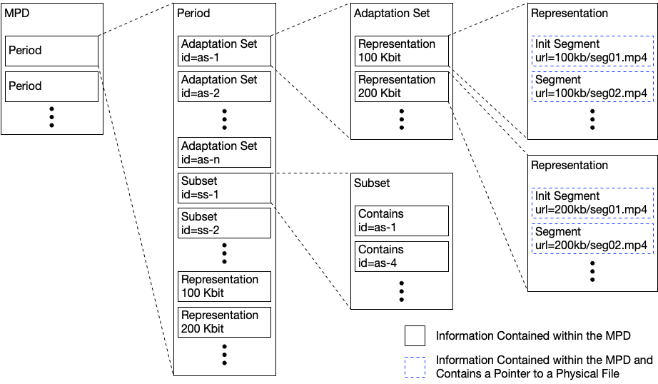
Figure 15.19.1.7.1-2: Example MPEG-DASH MPD
The Application Service Provider in this example is also responsible for determining and setting up the delivery system (i.e., the CDNs) to distribute CMMF-encoded media. Information about this setup is captured within the CMMF Configuration Information as a list of host URLs to each of the CDNs. It is important to note that both the MPEG-DASH master manifest and the CMMF Configuration Information is required to download the media. In this example, it is assumed that the Application Service Provider is utilizing two CDNs and each segment listed in the MPEG-DASH MPD is encoded and packaged into two unique CMMF bitstreams/objects, one intended for the first CDN and the other for the second CDN according to the list of host URLs provided in the CMMF Configuration Information. An example of this is shown in figure 15.19.1.7.1-3. Furthermore, example bitstream/object constructions can be found in annex C of [126].
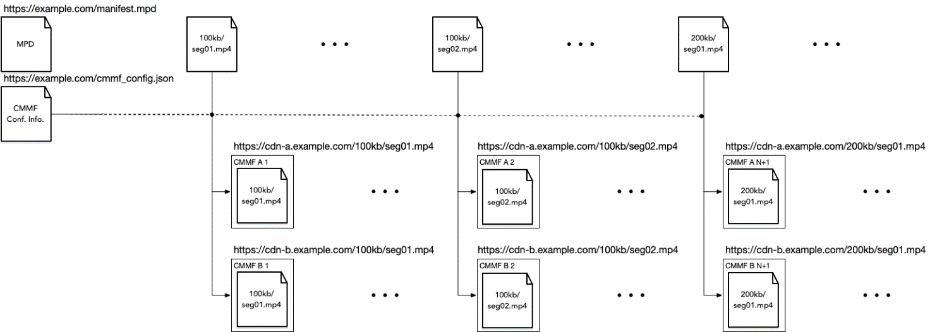
Figure 15.19.1.7.1-3: CMMF bitstreams/objects generated
to deliver the MPEG-DASH packaged content
The process for streaming this content is shown in figure 15.19.1.7.1-4.
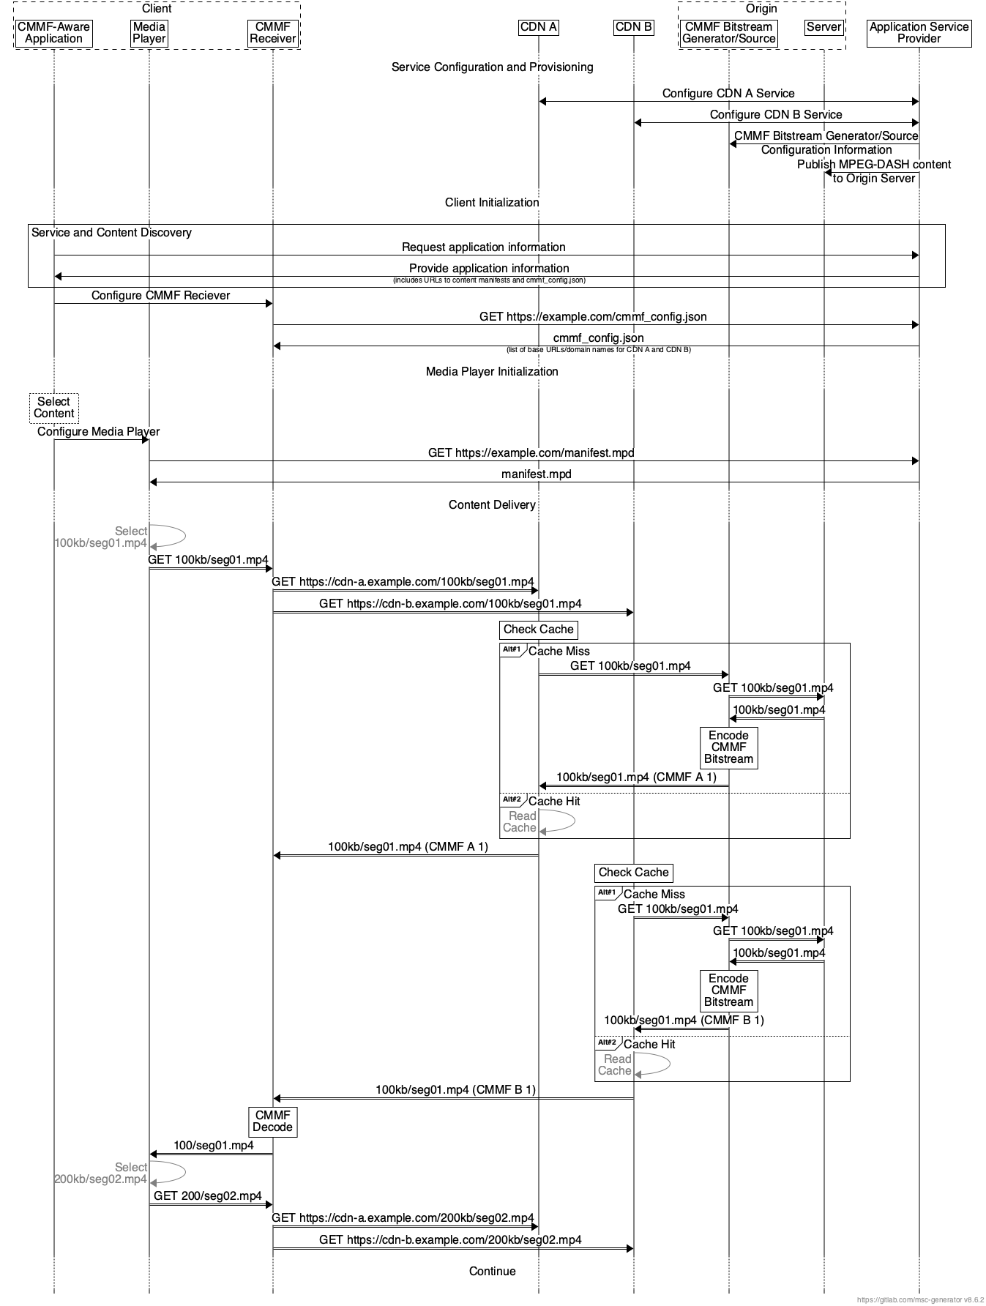
Figure 15.19.1.7.1-4: CMMF request and content delivery example for MPEG-DASH
An Application Service Provider first configures and provisions the CMMF service. The first steps are configuration of multiple CDNs. This configuration includes defining each CDN’s service domain names, origin host (e.g., the domain name of the CMMF Bitstream Generator/Source), caching policies, etc. The Application Service Provider also configures the CMMF Bitstream Generator/Source. This configuration includes the definition of necessary information for the CMMF Bitstream Generator/Source to properly encode and generate CMMF objects. Per ETSI TS 103 973 [126], this may include:
- the definition of a code type and code construction parameters,
- the definition of a CMMF profile,
- information about source object construction (e.g., fragmented HLS/MPEG-DASH segments, etc.),
- the location where source media can be found, etc.
The final step of this process is to publish MPEG-DASH and/or HLS content to an origin server (e.g., AWS S3 bucket).
Upon client initialization, the CMMF Receiver requests the CMMF Configuration Information (in this case it is stored as a JSON file) from the Application Service Provider. This information communicates a list of host URLs specifying the locations for which the client can retrieve CMMF encoded content for every segment listed within the master manifest file. In this case, this list includes the domain names used during the CDN configuration step. All other information required by the CMMF Receiver to successfully decode is provided within each downloaded CMMF object. This information includes the CMMF code type used to encode the source object, the methods used to construct the CMMF object (e.g., block structure, symbol size, etc.), and other relevant information.
Upon media player/delivery session initialization, the media player retrieves and parses the presentation manifest (MPD) from the Application Service Provider and chooses the adaptation set(s) it wishes to stream. Once selected, the media player requests the appropriate segment from the CMMF Receiver. The CMMF Receiver converts the received URL to two CMMF bitstream/object URLs (one for each base URL obtained from the CMMF Configuration Information file) and requests two distinct CMMF bitstreams/objects of that segment from the two available CDNs. Assuming the appropriate CMMF bitstream is cached, the CDN begins delivery. Otherwise, the CDN requests the segment from the CMMF Bitstream Generator/Source. At which point, the original segment is pulled from storage, encoded, and delivered to the CDN and to the client. The CMMF Receiver downloads the two CMMF bitstreams of that segment until it is capable of decoding. These downloads are performed using an appropriate strategy based on the underlying network protocols in use and network conditions. Once enough CMMF-encoded content has been received, the CMMF Receiver decodes the segment and delivers it to the media player. The media player selects the next segment to be downloaded and the process repeats.
In the case of a third CDN being introduced, a new CMMF bitstream can be generated and cached without replacing or modifying the existing CMMF bitstreams already cached in the initial two CDNs. All that is required is an update to the host URL list managed by the Application Service Provider.

5.19.1.7.2 CMMF as a Content Delivery Protocol
Annex D of ETSI TS 103 973 [126] defines a content delivery protocol instantiation. In this case, CMMF is considered as a Content Delivery Protocol (CDP) as defined in clause 8 of RFC 5052 [131]. Annex D provides a mapping of CMMF to the RFC 5052 principles and vice versa. This instantiation also permits re-use of existing FEC Codes including Raptor (the 3GPP MBMS code) as defined in RFC 5053 [132] and RaptorQ as defined in RFC 6330 [127]. The content delivery protocol also makes use of 3GPP concepts such as the FLUTE [133] File Delivery Table (FDT) as used in MBMS User Services [54] and MBS User Services [135]. A simplified architecture to provide an overview of the CMMF instantiation is shown in figure 5.19.1.7.2-1.
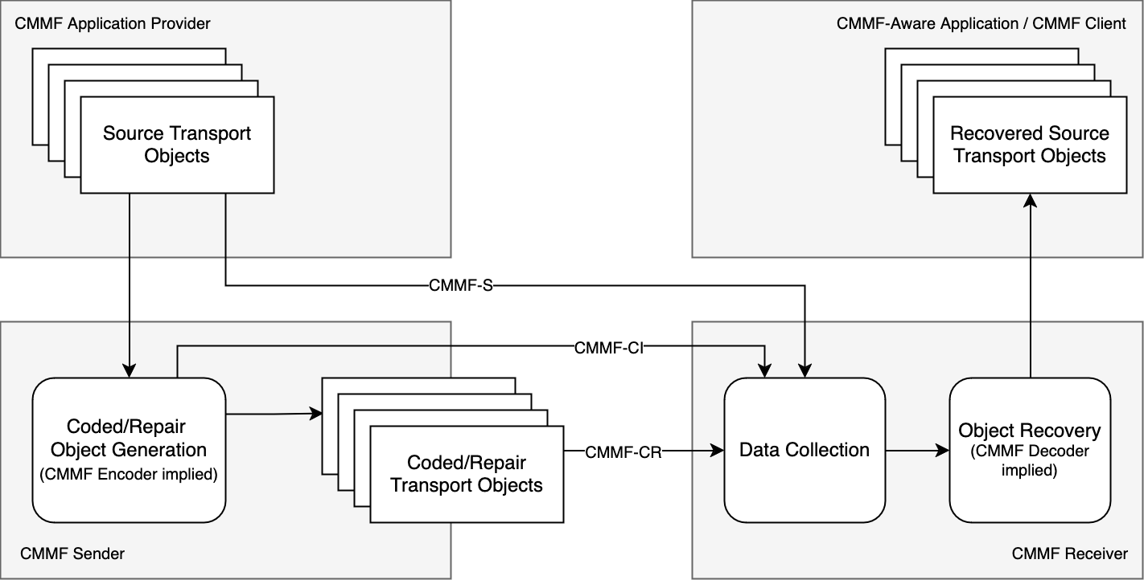
Figure 15.19.1.7.2-1: Simplified architecture addressing CMMF as a CDP
In this case, the following reference points are defined:
- CMMF-CI: This reference point provides Configuration Information describing the location and relationship of the source and coded/repair objects. This information may be provided to a CMMF receiver.
- CMMF-S: This reference point provides the source transport objects. For CMMF, these objects are unmodified from original data. Parts of these objects may be used by Object Recovery to recover source objects.
- CMMF-CR: This reference point provides the coded/repair transport objects.
Not explicitly mentioned in the diagram are the following reference points:
- The server-side configuration of the CMMF sender.
- The client-side API between the CMMF receiver and the application.
Operation is completely independent of any application manifest.
A call flow based on figure D.1 in ETSI TS 103 973 [126] is provided in the following.
Figure 15.19.1.7.2-2: Call flow for FLUTE-based CMMF CDP instantiation
According to ETSI TS 103 973 [126], object delivery may be organized in a session, where a session can include multiple transport flows, and each transport flow may include multiple objects. This arrangement is illustrated in figure 15.19.1.7.2-3.
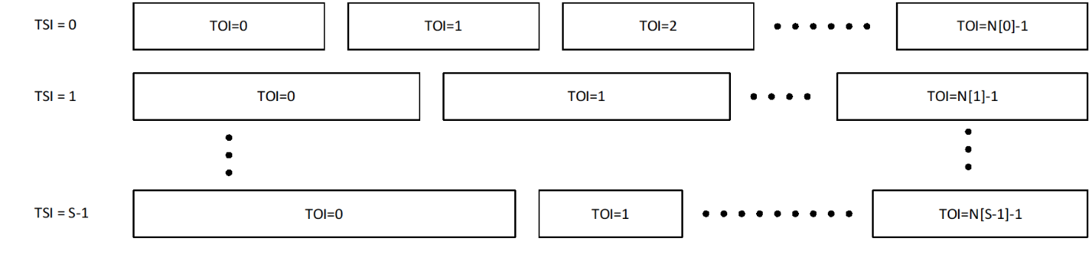
Figure 15.19.1.7.2-3: CMMF Transport Objects and Transport Sessions
In this case, information is provided to the CMMF receiver through configuration information, describing:
- Each logical flow that is operated.
- Each object, metadata of the object and other information.
- The type of the object as well encoding parameters.
More specifically:
- The Configuration Information describes source and coded/repair transport objects.
- The Configuration Information describes the CMMF encoding details, i.e. the FEC code in use, the structure of each object, etc.
- The Configuration Information allows the CMMF client to map an application request to CMMF receiver operations, for example to collect the relevant information from the network and recover an object.
- An application may also subscribe to a TSI, and the CMMF receiver pre-fetches all objects at the appropriate time for the application.
Some use cases may require additional information or only a subset of this information, and a simpler version of this parameter set may be used. The Configuration Information may be updated during the course of a session, for example when no files are available in a live service.
Table 15.19.1.7.2-1 lists typical configuration parameters.
Table 15.19.1.7.1-1: CMMF Configuration Information based on annex D of ETSI TS 103 973 [126]
Parameter |  |  |  | Usage | Definition
Complete |  |  |  | OD | Indicates whether the Configuration Information is complete.
Location |  |  |  | O | Information where the Configuration Information can be accessed, if carried externally.
Expires |  |  |  | M | Provides information when this Configuration Information is no longer valid and an update is needed, for example using a reload from Location.
Source Flow |  |  |  | 1 … S | Provides 1 … S source flows.
 | TSI |  |  | M | Transport Session Identifier (TSI) of the source flow.
 |  | Object |  | 1 … N | Provides 1 … N objects in the source flow.
 |  |  | TOI | M | Transmission Object Identifier (TOI) value that represents the source object.
 |  |  | Size | M | Size of the transmission object in bytes.
 |  |  | Content type |  | MIME media type of transmission object.
 |  |  | Encoding |  | Encoding of the transmission object.
 |  |  | Message Digest |  | Message digest of transmission object.
 |  |  | Associated URI |  | Name, identification, and location of transmission object (specified by the URI).
 |  |  | Access URL |  | The URL where the source object can be accessed. If the field is not present, then the source flow is not directly accessible.
 |  |  | Availability start time |  | Wall-clock time when the resource is accessible.
 |  |  | Availability end time |  | Wall-clock time when the resource ceases to be available.
 |  |  | <Additional metadata> |  | May include cache or entity tag metadata.
 |  | Representation |  |  | Refers to a DASH Representation in an MPD or a Track in an HLS manifest.
Coded/Repair Flow |  |  |  | 1 … R | Provides 1 … R coded/repair flows.
 | TSI |  |  | M | Identifier of the coded/repair flow.
 |  | Object |  | 1 … N | Provides 1 … N objects in the coded/repair flow.
 |  |  | TOI | M | Transmission Object Identifier (TOI) value that represents the coded/repair transport object.
 |  |  | FEC-OTI |  | If the transmission object is coded using a scheme based on RFC 5052 [131], FEC Object Transmission Information including the FEC Encoding ID and, if relevant, the FEC Instance ID.
 |  |  | Included source TOI | M | List of (TSI, TOI pairs) of the included source transport objects forming super objects.  Typically, only a single pair is provided.
 |  |  | Content type |  | MIME content type of the transmission object.
 |  |  | Complete object | OD  FALSE | Indicates whether the transmission object includes sufficient information to recover all files included in this coded/repair object.
 |  |  | Symbol arrangement |  | If not present, the symbol arrangement is unknown and only present in the bitstream.
 |  |  | Symbol arrangement parameters |  | May be present if the symbol arrangement is present. If present, it provides the parameters assigned to the symbol arrangement. For arrangement 2 and 3, this is a list of: index difference, symbol group, index in symbol group.
 |  |  | Access URLs |  | The URLs where the coded/repair object can be accessed.
 |  |  | Availability start time |  | Wall-clock time when the resource is accessible.
 |  |  | Availability end time |  | Wall-clock time when the resource ceases to be available.
 |  |  | <Additional metadata >

An example of a configuration file based on an extension of the FDT is provided in listing 15.19.1.7.1-1.
Listing 15.19.1.7.1-1: EFDT as defined in TS 103 973 [126] with multiple files and self-contained objects including source symbols
<FDTInstance xmlns:xsi="http://www.w3.org/2001/XMLSchema-instance"
xmlns="urn:ETSI:CMMF:2023:FDT"
xsi:schemaLocation="urn:ETSI:CMMF:2023:FDT extendedFDT.xsd"
Expires="2024-05-30T09:30:10Z"
Complete="true"
FEC-OTI-FEC-Encoding-ID="6"
FEC-OTI-Encoding-Symbol-Length="64">
<File ContentLocation="https://example.com/efd1-video.mp4"
ContentType="video/mp4 codecs='avc1.42c01e' profiles='iso8'"
TOI="0"
Content-Length="64000">
<EncodedObjects type="self-contained"
interleavingType="spread"
independentObject="true"
includedSymbols="1001,3,1,0,0,0">https://example.com/part1-video.cmf</EncodedObjects>
<EncodedObjects type="self-contained"
interleavingType="spread"
independentObject="true"
includedSymbols="1001,3,1,0,0,1">https://example.com/part2-video.cmf</EncodedObjects>
<EncodedObjects type="self-contained"
interleavingType="spread"
independentObject="true"
includedSymbols="1001,3,1,0,0,2">https://example.com/part3-video.cmf</EncodedObjects>
</File>
<File ContentLocation="https://example.com/efd1-audio.mp4"
ContentType="audio/mp4 codecs='mp4a.40.29' profiles='iso8'"
TOI="1"
Content-Length="4800">
<EncodedObjects type="self-contained"
interleavingType="spread"
independentObject="true"
includedSymbols="80,3,1,0,0,0">https://example.com/part1-audio.cmf</EncodedObjects>
<EncodedObjects type="self-contained"
interleavingType="spread"
independentObject="true"
includedSymbols="80,3,1,0,0,1">https://example.com/part2-audio.cmf</EncodedObjects>
<EncodedObjects type="self-contained"
interleavingType="spread"
independentObject="true"
includedSymbols="80,3,1,0,0,2">https://example.com/part3-audio.cmf</EncodedObjects>
</File>
</FDTInstance>

CMMF defines a format to allow creating redundant objects of a source object. CMMF does not define any of the following:
- Structured configuration information beyond the Extended FDT.
- APIs to the CMMF Client for configuration of the CMMF client and for communication between an application and the client
- A normative and well-defined CMMF client implementation that describes the operation for different configuration parameters.

5.19.1.7.3 CMMF requirements on multi-CDN delivery
Based on the description in the previous clause, multi-CDN and/or multi-access media delivery using CMMF requires preparation of the content to be served to a population of clients and clients that can access and download from multiple sources in parallel. Specifically,
1. The ability to create CMMF-encoded media objects and distribute/stripe these (in addition to possibly distributing the original source media such as MPEG-DASH or HLS media segments) across multiple client-accessible network locations (e.g., 5GMS Application Servers, CDNs, etc.).
Accessing content efficiently from multiple sources/endpoints within the network simultaneously requires that each network source/endpoint be populated with a unique CMMF bitstream/object containing the content being requested. A CMMF network source/endpoint is one that can be individually addressable or reachable (i.e., it is recommended that there exists a one-to-one mapping between the set of individually addressable or reachable sources/endpoints and the set of CMMF bitstreams/objects for each CMMF encoded piece of content). Source/endpoint types may be entire CDN distributions, single points-of-presence (PoPs) within a single CDN distribution, or standalone servers. For example, a single CDN which replicates content across their PoPs and uses DNS or anycast to route traffic to the PoPs within their network would be considered one source/endpoint. Alternatively, a CDN that enables clients to reach individual PoPs within their network may allow for each PoP to be an CMMF source/endpoint assuming each PoP can be populated with a unique CMMF bitstream/object.
Various methods for creating unique CMMF bitstreams/objects for each CMMF network source/endpoint exist. The necessary CMMF bitstreams/objects can be created offline (e.g., at the time the video/audio is encoded and packaged) and stored on an origin server for later retrieval by the CMMF network sources/endpoint. They can also be created on demand using a cloud-based or edge-based just-in-time encoder as client requests are received.
Detailed examples for preparing original source media for delivery from multiple serving endpoints using CMMF are provided in [126]. In general, the processing required to create CMMF bitstreams/objects is minimal (and scalable) allowing for a wide range of available implementation options.
2. The capability for clients to access, efficiently download, and decode information collected from the partially received CMMF-encoded media bitstreams/objects obtained in parallel from multiple network endpoints where CMMF-encoded media objects (and possibly original source media) are stored/cached.
These capabilities can be implemented as a plug-in similar to the MBMS Client shown in clause 4.6.1 of TS 26.501 [15] to simplify integration into existing platforms and players, or they can be implemented directly within the streaming media player located on each client. When downloading content (e.g., a segment that is intended to be played), a CMMF client will connect to multiple sources/endpoints and request the CMMF bitstream/object associated with that content from each. Any one of these CMMF bitstreams/objects do not need to be obtained in their entirety, nor does any byte-level scheduling need to occur (e.g., each CMMF bitstream/object can be transmitted from their beginning to their end). Rather, a client only needs to obtain enough information from all of the transmitted CMMF bitstreams/objects so that it can decode the content those bitstreams/objects carry.
The methods used to efficiently download media using CMMF from multiple sources/endpoints are heavily dependent on the underlying network and transport protocols used to deliver CMMF-encoded bitstreams/objects, as well as the implementation of the CMMF-enabled client. For streaming use cases utilizing either HTTP/1.1 [3] or HTTP/2 [4] over TCP, total overhead (i.e., total amount of data egressed from all of the sources/endpoints (including HTTP and CMMF headers) with respect to the size of the original source media object) has been demonstrated to be between 0.5-3% when downloading 1080p, 4-second MPEG-DASH segments encoded at approximately 5 Mbps (it should be highlighted that this is roughly on-par with the overhead induced by in-market media players related to downloading multiple bit rates of the same segment and (obviously) rendering only one during playback). Overhead when using other network/transport protocols or different implementations may differ.
Likewise, the number of requests sent by a CMMF-enabled client to each CMMF endpoint can also be considered overhead. Various strategies can be employed depending on the capabilities or limitations of the underlying transport protocols and network. Cases where the client is limited (e.g., it is using HTTP/1.1 [3] to obtain CMMF-encoded content where the client can only make requests serially and cancel them by closing the underlying TCP connection) may require a different strategy than cases where a more advanced protocol is used (e.g., HTTP/2 [4]).
- In the case where HTTP/1.1 is used as the application protocol, one strategy to download CMMF-encoded content while limiting the amount of extra data downloaded as well as avoiding cancelling requests may be to make several byte range requests to each CMMF endpoint where these byte range requests are sized appropriately for the observed network conditions and the amount of data that is still required at that time. A current, state-of-the-art implementation of this strategy generates between three and six requests to each CMMF endpoint (depending on the network conditions) while downloading 1080p, 4-second MPEG-DASH segments encoded at approximately 5 Mbps.
- In cases where the client is using an underlying protocol suite with more features (e.g., HTTP/2 over TCP or HTTP/3 [5] over QUIC [32]), those features may allow for different strategies. A strategy that uses flow control features available within HTTP/2 achieves the same download as mentioned above while only sending one request to each CMMF endpoint.
Of course, other strategies exist, and the approach they take to obtain CMMF-encoded content from multiple CMMF endpoints is dependent on the network protocols used, the underlying networks’ capabilities, and the overall use case.
The complexity and client device impacts of decoding received CMMF bitstreams/objects has also been demonstrated to be minimal. While the decode complexity is dependent on the CMMF code type used (CMMF [126] supports a variety of different code types including general deterministic and random linear codes (RLC), the 3GPP Raptor code specified in RFC 5053 [132] as defined in TS 26.346 [54], RaptorQ as specified in RFC 6330 [127], and Reed-Solomon as specified in RFC 5110 [128]), CMMF has been demonstrated on over 4000 unique client device models without issue.

5.19.1.7.4 CMMF performance
To understand some of the advantages of using CMMF for streaming media, CMMF was implemented and trialed on a commercial streaming platform from approximately September 2022 through September 2023. This platform offers a large content library, streamed to a world-wide customer base where the majority of the content had a maximum bit rate of 5 Mbps or less (the median maximum bit rate available was approximately 3.5 Mbps while over 70% of all sessions had a maximum possible bit rate of 5 Mbps or less). Approximately 5%–50% of the traffic on selected device types was streamed using CMMF while the remainder of the traffic was streamed using a popular conventional server-side switching/DNS-based multi-CDN implementation. Both the CMMF multi-source and the conventional multi-CDN approach used three tier 1 CDNs. CMMF clients downloaded content from each CDN in parallel, while the "conventional" clients switched between the three based on input from the multi-CDN switching platform. Performance measurements for all traffic were collected using an industry-leading performance measurement platform. This data includes session-level information about relevant QoE key performance indicators (KPIs). In addition, supplemental QoS information was collected for only those sessions using CMMF multi-source as a delivery method.
A summary of the amount of traffic measured for each delivery method during this trial is provided in table 5.19.1.7.3-1. This and subsequent tables only show traffic measured for Android clients streaming over cellular networks from January 1 through July 26, 2023. Furthermore, only those sessions where the mean edge cache hit rate is greater than 50% are considered. For CMMF traffic, this was determined using the supplemental QoS information collected for each CMMF session. For conventional traffic, this supplemental information was not available on a session-by-session basis since this traffic bypassed the functionality added when implementing CMMF within the player. Rather, it was confirmed, via querying each CDN utilized, that the mean edge cache hit rates for all conventional traffic was greater than 95%. This estimate of the edge cache hit rate was also validated in a separate experiment where conventional traffic was routed through the new CMMF player functionality so that QoS metrics (including cache hit status) could be collected. Unfortunately, the volume of CMMF traffic and the diversity of the content streamed during the trial made it very difficult to keep CDN caches warm with CMMF encoded content. Trying to match multi-source and conventional edge cache hit rates on a one-to-one basis was not possible. As a result, the threshold established above provides sufficient data to provide statistically significant results; but it also implicitly favors conventional delivery since those sessions were more often served by the CDNs’ edge.
Table 5.19.1.7.4-1: CMMF real-world multi-CDN trial summary. Only sessions measured on cellular networks and running Android are shown
Delivery method | Hours watched | Number of playback sessions | Number of unique devices | Number of unique countries | Minutes watched per unique device
Conventional | 25,026.92 | 120,269 | 23,752 | 178 | 63.22
CMMF | 14,013.76 | 44,081 | 12,534 | 141 | 67.08

An overview of the performance improvements multi-source delivery provided over conventional multi-CDN switching for various QoE KPI’s is shown in table 5.19.1.3.6.3-2. The table provides the mean value of the relevant KPI plus/minus one standard deviation. In general, double-digit gains were observed across all key QoE performance indicators showing that CMMF enabled multi-source delivery can drastically improve the quality of streamed media.
Table 5.19.1.7.4-2: Real-world multi-CDN QoE performance results
Delivery method | Normalized average session bit rate (% of max session bit rate)  (NOTE 1) | Playback start-up time (s)  (NOTE 2) | Connection-induced rebuffering ratio (%)  (NOTE 3) | Start-up failure rate (%) | Playback failure rate (%)
Conventional | 83.70 ± 28.08 | 3.40 ± 10.08 | 0.28 ± 1.78 | 0.51 | 1.22
CMMF | 94.31 ± 16.23 | 1.83 ± 9.34 | 0.19 ± 1.17 | 0.07 | 0.59
Difference | 10.61 ± 32.43 | -1.57 ± 13.74 | -0.09 ± 2.13 | -0.44 | -0.63
Gain | + 12.68% | - 46.18% | - 32.14% | -86.27 % | - 51.64%
NOTE 1: The normalized average session bit rate is defined as the average bit rate measured during a session divided by the maximum bit rate listed in the session’s content manifest. Only sessions without a start-up or video playback failure, a playing time greater than or equal to 60 seconds, playback completed at least 10% of the content, and the maximum bit rate as defined by the sessions’ corresponding manifest was available. These statistics are weighted using the sessions’ duration.
NOTE 2: Only sessions without a start-up or playback failure and a start-up time greater than 0 seconds.
NOTE 3: Only sessions without a start-up or playback failure, a playing time greater than or equal to 60 seconds, and playback completed at least 10% of the content. These statistics are weighted using the sessions’ duration.

The empirical CDFs for the content normalized average session bit rate, start-up time, and connection-induced rebuffering ratio are provided in figures 5.19.1.7.4-1, 5.19.1.6.4-2, and 5.19.1.7.4-3 respectively. These results were collected using a system similar to that presented in clause 15.19.1.7.1.
Figure 5.19.1.7.4-1 shows that 60% of the sessions, regardless of delivery method, experienced an average session playback bit rate close to the maximum possible based on the content being played. However, CMMF multi-source delivery was able to lift more of those clients that could not reach the highest bit rate further up the bit rate ladder than conventional delivery.
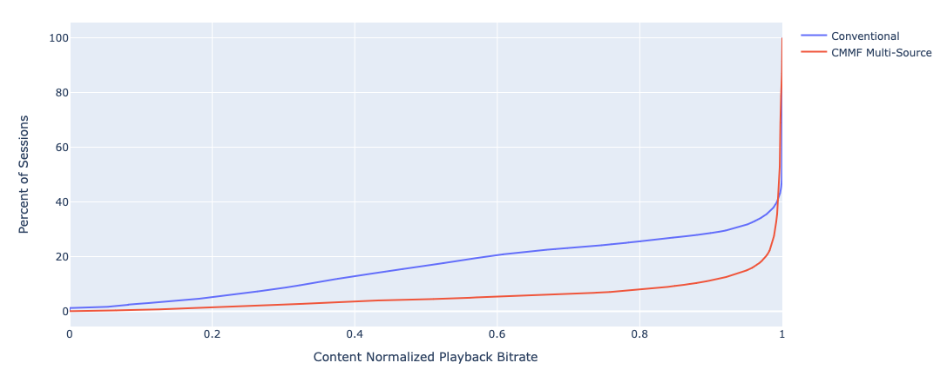
Figure 5.19.1.7.4-1: Empirical CDF of the content normalized average session bit rate
Figure 5.19.1.7.4-2 shows that CMMF multi-source delivery was able to significantly reduce the playback start-up time as well. For example, only 10.4% of the CMMF sessions experienced a startup time greater than 3 seconds compared to 29.0% of the conventional sessions.
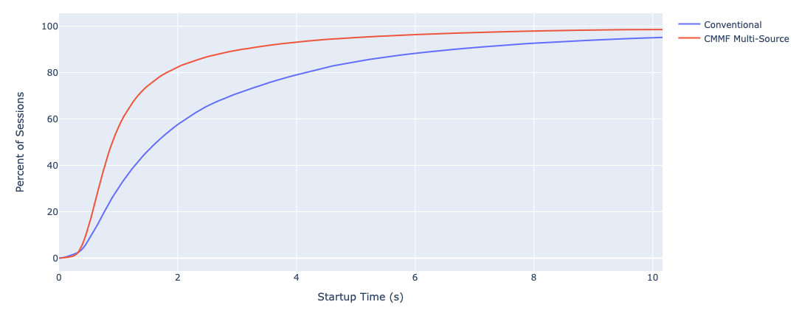
Figure 5.19.1.7.4-2: Empirical CDF of the video startup time
Finally, figure 5.19.1.7.3-3 shows that CMMF multi-source delivery reduced the number of sessions that experienced a connection-induced rebuffering event from 22.4% to 14.9% in addition to reducing the total duration of rebuffering given a rebuffering event occurred.
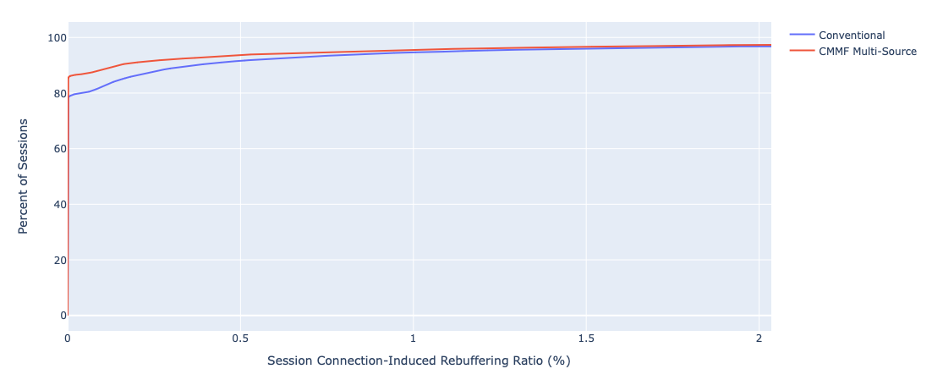
Figure 5.19.1.7.4-3: Empirical CDF of the connection-induced rebuffering ratio (CIRR)

5.19.2 Collaboration scenarios

5.19.2.1 Multi-source media delivery
In this scenario, the 5GMSd Client requests adaptive media streaming content from two or more 5GMSd AS endpoints. These 5GMS AS endpoints are functionally identical and differ only in configuration and potentially in the content that they host. The 5GMSd Client may use one 5GMSd AS endpoint or use multiple simultaneously. This allows the network load to be distributed across the 5GMSd AS endpoints and transport sessions setup at reference point M4d, the cost to be optimized, as well as the QoS to be improved.
As an example, a 5GMS System Operator provides a video streaming service where media is streamed from a 5GMSd AS endpoint deployed within its Trusted DN. To manage peak demand, it may choose to offload a fraction of the total traffic to an externally deployed 5GMSd AS. The quality of the streaming service in this case may be required to be equivalent regardless of whether media is streamed from the 5GMSd AS deployed within the Trusted DN or that deployed externally. By enabling traffic to be offloaded to an externally deployed 5GMSd AS, the 5GMS System Operator may be able to optimize the costs of hosting and delivering media by exploiting third-party capacity during peak periods to deliver content in a stable and consistent manner.
The client’s Media Session Handler discovers the URLs of these 5GMSd AS endpoints from the 5GMSd Application Function (AF), either through a Media Entry Point or from a separate piece of metadata. QoE metrics from the 5GMSd Client may be used by the 5GMSd AF to determine the best 5GMSd AS endpoint(s) for each Media Player to use when streaming media.
Figure 5.19.2.1-1 shows an example collaboration scenario where the Media Player in a 5GMSd Client communicates with multiple 5GMSd AS instances to stream media. Each 5GMSd AS instance has no direct communication with its peers; rather it communicates directly with the 5GMSd Application Provider via reference point M2d and with the 5GMSd AF (not depicted) via reference point M3d.
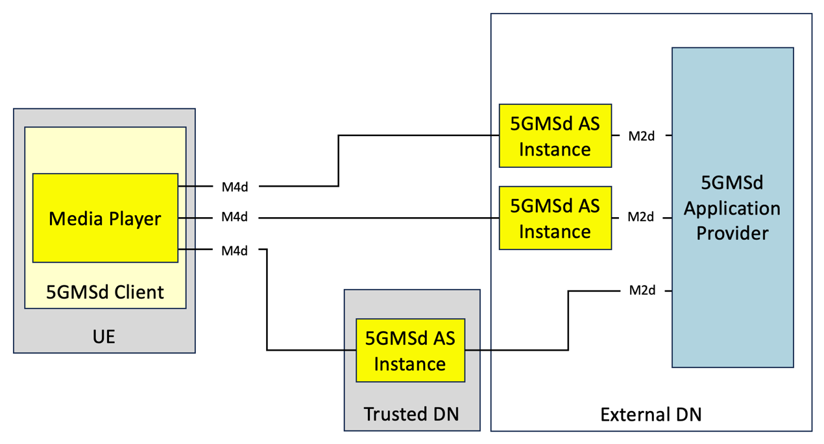
Figure 5.19.2.1-1: Multi-CDN media delivery within 5G system

5.19.2.2 Joint multi-source and multi-access media delivery
In this scenario, the 5GMSd Client is directly connected to multiple Data Networks or access networks (e.g., an unmanaged Wi-Fi network and the 5G network), as described in clause 5.18. The Media Player in the 5GMSd Client requests adaptive media streaming content from two or more 5GMSd AS endpoints. The Media Player may choose one endpoint or use multiple simultaneously. This allows the 5GMSd Client to distribute network load across access networks and 5GMSd AS instances, optimize costs, as well as improve QoS.
The client’s Media Session Handler discovers the URLs of these 5GMSd AS endpoints from the 5GMSd AF, either through a Media Entry Point or from a separate piece of metadata. QoE metrics from the 5GMSd Client may be used by the 5GMSd AF to determine the best 5GMSd AS instance for each Media Player to use when streaming media.
Figure 5.19.2.2-1 shows an example collaboration scenario where the Media Player is consuming media from multiple 5GMSd AS endpoints through different data networks. Neither data network nor the deployed 5GMSd AS instances has direct communication with its peers. Rather, each 5GMSd AS instance communicates with the 5GMSd Application Provider at reference point M2d and with the 5GMSd AF (not depicted) via reference point M3d.
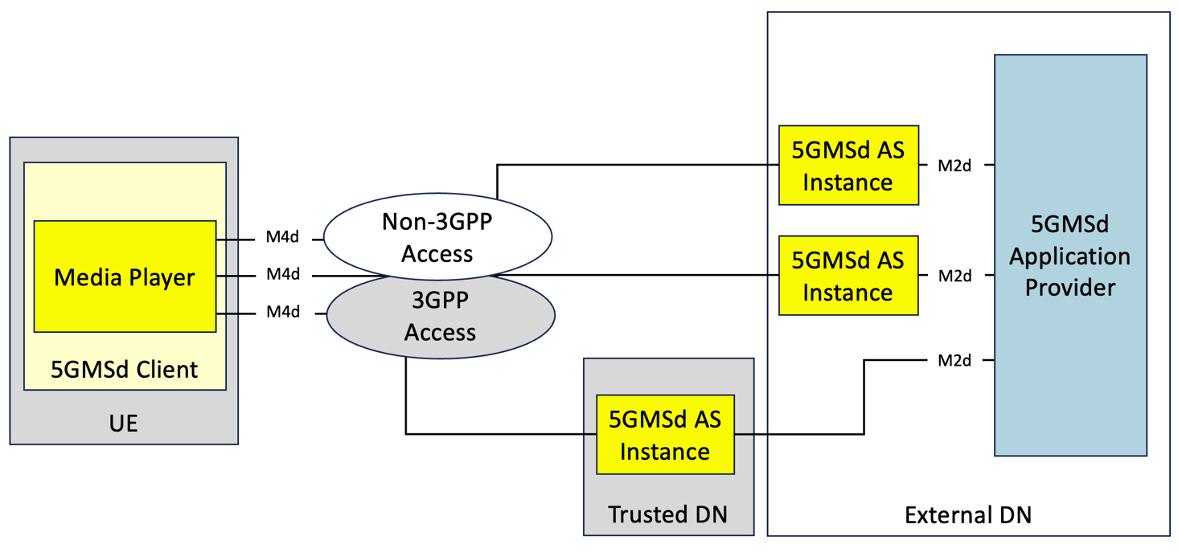
Figure 5.19.2.2-1: Multi-access media delivery within 5G system

5.19.2.3 MPEG-DASH presentations with multiple service locations
Aligned with the functional description of DASH-based client-side switching in clause 5.19.1.4.1, a service location defines a collection of network resources that share commonalities and can be referred to by a common label. Typically, service locations have assigned different URLs. Two different collaboration scenarios are considered:
1) The Application Service Provider creates multiple service locations, one of which is a 5GMSd AS. In this case, the management of the resources, management of switching and so on, is the responsibility of the Application Service Provider, largely outside the scope of the 5GMSd System.
2) The 5GMSd Application Provider creates multiple service locations to distribute content using the 5GMS System based on configuration by the 5GMSd Application Provider.

5.19.3 Architecture mappings

5.19.3.1 Architecture mapping #1: Over-the-top (OTT) multi-source delivery

5.19.3.1.1 General architecture mapping
A general architecture mapping for the case where the 5GMSd Application Provider supplements media delivery over the 5GMS System with externally configured sources (e.g., CDNs) is shown in figure 5.19.3.1.1-1. In this architecture, the 5GMS System is configured and provisioned to deliver media from a single content source/endpoint (i.e., 5GMSd AS); and additional sources/endpoints are configured and provisioned by the 5GMSd Application Provider independent of the 5GMS System. With minor exceptions (as noted below), the use of multi-source delivery is largely transparent to the 5GMS System.
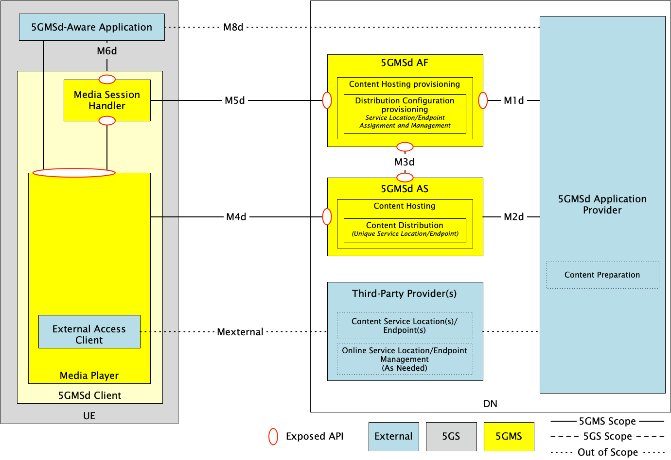
Figure 5.19.3.1.1-1: General architecture mapping for Over-The-Top (OTT) multi-source delivery
A description of the functions and reference points specific to multi-source delivery shown in figure 5.19.3.1.1-1 are provided below. Gaps between these descriptions and the architecture specified in clause 4.2 of TS 26.501 [15] are highlighted in boldface.
The following functions are defined:
- 5GMSd Application Provider: A 5GMSd Application Provider as defined in clause 4.2 of TS 26.501 [15]. The 5GMSd Application Provider is responsible for overall configuration and operation of the multi-source delivery session. This includes selecting the multi-source delivery approach used to deliver content from multiple endpoints, configuring all endpoints (both within the 5GMS System and external to it), preparing all content for multi-source delivery, operation of any management functions required by the multi-source delivery approach in use, etc. Specific subfunctions that may be used include:
- Content Preparation: For multi-source approaches that require content preparation (e.g., content manifest manipulation, CMMF object creation, etc.), the 5GMSd Application Provider is responsible for preparing the content prior to its distribution to the service location/endpoint.
- Content service location(s)/endpoints(s): The 5GMSd Application Provider is responsible for configuration and provisioning of all service locations/endpoints external to the 5GMS System and available to Media Players at a new reference point Mexternal. An example of an external service location/endpoint may include a commercial CDN. Furthermore, each Content service location/endpoint is required to be uniquely addressable and reachable by 5GMSd Clients (e.g., each service location/endpoint, whether external or not, has a unique domain name or base URL).
- Online Service Location/Endpoint Management: Depending on the multi-source approach in use, some form of management function may be required. An example may include a Content Steering Server [111]. The 5GMSd Application Provider is responsible for operation of this function.
- 5GMSd AF: A 5GMSd AF as defined in clause 4.2 of TS 26.501 [15]. The 5GMSd Application Provider provisions the Content Hosting feature for downlink media delivery. Furthermore, the Content Hosting Configuration defines one or more Distribution Configurations (clause 8.8.3.1 of TS 26.510 [108]). Each Distribution Configuration is assigned a base URL (i.e., one that includes a scheme, authority and, optionally, path segments) from which content is made available to 5GMSd Clients at reference point M4d. See clause 8.8.3.1 of TS 26.510 [108] for further details. Details about the provisioned Content Hosting Configuration are made available to the 5GMSd Client’s Media Session Handler at reference point M5d via the Service Access Information (clause 9.2 of TS 26.510 [108]) and the 5GMSd Application Provider via the Maf_Provisioning API at reference point M1d.
- 5GMSd AS: An Application Server as defined in clause 4.2 of TS 26.501 [15]. Content Hosting is provisioned and configured on the 5GMSd AS by the 5GMSd AF using the Mas_Configuration API at reference point M3d. The provisioned Content Distribution ingests content from the 5GMSd Application Provider at reference point M2d and makes this content available to 5GMSd Clients at reference point M4d. Each provisioned Content Distribution may be located on a single physical host or span multiple physical hosts as required.
- 5GMSd-Aware Application: A 5GMSd-Aware Application as defined in clause 4.2 of TS 26.501 [15]. The 5GMSd-Aware Application is responsible for communicating with the 5GMSd Application Provider at reference point M8d to obtain any necessary configuration information required to access media from multiple service locations/endpoints. This information may include the necessary information required by the specific multi-source approach in use, base URLs of the configured Content Distributions, URLs of any provisioned multi-source management functions, etc. The 5GMSd-Aware Application is also responsible for any configuration of the Media Player needed to enable multi-source delivery via reference point M7d.
- 5GMSd Client: A 5GMSd Client as defined in clause 4.2 of TS 26.501 [15]. Depending on the specific multi-source approach used to deliver media, the 5GMSd Client may require additional functionality than is currently specified. Any differences to the architecture shown here to enable these multi-source delivery approaches are expanded upon in clause 5.19.3.1.2. The 5GMSd Client contains two subfunctions:
- Media Session Handler: A Media Session Handler as defined in clause 4.2 of TS 26.501 [15]. The Media Session Handler communicates with the 5GMSd AF at reference point M5d to establish, control, and support delivery of media from Content Distributions provisioned within the 5GMS System.
- Media Player: A Media Player as defined in clause 4.2 of TS 26.501 [15]. The Media Player communicates with the 5GMSd AS at reference point M4d and external service location(s)/endpoint(s) at reference point Mexternal to download content. The Media Player may also include a Media Access Client subfunction required to operate when using a specific multi-source delivery approach (e.g., switching logic, CMMF decoder, etc.). Specifics are provided in clause 5.19.3.1.2.
The following reference points are defined:
- M1d (5GMSd Provisioning API): 5GMSd Provisioning API as defined in clause 4.2 of TS 26.501 [15].
- M2d (5GMSd Ingest API): 5GMSd content ingest interactions as defined in clause 4.2 of TS 26.501 [15].
- M3d: Internal API as defined in clause 4.2 of TS 26.501 [15].
- M4d (Media Streaming APIs): Media Streaming interactions as defined in clause 4.2 of TS 26.501 [15].
- Mexternal (External Media Streaming APIs): Media Streaming interactions and in-band metrics reporting interactions as described in clause 5.19.3.1.2.4 below between the Media Player and a third-party provider or the 5GMSd Application Provider.
NOTE: This reference point is private and therefore beyond the scope of standardisation.
- M5d (Media Session Handling API): Media Session Handling API as defined in clause 4.2 of TS 26.501 [15].
- M6d (UE Media Session Handling APIs): UE Media Session Handling APIs as defined in clause 4.2 of TS 26.501 [15]. See description of reference point M8d below.
- M7d (UE Media Player APIs): UE Media Player APIs as defined in clause 4.2 of TS 26.501 [15]. See description of reference point M8d below.
- M8d (Application API): Application interface as defined in clause 4.2 of TS 26.501 [15]. In the case where the 5GMSd AS is deployed in an external DN and is not directly configured by the 5GMSd AF (the collaboration scenario depicted in clause A.4 of TS 26.501 [15]), service information (e.g., service location/endpoint base URLs, multiple service location/endpoint delivery configuration information, CMMF Configuration Information, etc.) are communicated from the 5GMSd Application Provider to the 5GMSd-Aware Application via reference point M8d. This information is provided to the Media Session Handler at reference point M6d to be combined with the corresponding Service Access Information obtained from the 5GMSd AF over reference point M5d, or it may be provided directly to the Media Player over reference point M7d.
- M11d (UE Media Player APIs and UE Media Session Handling APIs): UE Media Player APIs and UE Media Session Handling APIs as defined in clause 4.2 of TS 26.501 [15]. Any necessary information obtained from the Service Access Information at reference point M5d or from the 5GMSd-Aware Application at reference point M6d to configure the Media Player for multi-source media delivery is provided at reference point M11d. This information may be dependent on the multi-source delivery approach used. Further details are provided in clause 5.19.3.1.2.
Variations of this general architecture are possible depending on the use case and configuration of the network.

5.19.3.1.2 Multi-source approach-specific architecture mappings

5.19.3.1.2.1 Overview
Depending on the approach used to implement multi-source functionality, the functions and reference points discussed in clause 5.19.3.1.1 may be used differently. These are expanded upon in subsequent clauses.

5.19.3.1.2.2 DNS-based switching
Multi-source delivery using DNS to switch between provisioned service locations/endpoints as described in clause 5.19.1.3 can be realized using the architecture depicted in figure 5.19.3.1.1-1. As an example, the Online Service Location/Endpoint Management function within the 5GMSd Application Provider is used to collect performance metrics from the population of 5GMSd Clients, to make decisions on when 5GMSd Clients should switch to a different service location/endpoint, and to update the appropriate DNS records accordingly, should it determine switching is necessary. Additional 5GMSd Client functionality is not needed if these metrics are reported to the 5GMSd Application Provider via reference point M8d after exposure to the 5GMSd-Aware Application via reference point M7d (see clause 13.2.6 of TS 26.512 [16]). However, modifications to the client may be necessary if those metrics need to be sent via reference point M4d′.

5.19.3.1.2.3 MPEG-DASH client-side switching
Multi-source delivery using MPEG-DASH client-side switching as described in clause 5.19.1.4 may be realized using the architecture depicted in figure 5.19.3.1.1-1. However, additional functionality in the Media Player is required (if not already implemented) to switch between the available Content Distributions (or service locations) as necessary. As described in clause 5.19.1.4, MPEG-DASH client-side switching is signalled using service location decorators within the manifest (i.e., MPD). These service location decorators may be added to each MPD using the 5GMSd Application Provider’s Content Preparation subfunction prior to distribution of those MPDs to 5GMSd Clients.

5.19.3.1.2.4 Content Steering Server driven switching
Multi-source delivery using a Content Steering Server as described in clause 5.19.1.5 may be realized using the architecture as shown in figure 5.19.3.1.1-1. In this case, the 5GMSd Application Provider implements the Content Steering Server within the Online Service Location/Endpoint Management subfunction. The Content Steering Server’s location is signalled privately via reference point M8d or in the content presentation manifest (i.e., MPD). Additional functionality within the Media Player is required (if not already implemented) to switch between provisioned service locations/endpoint accessible via reference points M4d and M4d′, in addition to the functionality to communicate with the Content Steering Server via reference point M4d′.

5.19.3.1.2.5 SAND4M multi-source delivery
Determination of how SAND4M multi-source delivery can be realized within the architecture shown in figure 5.19.3.1.1-1 is left for further study.

5.19.3.1.2.6 CMMF-based multi-source delivery
Several options exist when implementing CMMF as described in clause 5.19.1.7 within the architecture shown in figure 5.19.3.1.1-1. These are expanded upon below.

5.19.3.1.2.6.1 CMMF-enabled 5GMS client architecture
Implementing multi-source delivery using CMMF requires modifications to the 5GMSd client architecture. At minimum, a UE must be able to download CMMF bitstreams/objects from multiple service locations/endpoints (including 5GMSd Content Distributions) simultaneously and be able to decode the received bitstreams/objects. Options for implementing multi-source delivery using CMMF within the UE include:
1. CMMF Client Proxy. This option implements multi-source using CMMF within the UE as a proxy between the Media Player and each CMMF service location/endpoint (which may be a 5GMSd Content Distribution at reference point CMMF-1). The proxy consists of a CMMF Client and a Media Server. Once the Media Session Handler of the 5GMSd Client has configured the CMMF Client via reference point CMMF-2, the Media Player may request source content via the Media Server using reference point CMMF-3. Once a request is received, the CMMF Client downloads different CMMF encoded representations of the requested content via reference point(s) CMMF-1 and/or CMMF-1′ (these reference points are functionally equivalent to reference points M4d and M4d′ respectively despite terminating on a different logical function in the UE), decodes the received CMMF bitstreams/objects, and replies to the Media Player with the requested source content via CMMF-3. This option is illustrated in figure 5.19.3.1.2.6.1-1.
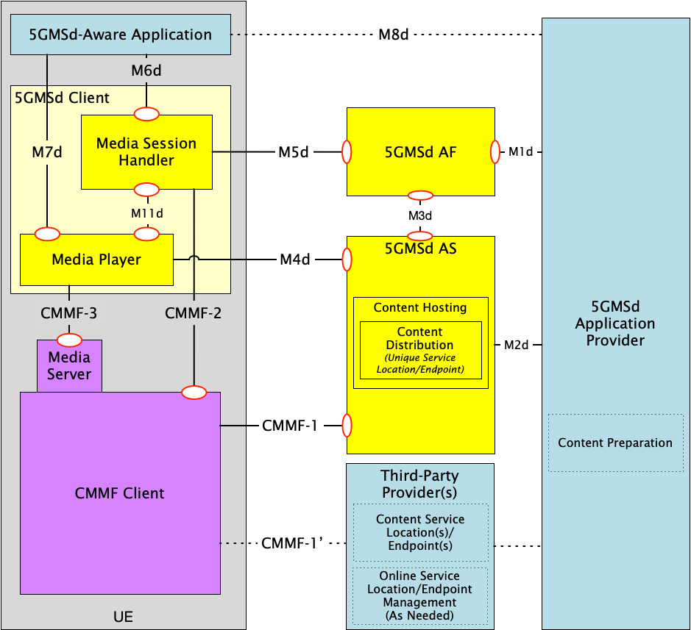
Figure 5.19.3.1.2.6.1-1: Client architecture #1 for integration of CMMF within the 5GMS Client where CMMF is implemented as a client proxy
2. CMMF decoder integrated within the Media Player. This option implements CMMF within the Media Player itself. An example is provided in figure 5.19.3.1.2.6.1-2 depicting CMMF integrated within the DASH-based 5GMSd Client specified in clause 13.2 of TS 26.512 [16]. The architecture and operation of the 5GMS Client is similar to that in [16] with the following exceptions:
a. Download: Downloads source content objects and/or CMMF bitstreams/objects from one or more service location(s)/endpoint(s) in parallel.
b. Request Scheduling: Performs the same function as defined in clause 13.2 of [16] with the addition of managing concurrent requests sent over reference point M4d and CMMF-1′ during the download of CMMF-encoded bitstreams/objects.
c. Throughput Estimation: Estimates the throughput from each individual service location/endpoint (including 5GMSd Content Distributions at reference point M4) in addition to estimating the aggregated throughput from all these service locations/endpoints.
d. CMMF Receiver/Decoder: Temporarily stores and jointly decodes CMMF bitstreams/objects as they are downloaded. Once decoded, the source content objects are moved to the Media Playback Management and Protection Controller subfunctions. The CMMF Receiver/Decoder subfunction also provides status updates containing decode progress to each active download function for the purposes of managing/terminating in-process downloads.
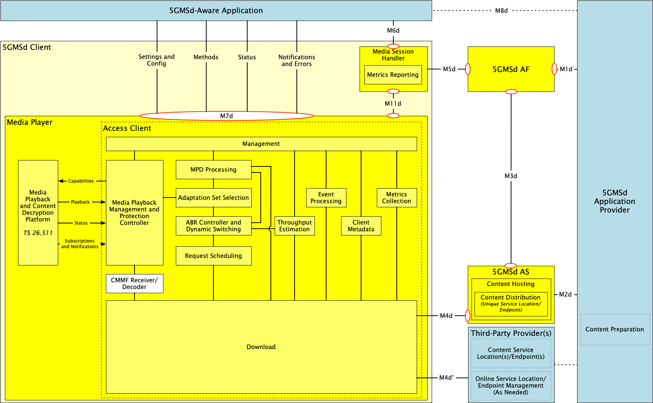
Figure 5.19.3.1.2.6.1-2: Client architecture #2 for integration of CMMF within the 5GMS Client where CMMF is integrated directly within the Media Player

5.19.3.1.2.6.2 5GMSd Client configuration for downlink media streaming using CMMF
CMMF supplements existing media streaming architectures (e.g., MPEG-DASH, etc.) to enable clients to obtain media from multiple endpoints in parallel. Enabling this functionality requires, at a minimum, information concerning where and how CMMF-encoded media can be accessed on one or more service location(s)/endpoint(s) within the network(s).
This CMMF client configuration information may be conveyed to the CMMF Client (assuming client architecture #1 in clause 5.19.3.1.2.6.1) or to the Media Player (assuming client architecture #2 in clause 5.19.3.1.2.6.1) in the 5GMSd Client either:
1. Privately by the 5GMSd Application Provider via a 5GMSd-Aware Application at reference point M8d.
- For client architecture #1, this information may be provided to the Media Session Handler via reference point M6d and then on to the CMMF Client via reference point CMMF-2.
- For client architecture #2, this information may be provided directly to the Media Player via reference point M7d or routed through the Media Session Handler via reference point M6d followed by reference point M11d.
This option is relevant when the CMMF client configuration information is relatively static and is not frequently updated.
2. Contained within a Media Entry Point specified by an existing media streaming framework that is understood by the Media Player (e.g., as additional XML elements or attributes within an MPEG-DASH MPD). This option is relevant when the CMMF client configuration information is relatively static and is not frequently updated.
3. Over reference M4d′ from the Online Service Location/Endpoint Management subfunction (e.g. a Content Steering Server) when more active or extensive management is required. This option is relevant when the CMMF client configuration information is dynamic and may be frequently updated.
The CMMF client configuration information is the set of parameters and addresses which are needed by a 5GMSd Client to activate and control the reception of a CMMF-enabled media downlink media streaming session, primarily information concerning how the CMMF Client (client architecture #1) or Media Player (client architecture #2) accesses one or more CMMF-encoded objects, each containing a different encoded representation of the original source media to be played, from the available service locations/endpoints hosting this content (some of which may be 5GMSd Content Distributions at reference point M4d).
Other CMMF client configuration information that are outside the scope of the present document may also be provided and/or required based on implementation. This may include additional configurable parameters such as load-balancing policies that influence client behaviour when downloading from multiple CMMF endpoints, information about the CMMF profile in use, etc.

5.19.3.1.2.6.3 CMMF content preparation and distribution
CMMF content preparation and distribution is the overall responsibility of the 5GMSd Application Provider in this architecture mapping.
- The 5GMSd Application Provider configures and provisions resources to deliver media using CMMF across both external and trusted data networks. For the architecture shown in figure 5.19.3.1.1-1, CMMF-encoded media delivery is transparent to both the 5GMSd AS at reference point M4d and to any third-party CDN at reference point M4d′/CMMF-1′.
- The 5GMSd Application Provider prepares all CMMF bitstreams/objects intended to be distributed across every service location/endpoint (including 5GMSd Content Distribution) whether or not located within the 5GMS System.
- Hosting of CMMF-encoded media within the 5GMS System follows the established architecture (see clause 4.2 of TS 26.501 [15]) and procedures (see clause 5.2 of [15]) for downlink 5G Media Streaming.
- CMMF-enabled 5GMSd Clients accessing CMMF-encoded media hosted on one or more service locations/endpoints where the media is replicated (rather than different CMMF-encoded representations of that media) treat the set of service endpoints/locations as a single CMMF endpoint. CMMF endpoints established in external Data Networks configured and provisioned by the 5GMSd Application Provider can be used to supplement at reference point M4d′/CMMF-1′ the 5GMS-delivered media at reference point M4d.

5.19.3.1.2.6.4 CMMF object addressing and URL handling
The capability to locate and access multiple CMMF-encoded media objects (each containing different encoded representations of the same original source media) and/or the original source media across multiple service locations/endpoints is required by Media Players to effectively acquire streaming content. Furthermore, the creation of these CMMF-encoded media representations may be dynamic where the 5GMSd Application Provider is creating and caching new CMMF-encoded media objects on demand. Having robust and extensible methods for addressing each CMMF-encoded media object, including the original source media, is necessary to ensure the proper operation of coded multi-source media delivery. At least two approaches exist for addressing these media. Each approach can be used independently or a hybrid of the two can be used in combination.
1. Unique URL path names. Each CMMF-encoded media object containing a different representation of the same original source media object, as well as the original source media object itself, is assigned a unique URL path (i.e., there exists a one-to-one mapping between each CMMF-encoded media object or original source media object and each URL path). For example, every URL contains a unique path to a unique CMMF-encoded media object and original source media object. Table 5.19.3.1.2.6.4-1 provides examples of possible URL path formats where the differences in each URL are emphasised in boldface. This approach enables multiple CMMF-encoded media objects, each containing a different representation of the same original source media object, to be hosted side by side at a single service location/endpoint (or CMMF endpoint) if desired.
Definition of the patterns used may be defined by a CMMF URL template that aids in mapping the URLs obtained from a content manifest (e.g., MPD) to CMMF-encoded media resources that are available via reference points M4d, CMMF-1 or M4d′ (client architecture #2). In addition to this CMMF URL template, the CMMF endpoint URLs may also be required by the CMMF Client (client architecture #1) or Media Player (client architecture #2) to construct a complete URL needed to fetch CMMF-encoded content.
Table 5.19.3.1.2.6.4-1: Approach #1 example URLs assigned to each unique CMMF-encoded media object and original source media object
Object description | Path examples
Original source media object (e.g., media object referenced within an MPEG-DASH MPD or HLS manifest) | /1080p/4mbps/1.m4s
CMMF-encoded media object containing representation A of the original source media object | Example 1: /1080p/4mbps/1.m4s.cmmf-a  Example 2: /1080p/4mbps/cmmf-a/1.m4s
CMMF-encoded media object containing representation B of the original source media object | Example 1: /1080p/4mbps/1.m4s.cmmf-b  Example 2: /1080p/4mbps/cmmf-b/1.m4s
… | …

2. Unique URL authority names. Each CMMF-encoded media object containing a different representation of the same original source media object, as well as the original source media object itself, are each assigned a unique URL where they all share a common URL path, but their URLs differ in the authority (host name and/or port subcomponents per section 3.2 of RFC 3986 [104]). Table 5.19.3.1.2.6.4-2 provides examples of possible URLs where the differences in each URL are emphasised in boldface; and the approach is also illustrated in figure 15.19.1.7.1-3.
URL assignment following this method requires that each service location/endpoint (CMMF endpoint) hosts one, and only one, representation of the original source media. That representation may be the original source media object itself, or a CMMF-encoded media object created from the original source media object. While this approach limits how CMMF-encoded media is distributed within the 5GMS System, it may also simplify content preparation and hosting management by eliminating the need to track and manage creation and placement of CMMF-encoded media objects across service locations/endpoints because it is implied that each and every uniquely addressable Content Distribution (CMMF endpoint) hosts a different representation of the original source media (whether that is the original source media object itself or a CMMF-encoded media object created from the original source media object).
Table 5.19.3.1.2.6.4-2: Approach #2 example URLs assigned to each unique CMMF-encoded media object and original source media object
Object description | Path examples
Original source media object (e.g., media object referenced within an MPEG-DASH or HLS manifest) | //5gms-as-1/1080p/4mbps/1.m4s
CMMF-encoded media object containing representation A of the original source media object | //5gms-as-2/1080p/4mbps/1.m4s
CMMF-encoded media object containing representation B of the original source media object | //5gms-as-3/1080p/4mbps/1.m4s
… | …

5.19.3.2 Architecture mapping #2: 5GMS-integrated multi-source delivery

5.19.3.2.1 General architecture mapping
A general architecture mapping for the case where the multi-source delivery is integrated within the 5GMS System is shown in figure 5.19.3.2.1-1. In this architecture, the 5GMS System is configured and provisioned to deliver media from one or more content sources/endpoints (i.e., Content Distributions) located within the 5GMS System.
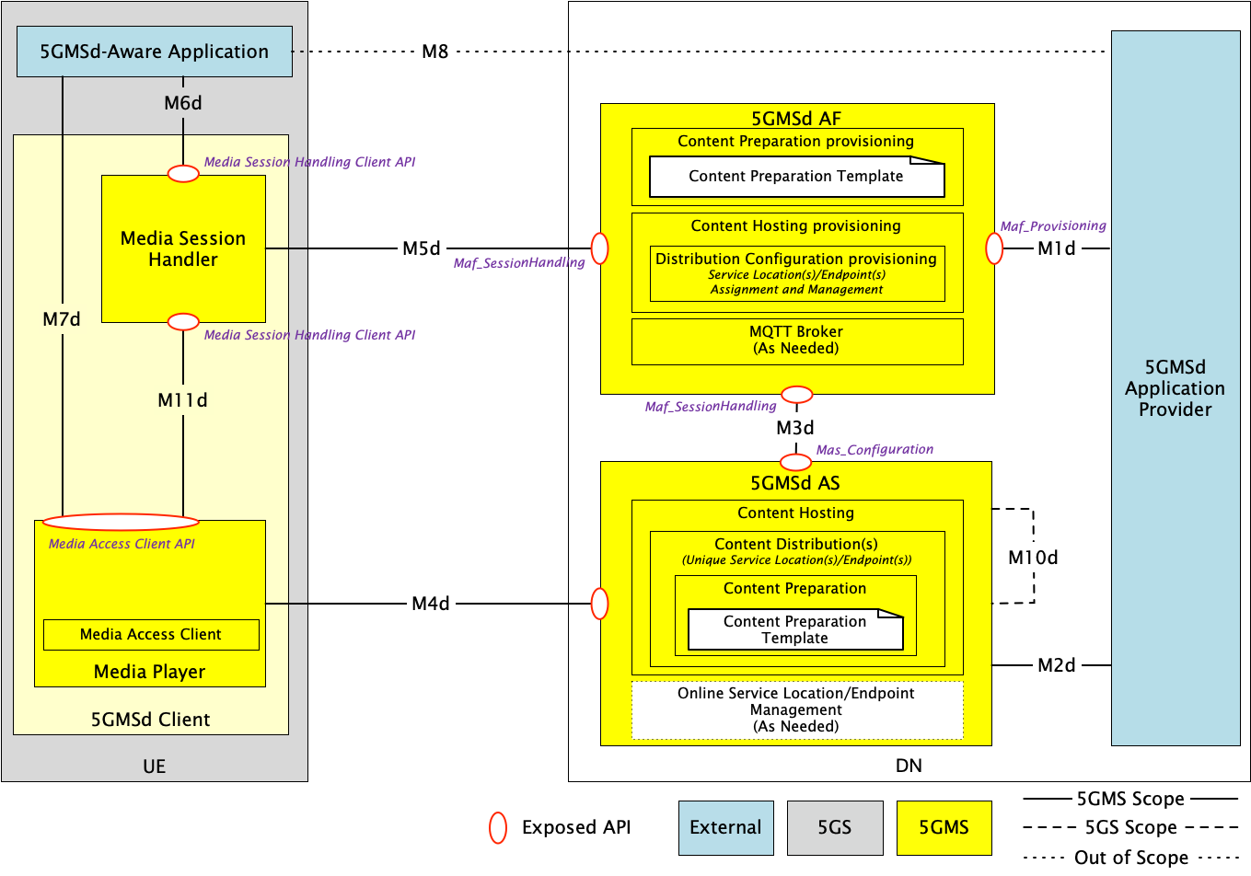
Figure 5.19.3.2.1-1: General architecture mapping for 5GMS-integrated multi-source delivery
A description of the functions and reference points specific to multi-source delivery shown in figure 5.19.3.2.1-1 are provided below. Gaps between these descriptions and the architecture specified in clause 4.2 of TS 26.501 [15] are highlighted in boldface.
The following functions are defined:
- 5GMSd Application Provider: A 5GMSd Application Provider as defined in clause 4.2 of TS 26.501 [15]. The 5GMSd Application Provider provisions the 5GMS System for multi-source media delivery at reference point M1d. The 5GMSd Application Provider provisions the 5GMSd AF with Content Preparation Template(s) (clause 5.2.5 of TS 26.510 [108]) as required by the multi-source delivery approach used; in addition to providing the 5GMSd AF with a Content Hosting Configuration (clause 5.2.8 of TS 26.510 [108]) which indicates one or more Distribution Configurations, one for each intended service location/endpoint.
- 5GMSd AF: An Application Function as defined in clause 4.2 of TS 26.501 [15]. The following 5GMSd AF subfunctions are used to enable multiple service location/endpoint capabilities within the 5GMS System:
- Content Preparation provisioning: For cases where the 5GMSd AS is required to process content ingested at reference point M2d, the necessary content processing operations are described by Content Preparation Templates provisioned within the 5GMSd AF by the 5GMSd Application Provider at reference point M1d. These Content Preparation Templates are referenced by the Distribution Configuration(s) indicated within the Content Hosting Configuration. Examples of Content Preparation Templates for the purposes of multiple service location/endpoint delivery may include manifest (e.g., MPD) manipulation to update service location references, CMMF encoding and packaging, etc.
- Content Hosting provisioning: The 5GMSd Application Provider provisions the Content Hosting feature for downlink media delivery. For cases where multiple service locations/endpoints are needed, the Content Hosting Configuration defines multiple Distribution Configurations. Each Distribution Configuration is assigned a base URL (i.e., one that includes a scheme, authority and, optionally, path segments) from which content is made available to 5GMSd Clients at reference point M4d. This base URL is chosen by the 5GMSd AF when the Content Hosting Configuration is provisioned. Furthermore, provisioned Content Preparation Templates are referenced by each configured Distribution as needed to perform any necessary content preparation required to enable multiple service location/endpoint operation. See clause 8.8.3.1 of TS 26.510 [108] for further details. The format and/or detailed specification of the Content Preparation Template depends on the multi-source delivery approach used. Details of the Media Entry Point specified in each Distribution Configuration in the provisioned Content Hosting Configuration are made available to the 5GMSd Client Media Session Handler at reference point M5d via the Service Access Information.
- MQTT Broker: Optionally, the 5GMSd AF may provide an MQTT Broker (clause 10.2 of TS 26.510 [108]) for the purposes of managing MQTT notification channels that are used by the 5GMSd AF to notify the 5GMSd Client Media Session Handler about updates to the Service Access Information available at reference point M5d. Updates triggering a notification may include changes to the Distribution Configuration(s) defined in the Content Hosting Configuration such as updates to the Distribution Configuration base URL(s).
- 5GMSd AS: An Application Server as defined in clause 4.2 of TS 26.501 [15]. The following 5GMSd AS subfunctions are used to enable multiple service location/endpoint operations within the 5GMS System.
- Content Hosting: Content Hosting is configured in the 5GMSd AS by the 5GMSd AF using the Mas_Configuration API at reference point M3d. For cases where multiple service locations/endpoints are needed, multiple Content Distributions are configured where each is assigned a unique base URL by the 5GMSd AF. In some cases, a Content Distribution may prepare ingested content prior to making it available to 5GMSd Clients at reference point M4d. Examples of content preparation for multiple service point/endpoint delivery may include manifest (e.g., MPD) manipulation to update service location/endpoint references, CMMF encoding and packaging, etc. Furthermore, each configured Content Distribution may be instantiated on a different physical host as needed to improve reliability and robustness of the 5GMSd System in the cases of hardware failure, network congestion, etc.
- Online Service Location/Endpoint Management: Optionally, an Online Service Location/Endpoint Management subfunction is configured by the 5GMSd AF to support multiple service point/endpoint use cases where more complex management is required than the 5GMSd AF can provide. For example, a Content Steering Server [111] is needed to steer 5GMSd Clients to specific service locations/endpoints based on application-specific rules and/or performance requirements. 5GMSd Clients communicate with this subfunction over reference point M4d, and the subfunction can receive input from the 5GMSd Application Provider over reference point M2d.
- 5GMSd-Aware Application: A 5GMSd-Aware Application as defined in clause 4.2 of TS 26.501 [15].
- 5GMSd Client: A Media Client as defined in clause 4.2 of TS 26.501 [15]. The following 5GMSd Client subfunctions are used to enable multiple service locations/endpoint operations within the 5GMS System.
- Media Session Handler: A Media Session Handler as defined in clause 4.2 of TS 26.501 [15]. The Media Session Handler obtains complete Service Access Information from the 5GMSd AF via reference point M5d. This Service Access Information contains information regarding the service location/endpoint of each provisioned Content Distribution in the form of Media Entry Points. This information can be made available to the Media Player at reference point M11d to enable multiple service location/endpoint delivery. Optionally, the Media Session Handler may subscribe to an MQTT notification channel established by the 5GMSd AF for the purpose of signalling changes to the Service Access Information (including the changes to the provisioned Media Entry Points) at reference point M5d.
- Media Player: A Media Player as defined in clause 4.2 of TS 26.501 [15]. The Media Player is provided with information about each of the provisioned service locations/endpoints (Media Entry Points) either by the Media Session Handler at reference point M11d or else by the 5GMSd-Aware Application at reference point M7d. This information is provided to the Media Player’s subfunctions, such as the Media Access Client. The Media Access Client uses this information for the purposes of accessing content over reference point M4d from one or more provisioned Content Distributions. For example, this information may be used by the Media Access Client to switch between available Content Distributions or, in the case of CMMF delivery, to download from multiple Content Distributions simultaneously. In the case where an active 5GMSd AS Online Service Location/Endpoint Management subfunction exists in the 5GMSd AS, the Media Access Function communicates with this subfunction via reference point M4d to influence its selection of the appropriate Content Distribution(s) in the 5GMSd AS from which it should access and download content.
The following reference points are defined:
- M1d (5GMSd Provisioning API): 5GMSd Provisioning API as defined in clause 4.2 of TS 26.501 [15].
- M2d (5GMSd Ingest API): 5GMSd content ingest interactions as defined in clause 4.2 of TS 26.501 [15].
- M3d: Internal API as defined in clause 4.2 of TS 26.501 [15].
- M4d (Media Streaming APIs): Media Streaming interactions as defined in clause 4.2 of TS 26.501 [15]. The 5GMSd Client connects to the 5GMSd AS and streams from one or more configured Content Distributions. In addition, the 5GMSd Client may provide performance metrics and service location/endpoint management information to the Online Service Location/Endpoint Management function configured within the 5GMSd AS as described in clause 5.19.3.2.2.4 below. In cases where performance metrics are reported at this reference point, the reported metrics may be in lieu of or in addition to any reporting the Media Session Handler performs over reference point M5d.
- M5d (Media Session Handling API): Media Session Handling API as defined in clause 4.2 of TS 26.501 [15]. The Media Session Handling API is used to provide Service Access Information to the Media Session Handler. This Service Access Information includes references to the Media Entry Point indicated in each of the provisioned Content Distributions. Furthermore, this Service Access Information may be augmented to provide additional information necessary to operate an integrated multi-source delivery platform within the 5GMS System. Further details are provided in clause 5.19.3.2.2.
In the case where the 5GMSd AS is deployed in an external DN and is directly configured by the 5GMSd AF via reference point M3d (the collaboration scenario depicted in clause A.5 of TS 26.501 [15]), service information is communicated as part of the complete Service Access Information provided by the 5GMSd AF at reference point M5d and may additionally be provided at reference point M8d.
- M6d (UE Media Session Handling APIs): UE Media Session Handling APIs as defined in clause 4.2 of TS 26.501 [15]. See description of reference point M8d.
- M7d (UE Media Player APIs): UE Media Player APIs as defined in clause 4.2 of TS 26.501 [15]. See description of reference point M8d.
- M8d (Application API): Application interface as defined in clause 4.2 of TS 26.501 [15].
In the case where the 5GMSd AS is deployed in an external DN and is directly configured by the 5GMSd AF via reference point M3d (the collaboration scenario depicted in clause A.5 of TS 26.501 [15]), service information may be communicated at reference point M8d in addition to being part of the Service Access Information provided by the 5GMSd AF at reference point M5d, as noted above.
- In the case where the 5GMSd AS is deployed in an external DN and is not directly configured by the 5GMSd AF (the collaboration scenario depicted in clause A.4 of TS 26.501 [15]), service information (e.g., service location/endpoint base URLs, multiple service location/endpoint delivery configuration information, CMMF Configuration Information, etc.) may be communicated from the 5GMSd Application Provider to the 5GMSd-Aware Application via reference point M8d. This information is provided to the Media Session Handler at reference point M6d to be combined with the corresponding Service Access Information obtained from the 5GMSd AF over reference point M5d, or it may be provided directly to the Media Player over reference point M7d.
- M11d (UE Media Player APIs and UE Media Session Handling APIs): UE Media Player APIs and UE Media Session Handling APIs as defined in clause 4.2 of TS 26.501 [15]. Any necessary information obtained from the Service Access Information at reference point M5d or from the 5GMSd-Aware Application at reference point M6d to configure the Media Player for multi-source media delivery is provided at reference point M11d. This information may be dependent on the multi-source delivery approach used. Further details are provided in clause 5.19.3.2.2.
Variations of this general architecture, including the combination of this architecture and the one discussed in clause 5.19.3.1.1, are possible depending on the use case and network configuration.

5.19.3.2.2 Multi-source approach-specific architecture mappings

5.19.3.2.2.1 Overview
Depending on the approach used to implement multi-source functionality, the functions and reference points discussed in clause 5.19.3.2.1 may be used differently. These are expanded upon in subsequent clauses.

5.19.3.2.2.2 DNS-based switching
Multi-source delivery using DNS to switch between provisioned Content Distributions as described in clause 5.19.1.3 can be realized using the architecture depicted in figure 5.19.3.2.1-1. Upon provisioning of each Content Distribution in a Content Hosting Configuration, the 5GMSd AF assigns a canonical Fully-Qualified Domain Name (FQDN) where this Content Distribution is accessible via reference point M4d. An alias domain name may also be specified by the 5GMSd Application Provider for use in the URL of the Media Entry Point and/or media. This alias is then used within a DNS CNAME record where the record’s name references the canonical Content Distribution FQDN. Either the 5GMSd AS Online Service Location/Endpoint Management subfunction or another 5GMS System function can update these DNS CNAME records when it determines switching to a different Content Distribution is necessary. No additional 5GMSd Client functionality is needed to implement this approach.

5.19.3.2.2.3 MPEG-DASH client-side switching
Multi-source delivery using MPEG-DASH client-side switching as described in clause 5.19.1.4 may be realized using the architecture depicted in figure 5.19.3.2.1-1. However, additional functionality in the Media Player is required (if not already implemented) to switch between the available Content Distributions as necessary.
Two approaches are possible:
1. MPEG-DASH client-side switching is signalled using service location decorators within the manifest (i.e., MPD) as described in clause 5.19.1.4. These service location decorators may be added to each MPD using a provisioned Content Preparation subfunction that modifies each MPD prior their delivery over reference M4d.
2. A list of the provisioned Content Distribution base URLs or domain names is made available to the Media Access Client by the Media Session Handler over reference point M11d, this list of base URLs having been retrieved from the Service Access Information obtained from the 5GMSd AF over reference point M5d. The Media Player selects one of the available base URLs from the list and joins it to the path URL of the media to be streamed.

5.19.3.2.2.4 Content Steering Server driven switching
Multi-source delivery using a Content Steering Server as described in clause 5.19.1.5 may be realized using the architecture depicted in figure 5.19.3.2.1-1. In this case, the Content Steering Server is implemented within the Online Service Location/Endpoint Management subfunction of the 5GMSd AS. The Content Steering Server’s location is signalled in the content presentation manifest (i.e., MPD). Additional functionality within the Media Player is required (if not already implemented) to switch between provisioned Content Distributions accessible via reference point M4d, in addition to the functionality to communicate with the Content Steering Server via reference point M4d.
No changes are needed when deploying.

5.19.3.2.2.5 SAND4M multi-source delivery
Determination of how SAND4M multi-source delivery can be realized within the architecture shown in figure 5.19.3.2.1-1 is left for further study.

5.19.3.2.2.6 CMMF-based multi-source delivery
Several options exist when implementing CMMF as described in clause 5.19.1.7 within the architecture shown in figure 5.19.3.2.1-1. These are expanded upon below.

5.19.3.2.2.6.1 CMMF-enabled 5GMS client architecture
The 5GMSd Client architecture options described in clause 5.19.3.1.2.6.1 also support the use of CMMF delivery within the general architecture shown in figure 5.19.3.2.1-1.

5.19.3.2.2.6.2 5GMSd Client configuration for downlink media streaming using CMMF
CMMF supplements existing media streaming architectures (e.g., MPEG-DASH, etc.) to enable clients to obtain media from multiple endpoints in parallel. Enabling this functionality requires, at a minimum, information concerning where and how CMMF-encoded media can be accessed on one or more service location(s)/endpoint(s) within the network(s).
This CMMF client configuration information may be conveyed to the CMMF Client (assuming client architecture #1 in clause 5.19.3.1.2.6.1) or to the Media Player in the 5GMSd Client (assuming client architecture #2 in clause 5.19.3.1.2.6.1) either:
1. By the 5GMSd AF to the Media Session Handler as Service Access Information (e.g. Media Entry Point metadata) made available at reference point M5d. The Media Session Handler may then provide this information to the CMMF Client (assuming client architecture #1) via reference point CMMF-2 or to the Media Player (assuming client architecture #2) via reference point M11d. This option is relevant when the CMMF client configuration information is relatively static and is not frequently updated.
2. Contained within a Media Entry Point specified by an existing media streaming framework that is understood by the Media Player (e.g., as additional XML elements or attributes within an MPEG-DASH MPD). This option is relevant when the CMMF client configuration information is relatively static and is not frequently updated.
3. Over reference point M4d from the Online Service Location/Endpoint Management subfunction of the 5GMSd AS (e.g. a Content Steering Server) when more active or extensive management is required. This option is relevant when the CMMF client configuration information is dynamic and may be frequently updated.
The CMMF client configuration information is the set of parameters and addresses which are needed by a 5GMSd Client to activate and control the reception of a CMMF-enabled media downlink media streaming session, primarily information concerning how the CMMF Client (client architecture #1) or Media Player (client architecture #2) accesses one or more CMMF-encoded objects, each containing a different encoded representation of the original source media to be played, from the available Content Distributions hosting this content.
- For option 1 above, additions to the Service Access Information defined in clause 4.2.3 of TS 26.501 [15] may be needed to enable the use of CMMF. This additional information can be used along with existing Service Access Information (e.g., a Media Entry Point document such as an MPEG-DASH MPD) to construct proper URLs that enable the download of CMMF-encoded content from each 5GMSd AS Content Distribution (CMMF endpoint).
- For option 2 above, additional XML elements or attributes in the MPEG-DASH MPD are needed to enable the use of CMMF. This additional information is then used along with the base URLs provided in the MPEG-DASH MPD (i.e., service locations) to construct proper URLs to download CMMF-encoded content from each 5GMSd AS Content Distribution (CMMF endpoint).
Other CMMF client configuration information that are outside the scope of the present document may also be provided and/or required based on implementation. This may include additional configurable parameters such as load-balancing policies that influence client behaviour when downloading from multiple CMMF endpoints, information about the CMMF profile in use, etc.

5.19.3.2.2.6.3 CMMF content preparation and distribution
CMMF configuration, provisioning, and hosting is the overall responsibility of the 5GMSd Application Provider in this architecture mapping.
- The 5GMSd Application Provider may configure and provision resources to deliver media using CMMF across both external and trusted data networks.
- For the general architecture shown in figure 5.19.3.2.1-1, CMMF content preparation and/or hosting is performed by the 5GMS System. The 5GMSd Application Provider configures and provisions 5GMS System resources (e.g., 5GMSd AF, 5GMSd AS, etc.) via reference point M1d to prepare and/or deliver CMMF-encoded media. The 5GMSd Application Provider specifies CMMF content preparation (e.g., CMMF encoding, etc.) and/or hosting by network-side components of the 5GMS System according to a provisioned CMMF Content Preparation Template. In such cases, individual 5GMSd AS Content Distributions operate as separate CMMF endpoints for the purposes of CMMF-enabled media delivery, assuming the 5GMS System has been appropriately configured and provisioned to ensure CMMF-encoded media is not replicated between available Content Distributions.
- 5GMSd Client configuration information is provided to the 5GMSd Client from the 5GMS AF in Service Access Information obtained via reference point M5d.
The provisioning step allows a 5GMSd Application Provider to configure information about its CMMF content preparation and hosting requirements for media streaming sessions using 5GMS resources. The following information is made available and/or configurable over reference point M1d:
- Endpoint locations or base URLs outside the 5GMS System, if any, that support CMMF delivery.
- Information necessary for configuring the preparation of CMMF-encoded media within 5GMSd AS Content Distributions. This includes any necessary CMMF bitstream/object preparation parameters as defined in [126] required to properly encode and package media within CMMF bitstreams/objects. Examples may include CMMF code type, CMMF profile, etc.
- Information necessary for configuring the hosting of CMMF-encoded media on the 5GMSd AS in the form of a Content Hosting Configuration containing one or more Content Distributions.
  - Each Content Distribution is configured with a unique base URL or FQDN.
  - Each Content Distribution may also be configured with a Content Preparation Template describing how to create CMMF bitstreams/objects from ingested media.
- CMMF object and original source object URL handling parameters describing the method and/or format used to assign URLs to CMMF objects created within the 5GMS System. More detail is provided in clause 5.19.3.1.2.6.4.
Once provisioned, the 5GMSd AF allocates and manages the set of Content Distributions (including Content Preparation resources, if necessary) needed for the creation and/or hosting of CMMF bitstreams/objects generated from media provided by the 5GMSd Application Provider at reference point M2d. The 5GMSd AF ensures that each Content Distribution (acting as a single individual CMMF endpoint) is configured to distribute unique CMMF bitstreams/objects created from the original source media to CMMF-enabled UEs.
CMMF multi-source delivery supports several content preparation and hosting workflows. These include:
1. 5GMSd Application Provider Content Preparation. In this option, it is the responsibility of the 5GMS Application Provider to encode and package source content within CMMF bitstreams/objects prior to delivery of that content separately to each 5GMSd AS Content Distribution via reference point M2d, or to each external service location/endpoint (e.g., commercial CDN). This is outlined in clause 5.19.3.1.2.6.3 above.
2. Centralized 5GMSd Content Preparation. In this option, a single, primary 5GMSd AS instance encodes and packages source content that has been ingested at reference point M2d into CMMF bitstreams/objects according to a (yet to be defined) configuration provided by a Content Preparation Template. The CMMF bitstreams/objects created during this media processing task may be delivered directly to the 5GMSd Client (via instances of reference point M4d), delivered to another (secondary) 5GMSd AS instance (via instances of reference point M10d), or delivered to a 5GMSd AS instance located in an external, possibly untrusted, Data Network. These CMMF bitstreams/objects may then be cached and/or forwarded onward. This primary 5GMSd AS instance is responsible for creation of all CMMF encoded representations used to deliver content from multiple sources. This is illustrated in figure 5.19.3.2.2.6.3-1 below. The secondary 5GMSd AS instance may be deployed either in the Trusted DN, in an Edge DN or in an External DN.
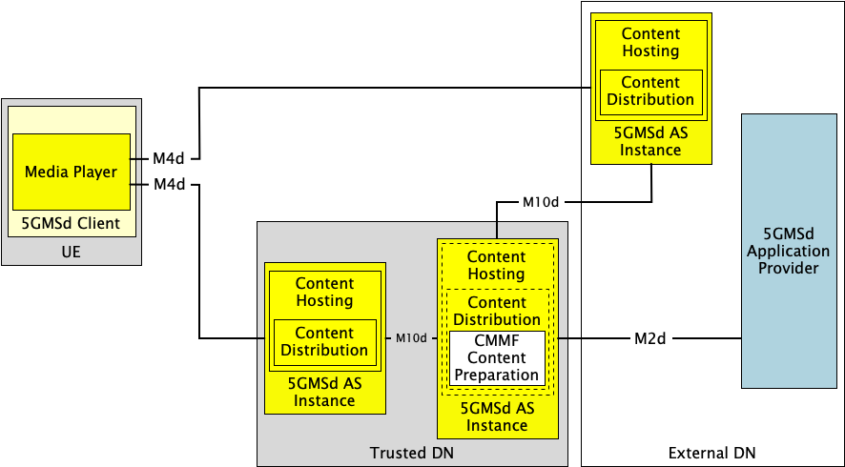
Figure 5.19.3.2.2.6.3-1: Option #2 for deploying CMMF within 5GMS
where a single, primary 5GMSd AS instance performs all CMMF content preparation.
3. Decentralized 5GMSd Content Preparation. The possibility also exists to distribute the CMMF media processing across 5GMSd AS instances such that each one is only responsible for creation of a single CMMF representation which it intends to cache and/or deliver to a 5GMSd Client via an instance of reference point M4d. In this option, each 5GMSd AS instance provisioned with the Content Preparation Template may receive original source content or CMMF-encoded content from either the 5GMSd Application Provider at reference point M2d or from another 5GMSd AS instance via an instance of reference point M10d. This received content is then processed to create a new, unique CMMF-encoded representation which can be used in conjunction with others during a multi-source download. Similarly, an externally deployed 5GMSd AS Content Distribution may be configured by the 5GMSd Application Provider (by private means, denoted M2d′) to perform a similar media processing task to create its own CMMF-encoded representation. This is illustrated in figure 5.19.3.2.2.6.3-2 below.
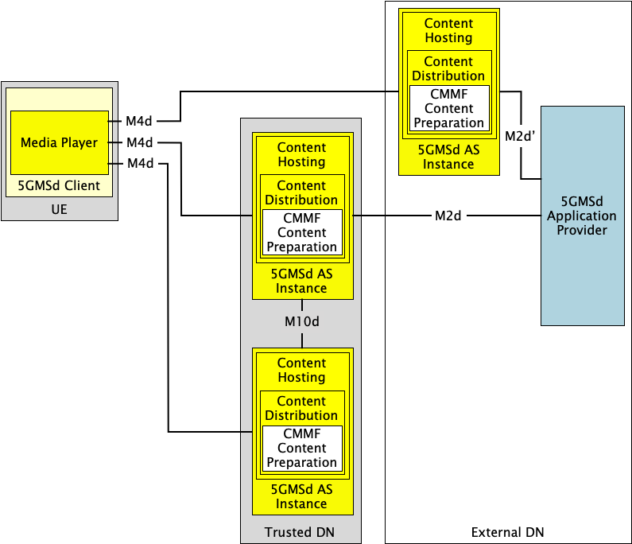
Figure 5.19.3.2.2.6.3-2: Option #3 for deploying CMMF within 5GMS
where each 5GMSd AS Content Distribution performs independent CMMF content preparation.
A combination of the above options is also possible where some aspect of all three exist within a physical realization of the network.

5.19.3.2.2.6.4 CMMF object addressing and URL handling
Details regarding how CMMF objects are addressed and how their URLs are handled are described in clause 5.19.3.1.2.6.4.
The use of one approach over another may be influenced by the method in which CMMF content is prepared and distributed within the 5GMS System.
- For content preparation options #1 and #2 in clause 5.19.3.2.2.6.3, where CMMF content preparation is centralized within either the 5GMS Application Provider or within a single primary 5GMSd AS instance, assigning unique URL path names to each original source media object and each CMMF-encoded media object can be easily implemented and managed according to object addressing Approach #1 in clause 5.19.3.1.2.6.4.
- Object addressing Approach #2, where each CMMF-encoded media object representation is assigned a different URL authority name, may be appropriate when CMMF content preparation is performed in a decentralized manner as shown in content preparation option #3 of clause 5.19.3.2.2.6.3. In these cases, no central management is necessary once the 5GMS System has been configured to prepare CMMF-encoded content or assign URLs and track the location of that content.

5.19.3.3 Multiple service locations/endpoints in the User Plane

5.19.3.3.1 General architecture mapping
A general architecture mapping for the case where the multi-source delivery is integrated within the 5GMS System is shown in figure 5.19.3.3.1-1. In this architecture, the 5GMS System is configured and provisioned to deliver media from one or more service locations. In addition to the multiple service location/endpoint functionality, independent content processing may be provided by the 5GMSd AS to prepare content for multiple service locations/endpoints.
Figure 5.19.3.31-1: General architecture mapping for with multiple service locations/endpoints
Multiple service locations/endpoints are integrated into functions of the Media Player and the 5GMSd AS. The description of multiple service locations/endpoints and related processing is described in the Media Entry Point document. No extensions or new reference points are needed. Gaps between these descriptions and the architecture specified in clause 4.2 of TS 26.501 [15] are highlighted in boldface.
The following functions are defined:
- 5GMSd Application Provider: A 5GMSd Application Provider as defined in clause 4.2 of TS 26.501 [15]. The 5GMSd Application Provider provisions the 5GMS System for multiple service location/endpoint media delivery at reference point M1d. The 5GMSd Application Provider provisions the 5GMSd AF with for multiple service locations/endpoints as well as Content Preparation Template(s) (clause 5.2.5 of TS 26.510 [108]) in order to prepare the content according to the multiple service location/endpoint approach to be used.
- 5GMSd AF: An Application Function as defined in clause 4.2 of TS 26.501 [15]. The following 5GMSd AF subfunctions are used to enable multiple service location/endpoint capabilities within the 5GMS System:
- Content Preparation provisioning: For cases where the 5GMSd AS is required to process content ingested at reference point M2d, the necessary content processing operations are described by Content Preparation Templates provisioned within the 5GMSd AF by the 5GMSd Application Provider at reference point M1d. These Content Preparation Templates are subsequently referenced by the Distribution Configuration(s) indicated within the Content Hosting Configuration. The details of content preparation are opaque to the 5GMSd AF.
- Content Hosting provisioning: The 5GMSd Application Provider provisions the Content Hosting feature for downlink media delivery. For cases where multiple service locations/endpoints are needed, the Content Hosting Configuration defines multiple Distribution Configurations and, in response, the 5GMSd AF provides the base URLs for each Distribution Configuration to the 5GMS Application Provider.
- MQTT Broker: Optionally, the 5GMSd AF may provide an MQTT Broker (clause 10.2 of TS 26.510 [108]) for the purpose of managing MQTT notification channels that are used by the 5GMSd AF to notify the 5GMSd Client Media Session Handler about updates to the Service Access Information available at reference point M5d.
- 5GMSd AS: An Application Server as defined in clause 4.2 of TS 26.501 [15]. The following 5GMSd AS subfunctions are used to enable multiple service location/endpoint operations within the 5GMS System.
- Content Hosting: Content Hosting is configured in the 5GMSd AS by the 5GMSd AF using the Mas_Configuration API at reference point M3d. For cases where multiple service locations/endpoints are provisioned at reference point M1d, multiple Content Distributions are configured where each is assigned a unique base URL by the 5GMSd AF.
- Content Preparation: If configured, the Content Preparation Template may include instructions on how to prepare redundant content, for example in the case of CMMF. It may also include mapping of specific content to specific service locations/endpoints.
NOTE: The functions of redundant content preparation and assignment to service locations/endpoints may be split into two different tasks.
- Service Location Management: A Service Location Management subfunction may be configured by the provisioning information to support multiple service location/endpoint use cases where more complex management is required. For example, in cases where a Content Steering Server [111] is used to steer 5GMSd Clients to specific service locations/endpoints based on application-specific rules and/or performance requirements. 5GMSd Clients communicate with this subfunction over reference point M4d.
- For CMMF, the service location management includes the CMMF configuration information and may update the configuration information.
- For SAND4M, the management uses in-band information to inform clients about changes.
- 5GMSd-Aware Application: A 5GMSd-Aware Application as defined in clause 4.2 of TS 26.501 [15].
- 5GMSd Client: A Media Client as defined in clause 4.2 of TS 26.501 [15]. The following 5GMSd Client subfunctions are used to enable multiple service locations/endpoint operations within the 5GMS System:
- Media Session Handler: A Media Session Handler as defined in clause 4.2 of TS 26.501 [15]. The Media Session Handler obtains complete Service Access Information from the 5GMSd AF via reference point M5d. This Service Access Information may include information that binds different service locations/endpoints to different distributions. The Media Session Handler may provide this information to the Media Player at reference point M11d, but this is transparent to the Media Session Handler.
- Media Player: A Media Player as defined in clause 4.2 of TS 26.501 [15]. The Media Player is provided with Service Access Information and the Service Access Information may include different service locations/endpoints. The Media Player uses the information according to the rules of the multi-source technology to access the content from multiple service locations/endpoints via M4d. The Media Player may be a DASH/HLS client with extended multi-source functionalities, or it may be a combination of a CMMF Client. In the latter case, the CMMF client may be a combination of a CMMF access client and a DASH/HLS player. The details of the player are outside of the scope.
The following reference points are defined:
- M1d (5GMSd Provisioning API): 5GMSd Provisioning API as defined in clause 4.2 of TS 26.501 [15].
- M2d (5GMSd Ingest API): 5GMSd content ingest interactions as defined in clause 4.2 of TS 26.501 [15].
- M3d: Internal API as defined in clause 4.2 of TS 26.501 [15].
- M4d (Media Streaming APIs): Media Streaming interactions as defined in clause 4.2 of TS 26.501 [15]. The 5GMSd Client connects to the 5GMSd AS and streams from one or more configured Content Distributions. In addition, the Media Player may provide performance metrics and service location management information to the Service Location Management function configured within the 5GMSd AS as described in clause 5.19.3.3.2.4 below.
- M5d (Media Session Handling API): Media Session Handling API as defined in clause 4.2 of TS 26.501 [15]. The Media Session Handling API is used to provide Service Access Information to the Media Session Handler. No changes are done to this API.
- M6d (UE Media Session Handling APIs): UE Media Session Handling APIs as defined in clause 4.2 of TS 26.501 [15].
- M7d (UE Media Player APIs): UE Media Player APIs as defined in clause 4.2 of TS 26.501 [15].
- M8d (Application API): Application interface as defined in clause 4.2 of TS 26.501 [15].
- M11d (UE Media Player APIs and UE Media Session Handling APIs): UE Media Player APIs and UE Media Session Handling APIs as defined in clause 4.2 of TS 26.501 [15].

5.19.3.3.2 Specific instantiations

5.19.3.3.2.1 DNS-based switching
Multi-source delivery using DNS to switch between provisioned Content Distributions as described in clause 5.19.1.3 can be realized using the architecture depicted in figure 5.19.3.2.2-1.
Upon provisioning of each Content Distribution in a Content Hosting Configuration, the 5GMSd AS assigns a canonical Fully-Qualified Domain Name (FQDN) where this Content Distribution is accessible via reference point M4d. An alias domain name may also be specified by the 5GMSd Application Provider for use in the URL of the Media Entry Point and/or media. This alias is then used within a DNS CNAME record where the record’s name references the canonical Content Distribution FQDN. The Service Location/Endpoint Management subfunction or another 5GMS System function can update these DNS CNAME records when it determines switching to a different Content Distribution is necessary. No additional 5GMSd Client functionality is needed to implement this approach.

5.19.3.3.2.2 MPEG-DASH client-side switching
Multi-source delivery using MPEG-DASH client-side switching as described in clause 5.19.1.4 may be realized using the architecture depicted in figure 5.19.3.3.1-1. However, additional functionality in the Media Player is required (if not already implemented) to switch between the available Content Distributions as necessary.
For MPEG-DASH, client-side switching to different service locations/endpoints is done based on the service location information within the manifest (i.e., MPD) as described in clause 5.19.1.4. This service location/endpoint information may be added to each MPD using a provisioned Content Preparation subfunction that modifies each MPD prior their delivery over reference point M4d. It may also be the case that not all resources are redundantly made available on all service locations, but only a subset, for example certain language tracks, or the differentiation between UHD/HD content.
NOTE: The MPD is typically also available from multiple service locations/endpoints.

5.19.3.3.2.3 Content Steering Server driven switching
Multi-source delivery using a Content Steering Server as described in clause 5.19.1.5 may be realized using the architecture depicted in figure 5.19.3.3.1-2.
Content preparation is similar to what is done in clause 5.19.3.3.2.2. In addition, in this case, the Content Steering Server is implemented within the Multi-source Delivery subfunction of the 5GMSd AS. The Content Steering Server’s location is signalled in the content presentation manifest (i.e., MPD). Additional functionality within the Media Player is required (if not already implemented) to switch between provisioned service locations/endpoints, possibly assigned to different Content Distributions accessible via reference point M4d, in addition to the functionality to communicate with the Content Steering Server via reference point M4d.
No changes are needed when deploying.

5.19.3.3.2.4 SAND4M multi-source delivery
Multi-source delivery using a SAND4M as described in clause 5.19.1.6 may be realized using the architecture depicted in figure 5.19.3.3.1-1.
Content preparation is similar to what is none in clause 5.19.3.3.2.2. In addition, in this case, the SAND server is implemented within the Multi-Source Delivery subfunction of the 5GMSd AS. The information is provided together with MPD updates, and the update frequency is signalled in the content presentation manifest (i.e., MPD). Additional functionality within the Media Player is required (if not already implemented) to switch between provisioned service locations/endpoints, possibly assigned to different Content Distributions accessible via reference point M4d, in addition to the functionality to communicate with the Content Steering Server via reference point M4d.

5.19.3.3.2.5 CMMF-based multi-source delivery
Several options exist when implementing CMMF as described in clause 5.19.1.7 within the architecture shown in figure 5.19.3.3.1-1. The mapping of CMMF distribution to the architecture is shown in figure 5.19.3.3.5-1.
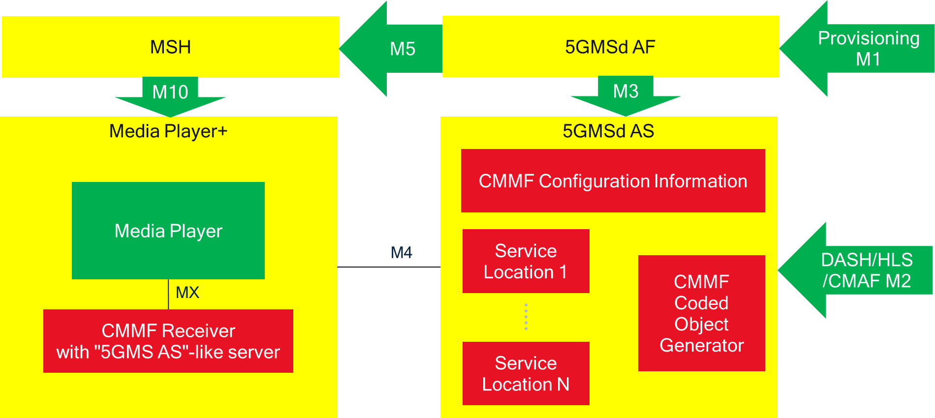
Figure 5.19.3.3.5-1: CMMF distribution mapping to generic architecture
In the provisioning step, the 5GMSd AF is provisioned to provide multiple service locations/endpoints, and to make redundant copies of DASH/HLS/CMAF content available at reference point M4d that have been ingested at reference point M2d. To achieve this, it configures multiple Content Distributions in the 5GMSd AF, and different service locations/endpoints may be mapped to these Content Distributions. Redundant content is generated with CMMF and provided at these different service locations/endpoints.
The configuration information provides all of this information in a manifest document,including an indication that the content included in the CMMF objects is DASH/HLS/CMAF content and possibly the location of the presentation manifest (e.g., MPD). As an example, ETSI TS 103 973 [126] specifies the use of the Extended FDT for this purpose.)
In the UE, the Media Player is the combination of a regular DASH/HLS media player, plus the CMMF Receiver. The CMMF Receiver provides the management and the usage of the DASH media player. Figure 5.19.3.3.5-1 illustrates one embodiment in which the CMMF Receiver includes the functionality a media server.

5.19.4 High-level call flows

5.19.4.1 Over-the-top multi-source for downlink Media Streaming

5.19.4.1.1 General high-level call flows
The procedures defined in clause 5 of TS 26.501 [15] generally apply to the architecture described in clause 5.19.3.1 of the present document. However, the procedure(s) for unicast downlink Media Streaming session establishment defined in clause 5.2 of TS 26.501 [15] are dependent on the multi-source approach in use. Any differences are expanded upon further in subsequent clauses.

5.19.4.1.2 Multi-source approach-specific high-level call flows

5.19.4.1.2.1 Overview
Depending on the approach used to implement multi-source functionality, the procedures for unicast downlink Media Streaming session establishment may differ from those defined in clause 5.2 of TS 26.501 [15]. For the purposes of this study, only differences in the DASH streaming procedures (clause 5.2.3 in TS 26.501 [15]) are shown below.

5.19.4.1.2.2 DNS-based switching
The procedure for streaming MPEG-DASH content using DNS-based switching to determine which content service location/endpoint (including 5GMSd Content Distribution) is used at any one time is shown in figure 5.19.4.1.2.2-1. For this procedure, the following assumptions apply:
- URLs describing the Media Entry Point(s) and media use an alias domain name that can be resolved using DNS.
- 5GMSd Application Provider can create/modify/update DNS CNAME records.
- 5GMSd Client can report performance metrics to an Online Service Location/Management subfunction within the 5GMSd Application Provider for the purposes of determining if switching from one Content Distribution to another is necessary.
- Media hosted in each content service location/endpoint (including 5GMSd Content Distribution) is identical (i.e., media is replicated across these content service locations/endpoints).
Differences from the baseline procedure in clause 5.2.3 of TS 26.501 [15] are highlighted in boldface.
NOTE: The indicated modifications to the baseline procedure can also be extended to the other procedures defined in clause 5.2 of TS 26.501 [15].
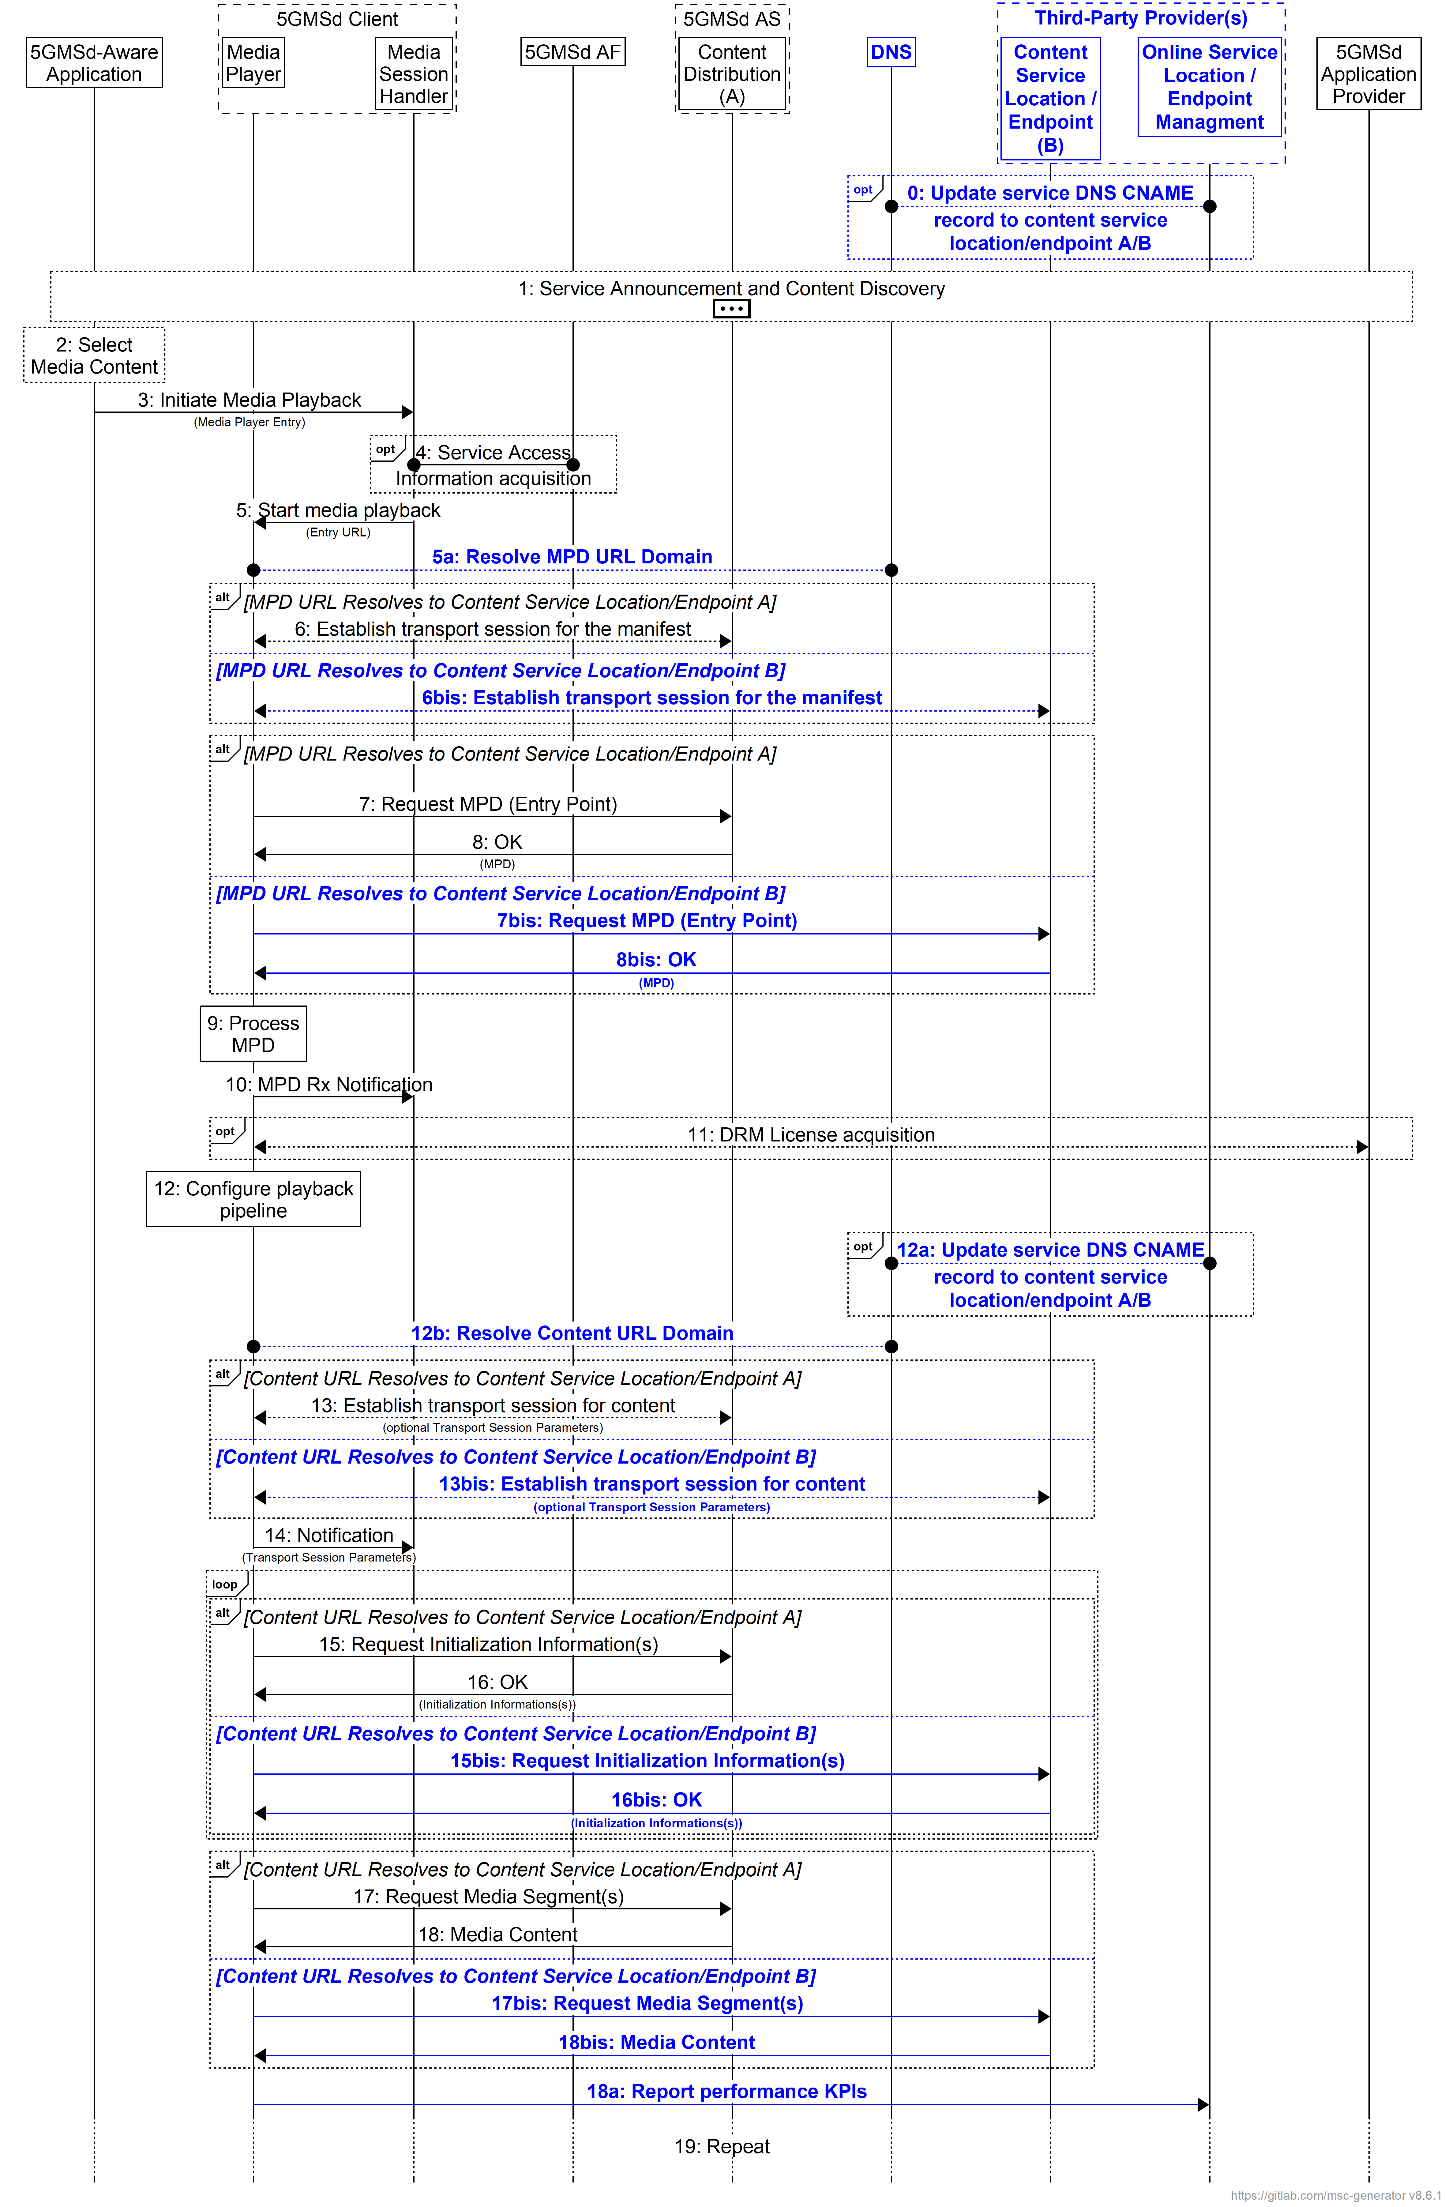
Figure 5.19.4.1.2.2-1: High-level procedure for DASH content using DNS-based switching
The steps for this procedure are largely the same as that shown in clause 5.2.3 of TS 26.501 [15]. The only differences are:
0. An Online Service Location/Endpoint Management subfunction, operated by a Third-Party Provider that is directly managed by the 5GMSd Application Provider, optionally updates the DNS CNAME record with the content service location/endpoint 5GMSd Clients should access to stream content.
NOTE 1: These updates are independent of any 5GMSd Client activity, and the 5GMSd Application Provider or Third-Party Provider can execute this update at any time.
5a. The step showing that the Media Player resolves the domain names of the URLs for the manifest and content is explicitly shown. These steps already occur during transport session establishment and do not indicate the Media Player needs to do anything different than what is described in clause 5.2.3 of TS 26.501 [15].
6bis. The source location/endpoint is different depending on the outcome of the DNS resolution when establishing the transport session.
7bis. The target source location/endpoint for the MPD request is different depending on the outcome of the DNS resolution.
8bis. The source location/endpoint responding to the MPD request is different depending on the outcome of the DNS resolution.
12a. An Online Service Location/Endpoint Management subfunction, operated by a Third-Party Provider that is directly managed by the 5GMSd Application Provider, optionally updates the DNS CNAME record with the content service location/endpoint 5GMSd Clients should access to stream content.
NOTE 2: These updates are independent of any 5GMSd Client activity, and the 5GMSd Application Provider or Third-Party Provider can execute this update at any time.
12b. The step showing that the Media Player resolves the domain names of the URLs for the manifest and content is explicitly shown. These steps already occur during transport session establishment and do not indicate the Media Player needs to do anything different than what is described in clause 5.2.3 of TS 26.501 [15].
13bis. The target source location/endpoint is different depending on the outcome of the DNS resolution when establishing the transport session.
15bis. The source location/endpoint for requesting initialization segments is different depending on the outcome of the DNS resolution.
16bis. The source location/endpoint responding to initialization segment requests is different depending on the outcome of the DNS resolution.
17bis. The source location/endpoint for requesting media segments is different depending on the outcome of the DNS resolution.
18bis. The source location/endpoint responding to media segment requests is different depending on the outcome of the DNS resolution.
18a. Media Player reports performance KPIs to the Third-Party’s Online Service Location/Endpoint Management subfunction. This reporting is necessary so that the subfunction can make informed decisions on whether and when to switch to a different service location/endpoint or not (see step 12a).

5.19.4.1.2.3 MPEG-DASH client-side switching
Streaming MPEG-DASH content using MPEG-DASH client-side switching to determine which Content Distribution and/or content service location/endpoint to stream media from is shown in figure 5.19.4.1.2.3-1.
For this procedure, the following assumptions apply:
- The 5GMSd Application Provider has included the appropriate service location decorators within the MPD that describe where the Media Player can access and download media.
- Media hosted in each Content Distribution and/or content service location/endpoint is identical (i.e., media is replicated across Content Distributions and content service locations/endpoints).
Differences from the baseline procedure in clause 5.2.3 of TS 26.501 [15] are highlighted in boldface.
NOTE: The indicated modifications to the baseline procedure can also be extended to the other procedures contained within clause 5.2 of TS 26.501 [15].
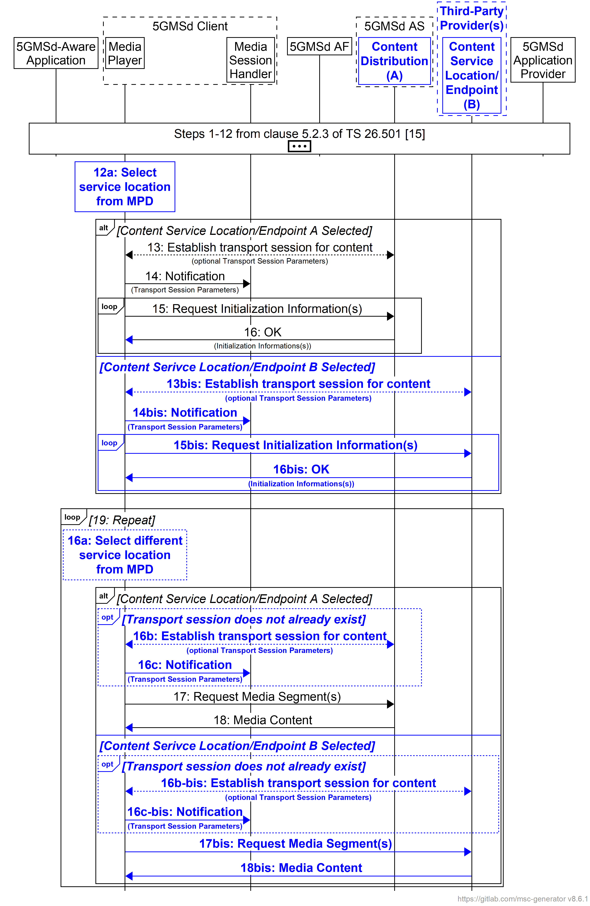
Figure 5.19.4.1.2.3-1: High-level procedure for DASH content using MPEG-DASH client-side switching
The steps for this procedure are largely the same as that shown in clause 5.2.3 of TS 26.501 [15]. The only differences are:
12a. The Media Player selects a service location/endpoint from the MPD for retrieving initialisation segments.
NOTE: The Media Player may establish a separate transport session for each media component (audio, video, etc) and possibly additional transport sessions for other media representations. This detail is omitted from figure 5.19.4.1.2.3-1 for the sake of simplicity.
15bis.The source location/endpoint for requesting initialisation segments is different depending on the Media Player’s service location selection in step 12a.
16bis. The source location/endpoint responding to initialisation segment requests is different depending on the Media Player’s service location selection in step 12a.
16a. The Media Player may select a different service location/endpoint from the MPD for retrieving media segments.
16b. If a transport session with the service location/endpoint selected in step 16a does not already exist, the Media Player establishes one.
16c. The Media Player notifies the Media Session Handler of any updates to the transport session parameters.
16b-bis. As step 16b except that the source location/endpoint for requesting media segments is different depending on the Media Player’s service location selection in step 16a.
16c-bis. As step 16c except that the source location/endpoint responding to nedia segment requesta is different depending on the Media Player’s service location selection in step 16a.
For progressive download or on-demand streaming, the call flows documented in clauses 5.7.3 and 5.7.4 of TS 26.501 [15] apply. In the case of client-side CDN switching, the Dynamic Policy resource in step 8 of clause 5.7.3 and step 15 of clause 5.7.4 declares a separate Application Data Flow description for each 5GMSd AS endpoint to which the Media Player connects at reference point M4d.
By having multiple Application Data Flow descriptions, Dynamic Policies can be instantiated that cover the multiple paths related to the multi-source deployment.
NOTE: In the case of on-demand streaming, it is straightforward to declare each 5GMSd AS endpoint address up front when the Dynamic Policy is instantiated, based on information in the Media Player Entry (MPD). In the case of live content and changing content, however, the 5GMSd AS endpoint addresses could change dynamically.

5.19.4.1.2.4 Content Steering Server driven switching
Streaming MPEG-DASH content using Content Steering Server driven switching to determine which Content Distribution and/or content service location/endpoint to stream media from is shown in figure 5.19.4.1.2.4-1. For this procedure, the following assumptions apply:
- The 5GMSd Application Provider has included the appropriate service location decorators within the MPD that describe where the Media Player can access and download media. This also includes the location of the Content Steering Server.
- The Media Player conforms to [111].
- Media hosted in each Content Distribution and/or content service location/endpoint is identical (i.e., media is replicated across Content Distributions and content service locations/endpoints).
Differences from the baseline procedure in clause 5.2.3 of TS 26.501 [15] are highlighted in boldface.
NOTE: The indicated modifications to the baseline procedure can also be extended to the other procedures contained within clause 5.2 of TS 26.501 [15].
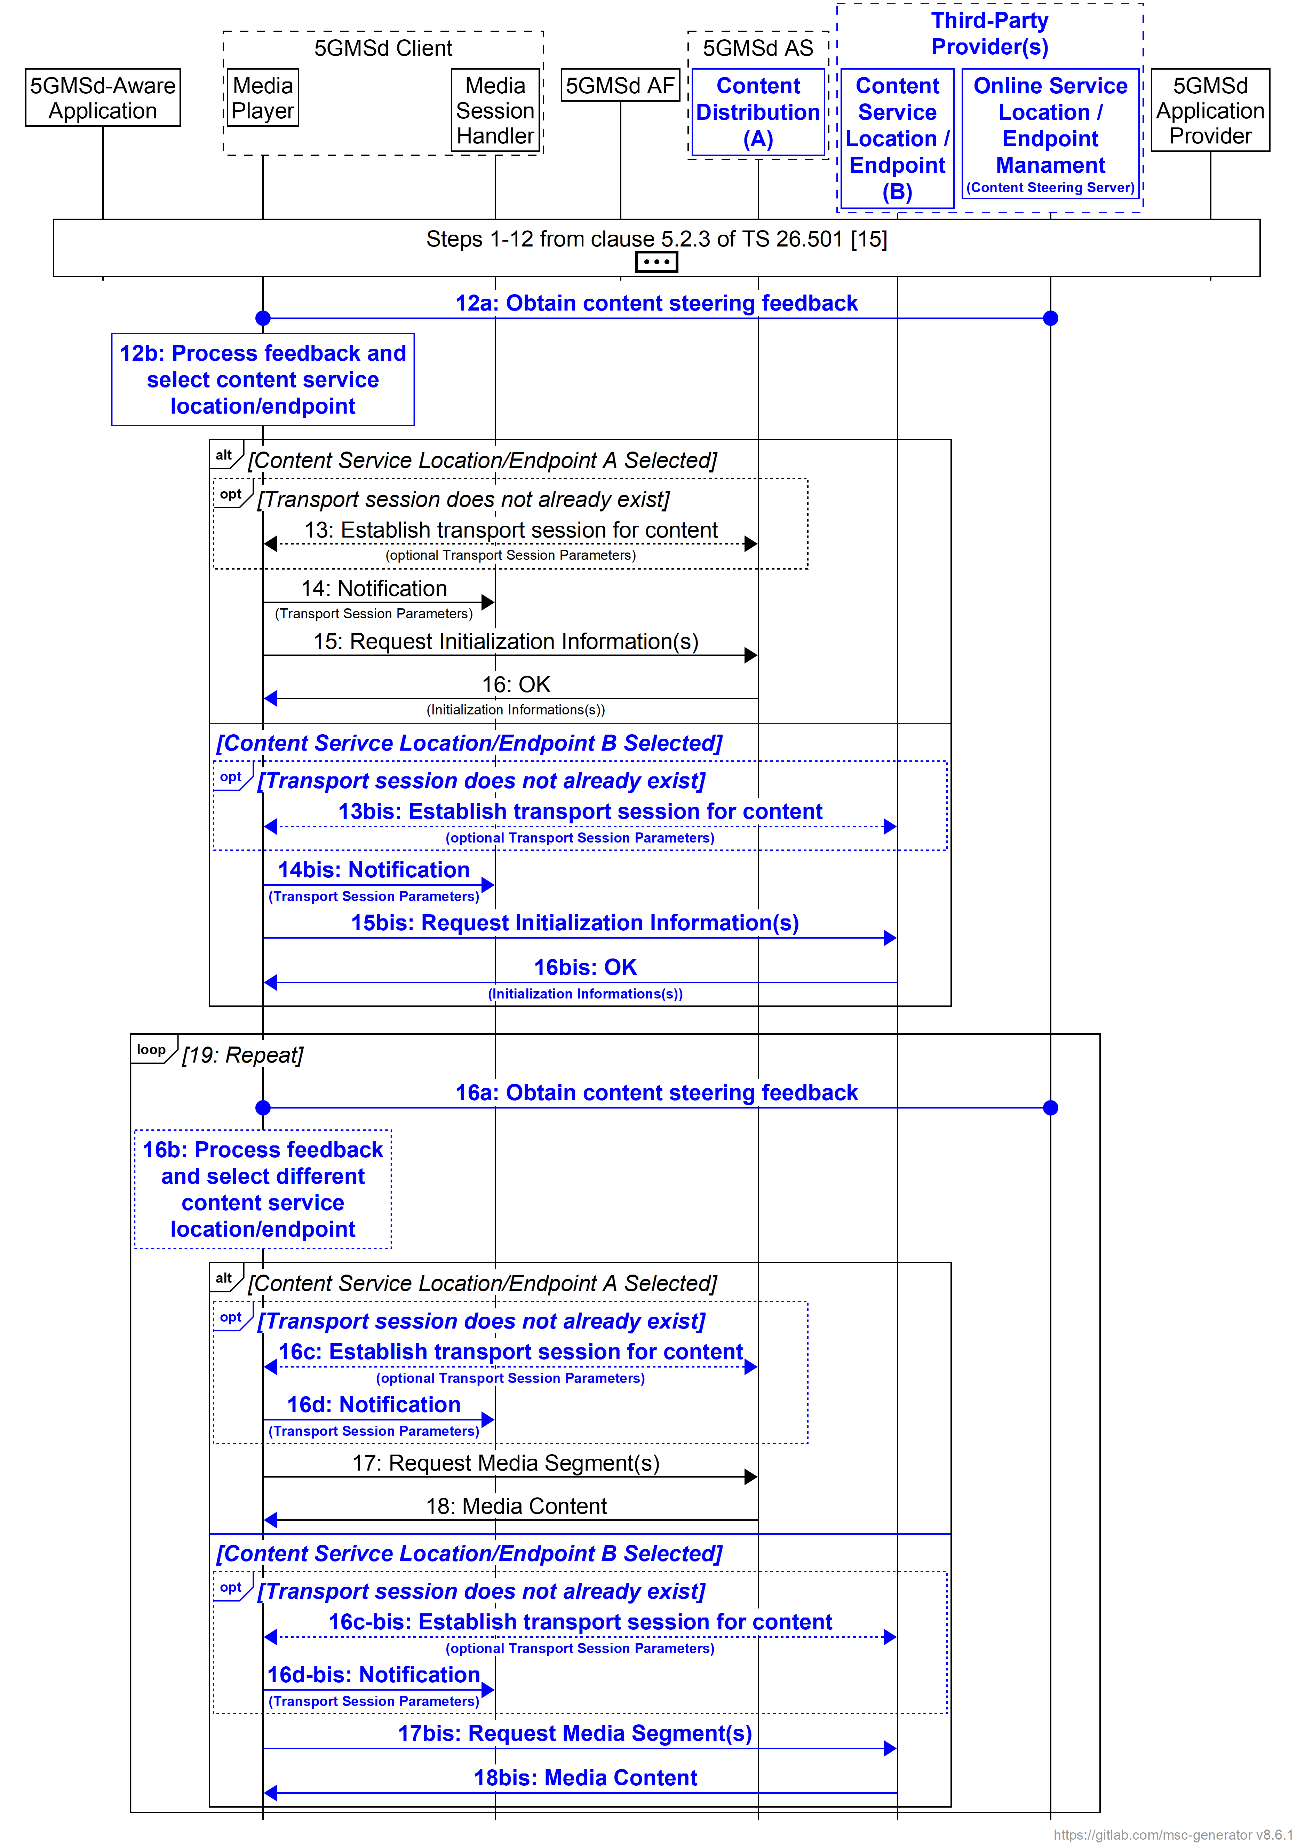
Figure 5.19.4.1.2.4-1: High-level procedure for DASH content using Content Steering Server driven switching
The steps for this procedure are largely the same as that shown in clause 5.2.3 of TS 26.501 [15]. The only differences are:
12a. The Media Player requests and receives Steering Instruction from the Content Steering Server per [111].
12b. The Media Player selects a service location/endpoint using feedback obtained from the Content Steering Server.
NOTE: The Media Player may establish a separate transport session for each media component (audio, video, etc) and possibly additional transport sessions for other media representations. This detail is omitted from figure 5.19.4.1.2.4-1 for the sake of simplicity.
15bis. The source location/endpoint for requesting initialisation segments is different depending on the Media Player’s service location selection in step 12a.
16bis.The source location/endpoint responding to initialisation segment requests is different depending on the Media Player’s service location selection in step 12a.
16a. The Media Player requests and receives Steering Instruction from the Content Steering Server per [111].
16b. The Media Player selects a service location/endpoint using feedback obtained from the Content Steering Server.
16c. If a transport session with the service location/endpoint selected in step 16b does not already exist, the Media Player establishes one.
16d. The Media Player notifies the Media Session Handler of any updates to the transport session parameters.
16c-bis. As step 16c except that the source location/endpoint is different depending on the Media Player’s service location selection in step 18a.
16d-bis. As step 16d except that the source location/endpoint is different depending on the Media Player’s service location selection in step 18a.

5.19.4.1.2.5 SAND4M multi-source delivery
High-level call flows describing how SAND4M can be used to enable multi-source delivery are left for further study.

5.19.4.1.2.6 CMMF-based multi-source delivery
The intent of CMMF is to supplement existing downlink streaming procedures, rather than replace them entirely. As such, minimal changes to the procedures provided in clause 5 of TS 26.501 [15] are necessary. Enabling multi-source media delivery using CMMF within existing downlink media delivery workflows can generally be realised through the following:
1. CMMF-encoded media objects, and possibly original source media (e.g., MPEG-DASH or HLS media segments), are striped across multiple uniquely addressable service endpoints/locations, which may include 5GMSd AS Content Distributions as well as third-party CDNs. Each service endpoint/location containing the same CMMF-encoded media object (or stripe) of the media (i.e., the CMMF-encoded media object is replicated across multiple service endpoints/locations, which may be 5GMSd AS instances) is considered a single CMMF endpoint. Within the architecture shown in figure 5.19.3.1.1-1, the 5GMSd Application Provider makes the CMMF-encoded media objects, and possibly original source media (e.g., MPEG-DASH or HLS media segments), available at reference point M2d as well as to third-party CDNs.
2. Upon initialization, the 5GMSd-Aware Application obtains relevant Service Access Information from the 5GMSd Application Provider at reference point M8d. At a minimum, this includes details concerning the location of each service endpoint/location (CMMF endpoint) from which a stripe of CMMF-encoded and possibly original media (e.g., MPEG-DASH or HLS media segments) may be obtained, as well as appropriate signalling to indicate whether the media at each location is CMMF-encoded.
3. The 5GMSd Client connects to and downloads CMMF-encoded media objects, and possibly the original source media (e.g., MPEG-DASH or HLS media segments), from each service endpoint/location (CMMF endpoint) simultaneously via reference point CMMF-1 (client architecture #1) or M4d (client architecture #2), terminating downloads early upon obtaining enough of the CMMF-encoded objects to recover the source media (e.g., MPEG-DASH or HLS media segment). Successfully decoded source media is presented by the Media Player.
The procedure depicted below illustrates how CMMF can supplement downlink media delivery using MPEG-DASH as defined in clause 5.2.3 of TS 26.501 [15]. The following assumptions apply:
- The 5GMSd Application Provider prepares source media for distribution using CMMF and ensures that each service endpoint/location (CMMF endpoint) is provisioned with a uniquely encoded representation (or stripe) of all media.
- CMMF-encoded content hosted is treated within the 5GMS System as any other non-CMMF-encoded content is treated (i.e., hosting CMMF-encoded content within the 5GMS System is transparent to the 5GMS Content Hosting function).
- The 5GMSd Client is provisioned with the functionality to access and download from multiple CMMF endpoint in parallel. This includes the functionality to efficiently download partial CMMF objects and jointly decode these partially received CMMF objects to recover the original source media requested by the Media Player.
Differences from the baseline procedure in clause 5.2.1 of TS 26.501 [15] are highlighted in boldface.
NOTE 1: Variations to the procedure below are possible for signalling necessary CMMF configuration information to the 5GMSd Client. For example, the 5GMSd Application Provider may provide an Online Service Location/Endpoint Management endpoint for the purpose of communicating this information at reference point M4d.
NOTE 2: The indicated modifications to the baseline procedure can also be extended to the other procedures contained within clause 5.2 of TS 26.501 [15].
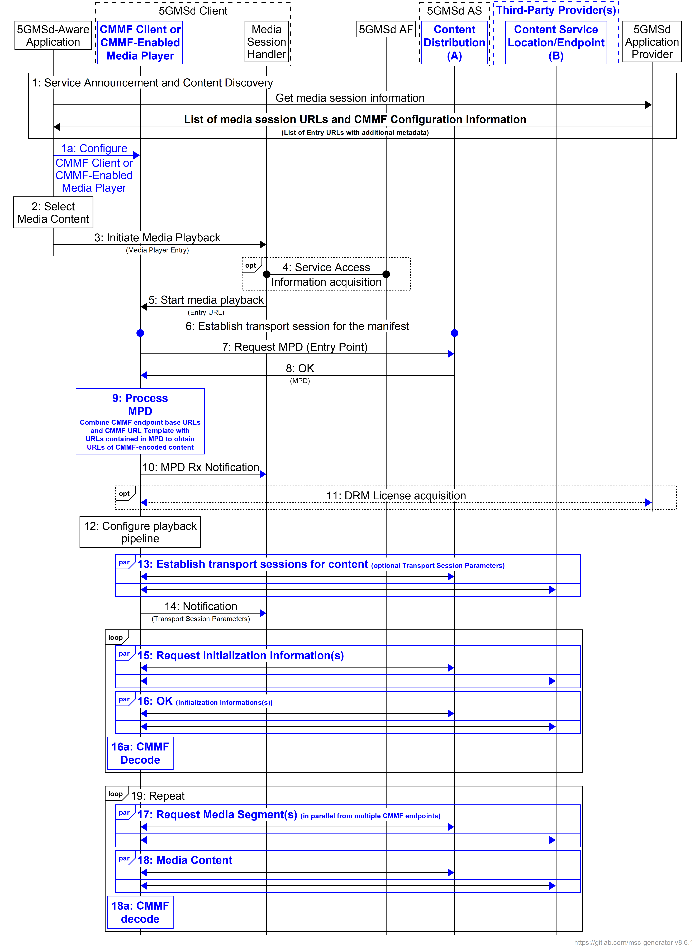
Figure 5.19.4.1.2.6: High-level procedure for DASH content using CMMF delivery
The steps for this procedure are largely the same as that shown in clause 5.2.3 of TS 26.501 [15]. The only differences are:
1. The 5GMSd-Aware Application triggers the Service Announcement and Service and Content Discovery procedure. The Service and Content Discovery procedure only involves the App and the external Application Server. The Service Announcement includes either the whole Service Access Information (i.e. details for Media Session Handling (M5d) and for Media Streaming access (M4d)) or a reference to the service access information. The Service Access Information includes relevant CMMF Client configuration information. This CMMF client configuration information may consist of URLs to each CMMF endpoint, a CMMF URL template allowing for translation of the URLs provided in content manifests (e.g., MPD) into URLs that can be used to access CMMF-encoded media within the 5GMS System, etc.
1a. The 5GMSd-Aware Application uses the CMMF client configuration information to set up and configure the CMMF object and decode functions within the CMMF Client or CMMF-Enabled Media Player.
9. The Media Player processes the MPD. Based on the information contained within the MPD as well as the relevant CMMF client configuration Information contained in the Service Access Information, the CMMF Client or CMMF-enabled Media Player determines, for example, the number of transport sessions needed for media acquisition, complete URLs to CMMF-encoded media, etc. The Media Player should use the MPD information to initialize the media pipelines for each media stream. The MPD should also contain information to initialize the DRM client, when DRM is used.
NOTE: CMMF does not impede the use of DRM as long as DRM is applied to the original source media prior to creation of CMMF-encoded objects of that media.
14. The Media Player establishes the necessary transport sessions for the CMMF-encoded content. For example, the CMMF Client or CMMF-enabled Media Player may establish one transport session for each media component (audio, video, etc) and possibly additional transport sessions for other media representations to each CMMF endpoint communicated by the CMMF client configuration information.
15. The Media Player requests initialization information. In the case where this initialization information has been encoded within CMMF objects, the CMMF Client or CMMF-enabled Media Player requests the CMMF-encoded initialization information objects from each CMMF endpoint in parallel. The URLs of the CMMF-encoded initialization information objects are determined using the MPD and information contained within the CMMF client configuration information (e.g., base URLs to each CMMF endpoint, CMMF URL Template, etc.). The CMMF Client of CMMF-enabled Media Player repeats this step for each required initialization segment.
16. The CMMF Client or CMMF-enabled Media Player receives the initialization information. In the case where this initialization information has been encoded within CMMF objects, the CMMF Client or CMMF-enabled Media Player downloads these multiple CMMF-encoded initialization information objects from each CMMF endpoint in parallel until such time as the CMMF decoder has received enough information to successfully decode, at which point the download of any incompletely acquired CMMF object is abandoned.
16a. In the case where the initialization information has been encoded within CMMF objects, the received information from the CMMF objects containing the initialization information is decoded by the CMMF decoder in the CMMF Client.
17. The CMMF Client or CMMF-enabled Media Player requests media segments according to the MPD. In the case where these media segments have been encoded within CMMF objects, the CMMF Client or CMMF-enabled Media Player requests the CMMF-encoded media segment objects from each CMMF endpoint in parallel. The URLs of the CMMF-encoded media segment objects are determined using the MPD and information contained within the CMMF Client configuration information (e.g., base URLs to each CMMF endpoint, CMMF URL template, etc.).
18. The CMMF Client or CMMF-enabled Media Player receives media segments. In the case where these media segments have been encoded within CMMF objects, the CMMF Client or CMMF-enabled Media Player downloads these multiple CMMF-encoded media segment objects from each CMMF endpoint in parallel until such time as the CMMF decoder has received enough information to successfully decode, at which point the download of any incompletely acquired CMMF object is abandoned.
18a. In the case where the media segments have been encoded within CMMF objects, the received information from the CMMF objects containing the media segment is decoded by the CMMF decoder in the CMMF Client and the decoded information is placed into the appropriate media rendering pipeline.

5.19.4.2 5GMS-integrated multi-source delivery

5.19.4.2.1 General high-level call flows
The procedures defined in clause 5 of TS 26.501 [15] generally apply to the architecture described in clause 5.19.3.2. However, some procedure(s) for unicast downlink Media Streaming session establishment defined in clause 5.2 of TS 26.501 [15] and media preparation are dependent on the multi-source approach in use. Any differences are expanded upon further in subsequent clauses.

5.19.4.2.2 Multi-source approach-specific high-level call flows

5.19.4.2.2.1 Overview
Depending on the approach used to implement multi-source functionality, the procedures for unicast downlink Media Streaming session establishment and content preparation may differ from those defined in clause 5 of TS 26.501 [15].

5.19.4.2.2.2 DNS-based switching
The call flow is similar to that contained in clause 5.19.4.1.2.2 with the following exceptions:
- The Content Service Location/Endpoint located within the Third-Party Provider(s) becomes a second Content Distribution within the 5GMSd AS.
- The Online Service Location/Endpoint Management subfunction located within the Third-Party Provider(s) is becomes a subfunction within the 5GMSd AS.

5.19.4.2.2.3 MPEG-DASH client-side switching
The call flow is similar to that contained in clause 5.19.4.1.2.3 with the following exceptions:
- The Content Service Location/Endpoint located within the Third-Party Provider(s) becomes a second Content Distribution within the 5GMSd AS.

5.19.4.2.2.4 Content Steering Server driven switching
The call flow is similar to that contained in clause 5.19.4.1.2.3 with the following exceptions:
- The Content Service Location/Endpoint located within the Third-Party Provider(s) becomes a second Content Distribution within the 5GMSd AS.
- The Online Service Location/Endpoint Management subfunction located within the Third-Party Provider(s) becomes a subfunction within the 5GMSd AS.

5.19.4.2.2.5 SAND4M multi-source delivery
High-level call flows describing how SAND4M can be used to enable multi-source delivery are left for further study.

5.19.4.2.2.6 CMMF-based multi-source delivery

5.19.4.2.2.6.1 Overview
The intent of CMMF is to supplement existing downlink streaming procedures, rather than replace them entirely. As such, minimal changes to the procedures provided in clause 5 of TS 26.501 [15] are necessary. Enabling multi-source media delivery using CMMF within existing downlink media delivery workflows can generally be realised through the following:
1. CMMF-encoded media objects, and possibly original source media (e.g., MPEG-DASH or HLS media segments), are striped across multiple uniquely addressable 5GMSd AS Content Distributions. Each 5GMSd AS Content Distribution containing the same CMMF-encoded media object (or stripe) of the media (i.e., the CMMF-encoded media object is replicated across multiple 5GMSd AS instances with an identical Content Distribution) is considered a single CMMF endpoint. The 5GMSd Application Provider makes the CMMF-encoded media objects, and possibly original source media (e.g., MPEG-DASH or HLS media segments), available at reference point M2d or they may be created by the 5GMSd AS performing content preparation on either regular media objects (e.g., MPEG-DASH or HLS media segments) ingested at reference point M2d or already created CMMF-encoded media objects ingested at reference point M2d.
2. Upon initialization of a playback session, the 5GMSd Client’s Media Session Handler obtains relevant Service Access Information from the 5GMSd AF at reference point M5d. At a minimum, this includes details concerning the location of each 5GMSd AS Content Distribution (CMMF endpoint) from which a stripe of CMMF-encoded and possibly original media (e.g., MPEG-DASH or HLS media segments) may be obtained, as well as appropriate signalling to indicate whether the media at each location is CMMF-encoded.
3. The 5GMSd Client connects to and downloads CMMF-encoded media objects, and possibly the original source media (e.g., MPEG-DASH or HLS media segments), from each 5GMSd AS Content Distribution (CMMF endpoint) simultaneously via reference point CMMF-1 (client architecture #1) or M4d (client architecture #2), terminating downloads early upon obtaining enough of the CMMF-encoded objects to recover the source media (e.g., MPEG-DASH or HLS media segment). Successfully decoded source media is presented by the Media Player.
The procedures for enabling multi-source delivery using CMMF for MPEG-DASH streaming sessions and provisioning the 5GMS System as shown in figure 5.19.3.2.1-1 to deliver CMMF-encoded media objects are provided in the following clauses.

5.19.4.2.2.6.2 CMMF provisioning, hosting, and processing procedure
The workflow for provisioning network resources and/or hosting CMMF-encoded media is dependent on the 5GMSd Application Provider requirements and network configuration. Assuming the 5GMSd Application Provider creates CMMF-encoded media, provides that media over reference point M2d, provisions CMMF endpoints external to the 5GMS System, and manages the configuration of the 5GMSd Client over reference point M8d, the procedures as outlined in clause 5.19.4.1.2.6 are sufficient to host and deliver CMMF-encoded media. However, cases exist where the 5GMS System may take a more active role in delivering CMMF-encoded media. These cases are outlined in the procedure below. Differences from the baseline procedure in clause 7.2 of TS 26.501 [15] are highlighted in boldface.
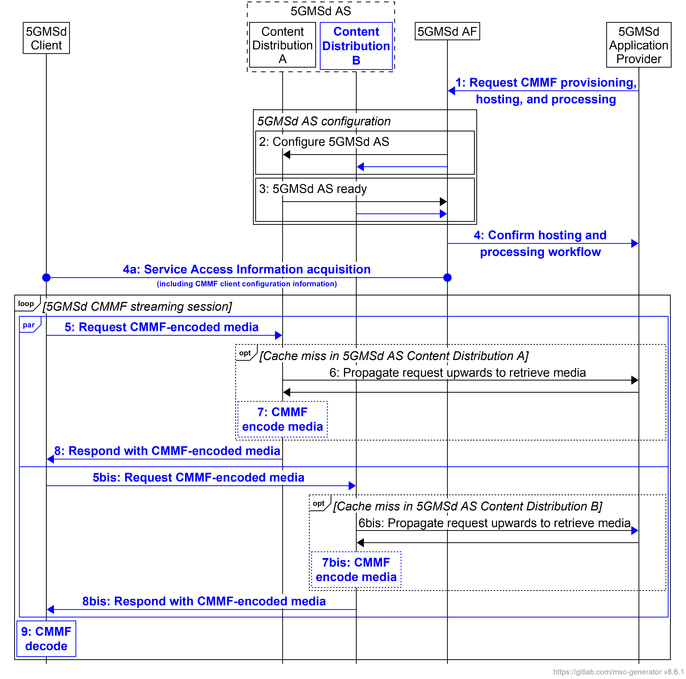
Figure 5.19.4.2.2.6.2-1: Media provisioning, hosting, and processing procedures for downlink media streaming using CMMF
Steps:
1. Upon setting up a CMMF Provisioning and Content Hosting Configuration, the 5GMSd Application Provider requests CMMF media processing and hosting to be set up. The 5GMSd Application Provider provides a description of the type and placement of the processing used to encode CMMF objects, including the required number of CMMF endpoints to be exposed as addressable 5GMSd AS Content Distribution sets, and defines the flow of content through the 5GMS System. The 5GMS System may only allow a shortlisted set of media processing functions to be used by the 5GMSd Application Provider.
4. The 5GMSd AF confirms the successful creation of the CMMF Provisioning and Content Hosting Configuration with the requested media processing to the 5GMSd Application Provider.
4a. The 5GMSd AF exchanges relevant CMMF client configuration information with the 5GMSd Client to enable the 5GMSd Client to access and download both CMMF-encoded media and original source media. This CMMF client configuration information may consist of URLs to each CMMF endpoint established in step 2, a CMMF URL template allowing for translation of the URLs provided in content manifests (e.g., MPD) into URLs that can be used to access CMMF-encoded media within the 5GMS System, etc.
5. A 5GMSd Client sends one or more requests for CMMF-encoded media content to one or more of the 5GMSd AS Content Distributions (established as CMMF endpoints) listed in the provisioned Content Hosting Configuration (see clause 5.4 of TS 26.501 [15]).
6. If it does not already have a copy of the requested media cached, the 5GMSd AS Content Distribution by the 5GMSd Client fetches the media from a back-end 5GMSd AS Content Distribution or from the 5GMSd Application Provider.
NOTE 1: Multiple options are available for distributing CMMF-encoded media to the addressed 5GMSd AS Content Distribution. These options are dependent on how the 5GMS System is provisioned and configured during steps 1–4. Options and details on the call flows involving cache misses are provided below.
7. Depending on the media content received from a back-end 5GMSd AS Content Distribution or from the 5GMSd Application Provider, the addressed 5GMSd AS Content Distribution may be required to create a unique CMMF-encoded representation of the requested media using content processing provisioned in step 1 and referenced by the Content Hosting Configuration.
NOTE 2: Additional details are provided below.
8. The addressed 5GMSd AS Content Distribution serves the requested CMMF-encoded media or original source media to the 5GMSd Client.
9. In the case where CMMF-encoded media is obtained from one or more 5GMSd AS Content Distributions, the 5GMSd Client decodes this CMMF-encoded media and recovers the original source media.
Different variants of these procedures (specifically steps 6 and 7) may be possible, depending on the placement of the processing, the placement of the CMMF endpoints, and the characteristics of the CMMF Content Provisioning and Hosting Configuration. Furthermore, the introduction of CMMF to supplement the download of media in other scenarios (e.g., downlink streaming to Media Players with different presentation manifests per clause 5.2.4 of TS 26.501 [15]) can be applied in a similar fashion to that shown below.
1. Content preparation by 5GMSd Application Provider. The procedure used when the 5GMSd Application Provider is responsible for encoding and packaging source media within CMMF bitstreams/objects prior to delivery of that content separately to each 5GMSd AS Content Distribution via reference point M2d, or to each externally deployed 5GMSd AS Content Distribution, is provided in figure 15.19.4.2.2.6.2-2. In these cases, the 5GMSd Application Provider provides a unique CMMF-encoded representation of the original source media to each 5GMSd AS Content Distribution configured as a CMMF endpoint.
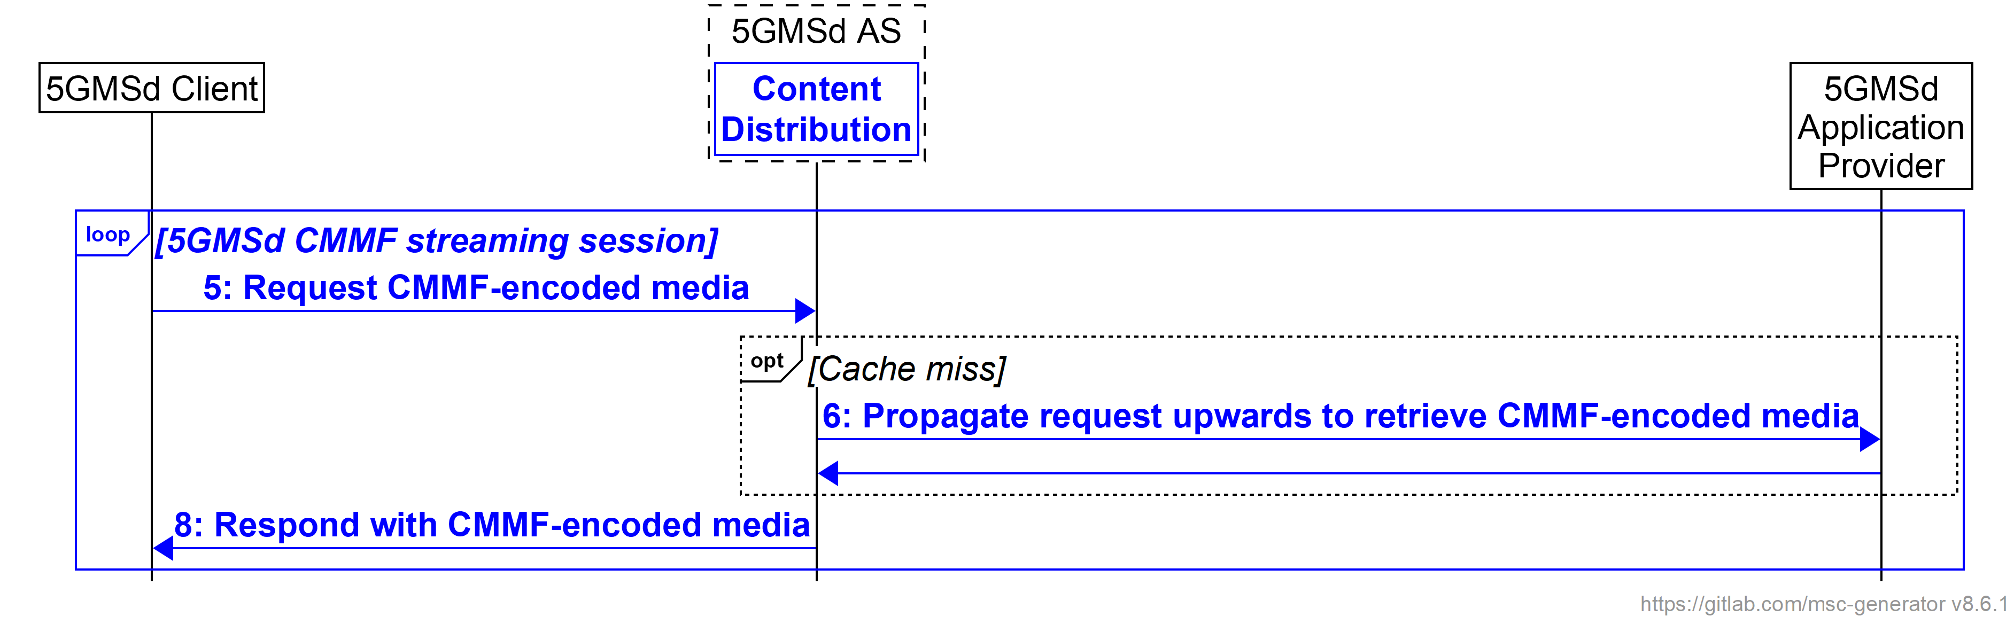
Figure 5.19.4.2.2.6.2-2: 5GMSd Application Provider CMMF Content Preparation and media processing procedures for downlink media streaming
Steps:
5. A 5GMSd Client sends one or more requests for CMMF-encoded media content to one or more of the 5GMSd AS Content Distributions (established as CMMF endpoints) listed in the provisioned Content Hosting Configuration (see clause 5.4 of TS 26.501 [15]).
6. If the 5GMSd AS Content Distribution does not have the required CMMF-encoded media cached, it requests and fetches a unique CMMF-encoded representation of the requested media from the 5GMSd Application Provider. In this case, it is the responsibility of the 5GMSd Application Provider to ensure that the CMMF-encoded representations of the requested media provided to each CMMF endpoint are unique. Upon receipt of the requested unique CMMF-encoded representation of the requested media, the 5GMS AS Content Distribution may cache the CMMF object locally to support subsequent requests for that content.
7. Media processing by the 5GMSd AS is not required.
8. The addressed 5GMSd AS Content Distribution serves the requested CMMF-encoded media to the 5GMSd Client.
2. Centralized 5GMSd content preparation. Figure 5.19.4.2.2.6.2-3 shows the procedure used when source content is ingested at reference point M2d by a single, primary 5GMSd AS Content Distribution that encodes and packages it into CMMF bitstreams/objects according to a Content Preparation Template reference by a Content Hosting Configuration previously provisioned by the 5GMSd Application Provider.
In these cases, the placement of 5GMSd AS Content Distribution is hierarchical, as shown in figure 5.19.3.2.2.6.3-1 and the client-addressable 5GMSd AS Content Distribution (CMMF endpoint) accessed at reference point M4d by 5GMSd Clients ingests, via reference point M10d, CMMF-encoded media from an upstream back-end 5GMSd AS Content Distribution that is configured to encode and package source media into CMMF bitstreams/objects. The 5GMSd AS Content Distribution performing CMMF content preparation is responsible for providing a unique CMMF-encoded representation of the original source media to each client-addressable 5GMSd AS Content Distribution configured as a CMMF endpoint.
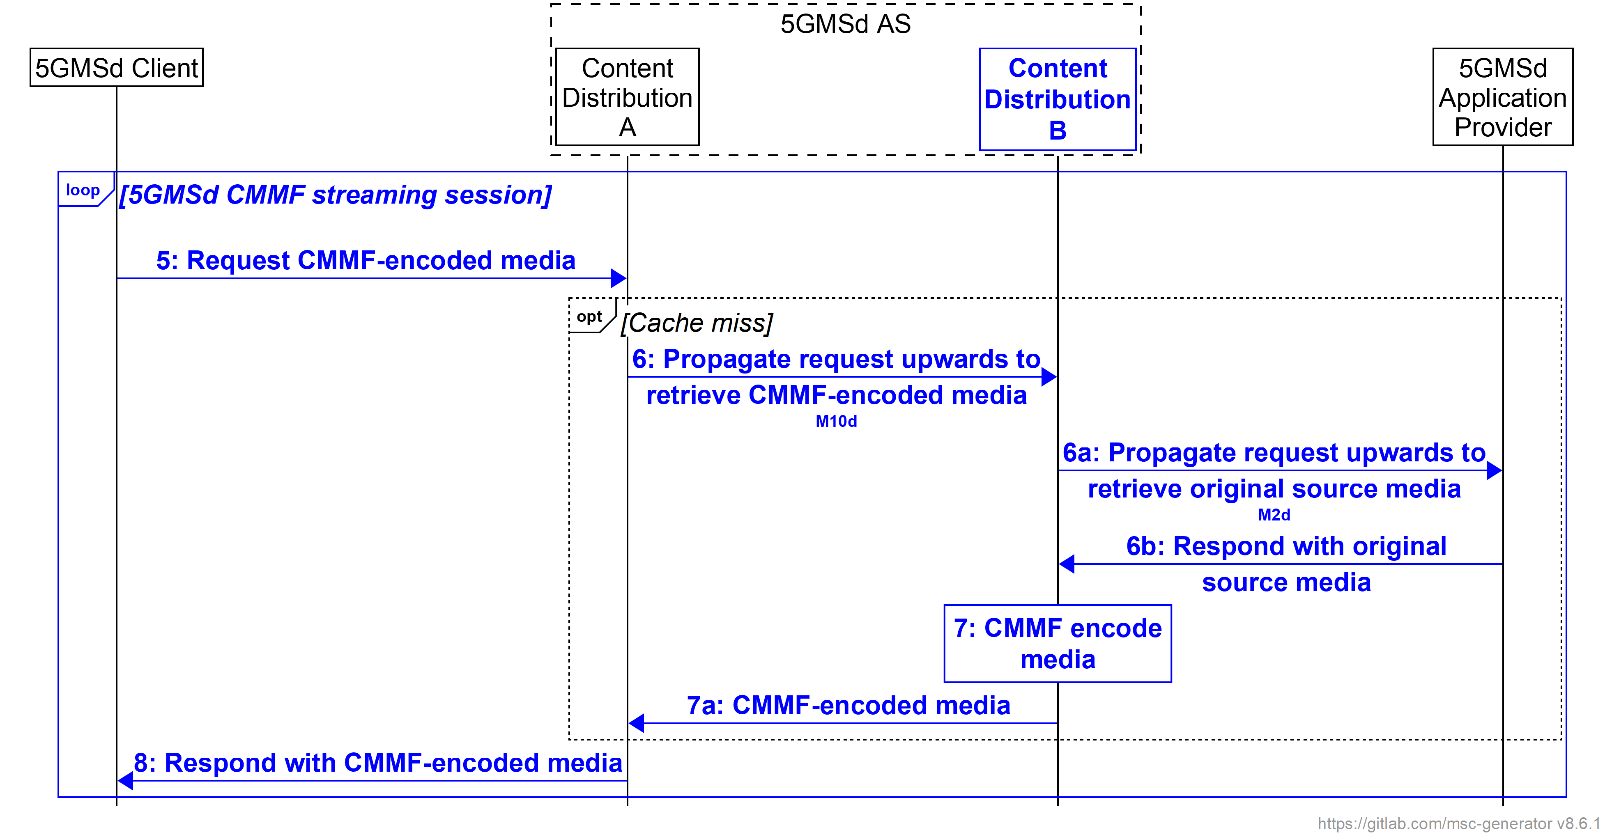
Figure 5.19.4.2.2.6.2-3: Centralized 5GMSd Content Preparation and media processing procedures for downlink media streaming
Steps:
5. The 5GMSd Client sends request(s) for CMMF-encoded media to one or more 5GMSd AS Content Distributions where each is configured as a different CMMF endpoint.
6. If 5GMSd AS Content Distribution (A) does not have the required CMMF-encoded media cached, it requests a unique CMMF-encoded representation of the requested media from a back-end 5GMSd AS Content Distribution (B).
6a. If 5GMSd AS Content Distribution (B) does not have the required CMMF-encoded media cached, it requests the original source media from the 5GMSd Application Provider.
6b: The 5GMSd Application Provider returns the requested original source media to 5GMSd AS Content Distribution (B).
7: 5GMSd AS Content Distribution (B) encodes the received original source media to create a CMMF-encoded representation unique to the requesting 5GMSd AS Content Distribution (A).
7a: 5GMSd AS Content Distribution (B) sends the requested CMMF-encoded media to 5GMSd AS Content Distribution (A).
8. 5GMSd AS Content Distribution (A) responds to the 5GMSd Client’s request with a CMMF-encoded representation of the requested media that is unique to the CMMF endpoint to which 5GMSd AS Content Distribution (A) belongs.
3. Decentralized 5GMSd content preparation. The procedure shown in figure 5.19.4.2.2.6.2-4 is used when CMMF media processing and content preparation is distributed across 5GMSd AS Content Distributions where each 5GMSd AS Content Distribution is responsible for the creation of a single CMMF representation which it intends to cache and/or deliver via reference point CMMF-1 or M4d (depending on the assumed 5GMSd Client architecture described in clause 5.19.3.2.1). This case is illustrated in figure 5.19.3.2.2.6.3-2.
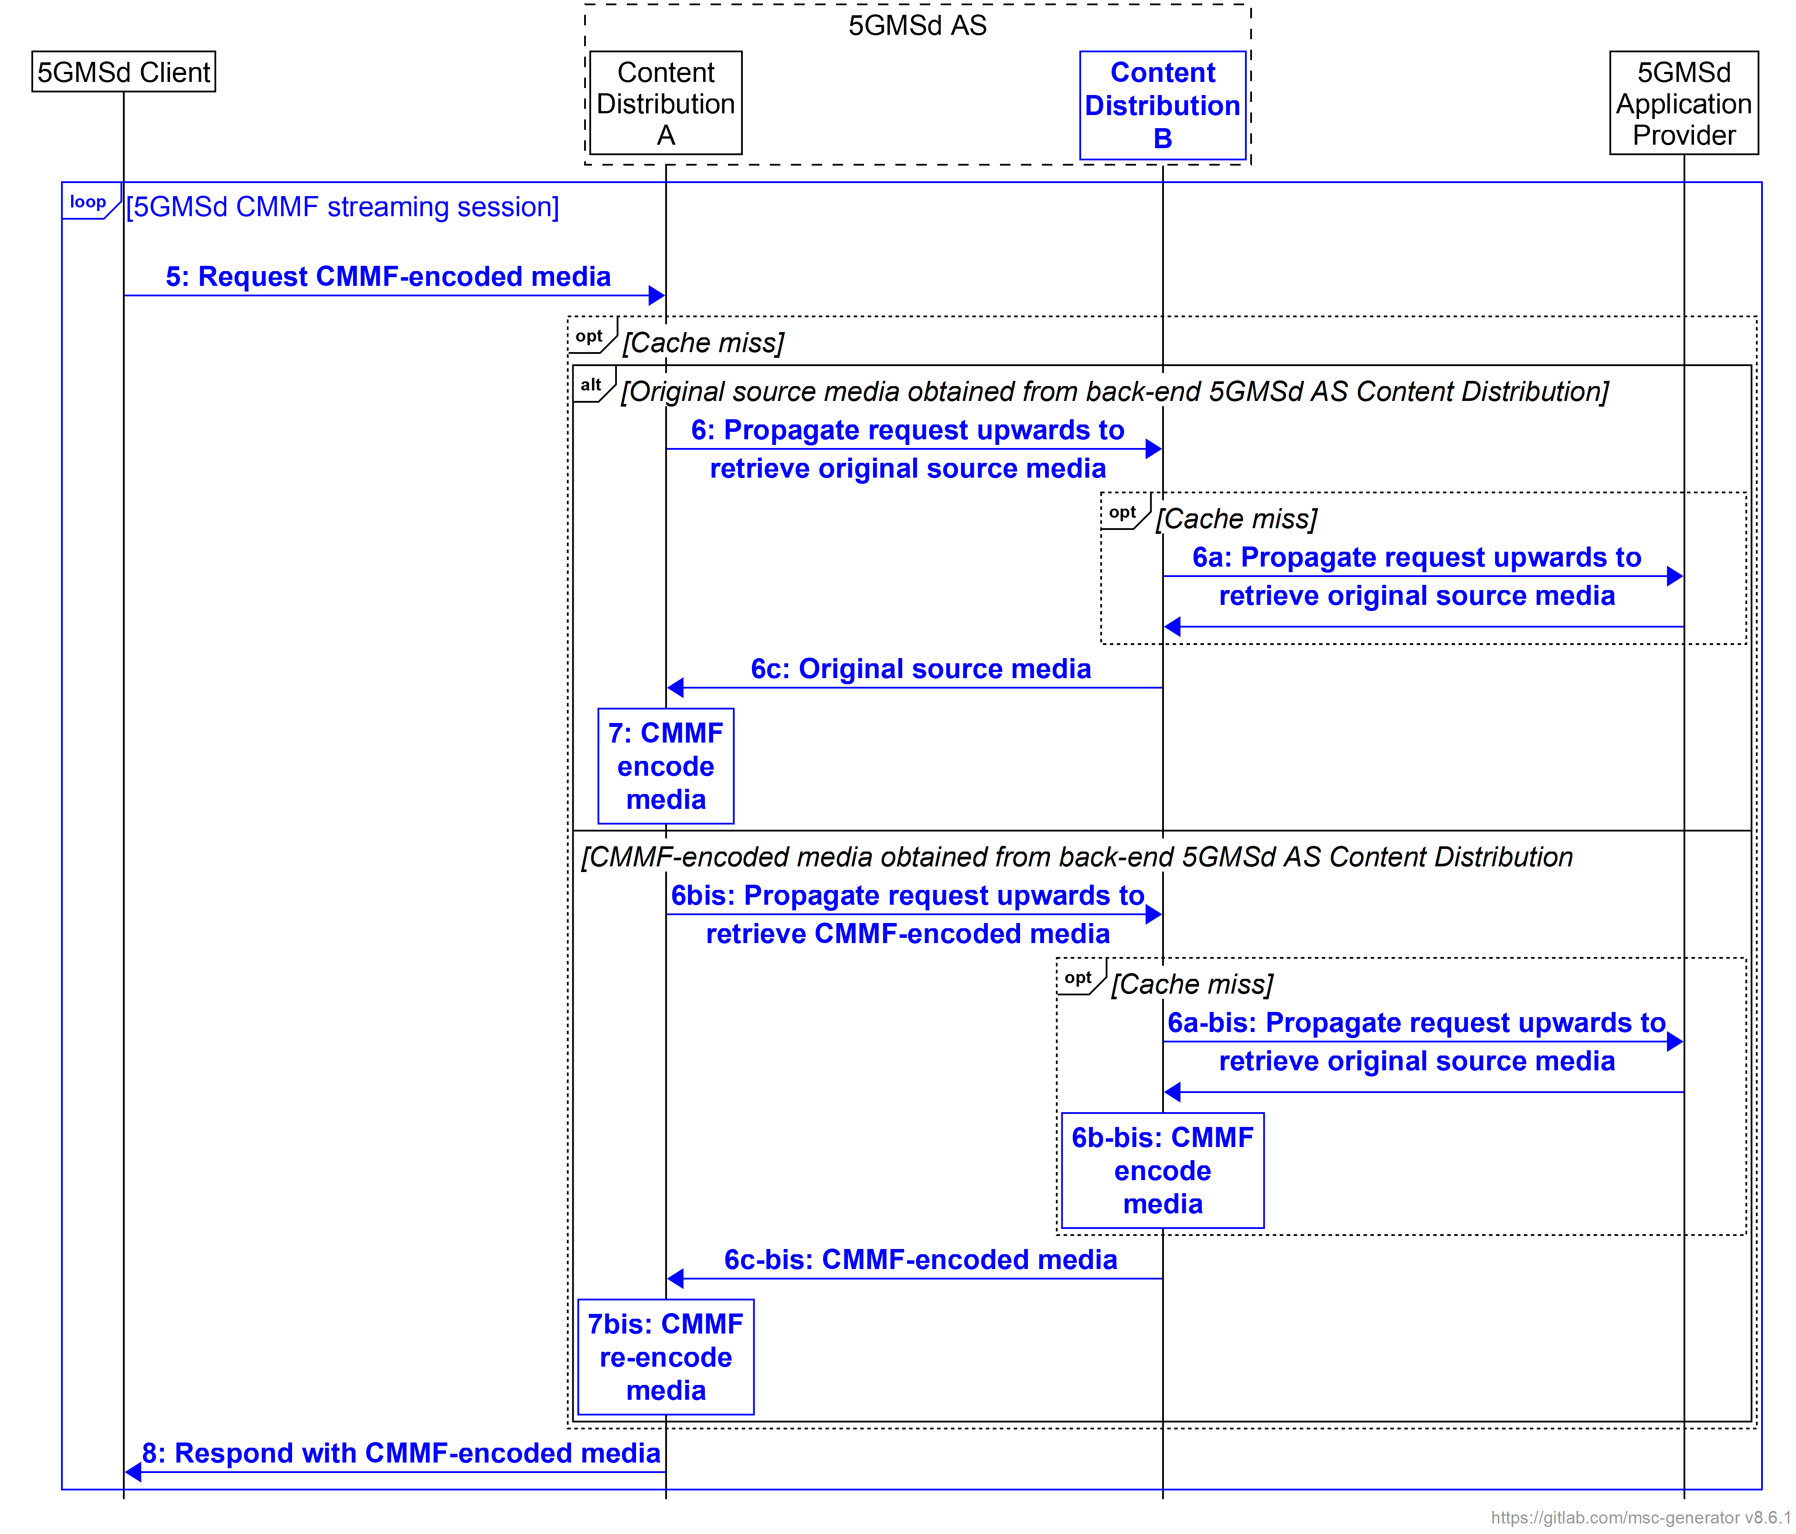
Figure 5.19.4.2.2.6.2-4: Decentralized 5GMSd Content Preparation and media processing procedures for downlink media streaming
Steps:
5. The 5GMSd Client sends request(s) for CMMF-encoded media to one or more 5GMSd AS Content Distributions where each is configured as a different CMMF endpoint.
6. If 5GMSd AS Content Distribution (A) does not have the required CMMF-encoded media cached, it requests the media from a back-end 5GMSd AS Content Distribution (B). 5GMSd AS Content Distribution (A) can explicitly request either the original source media or the CMMF representation unique to the back-end 5GMSd AS Content Distribution (B), or it can make a general request that may return one or the other.
6a. If the back-end 5GMSd AS Content Distribution (B) does not have a copy of the original source media or a CMMF-encoded representation cached, it may obtain it from the 5GMSd Application Provider.
6b. In the case where original source media is obtained in step 6, 5GMSd AS Content Distribution (B) encodes it into a unique CMMF representation where it may also be cached for later retrieval.
6c. Either the original source media or a CMMF-encoded representation unique to 5GMSd AS Content Distribution (B) is returned to 5GMSd AS Content Distribution (A).
7. In the case where original source content is obtained from the back-end 5GMSd AS Content Distribution (B), a CMMF-encoded representation unique to 5GMSd AS Content Distribution (A) is created. In the case where a CMMF-encoded representation unique to the back-end 5GMSd AS Content Distribution (B) is obtained, the CMMF-encoded representation is decoded back to the original source content and re-encoded to create a CMMF-encoded representation unique to 5GMSd AS Content Distribution (A).
8. 5GMSd AS Content Distribution (A) responds to the 5GMSd Client’s request with a CMMF-encoded representation of the requested media that is unique to the CMMF endpoint to which the 5GMSd AS Content Distribution (A) belongs.
Variations to the above content provisioning, preparation, and hosting procedures are possible to support different use cases, and 5GMS network configurations.

5.19.4.2.2.6.3 Procedures for CMMF downlink media streaming
The call flow is similar to that described in clause 5.19.4.1.2.6 with the following exceptions:
- The Content Service Location/Endpoint located within the Third-Party Provider(s) becomes a second Content Distribution within the 5GMSd AS.

5.19.4.3 Multiple service locations/endpoints in the User Plane

5.19.4.3.1 DNS-based switching
Call flows for multi-source delivery using DNS to switch between provisioned Content Distributions as described in clause 5.19.1.3 for the architecture option defined in clause 5.19.3.3 and the specific description in clause 5.19.3.3.1 are for further study.

5.19.4.3.2 MPEG-DASH client-side switching
Call flows for multi-source delivery using MPEG-DASH client-side switching as described in clause 5.19.1.4 for the architecture option defined in clause 5.19.3.3 and the specific description in clause 5.19.3.3.2 are for further study.

5.19.4.3.3 Content Steering Server driven switching
Call flows for multi-source delivery using a Content Steering Server as described in clause 5.19.1.5 for the architecture option defined in clause 5.19.3.3 and the specific description in clause 5.19.3.3.3 are provide in the following.
For provisioning, the call flow in clause 5.3.2 of TS 26.501 [15] applies with the following extensions that new provisioning parameters are needed including:
- Request for content using multiple service locations:
- Distribution of resources (copy, selected content on service locations, etc.)
- MPD hosting.
- Request for adding a Content Steering Server with parameters
- Update frequency.
- The number of service locations/endpoints, and parameters for each one.
- Each service location/endpoint may be assigned with different QoS parameters.
- Each service location/endpoint may be hosted in a different network slice.
- Other differentiating aspects may be considered.
- In a variant, the 5GMSd AS may also be informed about existing service locations/endpoints that are outside the 5GMS System, including policies on how they are to be used.
- Information on how the Content Steering Server may be used.
- In another embodiment, Content Steering for DASH and HLS may also be provided.
Details of the distribution call flow are shown in figure 5.19.4.3.4 based on clause 5.7.4 of TS 26.501 [15] as well as the call flow in clause 5.19.1.5 of the present document.
Figure 5.19.4.3.4-1: Call flow for Distribution Session with content steering
Differences with the baseline call flow in clause 5.7.4 of TS 26.501 [15] are highlighted in boldface for multiple service locations/endpoints with content steering:
8: The Media Player Entry document includes information about multiple service locations/endpoints as well as the location of the Content Steering Server.
9: The content steering and multiple service location data is processed by the Media Player.
13: The information may be used when establishing transport session.
20, 22: When accessing content segments, the selected service locations/endpoints are used.
21, 23: When accessing content segments and Media Entry documents, new information may be provided (updates to the Media Player Entry).
21a: Updated content steering information may be provided by the 5GMSd AS.
20, 22: The updated content steering information is used by the Media Player when requesting content segments available from different content locations/endpoints.

5.19.4.3.4 SAND4M multi-source delivery
Call flows for multi-source delivery using a SAND4M as described in clause 5.19.1.6 for the architecture option defined in clause 5.19.3.3 and the specific description in clause 5.19.3.3.4 are closely aligned with those for Content Steering in clause 5.19.4.3.3.

5.19.4.3.5 CMMF-based multi-source delivery
Call flows for CMMF-based media delivery as described in clause 5.19.1.7 for the architecture option defined in clause 5.19.3.3 and the specific description in clause 5.19.3.3.5 are provided in the following.
For the provisioning call flow, the call flow in TS 26.501 [15], clause 5.3.2 applies with the following extensions that new provisioning parameters are needed including:
- Request for CMMF processing with configuration parameters.
- Parameters for CMMF processing:
- Number of service locations.
- Formation of source and repair objects – (spreading, size).
- Usage of FEC code with code parameters.
- Distribution of Media Player Entry document.
- The number of service locations/endpoints and parameters for each one.
- Each service location/endpoint may be assigned with different QoS parameters
- Each service location/endpoint may be hosted in a different network slice.
- Other differentiating aspects to be added to service locations may be considered.
Details of the distribution call flow are shown in figure 5.19.4.3.4 based on clause 5.7.4 of TS 26.501 [15] as well as the call flow in clause 5.19.1.7.2 of the present document.
Figure 5.19.4.3.5-1: Call flow for Distribution Session with CMMF Content Delivery Protocol
For the distribution call flow, the updates based on clause 5.7.4 of TS 26.501 [15] are provided in bold for multiple service locations/endpoints with CMMF CDP
- Service announcement includes a CMMF Configuration Information document URL, including MIME content type.
- The Media Session Handler starts CMMF part of the Extended Media Player.
- The CMMF Configuration Information is acquired by the Extended Media Player.
- The CMMF Receiver in the Extended Media Player identifies MPD and starts the Media Player.
- Media Player identifies segments to be requested and requests them from the CMMF Receiver.
- CMMF Receiver, based on continuous updates, retrieves the associated encoded objects from the 5GMSd AS, recovers the source objects and provides the media segments to the Media Player for presentation.
In variants of the above:
- Parts of the information may go directly to the Media Player.
- The CMMF Configuration Information is static (for example, a template).

5.19.5 Gap analysis and requirements

5.19.5.1 Over-the-Top (OTT) multi-source delivery
Support for delivering media from multiple locations using the architecture described in clause 5.19.3.1 is largely supported by the 5GMS System. Within this architecture, the 5GMS System is configured such that it can be considered a single service location/endpoint; additional service location(s)/endpoint(s) (e.g., commercial CDNs) are outside of the scope of the 5GMS System. Furthermore, signalling availability of multiple service locations and management of their selection is performed by the 5GMSd Application Provider and the 5GMSd-Aware Application at reference point M8d which is also outside of the scope of the 5GMS System. However, 5GMSd Client support for multi-source/endpoint functionality is necessary for most multi-source delivery approaches considered. The required functionality includes:
1. 5GMSd Client supports the multi-source/endpoint approach in use. This includes:
a. Functionality to switch between or simultaneously use multiple source/endpoints located within either the Trusted or External DNs. For MPEG-DASH client-side switching and client-side switching driven by a Content Steering Server, this functionality includes the capability to switch the source/endpoint in use while accessing/downloading media. For CMMF-based delivery, this functionality includes the capability to efficiently access/download multiple CMMF-encoded media objects in parallel, as well as the capability to decode these received (or partially received) CMMF-encoded media objects to recover original source media objects required for playback.
b. Functionality necessary to support signalling of measurement and control messaging at reference point M4d′.
2. Multi-source/endpoint configuration information exchanged over client Media Session Handling (M6) and/or Media Stream Handler (M7/M11) APIs (clauses 12 and 13 of TS 26.512 [16]). In cases where multi-source delivery is configured and signalled by the 5GMSd Application Provider at reference point M8d rather than in-band (e.g., within the manifest), the Media Session Handling (M6) and/or Media Stream Handler (M7/M11) APIs are required to support signalling of parameters needed to configure a Media Player to execute multi-source/endpoint delivery. These parameters may include a list of source/endpoint base URLs, CMMF configuration information, remote multi-source/endpoint management information (e.g., Content Steering Server URL), etc.
3. User-plane reference point between Media Player and out-of-scope function. A new reference point is necessary in the 5GMS Architecture between the Media Player and a third-party provider that carries user-plane information (e.g., media).

5.19.5.2 5GMS-integrated multi-source delivery
Fully integrating multi-source/endpoint delivery within the 5GMS System as described in clause 5.19.3.2 is generally supported with several exceptions. Within this architecture, the 5GMS System is configured such that it natively supports multi-source/endpoint delivery. The 5GMS System currently supports establishment of multiple Content Distributions in the Content Hosting Configuration where each can be considered a distinct content location/endpoint. Each Content Distribution can also be configured to perform Content Preparation as needed by the specific multi-source/endpoint approach in use. However, this Content Preparation subfunction or its configuration is not fully specified. Furthermore, signalling of necessary multi-source/endpoint delivery parameters both to the 5GMSd Client and within the 5GMSd Client is also not fully specified. The following gaps in existing 5G Media Streaming specifications have not yet been addressed to support the capabilities discussed.
1. Capability to configure and provision content locations/endpoints within the 5GMS network to support multi-source/endpoint delivery. Multiple content endpoints can be provisioned and established within the 5GMS System by means of a Content Hosting Configuration (see clause 8.8 of TS 26.510 [108]). Each content location/endpoint is established as a unique Distribution Configuration where each Distribution Configuration is assigned a canonical Fully-Qualified Domain Name (FQDN) and base URL by the 5GMSd AF. Content in each Content Distribution is made available to 5GMSd Clients at reference point M4d. Furthermore, Content Preparation Templates can be linked to each Content Distribution to support use cases where either the manifest (i.e., MPD) or content requires modification/preparation prior to its delivery at reference point M4d. While most of the capabilities currently exist to configure and provision multiple content endpoints within the Content Hosting Configuration, the following capabilities are currently missing:
a. Content Preparation and Content Preparation Templates to support multi-source/endpoint delivery. Content Preparation Templates used during Content Distribution provisioning are not currently specified by 5GMS. These Content Preparation Templates need to define the content preparation operations necessary to prepare content for delivery at reference point M4d, specifically:
i. Manipulation of the presentation manifest (e.g. MPEG-DASH MPD) for cases where content endpoints/locations and/or the content endpoint access management function (e.g., Content Steering Server) locations are communicated within the manifest. The Content Preparation subfunction needs to accept content endpoint URLs and content endpoint access management function locations from the 5GMSd AF and make the appropriate changes to each manifest before delivery to a 5GMSd Client at reference point M4d.
ii. CMMF encoding and packaging for cases where the content endpoints are provisioned to perform these operations. These Content Preparation Templates and Content Preparation subfunctions is required to support the workflows described in clause 5.19.4.2.2.6.2.
To simplify deployments, it is desirable to be able to address fragments of a shared Content Preparation Template from a Content Distribution to dereference a particular Content Preparation action rather than provision each action using a separate Content Preparation Template document.
b. Capability to configure and provision Content Distribution ingest configurations. As currently specified in clause 8.8.3.1 of TS 26.510 [108], Content Distributions are implicitly fed from the ingest configuration of the Content Hosting Configuration to which they belong, and the ingest configuration specifies the parameters for ingesting media content into the 5GMSd AS at reference point M2d. Support for more complex Content Distribution deployments (e.g., the centralized and decentralized content preparation workflows described in clause 5.19.4.2.2.6.2) in which a Content Distribution is instead fed from a parent or sibling Content Distribution at reference point M10d also needs to be supported.
c. Capability to configure Content Distribution deployment requirements. Current specifications are unclear about where and how distinct Content Distributions in the (logical) 5GMSd AS are to be deployed in the DN. As an example, the capability to configure each Content Distribution on a separate 5GMSd AS physical host or Edge AS may be desirable for cases where improved robustness to content endpoint degradation/failure is required.
2. Capability to signal multi-source/endpoint configuration information to 5GMSd Clients at reference point M5d. For use cases where multi-source/endpoint delivery configuration information is not signalled in-band at reference point M4d (e.g., via a presentation manifest), out-of-band signalling of this information is necessary. The 5GMS System supports this via the Service Access Information provided by the 5GMSd AF at reference point M5d. However, the currently specified Service Access Information does not allow for the following:
a. Capability to signal external content endpoint locations. Use cases where the 5GMSd Application Provider provisions content endpoints externally to the 5GMS System are not currently supported since there are currently no methods to communicate content endpoints provisioned by the 5GMSd Application Provider in External DNs via the 5GMSd AF.
b. Capability to signal a list of endpoint locations that can be used for multi-source/endpoint delivery. The Service Access Information currently only supports the communication of a list of Media Entry Point resources (e.g., MPDs). To support multi-source/endpoint delivery, the Service Access Information is also required to be able to communicate FQDN base URLs of the provisioned Content Distributions defined in the Content Hosting Configuration.
c. Capability to signal 5GMSd AS Online Service Location/Endpoint Management subfunction configuration information. For cases where an Online Service Location/Endpoint Management function (e.g., a Content Steering Server) is provisioned within the 5GMSd AS, information about the endpoint URL used to access this function at reference point M4d, the API in use, etc. needs to be made available to the 5GMSd Client at reference point M5d.
d. Capability to signal URL path rewrite rules 5GMSd Clients should use when accessing media from different Content Distributions. In some use cases, media may be assigned a unique URL based on the Content Distribution from which it is served, how it was packaged, etc. An example includes CMMF-encoded media where CMMF-encoded media objects containing different representations (or stripes) of the same original source media are accessible via unique URLs. Clause 5.19.3.2.2.6.4 provides examples of different URL path rewrite rules addressing CMMF-encoded content.
e. Capability to signal CMMF-specific configuration information. In some cases, additional information beyond what is discussed above may be required to support CMMF-based multi-source delivery. This additional information may include the CMMF code type used to encode media, the CMMF profile in use, etc.
3. Capability to configure and provision Online Service Location/Endpoint Management subfunctions within the 5GMSd AS. An example may include the configuration and deployment within the 5GMSd AS of a Content Steering Server such as that specified in ETSI TS 130 998 [111].
4. 5GMSd Client multi-source/endpoint functionality is necessary for most multi-source delivery approaches considered. The required functionality includes:
a. 5GMSd Client that supports the multi-source/endpoint approach in use. This includes:
i. Functionality to switch between or simultaneously use multiple source/endpoints located within either the Trusted or External DNs. See item 1a in clause 5.19.5.1.
ii. Functionality necessary to support signalling of measurement and control messaging between the 5GMSd Client and a 5GMSd AS Online Service Location/Endpoint subfunction at reference point M4d. See item 1b in clause 5.19.5.1.
b. Exchange multi-source/endpoint configuration information over Media Session Handling (M6) and/or Media Stream Handler (M7/M11) APIs (clauses 12 and 13 of TS 26.512 [16]). See item 2 in clause 5.19.5.1.

5.19.5.3 Multiple service locations/endpoints in the User Plane

5.19.5.3.1 DNS-based switching
Gap analysis for multi-source delivery using DNS to switch between provisioned Content Distributions as described in clause 5.19.1.3 for the architecture option defined in clause 5.19.3.3 and the specific description in clause 5.19.3.3.2.1 as well as the call flows in clause 5.19.4.3.1 is for further study.

5.19.5.3.2 MPEG-DASH client-side switching
Gap analysis for multi-source delivery using MPEG-DASH client-side switching as described in clause 5.19.1.4 for the architecture option defined in clause 5.19.3.3 and the specific description in clause 5.19.3.3.2.2 as well as the call flows in clause 5.19.4.3.2 is for further study.

5.19.5.3.3 Content Steering Server driven switching
Gap analysis for multi-source delivery using a Content Steering Server as described in clause 5.19.1.5 for the architecture option defined in clause 5.19.3.3 and the specific description in clause 5.19.3.3.2.3 as well as the call flows in clause 5.19.4.3.3 are provided in the following.
For the provisioning call flow, the call flow in clause 5.3.2 of TS 26.501 [15] applies with the following additional provisioning parameters needed:
- Request for using multiple service locations/endpoints.
- Distribution of resources (copy, selected content on service locations, etc.).
- MPD hosting.
- Request for adding a Content Steering Server with the following parameters:
- Update frequency of the content steering information.
- The number of service locations/endpoints and parameters for each one.
- Each service location/endpoint may be assigned different QoS parameters.
- Each service location/endpoint may be hosted in a different network slice.
- Other differentiating aspects for service locations/endpoints may be considered.
- In a variant, the 5GMSd AS may also be informed about existing service locations/endpoints that are outside the 5GMS System and may provide policies on how to use them.
- Information on how the content steering server may be used.
- In another embodiment, Content Steering for DASH and HLS may also be provided.
For the distribution call flow, the following updates based on clause 5.7.4 of TS 26.501 [15] are needed:
- Media Player Entry document includes information about multiple service locations/endpoints and the location of the Content Steering Server.
- The content steering and multiple service location data is processed by the Media Player.
- The information may be used when establishing a transport session.
- When accessing media segments, the selected service locations/endpoints are used.
- When accessing media segments and Media Entries, new information may be provided (updates to Media Player Entry document).
- Updated content steering information may be provided by the 5GMSd AS.
- The information is used by the Media Player when requesting media segments that are available from different service locations/endpoints.

5.19.5.3.4 SAND4M multi-source delivery
Gap analysis for multi-source delivery using a SAND4M as described in clause 5.19.1.6 for the architecture option defined in clause 5.19.3.3 and the specific description in clause 5.19.3.3.2.4 is similar to that for Content Steering in clause 5.19.5.3.3.

5.19.5.3.5 CMMF-based multi-source delivery
Gap analysis for CMMF-based media delivery as described in clause 5.19.1.7 for the architecture option defined in clause 5.19.3.3 and the specific description in clause 5.19.3.3.2.5 as well as the call flows in clause 5.19.4.3.5 is provided in the following.
For the provisioning, the call flow in clause 5.3.2 of TS 26.501 [15] applies with the following additional provisioning parameters needed:
- Request for CMMF processing with configuration parameters.
- Parameters for CMMF processing:
- Number of service locations/endpoints.
- Formation of source and repair objects – (spreading, size).
- Usage of FEC code with code parameters.
- Distribution of Media Player Entry document.
- The number of service locations/endpoints and parameters for each service location/endpoint:
- Each service location/endpoint may be assigned different QoS parameters.
- Each service location/endpoint may distribute a different slice of content.
- Other differentiating aspects may be considered.
For the distribution, the details are shown in figure 5.19.4.3.4 based on clause 5.7.4 of TS 26.501 [15] as well as the call flow in clause 5.19.1.7.2. The following is needed to support multiple service locations/endpoints with the CMMF Content Delivery Protocol.
- The service announcement includes CMMF configuration information URL and MIME content type.
- The Media Session Handler starts the CMMF part of an extended CMMF-capable Media Player.
- The CMMF Configuration information acquired.
- The CMMF Receiver identifies MPD and starts the Media Player.
- The Media Player identifies segments to be requested and asks CMMF receiver.
- The CMMF Receiver, based on continuous updates, acquires the associated encoded objects, recovers the source objects and provides the media segments for presentation.

5.19.6 Candidate solutions

5.19.6.1 Overview
This clause provides an overview of candidate solutions that address the gaps identified in clause 5.19.5.
5GMS largely supports Over-the-Top (OTT) multi-source/endpoint media delivery (see clause 5.19.3.1) regardless of the multi-source/endpoint approach used. In this architecture, the 5GMS System is largely agnostic to availability of multiple content endpoints and all signalling of the availability of these content endpoints is generally performed over reference points outside the scope of the 5GMS architecture (i.e., M8d). However, most of the multi-source/endpoint media delivery approaches do require 5GMSd Client functionality that is not explicitly defined in TS 26.501 [15] or specified in TS 26.512 [16].
For use cases where the 5GMS System performs a more active role enabling multi-source/endpoint content delivery, several gaps exist. These range from how the 5GMS System is configured and provisioned to functionality required by the 5GMSd Client.
Proposed candidate solutions that may address these deficiencies are discussed below. Each clause proposes multiple candidate solution options to address the identified gap.

5.19.6.2 Content endpoint provisioning and configuration candidate solutions

5.19.6.2.1 Content Preparation Templates and Content Preparation candidate solutions

5.19.6.2.1.1 Overview
Examples of content preparation that might be needed to support different multi-source/endpoint use cases include:
- Repackaging ingested content (e.g., repackage content from MPEG-DASH to CMAF).
- Encoding content ingested at reference point M2d into multiple CMMF representations/stripes before distributing it at reference point M4d (e.g., CMMF delivery).
- Embellishing, or otherwise modifying, the Media Entry Point resource (e.g., MPEG-DASH MPD) ingested at reference point M2d before distributing it at reference point M4d to include references to content service locations/endpoints (e.g., BaseURL elements), content steering service endpoints (e.g., ContentSteering URL), etc.
Before provisioning the Content Hosting Configuration and Distribution Configurations, the 5GMSd Application Provider first provisions one or more Content Preparation Templates at reference point M1d. If necessary, a Content Preparation Template is referenced by a Distribution Configuration using the Content Preparation Template’s contentPreparationTemplateId.
The syntax and semantics of all Content Preparation Template formats are opaque to the 5GMSd AF, but they are understood by the 5GMSd AS. Different 5GMSd AS Content Distributions may support different types of Content Preparation Template, or different subsets of functionality expressed in each Content Preparation Template format. The Content Protocols Discovery API specified in clause 8.3 of TS 26.510 [108] is extended to allow a 5GMSd Application Provider to determine which types of Content Preparation Template (and which sub-features of each) are supported in a particular 5GMS System.
The following options for the format of the Content Preparation Template should be considered.

5.19.6.2.1.2 Candidate Solution 1a: Multipurpose Content Preparation Template document format specified outside the scope of 3GPP
The Content Preparation Template follows a multi-purpose format specified outside the scope of 3GPP (e.g. MPEG-I Part 8 (Network-Based Media Processing) as specified in ISO/IEC 23090-8 [130]). The MIME content type of the Content Preparation Template is as specified in [130]. The usage of this generic Content Preparation Template in the context of 5G Media Streaming is profiled in new clauses of 3GPP TS 26.511 [96]. The generic MIME content type is listed in clause 4.3.5.2 of TS 26.512 [16] as valid for use with the 5GMS System, along with a reference to the set of valid profiles specified in TS 26.511 [96].

5.19.6.2.1.3 Candidate Solution 1b: Bespoke Content Preparation Template document format specified outside the scope of 3GPP
The Content Preparation Template follows a file format specified outside the scope of 3GPP that is bespoke to the form of content preparation (e.g., a CMMF configuration file format specified in an annex to ETSI TS 103 973 [126]). The MIME content type of the bespoke Content Preparation Template document format is also specified outside the scope of 3GPP, but it is listed in clause 4.3.5.2 of TS 26.512 [16] as valid for use with the 5GMS System along with a reference to the relevant external specification.

5.19.6.2.1.4 Candidate Solution 1c: Bespoke Content Preparation Template document format specified by 3GPP
The Content Preparation Template follows a format specified by 3GPP that is bespoke to the form of content preparation (e.g. a CMMF configuration file format specified in a new annex to TS 26.511 [96]). The MIME content type of the bespoke Content Preparation Template document format is also specified in TS 26.511 [96], and it is also listed in clause 4.3.5.2 of TS 26.512 [16] as valid for use with the 5GMS System, alongside a reference to TS 26.511 [96].

5.19.6.2.2 Content Hosting Configuration candidate solutions

5.19.6.2.2.1 Overview
The 5GMS System allows for the establishment of multiple logical content endpoints that can be used for multi-source/endpoint delivery through the Content Hosting provisioning API specified in clause 8.8 of TS 26.510 [108] and used by a 5GMSd Application Provider at reference point M1d. An ingest configuration for media ingested at reference point M2d is specified and one or more Distribution Configurations where media is made available to 5GMSd Clients at reference point M4d. Each such Distribution Configuration is accessible through a canonical Fully-Qualified Domain Name (FQDN), and baseURL, both assigned by the 5GMSd AF. A Distribution Configuration may describe a single content item, or multiple content items. A Media Entry Point resource (e.g., MPD) is defined if the former, and it is omitted if the latter.
Several options exist for Content Hosting provisioning within the 5GMS System to support multi-source/endpoint media delivery. In some cases, the Content Hosting provisioning API is extended to allow a 5GMSd Application Provider to define a Content Hosting Configuration that supports their multi-source/endpoint use case.
The following should be considered.

5.19.6.2.2.2 Content distribution ingest configuration candidate solutions

5.19.6.2.2.2.1 Candidate Solution 2a: 5GMSd AF-managed Content Distribution ingest configuration
The 5GMSd AF configures individual 5GMSd AS Content Distributions at reference point M3d with appropriate Content Preparation Template(s). Content preparation may be centralized or distributed among multiple 5GMSd AS Content Distributions at the discretion of the 5GMSd AF. Content prepared in one 5GMSd AS Content Distribution may be conveyed to another 5GMSd AS Content Distribution via reference point M10d on a hierarchical or peer-to-peer basis at the discretion of the 5GMSd AF. Clause 5.2.8 in TS 26.510 [108] is updated appropriately.

5.19.6.2.2.2.2 Candidate Solution 2b: 5GMSd Application Provider guided content distribution ingest configuration
In some use cases, the 5GMSd Application Provider may require specific deployment configurations where it dictates the structure of Content Distributions within the Content Hosting Configuration. In such cases, Content Distributions can be chained together to form linear, hierarchical, or peer-to-peer structures within the 5GMSd AS by adding a distributionIngest configuration property (similar to that of the ingestConfiguration property in the Content Hosting Configuration resource specified in clause 8.8.3 of TS 26.510 [108]) to both clauses 5.2.8 and 8.8.3 of TS 26.510 [108]. Additional properties are added to the Content Hosting Configuration resource, including:
- distributionConfigurations[ ].name. A name assigned by the 5GMSd Application Provider to this Content Distribution. This name may be referenced by other Distribution Configurations defined within the Content Hosting Configuration.
- distributionConfigurations[ ].ingestSource: A reference to the name of another distribution configuration which will be used for the purposes of ingesting media into the Content Distribution represented by this Distribution Configuration. If empty, the information defined within the ingestConfiguration is used as the source of content.
In cases where the distributionConfigurations[ ].ingestSource property is present for a Content Distribution Configuration by the 5GMSd Application Provider, the 5GMSd AF takes it into account when configuring Content Hosting within the 5GMSd AS instances at reference point M3d. If this property is not defined, Content Distribution provisioning is left to the discretion of the 5GMSd AF.

5.19.6.2.2.3 Content Distribution 5GMSd AS instance deployment configuration candidate solutions

5.19.6.2.2.3.1 Candidate Solution 3a: Require 5GMSd AF provisioning of Content Distributions on separate 5GMSd AS instance
A flag is added to the Content Hosting Configuration specified in clauses 5.2.8 and 8.8 of TS 26.510 [108] declaring the requirement that each Content Distribution is configured by the 5GMSd AF on a separate 5GMSd AS instance.

5.19.6.2.2.3.2 Candidate Solution 3b: Content Distribution affinity property
A new top-level Boolean distributionAffinity property is added to the ContentHostingConfiguration resource specified in clause 8.8.3 of TS 26.510 [108]. This property indicates whether all Content Distributions are to be hosted on the same 5GMSd AS instance as each other, or whether they are all to be hosted on different 5GMSd AS instances.
- If this flag is TRUE:
- The 5GMSd AF configures a set of 5GMSd AS instances at reference point M3d where each Content Distribution defined by the Content Hosting Configuration is provisioned on a different 5GMSd AS instance within the 5GMS System.
- The authority in both the distributionConfigurations[].canonicalDomainName and distributionConfigurations[].‌baseURL assigned by the 5GMSd AF for each Content Distribution is unique to the provisioned Content Distribution.
- If the flag is FALSE or omitted:
- Provisioning of content distributions across a set of 5GMSd AS instances is at the discretion of the 5GMSd AF, i.e., the 5GMSd AF may configure each Content Distribution in the Content Hosting Configuration on the same or on a different 5GMSd AS instance.
- When two or more content distributions are provisioned on a single 5GMSd AS instance, the authority in both the distributionConfigurations[].canonicalDomainName and distributionConfigurations[].baseURL assigned by the 5GMSd AF for each Content Distribution may or may not be unique. In the latter case, the path is unique to each provisioned content distribution.

5.19.6.2.2.3.3 Candidate Solution 3c: Content Distribution affinity groups
A new optional property affinityGroup is added to the DistributionConfiguration data type. This property assigns the Content Distribution to a named affinity group chosen by the 5GMSd Application Provider.
- Content Distributions belonging to the same affinity group are intended to be hosted on the same 5GMSd AS instance.
- Content Distributions belonging to different affinity groups are intended to be hosted on different 5GMSd AS instances.
- Provisioning of Content Distributions across a set of 5GMSd AS instances is at the discretion of the 5GMSd AF if this property is omitted.

5.19.6.3 Multi-source/endpoint service information candidate solutions

5.19.6.3.1 Overview
5GMSd Clients may require the following information to use any of the multi-source/endpoint approaches described in clause 5.19.1:
- Content service locations/endpoints (i.e., URLs) where content is accessible, whether internal to the 5GMSd System (e.g., 5GMSd AS Content Distributions) or external (e.g., commercial CDNs).
- Location (i.e., URL) of any functions provisioned within the network that provide service location/endpoint management (e.g., a Content Steering Server).
- URL path rewrite rules for cases where URLs available to the 5GMSd Client (e.g., URLs contained within a presentation manifest) differ from where the content can be accessed on each service location/endpoint (e.g., URLs to CMMF-encoded media are dynamically built using the URLs contained within a manifest).
- Necessary information about the multi-source/endpoint approach in use (e.g., CMMF-specific configuration information as specified within ETSI TS 103 973 [126], Content Steering Server API version, etc.).
Several methods exist that can be used to provide this information to 5GMSd Clients. These are enumerated in subsequent clauses.

5.19.6.3.2 Candidate Solution 4a: Media Entry Point signalling of multi-source/endpoint service information
A Media Entry Point resource is used to convey necessary multi-source/endpoint information to 5GMSd Clients. For example:
- Service location information (e.g., base URLs). For example, this information may be added as decorators to every manifest.
- A content steering decorator is added to every manifest that provides a URL to the multi-source/endpoint management function, etc.
- CMMF configuration information required by the 5GMSd Client is included within the Media Entry Point. This may include information as specified within ETSI TS 103 973 [126] (e.g., Extended FDT information).
The definition of the Media Entry Point in clause 4 of TS 26.501 [15] and TS 26.510 [108] is relaxed to allow for the transmission of multi-source/endpoint service information which can then be combined with a Media Player Entry by the 5GMSd Client.

5.19.6.3.3 Candidate Solution 4b: 5GMSd-Aware Application signalling of multi-source/endpoint service information at reference point M8d
Information necessary for 5GMSd Clients to stream media from multiple sources/endpoints within the network is signalled between a 5GMSd Application Provider and a 5GMSd-Aware Application at reference M8d. The method(s) used are outside of the scope of the 5GMS System and no normative changes to TS 26.510 [108] are necessary, but changes to the media stream handling client API in TS 26.512 [16] are needed (see clause 5.19.6.5.4.2 below).

5.19.6.3.4 Candidate Solution 4c: 5GMSd AF signalling of multi-source/endpoint service information at reference point M5d
Information necessary for 5GMSd Clients to stream media from multiple source/endpoints within the network may be signalled between the 5GMSd Client’s Media Session Handler and 5GMSd AF in the Service Access Information resource provided at reference point M5d and this information is passed on to the Media Player via the client API at reference point M11d (see clause 5.19.6.5.4.2 below).
In this candidate solution, the ServiceAccessInformation resource specified in clause 9.2.3.1 of TS 26.510 [108] is extended to include the necessary information to describe the content service locations/endpoints where media can be streamed, information required by the multi-source/endpoint approach in use (e.g., Content Steering Server URL, CMMF configuration information, etc.), etc.
Additional properties in the ContentHostingConfiguration resource specified in clause 8.8.3.1 of TS 26.510 [108] may also be defined in the case where the Service Access Information is used to communicate details about content service locations/endpoints external to the 5GMS System (e.g., third-party service locations) for subsequent exposure in the ServiceAccessInformation resource.

5.19.6.4 Online Service Location/Endpoint Management configuration and provisioning candidate solutions
Configuration and provisioning of an Online Service Location/Endpoint Management function within the 5GMSd AS is necessary if the desired multi-source/endpoint approach (e.g., Content Steering Server driven switching) requires it. However, candidate solutions describing how this is done are considered outside the scope of this Key Issue. See clause 5.17 for further details.

5.19.6.5 5GMSd Client multi-source/endpoint candidate solutions

5.19.6.5.1 Overview
Whether multi-source/endpoint media delivery is deployed as shown by the architectural mapping in clause 5.19.3.1 or that in clause 5.19.3.2, 5GMSd Clients are required to support the specific multi-source/endpoint approach used (e.g., MPEG-DASH client-side switching, CMMF-enabled delivery, etc.). The following candidate solutions address identified gaps within the 5GMSd Client that are required to be filled to support multi-source/endpoint media delivery.

5.19.6.5.2 Multi-source/endpoint capable 5GMSd Client candidate solutions

5.19.6.5.2.1 Candidate Solution 5a: Media Player supported multi-source/endpoint media delivery
The design of the Media Player and the functionality it supports are considered outside of the scope of the 5GMS architecture. It is further assumed that the Media Player as defined in clause 4.2.2 of TS 26.501 [15] and clause 13.2 of TS 26.512 [16] natively supports the multi-source/endpoint media delivery approach (e.g., MPEG-DASH client-side switching, CMMF-enabled delivery, etc.) in use. (In the case of CMMF, this corresponds to an architecture similar to client architecture #2 as described in clause 5.19.3.1.2.6.1 of the present document.) Both clauses are updated to explicitly state that the Media Player natively supports the multi-source/endpoint delivery approaches considered within this Key Issue when the approach(es) are used to delivery media.

5.19.6.5.2.2 Candidate Solution 5b: New 5GMSd Client or UE functions that enable multi-source/endpoint delivery
New 5GMSd Client or UE functions are defined within clause 4 of TS 26.501 [15] that extend the capabilities of existing Media Players that are not capable of performing multi-source/endpoint delivery to be able to switch among and/or simultaneously use multiple content sources/endpoints. An example of these functions specific to CMMF-enabled delivery is shown in figure 5.19.3.1.2.6.1-1. This architecture can be generalized for each multi-source/endpoint media delivery approach considered within this study.

5.19.6.5.2.3 Candidate Solution 5c: Specify Media Player multi-source/endpoint architecture within 5GMS
The Media Player architectures, as defined in clause 4.2.2 of TS 26.501 [15] and clause 13.2 of TS 26.512 [16] are expanded to explicitly define and specify the subfunctions necessary to stream media from multiple content sources/endpoints. In most cases, this can be accomplished by updating the descriptions of existing subfunctions to include details about operating when multiple content sources/endpoints are available. For example, the description of the Media Access Client is updated so that it includes the functionality to switch among multiple content sources/endpoints and/or to use multiple content sources/endpoints to download and decode CMMF-encoded media.
This extension may also include the definition of a new subfunction for the purposes of interacting with a 5GMSd AS Online Service Location/Endpoint Management function at reference point M4d.

5.19.6.5.3 5GMSd AS Online Service Location/Endpoint Management signalling candidate solutions
Definition of the interactions (i.e., APIs) between the 5GMSd Client and Online Service Location/Endpoint Management function deployed in the 5GMSd AS via reference point M4d or deployed externally to the 5GMS System accessed via reference point M4d′ are necessary. However, candidate solutions describing how this is done are considered outside the scope of this Key Issue. See clause 5.17 for further details.

5.19.6.5.4 Media Session Handling (M6d) and Media Stream Handler (M7d/M11d) API candidate solutions

5.19.6.5.4.1 Candidate Solution 6a: Media Entry Point signalling of multi-source/endpoint service access information
This candidate solution is relevant if Candidate Solution 4a in clause 5.19.6.3.2 is selected.
The information needed by the Media Player to enable it to use multiple sources/service locations/endpoints is contained within the Media Entry Point resource (e.g., MPD) and no modifications to existing Media Session Handling (M6d) or Media Stream Handler (M7d/M11d) APIs are necessary.

5.19.6.5.4.2 Candidate Solution 6b: 5GMSd-Aware Application and Media Session Handler signalling of multi-source/endpoint Service Access Information at reference points M7d and M11d
This candidate solution is applicable if Candidate Solutions 4b or 4c in clauses 5.19.6.3.3 and 5.19.6.3.4, respectively, are selected. The selection of this candidate solution does not impact the use of Candidate Solution 4a in clause 5.19.6.3.2 since the recommendations below would not be used or applicable.
Clause 13 of TS 26.512 [16] is updated so that information required to configure the Media Player to switch between – or simultaneously use – multiple sources/endpoints is available at reference point M7d and M11d. The Configurations and settings API defined in clause 13.2.4 of TS 26.512 [16] is updated to include additional properties within the serviceDescriptions[ ] array:
- serviceDescriptions[ ].baseURL: Base URL from which content is made available to the Media Player at reference point M4d. These base URLs may be for both content distributions provisioned within the 5GMSd AS, as well as the base URLs of content service locations/endpoints provisioned external to the 5GMS System by the 5GMSd Application Provider.
- serviceDescriptions[ ].pathRewriteRules: An ordered set of rules for each baseURL. These rules are used for rewriting the request URL paths obtained from a manifest (e.g., MPD) and translating them to URL paths specific to the referenced content service location/endpoint at reference point M4d. An example use case is provided in clause 5.19.3.1.2.6.4.
- serviceDescriptions[ ].multiSourceProfiles[ ]: An optional list of (a yet to be defined) multi-source/endpoint profiles that provide the ability to communicate information necessary for the Media Player to use the referenced content distribution in a multi-source/endpoint configuration. These profiles may indicate that the use of the referenced content distribution is controlled by an Online Service Location/Endpoint Management subfunction, indicate that the referenced content distribution can be used for the delivery of CMMF-encoded media formatted using a specific CMMF profile, etc. Furthermore, these profiles are to be defined in TS 26.511 [96].
Furthermore, the Configurations and setting API is updated to include a new top-level multiSourceManagment object that provides necessary information to the Media Player to connect with and use Online Service Location/Endpoint Management subfunctions provisioned within the 5GMSd AS or externally by the 5GMSd Application Provider. This object may include a URL where the Online Service Location/Endpoint Management subfunction can be accessed at reference point M4d/M4d′, information concerning the API(s) that the subfunction conforms to (e.g., Content Steering Server as specified in [111]), etc.

5.19.6.6 Candidate Solution 7: Reference Point between Media Player and non-5GMS content hosting function
A new reference point, Mexternal, is added to the 5GMS architecture between the Media Player and a non-5GMS content hosting function for the purposes of user plane information exchange. This reference point may terminate at the 5GMSd Application Provider or similar function as shown in figure 5.19.3.1.1-1. This reference point is for information purposes only and its definition is outside the scope of the 5GMS System.

5.19.7 Summary and conclusions
This Key Issue has considered the integration of different technologies into the 5G Media Streaming System that allow downlink media streaming applications to efficiently access content located across multiple content sources/endpoints. These technologies include:
- DNS-based switching,
- MPEG-DASH client-side switching,
- Content steering driven switching,
- SAND4M multi-source/endpoint delivery (to a limited extent), and
- CMMF-based multi-source/endpoint delivery.
In almost all cases, these technologies may be employed over-the-top of the 5GMS System using methods outside the scope of 5GMS (with the exception that the 5GMS Client is underspecified regarding multi-source/endpoint operation). However, explicit support for multi-source/endpoint media delivery throughout the 5GMS System is recommended through the following changes to 5GMS specifications:
1. Document additional collaboration scenarios for multi-source media streaming, including associated call flows for both over-the-top multi-source delivery and 5GMS-integrated multi-source delivery, in annex A of TS 26.501 [15].
2. Candidate Solution 1a (clause 5.19.6.2.1.2) and Candidate Solution 1b (clause 5.19.6.2.1.3). Specification of Content Preparation Templates are outside the scope of 3GPP. These Content Preparation Templates may be used for the following purposes:
a. Repackaging ingested content (e.g., repackage content from MPEG-DASH to CMAF).
b. Embellishing, or otherwise modifying, the Media Entry Point resource (e.g., MPEG-DASH MPD) ingested at reference point M2d before distributing it at reference point M4d to include references to content service locations/endpoints (e.g., BaseURL elements), content steering service endpoints (e.g., ContentSteering URL), etc.
c. Encoding content ingested at reference point M2d into multiple CMMF representations/stripes before distributing it at reference point M4d (e.g., CMMF delivery).
Content Preparation Templates may be specified through:
- A multipurpose document format such as MPEG-I Part 8 (Network-Based Media Processing) as specified in ISO/IEC 23090-8 [130]), or
- A document format bespoke to the form of content preparation (e.g., a CMMF configuration file format specified in an annex to ETSI TS 103 973 [126]).
The generic MIME content type of each Content Preparation Template format is listed in clause 4.3.5.2 of TS 26.512 [16] as valid for use with the 5GMS System, along with references to the set of valid profiles specified in TS 26.511 [96] and relevant external specifications.
3. Verification of Content Preparation Template signalling and implementation within 5GMS specifications is correct.
4. Candidate Solution 2a (clause 5.19.6.2.2.2.1). At the discretion of the 5GMSd AF, content preparation may be centralized or distributed among multiple 5GMSd AS Content Distributions defined within a single Content Hosting Configuration. Content prepared in one 5GMSd AS Content Distribution may be conveyed to another 5GMSd AS Content Distribution via reference point M10d on a hierarchical or peer-to-peer basis at the discretion of the 5GMSd AF. Clause 5.2.8 in TS 26.510 [108] is updated appropriately.
To support this, the 5GMS architecture defined in clause 4.1 of TS 26.501 [15] and the reference point definitions are amended to bring reference point M10 into scope.
5. Candidate Solution 3c (clause 5.19.6.2.2.3.3). Provide the option in clauses 5.2.8 and 8.8.3 of TS 26.510 [108] for the 5GMSd Application Provider to influence how Content Distributions are provisioned across multiple 5GMSd AS instances.
Candidate Solution 3c provides the 5GMSd Application Provider the ability to define distribution affinity groups which may be used by the 5GMSd AF when provisioning the Content Hosting Configuration across a set of 5GMSd AS instances. This candidate solution not only supports the intent of Candidate Solutions 3a (clause 5.19.6.2.2.3.1) and 3b (clause 5.19.6.2.2.3.2), but it also provides greater flexibility in how Content Distributions are provisioned within the 5GMSd AS.
6. Candidate Solution 4a (clause 5.19.6.3.2). Where applicable, document within 5GMS specifications the ability to signal the capability to deliver media from multiple content sources/endpoints using information contained within the Media Entry Point resource. This includes updating clauses within both TS 26.501 [15] and TS 26.512 [16]. Since signalling relevant information is performed outside the scope of 3GPP, 5GMS specification updates should be limited to providing clarity that this option exists.
7. A "5GMS Media Player" is defined within TS 26.501 [15] where appropriate requirements, functions, APIs, etc. are specified for the purposes of Media Player interoperability within the 5GMS System.
8. Candidate Solutions 5a (clause 5.19.6.5.2.1). The Media Player as defined in clause 4.2.2 of TS 26.501 [15] and clause 13.2 of TS 26.512 [16] natively supports the multi-source/endpoint media delivery approach (e.g., MPEG-DASH client-side switching, CMMF-enabled delivery, etc.) in use. However, its design is considered outside the scope of the 5GMS architecture. Both clauses should be updated to explicitly state that the Media Player natively supports the multi-source/endpoint delivery approaches considered within this Key Issue when the approach(es) are used to deliver media.
9. Candidate Solution 6a (clause 5.19.6.5.4.1). Changes to the existing Media Session Handling (M6d) or Media Stream Handler (M7d/M11d) APIs are not recommended at this time since the preferred solution is that multiple source/service location information required by the Media Player are communicated within a Media Entry Point document.
10. Candidate Solution 7. A new reference point between the Media Player and a non-5GMS content hosting function, currently labelled mExternal in clause 5.19.3.1.1, is added to the 5GMS architecture defined in clause 4 of TS 26.501 [15] for user plane information exchange. This may also include the definition of a new Media Player function referenced as the "External Access Client" in clause 5.19.3.1. The operation of this function is considered outside the scope of the 5GMS System.

===== CHANGE =====

5.20 Optimising modem usage for media streaming

5.20.1 Description

5.20.1.1 Background Data Transfer for 5G Media Streaming
In Release 18 TS 26.501 [15] and TS 26.510 [108] added support for Background Data Transfer to the Dynamic Policies feature of the 5G Media Streaming System. This capability allows a UE to download content using downlink media streaming in non-real time ahead of consumption, or to uplink stream recorded content in non-real time when the content can be delivered with delay. Background Data Transfers occur during time intervals that are announced in advance by the Media AF and are scheduled at times expected to provide higher bandwidth and lower delivery cost due to the expected low traffic of the network during those time intervals.

5.20.1.2 W3C Managed Media Source Extension
The Managed Media Source Extension [172] is a UE platform solution which was recently proposed to W3C based on recently developments to optimise the efficiency of media segment requests. It is currently supported by the Safari web browser on iOS devices. Similar to the W3C Media Source Extension [139], it enables a user agent to expose a system-level API on the UE platform to assist with playback of media streams. The web application using this API appends media segments of media to the user agent's playback buffer using this API, and instructs the platform media player to decode and play back the buffered media.
In the case of [139], the web application is in complete control of when to request the media segments from the network and when to append them to the user agent's media playback buffer, but it may not know about underlying system resources, such as memory consumption and modem power consumption. The Managed Media Source Extension works similarly to W3C MSE, but additionally it enables the user agent to provide hints to the web application on resource utilisation, in particular source buffer management, and when to make segment requests in order to maintain a healthy media playback buffer occupancy.
- The user agent may fire a startstreaming event recommending that the application begin streaming new media segments.
- The user agent may fire a stopstreaming event to indicate that enough media data is buffered.
These hint events help the application to utilise the platform resources more efficiently by, for example, keeping the modem turned on for a shorter total time. This may, in turn, result in lower battery consumption by the UE.

5.20.1.3 Objective
The objective of this Key Issue is to study the way to use these two techniques to improve the efficiency of 5G Media Streaming with respect to the device resources such as power consumption and memory consumption. In particular the following questions are the subject of this study:
1. Does the use of Managed Media Source Extension result in less battery consumption of the UE and does the device need to expose any standard APIs and/or QoS parameter to improve the efficiency of the Managed Media Source Extension hints?
2. Can the current Background Data Transfer feature utilise the network efficiency (and therefore the uptime of the UE modem) during a media streaming session, and are additional features of Background Data Transfer needed specifically for this purpose?
3. Does the combination of the above features provide any benefit?

5.20.2 Collaboration scenarios

5.20.2.1 Collaboration scenario 1
The 5GMSd Client uses a Media Player that supports the Managed Media Source Extension.

5.20.3 Architecture mappings
The expected architecture is intended to combine Managed Media Source Extensions and Background Data Transfer to optimize modem usage. The objective is to define reference architectures that balance battery consumption and seamless media playback across scenarios where collaboration is internal to the device or involves network interactions. This is for further study.

5.20.4 High-level call flows
The high-level call flow is expected to include the following:
- The 5GMSd Client initialises a media playback session.
- The Managed Media Source Extension triggers events such as startstreaming or stopstreaming to guide the application on resource-efficient media segment requests.
- The 5GMSd Client schedules non-real-time content downloads during low-traffic intervals using Background Data Transfer.
- Dynamic adjustments to the content downloads based on device power states and network conditions, with minimal power consumption.
A full description of the call flow is for further study.

5.20.5 Gap analysis and requirements
The gap analysis is expected to identify the limitations of current APIs to support resource-aware streaming, mechanisms for Background Data Transfer synchronization.
This analysis is for further study.

5.20.6 Candidate solutions
Based on the above gap analysis, the candidate solutions may include Background Data Transfer enhancements, MSE including QoS parameters for segment scheduling.
Details are for further study.

5.20.7 Summary and conclusions
The combination of device-level media resource management with network-assisted scheduling is a promising feature of media delivery.
Further study is recommended to identify the current limitations and assess the potential of candidate solutions.

===== CHANGE =====

5.21 DASH/HLS interoperability

5.21.1 Description
In Release 18, TS 26.501 [15] and TS 26.510 [108] added support for media delivery in multiple formats. A downlink media streaming service may be provisioned to support multiple ingest and distribution formats. Among popular streaming formats are MPEG DASH as specified in ISO/IEC 23009-1 [11] and HLS [87]. Both of these delivery formats allow the use of a common media format known as CMAF [19] for distribution.
Furthermore, the DASH-IF Live Ingest specification [146] enables streaming of the content to an ingest point using CMAF with an additional DASH MPD or HLS m3u8 manifest. TS 26.501 [15] and TS 26.512 [16] also specify the optional use of this protocol for uplink media contribution and egest.
DASH/HLS interoperability is a key issue in supporting highly scalable distribution systems for CDN-based distribution as well as for MBS/MBMS distribution. Offering common CMAF segments that can be consumed by both DASH and HLS media players promises to address these issues.
The CTA WAVE DASH-HLS Interoperability Specification [147] specifies how to generate CMAF content that can be delivered using both a DASH MPD and an HLS m3u8 manifest. These guidelines cover the following use cases:
1. Basic on-demand and live streaming: The CMAF content is provided without encryption for on-demand or live consumption.
2. Low-latency live streaming: The CMAF content is provided to be consumed in a low-latency fashion with an end-to-end delay less than 3 times that of the CMAF segment duration.
3. Encrypted media content: The content of case 1, but MPEG Common Encryption [148] is applied.
4. Presentation splicing: The content is similar to case 1, but consists of multiple CMAF presentations, either concatenated or spliced in the middle from one to another.
5. Carriage of timed event data: Timed metadata is delivered with the CMAF content, either as part of the media segments, or as part of the presentation manifest, and is expected to be delivered and processed along the media timeline.
6. Carriage of track roles: Content is annotated with the role of each track/switching set and these annotations need to be delivered to the client to be used for the selection process.
In addition to the above, the following additional use cases are considered in this Key Issue:
7. Content steering: When the content is deployed using the two-manifest formats, content steering is expected to work seamlessly for both, optimising the delivery of CMAF media segments to any client using any of the manifest formats, using the same content steering server (see clause 5.17).
8. Server guided content insertion: The same content (e.g. commercial advertisements) encoded in CMAF is expected to be inserted by clients during the playback of on-demand or live content including pre-roll and mid-roll advertising breaks and early termination scenarios.
In this Key Issue, the following questions are studied:
a) Whether the existing codec profiles for 5G Media Streaming in TS 26.511 [96] satisfy the conditions defined by CTA-WAVE in [147], or if any additional constraints must to be added to leverage the same CMAF content for the above use cases.
b) In deployments of the above use cases, whether various 3GPP-defined service descriptions can be realised in the two formats with the same quality or whether there are any limitations in the various deployment scenarios.
c) In deployments of the above use cases, whether the reporting mechanism in 3GPP works on par for both formats, including the use of the CMCD [105] (see clause 5.16).

5.21.2 Collaboration scenarios

5.21.2.1 Collaboration Scenario 1: CMAF content and both DASH and HLS manifest provided by the 5GMSd Application Provider
In this collaboration scenario, DASH and HLS presentation manifests for the same content are generated by the 5GMSd Application Provider and are delivered to the 5GMSd AS. The CMAF media segments are common between the two manifests and are either pushed to the 5GMSd AS promptly by the 5GMSd Application Provider, or pulled bythe 5GMSd AS from the 5GMSd Application Provider on first request from a 5GMSd Client.

5.21.2.2 Collaboration Scenario 2: CMAF content and one manifest format provided by the 5GMSd Application Provider
In this collaboration scenario, the CMAF content and either a DASH MPD or an HLS m3u8 presentation manifest is provided by the 5GMSd Application Provider to the 5GMSd AS. The content is either pushed to the 5GMSd AS promptly by the 5GMSd Application Provider or pulled by the 5MGSd AS from the 5GMSd Application Provider on first request from a 5GMSd Client. The content preparation function of the 5GMSd AS generates the other manifest format upon receiving the provided manifest format.

5.21.3 Architecture mappings
For further study.

5.21.4 High-level call flows
For further study.

5.21.5 Gap analysis and requirements
For further study.

5.21.6 Candidate solutions
For further study.

5.21.7 Summary and conclusions
For further study.

===== CHANGE =====

5.22 Further harmonization of RTC and 5G Media Streaming for Advanced Media Delivery
This Key Issue is for future study.

===== CHANGE =====

5.23 Improved QoS support for Media Streaming services

5.23.1 Description

5.23.1.1 General
QoS support for Media Streaming services was introduced in Release 16. For example, the dynamic policy feature allows a 5GMSd Client to request specific QoS handling of its application flows, and the network assistance feature allows it to find out about the current network status. New QoS enhancements and the network information exposure have been introduced in recent releases, which could be useful for Media Streaming services.
This Key Issue proposes to study whether and how to integrate the new features of 5GS to improve the QoS support for Media Streaming services.

5.23.1.2 QoS enhancements and network information exposure in 5GS

5.23.1.2.1 Support of ECN marking for L4S
As described in RFC 9330 [149], RFC 9331 [150] and RFC 9332 [151], the purpose of ECN marking for L4S (Low Latency, Low Loss and Scalable Throughput) is to inform a recipient host at the earliest opportunity that an IP packet has experienced network congestion at some point in its routing path. It exposes congestion information by marking ECN bits in the IP header of the user IP packets between the UE and the Application Server. This early notification may be used by the receiving application to report the congestion to its sending peer using a suitable Layer 4 feedback mechanism. Based on this feedback, the sender should reduce the sending bit rate. In the context of adaptive segmented media delivery, application layer rate adaptation may be needed in addition.
- For example, a media player consuming a media presentation that receives an ECN-marked downlink packet from a streaming media server may induce a reduction in the sender’s bit rate by switching to a representation of a lower bit rate. To support this functionality, the recipient host needs to support L4S feedback as described in RFC 9330 [149].
- Furthermore, early notification of congestion reflected back to an Application Server may be used to improve the current delivery process or to facilitate session establishment for new clients. For example, if significant congestion is detected, the 5GMS AS may update the DASH presentation manifest to remove/add one or more representations.
L4S is based on the idea that delay is mainly caused by the classic congestion control algorithms introduced with TCP. L4S replaces these traditional congestion control algorithms with a class of scalable congestion control algorithms.
The L4S architecture relies on three components to operate:
- A scalable congestion control algorithm,
- A modified ECN marking behaviour,
- An active queue management algorithm that isolates L4S traffic
An example of a scalable congestion control algorithm that is widely deployed today is TCP Prague. In TCP Prague the congestion window is adjusted proportionally to the probability of receiving an ECN mark.
cwnd= 1pα , where p is the probability of receiving an ECN mark, and α is a constant
TCP Prague further adjust the congestion window to implement an RTT independence, which is crucial to not overly react to RTT variations. The additive increase part of the algorithm is also adjusted to ensure that flows with short RTT are not penalized by a slow increase.
Another popular scalable congestion control algorithm is BBRv2, which stands for Bottleneck Bandwidth and Round-trip propagation time. BBRv2 continuously estimates the bottleneck bandwidth of the connection and the RTT. It then uses the two parameters to adjust its congestion window using the formula cwnd=BtlBW*RTprop , where BtlBW is the estimated bottleneck bandwidth and RTprop is the estimated minimum round-trip propagation time.
The algorithm’s reaction to packet loss and ECN marks is also modified to be less aggressive, compared to classic congestion control algorithms. To accurately estimate the bottleneck bandwidth, BBRv2 periodically sends data at a high rate to probe the network for the maximum throughput. BBRv2 also tracks the data that is sent and received during a RTT cycle.
The ECN mechanism is also modified in L4S. The default reaction to an ECN mark is to treat it as an equivalent to a packet loss. This is no more the case in L4S, which allows the network to signal the start of congestion more frequently without the risk of messing up the connection’s bandwidth. This change requires the identification of L4S connections by the network. The ECT code point is used for this purpose. When set to 1, the network identifies the sender as L4S capable and deploys the fine-tuned congestion notification mechanism.
Finally, the queue management approach closes the loop for L4S. RFC9332 [151] defines one such management approach, the Dual Queue Coupled Active Queue Management, which in essence separates the L4S and non-L4S traffic into two separate queues for differentiated latency treatment and ECN marking. The available bandwidth is still shared among both queues though through the coupling mechanism.
According to clause 6.1.3.22 of TS 23.503 [41], an Application Function may provide an explicit indication that the uplink and/or downlink path of a service data flow supports ECN marking for L4S by means of the Nnef_AfsessionWithQoS service at reference point N33 or the Npcf_PolicyAuthorization service at reference point N5. The indication is supported at both MediaComponent and MediaSubComponent levels, which provides a high degree of flexibility on its usage. Based on AF input and/or local configuration, the PCF indicates to the SMF that ECN marking for L4S is enabled for that service data flow. The SMF accordingly configures ECN marking for the corresponding QoS Flow in the uplink and/or downlink direction. ECN marking for L4S in the IP header is supported in either the NG-RAN (see clause 5.37.3.2 of TS 38.300 [152]), or in the PDU Session Anchor (PSA) UPF (see clause 5.37.3.3 of TS 23.501 [23]).
In the case of ECN marking for L4S by the PSA UPF, the NG-RAN is instructed to perform congestion information monitoring and report to the PSA UPF the congestion information of the QoS Flow in the uplink and/or downlink directions via GTP-U header extension. Accordingly, the PSA UPF may mark the uplink and/or downlink direction packets as congested.

5.23.1.2.2 Support of PDU Set handling
A PDU Set is comprised of one or more PDUs carrying an application layer payload that together form a logical access unit such as a video frame or a slice of a video frame.
The AF may provide a Protocol Description and PDU Set QoS Parameters to the 5GC (i.e. PCF) by means of the Nnef_AfsessionWithQoS service at reference point N33 or the Npcf_PolicyAuthorization service at reference point N5.
- The Protocol Description is used to assist UPF/UE in identifying PDUs that belong to a PDU Set. This may involve deep packet inspection of the PDU payload by the UPF (downlink PDUs) or by the UE (uplink PDUs).
- The PDU Set QoS parameters, including a PDU Set Integrated Handling Information (PSIHI), PDU Set Delay Budget (PSDB) and PDU Set Error Rate (PSER), are used to instruct the PDU Set based handling in NG-RAN.
To support QoS handling of PDU Sets in the downlink direction, the PSA UPF identifies PDUs that belong to PDU Sets based on a protocol description (e.g. the RTP Header Extension defined in TS 26.522 [153]) if available or else in an implementation-specific way), and determines the following PDU Set Information which it sends to the NG-RAN in the GTP-U header. The PDU Set information is used by the NG-RAN for QoS handling of PDU Sets as described above.
The PDU Set Information comprises:
- PDU Set Sequence Number.
- Indication of End PDU of the PDU Set.
- PDU Sequence Number within a PDU Set.
- PDU Set Size in bytes.
- PDU Set Importance, which identifies the relative importance of a PDU Set compared to other PDU Sets within a QoS Flow.
Based on the PDU Set QoS parameters provided by the 5GC and the PDU Set Information carried over the GTP-U header of downlink packets, the NG-RAN applies PDU Set QoS handling accordingly.
In the uplink direction, based on the PDU Set QoS parameters, the RAN configures the UE to apply QoS handling to PDU Sets. Uplink PDU Sets are identified by the UE based on the protocol description or else in an implementation-specific way.

5.23.1.2.3 Support of QoS monitoring
QoS monitoring comprises of measurements of QoS monitoring parameters and reports of the measurement result for a service data flow (i.e., QoS Flow) and can be enabled based on third-party application requests and/or operator policies configured in the 5GC (i.e. PCF).
The AF may request measurements and subscribe to the event for one or more of the following QoS monitoring parameters by means of the Nnef_AfsessionWithQoS service at reference point N33 or the Npcf_PolicyAuthorization service at reference point N5, which may trigger QoS monitoring for service data flow(s):
- Uplink packet delay, downlink packet delay and round-trip packet delay for a service data flow (see clause 5.45.2 of TS 23.501 [23]).
- Congestion (see clause 5.45.3 of TS 23.501 [23]).
- Data Rate (see clause 5.45.4 of TS 23.501 [23]).
- Packet Delay Variation (see clause 5.37.7 of TS 23.501 [23]).
- Round-trip packet delay considering the uplink path of one service data flow and the downlink path of another service data flow (see clause 5.37.4 of TS 23.501 [23]).
Using the QoS monitoring mechanisms of the 5G Core, the above parameters can be derived and further exposed to the AF via the PCF or the UPF (directly or further via NEF) as requested.

5.23.1.2.4 Existing APIs for application access to L4S
Currently, only Apple platforms have functionality that allows access to ECN status through IP packet metadata [154]. With the proliferation of L4S, it is expected that more APIs will be introduced to enable this access.
The example in listing 5.23.1.2.4-1 shows how this access can be achieved:
Listing 5.23.1.2.4-1 Example how access to ECN status can be achieved
import Network

class ECNMonitor {
var connection: NWConnection?

func setupConnection(to endpoint: NWEndpoint) {
// Create connection parameters
let parameters = NWParameters()
parameters.allowLocalEndpointReuse = true

// Enable IP metadata for ECN access
parameters.requireIPMetadata = true

// Create the connection
connection = NWConnection(to: endpoint, using: parameters)

// Set up receive handler
connection?.receiveMessage { [weak self] content, context, isComplete, error in
if let context = context {
// Get IP metadata from context
let metadata = context.protocolMetadata.first { $0 is NWProtocolIP.Metadata } as? NWProtocolIP.Metadata

if let metadata = metadata {
// Access ECN flags using nw_ip_metadata_get_ecn_flag
let ecnFlag = nw_ip_metadata_get_ecn_flag(metadata)

// Interpret ECN flags
switch ecnFlag {
case 0: // Non-ECT
print("Packet is Not-ECN-Capable Transport (Non-ECT)")
case 1: // ECT(1)
print("Packet is ECN Capable Transport (1)")
case 2: // ECT(0)
print("Packet is ECN Capable Transport (0)")
case 3: // CE
print("Packet has Congestion Experienced (CE)")
default:
print("Unknown ECN flag value")
}
}
}

// Continue receiving
…
}

// Start the connection
connection?.start(queue: .main)
}
…
}

This API allows applications to:
- Enable ECN metadata access through connection parameters.
- Access raw ECN flags from each received packet.
- Distinguish between all ECN codepoints (Non-ECT, ECT(0), ECT(1), and CE).
The ECN flags follow the standard encoding defined in RFC 3168 [30]:
- 00: Not-ECN-Capable Transport (Non-ECT)
- 10: ECN Capable Transport (0)
- 01: ECN Capable Transport (1)
- 11: Congestion Experienced (CE)
For L4S deployment in media delivery, applications can use this API to implement appropriate congestion control responses to ECN marks.

5.23.1.3 Key Issue objectives
Regarding the features described in clause 5.23.1.2, it is proposed to study:
- Whether these features of the 5G System can be beneficial and valid for the Media Delivery System in the context of segmented media delivery (i.e., 5G Media Streaming):
- Whether ECN marking for L4S can be beneficial and valid.
- Whether PDU Set handling can be beneficial and valid.
- Whether QoS monitoring can be beneficial and valid.
- How to apply these features to the Media Delivery System:
- How to integrate the ECN marking for L4S feature into the Media Delivery System.
- How to integrate the PDU Set handling feature into the Media Delivery System.
- How to integrate the QoS monitoring feature into the Media Delivery System.

5.23.2 Collaboration scenarios

5.23.2.1 General
Collaboration scenarios 2–11 and 13–15 from TS 26.501 [15] are potential points of departure for improved QoS handling support with the following additions:
1. Similar to the Network Assistance feature in TS 26.501 [15], the network status of the 5G System may be exposed to media delivery sessions using the QoS monitoring feature and the ECN marking for L4S feature. The network status, including the data rate, latency, congestion, etc. may be used by the Media Delivery System for bit rate adaptation and/or congestion control.
The PDU Set handling feature may be used to label PDUs belonging to a video frame or video slice as members of the same PDU Set.
NOTE: Whether the concept of PDU Set is applicable to media segments in a segment-based streaming service is not clear.
2. In the case of network congestion, the NG-RAN may consider the PDU Set Importance when deciding whether to discard packets at the level of a PDU Set level. This is not expected for delivery of media segments over reliable transports such as TCP or a stream-based QUIC.
NOTE: Whether the PDU Set feature is beneficial for segment-based Media Streaming services is for future study.

5.23.2.2 Collaboration scenarios for L4S ECN marking
Collaboration scenarios for L4S ECN marking are depicted below. Both the Media AS and the 5GMS Client make use of an L4S-enabled protocol stack. Figure 5.23.2.2-1 assumes that the Media AS resides within the external DN, while figure 5.23.2.2-2 assumes the Media AS within the Trusted DN.
Figure 5.23.2.2-1: Media AS in External DN
Figure 5.23.2.2-1: Media AS in Trusted DN

5.23.3 Architecture mappings
Not applicable to this Key Issue.

5.23.4 High-level call flows

5.23.4.1 Integrating QoS monitoring and/or ECN marking for L4S
The high-level call flow for integrating the QoS monitoring and/or ECN marking for L4S is shown below as well as the corresponding procedures.
It is assumed that the MNO and the 5GMS Application Provider have negotiated a Service Level Agreement that allows the 5GMS Application Provider to enable the ECN marking for L4S and QoS monitoring in the 5G System for media delivery.
Figure 5.23.4.1-1: Potential call flow for improved QoS handling support
Prerequisites:
- The 5GMS Application Provider has agreed an SLA with the Network Operator to allow the usage of network assistance for Media Streaming service.
Steps:
- The 5GMS Application Provider provisions the 5G Media Streaming System configures content ingest. A Network Assistance configuration is provided to allow the usage of ECN marking for L4S and/or QoS monitoring to notify the 5GMS Client of the latest network status.
NOTE: Whether to introduce the feature of "Improved QoS Support" or reuse the "Network Assistance" feature is for further study.
2. When the 5GMS-Aware Application starts, the Media Session Handler retrieves the Service Access Informaiton via M5 or M8. The 5GMS AF address that offers the network assistance is provided in the Service Access Information and the options for QoS monitoring and/or ECN marking are also present.
3. The Media Session Handler invokes the Enhanced Network Assistance API on the 5GMS AF to find out about the latest network status. For instance, the 5GMS Media Session Handler may subscribe to the periodic congestion status report from 5GMS AF.
4. The 5GMS AF interacts with the PCF or NEF to enable QoS monitoring and/or ECN marking for L4S in the 5G System via the Npcf_PolicyAuthorization service at reference point N5 or the Nnef_AFsessionWithQoS service at reference point N33.
5. In the case of QoS monitoring, the 5GMS AF can receive the notifications from PCF or NEF via the Npcf_PolicyAuthorization_Notify at reference point N5 or the Nnef_AFsessionWithQoS_Notify at reference point N33.
6. Alternatively, in the case of QoS monitoring, the 5GMS AF may receive the notifications directly from the UPF via the Nupf_EventExposure_Notify (see clause 5.8.2.17 of TS 23.501 [23]) or from NEF the Nnef_EventExposure_Notify service at reference point N33. This is beneficial when the 5GMS AF is deployed in the Edge DN and the SMF/PCF is generally deployed centrally.
7. The 5GMS AF further sends the notifications exposed by the network to the Media Session Handler using the MQTT notification channel for the Provisioning Session. The 5GMS Client may take this into account for rate adaptation, congestion/flow control.

5.23.4.2 QoS monitoring for media streaming
Figure 5.23.4.2-1: High-level call flow for QoS monitoring for Media Streaming
- 5GMS Application Provider provisions the 5GMS AF with the Network Assistance configuration as described in step 1 of clause 5.23.4.1 The Network Assistance configuration contains the configuration of QoS monitoring, including the parameters to be monitored, reporting frequency (event triggered, periodic), optionally target entity of reporting and optionally the notification via UPF.
NOTE: In case the 5GMS AS is deployed as an EAS instance in the Edge DN, a local UPF can also be inserted for local access to the 5GMS EAS. In order to reduce the latency used for exposure of the QoS monitoring results, the local UPF is expected to provide the notifications of network status directly to the 5GMS AF and 5GMS AS, or via a locally deployed NEF as defined in clause 5.8.2.17 of TS 23.501 [23].
2. The Media Session Handler retrieves Service Access Information with the configuration of QoS monitoring provided inside the client Network Assistance configuration.
3. If the Media Session Handler is interested in understanding the network status (e.g., congestion status, packet latency) it creates an enhanced Network Assistance Session that includes the requested QoS monitoring configuration on the 5GMS AF at reference point M5.
4. Based on the QoS monitoring configuration received in the previous step, or based on the provisioning from the 5GMS Application Provider requiring 5GMS AS traffic control, e.g. congestion control, bit rate adaptation for progressive download, the 5GMS AF recognises the need to enable QoS monitoring.
5. The 5GMS AF invokes the Npcf_PolicyAuthorization service or the Nnef_AFsessionWithQoS service with the requested QoS monitoring configurations. In the case where the 5GMS AS is deployed in the Edge DN, the 5GMS AF may additionally enable the exposure of QoS monitoring results via the local UPF or local NEF in this step.
6. The PCF accepts the request and enables QoS monitoring within the 5G System, i.e., by configuring the RAN and/or the (local) UPF for monitoring and reporting of target QoS parameters.
7. Following the QoS monitoring request(s), the PCF exposes the QoS monitoring results to the 5GMS AF periodically or by event triggers.
8. Alternatively, the QoS monitoring results can be exposed to the 5GMS AF by the UPF directly using the Nupf_EventExposure_Notify service or via a locally deployed NEF using the Nnef_EventExposure_Notify service at reference point N33.
9. If QoS monitoring was requested by the Media Session Handler, the 5GMS AF sends the notifications of the QoS monitoring results to the Media Session Handler via the MQTT notification channel at reference point M5 associated with the Network Assistance Session.
10. The Media Session Handler further provides the QoS monitoring results to the Media Stream Handler at reference point M11.
11. The Media Stream Handler may use the notified QoS monitoring results to modify its behaviour.
For example, in the case of downlink media streaming, the Media Player may use the monitored packet latency to determine when to request the next media segment, and/or to change the bit rate of the next media segemtn based on the monitored congestion status.
NOTE: Whether notification of network status by the 5GMS AF to the 5GMS AS at reference point M3 is practical, useful and desirable is for further study. This could, for example, use the same asynchronous MQTT-based notification mechanism available at reference point M5.

5.23.4.3 L4S-on-request for downlink media streaming
An Application Function may request L4S support from the 5G Network for a certain QoS Flow, e.g. by invoking the Nnef_AfsessionWithQoS service. The concept of this solution is that an application only requests L4S support from the network when the application layer is able to adjust its load on the network depending on the L4S feedback (e.g. the percentage of congestion marks) it receives. The activation leverages the existing 5GMS Dynamic Policy invocation API, allowing the 5GMS-Aware Application to request L4S support as and when it is needed.
A high-level call flow for downlink media streaming is sketched in figure 5.23.4.3-1 below. The following is assumed:
- The service here is a unicast downlink media streaming service with dynamic policy support, as described in clause 5.7 of TS 26.501 [15].
- The Layer 4 protocol used for application flows is TCP and the TCP stack used supports L4S.
- The network supports L4S packet marking.
- The application has specifically requested ECN marking for its media delivery session.
- NG-RAN manipulates the ECN bits (per clause 5.37.3.2 of TS 23.501 [23]). It is equally possible that the PSA-UPF manipulates the ECN bits (per clause 5.37.3.3 of [23]).
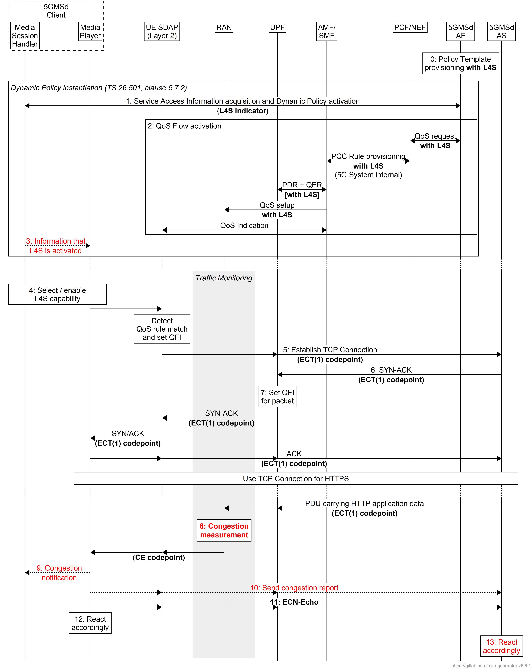
Figure 5.23.4.3-1: Downlink media streaming call flow for L4S on request
The steps are as follows:
0: Policy Template Provisioning. A Policy Template is provisioned with the requirement for L4S capability indicated by setting a flag.
1: Dynamic Policy activation. The Media Session Handler within the 5GMSd Client obtains Service Access Information and triggers a dynamic policy activation. A Policy Template Binding is present within the Service Access Information for each provisioned Policy Template. Policy Template Bindings suitable for L4S are indicated by an L4S capability requirement flag being set. The 5GMSd Client detects that an L4S-capable media transport stack is present and in use. The selected Policy Template is one configured with L4S capability.
2: QoS request. The 5GMSd AF requests QoS handling using e.g. the Nnef_AfSessionWithQoS service or the Npcf_PolicyAuthorization service. If the L4S capability requirement flag is set in the selected Policy Template, this indicates that the new QoS flow is required to be L4S-enabled. The new QoS flow with the L4S indication setting propagates through the 5G System.
3: The Media Session Handler may inform the Media Player via the M11 interface API about the activation of L4S. Subject to availability of API access, the Media Player may use congestion notifications to perform early adaptation.
4: If the L4S capability requirement flag is set in the Policy Template Binding for the selected Policy Template, the 5GMSd Client selects/enables the L4S capability of the used transport protocol.
NOTE: This step may happen implicitly by selecting an L4S-supporting transport protocol stack.
5: The Media Player within the 5GMSd Client triggers the establishment of a TCP connection. The ECT(1) codepoint is set in the IP header, indicating an L4S-Capable Transport, and the SDAP entity ensures that the packet is forwarded via the matching QoS flow.
6: The 5GMSd AS responds to the TCP connection establishment request. The 5GMSd AS sets ECT(1) in the IP headers, indicating an L4S-Capable Transport.
7: The UPF finds the matching QoS flow identifier for the downlink packet and sends the packet via the according QoS flow to the UE. TCP Connection setup continues, with one ECT bit set in all packets.
8:. When the RAN detects an upcoming congestion according to the congestion measurement (based on continuous congestion monitoring), the 5G System sets the CE (Congestion Experienced) codepoint in the IP header of the downlink packet.
9. (Optional) The Media Player may generate a Congestion Notification based on, for example, calculating the proportion of CE marks over a sample period and the congestion trend, and notifies the Media Session Handler using the Network Assistance client API.
10. (Optional) The Media Player sends the congestion information to the 5GMS AS in a congestion report.
11. The TCP protocol stack used by the Media Player in the 5GMSd Client reflects the Early Congestion Notification to the TCP sender by setting the ECN-Echo (ECE) flag in the TCP header of an uplink PDU of the same TCP connection. The TCP sender reacts to the ECN-Echo accordingly (i.e., by reducing its sending congestion window).
NOTE 1: The ECN-Echo flag is also acknowledged by the TCP sender setting the Congestion Window Reduced (CWR) flag in an outgoing TCP frame, but this acknowledgement is not illustrated in this call flow.
NOTE 2: Classic ECN as specified in RFC 3168 [155] requires an ECN signal to be treated as equivalent to a packet drop. L4S as specified in RFC 9330 [149] specifies a more fine-grained response and an early congestion signal triggers a less severe reaction. How a TCP sender behaves “accordingly” is not in scope of the specification.
12. Based on the CE indication received in step 8, or by detecting a reduced bit rate in the downlink application flow, the Media Player in the 5GMSd Client reacts by, for example, changing the requested representation.
13. Based on the congestion report received in step 10, or the CE indication received in step 11, or detection of a reduced bit rate in the downlink application flow, the 5GMSd AS may react by, for example, updating the DASH presentation manifest to remove/add one or more representations.

5.23.4.4 L4S-on-request for uplink media streaming
Support for uplink media streaming is very similar to that for downlink media streaming.
A high-level call flow for uplink media streaming is sketched in figure 5.23.4.3-1 below. The following is assumed:
- The service here is a unicast uplink media streaming service with dynamic policy support, as described in clause 6.9 of TS 26.501 [15].
- The Layer 4 protocol used for application flows is TCP and the TCP stack used supports L4S.
- The network supports L4S packet marking.
- The application has specifically requested ECN marking for its media delivery session.
- NG-RAN manipulates the ECN bits (per clause 5.37.3.2 of TS 23.501 [23]). It is equally possible that the PSA-UPF manipulates the ECN bits (per clause 5.37.3.3 of [23]).
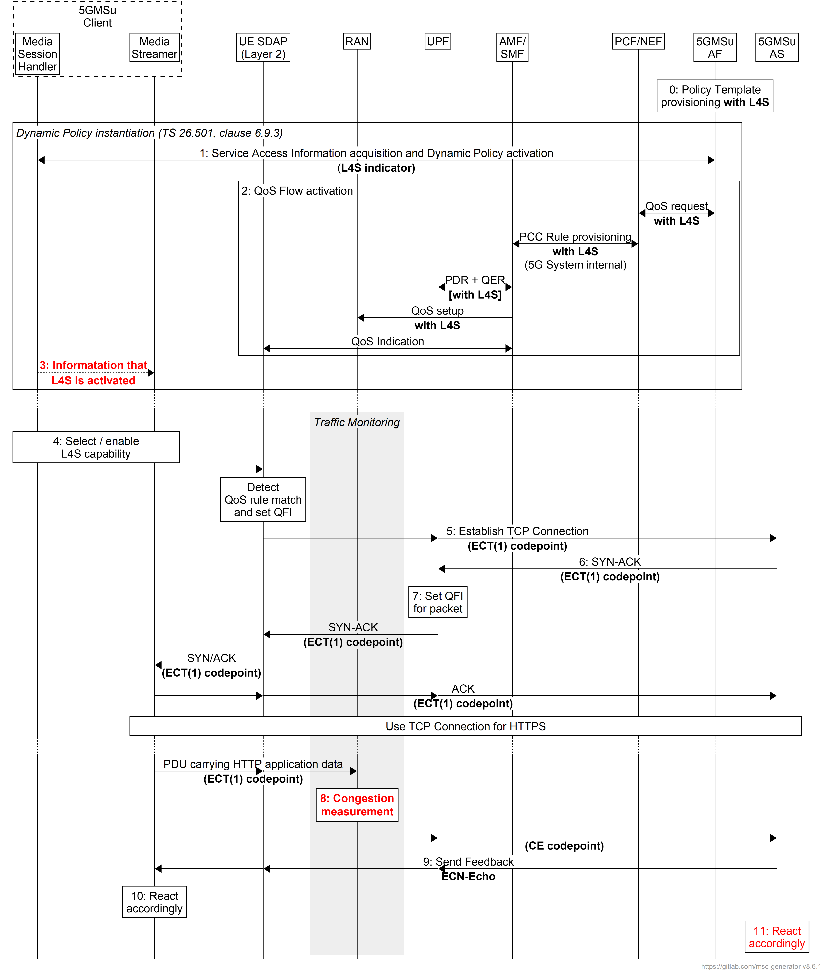
Figure 5.23.4.4-1: Uplink media streaming call flow for L4S on request
The steps are as follows:
0: Policy Template Provisioning. A Policy Template is provisioned with the requirement for L4S capability indicated by setting a flag.
1: Dynamic Policy activation. The Media Session Handler within the 5GMSu Client obtains Service Access Information and triggers a dynamic policy activation. A Policy Template Binding is present within the Service Access Information for each provisioned Policy Template. Policy Template Bindings suitable for L4S are indicated by an L4S capability requirement flag being set. The 5GMSu Client detects that an L4S-capable media transport stack is present and in use. The selected Policy Template is one configured with L4S capability.
2: QoS request. The 5GMSu AF requests QoS handling using e.g. the Nnef_AfSessionWithQoS service or the Npcf_PolicyAuthorization service. If the L4S capability requirement flag is set in the selected Policy Template, this indicates that the new QoS flow is required to be L4S-enabled. The new QoS flow with the L4S indication setting propagates through the 5G System.
3: The Media Session Handler may inform the Media Streamer via the M11 interface API about the activation of L4S. Subject to availability of API access, the Media Player may use congestion notifications to perform early adaptation.
4: If the L4S capability requirement flag is set in the Policy Template Binding for the selected Policy Template, the 5GMSu Client selects/enables the L4S capability of the used transport protocol.
NOTE: This step may happen implicitly by selecting an L4S-supporting transport protocol stack.
5: The Media Streamer within the 5GMSu Client triggers the establishment of a TCP connection. The ECT(1) codepoint is set in the IP header, indicating an L4S-Capable Transport, and the SDAP entity ensures that the packet is forwarded via the matching QoS flow.
6: The 5GMSu AS responds to the TCP connection establishment request. The 5GMSu AS sets ECT(1) in the IP headers, indicating an L4S-Capable Transport.
7: The UPF finds the matching QoS flow identifier for the downlink packet and sends the packet via the according QoS flow to the UE. TCP Connection setup continues, with one ECT bit set in all packets.
8: When the RAN detects an upcoming congestion according to the congestion measurement (based on continuous congestion monitoring), the 5G System sets the CE (Congestion Experienced) codepoint in the IP header of the uplink packet.
9: The TCP protocol stack used by the 5GMSu AS reflects the Early Congestion Notification to the TCP sender by setting the ECN-Echo (ECE) flag in the TCP header of a downlink PDU of the same TCP connection. The TCP sender reacts to the ECN-Echo accordingly (i.e., by reducing its sending congestion window).
NOTE 1: The ECN-Echo flag is also acknowledged by the TCP sender setting the Congestion Window Reduced (CWR) flag in an outgoing TCP frame, but this acknowledgement is not illustrated in this call flow.
NOTE 2: Classic ECN as specified in RFC 3168 [155] requires an ECN signal to be treated as equivalent to a packet drop. L4S as specified in RFC 9330 [149] specifies a more fine-grained response and an early congestion signal triggers a less severe reaction. How a TCP sender behaves “accordingly” is not in scope of the specification.
10: Based on the CE indication received in step8, or by detecting a reduced bit rate in the uplink application flow, the Media Streamer in the 5GMSu Client may react by, for example, changing the requested representation.
11. Based on the CE indication received in step 8, or by detection of a reduced bit rate in the uplink application flow, the 5GMSu AS may react by, for example, updating the DASH presentation manifest to remove/add one or more representations.

5.23.5 Gap analysis and requirements

5.23.5.1 Integrating QoS monitoring and/or ECN marking for L4S

5.23.5.2 QoS monitoring for media streaming
Based on the call flow in clause 5.23.4.3, the following observations are made:
- The 5GMS AF needs to explicitly request QoS monitoring by the 5G System for specific parameters (i.e., congestion information, packet latency, data rate and Packet Delay Variation) by interacting with the PCF at reference point N5 (or else via the NEF at reference point N33).
- The Policy Template resource structure at reference point M1 needs to be extended to include the QoS monitoring configuration, including the parameters to be monitored, reporting frequency (event triggered, periodic), optionally the target entity of reporting and optionally the notification via UPF.
- The Policy Template Binding data structure carried in the Service Access Information resource at reference point M5 needs to be extended to reflect the QoS monitoring configuration in the corresponding Policy Template.
- QoS monitoring results need to be exposed to the 5GMS AF, either at reference point N5 using the Npcf_PolicyAuthorization_Notify service, or directly with a UPF using the Nupf_EventExposure_Notify service, or else via a NEF using the Nnef_EventExposure_Notify service at reference point N33.
- To expose QoS monitoring results to the Media Session Handler in the 5GMS Client, notification events relating to Dynamic Policies at reference point M5 need to be extended to include the QoS monitoring results.
- The QoS monitoring results need to be further provided to the Media Stream Handler by the Media Session Handler at reference point M11.

5.23.5.3 L4S-on-request for downlink and uplink media streaming
Based on the call flow in clause 5.23.4.3, the following observations are made:
- L4S/ECN does not require modifications to the Media Player or a TCP based Media Streamer.
- The 5GMS AF needs to explicitly request L4S handling of packets by the 5G System by interacting with the PCF at reference point N5 (or else via the NEF at reference point N33).
- The Policy Template resource structure at reference point M1 needs to be extended to include an L4S capability requirement flag.
- The Policy Template Binding data structure carried in the Service Access Information resource at reference point M5 needs to be extended to reflect the value of the L4S capability requirement flag in the corresponding Policy Template.
- The notification about successful QoS policy activation sent by the Media Session Handler at reference points M11 does not currently include information about the status of the L4S mechanism in relation to the activated Dynamic Policy.
- An L4S-capable transport protocol stack is required in both the 5GMS Client and at the 5GMS AS.
NOTE 1: When the transport protocol stack used on the UE or the Application Server does not support ECN marking, the ECT flags are set accordingly to explicitly indicate lack of support.
NOTE 2: Application processes such as the Media Player and 5GMS AS are not currently capable of obtaining L4S Congestion Notifications from the underlying Operating System. Future studies on API extensions to facilitate the usage of L4S are expected to bridge this gap.
- The Network Assistance client API needs to be extended to convey a new Congestion Notification including, for example, the percentage of congestion marks and the congestion trend.
NOTE 3: The candidate solutions proposed below do not address this gap pending resolution of the gap identified in NOTE 2 above.
- The Media Session Handling API needs to be extended to specify the means to convey congestion information from the Media Session Handler to the 5GMS AS in a congestion report.
NOTE 4: The candidate solutions proposed below do not address this gap pending resolution of the gap identified in NOTE 2 above.
- Depending on the transport stack implementation, an explicit L4S activation is required at session start.

5.23.5.4 API access limitations
Currently, access to the ECN bit status through existing APIs offered by the OS or protocol libraries (e.g. the QUIC protocol libraries) is considered to be very limited and in some cases may require privileged rights. As L4S is getting more traction, this situation might change. However, without proper exposure to the application through appropriate APIs, the feasibility of pro-active early reaction to congestion notifications will remain limited.

5.23.6 Candidate solutions

5.23.6.1 Integrating QoS monitoring and/or ECN marking for L4S
Candidate solutions addressing this topic are for future study.

5.23.6.2 QoS monitoring for media streaming
Provisioning information is provided by the 5GMS Application Provider at reference point M1 to declare that a Policy Template requires QoS monitoring. The Policy Template structure is enhanced to provide a QoS monitoring configuration (qosMonInfo and directNotifInd as described in clause 5.14.2.1.2 of TS 29.122 [156]). This QoS monitoring configuration is also provided to the Media Session Handler in the Policy Template binding exposed in Service Access Information.
In this candidate solution, two Policy Templates may be provisioned by the 5GMS Application Provider, one with QoS monitoring configuration and one without. The Media Session Handler in the 5GMS Client then instantiates the appropriate Policy Template depending on its requirements.
When the QoS monitoring configuration is included in the instantiated Policy Template, the 5GMS AF requests QoS monitoring by the 5G System and the 5G System enables the QoS monitoring as requested.
The DynamicPolicy resource is extended to include the QoS monitoring results. When the 5G System reports the QoS monitoring results to the 5GMS AF as requested, the 5GMS AF further provides the notification of the QoS monitoring results to the Media Session Handler via the asynchronous MQTT notification channel as an Application Message conveyed as the payload of an MQTT PUBLISH message.
The Dynamic Policy client API is extended to support the notification events relating to Dynamic Policy. When the QoS monitoring results are received by the Media Session Handler, it further exposes the QoS monitoring results to the Media Stream Handler to react accordingly.

5.23.6.3 L4S-on-request for downlink and uplink media streaming
Provisioning information is provided by the 5GMS Application Provider at reference point M1 to declare that a Policy Template requires L4S support. The Policy Template structure is enhanced to offer a L4S enablement flag. This flag is also exposed to the Media Session Handler in the Policy Template binding exposed in Service Access Information.
In this candidate solution, two Policy Templates may be provisioned by the 5GMS Application Provider, one with L4S enabled and one without. The Media Session Handler in the 5GMS Client then instantiates the appropriate Policy Template depending on its requirements.
When the L4S flag is set in the instantiated Policy Template, the 5GMS AF requests L4S handling by the 5G System and the 5G System assumes that the traffic is L4S-enabled.
The Media Session Handler announces to the Media Player or Media Streamer the successful activation of L4S in the Dynamic Policy by means of a new parameter carried in the POLICY_ACTIVATED asynchronous notification it sends at reference point M11.

5.23.7 Summary and conclusions
This Key Issue has explored several QoS features which could be beneficial to the Media Delivery System, including:
1. ECN marking for L4S,
2. PDU Set handling and
3. QoS monitoring.
Detailed description of the above features is provided in clause 5.23.1.2. Moreover, the high-level call flows for features 1 and 3 are documented in clause 5.23.4, and corresponding gaps are analysed in clause 5.23.5. Finally, candidate solutions to address the identified gaps are provided in clause 5.23.6.
Based on the study, it is recommended to make the following changes to TS 26.501 [15]:
1. Integrate ECN marking for L4S into the architectures, high-level call flows and collaboration scenarios for both 5GMSd and 5GMSu.
a. Extend the Dynamic Policy feature introduced in clause 4.0.6 to include an L4S enablement flag, including updates to the domain model and corresponding description.
b. Add new call flows on ECN marking for L4S in clauses 5.7 and 6.9 for downlink and uplink media streaming respectively.
c. Add informative collaboration scenarios on ECN marking for L4S to annex A.
2. Integrate the QoS monitoring feature into the architectures, high-level call flows and collaboration scenarios for both 5GMSd and 5GMSu.
a. The Dynamic Policy feature need to be extended to include the QoS monitoring configuration in clause 4.0.6, including the domain model and corresponding description.
b. New call flows on QoS monitoring are needed in clauses 5.7 and 6.9 for downlink and uplink media streaming respectively.
Based on the study, it is recommended to make the following changes to TS 26.510 [108]:
1. Integrate ECN marking for L4S into the Media Delivery System to support downlink and uplink media streaming.
a. Enhance Dynamic Policy provisioning procedures in clause 5.2.7 and extend the PolicyTemplate data structure in clause 8.7.3.1 to include an L4S enablement flag in the Policy Template.
b. Extend the Dynamic Policy invocation procedures in clause 5.3.3 and 5.4.3 and the corresponding API in clause 9.3 to indicate the activation of ECN marking for L4S by Media Session Handler.
c. Enhance the specification of policy control interactions with the 5G System (i.e. PCF, NEF) for Dynamic Polices in clause 5.5.3 to support requesting ECN marking for L4S.
d. Extend the Dynamic Policy client API in clause 11.3 to enable the Media Session Handler to notify the Media Player/Media Streamer about the activation of L4s at reference point M11.
2. Integrate the QoS monitoring feature into the Media Delivery System to support 5G Media Streaming.
a. Enhance Dynamic Policy provisioning procedures in clause 5.2.7 and extend the PolicyTemplate data structure in clause 8.7.3.1 to include the QoS monitoring configuration.
b. Extend the Dynamic Policy invocation procedures in clauses 5.3.3 and 5.4.3 and the corresponding API in clause 9.3 to indicate the activation of QoS monitoring configuration by the Media Session Handler.
c. Enhance the specification of policy control interactions with the 5G System (i.e. PCF, NEF) for Dynamic Polices in clause 5.5.3 to support requesting QoS monitoring.
e. Extend the DynamicPolicy resource in clause 9.3.3.1 to include the QoS monitoring results so that these can be included in asynchronous MQTT notifications sent by the Media AF to the Media Session Handler.
f. Extend the Dynamic Policy client API in clause 11.3 to enable the Media Session Handler to expose QoS monitoring results at reference point M11.

===== CHANGE =====

5.24 QUIC-based segmented media delivery

5.24.1 Description

5.24.1.1 General
QUIC, specified in RFC 9000 [32], is a secure, reliable, multiplexed, connection-oriented transport protocol built on top of UDP. It is widely available and its impact on media streaming requires further study. In this clause QUIC-specific media streaming is studied, not necessarily based on HTTP/3 [5] that is studied in clause 5.4.
A QUIC client establishes a connection with a server, and within this connection multiple concurrent streams can transport data. Thanks to a more efficient implementation of the TLS initial handshake, a QUIC connection is typically established faster than a TCP + TLS connection, therefore reducing initialization time. Additionally, by allowing QUIC streams to be multiplexed into a single QUIC connection, they can operate independently of each other, each with its own separate congestion window. Because packet retransmission occurs within a stream, a stall in one stream does not block the progress in the other streams. Similarly, packet loss in one stream does not affect the progress of data transfer in other streams multiplexed in the same QUIC connection. Finally, QUIC, like HTTP/2 [4], enables a sender to prioritise traffic at an individual stream level. Unlike HTTP/2, however, QUIC does not provide the means to signal this prioritisation to its connection peer, and so it is entirely up to the sending application to set appropriate priorities when multiplexing streams.
Even though QUIC solves many issues compared to TCP e.g. faster connection establishing and non-blocking multiplexing (using streams), there are some open issues and shortcomings when it comes to media content delivery.
A 5GMS Application Provider runs an adaptive media streaming service between a 5GMS AS and a 5GMS Client running on a UE using 5G Media Streaming protocols conveyed at reference points M2 and M4. However, only M4 is relevant for this key topic since it focuses on the media delivery to the UE and not on the ingest of the media itself. Also, since M5 is not meant to transport media, this reference point is also excluded from this key topic.

5.24.1.2 Relevant existing technologies

5.24.1.2.1 Extensible Prioritization Scheme for HTTP
RFC 9218 [164] defines the signalling for an HTTP client to express its preferences in terms of relative priorities when multiple requests are concurrently sent. Upon reception, the HTTP server can make use of this information for serving the response deemed to be of highest priority by the client. Similarly, an HTTP server may use this prioritisation scheme to inform downstream entities about the relative priorities of multiple responses.

5.24.1.2.2 MPEG-DASH Part 6: DASH with Server Push and WebSockets
Published in 2017, MPEG-DASH Part 6 [165] is the part of the MPEG-DASH standard that enables a DASH server to send multiple segments to a DASH client without the need to receive individual segment requests. To this end, [DASH-6] defines the concept of push directives sent by the DASH client to the DASH server, indicating which segments should be pushed. Two alternative instantiations are defined in [165]:
1. Based on HTTP/2 [4] server push functionality with specific HTTP header extensions for the DASH client to send the so-called push directives.
2. Based on the WebSocket protocol, and comprising a set of messages for the exchange of MPD, segment and push directives. This constitutes the WebSocket sub-protocol for DASH registered with IANA as 2016.serverpush.dash.mpeg.org. The WebSocket sub-protocol for DASH uses a binary format for all messages exchanged over the WebSocket connection.

5.24.1.2.3 WebTransport
The WebTransport protocol developed by the IETF can be layered over either HTTP/2 as specified in RFC 9113 [4] or HTTP/3 as specified in RFC 9114 [5].
When it is layered over HTTP/3 as envisaged in [161], WebTransport allows a client and a server to communicate over a secure, multiplexed QUIC-based transport. WebTransport leverages the QUIC streams to offer unidirectional and bidirectional streams and guarantee reliable, ordered reception of byte streams. WebTransport over HTTP/3 relies on HTTP/3 to establish the WebTransport session with the session peer using the extended CONNECT HTTP method. After that point, the application directly integrates with the QUIC layer.

5.24.1.2.4 Push-based adaptive media streaming over WebTransport with server-side throughput estimation
Conference paper [169] proposes a mechanism to support HTTP adaptive media streaming in the WebTransport protocol. In essence, this works as follows:
1. The delivery of the MPD to the DASH client is assumed to have taken place prior to the establishment of the WebTransport transport connection for media.
2. The WebTransport-capable DASH client connects to a WebTransport-capable DASH server and establishes a WebTransport connection.
3. The DASH server sends media segments of default start-up quality for the audio and video Adaptation Setsto the DASH client.
NOTE: In the prototype implementation described in [169], there is only one audio Adaptation Set listed in the DASH MPD and only one video Adaptation Set, so there is no need for the DASH client to indicate which ones it is interested in receiving.
4. The DASH client starts receiving media segments and starts sending back qlog metrics reports [84] (as summarised in clause 5.4.1.6) to the DASH server on the same bidirectional stream.
5. Based on the received qlog metrics reports, the DASH server continuously estimates the throughput available to the DASH client.
6. When the new throughput is estimated, the DASH server may decide to change the pushed Representation or inform the DASH client about the new estimated throughput for the DASH client to switch. (The paper [169] does not explicitly mention which option is used.)

5.24.1.2.4 Media-over-QUIC Transport
The Media-over-QUIC transport protocol [166] is based on QUIC or can alternatively be layered on top of WebTransport. Although generic, the transport protocol has been initially designed for media delivery. Based on a publish–subscribe interaction pattern, it allows a publisher to distribute media content to many subscribers with a focus on latency and scalability. Since QUIC and WebTransport are merely opening communication channels between client and server, MoQT defines a set of messages to establish and operate a MoQT session. In particular, a MoQT client can indicate the desired media content to receive by sending a SUBSCRIBE message to a publisher.

5.24.1.3 Application access to QUIC protocol features
In a common scenario, QUIC is not directly exposed to the application, but it is more typically mediated through a QUIC-enabled application protocol such as HTTP/3 as specified in RFC 9114 [5] or Media over QUIC Transport [166], or else through a protocol framework such as WebTransport [160] mapped onto HTTP/3 [161]. For this reason, the set of QUIC features available to an application is the subset exposed by the chosen application protocol or framework (typically invoked via the public API of a client or server library). This approach facilitates the development of QUIC-based communication but at the cost of limiting the level of control an application has over the connection and stream management.

5.24.1.4 Connection and stream management
Applications are encouraged to keep QUIC connections alive when it makes sense to do so, and HTTP/3 client libraries typically facilitate connection keep-alive behaviour for efficiency reasons. In addition, QUIC’s "0-RTT" connection establishment procedure allows a client to reconnect to a server it has previously connected to, and to reuse a security context negotiated during a previous connection and cached by both parties to send application payload data to the server in the first UDP datagram of the new QUIC connection.
In the context of HTTP/3 [5], the mechanism for handling streams is tightly specified by the HTTP/3 protocol that is each HTTP request-response transaction consumes one stream in the QUIC connection.
In contrast, WebTransport [160] allows the application a greater degree of control over QUIC connections and streams when layered on top of HTTP/3 [161]. However, the use of WebTransport for segmented media delivery is not a well-studied area. In one implementation of WebTransport for segmented media streaming [169] the client sends metrics to the server, the server performs throughput estimation and then sends the respective segments to the client.
QUIC allows both the client and the server to initiate the opening of a new stream in a connection and the WebTransport API exposes this capability to applications. This feature is not directly supported by HTTP/3 [5] where a server push is always stimulated by a client-initiated request.
The protocol extension in RFC 9221 [163] specifies how peers in a QUIC connection can exchange unreliable application messages using a special-purpose QUIC datagram frame. This type of frame is acknowledged by the QUIC recipient, but is never retransmitted if left unacknowledged. Section 2 of RFC 9297 [162] specifies how QUIC datagrams can be used to support the exchange of unreliable HTTP messages in HTTP/3. Furthermore, [161] specifies how this feature can be exposed in the WebTransport framework when that is layered on top of HTTP/3 (and hence on top of QUIC).
Finally, QUIC supports different congestion control algorithms and control over this is exposed to the application in the WebTransport API [160].
An overview of the protocol stack is illustrated in figure 5.24.1.1-1. Everything in user space is potentially accessible from the application and must rely on the implementation of the API, while the layers in kernel space are accessed via Operating System calls (e.g. UDP can typically only be accessed via an API provided by the OS-provided socket library).
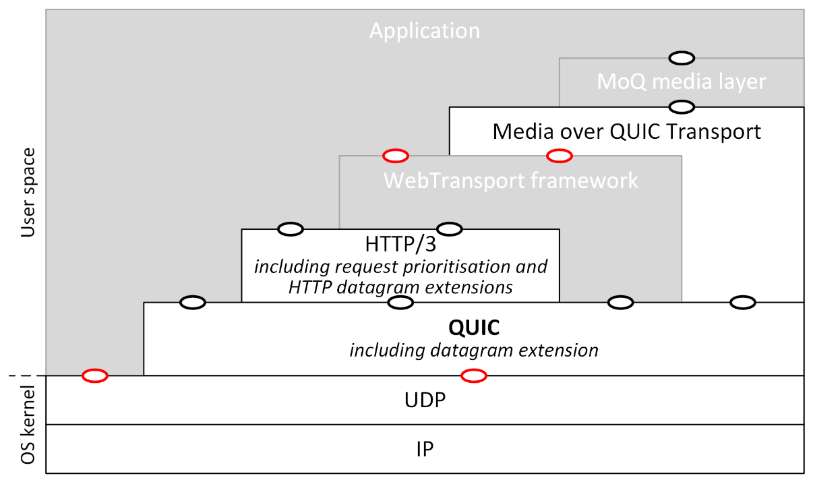
NOTE 1: White boxes denote protocol layers; grey boxes non-protocol layers, such as client/server frameworks.
NOTE 2: Ovals denote instantiations of the API defined by a given block, with red colour indicating a standardized API and black indicating non-standardized implementation-specific APIs (e.g. library APIs).
NOTE 3: The WebTransport framework intiallly uses HTTP/3 for connection establishment and afterwards switches to interfacing with the QUIC layer for data transfer.
NOTE 4: The Media over QUIC Transport layer [166] typically uses QUIC directly, but can also be layered on top of WebTransport.
NOTE 5: The MoQ media layer uses the MoQ Streaming Formats catalogue [167] that defines policies on content discovery and subscription and information on encoding, packaging and mapping the content to MoQ objects.
Figure 5.24.1.1-1: QUIC high-level protocol stack

5.24.1.5 Stream prioritisation
By design, QUIC does not provide the means for connection peers to signal the priority of a stream, leaving decision-making over stream prioritisation to the application. To support this, section 2.3 of RFC 9000 [32] recommends that QUIC implementations should expose the means for applications to set relative stream priorities, thus providing the ability to influence the scheduling of packets for transmission in a QUIC connection. Thus, stream prioritisation is typically handled on the higher application layers, but neither the network nor the recipient is aware of the applied mechanism. Relevant standardization efforts include an extensible prioritisation scheme for HTTP (including HTTP/3) defined in RFC 9218 [164], and prioritisation scheme for the Media over QUIC (MoQ) Transport protocol [166] currently being developed by IETF.

5.24.1.6 Computational overhead of QUIC endpoints
Adoption of QUIC-based application protocols such as HTTP/3 [5], Media over QUIC Transport [166] and application frameworks such as WebTransport [160] can have impact on the UEs due to the processing required for the underlying QUIC protocol itself. In TCP, most functions are executed in kernel space, which over the years have been heavily optimised including, in some hosts, hardware offload. In QUIC, by contrast, most protocol functions are executed in user space.
There are two identified sources for this computational overhead [168]:
1. The in-kernel UDP stack issues many packet reads; this is because each datagram arriving in the link layer is forwarded for processing to the transport layer i.e., there are no offload mechanisms used like the sender-side Generic Segmentation Offload (GSO), or the generic receive offload mechanism (GRO) used by the link layer module to combine datagrams into a mega datagram before forwarding it to the transport layer.
2. There is increased overhead of processing packets (and, as a result, in generating responses) due to increased user space processing required as a result of 1 above (i.e. all the packets need to be processed individually) combined with managing QUIC acknowledgements in user space (instead of kernel space as with TCP in HTTP/2).
These potential performance effects should be taken in consideration because they can negatively impact the overall Quality of Service that can be obtained from a QUIC connection, and can increase the energy consumption of the UE.

5.24.1.7 Key Issue objectives
The objectives listed below are targeting QUIC-specific delivery aspects:
- Application access to QUIC connections (e.g. via QUIC libraries).
- Variability of QUIC implementations.

5.24.2 Collaboration scenarios

5.24.2.1 General
For the purpose of describing the following scenarios, it is only assumed that the 5GMS Client supports the QUIC protocol. Additionally, the 5GMS Client may support higher level protocols based on QUIC (for instance HTTP/3 or WebTransport) but this is not required, and the analysis of those collaboration scenarios is still applicable to any of those cases.

5.24.2.2 QUIC-agnostic 5GMS Client
In this scenario, the Media Stream Handler of the 5GMS Client operates a QUIC session over reference point M4 but the 5GMS Client has no specific feature regarding QUIC. This has the advantage that 5GMS Client is generic and implements the same logic whether or not QUIC is used for the delivery of the media.
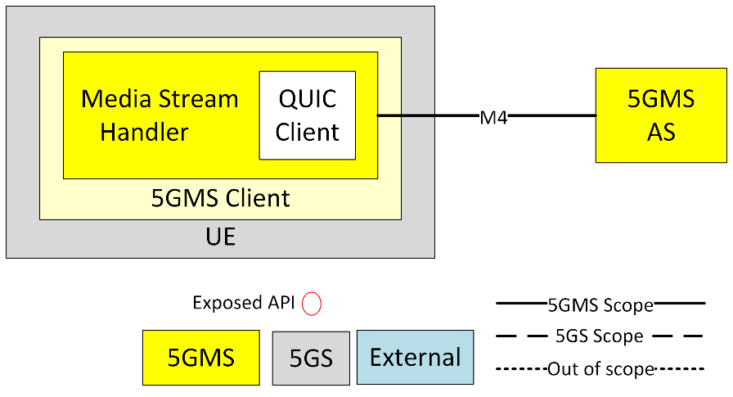
Figure 5.24.2.2-1: QUIC-agnostic 5GMS Client

5.24.2.3 Media-independent QUIC-aware 5GMS Client
In this scenario, the Media Stream Handler of the 5GMS Client operates a QUIC session over reference point M4 and the 5GMS Client is able to detect whether QUIC is used and, in case it is used, the 5GMS Client can apply different logic.
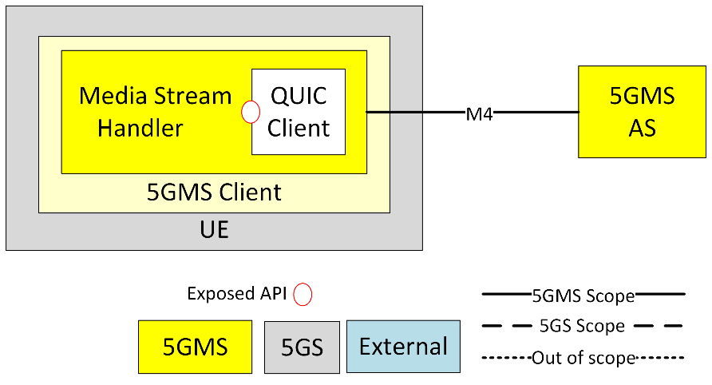
Figure 5.24.2.3-1: Media-independent QUIC-aware 5GMS Client
In this case, the QUIC client implementation is not specifically optimised for media transport (e.g. a generic off-the-shelf QUIC client library) and the set of QUIC protocol features exposed to the Media Stream Handler is limited by the richness of its API.
With some limited control over the QUIC streams, such a 5GMS Client would typically be able to:
- Set relative priorities between the different QUIC streams. Relative stream priorities can be useful to differentiate audio and video, base layer and enhancement layer, etc.
- Receive updates sent proactively by the 5GMS AS. For example, a 5GMSd AS could send MPD updates to a Media Player using this mechanism.

5.24.2.4 Media-optimised QUIC-aware 5GMS Client
In this scenario, the Media Stream Handler of the 5GMS Client operates a QUIC session over reference point M4 and the 5GMS Client is able to control the delivery of the media within the QUIC session.
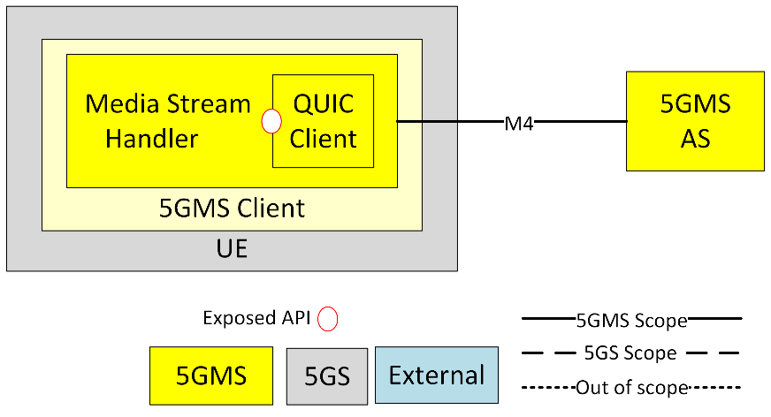
Figure 5.24.2.4-1: Media-optimised QUIC-aware 5GMS Client
In this case, the QUIC client implementation is optimised for media transport and the set of QUIC protocol features exposed to the Media Stream Handler is therefore unlimited. Hence, the media-optimised, QUIC-aware 5GMS Client provides the finest control over the delivery of media within the QUIC session.
With fine control over the QUIC streams, such a 5GMS Client would typically be able to:
- Set relative priorities between the different QUIC streams. Relative stream priorities can be useful to differentiate audio and video, base layer and enhancement layer, etc.
- Receive updates sent proactively by the 5GMS AS. For example, a 5GMSd AS could send MPD updates to a Media Player using this mechanism.
- Use one QUIC stream for all the media segments of a given component (e.g. per CMAF Track).

5.24.3 Architecture mappings

5.24.3.1 General
In the 5GMS architecture, the Media Stream Handler in the 5GMS Client is connected to the 5GMS Application Server (5GMS AS) via reference point M4. Therefore, both the client and the server on that interface need to be compatible in terms of protocols and functionalities. In the clause, the QUIC Client module which is part of the 5GMS Client will thus be connected to a QUIC Server connected or part of the 5GMS AS. Three mappings are considered, one for each collaboration scenario.

5.24.3.2 Mapping with a QUIC-agnostic 5GMS Client
In this mapping, both 5GMS Client and 5GMS AS are agnostic to the QUIC protocol and the usage of QUIC as a network protocol is thus transparent for system. The integration of the QUIC Client in the UE and the QUIC Server with the 5GMS AS is considered to be out of scope of the 5GMS System.
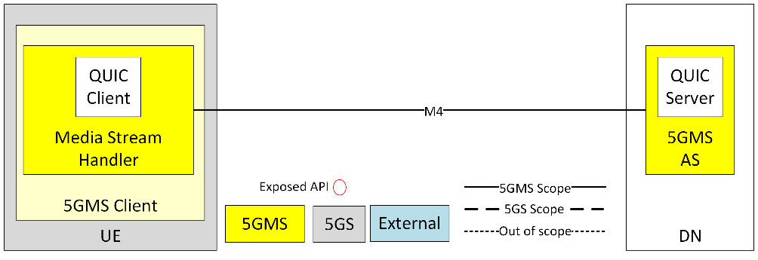
Figure 5.24.3.2-1: Architecture with QUIC-agnostic 5GMS Client and 5GMS AS

5.24.3.3 Mapping with a Media-independent QUIC-aware 5GMS Client
In this mapping, the 5GMS Client and the 5GMS AS are integrated with, respectively, a QUIC Client and QUIC Server. The QUIC Client and the QUIC Server are external to the systems which means that any software implementation may be used. The integrations of the QUIC Client in the UE and the QUIC Server with the 5GMS AS are achieved via the exposed APIs by both the QUIC Client and QUIC Server. However, since the QUIC Client and Server are not a standardised part of the 5GMS System, the APIs exposed by the QUIC Client and the QUIC Server may thus also differ in capabilities.
In addition, the QUIC Client and the QUIC Server need to support a common QUIC protocol version. The QUIC protocol does not provide the means for negotiating the protocol version when establishing the connection, but rather enables a QUIC Server to reject unsupported version and propose alternative versions to a QUIC Client. This step of version selection may be influenced by Media Stream Handler and the 5GMS AS through those APIs.
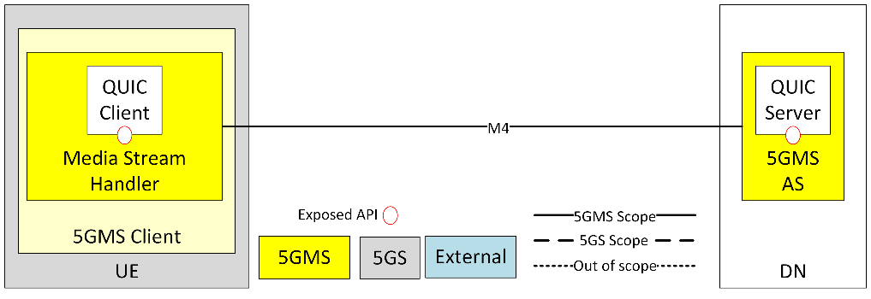
Figure 5.24.3.3-1: Architecture with QUIC-aware 5GMS Client and 5GMS AS

5.24.3.4 Mapping with a Media-optimised QUIC-aware 5GMS Client
In this mapping, the 5GMS Client and the 5GMS AS are integrated with, respectively, a QUIC Client and QUIC Server. The QUIC Client and the QUIC Server are part of the 5GMS System which means that their software implementation follows requirement and functionalities supporting the 5GMS Client’s needs. The integrations of the QUIC Client with the Media Stream Handler in the UE and the QUIC Server with the 5GMS AS are achieved via the exposed APIs by both the QUIC Client and QUIC Server. Since the functionality of the QUIC Client and Server are standardised as part of the 5GMS System in this mapping, the APIs exposed by the QUIC Client and the QUIC Server are compatible in terms of functionalities. In addition, the QUIC Client and the QUIC Server support a commonly agreed QUIC version to guarantee the establishment of the QUIC connection. In addition, those client and server APIs enables the 5GMS Client to optimise the media delivery.
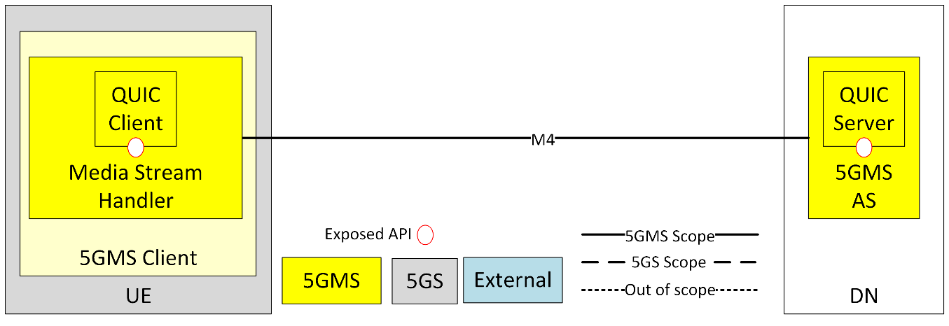
Figure 5.24.3.4-1: Architecture with media-optimised QUIC-aware 5GMS Client and 5GMS AS

5.24.4 High-level call flows

5.24.4.1 General
This clause collects high-level call flows highlighting steps where the usage of QUIC or a QUIC-based protocol for the delivery of segmented content would have an impact on the 5GMS System.
Some of those call flows are hypothetical since they may deviate from the strict definition of a given specification or make some assumptions about combining different specifications together to achieve the call flow. In those cases, the description text of the call flow explicitly states that the call flow is illustrative of an hypothetical scenario.

5.24.4.2 Impact of a QUIC-agnostic 5GMS Client on the 5GMS high-level procedure for DASH content
For the purpose of illustration, and to assist later gap analysis, an HTTP/3 client instantiated inside a Media Player provides a concrete example of an application layer protocol used in the context of a QUIC-agnostic 5GMS Client. In this case, the DASH MPD and the segments are requested and served within a QUIC connection underlying the HTTP/3 session. The usage of QUIC as transport protocol in this case has no impact on the steps of the high-level procedure for DASH content defined in clause 5.2 of TS 26.501 [15]. The same 19 steps are presented. However, the following notes describe the differences which are blue-highlighted in the sequence diagram in figure 5.24.4.2-1.
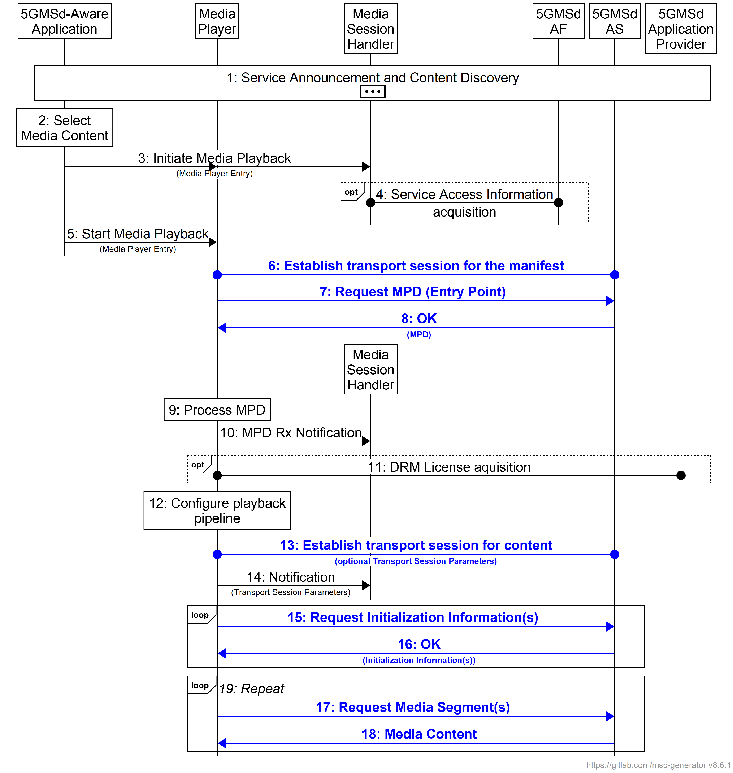
Figure 5.24.4.2-1 High-level call flow for DASH content using a QUIC-agnostic 5GMS Client
based on figure 5.2-2 from TS 26.501 [15]
The specifics of using QUIC-based protocol in this procedure are (emphasis in boldface):
6: The Media Player establishes a QUIC connection with the 5GMSd Application Server.
7: The MPD is requested using an HTTP/3 request message which goes over a new client-initiated QUIC stream in the QUIC connection established in step 6.
8: The MPD is delivered over the QUIC stream initiated in step 7.
13: If the QUIC connection of step 6 is no longer open, the QUIC Client establishes a new connection with the QUIC server.
15: The Initialization Segments are requested using an HTTP/3 request message which goes over a new client-initiated QUIC stream in the open QUIC connection.
16: The Initialization Segment response is delivered over the QUIC stream initiated in step 15.
17: The media segment is requested using an HTTP/3 request message which goes over a new client-initiated QUIC stream in the open QUIC connection.
18: The media segment response is delivered over the QUIC stream initiated in step 17.
NOTE: After step 18, the Media Player may have to establish a new connection whenever necessary. This can, for instance, be the case if the 5GMSd AS closes the QUIC connection due to inactivity by the Media Player.

5.24.4.3 Impact of a Media-independent QUIC-aware 5GMS Client on the 5GMS high-level procedure for DASH content
For the purpose of illustration, and to assist later gap analysis, a HTTP/3 client instantiated inside a Media Player provides a concrete example of an application layer protocol used in the context of a Media-independent QUIC-aware 5GMS Client. In this context, the DASH MPD and the segments are typically requested and served within the same QUIC connection which is kept alive by the 5GMS Client.
Compared with the 5GMS high-level procedure for DASH content defined in clause 5.2 of TS 26.501 [15], the possible backward compatible enhancements are:
- A new step 8a allows the 5GMSd AS to optionally push Initialization Segments to the Media Player using HTTP/3 server push.
- Steps 15 and 16 are omitted unless the Media Player requires different Initialization Segments than those pushed in step 8a, or if step 8a has not been performed.
- In step 17, the request for each media segment by the Media Player may be enhanced with the ability to indicate a request priority.
However, the following notes can be made and are captured with blue highlight in the sequence diagram in figure 5.24.4.3-1.
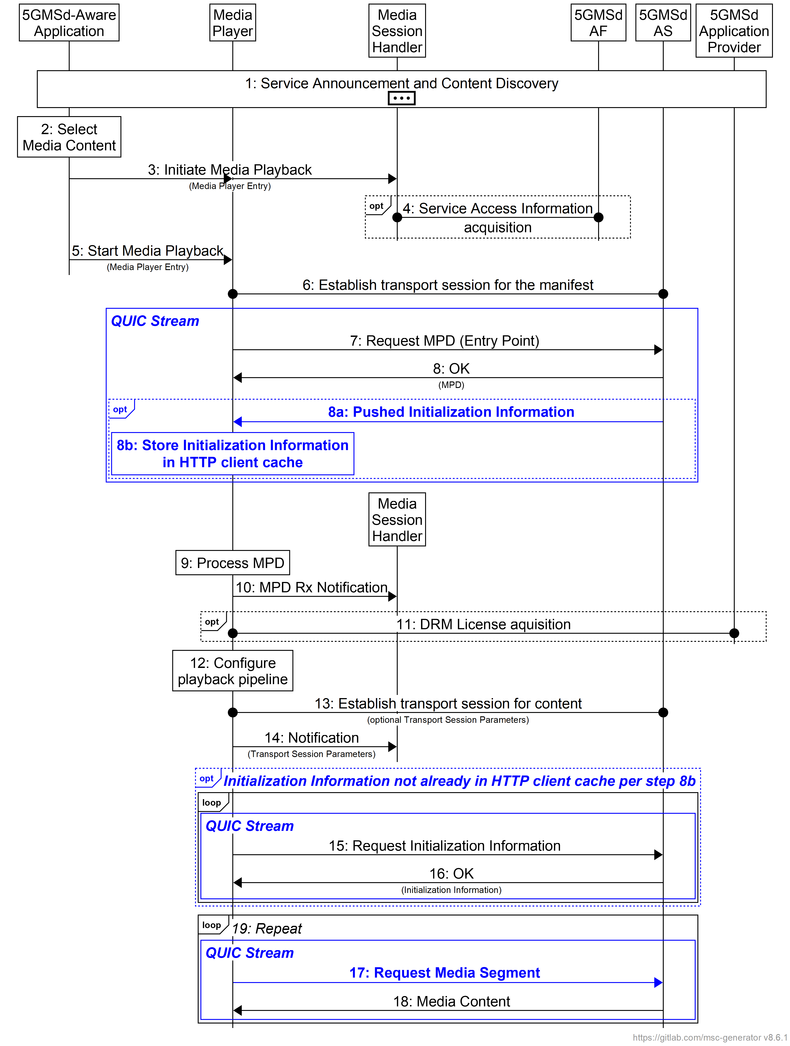
Figure 5.24.4.3-1 High-level call flow for DASH content using an HTTP/3 client as a
media-independent QUIC-aware 5GMS Client
The specifics of using an HTTP/3 client as media-independent QUIC-aware 5GMS Client in this procedure are (emphasis in boldface):
8a: The 5GMSd AS may send Initialization Segments to the HTTP client cache of the Media Player ahead of time using HTTP/3 server push functionality. Each Initialization Segment is pushed down into the same QUIC stream as used for the MPD request in step 7 and hence the same QUIC connection established in step 6. (The QUIC connection can remain open until segment requests are subsequently sent by the Media Player.)
8b: Pushed Initialization Segments are cached by the Media Player.
15: If not already pushed to and cached by the Media Player in step 8b, the 5GMSd AS receives the requests for the Initialization Segments from the Media Player. Each segment request/response consumes a QUIC client-initiated stream in the HTTP/3 protocol mapping.
17: The Media Player sends requests for media segments. Each segment request/response consumes a QUIC client-initiated stream in the HTTP/3 protocol mapping. If sent concurrently, the Media Player may send priority information along with the media segment requests using the Extensible Prioritization Scheme specified in RFC 9218 [164], which is supported by HTTP/3.
18: The 5GMSd AS responds to the requests according to the prioritisation.
Regarding step 8a, the benefit is to decrease the media presentation start-up time by avoiding the need for the Media Player to make additional requests for initialization segments. In this case, the Media Player performs step 16a instead of steps 15 and 16.
For steps 17 and after, a Media Player may send several requests for segments of the same Representation, of different Adaptation Sets, etc. In this case, the Media Player is able to express relative priorities and expects quicker reception of the ones that matter most, for instance the next segment on the media timeline compared to future ones, audio segments compared to video segments, etc. Those possibilities are listed in clause 5.24.2.3.
NOTE: Prioritisation by itself is not supported by the QUIC protocol natively but enabled by prioritising QUIC streams when multiplexing on the UDP connection. Also, HTTP/3 support the Extensible Prioritization Scheme specified in RFC 9218 [164] which allows an HTTP/3 client to express request priorities. These techniques are described in clause 5.24.1.4.

5.24.4.4 Impact of a media-optimised QUIC-aware 5GMS Client on the 5GMS high-level procedure for DASH content
For the purpose of illustration, and to assist later impact analysis, a client sharing some commonalities with an MPEG-DASH Part 6 [165] client inside a Media Player provides a hypothetical example of an application layer protocol which may be used in the context of a media-optimised QUIC-aware 5GMS Client. For the purpose of illustration, the use of HTTP/2 [4] and WebSocket specified in [165] are replaced with HTTP/3 [5] and WebTransport over HTTP/3 [161] respectively.
Compared with the call flow for a media-independent QUIC-aware 5GMS Client presented in clause 5.24.3.3, the differences are:
- Requests for media segments in steps 17_{i} and 18_{i} are grouped over the same QUIC stream.
- There can be one or more repetitions of the steps 17_{i} and 18_{i} within each QUIC stream over time.
The concept of groups aims at encompassing different approaches when using a media-optimised application layer protocol:
- A first approach is to use a single group for all media segment requests, which has the effect of treating all segment requests equally on a first-in-first-out basis.
- Another approach is to group media segment requests per DASH Representation, i.e. one group per quality of audio and video components. This approach corresponds to the MoQ Transport protocol case where a Track is delivered on a dedicated QUIC stream.
- Yet another approach is to group segment requests per Adaptation Set.
- Finally another approach is to use one group per segment request. This approach corresponds to the HTTP/3 case by definition of the HTTP/3 specification in RFC 9114 [5].
NOTE: It is for future study whether further classification of media into groups in an HTTP streaming scenario such as DASH is feasible/required.
Those differences compared with the 5GMS high-level procedure for DASH content are blue-highlighted in the sequence diagram in figure 5.24.4.4-1.
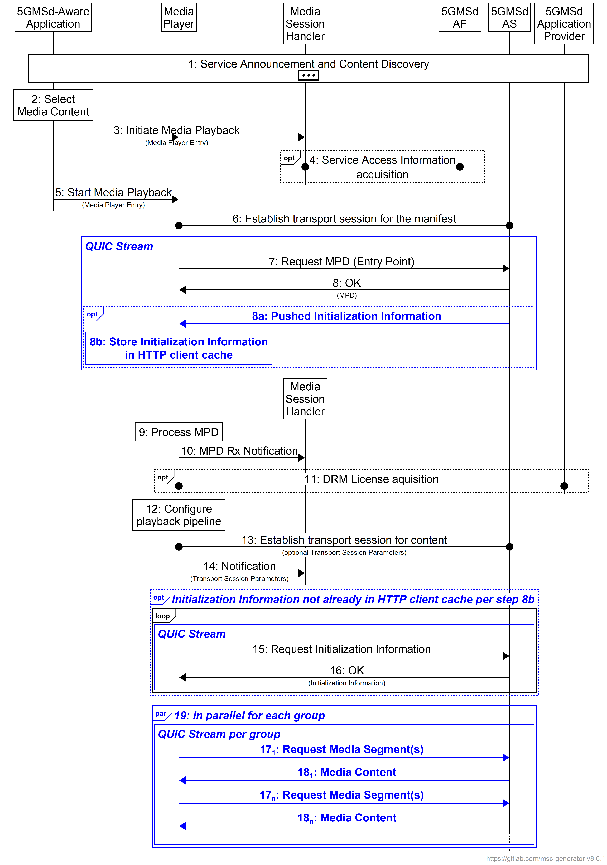
Figure 5.24.4.4-1 High-level call flow for DASH content using a media-optimised QUIC-aware 5GMS Client
The specifics of using QUIC in this procedure are (emphasis in boldface):
8a: The 5GMSd AS may send the Initialization Segments to the Media Player ahead of time via the same QUIC stream as used for the MPD request in step 7 and hence the same QUIC connection established in step 6. (The QUIC connection remains open until segment requests are received from the Media Player.)
8b: Pushed Initialization Segments are cached by the Media Player.
15: If not already pushed to and cached by the Media Player in step 8b, the Media Player requests Initialization Segments from the 5GMSd AS. Each segment request/response consumes a QUIC client-initiated stream in the HTTP/3 protocol mapping.
17_{n}: The Media Player sends requests for media segments of the same group within the corresponding QUIC stream. If sent simultaneously, the Media Player may send priority information with or apply the prioritization to the media segment requests.
18_{n}: The 5GMSd AS responds to the requests of a same groups within the corresponding QUIC stream.
19: Requests on the QUIC stream for each group operate in parallel in the same QUIC connection if they are targeting the same 5GMSd AS endpoint at reference point M4.

5.24.4.5 Impact of a push-based QUIC-aware 5GMS Client on the 5GMS high-level procedure for DASH content
For the purpose of illustration, and to assist later impact analysis, a Media-over-QUIC client instantiated inside a Media Player provides a hypothetical example of an application layer protocol used in the context of a push-based QUIC-aware 5GMS Client. This analysis uses the Track concept defined in [166] as well as its subscription mechanism.
NOTE: The 5GMSd AS may be a MoQ relay or MoQ publisher. Further details are for further study.
Compared with the call flow for a media-optimised QUIC-aware 5GMS Client presented in clause 5.24.3.4, the differences are:
- Requests for media segments in steps 17_{i} are replaced by the client subscription to the desired content.
- In response to the client subscription for media content, media segments are pushed by the 5GMS AS to the Media Player in steps 18_{i}.
Those differences compared with the 5GMS high-level procedure for DASH content are blue-highlighted in the sequence diagram in figure 5.24.4.5-1.
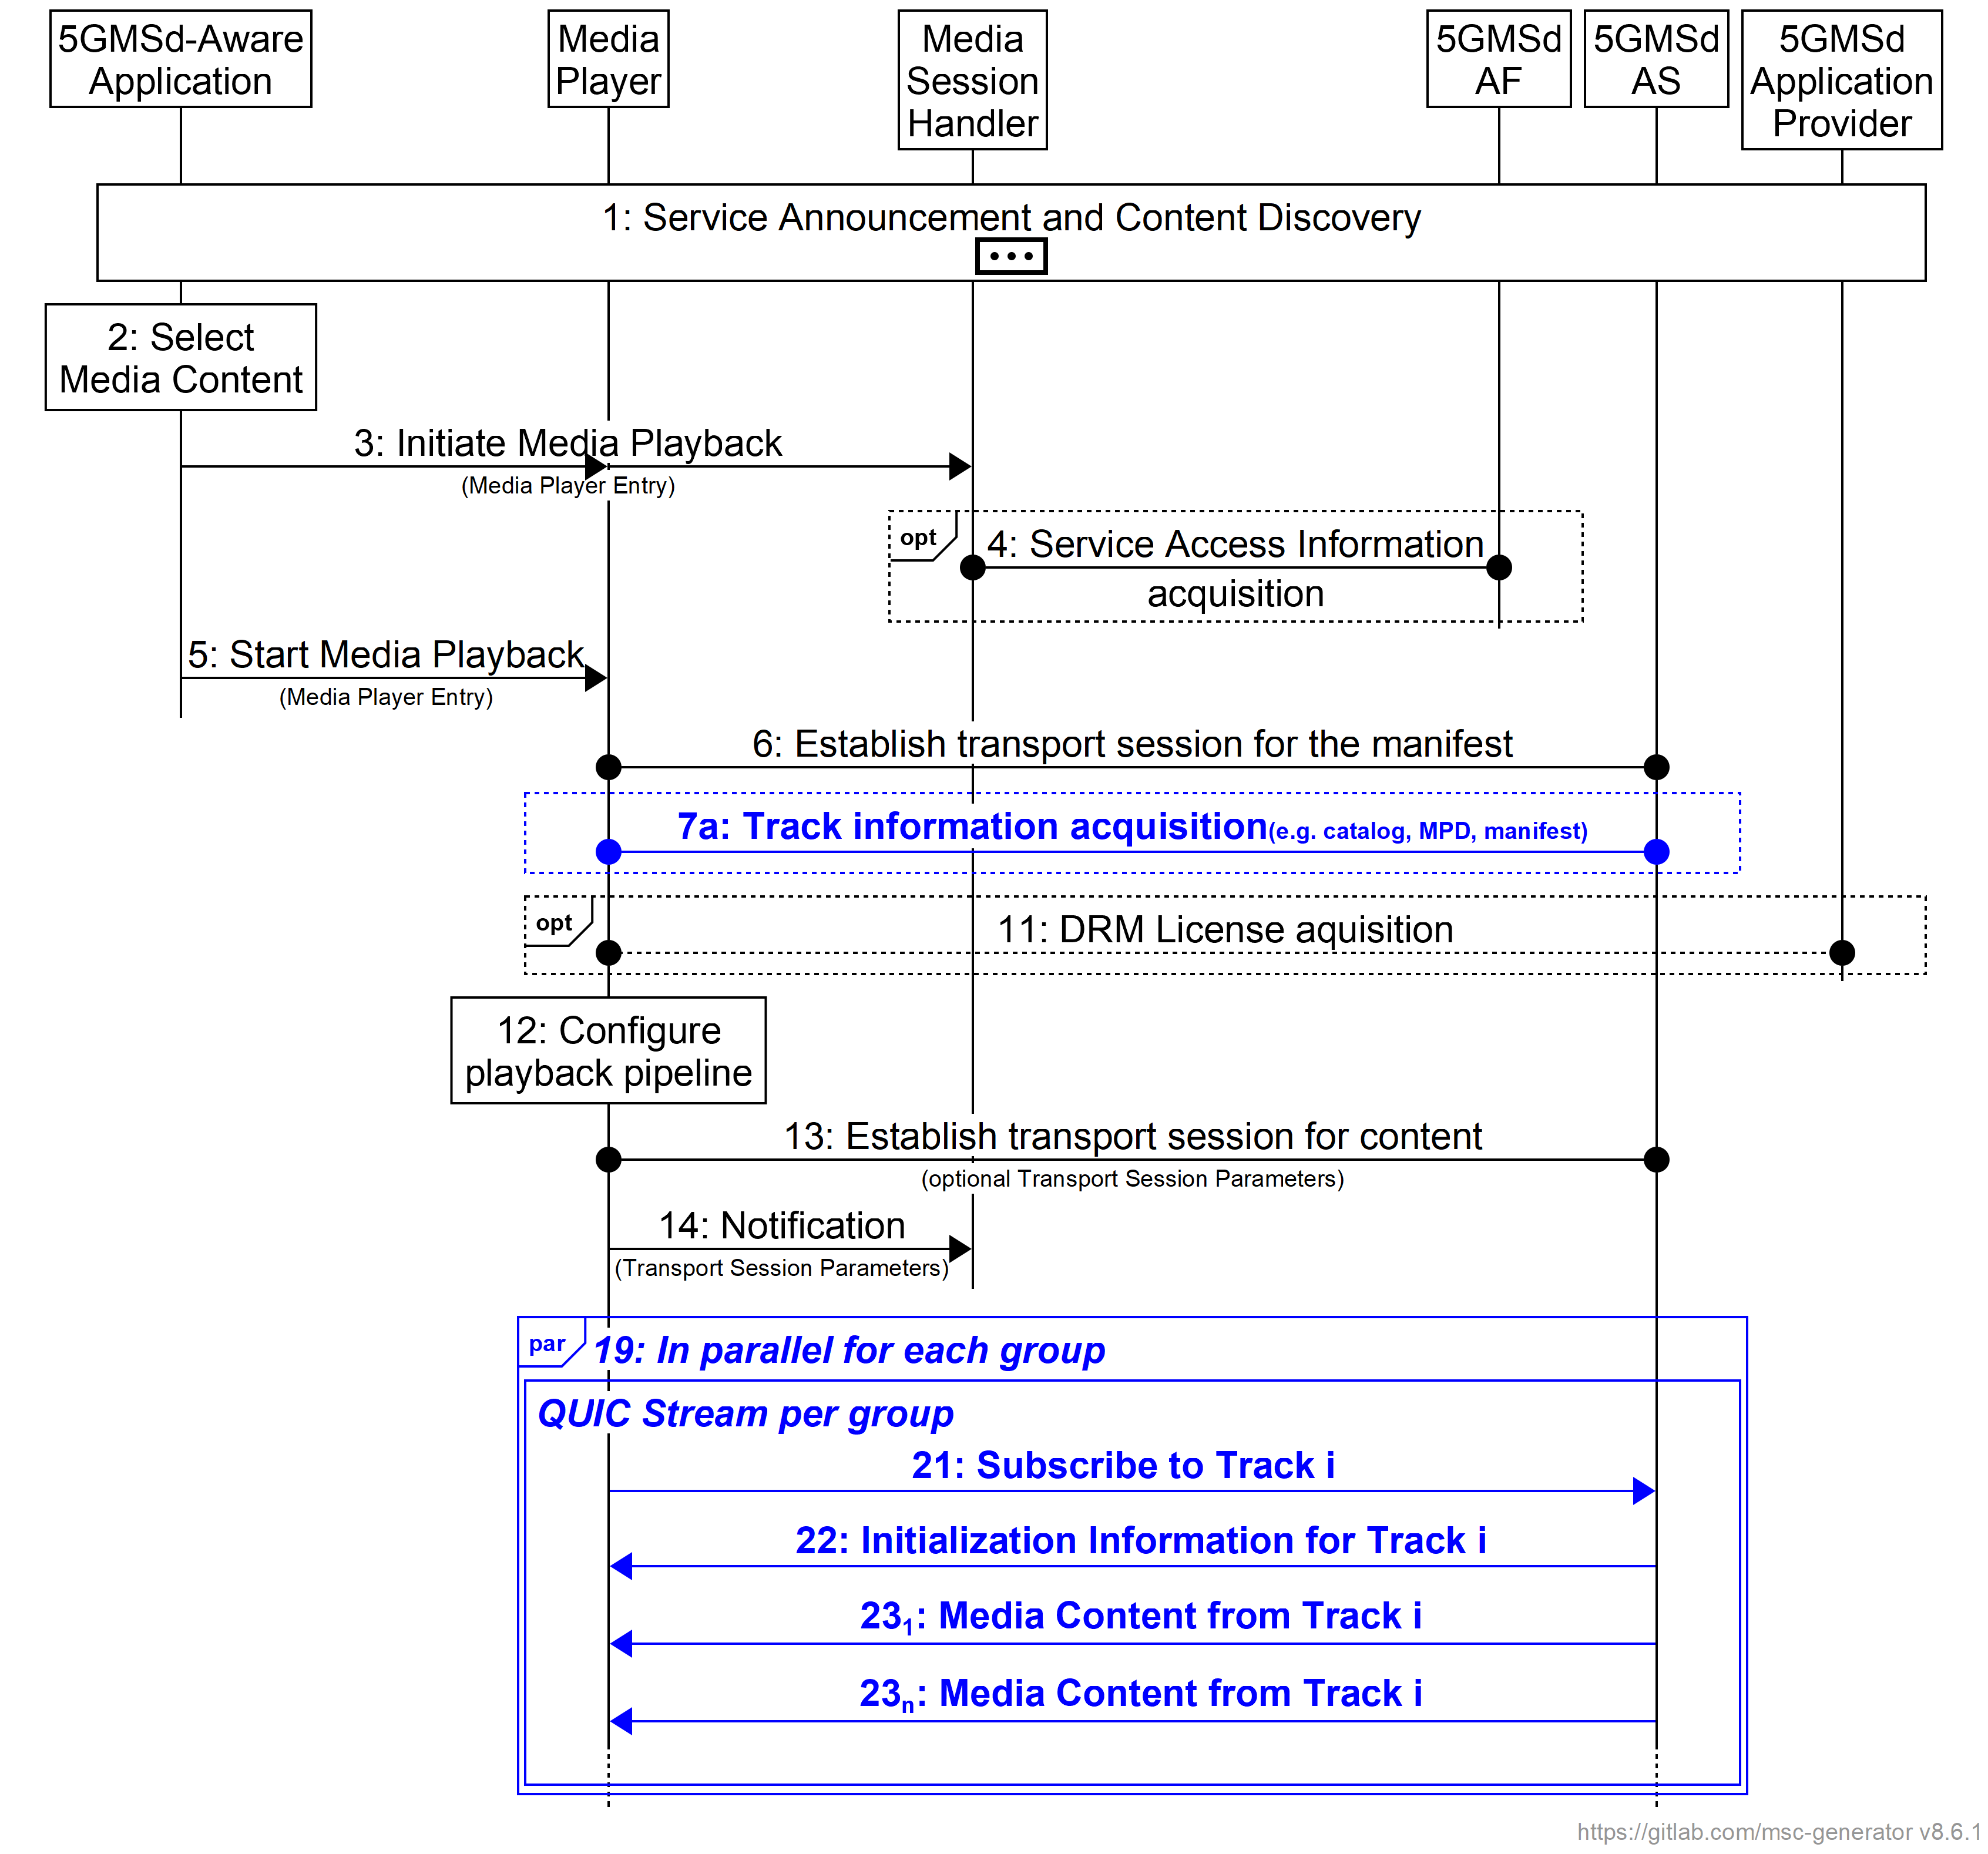
Figure 5.24.4.5-1 High-level call flow for DASH content
using a push-based QUIC-aware 5GMS Client
The specifics of using a QUIC-based protocol in this procedure are (emphasis in boldface):
7a: The Media Player acquires the Track information describing codec information, media information (bitrate, resolution, sampling rate, etc..). The information may be formatted following the MoQ Common Catalog format [167], an MPD or other manifest file formats.
21: The Media Player sends a subscription request for Track i.
22: The 5GMS Player sends Initialiazation Information for Track i.
23₁-23_{n}: Subsequently, and until the Media Player sends a subscription cancellation, the 5GMSd AS sends the media content belonging to the Track i.

5.24.5 Gap analysis and requirements
An analysis of the gaps identified in clause 5.24.4 and the derivation of requirements from these is for further study.

5.24.6 Candidate solutions

5.24.6.1 General
The candidate solutions in the following clauses are considered in relation to instantiation of the following types of 5GMS Client:
- Media-independent QUIC-aware 5GMS Client, as introduced in clause 5.24.2.3 and as mapped in clause 5.24.3.3.
- Media-optimised QUIC-aware 5GMS Client, as introduced in clause 5.2.4.2.4 and as mapped in clause 5.24.3.4.
NOTE: The QUIC-agnostic 5GMS Client type is covered by clause 5.4.
Additional candidate solutions may be identified subsequently, subject to further study.

5.24.6.2 MPEG-DASH over HTTP/3 with server push and priority information
This candidate solution is an instantiation of the media-independent QUIC-aware 5GMS Client based on the following technologies:
- MPEG-DASH Part 1 [11].
- The HTTP/3 protocol as specified in RFC 9114 [5], including the server push functionality.
- The Extensible Prioritization Scheme for HTTP as specified in RFC 9218 [164].
This candidate solution enables the delivery of DASH content to a 5GMSd Client using the HTTP/3 protocol at reference point M4d. In addition, both the 5GMSd AS and the Media Player support the server push functionality and the extensible prioritisation scheme for HTTP.
The call flow in clause 5.24.4.3 applies.

5.24.6.3 MPEG-DASH Part 6 over WebTransport

5.24.6.3.1 Prerequisites
This candidate solution is an instantiation of the media-optimised QUIC-aware 5GMS Client based on the following technologies:
- MPEG-DASH Part 1 [11].
- MPEG-DASH Part 6 [165].
- WebTransport protocol over HTTP/3 [161].
This candidate solution enables the delivery of DASH content to a UE using the WebTransport protocol layered over HTTP/3 at reference point M4. In addition, both the 5GMSd AS and the Media Player support the WebSocket sub-protocol for DASH specified in clause 8.2 of MPEG-DASH Part 6 [165]. However, the communication runs over a WebTransport connection instead of a WebSocket connection.
The call flow in clause 5.24.4.4 applies.

5.24.6.4 Media-over-QUIC
This candidate solution is an instantiation of the push-based QUIC-aware 5GMS Client based on the following technologies:
- MPEG-DASH Part 1 [11].
- Media-over-QUIC Transport protocol [166]
This candidate solution enables the delivery of DASH content to a UE using the WebTransport protocol over HTTP/3 or the QUIC protocol at reference point M4. In addition, both the 5GMSd AS and the Media Player support the Media-over-QUIC Transport protocol. The media content delivered using the Media-over-QUIC Transport protocol is assumed to be DASH segments, and it is also assumed that the MPD has been delivered in the initialisation phase such that the Media Player is able to generate SUBSCRIBE messages with the information related to desired Representation or simply called tracks in the context of MoQ.
The call flow in clause 5.24.4.5 applies.

5.24.6.5 Push-based adaptive media streaming over WebTransport with server-side throughput estimation
This candidate solution is an instantiation of the push-based QUIC-aware 5GMS Client based on the following technologies:
- MPEG-DASH Part 1 [11].
- WebTransport protocol over HTTP/3 [161].
- A specific WebTransport sub-protocol for MPEG-DASH as specified in [169].
This candidate solution enables the delivery of DASH content to a UE using the WebTransport over HTTP/3 protocol at reference point M4. In addition, both the 5GMSd AS and the Media Player support the protocol described in [169] (as summarised in clause 5.24.1.2.3).
The call flow in clause 5.24.4.5 applies.

5.24.7 Summary and conclusions
The study of this Key Issue has explored the ways in which QUIC can enhance the deployment of 5G Media Streaming services, and the potential open issues arising from this deployment. Based on the candidate solutions and the overall capabilities of QUIC, the following conclusions can be drawn.
QUIC is a widely deployed and supported protocol. However, when it comes to using QUIC for media delivery, the early deployments of segmented streaming over QUIC were achieved by using the HTTP/3 protocol for MPD and segment requests, as documented in clause 5.4. This approach is QUIC-agnostic and thus does not take full advantage of the capabilities offered by QUIC. In some cases, as reported by clause 5.4, there may even be some degradations of the performances compared to using HTTP/1.1. When it comes to non-QUIC-agnostic approaches, there exist several candidate technologies ranging from early standardization efforts based on QUIC, previous standardization activities based on HTTP/2 and WebSocket that could be reused with QUIC and WebTransport, as well as research prototypes natively built on QUIC and WebTransport. As a result, it appears that there is thus no obvious path, from the candidate solutions, for enhancing segmented delivery by leveraging the emergence of the QUIC protocol.
At this stage, there is thus no basis justifying the need for any normative work.
However, the following aspects are to be further studied:
- The fragmentation of QUIC implementations (both client and server side) and their performances for segmented media delivery.
- The impact of reporting qlog metrics via the downlink interface (M4) to the UE (bidirectional streams).
- The standardized definitions and their availability on the market of QUIC client and server APIs.
- The standardized definitions and their availability on the market of WebTransport client and server APIs.
- Evaluation of the identified candidate technologies with regards to QoE metrics (start-up delay, stalling events, etc.).

===== CHANGE =====

5.25 In-band signalling of QoS for 5G Media Streaming
This Key Issue is for future study.

===== CHANGE =====

5.26 Dynamic content generation from multiple sources

5.26.1 Description

5.26.1.1 Introduction
Media service providers may obtain content from multiple sources. Examples include:
- Advertising content is inserted into live content that is distributed
- Content targeted at a specific user is inserted into content in certain periods of time.
3. Content is obtained from multiple sources to have redundancy in the operation.
In order to integrate the content into a conforming Media Presentation – typically CMAF-based with an MPEG-DASH and/or HLS manifest – the content needs to fulfil certain conditions. One way to address the issue is the use of transcoding at the combination point of the content from multiple sources. However, such a process is costly and time-consuming. Hence, it is preferable that the content that needs to be combined into a conforming media presentation is produced in a way such that it can be combined to produce conforming content in a dynamic fashion without transcoding.
1. Content from different sources needs to be interchangeable (not necessarily identical). This is not a problem for static content, but for dynamically generated content such as live media this can be problematic because differences may occur during various system configuration such as clock synchronization issues or delay in different parts of the workflow, but also general configuration settings related to the media processing to dynamically generate the presentation.
2 When content is generated closer to the user (e.g., at the edge of the network) more dynamic and interesting media presentations can be realized as a more localized version of the media can be generated. Dynamic content generation in the network can be attractive for operators.
This study considers integration of different technologies into the 5G Media Streaming System that addresses the case of dynamic content generation at different points in the content distribution chain, and similar issues by allowing media streaming applications to efficiently generate and access content that may be changing dynamically at the edge of the network from different content serving endpoints. Different client implementations may then beneficially use the content from these multiple sources or networks concurrently, potentially guided by the service or by the network provider.
This both improves redundancy (resilience to failures) and flexibility (extending media services).
In addition to be being able to dynamically generate content from multiple endpoints for redundancy/resilience, it can also enable use cases such as content replacement, introducing new codecs and/or DRM systems (as each endpoint can generate representations of a different codec or DRM system). Another application is watermarking where multiple sources generate otherwise identical content, but the embedded watermark is different, and both segments and playlists need to be interchangeable.
The key aspect addressed is the use of redundant workflows with multiple encoding and/or packaging steps. In this case, a single contribution source passes through multiple distribution encoders and packagers that may be deployed throughout the network.

5.26.1.2 Challenges in Multi-endpoint dynamic content generation
Dynamic content generation usually includes different components such as contribution encoders, distribution encoders, DRM encryptors etc. This is to be able to create an optimized and targeted experience for the end user. By generating content closer to the end user in the network, more targeted and personalized experience can be achieved.
Challenges in deployments with multi-endpoint deployments and architectures with dynamic content generation may include:
1. Sustained CDN-/network-wide service disruptions where network access, connectivity or QoS is severely degraded. Examples may include cases where an entire CDN’s network is degraded because of a network-wide misconfiguration or power failure. In this case a client should switch to another CDN for retrieving the content.
2. Intermittent or short-term disruptions or delay between upstream components. Examples include short periods of congestion within the network, isolated HTTP request/response failures or delays caused by servers that may lead to different state at different downstream servers.
3. Timeline issues with the content. Due to slight time differences, the playlists or manifests may list a different number of segments or have a different live edge. When a player switches from one endpoint to another, it may therefore result in retroactive timeline changes and may potentially be unable to continue playback. These changes may happen because of different delays on different network paths, or slightly different configurations on a particular path.
4. Segment replacement and substitution at the edge requires aligned timelines and segment durations to be successful. Guidelines for appropriate content formatting and generalized content formatting may be needed. This can enable redundant segment generation for resilience, watermarking, content replacement etc.

5.26.1.3 Dynamic Content Publishing from multiple endpoints
When streaming media presentations originate from different sources, consistency of the media presentations is important.
This is trivial to achieve for the case of static non-changing content.
However, live media streaming presentations are updated frequently, resulting in updated presentation manifests (e.g., MPEG-DASH MPD), updated media playlists (HTTP Live Streaming), and different segments becoming available or no longer being available.
The support for such live streaming cases is important for multi-endpoint scenarios, because it is desirable that both media segments and presentation manifests are interchangeable even when they originate from different endpoints.
In practice, CDN source A may have a slightly delayed version of a presentation compared to CDN source B, resulting in different segment availability, and potentially conflicting presentation manifests and/or media playlists.
Such timing differentiations may happen upstream in the workflow due to different delays or differently configured upstream components. Even if the delays are relatively modest, discrepancies between sources may still occur that are disruptive to the user experience.
Practice has shown that players of streaming media presentations are sensitive to such issues. For example, retroactive changes to the media timeline may cause playback failure.
Figure 5.26.1.3-1 shows the example case of a retroactive timeline changes caused by switching from one endpoint to another that has a delayed version of the dynamic media presentation.
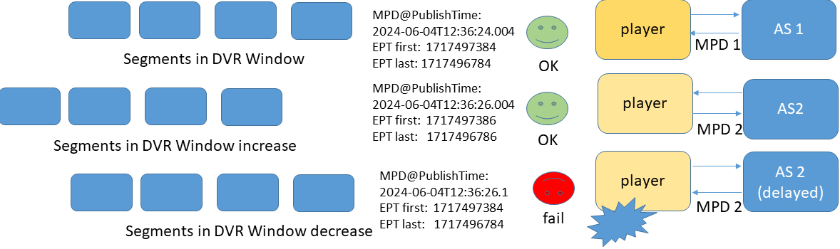
Figure 5.26.1.3-1: Sample case of playback failure in multi-CDN delivery
The corresponding example sequence of events is as follows:
1. The media presentation description is received with given MPD@publishTime, earliest media presentation time EPT, last segment presentation time LPT in the DVR window.
2. Playback starts.
3. After an MPD update request the DVR window is updated without problems because the update is consistent since it comes from the same sources.
4. In a subsequent request, the media player switches to an alternative endpoint AS 2 (or CDN source B) and this has delayed input.
5. An updated MPD is received with a later publish time, but the earliest presentation time of the newest segment is decreased, and the timeline is changed retroactively.
6. As a consequence, playback is interrupted because the media player could not handle this.
Other related issues that may occur due to different source versions may be different timeline gaps in the media presentation and overall differences in the segment availability between subsequent updates.

5.26.1.4 Examples of inconsistent Content Publishing from multiple sources (CDN)
This clause provides some example scenarios in which inconsistent timelines can occur in dynamic content publishing, even if the segments are interchangeable and both source contents have an identical timeline. The cause can be that content publishing origin B receives a delayed input compared to content publishing origin A.
Each dynamic content publishing origin generates the media playlist description based on its input and sets the publishTime based on the system clock time that is synchronized to global timing systems.
In this case the first MPD is retrieved from origin A that is ahead, in this case the newest segment time is:
1031634228096 + 1152 × (312 + 1) = 1031634588672
Then the player receives the MPD from content publishing origin B in a delayed data centre it receives an MPD with a later publish time, but the start time of the newest segment is:
1031634226944 + 1152 × (312 + 1) = 1031634587520
which is earlier. This implies that the newest segment from the MPD from origin A is not the MPD, but the publishtime is later, leading to a retroactive timeline change interpreted by the media player.
Listing 5.26.1.4-1 Snapshot of publishTime and segmentTimeline
in MPD retrieved from origin A
<?xml version="1.0" encoding="utf-8"?>
<MPD
xmlns:xsi="http://www.w3.org/2001/XMLSchema-instance"
xmlns="urn:mpeg:dash:schema:mpd:2011"
xsi:schemaLocation="urn:mpeg:dash:schema:mpd:2011 http://standards.iso.org/ittf/PubliclyAvailableStandards/MPEG-DASH_schema_files/DASH-MPD.xsd"
type="dynamic"
availabilityStartTime="1970-01-01T00:00:00Z"
publishTime="2024-06-26T08:36:24.332711Z"
minimumUpdatePeriod="PT2S"
timeShiftBufferDepth="PT10M"
maxSegmentDuration="PT2S"
minBufferTime="PT10S"
profiles="urn:mpeg:dash:profile:isoff-live:2011,urn:com:dashif:dash264">
<Period
id="1"
start="PT0S">

<AdaptationSet
……
<SegmentTemplate
timescale="600"
initialization="live-$RepresentationID$.dash"
media="live-$RepresentationID$-$Time$.dash">
<!-- 2024-06-26T08:26:20.160000Z / 1719390380 - 2024-06-26T08:36:21.120000Z -->
<SegmentTimeline>
<S t="1031634228096" d="1152" r="312" />
</SegmentTimeline>
……
</MPD>

Listing 5.26.1.4-2: Snapshot of publishTime and segmentTimeline
in MPD retrieved from origin B
<MPD
xmlns:xsi="http://www.w3.org/2001/XMLSchema-instance"
xmlns="urn:mpeg:dash:schema:mpd:2011"
xsi:schemaLocation="urn:mpeg:dash:schema:mpd:2011 http://standards.iso.org/ittf/PubliclyAvailableStandards/MPEG-DASH_schema_files/DASH-MPD.xsd"
type="dynamic"
availabilityStartTime="1970-01-01T00:00:00Z"
publishTime="2024-06-26T08:36:25.378162Z"
minimumUpdatePeriod="PT2S"
timeShiftBufferDepth="PT10M"
maxSegmentDuration="PT2S"
minBufferTime="PT10S"
profiles="urn:mpeg:dash:profile:isoff-live:2011,urn:com:dashif:dash264">
<Period
id="1"
start="PT0S">
<AdaptationSet
….
<SegmentTemplate
timescale="600"
initialization="live-$RepresentationID$.dash"
media="live-$RepresentationID$-$Time$.dash">
<!-- 2024-06-26T08:26:18.240000Z / 1719390378 - 2024-06-26T08:36:19.200000Z -->
<SegmentTimeline>
<S t="1031634226944" d="1152" r="312" />
</SegmentTimeline>
….
</MPD>

5.26.1.5 Redundant Encoding and Packaging (REaP)
Redundant Encoding and Packaging (REaP), as defined in MPEG-DASH Part 9 [112], specifies a Delivery Media presentation Description (D-MPD) which adds constraints on the formatting and output generation of the media presentation description to make sure that outputs form different distributed origins application servers are interchangeable by a player (i.e. no retroactive timeline changes). These constraints apply to the representations, the setting of MPD@publishTime and some other attributes/elements in the MPD. A corresponding version for HTTP Live Streaming playlists is defined as well.
NOTE: REaP is not an API but rather an architecture to support existing segmented media streaming formats and additional constraints on formats to enable use cases with dynamic content generation.
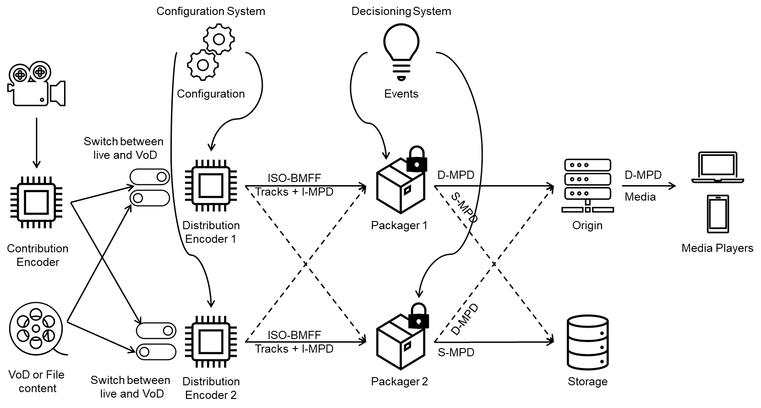
Figure 5.26.1.5-1: Architecture for redundant encoding and packaging
The REaP architecture depicted in figure 5.26.1.5-1 starts from defining a reference/example head-end architecture, that in the case of 5G Media streaming may be the 5GMS AS or even components upstream of the 5GMS AS. The key assumption is that a common contribution source (encoder) with a common timeline is used that can be converted back to a timeline relative to Unix epoch, which is to say midnight UTC on 1st January 1970. This assumption can hold in many cases where a common contribution signal is used in the streaming head-end. This way all tracks and streams have the same timeline origin. Secondly a regular media segmentation strategy is proposed resulting in aligned media segment boundaries of the different segments.
This is used in the output of one or more distribution encoders that produce ISO BMFF tracks with aligned segment boundaries and a common shared timeline relative to Unix epoch. In addition, REaP defines the I-MPD, a constrained version of the media presentation description to announce the streams that is for example used for live ingest or distribution encoder egress.
The critical part are the distributed packagers in combination with the origin as this corresponds to the output generated at the content origin or multiple content origins in the multi-source dynamic content generation case.
For this case REaP defines the Delivery MPD (D-MPD) that constrains the formatting of the output MPD by linking some of the fields in DASH MPD that can cause retroactive changes to the media timeline. For example, by linking the MPD@publishTime explicitly to the earliest presentation time of the newest segment, and constraining the way the set of available segments are updated, it is possible to generate consistent media presentation description or HTTP live streaming playlists.
The approach in REaP can work in modestly well synchronized content origins up to 100 ms out of sync. A key aspect for a REaP setup is to configure the expected maximum delay incurred in the workflow/AS to account for this setting MPD@publishTime as a function of the earliest media presentation time of the latest segment at the live edge.
The approach has, for example, been demonstrated using an open-source implementation [170] to implement a pseudo-watermarking workflow. In pseudo-watermarking, the two content origins create interchangeable content that only differs by an embedded watermark. In this demo the watermark was shown visually on the screen, showing how the player is able to seamlessly play content generated dynamically from different sources.
In REaP this problem case shown in figure 5.26.1.5.1-1 is overcome by coupling the publish time to the media timeline in the output to enable consistent dynamic content publishing between sources. If the publish time was coupled to the media time this specific case of retro-active timeline change could have been avoided, but it requires some further configuration.
Therefore, some configurations from REaP may be considered in 5GMS, such as segment duration, the epoch used, the synchronization time stamp for linking the publish time and media timeline.

5.26.1.6 Key Issue objectives
This Key Issue aims to tackle the following questions:
1. How can dynamic content generation from multiple sources be integrated into the 5GMS System in order to address the problem of dynamic content generation from multiple sources.
a. Where in the 5GMS architecture does the generation of content segments occur?
b. Where in the 5GMS architecture does the generation of presentation manifests occur?
c. Is the Content Preparation feature of the 5GMSd AS fit for purpose in this context?
2. Review use cases enabled by dynamic generation from multiple sources.
a. Explore and document use cases for generating content dynamically in the trusted network.
b. Improving redundancy and failover in 5GMS deployments using dynamic content generation from multiple sources and configuring this in 5GMS.
c. Develop call flows and workflows for such cases of dynamic content generation from multiple sources.

5.26.2 Collaboration scenarios

5.26.2.1 Multi-endpoint media delivery with dynamic content generation
In this scenario, the 5GMSd Client requests adaptive media streaming content from two or more 5GMSd Application Server endpoints. The 5GMSd Client may choose one 5GMSd AS endpoint or use multiple simultaneously. This allows the client to distribute network load across Application Server instances and M4 downlink transports, optimize costs, as well as improve QoS.
The content retrieved over reference point M4d includes both media segments and manifests/playlists. In some cases, a different 5GMSd AS endpoint may serve different groups of segments and/or different media playlists/manifests.
The 5GMSd Client’s Media Session Handler discovers the URLs of these 5GMSd AS endpoints from the 5GMSd Application Function (5GMSd AF), either through a Media Entry Point or from a separate piece of metadata. QoE metrics from the 5GMSd Client may be used by the 5GMSd AF to determine the best 5GMSd AS instance(s) for each client to use when streaming media. Figure 5.26.2.1-1 shows the 5GMSd Client communicating with multiple 5GMSd AS instances. Each 5GMSd AS instance has no direct communication with its peers; rather it communicates (minimally) with the 5GMSd Application Provider via reference point M2d and with the 5GMSd AF (not depicted) via reference point M3d.
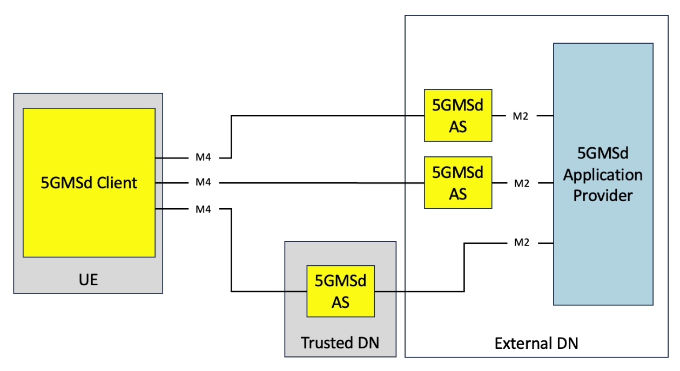
Figure 5.26.2.1-1: Multi-AS media delivery within 5G system with dynamic content generation
In this case the 5GMSd AS includes dynamic content generation and generates, based on content ingested from the 5GMSd Application Provider via reference point M2d, new media segments and/or representations.

5.26.3 Architecture mappings

5.26.3.1 Content formatting at multiple 5GMSd AS endpoints following REaP
REaP as defined in [112] may be used in the context of the downlink media streaming architecture by instantiating a streaming head-end in the 5GMSd AS. To create an interchangeable media presentation independently at each 5GMSd AS instance, the content preparation feature is used as shown in the below figure.
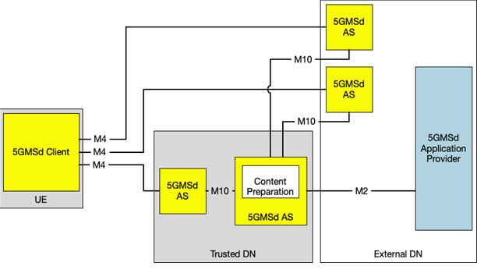
Figure 5.26.3.1-1: Possible deployment scenario with multiple 5GMsd AS implementations

5.26.4 High-level call flows
This aspect is for further study.

5.26.5 Gap analysis and requirements
This aspect is for further study.

5.26.6 Candidate solutions

5.26.6.1 Content formatting at multiple 5GMSd AS endpoints following REaP
This solution proposes to solve the issue of dynamic content generation from multiple sources by using additional format constraints that can be applied to DASH and HLS streaming media presentations (both media segments and media playlist or media presentation description). These constraints are based on the Redundant Encoding and Packaging ISO/IEC 23009-9 from MPEG (ISO/IEC SC 29 WG 3) and no new formats envisioned to be defined in 3GPP. Also REaP formats from ISO/IEC 23009-9 are a subset of current formatting options available) so it is more an enhancement to enable use cases with multiple encoders/packagers for live content production.
This solution is based on Redundant Encoding and Packaging (REaP) as defined in MPEG-DASH Part 9 [112]. The solution defines formats for usage in the streaming head-end that typically resides in the 5GMSd AS enabling generation of interchangeable media presentations at different sources. The formats in REaP are based on existing MPEG formats such as MPEG-DASH, ISO BMFF and Common Media application with some additional constraints to enable interchangeable formats. Aspects include consistent segment durations, shared timeline (originating from epoch).
Proposed standardization work is for further study and could include the following:
At stage 2, the recommendation is to update TS 26.501 [15] to include the use case of redundant encoding and packaging in the description of the content preparation use case.
At stage 3, the recommendation is to add some REaP-specific features to TS 26.512 [16], namely:
- REaP formatting enablement at the 5GMSd AS using its content preparation feature.
- Configuration of REaP parameters for the content preparation (e.g. Segment Duration, REaP synchronization timestamp P-STS).
The advantage of integrating REaP into the 5GMS architecture is that changes are limited, and the output format from the 5GMSd AS can be easily checked for conformance using existing conformance tooling. In addition, very limited or up to no signalling is needed between 5GMSd AS instances, making the solution very easy to adopt and maintain in practice.

5.26.7 Summary and conclusions
Support for ReAP and configuration of REaP in 5GMS is for further study. Some possible directions are given by the candidate solution in clause 5.26.6.1.

===== CHANGE =====

6.1 List of conclusions
Table 6.1-1 points to conclusions and next steps for each of the key issues studied in the present document.
Table 6.1-1: Index of Key Issues, conclusions, and next steps
Key Issue | Conclusions and next steps clause
Key Issue #1: Content Preparation | 5.2.9
Key Issue #2: Traffic identification | 5.3.7
Key Issue #3: Use of HTTP/3 in the Media Delivery System | 5.4.7
Key Issue #4: Uplink media streaming | 5.5.7
Key Issue #5: Background traffic | 5.6.7
Key Issue #6: Content-aware streaming | —
Key Issue #7: Network event usage | 5.8.5
Key Issue #8: Per-application authorization | 5.9.7
Key Issue #9: Support for distributing DRM-protected, encrypted and high-value content | 5.10.6
Key Issue #10: TV-grade mass distribution of unicast live services | 5.11.7
Key Issue #11: Network slicing extensions for 5G Media Streaming | 5.12.7
Key Issue #12: 3GPP Service Handler and URLs | 5.13.7
Key Issue #13: 5GMS Application Server configuration and management | 5.14.7
Key Issue #14: Media Delivery specification | —
Key Issue #15: Common Media Client Data (CMCD) | 5.16.7
Key Issue #16: Common server and network-assisted streaming | 5.17.7
Key Issue #17: Multi-access media delivery | 5.18.7
Key Issue #18: Media delivery from multiple service endpoints/locations | 5.19.7
Key Issue #19: Optimising modem usage for media streaming | 5.20.7
Key Issue #20: DASH/HLS Interoperability | 5.21.7
Key Issue #21: Further harmonization of RTC and 5G Media Streaming for Advanced Media Delivery | —
Key Issue #22: Improved QoS support for Media Streaming services | 5.23.7
Key Issue #23: QUIC-based segmented media delivery | 5.24.7
Key Issue #24: In-band signalling of QoS for 5G Media Streaming | —
Key Issue #25: Dynamic content generation from multiple sources | 5.26.7

===== CHANGE =====

6.4 Use of HTTP/3 in the Media Delivery System
The latest version of HTTP, HTTP/3, [5] can be used for at least some types of media immediately, but some existing 3GPP Stage 3 specifications are explicitly tied to specific versions of HTTP and need to be updated to allow HTTP/3 as a supported version, in order to allow deployment of this new protocol.
HTTP/3 is defined in the IETF and has been completed in the QUIC working group and approved for publication as an RFC but has not been published yet because of a normative dependency on other documents. The HTTP/3 document is stable (has not changed since February 2021)
When HTTP is used in 5GMS applications, it is often used with application-level protocols such as DASH or HLS that are defined (partially) outside of 3GPP. Some usages in 5GMS will depend on support for HTTP/3 in these application-level protocols.
The following actions are recommended:
- Update 5GMS stage 3 specifications to allow the use of HTTP/3 at relevant reference points in the 5GMS architecture, to allow early deployment and to identify any unforeseen open issues with using HTTP/3 in a 5G System.
- At this time, support for HTTP/3 in 5GMS specifications, can be allowed, but not required.

===== CHANGE =====

6.5 Uplink media streaming
The study of this key issue demonstrates that uplink streaming is severely underspecified in TS 26.501 and TS 26.512 in Release 16, and several gaps are identified.
The following extensions are recommended:
1. Inclusion of collaboration scenarios and associated call flows in Stage 2.
2. Specification of egest protocol(s), Content Publishing Configuration APIs and a corresponding Content Publishing Configuration resource, and the UE’s uplink streaming entry point in Stage 3.
5G-MAG published the report "Uplink media delivery: Architectures & Features" [173] in late 2024. This report covers the following aspects:
- Identification of systems and features enabling enhancements for uplink media delivery and traffic management in the content of media production and contribution applications.
- Description of architectures, reference points and relevant procedures in the context of uplink media delivery using 3GPP technology.
- Feasibility analysis of the status of the technology and its potential applicability based on 3GPP Release 17 and Release 18 specifications.
- Identification of possible gaps in existing specifications to support their application for uplink media delivery.
In an updated version of the present document, it is further recommended to study the application of uplink 5G Media Streaming for media production and contribution in more detail based on the information from 5G-MAG in clause 5.5.1.5. Specific topics are:
- Network assistance as elaborated in clause 5.5.1.5.2,
- QoE metrics reporting as elaborated in clause 5.5.1.5.3,
- Consumption reporting as elaborated in clause 5.5.1.5.4,
- Traffic steering and multipath as elaborated in clause 5.5.1.5.5.

===== CHANGE =====

6.8 Network Event usage
The 5GMS AF performs several critical support operations for media streaming sessions and collects information about the progress and status of media streaming sessions. This information can be of interest to the 5GMS Application Provider or to other Network Functions in the 5G System.
The following extensions (Stage 2 and Stage 3) are recommended:
- Identify and define the media-related data to be exposed by the 5GMS AF towards the 5G System and other event consumer entities. Work with other 3GPP groups for carriage in existing AF events or the definition of new AF Events.
- Enhance the 5GMS AF data collection to support direct and indirect collection of UE data pertaining to media sessions.
- Devise mechanisms to control the access to the collected media session data.
- Define a generic architecture within which media-specific solutions for the configuration and subsequent operation of data collection and data reporting (via event exposure) by the AF can be specified.

===== CHANGE =====

6.10 Support for distributing DRM-protected, encrypted and high-value content

DRM and Conditional Access are commonly used by third-party streaming services. However, in case streaming is done through MBS or MBMS, a more careful management of the encryption/decryption keys needs to be checked. Scalability of key delivery is an issue. The support for encrypted content in unicast/multicast and broadcast is relevant. Integration of Content Protection interfaces in the provisioning of 5G Media Streaming – for example using CPIX back-end interfaces – is of high relevance for the industry and needs to be addressed accordingly. With the inclusion of DRM support in 5GMS, and the support of 5GMS via MBS and MBMS, these use cases need to be supported not only for unicast but also for multicast/broadcast User Services.
Based on the considerations in clause 5.10, it is recommended to:
- Support the Content Protection Information Exchange Format (CPIX) as specified in ETSI TS 103 799 [143] at reference point M2d by specifying the necessary stage-2 and stage-3 extensions in TS 26.501 [15] and TS 26.512 [16] respectively.
- Support the DASH-IF Interoperability Points specified in [144] at reference point M4d for both DASH and HLS by specifying the necessary stage-2 and stage-3 extensions in TS 26.501 [15] and TS 26.512 [16], respectively.
- Specification of a Content Preparation Template format in TS 26.512 [16] or TS 26.510 [108] that can configure encryption content preparation tasks in the 5GMS AS.
NOTE: Maintaining functional symmetry with uplink media streaming (where applicable) is generally considered important, but DRM is considered to be applicable only for 5GMS downlink.
In particular, stage 2 extensions are needed to address the open issues:
- Functional updates to the definition of the 5GMS AS to support:
- Ingest, delivery, and contribution of encrypted content
- Content preparation tasks for:
- Decrypting content ingested at reference point M2d.
- (Re-)encrypting content prior to distribution at reference point M4d.
- Updates to the definitions of reference points to support:
- Carriage of Content Protection information at reference point M2d.
- Delivery of Content Protection information in presentation manifests at reference point M4d.
Stage 3 aspects are provided above.

===== CHANGE =====

6.15 Media Delivery specification
Conclusions for this Key Issue are for further study.

===== CHANGE =====

6.16 Common Media Client Data (CMCD)
CMCD [105] defines a set of media client data, structured as key/value pairs, which allows a media player to communicate mutually beneficial media-related information to a CDN via either (i) a set of custom headers, (ii) a URL request query string, or (iii) a JSON object. Common is used because the same data structure can be used across all players and all CDNs. CTA WAVE is currently extending its specification, and a new version is expected to be available by the end of 2025. A player may be instructed through a configuration API, for example defined in dash.js, on how to exactly report. In addition, in the 6th edition of MPEG-DASH in ISO/IEC 23009-1 [11], a configuration API and an MPD-based signalling of configuration are specified in order for the DASH client to be instructed to enable CMCD information collection and reporting.
The use cases which CMCD enables are broad – including robust pre-fetching of content, analytics solutions, forensic debugging, CDN delivery optimisation, alerting and monitoring systems, low latency optimisations, server-side switching, research analytics and content steering decision-making. In the context of 5G Media Streaming, the CMCD information may be used for several purposes as described in clause 5.16.1.2. In addition, the analysis in clause 5.16.1.3 and annex B indicates minimal overlap between CMCD information [105] and existing reporting mechanisms for 5G Media Streaming (QoE metrics reporting and consumption reporting). Based on this, it is recommended that CMCD be considered as a supplementary reporting mechanism for media client data at this point, operating alongside QoE metrics reporting and consumption reporting.
Based on the analysis in clause 5.16.7, the preferred solution to add CMCD to 5G Media Streaming is Option 1 In-band reporting of CMCD information via reference points M4d and M3d. Hence, it is recommended to implement the solution defined in clause 5.16.6.1 in the relevant 3GPP specifications. Furthermore, there is a preference to provide deployment choices to the 5GMSd Service Provider to select the use of reporting scheme using either the CMCD query parameter or CMCD request headers.
The updates include stage-2 updates as follows:
- Functional changes to the 5GMSd AF as outlined in clause 5.16.6.1.8,
- Functional changes to the 5GMSd AS as outlined in clause 5.16.6.1.9,
- Functional changes to the Media Player as outlined in clause 5.16.6.1.10,
- Functional changes to the Media Session Handler for downlink media streaming only as outlined in clause 5.16.6.1.11.
No architectural updates to the reference architecture are identified, nor is there any need for new reference points.
Impacts on stage-3 are expected to:
- TS 26.247 [109],
- TS 26.510 [108],
- TS 26.512 [16],
- TS 26.532 [107] and
- TS 29.517 [25].
Furthermore, it is recommended:
- To monitor the work in CTA WAVE on potential extensions of CMCD and potentially study how these extensions would be beneficial for 5G media streaming,
- To collaborate with the other organizations including 5G-MAG, SVTA, DVB and CTA WAVE to implement and validate the usage of CMCD for the considered use cases,
- To further study the usage of CMCD when 5GMS is deployed over MBS and/or MBMS,
- To further study the aggregation of different reports (Metrics, CMCD, Consumption) in the 5GMS AF and the potential consolidation of information into a single data structure when exposed to the 5GMS Application Provider.

===== CHANGE =====

6.17 Common server-and network-assisted streaming
Conclusions for this Key Issue are for further study.

===== CHANGE =====

6.18 Multi-access media delivery
Multi-access media delivery enables media streaming applications to efficiently access content over multiple access networks. This Key Issue has examined existing specification relating to the ATSSS (Access Traffic Steering, Switching and Splitting) architecture in TS 23.501 [23] and TS 23.502 [24] to identify its impact on 5GMS. Topics relating to application awareness and influence on multi-access delivery, potential enhancements to dynamic policy feature of 5GMS to support multiple access paths, and network assistance with multi-access delivery have been studied. The Key Issue has documented collaboration scenarios and the mapping of the ATSSS architecture into the 5GMS architecture.
Based on the conclusions, following are recommended for stage-2:
- An informative annex is added to TS 26.501 [15] documenting:
a. A brief description of multi-access media delivery, based on clause 5.18.1 of the present document.
b. The mapping of the ATSSS architecture into the 5GMS architecture, as described in clause 5.18.3.2 of the present document.
Based on the conclusions, following are recommended for stage-3:
- Changes to the Configuration Settings API and to the Dynamic Status Information API as described in clause 5.18.6.2 of the present document are implemented in TS 26.510 [108] to allow for application configuration and status information exchange for multi-access media delivery.
It is recommended that future specification work on ATSSS in TS 23.501 [23] and TS 23.502 [24] is to be monitored to further study traffic splitting of M4 flows across multiple access networks.

===== CHANGE =====

6.19 Media delivery from multiple service endpoints/locations
A multi-CDN or multiple service location/endpoint content offering generally provides content in a redundant manner at locations that can be differentiated by the client. The study of this Key Issue identifies gaps within the existing 5GMS architecture and recommends solutions to enable the ability use multiple sources or service locations/endpoints both internal and external to the 5GMS System. Multi-source/service location approaches considered include:
- DNS-based switching.
- MPEG-DASH client-side switching.
- Content steering driven switching.
- SAND4M-based switching.
- CMMF-based multi-source delivery.
The following stage 2 extensions are recommended to TS 26.501 [15]:
1. Multi-source media streaming collaboration scenarios and associated call flows are documented (item 1 in clause 5.19.7).
2. Reference point M10 is brought into scope of 5GMS for the purposes of content preparation chaining and media delivery between provisioned content distributions (item 4 in clause 5.19.7).
3. Document the capability to signal information to the 5GMSd Client that is required to deliver media from multiple content sources/endpoints using the Media Entry Point (item 6 in clause 5.19.7).
4. Define the requirements and functions necessary for a Media Player to be interoperable within the 5GMS System (item 7 in clause 5.19.7).
5. Clarify that the Media Player used for the purposes of multi-source/service location media delivery natively supports the multi-source/service location delivery approach in use (item 8 in clause 5.19.7).
6. Define a new reference point between a new External Access Client function located with the Media Player and a non-3GPP content hosting function or 5GMSd Application Provider for the purposes of communicating user plane information between the two functions (item 10 in clause 5.19.7).
The following stage 3 extensions are recommended to TS 26.510 [108] and TS 26.512 [16]:
7. Document the generic MIME content types and references to valid profiles or relevant external specifications for Content Preparation Templates used for the purposes of multi-source/service location content preparation (item 2 of clause 5.19.7).
8. Update the description of the Content Hosting Configuration to describe the ability of the 5GMSd AF to provision Content Distributions in hierarchical or peer-to-peer configurations (item 4 of clause 5.19.7).
9. Extend the ContentHostingConfiguration resource to allow the 5GMSd Application Provider the capability to influence the configuration and deployment of Content Distributions with the 5GMSd AS at the time of provisioning (item 5 of clause 5.19.7).
10. Clarify the use of the Media Entry Point for the purposes of communicating service location and multi-source/service location configuration information to 5GMSd Clients (item 6 of clause 5.19.7).
11. Clarify the expectation that the Media Player natively supports the multi-source/service location approach in use (item 8 of clause 5.19.7).
The set of recommended technologies within 5GMS for performing multi-source/service location media delivery (among those listed within clause 5.19.7) is to be determined.
The following are recommended for further study:
12. Verification of Content Preparation Template signalling and implementation within 5GMS specifications (item 3 of clause 5.19.7). This verification may be conducted outside 3GPP.

===== CHANGE =====

6.20 Optimising modem usage for media streaming
Conclusions for this Key Issue are for further study.

===== CHANGE =====

6.21 DASH/HLS interoperability
Conclusions for this Key Issue are for further study.

===== CHANGE =====

6.22 Further harmonization of RTC and 5G Media Streaming for Advanced Media Delivery
Conclusions for this Key Issue are for further study.

===== CHANGE =====

6.23 Improved QoS support for Media Streaming services
This Key Issue has explored several QoS features which could be beneficial to the Media Delivery System, including:
1. ECN marking for L4S,
2. PDU Set handling and
3. QoS monitoring.
Detailed description of the above features is provided in clause 5.23.1.2. High-level call flows for features 1 and 3 are documented in clause 5.23.4, and corresponding gaps are analysed in clause 5.23.5. Finally, candidate solutions to address the identified gaps are provided in clause 5.23.6.
Based on the study of improved QoS support for Media Streaming services, it is recommended to make the following changes to normative specifications.
At stage 2 in TS 26.501 [15]:
1. Integrate ECN marking for L4S into the architectures, high-level call flows and collaboration scenarios for both 5GMSd and 5GMSu.
2. Integrate the QoS monitoring feature into the architectures, high-level call flows and collaboration scenarios for both 5GMSd and 5GMSu.
At stage 3 in TS 26.510 [108]:
1. Integrate ECN marking for L4S into the procedures for both 5GMSd and 5GMSu.
2. Integrate the QoS monitoring feature into the procedures for both 5GMSd and 5GMSu.

===== CHANGE =====

6.24 QUIC-based segmented media delivery
QUIC is a widely deployed and supported protocol built on top of UDP [32]. For the QUIC-aware approaches on delivering segmented media the following technologies have been identified:
- MPEG-DASH over HTTP/3 with server push and priority information.
- MPEG-DASH Part 6 over WebTransport.
- Media-over-QUIC.
- Push-based adaptive media streaming over WebTransport with server-side throughput estimation.
The maturity of these technologies varies, from using features of QUIC in existing solutions, to research prototypes built on QUIC and WebTransport. As a result, it appears from the candidate solutions that there is no obvious path at the time of writing for enhancing segmented delivery by leveraging the emergence of the QUIC protocol.
Due to the diversity of the technologies and their different stages of maturity, it is recommended that the following aspects are further studied:
1. The standardized definitions of QUIC client and server APIs and their availability on the market.
2. The standardized definitions of WebTransport client and server APIs and their availability on the market.
3. The fragmentation of QUIC implementations (both on the client and server side) and their performance for segmented media delivery.
4. Evaluation of the identified candidate technologies with regards to QoE metrics (start-up delay, stalling events, etc.).
5. The impact of reporting qlog metrics via the downlink interface (M4) to the UE (bidirectional streams).

===== CHANGE =====

6.25 In-band signalling of QoS for 5G Media Streaming
Conclusions for this Key Issue are for further study.

===== CHANGE =====

6.26 Dynamic content generation from multiple sources
Conclusions for this Key Issue are for further study.

===== CHANGE =====

7.1 General
5G Media Streaming provides significant opportunities to integrate operator and third-party media streaming services into 5G Systems. The present document provides a set of considered extensions to 5G Media Streaming as defined in TS 26.501 [15], as well as the format and protocol specifications in TS 26.511 [96] and TS 26.512 [16], respectively. Advances in 5G System technologies, external enhancement and developments in other SDOs such as IETF, DASH-IF or MPEG, as well as initial experiences from deployments have led to a set of conclusions in clause 6.
Recommendations for normative work are summarised in the following clauses.
All work topics will benefit from continuously checking relevance and support across 3GPP members. In addition, close coordination with other groups in 3GPP on 5G System and radio-related matters, edge computing, applications, operational management and security as well, in communication with experts in 5G-MAG, MPEG, SVTA (in particular the DASH-IF Working Group), CTA WAVE on DASH, HLS and CMAF, as well as with IETF on new protocols.

7.2 Recommendations for future work arising from versions 17 and 18
Based on the first and second phases of feasibility studied in clause 5 of the present document, the following next steps are proposed.
1. Initiate stage 2 and stage 3 work on Network Event usage based on the conclusions in clause 6.8. Note that this is already addressed in TS 26.531 [94] and TS 26.532 [95], respectively.
2. Provide relevant extensions to the Stage 2 5G Media Streaming architecture defined in TS 26.501 [15] based on the conclusions in clause 6. Candidates for these extensions are:
a) Content preparation deployment scenarios and associated call flows in Stage 2 according to clause 6.2.
b) Inclusion of collaboration scenarios and associated call flows in Stage 2 for uplink media streaming according to clause 6.5.
c) Inclusion and extensions of procedures and call flows for end-to-end low latency live streaming based on the conclusions in clause 6.11.
d) Extend the baseline 5G Media Streaming architecture to add a 3GPP Service and URL Handler in the UE and the network based on the conclusions in clause 6.13.
e) Inclusion of collaboration scenarios and associated call flows for configuration of 5GMS AS instances at reference point M3, based on the conclusions in clause 6.14.
f) Referencing of generic procedures and call flows for the management of AS instances in the context of the 5GMS architecture at reference point M3, based on the conclusions in clause 6.14.
3. Provide relevant extensions to 5G Media Streaming protocols and formats based on the conclusions in clause 6. Candidates for these extensions are:
a) Stage-3 follow-up work from 5G Media Streaming architecture extensions referred to above based on conclusions in clauses 6.2, 6.5, or 6.11.
b) Extensions to 5GMS protocols to support traffic identification based on the conclusions in clause 6.3.
c) Addition of HTTP/3 to the 5GMS protocols as an optional alternative based on the conclusions in clause 6.4.
d) Addition of necessary parameter extensions to the M1, M5, and M6 reference points to provide access to Background Data Transfer based on the conclusions in clause 6.6.
e) Specification of the usage of OAuth 2.0 (according to the SA3 guidelines) for 5GMS protocols based on the conclusions in clause 6.9.
f) Specifications for the 3GPP Service Handler and 3GPP Service URL including the necessary UE functions to support automatic launch of 5G System services in the context of 5G Media Streaming based on the conclusions in clause 6.13.
g) Specification of a RESTful API for configuration of the 5GMS AS via reference point M3 in TS 26.512 [16] based on the conclusions of clause 6.14.
4. Continue the study of additional extensions to 5G Media Streaming. Potential candidate topics based on this Technical Report are:
a) Content-aware streaming based on the initial considerations in clause 5.7.
b) Study even lower-latency streaming technologies based on the use cases and considerations of the DASH-IF WebRTC streaming report [94].
c) Distribution of encrypted and high-value content based on the considerations in clause 5.10.
d) Network slicing extensions for 5G Media Streaming based on the conclusions in clause 6.12.
e) Investigate and study the application of 3GPP services and URL handling beyond 5G Media Streaming based on the conclusions in 6.13.
5. Liaise with SA2 and other relevant groups on the standardisation of a generic Application Server management service based on the conclusions of clause 6.14.

7.3 Recommendations for future work arising from version 19

7.3.1 Introduction
In a third phase of feasibility study, existing Key Issues have been refined and new Key Issues have been documented in version 19 of the present document. Based on the study of these, the following next steps are recommended.

7.3.2 Recommendations for normative specification arising from version 19 for stage-2
It is recommended to provide relevant extensions to the stage 2 5G Media Streaming architecture defined in TS 26.501 [15] based on the updated conclusions in clause 6, and to fully specify these in relevant stage 3 technical specifications. Candidates for these extensions are:
1. For Common Client Metadata as introduced in clause 5.16 and based on the conclusions in clause 6.16:
a. Functional changes to the 5GMSd AF as outlined in clause 5.16.6.1.8,
b. Functional changes to the 5GMSd AS as outlined in clause 5.16.6.1.9,
c. Functional changes to the Media Player as outlined in clause 5.16.6.1.10,
d. Functional changes to the Media Session Handler for downlink media streaming only as outlined in clause 5.16.6.1.11.
2. For Multi-access media delivery as introduced in clause 5.18 and based on the conclusions in clause 6.18:
- Adding an informative annex is added to TS 26.501 [15] documenting:
i. A brief description of multi-access media delivery, based on clause 5.15.1 of the present document.
ii. The mapping of the ATSSS architecture into the 5GMS architecture, as described in clause 5.15.3.2 of the present document.
3. For Media delivery from multiple service endpoints/locations as introduced in clause 5.19 and based on the conclusions in clause 6.19:
a. Multi-source media streaming collaboration scenarios and associated call flows are documented (item 1 in clause 5.19.7).
b. Reference point M10 is brought into scope of 5GMS for the purposes of content preparation chaining and media delivery between provisioned content distributions (item 4 in clause 5.19.7).
c. Document the capability to signal information to the 5GMSd Client that is required to deliver media from multiple content sources/endpoints using the Media Entry Point (item 6 in clause 5.19.7).
d. Define the requirements and functions necessary for a Media Player and the equivalent network functions in the AS to be interoperable within the 5GMS System (item 7 in clause 5.19.7).
e. Clarify that the Media Player used for the purposes of multi-source/service location media delivery natively supports the multi-source/service location delivery approach in use (item 8 in clause 5.19.7).
f. Define a new reference point between a new External Access Client function located with the Media Player and a non-3GPP third-party provider content hosting function or 5GMSd Application Provider for the purposes of communicating user plane information between the two functions (item 10 in clause 5.19.7).
4. For distributing encrypted and high-value content as introduced in clause 5.10 and based on the conclusions in clause 6.10:
a. Functional updates to the definition of the 5GMS AS in TS 26.501 [15] to support:
i. Ingest, delivery, and contribution of encrypted content
ii. Content preparation tasks for:
iii. Decrypting content ingested at reference point M2d.
iv. (Re-)encrypting content prior to distribution at reference point M4d.
b. Updates to the definitions of reference points in clause 4 of TS 26.510 [15] to support:
i. Carriage of Content Protection information at reference point M2d.
ii. Delivery of Content Protection information in presentation manifests at reference point M4d.
5. For Improved QoS support for Media Streaming services as introduced in clause 5.23 and based on the conclusions in clause 6.23:
a. Integrate ECN marking for L4S into the architectures, high-level call flows and collaboration scenarios for both 5GMSd and 5GMSu.
b. Integrate the QoS monitoring feature into the architectures, high-level call flows and collaboration scenarios for both 5GMSd and 5GMSu.

7.3.3 Recommendations for normative specification arising from version 19 for stage-3
It is recommended to provide relevant extensions to 5G Media Streaming protocols and formats specified in TS 26.512 [16], TS 26.510 [26510] and TS 26.511 [96] based on the updated conclusions in clause 6 and the stage-2 extensions in clause 7.3.2, if applicable. Candidates for these extensions are:

1. For Common Client Metadata as introduced in clause 5.16 and based on the conclusions in clause 6.16
a. Updates to TS 26.247 [109] to introduce CMCD
b. Updates to TS 26.510 [108] to introduce CMCD,
c. Updates to TS 26.512 [16] to introduce CMCD,
d. Updates to TS 26.532 [107] to introduce CMCD, and
e. Updates to TS 29.517 [25] to introduce CMCD.
2. For Media delivery from multiple service endpoints/locations as introduced in clause 5.19 and based on the conclusions in clause 6.19:
a. Document the generic MIME content types and references to valid profiles or relevant external specifications for Content Preparation Templates used for the purposes of multi-source/service location content preparation (item 2 of clause 5.19.7).
b. Update the description of the Content Hosting Configuration to describe the ability of the 5GMSd AF to provision Content Distributions in hierarchical or peer-to-peer configurations (item 4 of clause 5.19.7).
c. Extend the ContentHostingConfiguration resource to allow the 5GMSd Application Provider the capability to influence the configuration and deployment of Content Distributions with the 5GMSd AS at the time of provisioning (item 5 of clause 5.19.7).
d. Clarify the use of the Media Entry Point for the purposes of communicating service location and multi-source/service location configuration information to 5GMSd Clients (item 6 of clause 5.19.7).
e. Clarify the expectation that the Media Player natively supports the multi-source/service location approach in use (item 8 of clause 5.19.7).
3. For Multi-access media delivery as introduced in clause 5.18 and based on the conclusions in clause 6.18:
- Changes to the Configuration Settings API and to the Dynamic Status Information API as described in clause 5.15.6.2 of the present document are implemented in TS 26.510 [108] to allow for application configuration and status information exchange for multi-access media delivery.
5. For Distributing DRM-protected, encrypted and high-value content as introduced in clause 5.10 and based on the conclusions in clause 6.10:
a. Support the Content Protection Information Exchange Format (CPIX) as specified in ETSI TS 103 799 [143] at reference point M2d.
b. Support the DASH-IF Interoperability Points specified in [144] at reference point M4d for both DASH and HLS.
c. Specification of a Content Preparation Template format in TS 26.512 [16] or TS 26.510 [108] that can configure encryption content preparation tasks in the 5GMS AS.
5. For Improved QoS support for Media Streaming services as introduced in clause 5.23 and based on the conclusions in clause 6.23:
a. Integrate ECN marking for L4S into the procedures for both 5GMSd and 5GMSu.
b. Integrate the QoS monitoring feature into the procedures for both 5GMSd and 5GMSu.

7.3.4 Recommendations for further study arising from version 19
It is recommended to continue the study of additional extensions to 5G Media Streaming. Candidate topics based on the present document are:
1. For Uplink Streaming as introduced in clause 5.5 and based on the conclusions in clause 6.5, for the application of uplink 5G Media Streaming for media production and contribution be studied in more detail based on the information from 5G-MAG in clause 5.5.1.5. Specific topics are:
a. Network Assistance as elaborated in clause 5.5.1.5.2,
b. QoE metrics reporting as elaborated in clause 5.5.1.5.3,
c. Consumption reporting as elaborated in clause 5.5.1.5.4,
d. Traffic steering and multipath as elaborated in clause 5.5.1.5.5.
2. For Common Media Client Data (CMCD) as introduced in clause 5.16 and based on the conclusions in clause 6.16:
a. To monitor the work in CTA WAVE on potential extensions of CMCD, and potentially study how these extensions would be beneficial for 5G Media Streaming.
b. To further study the usage of CMCD when 5GMS is deployed over MBS and/or MBMS.
c. To further study the aggregation of different reports (Metrics, CMCD, Consumption) in the 5GMS AF and the potential consolidation of information into a single data structure when exposed to the 5GMS Application Provider.
3. For Common server-and network-assisted streaming as introduced in clause 5.17 and based on the conclusions in clause 6.17
- To continue studying Common Media Server Data (CMSD) and its potential benefits in the context of 5G Media Streaming.
4. For Media delivery from multiple service endpoints/locations as introduced in clause 5.19 and based on the conclusions in clause 6.19:
- To verify Content Preparation Template signalling and implementation within 5GMS specifications (item 3 of clause 5.19.7). This verification may be conducted outside 3GPP.
5. For Multi-access media delivery as introduced in clause 5.18 and based on the conclusions in clause 6.18:
- To monitor future specification work on ATSSS in TS 23.501 [23] and TS 23.502 [24] to further study traffic splitting of M4 flows across multiple access networks.
6. For Optimising modem usage for media streaming in clause 5.20 and based on the conclusions in clause 6.20:
- To identify the current limitations and assess the potential of candidate solutions of device-level media resource management with network-assisted scheduling for media delivery.
7. For DASH/HLS Interoperability in clause 5.21 and based on the conclusions in clause 6.21:
- To continue studying this Key Issue in future versions of the present document.
- To take into account the expected revised version of CTA-5005A [147] in such a future study.
8. For QUIC-based Media Delivery as introduced in clause 5.24 and based on the conclusions in clause 6.24 to further study:
a. The standardized definitions of QUIC client and server APIs and their availability on the market.
b. The standardized definitions of WebTransport client and server APIs and their availability on the market.
c. The fragmentation of QUIC implementations (both on the client and server side) and their performance for segmented media delivery.
d. Evaluation of the identified candidate technologies with regards to QoE metrics (start-up delay, stalling events, etc.).
e. The impact of reporting qlog metrics via the downlink interface (M4) to the UE (bidirectional streams).
9. For Secure Communication of Network Properties (SCONE-PRO) and 5G Media Streaming as introduced in clause 5.25 and based on the conclusions in clause 6.25:
- To study the potential impact of Secure Communication of Network Properties (SCONE-PRO) as defined in IETF on 5G Media Streaming.
10. For Dynamic content generation from multiple sources as introduced in clause 5.26 based on the conclusions in clause 6.26:
- To further study support for ReAP and configuration of REaP in 5GMS.

7.3.5 Recommendations for coordination with other groups arising from version 19
It is recommended to coordinate work with other working groups and organizations as follows:
1. For Uplink Streaming as introduced in clause 5.5 and based on the conclusions in clause 6.5:
- To collaborate with 5G-MAG to implement and validate the usage of 5GMSu for media production and contribution use cases.
2. For Common Client Metadata as introduced in clause 5.16 and based on the conclusions in clause 6.16:
- To collaborate with the other organizations including 5G-MAG, SVTA (in particular the DASH-IF Working Group), DVB and CTA WAVE to implement and validate the usage of CMCD for the considered use cases.
3. For Secure Communication of Network Properties (SCONE-PRO) and 5G Media Streaming as introduced in clause 5.25 and based on the conclusions in clause 6.25:
- To monitor the work in IETF on this matter

===== CHANGE =====

A.1.0 General
The site HTTPArchive.org [149] offers some insights into the uptake of different HTTP protocol versions by publicly accessible websites. The Report “State of the Web” contains statistics about the number of TCP connections per page and the number of HTTP/2 requests over a time period. The site crawls millions of URLs every month. The URLs are taken from the Chrome User Experience Report.
Currently, around 70% of websites support HTTP/2. Unfortunately, the site does not show statistics for video usage.
The site quic.netray.io [150] offers some insights into the HTTP/3 (QUIC) take-up.

===== CHANGE =====

A.1.2 Results of HTTP protocol version usage study
NOTE: It is currently unclear how to document the results of the transport connection usage study. It is clear, this this represents only a small snapshot on how the different HTTP versions are used and currently only focused on browser-based clients.
Within a small study, the transport protocol usage of three major video-on-demand providers were studied, namely YouTube, Netflix and Amazon. The study leveraged browser-based DASH players, using the popular web browsers Google Chrome (version 87.0.4280.141, 64-bit running on Win 10 Pro Version 2004 b 19041.746) and Mozilla Firefox (version 84.0.2, 64-bit running on Win 10 Pro Version 2004 b 19041.746). The intention was to get more insights into HTTP usage.
a) Accessing YouTube with Chrome, we found that YouTube in a Chrome Browser uses MPEG-DASH with HTTP/3 transport. Several YouTube clips were selected, and HTTP/3 was consistently used for retrieving both media segments and other content. Detailed investigations showed that only a single HTTP/3 connection was established to the server.
b) Accessing Amazon Prime with Chrome, we found that Amazon Prime uses MPEG-DASH. For some movies, HTTP/2 is used for all content (including media segments). Some other movies used HTTP/1.1 for media segments and HTTP/2 for non-media segments. It is not clear on which basis the application protocol is selected.
c) Accessing Netflix with Firefox, we found that Netflix uses MPEG-DASH with HTTP/1.1. Some objects, such as images, are fetched using HTTP/2.
d) Accessing YouTube with Firefox, we found that YouTube uses MPEG-DASH with HTTP/1.1. Non-video transactions use HTTP/2.

===== CHANGE =====

Annex B:
Comparison of CMCD information with QoE metrics reporting and consumption reporting
This annex compares the existing 5GMS reporting mechanisms with CMCD [105], as discussed in clause 5.16.1.3 of the present document.
Table B-1: Comparison of CMCD information with QoE metrics reporting and consumption reporting
CMCD  [105] |  |  |  | Media delivery QoE metrics reporting  [3GPP TS 26.510 Rel-18] |  |  | Media delivery consumption reporting [3GPP TS 26.510 Rel-18]
Scope | Key | Description | Type and unit | Source | Xpath | Description | Data type and property | Description
CMCD-Session | v | CMCD version | Integer | TS 26.247 clause 10.6.2 | ReceptionReport‌@schemaVersion | Schema version
CMCD-Session | cid | Content identifier | String | TS 26.247 clause 10.6.2 | ReceptionReport‌@contentURI | Content URI | ConsumptionReport.‌mediaPlayerEntry | Media Player Entry URL
 |  |  |  | TS 26.247 clause 10.6.2 | ReceptionReport‌@clientID | Client identifier | ConsumptionReport.‌reportingClientId | Reporting client identifier
CMCD-Session | sid | Session identifier | String | TS 26.247 clause 10.6.2 | ReceptionReport/QoeReport‌@recordingSessionID | Media delivery session identifier | ConsumptionReport.‌sessionId | Media delivery session identifier
CMCD-Session | st | Stream type (live/on-demand) | String token
CMCD-Session | sf | Streaming format (DASH, HLS, Smooth, other) | String token
 |  |  |  | TS 26.247 clause 10.2.8 | ReceptionReport/QoeReport/‌QoEMetric/MPDInformation‌@representationId | RepresentationID
 |  |  |  | TS 26.247 clause 10.2.8 | ReceptionReport/QoeReport/‌QoEMetric/MPDInformation‌@subreplevel | Unspecified
 |  |  |  | TS 26.247 clause 10.2.8 | ReceptionReport/QoeReport/‌QoEMetric/MPDInformation/‌MpdInfo‌@codecs | Unspecified
 |  |  |  | TS 26.247 clause 10.2.8 | ReceptionReport/QoeReport/‌QoEMetric/MPDInformation/‌MpdInfo‌@bandwidth | Representation bit rate?
 |  |  |  | TS 26.247 clause 10.2.8 | ReceptionReport/QoeReport/‌QoEMetric/MPDInformation/‌MpdInfo‌@qualityRanking | Unspecified
 |  |  |  | TS 26.247 clause 10.2.8 | ReceptionReport/QoeReport/‌QoEMetric/MPDInformation/MpdInfo‌@frameRate | Representation frame rate (video representations only)?
 |  |  |  | TS 26.247 clause 10.2.8 | ReceptionReport/QoeReport/‌QoEMetric/MPDInformation/‌MpdInfo‌@width | Representation width (video representations only)?
 |  |  |  | TS 26.247 clause 10.2.8 | ReceptionReport/QoeReport/‌QoEMetric/MPDInformation/‌MpdInfo‌@height | Representation height (video representations only)?
 |  |  |  | TS 26.247 clause 10.2.8 | ReceptionReport/QoeReport/‌QoEMetric/MPDInformation/‌MpdInfo‌@mimeType | Representation MIME content type?
 |  |  |  | TS 26.247 clause 10.2.10 | ReceptionReport/QoeReport/‌supplementQoEMetric/‌deviceinformation/Entry‌@start | Sampling timestamp (wallclock)
 |  |  |  | TS 26.247 clause 10.2.10 | ReceptionReport/QoeReport/‌supplementQoEMetric/‌deviceinformation/Entry@mstart | Sampling timestamp (media presentation)
 |  |  |  | TS 26.247 clause 10.2.10 | ReceptionReport/QoeReport/‌supplementQoEMetric/‌deviceinformation/Entry‌@videoWidth | Width of video viewport (pixels)
 |  |  |  | TS 26.247 clause 10.2.10 | ReceptionReport/QoeReport/‌supplementQoEMetric/‌deviceinformation/Entry‌@videoHeight | Height of video viewport (pixels)
 |  |  |  | TS 26.247 clause 10.2.10 | ReceptionReport/QoeReport/‌supplementQoEMetric/‌deviceinformation/Entry‌@screenWidth | Width of screen (pixels)
 |  |  |  | TS 26.247 clause 10.2.10 | ReceptionReport/QoeReport/‌supplementQoEMetric/‌deviceinformation/Entry‌@screenHeight | Height of screeen (pixels)
 |  |  |  | TS 26.247 clause 10.2.10 | ReceptionReport/QoeReport/supplementQoEMetric/deviceinformation/Entry@pixelWidth | Width of screen pixel (mm)
 |  |  |  | TS 26.247 clause 10.2.10 | ReceptionReport/QoeReport/‌supplementQoEMetric/‌deviceinformation/Entry‌@pixelHeight | Height of screen pixel (mm)
 |  |  |  | TS 26.247 clause 10.2.10 | ReceptionReport/QoeReport/‌supplementQoEMetric/‌deviceinformation/Entry‌@fieldOfView | Horizontal angle subtended at eye by screen (degrees)
 |  |  |  | TS 26.247 clause 10.2.5 | ReceptionReport/QoeReport/‌QoEMetric/InitialPlayoutDelay | Initial playout delay
 |  |  |  | TS 26.247 clause 10.2.9 | ReceptionReport/QoeReport/‌QoEMetric/PlayoutDelayfor‌MediaStartup | Media playout start-up delay
CMCD-Status | rtp | Requested maximum throughput | Integer kbit/s
CMCD-Status | bs | Buffer starvation | Boolean
 |  |  |  | TS 26.247 clause 10.2.6 | ReceptionReport/QoeReport/‌QoEMetric/BufferLevel@t | Buffer level timestamp
 |  |  |  | TS 26.247 clause 10.2.6 | ReceptionReport/QoeReport/‌QoEMetric/BufferLevel@level | Buffer level
 |  |  |  | TS 26.247 clause 10.2.4 | ReceptionReport/QoeReport/‌QoEMetric/AvgThroughtput@t | Sampling timestamp (wallclock)
 |  |  |  | TS 26.247 clause 10.2.4 | ReceptionReport/QoeReport/‌QoEMetric/AvgThroughtput@duration | Sampling period
 |  |  |  | TS 26.247 clause 10.2.4 | ReceptionReport/QoeReport/‌QoEMetric/AvgThroughtput@numBytes | HTTP body bytes downloaded
 |  |  |  | TS 26.247 clause 10.2.4 | ReceptionReport/QoeReport/‌QoEMetric/AvgThroughtput@activityTime | Time of incomplete GET
 |  |  |  | TS 26.247 clause 10.2.4 | ReceptionReport/QoeReport/‌QoEMetric/AvgThroughtput@inactivityType | Pause, client buffer control, error
 |  |  |  | TS 26.247 clause 10.2.4 | ReceptionReport/QoeReport/‌QoEMetric/AvgThroughtput@accessbearer | Access bearer used for download
CMCD-Object | ot | Object type (init, audio, video, audio-video, subtitle, text, crypto, other) | String token
CMCD-Object | d | Object duration | Integer ms
CMCD-Object | br | Encoded bit rate | Integer kbit/s
CMCD-Object | tb | Top bit rate | Integer kbit/s
 |  |  |  | TS 26.510 clause 10.2.7 | ReceptionReport/QoeReport/‌QoEMetric/PlayList/Trace‌@start | Playback period start time (wallclock)
 |  |  |  | TS 26.510 clause 10.2.7 | ReceptionReport/QoeReport/‌QoEMetric/PlayList/Trace‌@mstart | Playback period start time (media presentation)
 |  |  |  | TS 26.510 clause 10.2.7 | ReceptionReport/QoeReport/‌QoEMetric/PlayList/Trace‌@startType | New playout request, Resume from pause, Start metrics collection, Other
 |  |  |  | TS 26.510 clause 10.2.7 | ReceptionReport/QoeReport/‌QoEMetric/PlayList/Trace/‌TraceEntry@representationId | RepresentationID | ConsumptionReportingUnit.‌mediaConsumed | e.g. MPEG-DASH representationID
 |  |  |  | TS 26.510 clause 10.2.7 | ReceptionReport/QoeReport/‌QoEMetric/PlayList/Trace/‌TraceEntry@subrepLevel | Greatest value of sub-representation level being rendered
 |  |  |  | TS 26.510 clause 10.2.7 | ReceptionReport/QoeReport/‌QoEMetric/PlayList/Trace/‌TraceEntry@start | Time when first media sample rendered (wallclock) | ConsumptionReportingUnit.‌startTime | Start of consumption
 |  |  |  | TS 26.510 clause 10.2.7 | ReceptionReport/QoeReport/‌QoEMetric/PlayList/Trace/‌TraceEntry@sstart | Time when first media sample rendered (media presentation)
 |  |  |  | TS 26.510 clause 10.2.7 | ReceptionReport/QoeReport/‌QoEMetric/PlayList/Trace/‌TraceEntry@duration | Duration of continuously presented media samples | ConsumptionReportingUnit.‌duration | Duration of consumption
CMCD-Session | pr | Playback rate | Decimal | TS 26.510 clause 10.2.7 | ReceptionReport/QoeReport/‌QoEMetric/PlayList/Trace/‌TraceEntry@playbackSpeed | Playback speed relative to normal (normal = 1.0)
 |  |  |  | TS 26.510 clause 10.2.7 | ReceptionReport/QoeReport/‌QoEMetric/PlayList/Trace/‌TraceEntry@stopReason | Representation switch, Rebuffering, User request, Period end, Presentation end, Metrics collection end, Failure, other
 |  |  |  | TS 26.510 clause 10.2.7 | ReceptionReport/QoeReport/‌QoEMetric/PlayList/Trace/‌TraceEntry@stopReasonOther | Other stop reason (free text)
 |  |  |  |  |  |  | ConsumptionReportingUnit.‌clientEndpointAddress | Client endpoint address
 |  |  |  |  |  |  | ConsumptionReportingUnit.‌serverEndpointAddress | Server endpoint address
 |  |  |  |  |  |  | ConsumptionReportingUnit.‌sliceInfo | S-NSSAI
 |  |  |  |  |  |  | ConsumptionReportingUnit.‌dnn | Data Network Name
 |  |  |  |  |  |  | ConsumptionReportingUnit.‌locations | Locations where content was consumed
CMCD-Request | bl | Buffer length | Integer ms
CMCD-Request | dl | Deadline | Integer ms
CMCD-Request | mtp | Measured throughput | Integer kbit/s
CMCD-Request | nor | Next object request | String
CMCD-Request | nrr | Next range request | String
CMCD-Request | su | Start-up | Boolean

===== END OF CHANGES =====

