3GPP TSG SA WG4 Meeting #120e S4-221036r01
17th – 26th August 2022

Source: Samsung Electronics Co., Ltd.
Title: On processing flow and observation point
Document for Discussion and Agreement
Agenda item 9.5

Introduction
Various end-to-end processings such as viewport independent delivery and viewport dependent delivery have been discussed in TR 26.998 [1] and TR 26.928 [2]. From the use case point of view, the user experience is same or similar but the end-to-end processes and the architecture of devices can be different. For example, AR downlink streaming is the one of use cases, while viewport independent delivery, viewport dependent delivery, STAR-based downlink streaming, and EDGAR-based downlink streaming are the different end-to-end processes and architectures.
For application providers and delegated 5GMS which provide one user experience with different processing flows, the conditions for selecting one of the processing flows may depend on the performance of the device and the availability of computing resources of the edge network system.
TS 26.118 may provide a reference model on having a processing flow and observation points as shown in Figure 1. Regarding VR service scenario, it provides a basic VR processing flow and observation points (OP) from each process. Then the VR parameters are listed under the observation points.
This contribution proposes to consider processing flows for key services, and provides a draft processing flow with observation points for AR split rendering.
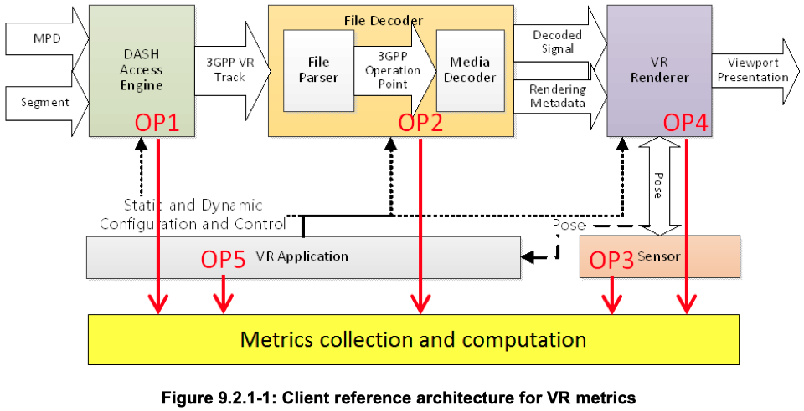
Figure 1 Client reference architecture for VR metricss from TS 26.118

Proposal on processing flow and observation points for AR split rendering
5.X Processing flow and observation points
5.X.1 General
A device may provide media capability of an individual component as the highest performance value that has been decided in a manufacturer or measured at the requested moment. When the device plays AR media, all of the required processes are executed in the device. The device may report the optimal performance in consideration of all necessary processes to be executed at the same time, rather than the highest performance of each component in sole operation.
A processing flow information identifies all processes executed in the device for a service.
Observation points are processes in the processing flow that have capability parameters to be exchanged.
Capability parameters are performance indexes that can be measured or reported under the observation point.

5.X.2 AR split rendering processing flow
The AR split rendering is one of AR/MR service scenario from [1]. It consists of the following processes:
- Pose acquisition & uplink
- Content rendering
- 2D flattened view encoding
- 2D media stream downloading
- 2D media stream decoding
- Pose correction & Presentation
Figure 2 Process flow for AR split rendering
Note) The processes could be divided into further details or merged together. It is the draft to discuss observation points based on the processing flow.
Observation points and relevant capability parameters for AR split rendering processing flow are as follows:
- Pose acquisition & uplink
  - The number of poses
  - Latency
- Content rendering
  - Resolution
  - The number of frames
- 2D flattened view encoding
  - (Encoder) output bandwidth
  - Profile and codec
- 2D media stream downloading
  - Receiving bitrate
  - (Network) buffer level
- 2D media stream decoding
  - (Decoder) buffer level
  - The number of frames
- Pose correction & Presentation
  - Actual device pose for the input 2D frame
  - Actual device presentation time for the input 2D frame

Note) The number of poses sent in a dedicated time period and latency can be referred as parameters showing the stability and reliability of the pose information.
Note) The number of rendered frames may affect subsequent processes therefore it can be referred as parameters to determine computing resource relocation dynamically.
Note) The output bandwidth, receiving bitrate, and network buffer level can be referred as parameters for configuration of rendering and encoding profile to overcome network resource limitation.
Note) The pose estimation process and subsequent processes can be configured by comparing the estimated pose and time information with the actual device pose and time information.

5.X.3 AR media downlink streaming processing flow
Note) To be added

Proposal
We propose to consider proposed text in clause 2 and document in the PD for MeCAR.

References
- 3GPP TR 26.998: "Support of 5G Glass-type Augmented Reality / Mixed Reality (AR/MR) devices"
- 3GPP TR 26.928: "Extended Reality (XR) in 5G"
- 3GPP TS 26.118: "Virtual Reality (VR) profiles for streaming applications"

