Agenda item: 8.6
Source: Qualcomm Incorporated
Title: [FS_5GMS_Multicast] Client Architectures
Document for Discussion and Agreement

Introduction
In S4aI201109, two architectures were agreed. This does not contain any client architecture. This document provides some second ideas on client architecture, based on
- the S4aI201109 5G MBS architecture
- the Client architecture in MBMS
- the 5GMS client architecture
- the feedback received on S4aI1113 as below
- Richard: Need to cater for the case of MBS-unaware application as well so that the client-side components can be made transparent to the application in the first Use Case.
- Paul: Can the existing modules in the 5GMS Client be reused?
- Thomas: No. Especially if we want the 5MBS system to be transparent to the player.
- Paul: Doesn’t this fit into the generic MSH + MP UE architecture? Why do we need a new completely different kind of function? Are we going into too much detail on the UE side?
- Fred: We haven’t told SA2 that we need an MBS Client as a counterpart of the MBSF. Should we rectify this omission?
- Thomas: SA2 reference architecture says nothing about the client side.
- Thorsten: “MBSU Client” would be a better name.
- Thomas: OK.
- Thomas: Prefers not to overload existing functions.
- Thorsten: Conceptually understands Paul’s concerns, but would be nice to draw at least one example UE architecture, and to mirror 5GMS architecture.
  - 5GMSU Client receives multicast and hands it up to a higher level entity.
  - Could just be one sample implementation.
  - Apple has an interesting implementation. We shouldn’t forget that.
- Thomas: Can always add boxes around things (co-locate functions) to avoid implementing the standard interface. We allow separation of functions, but don’t mandate their implementation.
- Thomas: Need an intermediate client coming with the device that abstracts the 5MBS functionality.
- Thorsten: The application may not be aware of the use of 5MBS.
- Cédric: In the MBSU Client the unicast should also be present, including local DASH Server and cache. This would allow switching between unicast and multicast.
- Thomas: Not sure. The MBSU Client could direct unicast for repairing. Do we really want to re-implement the MBMS Client including MooD and everything? Maybe the player does the unicast?
- Cédric: Maybe list the features (e.g. fast channel change/zapping) that the solution needs to support.
- Thomas: Question is similar to earlier. Where is the MPD terminated? Need to understand what information the MBSU Client reads.
- Cédric: Need to spend time on what approach we need to take.
- Thomas: Agree. At this stage, which tasks are assigned to each logical client function.
- Cédric: What about an architecture where there is no MBSU Client; or a more powerful one where it manipulates the MPD or acts as a proxy or does ad insertion.
- Charles: Section 5 decomposition into control plane and user plane parts confusion.
- Thomas: Fixes typo.
- Charles: Add a parallel statement in section 5 about control plane?
- Thomas: No. Media Session Handler communicating with 5GMS AF over M5 already covers this. This would be extended to cover multicast-broadcast.
Decision:
- No opposition to the proposal, but maybe too premature to agree.
- Comments welcomed offline.
S4al201109 is noted (to be revised).
Then S4aI201120 was submitted and online comments were received.
Presenter: Thomas Stockhammer (Qualcomm)
Discussion:
- Richard - great start, helps progress. Could the MBS-aware app be separate from the 5GMS-aware app? → Yes. This is one deployment model to check.
- Richard - M4 is still relevant, also for fetching non-5MBS stuff. Also, if repair is part of MBSF then use M4 to AS. Thomas -. Or repair is independent of 5GMS AS.
- Thorsten - needs further study - x could be inside y.
- Thomas - case of doing MBS without 5GMS, then need a unicast API.
- Cedric - need a kind of M4 link from MBSF client(?)
- Thomas - agrees with the functionality, but not sure about the interface, likely not M4.
- Richard - maybe need 2 unicast interfaces - one on M4 and another to a 3rd-party system and it’s an implementation option which to use.
- Thomas - MBSU client being media aware mixes too many things.
- Cedric - it’s just HTTP download.
- Fred - could be a subset of M4, and time is up.
- Thorsten - good starting point, MB-M4 is a multicast stream. Media player should not be MBS-aware, so should not have interface MB-M7.
- Thomas - 347 has a data interface, so maybe need to extend M4.
- Thosten - MB-M4 instead of M6… adding some MBS… MB-UPF… align with upper one, call it MB-M4.
- Fred - time is up, seem to have identified issues to be resolved.
- Thorsten - convert it into a key issue, then include in gap analysis.
Decision:
- Noted.
S4al201120 is noted.
These are all good comments – no time to implement yet
Offline from Thorsten
thanks for the good second thoughts on client architecture. Here some feedback.

- Good idea to insert separate MBSU and MBSF Clients into the UE.
- Good idea to color the 5MBS Functions separately.
- When the MBSU Client may exist outside of the 5GMS Client, we may think about the MBSF Client outside of the MSH. How would the MBSU Client receive its configuration (Session Announcement), when the 5GMSd Client is not used?
- Does the “5GMSd aware Application” also become “MBS aware” (i.e. MBS aware Application inside of the 5GMSd Aware Application), or is this more an option of receiving 5MBS sessions without 5GMS?
  - I guess, it is better to draw the “MBA aware application” outside.
  - Is the 5GMSd aware application aware about MBS? I was thinking, that the 5GMSd Aware Application is not aware, whether content is received via MBS or unicast.
- In LTE Broadcast, we aimed for to support “normal” DASH players. Does the presence of the MB-M7 API mean, that this Media Player contains some MBS specifics? Or is this a heads up for studying the player API?
- On MB-M4: Maybe this is just my word copy. However, in my version, the MB-M4 interfaces look like a south interface, i.e. between the MBSU and the MBSU Client. But you presented the interface verbally as interface between the MBSU client and the Media Player.
  - I think, we should label the interface between MBSU and MBSU Client (MB Session payload) to differentiate the 5MBS interface from the M4 (unicast) interface.
  - When the MBSU Client adds some additional headers, then we should also label the interface between the MBSU Client and the Media Player.
- Bit more editorial:
  - N6 is the interface between MBSU and MB-UPF, not between MBSU and MBSU Client.
  - I think, we should change the label in the figure from “5G-MBS” to “5MBS” to avoid confusion with SA4.

Good comment, no time to implement.

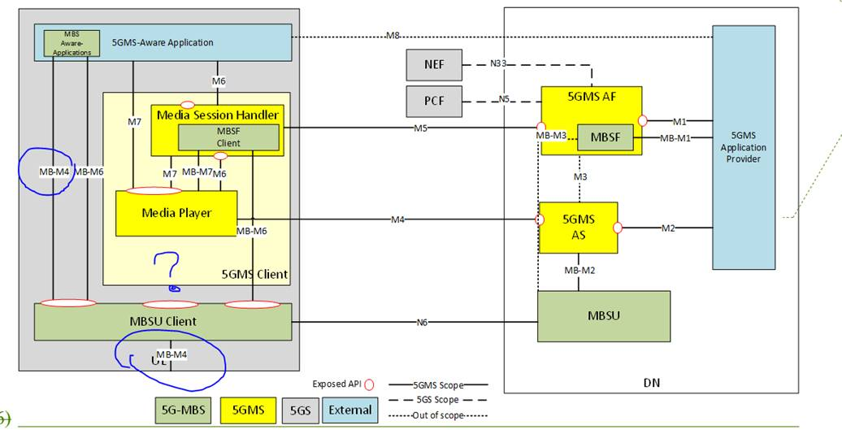
Good Comments from Richard

Why is an MBSF Client needed?
Point 2 above the diagram makes a bald proposal that a client-side counterpart to the MBSF is needed without explaining why. I think the first question that needs to be asked with respect to this proposed MBSF Client is what its role might be. Would this client function be the consumer of service announcement metadata, for example? Anything else?
I appreciate the general argument that if the (former) BM-SC is now split into separate control and data functions, then the client architecture might want to reflect that split. But that doesn't seem enough of a justification on its own. It would be useful to at least outline what kind of things need to be signalled to this proposed MBSF Client before we can rationally decide how best to realise it.

What is the best way to realise a 5MBS signalling client?
I can see that there is a pleasing symmetry in embedding the proposed MBSF Client in the Media Session Handler given the earlier proposal to embed the MBSF in the 5GMS AF. This arrangement would logically result in a 5MBS Session Discovery API specified as an extension to interface M5, with session description metadata exposed using HTTP(S) push/pull mechanisms. The 5GMS AF would essentially be acting as a web-based front-end to the MB-SMF. That all has a nice self-consistency about it.
Whether this is the "correct" architecture depends on how we see 5MBS being deployed to UEs without the added sugar of 5GMS. In that case, there is no 5GMS Client on the UE, and therefore no Media Session Handler and no MBSF Client embedded in it. In this case, the only ways for the UE to exploit (generic) 5MBS services are:
- to know about them a priori, e.g. using a well-known equivalent to the MBMS TMGI;
- by discovering services via some in-band Service Announcement channel provided by the MBSU, under the direction of the MBSF; or
- by private means, analogous to our M8 interface, but completely outside the scope of 5GMS.
As a guiding principle, I think the client architecture we develop in SA4 needs to build on top of a vanilla non-5MBS architecture so that simpler Use Cases are supported in the UE that do not depend on fancy 5GMS features. We know that there are several of these, including Mission Critical Services. It would be nonsense to require a push-to-talk handset to incorporate a 5GMS Client, for example.
I actually think that Thomas' diagram comes pretty close to supporting the vanilla case. The MBSF Client does seem redundant in that kind of deployment since any Service Announcement channel would presumably terminate in the MBSU Client and be exposed directly to a 5MBS-Aware Application via the new 5MBS APIs he has illustrated.
SA2 is not looking at client architecture (since that's outside their remit), so somebody needs to cover this gap. If not SA4, then perhaps it's one of the CT groups? We would then need to build on top of some basic client architecture defined by them. Or we could just do it ourselves. I don't know what's most appropriate in terms of 3GPP turf.

- Good idea to color the 5MBS Functions separately.
Yes, although we didn't quite reach an agreement on how to avoid colour coding clashes with the EMSA study, unfortunately.

- When the MBSU Client may exist outside of the 5GMS Client, we may think about the MBSF Client outside of the MSH. How would the MBSU Client receive its configuration (Session Announcement), when the 5GMSd Client is not used?
(Agree that this is a key question per my remarks above.)

- Does the “5GMSd aware Application” also become “MBS aware” (i.e. MBS aware Application inside of the 5GMSd Aware Application), or is this more an option of receiving 5MBS sessions without 5GMS?
  - I guess, it is better to draw the “MBA aware application” outside.
  - Is the 5GMSd aware application aware about MBS? I was thinking, that the 5GMSd Aware Application is not aware, whether content is received via MBS or unicast.
To repeat a comment I made before Christmas, I think it is extremely important that the solution supports 5MBS-unaware operation. By this, I mean that there is some mode of operation in which the application simply requests content (e.g. a DASH presentation) and this is delivered partly via multicast/broadcast and partly via unicast without any need to call a 3GPP API. Some function in the middleware provides this service transparently so that the media player API does not need to be modified and therefore the application does not need to be modified.
How achievable this is should be the subject of the study. In the precursor architecture, it was mostly achieved by means of an HTTP proxy service provided by the MBMS Client, but it wasn't perfectly transparent by my limited understanding. This time, we should aim to do better than MBMS, not simply replicate its flaws.

- In LTE Broadcast, we aimed for to support “normal” DASH players. Does the presence of the MB-M7 API mean, that this Media Player contains some MBS specifics? Or is this a heads up for studying the player API?
- On MB-M4: Maybe this is just my word copy. However, in my version, the MB-M4 interfaces look like a south interface, i.e. between the MBSU and the MBSU Client. But you presented the interface verbally as interface between the MBSU client and the Media Player.
  - I think, we should label the interface between MBSU and MBSU Client (MB Session payload) to differentiate the 5MBS interface from the M4 (unicast) interface.
  - When the MBSU Client adds some additional headers, then we should also label the interface between the MBSU Client and the Media Player.
- Bit more editorial:
  - N6 is the interface between MBSU and MB-UPF, not between MBSU and MBSU Client.
  - I think, we should change the label in the figure from “5G-MBS” to “5MBS” to avoid confusion with SA4.

No time to implement.
Comments during first revision
Just to report that SA2 are close to agreeing revised names for the multicast–broadcast service functions in their reference architecture:
- MBSF remains favourite for the control plane function.
- A new name MBSTF emerged last week as a consensus preference for the user plane function. This change is likely to be confirmed at the forthcoming SA2#143-e meeting, at which point we will need to update all our architecture diagrams.

5MBS architecture combined with 5GMS

4.4.1.2 5GMSA functions in the Trusted DN
Thie following diagram illustrates a network reference architecture with all 5GMS and 5MBS functions within the Trusted DN. A 5GMS Application Provider (typically) in an External DN configures the 5GMS features via a Release 17 version of M1d interface. Three different models are considerd:
1: The usage of 5MBS for media distribution is completely hidden from the 5GMS Application Provider. The 5GMS System selects usage of 5MBS based on internal criteria.
2: By means of 5GMS provisioning procedures at (extended) M1d, the 5GMS Application Provider explicitly controls the potential usage of 5MBS in certain areas and for certain content. For example, some content might not be authorized for 5MBS distribution by content rights owners. Or, some content might only be authorized for 5MBS distribution.
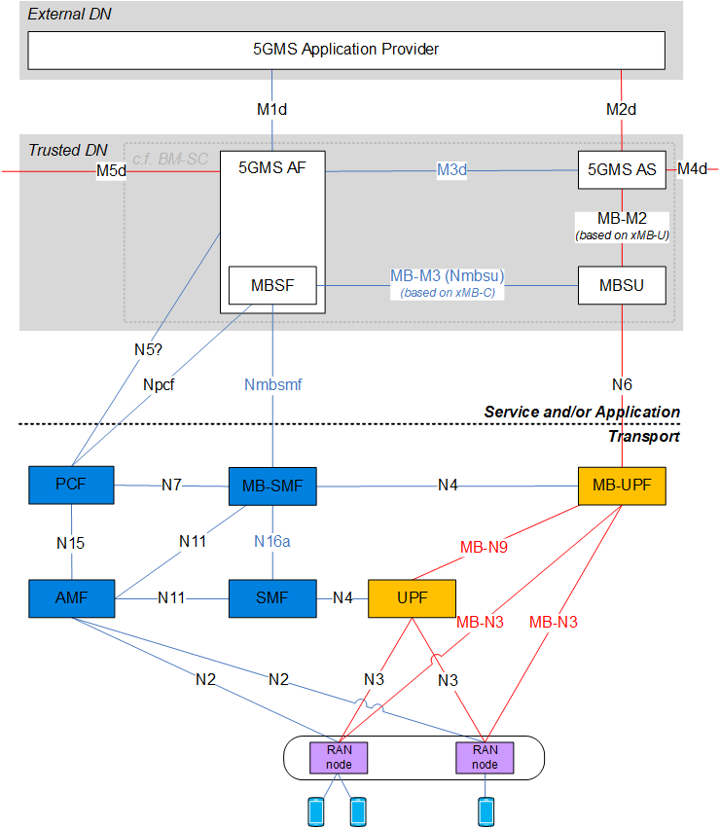
Figure 4.4.1.2-1: 5MBS architecture combined with 5GMS hosted in Trusted DN

4.4.1.3 5GMSA functions in an External DN
Thie following diagram illustrates a network reference architecture with all 5GMS within an external DN. Only the MBSU resides insode a trusted DN. An 5GMS Application Provider (typically) in an external DN configures the 5GMS features via a Release 17 version of M1d interface.
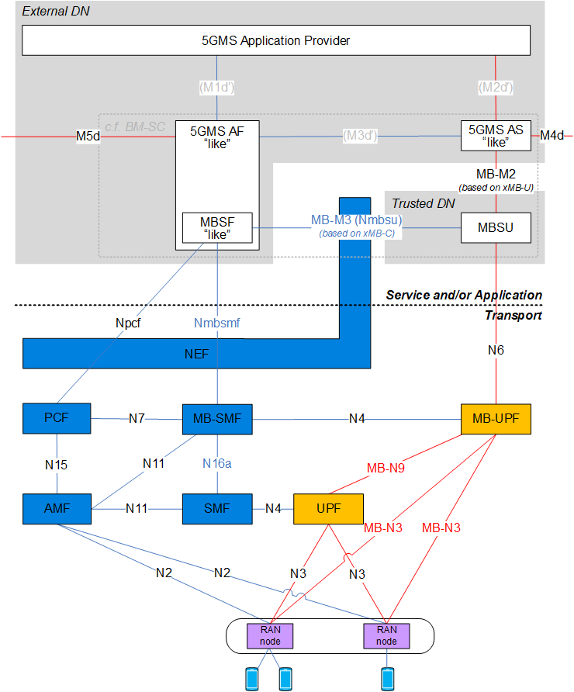
Figure 4.4.1.3-1: 5MBS architecture combined with 5GMS hosted in External DN

MBMS Client Architecture from TS 26.347
Figure 5.1 shows a general service architecture including a reference client. On the network side, an MAA and content provider provides media formats to a BM-SC, typically through the xMB interface and initiates services and sessions through the xMB interface. The BMSC establishes MBMS User Services and the lower layers support the delivery of the data through regular 3GPP unicast as well as MBMS broadcast bearers.
The MAA initiates the communication with the MBMS client using the MBMS-API. The MBMS client identifies the relevant services and provides the delivered user data to MAA. Typically, the media formats are provided through interfaces and to functions that conform to well-defined media delivery formats. The MAA controls the media client.
In TS 26.346 [5] the interface between the BMSC and the MBMS client for both unicast and broadcast related services and functions are defined. The interface between the MBMS client and the MAA is defined in the present document..
The focus of the present document is to define app-developer and web-friendly interfaces and programming structures to enable such an MAA to interact with the MBMS client.
An MAA that communicates with the MBMS client through APIs and possibly URL handlers as defined in the present document is referred to as MAA. The MBMS Client is a function that implements functionalities defined in TS 26.346 and provides APIs interfaces to expose relevant functionalities to an MAA.
Figure 5.1: General Reference Architecture for Client
Figure 5.2 shows a specific instantiation for the media streaming Application User Service using the Media Streaming MBMS-API. In this case the content formats conform to TS 26.247. The DASH client may be viewed as part of the MAA, and as 3GPP defines interfaces into a DASH client in TS 26.247 [7] also interfaces to the DASH client function are in focus of the present document.
Figure 5.2: Client Reference Architecture for DASH-over-MBMS Streaming
The control part of the MBMS-API are used for service discovery, registration, notifications, state changes and other control messages between the MAA and the MBMS client and for other control messages. The control part of the MBMS-APIs are defined in clause 6.
The data part interfaces are used to provide content delivered through MBMS User services to the MAA. However, the data is using formats and interfaces that are primarily MBMS independent such that for the MAA the delivery over MBMS is obscured. MBMS Client to application interfaces for data is primarily introduced in clause 7.

5GMS Client Architecture from TS 26.512
In the following, it is assumed that the Media Session Handler for downlink streaming adheres to a basic set of functionalities as shown in Figure 12.2.1-1.
Figure 12.2.1-1: Usage of M6d in Media Downlink Streaming
The key functionalities of each of the functions as shown in Figure 13.2-1 are summarized in the following:
- 5GMSd-Aware Application: Application that makes use of the DASH/Media Player to playback a DASH Media Presentation using the APIs defined in this clause.
- Media Player: A complete player for the playback of a Media Presentation, including the Media Playback and Content Decryption Platform as defined in TS 26.511.
- Access Client: A part of the DASH Player that accesses and downloads of the resources and provides the downloaded resources to the Media Playback Platform and Content Decryption for the playback of DASH content.
- Management: Controls all internal processes and the communication with the 5GMSd-aware application. In particular this includes the handling of service descriptions and operation points.
- MPD Processing: parses and processes the MPD and extracts the relevant information.
- Adaptation Set Selection: selects the Adaptation Set based on user, application and/or device capability information. Information provided through M7d may be used.
- ABR Controller and Dynamic Switching: runs adaptive bit rate logic and triggers adaptive switching of Representations. Information provided to the DASH client through M7d may be used.
- Throughput Estimation: estimates the throughput from the 5GMSd Application Server
- Metrics Logging: logs relevant low-level metrics and provides those to the metrics aggregation and reporting functions in the MSH.
- Media Playback Management and Protection Controller: manages the media playback by moving downloaded information into media playback platform and also addresses handling of protection and DRM related information.
- Media Playback and Content Decryption Platform: plays back CMAF-based media content according to the playback requirements in TS 26.511. It also provides status information as well as events that maybe be provided through M7d.
- Event Processing: Processes DASH events and provides information to application as defined in TS 26.247 [4].
Figure 13.2.1-1: DASH Client Architecture

5GMS Independent 5MBS
Based on the discussions, it seems relevant to develop an architecture that deploys MBS independent of 5GMS. Figure 1 provides an overview on this.
Also interfaces are introduced that are MBS specific. They match the same architecture as we have for 5GMS as well as for TS 26.347. Some quick explanations
- For MBS-4 we have a multicast and a unicast version. The unicast version may terminate in the MBSTF or may terminate in the application provider (the latter is not yet expressed).
- For MBS-6, and MBS-6’ is indicated that is for now to be implemented. This configures the transport function client, but this may be covered by MBS-6.
- Note that MBS-6 aligns with TS 26.347, clause 6 and MBS-7 with clause 7.
Figure 1 5MBS architecture independent of 5GMS
Responses to comments that are addressed by this architecture. Cyan ones are answered below.
Discussion:
- Richard - great start, helps progress. Could the MBS-aware app be separate from the 5GMS-aware app? → Yes. This is one deployment model to check.
Yes, done
- Richard - M4 is still relevant, also for fetching non-5MBS stuff. Also, if repair is part of MBSF then use M4 to AS. Thomas -. Or repair is independent of 5GMS AS.
Done independent, integrated version below
- Thorsten - needs further study - x could be inside y.
- Thomas - case of doing MBS without 5GMS, then need a unicast API.
- Cedric - need a kind of M4 link from MBSF client(?)
- Thomas - agrees with the functionality, but not sure about the interface, likely not M4.
- Richard - maybe need 2 unicast interfaces - one on M4 and another to a 3rd-party system and it’s an implementation option which to use.
- Thomas - MBSU client being media aware mixes too many things.
- Cedric - it’s just HTTP download.
- Fred - could be a subset of M4, and time is up.
- Thorsten - good starting point, MB-M4 is a multicast stream. Media player should not be MBS-aware, so should not have interface MB-M7.
- Thomas - 347 has a data interface, so maybe need to extend M4.
- Thosten - MB-M4 instead of M6… adding some MBS… MB-UPF… align with upper one, call it MB-M4.
- Fred - time is up, seem to have identified issues to be resolved.
- Thorsten - convert it into a key issue, then include in gap analysis.

A simplified version is provided below.

Combined MBS and 5GMS
Based on the discussions, an updated diagram is provided below that combines 5GMS and MBS and MBS is completely shielded to the application on network and device side.

Proposal
It is proposed to
- verify the network and client implementations against different deployment scenarios.
- Progress the work during SA4#112e
We will provide an update.

