3GPP TSG-SA4 Meeting #-SA4-e (AH) MBS SWG post 133-e S4aI250197

Online, , 23rd Oct 2025 - 23rd Oct 2025
CR-Form-v12.3
CHANGE REQUEST
 | 26.942 | CR | 0008 | rev | -1 | Current version: | 19.0.0
For HELP on using this form: comprehensive instructions can be found at
http://www.3gpp.org/Change-Requests.

Proposed change affects: | UICC apps |  | ME |  | Radio Access Network |  | Core Network

Title: | [FS_Energy_Ph2_MED]: Solution for KI1 for collecting and exposing Energy-Related information to authorized 3rd parties defining an Energy-Related metric
Source to WG: | InterDigital France R&D, SAS
Source to TSG:
Work item code: | FS_Energy_Ph2_MED |  |  |  |  |  | Date: |  |  | 2025-10-21
Category: | B |  |  |  |  |  | Release: |  |  | Rel-19
 | Use one of the following categories:  F (correction)  A (mirror corresponding to a change in an earlier release)  B (addition of feature),  C (functional modification of feature)  D (editorial modification)  Detailed explanations of the above categories can  be found in 3GPP TR 21.900. |  |  |  |  |  |  |  | Use one of the following releases:  Rel-8 (Release 8)  Rel-9 (Release 9)  Rel-10 (Release 10)  Rel-11 (Release 11)  …  Rel-17 (Release 17)  Rel-18 (Release 18)  Rel-19 (Release 19)  Rel-20 (Release 20)
Reason for change:
Summary of change:
Consequences if not approved:
Clauses affected:
 |  | Y | N
Other specs |  |  |  | Other core specifications |  |  |  | TS/TR ... CR ...
affected: |  |  |  | Test specifications |  |  |  | TS/TR ... CR ...
(show related CRs) |  |  |  | O&M Specifications |  |  |  | TS/TR ... CR ...
Other comments:
This CR's revision history:

1ST Change
…
[88] 3GPP TS 26.510: "Media delivery; interactions and APIs for provisioning and media session handling".
[89] 3GPP TS 26.531: “Data Collection and Reporting”
2ND Change

7.5 Solution #10: Energy-related metrics reporting and exposure

7.5.1 Key Issue mapping
This Candidate Solution addresses Key Issue #1.

7.5.2 Functional description

7.5.2.1 Introduction
In line with [PR 1-1] of TR 26.942, this Candidate Solution to Key Issue #1intends to reuse existing 3GPP mechanisms for reporting an Energy-Related metric. Similar to QoE metrics, the new Energy-of-Service metric (i.e. EoS) is defined in the context of the Metrics Reporting provisioning feature at reference point M1. The Metrics Reporting Configuration provided by the Media Application Provider determines what energy-related information is to be collected and reported by the UE, Application Server and the Core Network, and how often.

7.5.2.2 Metrics Reporting Configuration: extensions for Energy-of-media Service (EoS)
Up to and including Release 19, the Metrics Reporting Configuration resource is limited to Quality of Experience (QoE) metrics. The present clause specifies extensions enabling Energy-related reporting (EoS metrics) in addition to QoE in the Table 1.
Table 1: EoS extensions of the Metrics Reporting Configuration
Abstract element | Semantics / constraints (abstract)
EoS Scheme | The EoS scheme indicates that the metrics scheme pertains to Energy-related information reporting and define the format of the Energy-Related metric report fetched by the Media Session Handler for the UE energy information, the EIF for the Core Network energy information and the AS for the Application server energy information.  Consequently, the scope of the Metrics Reporting Configuration is extended to cover either QoE metrics reporting or EoS metrics reporting.
EoS reporting scope | What is reported:  - per‑sampled media delivery session, the sum of the energy metric value of all the components of the session,  - per‑sampled media delivery session, the energy metric value of all the components of the session or the ones of content type given by the element “component content type” below  - aggregated energy metric value across all the active sample media delivery sessions
EoS metric type | Metric value type:  - carbon intensity; in g CO2-e / Wh  - energy consumption; Wh  - power consumption. W.
Component content types | MIME content types (e.g., video/mp4) used to filter components included in per‑component reporting.
Contribution ratio flag | If true, include contribution ratio information across UE, RAN, and CN in the report.

Note :
- When the metrics scheme of the Metrics Reporting Configuration indicates QoE, behaviour remains as specified in Release 19; the EoS-specific constraints above do not apply.

g CO2Wh
Wh
W

7.5.2.2 Architecture mapping
Editor’s Note: Add an architecture diagram based on figure 7.6.2.4 showing both the Energy Information AF and the Data Collection AF instantiated in the Media AF, and which reference points are relevant.
The solution is based on the Data collection and reporting architecture defined in TS 26.531.

7.5.3 Procedures
The high-level procedure for data collection and reporting, including energy-related information is the same as that defined in clause 5.1 of TS 26.531 [21] and the detailed call flow for reporting to the Data Collection AF is the same as that defined in clause 5.5 of [21] except the UE data report includes energy-related information.
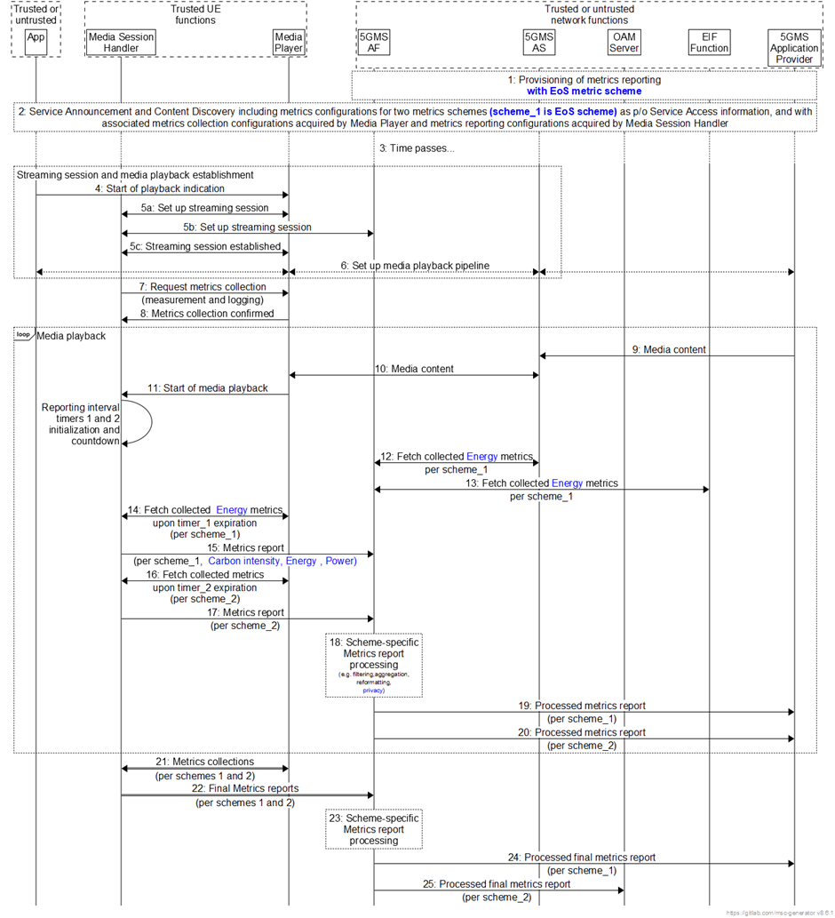
Figure 7.5.3-1: High-level procedures for UE energy-related Metric reporting
1 The 5GMSd AF is provisioned with two separate sets of metrics reporting configuration information (see the clause 5.1 of TS 26.510) - metrics scheme_1 as defined by the 5GMSd Application Provider and metrics scheme_2 as defined by 3GPP, each pertaining to metrics collection by the Media Player, retrieval of those collected metrics from the Media Player by the Media Session Handler, and the generation and delivery of metrics reports from the Media Session Handler to the 5GMSd AF. The 5GMSd AF is similarly provisioned with two separate sets of metrics reporting configuration information, associated with the metrics schemes 1 and 2, regarding required post-processing functionality and subsequent and separate delivery of processed metrics reports to the 5GMSd Application Provider and to the OAM Server. The scheme_1 is the EoS scheme to request the Application function to retrieve the energy metrics available at the UE Media Player level: Carbon intensity and/or Energy consumption and/or Power consumption.
2: The 5GMS-Aware Application triggers the Service Announcement and Content Discovery procedure. The Service Announcement includes the whole Service Access Information that contains metric configuration info for metrics schemes 1 and 2, with their associated metrics collection configurations acquired by the Media Player and metrics collection configurations acquired by the Media Session Handler.
3: Time passes until the 5GMS UE initiates session establishment and media playback.
4: The 5GMS-Aware Application informs the Media Player of impending media playback.
5a: The Media Player requests the establishment of a streaming session with the Media Session Handler which acknowledges the request.
5b: The Media Session Handler requests the establishment of a streaming session with the 5GMS AF which confirms the streaming session establishment.
5c: The Media Session Handler informs the Media Player the successful set-up of the streaming session.
6: Media playback pipeline is set up between the Media Player, the 5GMS AS and the 5GMS Application Provider.
7: The Media Session Handler queries the Media Player on its capability to perform metrics collection (measurement and logging function) in accordance with both schemes 1 and 2 as defined by its metrics configuration. At this step it is checked if the Media player can support the reporting of EoS metrics.
8: The Media Player acknowledges its support for the collection of the required metrics of all configured schemes.
During the course of media playback, steps 9-18 below may be repeated, depending on the duration of the playback and the frequency of metrics reporting as set by the metrics configuration for each of the two schemes.
9: Assuming a live streaming service, media content is delivered via push ingest from the 5GMSd Application Provider to the 5GMSd AS.
10: The Media Player fetches media content from the 5GMSd AS and begins media playback.
11: The Media Player notifies the Media Session Handler of the start of media playback, causing the Media Session Handler to initialize and begin countdown of separate metrics reporting interval timers for schemes 1 and 2.
12: the 5GMSd AF retrieves the logged metrics measurements from the 5GMSd AS according to scheme_1.
13: the 5GMSd AF retrieves the logged metrics measurements from the EIF function of the Core Network according to scheme_1.
14: Upon expiration of timer_1 (associated with scheme_1), the Media Session Handler retrieves the logged metrics measurements from the Media Player according to scheme_1.
15: In accordance with its metrics reporting configuration as provisioned in step 2, a metrics report for scheme_1 is sent from the Media Session Handler to the 5GMSd AF.
16: Upon expiration of timer_2 (associated with scheme_2), the Media Session Handler retrieves the logged metrics measurements from the Media Player according to scheme_2.
17: In accordance with its metrics reporting configuration as provisioned in step 2, a metrics report for scheme_2 is sent from the Media Session Handler to the 5GMSd AF.
18: In accordance with its metrics reporting configuration as provisioned in step 1, the 5GMSd AF performs separate post-processing in accordance with schemes 1 and 2 (e.g. filtering, aggregation, reformatting, privacy) of the received types of metrics reports.
Furthermore, in accordance with its metrics reporting configuration as provisioned in step 1:
19: The 5GMSd AF sends a processed metrics report in accordance with scheme_1 to the 5GMSd Application Provider.
20: The 5GMSd AF sends a processed metrics report in accordance with scheme_2 to the 5GMSd Application Provider.
Upon the termination of media playback (as notified by the 5GMSd-Aware Application to the Media Player) a final round of metrics collection and reporting is performed:
21: The Media Session Handler obtains the latest metrics measurements from the Media Player in accordance with schemes 1 and 2. These procedures might occur prior to the nominal expiration of the metrics reporting interval timers.
22: Final metrics reports, in accordance with schemes 1 and 2 are sent by the Media Session Handler to the 5GMSd AF. These procedures might occur prior to the expiration of the nominal metrics reporting intervals.
23: The 5GMSd AF performs post-processing of the received final metrics reports in accordance with schemes 1 and 2.
24: Same as step 17.
25: Same as step 18.

7.5.4 Impacts on existing services, entities and interfaces

7.5.4.1 Media AF
The Media AF would be required to support an Energy Metrics Reporting Configuration as part of the Metrics Reporting Configuration.

7.5.4.2 Data Collection AF
The Data Collection AF is instantiated as a subfunction of the Media AF to collect energy-related information per application, per media session, and per media component, at multiple granularities and across UE, CN, and AS domains.
Collected information is reported to a Data Collection AF instantiated within the 5GMS AF, aligned with existing Metrics Reporting Configuration. Prior to exposure to authorized third parties, privacy-preserving post-processing is applied.

7.5.4.3 Reference point M1
At reference point M1, the 5GMS Application Provider shall instantiate a Metrics Reporting Configuration resource associated with the target Provisioning Session to enable Energy-of-Media-Service collection and reporting
End of changes

