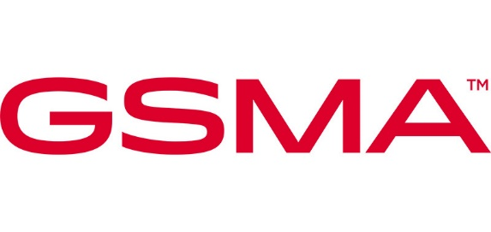

Liaison Statement

Liaison Statement Title: | LS to 3GPP SA3 re SCAS Improvements

Source Meeting Information
Meeting Number | Meeting Date | Meeting Location
NESASG#44 | 30-Oct-2025 | Microsoft Teams

Document Details
Document Number: | Creation Date: | Document Author:
NESAS Doc 44_006 | 09-Oct-2025 | James Moran, GSMA
Originating GSMA Source: | Deadline for response: | Liaison Statement Contact
GSMA Network Equipment Security Assurance Scheme Group | N/A | gsmaliaisons@gsma.com
Security classification: | Non-confidential

Recipients:
Internal recipients: | N/A
External recipients: | 3GPP SA3

Introduction
GSMA PRD FS.50 defines the requirements that need to be met by SCASes for adoption and use in GSMA’s Network Equipment Security Assurance Scheme (NESAS). GSMA’s NESAS Group has responsibility for maintaining NESAS documents and for periodically reviewing them to ensure they attain quality levels sufficient to meet the needs of NESAS users.

GSMA SCAS Review
GSMA’s NESAS Group has reviewed the existing 3GPP SCASes and it has identified the opportunity to enhance some that have already been adopted for use in NESAS. The deficiencies are not sufficient to require the relevant SCASes to be delisted from the adopted SCASes in FS.63 but improvements to the SCASEs will benefit NESAS users.

The purpose of this LS is to bring to the attention of SA3 members GSMA’s plans to submit change requests to individual SCASes in a range of contributions to future SA3 meetings. When the NESAS Group has SCAS change requests to submit to SA3 it, in consultation with the SA3 leadership, will schedule a joint session with SA3 delegates to explain the changes in each contribution. SA3 delegates will be afforded the opportunity to comment and provide feedback on any proposed changes to SCASes before they are submitted for approval at SA3 plenary meetings.
The NESAS Group currently plans to prepare contributions to the upcoming meetings, starting with the Dallas meeting in November 2025. The NESAS Group looks forward to working with SA3 delegates on these improvements that will benefit NESAS and its users.

Next Meetings
NESASG#45 – 13th November 2025
NESASG#46 – 2nd to 4th December 2025

