

have the pleasure of inviting you to 3GPP Meetings (SA1-#81, SA4- #97) in Fukuoka, Japan.

3GPP SA1-#81 | 5-9 February 2018
3GPP SA4-#97 | 5-9 February 2018

3GPP Meetings (SA1-#81, SA4-#97)

The Japanese Friends of 3GPP, Anritsu, Ericsson Japan, Fujitsu, Huawei Technologies Japan, KDDI, KYOCERA, MITSUBISHI ELECTRIC, NEC, Nokia Networks Japan, NTT DOCOMO, OKI, Panasonic, Qualcomm Japan, SHARP, SoftBank, and Sony Mobile Communications Japan have the pleasure of inviting you to the above-mentioned meeting.

We look forward to seeing you all in Fukuoka.

Yours sincerely,
"Japanese Friends of 3GPP"

Meeting Registration
Please register for the meeting online via 3GPP website.
SA1-#81 https://portal.etsi.org/webapp/MeetingCalendar/MeetingDetails.asp?m_id=19553
SA4-#97 https://portal.etsi.org/webapp/MeetingCalendar/MeetingDetails.asp?m_id=19568

Host Contacts
For any questions about the meeting, please contact our Meeting Coordinators.

ILCC Co., Ltd.
E-mail: jf3wgs_sec@ilcc.com Tel: +81-3-5562-3665

Hotel Reservation Contacts
For any questions about the hotel reservation, please contact:
JTB Corporate Sales Inc. (Toranomon Account Sales division 1 )
E-mail: y_morimoto854@bwt.jtb.jp

The Certified Travel Service Manager: Kei Matsubara (Mr.)
Certified Travel supervisor is responsible for transactions made by the JTB handling travel arrangements for customers.

Meeting Venue
AQUA Hakata
5-3-8, Nakasu, Hakata-ku, Fukuoka-shi, Fukuoka 810-0801,Japan
TEL: 81-92-733-1310

*Registration desk for 3GPP will be set on 3rd floor of AQUA Hakata.

Access information of the venue http://www.ohi-kaigi.com/aqua/accessmap/

Airport: Fukuoka Airport: FUK

<Recommended route from Fukuoka Airport to AQUA Hakata by public transportation>

Take Kuko Line from Fukuoka Airport to Nakasu-Kawabata Station (9 min. ride). The AQUA Hakata is 2min. walk from Nakasu-Kawabata Station, or 20 minutes from Fukuoka Airport by taxi.

<Subway Route Map>
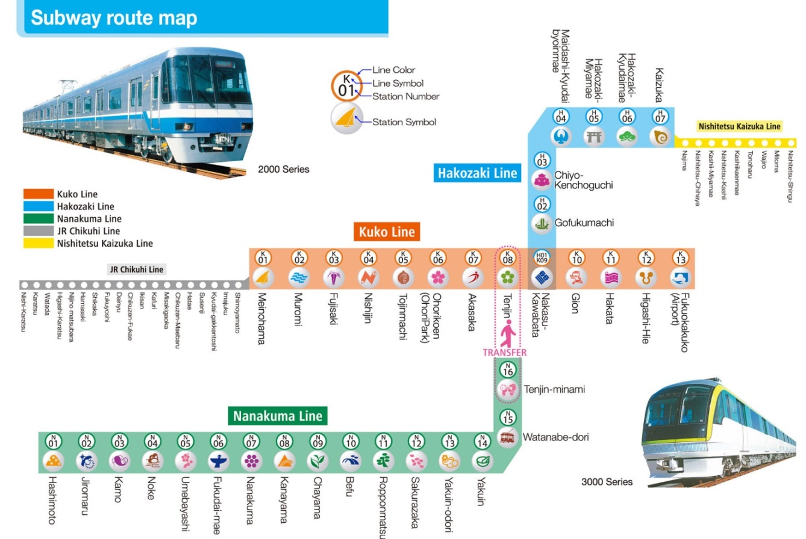
Nakasu Kawabata
Access to Venue
Tenjin Sta.
1 min
1 min
Hakata Excel Hotel Tokyu
AQUA Hakata <venue>
Hotel Ascent Fukuoka
2 min
Hotel Sunroute Hakata
Hotel Resol Hakata
Vessel Inn Hakata Nakasu
Imperial Palace City Hotel Fukuoka
Dukes Hotel Nakasu
taxi
20 min
Nakasu Kawabata Sta.

7min
3min
Plaza Hotel Premier
Gion Sta.
Hakata Sta.
4 min
Kuko Line
Bangkok, Beijing, Busan, Dalian, Guam, Hanoi, Hong Kong, Honolulu, Ho Chi Minh City, Manila, Qingdao, Seoul, Singapore, Shanghai(pudong), Taipei(Taoyuan), Wuhan
Kansai International Airport (KIX)
Tokyo International Airport (HND)
Narita International Airport (NRT)
FUKUOKA AIRPORT [FUK]
International Flights
5min
2min
2min
2min
Accommodation

JTB Corporate Sales Inc. (JTB) was designated as the official agent for 3GPP Meetings SA1-#81,SA4 -#97and has been handling accommodations. We have blocked a sufficient number of rooms for 3GPP participants at the following hotels listed below. However it is an entrance examination season in Japan then and so, many of the hotels are likely to be fully booked. We recommend that you book your rooms as soon as you can. When you plan to reserve your accommodation by other means, please be aware that the availability of hotel accommodations are limited.

Please also be informed that if you wish to extend your reservation after the meeting ends on Feb 9th, hotel rooms are available only at three hotels (B, C and H) in the list
Regarding a receipt, if you request JTB directly, JTB shall make the required receipt. However, it will take 2 to 3 weeks after your request.

Please note the "Japanese Friends of 3GPP (JF3)" is not responsible for arranging accommodations such as confirmation, cancellation and changing of hotel reservation.

The room rates below are only applicable to reservations handled by JTB Corporate Sales Inc. Please do NOT contact the hotels directly regarding your reservations and the below room rates – all inquiries and booking requests should be made directly to JTB Corporate Sales Inc.at:
E-mail: y_morimoto854@bwt.jtb.jp

※The required time and fare from Fukuoka Airport to each hotel is around 20 min and 1,680-1,780 yen if you go directly by taxi. *subject to traffic conditions and arrival time.

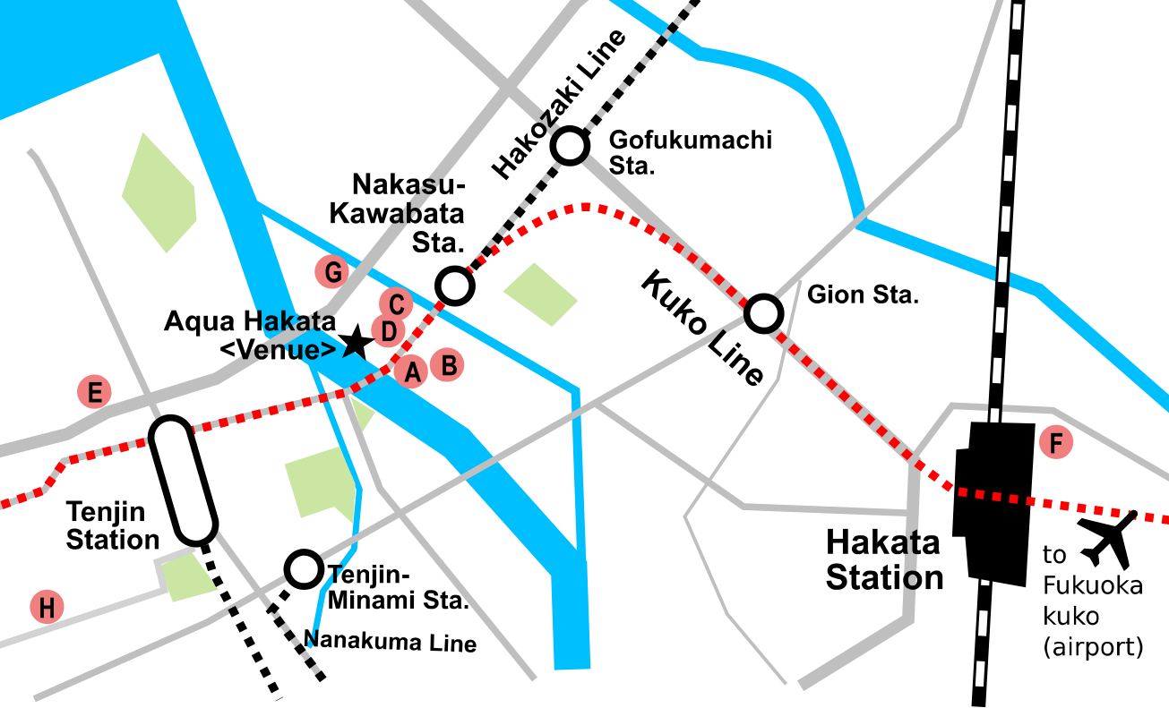

A: Hakata Excel Hotel Tokyu  B: Hotel Resol Hakata  C: Vessel Inn Hakata  D: Imperial Palace City Hotel Fukuoka | E: Hotel Ascent Fukuoka  F: Hotel Sunroute Hakata  G: Dukes Hotel Nakasu  H: Plaza Hotel Premier

 | HOTEL |  | 2018/  2/4 | 2018/  2/5 | 2018/  2/6 | 2018/  2/7 | 2018/  2/8 | 2018/  2/9 | 1）Address  2）Phone  3）Access to Closest station  4)Check-in/Check-out Time  5）Access to the venue
A | Hakata Excel Hotel Tokyu | Single  Non-Smoking | 14,000 | 14,000 | 14,000 | 14,000 | 14,000 | － | 1)4-6-7,Nakasu,Hakata-ku,Fukuoka City  2) 092-262-0109  3)Nakasu Kawabata Sta. (1 min walk)  4)14:00／11:00  5)3 min walk
B | Hotel Resol Hakata | Single  Non-Smoking  or  Smoking | 11,300 | 11,300 | 11,300 | 11,300 | 11,300 | 13,800 | 1)4-14-10,Nakasu,Hakata-ku,Fukuoka City  2) 092-282-9269  3) Nakasu Kawabata Sta. (1 min walk)  4)15:00／10:00  5) 3 min walk
C | Vessel Inn Hakata  Nakasu | Single  Non-Smoking | 8,200 | 8,200 | 8,200 | 8,200 | 8,200 | 8,200 | 1)5-1-12,Nakasu,Hakata-ku,Fukuoka City  2)092-271-4055  3)Nakasu Kawabata Sta.(1 min,walk)  4)14:00／11:00  5）3min walk
D | Imperial Palace City Hotel Fukuoka | Single  Non-Smoking | 8,000 | 8,000 | 8,000 | 8,000 | 8,000 | － | 1)5-2-18,Nakasu,Hakata-ku,Fukuoka City  2) 092-262-2009  3) Nakasu Kawabata Sta. (1 min walk)  4)15:00／11:00  5) 3 min walk
E | Hotel Ascent Fukuoka | Single  Non-Smoking | 7,600 | 7,600 | 7,600 | 7,600 | 7,600 | － | 1)3-3-14,Tenjin,Chuo-ku,Fukuoka City  2) 092-711-1300  3) Tenjin sta. (3 min walk)  4)15:00／11:00  5) 10 min walk
F | Hotel Sunroute Hakata | Single  Non-Smoking | 8,640 | 8,640 | 8,640 | 8,640 | 8,640 | － | 1)4-10,Hakataeki-Chuougai,Hakata-ku,Fukuoka City  2) 092-434-1311  3) Hakata Station (1min walk)  4)15:00／11:00  5) 5 min byTaxi or 2 stops by subway + 1 min walk from Nakasu-Kawabata Station
G | Dukes Hotel Nakasu | Single  Non-Smoking | 10,800 | 10,800 | 10,800 | 10,800 | 10,800 | － | 1)1-1,Nakasu-Nakajimacho,Hakata-ku,Fukuoka City  2)092-283-2800  3) Nakasu Kawabata Sta.. (4 min walk)  4)15:00／11:00  5) 3 min walk
H | Plaza Hotel Premier | Single  Non-Smoking | 9,180 | 9,180 | 9,180 | 9,180 | 9,180 | 9,180 | 1）1-14-13,Daimyo,Chuo-ku,Fukuoka City  2）092-734-7600  3）Tenjin sta. (7 min walk)  4) 15:00／11:00  5）15 min walk

Online Reservation
Please access the URL below for online application operated by JTB Corporate Sales Inc. to make your hotel reservations. Please note that online reservation will be available on the website starting from (((12:00 PM (JST=UTC+9) 27, October, 2017.)))

https://amarys-jtb.jp/3gpphakata/

Application and Payment for Hotel
Participants wishing to reserve hotel accommodation should apply online no later than 12:00 PM (JST=UTC+9) 19, January, 2018.
Application should be accompanied by the details of your credit card to guarantee your reservation.
No reservation will be confirmed in the absence of your credit card details.

*Delegates are strongly advised to make their reservations as early as possible. Reservations will be accepted on a first-come, first-served basis.

Confirmation
Your reservation will be completed upon receipt of your on-line Accommodation Information and verifying the payment.
Please print out your confirmation slip by clicking the "Confirmation sheet" button and bring it with you upon check-in at the hotel.

Cancellation/ Revision
*In case of cancellation, your deposit will be refunded after deducting the cancellation fees as shown below.
*JTB shall make the corresponding refund within the 7days from the day following cancellation, when effecting refund before tour departure.
*Please revise and/or cancel your reservation by logging in to your "My Page".
*Cancellation fee when notice is given:
8 or more days prior to the first night of stay | No charge
2 to 7 days before the first night of stay | 20% of total room rate
1 day before the first night of stay | 40% of total room rate
On the first night of stay | 50% of total room rate
On ｔhe first night of stay or no notice given | 100% of total/daily room rate

Other hotels

If you wish to reserve your accommodation on your own, we have listed the following hotels below for your reference. Please note that JTB and JF3 Secretariat are not responsible for arranging the hotels below.

Nishitetsu Inn Fukuoka (4 min walk)
http://inn-fukuoka.nishitetsu-hotels.com/

Hotel Fukuoka Garden Palace (9 min walk)
http://www.hotelgp-fukuoka.com/

Hakata Floral Inn Nakasu (8 min walk)
http://www.floral-nishinakasu.com/

Hakata Nakasu Washington Hotel Plaza (10 min walk)
http://washington.jp/en/hakata/

Hotel Eclair Hakata (8 min walk)
https://www.japanican.com/en/hotel/detail/8115069/

Hotel Okura Fukuoka (6 min walk)
https://www.fuk.hotelokura.co.jp/en/

Mishitetsu Solaria Hotel Fukuoka (12 min walk)
http://www.solaria-h.jp/english/

Canal City Washington (15 min walk)
http://washington-hotels.jp/fukuoka/

Toyoko Inn Nishinakasu (15 min walk)
https://www.toyoko-inn.com/index.php/eng/search/detail/00044.html

Visa Request
To find out whether you need a visa for entry to Japan, please consult http://www.mofa.go.jp/j_info/visit/visa/faq.html#q1-1 and click the link "the List of Countries and Regions That Have Visa Exemption Arrangements with Japan" in the Q&A No.1. The list shows "Arrangements of Exemption of Visas". If your home country’s name is not shown on the list, you need a visa.

If you need a visa, please fill out the attached invitation letter request form (ANNEX 1) and send it to visa1@s.ttc.or.jp by 12:00 (JST=UTC+9), 21 December, 2017

For any questions, please contact visa1@s.ttc.or.jp (attn. 3GPP secretary in TTC).
For members in a company who are in the same office facility, it is suggested that you make your requests as a group, if possible.

If you prefer, you can obtain a public key for e-mail encryption simply by sending an e-mail to visa1@s.ttc.or.jp with the subject "Public Key request" BEFORE sending your personal information in an attachment.

WLAN
Wireless LAN (802.11 g/b) is available in the meeting rooms.

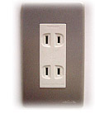
Voltage
100V/60Hz. Japanese plugs are two flat pin type (A-type) plugs. Please make sure you have correct adapters. Voltage converters or adapters will NOT be provided at the meetings.
Please bring your voltage converters and plug adapters! (100 volts/60hertz)

Currency
Yen (\) http://www.xe.com/currency/jpy-japanese-yen
ATTENTION!!
Credit cards can be taken at hotels in Fukuoka, but not at some restaurants, taxis, and small shops.

Time Zone
JST=UTC+9 hours

GSM / W-CDMA/LTE coverage
Only W-CDMA and/or LTE are available. For availability of GSM chip-roaming, please check with your operator. cdma2000 and/or LTE are also available in the area.

Weather
http://www.jma.go.jp/en/yoho/346.html (Fukuoka lies in Kyushu island.)

Sightseeing
Japan National Tourism Organization: http://www.jnto.go.jp/eng/
Fukuoka Convention & Visitors Bureau: http://www.welcome-fukuoka.or.jp/english/

(ANNEX 1)
Visa support letter application form
Please fill in the form below and e-mail it to visa1@s.ttc.or.jp by 12:00 (JST=UTC+9), 21 December, 2017.
(Note: you can obtain a public key for e-mail encryption simply by sending an e-mail to visa1@s.ttc.or.jp with the subject "Public Key request" BEFORE sending your personal information in an attachment.)

Given name (First name) |  | alphabetical
Family name (Last name) |  | alphabetical
Date of Birth (dd/mm/yy)
Gender (Male/Female)
Nationality
Valid passport number
Passport Valid until (dd/mm/yy)
Country to submit your visa application
Postal Address for your visa support documents to be shipped | Address
Postal Address for your visa support documents to be shipped | Postal Code
Postal Address for your visa support documents to be shipped | Country
The above address is: (please select one) |  |  | Office / home / other (specify: )
Occupation and Job title
Name of Company/Organization
Company/Organization Address
(fill in “same as above” if shipping address is your office)
Telephone number |  |  | +
Fax number |  |  | +
Email address
Itinerary (refer to examples shown in the table.)
D/M/Y | Schedule |  | Address and Phone number to reach | Hotel
ex) 3/ Feb./ 2018 | Arrival from Paris to Fukuoka International Airport, Flight xxx |  | *1 | *1
ex) 4 / Feb./ 2018 | Preparation for SA1-#81 meeting |  | *1 | *1
ex) 5-9 / Feb./ 2018 | Attending SA1-#81 meeting |  | *1 | *1
ex) 10/ Feb. / 2018 | Departure from Fukuoka International Airport to Paris, Flight xxx
*1 Hotel Sunroute Hakata: 4-10 Hakataeki-chuogai, Hakata-ku, Fukuoka-shi, Fukuoka
Tel +81-92-434-1311
Fill in your Itinerary below

