 | Telecommunications Technology Association
267-2, Seohyeon-dong, Bundang-gu, Seongnam-City, Kyonggi-do, 463-824, Korea
Telephone: +82 31 724 0122 , Facsimile: +82 31 724 0109, http://www.tta.or.kr

TO THE MEMBERS OF 3GPP TSG SA

Invitation to the 3GPP TSG SA #15 meeting to be held on 11th – 14th March 2002 in Jeju, Korea

Dear Colleagues,

I have the pleasure to invite you to the 3GPP TSG SA #15 meeting that will be held in Jeju, Korea on 11th-14th March 2002.

The venue of this meeting will be the Shilla Cheju Hotel(3039-3 Saekdal-dong, Seogwipo-shi
Jeju, Korea, TEL: +82-64-735-5501 FAX: +82-64-735-5415)

The meeting will start on 11 March 2002 at 9:00 and end on 14 March 2002 at 17:00.
Registration will take place on the first day of the meeting between 08:30 and 09:30.

The registration form can be found on the 3GPP website. Please visit http://webapp.etsi.org/3GPPRegistration/fMain.asp?mid to register on line. Your completed registration helps in the accurate planning of the meeting.

You should return the Hotel Reservation Form by fax before 5 February. Early hotel reservation is strongly recommended.

Submission Of Documents

Please contact the secretary to obtain a Tdoc template and an allocated Tdoc number (See below for contact details)
SA secretary, Mr. Maurice POPE, Tel: 33 4 9294 4259, E-mail: maurice.pope@etsi.fr

VISA may be required for some nationals to enter Korea. Please contact the Korean Embassy at your country as soon as possible. If you need a Letter of Invitation to get a VISA, please fill in attached Letter of Invitation Request Form and email to Mr. Ki-Hoon KIM(channel@tta.or.kr).

Looking forward to seeing you in Jeju, Korea.

Yours sincerely,

Chu Hwan, YIM
Secretary General
Telecommunications Technology Association

Encl.: Hotel Reservation Form
Letter of Invitation Request form for VISA
Useful Information about Jeju Island and The Shilla Cheju

HOTEL RESERVATION FORM

To : THE SHILLA CHEJU Seoul Office
Fax : (822)2230-3687

Name Of Representative Requiring Hotel Accommodation
First Name : Last Name : ______________
Tel : Fax : _____________
Arrival Date : Arrival Time : Flight No : ____________
Departure Date : ________ Departure Time: :__________ Flight No:____________
Sharing Room with __________________________________
Room Type : - Single/Double □ - Twin □
Room Rate (per Night / including 1 breakfast coupon ) :
* Mountain view : \KRW 170,000 □ * Ocean view : \KRW 220,000 □
* The above Room Rate excluded 10%SVC, 10%TAX, 2% Tourism Contribution.
* 10% tax charge on the room rate will be waived to Foreigners of all nationalities.

Credit Card Details
Visa□ Mastercard□ American Express□ Diners Club□
Name Of Cardholder : ______________
Card Number : ________________
Expiry Date : Signature : ______________
I require a written confirmation from the hotel to be faxed to me. yes□ no□

Remarks : Thank you in advance for your visit to THE SHILLA CHEJU.
Please check the following for your reservation.

1. Due Date of Reservation
- please submit this form and fax to us by February 5, 2002. we may not guarantee your
reservation after the due date.
- reservation must be accompanied by credit card information to be guaranteed
2.Cancellation Policy
-50% of one night room rate and tax levied for any cancellation made than 3days prior to the scheduled arrival.
-100% of one night room rate and tax will be levied for any cancellation made less than
1day prior to the scheduled arrival. this will applied for no show.

3. Hotel Check-in Time is 2:00PM, Check out time is 12:00 noon.

Letter of Invitation Request Form

Family Name ______________________________________________

Given Name ______________________________________________

Birth of Date ______________________________________________

Gender ______________________________________________

Company/Organization ____________________________________________

Department ______________________________________________

Mailing Address _______________________________________________

_______________________________________________

Email Address _______________________________________________

Nationality _______________________________________________

Passport Number _______________________________________________

Address in Korea _______________________________________________

Schedule for Stay(Arrival & Departure Date) __________________________

Flight Number ________________________________________________

Please return this form to Mr. Ki-Hoon Kim(channel@tta.or.kr) or fax(+82 31 724 0109)

Useful Information about Jeju Island and The Shilla Cheju

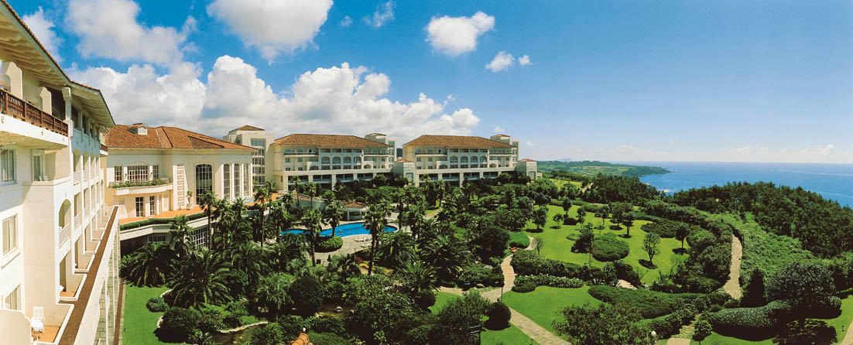

l. Location
Jeju Island is located about 60 miles(100km) off the southern tip of the Korean Peninsula which is about 280 miles(451km) from Seoul -the capital city of South Korea.

2. Climate
Jeju Island has a subtropical maritime climate. It has four distinct seasons and an average yearly temperature of 16℃(60°F). In summer, June through August, the temperature ranges between 22℃ and 26℃(72°-80°F), while in winter, December through February, the temperature drops between 5℃ and 7℃ (40°- 45°F). During the spring, it remains the most comfortable temperature of 16℃.

3. Bank Business Hours
Bank business hours are from 9:30am to 4:30pm on weekday and from 9:30am to 1:30pm on Saturday. Major department stores are open from 10:30am to 7:30pm, including Sundays, Smaller shops tend to be open from early morning until late seven days a week.

4. Tax and Tipping
A value-added tax(VAT) is levied on most goods and services at a standard rate of 10% and is included in the retail price. At hotels, a 10% VAT plus a 10% service and 2% tourism contribution charge is applied to rooms. For the meals and other services, 10% VAT plus a 10% service charge is applied to the bill.

5. Electricity
Outlet for both 110 and 220 volts 60HZ are available. The connection for appliances is a 2-round plug. (IMPORTANT: 220 volts is only available in the Meeting rooms.)

6. Telephones
Local calls by pay phone cost 50won for 3 minutes. Coin-type pay phones take \10, \50 and \100 coins. Some public phones also accept major credit cards. Card telephones can be used to make international calls as well as local and long distance calls. Phone cards come in \3,000, \5,000 and \10,000 units and are on sale in shops in the hotel. To make an international call, first dial the international dialing code (001 or 002), then the country code, area code and individual number. International calls can also be made through the operator by dialing 0077. To make a collect call, also dial 0077
a) Important Numbers
Fire & Ambulance 119
Police 112
Tourist Information 134
Int'l Telephone Call Information 0074
Int'l Telephone Call Operator 0077

7. Transportation
By far the easiest way to visit Jeju Island is by air. Regular service by Korean Air and Asiana Airlines connect Jeju Island with the mainland airports, and international flights connect Jeju with Seoul Korea, and with Tokyo, Osaka, Fukuoka, and Nagoya of Japan and Hong Kong also Beijing and Shanghai of China.

a) Airport Limousine Bus
Limousine buses operated by Jeju International airport run between the airport and hotels in Chumgmun resort complex in 15 minutes interval. The Bus fare is \3,300 and it takes about 50 minutes from the Airport to The Shilla Cheju. Bus station is at the left entrance of the main floor as you walk out. There is a number on the bus "600"

b) Taxi
Taxi in Jeju Island is safe and easy to get. There will be a line of taxi right in front of airport terminal as you get off. The fare to get to our hotel is about \30,000. It takes about 40-50 minutes.

8. The Shilla Cheju (www.Jejushilla.com)
a) Location
The Shilla Cheju is a 21-acre lush, landscaped resort property in the Chungmun Resort Complex of Jeju Island. By car, The Shilla Cheju is 50 minutes from Jeju International Airport and 20 minutes west of Seogwipo city.

b) Facilities
- 429 luxury Guest Rooms
- 6 Banquet Rooms, 3 Restaurants, Lounge and Bars
- Fitness Club, Indoor-Outdoor Swimming Pool, Sauna, Bowling Alley,
- Racquetball Court, Tennis Courts, and Recreational Room
- Rent a Car and Travel Agent
- Beauty Salon and Barber Shop

9. Other Activities

a) Golf
Chungmun Golf Club is located withing walkin g distance from The Shilla Cheju. Chungmun Golf Club has the longest golf course in Korea, stretching along the coast between the ocean and the mountain. The cost are as below:-
- Green Fees : \108,000(Weekdays), \128,000(Weekends)
- Caddie Tip : \60,000 (For two bags)
- Equipment Rental : Full Set Clubs \25,000, Shoes \5,000

b) Fishing
Fishing at Jeju Island are enjoyed by travelers, boat fishing and by the rocks. About 220 kinds of fish are being caught around Jeju Island. With an abundance of high class game fish almost everywhere, the mild temperature and cobalt-blue seas offer conditions for the great amount of enjoyment to the serious sports-fishermen as well as novice fishers.

c) Hunting
Hunting season opens the first of November each year and runs through the end of the following February except in the restricted areas. However, private hunting ground offers hunting all year around. "Daeyoo Shooting Range" near to The Shilla Cheju offers hunting and practice shooting through the year.

d) Sight Seeing
Jeju Island offers many attractions to see, such as Folk Villages, Water Falls, Caves, Punsai Park, and more. I will send you a guide book about Jeju Island for more information

