3GPP TR 38.871 V0.1.0 (2023-03)
Technical Report

3rd Generation Partnership Project;
Technical Specification Group Radio Access Network;
NR;
Study on NR frequency range 2 (FR2) Over-the-Air (OTA) testing enhancements;
(Release 18)
 | 
The present document has been developed within the 3rd Generation Partnership Project (3GPP TM) and may be further elaborated for the purposes of 3GPP.
The present document has not been subject to any approval process by the 3GPP Organizational Partners and shall not be implemented.
This Specification is provided for future development work within 3GPP only. The Organizational Partners accept no liability for any use of this Specification.
Specifications and Reports for implementation of the 3GPP TM system should be obtained via the 3GPP Organizational Partners' Publications Offices.

3GPP
Postal address

3GPP support office address
650 Route des Lucioles - Sophia Antipolis
Valbonne - FRANCE
Tel.: +33 4 92 94 42 00 Fax: +33 4 93 65 47 16
Internet
http://www.3gpp.org

Copyright Notification
No part may be reproduced except as authorized by written permission.
The copyright and the foregoing restriction extend to reproduction in all media.

© 2022, 3GPP Organizational Partners (ARIB, ATIS, CCSA, ETSI, TSDSI, TTA, TTC).
All rights reserved.

UMTS™ is a Trade Mark of ETSI registered for the benefit of its members
3GPP™ is a Trade Mark of ETSI registered for the benefit of its Members and of the 3GPP Organizational Partners
LTE™ is a Trade Mark of ETSI registered for the benefit of its Members and of the 3GPP Organizational Partners
GSM® and the GSM logo are registered and owned by the GSM Association

Contents
Foreword 4
1 Scope 6
2 References 6
3 Definitions of terms, symbols and abbreviations 7
3.1 Terms 7
3.2 Symbols 7
3.3 Abbreviations 7
4 General 8
4.1 Objective 8
4.2 Devices Type 8
5 UE RF testing methodology for multi-Rx chain DL reception 9
5.1 General 9
5.2 Measurement setup 9
5.2.1 Measurement Setup with Full Degree of Rotation Freedom for Each AoA 9
5.2.2 Measurement Setup with Full Degrees of Freedom for AoA1 with Fixed Angular Offset(s) Between AoA1 and AoA2 18
5.2.3 Measurement Setup with Full Degrees of Freedom for AoA1 with Variable Angular Offset(s) between AoA1 and AoA2 22
5.2.4 Measurement Setup with Full Degrees of Freedom for AoA1 with Partial Freedom of Variable Angular Offset(s) between AoA1 and AoA2 24
5.2.5 Measurement Setup with Full Degrees of Freedom for AoA1 with Fixed AoA2/Anchor in NF 26
5.2.6 Measurement Setup with Test Modes 27
5.3 Test System Aspects 28
5.3.1 Absolute Probe Locations 28
5.3.2 Minimum and Maximum Angular Separation between Probes 31
5.4 Calibration Measurement Procedure 32
5.4.1 Direct far field (DFF) 32
6 UE RRM testing methodology for multi-Rx chain DL reception 32
6.1 General 32
6.2 Measurement setup 33
7 UE demodulation and CSI testing methodology for multi-Rx chain DL reception 33
7.1 General 33
7.2 Measurement setup 33
Annex A: Measurement uncertainty 34
A.1 Measurement uncertainty budget for UE RF testing methodology 34
A.2 Measurement uncertainty budget for UE RRM testing methodology 34
A.3 Measurement uncertainty budget for UE demodulation testing methodology 34
Annex <X>: Change history 35

For definitive guidance on drafting 3GPP TSs and TRs, see 3GPP TS 21.801 supplemented by the 3GPP web page http://www.3gpp.org/specifications-groups/delegates-corner/writing-a-new-spec.
Ensure all blue guidance text is removed before submitting the TS/TR to the TSG for approval.

Foreword
This Technical Report has been produced by the 3rd Generation Partnership Project (3GPP).
The contents of the present document are subject to continuing work within the TSG and may change following formal TSG approval. Should the TSG modify the contents of the present document, it will be re-released by the TSG with an identifying change of release date and an increase in version number as follows:
Version x.y.z
where:
x the first digit:
1 presented to TSG for information;
2 presented to TSG for approval;
3 or greater indicates TSG approved document under change control.
y the second digit is incremented for all changes of substance, i.e. technical enhancements, corrections, updates, etc.
z the third digit is incremented when editorial only changes have been incorporated in the document.
In drafting the TS/TR, pay particular attention to the use of modal auxiliary verbs! TRs shall not contain any normative provisions.
In the present document, modal verbs have the following meanings:
shall indicates a mandatory requirement to do something
shall not indicates an interdiction (prohibition) to do something
The constructions "shall" and "shall not" are confined to the context of normative provisions, and do not appear in Technical Reports.
The constructions "must" and "must not" are not used as substitutes for "shall" and "shall not". Their use is avoided insofar as possible, and they are not used in a normative context except in a direct citation from an external, referenced, non-3GPP document, or so as to maintain continuity of style when extending or modifying the provisions of such a referenced document.
should indicates a recommendation to do something
should not indicates a recommendation not to do something
may indicates permission to do something
need not indicates permission not to do something
The construction "may not" is ambiguous and is not used in normative elements. The unambiguous constructions "might not" or "shall not" are used instead, depending upon the meaning intended.
can indicates that something is possible
cannot indicates that something is impossible
The constructions "can" and "cannot" are not substitutes for "may" and "need not".
will indicates that something is certain or expected to happen as a result of action taken by an agency the behaviour of which is outside the scope of the present document
will not indicates that something is certain or expected not to happen as a result of action taken by an agency the behaviour of which is outside the scope of the present document
might indicates a likelihood that something will happen as a result of action taken by some agency the behaviour of which is outside the scope of the present document
might not indicates a likelihood that something will not happen as a result of action taken by some agency the behaviour of which is outside the scope of the present document
In addition:
is (or any other verb in the indicative mood) indicates a statement of fact
is not (or any other negative verb in the indicative mood) indicates a statement of fact
The constructions "is" and "is not" do not indicate requirements.

1 Scope
The objectives for FR2-1 OTA testing for UEs with multi-panel reception and 4DL layer are as follows.

- Define a test methodology for RF/RRM/Demodulation requirements testing for devices that can receive simultaneously from multiple Angle of Arrival (AoA)
- The multiple AoA test setup should enable testing of up to 2 DL Layers with dual polarization for each angle
- For RRM, the target should be to allow testing of 4 AoAs with 2 simultaneously active AoAs
- Define a test methodology for up to 4 DL MIMO layer demodulation testing
- Smartphone form factor should be the first priority, other UE types should also be discussed as 2nd priority
- Develop the related preliminary uncertainty assessments for the test methodologies
- The tests shall take the test system reuse, test system complexity and test time into account to keep the whole test costs within a reasonable level.

2 References
The following documents contain provisions which, through reference in this text, constitute provisions of the present document.
- References are either specific (identified by date of publication, edition number, version number, etc.) or non-specific.
- For a specific reference, subsequent revisions do not apply.
- For a non-specific reference, the latest version applies. In the case of a reference to a 3GPP document (including a GSM document), a non-specific reference implicitly refers to the latest version of that document in the same Release as the present document.
[1] 3GPP TR 21.905: "Vocabulary for 3GPP Specifications".
[2] 3GPP TS 38.101-2: "User Equipment (UE) radio transmission and reception; Part 2: Range 2 Standalone".
[3] 3GPP TR 38.810: "Study on test methods".
[4] 3GPP TR 38.884: " Study on enhanced test methods for FR2 NR UEs".
[5] TS 38.509, Special conformance testing functions for User Equipment (UE)
[6] TS 38.521-2, User Equipment (UE) conformance specification; Radio transmission and reception; Part 2: Range 2 Standalone
[7] TS 38.508-1, User Equipment (UE) conformance specification; Part 1: Common test environment
[8] TS 38.151, Multiple Input Multiple Output (MIMO) Over-the-Air (OTA) performance requirements
[9] TR 38.884, Study on enhanced test methods for FR2 NR UEs
[10] TS 38.508-1, User Equipment (UE) conformance specification; Part 1: Common test environment
[11] 3GPP TS 34.114: "User Equipment (UE) / Mobile Station (MS) Over The Air (OTA) antenna performance; Conformance testing".
[x] <doctype> <#>[ ([up to and including]{yyyy[-mm]|V<a[.b[.c]]>}[onwards])]: "<Title>".

3 Definitions of terms, symbols and abbreviations
<Editor’s note: this clause and its three subclauses are mandatory. The contents shall be shown as "void" if the TS/TR does not define any terms, symbols, or abbreviations.>

3.1 Terms
For the purposes of the present document, the terms given in 3GPP TR 21.905 [1] and the following apply. A term defined in the present document takes precedence over the definition of the same term, if any, in 3GPP TR 21.905 [1].
Definition format (Normal)
<defined term>: <definition>.
example: text used to clarify abstract rules by applying them literally.

3.2 Symbols
For the purposes of the present document, the following symbols apply:
Symbol format (EW)
<symbol> <Explanation>

3.3 Abbreviations
For the purposes of the present document, the abbreviations given in 3GPP TR 21.905 [1] and the following apply. An abbreviation defined in the present document takes precedence over the definition of the same abbreviation, if any, in 3GPP TR 21.905 [1].
Abbreviation format (EW)
<ABBREVIATION> <Expansion>
AoA Angle of Arrival
CATR Compact Antenna Test Range
DFF Direct Far Field
DUT Device Under Test
EIS Effective Isotropic Sensitivity
EIRP Effective (or equivalent) isotropic radiated power
IFF Indirect Far Field
SGH Standard Gain Horn

4 General
<Editor’s note: general aspects related to the scope of the study or common study outcomes can be captured in this clause>

4.1 Objective
In Rel-17 WI on further enhancements on MIMO for NR (Acronym: NR_FeMIMO), the objective is to extend the specification to support several aspects on NR MIMO including simultaneous multi-Rx chain DL reception. With considering the objective to define new requirements for the UE with multi-Rx chain DL reception, the FR2 test methods for RF, RRM and demodulation need to be enhanced. This document is to define the enhanced test methods for the verifications of these new requirements for FR2 UE with multi-Rx chain DL receptions.

4.2 Devices Type
The following device types are considered in the scope of this study:
- Smartphone
- Tablet
- Wearable devices
- Vehicular mounted device
- Fixed Wireless Access (FWA) terminal
- Other UE types are not precluded
The development of test methods shall initially focus on the smartphone device type. Other UE types should also be studied as 2nd priority.

5 UE RF testing methodology for multi-Rx chain DL reception

5.1 General
<Editor’s note: general aspects related to the UE RF testing methodology for multi-Rx chain DL reception can be captured in this clause>

5.2 Measurement setup
<Editor’s note: outcome of measurement setup for UE RF testing can be captured in this clause>

5.2.1 Measurement Setup with Full Degree of Rotation Freedom for Each AoA
FR2 OTA measurement setups with full degree of rotation freedom for each AoA support two simultaneous AoAs with any combination of DL directions, i.e., any permutation of possible AoAs shall be supported. This setup was initially considered as the preferred measurement setup for multi-AoA UE RF testing but later discarded for reasons outlined below.
Such setup was also considered the default measurement setup for FR2 UE RF testing during the SI phase of FR2 OTA testing [3] given the requirement to perform off-centre of beam measurements as illustrated in Figure 5.2.1-1. However, the adoption of the UE Beamlock test Function (UBF), see Clause 5.4 of [5], to readily perform off-centre of beam measurements shifted the focus towards more practical single-AoA/single-probe UE RF setups, e.g., the Indirect Far Field (IFF) methodology [3] which subsequently became the de-facto setup for FR2 UE RF testing.
Figure 5.2.1-1: DFF measurement setup of UE RF characteristics for TRP scans (Figure 5.2.1.1-1 of [3]).
Measurement setups that allow arbitrary positioning for each probe, i.e., the UE does not necessarily require a positioning system are illustrated in Figure 5.2.1-2 and Figure 5.2.1-3. The Direct Far Field (DFF) methodology, i.e., millimeter-wave measurement probes placed in the far-field away from the DUT when adapted to two-simultaneous AoA testing, is illustrated in Figure 5.2.1-2. Here, the probes introducing AoA1 (beam shown in blue) and AoA2 (beam shown in red) can be positioned arbitrarily while the DUT is fixed. When the DFF probes are replaced with Indirect Far Field (IFF) probes, i.e., measurement probe and reflector, a sample test system with full degrees of freedom for each AoA is shown in Figure 5.2.1-3. The full degree of rotation freedom for each probe is highlighted with the yellow arrows behind each DFF probe/IFF probe&reflector combination. The positioning requirements to accurately position probe(s) along two principal axes in 3D yield a very high positioning complexity.
Figure 5.2.1-2: Example DFF measurement setup for two-simultaneous AoA testing with full degrees of freedom for each probe.
Figure 5.2.1-3: Example IFF measurement setup for two-simultaneous AoA testing with full degrees of freedom for each probe.
Size (width/depth/height) estimations performed for such DFF/IFF systems supporting the FR2-1 frequency range and devices up to a 40 cm diameter (40 cm QZ) are tabulated in Table 5.2.1-1. The increase in chamber sizes (footprint and heights) when compared to existing FR2 UE RF chambers is significant and existing chambers are not upgradable to support full degrees of freedom. The lead times to develop such systems with full degrees of freedom could be quite significant and could thus delay the commercial adoption of these test cases. Additionally, the overall system complexities of such systems could further require an increase in measurement uncertainties (MUs) and thus test tolerances (TTs).
Table 5.2.1-1: Size estimates for UE RF systems with full degrees of freedom for each probe.
Size  Test Method | Width [m] | Depth [m] | Height [m]
DFF | 3.2 | 3.2 | 3.2
IFF | 4.4 | 4.4 | 4.4
Measurement setups that allow full degrees of positioning freedom for one probe and the DUT while the other probe is fixed are shown in Figure 5.2.1-4 for the DFF and Figure 5.2.1-5 for the IFF methodology. The probe introducing AoA1 (beam shown in blue) is fixed while the DUT and the probe introducing AoA2 (beam shown in red) can be positioned arbitrarily (as indicated with the yellow arrows). This approach therefore also support full degrees of rotational freedom for each AoA.
Figure 5.2.1-4: Example DFF measurement setup for two-simultaneous AoA testing with arbitrary positioning capability for one probe and DUT supporting full degrees of freedom.
Size (width/depth/height) estimations were performed for such DFF/IFF systems as well which are tabulated in Table 5.2.1-2. Only a very small improvement in footprint, i.e., width, can be observed for this system architecture when compared to Table 5.2.1-1. The same conclusions/observations can be made as those above, i.e., the increase in chamber sizes (footprint and heights) when compared to existing FR2 UE RF chambers is significant and existing chambers are not upgradable to support full degrees of freedom.
Figure 5.2.1-5: Example IFF measurement setup for two-simultaneous AoA testing with full degrees of freedom for one probe & DUT
Table 5.2.1-2: Size estimates for UE RF systems with full degrees of freedom for each probe.
Size  Test Method | Width [m] | Depth [m] | Height [m]
DFF | 3.2 | 3.2 | 3.2
IFF | 4.4 | 4.4 | 4.4
Alternate example measurement setups to support full degrees of freedom for AoA are shown in Figures 5.2.1-6 through 5.2.1-9.
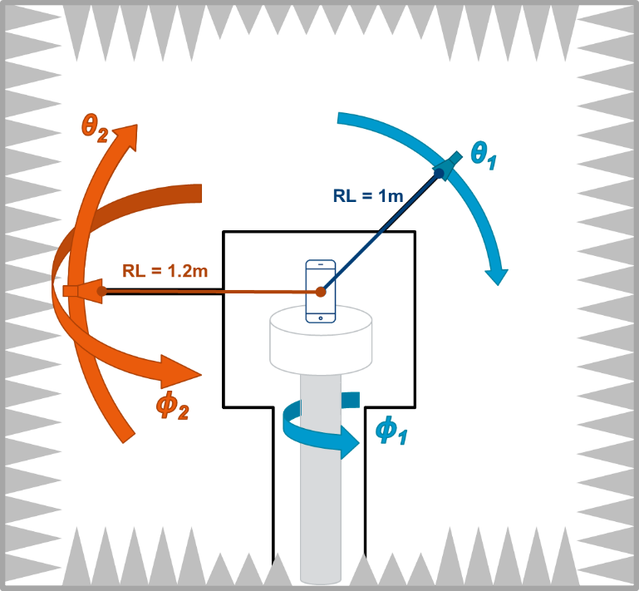
Figure 5.2.1-6: Example of 2AoA DFF test system with full degrees of freedom
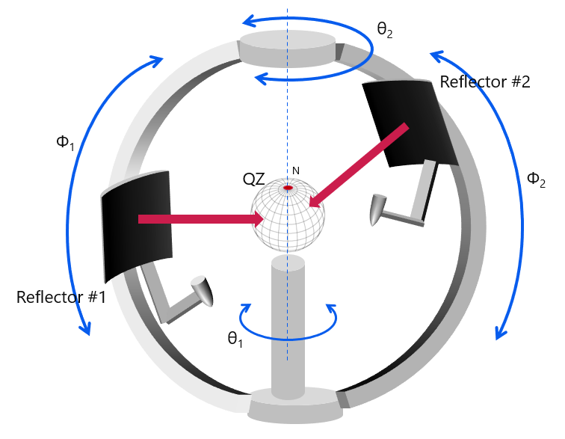
Figure 5.2.1-7: Distributed-axes system with two moving IFF reflectors
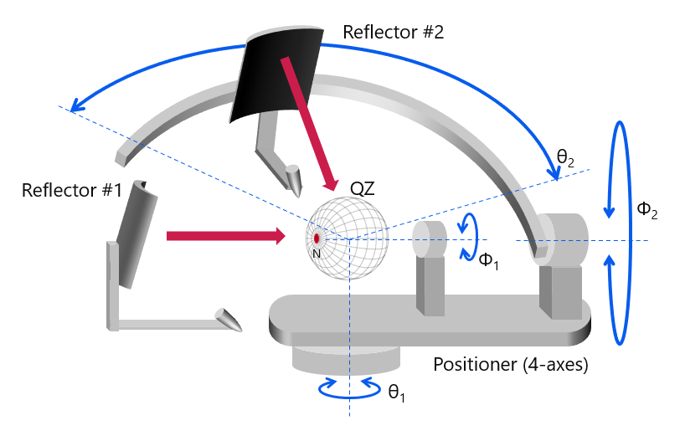
Figure 5.2.1-8: Distributed-axes system with two moving IFF reflectors
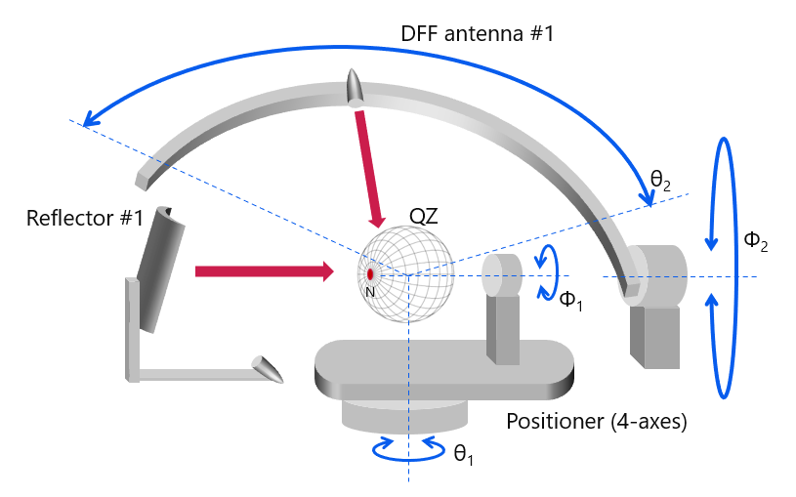
Figure 5.2.1-9: 2AoA RF test system with DFF antenna as the second NR anchor on a slider
The full degrees of freedom for each AoA supports a probe offset option with variable angular offset(s) between AoA1 and AoA2 in the chamber. The angular separation between AoA1 and AoA2 can change during the testing. This is further illustrated with a sample DUT with a beam peak in the DUT y direction, as illustrated in Figure 5.2.1-10. As the AoA2 probe has full degrees of freedom, i.e., the angular difference between AoA1 and AoA2 is arbitrary, the AoA2 probe can track/follow the DUT’s beam peak during testing as illustrated in Table 5.2.1-3 for two different DUT orientations/test points.
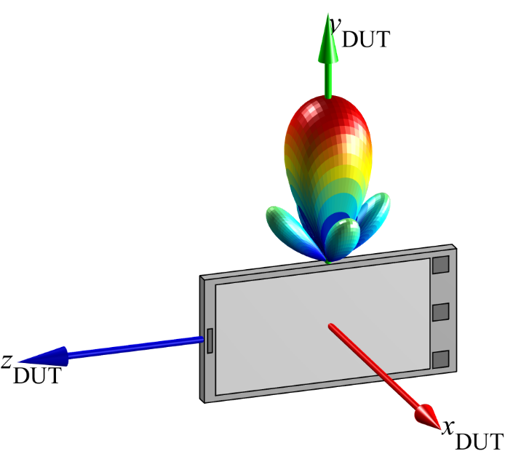
Figure 5.2.1-10: Sample DUT with assumed beam peak in the DUT’s y direction
Table 5.2.1-3: Ability of tracking a DUT reference direction
DUT Orientation  (θ, φ) | Offset Option: variable angular offset(s) between AoA1 and AoA2
(0°, 0°) | 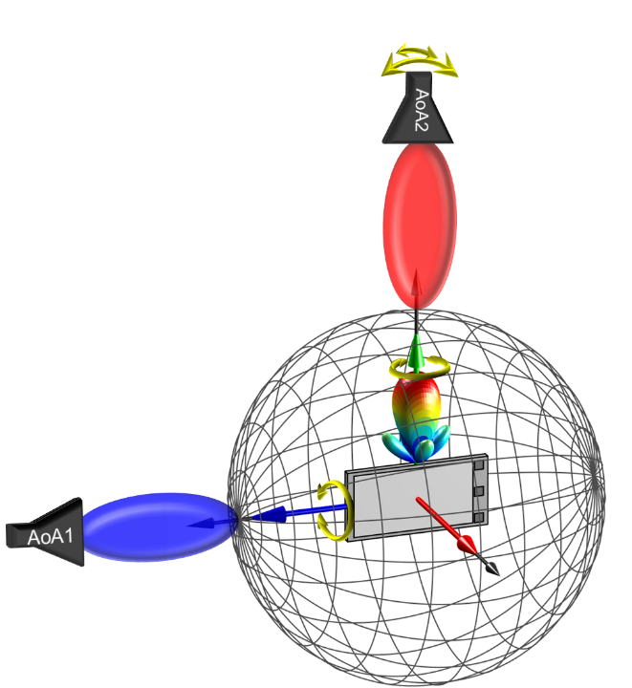
(45°, -45°) | 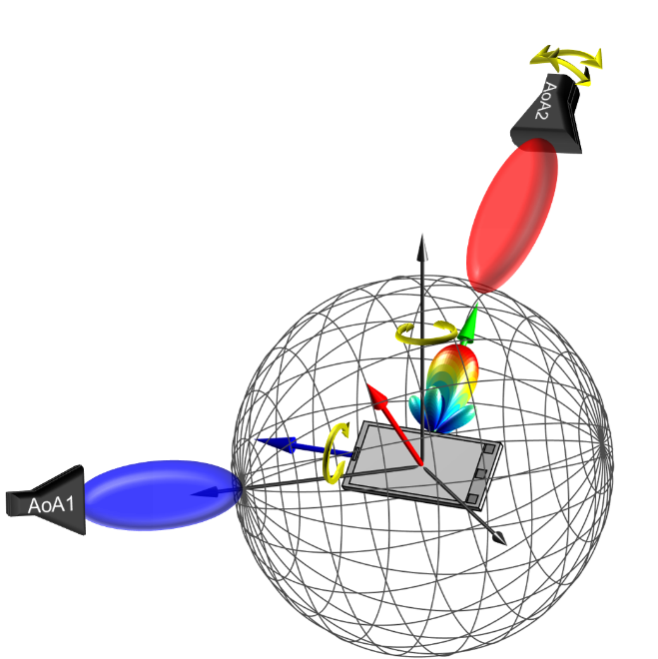

Efforts for multi-AoA DL spherical coverage testing based on the assumptions that no prior knowledge of the performance of any panel/chain is available, e.g., beam peak directions of each panel, are significant and quantified next. The spherical coverage test for any multi-chain UE system configuration would require a spherical coverage test with N*(N-1)≈N² AoA combinations. Here, N is the minimum number of spherical coverage grid points. The effort in terms of minimum number of test points is quantified in Table 5.2.1-4 assuming that the same measurement grids/grid density are used as for legacy spherical coverage testing, defined in Clause M.3 of [6].
Table 5.2.1-4: Test Effort Estimates for UE RF Systems with Full Degrees of Freedom for AoA.
Power Class | Grid Type | Minimum Number of Spherical Coverage Test Points N (single chain) as defined in M.3 of Error! Reference source not found. | Number of Spherical Coverage Test Points N (multi chain)  N*(N-1)
PC1 | constant density | 200 | 39,800
PC3 | constant density | 180 | 32,220
PC1/PC3 | constant-step size | 266 | 70,490
The number of test points for this test approach is test time prohibitive given the very large number of test points.
This measurement setup has its pros/cons summarized in Table 5.2.1-4.
Table 5.2.1-4: Overview of Measurement Setup
Description | Full degrees of freedom for both AoAs
Probe Offset Option | Variable Angular Offset(s) between AoA1 and AoA2 in the chamber. The angular separation between AoA1 and AoA2 can change during the testing
Pros | - AoA2 can follow/track a specific reference direction
Cons | - Very high system complexity  - Existing systems cannot be re-used  - Large/very large chamber footprint/chamber heights  - Long development time/TTM  - Increase in MU/TT

When the AoA2 probe/anchor probe is placed in the NF while supporting variable angular offsets, different system aspects must be taken into account. A sample measurement setup is shown in Figure 5.2.1-11 where both AoA1 (in FF) and AoA2 (in NF) have full degrees of freedom.
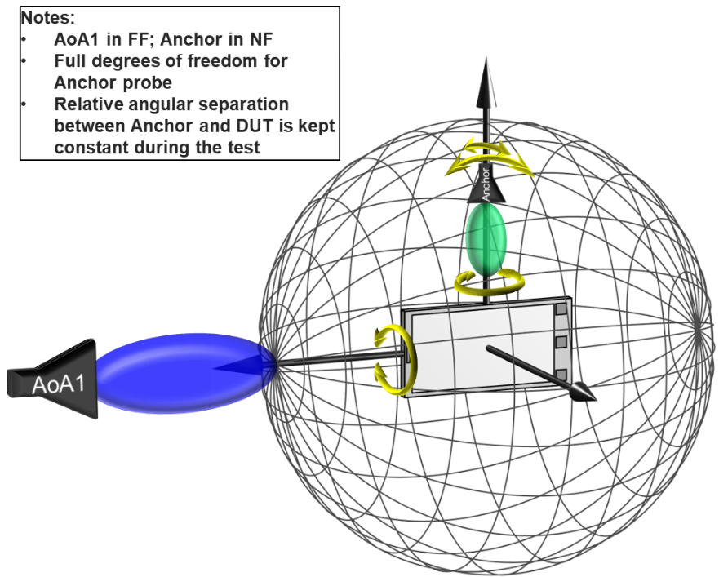
Figure 5.2.1-11: Example Measurement Setup with AoA2/Anchor in NF
An example implementation with the anchor probe mounted to the roll motor with independent positioning control (purple arrows) is shown in Figure 5.2.1-12.
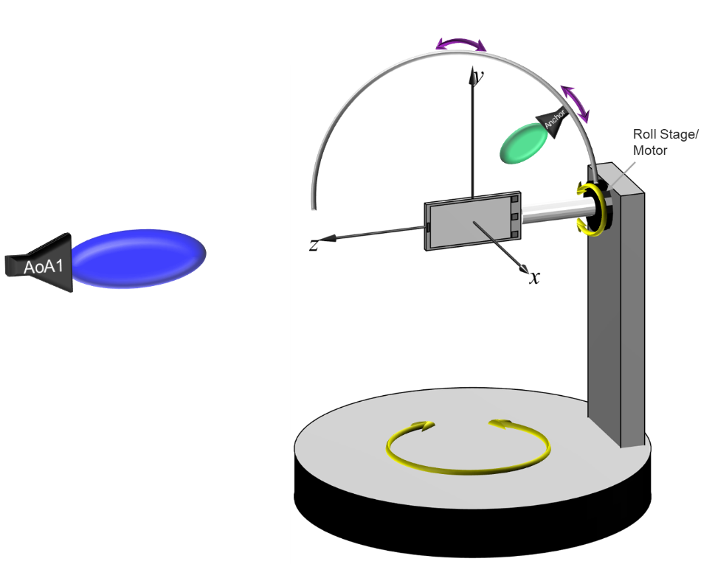
Figure 5.2.1-12: Example Implementation of Measurement Setup with AoA2/Anchor in NF
It should be noted that link antennas used in existing systems commonly do not have completely independent positioning control to support the full degrees of freedom. Link antennas are traditionally used to introduce an auxiliary communication link between the gNB and the DUT to avoid poor signal conditions in the non-tested DL or UL (for UL or DL measurements) and thus dropped calls. As no calibrated measurements are performed over this link, this signal path is generally never calibrated and the positioning and link probe requirements are very relaxed, e.g., large positioning uncertainty of the link antenna are acceptable, and the link antenna can be a low performance antenna coupler. Hence, such link antenna setups are not suitable for UE RF measurements.
In [9], NF methodologies for single-UL and DL were investigated and eventually considered permitted methodologies for FR2 test cases that currently require large relaxations in RAN5 technical specifications. The EIS/EIRP measurements in the immediate NF require very accurate positioning of the NF probe, a high-end antenna probe, and the NF antenna pattern characterization. Given the need for accurate positioning and relatively large NF probe antennas supporting two principal polarizations, antenna(s) and fixturing will result in significant blocking in various AoA1 measurement directions. More importantly, to accurately determine EIS in the NF, it is required to calibrate out the offset of the active DUT antenna from the centre of QZ to account for the correct path loss between the NF measurement probe and the active antenna. This offset can either be determined using a set of measurements which need to be performed for each AoA1 measurement direction (black box approach of CFFNF in Clause 5.1.4 of [9]) or based on a rather extensive vendor declaration, e.g., location of all antenna panels and which antenna is active for any given measurement direction. Applying these NF findings to multi-Rx UE RF testing has the following implications:

- The vendor declaration would require the exact location of all active antenna pairs for each AoA2 probe direction, i.e., an even more extensive vendor declaration than for single DL EIS measurements
- The NF probe needs to guarantee the same DL conditions to both active DUT receivers as a FF probe would since UE RF requirements are defined in the FF
This measurement setup has its pros/cons summarized in Table 5.2.1-5.
Table 5.2.1-5: Overview of Measurement Setup with AoA2 Probes in the NF
Description | Full Degrees of Freedom for AoA1 and AoA2 with AoA2 Probe in NF
Probe Offset Option | Variable Angular Offset(s) between AoA1 and AoA2 in the chamber. The angular separation between AoA1 and AoA2 can change during the testing
Pros | - Existing systems could potentially be re-used after some modifications
Cons | - Blocking of AoA1 in various directions by AoA2 probes  - Existing link antennas are not applicable; instead, very accurate positioning of the NF probe(s), high-end antenna probe(s), and the NF antenna pattern characterization are required  - Test-time intensive algorithms required to determine unknown offset of active antenna array(s) or  - Very extensive vendor declarations (location of all antenna panels and which sets of antenna panels are active for any given AoA2 measurement direction)  - The NF probe needs to guarantee the same DL conditions to both active DUT receivers as a FF probe would

5.2.2 Measurement Setup with Full Degrees of Freedom for AoA1 with Fixed Angular Offset(s) Between AoA1 and AoA2
An alternate measurement setup considered for multi-AoA UE RF testing is based on full degrees of freedom for AoA1 with fixed angular offsets between AoA1 and AoA2 with the angular separations between AoA1 and AoA2(s) not changing during the testing. Example measurement setups are illustrated in Figure 5.2.2-1 where the (fixed) probe locations, the number of probes, and probe type (DFF, IFF) were selected arbitrarily.
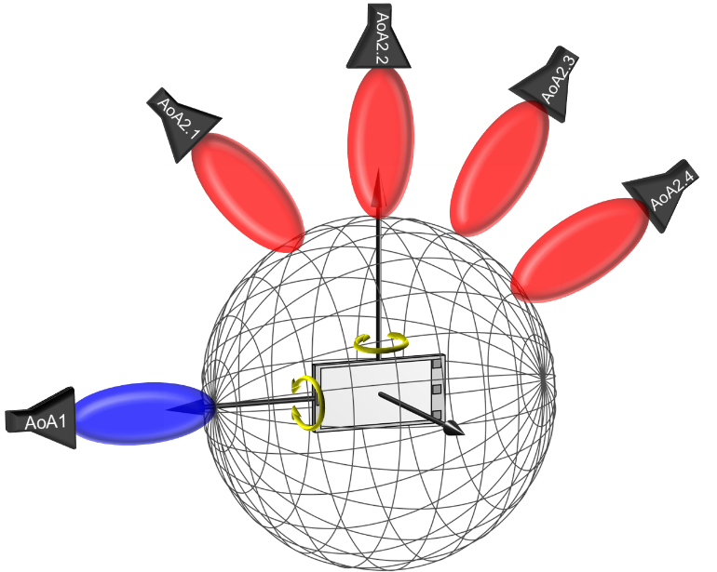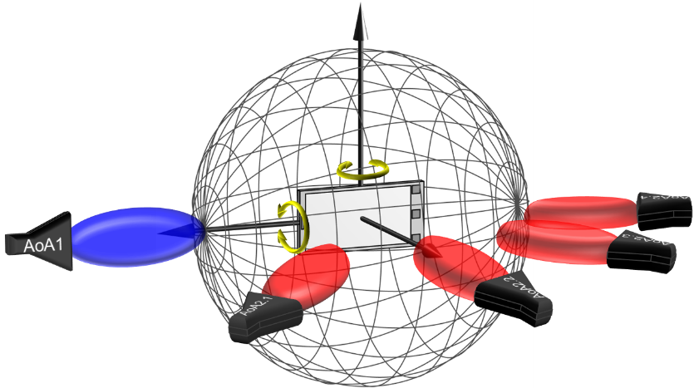
Figure 5.2.2-1: Example measurement setups for two-simultaneous AoA testing supporting 3D AoAs for the 1st DL direction and discrete, fixed AoAs for the 2nd DL direction. Top: probes in the vertical plane, Bottom: probes in the horizontal plane.
This multi-AoA measurement setup is similar to baseline setups for 2 AoA RRM testing [7], see Clause B.2, as illustrated in Figure 5.2.2-2 or FR2 MIMO testing [8], see Clause B.2, as illustrated in Figure 5.2.2-3.
Figure 5.2.2-2: Example RRM baseline system with two simultaneously active AoA using top: DFF setup, centre: Enhanced IFF setup, bottom: IFF+DFF setup.
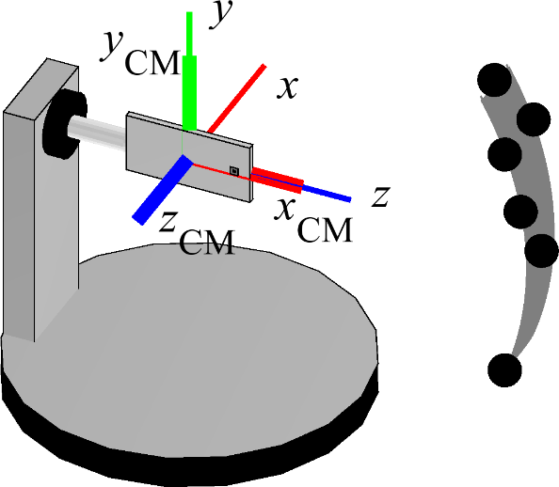
Figure 5.2.2-3: Example FR2 MIMO OTA 3D-MPAC system.
Due to the fixed offset between AoAs, the AoA2 probe cannot track/follow a DUT’s reference direction, e.g., beam peak, during testing as illustrated in Table 5.2.2-1 for two different DUT orientations/test points.
Table 5.2.2-1: Lack of ability of tracking a DUT reference direction
DUT Orientation  (θ, φ) | Offset Option: fixed angular offset(s) between AoA1 and AoA2
(0°, 0°) | 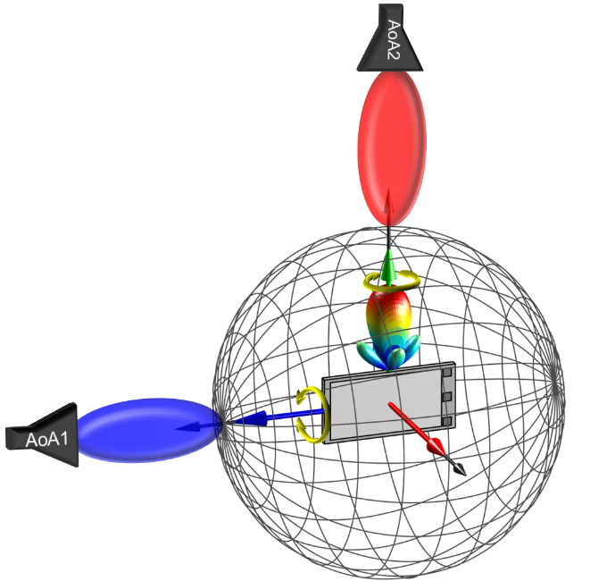
(45°, -45°) | 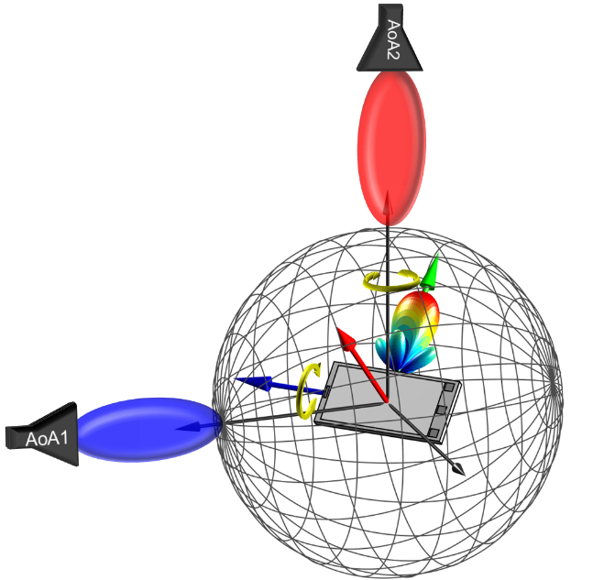

This measurement setup has its pros/cons summarized in Table 5.2.2-2.
Table 5.2.2-2: Overview of Measurement Setup
Description | Full degrees of freedom for AoA1 with fixed angular offset(s) between AoA1 and AoA2
Probe Offset Option | Fixed Angular Offset(s) between AoA1 and AoA2 in the chamber. The angular separation between AoA1 and AoA2 is NOT changing during the testing
Pros | - System complexity is manageable  - Existing systems, e.g., 2 AoA FR2 RRM, can be re-used (as long as common AoA2 probe locations are defined)  - Small chamber footprint/chamber heights  - Little to no development time/TTM  - Little to no impact in MU  - Multiple AoA1/AoA2 combinations can be tested  - A wide range of angular difference between AoA1 and AoA2 can readily be tested  - IFF methodology can be applied for each AoA probe for lowest MU and widest applicability.
Cons | - AoA2 cannot follow/track a specific reference direction

This measurement setup was selected the baseline for multi-AoA UE RF testing.

5.2.3 Measurement Setup with Full Degrees of Freedom for AoA1 with Variable Angular Offset(s) between AoA1 and AoA2
An alternate measurement setup considered for multi-AoA UE RF testing is based on full degrees of freedom for AoA1 with variable angular offsets between AoA1 and AoA2. At least one of the probes must utilize a 2-axis positioning system for full degrees of freedom as illustrated in Figure 5.2.3-1. The analyses for such system setup are very similar to the systems with full degrees of freedom for two AoAs in Clause 5.2.1.

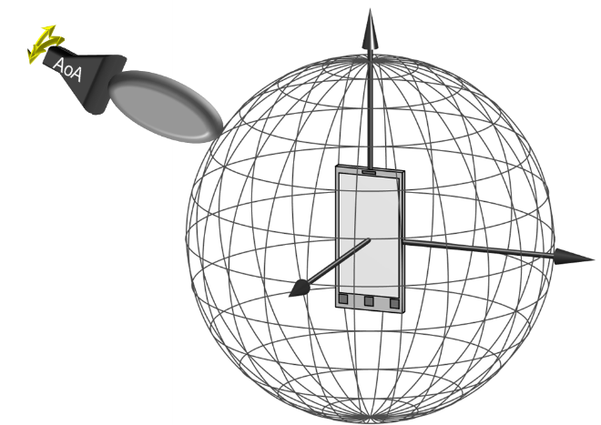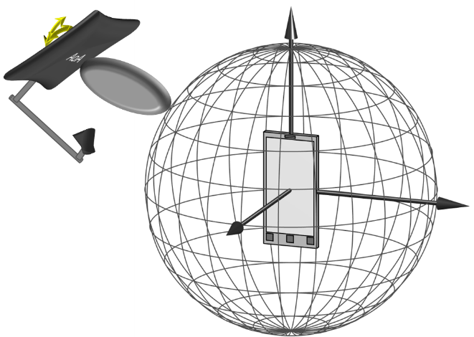
Figure 5.2.3-1: Example DFF (left)/IFF (right) measurement setup to support full degrees of freedom with two-axis positioning system for one probe.
The positioning requirements to accurately position a probe along two principal axes in 3D yield a very high positioning complexity. A sample measurement setup is shown in Figure 5.2.3-2. The system implementation with AoA1 supporting the 2-axis positioner and with a single or multiple AoA2 probe(s) require very large systems since AoA2 probe(s) must be placed behind AoA1 probe as shown in Figure 5.2.3-3 to support free movement of AoA1 and no interference with AoA2.
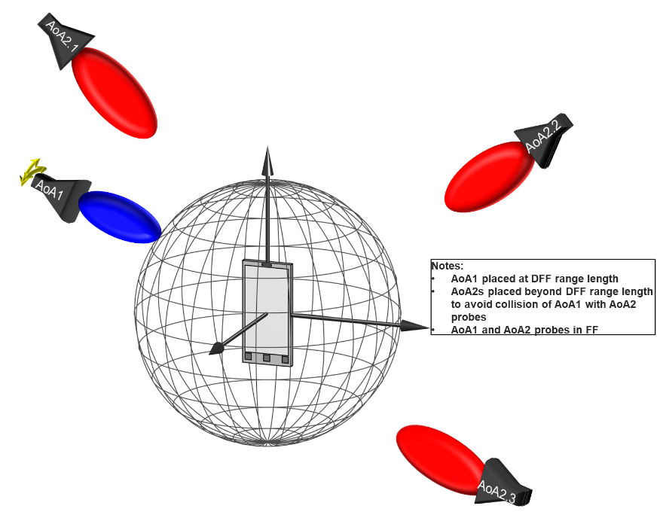
Figure 5.2.3-2: Example DFF measurement setup with full degrees of freedom for AoA1 with variable angular offset(s) between AoA1 and AoA2.

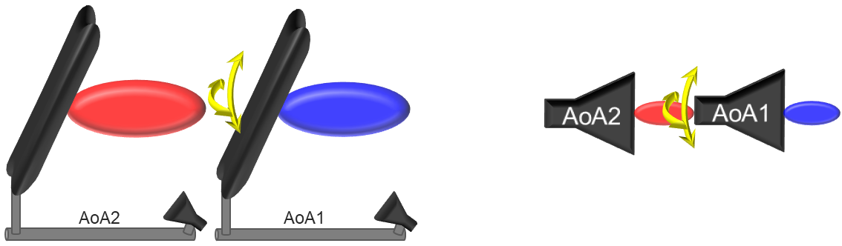
Figure 5.2.3-3: Illustration of IFF (left)/DFF (right) back-to-back probe placement.
Size (width/depth/height) estimations for such DFF/IFF systems supporting the FR2-1 frequency range and devices up to a 40 cm diameter (40 cm QZ) are tabulated in Table 5.2.3-1. The increase in chamber sizes (footprint and heights) when compared to existing FR2 UE RF chambers is significant and existing chambers are not upgradable to support full degrees of freedom. The lead times to develop such systems with full degrees of freedom could be quite significant and could thus delay the commercial adoption of these test cases. Additionally, the overall system complexities of such systems could further require an increase in measurement uncertainties (MUs) and thus test tolerances (TTs).
Table 5.2.3-1: Size estimates for UE RF systems with Full Degrees of Freedom for AoA1 with Variable Angular Offset(s) between AoA1 and AoA2.
Size  Test Method | Width [m] | Depth [m] | Height [m]
DFF | 3.6 | 3.6 | 3.6
IFF | 6.6 | 6.6 | 6.6

This measurement setup has its pros/cons summarized in Table 5.2.3-2.
Table 5.2.3-2: Overview of Measurement Setup with Probes in the FF
Description | Full Degrees of Freedom for AoA1 with Variable Angular Offset(s) between AoA1 and AoA2 with Probes in FF
Probe Offset Option | Variable Angular Offset(s) between AoA1 and AoA2 in the chamber. The angular separation between AoA1 and AoA2 is changing during the testing
Pros | - The link/measurement conditions of AoA2 can be fixed during the testing
Cons | - AoA2 cannot follow/track a specific reference direction  - Very high system complexity  - Existing systems cannot be re-used  - Large/very large chamber footprint/chamber heights  - Long development time/TTM  - Increase in MU/TT

5.2.4 Measurement Setup with Full Degrees of Freedom for AoA1 with Partial Freedom of Variable Angular Offset(s) between AoA1 and AoA2
An alternate measurement setup considered for multi-AoA UE RF testing is based on full degrees of freedom for AoA1 with partial freedom of variable angular offsets between AoA1 and AoA2.
When all AoA1 and AoA2 probes are located in the Far Field (FF), the system complexity becomes manageable for the AoA2 positioner as AoA2 does not need to support full degrees of freedom; given the potentially large radial movements of AoA2 probe(s), the positioning complexities can still be pretty significant. A sample system is shown Figure 5.2.4-1 where the AoA1 and AoA2 probes need to be displaced from each other to avoid collisions, i.e., the chamber size estimates need to take the back-to-back probe placement illustrated in Figure 5.2.3-3 into account. As such, the size estimates with all probes in the FF are likely in the order of those listed in Table 5.2.3-1. This setup (with all probes in the FF) requires very large chambers, rather complex positioning needs for AoA2, lacks the ability to re-use existing test systems, and likes yields an increase of MUs and TTs.
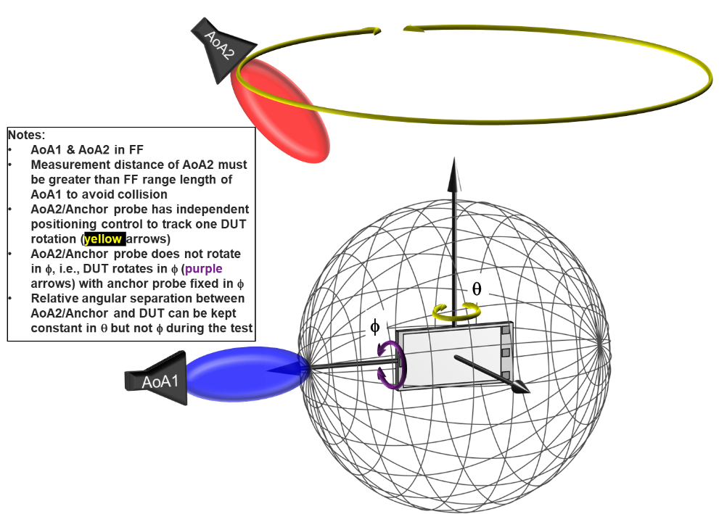
Figure 5.2.4-1: Example DFF measurement setup with full degrees of freedom for AoA1 with partial freedom of variable angular offset(s) between AoA1 and AoA2 with AoA2 in FF.
When AoA2 probes are placed in the NF of the DUT, e.g., using one or multiple link antennas as illustrated in the example illustration in Figure 5.2.4-2, similar aspects considered in the previous section apply here. The immediate seemingly advantage is that existing test systems could be used with some modifications to link antenna setups. However, as outlined in Clause 5.2.1, there are various disadvantages and testing considerations that need to be taken into account when the AoA2/anchor probe is in the NF
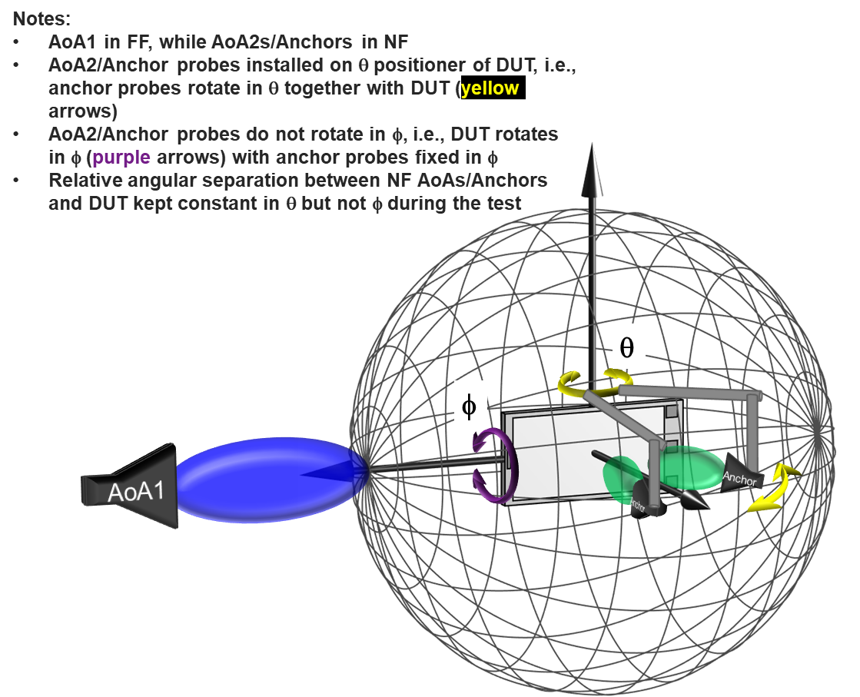
Figure 5.2.4-2: Example DFF measurement setup with full degrees of freedom for AoA1 with partial freedom of variable angular offset(s) between AoA1 and AoA2 with AoA2 in NF.
This measurement setup has its pros/cons summarized in Table 5.2.4-1.
Table 5.2.4-1: Overview of Measurement Setup
Description | Measurement Setup with Full Degrees of Freedom for AoA1 with Partial Freedom of Variable Angular Offset(s) between AoA1 and AoA2
Probe Offset Option | Full degrees of freedom for AoA1 with partial freedom of variable angular offset(s) between AoA1 and AoA2, e.g., relative angular separation between anchor and DUT kept constant in θ but not φ)
Pros | AoA1 & AoA2 probes in the FF  - N/A  AoA1 in FF with AoA2 probe(s)s in the NF  - Existing systems could potentially be re-used after some modifications
Cons | AoA1 & AoA2 probes in the FF  - High system complexity  - Existing systems cannot be re-used  - Large/very large chamber footprint/chamber heights  - Long development time/TTM  - AoA2 cannot follow/track a specific reference direction  AoA1 in FF with AoA2 probe(s)s in the NF  - Blocking of AoA1 in various directions by AoA2 probes  - Existing link antennas are not applicable; instead, very accurate positioning of the NF probe(s), high-end antenna probe(s), and the NF antenna pattern characterization are required  - Test-time intensive algorithms required to determine unknown offset of active antenna array(s) or  - Very extensive vendor declarations (location of all antenna panels and which sets of antenna panels are active for any given AoA2 measurement direction)  - The NF probe needs to guarantee the same DL conditions to both active DUT receivers as a FF probe would  - AoA2 cannot follow/track a specific reference direction

5.2.5 Measurement Setup with Full Degrees of Freedom for AoA1 with Fixed AoA2/Anchor in NF
An alternate measurement setup considered for multi-AoA UE RF testing is based on full degrees of freedom for AoA1 with fixed AoA2/Anchor located in the NF, sample measurement setups are shown in Figure 5.2.5-1.

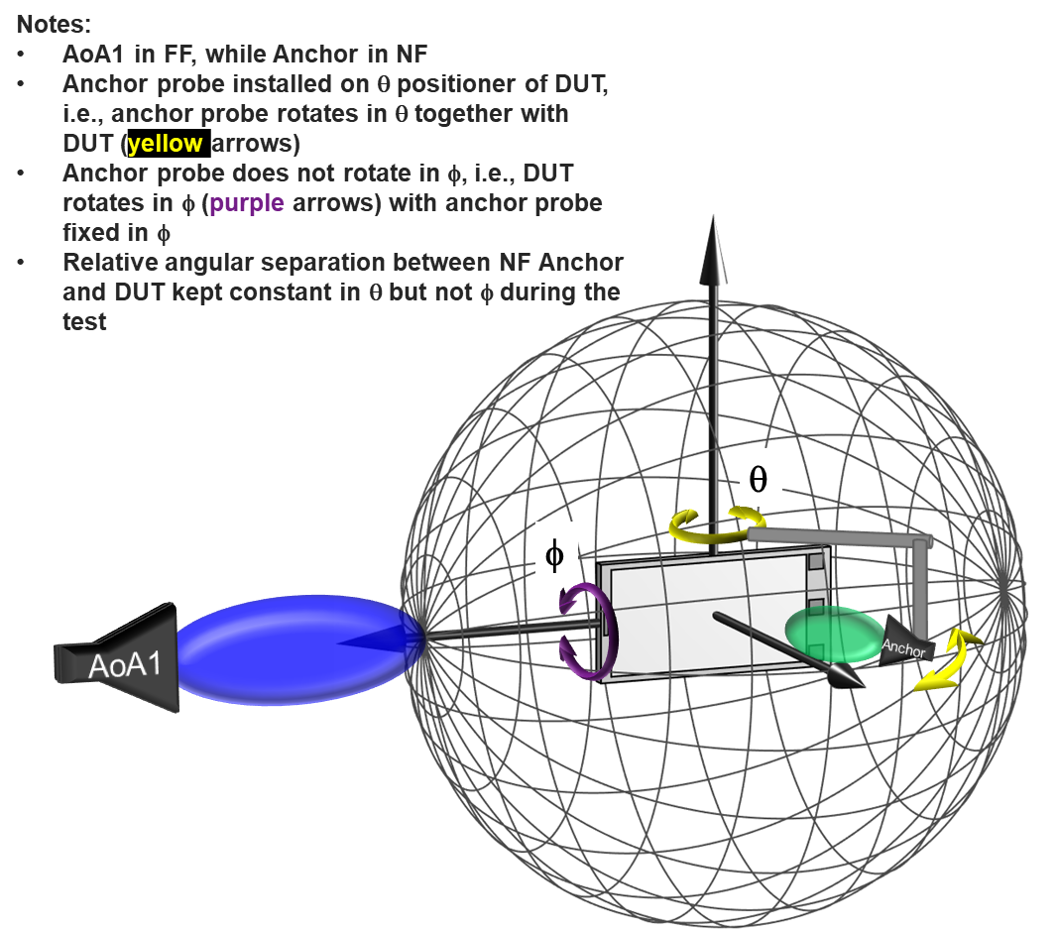
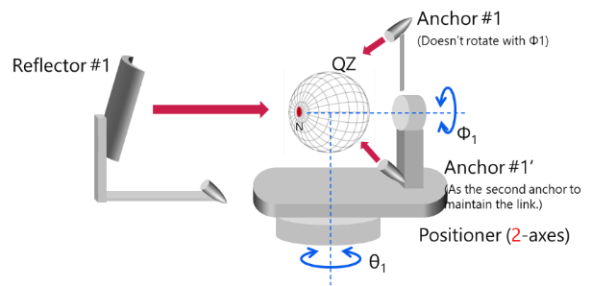
Figure 5.2.5-1: Example measurement setups with full degrees of freedom for AoA1 with fixed AoA2/Anchor in FF.
Many of the aspects discussed in Clause 5.2.4 apply here. This measurement setup has its pros/cons summarized in Table 5.2.5-1.

Table 5.2.5-1: Overview of Measurement Setup
Description | Full Degrees of Freedom for AoA1 with Fixed AoA2/Anchor in NF
Probe Offset Option | Full degrees of freedom for AoA1 with partial freedom of variable angular offset(s) between AoA1 and AoA2 or fixed angular offset
Pros | - Existing systems could potentially be re-used after some modifications
Cons | - Blocking of AoA1 in various directions by AoA2 probes  - Existing link antennas are not applicable; instead, very accurate positioning of the NF probe(s), high-end antenna probe(s), and the NF antenna pattern characterization are required  - Test-time intensive algorithms required to determine unknown offset of active antenna array(s) or  - Very extensive vendor declarations (location of all antenna panels and which sets of antenna panels are active for any given AoA2 measurement direction)  - The NF probe needs to guarantee the same DL conditions to both active DUT receivers as a FF probe would  - AoA2 cannot follow/track a specific reference direction

5.2.6 Measurement Setup with Test Modes
An alternate measurement setup considered for multi-AoA UE RF testing is based on full degrees of freedom for AoA1 with the use of test modes and performing tests sequentially.
The first approach (Method 1) is illustrated in Figure 5.2.6-1. Though this methodology cannot test a behaviour of the DUT with two simultaneous DLs from different AoAs, the idea behind this approach is to introduce a test command to fix the active antenna panel in the DUT and evaluate the RF characteristics of the DUT without increasing the complexity of the 1-AoA IFF test system. This approach would require OEMs to declare the number of integrated antennas at a minimum and require a new test mode dedicated for just this one conformance test.
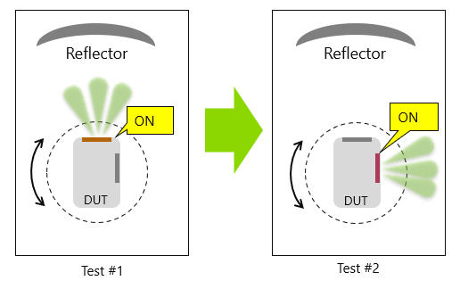
Figure 5.2.6-1: Example measurement setup (Method 1) with test mode to fix active antenna.
The second approach (Method 2) is illustrated in Figure 5.2.6-1 and based on the following high-level procedure:
- Perform Rx Beam peak search for AoA₁.
- Connect the SS (System Simulator) with the DUT through the measurement antenna to form the RX beam towards the RX beam peak direction and respective polarization found for AoA₁.
- SS activates the UE Beamlock Function (UBF) on AoA₁. If necessary, switch the connection of the SS from the measurement antenna to the link antenna.
- Perform Rx Beam peak search for AoA₂.
The idea behind this approach is to augment/modify the existing UE Beamlock Function (UBF), i.e., lock a beam connected to one receiver while a second connection is still possible with freedom on the direction and/or panel used.
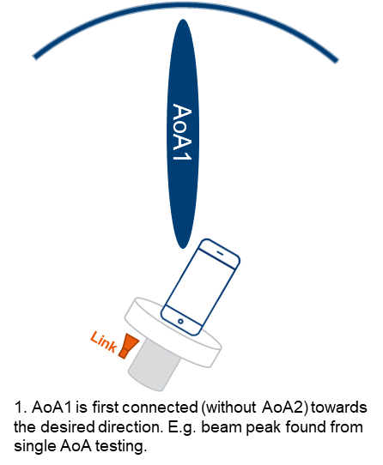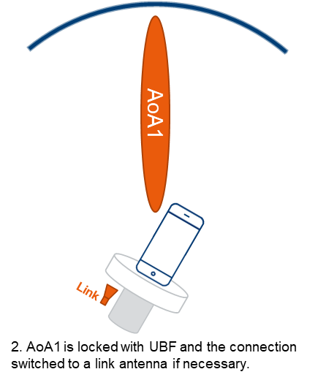
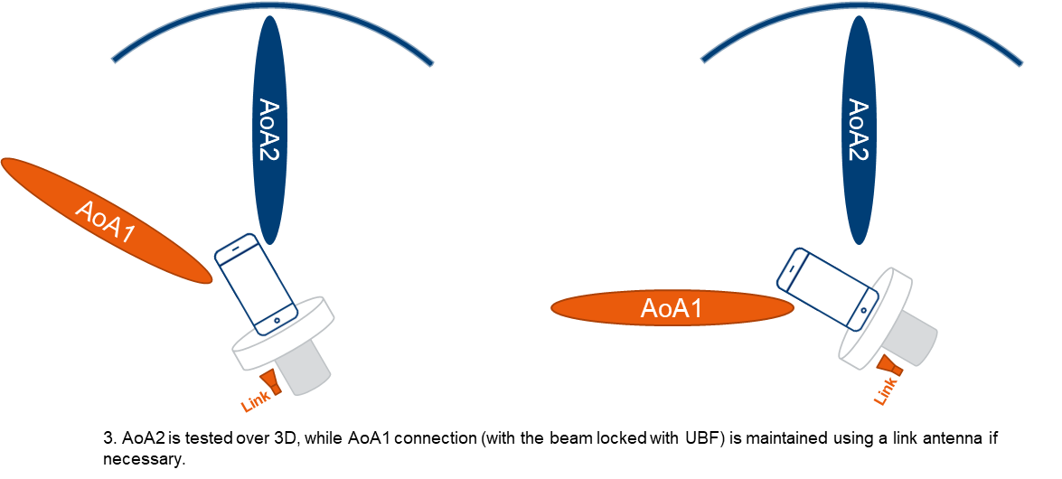
Figure 5.2.6-2: Example measurement setup (Method 2) with augmented UBF test mode.
Method 1 cannot verify the potential cross talk between two AoAs especially then the two AoAs are with a small angular separation. When performing sequential tests, the testing is not verifying the real performance of multi-Rx UEs. Method 2 does not suffer from these issues, but it was not concluded whether the measurements on the locked beam (i.e. AoA1 in Figure 5.2.6-2) may be impacted by the link antenna in the Near Field.

5.3 Test System Aspects

5.3.1 Absolute Probe Locations
A sample system with three different probe locations as shown in Figure 5.3.1-1 is investigated to provide detailed justification to define absolute probe locations/directions for Multi-AoA UE RF testing. The sample implementation has a 2-axis positioning system for the DUT to implement a 3D scan and three probes in the x, y, and z axes with the assumption that AoA1 is along z and AoA2 along x or y. The DL directions perceived by the DUT from each probe are illustrated with red, green, and red spheres on the DUT grid in the x, y, and z directions, respectively, for this initial test point of (θ, φ) = (0°, 0°).
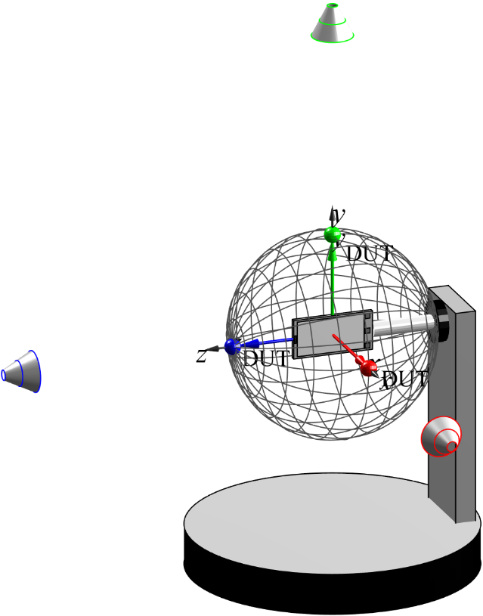
Figure 5.3.1-1: Sample measurement setup with three fixed probe locations for initial test point of (0°, 0°)
For the sample multi-AoA system investigated, the angular difference between AoA1 (z direction) and AoA2 (x direction) and between AoA1 (z direction) and AoA2 (y direction) is 90° in both cases. One could seemingly argue that the roll motor of the DUT (rotation around the DUT z axis) makes it irrelevant whether AoA2 is along the y or the x axis. However, once the device is rotated in 3D, i.e., θ and φ, this argument is no longer applicable which is further analysed and illustrated below. For a second sample device orientation of (θ, φ) = (45°, -45°), the perceived DL directions are illustrated on the rotated DUT grid in Figure 5.3.1-2. Clearly, a 90° rotation of the device around its z axis would no longer map the green sphere onto the red sphere.
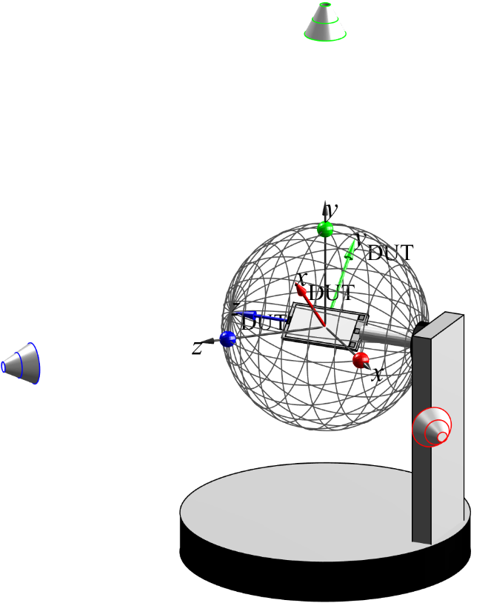
Figure 5.3.1-2: Sample measurement setup with three fixed probe locations for test point of (45°, -45°)
It is now assumed that the test points in 3D are based on a constant-step size grid with 266 unique grid points (Δθ=Δφ=15°), i.e., as defined for PC1 & PC3 spherical coverage test cases for 1-DL in Clause 5.3 of [6], or on a constant density grid with 200 unique grid points, i.e., as defined for PC1 spherical coverage test cases for 1-DL in Clause 5.3 of [6]. These test/grid points are visualized in Table 5.3.1-1.
Table 5.3.1-1: Visualization of spherical coverage test/grid points
Constant-step size grid with 266 unique grid points (Δθ=Δφ=15°) | Constant density grid with 200 unique grid points
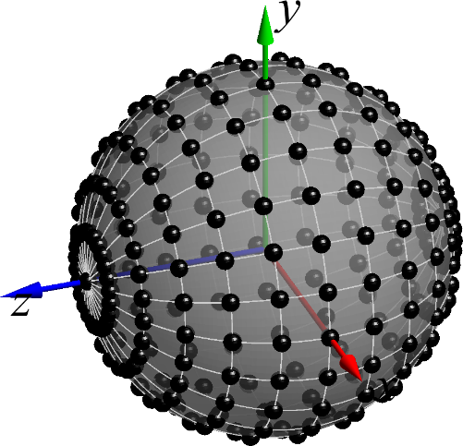 | 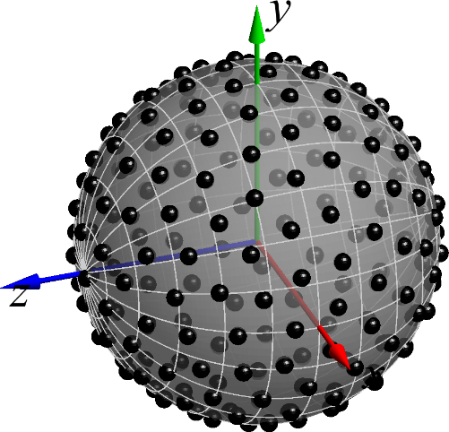
When all spherical coverage grid points are sampled with 0°≤θ≤180° and 0°≤φ≤360°, the DL directions perceived by the UE from the various probes are plotted in Table 5.3.1-2. Clearly, these results show vastly different results.
- For the probe aligned with the z axis, the perceived DL directions match the test points.
- For the probe aligned with the y axis, the DUT only perceives the DL in a single plane only, i.e., the DUT’s xy plane. This is due to the turntable axis of the OTA positioner aligned with the y axis, i.e., the turntable rotation merely changes the polarization but not the DL direction with this probe. The roll motor, i.e., the rotation of the DUT around its z axis, only adjusts the DL direction within the xy plane.
- For the AoA2 probe aligned with the x axis, the DL directions are perceived from different directions in (θ, φ) but limited to a single hemisphere only.
The plots of the perceived DL directions from different, fixed probes demonstrate the need to define the absolute probe locations/directions for UE RF systems so that different test systems yield the same results.
Table 5.3.1-2: DL directions perceived by the DUT from probes in the x, y, and z axes.
Probe Along Direction | DL Directions perceived by DUT with constant-step size grid with 266 unique grid points (Δθ=Δφ=15°) | DL Directions perceived by DUT with constant density grid with 200 unique grid points
z | 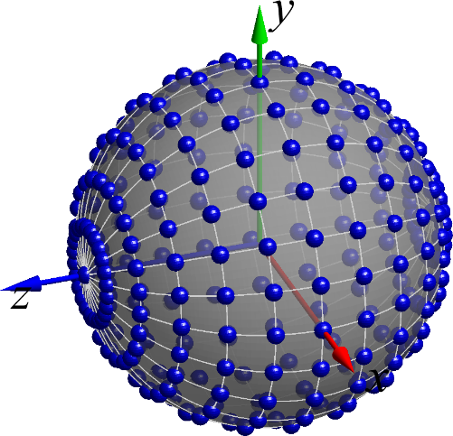 | 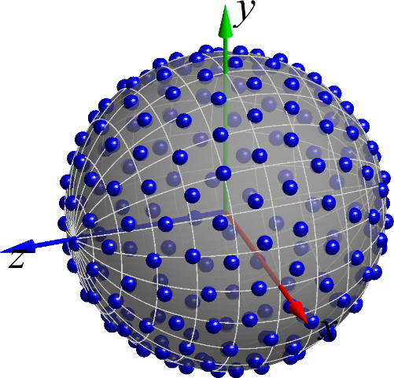
y | 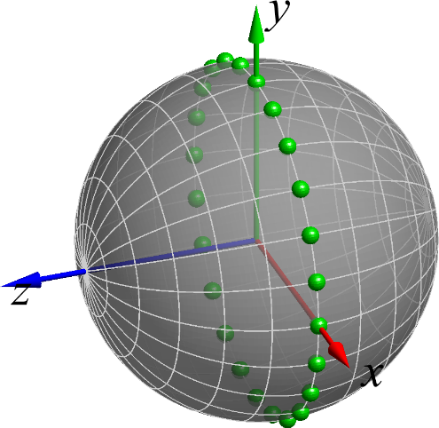 | 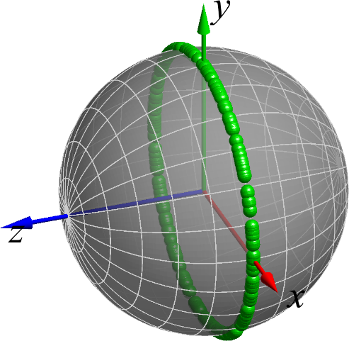
x | 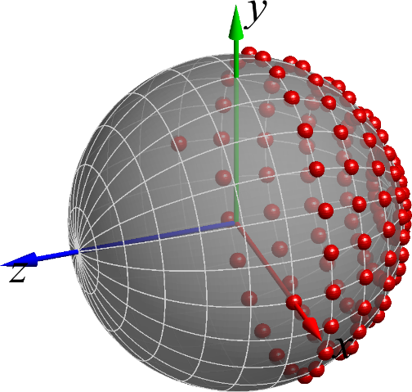 | 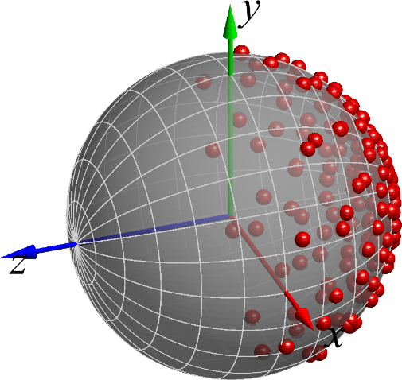

5.3.2 Minimum and Maximum Angular Separation between Probes
Editor’s Note: the maximum angular separation is FFS.
Due to the finite size of the probes, the minimum angular separation between probes will be limited to prevent collisions and thus prevent a “full” degree of rotation freedom of one AoA unless probes are placed back-to-back as illustrated in Figure 5.2.3-3 which on the other hand introduces blocking effects.
The minimum angular separation between neighbouring reflectors is larger than the minimum separation between two regular millimetre-wave probes as illustrated in Figure 5.3.2-1. It is estimated that the minimum angular separation between two IFF probes is about 30° while the minimum angular separation between two DFF probes is about 5°.
Although DFF is one of the permitted methodologies for FR2 OTA testing [10], IFF is the de-facto reference methodology for FR2 OTA measurements. To enable the applicability of IFF to multi-AoA UE RF testing, the largest minimum angular separation of DFF and IFF must be selected, i.e., the minimum angular separation between probes must be 30°.
Figure 5.3.2-1: Illustration of minimum angular separations between IFF (top) and DFF probes.

5.4 Calibration Measurement Procedure

5.4.1 Direct far field (DFF)
The calibration measurement per DFF probe is done by using a reference calibration antenna with known gain values. For the calibration measurement, the reference antenna is placed in the centre of the quiet zone. If an antenna with moving phase centre is used, a multi-segmented approach could be chosen where for multiple frequency segments the respective phase centre of the calibration antenna is placed in the centre of quiet zone. The calibration process determines the composite loss, L_{path,pol}, of the entire transmission and receiver chain path gains (measurement antenna, amplification) and losses (switches, combiners, cables, path loss, etc.). The calibration measurement is repeated for each measurement path (two orthogonal polarizations and each signal path). Additional details of the calibration procedure are outlined in [11].
5.4.2 Indirect far field (IFF)
The calibration measurement per IFF probe is done by using a reference antenna (SGH used in Figure 5.2.2.1-1) with known efficiency or gain values. In the calibration measurement the reference antenna is measured in the same place as the DUT, and the attenuation of the complete transmission path (C↔A, as in Figure 5.2.2.1-1) from the DUT to the measurement receiver (EIRP), and from the RF source to DUT (EIS) is calibrated out. Figure 5.2.2.1-1 presents a setup of a typical compact antenna test range for EIRP calibration per IFF probe:

6 UE RRM testing methodology for multi-Rx chain DL reception

6.1 General
<Editor’s note: general aspects related to the UE RRM testing methodology for multi-Rx chain DL reception can be captured in this clause>

6.2 Measurement setup
<Editor’s note: outcome of measurement setup for UE RF testing can be captured in this clause>

7 UE demodulation and CSI testing methodology for multi-Rx chain DL reception

7.1 General
<Editor’s note: general aspects related to the UE RRM testing methodology for multi-Rx chain DL reception can be captured in this clause>

7.2 Measurement setup
<Editor’s note: outcome of measurement setup for UE RF testing can be captured in this clause>

Annex A:
Measurement uncertainty

A.1 Measurement uncertainty budget for UE RF testing methodology
<Editor’s note: the outcome of MU budget for UE RF testing methodology can be captured in this clause>

A.2 Measurement uncertainty budget for UE RRM testing methodology
<Editor’s note: the outcome of MU budget for UE RRM testing methodology can be captured in this clause>

A.3 Measurement uncertainty budget for UE demodulation testing methodology
<Editor’s note: the outcome of MU budget for UE demodulation testing methodology can be captured in this clause>

Annex <X>:
Change history
This is the last annex for TS/TSs which details the change history using the following table.
This table is to be used for recording progress during the WG drafting process till TSG approval of this TS/TR.
For TRs under change control, use one line per approved Change Request
Date: use format YYYY-MM
CR: four digits, leading zeros as necessary
Rev: blank, or number (max two digits)
Cat: use one of the letters A, B, C, D, F
Subject/Comment: for TSs under change control, include full text of the subject field of the Change Request cover
New vers: use format [n]n.[n]n.[n]n

Change history
Date | Meeting | TDoc | CR | Rev | Cat | Subject/Comment | New version
2022-08 | R4#104e | R4-2213182 |  |  |  | Initial skeleton | 0.0.1
2022-03 | R4#106 | R4-2300085 |  |  |  | The following TPs were agreed:  - R4-2300086, TP on TR 38.871 for editorial correction and general aspects, Qualcomm Incorporated  - R4-2302924, TP to introduce Multi-AoA UE RF Test Aspects, Keysight Technologies UK Ltd  - R4-2302150, TP on TR 38.871 calibration measurement procedure, Huawei, HiSilicon | 0.1.0

