3GPP TS 38.151 V0.6.0 (2021-11)
Technical Specification

3rd Generation Partnership Project;
Technical Specification Group Radio Access Network;
NR;
Multiple Input Multiple Output (MIMO) Over-the-Air (OTA) performance requirements for NR UEs
(Release 17)

 | 
The present document has been developed within the 3rd Generation Partnership Project (3GPP TM) and may be further elaborated for the purposes of 3GPP.
The present document has not been subject to any approval process by the 3GPP Organizational Partners and shall not be implemented.
This Specification is provided for future development work within 3GPP only. The Organizational Partners accept no liability for any use of this Specification.
Specifications and Reports for implementation of the 3GPP TM system should be obtained via the 3GPP Organizational Partners' Publications Offices.

3GPP
Postal address

3GPP support office address
650 Route des Lucioles - Sophia Antipolis
Valbonne - FRANCE
Tel.: +33 4 92 94 42 00 Fax: +33 4 93 65 47 16
Internet
http://www.3gpp.org

Copyright Notification
No part may be reproduced except as authorized by written permission.
The copyright and the foregoing restriction extend to reproduction in all media.

© 2021, 3GPP Organizational Partners (ARIB, ATIS, CCSA, ETSI, TSDSI, TTA, TTC).
All rights reserved.

UMTS™ is a Trade Mark of ETSI registered for the benefit of its members
3GPP™ is a Trade Mark of ETSI registered for the benefit of its Members and of the 3GPP Organizational Partners
LTE™ is a Trade Mark of ETSI registered for the benefit of its Members and of the 3GPP Organizational Partners
GSM® and the GSM logo are registered and owned by the GSM Association

Contents
Foreword 4
1 Scope 6
2 References 6
3 Definitions of terms, symbols and abbreviations 6
3.1 Terms 6
3.2 Symbols 7
3.3 Abbreviations 7
4 General 8
4.1 Relationship between minimum requirements and test requirements 8
4.2 Applicability of minimum requirements 8
5 Frequency bands 8
5.1 General 8
5.2 Operating bands 8
6 FR1 MIMO OTA requirements 8
6.1 General 8
6.2 Minimum requirement 10
7 FR2 MIMO OTA requirements 10
7.1 General 10
7.2 Minimum requirement 10
Annex A (normative): <FR1 Test methodology> 11
Annex B (normative): <FR2 Test methodology> 14
Annex C (normative): <FR1 Channel models and Validation procedure> 20
Annex D (normative): <FR2 Channel models and Validation procedure > 35
Annex E (normative): <gNB configurations> 45
Annex F (normative): <Environmental requirements> 53
Annex G (informative): Change history 54

Foreword
This Technical Specification has been produced by the 3rd Generation Partnership Project (3GPP).
The contents of the present document are subject to continuing work within the TSG and may change following formal TSG approval. Should the TSG modify the contents of the present document, it will be re-released by the TSG with an identifying change of release date and an increase in version number as follows:
Version x.y.z
where:
x the first digit:
1 presented to TSG for information;
2 presented to TSG for approval;
3 or greater indicates TSG approved document under change control.
y the second digit is incremented for all changes of substance, i.e. technical enhancements, corrections, updates, etc.
z the third digit is incremented when editorial only changes have been incorporated in the document.
In the present document, modal verbs have the following meanings:
shall indicates a mandatory requirement to do something
shall not indicates an interdiction (prohibition) to do something
The constructions "shall" and "shall not" are confined to the context of normative provisions, and do not appear in Technical Reports.
The constructions "must" and "must not" are not used as substitutes for "shall" and "shall not". Their use is avoided insofar as possible, and they are not used in a normative context except in a direct citation from an external, referenced, non-3GPP document, or so as to maintain continuity of style when extending or modifying the provisions of such a referenced document.
should indicates a recommendation to do something
should not indicates a recommendation not to do something
may indicates permission to do something
need not indicates permission not to do something
The construction "may not" is ambiguous and is not used in normative elements. The unambiguous constructions "might not" or "shall not" are used instead, depending upon the meaning intended.
can indicates that something is possible
cannot indicates that something is impossible
The constructions "can" and "cannot" are not substitutes for "may" and "need not".
will indicates that something is certain or expected to happen as a result of action taken by an agency the behaviour of which is outside the scope of the present document
will not indicates that something is certain or expected not to happen as a result of action taken by an agency the behaviour of which is outside the scope of the present document
might indicates a likelihood that something will happen as a result of action taken by some agency the behaviour of which is outside the scope of the present document
might not indicates a likelihood that something will not happen as a result of action taken by some agency the behaviour of which is outside the scope of the present document
In addition:
is (or any other verb in the indicative mood) indicates a statement of fact
is not (or any other negative verb in the indicative mood) indicates a statement of fact
The constructions "is" and "is not" do not indicate requirements.

1 Scope
The present document establishes the Multiple Input Multiple Output (MIMO) Over-the-Air (OTA) performance requirements for NR UEs operating on frequency Range 1 and frequency rang 2, for NR standalone (SA) and NR non-standalone (NSA) operation mode. The corresponding test methodologies are also presented in the Annex of this Technical Specification.

2 References
The following documents contain provisions which, through reference in this text, constitute provisions of the present document.
- References are either specific (identified by date of publication, edition number, version number, etc.) or non-specific.
- For a specific reference, subsequent revisions do not apply.
- For a non-specific reference, the latest version applies. In the case of a reference to a 3GPP document (including a GSM document), a non-specific reference implicitly refers to the latest version of that document in the same Release as the present document.
[1] 3GPP TR 21.905: "Vocabulary for 3GPP Specifications".
[2] 3GPP TR 38.827: “Study on radiated metrics and test methodology for the verification of multi-antenna reception performance of NR User Equipment (UE)”.
[3] 3GPP TS 38.101-1: "NR; User Equipment (UE) radio transmission and reception; Part 1: Range 1 Standalone"
[4] 3GPP TS 38.101-2: "NR; User Equipment (UE) radio transmission and reception; Part 2: Range 2 Standalone"
[5] 3GPP TS 38.101-3: "NR; User Equipment (UE) radio transmission and reception; Part 3: Range 1 and Range 2 Interworking operation with other radios"
[6] 3GPP TS 36.101: "Evolved Universal Terrestrial Radio Access (E-UTRA); User Equipment (UE) radio transmission and reception"
[7] 3GPP TS 38.508-1: "5GS; User Equipment (UE) conformance specification; Part 1: Common test environment"
[8] 3GPP TR 38.901: "Study on channel model for frequencies from 0.5 to 100 GHz"
[9] F. Zhang, L. Hentilä, P. Kyösti and W. Fan, "Millimeter-wave New Radio Test Zone Validation for MIMO Over-the-air Testing," in IEEE Transactions on Antennas and Propagation, doi: 10.1109/TAP.2021.3111326.

3 Definitions of terms, symbols and abbreviations

3.1 Terms
For the purposes of the present document, the terms given in 3GPP TR 21.905 [1] and the following apply. A term defined in the present document takes precedence over the definition of the same term, if any, in 3GPP TR 21.905 [1].
PSP (PAS Similarity Percentage): The similarity of the PAS produced by the OTA system and the reference PAS, which is presented by the Total Variation Distance (TVD) of power angular spectrum (PAS). PSP is defined as (1-TVD)*100%. PSP=100% denotes full similarity and PSP=0% denotes full dissimilarity.

3.2 Symbols
For the purposes of the present document, the following symbols apply:
Symbol format (EW)
<symbol> <Explanation>

3.3 Abbreviations
For the purposes of the present document, the abbreviations given in 3GPP TR 21.905 [1] and the following apply. An abbreviation defined in the present document takes precedence over the definition of the same abbreviation, if any, in 3GPP TR 21.905 [1].

AOA Azimuth angle Of Arrival
AOD Azimuth angle Of Departure
BS Base Station
CDL Clustered Delay Line
DML Data Mode Landscape
DMP Data Mode Portrait
DMSU Data Mode Screen Up
EUT Equipment Under Test
FR1 Frequency Range 1
FR2 Frequency Range 2
FS Free Space
MASC MIMO Average Spherical Coverage
MIMO Multiple Input Multiple Output
MPAC Multi-Probe Anechoic Chamber
NR New Radio
NSA Non-Standalone, a mode of operation where operation of an other radio is assisted with an other radio
OTA Over The Air
PAS Power Angular Spectrum
PDP Power Delay Profile
PSP PAS Similarity Percentage
TRMS Total Radiated Multi-antenna Sensitivity
UE User Equipment
UMa Urban Macro
UMi Urban Micro
XPR Cross-Polarization Ratio
ZOA Zenith angle Of Arrival
ZOD Zenith angle Of Departure
ZSA Zenith angle Spread of Arrival
ZSD Zenith angle Spread of Departure

4 General

4.1 Relationship between minimum requirements and test requirements
The Minimum Requirements given in this specification make no allowance for measurement uncertainty. The test specification in RAN5 will define test tolerances for FR1 and FR2 MIMO OTA. The test tolerances are used to relax the minimum requirements in this specification to create test requirements.

4.2 Applicability of minimum requirements
<Editor’s note: Detailed structure of the subclause is TBD. >

5 Frequency bands

5.1 General
NR MIMO OTA Requirements are defined separately for different frequency ranges (FR). The frequency ranges in which NR can operate according to this version of the specification are identified as described in Table 5.1-1.
Table 5.1-1: Definition of frequency ranges
Frequency range designation | Corresponding frequency range
FR1 | 410 MHz – 7125 MHz
FR2 | 24250 MHz – 52600 MHz
The present specification covers both FR1 and FR2 operating bands.

5.2 Operating bands
NR is designed to operate in FR1 operating bands defined in TS 38.101-1 [3] and FR2 operating bands defined in TS 38.101-2 [4]. NSA band combinations are defined in TS 38.101-3 [5]. E-UTRA is designed to operate in operating bands defined in TS 36.101 [6].

6 FR1 MIMO OTA requirements

6.1 General

6.1.1 Definition of MIMO throughput
The MIMO throughput is defined here as the time-averaged number of correctly received transport blocks in a communication system running an application, where a Transport Block is defined in the reference measurement channel. From OTA perspective, this is also called MIMO OTA throughput. It will be used as the baseline figure of merit for FR1 and FR2 MIMO OTA testing.
The MIMO OTA throughput is measured at the top of physical layer of NR system under the use of FRC, the SS transmit fixed-size payload bits to the DUT. The DUT signals back either ACK or NACK to the SS. The SS then records the following:
− Number of ACKs,
− Number of NACKs, and
− Number of DTX slots
Hence the MIMO (OTA) throughput can be calculated as
Where Transmitted TBS is the Transport Block Size transmitted by the SS, which is fixed for a FRC during the measurement period. MeasurementTime is the total composed of successful slots (ACK), unsuccessful slots (NACK) and DTX-symbols.
The time-averaging is to be taken over a time period sufficiently long to average out the variations due to the fading channel. Therefore, this is also called the average MIMO OTA throughput. The throughput should be measured at a time when eventual start-up transients in the system have evanesced.

6.1.2 Total Radiated Multi-antenna Sensitivity (TRMS)
The average TRMS of free space data mode portrait (FS DMP), free space data mode landscape (FSDML), and free space data mode screen up (FS DMSU), is defined as the FR1 MIMO OTA requirement. The averaging shall be done in linear scale for the TRMS results at these DUT positions, according to the formula:
where
Such that MODE is one of {FS_DMP, FS_DML, FS_DMSU}, and {P_{MODE,70,0}, …, P_{MODE,70,11}} are the measured sensitivity values at each azimuth position at the 70% throughput outage.
If 1 azimuth position does not result in a defined measured sensitivity at 70% throughput, S_{MODE,70} is calculated using the 11 measured sensitivities and the maximum downlink RS-EPRE P_{RS-EPRE-MAX} (substitution approach) for the one missing result. P_{RS-EPRE-MAX} is the maximum downlink RS-EPRE supported by the test system, and is defined as [-80dBm/15kHz (or equivalent 77dBm/30kHz)] for FR1 MIMO OTA.
The TRMS shall be measured at the mid channel as specified in TS 38.508-1 subclause 4.3.1 [7]. The average TRMS shall be lower than the average TRMS requirements specified in Clause 6.2.
The additional criterion in azimuthal orientations shall be met:
- The EUT must meet 70% throughput in 11 of total 12 azimuthal orientations. If the EUT fails to meet this criterion even under maximum downlink power condition (i.e. P_{RS-EPRE-MAX}), the EUT shall fail the FR1 MIMO OTA test.
- The EUT must meet 90% throughput in [10] of total 12 azimuthal orientations. If the EUT fails to meet this criterion even under maximum downlink power condition (i.e. P_{RS-EPRE-MAX}), the EUT shall fail the FR1 MIMO OTA test.
Note: whether define different criterion on 90%TP for bands ≥3GHz and Bands <3GHz is FFS.

6.2 Minimum requirement
<Editor’s note: Detailed structure of the subclause is TBD. Subclause for SA and EN-DC bands can be added>

7 FR2 MIMO OTA requirements

7.1 General

7.1.1 MIMO Average Spherical Coverage (MASC)
The MIMO Average Spherical Coverage (MASC) is the Figure of Merit of FR2 MIMO OTA requirement. FR2 MIMO OTA is measured with 36 constant-density points within the 3D sphere. The MASC is determined by the averaging of the best 18 sensitivity values for power class 3 UE. The averaging shall be done in linear scale for the MASC result according to the formula:

$$MASC_{70}=10\log\left[\frac{18}{\left(\frac{1}{10^{\frac{P_{70,1}}{10}}}+\frac{1}{10^{\frac{P_{70,2}}{10}}}+⋅⋅⋅+\frac{1}{10^{\frac{P_{70,18}}{10}}}\right)}\right]$$

Such that {P_{70,1}, …, P_{70,18}} are the best 18 sensitivity values from all the 36 constant density measurement points, as defined in Annex B.2.3, as defined in Annex B.2.3.
The MASC shall be measured at the mid channel as specified in TS 38.508-1 subclause 4.3.1 [7]. The MASC shall be lower than the requirements specified in Clause 7.2.
If the number of test points where the UE can meet 70% maximum throughput outage is less than TBD, then UE fails the test.
Other criteria for FR2 are FFS.

7.2 Minimum requirement
<Editor’s note: Detailed structure of the subclause is TBD. >

Annex A (normative):
<FR1 Test methodology>

A.1 General
FR1 MIMO OTA requirement testing is based on UE-noise limited environmental condition, i.e., UE throughput characterized as a function of signal power incident to the DUT antennas.
The minimum test zone size for FR1 MIMO OTA test methods is 20cm. “Black-box” testing approach is adopted for NR MIMO OTA testing, the physical centre of the EUT shall be placed in the centre of the test zone, the EUT shall be completely contained within the minimum test zone size.

A.2 Multi-Probe Anechoic Chamber (MPAC)

A.2.1 system setup
MPAC test method is the reference methodology for FR NR MIMO OTA testing. By arranging an array of antennas around the Equipment Under Test (EUT), a spatial distribution of angles of arrival in MPAC system may be simulated to expose the EUT to a near field environment that appears to have originated from a complex multipath far field environment.
As illustrated schematically in Figure A.2.1-1, signals propagate from the base station/communication tester to the EUT through a simulated multipath environment known as a spatial channel model, where appropriate channel impairments such as Doppler and fading are applied to each path prior to injecting all of the directional signals into the chamber simultaneously through the antenna array. The resulting field distribution in the test zone is then integrated by the EUT antenna(s) and processed by the receiver(s) just as it would do so in any non-simulated multipath environment. MPAC system with 16 uniformly-spaced dual-polarized probes is permitted for NR FR1 MIMO OTA testing.
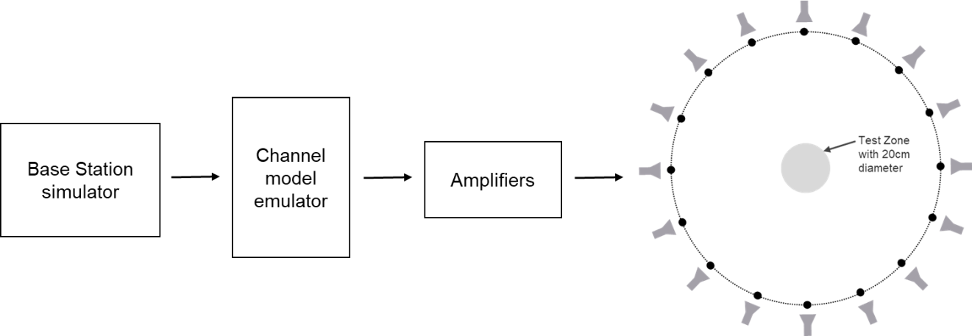
Figure A.2.1-1: MPAC system layout for NR FR1 MIMO OTA testing

A.2.2 Calibration procedure
The system needs to be calibrated by using a reference calibration antenna with known gain values in order to ensure that the downlink signal power is correct. In non-standalone (NSA) mode, the LTE link antenna provides a stable LTE signal without precise path loss or polarization control.
Unlike traditional TRP/TRS testing where the path loss corrections can all be applied as a post processing step to the measured data, the path loss for each probe in the MPAC system must be balanced at test time in order to generate the desired channel model environment within the test zone of the chamber. The imbalance of each path during testing would result in an alteration of the angular dependence of the channel model (i.e. varied characteristics of generated channel model) within the test zone of the chamber.
1. Place a vertical reference dipole in the centre of the test zone, connected to a VNA port, with the other VNA port connected to the input of the channel emulator unit.
2. Configure the channel emulator for bypass mode.
3. Measure the response of each path from each vertical polarization probe to the reference antenna in the centre of test zone.
4. Adjust the power on all vertical polarization branches of the channel emulator so that the powers received at the centre are equal.
5. Repeat the steps 1 to 4 with the magnetic loop or horizontally polarized reference dipole instead, and adjust the horizontal polarization branches of the channel emulator.
6. The worst-case path loss becomes the reference path loss of the entire system, this loss is used to compute the power in the centre of the test zone relative to the output power of the Base Station simulator. Besides, based on the reference path loss, the relative offset of each path loss shall be corrected.
Note: calibration based on other antennas, e.g., horn antennas is not precluded.

A.2.3 Test procedure
Before throughput testing, the initial conditions shall be confirmed to reach the correct measurement state for each test case.
1. Ensure environmental requirements of Annex F are met.
2. Configure the test system according to Annex C, D and E for the applicable test case.
3. Verify the implementation of the channel model as specified in Annex C.3.
4. Position the UE in the chamber according to Annex A.3.
5. Power on the UE.
6. Set up the connection.
Note: For step 3, the verification of the channel model implementation is usually performed once for each channel model as part of the laboratory accreditation process, and will remain valid as long as the setup and instruments remain unchanged. Otherwise the channel model validation may need to be performed prior to starting each throughput test.
For throughput testing, the following steps shall be followed in order to evaluate NR MIMO OTA performance of the DUT:
1. Measure MIMO OTA throughput from one measurement point, the maximum downlink power P_{RS-EPRE-MAX} is defined in Clause 6.1.2. MIMO OTA throughput is the minimum downlink signal power resulting in a pre-defined throughput value, i.e., 70% and 90% of the maximum theoretical throughput. The downlink signal power step size shall be no more than 0.5 dB when RF power level is near the NR MIMO sensitivity level.
2. Rotate the UE around vertical axis of the test system by 30 degrees and repeat from step 1 until one complete rotation has been measured i.e. 12 different UE azimuth rotations.
3. Repeat the test from step 1 for each specified device orientation. A list of orientations is given in Annex A.3.
4. The postprocessing method to calculate the average MIMO Throughput is defined in Clause 6.
Note: For step 1 of throughput testing, the measurement is not needed to start from maximum downlink power each time. To save testing time, the starting downlink power can be set as a proper value (lower than maximum downlink power supported by test system) as long as all the throughput curve curves at 12 different UE azimuth rotations can reach at least 90% of the maximum theoretical throughput.

A.2.4 Minimum Range Length
The minimum range length of FR1 MPAC system is defined as the distance from the centre of the test zone to the aperture of the measurement probes/antennas, as illustrated in Figure A.2.4-1.
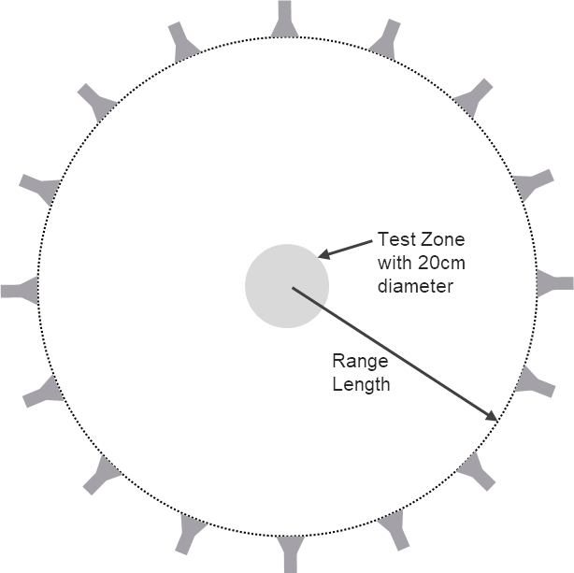
Figure A.2.4-1: Illustration of range length definition of FR1 MPAC
The minimum range length for NR FR1 MPAC OTA systems with 20cm test zone size is 1.2m. While for MPAC systems, the far-field requirements do not have to apply, it was shown that the spatial correlation can be impacted significantly for distances below 1.2m.

A.2.5 Example MU of FR1 MPAC system
<Editor’s note: Detailed structure of the subclause is TBD. >

A.3 EUT positioning
This Clause defines the measurement coordinate system for the NR MIMO OTA.
For FR1 MIMO OTA, the DUT shall be tested under Free Space Data Mode Portrait (FS DMP), Free Space Data Mode Landscape (FS DML), and Free Space Data Mode Screen Up flat (FS DMSU), the DUT azimuthal rotation shall be performed over 360 degrees per orientation in 30 degree steps (12 total positions).

Annex B (normative):
<FR2 Test methodology>

B.1 General
FR2 MIMO OTA requirement testing is based on UE-noise limited environmental condition, i.e., UE throughput characterized as a function of signal power incident to the DUT antennas.
The minimum test zone size for FR2 MIMO OTA 3D-MPAC system is 20cm. “Black-box” testing approach is adopted for NR MIMO OTA testing, the physical centre of the EUT shall be placed in the centre of the test zone, the EUT shall completely contained within the minimum test zone size.

B.2 FR2 3D Multi-Probe Anechoic Chamber (3D-MPAC)

B.2.1 system setup
The 3D MPAC test method is the reference methodology for FR2 NR MIMO OTA testing. By arranging an array of antennas around the Equipment Under Test (EUT), a spatial distribution of angles of arrival in the 3D MPAC system may be simulated to expose the EUT to a near field environment that appears to have originated from a complex multipath far field environment.
As illustrated schematically in Figure B.2.1-1, signals propagate from the base station/communication tester to the EUT through a simulated multipath environment known as a spatial channel model, where appropriate channel impairments such as Doppler and fading are applied to each path prior to injecting all of the directional signals into the chamber simultaneously through the probe array. The resulting field distribution in the test zone is then integrated by the EUT antenna(s) and processed by the receiver(s) just as it would do so in any non-simulated multipath environment. The 3D MPAC system with 6 dual-polarized probes (illustrated with black dots in Figure B.2.1-1) placed on a sector with minimum radius of 0.75m from the centre of the test zone is permitted for NR FR2 MIMO OTA testing.
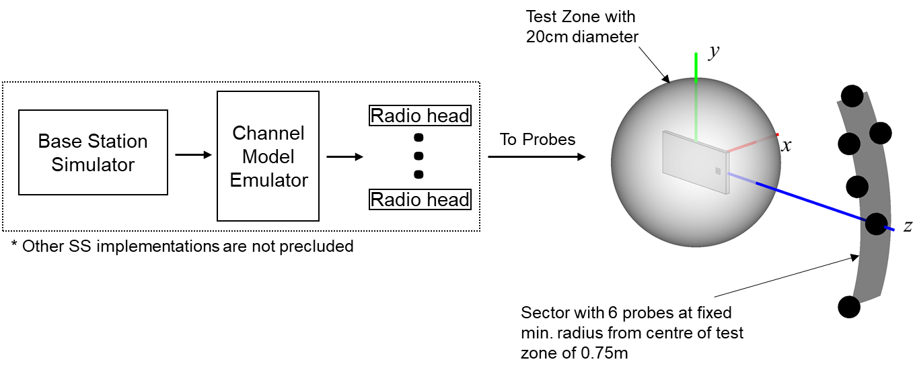
Figure B.2.1-1: 3D MPAC system layout for NR FR2 MIMO OTA testing
The exact probe locations with respect to the OTA test system coordinate system are tabulated in Table B.2.1-1.
Table B.2.1-1. FR2 3D MPAC Probe Locations in OTA test system coordinate system
Probe Number | Theta [deg] | Phi  [deg]
1 | 0.0 | 0.0
2 | 11.2 | 116.7
3 | 20.6 | -104.3
4 | 20.6 | 104.3
5 | 20.6 | 75.7
6 | 30.0 | 90.0

The 3D MPAC probes in Table B.2.1-1 can be implemented using conventional millimetre-wave probes as well as IFF-based probes as long as the same probe configuration and same number of probes is used.
The channel model parameters and probe locations for channel model implementation are defined in a channel model coordinate system, which is illustrated in figure B.2.1-2. The channel model coordinate axes x_{CM}, y_{CM}, and z_{CM} correspond to the OTA test system coordinate axes z, y, and -x, respectively.
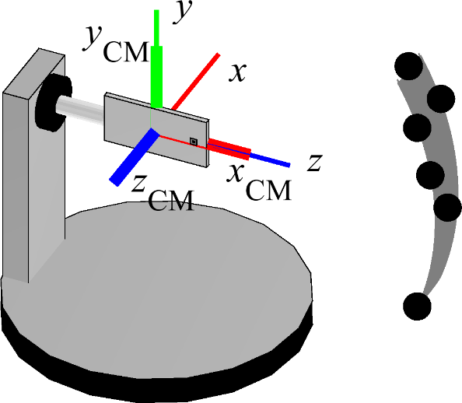
Figure B.2.1-2: Channel Model Coordinate Axes in FR2 3D-MPAC system
The probe locations with respect to channel model coordinate axes are tabulated in table B.2.1-2.
Table B.2.1-2. FR2 3D MPAC Probe Locations in Channel Model Coordinate System
Probe Number | Theta [deg] | Phi [deg]
1 | 90 | 0
2 | 85 | 10
3 | 85 | -20
4 | 85 | 20
5 | 95 | 20
6 | 90 | 30
The channel model rotations assumed for this probe configuration are tabulated in Table B.2.1-3.
Table B.2.1-3. Channel Model Rotations
UMi CDL-C
Phi [deg] | Theta [deg]
32 | 15.0

This channel model rotation assumes the relative orientations of BS and UE antennas displayed in Figure B.2.1-3, i.e., the DUT antenna is pointed towards the BS in channel model coordinate system.
In order to avoid positioning ambiguities, the turntable implementing the rotation in θ shall match the intended DUT θ for P0 Orientation 1 without the re-positioning approach, as defined in Annex A.3 in [2], applied. With the re-positioning approach applied, the relative orientation between the DUT and the probes for P0 Orientation 2 shall be the same the relative orientation between DUT and probes as for P0 Orientation 1.

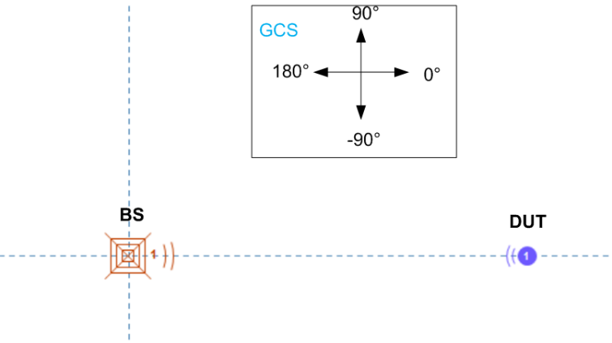
Figure B.2.1-3: Relative orientations of BS and UE antennas.
Since the test points are uniformly spaced in 3D already, Table B.2.3-1, there is no need to adjust/rotate the DUT rotations by the channel model rotations.

B.2.2 Calibration procedure
The system needs to be calibrated by using a reference calibration antenna with known gain values in order to ensure that the downlink signal power is correct. In non-standalone (NSA) mode, the LTE link antenna provides a stable LTE signal without precise path loss or polarization control.
The path loss for each probe in the 3D MPAC system must be calibrated at test time in order to generate the desired channel model environment within the test zone of the chamber. The imbalance of each path during testing would result in an alteration of the angular dependence of the channel model (i.e. varied characteristics of generated channel model) within the test zone of the chamber.
For the calibration measurement, the reference antenna is placed in the centre of the quiet zone, connected to a VNA port, with the other VNA port connected to the input of the channel emulator unit as illustrated schematically in Figure D.3.2-1. For each probe antenna, the reference antenna needs to be aligned in polarization, i.e., θ or φ, and direction with the probe antenna that corresponds to the respective path to be calibrated. For each calibration measurement, the channel emulator needs to be configured in bypass mode. The calibration process determines the composite loss, Lpath,pol, of the entire receiver chain path gains (measurement antenna, amplification) and losses (switches, combiners, cables, path loss, etc.). The calibration measurement is repeated for each measurement path (two orthogonal polarizations and each signal path).

B.2.3 Test procedure
Before throughput testing, the initial conditions shall be confirmed to reach the correct measurement state for each test case.
1. Ensure environmental requirements of Annex F are met.
2. Configure the test system according to Annex E.2 and Annex D.1 for the applicable test case.
3. Verify the implementation of the channel model as specified in Annex D.3.
4. Position the UE in the chamber according to Annex B.3.
5. Power on the UE.
6. Set up the connection.
Note: For step 3, the verification of the channel model implementation is usually performed once for each channel model as part of the laboratory accreditation process, and will remain valid as long as the setup and instruments remain unchanged. Otherwise the channel model validation may need to be performed prior to starting each throughput test.
For throughput testing, the following steps shall be followed in order to evaluate FR2 MIMO OTA performance of the DUT:
1. Position the DUT in the default P0 alignment option (Orientation 1), as defined in Annex A.3 in TR38.827 [2].
2. Measure MIMO OTA throughput, the maximum downlink power is TBD. MIMO OTA throughput is the minimum downlink signal power resulting in a pre-defined throughput value (70%) of the maximum theoretical throughput. The downlink signal power step size shall be no more than 0.5 dB when RF power level is near the NR MIMO sensitivity level.
3. Rotate the UE to the next test point. Table B.2.3-1 lists 36 evenly spaced test points determined using the charged particle approach and with test point #1 centred at (0,0).
4. Repeat the test from step 2 for each specified test point. If the re-positioning concept is applied, the device needs to be positioned in P0 Orientation 2 (either option 1 or option 2).
5. The postprocessing method and the performance metric are defined in Clause 7.1.
Table B.2.3-1. Evenly spaced FR2 test points with a constant density
Test Point Number | Theta [deg] | Phi [deg]
1 | 0.0 | 0.0
2 | 33.5 | 139.7
3 | 33.9 | 49.7
4 | 35.5 | -142.9
5 | 35.5 | -76.9
6 | 37.6 | -17.2
7 | 52.3 | 94.7
8 | 56.9 | 175.7
9 | 62.5 | 20.4
10 | 63.7 | -99.8
11 | 67.1 | -55.0
12 | 69.3 | -139.5
13 | 69.5 | 130.1
14 | 70.3 | 60.8
15 | 72.1 | -16.2
16 | 88.7 | -167.5
17 | 88.7 | 98.5
18 | 89.3 | 157.0
19 | 93.9 | -78.9
20 | 94.6 | 31.6
21 | 95.3 | -115.6
22 | 99.6 | -38.3
23 | 103.8 | -1.1
24 | 104.4 | 66.3
25 | 110.1 | 127.5
26 | 115.1 | -145.6
27 | 120.8 | 171.9
28 | 125.3 | -60.7
29 | 128.2 | -104.1
30 | 128.8 | 91.3
31 | 129.9 | 35.8
32 | 136.0 | -13.4
33 | 145.8 | 138.1
34 | 150.2 | -153.3
35 | 160.6 | -67.4
36 | 161.7 | 59.1

B.2.4 Minimum Range Length
The minimum range length of FR2 MPAC system is defined as the distance from the centre of the test zone to the aperture of the measurement probes/antennas, as illustrated in Figure B.2.4-1.
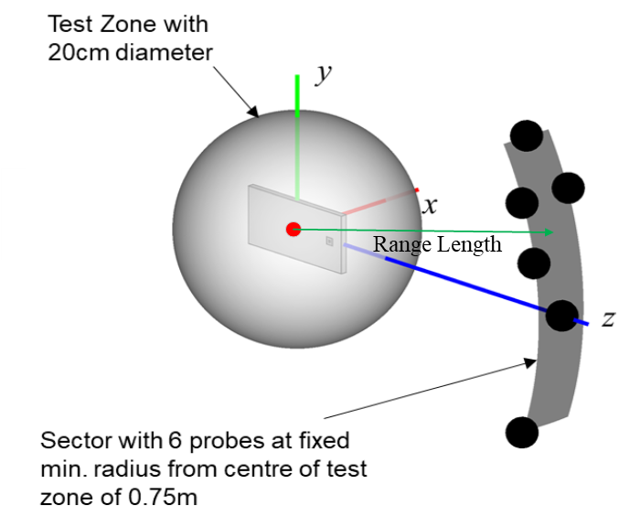
Figure B.2.4-1: Illustration of range length definition of FR2 3D-MPAC
The minimum range length for NR FR2 MPAC OTA systems with 20cm test zone size is 0.75m. It was shown that the PSP can be reduced significantly for distances below 0.75m.

B.2.5 Example MU of FR2 3D-MPAC system
<Editor’s note: Detailed structure of the subclause is TBD. >

B.3 EUT positioning
This Clause defines the measurement coordinate system for the NR MIMO OTA.
For FR2 MIMO OTA, the DUT shall be tested using a 3D scan. With the DUT positioned in the default P0 alignment option, as defined in Annex A.3 in [2], measurements on 36 evenly spaced test points with a constant density shall be performed.

Annex C (normative):
<FR1 Channel models and Validation procedure>

C.1 FR1 Channel models
The following channel models are required for FR1 MIMO OTA measurement.
The generic models are Table C.1-1 FR1 UMi CDL-C and Table C.1-2 FR1 UMa CDL-C, which do not include base station antenna filtering. UMi CDL-C and UMa CDL-C are selected to define 2x2 and 4x4 MIMO OTA requirements, respectively.
Therefore, in addition, the BS beam filtering effect defined in Annex C.2 also apply when emulating the channel models.
Table C.1-1: Channel model parameters for UMi CDL-C at 3.5 GHz
Cluster # | Absolute Delay [ns] | Power in [dB] | AOD in [°] | AOA in [°] | ZOD in [°] | ZOA in [°]
1 | 0 | -4.4215 | -36.1891 | -122.2815 | 98.9242 | 90
2 | 20.99 | -1.25 | -21.5937 | 125.831 | 99.1915 | 90
3 | 22.19 | -3.4684 | -21.5937 | 125.831 | 99.1915 | 90
4 | 23.29 | -5.2294 | -21.5937 | 125.831 | 99.1915 | 90
5 | 21.76 | -2.5215 | -32.5709 | -143.6126 | 99.5732 | 90
6 | 63.66 | 0 | -7.4275 | 166.4003 | 99.306 | 90
7 | 64.48 | -2.2185 | -7.4275 | 166.4003 | 99.306 | 90
8 | 65.6 | -3.9794 | -7.4275 | 166.4003 | 99.306 | 90
9 | 65.84 | -7.4215 | 37.2175 | 73.8315 | 100.4513 | 90
10 | 79.35 | -7.1215 | -47.1664 | 82.7664 | 98.5616 | 90
11 | 82.13 | -10.7215 | 41.5716 | -79.6999 | 100.6231 | 90
12 | 93.36 | -11.1215 | -67.1585 | 66.9895 | 98.218 | 90
13 | 122.85 | -5.1215 | -41.5244 | 84.0543 | 100.165 | 90
14 | 130.83 | -6.8215 | -47.0437 | -96.2818 | 100.2604 | 90
15 | 217.04 | -8.7215 | -55.7519 | 94.8406 | 98.1225 | 90
16 | 271.05 | -13.2215 | 55.3698 | 53.9494 | 100.2604 | 90
17 | 425.89 | -13.9215 | 53.2234 | 16.0364 | 98.4852 | 90
18 | 460.03 | -13.9215 | 46.8456 | 32.2963 | 98.1416 | 90
19 | 549.02 | -15.8215 | -70.1021 | 18.2098 | 97.9698 | 90
20 | 560.77 | -17.1215 | 48.9306 | 37.0455 | 100.7376 | 90
21 | 630.65 | -16.0215 | 49.6052 | 33.7452 | 98.1225 | 90
22 | 663.74 | -15.7215 | 57.7615 | 29.801 | 98.1034 | 90
23 | 704.27 | -21.6215 | 65.6725 | 11.6092 | 100.4513 | 90
24 | 865.23 | -22.8215 | -83.5324 | 56.2837 | 100.9476 | 90
Per-Cluster Parameters
Parameter | CASD in [°] | CASA in [°] | CZSD in [°] | CZSA in [°] | XPR in [dB]
Value | 1.2265 | 12.0742 | 0.5726 | 0 | 7

Table C.1-2: Channel model parameters for UMa CDL-C at 3.5 GHz
Cluster # | Absolute Delay [ns] | Power in [dB] | AOD in [°] | AOA in [°] | ZOD in [°] | ZOA in [°]
1 | 0 | -4.4215 | -37.4195 | -96.4031 | 96.7645 | 90
2 | 76.6135 | -1.25 | -21.7362 | 118.7405 | 98.4506 | 90
3 | 80.9935 | -3.4684 | -21.7362 | 118.7405 | 98.4506 | 90
4 | 85.0085 | -5.2294 | -21.7362 | 118.7405 | 98.4506 | 90
5 | 79.424 | -2.5215 | -33.5316 | -124.0196 | 100.8594 | 90
6 | 232.359 | 0 | -6.5142 | 171.2639 | 99.1732 | 90
7 | 235.352 | -2.2185 | -6.5142 | 171.2639 | 99.1732 | 90
8 | 239.44 | -3.9794 | -6.5142 | 171.2639 | 99.1732 | 90
9 | 240.316 | -7.4215 | 41.4581 | 51.4188 | 106.3995 | 90
10 | 289.6275 | -7.1215 | -49.2149 | 62.9864 | 94.4761 | 90
11 | 299.7745 | -10.7215 | 46.1367 | -41.2744 | 107.4834 | 90
12 | 340.764 | -11.1215 | -70.697 | 42.5606 | 92.3083 | 90
13 | 448.4025 | -5.1215 | -43.1524 | 64.6538 | 104.5929 | 90
14 | 477.5295 | -6.8215 | -49.0831 | -62.7423 | 105.1951 | 90
15 | 792.196 | -8.7215 | -58.4403 | 78.6184 | 91.7061 | 90
16 | 989.3325 | -13.2215 | 60.9633 | 25.6781 | 105.1951 | 90
17 | 1554.4985 | -13.9215 | 58.6569 | -23.4063 | 93.9944 | 90
18 | 1679.1095 | -13.9215 | 51.8037 | -2.3553 | 91.8265 | 90
19 | 2003.923 | -15.8215 | -73.86 | -20.5926 | 90.7426 | 90
20 | 2046.8105 | -17.1215 | 54.0442 | 3.7933 | 108.2061 | 90
21 | 2301.8725 | -16.0215 | 54.7691 | -0.4794 | 91.7061 | 90
22 | 2422.651 | -15.7215 | 63.5332 | -5.5859 | 91.5856 | 90
23 | 2570.5855 | -21.6215 | 72.0338 | -29.1381 | 106.3995 | 90
24 | 3158.0895 | -22.8215 | -88.2912 | 28.7003 | 109.5309 | 90
Per-Cluster Parameters
Parameter | CASD in [°] | CASA in [°] | CZSD in [°] | CZSA in [°] | XPR in [dB]
Value | 1.3179 | 15.632 | 3.6131 | 0 | 7

C.2 FR1 Base Station beam configuration
The emulated BS beam configuration to be used for all emulation of channel models defined in Annex C.1 is specified in this clause.
The Base Station beam configuration includes basic antenna parameters and beamforming characteristic. The basic BS antenna parameters is defined in Table C.2-1.
Table C.2-1: BS Antenna Parameters
Parameter description | Symbol | Parameter value
Parameter description | Symbol | FR1 ≤2.5GHz | FR1 >2.5GHz
Antenna panels in vertical dimension | M_{g} | 1 | 1
Antenna panels in horizontal dimension | N_{g} | 1 | 1
Elements per panel in vertical dimension | M_{e} | 4 | 8
Elements per panel in horizontal dimension | N_{e} | 8 | 8
Number of polarizations per panel | P | 2 | 2
Element spacing in horizontal dimension (λ) | d_{H} | 0.5 | 0.5
Element spacing in vertical dimension (λ) | d_{V} | 0.5 | 0.5

Antenna element radiation patterns, including orientation of the element main polarization components as well as orientation of the antenna array are as in the example pattern in Table 7.3-1 of TR38.901. The antenna element has ±45° polarization components and the radiation pattern parameters are θ_{3dB} = 65°, φ_{3dB} = 65°, A_{max} = 30dB, SLAv = 30dB, G_{E,max} =8 dBi.
The beamforming characteristic of the FR1 BS pattern is defined as follow:
- A code book of 60 fixed beams is constructed to a grid of five elevation angles from –20° to +20° with 10° steps and 12 azimuth angles from –80° to +80° with ~15° steps；
- For 4x4 MIMO OTA, two strongest transmitting beams are selected from the pre-defined beam grid based on their proximity to the strong clusters of each FR1 channel model. These beams should have different azimuth directions and can provide the highest receive power for UE.
- For 2x2 MIMO OTA, 1 strongest transmitting beam is selected from the pre-defined beam grid which provides the highest received power for UE based on the FR1 channel model.
- Beam directions for channels model given in Annex C.1 are:
- For UMa CDL-C, the beam directions are:
- Strongest beam: AoD: -7.27°, ZoD: 100°
- 2nd strongest beam: AoD: -21.82°, ZoD: 100°
- For UMi CDL-C, the strongest beam direction is: AoD: -7.27°, ZoD: 100°.

C.3 FR1 Channel model validation

C.3.1 General
This clause describes the MIMO OTA validation measurements, in order to ensure that the channel models are correctly implemented and hence capable of generating the propagation environment, as described by the model, within the test zone.
The following measurements shall be done for FR1 channel model validation:
Power Delay Profile (PDP)
Doppler/Temporal correlation
Spatial correlation
Cross-polarization
Power validation
Frequencies to be used to test for channel model validation:
Table C.3.1-1: Frequencies for PDP, Doppler, Spatial correlation, and Cross-polarization validation
NR FR1 Bands | Range | Test frequency (MHz)
n71 | Low | 617MHz
n12, n17, n29, n14, n28 | Low | 722MHz
n5, n8, n18, n20 | Low | 836.5MHz
n50, n51, n74 | Mid | 1575.42MHz
n3, n2, n25, n39 | Mid | 1880MHz
n1, n34, n65 | Mid | 2132.5MHz
n7, n30, n41, n40, n38, [n90] | Mid | 2450MHz
n77,n78 | High | 3600MHz
n79 | High | [4700MHz]

Table C.3.1-2: Frequencies for Power validation
NR FR1 Bands | Range | Test frequency (centre frequency of each band)
n71 | Low | n71
n12, n17, n29, n14, n28 | Low | n28
n5, n8, n18, n20 | Low | n8
n50, n51, n74 | Mid | n51
n3, n2, n25, n39 | Mid | n3
n1, n34, n65 | Mid | n1
n7, n30, n41, n40, n38, [n90] | Mid | n41
n77, n78 | High | n78
n79 | High | n79

C.3.2 Power Delay Profile (PDP)
This measurement checks that the resulting power delay profile (PDP) is in-line with the PDP defined for the channel model. For PDP validation measurement, only Vertical validation is required.
The PDP measurement is performed with a Vector Network Analyser (VNA). An example setup for PDP measurement is shown in Figure C.3.2-1. VNA transmits frequency sweep signals thorough the NR MIMO OTA test system. A reference antenna (i.e dipole antenna), within the centre of the test zone, receives the signal and VNA analyses the frequency response of the system. A number of traces (frequency responses) are measured and recorded by VNA and analysed by a post processing SW, e.g., Matlab. Special care has to be taken into account to keep the fading conditions unchanged, i.e. frozen, during the short period of time of a single trace measurement. The fading may proceed only in between traces.
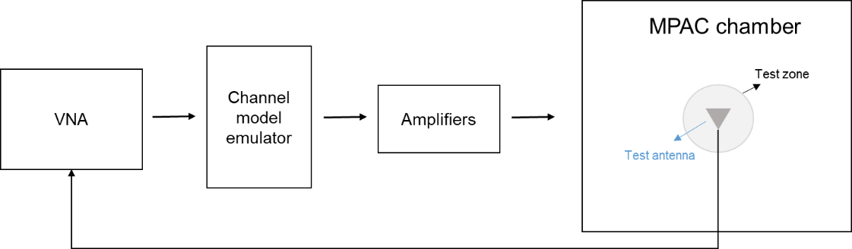
Figure C.3.2-1: Setup for PDP measurements
Step the emulation and store traces from VNA. I.e. run the emulation to CIR number 1, pause, measure VNA trace, run the emulation to CIR number 10, pause, measure VNA trace. Continue until 1000 VNA traces are measured.
VNA settings:
Table C.3.2-1: VNA settings for PDP measurements
Item | Unit | Value
Centre frequency | MHz | Downlink centre frequency  in Table C.3.1-1
Span | MHz | 200
Number of traces |  | 1000
Number of points |  | 1101
Averaging |  | 1

Channel model specification:
Table C.3.2-2: Channel model specification for PDP measurements
Item | Unit | Value
Centre frequency | MHz | Downlink centre frequency  in Table C.3.1-1
Distance between traces in channel model | wavelength (Note) | > 2
Channel model |  | As specified in Annex C.1
NOTE: Time [s] = distance [λ] / MS speed [λ/s]
MS speed [λ/s] = MS speed [m/s] / Speed of light [m/s] * Centre frequency [Hz]

Method of measurement result analysis:
Measured VNA traces (frequency responses H(t,f)) are saved into a hard drive. The data is read into, e.g., Matlab.
The analysis is performed by taking the Fourier transform of each FR. The resulting impulse responses h(t,τ) are averaged in power over time:
Finally the resulting PDP is shifted in delay, such that the first tap is on delay zero.

C.3.3 Doppler/Temporal correlation
This measurement checks the Doppler/temporal correlation. For Doppler/Temporal correlation validation measurement, only Vertical validation is required.
The Doppler spectrum is measured with a spectrum analyser as shown in Figure C.3.3-1. In this case a signal generator transmits CW signal through the NR MIMO OTA test system. The signal is received by a test antenna within the test area. Finally, the signal is analysed by a spectrum analyser and the measured spectrum is compared to the target spectrum. This setup can be used to measure Doppler Spectrum of the Channel models defined in Annex C.1.
Method of measurement:
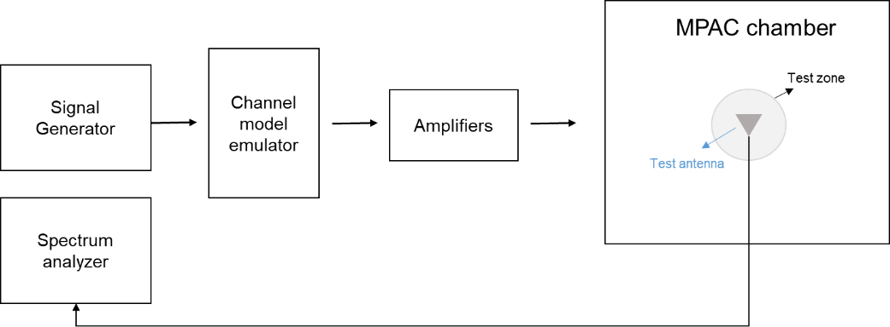
Figure C.3.3-1: Setup for Doppler measurements
Sine wave (CW, carrier wave) signal is transmitted from the signal generator. The signal is connected from the signal generator to fading emulator via cables. The fading emulator output signals are connected to power amplifier boxes via cables. The amplified signals are then transferred via cables to the probe antennas. The probe antennas radiate the signals over the air to the test antenna The Doppler spectrum is measured by the spectrum analyser and the trace is saved.
Signal generator settings:
Table C.3.3-1: Signal generator settings for Doppler/Temporal correlation measurements
Item | Unit | Value
Centre frequency | MHz | Downlink centre frequency  in Table C.3.1-1
Modulation |  | OFF

Spectrum analyser settings:
Table C.3.3-2: Spectrum analyser settings for Doppler/Temporal correlation measurements
Item | Unit | Value
Centre frequency | MHz | Downlink centre frequency  in Table C.3.1-1
Minimum Span | Hz | 4 kHz
RBW | Hz | 1
VBW | Hz | 1
Number of points |  | 16002
Averaging |  | 100

Channel model specification:
Table C.3.3-3: Channel model specification for Doppler/Temporal correlation measurements
Item | Unit | Value
Centre frequency | MHz | Downlink centre frequency  in Table C.3.1-1
Channel model |  | As specified in Annex C.1
Mobile speed | km/h | 100

Method of measurement result analysis: Measurement data file (Doppler power spectrum) is saved into hard drive. The data is read into, e.g., Matlab. The analysis is performed by taking the Fourier transformation of the Doppler spectrum. The resulting temporal correlation function is normalized such that . Then the function values left from the maximum is cut out. Further on the function values after, e.g. seven periods is cut out.

C.3.4 Spatial correlation
This measurement checks whether the measured correlation curve follows the theoretical curve. For spatial correlation validation measurement, only Vertical validation measurement is required. Spatial correlation validation is only adopted for FR1 MIMO OTA.
The spatial correlation validation measurement setup is illustrated in Figure C.3.4-1. The network analyser transmits signals through the fading emulator and probes. The 16 probes radiate the signals within the anechoic chamber and a receiving test antenna is placed within the test zone. The test antenna is attached to a positioner that can move the antenna to pre-defined spatial locations on a fixed radius from the centre of the quiet zone. The received signal is measured with the network analyser.
The measurement and analysis procedure is as follows:
Set the target channel model to fading emulator.
1. For each position of the test antenna in the test zone, step & pause the emulator to different time instances. Measure the frequency responses for all stepped channel snapshots 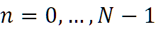, where the interval between frequency and time samples is 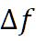 and 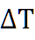, respectively. The number of channel snapshots $N$ and frequency samples $M$ should be sufficiently high so that the matrix can be estimated reliably.
2. Move the measurement antenna with a positioner to another location $k$ and repeat step 2 to record frequency responses 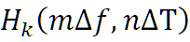 of all stepped channel snapshots.
3. Repeat step 3 to record frequency responses at all 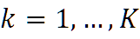 spatial sample points.
4. Stack measured time and frequency samples to a vector and calculate correlation between the first spatial sample point (i.e. $k=1$) and other spatial points 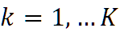
5.
6. Take the theoretical reference spatial correlation of the corresponding spatial sample points. Plot both the measured and theoretical curves.
7. Calculate the weighted RMS correlation error between the measured and the reference.
Figure C.3.4-1: Configuration for spatial correlation validation
Time and frequency samples
The number of temporal snapshots N and frequency samples M is TBD. They must be chosen to minimize the validation measurement time, but sufficiently high to keep an adequate correlation estimation accuracy. It is beneficial to choose the time sampling interval 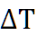 larger than the coherence time of the channel model. such that the recorded time samples represent independent fading occasions. The same principle applies also to frequency sampling interval 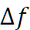 and the channel coherence bandwidth.
Spatial samples
The spatial samples for the correlation validation measurement are on the circumference of the quiet zone, as illustrated in Figure C.3.4-2. The test zone is a circle with 20 cm diameter in the horizontal plane. The reference point (denoted by a red marker) is in AoA 270°. The mean AoAs of the CDL-A and CDL-C models are slightly different, but the underlying geometry for the CDL model indicates that the mean AoA (or assumed LoS direction) of the model is 180°. The reference point orientation of the validation measurement is proposed to be with 90° offset to the channel model reference AoA to enable accurate sampling of the main lobe of the spatial correlation curve. The reference point orientation must be defined in the channel model coordinate system instead of the chamber/probe coordinate system to enable optimization of OTA model implementation to achieve better alignment with the cluster AoAs and probe directions. In order to have spatial samples that yield reasonable measurement times and adequately capture the main lobe of the correlation curve, a non-uniform sampling is used where the first quadrant i.e., 270°-180°, is sampled with dense sampling compared to the rest of the circle. The spacing of the spatial samples is summarized in Table C.3.4-1 for test frequencies less than 1800 MHz and equal to or greater than 1800 MHz.
Table C.3.4-1: Spacing of Spatial Samples
Test Frequencies [MHz] | First quadrant of test zone circumference (270º-180º) | Remaining quadrants
617, 722, 836.5 1575.42 | λ/15 | λ/4
1800, 2132.50, 2450, 3600, 4700 | λ/10 | λ/2

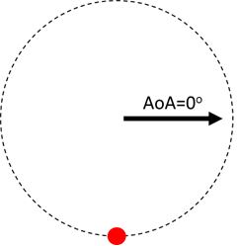
Figure C.3.4-2: Spatial sampling for spatial correlation validation measurement for test frequencies less than and equal to or greater than 1800 MHz: 617 MHz spatial sampling (left) and 4700 MHz spatial sampling (right).
Reference Spatial Correlation Curves
The spatial correlation validation reference curves are tabulated in Tables C.3.4-2 and C.3.4-3 for CDL-A UMi and in Tables C.3.4-4 and C.3.4-5 for CDL-C UMa for a vertically polarized MPAC OTA setup with 16 uniformly spaced probes.
Table C.3.4-2: Spatial correlation reference curves for CDL-A UMi model for a vertically polarized MPAC OTA setup with 16 uniformly spaced probes at FR1 test frequencies below 1800 MHz
617 MHz |  | 722 MHz |  | 836.5 MHz |  | 1575.42 MHz
Azimuth [º] | ρ_{ref} | Azimuth [º] | ρ_{ref} | Azimuth [º] | ρ_{ref} | Azimuth [º] | ρ_{ref}
270.0 | 1.000 | 270.0 | 1.000 | 270.0 | 1.000 | 270.0 | 1.000
251.4 | 0.999 | 254.1 | 0.999 | 256.3 | 0.999 | 262.7 | 0.999
232.9 | 0.997 | 238.3 | 0.997 | 242.6 | 0.996 | 255.5 | 0.996
214.3 | 0.992 | 222.4 | 0.993 | 228.9 | 0.993 | 248.2 | 0.992
195.8 | 0.981 | 206.6 | 0.984 | 215.2 | 0.987 | 240.9 | 0.987
110.40 | 0.809 | 190.7 | 0.969 | 201.6 | 0.975 | 233.7 | 0.982
40.80 | 0.823 | 120.52 | 0.778 | 187.9 | 0.955 | 226.4 | 0.977
331.21 | 0.96 | 61.05 | 0.731 | 128.66 | 0.751 | 219.1 | 0.971
 |  | 1.57 | 0.88 | 77.33 | 0.645 | 211.9 | 0.962
 |  | 302.09 | 0.99 | 25.99 | 0.762 | 204.6 | 0.949
 |  |  |  | 334.66 | 0.928 | 197.3 | 0.929
 |  |  |  | 283.32 | 0.998 | 190.0 | 0.903
 |  |  |  |  |  | 182.8 | 0.868
 |  |  |  |  |  | 152.74 | 0.620
 |  |  |  |  |  | 125.48 | 0.363
 |  |  |  |  |  | 98.23 | 0.299
 |  |  |  |  |  | 70.97 | 0.364
 |  |  |  |  |  | 43.71 | 0.460
 |  |  |  |  |  | 16.45 | 0.58
 |  |  |  |  |  | 349.20 | 0.71
 |  |  |  |  |  | 321.94 | 0.86
 |  |  |  |  |  | 294.68 | 0.97
Table C.3.4-3: Spatial correlation reference curves for CDL-A UMi model for a vertically polarized MPAC OTA setup with 16 uniformly spaced probes at FR1 test frequencies equal to or greater than 1800 MHz
1800 MHz |  | 2132.5 MHz |  | 2450 MHz |  | 3600 MHz |  | 4700 MHz
Azimuth [º] | ρ_{ref} | Azimuth [º] | ρ_{ref} | Azimuth [º] | ρ_{ref} | Azimuth [º] | ρ_{ref} | Azimuth [º] | ρ_{ref}
270.0 | 1.000 | 270.0 | 1.000 | 270.0 | 1.000 | 270.0 | 1.000 | 270.0 | 1.000
260.9 | 0.998 | 261.9 | 0.998 | 263.0 | 0.997 | 265.2 | 0.997 | 266.3 | 0.997
251.7 | 0.991 | 253.9 | 0.990 | 256.0 | 0.990 | 260.5 | 0.990 | 262.7 | 0.990
242.6 | 0.981 | 245.8 | 0.980 | 249.0 | 0.979 | 255.7 | 0.979 | 259.0 | 0.979
233.5 | 0.967 | 237.8 | 0.967 | 242.0 | 0.966 | 250.9 | 0.966 | 255.4 | 0.969
224.3 | 0.951 | 229.7 | 0.952 | 234.9 | 0.951 | 246.1 | 0.950 | 251.7 | 0.956
215.2 | 0.932 | 221.7 | 0.933 | 227.9 | 0.932 | 241.4 | 0.932 | 248.1 | 0.942
206.0 | 0.906 | 213.6 | 0.911 | 220.9 | 0.913 | 236.6 | 0.908 | 244.4 | 0.922
196.9 | 0.877 | 205.6 | 0.883 | 213.9 | 0.888 | 231.8 | 0.881 | 240.8 | 0.896
187.8 | 0.845 | 197.5 | 0.854 | 206.9 | 0.862 | 227.1 | 0.857 | 237.1 | 0.872
134.3 | 0.748 | 189.5 | 0.823 | 199.9 | 0.833 | 222.3 | 0.832 | 233.5 | 0.842
88.6 | 0.729 | 181.4 | 0.795 | 192.9 | 0.805 | 217.5 | 0.815 | 229.8 | 0.817
43.0 | 0.833 | 139.7 | 0.737 | 185.9 | 0.783 | 212.7 | 0.800 | 226.1 | 0.792
357.3 | 0.953 | 99.5 | 0.725 | 144.9 | 0.742 | 208.0 | 0.792 | 222.5 | 0.775
311.6 | 0.978 | 59.2 | 0.753 | 109.9 | 0.754 | 203.2 | 0.785 | 218.8 | 0.760
 |  | 18.9 | 0.884 | 74.8 | 0.727 | 198.4 | 0.782 | 215.2 | 0.753
 |  | 338.6 | 0.970 | 39.8 | 0.778 | 193.7 | 0.781 | 211.5 | 0.750
 |  | 298.4 | 0.982 | 4.7 | 0.901 | 188.9 | 0.786 | 207.9 | 0.753
 |  |  |  | 329.7 | 0.974 | 184.1 | 0.795 | 204.2 | 0.760
 |  |  |  | 294.6 | 0.980 | 156.1 | 0.886 | 200.6 | 0.775
 |  |  |  |  |  | 132.3 | 0.952 | 196.9 | 0.792
 |  |  |  |  |  | 108.4 | 0.949 | 193.3 | 0.817
 |  |  |  |  |  | 84.6 | 0.906 | 189.6 | 0.840
 |  |  |  |  |  | 60.7 | 0.830 | 185.9 | 0.865
 |  |  |  |  |  | 36.9 | 0.741 | 182.3 | 0.888
 |  |  |  |  |  | 13.0 | 0.774 | 161.7 | 0.978
 |  |  |  |  |  | 349.1 | 0.894 | 143.5 | 0.945
 |  |  |  |  |  | 325.3 | 0.966 | 125.2 | 0.926
 |  |  |  |  |  | 301.4 | 0.969 | 106.9 | 0.926
 |  |  |  |  |  | 277.6 | 0.994 | 88.6 | 0.948
 |  |  |  |  |  |  |  | 70.4 | 0.948
 |  |  |  |  |  |  |  | 52.1 | 0.896
 |  |  |  |  |  |  |  | 33.8 | 0.747
 |  |  |  |  |  |  |  | 15.5 | 0.682
 |  |  |  |  |  |  |  | 357.3 | 0.799
 |  |  |  |  |  |  |  | 339.0 | 0.912
 |  |  |  |  |  |  |  | 320.7 | 0.956
 |  |  |  |  |  |  |  | 302.4 | 0.968
 |  |  |  |  |  |  |  | 284.2 | 0.973

Table C.3.4-4: Spatial correlation reference curves for CDL-C UMa model for a vertically polarized MPAC OTA setup with 16 uniformly spaced probes at FR1 test frequencies below 1800 MHz
617 MHz |  | 722 MHz |  | 836.5 MHz |  | 1575.42 MHz
Azimuth [º] | ρ_{ref} | Azimuth [º] | ρ_{ref} | Azimuth [º] | ρ_{ref} | Azimuth [º] | ρ_{ref}
270.0 | 1.000 | 270.0 | 1.000 | 270.0 | 1.000 | 270.0 | 1.000
251.4 | 0.999 | 254.1 | 0.999 | 256.3 | 0.999 | 262.7 | 0.999
232.9 | 0.997 | 238.3 | 0.997 | 242.6 | 0.996 | 255.5 | 0.996
214.3 | 0.992 | 222.4 | 0.993 | 228.9 | 0.993 | 248.2 | 0.992
195.8 | 0.981 | 206.6 | 0.984 | 215.2 | 0.987 | 240.9 | 0.987
110.40 | 0.809 | 190.7 | 0.969 | 201.6 | 0.975 | 233.7 | 0.982
40.80 | 0.823 | 120.52 | 0.778 | 187.9 | 0.955 | 226.4 | 0.977
331.21 | 0.96 | 61.05 | 0.731 | 128.66 | 0.751 | 219.1 | 0.971
 |  | 1.57 | 0.88 | 77.33 | 0.645 | 211.9 | 0.962
 |  | 302.09 | 0.99 | 25.99 | 0.762 | 204.6 | 0.949
 |  |  |  | 334.66 | 0.928 | 197.3 | 0.929
 |  |  |  | 283.32 | 0.998 | 190.0 | 0.903
 |  |  |  |  |  | 182.8 | 0.868
 |  |  |  |  |  | 152.74 | 0.620
 |  |  |  |  |  | 125.48 | 0.363
 |  |  |  |  |  | 98.23 | 0.299
 |  |  |  |  |  | 70.97 | 0.364
 |  |  |  |  |  | 43.71 | 0.460
 |  |  |  |  |  | 16.45 | 0.58
 |  |  |  |  |  | 349.20 | 0.71
 |  |  |  |  |  | 321.94 | 0.86
 |  |  |  |  |  | 294.68 | 0.97

Table C.3.4-5: Spatial correlation reference curves for CDL-C UMa model for a vertically polarized MPAC OTA setup with 16 uniformly spaced probes at FR1 test frequencies equal to or greater than 1800 MHz
1800 MHz |  | 2132.5 MHz |  | 2450 MHz |  | 3600 MHz |  | 4700 MHz
Azimuth [º] | ρ_{ref} | Azimuth [º] | ρ_{ref} | Azimuth [º] | ρ_{ref} | Azimuth [º] | ρ_{ref} | Azimuth [º] | ρ_{ref}
270.0 | 1.000 | 270.0 | 1.000 | 270.0 | 1.000 | 270.0 | 1.000 | 270.0 | 1.000
260.9 | 0.998 | 261.9 | 0.998 | 263.0 | 0.997 | 265.2 | 0.997 | 266.3 | 0.996
251.7 | 0.991 | 253.9 | 0.991 | 256.0 | 0.992 | 260.5 | 0.989 | 262.7 | 0.988
242.6 | 0.984 | 245.8 | 0.984 | 249.0 | 0.983 | 255.7 | 0.979 | 259.0 | 0.976
233.5 | 0.976 | 237.8 | 0.975 | 242.0 | 0.975 | 250.9 | 0.969 | 255.4 | 0.966
224.3 | 0.967 | 229.7 | 0.966 | 234.9 | 0.965 | 246.1 | 0.960 | 251.7 | 0.957
215.2 | 0.955 | 221.7 | 0.955 | 227.9 | 0.953 | 241.4 | 0.954 | 248.1 | 0.951
206.0 | 0.936 | 213.6 | 0.940 | 220.9 | 0.939 | 236.6 | 0.947 | 244.4 | 0.945
196.9 | 0.908 | 205.6 | 0.918 | 213.9 | 0.921 | 231.8 | 0.937 | 240.8 | 0.940
187.8 | 0.863 | 197.5 | 0.888 | 206.9 | 0.898 | 227.1 | 0.925 | 237.1 | 0.935
134.3 | 0.309 | 189.5 | 0.846 | 199.9 | 0.867 | 222.3 | 0.903 | 233.5 | 0.928
88.6 | 0.269 | 181.4 | 0.793 | 192.9 | 0.829 | 217.5 | 0.876 | 229.8 | 0.918
43.0 | 0.396 | 139.7 | 0.280 | 185.9 | 0.786 | 212.7 | 0.837 | 226.1 | 0.902
357.3 | 0.619 | 99.5 | 0.252 | 144.9 | 0.245 | 208.0 | 0.798 | 222.5 | 0.882
311.6 | 0.879 | 59.2 | 0.257 | 109.9 | 0.299 | 203.2 | 0.753 | 218.8 | 0.851
 |  | 18.9 | 0.471 | 74.8 | 0.215 | 198.4 | 0.708 | 215.2 | 0.816
 |  | 338.6 | 0.661 | 39.8 | 0.251 | 193.7 | 0.669 | 211.5 | 0.767
 |  | 298.4 | 0.937 | 4.7 | 0.489 | 188.9 | 0.624 | 207.9 | 0.708
 |  |  |  | 329.7 | 0.652 | 184.1 | 0.580 | 204.2 | 0.651
 |  |  |  | 294.6 | 0.946 | 156.1 | 0.175 | 200.6 | 0.580
 |  |  |  |  |  | 132.3 | 0.565 | 196.9 | 0.516
 |  |  |  |  |  | 108.4 | 0.745 | 193.3 | 0.444
 |  |  |  |  |  | 84.6 | 0.820 | 189.6 | 0.383
 |  |  |  |  |  | 60.7 | 0.750 | 185.9 | 0.310
 |  |  |  |  |  | 36.9 | 0.493 | 182.3 | 0.229
 |  |  |  |  |  | 13.0 | 0.120 | 161.7 | 0.445
 |  |  |  |  |  | 349.1 | 0.272 | 143.5 | 0.750
 |  |  |  |  |  | 325.3 | 0.498 | 125.2 | 0.879
 |  |  |  |  |  | 301.4 | 0.843 | 106.9 | 0.813
 |  |  |  |  |  | 277.6 | 0.991 | 88.6 | 0.733
 |  |  |  |  |  |  |  | 70.4 | 0.740
 |  |  |  |  |  |  |  | 52.1 | 0.873
 |  |  |  |  |  |  |  | 33.8 | 0.944
 |  |  |  |  |  |  |  | 15.5 | 0.643
 |  |  |  |  |  |  |  | 357.3 | 0.250
 |  |  |  |  |  |  |  | 339.0 | 0.178
 |  |  |  |  |  |  |  | 320.7 | 0.375
 |  |  |  |  |  |  |  | 302.4 | 0.726
 |  |  |  |  |  |  |  | 284.2 | 0.929

Time Domain Alternative Method:
Time domain techniques can also be used to validate the spatial correlation. The spatial correlation validation measurement setup is illustrated in Figure C.3.4-3. In this case a Signal generator transmits a CW signal through the MIMO test system. The signal is received by a test antenna within the test area. Finally, the signal is collected by a signal analyser and the measured signal is stored for postprocessing.
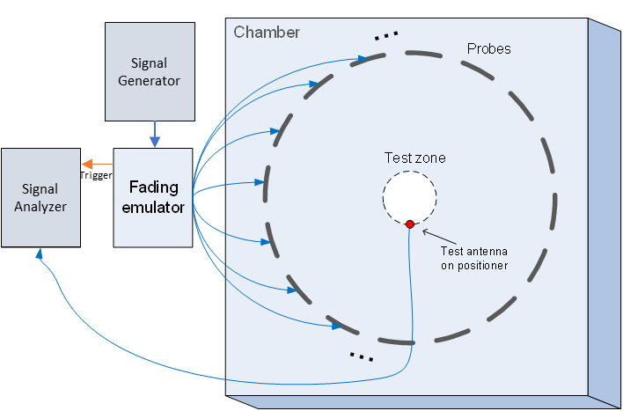
Figure C.3.4-3: Configuration for spatial correlation validation based on time domain techniques
For each spatial point, the channel emulator should issue a trigger signal each time fading is started. For each point collect a time domain trace with the signal analyser, when done, stop fading. Data recording is synchronized with the channel emulator trigger.
Follow the same procedure to postprocess the data and calcalate the spatial correlation by setting m to 1. The settings for the Signal Generator and Signal Analyser are in Table C.3.4-6 and C.3.4-7 respectively.
Table C.3.4-6: Signal Generator Settings
Item | Unit | Value
Centre frequency | MHz | Downlink centre frequency in Table C.3.1-1
Output power | dBm | Function of the CE. Sufficiently above Noise Floor

Table C.3.4-7: Signal Analyser Settings
Item | Unit | Value
Centre frequency | MHz | Downlink centre frequency in Table C.3.1-1
Sampling | Hz | At least 15 times bigger than the max Doppler spread (f_{d}=v/λ)
Observation time | s | At least 16s. Channel Model length should be the same or greater than the observation time.

C.3.5 Cross-polarization
This measurement checks how well the measured vertically or horizontally polarized power levels follow expected values. The test setup for cross-polarization is the same as PDP validation in Figure C.3.2-1.
Method of measurement: Step the emulation and store traces from VNA.
VNA settings:
Table C.3.5-1: VNA settings for cross-polarization
Item | Unit | Value
Centre frequency | MHz | Downlink Centre Frequency  in Table C.3.1-1
Span | MHz | 40
Number of traces |  | 1000
Number of points |  | 802
Averaging |  | 1

Channel model specification:
Table C.3.5-2: Channel model specification for cross-polarization.
Item | Unit | Value
Centre frequency | MHz | Downlink centre frequency  in Table C.3.1-1
Distance between traces in channel model | wavelength (Note) | > 2
Channel model |  | As specified in Annex C.1
Mobile speed | km/h | 30
NOTE: Time [s] = distance [λ] / MS speed [λ/s]
MS speed [λ/s] = MS speed [m /s] / Speed of light [m/s] * Centre frequency [Hz]

Measurement Procedure:
1. Play or step through the channel model listed in Annex C.1.
2. Measure the absolute power received at the centre of the test zone, averaged over a statistically significant number of fades.
a. Use a vertically polarized sleeve dipole to measure the V component.
b. Use a horizontally polarized (vertically oriented) magnetic loop dipole, or a horizontally polarized sleeve dipole measured in four orthogonal horizontal positions and summed to measure the H component.
3. Calculate the V/H ratio.
4. Compare it with the theory value.

C.3.6 Power validation
This measurement checks the total power in the centre of the test zone. The power validation is measured with a spectrum analyser as shown in Figure C.3.6-1.
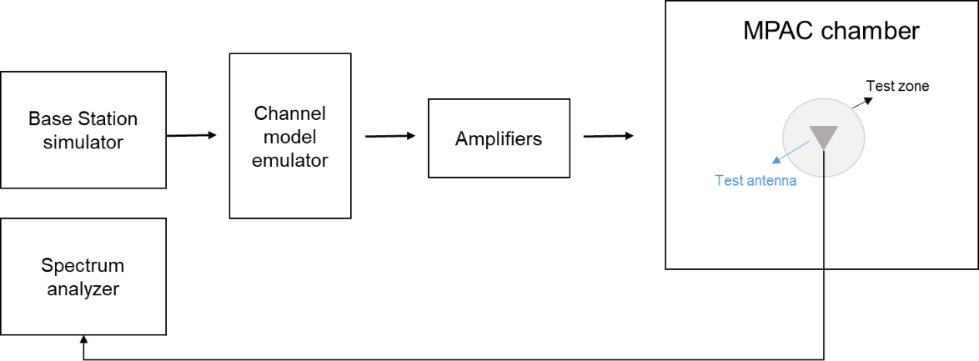
Figure C.3.6-1: Setup for power validation measurements
Spectrum analyser settings:
Table C.3.6-1: Spectrum analyser settings for power validation measurements
Item | Unit | Value
Centre frequency | MHz | Downlink centre frequency  in Table C.3.1-2
Integrated Channel Span | Hz | 20MHz
RBW | Hz | 30 kHz
VBW | Hz | ≥10MHz
Number of points |  | ≥400
Averaging |  | ≥100
Detector |  | RMS

Measurement Procedure:
1. Place a vertical reference dipole in the centre of the test zone connected to a spectrum analyser (or power meter) via a cable.
2. Record the cable and reference dipole gains.
3. Load the target channel model into the channel emulator.
4. Start the NR FR1 signaling in the base station emulator with the required parameter identical to the measurements conditions.
5. Average the power received by the spectrum analyser for a sufficient amount of time to account for the fading channel – one full channel simulation might be unnecessary.
6. Repeat steps 1 to 4 with a magnetic loop for the horizontal polarization, or a horizontally polarized sleeve dipole measured in at least four orthogonal horizontal positions and summed to measure the H component.
7. Calculate the total power received at the test area as the sum of the power in the two polarizations.
Note: in step 6, if horizontally polarized sleeve dipole is used, the reference gain correction should be the average of the theta gain pattern cut of the dipole. Besides, more horizontal positions for averaging will improve the measurement accuracy but increase the total measurement time.
The power validation result is considered as systematic offset, which needs to be corrected on the UE final sensitivity value to further reduce measurement uncertainty.

C.4 Validation Pass/fail limit

Annex D (normative):
<FR2 Channel models and Validation procedure >

D.1 FR2 Channel models
The following channel model is required for FR2 MIMO OTA measurement.
The generic model is Table D.1-1 FR2 UMi CDL-C, which does not include base station antenna filtering. Therefore, in addition, the BS beam filtering effect defined in Annex D.2 also apply when emulating the channel models.
Table D.1-1: Channel model parameters for UMi CDL-C at 28 GHz
Cluster # | Absolute Delay [ns] | Power in [dB] | AOD in [°] | AOA in [°] | ZOD in [°] | ZOA in [°]
1 | 0 | -4.4215 | -30.4353 | -134.4434 | 98.9242 | 83.3318
2 | 12.594 | -1.25 | -20.9269 | 129.1633 | 99.1915 | 72.5229
3 | 13.314 | -3.4684 | -20.9269 | 129.1633 | 99.1915 | 72.5229
4 | 13.974 | -5.2294 | -20.9269 | 129.1633 | 99.1915 | 72.5229
5 | 13.056 | -2.5215 | -28.0782 | -152.8206 | 99.5732 | 71.1282
6 | 38.196 | 0 | -11.6982 | 164.1145 | 99.306 | 74.7544
7 | 38.688 | -2.2185 | -11.6982 | 164.1145 | 99.306 | 74.7544
8 | 39.36 | -3.9794 | -11.6982 | 164.1145 | 99.306 | 74.7544
9 | 39.504 | -7.4215 | 17.3861 | 84.3647 | 100.4513 | 69.2454
10 | 47.61 | -7.1215 | -37.5865 | 92.0623 | 98.5616 | 66.7349
11 | 49.278 | -10.7215 | 20.2226 | -97.7585 | 100.6231 | 72.0348
12 | 56.016 | -11.1215 | -50.6106 | 78.4702 | 98.218 | 64.4337
13 | 73.71 | -5.1215 | -33.911 | 93.1719 | 100.165 | 85.4238
14 | 78.498 | -6.8215 | -37.5066 | -112.0441 | 100.2604 | 64.1548
15 | 130.224 | -8.7215 | -43.1797 | 102.4645 | 98.1225 | 64.7824
16 | 162.63 | -13.2215 | 29.2116 | 67.2359 | 100.2604 | 92.467
17 | 255.534 | -13.9215 | 27.8133 | 34.5731 | 98.4852 | 65.6889
18 | 276.018 | -13.9215 | 23.6584 | 48.5813 | 98.1416 | 68.7572
19 | 329.412 | -15.8215 | -52.5282 | 36.4455 | 97.9698 | 59.1339
20 | 336.462 | -17.1215 | 25.0168 | 52.6729 | 100.7376 | 65.3402
21 | 378.39 | -16.0215 | 25.4562 | 49.8296 | 98.1225 | 58.4365
22 | 398.244 | -15.7215 | 30.7697 | 46.4316 | 98.1034 | 65.2705
23 | 422.562 | -21.6215 | 35.9234 | 30.759 | 100.4513 | 62.6903
24 | 519.138 | -22.8215 | -61.2775 | 69.2469 | 100.9476 | 61.993
Per-Cluster Parameters
Parameter | CASD in [°] | CASA in [°] | CZSD in [°] | CZSA in [°] | XPR in [dB]
Value | 0.799 | 10.4021 | 0.5726 | 4.8814 | 7

D.2 FR2 Base Station beam configuration
The emulated BS beam configuration to be used for emulation of channel model defined in Annex D.1 is specified in this clause.
The Base Station beam configuration includes basic antenna parameters and beamforming characteristic. The basic BS antenna parameters is defined in Table D.2-1.
Table D.2-1: FR2 BS Antenna Parameters
Parameter description | Symbol | Parameter value
Parameter description | Symbol | FR2
Antenna panels in vertical dimension | M_{g} | 1
Antenna panels in horizontal dimension | N_{g} | 1
Elements per panel in vertical dimension | M_{e} | 8
Elements per panel in horizontal dimension | N_{e} | 16
Number of polarizations per panel | P | 2
Element spacing in horizontal dimension (λ) | d_{H} | 0.5
Element spacing in vertical dimension (λ) | d_{V} | 0.5

Antenna element radiation patterns, including orientation of the element main polarization components as well as orientation of the antenna array are as in the example pattern in Table 7.3-1 of TR38.901. The antenna element has ±45° polarization components and the radiation pattern parameters are θ_{3dB} = 65°, φ_{3dB} = 65°, A_{max} = 30dB, SLAv = 30dB, G_{E,max} =8 dBi.
The beamforming characteristic of the FR2 BS pattern is defined as follow:
- A code book of 128 fixed beams is constructed to a grid of eight elevation angles from –25° to +25° with ~7.1° step size and 16° azimuth angles from –60° to +60° with 8° step size；
- 1 strongest transmitting beam is generated from BS, the direction of this beam towards the strongest cluster of the FR2 channel model. Specifically, the direction in UMi CDL-C model is: AoD: -12º, ZoD: 100.71º

D.3 FR2 Channel model validation

D.3.1 General
This clause describes the FR2 MIMO OTA validation measurements, in order to ensure that the channel models are correctly implemented and hence capable of generating the propagation environment, as described by the model, within the test zone of the 3D-MPAC system.
The following measurements shall be done for FR2 channel model validation:
Power Delay Profile (PDP)
Doppler/Temporal correlation
PAS similarity percentage (PSP)
Cross-polarization
Power validation
Frequencies to be used to test for FR2 channel model validation:
Table D.3.1-1: FR2 Channel model validation frequencies
NR FR2 Bands | Range | Test Frequency (MHz)
n257 | Low | 27750
n260 | High | 38500
n258 | Low | 25875
n261 | Low | 27925

D.3.2 FR2 Power Delay Profile (PDP)
This measurement checks that the resulting power delay profile (PDP) is in-line with the PDP defined for the channel model. For PDP validation measurement, only Vertical validation is required.
The PDP measurement is performed with a Vector Network Analyser (VNA). An example setup for PDP measurement is shown in Figure D.3.2-1. VNA transmits frequency sweep signals thorough the NR MIMO OTA test system. A reference antenna, within the centre of the test zone, receives the signal and VNA analyses the frequency response of the system. A number of traces (frequency responses) are measured and recorded by VNA and analysed by a post processing SW, e.g., Matlab. Special care has to be taken into account to keep the fading conditions unchanged, i.e. frozen, during the short period of time of a single trace measurement. The fading may proceed only in between traces.
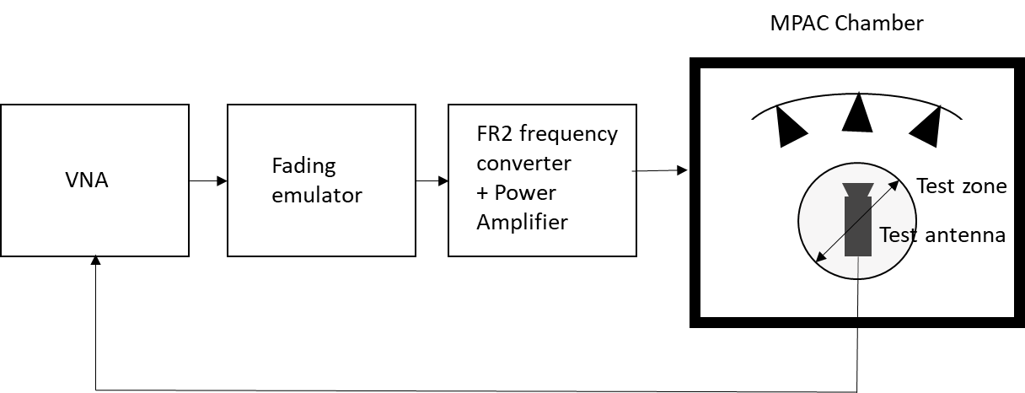
Figure D.3.2-1: Setup for PDP measurements (FR2)
Step the emulation and store traces from VNA. I.e. run the emulation to CIR number 1, pause, measure VNA trace, run the emulation to CIR number 10, pause, measure VNA trace. Continue until 1000 VNA traces are measured.
VNA settings:
Table D.3.2-1: VNA settings for FR2 PDP measurements
Item | Unit | Value
Centre frequency | MHz | Downlink centre frequency  in Table D.3.1-1
Span | MHz | 200
Number of traces |  | 1000
Number of points |  | 1101
Averaging |  | 1

Channel model specification:
Table D.3.2-2: Channel model specification for FR2 PDP measurements
Item | Unit | Value
Centre frequency | MHz | Downlink centre frequency  in Table D.3.1-1
Distance between traces in channel model | wavelength (Note) | > 2
Channel model |  | As specified in Annex D.1
NOTE: Time [s] = distance [λ] / MS speed [λ/s]
MS speed [λ/s] = MS speed [m/s] / Speed of light [m/s] * Centre frequency [Hz]

Method of measurement result analysis:
Measured VNA traces (frequency responses H(t,f)) are saved into a hard drive. The data is read into, e.g., Matlab.
The analysis is performed by taking the Fourier transform of each trace. The resulting impulse responses h(t,τ) are averaged in power over time:
Finally, the resulting PDP is shifted in delay, such that the first tap is on delay zero.

D.3.3 FR2 Doppler/Temporal correlation
This measurement checks the Doppler/temporal correlation. For Doppler/Temporal correlation validation measurement, only Vertical validation is required.
The Doppler spectrum is measured with a spectrum analyser as shown in Figure D.3.3-1. In this case a signal generator transmits CW signal through the NR MIMO OTA test system. The signal is received by a test antenna within the test area. Finally, the signal is analysed by a spectrum analyser and the measured spectrum is compared to the target spectrum. This setup can be used to measure Doppler Spectrum of the Channel models defined in Annex D.2.
Method of measurement:
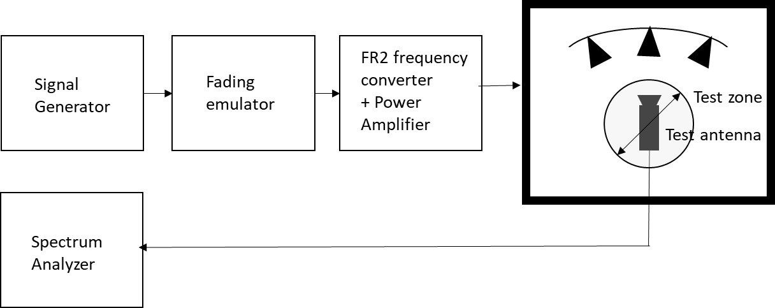
Figure D.3.3-1: Setup for FR2 Doppler measurements
Sine wave (CW, carrier wave) signal is transmitted from the signal generator. The signal is connected from the signal generator to fading emulator via cables. The fading emulator output signals are connected to frequency converter and power amplifier boxes via cables. The amplified signals are then transferred via cables to the probe antennas. The probe antennas radiate the signals over the air to the test antenna The Doppler spectrum is measured by the spectrum analyser and the trace is saved.
Signal generator settings:
Table D.3.3-1: Signal generator settings for FR2 Doppler/Temporal correlation measurements
Item | Unit | Value
Centre frequency | MHz | Downlink centre frequency  in Table D.3.1-1
Modulation |  | OFF

Spectrum analyser settings:
Table D.3.3-2: Spectrum analyser settings for FR2 Doppler/Temporal correlation measurements
Item | Unit | Value
Centre frequency | MHz | Downlink centre frequency  in Table D.3.1-1
Minimum Span | Hz | 4 kHz
RBW | Hz | 1
VBW | Hz | 1
Number of points |  | 16002
Averaging |  | 100

Channel model specification:
Table D.3.3-3: Channel model specification for FR2 Doppler/Temporal correlation measurements
Item | Unit | Value
Centre frequency | MHz | Downlink centre frequency  in Table D.3.1-1
Channel model |  | As specified in Annex D.1
Mobile speed | km/h | 3

Method of measurement result analysis: Measurement data file (Doppler power spectrum) is saved into hard drive. The data is read into, e.g., Matlab. The analysis is performed by taking the Fourier transformation of the Doppler spectrum. The resulting temporal correlation function is normalized such that . Then the function values left from the maximum is cut out. Further on the function values after, e.g. seven periods is cut out.

D.3.4 FR2 PAS similarity percentage (PSP)
The PSP validation measurements aim at evaluating PAS similarity percentage (PSP), which is one of the validation metrics for characterizing FR2 channel model under test in the quite zone of 3D-MPAC. For PSP validation measurement, only vertical polarization validation is required.
The measurement array is essentially a virtual array configuration realized in 3D-MPAC through a φ-θ positioning system. The measurement array is a semi-circle and sectored array configuration illustrated in Figure D.3.4-1 where complex channel frequency response is measured at each antenna location 0.5 λ apart using a vector network analyser (VNA) setup. The vertical sectors of the measurement array are limited to 60° (±30°) and the horizontal sector to 180° (±90°) with the broad side direction points towards the probes. Depending of the turntable architecture/implementation, the virtual array configuration for the PSP validation is composed of two alternative semi-circle arrangements (1 x horizontal and either 2 x crossed vertical or 2 x parallel vertical). The radius of the array element locations with respect to the centre of the test zone is 5 cm, which is equivalent to the half of the test zone radius at 28 GHz. For different frequency bands, the radius of the measurement array sectored semi-circles remains fixed at 5 cm while the spatial sampling of the array varies. This measurement validates the proper angular behaviour in the test zone.
Figure D.3.4-1: Semi-circle measurement array configurations with K = 37 elements (at 28 GHz). On the left with two crossed vertical sectors, on the right with two parallel vertical sectors.

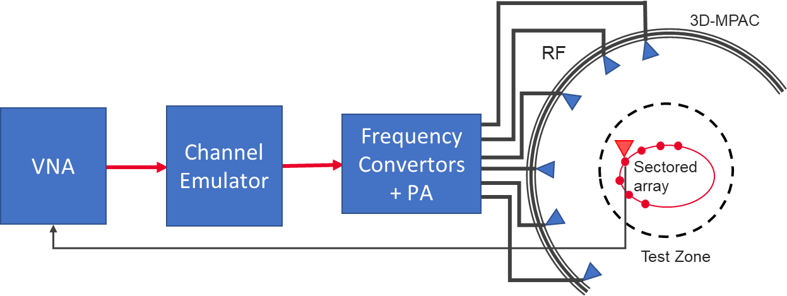
Figure D.3.4-2: Setup for FR2 PSP validation measurements
The PSP validation is measured with a vector network analyser as shown in Figure D.3.4-2 illustrating the PSP measurement setup. Port 1 of the VNA transmits signals through the fading emulator and radiate them through L probes within the anechoic chamber. The radiated signals are then received at the test antenna that is positioned inside the test zone. The test antenna is mounted on a φ-θ positioner which is capable of moving the antenna to pre-defined spatial locations on a fixed radius from the centre of the quiet zone according the measurement array configuration. Finally, the signal is received at port 2 of the VNA. The most suitable approach for the PSP validation is based on an omnidirectional antenna (omnidirectional pattern in AZ and wide BW in EL) as the test can be automated easily. Alternatively, a directional antenna could be used but requires frequent re-positioning.
The measurement and analysis procedure are given as follows:
1. Set the target channel model in the Channel Emulator.
2. For each position of the test antenna on the measurement array configuration in the test zone, step & pause the emulator to different time instances. Measure the complex frequency responses $H\left(f,t\right)=H\left(m∆f,n∆T\right), m=0,..., M-1$ for all stepped channel snapshots$n=0,..., N-1$ , where the interval between frequency and time samples is$∆f$ and$∆T$, respectively. The number of channel snapshots $N$ and frequency samples $M$.
3. Move the measurement antenna with a positioner to another location $k$ and repeat step 2 to record frequency responses $H_{k}(m∆f,n∆T)$ of all stepped channel snapshots.
4. Repeat step 3 to record frequency responses at all$k=0,..., K$ spatial sample points.
5. Estimate the measured PAS through the following two- stage processing:
a. In the first stage, calculate the discrete azimuth and elevation angles (DoA) for the measurement array configuration by applying the MUSIC algorithm. Estimate the powers from the DoA and auto-covariance matrix of the received signal acquired through VNA complex frequency response data.
i) Compose an estimate of the covariance matrix $R_{H}∈C^{K×K}$. The entry on the $k$th row and $k'$th column of $R_{H}$ is
$$R_{H}\left(k,k'\right)=\sum_{n=1}^{N}{\sum_{m=1}^{M}{H_{k}\left(m∆f,n∆T\right) \overline{H_{k'}}\left(m∆f,n∆T\right)}},$$
where is the complex conjugate operator.
ii) Compose pseudo-PAS of the chamber environment and channel model using the MUSIC algorithm. The intention of this step is to estimate DoAs of signals radiated by probes. Perform first the eigen decomposition of $R_{H}$ and pick the noise-subspace matrix $V$. The matrix $V$ is obtained from the eigen decomposition by removing eigenvectors, i.e. columns, that correspond to X strongest eigenvalues, where X is the number of active probes in the MPAC setup. The pseudo-PAS is [9]
$$P_{MUSIC}\left(β\right)=\frac{1}{ω\left(β\right) VV^{H} ω^{H}\left(β\right)} ,$$
where ${\left(\right)}^{H}$ is the matrix Hermitean operator and the near-field array factor of the virtual array composed by K spatial measurement antenna locations is
$$ω\left(β\right)=\frac{λ_{0}}{4π\left\|{\vec{r}}_{k}-R \vec{u}\left(β\right)\right\|}\exp\left(\frac{j2π\left\|{\vec{r}}_{k}-R \vec{u}\left(β\right)\right\|}{λ_{0}}\right),$$
where $λ_{0}$ is the wavelength at the carrier centre frequency, is the norm of a vector, ${\vec{r}}_{k}$ is a location vector of the kth virtual array element, $\vec{u}\left(β\right)$ is the unit vector to direction $β$, and R is the a priori known approximate range length [9]. Both vectors ${\vec{r}}_{k}$ and $\vec{u}\left(β\right)$ are defined with respect to same origin, which is the centre of the test zone.
iii) Find local maxima of $P_{MUSIC}\left(β\right)$ and pick directions $β_{x}$, $x=1,…,X$ of the X highest peaks.
iv) Perform Bartlett beamforming as defined in step 6 with the steering vector $ω\left(β_{x}\right)$ (instead of $a(β)$) to the X directions identified in iii). The output is X power estimates $P_{est}\left(β_{x}\right)$.

b. In the second stage, use the angle and power estimates, i.e. the discrete PAS of X azimuth and elevation directions and power values in conjunction with a 4x4 DUT sampling array for beamforming with the conventional Bartlett beamformer to estimate the “measured PAS seen by DUT” for PSP calculation. This is
$${\hat{P}}_{o}\left(β\right)=a^{H}\left(β\right)\left(\sum_{x=1}^{X}{a\left(β_{x}\right)P_{est}\left(β_{x}\right)a^{H}\left(β_{x}\right)}\right)a\left(β\right),$$
where $a(β)$ is the array steering vector of the 4x4 DUT array.

6. Evaluate the reference OTA PAS for the 4x4 DUT array by applying the conventional Bartlett beamformer. The theoretical PAS as reference is calculated for the ideal channel model as
$${\hat{P}}_{r}\left(β\right)=a^{H}\left(β\right) ∮a(\acute{β)} P(\acute{β)}a^{H}(\acute{β)}d\acute{β} a\left(β\right),$$
where $a(β)$ is the array steering vector of the 4x4 DUT array and $P(\acute{β)}$ is the PAS of the reference channel model.

7. Calculate total variation distance (D_{p}) from the reference and measured PAS. Mathematically,
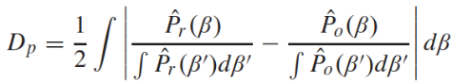
8. Calculate PSP values as PSP = (1-D_{p}) x 100%.

VNA settings:
Table D.3.4-1: VNA settings for FR2 PSP measurements
Item | Unit | Value
Centre frequency | MHz | Downlink centre frequency  in Table D.3.1-1
Span | MHz | 0 (or the minimum)
Number of traces |  | 1000
Number of points |  | 1

Channel model specification:
Table D.3.4-2: Channel model specification for FR2 PSP measurements
Item | Unit | Value
Centre frequency | MHz | Downlink centre frequency  in Table D.3.1-1
Distance between traces in channel model | wavelength (Note) | > 2
Channel model |  | As specified in Annex D.1
NOTE: Time [s] = distance [λ] / MS speed [λ/s]
MS speed [λ/s] = MS speed [m/s] / Speed of light [m/s] * Centre frequency [Hz]

Time Domain Alternative Method:
PSP validation can also be implemented using time-domain techniques using the testing setup presented in Figure D.3.4-3. The VNA is substituted by a signal generator, and a signal analyser.
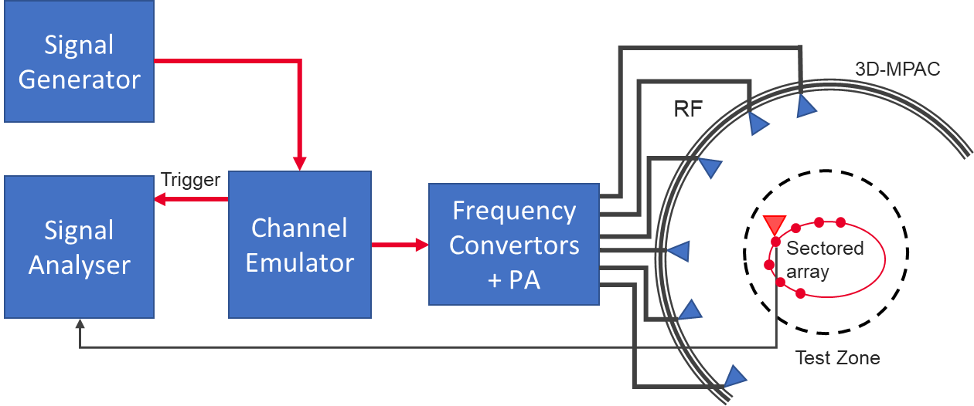
Figure D.3.4-3: Setup for FR2 PSP validation measurements based on time domain
Table D.3.4-3: Signal Generator Settings for FR2 PSP measurements based on time domain
Item | Unit | Value
Centre frequency | MHz | Downlink centre frequency in Table D.3.1-1
Output power | dBm | Function of the CE. Sufficiently above Noise Floor

Table D.3.4-4: Signal Analyser Settings for FR2 PSP measurements based on time domain
Item | Unit | Value
Centre frequency | MHz | Downlink centre frequency in Table D.3.1-1
Sampling | Hz | At least 10 times bigger than the max Doppler spread (f_{d}=v/λ)
Observation time | s | At least 32s
The measurement and analysis procedure are given as follows:
Follow the same procedure as before, but M is set to 1. The Channel Emulator is not stepped, but it is allowed to play in free run mode for each of the K spatial points.

D.3.5 FR2 Cross-polarization
This measurement checks how well the measured vertically or horizontally polarized power levels follow expected values. The test setup for cross-polarization is the same as PDP validation in Figure D.3.2-1.
Method of measurement: Step the emulation and store traces from VNA.
VNA settings:
Table D.3.5-1: VNA settings for FR2 cross-polarization
Item | Unit | Value
Centre frequency | MHz | Downlink Centre Frequency  in Table D.3.1-1
Span | MHz | 40
Number of traces |  | 1000
Number of points |  | 802
Averaging |  | 1

Channel model specification:
Table D.3.5-2: Channel model specification for FR2 cross-polarization.
Item | Unit | Value
Centre frequency | MHz | Downlink centre frequency  in Table D.3.1-1
Distance between traces in channel model | wavelength (Note) | > 2
Channel model |  | As specified in Annex D.1
Mobile speed | km/h | 30
NOTE: Time [s] = distance [λ] / MS speed [λ/s]
MS speed [λ/s] = MS speed [m /s] / Speed of light [m/s] * Centre frequency [Hz]

Measurement Procedure:
1. Play or step through the channel model listed in Annex D.1.
2. Measure the absolute power received at the centre of the test zone, averaged over a statistically significant number of fades.
a. Use a horn antenna with H polarization terminated to measure the V component.
b. Use a horn antenna with V polarization terminated for the horizontal polarization, in four orthogonal horizontal positions and summed to measure the H component.
3. Calculate the V/H ratio.
4. Compare it with the theory value.

D.3.6 FR2 Power validation
This measurement checks the total power in the centre of the test zone. The power validation is measured with a spectrum analyser as shown in Figure D.3.6-1.
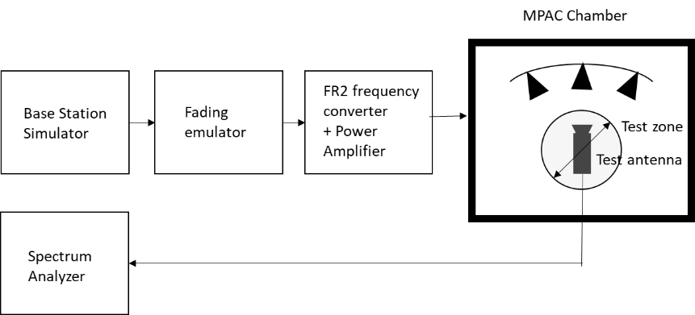
Figure D.3.6-1: Setup for FR2 power validation measurements
Spectrum analyser settings:
Table D.3.6-1: Spectrum analyser settings for FR2 power validation measurements
Item | Unit | Value
Centre frequency | MHz | Downlink centre frequency  in Table D.3.1-1
Integrated Channel Span | Hz | 20MHz
RBW | Hz | 30 kHz
VBW | Hz | ≥10MHz
Number of points |  | ≥400
Averaging |  | ≥100
Detector |  | RMS

Measurement Procedure:
1. Place a horn antenna with H polarization terminated in the centre of the test zone connected to a spectrum analyser (or power meter) via a cable.
2. Record the cable and horn antenna gains.
3. Load the target channel model into the channel emulator.
4. Start the NR FR2 signalling in the base station emulator with the required parameter identical to the measurements conditions.
5. Average the power received by the spectrum analyser for a sufficient amount of time to account for the fading channel – one full channel simulation might be unnecessary.
6. Repeat steps 1 to 4 with a horn antenna V polarization terminated for the horizontal polarization, in four orthogonal horizontal positions and summed to measure the H component.
7. Calculate the total power received at the test area as the sum of the power in the two polarizations.

D.4 Validation Pass/fail limit
TBD

Annex E (normative):
<gNB configurations>

E.1 FR1 gNB configurations
The gNodeB emulator parameters shall be set according to Table E.1-1 for FR1 common parameters, Table E.1-2 for FR1 FDD 2x2 test parameters, Table E.1-3 for FR1 TDD 2x2 test parameters, Table E.1-4 for FR1 FDD 4x4 test parameters, and Table E.1-5 for FR1 TDD 4x4 test parameters.
Table E.1-1: FR1 Common test parameters
Parameter |  |  | Unit | Value
PDSCH transmission scheme |  |  |  | Transmission scheme 1
Carrier configuration | Offset between Point A and the lowest usable subcarrier on this carrier (Note 2) |  | RBs | 0
Carrier configuration | Subcarrier spacing |  | kHz | 15 or 30
DL BWP configuration #1 | Cyclic prefix |  |  | Normal
DL BWP configuration #1 | RB offset |  | RBs | 0
DL BWP configuration #1 | Number of contiguous PRB |  | PRBs | Maximum transmission bandwidth configuration as specified in clause 5.3.2 of TS 38.101-1 for tested channel bandwidth and subcarrier spacing
Common serving cell parameters | Physical Cell ID |  |  | 0
Common serving cell parameters | SSB position in burst |  |  | First SSB in Slot #0
Common serving cell parameters | SSB periodicity |  | ms | 20
Common serving cell parameters | First DMRS position for Type A PDSCH mapping |  |  | 2
PDCCH configuration | Slots for PDCCH monitoring |  |  | Each slot
PDCCH configuration | Symbols with PDCCH |  | Symbols | 0, 1
PDCCH configuration | Number of PRBs in CORESET |  |  | Table 5.2-2 of TS 38.101-4 for tested channel bandwidth and subcarrier spacing
PDCCH configuration | Number of PDCCH candidates and aggregation levels |  |  | 1/AL8
PDCCH configuration | CCE-to-REG mapping type |  |  | Non-interleaved
PDCCH configuration | DCI format |  |  | 1_1
PDCCH configuration | TCI state |  |  | TCI state #1
Cross carrier scheduling |  |  |  | Not configured
CSI-RS for tracking | First subcarrier index in the PRB used for CSI-RS |  |  | k₀=0 for CSI-RS resource 1,2,3,4
CSI-RS for tracking | First OFDM symbol in the PRB used for CSI-RS |  |  | l₀ = 6 for CSI-RS resource 1 and 3  l₀ = 10 for CSI-RS resource 2 and 4
CSI-RS for tracking | Number of CSI-RS ports (X) |  |  | 1 for CSI-RS resource 1,2,3,4
CSI-RS for tracking | CDM Type |  |  | ‘No CDM’ for CSI-RS resource 1,2,3,4
CSI-RS for tracking | Density (ρ) |  |  | 3 for CSI-RS resource 1,2,3,4
CSI-RS for tracking | CSI-RS periodicity |  | Slots | 15 kHz SCS: 20 for CSI-RS resource 1,2,3,4  30 kHz SCS: 40 for CSI-RS resource 1,2,3,4
CSI-RS for tracking | CSI-RS offset |  | Slots | 15 kHz SCS:  10 for CSI-RS resource 1 and 2  11 for CSI-RS resource 3 and 4  30 kHz SCS:  20 for CSI-RS resource 1 and 2  21 for CSI-RS resource 3 and 4
CSI-RS for tracking | Frequency Occupation |  |  | Start PRB 0  Number of PRB = BWP size
CSI-RS for tracking | QCL info |  |  | TCI state #0
NZP CSI-RS for CSI acquisition | First subcarrier index in the PRB used for CSI-RS |  |  | k₀ = 0
NZP CSI-RS for CSI acquisition | First OFDM symbol in the PRB used for CSI-RS |  |  | l₀ = 12
NZP CSI-RS for CSI acquisition | Number of CSI-RS ports (X) |  |  | Same as number of transmit antenna
NZP CSI-RS for CSI acquisition | CDM Type |  |  | ‘FD-CDM2’
NZP CSI-RS for CSI acquisition | Density (ρ) |  |  | 1
NZP CSI-RS for CSI acquisition | CSI-RS periodicity |  | Slots | 15 kHz SCS: 20  30 kHz SCS: 40
NZP CSI-RS for CSI acquisition | CSI-RS offset |  | Slots | 0
NZP CSI-RS for CSI acquisition | Frequency Occupation |  |  | Start PRB 0  Number of PRB = BWP size
NZP CSI-RS for CSI acquisition | QCL info |  |  | TCI state #1
ZP CSI-RS for CSI acquisition | First subcarrier index in the PRB used for CSI-RS |  |  | k₀ = 4
ZP CSI-RS for CSI acquisition | First OFDM symbol in the PRB used for CSI-RS |  |  | l₀ = 12
ZP CSI-RS for CSI acquisition | Number of CSI-RS ports (X) |  |  | 4
ZP CSI-RS for CSI acquisition | CDM Type |  |  | ‘FD-CDM2’
ZP CSI-RS for CSI acquisition | Density (ρ) |  |  | 1
ZP CSI-RS for CSI acquisition | CSI-RS periodicity |  | Slots | 15 kHz SCS: 20  30 kHz SCS: 40
ZP CSI-RS for CSI acquisition | CSI-RS offset |  | Slots | 0
ZP CSI-RS for CSI acquisition | Frequency Occupation |  |  | Start PRB 0  Number of PRB = BWP size
PDSCH DMRS configuration | Antenna ports indexes |  |  | {1000, 1001} for Rank 2 tests  {1000-1003} for Rank 4 tests
PDSCH DMRS configuration | Number of PDSCH DMRS CDM group(s) without data |  |  | 1 for Rank 2 tests  2 for Rank 4 tests
TCI state #0 | Type 1 QCL information | SSB index |  | SSB #0
TCI state #0 | Type 1 QCL information | QCL Type |  | Type C
TCI state #0 | Type 2 QCL information | SSB index |  | N/A
TCI state #0 | Type 2 QCL information | QCL Type |  | N/A
TCI state #1 | Type 1 QCL information | CSI-RS resource |  | CSI-RS resource 1 from ‘CSI-RS for tracking’ configuration
TCI state #1 | Type 1 QCL information | QCL Type |  | Type A
TCI state #1 | Type 2 QCL information | CSI-RS resource |  | N/A
TCI state #1 | Type 2 QCL information | QCL Type |  | N/A
PT-RS configuration |  |  |  | PT-RS is not configured
Maximum number of code block groups for ACK/NACK feedback |  |  |  | 1
Maximum number of HARQ transmission |  |  |  | 1
HARQ ACK/NACK bundling |  |  |  | Multiplexed
Redundancy version coding sequence |  |  |  | N.A
Precoding configuration |  |  |  | SP Type I, Random per slot with PRB bundling granularity
Symbols for all unused REs |  |  |  | OCNG Annex A.5 of TS 38.101-4
Minimum Number of Slots per Stream |  |  |  | 20000 for 15kHz SCS  40000 for 30kHz SCS  (Note 3)
Transmit Power Control |  |  | dBm | 13 dBm
Note 1: UE assumes that the TCI state for the PDSCH is identical to the TCI state applied for the PDCCH transmission.
Note 2: Point A coincides with minimum guard band as specified in Table 5.3.3-1 from TS 38.101-1 for tested channel bandwidth and subcarrier spacing.
Note 3: For FR1 MIMO OTA test lab alignments and FR1 MIMO OTA UE performance requirements, the following values can be used:
For FR1 bands >1GHz: 20k for 30kHz SCS, 10k for 15kHz SCS;
For FR1 bands <1GHz: [20k] for 15kHz SCS;

Table E.1-2: Test parameters for FR1 FDD 2x2
Parameter |  | Unit | Value
Duplex mode |  |  | FDD
Reference channel |  |  | R.PDSCH.1-3.1 FDD (Note 1)
Bandwidth |  | MHz | 10
SCS |  | kHz | 15
Modulation DL |  |  | 64QAM
Modulation UL |  |  | QPSK
Active DL BWP index |  |  | 1
PDSCH configuration | Mapping type |  | Type A
PDSCH configuration | k0 |  | 0
PDSCH configuration | Starting symbol (S) |  | 2
PDSCH configuration | Length (L) |  | 12
PDSCH configuration | PDSCH aggregation factor |  | 1
PDSCH configuration | PRB bundling type |  | Static
PDSCH configuration | PRB bundling size |  | 2
PDSCH configuration | Resource allocation type |  | Type 0
PDSCH configuration | RBG size |  | Config2
PDSCH configuration | VRB-to-PRB mapping type |  | Non-interleaved
PDSCH configuration | VRB-to-PRB mapping interleaver bundle size |  | N/A
PDSCH DMRS configuration | DMRS Type |  | Type 1
PDSCH DMRS configuration | Number of additional DMRS |  | 1
PDSCH DMRS configuration | Maximum number of OFDM symbols for DL front loaded DMRS |  | 1
CSI-RS for tracking | CSI-RS periodicity | Slots | 20
CSI-RS for tracking | CSI-RS offset | Slots | Table 8.2-1.
Number of HARQ Processes |  |  | 1
The number of slots between PDSCH and corresponding HARQ-ACK information |  |  | 2
Note 1: “R.PDSCH.1-3.1 FDD” is defined in Table A.3.2.1.1-3 of TS 38.101-4

Table E.1-3: Test parameters for FR1 TDD 2x2
Parameter |  | Unit | Value
Duplex mode |  |  | TDD
Reference channel |  |  | R.PDSCH.2-3.1 TDD (Note 1)
Bandwidth |  | MHz | 40
SCS |  | kHz | 30
Modulation DL |  |  | 64QAM
Modulation UL |  |  | QPSK
Active DL BWP index |  |  | 1
PDSCH configuration | Mapping type |  | Type A
PDSCH configuration | k0 |  | 0
PDSCH configuration | Starting symbol (S) |  | 2
PDSCH configuration | Length (L) |  | Specific to each Reference channel
PDSCH configuration | PDSCH aggregation factor |  | 1
PDSCH configuration | PRB bundling type |  | Static
PDSCH configuration | PRB bundling size |  | 2
PDSCH configuration | Resource allocation type |  | Type 0
PDSCH configuration | RBG size |  | Config2
PDSCH configuration | VRB-to-PRB mapping type |  | Non-interleaved
PDSCH configuration | VRB-to-PRB mapping interleaver bundle size |  | N/A
PDSCH DMRS configuration | DMRS Type |  | Type 1
PDSCH DMRS configuration | Number of additional DMRS |  | 1
PDSCH DMRS configuration | Maximum number of OFDM symbols for DL front loaded DMRS |  | 1
CSI-RS for tracking | First OFDM symbol in the PRB used for CSI-RS |  | Table 8.2-1.
CSI-RS for tracking | CSI-RS periodicity | Slots | 40
CSI-RS for tracking | CSI-RS offset | Slots | Table 8.2-1.
Number of HARQ Processes |  |  | 1
TDD UL-DL pattern |  |  | FR1.30-1 (Note 2)
Note 1: “R.PDSCH.2-3.1 TDD” is defined in Table A.3.2.2.2-3 of TS 38.101-4
Note 2: “FR1.30-1” is defined in Annex A.1.2 of TS 38.101-4

Table E.1-4: Test parameters for FR1 FDD 4x4
Parameter |  | Unit | Value
Duplex mode |  |  | FDD
Reference channel |  |  | R.PDSCH.1-2.4 FDD (Note 1)
Bandwidth |  | MHz | 10
SCS |  | kHz | 15
Modulation DL |  |  | 16QAM
Modulation UL |  |  | QPSK
Active DL BWP index |  |  | 1
PDSCH configuration | Mapping type |  | Type A
PDSCH configuration | k0 |  | 0
PDSCH configuration | Starting symbol (S) |  | 2
PDSCH configuration | Length (L) |  | 12
PDSCH configuration | PDSCH aggregation factor |  | 1
PDSCH configuration | PRB bundling type |  | Static
PDSCH configuration | PRB bundling size |  | 2
PDSCH configuration | Resource allocation type |  | Type 0
PDSCH configuration | RBG size |  | Config2
PDSCH configuration | VRB-to-PRB mapping type |  | Non-interleaved
PDSCH configuration | VRB-to-PRB mapping interleaver bundle size |  | N/A
PDSCH DMRS configuration | DMRS Type |  | Type 1
PDSCH DMRS configuration | Number of additional DMRS |  | 1
PDSCH DMRS configuration | Maximum number of OFDM symbols for DL front loaded DMRS |  | 1
CSI-RS for tracking | CSI-RS periodicity | Slots | 20
CSI-RS for tracking | CSI-RS offset | Slots | Table 8.2-1.
Number of HARQ Processes |  |  | 1
The number of slots between PDSCH and corresponding HARQ-ACK information |  |  | 2
Note 1: “R.PDSCH.1-2.4 FDD” is defined in Table A.3.2.1.1-2 of TS 38.101-4

Table E.1-5: Test parameters for FR1 TDD 4x4
Parameter |  | Unit | Value
Duplex mode |  |  | TDD
Reference channel |  |  | R.PDSCH.2-2.4 TDD (Note 1)
Bandwidth |  | MHz | 40
SCS |  | kHz | 30
Modulation DL |  |  | 16QAM
Modulation UL |  |  | QPSK
Active DL BWP index |  |  | 1
PDSCH configuration | Mapping type |  | Type A
PDSCH configuration | k0 |  | 0
PDSCH configuration | Starting symbol (S) |  | 2
PDSCH configuration | Length (L) |  | Specific to each Reference channel
PDSCH configuration | PDSCH aggregation factor |  | 1
PDSCH configuration | PRB bundling type |  | Static
PDSCH configuration | PRB bundling size |  | 2
PDSCH configuration | Resource allocation type |  | Type 0
PDSCH configuration | RBG size |  | Config2
PDSCH configuration | VRB-to-PRB mapping type |  | Non-interleaved
PDSCH configuration | VRB-to-PRB mapping interleaver bundle size |  | N/A
PDSCH DMRS configuration | DMRS Type |  | Type 1
PDSCH DMRS configuration | Number of additional DMRS |  | 1
PDSCH DMRS configuration | Maximum number of OFDM symbols for DL front loaded DMRS |  | 1
CSI-RS for tracking | First OFDM symbol in the PRB used for CSI-RS |  | Table 8.2-1.
CSI-RS for tracking | CSI-RS periodicity | Slots | 40.
CSI-RS for tracking | CSI-RS offset | Slots | Table 8.2-1.
Number of HARQ Processes |  |  | 1
TDD UL-DL pattern |  |  | FR1.30-1 (Note 2)
Note 1: “R.PDSCH.2-2.4 TDD” is defined in Table A.3.2.2.2-2 of TS 38.101-4
Note 2: “FR1.30-1” is defined in Annex A.1.2 of TS 38.101-4

E.2 FR2 gNB configurations
The gNodeB emulator parameters for FR2 MIMO OTA testing shall be set according to Table E.2-1 for FR2 common parameters and Table E.2-2 for FR2 TDD 2x2 test parameters.
Table E.2-1: FR2 Common test parameters

Parameter |  |  | Unit | Value
PDSCH transmission scheme |  |  |  | Transmission scheme 1
PTRS epre-Ratio |  |  |  | 0
Actual carrier configuration | Offset between Point A and the lowest usable subcarrier on this carrier (Note 2) |  | RBs | 0
Actual carrier configuration | Subcarrier spacing |  | kHz | 120
DL BWP configuration #1 | Cyclic prefix |  |  | Normal
DL BWP configuration #1 | RB offset |  | RBs | 0
DL BWP configuration #1 | Number of contiguous PRB |  | PRBs | Maximum transmission bandwidth configuration as specified in clause 5.3.2 of TS 38.101-2 for tested channel bandwidth and subcarrier spacing
Common serving cell parameters | Physical Cell ID |  |  | 0
Common serving cell parameters | SSB position in burst |  |  | 1
Common serving cell parameters | SSB periodicity |  | ms | 20
Common serving cell parameters | First DMRS position for Type A PDSCH mapping |  |  | 2
PDCCH configuration | Slots for PDCCH monitoring |  |  | Each slot
PDCCH configuration | Symbols with PDCCH |  |  | 0
PDCCH configuration | Number of PRBs in CORESET |  |  | Table 7.2-2 of TS 38.101-4 for tested channel bandwidth and subcarrier spacing
PDCCH configuration | Number of PDCCH candidates and aggregation levels |  |  | 1/AL8
PDCCH configuration | CCE-to-REG mapping type |  |  | Non-interleaved
PDCCH configuration | DCI format |  |  | 1_1
PDCCH configuration | TCI state |  |  | TCI state #1
Cross carrier scheduling |  |  |  | Not configured
CSI-RS for tracking | First subcarrier index in the PRB used for CSI-RS (k₀) |  |  | 0 for CSI-RS resource 1,2,3,4
CSI-RS for tracking | First OFDM symbol in the PRB used for CSI-RS (l₀) |  |  | 6 for CSI-RS resource 1 and 3  10 for CSI-RS resource 2 and 4
CSI-RS for tracking | Number of CSI-RS ports (X) |  |  | 1 for CSI-RS resource 1,2,3,4
CSI-RS for tracking | CDM Type |  |  | ‘No CDM’ for CSI-RS resource 1,2,3,4
CSI-RS for tracking | Density (ρ) |  |  | 3 for CSI-RS resource 1,2,3,4
CSI-RS for tracking | CSI-RS periodicity |  | Slots | 120 kHz SCS: 160 for CSI-RS resource 1,2,3,4
CSI-RS for tracking | CSI-RS offset |  | Slots | 120 kHz SCS:  80 for CSI-RS resource 1 and 2  81 for CSI-RS resource 3 and 4
CSI-RS for tracking | Frequency Occupation |  |  | Start PRB 0  Number of PRB = BWP size
CSI-RS for tracking | QCL info |  |  | TCI state #0
NZP CSI-RS for CSI acquisition | First subcarrier index in the PRB used for CSI-RS (k₀) |  |  | 0
NZP CSI-RS for CSI acquisition | First OFDM symbol in the PRB used for CSI-RS (l₀) |  |  | 12
NZP CSI-RS for CSI acquisition | Number of CSI-RS ports (X) |  |  | 2
NZP CSI-RS for CSI acquisition | CDM Type |  |  | FD-CDM2
NZP CSI-RS for CSI acquisition | Density (ρ) |  |  | 1
NZP CSI-RS for CSI acquisition | CSI-RS periodicity |  | Slots | 120 kHz SCS: 160
NZP CSI-RS for CSI acquisition | CSI-RS offset |  |  | 0
NZP CSI-RS for CSI acquisition | Frequency Occupation |  |  | Start PRB 0  Number of PRB = BWP size
NZP CSI-RS for CSI acquisition | QCL info |  |  | TCI state #1
ZP CSI-RS for CSI acquisition | First subcarrier index in the PRB used for CSI-RS (k₀) |  |  | 4
ZP CSI-RS for CSI acquisition | First OFDM symbol in the PRB used for CSI-RS (l₀) |  |  | 12
ZP CSI-RS for CSI acquisition | Number of CSI-RS ports (X) |  |  | 4
ZP CSI-RS for CSI acquisition | CDM Type |  |  | FD-CDM2
ZP CSI-RS for CSI acquisition | Density (ρ) |  |  | 1
ZP CSI-RS for CSI acquisition | CSI-RS periodicity |  | Slots | 120 kHz SCS: 160
ZP CSI-RS for CSI acquisition | CSI-RS offset |  |  | 0
ZP CSI-RS for CSI acquisition | Frequency Occupation |  |  | Start PRB 0  Number of PRB = BWP size
CSI-RS for beam refinement | First subcarrier index in the PRB used for CSI-RS |  |  | k₀=0 for CSI-RS resource 1,2
CSI-RS for beam refinement | First OFDM symbol in the PRB used for CSI-RS |  |  | l₀ = 8 for CSI-RS resource 1  l₀ = 9 for CSI-RS resource 2
CSI-RS for beam refinement | Number of CSI-RS ports (X) |  |  | 1 for CSI-RS resource 1,2
CSI-RS for beam refinement | CDM Type |  |  | ‘No CDM’ for CSI-RS resource 1,2
CSI-RS for beam refinement | Density (ρ) |  |  | 3 for CSI-RS resource 1,2
CSI-RS for beam refinement | CSI-RS periodicity |  | Slots | 60 kHz SCS: 80 for CSI-RS resource 1,2  120 kHz SCS: 160 for CSI-RS resource 1,2
CSI-RS for beam refinement | CSI-RS offset |  | Slots | 0 for CSI-RS resource 1,2
CSI-RS for beam refinement | QCL info |  |  | TCI state #1
PDSCH DMRS configuration | Antenna ports indexes |  |  | {1000} for Rank 1 tests  {1000, 1001} for Rank 2 tests
PDSCH DMRS configuration | Number of PDSCH DMRS CDM group(s) without data |  |  | 1
TCI state #0 | Type 1 QCL information | SSB index |  | SSB #0
TCI state #0 | Type 1 QCL information | QCL Type |  | Type C
TCI state #0 | Type 2 QCL information | SSB index |  | SSB #0
TCI state #0 | Type 2 QCL information | QCL Type |  | Type D
TCI state #1 | Type 1 QCL information | CSI-RS resource |  | CSI-RS resource 1 from ‘CSI-RS for tracking’ configuration
TCI state #1 | Type 1 QCL information | QCL Type |  | Type A
TCI state #1 | Type 2 QCL information | CSI-RS resource |  | CSI-RS resource 1 from ‘CSI-RS for tracking’ configuration
TCI state #1 | Type 2 QCL information | QCL Type |  | Type D
PTRS configuration | Frequency density (K_{PT-RS}) |  |  | 2
PTRS configuration | Time density (L_{PT-RS}) |  |  | 1
Maximum number of code block groups for ACK/NACK feedback |  |  |  | 1
Maximum number of HARQ transmission |  |  |  | 1
HARQ ACK/NACK bundling |  |  |  | Multiplexed
Redundancy version coding sequence |  |  |  | {0,2,3,1}
Precoding configuration |  |  |  | SP Type I, Random per slot with PRB bundling granularity
Symbols for all unused Res |  |  |  | OCNG in Annex A.5 of TS 38.101-4
Minimum Number of Slots per Stream |  |  |  | 20000 for FR2 UMi CDL-C
Transmit Power Control |  |  | dBm | 13 dBm
Note 1: UE assumes that the TCI state for the PDSCH is identical to the TCI state applied for the PDCCH transmission.
Note 2: Point A coincides with minimum guard band as specified in Table 5.3.3-1 from TS 38.101-2 for tested channel bandwidth and subcarrier spacing.

Table E.2-2: Test parameters for FR2 TDD 2x2
Parameter |  | Unit | Value
Duplex mode |  |  | TDD
Reference channel |  |  | R.PDSCH.5-2.2 TDD (Note 1)
Bandwidth |  | MHz | 100
SCS |  | kHz | 120
Modulation DL |  |  | 16QAM
Modulation UL |  |  | QPSK
Active DL BWP index |  |  | 1
CSI-RS for tracking | First OFDM symbol in the PRB used for CSI-RS (l₀) |  | Table E.2-1
CSI-RS for tracking | CSI-RS offset | Slots | Table E.2-1
PDCCH configuration | Number of PDCCH candidates and aggregation levels |  | 1/AL8
PDSCH configuration | Mapping type |  | Type A
PDSCH configuration | k0 |  | 0
PDSCH configuration | Starting symbol (S) |  | 1
PDSCH configuration | Length (L) |  | Specific to each Reference channel as defined in A.3.2.2 of TS 38.101-4
PDSCH configuration | PDSCH aggregation factor |  | 1
PDSCH configuration | PRB bundling type |  | Static
PDSCH configuration | PRB bundling size |  | WB for Test 1-1,  2 for other tests
PDSCH configuration | Resource allocation type |  | Type 0
PDSCH configuration | RBG size |  | config2
PDSCH configuration | VRB-to-PRB mapping type |  | Non-interleaved
PDSCH configuration | VRB-to-PRB mapping interleaver bundle size |  | N/A
PDSCH DMRS configuration | DMRS Type |  | Type 1
PDSCH DMRS configuration | Number of additional DMRS |  | 1
PDSCH DMRS configuration | Maximum number of OFDM symbols for DL front loaded DMRS |  | 1
Number of HARQ Processes |  |  | 1
TDD UL-DL pattern |  |  | FR2.120-1 (Note2)
Note 1: “R.PDSCH.5-2.2 TDD” is defined in Table A.3.2.2.5-2 of TS 38.101-4
Note 2: “FR2.120-1” is defined in Annex A.1.3 of TS 38.101-4

Annex F (normative):
<Environmental requirements>

F.1 Scope
The requirements in this clause apply to all types of UE(s) in FR1 and FR2.

F.2 Ambient temperature
All the MIMO OTA requirements are applicable in room temperature e.g. 25°C.

F.3 Operating voltage
For FR1 MIMO OTA, all nominal voltage test cases shall be performed with the DUT operated in stand-alone battery powered mode.
For FR2 MIMO OTA, all nominal voltage test cases shall be performed with the DUT operated in stand-alone battery powered mode or external power source. It shall be demonstrated that the impact of external power source to device performance is negligible comparing to stand-alone battery powered mode.

Annex G (informative):
Change history
Change history
Date | Meeting | TDoc | CR | Rev | Cat | Subject/Comment | New version
2020-08 | RAN4#96-e | R4-2012709 |  |  |  | Initial Skeleton | 0.0.1
2020-11 | RAN4#97-e | R4-2016216 |  |  |  | R4-2016218, TP to TS 38.151 v0.0.1 on general part  R4-2016222, TP to TS 38.151 v0.0.1 on FR1 test system for requirements  R4-2017584, TP to TS 38.151 v0.0.1 on FR1 Channel model and RMC | 0.1.0
2021-02 | RAN4#98-e | R4-2101822 |  |  |  | R4-2103969 TP to TS38.151 v0.1.0 on FR2 Channel model and RMC  R4-2103970 TP to TS38.151 v0.1.0 on FR2 test system for requirements  R4-2103971 TP to TS38.151 v0.1.0 on Performance metrics for NR MIMO OTA requirements | 0.2.0
2021-04 | RAN4#98-bis-e | R4-2104512 |  |  |  | R4-2106094 TP to TS38.151 v0.2.0 on FR1 Channel model  R4-2104511 TP to TS38.151 v0.2.0 on FR1 Calibration and Test procedure  R4-2106093 TP to TS38.151: revision on MIMO Average Spherical Coverage | 0.3.0
2021-05 | RAN4#99-e | R4-2108094 |  |  |  | R4-2108614 TP to TS38.151 v0.3.0 on FR1 TRMS  R4-2109660 TP to TS38.151 v0.3.0 on CDL-C UMi channel model  R4-2108615 TP to TS38.151 v0.3.0 on Power validation | 0.4.0
2021-08 | RAN4#100-e | R4-2112976 |  |  |  | R4-2112977 Rapporteur input to TS38.151  R4-2112979 TP to TS38.151 on Minimum Number of Slots and Power Control  R4-2115757 TP on Channel Model and DUT Positioning Clarifications  R4-2115811 TP to TS38.151 on FR2 PAS similarity percentage | 0.5.0
2021-11 | RAN4#101-e | R4-2118299 |  |  |  | R4-2118302 TP to TS 38.151 on updated structure  R4-2119377 Clarification of NF Compensation for FR2 PSP | 0.6.0

