3GPP TSG-RAN WG3 Meeting #129-bis R3-25xxxx
Prague, Czech Republic, 13 – 17 October 2025

Agenda Item: 9.2.7
Source: Huawei (moderator)
Title: Summary of Offline Discussion for CB # 14_R19AmbientiIOT
Document for: Discussion

1 Introduction
CB: # 14_R19AmbientIOT
- NGAP encoding details: check 6642, taking into account 6661, 6883, 7061
- NGAP CR implementing above agreement
- whether Command Type is needed?
- NGAP misc corrections: check 6635, 6707
- Discuss security-related corrections if time allows
(Huawei - moderator)

2 For the Chair Notes
Propose the following:
R3-256642 rev in R3-25xxxx – agreed
(capture changes #1,2,4,5. keep the existing related magic sentence in asn.1 part for change#3)
R3-256661 – merged
R3-256883 – merged
R3-257061 – merged
R3-256644 rev in R3-25xxxx – agreed
(implement online agreement)
R3-256635 rev in R3-25xxxx – agreed
(capture changes #1,3,4,5)
R3-256708 rev in R3-25xxxx – agreed
(only keep the changes on introduction of Command Type IE)
Propose to capture the following in Chair Notes:
FFS on the NGAP impact on the A-IoT security aspects.

3 Discussion (optional)

3.1 NGAP encoding details: check 6642, taking into account 6661, 6883, 7061
About the leftovers on IE details:
- Encoding of A-IoT Correlation Identifier IE
  - 6642 proposes to use INTEGER (0..65535, ...)
  - 6883 proposes to use INTEGER (0..65535)
  - 7061 proposes to use OCTET STRING (SIZE(4))
In CT4 agreed CR C4-253537, the A-IoT Correlation Identifier is defined as Unit16 (Unsigned 16-bit integer), therefore regards the above proposals, it is better to define it as INTEGER (0..65535, ...).
- Encoding of AIOTF Identifier IE
  - 6642 proposes to use OCTET STRING (SIZE(16));
  - 6661 proposes to keep using OCTET STRING
  - 6883 proposes to use OCTET STRING (SIZE (6))
  - 7061 proposes to consider its definition as e.g. a PrintableString of at least 32 characters with a to be defined upper length limit.
In CT4 agreed CR C4-253537, the AIOTF Identifier is defined by CT4 as NfInstanceId, based on IETF RFC 9562, a UUID is 128 bits long, we need to update the encoding of AIOTF Identifier IE from OCTET STRING to OCTET STRING (SIZE(16)).
- Presence of Reader Report List IE in the Inventory Report Transfer IE
  - 6642 proposes to change AIoT-ReaderReportList to optional in asn.1, but wrongly changes the Device Report List to optional in tabular. -_-!
  - 6883 changes the Reader Report List to optional
In asn.1 part, the following can be found:
InventoryReportTransfer ::= SEQUENCE {
correlationIdentifier AIoT-CorrelationIdentifier,
globalgNB-ID GlobalGNB-ID,
readerReportList AIoT-ReaderReportList,--the presence of the IE may be revisited--
inventoryCompleteIndication ENUMERATED {true, ...} OPTIONAL,
iE-Extensions ProtocolExtensionContainer { { InventoryReportTransfer-ExtIEs} } OPTIONAL,
...
}
Considering of the singnalling efficiency and potential latency, it is better to change the Reader Report List IE to optional.
- Encoding of Time Interval IE
  - 6642/6883 proposes to keep current encoding of Time Interval IE, and remove the comment related;
  - 7061 proposes to discuss in which way stage 2 specification in TS 23.369 on the usage of the Time Interval IE should be referenced, either in 38.413 or in 38.300.

As no changes proposed for the encoding of Time Interval IE, it is better to keep the current encoding of the Time Interval IE. Considering that the Time Interval is a sub-IE of the Inventory Assistance Information IE which is “may take into account”, we do not see very strong need to add the reference.

- Encoding of A-IoT Device Identification Requested IE

  - 6642/6661 proposes to keep the current encoding of the A-IoT Device Identification Requested IE, and remove the comment related;
  - 6883 proposes to remove the branch of “all devices”
As discussed in last meeting, the “all devices” branch should be kept unless requested by other WGs, therefore it is better to keep current encoding of the A-IoT Device Identification Requested IE.

Proposal 1: agree the following detailed encoding:
(If any change is agreeable, revise R3-256642 to capture the agreed one(s).)
- Update the encoding of A-IoT Correlation Identifier IE from OCTET STRING to INTEGER (0..65535, ...).
- Update the encoding of AIOTF Identifier IE from OCTET STRING to OCTET STRING (SIZE(16)).
- Update the presence of Reader Report List IE in the Inventory Report Transfer IE from mandatory to optional.
- Keept the current encoding of the Time Interval IE.
- Keep the current encoding of the A-IoT Device Identification Requested IE.
Please provide your comments, if any
Company | View | Comments, if any.
Huawei | Agree.
Ericsson |  | (1) fine  (2) we can do better (why to transcode an IE at AIOTF/AMF?)  (3) objection, we have a procedure for nothing to report, which is the gNB initiated Release procedure. (the CN intiated release procedure needs to be triggered as per stage-2 anyhow), Please don’t overload procedures functionally, as discussed yesterday afternoon  [Futurewei: AF, through AIOTF, can ask for aggregated reporting by providing the time interval for aggregation, as specified in TS 23.369 v19.1.0 as below:  5.9 AIoT Service Operation Result Aggregation  ….  The AIOTF determines the aggregation assistance information based on the request from the AF or local configuration, which includes:  - Time interval: the fixed time interval for which NG-RAN collects multiple AIoT Devices’ operation responses before reporting the aggregated AIoT response to the AIOTF. The reporting based on time interval may potentially happen multiple times until the NG-RAN completes the request operation.  Therefore, it is possible that the reader collects no response to be reported for some of the interim aggregated reporting moments. If the gNB reader can only use the release procedure to indicate such case, it may prematurely terminate the service session.]  (4) fine  (5) unclear, I am fine to keep an encoding that enables the gNB to deduce whether a device identifier is relate to an individual device or a group
Qualcomm |  | - OK  - No strong view  - OK to make this optional to allow the gNB to flexibly send Inventory Complete IE at a later time and not necessarily together with the last Inventory Report (otherwise either the last inventory report might have to be sent late when reader is sure that inventory is complete or the reader has to send it a bit early even if it’s not fully sure)  - OK to current encoding. Also ok to refer 23.369.  - OK
Samsung |  | - Ok.  - Prefer to keep as OCTET STRING without size. Recall that in NGAP 9.3.3.13, the Routing ID IE used for positioning is defined as OCTET STRING without size.  - No strong view.  - Ok.  - Ok.
CATT |  | - Ok.  - No strong view.  - Ok.  - Ok.  - Ok
NEC |  | - Agree  - Agree  - OK to change to optional. No strong view.  - OK to keep current encoding, and refer the definition of Time Interval in TS 23.369 in the stage 2 description.  Huawei: how about we add reference in NGAP as follows:  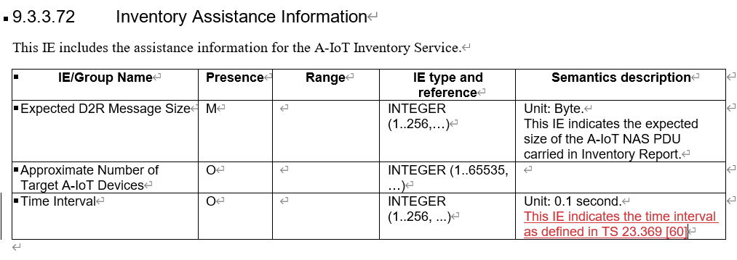  - Agree
CMCC | Agree
ZTE | Agree for all
Nokia | Agree to all | Same as Nokia.
LGE |  | - Ok  - No strong view  - No strong view  - Ok  - Ok
Futurewei | Agree to all | See our comment to Ericsson’s objection to 3), as inserted above.
- Moderator summary:
Revise 6642 to capture the following:
- (1) Update the encoding of A-IoT Correlation Identifier IE from OCTET STRING to INTEGER (0..65535, ...).
- (2) Update the encoding of AIOTF Identifier IE from OCTET STRING to OCTET STRING (SIZE(16)).
- (4) Keept the current encoding of the Time Interval IE, add reference to TS 23.369.
- (5) Keep the current encoding of the A-IoT Device Identification Requested IE.
Open issue to be discussed next meeting: (keep the related magic sentence in asn.1 part)
- (3) FFS on the presence of Reader Report List IE in the Inventory Report Transfer IE.

3.2 NGAP CR implementing online agreement
In R3-256644, two proposals are provided on interface management for A-IoT, and the first proposal was agreed online: Include the A-IoT Support IE in the RAN CONFIGURATION UPDATE message.
Proposal 2: Revised R3-256644 by only keeping the changes for proposal 1.
Please leave your comments on the changes on the agreement in R3-256644, if any.
Company | View | Comments, if any.
Huawei | Agree.
Ericsson | whatever
Qualcomm | Agree
Samsung | Agree.
CATT | Agree
CMCC | Agree
ZTE | Agree
Nokia | Agree
LGE | Agree
Futurewei | Agree
- Moderator summary:
Revise R3-256644 to implement the agreement.

3.3 Whether Command Type is needed?
In R3-256708, it is proposed to introduce Command Type IE (ENUMERATED (write, read, disable, ...)) in the Command Request Transfer IE.
Based on the online discussion, the current status is:
- Agree: ZTE, Huawei, CATT, Lenovo, E/// (at least the write codepoint), CMCC
- Disagree: Nokia, Xiaomi, NEC, QCOM
Moderator would like to ask companies to select among the following options:
- Option 1: Introduce Command Type IE (ENUMERATED (write, read, disable, ...))
- Option 2: Introduce Write Indication IE (ENUMERATED (true, ...))
- Option 3: Do nothing
Proposal 3: Please companies provide your views in the following table:
(If option 1 or option 2 is agreeable, revise R3-256708 to implement the selected option.)
Company | View | Comments, if any.
Huawei | Fine for 1 and 2. | From gNB point of view, aware of whether the command is a write command is essential, especially when take this into account together with the size of NAS PDU, the gNB can estimate the potential delay for the NAS response from the device.  If Option 1 is not acceptable for some companies, may I ask you to re-consider option 2?
Ericsson | Fine for 1 and 2 but | is the disable part of Rel-19? I seem to become forgetful 😉  Huawei: yes, “disable” is part of R19.
Qualcomm | Option 3 | As explained yesterday, RAN2 agreed to send “0 SDU” if Write Commnad Response will be delayed. So, the reader can know that this is a delayed write command and then can plan for future D2R resource for Write Command Response. Even if the reader is “proactively” provided that this is a Write command, this doesn’t help the reader in planning for a potential delayed Write command response as the reader will never know that the Write command will be delayed or not.  And for the general resource scheduling for read vs. write vs. disable, there is already the Expected D2R response size, which implicitly tell the reader what type of command it is and how much to plan for resources.  As there is no technical justification (other than “doesn’t harm” or nice to have), we can’t agree to option 1 and 2.
Samsung | Fine for 1 or 2.
CATT | Fine for 1 and 2 | If we include the command type, prefer option 1 for future proof.
NEC | Option 3 | Same as QC. We don’t see the strong motivation to add such a command indication. If RAN2 wants the indication, they will send LS to request adding the indication.  ZTE: The accurate/explicit indiction is used by gNB/reader, i.e., it is not related to RAN2 and it shall be decided by RAN3.
CMCC | Fine for 1 and 2.
ZTE | Fine for 1 and 2.
Nokia | Option 3 | No need of command type so far. Let us wait further input from other groups.
LGE | Fine for 1 and 2 | We slightly prefer Option 1
Futurewei | Fine for 1 and 2 | But same as LGE, we slightly prefer Option 1 if RAN3 is to add something.
- Moderator summary:
7 companies support option 1/2, 3 companies support option 3.

As 70% is achieved, let’s revise R3-256708 by only keep the changes on introduction of Command Type IE, and to be discussed online.

3.4 NGAP misc corrections: check 6635
In R3-256635, the following changes are made:
- Clarify which “inventory operation” is completed in the NG-RAN node in 8.20.2.2.
- Change “should” to “may” for the Interactions with the A-IoT Session Release procedure in 8.20.2.2.
- Clarify the “command” is “A-IoT NAS PDU received in the COMMAND REQUEST message” in 8.20.3.1 and 8.20.3.3.
- Replace “Correlation ID” with “A-IoT Correlation Identifier” in 8.20.4 and 8.20.5.
- Remove duplicated “ the NG-RAN node” in 8.20.3.2.
Question 4: Any comments of the changes in R3-256635?
(If any change is agreeable, revise R3-256635 to capture the agreed one(s).)
Company | View | Comments, if any.
Huawei | Ok for 1345  Not ok for 2 | For 2, as specified in stage2 call flow, in the mentioned scenario in that part, it should be “should” instead of “may”.  Other changes are fine, thank you for the careful checking!
Ericsson |  | 1. arent the two IEs mentioned in the proposed addition mandatory IEs? And shouldn’t this rather be a stage 2 thing to clarify?  2. We should align with the NG-RAN node initiated UE Context Release Request procedure, which states a "should" (we decided this in April 2013 (this memory is still intact)).  3. Don’t see the need  4. Very good catch, thank you  5. fine
Qualcomm |  | 1, 3: Not critical, but seems OK to clarify further  2: Disagree, should stay a “should”  4,5: OK
Samsung | 1,4,5 – OK  2,3 – No strong need
CATT | Ok for 1345  Further clarify 1,3. | For 1, better to have it to avoid misleading.  Here is the procedure text for the optional Inventory Complete Indication IE better to clarify. As there maybe parallel inventory procedures in an gNB, to say “the inventory operation is completed in the NG-RAN node” may cause misleading, beneficial to indicate which inventory opteration.  We can see similar texts for the A-IoT Session Release procedure, as below, similar texts “denoted by the AIOTF Identifier IE and the A-IoT Correlation Identifier IE” is applied for the complete indication.  Interactions with the A-IoT Session Release procedure:  In case the Inventory Complete Indication IE is included in the INVENTORY REPORT message and set to “true”, if there is no follow-on command to be transmitted, or all the follow-on command transmissions have been completed, the A-IoT CN node should initiate the A-IoT Session Release procedure for the A-IoT session denoted by the AIOTF Identifier IE and the A-IoT Correlation Identifier IE contained in the INVENTORY REPORT message.  For 2, ok to withdraw the change to align with the stage 2 call flow, and follow majority’s view.  For 3, beneficial to clarify what the “command” means?  As this is stage 3, we should clearly specify what information to be transferred.  If we use “command”, what is “the received command”, there’s no such kind of information in the Command Request message.  So, benefical to change “command” to “A-IoT NAS PDU in the Command Request Transfer IE in the COMMAND REQUEST message”
NEC |  | Neutral: 1, 3, 4, the current wording has no ambigurity.  Disagre: 2, when the AIoT transmission finished, the only option for CN is to release the session. So keep the “should”.  Agree: 5.
CMCC | Fine for 1345
ZTE | Fine for 1345
Nokia | Fine 1345  Nok for 2
LGE | OK for 1, 4, 5  No strong view for 3  No for 2
Futurewei | No to 2. OK to others.
- Moderator summary:
Majority companies fine for 1345 or no stong view.
Revise R3-256635 by only having changes on 1,3,4,5.

3.4 NGAP misc corrections: check 6707
In R3-256707, the following changes are made:
- In 8.20.1.2:
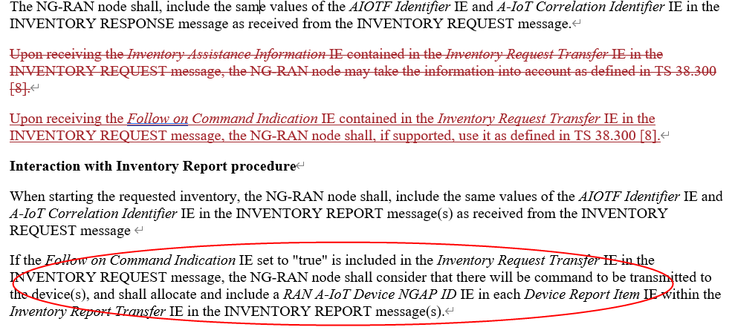
- In 8.20.3.2:
Question 5: Any comments on the changes in R3-256635?
(If any change is agreeable, revise R3-256635 to capture the agreed ones.)
Company | View | Comments, if any.
Huawei | Not ok for all | For the changes in 8.20.1.2, the first sentence was intended to be included, as for some of the sub-IE like Time Interval, the gNB may take into account. We strongly recommend to kepp the sentence.  ZTE: “Upon receiving…”, it means the IEs are optional, however it is not correct, because the IEs are mandatory. I provide other way to keep the “the gNB may take into account” as below.  Huawei: “Upon receiving” is used to describe the special handling for an mandatory IE in many cases. For optional IE, we use “if xxxx is included/provided”.  For the second change in 8.20.1.2, as shown above in the red circle, there is procedural text for this optional IE, no need to add another one.  For the change in 8.20.3.2, considering that this is assistance information, current gNB handling is all right, i.e., may take the information into account.
Ericsson | not ok | very well explained by Huawei
Samsung |  | - Prefer to remove the existing paragraph and no need to capture new description in NGAP, since normally we do not add descriptions for mandatory IE. If we really need to mention ‘the gNB may take into account’, we would suggest to add it in 300  Seems no need.
CATT | Seems not necessary | Similar view with Huawei.
NEC | No | Agree with HW
CMCC | Seems not necessary | Similar view with Huawei.
ZTE |  | For the changes in 8.20.1.2, the first sentence (i.e, Upon receiving the Inventory Assistance Information IE contained in the Inventory Request Transfer IE in the INVENTORY REQUEST message) means the IEs are optional, however it is not correct, because the IEs are mandatory.  I suggest to provide another way to indicate the IEs are mandatory, as below:  The A-IoT CN node shall send the Inventory Assistance Information IE contained in the Inventory Request Transfer IE in the INVENTORY REQUEST message, the NG-RAN node may take the information into account as defined in TS 38.300 [8].  Huawei: “Upon receiving” is used to describe the special handling for an mandatory IE in many cases. For optional IE, we use “if xxxx is included/provided”.  For the other changes, I can follow company's views.
Nokia | nok
LGE | No | Same view with Huawei
Futurewei | No
- Moderator summary:
The paper is noted.

3.5 Discuss security-related corrections if time allowsTopic 1
There are a set of papers on security submitted to this meeting.
The 128 bits RAND_{AIOT_n} was requestd by SA3 and its feasibility was confirmed by RAN2, from moderator point of view, RAN3 should include it in Inventory Request.
Besides RAND_{AIOT_n}, some companies also propose to include other A-IoT security parameters into NGAP, from moderator point of view, these parameters should not be introduced into NGAP unless other WGs request.
Proposal 6: Include RAND_{AIOT_n} in Inventory Request Transfer IE.
(If above proposal is aggregable, agree the R3-256844 and R3-256845.)
Company | View | Comments, if any.
Huawei | support
Ericsson | no support | as discussed in our paper, we prefer to include all those security parameters in a single NAS PDU, as there is no function associated to any securty related info from the CN. Of course, this depends on other groups as well.
Qualcomm |  | We can perhaps agree that it is feasible from RAN3 perspective to either add it as an explicit IE in NGAP or it can be added within an AIoT NAS PDU in NGAP in Inventory Request and it is upto RAN2 to finalize? We can even send an LS to check.
Samsung | Support
NEC |  | Support the RAND_{AIOT_n} in the Inventory Request, but we think it may be a NAS layer parameter because the RAND_{AIOT_n} is an AIoT device related parameter and has no impact on the RAN side.  For other security parameters, we believe the Identifier protection IE in the 6790 is necessary. As stated in clause 5.4.2&5.4.3 of TS 33.369, if the deviece identification protection is actived, the device identification information is not included in the D2R message. Then, the A-IoT NAS PDU IE should not be included in the Inventory Report at the RAN side. So the Identifier Protection IE should be explicitly included in the Inventory Request message.
CMCC | Support
ZTE | Not support | I suggest to wait for other group’s progress.
Nokia | wait | I suggest to wait for other group’s progress..
LGE | Wait | We also prefer to wait for other WG’ progress
Futurewei | Support
- Moderator summary:
Several companies support, several companies would like to wait for other WG’s progress.
Let’s mark this as open issue to be discussed at next meeting.

If you have any comments of the changes in R3-256844 and R3-256845, please list:
Company | View | Comments, if any.
Huawei | support
Samsung | Support
CMCC | Support
Nokia | See above.

