3GPP TSG-RAN WG3 Meeting #129-bis R3-25xxxx
Prague, Czech Republic, 13 – 17 October 2025

Agenda Item: 9.2.7
Source: Huawei (moderator)
Title: Summary of Offline Discussion for CB # 14_R19AmbientiIOT
Document for: Discussion

1 Introduction
CB: # 14_R19AmbientIOT
- NGAP encoding details: check 6642, taking into account 6661, 6883, 7061
- NGAP CR implementing above agreement
- whether Command Type is needed?
- NGAP misc corrections: check 6635, 6707
- Discuss security-related corrections if time allows
(Huawei - moderator)

2 For the Chair Notes
Editor’s Note: For Rel-20 study/work items, please consider that when agreements/FFSes are captured in a TP, additional inclusion in the Chair Notes may be unnecessary (particularly for stage 3 details).
Propose the following:
R3-25xxx1 – merged
R3-25xxx2 rev in R3-25xxx3 – agreed
R3-25xxx4 rev in R3-25xxx3 – endorsed

Propose to capture the following in Chair Notes:
Agreement: [carefully crafted text]
Agreement: [carefully crafted text]
WA: [carefully crafted text]
No consensus: [carefully crafted text]
To be continued: [carefully crafted text]

Propose to further discuss the following online:
[issue 1]
[issue 2]

3 Discussion (optional)

3.1 NGAP encoding details: check 6642, taking into account 6661, 6883, 7061
About the leftovers on IE details:
- Encoding of A-IoT Correlation Identifier IE
  - 6642 proposes to use INTEGER (0..65535, ...)
  - 6883 proposes to use INTEGER (0..65535)
  - 7061 proposes to use OCTET STRING (SIZE(4))
In CT4 agreed CR C4-253537, the A-IoT Correlation Identifier is defined as Unit16 (Unsigned 16-bit integer), therefore regards the above proposals, it is better to define it as INTEGER (0..65535, ...).
- Encoding of AIOTF Identifier IE
  - 6642 proposes to use OCTET STRING (SIZE(16));
  - 6661 proposes to keep using OCTET STRING
  - 6883 proposes to use OCTET STRING (SIZE (6))
  - 7061 proposes to consider its definition as e.g. a PrintableString of at least 32 characters with a to be defined upper length limit.
In CT4 agreed CR C4-253537, the AIOTF Identifier is defined by CT4 as NfInstanceId, based on IETF RFC 9562, a UUID is 128 bits long, we need to update the encoding of AIOTF Identifier IE from OCTET STRING to OCTET STRING (SIZE(16)).
- Presence of Reader Report List IE in the Inventory Report Transfer IE
  - 6642 proposes to change AIoT-ReaderReportList to optional in asn.1, but wrongly changes the Device Report List to optional in tabular. -_-!
  - 6883 changes the Reader Report List to optional
In asn.1 part, the following can be found:
InventoryReportTransfer ::= SEQUENCE {
correlationIdentifier AIoT-CorrelationIdentifier,
globalgNB-ID GlobalGNB-ID,
readerReportList AIoT-ReaderReportList,--the presence of the IE may be revisited--
inventoryCompleteIndication ENUMERATED {true, ...} OPTIONAL,
iE-Extensions ProtocolExtensionContainer { { InventoryReportTransfer-ExtIEs} } OPTIONAL,
...
}
Considering of the singnalling efficiency and potential latency, it is better to change the Reader Report List IE to optional.
- Encoding of Time Interval IE
  - 6642/6883 proposes to keep current encoding of Time Interval IE, and remove the comment related;
  - 7061 proposes to discuss in which way stage 2 specification in TS 23.369 on the usage of the Time Interval IE should be referenced, either in 38.413 or in 38.300.

As no changes proposed for the encoding of Time Interval IE, it is better to keep the current encoding of the Time Interval IE. Considering that the Time Interval is a sub-IE of the Inventory Assistance Information IE which is “may take into account”, we do not see very strong need to add the reference.

- Encoding of A-IoT Device Identification Requested IE

  - 6642/6661 proposes to keep the current encoding of the A-IoT Device Identification Requested IE, and remove the comment related;
  - 6883 proposes to remove the branch of “all devices”
As discussed in last meeting, the “all devices” branch should be kept unless requested by other WGs, therefore it is better to keep current encoding of the A-IoT Device Identification Requested IE.

Proposal 1: agree the following detailed encoding:
(If any change is agreeable, revise R3-256642 to capture the agreed one(s).)
- Update the encoding of A-IoT Correlation Identifier IE from OCTET STRING to INTEGER (0..65535, ...).
- Update the encoding of AIOTF Identifier IE from OCTET STRING to OCTET STRING (SIZE(16)).
- Update the presence of Reader Report List IE in the Inventory Report Transfer IE from mandatory to optional.
- Keept the current encoding of the Time Interval IE.
- Keep the current encoding of the A-IoT Device Identification Requested IE.
Please provide your comments, if any
Company | View | Comments, if any.
Huawei | Agree.

3.2 NGAP CR implementing online agreement
In R3-256644, two proposals are provided on interface management for A-IoT, and the first proposal was agreed online: Include the A-IoT Support IE in the RAN CONFIGURATION UPDATE message.
Proposal 2: Revised R3-256644 by only keeping the changes for proposal 1.
Please leave your comments on the changes on the agreement in R3-256644, if any.
Company | View | Comments, if any.
Huawei | Agree.

3.3 Whether Command Type is needed?
In R3-256708, it is proposed to introduce Command Type IE (ENUMERATED (write, read, disable, ...)) in the Command Request Transfer IE.
Based on the online discussion, the current status is:
- Agree: ZTE, Huawei, CATT, Lenovo, E/// (at least the write codepoint), CMCC
- Disagree: Nokia, Xiaomi, NEC, QCOM
Moderator would like to ask companies to select among the following options:
- Option 1: Introduce Command Type IE (ENUMERATED (write, read, disable, ...))
- Option 2: Introduce Write Indication IE (ENUMERATED (true, ...))
- Option 3: Do nothing
Proposal 3: Provide companies provide your views in the following table:
(If option 1 or option 2 is agreeable, revise R3-256708 to implement the selected option.)
Company | View | Comments, if any.
Huawei | Fine for 1 and 2. | From gNB point of view, aware of whether the command is a write command is essential, especially when take this into account together with the size of NAS PDU, the gNB can estimate the potential delay for the NAS response from the device.  If Option 1 is not acceptable for some companies, may I ask you to re-consider option 2?

3.4 NGAP misc corrections: check 6635
In R3-256635, the following changes are made:
- Clarify which “inventory operation” is completed in the NG-RAN node in 8.20.2.2.
- Change “should” to “may” for the Interactions with the A-IoT Session Release procedure in 8.20.2.2.
- Clarify the “command” is “A-IoT NAS PDU received in the COMMAND REQUEST message” in 8.20.3.1 and 8.20.3.3.
- Replace “Correlation ID” with “A-IoT Correlation Identifier” in 8.20.4 and 8.20.5.
- Remove duplicated “ the NG-RAN node” in 8.20.3.2.
Question 4: Any comments of the changes in R3-256635?
(If any change is agreeable, revise R3-256635 to capture the agreed one(s).)
Company | View | Comments, if any.
Huawei | Ok for 1345  Not ok for 2 | As specified in stage2 call flow, in the mentioned scenario in that part, it should be “should” instead of “may”.  Other changes are fine, thank you for the careful checking!

3.4 NGAP misc corrections: check 6707
In R3-256707, the following changes are made:
- In 8.20.1.2:
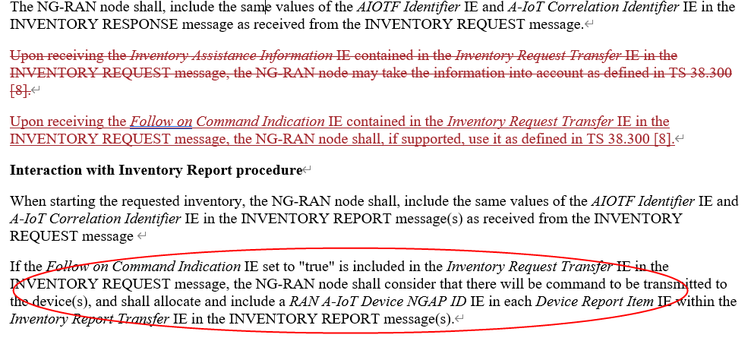
- In 8.20.3.2:
Question 5: Any comments on the changes in R3-256635?
(If any change is agreeable, revise R3-256635 to capture the agreed ones.)
Company | View | Comments, if any.
Huawei | Not ok for all | For the changes in 8.20.1.2, the first sentence was intended to be included, as for some of the sub-IE like Time Interval, the gNB may take into account. We strongly recommend to kepp the sentence.  For the second change in 8.20.1.2, as shown above in the red circle, there is procedural text for this optional IE, no need to add another one.  For the change in 8.20.3.2, considering that this is assistance information, current gNB handling is all right, i.e., may take the information into account.

3.5 Discuss security-related corrections if time allowsTopic 1
There are a set of papers on security submitted to this meeting.
The 128 bits RAND_{AIOT_n} was requestd by SA3 and its feasibility was confirmed by RAN2, from moderator point of view, RAN3 should include it in Inventory Request.
Besides RAND_{AIOT_n}, some companies also propose to include other A-IoT security parameters into NGAP, from moderator point of view, these parameters should not be introduced into NGAP unless other WGs request.
Proposal 6: Include RAND_{AIOT_n} in Inventory Request Transfer IE.
(If above proposal is aggregable, agree the R3-256844 and R3-256845.)
Company | View | Comments, if any.
Huawei | support

If you have any comments of the changes in R3-256844 and R3-256845, please list:
Company | View | Comments, if any.
Huawei | support

4 Conclusion (optional)

5 References (optional)
- Reference 1
- Reference 2

