3GPP TSG-RAN WG3 Meeting #128 <TDdoc#>
Malta, MT, 19 – 23 May, 2025

Title: Summary of Offline Discussion on NTN
Agenda Item: 10.3.1
Source: Huawei, CATT (moderator)
Document for: Approval

Introduction
# 28_Strange_and_Contentious_Topic
- capture initial assumptions
- merge/revise as needed
- remove ed notes
- attempt agreement on issues 1 and 2
- check details
(CompanyXXXX - moderator)
Summary of offline disc R3-25xxxx

For the Chairman’s Notes
Propose the following:
R3-25xxxa, R3-25xxxc merged
R3-25xxxc rev [in xxxg] – agreed
R3-25xxxd rev [in xxxh] – agreed
R3-25xxxe rev [in xxxi] – agreed
R3-25xxxf rev [in xxxj] – endorsed
Propose to capture the following:
Agreement text…
Agreement text…
WA: carefully crafted text…
Issue 1: no consensus
Issue 2: issue is acknowledged; need to further check the impact on xxx. May be possible to address with a pure st2 change. To be continued…

Discussion
General guidance from Chair:
“Considering it's late stage of R19, pls companies focus on the left open issues identified from last meeting and new issues are strongly not remmended to be raised for those ongoing R19 WIs.”

Area scope for NTN MDT
Issue 1: introduction of new area scope
RAN3 receives the reply LS from RAN2 in R3-253033, in which it says:
Q: On MDT for NTN, RAN3 assumes that the geographical area and/or the mapped cell ID can be used as the Area Scope for the logged MDT for NTN over NGAP. Further, RAN3 would like to confirm with RAN2 whether the geographical area defined for MBS NTN can be reused for Area Scope of logged MDT over Uu for NTN, to help RAN3 decide whether to specify geographical area and/or mapped cell ID over NGAP.
A: RAN2 confirms that the geographical area defined for MBS NTN can be used as a reference for Area Scope of logged MDT over Uu for NTN, including both reference location/radius and polygon-based area indication. RAN2 also agreed that only geographical area scope is used to indicate applicable logging area to the UE over Uu, i.e., no mapped cell ID(s).

Based on the reply LS, all companies (R3-253143, R3-253189, R3-253221, R3-253234, R3-253272. R3-253313, R3-253602, R3-253441) propose in this meeting to extend the Area Scope of MDT in MDT Configuration-NR to support a geographical area scope for NTN including either reference location/radius or a polygon-based area.
Therefore, the moderator would like to propose:
Proposal 1: To introduce a geographical area scope for NTN MDT including either reference location/radius or a polygon-based area.
Discussion:
Is proposal 1 agreeable?

On the other hand, R3-253272 and R3-253441 also propose to support the Mapped Cell Id. While, R3-253602 and R3-253189 see some issues to use the Mapped cell ID as the area scope.
Discussion:
Can mapped cell ID be used as the area scope of MDT in NTN?

Issue 2: apply to both logged and immediate MDT?
Furthermore, in R3-253189, it proposes that the geographical area scope applies to both logged and immediate MDT over NGAP. While in some companies contributions, only logged MDT is proposed.
In general, the moderator thinks that the new area scope should be applied to both type of MDT. RAN2 only discussed logged MDT because only logged MDT has UE impact.
The moderator then proposes:
Proposal 2: The geographical area scope applies to both logged and immediate MDT
Discussion:
Is proposal 1 agreeable?

In the end, R3-253272 and R3-253602 says this will impact on SA5, and propose to send a LS to SA5.
Then, the moderator proposes:
Proposal 3: To send a LS to RAN2 and SA5 to inform about RAN3 progress.

Distance based event trigger
Distance-based event trigger for logged MDT?
R3-253143, R3-253602. R3-253633 and three operators think that the distance based event trigger for logged MDT is needed. While, R3-253234 and R3-253313 explicitly states that no need to support this. R3-253272 thinks that it needs further discussion. R3-253441 thinks that the benefits are not clear.
Discussion”
Is the distance-based event trigger for logged MDT required to support or we consult RAN2 on the RAN2 impact first like the area scope?

If the answer is yes, can this be agreed?
Proposal 4: The distance based event trigger type can be configured simultaneously with the legacy event type.

MRO for RACH-less Handover for NTN:
Divide the MRO for RACH-less handover case into two scenarios:
- RACH-less handover was attempted but failed;
- UE was configured RACH-less handover but did not attempt RACH-less handover because RSRP is below threshold

Report the measured RSRP of SSB for RSRP threshold optimization:
R3-253221 things that
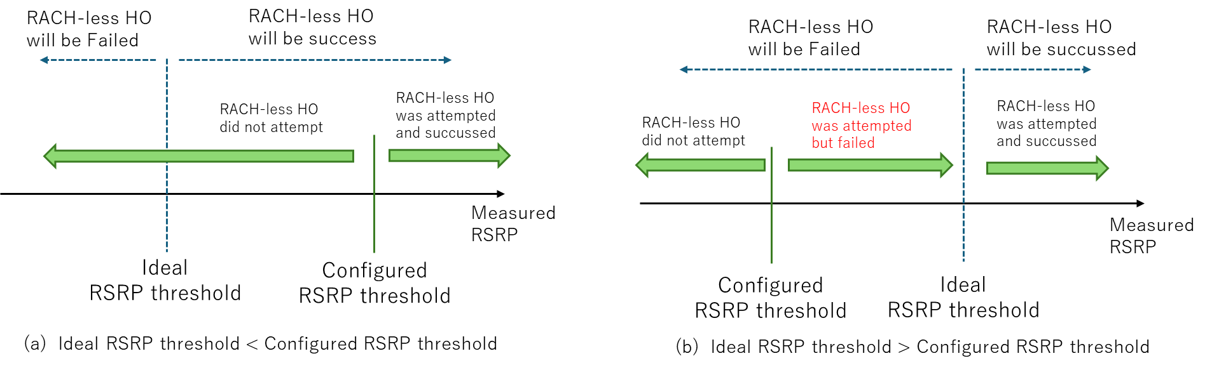
- For scenario 1 (i.e., RACH-less handover was attempted but failed), measured RSRP of SSB can be introduced in SON report.
- For scenario 2 (i.e., UE was configured RACH-less handover but did not attempt RACH-less handover because RSRP is below threshold), there is no need to be introduced in SON report.
R3-253189 also thinks that UE logs the information of the measured RSRP for the SSB beam(s) corresponding to the configured grant for RACH-less HO, but does not mention the scenario.
Report RACH less configuration:
R3-253234 thinks that the RACH-less HO related configuration (e.g., RSRP threshold for CG configuration, TCI State ID or SSB index for DG configuration) should be included in the RLF report.
RACH fallback optimisation
R3-253272 thinks that there is no need to report the ballback from RACH-less HO to RACH-based handover from the UE.
R3-253313 thinks that No need to include the RSRP threshold for RACH-less HO in RLF report, but an explicit indication regarding fallback from RACH-less HO to RACH-based HO is not needed in RLF report.
R3-253441 thinks that the network will know whether RACH-based or RACH-less is performed via RLF report and SHR.
R3-253441 proposes that UE should report a list of SSB and corresponding RSRP when fallback happens for optimization the fallback case i.e., to achieve more RACH-less handover.

Conclusion, Recommendations [if needed]
If needed

References
R3-253033 | Relay LS on MDT for NTN (RAN2(Qualcomm))
R3-253143 | SON MDT for NTN (Qualcomm Incorporated)
R3-253186 | (SON TP to BL CR to TS 38.423) Solution to avoid restarting MRO in NTN deployments (Nokia)
R3-253189 | SON-MDT enhancements for NTN (Ericsson)
R3-253190 | (BL CR to 38.413 for SON) Addition of SON enhancements (Ericsson)
R3-253221 | Discussion on SON/MDT enhancements for NTN (NEC)
R3-253234 | (TPs to BL CR for 38.300, 38.413 and 38.423) Further discussion on SONMDT enhancements for NTN (ZTE Corporation)
R3-253272 | (TP for MDT BLCRs for TS38.413, TS38.423) SON/MDT enhancements for NTN (Samsung)
R3-253313 | Discussion on SON/MDT for NTN (Lenovo)
R3-253358 | (TP for SON BLCR for 38.423) MRO for Intra-NTN mobility (Huawei)
R3-253441 | (TP for 38.300 and 38.413) Intra-NTN mobility for SONMDT (CATT)
R3-253602 | Discussion on SONMDT for Intra-NTN mobility (Huawei, CMCC, China Unicom)
R3-253603 | (TP for MDT BLCR for TS38.413): MDT enhancement for NTN (Huawei, CMCC, China Unicom)
R3-253604 | (TP for MDT BLCR for TS38.423): MDT enhancement for NTN (Huawei, CMCC, China Unicom)
R3-253605 | (TP for MDT BLCR for TS37.320): MDT enhancement for NTN (Huawei, CMCC, China Unicom)
R3-253633 | Discussion on SONMDT enhancements for NTN mobility (China Unicom)

