3GPP TSG-RAN WG3 Meeting #128 R3-253750

MT, MT, May 19 –23, 2025

Agenda Item: 10.2

Source: ZTE Corporation(moderator)

Title: SoD of MRO for LTM

Document for: Approval

# For the Chairman’s Notes

Propose to capture the following:

BFR shortly after successful LTM cell switch to the wrong beam(Case 1)

**RAN3 supports use DU-CU ACCESS AND MOBILITY INDICATION message for target DU send recovery beam information to the CU. Only one recovery beam information in each message.**

**Additional Information with recovery beam information from target DU to CU:**

* **CU-F1 AP ID**
* **Failure type (for case 1, case 2)**
* **beam failure indicator**

**RAN3 supports use ACCESS AND MOBILITY INDICATION message for CU forward recovery beam information to the source DU. Only one recovery beam information in each message.**

**Additional Information with recovery beam information from target CU to DU:**

* **Source DU-F1 AP ID**
* **Failure type (for case 1, case 2)**
* **beam failure indicator**

**Stage 2 38.300 impact**

**No new failure type defined for 38.300.**

**Stage 2 38.401 impact:**

**Tstore_UE_cntxt in the target DU is reused. The intention is for target DU to identify the time related to shortly after. Stage 2 in 38.401 is needed to captured the new behavior.**

**RAN3 to capture updates in TS38.401 for BFR shortly after successful LTM cell switch to the wrong beam.**

**Stage 3 impact**

FFS

UHI and ping-pong issue

**CU inform relevant information to the target DU, CU-DU Cell Switch Notification can be used during the same LTM procedure.**

**Down selection of following solutions:**

**1a: CU provide full UHI list with L1/L3 type to the DU (maximum item number is 16).**

**1b: CU provide full UHI list (except PScell) with L1/L3 type to the DU (maximum item number is 16).**

**2a: CU provide last consecutive L1 entries to the DU.**

**2b: CU provide FFS number of last consecutive L1 entries to the DU.**

**No stage 2 TP for LTM ping pong in 38.401.**

**Stage 3 in TS38.473: FFS**

LTM cell switch failure due to wrong beam (Case 2)

**[For online discussion]:**

**RAN3 supports network-based solution for the LTM cell switch failure due to wrong beam.**

**The target DU/gNB-CU identifies the LTM cell switch failure caused by wrong beam.**

**In case that the source DU selects a wrong beam among candidate beam list, the source DU is responsible for MRO optimization**

**In case that the target DU provides a wrong candidate beam list, the target DU is responsible for MRO optimization**

**Target DU needs to send the reconnect beam information to CU and CU forwards it to source DU.**

**CU does not need to send the old beam information to source DU.**

**Which message used for target DU send reconnect beam information to the CU?**

There are multiple options on the table:

1: DU-CU ACCESS AND MOBILITY INDICATION[QC][Lenovo][CMCC][Sam]

2: ACCESS SUCCESS[ZTE]

3: UL RRC message [Huawei]

**Which message used for CU forward reconnect beam information to the source DU?**

There are multiple options on the table:

1: ACCESS AND MOBILITY INDICATION message [QC][ZTE][Lenovo][CMCC][Sam]

2: DL RRC message [Huawei]

**Additional Information with recovery beam information?**

There are multiple options on the table:

**1:**  F1 AP ID[QC][ZTE] [Sam]

2: C-RNTI [ZTE]

3: Wrong beam type (case 1, case 2)[ZTE]

4: Recovery cell ID[Huawei]

5: new failure type (e.g. wrong TCI state selection) from CU to DU [Lenovo]

6: Target cell ID [Sam]

**Stage 2 in TS38.300**

**New failure type in stage 2: [QC][ZTE][Lenovo]**

**No new failure type defined for 38.300.**

**Stage 2 in TS 38.401**

**RAN3 capture stage 2 in 38.401 for case 2.**

Reply LS to RAN2

If the solution achieve consensus on case 1 & 2, a LS is needed for reply RAN2’s question.

Summary the situation of controversial topics:

|  |  |  |  |  |
| --- | --- | --- | --- | --- |
| Topic | Background | Network based solution Vs UE based solution | Solution comparison | Possible result |
| LTM failure due to outdated TA | Raised from RAN3  Agree to solve it in R19 | * **Support NW based solution:**   QC, ZTE, Lenovo, CMCC, Huawei, Google, CU, CATT, Samsung   * **Support UE based solution:**   Ericsson, Nokia, Samsung | Both solutions work. | Depends on on-line discussion. |
| TA acquisition type | Raised from RAN2  RAN2#127bis meeting agreed that unless RAN3 defines a NW-based solution, the UE logs and reports. | * **Support NW based solution:**   QC, ZTE, CMCC, CATT, Nokia, Samsung   * **Support UE based solution:**   Ericsson, Lenovo | Both solutions work. | If no consensus in RAN3, then RAN2 should select UE based solution. |
| Near LTM failure due to outdated TA | Raised from RAN3 | Only NW based solution |  |  |

LTM failure due to outdated TA

**[For online discussion]:**

**If UE based solution is selected**

**RAN3 supports UE-based solution for out dated TA.**

**What extra information should provide from the UE:**

**- TA value used for successful access;**

**- TA value received in cell switch command;**

**- The time difference between receiving PDCCH order and performing RACH-less LTM.**

**If Network based solution is selected**

**RAN3 supports network-based solution for out dated TA.**

**Target DU send the TA information to CU and CU forwards it to source DU.**

**CU does not need to send the old TA information to source DU.**

**Whether to introduce new failure type in TS 38.300**

In RAN3 #127bis also the following was marked as to be clarified in the next meeting:

Whether LTM failure due to outdated TA is defined as a new failure case or it can covered by existing failure case?

There is proposal on the table:

New out dated failure type: [QC][ZTE][Lenovo][CMCC][CATT][Nokia][Sam]

TA acquisition type

**[For online discussion]:**

**For inter DU case:**

**Network based Solution:**

Supportive companies: QC, ZTE, CMCC, CATT, Nokia, Sam

**For inter-DU case, CU aware TA acquisition type without any signaling impact in RAN3[QC][ZTE][Lenovo][CATT][Sam]**

* **gNB-CU knows whether it has configured the UE to perform UE-based TA measurement.**
* **gNB-CU knows the LTM target cell upon receiving the DU-CU CELL SWITCH NOTIFICATION with the target cell ID.**
* **gNB-CU knows whether early UL sync was performed for the target LTM cell if it had received the TA value for the target LTM cell via DU-CU TA Information Transfer during preparation phase**
* **gNB-CU can assume that the source gNB-DU must have sent the TA value of LTM candidate cells “as soon as possible” to the UE upon sending the TA value of LTM candidate cells in CU-DU TA Information Transfer.**

**For inter-DU case, CU aware TA acquisition type with following enhancements [Nokia]**

* **To add new binary indicator into Cell ID IE (representing target cell) of the DU-CU CELL SWITCH NOTIFICATION message (TS 38.473) informing CU about gNB indicated TA[Nokia in R3-253150 and corresponding TPs]**

**UE based solution :**

[Lenovo][E///]

**For intra DU case:**

**Network based Solution:**

**For intra-DU case, CU aware TA acquisition type without any signaling impact in RAN3.[Lenovo]**

**For intra-DU case, source DU aware TA acquisition type without any signaling impact in RAN3.[ZTE]**

**For intra-DU case, DU always enforce TA acquisition type selected by CU[CATT]**

**For intra-DU case, CU aware TA acquisition type with following enhancements [Nokia]**

**UE based solution :**

[Lenovo][E///]

Near LTM failure due to outdated TA

**MRO will cover the scenario that LTM nearly fails related to outdate TA.**

**Network based solution is used for LTM failure due to outdated TA.**

**The target DU identifies the LTM nearly fails related to outdated TA and has allocated a updated TA value to the UE.**

**Target DU needs to send the updated TA value information to CU and CU forwards it to source DU.**

**CU does not need to send the old TA information to source DU.**

Common framework for LTM recovery in target cell

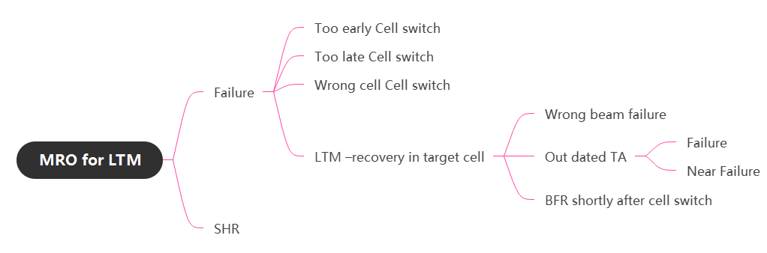

**RAN3 further study common framework for LTM recovery in target cell including following case:**

**1： BFR shortly after successful LTM cell switch to the wrong beam**

**2： LTM cell switch failure due to wrong beam**

**3： Near LTM failure due to outdated TA**

**4: LTM failure due to outdated TA**

**5: TA acquisition type**

**6: Near failure for wrong beam( Not even discussed )**

**7: Near failure for BFR shortly after successful LTM cell switch to the wrong beam( Not even discussed )**

Clarity C-RNTI IE in ACCESS AND MOBILITY INDICATION

Solution 1: Stage 2 update [Huawei] In [R3-253356], Huawei propose to add stage2 text to specify when CRNTI should be included (see also the TP in the annex)

Solution 2: Stage 3 update [Nokia, E///,Lenovo]

In [R3-253150], Nokia propose to update the Semantics description for the C-RNTI.

In [R3-253188], E/// propose to specify the conditions of the sending of the source C-RNTI in ACCESS AND MOBILITY message.

In [R3-253311], Lenovo propose to clarify C-RNTI in ACCESS AND MOBILITY INDICATION message.

**Conclusion:**

Stage3 to define the condition to include this optional C-RNTI in ACCESS AND MOBILITY INDICATION .

Proposed TPs online meeting:

General:

(BL CR to 38.420 for SON) Addition of SON enhancements

Proposed TPs after online meeting:

BFR shortly after successful LTM cell switch to the wrong beam

**TP to 38.473**

**TP to 38.401**

**TP to 38.300**

LTM cell switch failure due to wrong beam

**TP to 38.473:**

**TP to 38.401:**

**TP to 38.300:**

LTM failure due to outdated TA

Near LTM failure due to outdated TA

**TP to 38.473:**

**TP to 38.401:**

**TP to 38.300:**

TA acquisition type

**Depends on UE based solution or NW based solution**

UHI and ping-pong issue

**TP to 38.473**

**TP to 38.401**

# Discussion

## General principal [Huawei]

**Conclusion:**

**If DU make all analysis – it means we should send this info as soon as possible to the DU. This means there is no need for any analysis in the CU (no new failure case) and no additional info from source DU.**

**If CU make the analysis – a new failure type is needed, and we may need info from source DU.**

## LS from RAN2(Case 1 & Case 2)

In last RAN3 meeting, issues from RAN2 as below LS has been received [1]:

* BFR shortly after successful LTM cell switch to the wrong beam (“near failure”), and
* LTM cell switch failure due to wrong beam

On the former issue, RAN2 have acknowledged the issue but agreed not to define a UE-based solution. RAN2 respectfully asks RAN3 to consider defining a network-based solution for this. Furthermore, RAN2 asks RAN3 to see if/how the solution (if specified) could also be used for the latter issue.

### Case 1: BFR shortly after successful LTM cell switch to the wrong beam (“near failure”)

The progress during last RAN3 meeting as following:

|  |
| --- |
| **RAN3 supports network-based solution for the case of BFR shortly after a successful LTM cell switch.**  **The target DU identifies the BFR happened in UE shortly after successful LTM cell switch caused due to wrong beam.**  **In case that the source DU selects a wrong beam among candidate beam list, the source DU is responsible for MRO optimization**  **In case that the target DU provides a wrong candidate beam list, the target DU is responsible for MRO optimization**  **Target DU needs to send the recovery beam information to CU and CU forwards it to source DU.**  **CU does not need to send the old beam information to source DU.** |

#### **Which message used for target DU send recovery beam information to the CU?**

**Whether UE associated message or non UE associated message can be used to send information.**

There are multiple options on the table:

1: DU-CU ACCESS AND MOBILITY INDICATION message [QC][ZTE][Lenovo][CATT][Huawei][Sam][E///]

2: UE associated message [Nokia][Huawei: UL RRC message]

**Conclusion:**

**RAN3 support use DU-CU ACCESS AND MOBILITY INDICATION message for target DU send recovery beam information to the CU. Only one recovery beam information in each message.**

#### **Which message used for CU forward recovery beam information to the source DU?**

There are multiple options on the table:

1: ACCESS AND MOBILITY INDICATION message [QC][ZTE][Lenovo][CATT][E///][Sam]

2: UE associated message [Nokia][Huawei: DL RRC message]

**Conclusion:**

**RAN3 support use *ACCESS AND MOBILITY INDICATION* message for CU forward recovery beam information to the source DU. Only one recovery beam information in each message.**

#### **Additional Information with recovery beam information from target DU to CU?**

There are multiple options on the table:

**1:**  CU-F1 AP ID[QC][ZTE] [E///][Sam]

2: Failure type (for case 1, case 2) [QC][ZTE]--ffs

3: ~~C-RNTI [ZTE]~~

4: ~~Recovery cell ID[Huawei]~~

5: beam failure indicator [Lenovo] [CMCC]-ffs

~~6: Target Cell ID [Sam]~~

**Conclusion:**

**RAN3 agree to carry following information together with recovery beam information:**

**- F1 AP ID**

**- Failure type**

#### **Additional Information with recovery beam information from CU to source DU?**

There are multiple options on the table:

**1:**  Source DU-F1 AP ID[QC][ZTE] [E///][Sam]

2: Failure type (for case 1, case 2) [QC][ZTE]-FFS

3~~: C-RNTI [ZTE]~~

4: ~~Recovery cell ID[Huawei]~~

5: beam failure indicator [Lenovo] [CMCC]-ffs

6: ~~Target Cell ID [Sam]~~

**Conclusion:**

**RAN3 agree to carry following information together with recovery beam information:**

**- F1 AP ID**

**- Failure type**

#### **Additional configure in target DU?**

There is proposal on the table:

A threshold is configured by the OAM for the gNB-DU[NEC]

T-store-Context in the target DU is reused. The intention is for target DU to identify the time related to shortly after. Stage 2 in 38.401 is needed to captured case 1.

**Conclusion:**

#### **Stage 2 38.300 impact(FFS)**

Source DU optimize case 1

No New failure type defined for 300.

: BFR shortly after successful LTM cell switch to the wrong beam

**Conclusion: RAN3 support new/general failure type for BFR shortly after successful LTM cell switch to the wrong beam.**

#### **Stage 2 38.401 impact**

38.401:

The target gNB-DU detects that a Beam Failure Recovery (BFR) has happened in the UE shortly after a successful LTM cell switch. The target gNB-DU performs initial analysis and in case of the BFR caused by wrong beam selection at the source gNB-DU, it may send the recovery beam information to the source gNB-DU via the gNB-CU

**Conclusion:**

**RAN3 to capture updates in TS38.401 for BFR shortly after successful LTM cell switch to the wrong beam.**

#### **Stage 3 impact FFS**

Details can be further check

ZTE:

9.3.1.xxx LTM Wrong Beam Information

This information element is used to indicate the recovery beam information related to an LTM near failure, or the reconnect beam information related to an LTM failure.

| IE/Group Name | Presence | Range | IE type and reference | Semantics description |
| --- | --- | --- | --- | --- |
| UE Assistant Identifier | O |  | gNB-DU UE F1AP ID  9.3.1.5 |  |
| C-RNTI | O |  | 9.3.1.32 | C-RNTI allocated at the source gNB-DU. |
| Joint or DL TCI State ID | M |  | OCTET STRING | Includes the *TCI-StateId* IE, as defined in TS 38.331 [8]. |
| UL TCI State ID | O |  | OCTET STRING | Includes the *TCI-UL-StateId* IE, as defined in TS 38.331 [8]. |
| Wrong Beam Type | M |  | ENUMERATED (near-failure-LTM-to-Right-Cell-with-Wrong-Beam, failure-LTM-to-Right-Cell-with-Wrong-Beam, ...) |  |

Lenovo:

|  |  |  |  |  |  |  |
| --- | --- | --- | --- | --- | --- | --- |
| **Beam Failure Recovery Information** | O |  |  |  | YES | ignore |
| >TCI State of Beam Failure Recovery | M |  | OCTET STRING | Includes the TCI-State Id used for Beam Failure Recovery. | - |  |
| >Wrong TCI State Indication | M |  |  | Indicates BFR occurs due to Wrong *TCI-StateId* IE defined in TS 38.331 [8] | - |  |
| **LTM Failure Information** | O |  |  |  | YES | ignore |
| >TCI State of Reconnection | M |  | OCTET STRING | Includes the TCI-State Id used for LTM failure recovery or RRC re-establishment. | - |  |
| >Failed TCI State | M |  | OCTET STRING | Indicates the *TCI-StateId* IE used for LTM cell switch, as defined in TS 38.331 [8]. | - |  |

**E///:**

|  |  |  |  |  |  |  |
| --- | --- | --- | --- | --- | --- | --- |
| **Beam Failure Recovery Information** | O |  |  |  | YES | ignore |
| >Recovery TCI State | M |  | OCTET STRING | Includes the *TCI-StateId* IE used at Beam Failure Recovery, as defined in TS 38.331 [8]. | - |  |
| >gNB-DU UE F1AP ID | O |  | 9.3.1.5 | Included if available in gNB-CU. | - |  |

CATT:

|  |  |  |  |  |  |  |
| --- | --- | --- | --- | --- | --- | --- |
| Beam failure information | O |  |  |  | YES | ignore |
| >UE Assistant Identifier | M |  | gNB-DU UE F1AP ID  9.3.1.5 |  | - |  |
| >SSBIndex | O |  | INTEGER(0..63) |  |  |  |
| >CSI-RSIndex | O |  | INTEGER(0..191) |  |  |  |

Samsung:

|  |  |  |  |  |  |  |
| --- | --- | --- | --- | --- | --- | --- |
| TCI State Information List |  |  |  |  | YES | ignore |
| **>TCI state Information Item** |  | *1 .. <maxnoofTCIStateInformationItem>* |  |  | - |  |
| >>UE Assistant Identifier | M |  | gNB-DU UE F1AP ID  9.3.1.5 |  | - |  |
| >>Target Cell ID | O |  |  | NR CGI  9.3.1.12 |  |  |
| >>TCI State Information For Successful Access After Failure |  | *0..1* |  |  | - |  |
| >>>Joint or DL TCI State ID | M |  | OCTET STRING | Includes the *TCI-StateId* IE, as defined in TS 38.331 [8]. | - |  |
| >>>UL TCI State ID | O |  | OCTET STRING | Includes the *TCI-UL-StateId* IE, as defined in TS 38.331 [8]. | - |  |

### Case 2: LTM cell switch failure due to wrong beam

Background:

If the beam info is wrongly configured or indicated, there is one failure case about LTM to Right Cell, but Wrong Beam as shown in the following Figure .

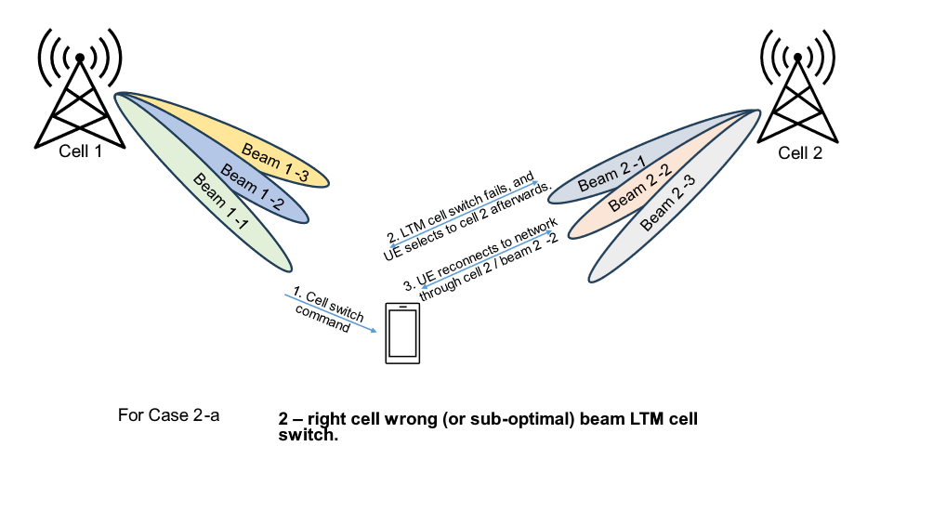

**Figure 2 A failure due to LTM to Right Cell and Wrong Beam.**

Step 1. An LTM cell switch decision is triggered by network, and the UE is switched to the right cell but wrong beam). E.g., a UE was in cell1/beam1-1 is commanded to LTM cell switch to cell2/beam 2-1.

Step 2. The LTM cell switch failed during the LTM cell switch procedure, e.g., UE was not able to detect any scheduling on Beam 2-1.

Step 3. UE executes the cell selection procedure, still selecting to cell 2, and afterwards re-establishing the connection at the cell2/beam2-2.

RAN3's progress on LTM cell switch failure due to wrong beam at last meeting:

**FFS if/how the solution for case 1 could also be used for the case of LTM cell switch failure due to wrong beam (case 2)?**

#### UE based or Network based solution for Case 2

Network based solution: [QC][ZTE][Lenovo][CMCC][Google][Huawei][Samsung]

UE based solution: [NEC][E///][Nokia]

Not support any solution: [CATT]

**Conclusion: RAN3 support**

#### How the solution for case 1 used for case 2.

##### Mechanism for Cell switch failure due caused by wrong beam

**Conclusion:**

**The target DU/gNB-CU identifies the LTM cell switch failure caused by wrong beam**

**In case that the source DU selects a wrong beam among candidate beam list, the source DU is responsible for MRO optimization**

**In case that the target DU provides a wrong candidate beam list, the target DU is responsible for MRO optimization**

**Target DU needs to send the reconnect beam information to CU and CU forwards it to source DU.**

**CU does not need to send the old beam information to source DU.**

##### Which message used for target DU send reconnect beam information to the CU?

There are multiple options on the table:

1: DU-CU ACCESS AND MOBILITY INDICATION[QC][Lenovo][CMCC][Sam]

2: ACCESS SUCCESS[ZTE]

3: UL RRC message[Huawei]

**Conclusion: RAN3 support**

##### Which message used for CU forward reconnect beam information to the source DU?

There are multiple options on the table:

1: ACCESS AND MOBILITY INDICATION message[QC][ZTE][Lenovo][CMCC][Sam]

2: DL RRC message [Huawei]

**Conclusion: RAN3 support**

##### Additional Information with recovery beam information?

There are multiple options on the table:

**1:**  F1 AP ID[QC][ZTE] [Sam]

2: C-RNTI [ZTE]

3: Wrong beam type(case 1,case 2)[ZTE]

4: Recovery cell ID[Huawei]

5: new failure type (e.g. wrong TCI state selection) from CU to DU [Lenovo]

6: Target cell ID [Sam]

**Conclusion**

##### Stage 2 in TS38.300

New failure type in stage 2: [QC][ZTE][Lenovo]

**Conclusion: RAN3 Define new failure types *LTM cell switch failure due to wrong beam* in stage-2 specifications.**

##### Stage 2 in TS 38.401

Stage 2 TP in 38.401[ZTE]

The target gNB-DU detects that the UE successfully performs a RACH-based access to the target cell during the LTM cell switch procedure, reconnecting to the same cell with a beam different from the target beam. The target gNB-DU performs initial analysis and in case of the RACH-less LTM failure caused by wrong beam selection at the source gNB-DU, it may send the reconnect beam information to the source gNB-DU via the gNB-CU.

**Conclusion: RAN3 capture stage 2 in 38.401 for case 2.**

### Reply LS to RAN2

If the solution achieve consensus on case 1 & 2, an LS is needed for reply RAN2’s question.

ZTE: draft LS in [**R3-253734**]

Sam: draft LS in [**R3-253626**]

## UHI and ping-pong issue

RAN3#126 meeting agreed that:

**CU can adjust the candidate Cell list for LTM based on UHI.**

**DU should be able to resolve LTM ping-pong based on information over F1.**

During RAN3#127bis, the following agreement was taken:

**For intra-CU case, CU detects the potential LTM ping-pong issue based on local information, DU decides and solves the LTM ping-pong issue.**

**RAN3 to discuss which option to be agreed:**

* **Option 1: CU sends the UHI to DU upon successful LTM cell switch/UHI is updated, e.g. via the CU-DU CELL SWITCH NOTIFICATION message.**
* **Option 2: CU sends the UHI to DU when LTM ping-pong is detected, e.g. via the ACCESS AND MOBILITY INDICATION message.**
* **Option 3: CU sends an indication to DU that LTM ping-pong has occurred, e.g. via the CU-DU CELL SWITCH NOTIFICATION message.**
* **Option 4: CU filters the LTM related UHI, and sends to DU via UE Context Setup Request, UE Context Modification Request or CU-DU CELL SWITCH NOTIFICATION.**
* **Option 5: No need to send UHI from CU to DU.**

Another issue is **whether to indicate HO type (e.g. L3 HO or LTM) in UHI.**

In [R3-253351],Huawei provide a good background and observations for Ping pong in LTM.

* UE history information is useful for ping pong detection and to determine the mobility profile of the UE
* Ping pong detection is performed in the node that makes the adjustment of the mobility parameters
* UE history is sent in the handover over preparation (or similar)
* Ping pong detection and mitigation is left to implementation (except for the inter-system mobility case)
* For successive mobility (CPAC or LTM) there is still no solution for the mobility events after the initial mobility. For S-CPAC it is currently only possible to send the UE history information to the SN during initial configuration.

### Mechanism used for LTM UHI:



***General mechanism***

Approach 1: CU inform relevant information to the target DU, *CU-DU Cell Switch Notification* can be used during the same LTM procedure. [E///][ZTE][HUAWEI]

1a: CU provide full UHI list with L1/L3 type to the DU (maximum number is 16).

1b: CU provide full UHI list (except PScell) with L1/L3 type to the DU DU (maximum number is 16).

2a: CU provide last consecutive L1 entries to the DU.

2b: CU provide FFS number of last consecutive L1 entries to the DU

Approach 2: CU inform UHI to the DU, *ACCESS AND MOBILITY INDICATION* can be used independent from LTM procedure [Lenovo][CMCC][CATT]

**Conclusion:**

**RAN3 to accept**

***What is the information provide to gNB-DU***

There are multiple options on the table:

1: One item of UHI.[E///]

2: Multiple items of UHI [ZTE][HW][CATT][Lenovo]

**Conclusion:**

**RAN3 to accept**

***CU behavior (always provide or when ping-pong detect)***

**1:**  CU always sends UHI to target DU during each LTM cell switch[ZTE][Huawei]

2: CU sends UHI to target/first DU when ping-pong occurred.[E///][Lenovo][CATT][CU]

**Conclusion:**

**RAN3 to accept**

***Extra information (e.g. Handover type)***

**1:**  L1/L3 handover type [ZTE][CATT]

2: Filter L1 UHI[Huawei]

**Conclusion:**

**RAN3 to accept**

### stage 2 in TS38.401:

No Stage 2 TP for ping pong in 38.401

In case of LTM cell switch, the gNB-CU collects and stores the UE History Information for as long as the UE stays in one of its cells. The gNB-CU may send UE history information to the target DU for the subsequent LTM cell switch, when notifying the target DU about the current initiation of the LTM cell switch command to the UE.

### stage 3 in TS38.473:

There are multiple options on the table, e.g, full UHI with "HO type", filtered UHI associated with LTM mobility, or a visited cell involved in LTM ping-pong. see below.

**1:**  In [R3-253733], a full UHI referencing the existing UHI definition in TS 38.413 is added to the CU-DU Cell Switch Notification message, and a "HO type" field is introduced in the UHI definition in TS 38.413 [ZTE]. [R3-253439] defines a new UHI IE in TS 38.473 based on the structure of the UHI in TS 38.413 with the added "HO type" field.

2: In [R3-253188], LTM ping-pong related information within the CU-DU Cell Switch Notification message is added to record a previously visited cell associated with the current ping-pong switch.

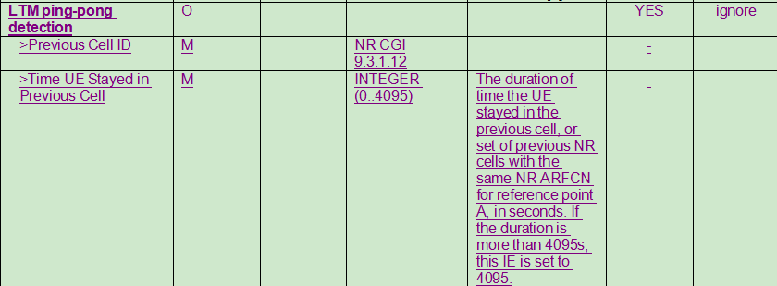

3: In [R3-253352], a new LTE UE History IE within CU-DU Cell Switch Notification message is defined to LTM UE history associated to LTM cell switch filtered by CU.

( Note that in order to avoid holes in the UE history, which may be misinterpreted, the solution would require to only send the sequence of consecutive LTM cell switch, i.e. the LTM UE history would start after the latest L3 event)

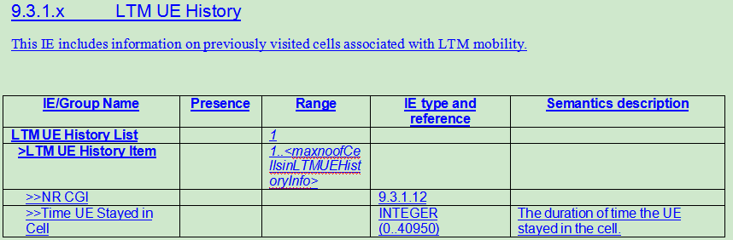

## Summary of controversial topics

|  |  |  |  |  |
| --- | --- | --- | --- | --- |
| Topic | Background | Network based solution Vs UE based solution | Solution comparision | Possible result |
| LTM failure due to outdated TA | Raised from RAN3  Agree to solve it in R19 | * **Support NW based solution:**   QC, ZTE, Lenovo, CMCC, Huawei, Google, CU, CATT, Samsung   * **Support UE based solution:**   Ericsson, Nokia, Samsung | Both solutions work. | Depends on on-line discussion. |
| TA acquisition type | Raised from RAN2  RAN2#127bis meeting agreed that unless RAN3 defines a NW-based solution, the UE logs and reports. | * **Support NW based solution:**   QC, ZTE, CMCC, CATT, Nokia, Samsung   * **Support UE based solution:**   Ericsson, Lenovo | Both solutions work. | If no consensus in RAN3, then RAN2 should select UE based solution. |
| Near LTM failure due to outdated TA | Raised from RAN3 | Only NW based solution |  |  |

## LTM failure due to outdated TA

Progress in RAN3#127bis:

|  |
| --- |
| **MRO will cover the scenario that RACH-less LTM fails including outdate TA and UE performs RACH based LTM.**  **RAN3 will not consider the case of LTM cell switch failure due to outdated TA calculated by UE.**  **For PDCCH order triggered early TA acquisition, RAN3 consider the case of RACH-less LTM fails due to outdate TA and UE performs RACH-based LTM failure recovery or RRC re-establishment to the same cell.**  **Whether UE based solution or network based solution is used for LTM failure due to outdated TA?**  **Whether LTM failure due to outdated TA is defined as a new failure case or it can covered by existing failure case?** |

### UE based Vs Network based solution:

* **Support NW based solution:**

QC, ZTE, Lenovo, CMCC, Huawei, Google, CU, CATT, Samsung

* **Support UE based solution:**

Ericsson, Nokia, Samsung

A comparison table provide in [R3-253735]:

|  |  |  |
| --- | --- | --- |
|  | UE based solution | NW based solution |
| Impacts on spec | Enhance RLF report | Enhance ACCESS SUCCESS message |
| Impacts on DU | None | Target DU may need to add TA value used for successful accessing in the ACCESS SUCCESS message. |
| Impacts on UE | Store TA information in the RLF report and sent to the NW. Besides TA value used for successful accessing, more information such as TA value received in cell switch command and time difference between receiving PDCCH order and performing RACH-less LTM are needed in the RLF report since the UE context may have been released by source gNB-DU when receiving RLF report. | None |
| Overhead on F1AP and Xn signalling | For one failure event due to outdated TA, one F1AP message (ACCESS AND MOBILITY INDICATION) is needed. In case RLF report is received by other CU, Xn message is needed. | For inter-DU LTM failure event due to outdated TA, one F1 message (ACCESS AND MOBILITY INDICATION) is needed.  For intra-DU LTM failure event due to outdated TA, no additional message. |
| Pros | Target DU can do nothing. | 1. Having no impacts on UE. 2. Providing faster response for the issue, since the source DU can acquire the assistant info to determine whether UL early sync should be optimized upon the RACH-less LTM cell switch is executed, without waiting for the UE RLF report which may be received long time later.   3)For intra-DU LTM failure event due to outdated TA, no additional message is needed. |

**Conclusion:**

### If UE based solution is selected

**Conclusion:**

**What extra information should provide from the UE:**

**- TA value used for successful access;**

**- TA value received in cell switch command;**

**- The time difference between receiving PDCCH order and performing RACH-less LTM.**

### If Network based solution is selected

**Conclusion:**

**RAN3 supports network-based solution for out dated TA.**

**Target DU send the TA information to CU and CU forwards it to source DU.**

**CU does not need to send the old TA information to source DU.**

### Whether to introduce new failure type in TS 38.300

In RAN3 #127bis also the following was marked as to be clarified in the next meeting:

Whether LTM failure due to outdated TA is defined as a new failure case or it can covered by existing failure case?

There is proposal on the table:

New out dated failure type: [QC][ZTE][Lenovo][CMCC][CATT][Nokia][Sam]

**Conclusion:**

**To introduce New** **LTM cell switch failure due to outdated TA type in TS38.300.**

### Reply LS to RAN2

If the solution achieve consensus, a LS is needed for reply RAN2’s question.

## Near LTM failure due to outdated TA

In [R3-253188], E/// propose the near LTM failure case: The near-failure case occurs when the first transmission from the UE was received almost outside the cyclic prefix. In other words, the access succeeded, but the timing was off so much that a better TA value could have been used. In that case the network will need to correct the TA with the UE.

In general, in [R3-253356] Huawei also support the capture near failure case due to outdated TA.

Check the following can be agreeable:

**MRO will cover the scenario that LTM nearly fails related to outdate TA.**

**Network based solution is used for LTM failure due to outdated TA.**

**Conclusion:**

**MRO will cover the scenario that LTM nearly fails related to outdate TA.**

**Network based solution is used for LTM failure due to outdated TA.**

**The target DU identifies the LTM nearly fails related to outdated TA and has allocated a updated TA value to the UE.**

**Target DU needs to send the updated TA value information to CU and CU forwards it to source DU.**

**CU does not need to send the old TA information to source DU.**

## Network based or UE based solution for TA acquisition type

RAN2#127bis meeting agreed that unless RAN3 defines a NW-based solution, the UE logs and reports whether and how the UE got the TA value used for a failed LTM switch (gNB indicated or UE determined).

RAN3#127 meeting discussed it but didn’t have consensus, two FFSs as below were left. We should continue the discussion.

RAN3#127bis meeting got following progress:

|  |
| --- |
| Network based or UE based solution for TA acquisition type  **For inter-DU case, CU aware TA acquisition type without any signaling impact in RAN3.**  **FFS for intra-DU case.** |

### Network based or UE based solution

#### For inter DU case:

**Network based Solution:**

Supportive companies: QC,ZTE,CMCC, CATT,Nokia, Sam

Can we agree the following:

**For inter-DU case, CU aware TA acquisition type without any signaling impact in RAN3[QC][ZTE][Lenovo][CATT][Sam]**

* **gNB-CU knows whether it has configured the UE to perform UE-based TA measurement****.**
* **gNB-CU knows the LTM target cell upon receiving the DU-CU CELL SWITCH NOTIFICATION with the target cell ID****.**
* **gNB-CU knows whether early UL sync was performed for the target LTM cell if it had received the TA value for the target LTM cell via DU-CU TA Information Transfer during preparation phase**
* **gNB-CU can assume that the source gNB-DU must have sent the TA value of LTM candidate cells “as soon as possible” to the UE upon sending the TA value of LTM candidate cells in CU-DU TA Information Transfer.**

**For inter-DU case, CU aware TA acquisition type with following enhancements[Nokia]**

* **To add new binary indicator into Cell ID IE (representing target cell) of the DU-CU CELL SWITCH NOTIFICATION message (TS 38.473) informing CU about gNB indicated TA[Nokia in R3-253150 and corresponding TPs]**

**UE based solution :**

[Lenovo] We think current signalling design of the DU-CU CELL SWITCH NOTIFICATION message may also support the CU to be aware of TA acquisition type without any signalling impact for intra-DU case, but if RAN3 can’t achieve consensus on whether/which network based solution to be adopted for TA acquisition type, we prefer the UE based solution agreed by RAN2 should be maintained.

**Conclusion:**

#### For intra DU case:

**Network based Solution:**

Can we agree the following:

**For intra-DU case, CU aware TA acquisition type without any signaling impact in RAN3.[Lenovo]**

**For intra-DU case, source DU aware TA acquisition type without any signaling impact in RAN3.[ZTE]**

**For intra-DU case, DU always enforce TA acquisition type selected by CU[CATT]**

**For intra-DU case, CU aware TA acquisition type with following enhancements[Nokia]**

**UE based solution :**

[Lenovo] We think current signalling design of the DU-CU CELL SWITCH NOTIFICATION message may also support the CU to be aware of TA acquisition type without any signalling impact for intra-DU case, but if RAN3 can’t achieve consensus on whether/which network based solution to be adopted for TA acquisition type, we prefer the UE based solution agreed by RAN2 should be maintained.

**Conclusion:**

## Common framework for LTM recovery in target cell

In [R3-253356], HW provide view on common framework

We think that in order for network to determine the failure type, we need to know whether it was due to TA or beam selection. Therefore, we prefer to discuss these topics together. In our understanding the topic: “Network based or UE based solution for TA acquisition type” is not a separate problem, but part of this problem discussion.

Since we think that all cases above share the same general solution space – sending information from target to source – we think that it would be beneficial to discuss this as a common framework.

Mind map of MRO of LTM:

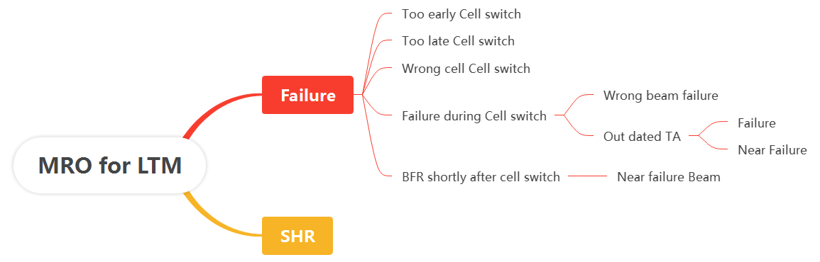

Or unified as suggested by Huawei in [R3-253356]



**Conclusion:**

**RAN3 further study common framework for LTM recovery in target cell including following case:**

**1： BFR shortly after successful LTM cell switch to the wrong beam**

**2： LTM cell switch failure due to wrong beam**

**3： Near LTM failure due to outdated TA**

**4: LTM failure due to outdated TA**

**5: TA acquisition type**

**6: Near failure for wrong beam( Not even discussed )**

**7: Near failure for BFR shortly after successful LTM cell switch to the wrong beam( Not even discussed )**

## Other issues:

More focus on identified issues, others can be handled in next meeting.

### Clarity C-RNTI IE in ACCESS AND MOBILITY INDICATION

**Issue 1:**

In RAN3 # 126 meeting the following was agreed:

For TP to BL CR to TS 38.473:

* In ACCESS AND MOBILITY INDICATION message, the presence of the C-RNTI IE is kept optional. FFS on stage2 or stage3 to define the condition to include this optional C-RNTI.

Solution 1: Stage 2 update [Huawei] In [R3-253356], Huawei propose to add stage2 text to specify when CRNTI should be included (see also the TP in the annex)

Solution 2: Stage 3 update [Nokia, E///,Lenovo]

In [R3-253150], Nokia propose to update the Semantics description for the C-RNTI.

In [R3-253188], E/// propose to specify the conditions of the sending of the source C-RNTI in ACCESS AND MOBILITY message.

In [R3-253311], Lenovo propose to clarify C-RNTI in ACCESS AND MOBILITY INDICATION message.

**Conclusion:**

Stage3 to define the condition to include this optional C-RNTI in ACCESS AND MOBILITY INDICATION .

# Conclusion, Recommendations [if needed]

If needed.

# References

1. R2-2501378, LS on SON for LTM, Apple
2. R3-253142 MRO enhancements for LTM (Qualcomm Incorporated)
3. R3-253150 (TP for SON BL CR for TS 38.473, TP for SON BL CR for TS 38.401, TP for SON BL CR for TS 38.300, TP for SON BL CR for TS 38.423) MRO Enhancements for LTM and CHO with Candidate SCG(s) (Nokia)
4. R3-253185 (TP for SON BL CR for TS 37.340) Reformulation of the forwarding mechanism and MRO Enhancements for optimisation of the S-CPAC selection (Nokia)
5. R3-253188 (TP for BL CR to 38.473 for SON) MRO enhancements for LTM (Ericsson)
6. R3-253214 (TP for SON BLCR of 38.473) Discussion on MRO for LTM (NEC)
7. R3-253278 (TP for SON BL CR for TS 38.473) Discussion on LTM MRO (Google)
8. R3-253311 (TP for SON BLCR for 38.473) Discussion on MRO for LTM (Lenovo)
9. R3-253312 (TP for SON BLCR for 38.423) Discussion on MRO for CHO with candidate SCG(s) and subsequent CPAC (Lenovo)
10. R3-253351 Ping-Pong (Huawei, CMCC, Qualcomm, Jio Platforms )
11. R3-253352 (TP for SON BLCR for 38.473) Ping-Pong (Huawei, CMCC, Qualcomm, China Unicom, Jio Platforms )
12. R3-253353 (TP for SON BLCR for 38.413) Ping-Pong (Huawei, CMCC, Qualcomm, Jio Platforms )
13. R3-253354 (TP for SON BLCR for 37.340) Ping-Pong (Huawei, CMCC, Qualcomm, China Unicom, Jio Platforms )
14. R3-253355 (TP for SON BLCR for 38.423) Ping-Pong (Huawei, CMCC, Qualcomm, Jio Platforms )
15. R3-253356 (TP for SON BLCR 38.401, 38.473) MRO for LTM (Huawei)
16. R3-253357 (TP for SON BLCR for 37.340) MRO for others (Huawei)
17. R3-253439 (TP for 38.473 and 38.401) MRO for Rel-18 LTM (CATT)
18. R3-253440 (TP for 38.423 and 38.300) MRO for CHO with Candidate SCG(s) and S-CPAC (CATT)
19. R3-253626 (TP to BL CR for TS38.473 and TS38.401) MRO for LTM (Samsung)
20. R3-253627 (BL CR to 38.420 for SON) Addition of SON enhancements (Samsung, ZTE, CATT, Lenovo, Cybecore)
21. R3-253628 (TP for SON BLCR TS38.300, TS37.340 and TS38.423) MRO for CHO with candidate SCGs and S-CPAC (Samsung, Jio Platforms)
22. R3-253629 Failure scenarios on MRO for CHO with candidate SCGs (Samsung, Cybercore, Lenovo)
23. R3-253632 Discussion on MRO Enhancements (China Unicom)
24. R3-253696 Discussion on MRO enhancements for LTM (CMCC)
25. R3-253733 (TP for SON BLCR for 38.401, 38.473, 38.413, 37.340, and 38.423)Discussion on MRO (ZTE Corporation)
26. R3-253734 (TP for SON BLCR for 38.300, 38.401, and 38.473) LTM failure and near failure caused by wrong beam (ZTE Corporation)
27. R3-253735 (TP for SON BLCR 38.300, 38.401 and 38.473)MRO for LTM outdated TA and TA acquisition type (ZTE Corporation)