**3GPP TSG-RAN WG3 #128 Draft-R3-253811**

**St. Julien, Malta, 19th – 23rd May 2025**

**Agenda Item: 17.2**

**Source: Ericsson (Moderator)**

**Title: Network Energy Saving Summary of offline discussion**

**Document for: Discussion and Approval**

# Introduction

**Early RAN3 agreements (from RAN3#127bis)**

In the new Class 1 message (Direction NES gNB to Cell A gNB), RAN3 has agreed that:

* One Choice “Start with UL WUS Configuration”;
* One Choice “Stop” meaning the Cell A gNB will remove/release/discard the UL WUS Configuration and stop the broadcasting, it also means that next time the NES gNB should use “Start with UL WUS Configuration”.

# For the Chairman’s Notes

It is proposed to capture in the Chairman’s note the below agreements:

**Agreement 1: One “Provision Request message includes one “OD-SIB1 config R19” referring to the TS 38.331 definition, it is a RRC Container in octet string (presence M) + one NES Cell ID (presence M ) + one Cell-A ID (presence O )**

**Agreement 2: Cell A gNB-CU encoding the SIBxx.**

**Agreement 3: The NES gNB-CU sends the indication to NES gNB-DU the NES gNB-DU MAY go to OD-SIB 1 operation up to gNB-DU decision.**

**It is proposed agree the TP R3-253856 /R3-253857 capturing the above agreements.**

**It is proposed to agree** [**R3-253243**](Inbox\R3-253243.zip) **as Baseline CR.**

# The second offline discussion

3.1 Objective 1: Support on-demand SSB Scell

**Continue from the discussion we had from RAN3#127bis:**

Introduce a New list: ZTE, Samsung, Nokia

Reuse the list (May revise the procedural text): Rakuten, Huawei, CATT, Ericsson, DT

Nothing: Nokia, Ericsson

3.2 Objective 2: Support on-demand SIB1 for UEs

**Working Assumption:**

We are sending “Cell A list” from NES gNB to Cell-A gNB in the “WUS Configuration Provision Request” message, and send Cell A list from the Cell-A gNB to NES gNB in the response/failure

**The below list of the essential issues should be discussed for the closing of the WID:**

3.2.1 Related to the WUS Configuration Provision Request, choice of “Start”, Direction: NES gNB -> Cell-A gNB

* Should one “UL WUS Configuration Provision Request” message contain **one** UL WUS Configuration or **multiple different** UL WUS Configurations (i.e. a loop of the “single UL WUS Configuration”?
* Should the UL WUS Configuration in the request contain:
  + One NES Cell ID or a list of NES Cell IDs what share the same UL WUS Configuration?
  + the “octet string” that we can refer to TS 38.331 (OD-SIB1-Config-r19, refer to Annex)
  + It is a working assumption that a Cell-A list will be included. It is indicating to Cell A gNB that the UL WUS Configuration /OD-SIB1-Config-r19 should be broadcasted in the indicated Cell As.

3.2.2 Related to the UL WUS Configuration Provision Response/Failure, Direction: Cell-A gNB -> NES gNB

* For the “UL WUS Configuration provision”, what is considered as “successful” thus Cell-A gNB confirm to the NES Cell the broadcasting for the given UL WUS Configuration is successful?

Option 1: All the Cell-A cells have successfully broadcast UL WUS Configuration

Option 2: At least one Cell-A cell can broadcast the UL WUS Configuration

* It is a working assumption that a Cell-A list will be included. It is indicating to NES gNB that the UL WUS Configuration /OD-SIB1-Config-r19 cannot be broadcasted in the indicated Cell As.

**Discussion:**

QC: Would the message include a list of Cell A, particular for one NES cell or general Cell A?

Huawei: not prefer to have a list of Cell-A. It is up to the Cell A gNB to decide which Cell -A to broadcast. Not in the response message.

Rakuten: No Cell A, purely depend on Cell A gNB decision.

CATT: No Cell A in the response, but in the request message, Cell A is beneficial

Nokia: Cell A is beneficial in the request and response.

NEC: Should be some Cell A gNB to NES cell gNB information exchange before any OD-SIB 1 operation. Thus not depend on OAM. Not dynamic but allow change even on top of the OAM.

DT/ ZTE : A NES Cell who decides to go to OD-SIB1 would need to include the Cell A in the “UL WUS Configuration Provision” message.

Lenovo : one message includes on UL WUS Config, + a list of NES Cell + a list of Cell A

Samsung: One UL WUS Config can be used be different NES Cell, and different NES cell could have different Cell A for the broadcast. Cell A do not need to know the NES Cell ID because Cell A does not need to know / use the NES Cell ID.

QC: Purely on OAM, we may not need anything??

Ericsson: To be robust, the NES cell needs to know that the indicated Cell A is doing the broadcast.

**Discuss the simple solution: One “Provision Request message includes one “OD-SIB1 config R19”, it is kind of RRC Container in octet string + one NES Cell ID ? + one Cell-A ID ?**

Samsung: NES ID is useless.

Nokia: why NES ID is useless? It is useful as it is broadcasted in the SIB.

QC: Cell A ID can be optional, and NES Cell ID can be optional

CATT: NES Cell ID can be option or no existing. But Cell A can be included

Huawei: We do not need Cell A ID;

Rakuten: If the NES Cell /Cell A ID are not presented, if we only include UL WUS Config. How does it work

DT: UL WUS Config + Cell A + NES ID shall be included in this message

Moderator: can we listen to the operator on this and made an agreement?

**Moderator summary: capture the agreement.**

**Agreement 1: One “Provision Request message includes one “OD-SIB1 config R19” referring to the TS 38.331 definition, it is kind of RRC Container in octet string (presence M) + one NES Cell ID (presence M ) + one Cell-A ID (presence O )**

2.2.3 Related to the WUS Configuration Provision Request, choice of “Stop”, Direction NES gNB -> Cell-A gNB

* Can we agree that “Stop” is always successful?
* If NES Cell IDs are included, the Cell A will stop the UL WUS Configuration for the given NES Cell IDs, if provision ID ( assuming it is signalled in the request) is included, the broadcasting for all the NES Cell associated to the provision ID will be stopped?

2.2.4 Related to Cell-A gNB, if it is gNB-CU or gNB-DU to encode the new SIBxx

* Most of the company proposed that it is gNB-CU in the Cell-A gNB encode the new SIBxx. Can we make this agreement?

**Moderator summary: capture the agreement.**

**Agreement 2: Cell A gNB-CU encoding the SIBxx.**

2.2.4 Related to Cell-A gNB, if it is gNB-CU or gNB-DU to encode the new SIBxx

NES gNB-DU decides on going to OD-SIB1 operation and request NES gNB-CU;

NES gNB-CU sends the provision to Cell A gNB;

Cell A gNB response to NES gNB-CU;

**NES gNB-CU inform NES gNB-DU that the UL WUS Configuration broadcast request has been accepted by the Cell A gNB.**

**This is the Inter gNB case:**

**If the provision(s) are accepted:**

**Agreement 3: The NES gNB-CU sends the indication to DU the NES gNB-DU MAY go to OD-SIB 1 up to gNB-DU decision.**

**It is still DU to finally execute and determine if it goes on OD-SIB1 or not.**

**If rejected by Cell A gNB:**

Nokia: gNB-CU sends the indication to DU that it MAY go to OD-SIB 1, and it is still DU to finally execute and determine if it goes on OD-SIB1 or not.

NES Cell gNB-CU informs the NES Cell gNB-DU when the Cell A gNB confirms or rejects the UL WUS Configuration Request. ( re

**Moderator summary: Agreement 3 is captured in Chairman notes.**

# 3 Offline Discussion on Support on-demand SIB1 for UEs

3.1 Related to the WUS Configuration Provision Request, choice of “Start” NES Cell -> Cell A

* Should **one “WUS Configuration Provision Request” message** contain one WUS Configuration or **multiple different WUS Configurations?**

NEC: do we know RAN2’s design. -🡪 we do not need to have dependency on RAN2 on this aspect ( common understanding), **Prefer the single UL WUS Configuration**

QC: Provide a list, which means possible to contain multiple “**Different UL WUS Configuration**”

Huawei: Prefer multiple different WUS configuration in one message

Rakuten: Prefer single UL WUS Configuration, it is easy to handle with associated to a single provision ID

DT: If two requests at different times, NES gNB has to send twice the request.

Lenovo /ZTE/Samsung/CATT/Nokia : Prefer: multiple “**Different UL WUS Configuration**”

Ericsson: Prefer single **UL WUS Configuration**, to avoid the complexity for example how Cell A provide the response/failure.

**We will revisit this part when we see how the response message will look like.**

* Should each UL WUS Configuration instance contain:
  + the “octet string” format “WUS Config” that we can refer to TS 38.331 (OD-SIB1-Config-r19, refer to Annex).
  + One NES Cell ID or a list of NES Cell IDs what share the same UL WUS Configuration?

Option 1: Loop on the “UL WUS Configuration “: Huawei/CATT/DT/Ericsson/ZTE/Lenovo/NEC: multiple NES Cells shared the same UL WUS Config with the loop on “UL WUS Configuration”

Option 2: Loop on the “NES Cell”: Nokia/Rakuten: one NES cell associated with one UL WUS Configuration, “loop on the NES cells and each loop associates to a UL WUS Configuration”

* + One Cell-A ID or a list of Cell-A IDs that should broadcast the UL WUS Configuration?

**Samsung /DT/Nokia/CATT/ZTE/Lenovo/Ericsson/**: support list of Cell A ID, Configuration will be on NES.

**Huawei/Rakuten/**: prefer not to add Cell A ID;.

Nokia: Not to use CCO. Support to have Cell A ID

NEC: exchange the Cell A capability between to NES Cell

**Working Assumption:**

We do not send Cell A from NES to Cell A gNB in the request, and not Cell A in the response?

Rakuten, Huawei, NEC, CATT

We are sending Cell A list from NES to Cell A in the request, and send Cell A in the response?

DT, Ericsson, Samsung, ZTE, Lenovo, Nokia, QC

3.2 Related to the “WUS Configuration Provision Response/Failure”

The discussion should be based on the decisions we are going to make for 3.1.

* What is considered to be a “sucessful”, i.e. Cell A gNB will send “WUS Configuration Provision Response”
  + when all the indicated Cell A Cells have broadcasted the UL WUS?
  + When at least one indicated Cell A Cells has broadcasted the UL WUS ( but not all)?

**Rakuten**

**DT/ Ericsson/CATT:** do not support partical sucessful, as the NES would not know in this case if there is enough coverage.

**NEC:** thus prefer to have one UL WUS Config in the request and in the response we have response to the one UL WUS Configuration.

**DT:** all Cell A can broadcast UL WUS Configuration, then it is sucessufly.

**Rakuten:** if Cell A is not sent from NES Cell in the Request, it is up to Cell A to decide what is sucessful, blindly.

* What is considered to be a “failure”, i.e. Cell A gNB will send “WUS Configuration Provision Failure”
  + At least one indicated Cell A Cells cannot perfrom broadcasting WUS Configuration
    - The list of the failled Cell As are included in the failure message or not?
  + All the indicated Cell A Cells cannot perfrom broadcasting WUS Configuration

3.3 Related to the WUS Configuration Provision Request, choice of “Stop”

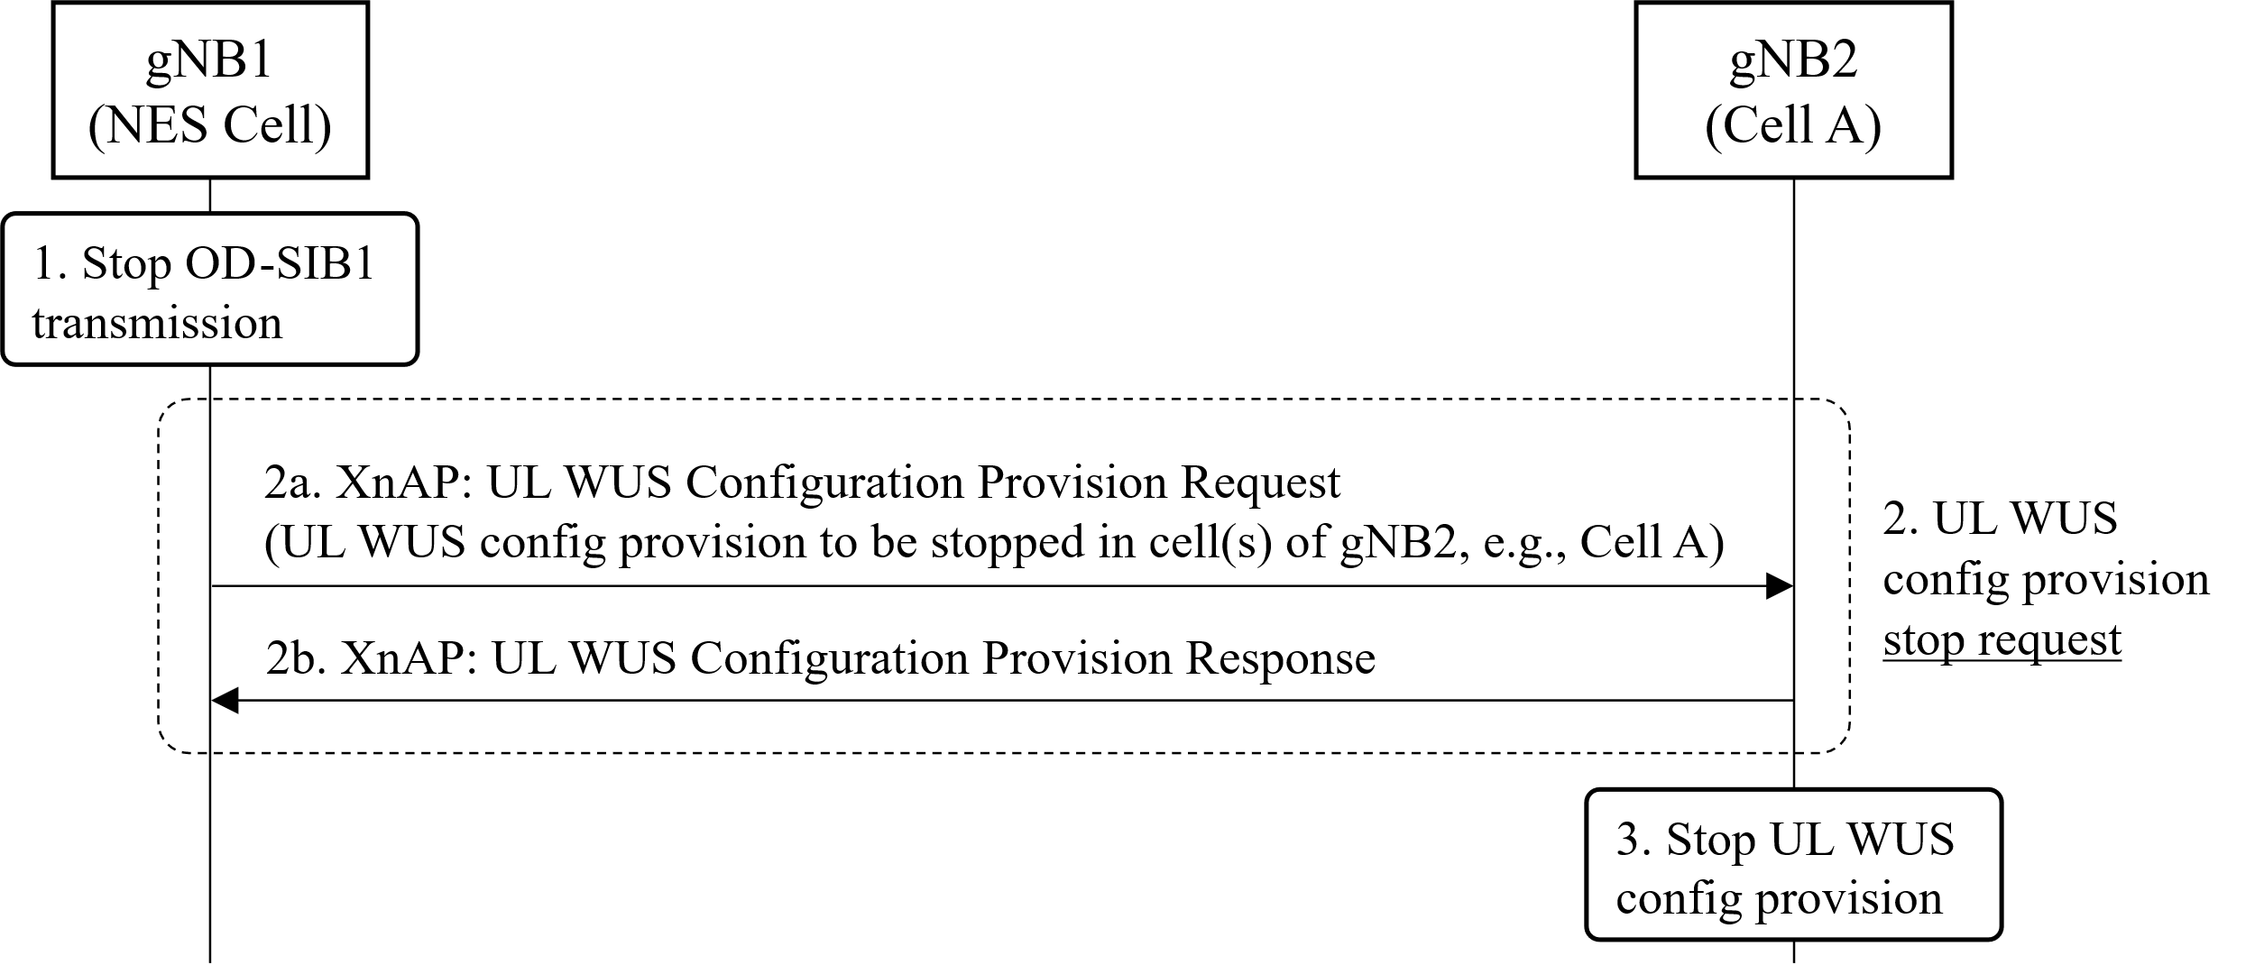

* The “Priovision ID” is included in the “Request”, in the “Stop” message, the “given Provision ID” associated UL WUS Configuration is remove/release/discard and the broadcast of UL WUS Configuraiton is stopped.
* The NES Cell list is included, all the indicated NES Cells UL WUS Configuration broadcasting is stopped ( and the configuration is removed/released/discarded).
* The “Stop” operation is always sucessful.

3.3 Related to the NES Cell CU and NES Cell DU

* Before the gNB-DU can determine if it can send the “on-demand SIB1 IE” to gNB-CU, receive a permission list from gNB-CU?
* After gNB-DU has sent the on-demand SIB1 IE” to gNB-CU, it will receive “confirmation” from gNB-CU that the UL WUS Configuration is broadcasoed, so that it can enter the OD-SIB1 operation.

3.4 Related to the Cell-A CU and Cell-A DU

* Should the UL WUS Configuration SIBx be encoded by Cell-A CU or Cell-A DU?

3.5 Related to the WUS Configuration Provision Request, we have already start and stop, if we need to have more choice option?

3.6 The following is up to implemenation or by OAM or need update the specification

* NES Cell goes to OD-SIB1 operation after it has received the suceesful response from the Cell A is up to implemenation
* Which gNB works as “Cell A gNB” for the other gNB.

3.7 Discussion on class 2 message (sending from Cell A -> NES Cell)



# 4 Discussion on Support on-demand SSB Scell

New list? ZTE, Samsung, Nokia

Reuse the list (may revise the text )? Rakuten, Huawei, CATT, Ericsson, DT

# 5 Discussion on Support adaptive

**Anything?**

# 6 Moderator Summary

# 7 Annex

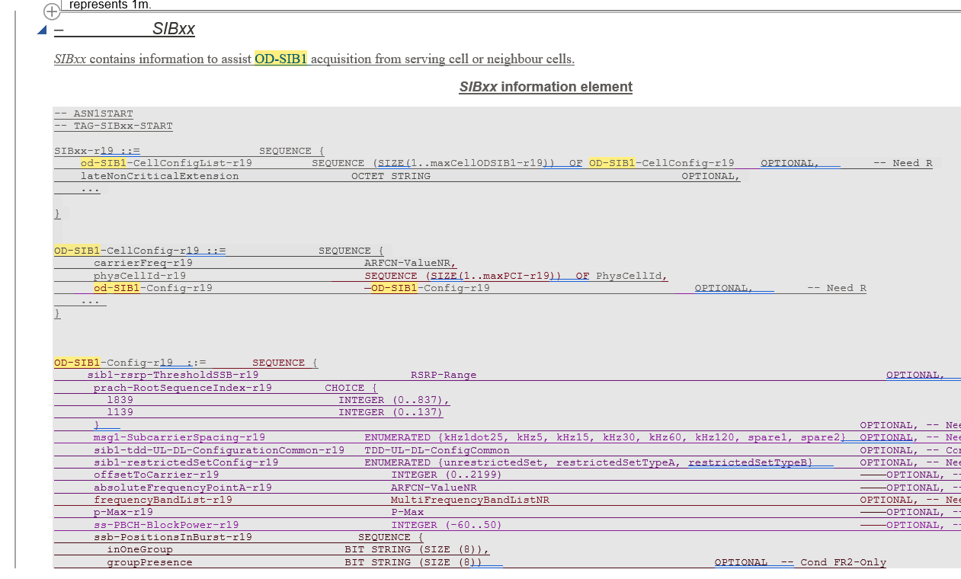

# 8 Reference