3GPP TSG-RAN WG3 #127 R3-25xxxx

Athens, Greece., 17th-21st February 2025

Agenda Item: 17.3
Source: Ericsson (Moderator)
Title: Summary of offline discussions: Rel-19 Network Energy Saving OD-SIB1
Document for: Discussion and Approval

Introduction
CB: # ES2
Check the signaling flow for the cases discussed online
Capture agreements and open issues
(moderator - E///)

For the Chairman’s Notes
It is proposed to capture the following RAN3 agreements in the chairman’s notes:
Proposal 1: It is agreed that “after Cell A gNB has received and accepted the UL WUS Configuration request from the NES Cell gNB, it broadcasts SIB at the first opportunity.
Proposal 2: It is agreed from the signalling point of view, in UL WUS Configuration Request (naming FFS) from NES Cell gNB to Cell A gNB, UL WUS Configuration is included to trigger Cell A to start broadcasting UL WUS configuration in SIB as in Proposal 1.
Proposal 3: It is agreed that NES Cell gNB can “stop” (naming FFS) Cell A to broadcast UL WUS configuration. But it is not agreed if the class 1 or class 2 procedure is used. For further discussion.

The XnTP capture the above agreement is in R3-25xxxx.
It implements proposal 1 and proposal 2.

3 Discussion on Support on-demand SIB1 for UEs
We have reached the below agreements:
It is agreed that “after Cell A gNB has received and accepted the UL WUS Configuration request from the NES Cell gNB, it broadcasts SIB at the first opportunity, as shown in the below figure:

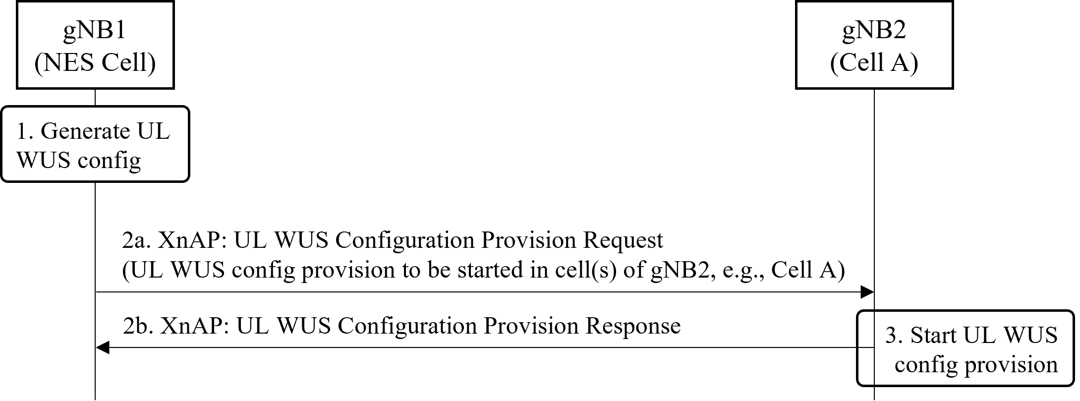
It is agreed from the signalling point of view, in UL WUS Configuration Req (naming FFS) from NES Cell gNB to Cell A gNB, one code point “start” with UL WUS Configraiton. This code point is used to trigger Cell A to broadcast UL WUS configruation in SIB.
It is agreed that NES Cell gNB can “stop” (naming FFS) Cell A to broadcast UL WUS configuration. But it is not agreed if the class 1 procedure or class 2 procedure is used. For further discussion.

The XnTP capture the above agreement is in R3-25xxxx.

6 Moderator Summary
Capture the agreement in the XnAP TP.

