3GPP TSG-RAN WG3 Meeting #127-bis R3-252297

Wuhan, China, 7-11 April, 2025

Agenda Item: 16.2

Source: Huawei - Moderator

Title: Summary of Offline Discussion – CB: # AIoT1_Procedures

Document for: Approval

# Introduction

This is the summary document for the following come back:

**CB: # AIoT1_Procedures**

**- Discuss the open issues**

**- Capture agreements and provide TPs if agreeable**

**- Check R3-252244**

(moderator - HW)

Summary of offline disc R3-252297

1. For the Chairman’s Notes

**General**

* **Turn previous “WA: Introduce a NGAP Class 1 Inventory Request procedure.” and “WA: Introduce a NGAP Class 1 Command Request procedure” to agreements.**
* **Define the Reader Index as INTEGER (1..65536, …).**
* **Introduce a new A-IoT Area, at least to be used in the *Inventory Request Transfer* IE**
* **AIOTF is aware of the supported A-IoT Area of the gNB, at least by OAM.**
* **It is FFS whether the new A-IoT Area is encoded as GNSS info or new A-IoT Area ID.**

**About Inventory**

* **WA: Include the *Correlation Identifier* IE outside of the Inventory related Transfer IEs in all the Inventory related messages.**
* **Include the *AIOTF Identifier* IE outside of the Inventory related Transfer IEs in all the Inventory related messages.**
* **The *Inventory Request Transfer* IE, also includes the following:**
  + **Device Identification for Paging (to enable paging for single device, a group of devices, all devices)**
  + **Requested Service Area Information (A-IoT Area list and/or Reader list)**
  + **Inventory Assistance Information (Approximates Number of Target A-IoT Devices).**
  + **It is FFS whether the Inventory Assistance Information includes the “Estimate of Expected D2R Message Size”**

**About Command after inventory**

* **Introduce a follow-on command indication in *Inventory Request Transfer* IE, in case of Command after inventory.**
* **For command related NGAP messages, the *Correlation Identifier* IE is the same one as in the related Inventory procedure.**
* **WA: NGAP: Command Request procedure is a per single device procedure, and no need to have a Command Report procedure.**
* **WA: Include the *Correlation Identifier* IE in both inside and outside of the Command related Transfer IEs in all the Command related messages.**
* **Include the *AIOTF Identifier* IE outside of the Command related Transfer IEs in all the command related messages.**
* **The *Command Request Transfer* IE, also includes the following:**
  + **An A-IoT NAS PDU**
  + **Command Assistance Information: (Estimate of Expected D2R Message Size)**
  + **It is FFS whether the Command Assistance Information includes the Command Type (read, write, disable…)**
* **Introduce per-session per-device Device Association (“RAN NGAP Device ID”, and “(FFS) CN NGAP Device ID” pair) between gNB and AIOTF, in case of Command after inventory.**
* **In case of command after inventory, the gNB allocates and provides a “RAN NGAP Device ID” in the *Inventory Report Transfer* IE for each device.**
* **The Device Association is included in the *Command Request Transfer* IE and *Command Response Transfer* IE.**

**It is FFS whether to introduce the Device Association or a transaction ID, outside of the Transfer IEs, to allow parallel Command Request procedures for different devices between gNB and AMF.**

**Other open issues:**

* **FFS on the Release/Cancel/End related procedure(s)/IE(s) for the A-IoT service/inventory/command.**
* **FFS on the NGAP signaling support to provide the A-IoT RAN Information (Reader List, Reader location, Supported A-IoT Areas) to the AIOTF.**

**Agree the following TPs:**

**R3-252328 (TP to TS 38.300 BL CR) Architecture aspects CMCC**

**R3-252329 (TP to TS 38.300 BL CR) Update of Inventory and Command call flows Nokia**

**R3-252330 (TP to TS 38.300 BL CR) Protocol Stack of the AIOTF containers CATT**

**R3-252331 (TP to TS 38.300 BL CR) Device Locating support ZTE**

**R3-252332 (TP to TS 38.401 BL CR) Device Association aspects Lenovo**

**R3-252334 (TP to TS 38.412 BL CR) SCTP association Xiaomi**

**R3-252335 (TP to TS 38.413 BL CR) Updates of the Inventory and command Huawei**

**R3-252336 (TP to TS 38.413 BL CR) Interface management Ericsson**

**Agree the draft LS:**

**R3-252338 [Draft] LS on RAN3 Ambient IoT further progress Huawei [to be RAN3]**

# Background

The following progresses were made during RAN3 Tue online session:

**Turn the WA to agreement, i.e., Including AIOTF information containers in NGAP.**

**Enhancing the existing NGAP interface management procedures.**

**Introducing an AIoT indicator in the NGAP Setup Request message. The detail of this indicator can be further discussed.**

**Introduce a “Correlation ID” in the respective NGAP inventory at least inside the transfer containers.**

**FFS on the command procedure.**

**Opt1: Reusing the existing TA in NGAP Setup Request message for AIoT, while introducing new AIoT service area in Inventory**

**Opt2: Introducing new AIoT service area in both NGAP Setup Request message and Inventory**

**Opt3: Reusing the existing TA in both NGAP Setup Request message and Inventory**

**Offline to discuss the assumption in RAN3 and send LS to SA2.**

Turn the following WA to agreement: Upon receiving only the reader list in Inventory Request, the gNB selects the readers as indicated by the reader list?

The gNB selects the readers taking the reader list provided by CN into account in some cases.

**Reader indexes and the gNB ID are mandatory included in Inventory Report Transfer IE.**

# Discussion

## **Previous WAs**

**WA: Introduce a NGAP Class 1 Inventory Request procedure.**

**WA: Introduce a NGAP Class 1 Command Request procedure**

**Proposal: Turn above two WAs to agreements.**

## **Command after inventory procedure**

**Proposal 1: Introduce a follow-on command indication in *Inventory Request Transfer* IE in case of Command after inventory.**

* **Need:**
* HW (command indication)
* QC (Follow-up command indicator)
* CATT (command indication)
* Xiaomi (service type: “inventory+command”)
* Lenovo (service type: “inventory+command”)
* E/// (Command follow-on)
* CMCC (service type indicator "A-IoT Inventory and Command")

**Proposal 2: Introduce per session per device Device Association (“RAN NGAP Device ID”, and “(FFS) CN NGAP Device ID’ pair) between gNB and AIOTF, in case of Command after inventory.**

* **Needed:** Huawei, CATT, Xiaomi, Lenovo, E///, China Telecom, CMCC

**Proposal 3: In case of command after inventory case, the gNB allocates and provides a “RAN NGAP Device ID” in the Inventory Report Transfer IE for each device.**

**Proposal 4: The “RAN NGAP Device ID” and “[FFS]CN NGAP Device ID’ pair is included in the *Command Request Transfer* IE and *Command Response Transfer* IE.**

**Introduce a “Correlation ID” in the respective NGAP inventory at least inside the transfer containers.**

**FFS on the command procedure.**

**Proposal 5: For command related messages, the *Correlation Identifier* IE (FFS if included) included in the Transfer IE is the same one as in the related Inventory procedure.**

* **Same one for Inventory and Command:** Huawei, QC, NEC, Lenovo, E///, CATT, Xiaomi, Nokia
* **Different ones:** ZTE
* **No need to add Correlation Identifier IE in the Command Request procedure:** CMCC

**For command related messages, the *Correlation Identifier* IE is the same one as in the related Inventory procedure.**

**WA: Include the *Correlation Identifier* IE in both inside and outside of the Command related Transfer IEs in all the Command related messages.**

WA: Include **the *Correlation Identifier* IE outside of the Inventory elated Transfer IEs in all the Inventory related messages. (for both inventory only case, and command after inventory case)**

**Proposal 6: WA: NGAP: Command Request procedure is a per single device procedure, and no need to have a Command Report procedure.**

* **Single device command only:** 
  + CMCC, Huawei, Nokia, Ericsson, NEC, CATT, Lenovo
* **Multiple devices commands within a single NGAP Command Request Message:** 
  + QC, China Telecom, ZTE, Samsung?

## **Allowing of parallel procedures between AMF and gNB in indirect case**

**Proposal 1: Include the following, in all NGAP Inventory related messages, outside of the Transfer IE.**

* **AIOTF identifier**
* **Global gNB ID**

**In the INVENTORY RESPONSE message and INVENTORY REPORT message, outside of the Transfer IE, includes:**

* **AIOTF identifier**

**In the INVENTORY REQUEST message, outside of the Transfer IE, includes:**

* **AIOTF identifier**

**Proposal 2:**

**In the COMMAND RESPONSE message, outside of the Transfer IE, includes:**

* **AIOTF identifier**
* **FFS: Device association/Transaction**

**In the COMMAND REQUEST message, outside of the Transfer IE, includes:**

* **AIOTF identifier**
* **FFS: Device association/Transaction**

## **IE definitions**

### Reader Index definition

**Reader indexes and the gNB ID are mandatory included in Inventory Report Transfer IE.**

Proposals on Reader Index definition from contributions:

* Huawei: Define the Reader Index as BIT STRING (SIZE(16, …)).
* Samsung: The Reader ID included in the Inventory Report/Command Response message can be TRP ID which uniquely identifies a TRP/Reader within an AIoT RAN node.
  + Moderator: In TS 38.455, the TRP Identifier is defined as BIT STRING (SIZE(16, …))
* CATT: defined as an INTEGER, e.g. INTEGER (1..65536).

**Proposal: Define the Reader Index as INTEGER (1..65536, …)**

### Other Sub-IEs in the *Inventory Request Transfer* IE

**Proposal: The *Inventory Request Transfer* IE, also includes the following:**

* **Device Identification for Paging (to enable paging for single device, a group of devices, all devices)**
* **Requested Service Area Information (Area list and/or Reader list)**
* **Inventory Assistance Information**
  + **Approximates Number of Target A-IoT Devices**
  + **FFS: Estimate of Expected D2R Message Size**

### Other Sub-IEs in the *Command Request Transfer* IE

**Proposal: The *Command Request Transfer* IE, also includes the following:**

* **An A-IoT NAS PDU**
* **Command Assistance Information:**
  + **Estimate of Expected D2R Message Size**
  + **FFS: Command Type (read, write, disable…)**

QCOM, CATT: Command Type needs to be further check, no SA2 requirement

## **AIOTF awareness of reader location**

**Proposal: FFS: Reader Location is known by the AIOTF.**

* AIOTF shall be/is aware of reader location: Huawei, QCOM, CATT, Xiaomi, SS, CTC, ZTE
* AIOTF may/can be aware of reader location: E///, CMCC, Nokia
* AIOTF should be aware of reader location:

Nokia: If OAM configuration only, SA5/implementation to decide the details of the Reader Location.

If NGAP signalling needed, RAN3 further discuss the details of Reader Location.

**Q1: Support NGAP signalling on Reader Location from the gNB to the AIOTF**

* Support: Nokia, QCOM, Huawei, CTC, Xiaomi, Lenovo
* OAM only, no NGAP signalling: E///, ZTE, CATT, NEC,

**Q2: If NGAP signalling is agreed,**

Option 1: New Transfer IE in NG Setup Request

Option 2: Inventory Report Transfer IE: Nokia

### Reader Location Definition (regardless of NGAP signaling or OAM config)

Proposals on Reader location definition from contributions:

* Huawei: The Reader Location can be indicated by Civic Address defined in TS 29.572, or NG-RAN Access Point Position or NG-RAN High Accuracy Access Point Position defined in TS 38.455.
* Samsung: current Geographical Coordinates IE specified in TS 38.455 can be referred to
* CMCC: The details of the location of reader can be GNSS information or refer to the existing TRP Position and TRP High Accuracy Access Position defined in TS 38.455

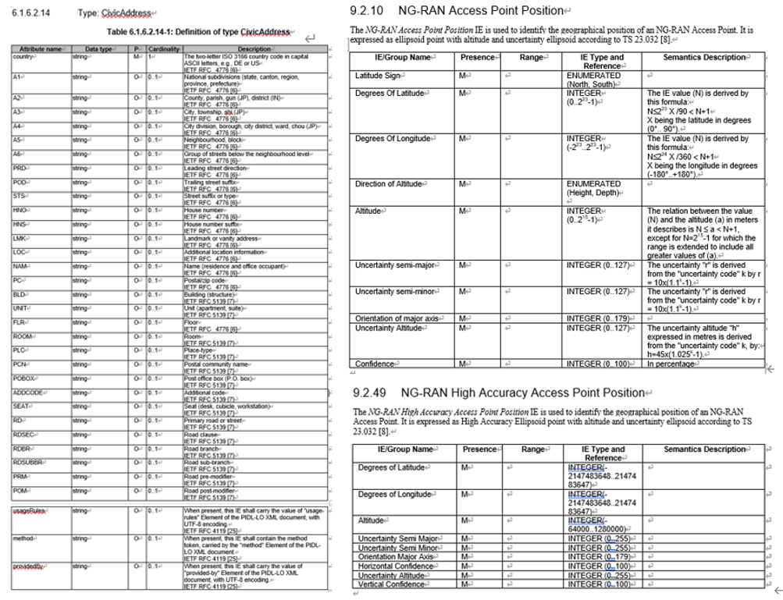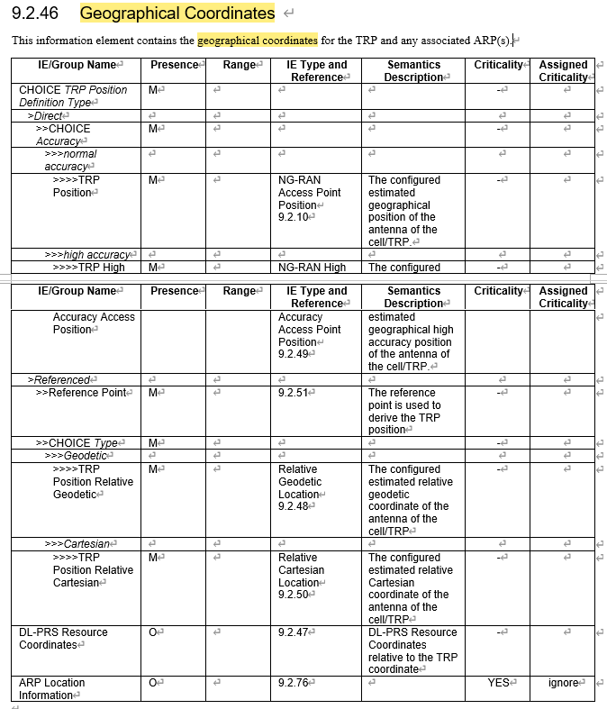

**Proposal: Choose the one(s) to be used as reader location:**

1. Civic Address defined in TS 29.572
2. NG-RAN Access Point Position defined in TS 38.455
3. NG-RAN High Accuracy Access Point Position defined in TS 38.455
4. Geographical Coordinates IE specified in TS 38.455

## ***-----------Followings are the continuous discussion after the Tue online discussion---------------***

## **New AIoT Area or AIoT dedicated TAI**

**Opt1: Reusing the existing TA in NGAP Setup Request message for AIoT, while introducing new AIoT service area in Inventory**

**Opt2: Introducing new AIoT service area in both NGAP Setup Request message and Inventory**

**Opt3: Reusing the existing TA in both NGAP Setup Request message and Inventory**

**Offline to discuss the assumption in RAN3 and send LS to SA2.**

**New A-IoT Area**

QCOM, NEC, CMCC, Nokia, ZTE, Lenovo

**A-IoT dedicated TAI**

CATT, Samsung, Ericsson

In Inventory Request, it was agreed in last meeting that:

*AIoT RAN node receives the requested service area information (encoded as area and/or reader ID list) from AIoT CN.*

**Question 1: What is the Area in the “requested service area information” in the Inventory Request Transfer IE?**

* **“New A-IoT Areas supported by the gNB”**: CMCC, QCOM, Huawei, Xiaomi, CTC, E///
* **Or**
* **“A-IoT dedicated TAIs supported by the gNB”**: CATT, E///,

**Question 2: What is the Area in the A-IoT RAN Information known by the AIOTF? (known by at least OAM)**

* **“New A-IoT Areas” or “A-IoT dedicated TAIs”?**

**Introduce a New A-IoT Area, at least to be used in the Inventory Request Transfer IE**

**AIOTF is aware of the supported A-IoT Area (new Area) supported by the gNB, at least by OAM.**

It is FFS whether the new area is GNSS info or new A-IoT Area ID.

## **(If time allows) NGAP signaling support about A-IoT RAN Information**

The A-IOT RAN Information includes:

- Served Reader List

- Supported A-IoT areas

- Reader location

**Question 1: is NGAP signaling is acceptable for the Supported A-IoT Areas? or only rely on OAM?**

**~~Question 1a: If A-IoT dedicated TAI is used, in NG Setup Request whether to have new Transfer IE to include it or enhance existing Supported TA list?~~**

**Question 1b: If new A-IoT Area is used, define it as follows?**

**“A-IoT Area Identity” = “PLMN ID” + “A-IoT Area Code OCTET STRING (SIZE(3))”**

**Question 2: Is NGAP signaling is acceptable for the Served Reader List? Or only rely on OAM?**

**Question 3: Is NGAP signaling is acceptable for the Reader Location? Or only rely on OAM?**

## **(If time allows) A-IoT Indicator in NG Setup Request**

**Introducing an AIoT indicator in the NGAP Setup Request message. The detail of this indicator can be further discussed.**

* **If only A-IoT dedicated TAIs are included, A-IoT only is implicitly indicated.**
* **If new A-IoT Area is introduced, the “AIoT indicator in the NGAP Setup Request message” should be “A-IoT only indicator’.**

## **(If time allows) Reader Selection**

The following agreements were achieved in last meeting:

* **AIoT RAN node receives the requested service area information (encoded as area and/or reader ID list) from AIoT CN.**
  + **Upon receiving only the area in Inventory Request, the gNB selects readers within the indicated area.**
  + **Upon receiving neither the area nor the reader list in Inventory Request, the gNB selects all the served readers.**
  + **WA: Upon receiving only the reader list in Inventory Request, the gNB selects the readers indicated by the reader list.**
  + **FFS: Upon receiving both the area and the reader list in Inventory Request, the gNB selects the readers within the indicated area and the readers within the reader list.**

The progress in Tue online discussion:

* Turn the following WA to agreement: Upon receiving only the reader list in Inventory Request, the gNB selects the readers as indicated by the reader list?
* The gNB selects the readers taking the reader list provided by CN into account in some cases.

**Proposal: Upon receiving only the reader list in Inventory Request**

* **the gNB uses the readers as indicated by the reader list**
* **Or**
* **the gNB takes the indicated reader list into account**

## **Other FFSs for next meeting**

* **FFS on the Release/Cancel/End related procedure(s)/IE(s) for the A-IoT service/inventory/command.**

## **About TPs**

38300 TP on the protocol stack of the AIOTF container

* CATT

38300 TP on all the other agreements for Architecture aspects

* CMCC

38300 TP to update inventory/command call flows

* Nokia

38300 TP on device locating

* ZTE

38401 TP e.g., the device association

* Lenovo

38412 TP on SCTP association for direct case

* Xiaomi

|  |
| --- |
| (R3-251791) |

Maybe we can change the TP to: the non UE-associated signallig SCTP association(s) are used for A-IoT between the NG-RAN node and the AIOTF.

38413 TP on Inventory/Command procedures/IEs

* Huawei

38413 TP on interface management procedures/IEs

* Ericsson

|  |  |
| --- | --- |
| R3-251603 | R3-252057 |
|  |  |

LS to other groups e.g., SA2/SA5/RAN2?

* Huawei

# References

1. R3-251526 Reply to LS on A-IoT Conclusions in SA WG2 SA5(China Unicom LS in
2. R3-251563 BL CR to 38.300) Introduction of Ambient IoT CMCC, Huawei draftCR
3. R3-251564 BL CR to 38.410) Introduction of Ambient IoT ZTE Corporation, China Telecom, Huawei, Samsung, CMCC, Nokia, Xiaomi CR
4. R3-251565 Introduction of Ambient IoT Huawei CR
5. R3-251603 TPs to TS 38.300 38.413 BL CRs) Architecture aspects and interface management procedures Huawei other
6. R3-251585 Architecture, Protocols and Signaling to support Topology 1 of A-IoT Qualcomm Incorporated discussion
7. R3-252056 TP for BL CR 38.401 and 38.300] Multiplexing several A-IoT service operations concerning multiple A-IoT devices on NG-C and other architectural topics Ericsson other
8. R3-251660 Conclusion on Ambient IoT Architecture Nokia discussion
9. R3-252183 TP to TS 38.300) Discussion on RAN Architecture for Ambient IoT CMCC other
10. R3-252241 TP for BL CR to 38.300, 38.413, 38.410) Leftover issues on AIoT ZTE Corporation, China Telecom other
11. R3-251586 Inventory and Command procedures for Topology 1 of A-IoT Qualcomm Incorporated discussion
12. R3-251604 TPs to TS 38.413 38.410 BL CRs) Support of Inventory Huawei other
13. R3-251605 TPs to TS 38.413 38.410 BL CRs) Support of Command Huawei other
14. R3-251661 TP for BL CR AIoT for TS 38.413] Additions for AIoT protocol Nokia other
15. R3-251662 Signalling Information Elements for Inventory Nokia discussion
16. R3-251663 Signalling Information Elements for Command Nokia discussion
17. R3-251687 Discussion on AIoT architecture aspects NEC discussion
18. R3-251688 Discussion on AIoT procedures aspects NEC discussion
19. R3-251715 TP to BL CR for TS38.300) A-IoT protocol stack CATT other
20. R3-251716 TP to BL CR for TS38.413) A-IoT inventory and command procedures CATT other
21. R3-251717 Discussion on A-IoT reader selection CATT discussion
22. R3-251762 Discussion on support of AIoT Xiaomi discussion
23. R3-251763 TP for TS 38.413) Support of AIoT Xiaomi other
24. R3-251765 Discussion on location of the device Xiaomi other
25. R3-251791 TP for TS 38.412) Support of Ambient IoT Xiaomi, Huawei, CMCC other
26. R3-251813 Discussion on RAN architecture and procedures for AIoT Samsung discussion
27. R3-251949 On A-IOT Inventory Procedure Lenovo discussion
28. R3-251950 On A-IOT Command Procedure Lenovo discussion
29. R3-252057 TP for BL CR 38.413] Applicability of NG Interface management procedures for A-IoT Ericsson other
30. R3-252058 TP for BL CR 38.300] AIoT service area indication Ericsson other
31. R3-252059 TP for BL CR 38.413 and 38.300 and 38.410] Introducing A-IoT protocol functions in NGAP Ericsson other
32. R3-252116 Ambient IoT support Jio Platforms Ltd (JPL discussion
33. R3-252165 Signalling Procedure for Inventory and Command China Telecom discussion
34. R3-252184 Discussion on Inventory Procedure and Signaling CMCC discussion
35. R3-252185 Discussion on Command Procedure and Signalling CMCC discussion
36. R3-252242 TP for BL CR 38.413) New AIoT procedures ZTE Corporation, China Telecom other
37. R3-252243 TP to BL CR 38.300, 38.410) New Ambient IoT procedures ZTE Corporation, China Telecom other
38. R3-251587 Locating Ambient IoT devices Qualcomm Incorporated discussion
39. R3-251689 Discussion on AIoT location reporting aspects NEC discussion
40. R3-251606 TPs to TS 38.300 38.413 BL CRs) Support of Device Locating Huawei other
41. R3-251718 Discussion on locating of A-IoT device CATT discussion
42. R3-251814 Discussion on Location report for AIoT Samsung discussion
43. R3-252186 TP to TS 38.300) Discussion on A-IoT device location reporting CMCC other
44. R3-252244 TP to (BL CR to 38.300) Location AIoT device ZTE Corporation, China Telecom other
45. R3-252248 Discussion on support of location report LG Electronics discussion