3GPP TSG-RAN WG3 Meeting #126 R3-247780
Orlando, USA, 18 – 22 Nov 2024

Agenda Item: 9.2
Source: ZTE corporation (moderator)
Title: Summary of MultipleXnSetup
Document for: Approval

Introduction
This is a summary of discussions to capture progress of offline of Multiplex Setup request.
CB: # 12_MultipleXnSetup
- Check the common understanding:
In case an additional Xn setup procedure is triggered for an already established Xn-C interface instance, it shall not impact the already established Xn-C interface instance regardless if the additional Xn setup procedure is successful or failed.
(moderator - ZTE)
Summary of offline disc R3-247780

For the Chairman’s Notes
Take the following into account.
In case an additional Xn setup procedure is triggered for an already established Xn-C interface instance, it shall not impact the already established Xn-C interface instance regardless if the additional Xn setup procedure is successful or failed.
To be continue.

Discussion
During on-line discussion, the following two user cases are discussed [1]
User case 1：
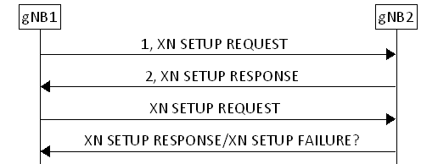
Figure 1: user case 1
As shown in the user case 1 figure, after the gNB2 responses the received the Xn setup response message, the gNB2 on the same Xn interface received another XN SETUP REQUEST message from the same Node (i.e the gNB1). The behavior of gNB2 when receiving the second XN SETUP RERQUEST is not specified.
User case 2：
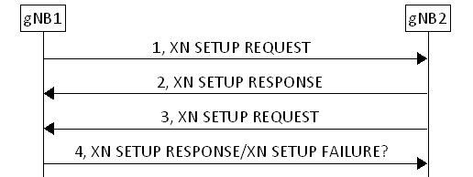
Figure 2: user case 2

Abnormal case 3:
Take the figure 2 as example. After step 1 and step 2, both gNB1 and gNB2 sets the Xn interface with peer as operational. In order to make sure the gNB1 received the Xn SETUP response message , the gNB2 may resend the Xn setup to the gNB1. If the gNB2 failed the request then the already established Xn interface broken.
For abnormal case 3 as defined in [1], the following chair Notes seems could be agreeable:
- Check the common understanding:
In case an additional Xn setup procedure is triggered for an already established Xn-C interface instance, it shall not impact the already established Xn-C interface instance regardless if the additional Xn setup procedure is successful or failed.

However, for abnormal case 1 as defined in [1], the above common understanding is not applicable.
It is not possible for receiving node to differentiate abnormal case 1 and abnormal case 3.
Abnormal case 1:
take the figure 1 as example, gNB2 received request from gNB1 and sends back XN setup Response message to the SCTP link layer. However the message delivery failed in SCTP link layer or gNB1 occur a failure after send the request to the gNB2. Since the SCTP links is still alive, gNB2 sets the Xn interface with gNB1 as operational. gNB1 on the opposite does not set the Xn interface as operational and would try to send a 'new 'request to gNB2 on the same SCTP link. If gNB2 thinks this request as additional one and failed the request then the Xn interface can not be recovered.
The reason for missing of Xn setup response message while the SCTP link is still alive is that in some gNB implementation XnAP endpoint and SCTP endpoint are decoupled .As shown in the following figure 3, in step 4 the gNB2 XnAP entity sends the Xn setup response message to it's SCTP endpoint. In turn gNB2 SCTP gets the ACK message from gNB1 SCTP.However, during the delivery gNB1 SCTP to its gNB1 XNAP endpoint, the failure happen due to XNAP entity restart(recovery). In this case, the SCTP link is still alive, and Xn interface state between gNB2 and gNB 1 is mistached.
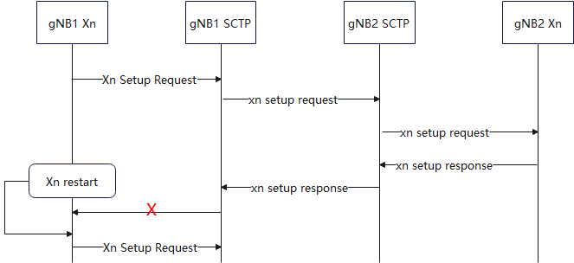
Figure 3: Decouple implementation of XnAP endpoint and SCTP endpoint

The moderator suggests continuing discuss the issue in next meeting to find out common rule for all mentioned user cases.

Conclusion, Recommendations [if needed]
If needed

References
[1]. R3-247704 Discussion on abnormal case of Xn setup procedure (ZTE Corporation)
[2]. R3-247705 Correction on Xn Setup message (ZTE Corporation)
[3]. R3-247706 Correction on Xn Setup message (ZTE Corporation)
[4]. R3-247707 Correction on Xn Setup message (ZTE Corporation)
[5]. R3-247708 Correction on Xn Setup message (ZTE Corporation)
[6]. R3-247515 Corrections on Xn Setup Duplication (Ericsson)
[7]. R3-247516 Corrections on Xn Setup Duplication (Ericsson)
[8]. R3-247517 Corrections on Xn Setup Duplication (Ericsson)
[9]. R3-247518 Corrections on Xn Setup Duplication (Ericsson)

