3GPP TSG-RAN WG3 Meeting #125 R3-244719

Maastricht, NL, 19 - 23 August 2024

Agenda Item: 13.2

Source: Lenovo (moderator)

Title: Summary of CB: # ME1_LTMPDCP

Document for: Approval

# Introduction

This contribution provides the summary of the CB: # ME1_LTMPDCP:

**CB: # ME1_LTMPDCP**

**- discuss on the technical issue and capture views on the solutions.**

**- try to work on a WF.**

(moderator - Lenovo)

Summary of offline disc [R3-244719](Inbox\R3-244719.zip)

# For the Chairman’s Notes

**There is no consensus on whether the PDCP anchor based solution violates the basic NG-RAN architecture.**

# Discussion

**Issue 1: whether the PDCP anchor based solution is outside of the scope of R19 WID?**

|  |
| --- |
| * Specify support for inter-CU Layer1/Layer 2 Triggered Mobility (LTM) [RAN2, RAN3]   + Prioritize the case when CU is acting as MN when DC is not configured   + When DC is configured, inter-CU LTM can be configured either in MN or in SN but not both at the same time. For such cases:     - As secondary priority, support the case where CU is acting as SN and MN is unchanged     - As secondary priority, support the case where CU is acting as MN and SN is unchanged or SN is released   + Specify support for subsequent LTM mobility procedures aiming to avoid RRC configuration between cell switches as per Rel-18 LTM     - Coordination with SA3 needed with respect to security key handling   + Note: Rel. 18 intra-CU LTM procedure is considered as baseline for adding inter-CU support |

NTT DCM/VDF: supporting both normal and PDCP anchor is beneficial. It may be in the scope of the WID. Thinks it is better to have technical discussion.

QC: thinks it is following Rel-18 as to avoid RRC configuration between cell switches as per Rel-18 LTM. Asks why it is not in the scope.

HW: different companies have different understanding. Prefer to go technical part discussion. Thinks Rel-18 procedure should be as BL.

Nokia also thinks we should follow Rel-18 procedure.

E///: see there is no consensus. Prefer to go technical part discussion.

Conclusions:

None.

**Issue 2: NG-RAN architecture**

whether the PDCP anchor based solution violates the basic NG-RAN architecture?

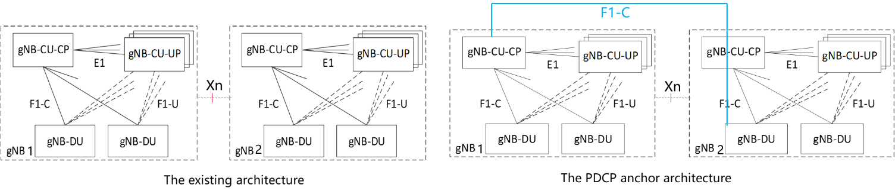

Figure 1: Architecture impact from the PDCP anchor solution

|  |
| --- |
|  |
| Figure 1: Inter-gNB LTM with fixed PDCP/RRC anchor is transparent to gNB-DUs. No inter-gNB F1 interface is needed. |

Sony/QC: think it is allowed and aligned with RAN3 spec.

HW and ZTE have different understanding. LGE think UE may remain in the anchor for long time. It seems like indirect F1 connection since all signaling are forwarded by Xn.

QC thinks it is similar as SDT. In SDT, there is without anchor relocation case. But it is a longer than SDT.

LGE: do we need procedures for UE context transfer from CU1 to CU2. Like Intra cell procedure???

E///, Nokia: it looks like DC. But we are talking handover. It is different with DC. RRC should be transferred to CU2.

HW/LGE: Different UEs in gNB2-DU may be controlled by different CUs which is not aligned with our spec.

QC thinks the current spec only limits the UPs can be controlled by one CP.

Nokia thinks it is like an implicit F1 connection between DU2 and CU1

Sony think it is not introduce any thing new. For UE can only connects only one CU and one DU.

NEC: which SRB type is used, SRB3?

Ericsson and ZTE thinks CU2 can also control DU2 which may cause collision of configuration between CU1 and CU2. Which may cause inter-operability issue.

CATT has concerns on DU2 can controlled by two CUs at the same time.

HW: in the F1 setup, DU provides cell list to the CU. But QC thinks it is not relevant to UE radio resource configuration.

- One gNB-DU can be connected to multiple gNB-CU-UPs under the control of the same gNB-CU-CP;

**Conclusions:**

No consensus.

**Issue 3: Standard Impact:**

Supporting the PDCP anchor based solution would have a significant impact on the standard and require a substantial workload?

LTM configuration related signalling (LTM preparation, subsequent LTM, LTM configuration update), NAS, anchor relocation?

**Issue 4: Performance related:**

The PDCP anchor based solution will introduce extra delay on both control plan and user plane on transmissions from/to the UE after cell switch? Ping-pong

**Issue 5: Impact on RRM, CN and OAM?**

The PDCP anchor based solution will disable the controller gNB-CU to perform high layer RRM functions towards a UE out of control , like MRO, MLB, overload control, energy saving , etc. ?

SA5 needs to be involved to evaluate the impact on the current NRM of the gNB for the PDCP anchor based solution, for example, managing the Cell Relations of a cell by a gNB-CU not controlling the cell?

Evaluation should be done in SA2, CT1 and CT4 to prove if any impact on core network functions when the AMF receives a NR CGI in the ULI which does not belong to the reporting gNB?

**Issue 6: Any Potential WF?**

# References

1. R3-244228 Inter-gNB LTM with no change of RRC/PDCP anchor (Qualcomm Incorporated, NTT DOCOMO, Vodafone, Bharti AirTel (India), Sony)
2. R3-244482 Discussion on the PDCP anchor based solution (Huawei, Ericsson, CATT, China Telecom, CMCC, Samsung)
3. R3-244646 Response to R3-244482. Qualcomm Incorporated