3GPP TSG-RAN WG3 Meeting #124 R3-243803

Fukuoka, Japan, from May 20 to May 24 2024

Agenda Item: 11.4

Source: ZTE (Moderator)

Title: SoD on CB: # AIML3_Leftover

Document for: Approval

# 1 Introduction

This SoD is to discuss the following CB:

**CB: # AIML3_Leftover**

**- Whether consensus on multi-hop UE trajectory and ES solution can be achieved, if not, these two cases are down-prioritized**

**- Continue the solution discussion on NR-DC, split architecture and continuous MDT collection**

(moderator - ZTE)

Summary of offline disc R3-243803

# 2 Discussion

## 2.1 Energy Saving enhancements

### 2.2.1 Measured Energy Cost

During Rel-18, it was agreed to transfer measured EC from DU to CU, but it was not specified because it can not reach consensus on whether to transfer the measured EC via existing legacy procedure or new procedure.

1. **Measured Energy Cost can be transferred from DU to CU.**
2. **Measured Energy Cost can be transferred from CU-UP to CU-CP.**

**Summary:**

### 2.2.2 Predicted Energy Cost

**Option 1: Re-use the current Data Collection Reporting Initiation and Data Collection Reporting procedures for Predicted Energy Cost. (CMCC, ZTE)**

How to predict the Energy Cost is an implementation level issue, the local node can use predicated UE traffic metrics, historical Energy Efficiency, resource status information. No extra information needs to be transferred through Xn interface.

**Option 2: Consider reusing the handover signaling over Xn as a way to characterize the additional load. This enables supporting the exchange of Energy Cost (EC) predictions that consider potential offloading actions. (E///)**

* 2a): NES CHO approach: NES CHO allows reusing the HO signaling over Xn to inform the target NG-RAN node of the additional load, to enable the inference of a predicted EC that considers the additional load, and to coordinate potential offloading actions with minimal additional signaling.
* 2b): Delaying RRC reconfiguration: This approach allows reusing the handover signaling over Xn to inform the target NG-RAN of the additional load, to enable the inference of a predicted EC that considers the additional load and to coordinate potential offloading actions with minimal additional signaling.

**Option 3:** **Enhance Energy Cost reporting of Rel-18 procedures to be measured per Handover event or per number of Handover events. (Nokia)**

**Summary:**

## 2.2 Multiple-hop UE trajectory

Regarding the multiple-hop UE trajectory prediction, it is proposed to reuse the Handover Request Message for transferring multiple-hop UE trajectory prediction.

1. **For multiple-hop UE trajectory, the predicted UE trajectory is sent in a hop-by-hop way from the gNB to the next gNB where UE is handovered to.**

Regarding how to collect the measured UE trajectory from multiple-hop target gNBs, there may be two options proposed:

**Option 1: Hop-by-hop (which reuses the current mechanisms):**



Following the current mechanisms, the DATA COLLECTION REQUEST message is initiated from the node to the neighbour nodes, and Handover Request message carries the DATA COLLECTION ID.

The target node transfers the UE trajectory measured in te his node to the requested node, and the all measured UE trajectory will go back to the source node by the chain of the DATA COLLECTION UPDATE message between gNBs.

Potential impacts proposed by companies for this approach:

* Enhance the Handover Request message to carry the updated collection configuration (e.g., time duration)

**Option 2: Parallel mode:**



Data Collection Reporting Initiation procedure is used to configure UE trajectory feedback. gNB2 as handover target gNB should be configured by data Collection Reporting Initiation procedure as in step 2a. If gNB3 is within the UE trajectory prediction, data Collection Reporting Initiation procedure may be also triggered towards gNB3 as in step 2b in order to collect UE trajectory feedback if UE could handover to gNB3 in the future.

Potential impacts for this approach proposed by companies:

For parallel feedback mode, the following information should be sent to multi-hop target gNBs which has specification impact.

* global Data Collection ID and global UE ID allocated by source gNB;
* source gNB ID

1. **Agree to support multiple-hop UE trajectory collection and reporting through a hop-by-hop way as a baseline considering limited specification impacts.**

If we can not reach consensus on the solution above, the topics will be down-prioritized.

## 2.3 Split architecture

1. **Transferring Measured UE performance from DU to CU.**
2. **Transferring Measured UE performance from CU-UP to CU-CP.**
3. **Transferring Measured UE traffic (e.g., data volume) from CU-UP to CU-CP.**

## 2.4 NR-DC mobility optimization

In the last meeting, mobility optimization for NR-DC case and enhancements to split architecture was agreed to be resolved during Rel-19:

**Agree to take as baseline for the Mobility Optimization for NR-DC that the use case is studied assuming inference at the MN. The main use case is limited to dual connectivity only (e.g. no conditional procedures are in scope).**

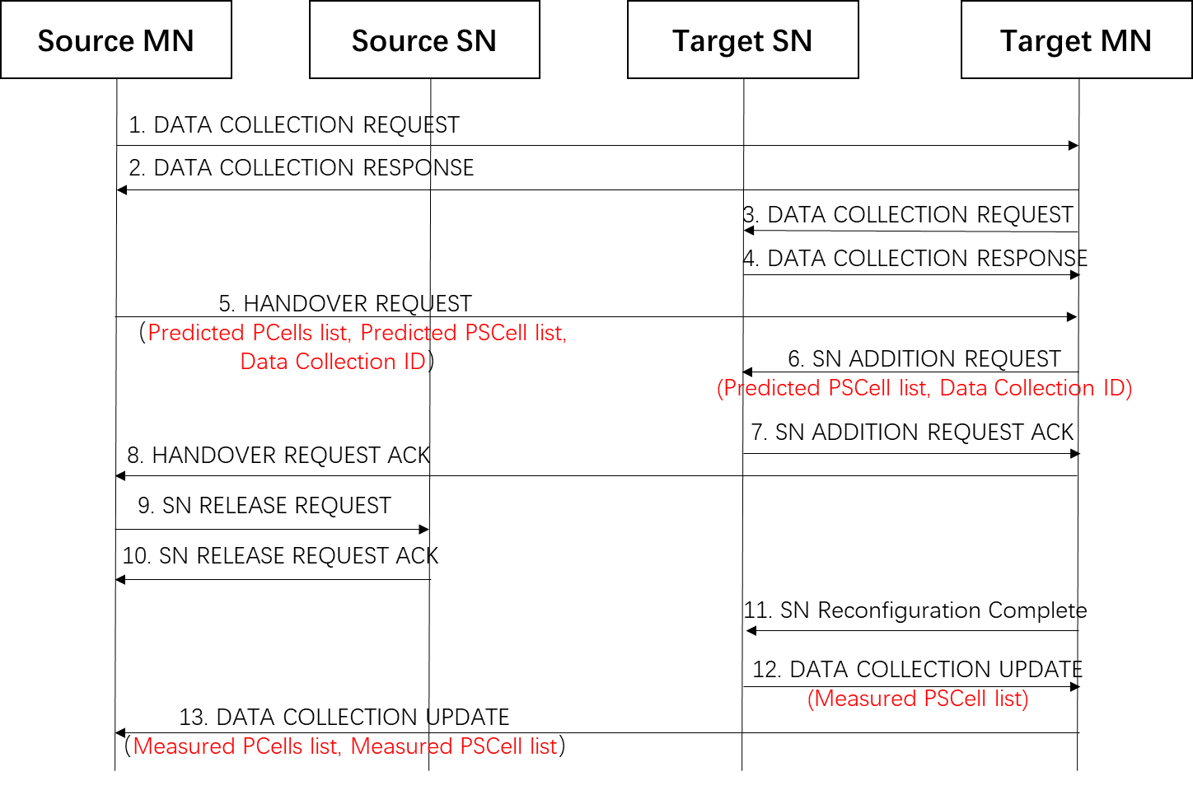

Figure 1. Overall flowchart for inter-master handover case

**Predicted information:**

1. **Extend the existing predicted cell-level UE trajectory to include the list of predicted PSCell(s).**
2. **Enhance the DC procedure (e.g., MN-initiated SN addition, MN-initiated SN change) to include the predicted UE trajectory information, e.g., the list of predicted PSCell(s).**

**Measured information:**

1. **Extend the existing measured cell-level UE trajectory to include the list of measured PScell(s).**
2. **Enhance the DC procedure (e.g., MN-initiated SN addition, MN-initiated SN change) to trigger the collection of measured UE performance and measured UE trajectory.**

## 2.5 Continuous MDT collection

In management-based MDT, a UE is not uniquely identified in the MDT activation. Therefore, when a UE transits to RRC_Connected state the network does not have standardized means to select a “specific” UE for continuous MDT.

In more detail, the problem of continuous data collection for management-based MDT can be described as follows: A UE in the RAN can be configured with management-based Logged MDT when in RRC_Idle and RRC_Inactive states and with management-based Immediate MDT when in RRC_Connected state. The question about maintaining Data Collection continuity in this scenario is two-fold. It is related to:

* **Problem A (measurement continuity)**: How to ensure that the same UE collecting logged MDT in RRC_Idle and RRC_Inactive states will be selected for immediate MDT upon transition to RRC_Connected state.
* **Problem B (trace correlation)**: How to ensure that the TCE that eventually receives the MDT Records can associate the received MDT measurements to a data collection session of measurements from the same UE.

1. **Capture the problem description above of continuous MDT collection into TR.**

According to the spec TS28.558 from SA5, S-TMSI is able to resolve the correlation between MDT measurement reports by the same UE because the S-TMSI does not change so long as the UE is within the same AMF pool.

1. **By leveraging the measurement definitions in TS28.558 it is possible to link all the Immediate MDT measurements reported by the same UE while the UE is within the same AMF Pool.**

**Summary:**

# 3 Reference

[1] R3-241867 Discussion on AI/ML assisted Network Slicing (ZTE) discussion

[2] R3-241868 (TP to TR38.743) AI/ML assisted Network Slicing (ZTE) other

[3] R3-241589 Considerations on AI/ML based network slicing (NEC) discussion

[4] R3-241590 TP to TR38.743 for AI/ML-based Network Slicing (NEC) other

[5] R3-241611 Discussion on NG-RAN AI/ML for Network Slicing (Qualcomm Incorporated) discussion

[6] R3-241729 (TP to TR 38.743) AI/ML enabled slicing (Samsung) other

[7] R3-241791 Discussion on AIML based network slicing (Lenovo) discussion

[8] R3-241792 TP to 38.743 for AIML based network slicing (Lenovo) other

[9] R3-241822 Discussion on support of AI/ML enabled slicing (CATT) discussion

[10] R3-241823 (TP for TR 38.743) Support of AI/ML enabled slicing (CATT) other

[11] R3-241843 (TP for TR 38.743) AI/ML Network Slicing for Rel-19 (Nokia, Telecom Italia) other

[12] R3-241941 Discussion on AI-based network slice (CMCC) discussion

[13] R3-241986 Discussion on RAN AI/ML for Network Slicing (Huawei) discussion

[14] R3-242065 TP on AIML for Network Slicing (Ericsson, Charter, InterDigital, Telecom Italia) discussion

[15] R3-242066 AIML for Network Slicing (Ericsson, Charter, InterDigital, Telecom Italia) discussion