3GPP TSG-RAN WG3 Meeting #122 R3-237753
Chicago, USA, 13 - 17 November 2023

Agenda Item: 9.2
Source: ZTE (moderator)
Title: Summary of Offline Discussion on CB: # 9_SNReconfigComplete
Document for: Approval

Introduction
CB: # 9_SNReconfigComplete
- Check all the cases that triggering S-NODE RECONFIGURATION COMPLETE message towards SN
- Provide stage2 CR if agreeable
(moderator - ZTE)
Summary of offline disc R3-237753

For the Chairman’s Notes

Propose to capture the following:
Proposal: [6/8] RAN3 observes that after receiving SN modification request ACK message from SN, if the MN decides to reject the configuration requested by the SN, it sends SN Reconfiguration Complete message to SN, then the UE is not involved and this procedure ends.

Discussion

Background
For both EN-DC and MR-DC with 5GC, the usage of SN reconfiguration complete message is in stage 3 and in stage 2 specs as below.
TS36.423
The SGNB RECONFIGURATION COMPLETE message may contain information that
- either the UE has successfully applied the configuration requested by the en-gNB. The MeNB may also provide NR RRCReconfigurationComplete message in the MeNB to SgNB Container IE.
- or the configuration requested by the en-gNB has been rejected. The MeNB shall provide information with sufficient precision in the included Cause IE to enable the en-gNB to know the reason for an unsuccessful reconfiguration.
Upon reception of the SGNB RECONFIGURATION COMPLETE message the en-gNB shall stop the timer T_{DCoverall}.

TS38.423
The S-NODE RECONFIGURATION COMPLETE message may contain information that
- either the UE has successfully applied the configuration requested by the S-NG-RAN node. The M-NG-RAN node may also provide configuration information in the M-NG-RAN node to S-NG-RAN node Container IE.
- or the configuration requested by the S-NG-RAN node has been rejected. The M-NG-RAN node shall provide information with sufficient precision in the included Cause IE to enable the S-NG-RAN node to know the reason for an unsuccessful reconfiguration. The M-NG-RAN node may also provide configuration information in the M-NG-RAN node to S-NG-RAN node Container IE.
Upon reception of the S-NODE RECONFIGURATION COMPLETE message the S-NG-RAN node shall stop the timer TXn_{DCoverall}.

MN initiated SN Modification

The following is abstracted from Chairs notes
HW: For ZTE’s stage2, maybe good to have some description on failure case. For E///’s paper, SN does not need to wait for the S-NODE RECONFIGURATION COMPLETE message at all
E///: Do need to specify the case what ZTE’s proposed.
ZTE: Stage2 CR is proposed to align with stage3. For E///’s case, SN knows the situation when it triggers the modification procedure towards SN, no indication is needed
CATT: It’s common understanding on the issue raised by ZTE. For the cases proposed by E///, it’s clear whether the S-NODE RECONFIGURATION COMPLETE message will be sent or not.
Nok: Would like to clarify the scenario rather than introducing the indication
Google: Support stage2 clarification. In the case there is no UE reconfiguration, whether SN still needs to start the timer.
QC: Some clarification may be needed
LG: Support to have stage2 description on rejection case. Also support to have clear indication E///’s proposal

Cases that triggering S-NODE RECONFIGURATION COMPLETE message towards SN

Cases indicated in R3-237709
In R3-237709, it provides the following observations.
Observation 1: The MN may send the SN reconfiguration complete message to SN if the configuration requested by SN is accepted by the MN.
- The RRC reconfiguration is successful - The MN sends the SN reconfiguration complete message to SN and includes the RRCReconfigurationComplete
- The RRC reconfiguration fails - The MN may not send the SN reconfiguration complete message
Observation 2: The MN sends the SN reconfiguration complete message to SN if the configuration requested by SN is rejected by the MN and provides a Cause.

For the above observation 2, Nokia wonders in which case, the MN will reject the configuration requested from the SN.
Moderator’s answer: In case that SN modification request acknowledge message includes some information which the MN does not comply with, or the MN wants to cancel the MN initiated SN modification procedure if e.g., receiving other procedures, the MN will reject the configuration requested from the SN.

Observation 1: After receiving SN modification request ACK message from SN (step 2), if the MN decides to reject the configuration requested by the SN, it sends SN Reconfiguration Complete message to SN (step 3), then the UE is not involved and this procedure ends.

Question 1: Do companies agree with observation 1?
Company | Yes/No | Comment
ZTE | Yes | It aligns with Stage 3 description (… or the configuration requested by the S-NG-RAN node has been rejected. The M-NG-RAN node shall provide information with sufficient precision in the included Cause IE to enable the S-NG-RAN node to know the reason for an unsuccessful reconfiguration. The M-NG-RAN node may also provide configuration information in the M-NG-RAN node to S-NG-RAN node Container IE.)
LGE | Yes
Google | Yes
NEC | Yes
Nokia | ? | It shall be clarified why the MN (based on the RAN3 spcification) would “reject” the SN MOD REQ ACK message – this is very strange bahaviour.
Huawei | Yes
CATT | Yes
E/// | No | It is not reasonable for the MN to reject the ACK from SN after it requests the reconfiguration from the SN. Then the question is whether the scenario mentioned by ZTE happens in the inter-operability scenario.
Summary：
8 companies input their view.
Yes: 6 No: 1 Not sure: 1
Proposal: [6/8] RAN3 observes that after receiving SN modification request ACK message from SN, if the MN decides to reject the configuration requested by the SN, it sends SN Reconfiguration Complete message to SN, then the UE is not involved and this procedure ends.
In R3-237709, it proposes that the above observation 1 shall be clarified in TS37.340.
MN initiated SN Modification
Figure 10.3.2-1: SN Modification procedure - MN initiated
The MN uses the procedure to initiate configuration changes of the SCG within the same SN, including addition, modification or release of the user plane resource configuration. The MN uses this procedure to perform handover within the same MN while keeping the SN, when the SN needs to be involved (i.e. in NGEN-DC). The MN also uses the procedure to query the current SCG configuration, e.g. when delta configuration is applied in an MN initiated SN change. The MN also uses the procedure to provide the S-RLF related information to the SN or to provide additional available DRB IDs to be used for SN terminated bearers. The MN also uses this procedure to activate or deactivate the SCG. The MN may not use the procedure to initiate the addition, modification or release of SCG SCells. The SN may reject the request, except if it concerns the release of the user plane resource configuration, or if it is used to perform handover within the same MN while keeping the SN. Figure 10.3.2-1 shows an example signalling flow for an MN initiated SN Modification procedure.
1. The MN sends the SN Modification Request message, which may contain user plane resource configuration related or other UE context related information, PDU session level Network Slice info and the requested SCG configuration information, including the UE capabilities coordination result to be used as basis for the reconfiguration by the SN. In case a security key update in the SN is required, a new SN Security Key is included. In case the PDCP data recovery in the SN is required, the PDCP Change Indication is included which indicates that PDCP data recovery is required in SN.
2. The SN responds with the SN Modification Request Acknowledge message, which may contain new SCG radio configuration information within an SN RRC reconfiguration message, and data forwarding address information (if applicable). If the MN requested the SCG to be activated or deactivated, the SN indicates whether the SCG is activated or deactivated.
NOTE 1: For MN terminated bearers to be setup for which PDCP duplication with CA is configured in NR SCG side, the MN allocates up to 4 separate Xn-U bearers and the SN provides a logical channel ID for primary or split secondary path to the MN.
For SN terminated bearers to be setup for which PDCP duplication with CA is configured in NR MCG side, the SN allocates up to 4 separate Xn-U bearers and the MN provides a logical channel ID for primary or split secondary path to the SN via an additional MN-initiated SN modification procedure.
NOTE 1a: In case the MN rejects the configuration requested by the SN, the MN may inform the SN via SN Reconfiguration Complete message with the rejected cause after step 2. The procedure ends.
2a. When applicable, the MN provides data forwarding address information to the SN. For SN terminated bearers using MCG resources, the MN provides Xn-U DL TNL address information in the Xn-U Address Indication message.
3/4. The MN initiates the RRC reconfiguration procedure, including an SN RRC reconfiguration message. The UE applies the new configuration, synchronizes to the MN (if instructed, in case of intra-MN handover) and replies with MN RRC reconfiguration complete message, including an SN RRC response message, if needed. In case the UE is unable to comply with (part of) the configuration included in the MN RRC reconfiguration message, it performs the reconfiguration failure procedure.
5. Upon successful completion of the reconfiguration, the success of the procedure is indicated in the SN Reconfiguration Complete message.
6. If instructed, the UE performs synchronisation towards the PSCell of the SN as described in SN addition procedure. Otherwise, the UE may perform UL transmission after having applied the new configuration.
7. If PDCP termination point is changed for bearers using RLC AM, and when RRC full configuration is not used, the SN Status Transfer takes place between the MN and the SN (Figure 10.3.2-1 depicts the case where a bearer context is transferred from the MN to the SN).
8. If applicable, data forwarding between MN and the SN takes place (Figure 10.3.2-1 depicts the case where a user plane resource configuration related context is transferred from the MN to the SN).
9. The SN sends the Secondary RAT Data Usage Report message to the MN and includes the data volumes delivered to and received from the UE as described in clause 10.11.2.
NOTE 2: The order the SN sends the Secondary RAT Data Usage Report message and performs data forwarding with MN is not defined. The SN may send the report when the transmission of the related QoS flow is stopped.
10. If applicable, a PDU Session path update procedure is performed.

Question 2: Do companies agree to add the following note in TS37.340?
Note: In case the MN rejects the configuration requested by the SN, the MN may inform the SN via SN Reconfiguration Complete message with the rejected cause after step 2. The procedure ends.
Company | Agree or disagree or no strong view | Comment
ZTE | Agree | It is benefit to have this clarification. Then it is clear that the UE is not involved, and after SN Reconfiguration Complete message, the subsequent other signalling/procedures are not needed.
LGE | Agree
Google | Agree
NEC | Agree | To have stage 2 will see more completion of signalling/the procedures
Nokia | Disagree | As commented – it is strange scenario that the MN rejects the reconfig… So, there is no point to add the note for a strange and negative scenario (a note is usually used to clarify implementation option – here, it should rather be a normative text, but it is not needed).
Huawei | Slightly negative | Although seems nothing wrong, but similar view with Nokia.
CATT | Agree
E/// | Disagree | No need to capture this note
Summary：
8 companies input their view.
Yes:5 No:2 Not strong veiw:1
[5/8] RAN3 has no consensus to capture the following note in TS37.340
Note: In case the MN rejects the configuration requested by the SN, the MN may inform the SN via SN Reconfiguration Complete message with the rejected cause after step 2. The procedure ends.

Cases indicated in R3-237699
The R3-237699 indicates the following cases.
Case 1:
When MN initiated SN modification, SN has something to configure to UE. Then MN informs SN about the RRC Reconfiguration result via the SN Reconfiguration Complete.
Case 2:
When MN initiated SN modification, SN may have nothing to configure to UE. In this example, when the measGap is configured then SN doesn’t need to adjust the DRX offset if DRX has not been configured to UE.
Then MN doesn’t have to inform SN about the RRC Reconfiguration result.
Case 3:
When MN initiated SN modification, SN may have nothing to configure to UE but needs to know RRC completion timing. In this example, when the measGap is configured then SN has nothing to configure it. But SN needs to know when the measGap takes effect. However, MN doesn’t inform SN about the RRC Reconfiguration result because nothing is configured to the UE.

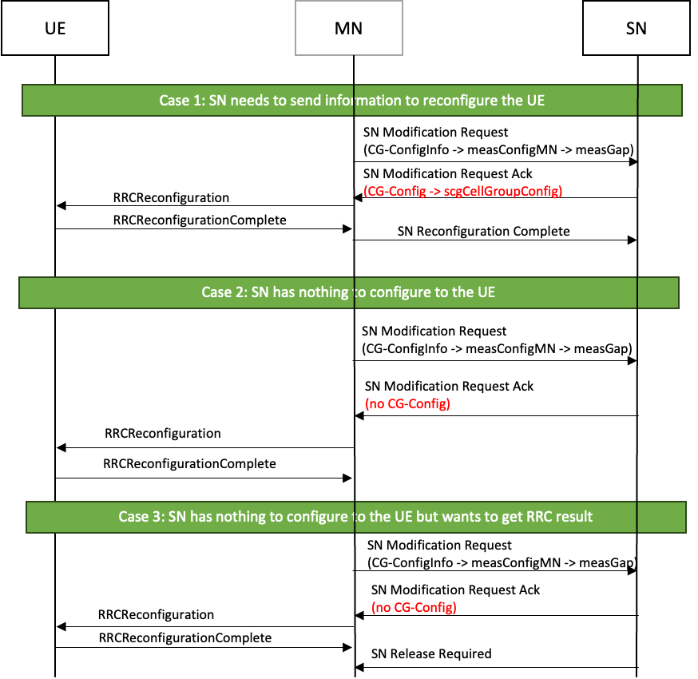
Figure 1. Cases for MN initiated SN Modification procedure
For MN-initiated SN modification, MN shall respond with SN Reconfiguration Complete message if SN requests to report the result of RRC. In current specification, during the MN initiated SN Modification procedure, it is not clearly stated when the MN should send SN Reconfiguration Complete message to the SN for case 3. Therefore, the MN and the SN may have different understanding of the UE context, and this results in unintended operation. In worst case, the UE may be released and no longer be able to receive any service. This would cause inter-operability issue. It needs to be clarified how MN can decide whether SN waits for response or not.
- For MN initiated SN modification, in the above case 3, it's not clear when the MN should send SN Reconfiguration Complete message to the SN.
So the intention from SN to MN to say explicitly that SN is waiting for the information from the MN, for instance, whether the UE reconfiguration is successful or not, so that the MN would be able to send SN Reconfiguration Complete message after receiving this indication.
- RAN3 to agree that the SN needs to explicitly tell the MN that it is expecting a SN Reconfiguration Complete message, i.e., in the SN Modification Request Ack message.

Question 3: Do companies agree that for MN initiated SN modification, in the case 3, it's not clear when the MN should send SN Reconfiguration Complete message to the SN?
Case 3:
When MN initiated SN modification, SN may have nothing to configure to UE but needs to know RRC completion timing. In this example, when the measGap is configured then SN has nothing to configure it. But SN needs to know when the measGap takes effect. However, MN doesn’t inform SN about the RRC Reconfiguration result because nothing is configured to the UE.
Company | Agree or disagree or no strong view | Comment
ZTE | disagree | SN has idea whether it wait for the SN Reconfiguration complete message. In detail, if the SN has not sent RRC container within the SN modification request ACK message, then it will not wait for the SN Reconfiguration complete message.
LGE | Could be | As commented online, we cannot dissect every single parameters within CG-ConfigInfo / CG-Config and clarify which scenario or usage of a specific parameter falls into Case 1 or Case 2 or Case 3 or another cases.  Considering the complication of those inter-node RRC containers, it is not hard to imagine Case 3 may be required.
Google | disagree | For the example in case 3, it is argued that the SN needs to know when the measGap takes effect and would start the timer and initiate SN Release Required once the timer expires. However, as commented online, we don’t think SN would start the timer in such case while it can expect the MN to perform a reconfiguration toward the UE. In case that the MN reconfiguration fails, the UE shall perform a re-establishment procedure with the MN and the MN can perform the SN release procedure to the SN as specified in TS37.340.
NEC | No strong view
Nokia | Disagree | Even if the SN does not reconfigure the UE, the UE is involved, so SN Reconfig Compl seems needed. And that behaviour removes the described ambiguity.  In general, the MN should not try to guess that SN Reconfig compl it not needed – it should be sent when UE is involved.
Huawei | disagree | Share the view with Google.
CATT |  | Maybe a clean way is to always let MN inform SN of the RRC reconfiguration completion
E/// | Agree | To Google’s comment, in this case MN reconfiguration does not fail, that’s why SN starts the timer after it sends out the ACK message. And when the timer expires, SN shall trigger release procedure, which should not happen.
Summary：
8 companies input their view.
Yes:2 No:5 Not strong veiw:1
[2/8] RAN3 has no consensus that for MN initiated SN modification, in the case 3, it's not clear when the MN should send SN Reconfiguration Complete message to the SN.

Question 4: Do companies agree that the SN needs to explicitly tell the MN that it is expecting a SN Reconfiguration Complete message, i.e., in the SN Modification Request Ack message?
Company | Agree or disagree or no strong view | Comment
ZTE | disagree | It is not needed, reason is as above.
LGE | Agree | Having an explicit flag seems straightforward (and not swarmped from the complicated CG-ConfigInfo / CG-Config handling)
Google | disagree | As described above, we don’t think SN would expect a SN Reconfiguration Complete message for case 3.
NEC | No strong view but more like disagree | Think this is too much to introcude an indicator to ask for the response message.
Nokia | Rather not
Huawei | disagree
CATT |  | See above
E/// | Agree
Summary：
8 companies input their view.
Yes:2 No:3 Not strong veiw:3
[2/8] RAN3 has no consensus that the SN needs to explicitly tell the MN that it is expecting a SN Reconfiguration Complete message, i.e., in the SN Modification Request Ack message.

Other Case or issue, if any
If company has other case or issue, please input your view.
Company |  | Comment

Conclusion, Recommendations

References
- R3-237709 Correction on the usage of SN Reconfiguration Complete (ZTE, NEC, China Telecom) discussion
- R3-237710 Correction on the usage of SN Reconfiguration Complete (37.340) (ZTE, LG Electronics, Google, NEC, China Telecom) draftCR
- R3-237711 Correction on the usage of SN Reconfiguration Complete (38.423) (ZTE) CR1112r, TS 38.423 v17.6.0, Rel-17, Cat. F
- R3-237699 Corrections on MN initiated SN Modification procedure (Ericsson) Discussion
- R3-237700 Corrections on MN initiated SN Modification procedure over Xn (Ericsson) CR1111r, TS 38.423 v17.6.0, Rel-18, Cat. F

