3GPP TSG-RAN WG3 #121 R3-234539
21st – 25th Aug 2023
Toulouse, France

Agenda Item: 10.2.1
Source: Qualcomm Incorporated (moderator)
Title: Summary of Offline Discussion: CB: # SONMDT1_SHRSPR
Document for: Discussion

Introduction
This is the offline summary for the following comeback:
CB: # SONMDT1_SHRSPR
- Discuss the open issues as above
- Capture agreements and open issue, no new issues are allowed to be raised
(moderator - QC)
Summary of offline disc R3-234539

For the Chairman’s Notes

Discussion

Who decides T310/T312 SPR triggers in case of MN-initiated PSCell change?
Down-select Opt2 and Opt3

Option 2: Source SN decides the T310/T312 triggers and performs root cause analysis.

Option 3: MN decides the T310/T312 triggers and performs root cause analysis, and whether and what information from SN as input needs to be further discussed.

The moderator has formulated the following questions based on offline discussion:
Q1: How are the T310/T312 SPR thresholds signaled to the UE in case of MN-initiated PSCell change and SN-initiated PSCell change? Are they signaled to the UE explicitly via a MN RRCReconfiguration message or is it sent transparent to the MN within a SN RRCReconfiguration message? (please check with your RAN2 colleagues internally)
Company | Comment

Q2a: In case of MN initiated PSCell change, should MN have the final say on how/when UE reports SPR? One reasoning provided in the offline discussion was that MN might be burdened with too frequent SPR if SN (in Option 2) decides to set a very small SPR threshold.
Q2b: If yes, should we then accept Option 3 as the way forward?
Company | Yes/No to Q2a and Q2b

Q3: In case of Option 3, can the SN propose its preferred T310/T312 SPR thresholds to MN? MN would still have the final say on the T310/T312 SPR thresholds, which it can signal it to the UE via a MN RRCReconfiguration message.
Company | Yes/No to Q3

Q4a: In case of Option 3, can the T310/T312 timer values be provided as assistance information from SN to MN in order to optimize the T310/T312 threshold values?
Q4b: If yes to Q4a, how is this provided?
- Option 1: MN requests for T310/T312 timer values via SN ADDITION/MODIFICATION REQUEST and SN shall provide the T310/T312 timer values in response via SN ADDITION/MODIFICATION REQUEST ACKNOWLEDGE
- Option 2: SN autonomously provides the T310/T312 timer values to MN via SN MODIFICATION REQUIRED
Company | Q4a (Yes/No), Q4b (Option 1 or 2 or both)

Objective of T304 in case of SPR
Which node needs to receive this SPR in case the trigger is T304 and the benefits? Identify the standard impact if any.
In case of T304, objective of collecting SPR is to
- Option A: Only optimize RACH access issues in target SN
- Option B: Optimize RACH access issues in target SN and to optimize mobility configurations in the initiating node
Option A is similar to SHR objective for T304 in Rel-17. Option B is enhancement on top of SHR objective for T304 in Rel-17 to also detect and optimize near failures at the initiating node.

Conclusion from offline discussion:
To assist the discussion next meeting, the moderator captures the following as discussion points:
RAN3 should discuss whether the objective of T304 SPR trigger is to only optimize RACH access issues in target SN or whether it can be also used to optimize mobility configurations in the initiating node.
In case the objective of T304 SPR trigger is to optimize both RACH access issues in target SN and to optimize mobility configurations in the initiating node, RAN3 should discuss and clarify:
- Whether this might cause any issue e.g., result in conflicting optimizations in the target SN and the initiating node?
- Any spec impacts (e.g., whether we need to capture something in stage-2) or can we leave it up to gNB implementation on which node(s) the SPR is to be forwarded in case of T304 trigger being met?
- Whether to change the objective of T304 SHR trigger as well?
Q5: Does the above way forward look OK or any comments?
Company | Comment

Correlating SHR and RLF in case of inter-RAT HO (NR→LTE)
Try to find the proceed way in R18:
Either
Reusing the solution in R17, opt1-1” Correlation at source gNB based on target C-RNTI” can be further discussed in R18, and check whether LS to RAN2 is needed.
Or
Postpone correlate of inter-RAT SHR and RLF in Rel-19.
Option 1: Support the correlation so that the network can discard SHR if it knows that there was RLF shortly after successful HO
- Option 1-1: the source gNB performs the correlation based on target C-RNTI (no additional reporting from the UE is needed).
- Option 1-2: the source gNB performs the correlation based on the source C-RNTI and time information between HO command and SHR retrieval
- Option 1-3: UE assistance-based option to support the correlation indication for SHR and RLF based on new flag reported within the SHR
Option 2: Postpone correlation of inter-RAT SHR and RLF to Rel-19
Option 3: Do not support SHR and RLF Report correlation
Based on offline discussion, the moderator proposes the following way forward for correlating SHR and RLF in case of inter-RAT HO (NR→LTE) for further discussion.
- Alt A: No need to further discuss SHR and RLF Report correlation in Rel-18
- Alt B: Reuse Target C-RNTI introduced in Rel-17. FFS whether Target C-RNTI also needs to be included in HANDOVER REPORT
- Alt C: UE based correlation.
Q6a: Any concerns with Alt B? Do we need to address the scenario where C-RNTI gets reassigned to another UE before the 2 reports are retrieved and thereby might lead to incorrect correlation?
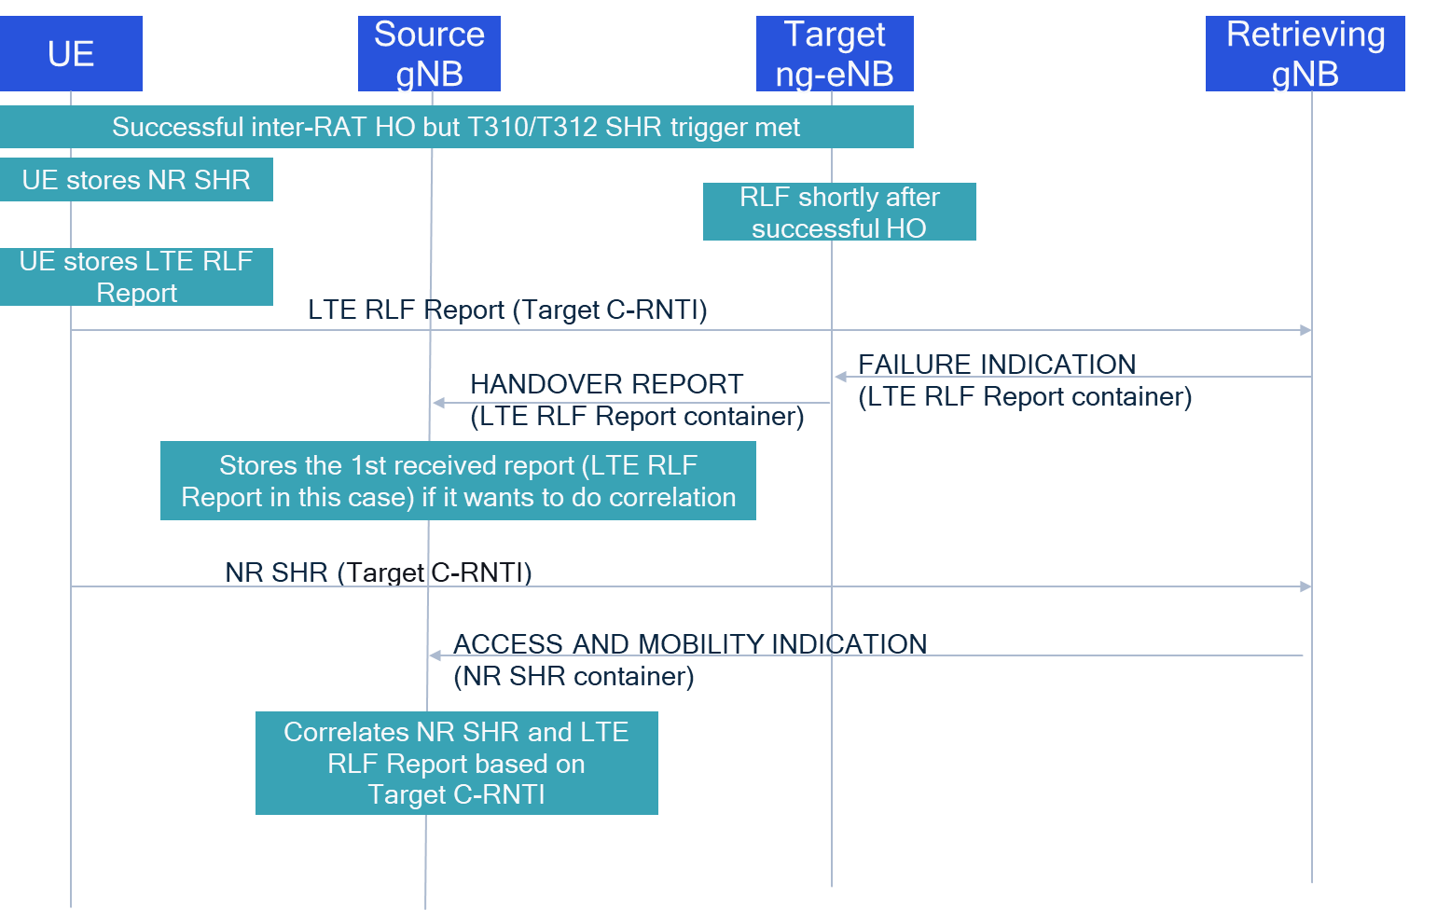
Company | Comment

Q6b: For Alt B, does Target C-RNTI need to be included in HANDOVER REPORT? One reasoning provided is that the source gNB might not be able decode the LTE RLF Report container and hence the target ng-eNB can include it explicitly in HANDOVER REPORT.

Company | Yes/No

Q7: For Alt C, UE needs to be configured with a “new timer” during which it checks whether there were correlated SHR and RLF Reports generated. Should this timer be same as Tstore_UE_cntxt defined in the network for detecting too early HO ? Isn’t this leading to duplicate functionalities at network and UE? Also, should UE discard SHR upon detecting a correlation or should it send both SHR and RLF Report with a correlation indicator?
Company | Comment

