3GPP TSG-RAN WG3 #113-e R3-214190
Online, 16 - 26 August 2021

Agenda Item: 31.2.1
Source: Ericsson (moderator)
Title: Summary of Offline Discussion on Local NG-RAN Node Identifier
Document for: Approval

Introduction
CB: # 28_LocalNG-RANnode_Identifier
- 4 solutions: Option2 ZTE; Option4 Nok;
- One NG-RAN node can select as many Local gNB IDs as needed according to maximum number of Inactive UE Contexts to support or one NG-RAN node belongs to a specific group, according to a configured I-RNTI profile identifier? E///
- The NG-RAN node’s neighbour nodes should be informed when the old node identifier is still valid or becomes invalid? HW
(E/// - moderator)
Summary of offline disc in R3-214190

For the Chairman’s Notes
Propose the following:
R3-20xxxa, R3-20xxxc merged
R3-20xxxc rev [in xxxg] – agreed
R3-20xxxd rev [in xxxh] – agreed
R3-20xxxe rev [in xxxi] – agreed
R3-20xxxf rev [in xxxj] – endorsed
Propose to capture the following:
Agreement text…
Agreement text…
WA: carefully crafted text…
Issue 1: no consensus
Issue 2: issue is acknowledged; need to further check the impact on xxx. May be possible to address with a pure st2 change. To be continued…

Solutions proposed in RAN3#113e
The following WAs and agreements were made during RAN3#112e meeting.
WA: a solution based on exchanges of Local gNB-ID over Xn should be pursued; Xn signaling impact should be limited
Continue discussions on Solutions design and Local gNB-ID conflict resolution at the next meeting

Four solutions (with some of them have been refreshed) have been proposed on how to disambiguate a NG-RAN node from I-RNTI.

Solution 1: Multiple Local gNB Identifiers per NG-RAN node.
This solution is summarized and presented in [2][3].
- the I-RNTI is encoded as follow:
  - a fixed number of bits, common for all nodes, to encode a UE Context Identifier
  - a fixed number of bits, common for all nodes, to encode a Local gNB ID
- A NG-RAN node can allocate multiple Local gNB IDs.
- The Local gNB Identifiers are selected randomly, and exchanged between NG-RAN nodes.
- Each RAN node communicates its own local identifiers to its neighbour RAN nodes and updates them when change occurs.

Solution 2: One Local gNB Identifier with I-RNTI profile per NG-RAN node.
This solution is summarized and presented in [2][4][5].
- The I-RNTI is encoded as follows
  - A fixed number of bits is used, for all nodes in the network, to identify an I-RNTI profile
  - One Local gNB ID is assigned per NG-RAN node
  - For each I-RNTI profile identifier, a fixed number of bits is used to encode a Local gNB ID
  - For each I-RNTI profile identifier, a fixed number of bits is used to encode a UE Context Identifier
- The Local gNB Identifiers are selected randomly, and exchanged between NG-RAN nodes.
- Each RAN node communicates its own local identifiers to its neighbor RAN nodes and updates them when change occurs.

Solution 3: Up to 6 Local NG-RAN node identifiers per NG-RAN node.
This solution is summarized and presented in [6][7].
- Multiple (up to 6) Local gNB IDs can be maintained in one NG-RAN node at the same time.
- An old Local gNB ID is released when all the inactive UEs with the old local node identifier are relocated or released.
- A list of Local gNB IDs is signaled between NG-RAN nodes.

Solution 4: One Local gNB Identifier with undefined length per NG-RAN node.
This solution is summarized and presented in [8][9].
- The Local gNB Identifier is assigned corresponding to the first leftmost bits of I-RNTI values which it allocates.
- The NG-RAN node selects a Local gNB ID which doesn’t match any MSB of a neighbour NG-RAN node or a neighbour of neighbour NG-RAN Node.
- The Local gNB Identifiers and global gNB Identifiers are exchanged between NG-RAN nodes.

Evaluation of feasibility
It is worth noticing that all the solutions on the table now are focusing on a standardized way to enabling inter-vendor inter-operability, deployments of network supporting variable maximum number of Inactive UE Context.
The basic concept of Solution 1 and 2 have been discussed and the feasibility is recognized by the group. In this meeting Solution 3 and 4 are refreshed, though a clear positive feasibility statement is not there. To elaborate more, the node receiving the I-RNTI at RRCResume needs to know the length of the Global NG-RAN node ID to disambiguate. The problem is explained in the figure below.

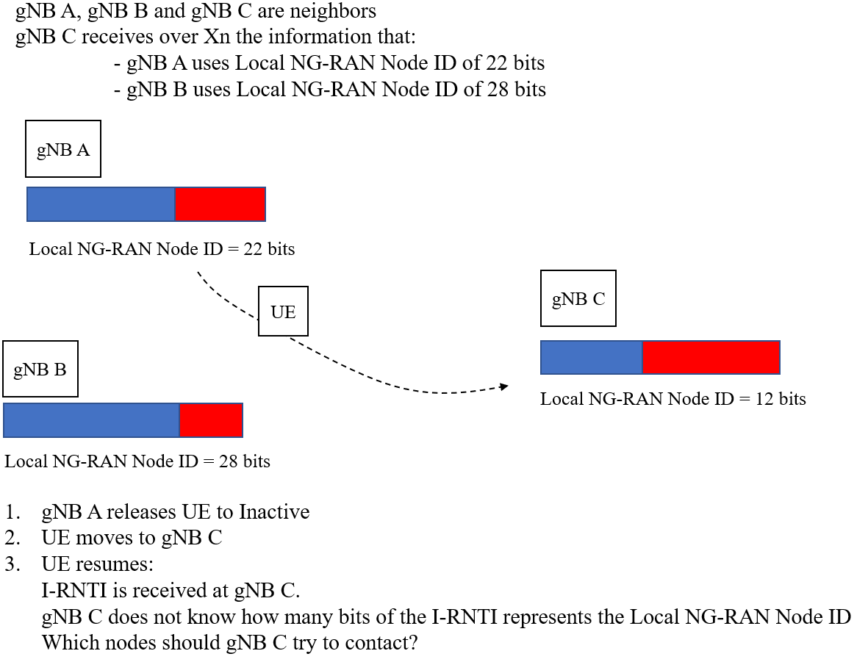

Companies are invited to provide their view on the feasibility of above Local gNB ID conflict resolutions.

Company | Comment
Ericsson | Solution 1 and 2 are feasible by explicitly sending the fixed Local NG-RAN Node ID split or combination with pre-defined I-RNTI profile.  Solution 3 and 4 cannot provide an effective way to indicate the bits of I-RNTI as the Local NG-RAN Node ID during exchange of such info.

Overall assessment
During comparison of the above, the following factors needs to be taken into account.
- Signaling exchange
- Minimized (zero) configuration effort
- Flexibility of the solutions
Company | Comment
Ericsson | Solution 1 is fully aligned with RAN3’s agreements, which are:  - When a Local gNB Identifier is no longer used by any Inactive UE context stored in the node, the Local gNB Identifier can be released.  - When a Local gNB Identifier is taken in use or its use is revoked, the NG-RAN node sends this information to the neighbor nodes via Xn signalling.  Regarding the flexibility, Solution 1 can offer the possibility to easily scale, compared to moving one bit less to local gNB ID. Furthermore, no signaling overhead is seen for Solution 1. To elaborate more, one thing to consider is that the split 10-30 in case of full I-RNTI is a suggestion which can be changed, e.g. a 12-28 (12 bits will mean 4096 users,) or a 14-26 (14 bits will mean 16384 users). It needs to be confirmed that allocation of a new Local gNB Identifier is on-demand, i.e. based on the need to serve the N-th+1 Inactive context (with N Inactive context admittable with a current allocation of Local gNB Identifiers), the need to release a Local gNB Identifier can follow a different principle, e.g. the evolution of the traffic over a long time scale.  In our opinion, Solution 3 should be left to implementation as a complementary meaning which requires to maintain more than one Local NG-RAN Node Identifier to account for the scenario where a current Local NG-RAN Node Identifier needs to be taken out of use.

Conclusion, Recommendations [if needed]
If needed

References
- R3-212633, SoD LocalNG-RANnodeID, Ericsson
- R3-213830, Node Identifier for RRC Inactive, Ericsson
- R3-213831, Addition of multiple Local gNB Identifiers per NG-RAN node, Ericsson
- R3-213247, Discussion on I-RNTI partitioning, ZTE
- R3-213248, CR for TS 38.423 on I-RNTI partitioning, ZTE
- R3-213558, Discussion on Local NG-RAN Node Identifier, Huawei
- R3-213559, Local NG-RAN Node Identifier, Huawei
- R3-213465, Support of Local NG-RAN node identifier, Nokia, Nokia Shanghai Bell
- R3-213466, Support of Local NG-RAN node identifier [Local_Node_ID], Nokia, Nokia Shanghai Bell

