3GPP TSG-RAN WG3 #111-e R3-211109
25 January – 4 February 2021
Online

Agenda Item: 9.3.8.1
Source: ZTE (moderator)
Title: Summary of Offline Discussion on MaxAMFregions
Document for: Approval

Introduction
CB: # 99_MaxAMFregions
- clarify usage and scenario
- may be solved via proper selection in NG-RAN node?
(ZTE - moderator)
Summary of offline disc R3-211109
Note:
The first round email discussion plan to be end at end of Friday of the first week.(Friday 17:00 UTC 2021-1-29)
The second round email discussion plan to be end 2 hours before the on-line session (Thursday 11:00 UTC).

For the Chairman’s Notes
Propose the following:

Propose to capture the following:

Discussion

Clarification of the usage and scenario
In [1], the company identify an issue for Max number of supported AMF Regions exceeded at NG-RAN node. The general description of the issue has been explained in [1]. In this part provide further clarification on the issue.
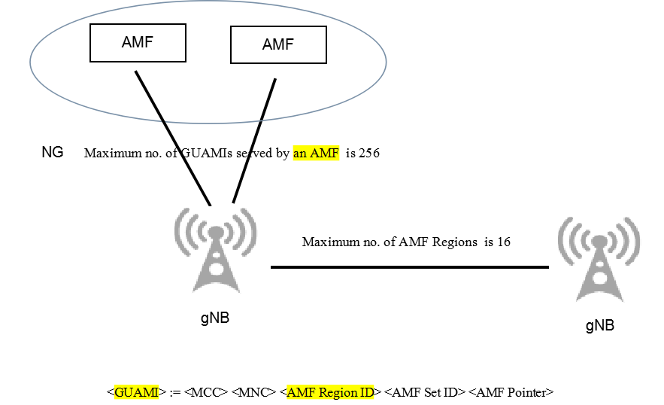

As shown in the figure, assume actually 20 AMF region acknowledged in NGAP, then the issue is how to transfer these AMF region to the new setup neighbor gNB in XnAP?
As defined in TS 38.423, copied below for easy reference , it is clear the the specification mandatory to ask source gNB provide complete AMF region list to the neighbor.
With limitation of only 16 items in current specification, how does source gNB provide complete AMF region list to the neighbor.
TS 38.423
The AMF Region Information IE in the XN SETUP REQUEST message shall contain a complete list of Global AMF Region IDs to which the NG-RAN node₁ belongs. The AMF Region Information IE in the XN SETUP RESPONSE message shall contain a complete list of Global AMF Region IDs to which the NG-RAN node₂ belongs.

Consequences not provide complete list:
1: first of all, break the law of specification , which is clearer.
2: can not fulfil the handover type decision: AMF region exchange is design for HO type decision, e.g. NG based HO or Xn based HO. If one gNB has 20 AMF region but only provide 16 items to the neighbour, it is highly possible the gNB will make wrong decision in HO type.

The possibility of the issue
First of all, this issue was discovered during the field test and was a practical problem. Secondly, this problem exists in theory, because the AMF region that an AMF can support can reach 256. When a NG RAN node is connected to multiple AMFs, the possibility of the issue will exist more higher. The problem is that when the issue happen, there is no solution to deal with the problem reasonably.

Q1: Provide you view on identify the issue of Max number of supported AMF Regions exceeded at NG-RAN node.
Company | Yes/no | Comment
ZTE | Yes

Candidate approaches for the issue
In [1], the company provides three candidate approaches.
Approach 1 [2]: Introduce a new cause value “Max number of supported AMF Regions exceeded at NG-RAN node” in NGAP.
After a successful NG SETUP procedure, NG-RAN node identifies that the number of new received AMF region ID contained in GUAMI(s) served by new AMF exceed 16. Then NG-RAN node sends an NGAP Error indication message to the AMF with new cause value as proposed in this contribution. In implementation, AMF and NG-RAN node suspends to server UE(s) in this connection and inform the situation to its OAM independently.

Approach 2: Expand the XnAP range of maxnoofAMFRegions from 16 to e.g. 256.

Approach 3: Other view ?e.g solved via proper selection in NG-RAN node ?
Q2: provide your view on approaches?
Company | Approach ? | Comment
ZTE | Approach 1 | For approach 3, multiple vendor scenario can not rule out. Then how does NG-RAN node do when facing the situation? For example, beak the law of specification ?

Any other stuff?
Please provide your view on the Proposal.
Company | Yes/no/other view | Comment

Conclusion, Recommendations [if needed]
If needed

References
- R3-210571 Max number of supported AMF Regions exceeded at NG-RAN node (ZTE, China Unicom ,China Telecom)
- R3-210572 Rel-15 CR Max number of supported AMF Regions exceeded at NG-RAN node (ZTE, China Unicom ,China Telecom)
- R3-210573 Rel-16 CR Max number of supported AMF Regions exceeded at NG-RAN node (ZTE, China Unicom ,China Telecom)

