3GPP TSG-RAN WG3 #111-e R3-211110
25 January – 4 February 2021
Online

Agenda Item: 9.3.8.1
Source: ZTE (moderator)
Title: Summary of Offline Discussion on MDTinactiveUEs
Document for: Approval

Introduction
CB: # 100_MDTinactiveUEs
- clarify scenario
- issue acknowledged?
(ZTE - moderator)
Summary of offline disc R3-211110
Note:
The first round email discussion plan to be end at end of Friday of the first week.(Friday 17:00 UTC 2021-1-29)
The second round email discussion plan to be end 2 hours before the on-line session (Thursday 11:00 UTC).

For the Chairman’s Notes
Propose the following:

Propose to capture the following:

Discussion

Clarification of the issue

How does NM/5GC to deactivate a signaling based logged MDT session

32.422

4.1.4.13 5GC deactivation mechanisms for MDT
When the AMF receives a Trace Session Deactivation request for an MDT Trace Session of a UE, it shall act according to the following.
In case of an immediate MDT trace session and the UE being in connected mode, the AMF shall send trace session deactivation toward the eNB/gNB. The eNB/gNB shall deactivate the corresponding MDT RRC measurements in the UE and shall discard the given trace session context.
In case of an immediate MDT trace session and the UE being in idle mode, the AMF shall silently discard the stored trace session context.
In case of an immediate MDT trace session and the UE being in inactive state, the AMF that is aware of inactive state shall silently discard the stored trace session context.
Note: Signaling based deactivation does not apply for logged MDT or Logged MBSFN MDT trace sessions. The logged MDT and Logged MBSFN MDT trace session terminates when logging duration expires.

Observation : Signalling based logged MDT can be deactivate from 5GC/NM view that when logging duration timer expired. A timer for logging duration shall be supported in 5GC/NM.

How does logged duration timer performed in NG-RAN ?
After UE receives signalling based logged MDT configuration from the network, the UE end the measurement based on logging duration parameter.
TS 37.320
- configuration of the logging duration. This configuration parameter defines a timer activated at the moment of configuration, that continues independent of state changes, RAT or RPLMN change. When the timer expires the logging is stopped and the configuration is cleared (except for the parameters that are required for further reporting e.g. network absolute time stamp, trace reference, trace recording session reference and TCE Id).

Observation : logging duration timer perform in NG-RAN independent of states change ,including RRC_INACTIVE state.

Issue for Logging duration time mismatch between NM/5GS and UE issue for UE in RRC_INACTIVE state

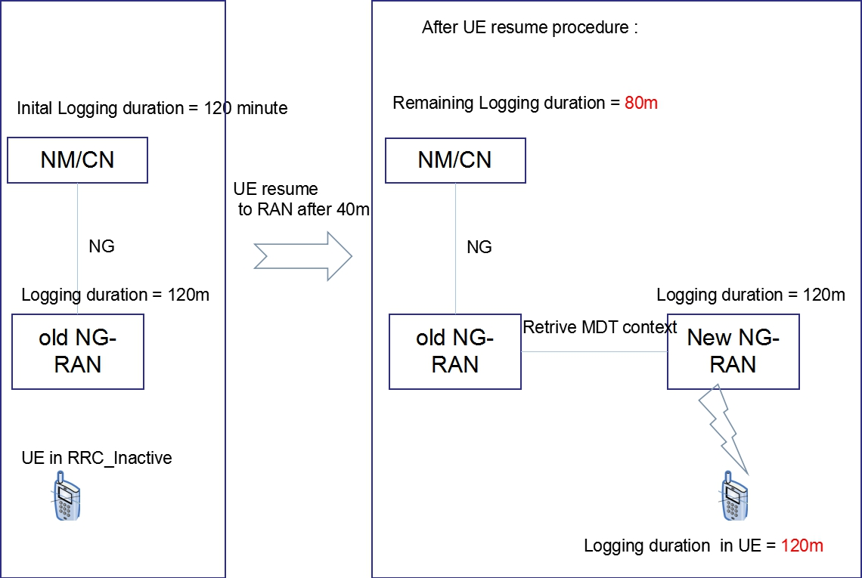
As shown in the above figure, In signaling based MDT, once the CN/OAM provides MDT configuration to NG-RAN node, a timer is started in CN and/or in NM system to keep track of the logging duration of the signaling based MDT, upon whose expiry another signaling based MDT can be triggered towards the same UE. However there is a potential mismatch in the logging duration timer between UE and network (OAM, core network) when UE goes to RRC_INACTIVE before the expiry of logging duration. When UE resumes at a new NG-RAN node , the new NG-RAN node retrieves the MDT configuration from the old RAN node and sends the MDT configuration to the UE. In the procedure, if the source node does not provide the remaining logging duration timer to the new node, the new node will provide original logging duration parameter to the UE thereby leading to a mismatch. Then the logging duration is mismatch in UE and Network( e.g. OAM, Core network). In the figure above, the timer in NM/CN is 80 minutes left and the timer in the UE is 120 minutes.
It is possible that MN/CN will trigger another signalling based logged MDT and overwrite the previous on-going one.

Q1: Provide you view on identify the issue for Logging duration time mismatch between NM/5GS and UE issue for UE in RRC_INACTIVE state?
Company | Yes/no | Comment
ZTE | Yes

Candidate approaches for the issue
In [1], the company provides three candidate approaches.
Appraoch1: old RAN node provide Remaining timer to new RAN node[2][3][4] :
During UE context retrieve procedure, the old RAN node provides an remaining timer to record the time UE context stay, the new RAN node takes way of remaining timer from logging duration and send the modified logging duration to UE. No UE impact in the approach.
Approach 2 Absolute time stamp [5] :
Add logged MDT status including “logging duration” and “logged MDT activation absolute time” which is same as absoluteTimeInfo in RRC LoggedMeasurementConfiguration in RETRIEVE UE CONTEXT RESPONSE message.From the absolute time stamp and the logging duration, the new NG-RAN can make decision whether the management based MDT can be configured to the UE. Based on the absolute time, new NG-RAN node can modify the logging duration and send it to UE. No UE impact in the approach.
Approach 3 :old RAN node takes way of UE context stay time
During UE context retrieve procedure, the old RAN node takes way of remaining timer from logging duration and send the modified logging duration to new RAN node. In this approach, no new information(e.g. Remaining time, absolute time) transmitted in XNAP.
Q2: provide your view on approaches?
Company | Approach | Comment
ZTE | Approach 1

Any other stuff?
Please provide your view on the Proposal.
Company | Yes/no/other view | Comment

Conclusion, Recommendations [if needed]
If needed

References
- R3-204308
- R3-203340 Prioritization of Signaling MDT over management based MDT for different RRC states ,Qualcomm Incorporated
- R3-203342 (TP for MDT BL CR for TS 38.423) Prioritization of Signaling MDT over management based MDT for different RRC states ,Qualcomm Incorporated
- R3-203887 Management based MDT should not overwrite signalling based MDT,ZTE
- R3-203950 About the solution to avoid the overwrite problem-XnAP, Samsung
- R3-210575 CR for Signalling absed logged MDT for UE in RRC_INACTIVE state
- R3-210576 LS-out Signalling based logged MDT for UE in RRC_INACTIVE

