3GPP TSG-RAN WG2 Meeting #130 R2-25xxxxx

St Julian's, Malta, 19 - 23 May, 2025

Title: Comparison of UE data collection request options [RRC3]

Source: Huawei, Ericsson, Nokia, Qualcomm

Agenda item: 8.1.2.2

Document for: Discussion/Decision

# Introduction

During online session, the following papers were treated, and this paper is to provide comparison of two options from these papers.

RRC3: UE data collection request

R2-2504414 On Enhancements for NW Involvement in UE-side DC for BM Nokia, T-Mobile USA Inc., Ericsson, BT plc, Verizon, Deutsche Telekom AG discussion Rel-19 NR_AIML_air-Core

R2-2503449 Discussion on open issues of AI/ML air LCM Xiaomi discussion Rel-19 NR_AIML_air-Core

# Discussion

## General

The discussion covers the following use cases:

1. UE-side BM
2. UE-side CSI prediction.

## Option 1

Figure 1 shows the signalling flow of option 1, which is based on [2].

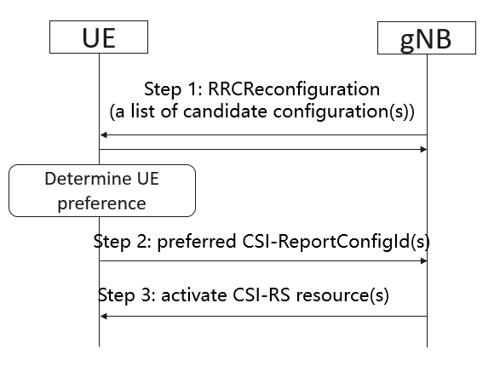

**Figure 1: basic signalling flow of option 1**

Option 1 includes the following steps:

**Step 1:**  The gNB provides a list of candidate configurations to the UE, and it can be indicated by *CSI-ReportConfigs* (under *CSI-MeasConfig*) which are referred to by *CSI-ReportConfigIds* with *reportQuantity-r19* set to *none-r19*. Introduce a flag in OtherConfig indicating whether UE report in Step 2 is enabled or disabled

With the following note in the running RRC CR, other parameters are waiting for RAN1

* Editor's Note: FFS how to add the L1 AI/ML parameters (e.g. Set A/B, associated ID, report quantities, etc.) based on the parameter list from RAN1, once this list is provided to RAN2.

**Step 2:**  From the list, the UE indicates *CSI-ReportConfigIds* as referred configurations to the gNB. UAI has been agreed, and FFS on *RRCReconfigurationComplete* message

**Step 3:**  The gNB activates/deactivate L1 CSI-RS resources without resulting in CSI measurement reports.

According to RAN1#120 agreement, UE performs measurement on all resources for the resources configured for data collection purpose without CSI report. For SP and AP resources, the gNB can use existing MAC CE/DCI. For periodic resources, they are directly activated once the UE receives such configurations in Step 1.

## Option 2

Figure 2 shows the signalling flow of option 2, which is based on [4].

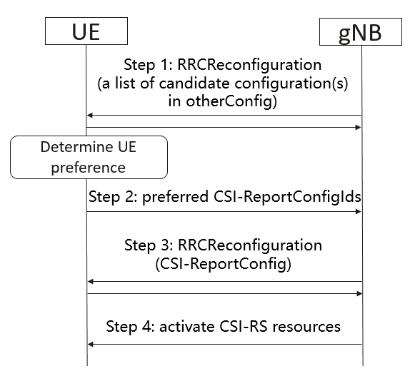

**Figure 2: basic signalling flow of option 2**

Option 2 includes the following steps:

**Step 1:**  The gNB provides *DataCollectionPreferenceConfig* (i.e., list of candidate data collection configurations) to the UE, which includes:

- CSI-ResourceConfigId of Set A

- CSI-ResourceConfigId of Set B

- One/two associated IDs (up to whether Set B is equal/subset of Set A or not)

Introduce a flag in OtherConfig indicating whether UE report in Step 2 is enabled or disabled

**Step 2:**  From the list, the UE indicates *CSI-ReportConfigIds* as referred configurations to the gNB. UAI has been agreed

**Step 3:**  The gNB provides *CSI-ReportConfigs* (under *CSI-MeasConfig*) which are referred to by *CSI-ReportConfigIds* with *reportQuantity-r19* set to *none-r19.* Other parameters are waiting for RAN1

**Step 4:**  The gNB activates/deactivate L1 CSI-RS resources without resulting in CSI measurement reports.

## Comparison

A comparison of option 1 and 2 is listed in Table 1:

**Table 1: Summary Table**

|  |  |  |  |
| --- | --- | --- | --- |
|  | **RAN1 impacts** | **RAN2 impacts** | **RAN3 impacts** |
| **Option 1** | No | Step 1: Introduce a flag in *OtherConfig* indicating whether UE report in Step 2 is enabled or disabled  Step 2: The UE indicates *CSI-ReportConfigIds* to the gNB | For CU-DU architecture:  **No RAN3 impact:** DU to provide *CSI-reporConfig* to CU. It may include new parameters like set A/set B/associated id information, but all the information are transparent to CU as legacy. |
| **Option 2** | In step 1, the detailed IEs need to be checked with RAN1. | Step 1: a list of *CSI-ReportCongfigs* in otherConfig. Introduce a flag in *OtherConfig* indicating whether UE report in Step 2 is enabled or disabled  Step 2: The UE indicates *CSI-ReportConfigIds* to the gNB | For CU-DU architecture:  **Has RAN3 impact:** DU has to provide information of data collection preferences {set A, set B, and associated ID} to the CU. The information is not transparent to CU. |

Based on Table 1, there are RAN1 and RAN3 impacts for Option 2, so it is suggested to select Option 1.

# Conclusion

Based on section 2, we propose:

**Proposal: RAN2 to agree on the following option for UE data collection request for both UE-side BM and CSI prediction:**

**Step 1: The gNB provides a list of candidate configurations to the UE, and it is indicated by *CSI-ReportConfigs* (under *CSI-MeasConfig*) which are referred to by *CSI-ReportConfigIds* with *reportQuantity-r19* set to *none-r19.* Introduce a flag in *OtherConfig* indicating whether UE report in Step 2 is enabled or disabled**

**Step 2: The UE indicates *CSI-ReportConfigIds* as referred configurations to the gNB. FFS on *RRCReconfigurationComplete* message**

**Step 3: The gNB activates/deactivate L1 CSI-RS resources without resulting in CSI measurement reports**

# References

[1] RAN2#130 chair notes

[2] R2-2504414 On Enhancements for NW Involvement in UE-side DC for BM Nokia, T-Mobile USA Inc., Ericsson, BT plc, Verizon, Deutsche Telekom AG discussion Rel-19 NR_AIML_air-Core

[3] R2-2504239 Discussion on training data collection for UE-sided model for BM and CSI prediction Huawei, HiSilicon discussion Rel-19 NR_AIML_air-Core

[4] R2-2503449 Discussion on open issues of AI/ML air LCM Xiaomi discussion Rel-19 NR_AIML_air-Core

# Annex – legacy CSI Reporting for the possible CSI-RS Configurations

Table 5.2.1.4-1: Triggering/Activation of CSI Reporting for the possible CSI-RS Configurations. (TS 38.214)

|  |  |  |  |
| --- | --- | --- | --- |
| CSI-RS Configuration | Periodic CSI Reporting | Semi-Persistent CSI Reporting | Aperiodic CSI Reporting |
| Periodic CSI-RS | No dynamic triggering/activation | For reporting on PUCCH, the UE receives an activation command [10, TS 38.321]; for reporting on PUSCH, the UE receives triggering on DCI | Triggered by DCI; additionally, activation command [10, TS 38.321] possible as defined in Subclause 5.2.1.5.1. |
| Semi-Persistent CSI-RS | Not Supported | For reporting on PUCCH, the UE receives an activation command [10, TS 38.321]; for reporting on PUSCH, the UE receives triggering on DCI | Triggered by DCI; additionally, activation command [10, TS 38.321] possible as defined in Subclause 5.2.1.5.1. |
| Aperiodic CSI-RS | Not Supported | Not Supported | Triggered by DCI; additionally, activation command [10, TS 38.321] possible as defined in Subclause 5.2.1.5.1. |

# Annex – RAN1 progress on UE-sided data collection for BM

## RAN1#120 agreements

For UE-sided model, for configuring the resource for data collection purpose, support

* *CSI-ReportConfig* can used for configuring the resources for data collection purpose without CSI report.
  + One *CSI-ResourceConfigId* is configured for Set A.
  + One *CSI-ResourceConfigId* is configured for Set B.
  + Note: UE performs measurement on all resources
  + One or two associated IDs can be configured in *CSI-ReportConfig*
    - When Set B is equal or a subset of set A (i.e., *NZP-CSI-RS-ResourceId*/*SSB-Index* in the resource setfor Set B is within the *NZP-CSI-RS-ResourceId*/*SSB-Index* in the resource setfor Set A), one associated ID is configured,
    - Otherwise, one associated ID is configured for Set A and another one associated ID is configured for Set B

FFS: whether/how to support 'aperiodic' CSI RS

# Annex - RAN1 progress on UE-sided data collection for CSI prediction

## RAN1#120bis agreements

Agreement

Introduce a dedicated AI/ML PU for AI/ML features for UE,

* The AI/ML PU is used at least for quantifying the simultaneous processing of multiple CSI reports subject to CSI-related AI/ML use case(s), e.g., CSI compression (if supported), CSI prediction, BM spatial prediction, BM temporal prediction.

Conclusion

For CSI prediction using UE-side model, for data collection for training, aperiodic CSI-RS resource for CMR is not supported.

Agreement

For CSI prediction using UE-side model, for training data collection, support

* *CSI-ReportConfig* can used for configuring the resources for data collection purpose without CSI report
  + FFS on how to indicate without CSI report in CSI-ReportConfig

Agreement

For CSI prediction using UE-side model, for performance monitoring, support UE assisted performance monitoring subject to an additional UE capability, and UE assisted performance monitoring is based on Type 3 performance monitoring

Agreement

For CSI prediction using UE-side model, for performance monitoring type 3, support SGCS as a performance metric.

Agreement

For the definition of SGCS,



Note: How to handle layer mapping mismatch, if any, is up to UE implementation.

Agreement

For CSI prediction using UE-side model, for reporting contents of UE assisted performance monitoring, down-select one alternative by RAN1#121.

* Alt 1: one SGCS is calculated based on predicted CSI for one inference reporting, ground truth CSI
* Alt 2: one SGCS is calculated based on predicted CSI for one inference reporting, and ground truth CSI, another SGCS is based on ground truth CSI and CSI (non-predicted) corresponding to the latest CSI-RS transmission occasion not later than CSI reference resource of the inference reporting instance.
* Alt 3: statistic of reporting contents (e.g., mean, x% CDF of SGCS values) of inference reporting instances within configured monitoring window
  + Monitoring window can be configured by NW
    - FFS on signalling details
* FFS on whether to report per prediction instance, selected prediction instance(s), averaged over prediction instances
* FFS on report frequency granularity (e.g., per wideband or per subband or averaged over subband or selected subband)
* FFS on whether to report per layer, the first layer, averaged over layer
* FFS on how to quantize and report mechanism

Agreement

For CSI prediction using UE side model, for inference, consider following options for potential down selection

* Option 1: only dedicated AI/ML PU (OAPU) is occupied
* Option 2: only legacy CPU (OCPU) is occupied
* Option 3: both dedicated AI/ML PU (OAPU) and legacy CPU (OCPU) are occupied
* FFS whether OAPU and OCPU are based on defined rule and/or reported by UE
* Note: The supported option(s) by UE is reported by UE capability, if multiple options are supported.

The total number of dedicated AI/ML PU for AI/ML is reported by UE capability.

* Note: The total number of Use case specific dedicated AI/ML PU could be discussed separately.

Agreement

For CSI prediction using UE-side model, at least for inference, introduce new RRC parameter for CSI report configuration to distinguish CSI report of AI-CSI prediction and non-AI CSI prediction.

* Note: terminology of “AI-CSI prediction” and “non-AI CSI prediction” is separate discussion
* Detailed parameter name is upto RAN2

## RAN1#120 agreements

**R1-2501528** **Summary #1 of CSI prediction Moderator (LG Electronics)**

From Wednesday session

Agreement

For CSI prediction using UE-side model, at least for inference, Rel-18 CSI framework is reused.

* For CSI-RS resource type for CMR, periodic, semi-persistent, and aperiodic CSI-RS are supported.
* For inference report,
  + for N4>=1, support Rel-18 codebook ('typeII-Doppler-r18')

R1-2501529 Summary #2 of CSI prediction Moderator (LG Electronics)

**R1-2501530** **Summary #3 of CSI prediction Moderator (LG Electronics)**

From Thursday session

Agreement

For CSI prediction using UE-side model, if performance monitoring type 1 or 3 is supported, for calculation of monitoring metric, support

* Based on intermediate KPI
  + Down select between SGCS and NMSE by RAN1#120bis
  + FFS on the definition of SGCS/NMSE and how to calculate monitoring metric

Agreement

For CSI prediction using UE-side model, for CSI processing criteria and timeline, at least for inference further study on

* Whether the CPU should be shared or separately counted between legacy CSI reporting and AI/ML-based CSI reporting
* Whether the Processing Unit should be shared or separately counted among AI/ML related features/functionalities.
* Whether new timeline is needed/updated for inference, and whether a different timeline is needed when functionality switches/activates.
* Whether legacy framework for active CSI-RS resource and port counting can be reused

Note: Strive to study CSI processing criteria considering both BM and CSI case, and take the existing solutions as starting point.

**R1-2501610** **Summary #4 of CSI prediction Moderator (LG Electronics)**

Presented in Friday session

Agreement

For CSI prediction using UE-side model, for data collection for training,

* For resource configuration,
  + For CSI-RS resource type for CMR, periodic and semi-persistent are supported.
    - FFS on support of aperiodic CSI-RS resource
  + FFS on whether to separately configure CSI-RS resource(s) used for measurements for model input and CSI-RS resource(s) used for measurements for ground-truth CSI
  + FFS whether/how to enhance CSI-RS resource configuration to reduce CSI-RS signalling overhead.
* FFS on CSI report configuration

Final summary in R1-2501626.