**3GPP TSG-RAN WG2 #130 R2-250XXXX**

**St.Julians, Malta, May 19th – 23rd, 2025**

Agenda Item: 8.9.3

Source: MediaTek

Title: Report of [AT130][301][R19 IoT NTN] CB-msg4 design (Mediatek)

Document for: Discussion

# 1 Introduction

RAN2 had made the following agreements regarding the CB-Msg4.

RAN2 Agreements

Contention resolution identity

- The UE stops the PDCCH monitoring window(s) once it receives a CB-msg4 containing a matching Contention Resolution Identity (FFS if there is no RRC message together with the CB-msg4)

- Assuming that there will be scenarios where it’s possible to receive a CB-msg4 before the UE transmits some replicas, a UE stops transmitting the remaining replicas if it has received a CB-msg4 containing a matching Contention Resolution Identity (FFS if there is no RRC message together with the CB-msg4)

Multiplexing

- RAN2 confirms the working assumption that one CB-Msg4 can target multiple UEs simultaneously. FFS how the multiplexing is organized.

C-RNTI

- - The C-RNTI is included in CB-Msg4 if the UE is expected to receive additional RRC messages or data from the network after CB-Msg4 (FFS how to include the C-RNTI)

Timing alignment information

- The timing alignment information (FFS reusing TAC MAC-CE) can be included in the CB-Msg4

Backoff information

- Backoff information could be included in CB-Msg4.

HARQ feedback for Msg4

- HARQ feedback is adopted to acknowledge Msg4. FFS for the detail (e.g., how the HARQ feedback is used for each response in Msg4 when there is multiplexing in Msg4.).

To progress the discussion on CB-Msg4, the following MAC open issues have been collected and highlighted in [1]:

* **MAC-12: FFS how the multiplexing is organized for CB-MSG4.**
* **MAC-13: FFS new MAC PDU format for CB-Msg4**
* **MAC-14: FFS for the detail of HARQ operation on CB-Msg4.**

This offline discussion paper is to offer initial proposals based on the companies’ contributions on these MAC open issues in RAN2#130.

**\* [AT130][301][R19 IoT NTN] CB-msg4 design (Mediatek)**

      Scope: discuss open issues MAC-12, MAC-13, MAC-14

      Intended outcome: summary of the offline discussion

      Offline time: Monday 2025-05-19 afternoon coffee break (BO3)

      Deadline for offline discussion summary:  Tuesday 2025-05-20 10:30

# 2 Discussion

## 2.1 MAC open issue MAC-12

Regarding the MAC open issue MAC-12, the following proposals are contributed by the companies.

**MAC-12: FFS how the multiplexing is organized for CB-MSG4.**

|  |  |  |
| --- | --- | --- |
| 1 | vivo | Proposal 21: For a given UE, SetupRAR and the corresponding DL RRC message are always sent in the same MAC PDU |
| 2 | ZTE | Proposal 11: For CB-msg3-EDT procedure, if the CB-msg4 of multiple UEs are multiplexed into the same MAC PDU, the MAC CE or MAC SDU targeting for the same UE should be placed after the UE Contention Resolution Identity of that UE. |
| 3 | Nokia | Proposal 22: Multiple RRC messages (MAC SDUs) can be included into one CB-Msg4. |
| 4 | NEC | Proposal 16: There is only one UE’s RRC message and/or DL data that could be included in CB-Msg4 if there are RRC messages and/or data from multiple UEs. |
| 5 | HONOR | Proposal 1: (issue MAC-12) For CB-MSG3 transmission on the same time domain resource or on the same frequence domain resource, MSG4 can be multiplexed into one MAC PDU.  Proposal 2: (issue MAC-12) For MSG4 multiplexing with the same time domain resource, it needs to indicate the information of the frequency domain resource that used for MSG4 multiplexing transmission.  Proposal 3: (issue MAC-12) For MSG4 multiplexing with the same time domain resource, the frequence domain resource occasion corresponding to CB-MSG3 transmission should be indicated for each MSG4.  Proposal 4: (issue MAC-12) For MSG4 multiplexing with the same frequency domain resource, the time domain resource occasion corresponding to CB-MSG3 transmission should be indicated for each MSG4.  Proposal 5: (issue MAC-12) If the successRAR is followed by one MAC SDU/padding, one filed in the subheader for successRAR can be used to indicate the length that the UE can skip decoding the followed MAC SDU/padding. |
| 6 | MediaTek | Proposal 6: (MAC-12) Multiple contention resolution IDs could be included in CB-MSG4, the information related to the UE can be assembled in the MAC PDU after the corresponding contention resolution ID. |
| 7 | Ericsson | Proposal 23        The Msg4 can contain MAC SDUs carrying downlink data for each UE that is replied to in the Msg4.  Proposal 25        The number of Msg3 replies in one Msg4 can be left to eNB implementation. |

Based on the contributions, the rapporteur offers the following proposals for further discussion:

**Proposal 1: (MAC-12)** **Multiple contention resolution IDs could be included in CB-MSG4, the information related to the UE can be assembled in the MAC PDU.**

Q1: Do companies agree the P1?

**Summary**

No concern, P1 is agreeable.

**Proposal 2: (MAC-12) The number of Msg3 replies in one Msg4 can be left to eNB implementation. No SPEC impact.**

Q2: Do companies agree the P2?

**Summary**

No concern, P2 is agreeable.

## 2.2 MAC open issue MAC-14

Regarding the MAC open issue MAC-14, the following proposals are contributed by the companies.

* **MAC-14: FFS for the detail of HARQ operation on CB-Msg4.**

|  |  |  |
| --- | --- | --- |
| 1 | CATT | Proposal 7 (MAC-14): It is up to RAN1 how to allocate the ACK/NCK feedback resources for a CB-Msg4 multiplexing responses to multiple UEs. |
| 2 | ZTE | Proposal 12: HARQ feedback should be given for each response in CB-msg4. |
| 3 | OPPO | Proposal 8  The resource information for HARQ feedback is indicated in CB-Msg4 for each UE with contention resolution. |
| 4 | Nokia | Proposal 20: A new HARQ-Ack resource indicator could be included in the CB-Msg4 to indicate multiple HARQ feedback resource for multiple HARQ feedback. |
| 5 | NEC | Proposal 17: HARQ feedback resource could be indicated to the UE by MAC CE. |
| 6 | Spreadtrum | Proposal 11: the PUCCH resource indicator is included in CB-msg4 for each UE. When CB-msg4 is successfully decoded and a matched Contention Resolution ID is found in CB-msg4, the UE use the PUCCH resource to transmit HARQ-ACK. |
| 7 | Huawei | Proposal 4: (MAC-14) HARQ feedback resources can be included in the Msg4 payload. |
| 8 | Samsung | Proposal 9: Send LS to RAN1 regarding design of the HARQ feedback resource configuration field. |
| 9 | CMCC | Proposal 13: It is proposed that provide HARQ ACK per UE corresponding to the successful reception UE to the network.  Proposal 14: The feedback resource could be included in the CB-Msg4 or PDCCH scheduling the CB-Msg4. |
| 10 | MediaTek | Proposal 7: (MAC-14) The HARQ resource information can be included in the CB-Msg4 together with contention resolution ID which identity the specific UE.  Proposal 8: (MAC-14) UE will send HARQ ACK for CB-Msg4 if the contention resolution ID matches. No HARQ NACK is sent.  Proposal 9: (MAC-14) The HARQ feedback for CB-Msg4 can be disabled if the HARQ feedback resource is not provided.  Proposal 10: (MAC-14) For NB-IoT, the SubCarrierSpacing of the HARQ feedback for CB-Msg4 is same as the CB-Msg3.  Proposal 13a: (MAC-13) The 2-bit HARQ ACK resource for eMTC and 4-bit HARQ ACK resource for NB-IoT is used in the CB-Msg3 response. |
| 11 | Ericsson | Proposal 24  For each UE answered in a Msg4, the successful reception of a Msg4 can be individually acknowledged with a HARQ ACK transmission.  Proposal 26   For each UE that is replied to, Msg4 has a 4 bit HARQ ACK resource allocation, reusing the existing HARQ ACK/NACK allocation signalling in the DCI. FFS eMTC  Proposal 27   In the HARQ-ACK resources for Msg4, the value ‘15’ indicate HARQ feedback disabled. FFS eMTC |

Based on the contributions, the rapporteur offers the following proposals for further discussion:

**Proposal 3: (MAC-14) The HARQ feedback resource information can be included in the CB-Msg4 together with contention resolution ID which identity the specific UE.**

Q3: Do companies agree the P3?

ZTE think this configuration could also be in SIB. Xiaomi think HARQ resource is UE specific. QC think we should inform RAN1.

**Summary**

This is agreeable from R2 point of view, could re-visit if RAN1 has concern.

**Proposal 4: (MAC-14) UE will not send HARQ ACK for CB-Msg4 if HARQ resource is not provided. No HARQ NACK is sent.**

Q4: Do companies agree the P4?

QC think TA command is needed.

**Summary**

No concern, P4 is agreeable.

**Proposal 5: (MAC-14) Whether to send the HARQ feedback for CB-Msg4 can be controlled by NW.**

Q5: Do companies agree the P5?

E/// think we should always has this field with some reserve value indicate no HARQ. Samsung agree with E///. QC and Nokia we can save some bit by having this optional. HW also agree.

**Summary**

No concern, P5 is agreeable.

**Proposal 6: (MAC-14) For NB-IoT, the SubCarrierSpacing of the HARQ feedback for CB-Msg4 is same as the CB-Msg3.**

Q6: Do companies agree the P6?

**Summary**

No concern, P6 is agreeable.

**Proposal 7: (MAC-14) Reuse the existing format of HARQ ACK/NACK allocation signalling in the DCI. There is 2-bit HARQ ACK resource for eMTC and 4-bit HARQ ACK resource for NB-IoT. Reuse the meaning of DCI field in R1 SPEC. Send LS to RAN1 for information.**

Q7: Do companies agree the P7?

E/// think we should reuse the meaning from DCI.

**Summary**

No concern, P7 is agreeable.

## 2.3 MAC open issue MAC-13

Regarding the MAC open issue MAC-13, the following proposals are contributed by the companies.

* **MAC-13: FFS new MAC PDU format for CB-Msg4**

|  |  |  |
| --- | --- | --- |
| 1 | Xiaomi | Proposal 4: Similar to legacy EDT procedure, the first 48 bits of CCCH SDU is included in Msg4 for contention resolution for CB-msg3 EDT.  Proposal 7: (MAC-13) Use MAC signaling to include the C-RNTI in CB-msg4, e.g. in MAC header. |
| 2 | vivo | Proposal 16: The new MAC PDU for Cb-msg4 consists of one or more MAC subPDUs and optionally padding. Each MAC subPDU consists one of the following:  - a MAC subheader with Backoff Indicator only;  - a MAC subheader and ReleaseRAR including CRID, TAC, HARQ-ACK feedback parameters;  - a MAC subheader and SetupRAR including C-RNTI, CRID, TAC, HARQ-ACK feedback parameters;  - a MAC subheader and MAC SDU for CCCH, DCCH or DTCH;  - a MAC subheader and padding.  Proposal 17: E/T/R/R/BI MAC subheader can be reused for Cb-msg4 MAC PDU format.  Proposal 18: E/T/D/R/R/R/R/R MAC subheader is introduced for SetupRAR. The D field is used to indicate whether the MAC PDU for DTCH is present.  Proposal 19: R/R/R/LCID/F/L MAC subheader is introduced for MAC SDU carrying CCCH, DCCH or DTCH.  Proposal 20: SetupRAR is introduced to include 48-bit CRID, 12-bit TAC, 16-bit C-RNTI, 2-bit TPC for HARQ-ACK, and 2-bit TPC for HARQ-ACK timing offset. |
| 3 | CATT | Proposal 6 (MAC-12/13): CB-Msg4 MAC PDU includes the following elements:   * One Backoff information MAC CE; * One or more Contention Resolution Identity MAC CEs, with each MAC CE including a Contention resolution Identity, C-RNTI (optionally) and timing alignment information (optionally); * (Optionally) One or more MAC SDUs, with each SDU including RRC signaling or User data and associated with a Contention Resolution Identity MAC CE. |
| 4 | OPPO | Proposal 9        In multiplexed CB-msg4, the following information should be included in MAC PDU:  a.        A MAC subheader with Backoff indicator.  b.        MAC subheaders with time/frequency info of PUSCH occasion.  c.        successRAR including Contention resolution ID, C-RNTI, RRC message, TAC, Resource Information for HARQ feedback. |
| 5 | Nokia | Proposal 23: RAN2 confirms the potential CB-Msg4 content may include:   * Contention Resolution Identities * RRC message for CB-Msg3 response * C-RNTI * Timing Advance information * HARQ feedback information * Backoff information * FFS on other NW control information (such as information for assisting Msg4 monitoring, network initiated fallback or CE level change) |
| 6 | NEC | Proposal 18: 6 bits relative TAC could be indicated to the UE by MAC CE.  Proposal 19: TPC is also indicated to the UE by MAC CE when the UE enters RRC_CONNECTED state.  Proposal 20: For CB-Msg4, one unified MAC CE could be introduced to include Contention resolution ID, C-RNTI, HARQ feedback resource, TAC, and TPC.  Proposal 21: The unified MAC CE has a variable size considering the different information requirements for the different scenarios.  Proposal 22: One MAC subheader with the number of MAC CEs for all multiplexed MAC CEs should be used to reduce the subheader overhead.  Proposal 23: For MAC PDU format of CB-Msg4, the following two options for the orders of subheader, MAC CE and MAC SDU may be considered:   * Option 1: BI subheader, MAC CE subheader, MAC SDU subheader, multiple MAC CEs, MAC SDU, and padding. * Option 2: BI subheader, MAC CE subheader, multiple MAC CEs, MAC SDU subheader, MAC SDU, and padding.   Proposal 24: RAN2 considers defining backoff value as number of DSA window periodicity and the parameter size can be less than 4bits.  Proposal 25: A fallback MAC CE could be included in CB-Msg4, and a UE will fall back to 4-step RACH procedure, when it has received a fallback MAC CE and failed to receive Msg4 response. |
| 7 | Samsung | Proposal 7: RAN2 introduces a single MAC subheader for the case of (MAC-layer) successful CB-Msg3 EDT procedure in CB-Msg4 with at least the following:  - UE CRID  - HARQ Feedback resource configuration  - Timing Advance Command  - C-RNTI  Proposal 8: This single MAC subheader is used for all successful cases, i.e completing EDT RRC procedure without RRC message (CP solution), completing EDT RRC procedures with RRC procedure with RRC message, falling back to RRC connected and for rejecting the UE.  Proposal 10: CB-Msg4 may contain a backoff indication sub-header, which only contains the Backoff Indication.  Proposal 11: MAC PDU for CB-Msg4 is specified as follows as a baseline (according to Figure 3):   * MAC header consists of optional Backoff indication subheader, CB-Success and 0-2 subheaders for LCID and length indicators for MAC SDUs. The sub-headers for the MAC SDU for a UE follows after the CB-Success. * MAC payload consists of MAC subPDUs for each UE along with padding. Each MAC subPDU consists of one or two MAC SDUs addressed to one UE. |
| 8 | CMCC | Proposal 9: Include multiple Contention Resolution Identities corresponding to different UEs in one CB-msg4.  Proposal 10: Reuse the TAC MAC CE to provide the timing alignment information.  Proposal 11: It is proposed to convey CB-Msg4, e.g., the UE Contention Resolution Identity information, C-RNTI, via MAC CE, rather than RRC signaling.  Proposal 12: The CB-Msg4 MAC PDU would have variable size and no padding bits, and each MAC CE consists of CRID MAC CE and/or TAC MAC CE and/or C-RNTI MAC CE for a specific UE. |
| 9 | HONOR | Proposal 6: (issue MAC-13) Reuse the legacy contention resolution mechanism, UE contention resolution identity(48bits) should be included.  Proposal 7: (issue MAC-13) The C-RNTI can be included in the success RAR to indicate the UE needs to receive the subsequent RRC messages or DL data.  Proposal 8: (issue MAC-13) A RRC message is allowed to be included in MSG4, and it is up to NW implementation to decide whether a RRC message is included in MSG4. |
| 10 | MediaTek | Proposal 11: (MAC-13) The MAC PDU for CB-Msg4 is consist of sub-header(s) follow by MAC payload and optional padding if needed. RAN2 takes the following figure as the baseline for the MAC PDU format of CB-Msg4.  Proposal 12a: (MAC-13) Introduce a new CB BI MAC sub-header in CB-MSg4 for backoff parameter. It has 1bit E for subhead/payload indication, 2 bits T for subhead type, 4 bits BI for backoff indication and 1 bit R for reservation.  Proposal 12b: (MAC-13) Introduce a new CB-Msg3 Response (CBR) MAC sub-header in CB-MSg4. It has 1bit E for subhead/payload indication, 2 bits T for subhead type, 1bit T2 for HARQ ACK resource present, 1 bit T3 for TAC present, 1 bit T4 for C-RNTI present and 2bit R for reservation.  Proposal 12c: (MAC-13) Introduce a new CB Data MAC sub-header in CB-MSg4. It has 1 bit E for subhead/payload indication, 2 bits T for subhead type, 5 bits LCID, 7 bits or 15 bits L for MAC SDU length, 1 bit F for 15 bits L indication.  Proposal 13a: (MAC-13) The 2-bit HARQ ACK resource for eMTC and 4-bit HARQ ACK resource for NB-IoT is used in the CB-Msg3 response.  Proposal 13b: (MAC-13) The 6-bit TAC is used in the in the CB-Msg3 response.  Proposal 13c: (MAC-13) New CB-Msg3 Response (CBR). It has 48 bits contention resolution ID, 2 bits HARQ ACK resource offset for eMTC, 4 bits HARQ-ACK resource for NB-IoT, 6 bits TAC, 16 bits C-RNTI. |
| 11 | Ericsson | Proposal 14        The CB-Msg4 can contain one C-RNTI MAC CE per UE that is replied to.  Proposal 22        The NW may include one Timing Advance Command field in Msg4 per UE replied to, the TAC field reuses the eleven-bit TAC field from RAR. |

There could be two different options for

* Option 1: A new format of MAC PDU for CB-Msg4 including new types of MAC subheader and a new type of MAC payload without introducing new types of MAC CE.
* Option 2: Legacy MAC PDU format for DL-SCH. Introducing new types of MAC CE for needed new information.

To avoid introduction of new LCID, the rapporteur suggests to go with option 1.

**Proposal 8: Introduce a new** **MAC PDU for CB-Msg4 including new types of MAC subheader and a new type of MAC payload without introducing new types of MAC CE.**

Q8: Do companies agree on P8?

Samsung/Nokia agree P8. ZTE disagree, prefer O2. Vivo think there will too many MAC-CE. QC think for each MAC-CE cost 1 byte.

**Summary**

Only 1 company disagree. It seems that we can follow majority.

**Proposal 9: (MAC-13) The MAC PDU for CB-Msg4 is consist of sub-header(s) follow by MAC payload and optional padding if needed. RAN2 takes the following figure as the baseline for the MAC PDU format of CB-Msg4.**



Q9: Do companies agree the P9?

QC think we should say we take 2-step as baseline. E/// and HW think UE has to read all sub-header. Samsung and Xiaomi think we should be put CBR in MAC header.

Vivo don’t want to support sub-sequence transmission.

**Summary**

UE should be able to find its own CR-ID from MSG4 without decoding all other UE. If the UE does not find CR-ID, UE continue to monitor.

FFS CR-ID is put in header or payload.

**Proposal 10: (MAC-13)** **Introduce a new CB BI MAC sub-header** **in CB-MSg4 for backoff parameter. It has 1bit E for subhead/payload indication, 2 bits T for subhead type, 4 bits BI for backoff indication and 1 bit R for reservation.**



Figure 2 CB BI MAC sub-header

Q10: Do companies agree the P10?

**Summary**

No concern, P10 is agreeable.

**Proposal 11: (MAC-13) Introduce a new** **CB-Msg3 Response (CBR) MAC sub-header in CB-MSg4. It has 1bit E for subhead/payload indication, 2 bits T for subhead type, 1bit T2 for HARQ ACK resource present, 1 bit T3 for TAC present, 1 bit T4 for C-RNTI present and 2bit R for reservation.**



Figure 3 CBR MAC sub-header

Q11: Do companies agree the P11?

**Summary**

FFS

**Proposal 12: (MAC-13) Introduce a new CB Data MAC sub-header in CB-MSg4 for MAC SDU. It has 1 bit E for subhead/payload indication, 2 bits T for subhead type, 5 bits LCID, 7 bits or 15 bits L for MAC SDU length, 1 bit F for 15 bits L indication.**



Figure 4 CB Data MAC sub-header

Q12: Do companies agree the P12?

Samsung and ZTE not sure why we need 3 different types. Suggest to use the middle one. QC think first one is needed in case length of LCID is known. Nokia/Ericsson don’t know why we needed the left one. QC think first one could be used for padding.

HW think no need T but to use LCID.

**Summary**

FFS

**Proposal 13: (MAC-13) New CB-Msg3 Response (CBR) with variable length. It has 48-bit contention resolution ID, optional HARQ ACK, optional TAC, optional 16-bit C-RNTI.**



Figure 5 CBR for NB-IoT



Figure 6 CBR for eMTC

Q13: Do companies agree the P13?

Nokia think good to follow NR 2-step. Samsung want to has similar structure but in subheader. QC think we can follow UL Grant in RAR. FFS fallback.

Samsung counter-proposal.

Our proposal is to simplify the MAC PDU and make the success response a lot more simple by not having any optionality. Our concern with the proposals is that a lot of flexibility will lead to a lot of work to consider when certain fields are present or not. This would be similar to 2-step random access. Also, there is not too much gain of having flexibility in terms of overhead due to the fact that the overhead is dominated by the CRID and that each and every field which is optional needs to be octet aligned. We have uploaded an excel file used to calculate the overhead.

We propose that the CRID and other required information is in a subheader. This allows the UE to acquire all of the required information in the MAC header to find its MAC SDUs.

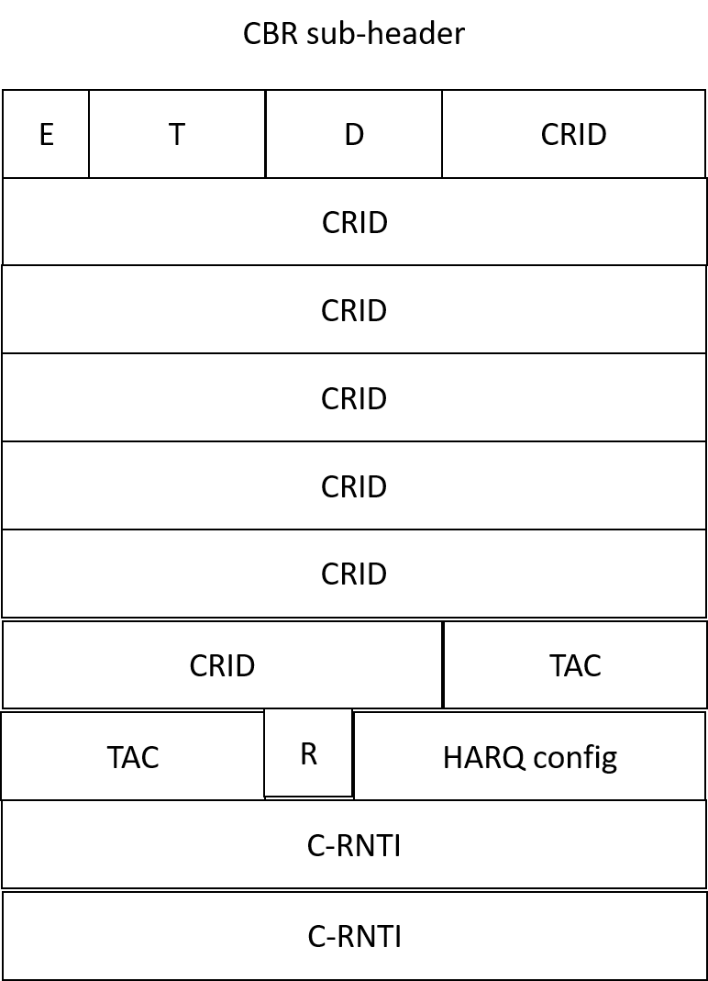

The full design of the MAC PDU would be the following:

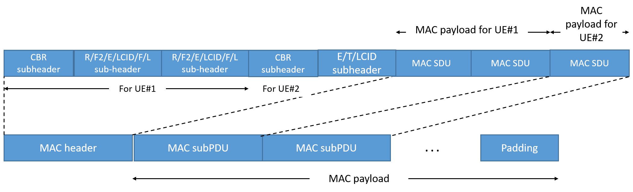

**Summary**

FFS

**Proposal 14: (MAC-13) The TAC is used in the in the CB-Msg3 response. RAN2 to discuss the length of the TAC field, 6 bits or 11 bits.**

Q14: Do companies agree the P14? Which TAC length is adopted?

Vivo/Nokia also agree 11 bits. QC think 6 bit is sufficient in NTN.

**Summary**

FFS

# 3 Conclusion

Easy

**Proposal 1: (MAC-12)** **Multiple contention resolution IDs could be included in CB-MSG4, the information related to the UE can be assembled in the MAC PDU.**

**Proposal 2: (MAC-12) The number of Msg3 replies in one Msg4 can be left to eNB implementation. Expect no SPEC impact.**

**Proposal 3: (MAC-14) The HARQ feedback resource information can be included in the CB-Msg4 together with contention resolution ID which identity the specific UE. RAN2 could revisit this proposal if RAN1 has some concern.**

**Proposal 4: (MAC-14) UE will not send HARQ ACK for CB-Msg4 if HARQ resource is not provided. No HARQ NACK is sent.**

**Proposal 5: (MAC-14) Whether to send the HARQ feedback for CB-Msg4 can be controlled by NW.**

**Proposal 6: (MAC-14) For NB-IoT, the SubCarrierSpacing of the HARQ feedback for CB-Msg4 is same as the CB-Msg3.**

**Proposal 7: (MAC-14) Reuse the existing format of HARQ ACK/NACK allocation signalling in the DCI. There is 2-bit HARQ ACK resource for eMTC and 4-bit HARQ ACK resource for NB-IoT. Reuse the meaning of DCI field in R1 SPEC. Send LS to RAN1 for information.**

Potential easy

**Proposal 8: Introduce a new MAC PDU for CB-Msg4 including new types of MAC subheader and a new type of MAC payload without introducing new types of MAC CE.**

**Proposal 10: (MAC-13) Introduce a new CB BI MAC sub-header in CB-MSg4 for backoff parameter. There is 4 bits BI for backoff indication.**

Need more discussion

**Proposal 9: (MAC-13) The MAC PDU for CB-Msg4 is consist of sub-header(s) follow by MAC payload and optional padding if needed. FFS whether contention resolution ID is put in sub-header or payload.**

**Proposal 11: (MAC-13) Introduce a new CB-Msg3 Response (CBR) MAC sub-header in CB-Msg4. It has 1bit E for subhead/payload indication, 2 bits T for subhead type, 1bit T2 for HARQ ACK resource present, 1 bit T3 for TAC present, 1 bit T4 for C-RNTI present and 2bit R for reservation.**

**Proposal 12: (MAC-13) Introduce a new CB Data MAC sub-header in CB-MSg4 for MAC SDU. It has 1 bit E for subhead/payload indication, 2 bits T for subhead type, 5 bits LCID, 7 bits or 15 bits L for MAC SDU length, 1 bit F for 15 bits L indication.**

**Proposal 13: (MAC-13) New CB-Msg3 Response (CBR) with variable length. It has 48-bit contention resolution ID, optional HARQ ACK, optional TAC, optional 16-bit C-RNTI.**

**Proposal 14: (MAC-13) The TAC is used in the in the CB-Msg3 response. RAN2 to discuss the length of the TAC field, 6 bits or 11 bits.**

# 4 Reference

[1] R2-2504526 Remaining MAC open issues in IoT NTN MediaTek Inc. discussion Rel-19 IoT_NTN_Ph3-Core

[2] R2-2503347 Discussion on uplink capacity enhancements for IoT NTN Xiaomi discussion Rel-19 IoT_NTN_Ph3-Core

[3] R2-2503355 Further Discussion on CB-msg3-EDT Mechanism vivo discussion Rel-19 IoT_NTN_Ph3-Core

[4] R2-2503461 Discussion on open issues for CB-Msg3 EDT CATT discussion

[5] R2-2503478 Further discussion on CB-Msg3 and Msg-4 enhancement NTU discussion Rel-19 Late

[6] R2-2503500 Remaining issues for CB-msg3-EDT in IoT NTN ZTE Corporation, Sanechips discussion Rel-19 IoT_NTN_Ph3-Core

[7] R2-2503529 Discussion on CB-msg3 EDT and msg4 enhancement OPPO discussion Rel-19 IoT_NTN_Ph3-Core

[8] R2-2503599 Discussion on UL Capability Enhancement for IOT NTN TCL discussion

[9] R2-2503662 Further discussion on UL capacity enhancement for IoT NTN Nokia, Nokia Shanghai Bell discussion Rel-19 IoT_NTN_Ph3-Core

[10]R2-2503675 Discussion of UL capacity in IoT NTN China Telecom discussion Rel-19 IoT_NTN_Ph3-Core

[11] R2-2503880 Discussion on UL Capacity Enhancement for IoT-NTN NEC discussion Rel-19 IoT_NTN_Ph3-Core

[12] R2-2503909 EDT for uplink capacity enhancement in NTN Lenovo discussion Rel-19

[13] R2-2503959 Remaining issues on CB-msg3-EDT Spreadtrum, UNISOC discussion Rel-19

[14] R2-2504047 Discussion on uplink capacity enhancement Transsion Holdings discussion Rel-19

[15] R2-2504065 Further consideration on UL capacity enhancement Huawei, HiSilicon, Turkcell discussion Rel-19 IoT_NTN_Ph3-Core

[16] R2-2504091 On procedures and open issues for CB-Msg3-EDT Samsung discussion Rel-19 IoT_NTN_Ph3-Core

[17] R2-2504098 Discussion on Diversity Slotted ALOHA Randomization Toyota ITC discussion Rel-19

[18] R2-2504175 Uplink capacity enhancement in IoT NTN Apple discussion Rel-19 IoT_NTN_Ph3-Core

[19] R2-2504180 CB-EDT Interdigital, Inc. discussion Rel-19 IoT_NTN_Ph3-Core

[20] R2-2504318 CB-Msg3-EDT and Msg4 multicast Qualcomm Incorporated discussion Rel-19 IoT_NTN_Ph3-Core

[21] R2-2504338 IoT-NTN uplink capacity enhancement Nordic Semiconductor ASA discussion Rel-19

[22] R2-2504393 Further discussion on uplink capacity enhancement for IoT-NTN CMCC discussion Rel-19 IoT_NTN_Ph3-Core

[23] R2-2504479 Discussion on UL capacity enhancement HONOR discussion Rel-19 IoT_NTN_Ph3-Core

[24] R2-2504528 Discussion on CB-Msg3 procedure MediaTek Inc. discussion IoT_NTN_Ph3-Core R2-2502771

[25] R2-2504645 UL capacity enhancements for IoT NTN Ericsson discussion Rel-19 IoT_NTN_Ph3-Core