3GPP TSG-RAN WG2 Meeting #111-e R2-200xxxx
Electronic Meeting, 17th – 28th August 2020

Agenda item: 5.4.3

Source: vivo

Title: Report of ‎[AT111-e][011][NR15] UE cap Additions (vivo)

Document for: Discussion and Agreement

1 Introduction
This is to report the result of the following email discussion in RAN2#111-e Meeting [1].
- [AT111-e][011][NR15] UE cap Additions (vivo)
Scope: Treat R2-2007303, R2-2007304, R2-2007305, R2-2007306, R2-2007212, R2-2007213, R2-2007084 (proponents to drive)
Part 1: Decision whether to make corrections, identify agreeable parts. Identify Controversial issues for on-line treatment (if any).
Deadline: Aug 20, 0900 UTC.
Part 2: For agreeable parts, continuation to agree CRs.
Deadline: Aug 26, 0900 UTC.

The remainder of this document is organized as the following. The discussions are in Section 2 and the conclusions are summaried in Section 3.

2 Discussion

2.1 Corrections on UE capability constraints
Companies are invited to provide their views/comments on the following CRs in the following table.

R2-2007303 Corrections on UE capability constraints vivo CR Rel-15 36.331 15.10.0 4377 - F NR_newRAT-Core
R2-2007304 Corrections on UE capability constraints vivo CR Rel-15 38.306 15.10.0 0377 - F NR_newRAT-Core
R2-2007305 Corrections on UE capability constraints vivo CR Rel-16 36.331 16.1.1 4378 - A NR_newRAT-Core
R2-2007306 Corrections on UE capability constraints vivo CR Rel-16 38.306 16.1.0 0378 - A NR_newRAT-Core

Company | Agree as is;  Agree with changes;  Disagree | Comments
Lenovo | 7303/7305: Disagree  7304/7306: Agree with changes | To 7303/7305: The need of #minCellperMeasObjectNR = 32 was already discussed in RAN2#109bis-e in the context of Google CR R2-2003684 and as part of offline discussion [059], see summary in R2-2004102. Conclusion was that there is no need to specify such a requirement. The reason is that for NR only detected cells are supported, i.e. UE will not be configured by MeasObjectNR with a list of NR cells to measure.  To 7304/7306: In NR MeasObjectEUTRA a list of E-UTRA black cells can be configured by blackCellsToAddModListEUTRAN = SEQUENCE (SIZE (1..maxCellMeasEUTRA)) OF EUTRA-BlackCell and thus, not ranges of black cells. Therefore, it’s ok to define #minBlackCellperMeasObjectEUTRA = 32 but not #minBlackCellRangesperMeasObjectEUTRA = 32 as proposed.  Furthermore, cover page issues need to be fixed: i) impact analysis is not complete, ii) in “Other specs affected” the box “N” to “Other core specs” needs to be ticked and the entry to “Other core specs” needs to be removed as it does not apply to shadow CRs.
Nokia | Agree with Lenovo’s feedback | Agree with Lenovo’s feedback

Proposed conclusion:
TBD

2.2 On support of 35MHz and 45MHz channel bandwidth
Companies are invited to provide their views/comments on the following CRs in the following table.

R2-2007212 CR on support of 35MHz and 45MHz channel bandwidth (R15) ZTE Corporation, Sanechips CR Rel-15 38.306 15.10.0 0374 - F NR_newRAT-Core
R2-2007213 CR on support of 35MHz and 45MHz channel bandwidth (R16) ZTE Corporation, Sanechips CR Rel-16 38.306 16.1.0 0375 - A NR_newRAT-Core

Company | Agree as is;  Agree with changes;  Disagree | Comments
Lenovo | Disagree | It is too early to introduce the new channel BWs, RAN2 can wait until RAN4 completed their work and sent LS to RAN2 on the signalling support acc. to the note below as stated in the WID RP-201321.  NOTE: Once RAN4 introduced the new channel bandwidth, the LS for related signalling will be sent to RAN2. So no RAN2 TU needs be requested.
Nokia | Disagree | Agree with Lenovo’s feedback

Proposed conclusion:
TBD

2.3 On CGI reporting in EN-DC and NE-DC

R2-2007084 Clarification on CGI reporting in EN-DC and NE-DC Apple discussion Rel-15 NR_newRAT-Core

This paper discusses the UE capabilities on supporting CGI reporting in case that MN and SN are configured with unaligned or aligned DRX pattern. The current specs only support the DRX alignment differentiation capabilities on MN/SN for NR-DC and EN-DC (on UTRA/GERAN/LTE), below is a summary from R2-2007084 on CGI reporting for EN-DC, NE-DC and NR-DC.

Table 1 - CGI reporting for EN-DC/NE-DC/NR-DC
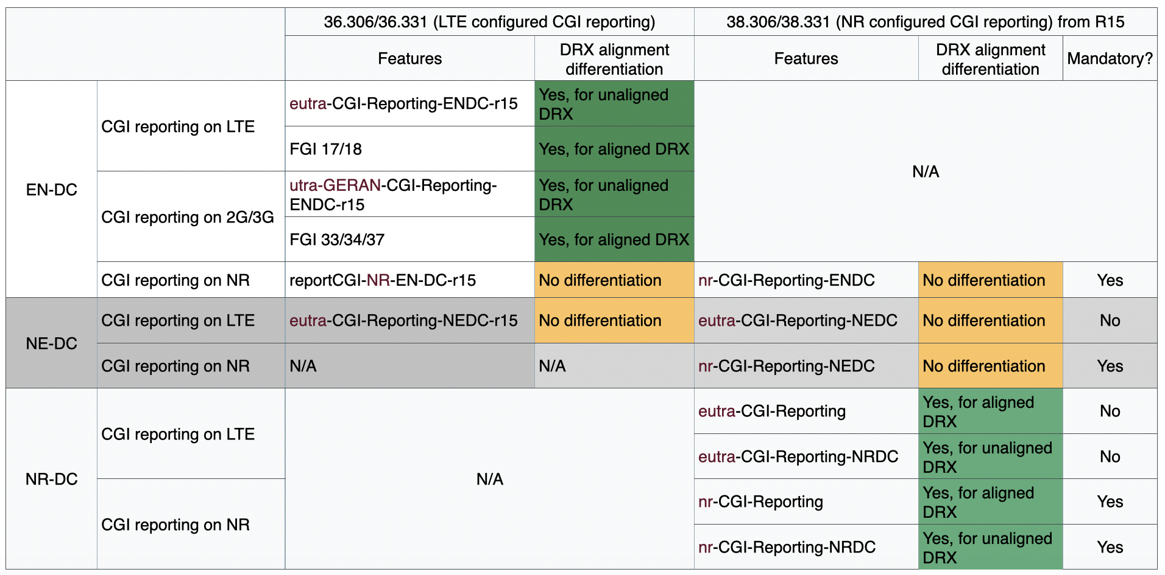
The DRX alignment differentiation capabilities can be applicable to other scenarios, but whether to enable such a flexibility for other scenarios can be further considered. Thus, companies are invited to provide their views/comments on the following questions in the following tables.

Question 1: Should the DRX alignment differentiation on MN/SN for CGI reporting on NR in EN-DC be introduced for both LTE and NR spec?

Company | Agree?  (Yes or No) | Comments
Nokia | No | Rel-15 changes are not acceptable as the use case is not really clear and what is broken in the specification. Enhancements in general are not okay for Rel-15.

Question 2: Should the DRX alignment differentiation on MN/SN for CGI reporting on LTE and NR in NE-DC be introduced for both LTE and NR spec?

Company | Agree?  (Yes or No) | Comments
Nokia | No | Same as above.

Proposed conclusion:
TBD

3 Conclusion
In the previous sections we made the following observations:
TBD

Based on the discussion in the previous sections we propose the following:
TBD

4 References
[1] R2-111e Chair Notes 2020-08-17 1000 UTC.docx

