RAN1#118 Online Session Schedule
Expo Foyer (Lv1)
0.4 Brussels (Lv0)
2.18/2.19 Mekiong/Madeira (Lv2)

 | Monday |  |  | Tuesday |  |  | Wednesday |  |  | Thursday |  |  | Friday
08:30  ~  10:30  (120 min) | RAN1#118 commences at 09:00 on Monday  Agenda items 1, 2, 3, 4, 5  Agenda items 7 |  |  | R19  LP-WUS (90)  R19 XR (30) | R19  7-24GHz (60)  AI 8.1 (60)  . MCE  . Mobility | R19 NTN (120) | R19  LP-WUS (90)  AI 8.1 (30)  . NES, Others | R19  7-24GHz (75)  R18 UE features (45)  8.2.2 MobEnh (15)  8.2.1 MCE (30) | R19 NTN (120) | AI 5 Incoming LSs (5)  R19  LP-WUS (115) | R19  7-24GHz (75)  R18 UE features (45)  8.2.2 MIMO (45) | R19 NTN (90)  AI 8.1 (30) | R19 NES (90)  TBD (30) | TBD (120) | R19 A-IoT (75)  R19 NTN (45)
Morning coffee break: 10:30 ~ 11:00
11:00  ~  13:00  (120 min) | Agenda item 7 (30)  Agenda item 8.1 (90)  . MIMO, NES, Others |  |  | R19 Duplex (120) | R19 AI/ML (120) | R19 A-IoT (120) | R19 Duplex (120) | R19 AI/ML (120) | R19 ISAC (75)  AI 8.1 (45)  . Pos | R19 XR (45)  AI 7 (45)  AI 8.1 (30) | R19 AI/ML (120) | R19 A-IoT (120) | AI 7 (30)  R19  LP-WUS (90)
Lunch break: 13:00 ~ 14:30
14:30  ~  16:30  (120 min) | R19 MIMO (120) | R18 UE features (60)  8.2.2 NES (30)  8.2.2 IoT-NTN (15)  8.2.2 MobEnh (15)  AI 8.1 (60)  . MC-Enh | R19 A-IoT (120) | R19 MIMO (90)  R19 Mobility (30) | R18 UE features (60)  8.2.2 Positioning (15)  8.2.2 NES (30)  8.2.2 IoT-NTN (15)  AI 7 (60) | AI 8.1 (120)  . MBS(30)  . Pos (90) | R19 MIMO (120) | AI 8.1 (60)  . MC-Enh  . Mobility  AI 7 (60) | R19 A-IoT (120) | R19 MIMO (90)  R19 Mobility (30) | AI 8.1 (60)  . MCE  . Mobility  AI 7 (60) | R19 A-IoT (120) | Any other issues  Session reports  RAN1#118 expected  to close at 17:00
Afternoon coffee break: 16:30 ~ 17:00
17:00  ~  19:30  (150 min) | R19 NES (120)  R19 Mobility (30) | R19 AI/ML (150) | R19 ISAC (60)  AI 8.1 (90)  . NTN(30)  . SL (60) | R19 NES (105)  AI 7 (45) | R19 AI/ML (150) | R19 A-IoT (150) | R19 NES (120)  AI 8.1 (30)  . MIMO | R19 AI/ML (150) | R19 A-IoT (150) | R19 Duplex (150) | R19 AI/ML (150) | AI 8.1 (60)  . SL  R19  ISAC (90)
All sessions end at 19:45 – no exceptions
RAN1#118 Offline Session Schedule
0.8 Rome (Lv0)
MECC Suite (Lv1)
 | Monday |  | Tuesday |  | Wednesday |  | Thursday |  | Friday
08:30  ~  10:30  (120 min) |  |  | R18/R19 Mobility (60)  R19 MIMO (60) | R19 AI/ML (120) | R19 Duplex (90)  R19 MIMO (30) | R19 AI/ML (120) | R19 A-IoT (120) | R19 AI/ML (120) | R19 LP-WUS (120)
Morning coffee break: 10:30 ~ 11:00
11:00  ~  13:00  (120 min) |  |  | R19 NES (120) | R19 ISAC (120) | R19 MIMO (45)  R19 NES (75) | R19 A-IoT (120) | R19 MIMO (120) | R19 Duplex (120) | Younsun (120)
Lunch break: 13:00 ~ 14:30
14:30  ~  16:30  (120 min) | R19 Duplex (120) | R19 7-24GHz (60)  R19 AI/ML (60) | R19 A-IoT (120) | R19 AI/ML (120) | R19 ISAC (60)  R19 NTN (60) | R19 AI/ML (120) | R19 Duplex (45)  R19 NES (75) | R19 AI/ML (120) | To be assigned by Xiaodong  To be assigned by David
Afternoon coffee break: 16:30 ~ 17:00
17:00  ~  19:30  (150 min) | R19 MIMO (60)  R19 LP-WUS (90) | A-IoT (90)  NTN (60) | R19 XR (30)  R19 Mobility (30)  R19 LP-WUS (90) | R19 7-24GHz (75)  R19 NTN (75) | R19 LP-WUS (150) | R19 7-24GHz (75)  R19 XR (35)  R19 Mobility (40) | R19 NES (90)  R19 NTN (60) | R19 A-IoT (150)
All sessions end at 19:45 – no exceptions
RAN1#118 Detailed Schedule for RAN1 Main Session

 | Monday | Tuesday | Wednesday | Thursday | Friday
08:30  ~  10:30  (120 min) | Agenda items 1, 2, 3, 4, 5  Agenda items 7 | R19 LP-WUS (90)  . 9.6.3  . 9.6.1  . 9.6.2  R19 XR (30) | R19 LP-WUS (90)  . 9.6.1  . 9.6.2  AI 8.1 (30)  . NES, Others | R19 LP-WUS (120)  . 9.6.1  . 9.6.2  . 9.6.3
Morning coffee break: 10:30 ~ 11:00
11:00  ~  13:00  (120 min) | Agenda item 7 (30)  Agenda item 8.1 (90)  . MIMO, NES, Others | R19 Duplex (120)  . 9.3.1  . 9.3.2  . 9.3.3 | R19 Duplex (120)  . 9.3.1  . 9.3.2  . 9.3.3 | R19 XR (45)  AI 7 (45)  AI 8.1 (30)
Lunch break: 13:00 ~ 14:30
14:30  ~  16:30  (120 min) | R19 MIMO (120)  . 9.2.1  . 9.2.2  . 9.2.3  . 9.2.4 | R19 MIMO (90)  . 9.2.1  . 9.2.2  R19 Mobility (30) | R19 MIMO (120)  . 9.2.3  . 9.2.4  . 9.2.2  . 9.2.1 | R19 MIMO (90)  R19 Mobility (30)
Afternoon coffee break: 16:30 ~ 17:00
17:00  ~  19:30  (150 min) | R19 NES (120)  . 9.5.1  . 9.5.2  . 9.5.3  R19 Mobility (30) | R19 NES (105)  . 9.5.1  . 9.5.2  . 9.5.3  AI 7 (45) | R19 NES (120)  . 9.5.1  . 9.5.2  . 9.5.3  AI 8.1 (30)  . MIMO | R19 Duplex (150)
All sessions end at 19:45 – no exceptions
Level 0: RAN1 Breakout#1, Offline#1

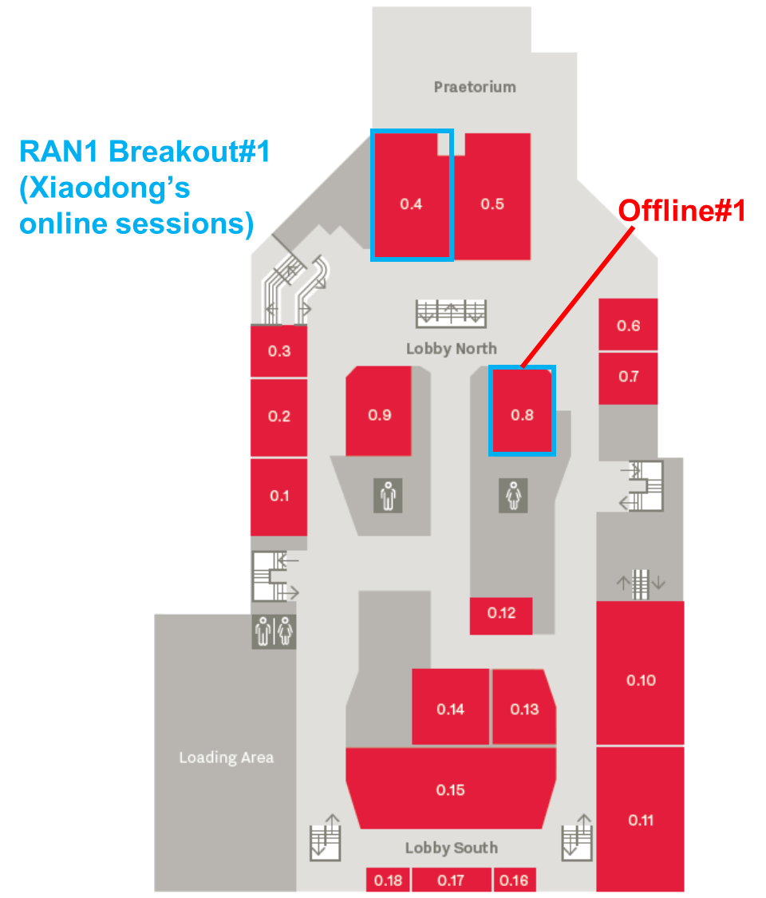

Level 1: RAN1 Main Session, Offline#2
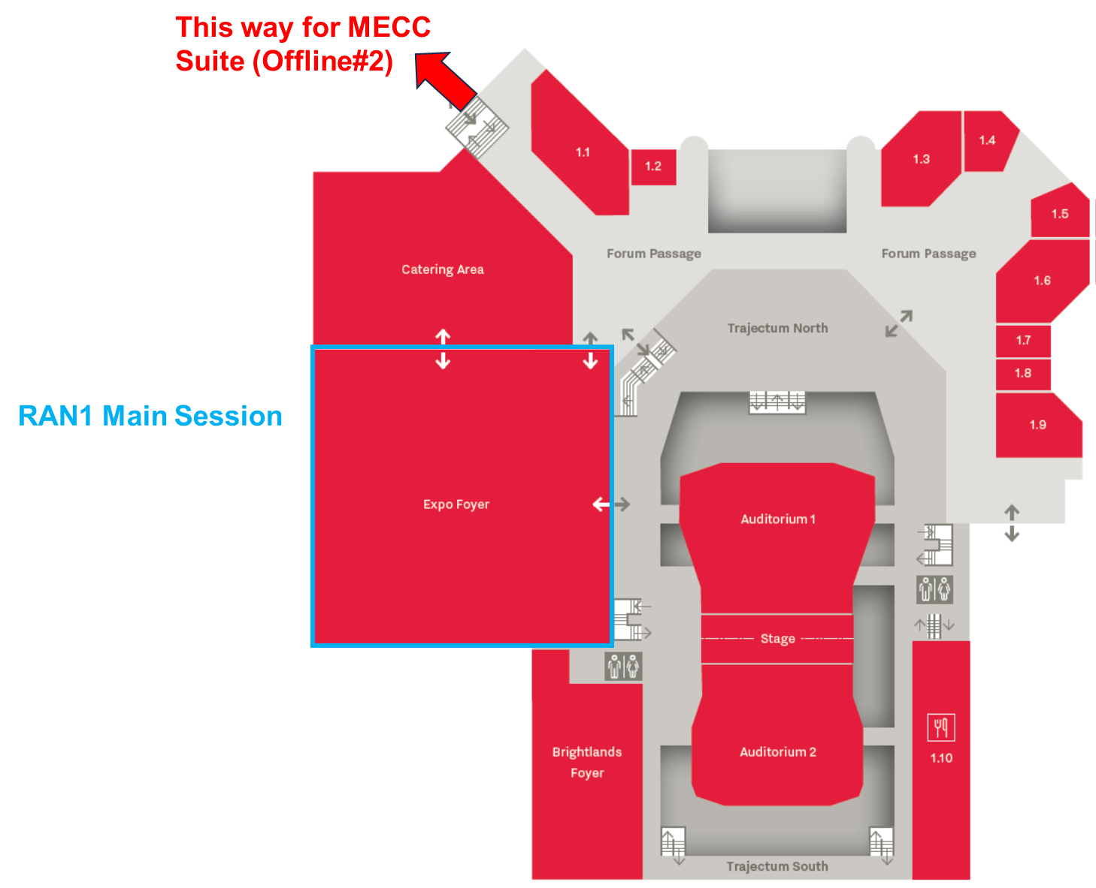
Level 2: RAN1 Breakout#2

