3GPP TSG RAN WG1 Meeting #106-e R1-210xxxx
e-Meeting, October 11th – 19th, 2021

Agenda Item: 8.13.2
Source: Moderator (Huawei)
Title: Summary of email discussion [106bis-e-R17-RRC-NR-DC] on efficient SCell activation/de-activation mechanism of NR CA
Document for: Discussion and Decision

Introduction
This summary is about the email discussion of RRC parameters for SCell activation enhancement.
[106bis-e-R17-RRC-NR-DC] Email discussion on Rel-17 RRC parameters for LTE_NR_DC_enh2 – Frank (Huawei)
- 1st check point: October 14
- Final check point: October 19

Schedule
For the two check points, companies are encouraged to provide your comment before the following time
- For 1st check point: October 13 UTC 13:59
- For Final check point: October 18 UTC 13:59

A draft list of RRC parameters can be found in file v004 in the draft folder under 8.13.2, which has only editorial changes compared to the v003 in [1]. Since there are two alternatives under discussion for MAC-CE to trigger temporary RS(s), the common RRC parameters are mainly targeted, as well as the key FFS/TBD points that have been identified last meeting. This discussion is very helpful for the down-selection between two alternatives but the down-selection can be discussed in the parallel main email thread for AI 8.13.2 since MAC-CE signaling is involved.
To facilitate the discussion, for those parameters specific to any alternative, they are also listed to provide a big picture for the discussion but their names are still kept in brackets since no agreement about which alternative to go yet. Additionally, the existing RRC parameters/structure that are reused by new RRC parameters are also listed with green mark.
For the first two check points, the major columns #C, G, H, J, K, P are prioritized because they mainly shape the structure of RRC parameters. With stable major columns, columns #L, M, N are much easier to be discussed.
For column #E, current values are to facilitate the discussion only, they will be removed to column #P in the end according to the Recommendations for RAN1 RRC Parameter Preparation (R1-2110415).
For your convenience, two diagrams for Alt.1 and Alt.2 are also provided below, respectively, to better understand the relationships between RRC parameters listed in the excel file.
Alt.1: For example, received MAC-CE value per cell => the corresponding entry number in a per-cell list => the entry number refers to a configuration of temporary RS per cell
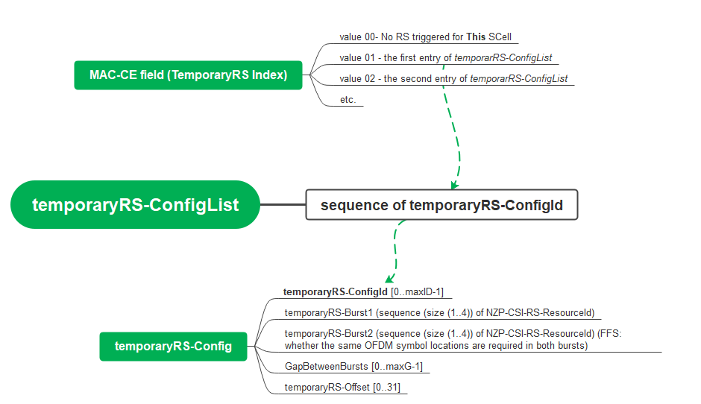

Alt.2: For example, received MAC-CE value for all cells => the corresponding trigger state number in a list => the state number refers to a list of “Configinfo” where each “Configinfo” for one cell => an entry number provided in each “Configinfo” => the entry number refers to a configuration of temporary RS for a cell
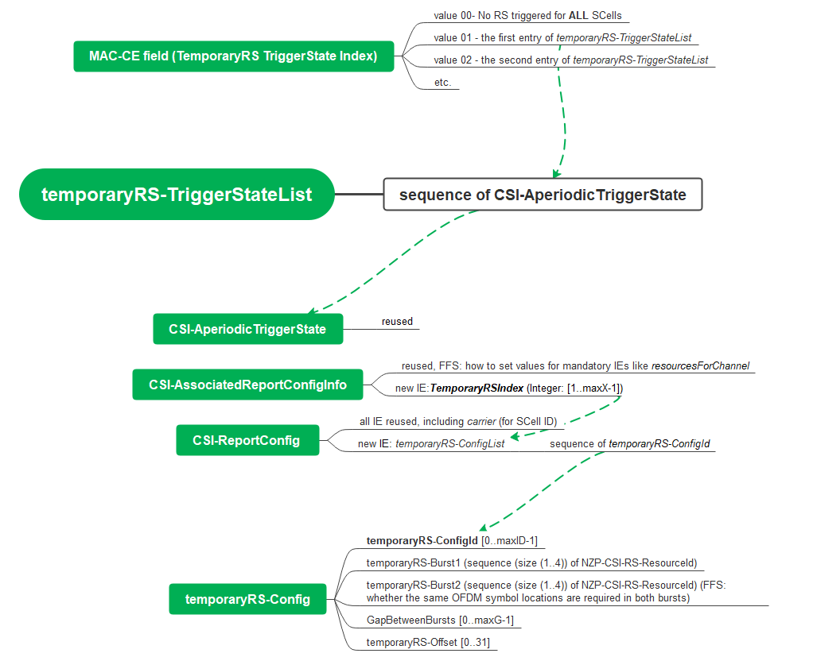

If any suggestions on the schedule, they are welcome here.
Company | View

Discussions

Common RRC parameters
In this section, rows #2 - #13 are discussed.

Major columns #C, G, H, J, K, P

Question: For these columns, any suggested change to rows #2 to #13?
The discussion is based on file v004.
Your comments are welcome! To better incorporate your suggested change into the excel file, it is appreciated if your comments could be provided in the following suggested form. Since the suggested change may be provided in a form of table. Let’s stack companies’ comments in a similar way to email reply. For example,
[The previous comments from other companies]
======= (breaking line)
[Your company name (in bold)]
//comment#1
[Concerned Parameter name: row#]
[Your detailed comments]
[Proposed changes to the row with track in color], e.g.

LTE_NR_DC_enh2-Core |  | 38.214 |  |  |  | Foobar Hydro | New |  | List of foobar Hydro configurations. | SEQUENCE (SIZE (1..maxX)) OF RS-ConfigId, maxX is TBD |  | per cell | UE-specific

//comment#2
[Concerned Parameter name: row#]
[Your detailed comments]
[Proposed change with track in color], e.g.
…
Etc.
======= (breaking line)
[The other company name]

Sub-question 1-1: regarding the FFS in row#6 column#J for RS resource indication, whether the OFDM symbol locations should be restricted to the same for both bursts?
LTE_NR_DC_enh2-Core |  | 38.214 |  | temporaryRS-Config |  | gapBetweenTemporaryRSbursts | New |  | The gap length between two temporary RS bursts, if temporaryRSBurst2-Resources (two temporary RS bursts) is indicated. If this field is present, the second burst is transmitted at the given offset/gap and shares the same signal structure in frequency domain [FFS: and time domain (i.e. OFDM symbol locations)] as applied to the first burst. If this field is not present, there is only one temporary RS burst. | TBD (unit of slot or symbol) | FFS | per cell | UE-specific | 38.331 | Common for both Alt.1 and Alt. 2a

The discussion is based on file v004.
Your comments are welcome! To better incorporate your suggested change into the excel file, it is appreciated if your comments could be provided in the following suggested form. Since the suggested change may be provided in a form of table. Let’s stack companies’ comments in a similar way to email reply.
======= (breaking line)
[Your company name (in bold)]
//comment#1
[Concerned Parameter name: row#]
[Your detailed comments]
[Proposed changes to the row with track in color], e.g.
//comment#2
[Concerned Parameter name: row#]
[Your detailed comments]
[Proposed change with track in color], e.g.
…
Etc.
======= (breaking line)

Sub-question 1-2: regarding the FFS in row#7 column#K, whether the maximum value maxG should be 31, the same as the max offset of A-TRS?
LTE_NR_DC_enh2-Core |  | 38.214 |  | temporaryRS-Config |  | temporaryRS-TriggeringSlotOffset | New |  | Offset X between the reference slot for triggering offset of temporary RS and the slot in which the temporary RS burtst(s) is transmitted. | [0..maxG-1]; TBD maxG, (unit of slot) | FFS | per cell | UE-specific | 38.331 | Common for both Alt.1 and Alt. 2a

The discussion is based on file v004.
Your comments are welcome! To better incorporate your suggested change into the excel file, it is appreciated if your comments could be provided in the following suggested form. Since the suggested change may be provided in a form of table. Let’s stack companies’ comments in a similar way to email reply.
======= (breaking line)
[Your company name (in bold)]
//comment#1
[Concerned Parameter name: row#]
[Your detailed comments]
[Proposed changes to the row with track in color], e.g.
//comment#2
[Concerned Parameter name: row#]
[Your detailed comments]
[Proposed change with track in color], e.g.
…
Etc.
======= (breaking line)

Columns #L, M, N
Question: For these columns, any suggested change to rows #2 to #13?
The discussion is based on file v004.
Your comments are welcome! Please take the same form for your comments as suggested in section 3.1.1.

======= (breaking line)
[Your company name (in bold)]
//comment#1
[Concerned Parameter name: row#]
[Your detailed comments]
[Proposed changes to the row with track in color], e.g.

RRC parameters specific to Alt.1
Question: Any suggested change specific to Alt.1? Any new row needed?
The discussion is based on file v004.
======= (breaking line)
[Your company name (in bold)]
//comment#1
[Concerned Parameter name: row#]
[Your detailed comments]
[Proposed changes to the row with track in color]

RRC parameters specific to Alt. 2
In this section, rows #14 - #18, starting from parameter temporaryRS-TriggerStateList, are discussed

Major columns #C, G, H, J, K, P

Question: Any suggested change specific to Alt.2? Any new row needed?
The discussion is based on file v004.
Your comments are welcome! Please take the same form for your comments as suggested in section 3.1.1.
======= (breaking line)
[Your company name (in bold)]
//comment#1
[Concerned Parameter name: row#]
[Your detailed comments]
[Proposed changes to the row with track in color]

Sub-question 3-1: regarding the FFS in row#17.20 column#P for Alt 2, how to set values for mandatory IEs like resourcesForChannel and its relationship with triggered temporary RSs?
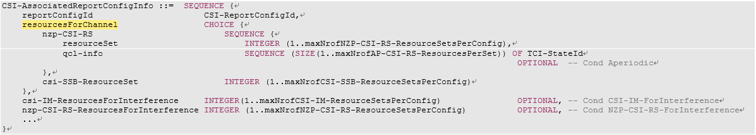

The discussion is based on file v004.
Your comments are welcome! Please take the same form for your comments as suggested in section 3.1.1.
======= (breaking line)
[Your company name (in bold)]
//comment#1
[Concerned Parameter name: row#]
[Your detailed comments]
[Proposed changes to the row with track in color]

Other Issues
Issues or comments that cannot fit in any of the previous sections of this document can be provided in this section.
Company | View

Conclusions

References
- R1-2108674 Summary of email discussion [Post-106-e-Rel17-RRC-14] on efficient SCell activation/de-activation mechanism of NR CA, Moderator (Huawei)

Appendix: Agreements

Agreements:
As working assumption, with respect to efficient SCell activation, reuse existing Rel-15/16 TRS structure for temporary RS
- FFS: how many burst/symbols are required for both AGC settling and Time/Frequency tracking for different cases, e.g. FR1 and FR2, known and unknown SCell
  - A burst of temporary RS is notated as in S5.1.6.1.1 of TS 38.214
    - “2-slot with four CSI-RSs resources (4 samples)” for FR1
    - either “1-slot with two CSI-RSs resources (2 samples)” or “2-slot with four CSI-RSs resources (4 samples)” for FR2
- The working assumption can be confirmed after RAN4 check. (A LS for such request is planned).

Agreements:
For efficient SCell activation, discuss and agree from the following alternatives at RAN1#104-e
- Alt 1: the trigger of temporary RS is integrated into a single triggering signaling with the trigger of SCell activation transmitted on an activated cell.
  - FFS detailed design of this integrated triggering signaling.
  - Potential examples of single triggering signaling for further discussions
  - A PDSCH TB, e.g. containing two respective MAC-CEs for both triggers, one MAC-CE for both triggers
  - A DCI for both triggers
  - A PDSCH TB and its scheduling DL grant, e.g. MAC-CE for activation and DL grant for temporary RS
  - A DL grant and a UL grant received in the same slot/OFDM symbols of PDCCH where the DL grant is scheduling a MAC-CE for SCell activation and the UL grant is triggering the RS.
  - Rel-15/16 SCell activation MAC-CE and a specific configuration of temporary RS being implicitly triggered as well
- Alt2: Triggering of temporary RS separately from SCell activation command is not precluded and both ‘separate’ triggers (examples below) and ‘integrated’ triggers (examples in Alt 1) are considered for SCell activation
  - FFS detailed design of separate triggering signaling.
  - Potential examples of separate triggering signaling for further discussions
  - Rel-15/16 SCell activation MAC-CE and Rel 15/16 DCI triggering
  - Rel-15/16 SCell activation MAC-CE and new DCI triggering for temporary RS
- Note: temporary RS should be triggered by DCI or MAC-CE.
- Note: the final mechanism of trigger signaling targets at applicability to one or more SCell activation.
- FFS handling of SCell activation by existing Rel15/16 CA activation command when temporary RS is configured and triggered/not triggered

Working Assumption
At least for the case of known cell, temporary RS is supported to expedite the activation process during the SCell activation procedure for efficient SCell activation for both FR1 and FR2:
- The temporary RS should provide at least the functionalities of AGC settling and time/frequency tracking during SCell activation procedure.
- FFS potential functionalities of CSI measurement/acquisition and cell search

Agreements:
TRS is selected as temporary RS for Scell activation
• If more functionalities are confirmed to be supported by temporary RS, other RS candidates, e.g. aperiodic CSI-RS, P/SP-CSI RS, SRS and RS based on SSS/PSS, are not precluded.
• The TRS should be triggered by DCI or MAC-CE. FFS which exact triggering command.

Agreements:
UEs measure the triggered temporary RS during Scell activation procedure no earlier than a slot m:
• FFS timeline values m which may need coordination with RAN4.
• FFS if the triggered temporary RS can be associated with a BWP, then the measurement above is independent of the activation state of the BWP.

Agreements:
Companies are encouraged to provide design details of temporary RS next meeting, at least including:
- TRS structure, e.g. whether to fully reuse existing Rel-15/16 TRS structure and configuration restriction (refer to S5.1.6.1.1 of TS 38.214), or any modification
- QCL information, if any
- Triggering command: DCI format/fields or MAC-CE fields
- Triggering timeline/scheduling offset

Working Assumption
For efficient SCell activation with assistance of temporary RS, a SSB of the to-be-activated SCell can be indicated as a QCL source for the temporary RS in case of known SCell
- FFS: QCL type
- FFS: the case of unknown SCell
- FFS: other QCL source, e.g. the SSB/P-TRS of another active cell
Agreement
For efficient activation of SCells, down select at least one option from below:
- Option 1a: MAC CE(s) contained in a single PDSCH to trigger both SCell activation and corresponding temporary RS(s)
  - Details FFS including timeline design for receiving temporary RS
- Option 1b: A single DCI to trigger both SCell activation and corresponding temporary RS(s)
  - Details FFS including potential impact on SCell activation related procedures and, e.g. timeline design for SCell activation and for receiving temporary RS
  - FFS: The same DCI for SCell deactivation
- Option 2: A Rel-15/16 SCell activation MAC-CE to trigger SCell activation and a Rel-15/16 DCI to trigger corresponding temporary RS(s) with enhancement of timeline
  - Details FFS including timeline design for receiving a DCI trigger of temporary RS, and for receiving temporary RS
- Note: Companies are encouraged to provide complete solutions for fast SCell activation.
- Note: the previous agreement on the definitions of Alt 1 and Alt 2 is still effective

Agreement
For efficient activation of SCells
- Option 1a: MAC CE(s) contained in a single PDSCH to trigger both SCell activation and corresponding temporary RS(s)
  - Details FFS including timeline design for receiving temporary RS
Note: Separate from the support of Option 1a, it is up to RAN4 whether or not to consider an activation time enhancement for Option 2 without requiring further RAN1 work
- Option 2: A Rel-15/16 SCell activation MAC-CE to trigger SCell activation and a Rel-15/16 DCI to trigger corresponding Rel-15/16 A-TRS(s)
Send an LS to RAN4. The LS is endorsed in R1-2104110.
Agreement
For efficient activation of Scells, the triggered temporary RS is aperiodic.
Agreement
For efficient activation of a Scell (in known Scell case), at least the number of temporary RS bursts is indicated by a field in new MAC-CE
- The number of temporary RS bursts is RRC configurable.
- FFS: which field in MAC-CE is used and how this field is associated with the number of bursts
- For the purpose of designing temporary RS Scell activation, there is no RAN1 specification impact for the case where the number of indicated temporary RS bursts is smaller than what is expected by the UE
Agreement
To trigger temporary RS for efficient activation of SCells, the contents of the triggering MAC-CE(s) in a single PDSCH provide at least the following information (explicitly or implicitly):
- Whether or not temporary RS is triggered
- FFS detailed Information of temporary RS, e.g.:
  - Resources used for triggered Temporary RS
  - Triggering time offset of triggered Temporary RS
  - QCL source for triggered Temporary RS
- FFS: Detailed signalling structure of the triggering MAC-CE(s) including the down-selection between the following example options and whether the decision should be made in RAN1 or RAN2
  - Opt. 1.1: One new MAC CE for both SCell activation triggering and corresponding temporary RS triggering
  - Opt. 1.2: One R15/16 SCell activation MAC CE for SCell activation triggering and one new MAC CE (in the same PDSCH) for corresponding temporary RS triggering
Agreement
For efficient activation of a Scell (in known Scell case), the triggering offset of temporary RS is indicated by a field in new MAC-CE
- The candidate value(s) of triggering offset(s) is RRC configurable
- FFS: which field in MAC-CE is used and how this field is associated with the value of triggering offset
Agreement
For the reference slot for triggering offset of temporary RS
- Option 2: the last DL slot of the to-be-activated Scell overlapping with slot n+k as defined in 38.213 sub-clause 4.3
- FFS: the earliest slot no earlier than the reference slot for a UE to receive a triggered temporary RS
Agreement
If a UE measures a temporary RS triggered by a MAC-CE during SCell activation procedure, the measurement is performed within the BWP bandwidth of BWP indicated by firstActiveDownlinkBWP-Id

Agreement
For efficient SCell activation, the earliest slot for a UE to receive a triggered temporary RS is the reference slot (i.e., the last DL slot of the to-be-activated Scell overlapping with slot n+k as defined in 38.213 sub-clause 4.3).

Conclusion
For the purpose of designing temporary RS for Scell activation, RAN1 will not discuss for the case where a gNB may assume the to-be-activated SCell with assistance of temporary RS is a known SCell for a UE but it is actually unknown SCell from the UE side during the SCell activation duration.

Agreement
For to-be-activated SCell, if any BWP ID is configured as part of temporary RS(s) configuration, the value of the BWP ID is expected to be equal to firstActiveDownlinkBWP-Id;

Agreement
For efficient SCell activation, the earliest slot for a UE to receive a triggered temporary RS is the reference slot (i.e., the last DL slot of the to-be-activated Scell overlapping with slot n+k as defined in 38.213 sub-clause 4.3).

Conclusion
For the purpose of designing temporary RS for Scell activation, RAN1 will not discuss for the case where a gNB may assume the to-be-activated SCell with assistance of temporary RS is a known SCell for a UE but it is actually unknown SCell from the UE side during the SCell activation duration.

Agreement
For to-be-activated SCell, if any BWP ID is configured as part of temporary RS(s) configuration, the value of the BWP ID is expected to be equal to firstActiveDownlinkBWP-Id;

Agreement
To trigger temporary RS,
- MAC-CE at least provides the following information:
  - temporary RSs are to be triggered on X out of Y (Y≥X) to-be-activated SCells, respectively, while no temporary RS is to be triggered on the other to-be-activated SCells.
- The following information can be provided by RRC for temporary RS for each SCell
  - The number of RS bursts and the gap length between the RS bursts (Opt 2.3.3)
  - Triggering offset of temporary RS (Opt 2.3.4)
    - Triggering offset can be provided, e.g., by reusing existing CSI-RS framework
  - QCL information (Opt 2.3.5)
    - Triggering QCL information can be provided, e.g., by reusing existing CSI-RS framework
  - A unique temporary RS configuration index
  - FFS: the maximum number of temporary RS per cell/per UE
Note: Reusing A-TRS triggering framework is not precluded.
- Information for 0, 1, or more temporary RS can be provided for each configured SCell

Agreement
- For triggering temporary RS, down-select based on the following alternatives, or let RAN2 be aware the status of this discussion
  - Alt 1: Bitmap approach in MAC-CE similar to SCell activation
    - Every Z-bit block in the bitmap corresponds to a SCell, Z>=0
    - A Z-bit block indicates the temporary RS [configuration index], and a value zero indicated by the bit block means no RS resource transmitted.
    - The to-be-activated SCell is indicated via the C values in the legacy SCell activation/de-activation MAC CE or in the new MAC-CE
  - Alt 2: Reuse A-TRS triggering framework
    - A trigger state is indicated by the MAC-CE explicitly
    - The association between a trigger state and aperiodic temporary RS for one or multiple SCells is configured by RRC according Rel-16 A-TRS triggering framework
      - SCell ID is configured as a part of the temporary RS configuration. Some SCell IDs derived from the trigger state triggered by the new MAC-CE may not refer to to-be-activated SCells that are indicated by the new MAC-CE or the legacy SCell activation/de-activation MAC-CE
    - FFS: The value zero of the MAC-CE indication means no temporary RS is triggered by the MAC-CE for all to-be-activated SCells
  - Note: The down-selection targets at a RAN1 consensus on MAC-CE functionality and the list of RRC parameters for this feature. Any MAC-CE signaling design above are reference concept, its final MAC-CE signaling design is up to RAN2.

