3GPP TSG RAN WG1 #105-e R1-21xxxxx

e-Meeting, May 10th – 27th, 2021

Source: Moderator (Qualcomm)

Title: [104b-e-NR-XR-03] Email discussion/approval on initial performance evaluation results

Agenda Item: 8.14.3

Document for: Discussion and Decision

# Introduction

GTW2 on 5/19 discussed the next FL proposal that was made based on the observations from initial evaluation results [1-14] summarized in Section 2 and 3.

|  |
| --- |
| **FL proposal (presented in GTW2 on 5/19):** Based on the above observation, FL proposes the following.   * For capacity and power evaluations, RAN1#106-e will start to collect formal results from companies that are to be captured in the TR, and are to be used to draw formal observations/conclusions to be captured in the TR. * When companies submit results for advanced features/enhancements, they also submit results for baseline feature so as to facilitate the performance comparison between baseline and advanced feature/enhancements, e.g., delay aware scheduler, HARQ/CG enhancement, power saving schemes, etc. * RAN#105-e focuses on discussion for clarification/calibration of results from companies and clarification of definition/intention of columns of the data collection format (excel sheet) that will help have more stable/converged results from RAN1#106-e.  This discussion is to be done via email threads [104b-e-NR-XR-02] and [104b-e-NR-XR-03]. To this end, I am going to present a summary of initial evaluation results from companies in the kick-off email for AI 3, where companies are encouraged to ask about other companies' results, clarification on data collection excel sheet. Again, the main goal is to do calibration of results among companies. |

Accordingly, FL is proposing to have “free” discussion directly in the email thread, [104b-e-NR-XR-03], where companies are invited to make any questions, clarifications, suggestions, responses, to the group or a certain company regarding initial evaluation results. FL will present a summary of the discussion, based on which possibly make proposals.

# Observations from Initial Evaluation Results

**Key observations from initial evaluation results from companies**

* Limited number of companies have submitted results, especially for UL AR capacity, FR2 capacity, and UE power consumption. This may be mainly due to limited time for simulations since traffic models and evaluation methodology had been agreed in April RAN1#104bis-e.
  + Capacity evaluation
    - For FR1
      * 4-6 companies have submitted results for DL and UL VR/CG.
      * Limited results for UL AR.
    - For FR2
      * 2-5 companies have submitted results for DL and 2-3 for UL.
  + Power evaluation
    - Limited number of companies have submitted results.
* It seems that companies have different understanding on some columns of data collection format (excel sheets), in particular for power evaluation. It is critical to have common understanding on the format because the results in the format are to be used for comparison/calibration of results among companies and draw formal observations that are to be captured in the TR.
* Some companies have submitted results only for a certain advanced feature. For instance, a company’s capacity results are based on a delay aware scheduling algorithm, while PF scheduler is the baseline assumption agreed by RAN1. In this case, it is difficult to draw an observation on how much the performance can be improved by the advanced feature. So, it is recommended that when companies submit results of advanced features, they also submit results for the baseline feature so as to facilitate the performance comparison between baseline and advanced feature.

# Initial Evaluation Results

## Capacity Results: FR1

**DU, VR, 30Mbps, 10ms PDB**

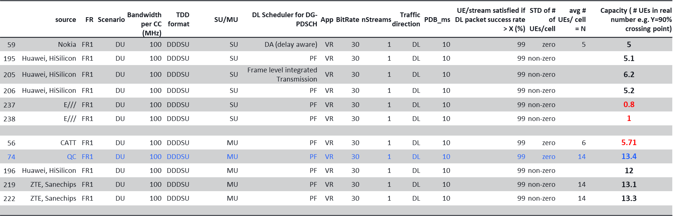

Observation: SU: 5-6 (E/// outlier); MU: 12-13 (CATT outlier)

**DU, VR, 30Mbps, 10ms PDB**

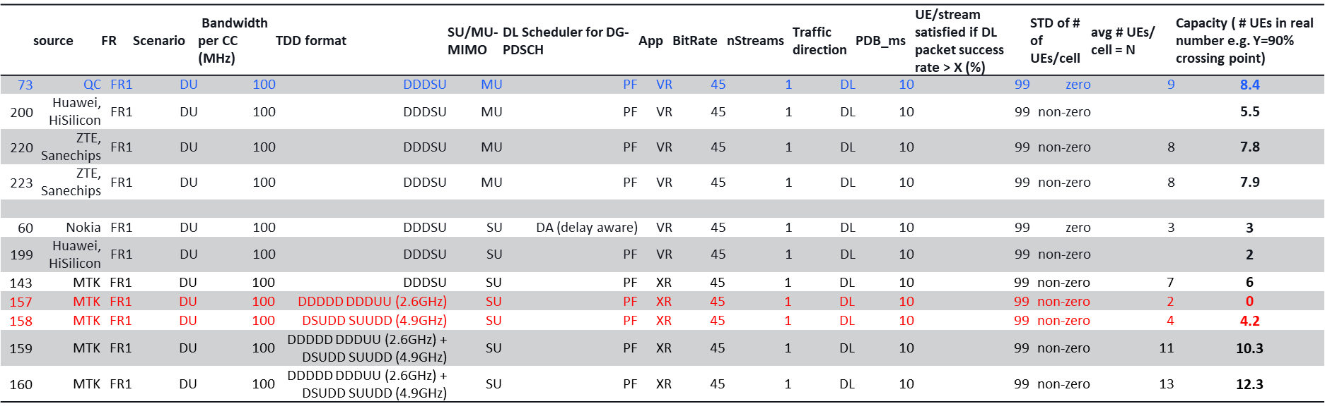

Observation: SU: 2-6, MU: 5.5 – 8.4

**DU, CG, 30Mbps, 15ms PDB**

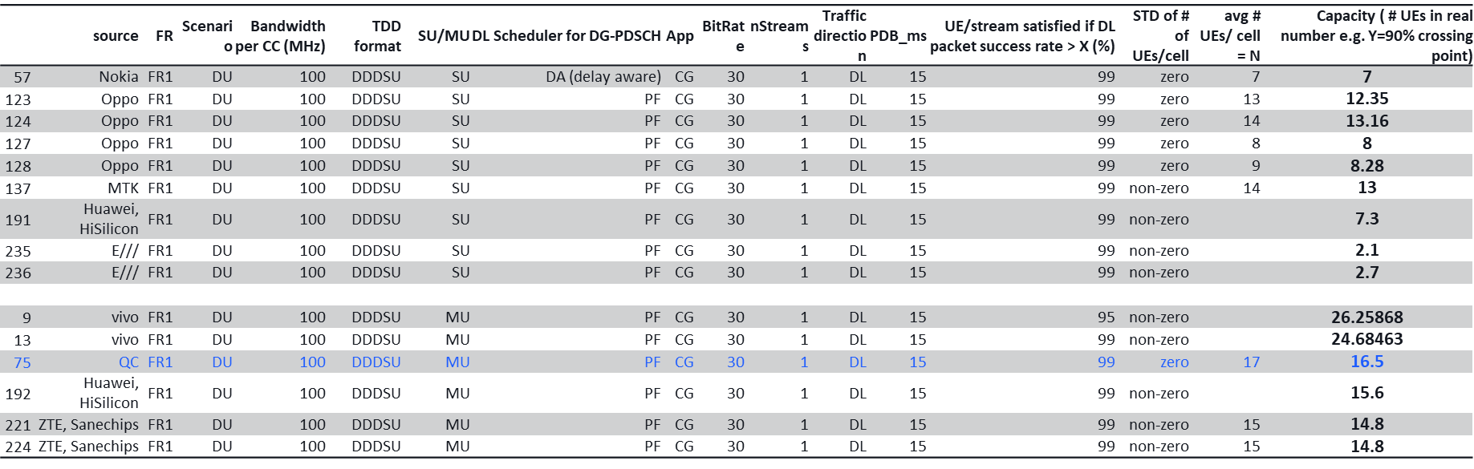

Observation: SU: 7 – 13 (E/// outlier); MU: 14 – 26

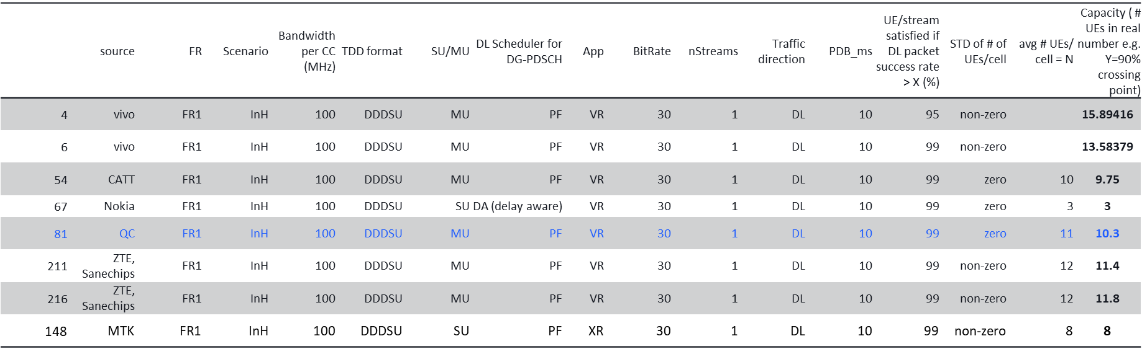**InH, VR, 30Mbps, 10ms PDB**

Observation: MU 9.75-15.89

**InH, VR, 45Mbps, 10ms PDB**

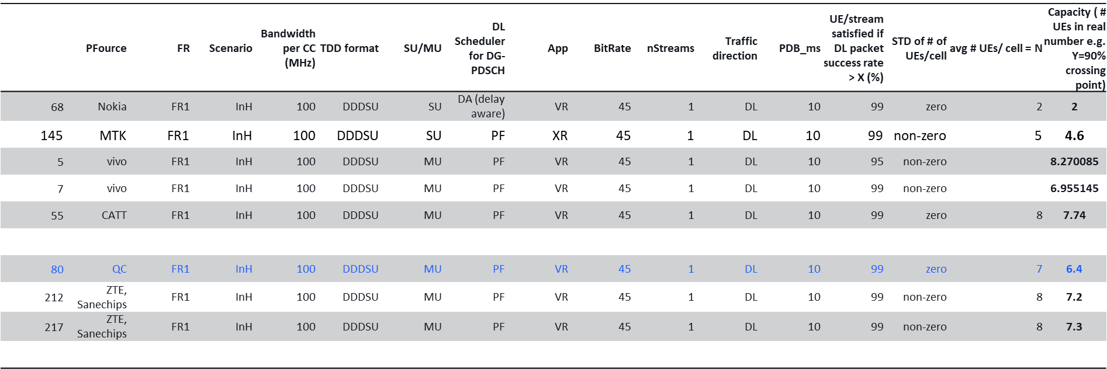

Observation: 6.54 – 8.2

**InH, CG, 30Mbps, 15ms PDB**

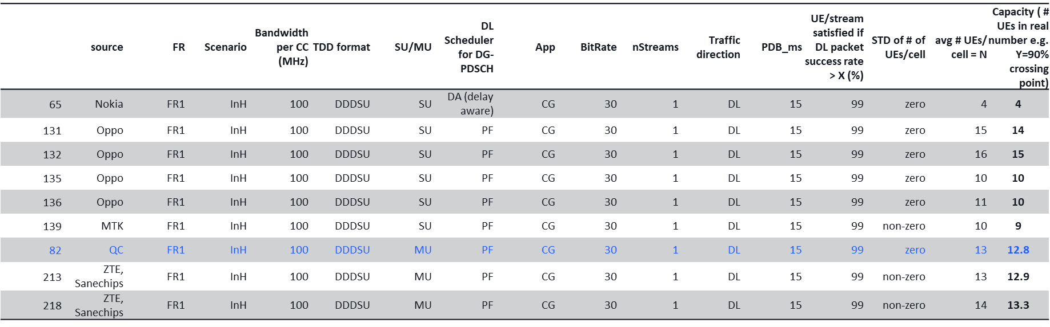

Observation: SU: 4 - 15, MU:12.8 - 13.3

**Urban Macro, VR, 30Mbps, 10ms PDB**

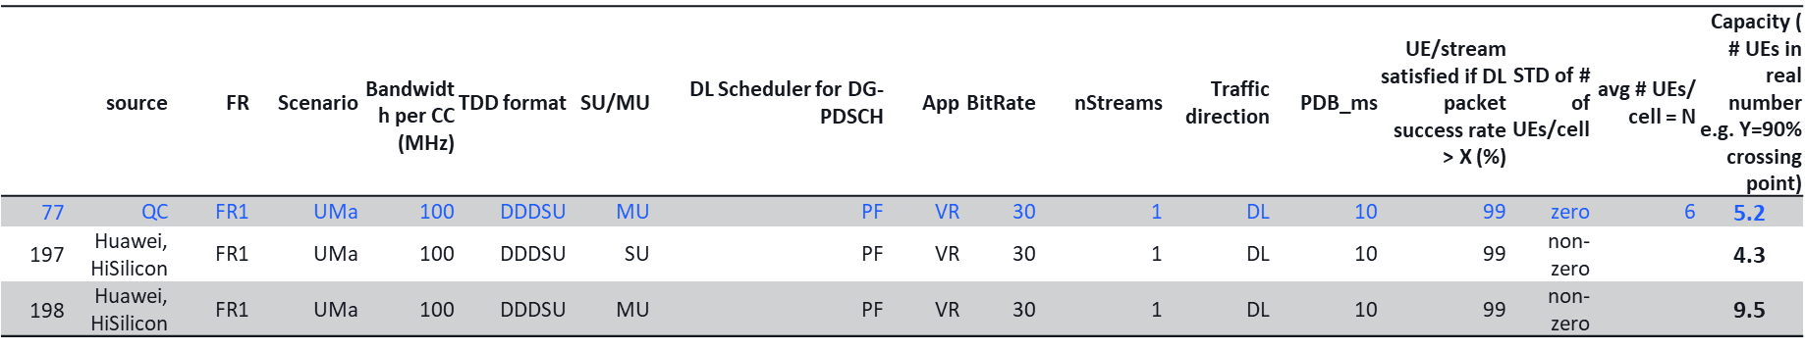

Observation: SU: 4.3, MU:5.2-9.5

**Urban Macro, VR, 45Mbps, 10ms PDB**

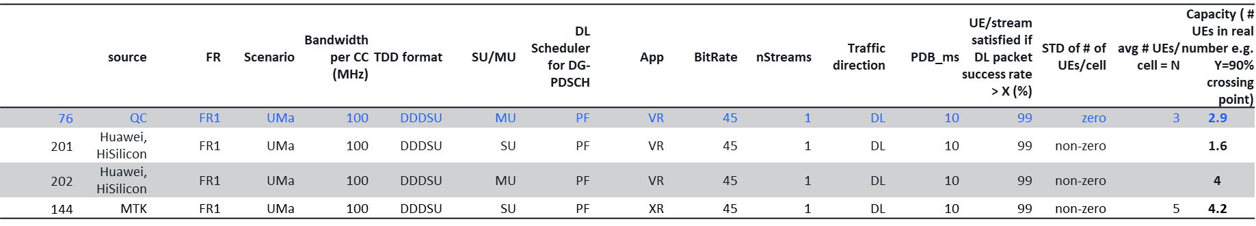

Observation: SU: 1.6-4.2, MU: 2.9-4

**Urban Macro, CG, 30Mbps, 15ms PDB**

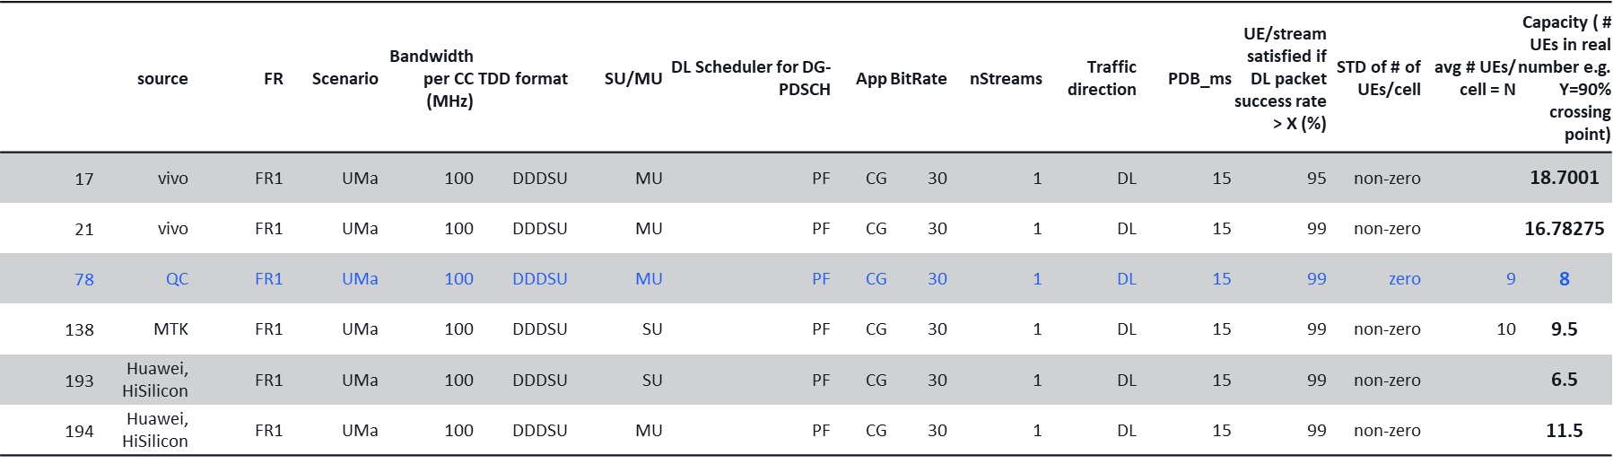

Observation: SU: 6.5-9.5, MU: 8-18.7

## Capacity Results: FR2

**DL, InH, 45Mbps, 10ms PDB**

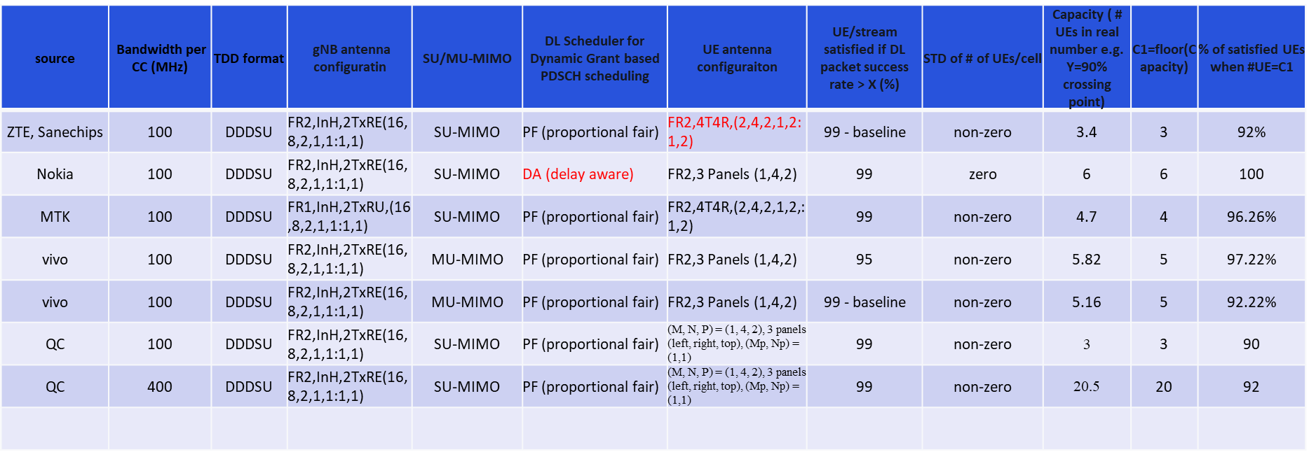

DU_45Mbps_10ms

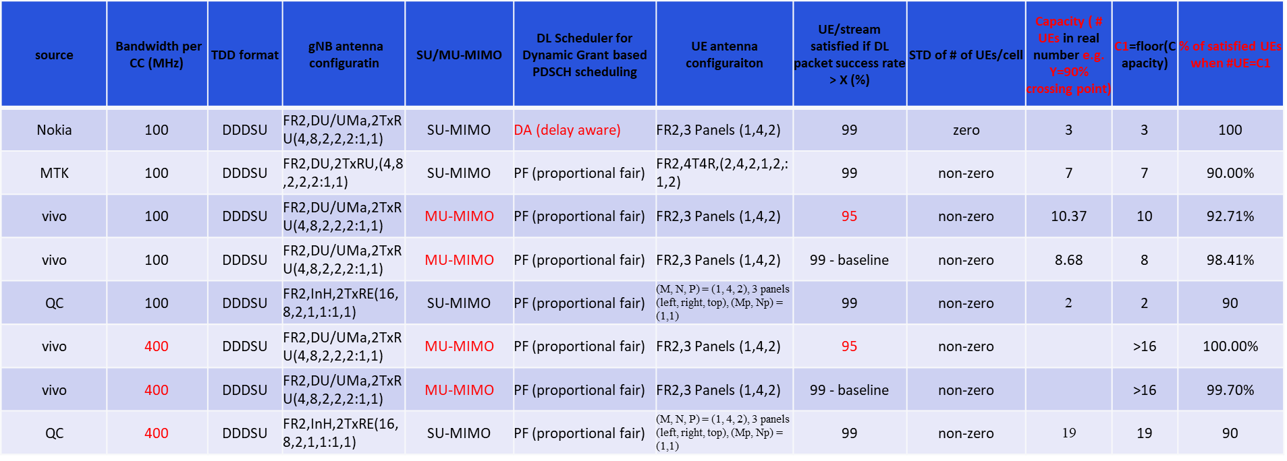

InH_30Mbps_10ms

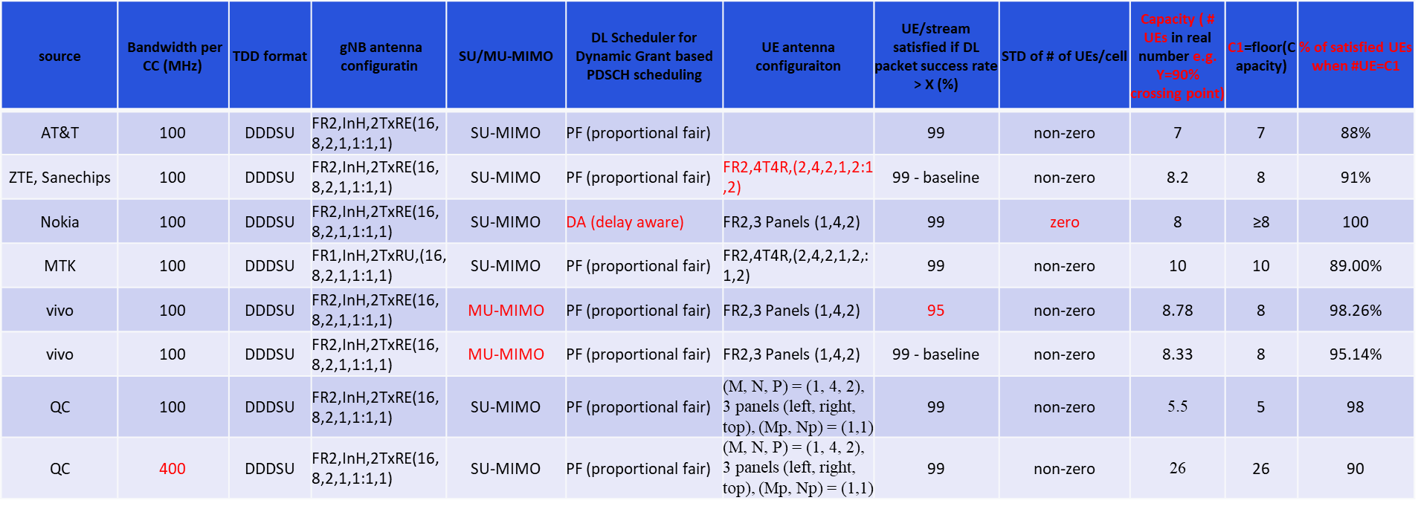

DU_30Mbps_10ms

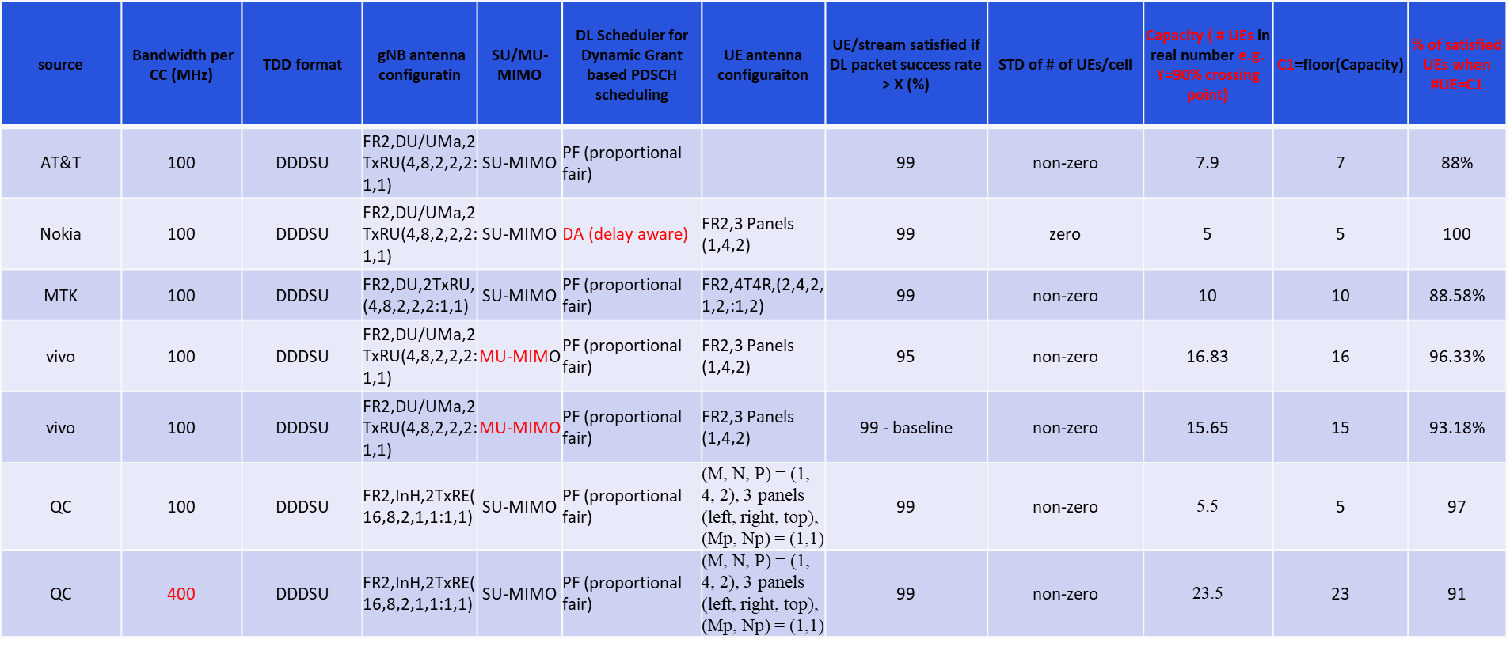

InH_30Mbps_15ms

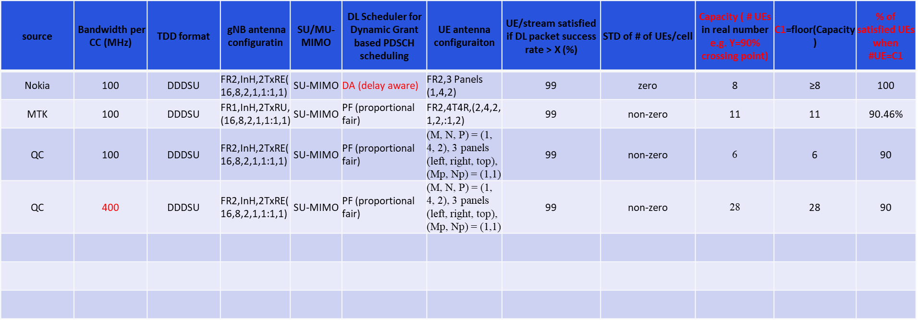

DU_30Mbps_15ms

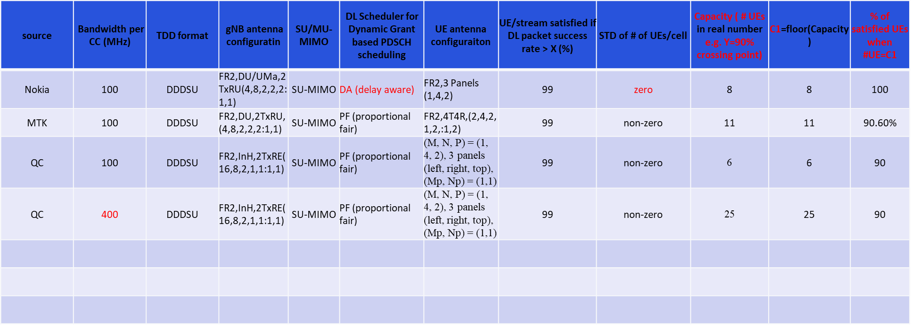

InH_8Mbps_15ms

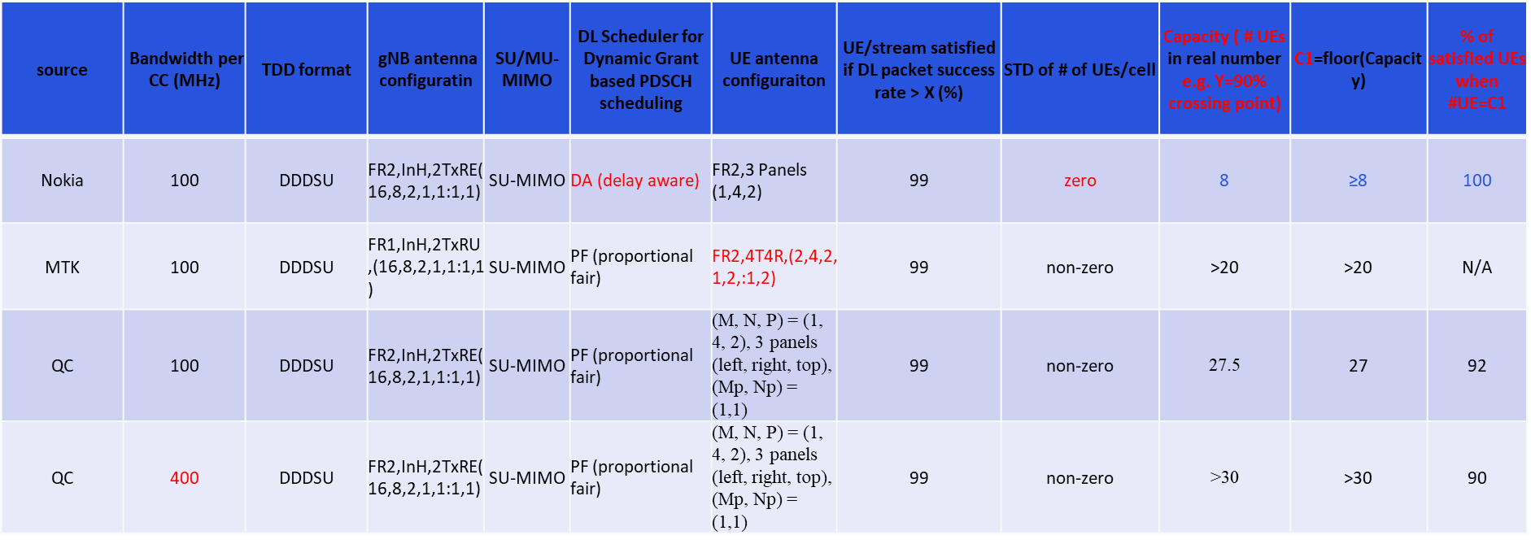

DU_8Mbps_15ms

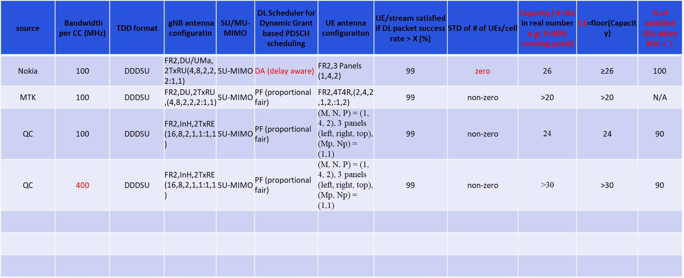

## UE Power Consumption Results: FR1

DU, VR30

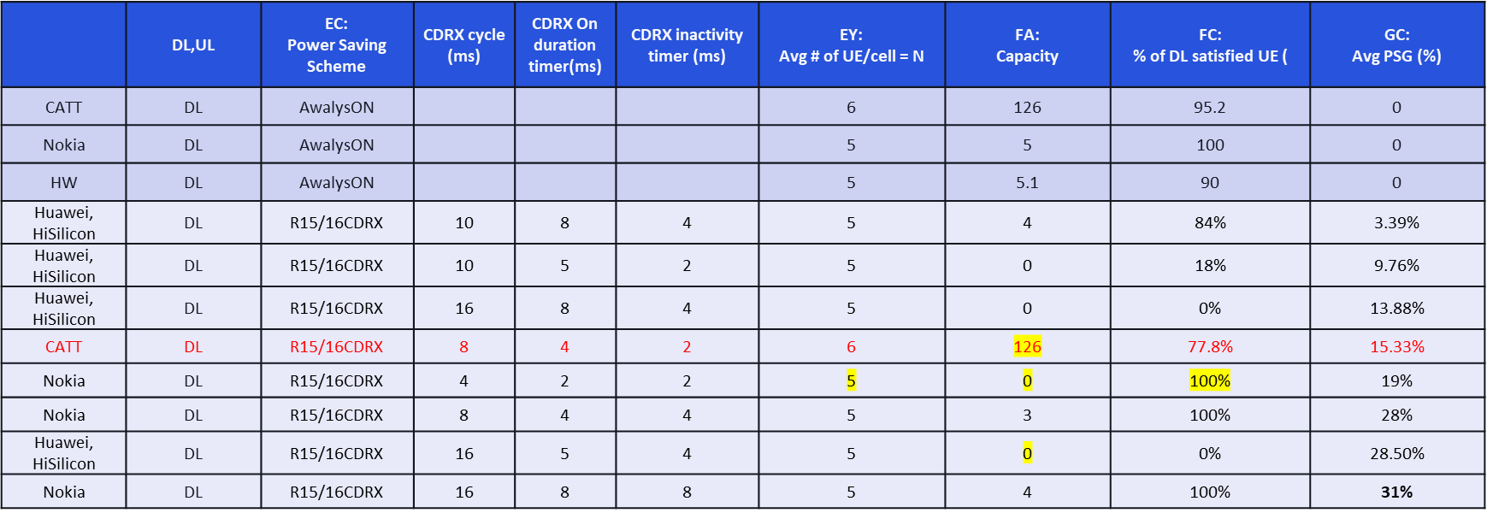

DU, VR45

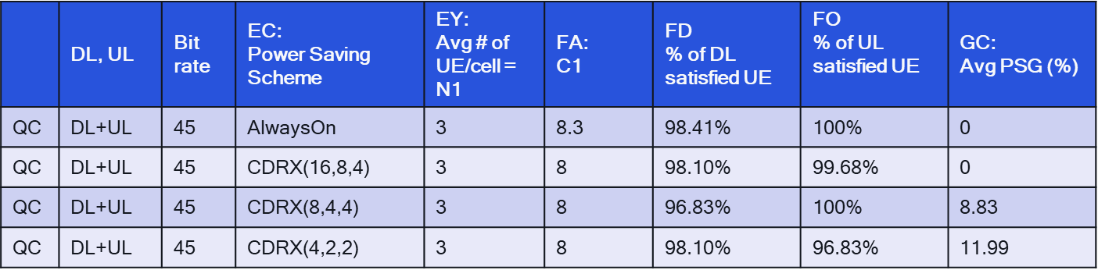

DU, CG30

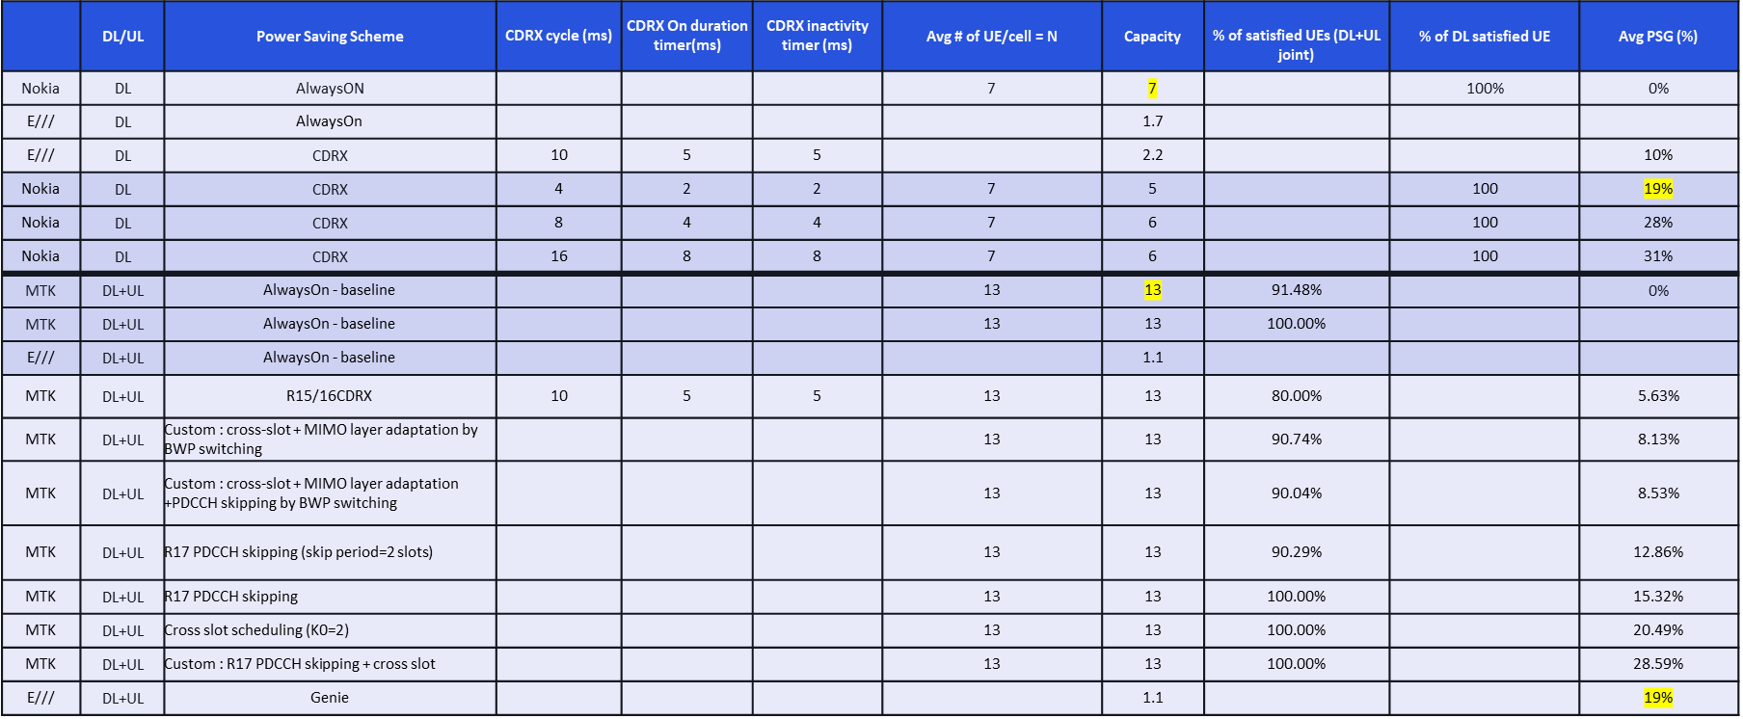

DU, CG8

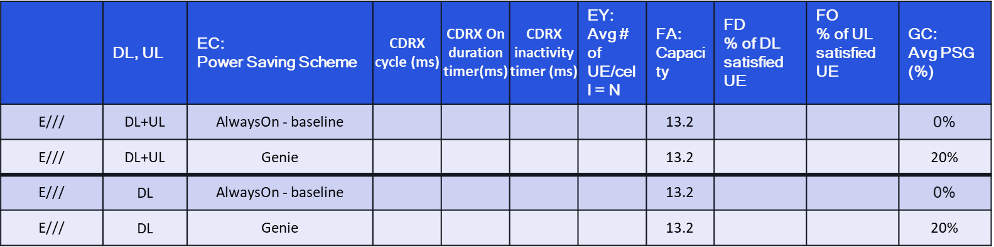

DU, AR45

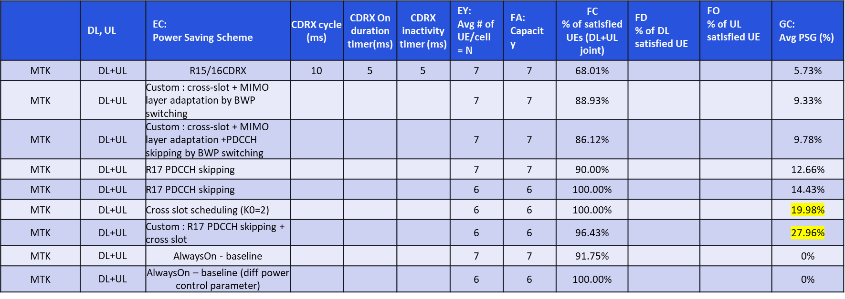

InH, VR30

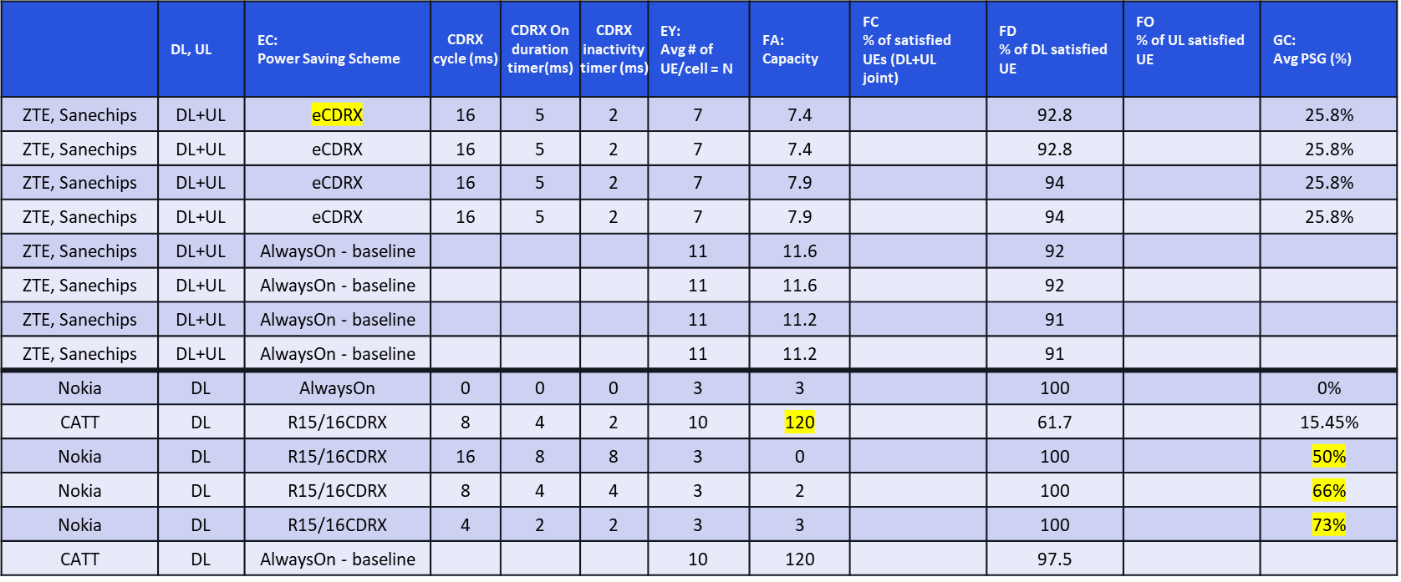

InH, VR45

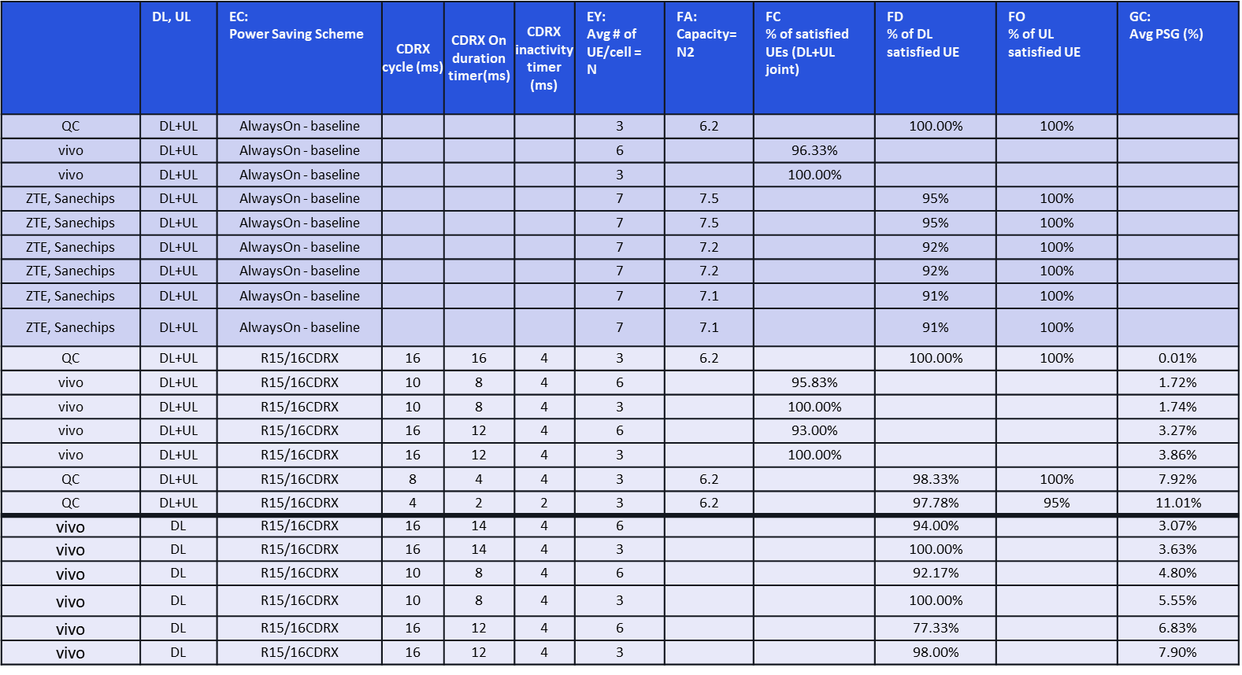

InH, CG30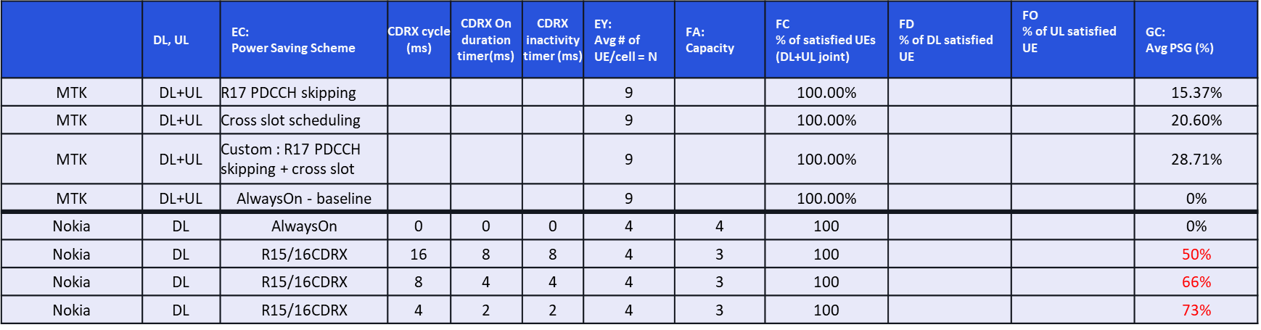InH, AR45



Uma, VR30

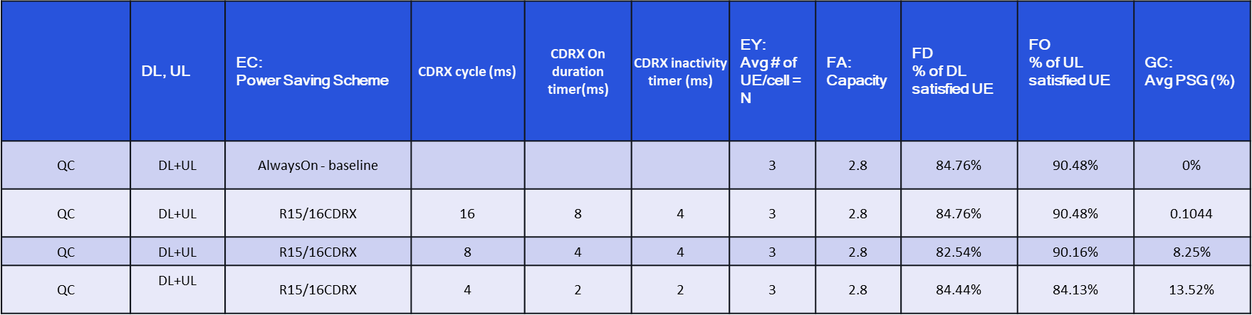

## UE Power Consumption Results: FR2

DL - InH_45Mbps_10ms - Power

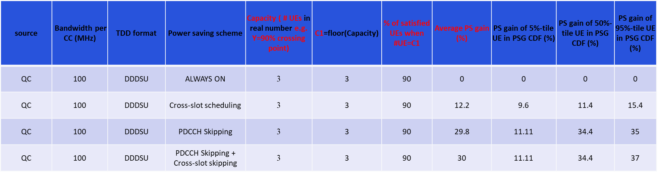

# List of contributions in RAN1 #105-e

1. R1-2104209 XR initial evaluations FUTUREWEI
2. R1-2104397 Initial performance evaluation results on XR vivo
3. R1-2104500 Evaluation results of XR performance CATT
4. R1-2104557 Performance results in indoor hotspot and dense urban deployments of CG and VR applications Nokia, Nokia Shanghai Bell
5. R1-2104703 Initial Evaluation Results for XR Capacity and UE Power Consumption Qualcomm Incorporated
6. R1-2104747 Evaluation results for XR evaluation OPPO
7. R1-2105963 Initial results for XR Intel Corporation
8. R1-2105136 Performance evaluation on XR Apple
9. R1-2105392 Initial Performance and Evaluation Results for XR and CG MediaTek Inc.
10. R1-2105501 Initial Performance Evaluation Results on XR InterDigital, Inc.
11. R1-2105521 Initial evaluation results for XR and Cloud Gaming Huawei, HiSilicon
12. R1-2105605 Performance Evaluation Results for XR ZTE, Sanechips
13. R1-2105664 XR Initial Performance Results AT&T
14. R1-2105831 Initial XR performance evaluation results Ericsson