3GPP TSG RAN WG1 Meeting #102-e R1-20xxxxx
E-meeting, August 17– 28, 2020

Agenda Item: 8.8.2.1
Source: Moderator (China Telecom)
Title: [102-e-NR-CovEnh-03] Email discussion/approval on PUSCH coverage enhancement
Document for: Discussion

1. Introduction
In RAN #86 meeting, a new Rel-17 study item on NR coverage enhancements was approved [1]. The objective of this study item is to study potential coverage enhancement solutions for specific scenarios for both FR1 and FR2. The detailed objectives are as follows.
- The target scenarios and services include
  - Urban (outdoor gNB serving indoor UEs) scenario, and rural scenario (including extreme long distance rural scenario) for FR1
  - Indoor scenario (indoor gNB serving indoor UEs), and urban/suburban scenario (including outdoor gNB serving outdoor UEs and outdoor gNB serving indoor UEs) for FR2.
  - TDD and FDD for FR1.
  - VoIP and eMBB service for FR1.
  - eMBB service as first priority and VoIP as second priority for FR2.
  - LPWA services and scenarios are not included.
- Identify baseline coverage performance for both DL and UL for the above scenarios and services based on link-level simulation
  - UL channels (including PUSCH and PUCCH) are prioritized for FR1.
  - Both DL and UL channels for FR2.
- Identify the performance target for coverage enhancement, and study the potential solutions for coverage enhancements for the above scenarios and services
  - The target channels include at least PUSCH/PUCCH
  - Study enhanced solutions, e.g., time domain/frequency domain/DM-RS enhancement (including DM-RS-less transmissions)
  - Study the additional enhanced solutions for FR2 if any
  - Evaluate the performance of the potential solutions based on link level simulation.
This contribution summarizes the email discussion on PUSCH coverage enhancement.

2. Summary of potential enhancements
In this section, companies’ proposals for PUSCH coverage enhancements are summarized.

2.1 Time domain based solutions
1. PUSCH repetition
In Rel-16, the number of repetitions (up to 16) can be dynamically indicated in the DCI for scheduling PUSCH. To further improve PUSCH coverage performance, one straightforward approach is to increase the number of repetitions. Several companies propose to either increase nominal repetition times [9, Intel][15, Spreadtrum][18, Apple] or actual repetition times [7, CTC]. One company [21, NTT DOCOMO] proposes to study PUSCH repetition with non-consecutive slots. One company [4, ZTE] proposes to study OCC spreading based repetition, which enables PUSCH multiplexing among different UEs. [16, Panasonic] propose to study Symbol-level repetition. [20, Ericsson] observes that CSI on PUSCH is one of the coverage bottlenecks and propose to study CSI repetition on PUSCH with repetition Type A or Type B.
In current Rel-16 specification, certain rules have been defined for PUSCH repetition type B to derive the actual repetitions from the nominal repetitions, as illustrated in the following figure. Each actual repetition needs to be rate matched, resulting in a higher code rate. Thus, although a repetition number increases, a loss of coding gain may not be recovered. If UE can utilize the UL resource in a less fragmented way, the better coding gain could be achieved. Based on the above view, three companies [12, Samsung][21, NTT DOCOMO][24, WILUS Inc.] propose to study enhancement on repetition Type B, including: support the actual repetition to be across the slot boundary or blank symbols and support PUSCH mapping on more than 14 OFDM symbols.

[10, Sierra Wireless] observes that there is no need to study increasing repetition for PUSCH for the eMBB use cases and propose that the maximum number of repeats to study for both control channel and voice use case should be 16.
Some simulation results are provided by companies.
Contribution [CTC, R1-2005732]
As discussed in section 2, in the current specification, the repetition mechanism for PUSCH is based on the nominal number of repetition, which is counted on the basis of contiguous slots. The enhanced repetition mechanism based on actual transmission, which is counted on the basis of available UL slots is evaluated. Voice service with frame structure DDDSUDDSUU is considered in the simulation. Both outdoor-to-indoor (O2I) and outdoor-to-outdoor (O2O) scenarios are evaluated in Fig. 3-1 and Fig. 3-2 respectively.
Fig. 3-1 Simulation results of enhanced repetition for voice service (O2I)
Fig. 3-2 Simulation results of enhanced repetition for voice service (O2O)
It can be seen from Fig. 3-1 and Fig. 3-2 that the performance can be enhanced significantly, if actual 8 repetitions is considered. For O2I scenario, the performance can be improved by 3.2dB if enhanced repetition mechanism is adopted, while the performance improvement is 4dB for O2O scenario.
Observation 1: The enhanced repetition mechanism can improve the performance of voice service for both O2I and O2O scenario, 3.2dB and 4dB gain with target 2% rBLER can be obtained respectively when 8 actual repetitions is considered.

Contribution [Intel, R1-2005889]
Figure 1 illustrates link level simulation results for PUSCH with different number of repetitions. Further, in the simulations, it is assumed DFT-s-OFDM waveform and intra-slot frequency hopping for PUSCH. In addition, it is assumed TBS = 136, MCS = 0, 2 DMRS symbols are allocated in each slot and moving speed of 3km/h.
From the figure, it can be observed that link level performance for PUSCH can be improved by increasing the number of repetitions. More specifically, ~2dB performance gain can be observed when doubling the repetition levels for PUSCH.
Figure 1. Simulation results for PUSCH with repetitions
Observation 1
- ~2dB performance gain can be observed when doubling the repetition levels for PUSCH.

Contribution [Sierra Wireless, R1-2005938]
The Rel 15 NR specification already supports PDSCH and PUSCH repeats up to 8 which at a TBS of 888 bits and 10% BLER provides the required 100kbps for the rural scenario. The figure below shows the LLS result for repeats [8 and 16] and TBS [888 and 1800] which corresponds to a data rate of 100kbps at 10% BLER (detailed simulation assumptions are in appendix A):
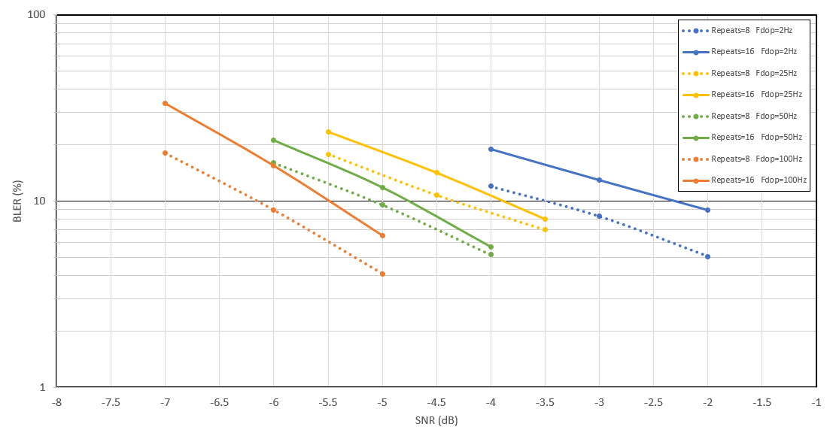
Figure 1: LLS Result for Repeats=8 and Repeats=16 for Data Rate=100kbps
As seen from the above figure, 16 repeats do not provide coverage gain compared to 8 repeats. This is expected since the energy per bit is the same and the data rate is kept constant at 100kbps. In fact, there is a small loss in coverage with 16 repeats. This is due to the loss of coding gain when using the larger TBS = 1800 since a higher code rate is needed. Some of this loss is recovered at F_{dop}=25Hz and 50Hz due to the increase in time diversity with 16 repeats but this is not enough to make up for the code gain loss. Another factor not shown in the graph is that with the larger TBS = 1800, the PDCP, MAC, and CRC overhead is reduced but this is a very small gain since TBS=888 bits is already large enough to make this overhead small by percentage. In summary, there is no substantial advantage in studying repeats higher than 8 for the eMBB use case.

2. Multi-slot PUSCH/TBS scaling/TTI bundling
[12, Samsung] proposes in order to maintain sufficient channel coding gain and avoid unnecessary TB segmentation, time domain enhancement, e.g., TTI bundling can also be considered together with smaller occupied bandwidth for uplink transmission. [14, InterDigital] proposes to Support TB scheduling over consecutive slots in the time domain without repetition. Spreading the TB over multiple slots in the time domain can improve the power spectral density. A single TB can be scheduled over multiple consecutive slots with a narrower frequency allocation. Modulated symbols can be mapped over multiple resources in the time domain to ensure a higher spectral density. UE can alternatively split the TB into multiple segments that are transmitted over multiple slots. [22/25, Qualcomm] propose to study TBS scaling for PUSCH coverage enhancement. Qualcomm provides some simulation results on TBS scaling.
Contribution [Qualcomm, R1-2006820]
Figure 7 illustrates the gains of letting a TB span multiple slots. The figure considers a UE with a 1 RB, MCS 0 allocation with TB size scaled to span a single slot, two slots, or up to 4 slots. It is seen that when the TB is allowed to span upto 4 slots, up to 2 dB gain is observed at 0.1 BLER.
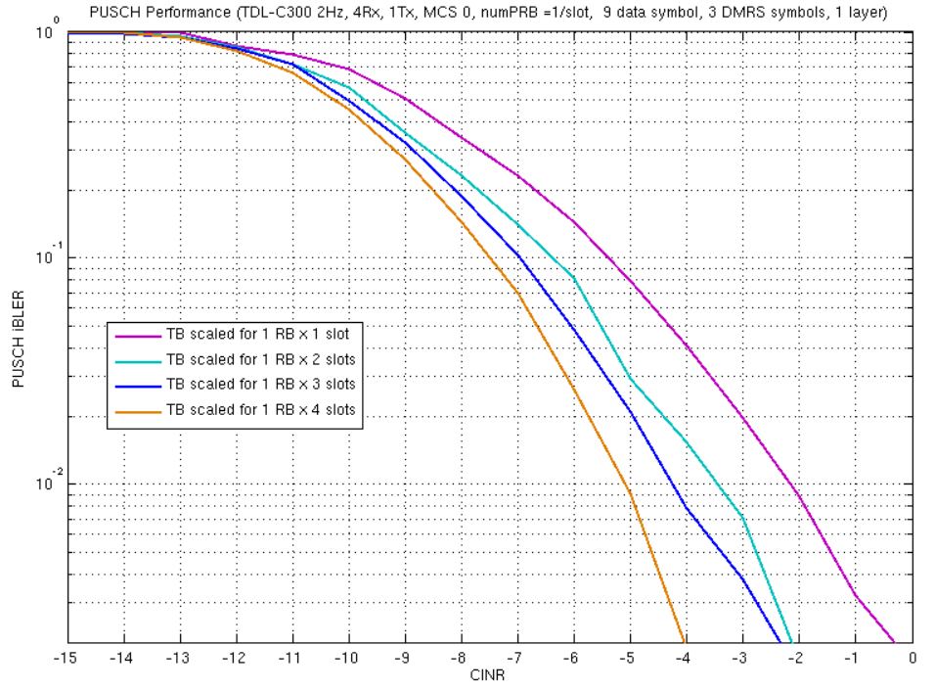
Figure 7 PUSCH Performance enhancement using TB size scaling
Proposal 5: Consider TBS scaling and optimization across multiple slots for coverage enhancement for eMBB and VoNR in Rel-17.

3. TB interleaving
Sierra Wireless mentioned in Rel 16, LTE-M and NB-IOT specified support for interleaving of transport blocks and found coverage gains between 2-5 dB using interleaved TBs. Two companies [5, Sony][10, Sierra Wireless] propose to study TB interleaving for NR.

4. RV repetition
RV repetition is where the same RV is repeated for e.g. 4 slots before moving to the next RV. This helps the receiver perform timing and frequency tracking. Thus, [10, Sierra Wireless] proposes to study RV repetition.
- 4 repetitions – RV 0,2,3,1 (no RV repetition)
- 8 repetitions – RV 0,0,2,2,3,3,1,1
- 16 repetitions – RV 0,0,0,0,2,2,2,2,3,3,3,3,1,1,1,1

5. Early termination of PUSCH repetitions
In Rel-16, dynamic indication of number of repetition is introduced. However, it is possible that one PUSCH is correctly decoded when part of repetitions are received. In this case, the remaining PUSCH transmission can cause resource waste. Two companies [4, ZTE][7, CTC] propose to study mechanism about early termination of PUSCH repetition, while [2, Nokia] thinks the potential advantage of introducing early termination of PUSCH repetition is unclear.

2.2 Frequency domain based solutions
Compared with LTE, larger spectrum bandwidth is expected, to exploit frequency diversity, many companies [4, ZTE] [5, Sony][6,CATT][7, CTC][8, NEC][9, Intel][10, Sierra Wireless][15, Spreadtrum][16, Panasonic][18, Apple][19, Sharp][21, NTT DOCOMO] propose to configure more frequency offsets or more frequency hopping positions or both to enhance frequency hopping. Three companies [7, CTC][9, Intel][12, Samsung] propose to study frequency hopping with inter-slot bundling to improve the accuracy of channel estimation. [6, CATT] proposes enhancements on frequency hopping for PUSCH repetition type B. [2, Nokia] thinks the benefit of increasing number of frequency hops as well as the implementation complexity should be evaluated. Some companies provide simulation results for frequency hopping enhancement as follows.
Contribution [vivo, R1-2005395]
To figure out the performance gain brought by enhanced frequency hopping, the performance of 2 hops and 4 hops with inter slot repetition are evaluated in Figure 3.
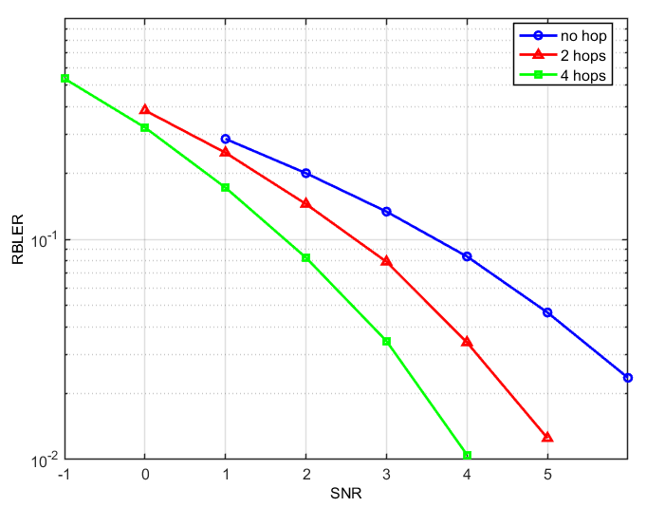
Figure 3. Performance of PUSCH frequency hopping with inter slot repetition
As shown in the figure above, frequency hopping on 4 different frequency locations can provide about 1dB performance gain compared with hopping on 2 frequency locations for inter-slot frequency hopping.
Observation 1: For inter-slot frequency hopping, frequency hopping on 4 different frequency locations can provide about 1dB performance gain compared with hopping on 2 frequency locations.

Contribution [ZTE, R1-2005427]
Figure 3 shows the performance of frequency hopping with 2 repetitions for rural scenario. The hopping offsets are different for intra-slot and inter-slot hopping. That is, there are totally 4 hopping positions for the cases with enabling both intra-slot and inter-slot hopping.

Figure 3. Simulation result for frequency hopping
Based on Figure 3, the enhanced hopping method with enabling both intra and inter slot hopping can provide additional 0.58/0.86 dB gain over inter-slot hopping in Rel-15 at target BLER 0.1 and 0.01.
Proposal 3: Enhancement to frequency hopping pattern can be considered for NR coverage enhancement.
- A more flexible frequency pattern for mitigating the inter-cell interference.
- A configurable time domain hopping interval for better channel estimation performance or DMRS sharing.
- A configurable number of hopping locations for better frequency diversity.

Contribution [CTC, R1-2005732]
The enhanced intra-slot frequency hopping for PUSCH is evaluated. Simulation results are shown with enhanced intra-slot frequency hopping in both O2I and O2O scenarios in Fig. 3-3 and Fig. 3-4, respectively. For the conventional intra-PUSCH hopping, 2 hops within one slot and 1 DMRS symbol for each hop is assumed, while for the enhanced intra-PUSCH hopping, 3 hops within one slot and 1 DMRS symbol for each hop is assumed. In the simulation, both eMBB and voice service are considered. The data rate is assumed as 100kbps for eMBB while the package size is assumed as 320bits for voice service. It can be seen from Fig. 3-3 that about 0.4dB gain can be observed with target 10% iBLER if the enhanced intra-slot frequency hopping scheme is adopted for eMBB service for O2I scenario, while the performance improvement is 1.6dB with target 2% rBLER for voice service for O2O scenario.
Fig. 3-3 Simulation results of enhanced intra-slot frequency hopping for eMBB service for urban scenario
Fig. 3-4 Simulation results of enhanced intra-slot frequency hopping for voice service
Observation 2: The enhanced frequency hopping scheme can improve the coverage performance, 0.4dB gain with target 10% iBLER and 1.6dB gain with target 2% rBLER can be obtained for eMBB and VoIP respectively compared with conventional frequency hopping scheme.

Contribution [Intel, R1-2005889]
Figure 3 illustrates link level simulation results for PUSCH with different frequency hopping (FH) patterns. In the simulations, it is assumed TBS = 136, MCS = 0 and 2 DMRS symbols are allocated in each slot. Further, 8 repetitions are used for PUSCH transmission with 1) intra-slot FH, 2) inter-slot FH and 3) enhanced inter-slot FH pattern with 4 consecutive slots in a same frequency resource. In addition, cross-slot channel estimation is employed with a fixed window size of 4 slots.
From the figure, it can be observed that when employing cross-slot channel estimation, substantial performance gain, i.e., ~0.9dB, can be achieved for enhanced inter-slot frequency hopping pattern, compared to Rel-15 intra-slot and inter-slot frequency hopping pattern.
Figure 3. Simulation results for PUSCH with different frequency hopping patterns
Observation 2
- When employing cross-slot channel estimation, substantial performance gain, i.e., ~0.9dB can be achieved for enhanced inter-slot frequency hopping pattern, compared to Rel-15 intra-slot and inter-slot frequency hopping pattern.
Figure 4 illustrates link level simulation results for PUSCH when 2 and 4 frequency hops are employed. In the simulation, it is assumed TBS = 136, MCS = 0 and 2 DMRS symbols are allocated in each slot. From the figure, it can be observed that compared to 2 frequency hops, ~1.5dB performance gain can be achieved when 4 frequency hops are used for PUSCH.

Figure 4. Simulation results for PUSCH with different number of hops
Observation 3
- ~1.5dB performance gain can be achieved when 4 frequency hops are employed for PUSCH repetition, compared to 2 frequency hops.

2.3 DMRS enhancements
1. DMRS bundling
In Rel-16, channel estimation for data demodulation is based on DMRS symbols within a slot. For cell edge UEs, the performance degradation due to channel estimation error may be significant. One potential solution to enhance the accuracy of channel estimation is DMRS bundling. With DMRS bundling, joint channel estimation can be performed at UE side, which can improve the performance of channel estimation and thus coverage. Based on the above view, many companies [1, HW][3, vivo][4, ZTE][6,CATT][7, CTC][8, NEC][11, OPPO][12, Samsung][13, CMCC] [16, Panasonic][18, Apple][19, Sharp][22/25, Qualcomm] propose to study DMRS bundling/joint channel estimation for PUSCH coverage enhancement. [14, InterDigital] propose to support placement of DMRS symbol in a special slot which is bundled with DMRS with adjacent uplink slot. [2, Nokia] thinks cross-slot channel estimation require several constraints to be applicable in practice. Some companies provide some simulation result on DMRS bundling/joint channel estimation as follows.
Contribution [Huawei, HiSilicon, R1-2005258]
Based on the parameter settings in table 3.1-1, we present preliminary simulation results of joint channel estimation under 100kbps and 1Mbps target data rates in figure 3.1-1 and 3.1-2, respectively.
Table 3.1-1 Parameter settings for joint channel estimation
Parameters | Values
Antenna configuration | 1T 64R
Channel model | TDL-C
UE speed | 3 km/h
Delay spread | 300ns
DMRS configuration per slot | Type I, max-length=1, 1 DMRS symbol per slot
DMRS multiple with data | No
As we can observe that compared to conventional channel estimation based on 1 slot, joint channel estimation of 2 slots and 3 slots with more accurate channel fading information can obtain approximately 1.4 and 2.1 dB gain at 10% BLER, respectively. Thus, joint channel estimation without increasing the DMRS overhead can be regarded as a promising way in PUSCH coverage enhancement and the applicability or conditions of the joint channel estimation can be studied during the SI.
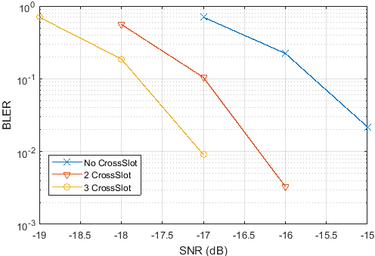
Figure 3.1-1 Joint channel estimation with 100kbps target data rate
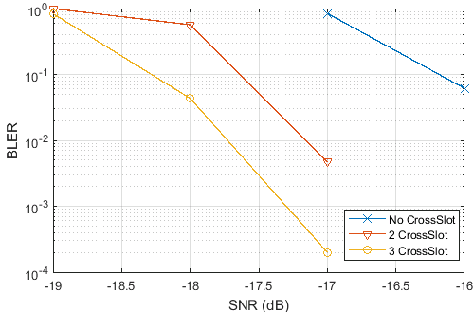
Figure 3.1-2 Joint channel estimation with 1Mbps target data rate
Observation 1: By joint channel estimation across consecutive PUSCH transmissions, a large coverage gain can be achieved as compared to conventional single slot channel estimation, i.e., 1.4 dB and 2.1 dB SNR gains are obtained at 10% BLER for 2 and 3 slots joint channel estimation, respectively.

Contribution [vivo, R1-2005395]
In order to clarify the benefit of joint channel estimation, we conduct the performance evaluation. Joint channel estimation based on PUSCH repetition transmission is assumed.
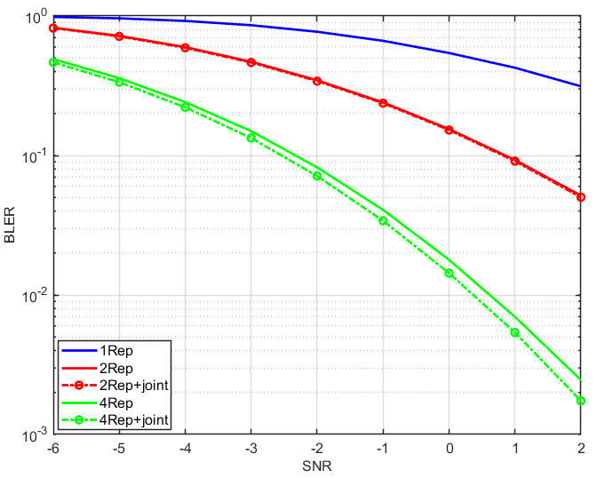
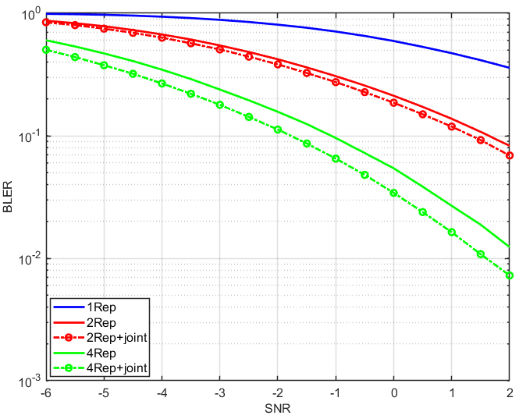
(a) Intra-slot repetition PUSCH (b) Inter-slot repetition PUSCH
Figure 4. Comparison of PUSCH with and without joint channel estimation
As shown in the figures above, it is observed that PUSCH with joint channel estimation can achieve better performance. With the increment of number of repetitions, the performance improvement of cases with joint channel estimation is more remarkable.
Observation 3: Joint channel estimation can bring about performance improvement for PUSCH transmission.

Contribution [CTC, R1-2005732]
Simulation results with cross-slot channel estimation over 2 continuous UL slots are shown in Fig. 3-9 and Fig. 3-10. It can be seen that about 0.4 dB and 0.8 dB gain with target 10% iBLER can be observed for TDD (DDDSUDDSUU) and FDD respectively.
Fig. 3-9 Cross-slot channel estimation in rural scenario for eMBB service for TDD (DDDSUDDSUU)
Fig. 3-10 Cross-slot channel estimation in rural scenario for eMBB service for FDD
Observation 5: Cross-slot channel estimation can improve the coverage performance, about 0.4dB and 0.8 dB gain with target 10% iBLER can be observed for TDD (DDDSUDDSUU) and FDD respectively.

Contribution [Intel, R1-2005889]
From the figure, it can be observed that for PUSCH with 8 repetitions and inter-slot frequency hopping, when employing cross-slot channel estimation algorithm, >1.7dB performance gain can be achieved compared to without cross-slot channel estimation.
Figure 7. Simulation results for PUSCH with cross-slot channel estimation
Observation 5
- For PUSCH with 8 repetitions and inter-slot frequency hopping, when employing cross-slot channel estimation algorithm, >1.7dB performance gain can be achieved compared to without cross-slot channel estimation.
- Advanced receiver needs to be considered when evaluating performance for different techniques for coverage enhancement.

Contribution [Samsung, R1-2006162]
The following link-level simulations have been performed in voice service for rural scenario at 4 GHz carrier frequency. We consider PUSCH repetition type B with 2 actual PUSCH repetitions and additional 3 re-transmissions, where one actual PUSCH transmission is scheduled with 6 symbols in a special (flexible) slot and another transmission is scheduled with 14 symbols in an UL slot. Figure 4 shows that time domain RS bundling has about 0.6 / 1 dB gain at 0.1 initial target BLER / at 0.02 residual target BLER, respectively.
Proposal 4: Consider enhancements on channel estimation with TDRS bundling.
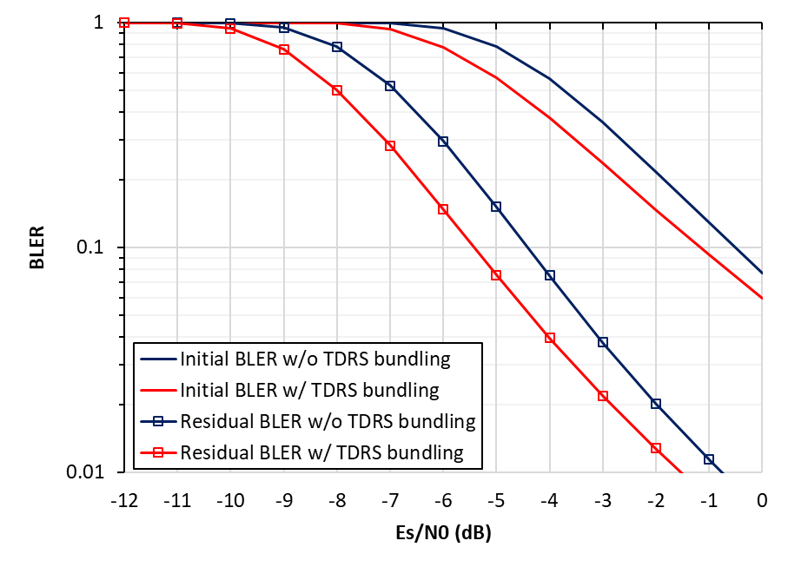
Figure 4. BLER for PUSCH repetition type B with vs. without time domain RS bundling

Contribution [Sharp, R1-2006579]
Figure 1 shows PUSCH BLER performance comparison of inter-slot joint channel estimation. In the figure, N indicates the number of PUSCH repetitions. If the number of repetitions is 4, about 1.5 dB performance improvement is observed in the target BLER of 0.1.
Proposal 1: Study channel estimation enhancement such as inter-slot joint channel estimation.

Figure 1: PUSCH BLER performance comparison

Contribution [Qualcomm, R1-2006820]
Fig 1, we compare the performance of DMRS transmission with and without bundling for PUSCH. In the simulations, we assume that the number of DMRS symbols is fixed to 1 symbol, and data communication occupies 13 OFDM symbols. For DMRS bundling, we consider both the case in which the same TBs are transmitted over different slot (i.e., slot aggregation), as well as the case in which different TBs are transmitted over different slots. In all the simulations, the same MCS value is used. The red curves illustrate the performance without DMRS bundling. The blue curves show the performance with DMRS bundling over two slots. The green curves show the performance with DMRS bundling over four slots. As can be seen from the figure, DMRS bundling offers more than 0.8~1.5 dB gain in the considered scenarios.
Fig 1: DMRS bundling performance with 1 DMRS symbol per slot
Fig 2: DMRS bundling performance with fixed TBS per slot
In Fig 2, we consider a scenario where a PUSCH is scheduled with 1 RB and 14 OFDM symbols. We change the number of DMRS symbols within the slot but kept the transport block size (TBS) fixed. It is appreciated that there is a trade off on how many DMRS symbols are used for the transmission. On the one hand, with more DMRS symbols, the channel estimation quality is better. On the other hand, using more DMRS symbols means higher coding rate (i.e., less resources for transmitting data). As can be seen from the figure, the performance of using 1 DMRS symbol and 2 DMRS symbols provide similar performance, which are uniformly better than using 4 DMRS symbols. However, by using 1 DMRS per slot and bundle across 2 slots, we may achieve around 0.5 dB gain compared to the case of no DMRS bundling with 1 or 2 DMRS symbols per slot. Further gains may be achieved by bundling across more slots.
Based on the above analysis, we make the following proposal:
Proposal 2: Consider DMRS bundling technique for coverage enhancement in NR Rel-17.

2. DMRS-less transmission
Four companies [3, vivo][9, Intel][11, OPPO][13, CMCC][15, Spreadtrum] propose to study DMRS-less transmission, e.g. for UE with low velocity or in static states, the DMRS can be put in some of the PUSCH slots while there is no DMRS in other PUSCH slots, the reduced DMRS symbols can then be utilized to transmit PUSCH. [2, Nokia] thinks DMRS-less PUSCH transmission require several constraints to be applicable in practice.
[4, ZTE][1, HW] propose to study DMRS sharing among multiple PUSCH retransmissions to reduce DMRS overhead. Moreover, [4, ZTE] also propose to study DMRS overhead reduction in frequency domain.
Some simulation results are provided by companies.

Contribution [Huawei, HiSilicon, R1-2005258]
According to the parameter settings in table 3.2-1, we provide a transmission mechanism with finer granularities and simulation results are shown in Figure 3.2-1.
Table 3.2-1 Parameter settings for finer granularity transmission
Parameters | Values
Antenna configuration | 1T 2R
Channel model | TDL-C
UE speed | 3 km/h
Delay spread | 300ns
DMRS configuration per slot | Type I, max-length=1

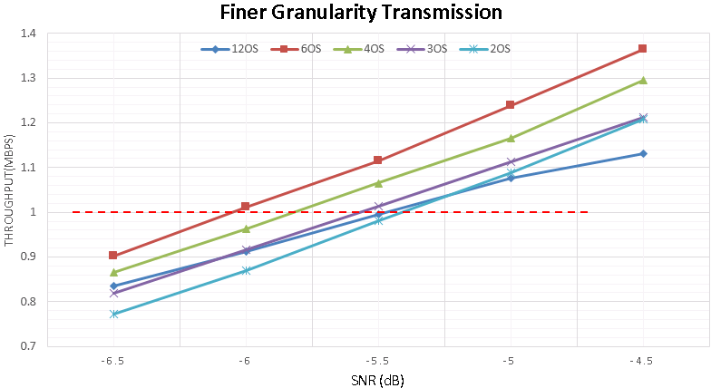
Figure 3.2-1 Required SNR gain by finer granularity transmission
Notes on the legends:
- The legend of 12OS means 12 symbols within one slot is scheduled in each transmission with. TBS=1256 bits, which is regarded as the baseline.
- The legend of 6OS means 2 transmission occasions within one slot with a granularity of 6 symbols for each transmission.
- The legend of 4OS means 3 transmission occasions within one slot with a granularity of 4 symbols for each transmission
- The legend of 3OS means 4 transmission occasions within one slot with a granularity of 3 symbols for each transmission
- The legend of 2OS means 6 transmission occasions within one slot with a granularity of 2 symbols for each transmission
- The TBS is kept the same in each transmission for above different scheduling granularities.
As we can observe from figure 3.2-1, by finer granularity transmission with 6OS in each scheduling, 0.6 dB SNR gain can be obtained compared to the baseline performance at 1Mbps target data rate.
Observation 2: By finer granularity of (re)transmission, a better coverage performance could be obtained while the large DMRS overhead in each finer granularity (re)transmission would degrade the coverage performance.

Contribution [vivo, R1-2005395]
The performance curves of DMRS-less with and without joint channel estimation are simulated and provided in Figure 6.
- X Rep：X repetitions. Other conditions are the same as normal PUSCH transmission.
- X Rep+DMRS-less：X repetitions without DMRS symbols configured at possible reduced DMRS symbols.
- X Rep+joint+DMRS-less：X repetitions without DMRS symbols configured at possible reduced DMRS symbols, but performing joint channel estimation among X repetitions at the receiver.
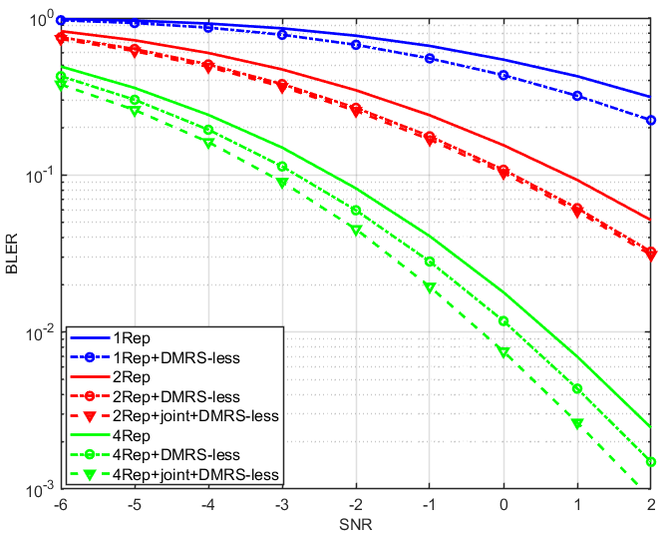
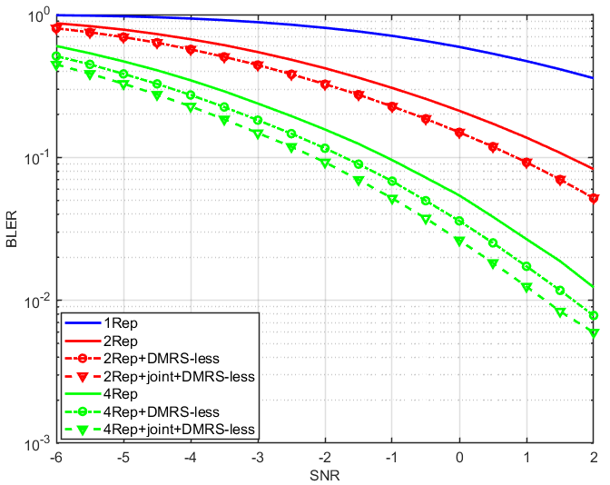
(a) Intra-slot repetition (b) Inter-slot repetition
Figure 6. Performance comparison of different schemes for PUSCH repetition transmission
As shown in the figures above, it is observed that DMRS-less PUSCH can achieve meaningful performance due to lower effective code rate. When combined with joint channel estimation, further performance gain can be achieved.
Observation 4: Joint channel estimation with DMRS-less PUSCH can achieve about 1dB performance gain compared with current PUSCH transmission without joint channel estimation and DMRS-less.

Contribution [ZTE, R1-2005427]
Figure 1 shows the performance comparison of PUSCH w/ or w/o DMRS sharing for 8 repetitions in urban scenario. For the both cases, one DMRS is configured for every PUSCH repetition. For DMRS sharing, it means gNB enables joint DMRS estimation across repetitions.

Figure 1. Performance comparison of PUSCH w/ or w/o DMRS sharing
As shown in Figure 1, the case with DMRS sharing (joint channel estimation across repetitions) can provide additional 1.8 dB gain over w/o DMRS sharing for urban scenario with 8 repetitions at target BLER 0.1.
Observation 1: DMRS sharing among PUSCH repetitions can provide 1.8dB gain in urban scenario.

3. Higher DMRS density
Three companies [7, CTC][9, Intel][18, Apple][21, NTT DOCOMO] propose to study higher DMRS density to improve channel estimation performance.
Some simulation results are provided by companies.
Contribution [CTC, R1-2005732]
DM-RS with single port can span to occupy the whole DM-RS symbol to improve the performance of channel estimation. It can be seen from Fig. 3-7 and Fig. 3-8 that about 0.5dB and 1.5 dB gain with target 10% iBLER can be observed for eMBB service for urban scenario and rural scenario respectively.
Fig. 3-7 Full-DMRS in urban scenario for eMBB service
Fig. 3-8 Full-DMRS in rural scenario for eMBB service
Observation 4: Full DMRS scheme can improve the coverage performance, about 0.5dB and 1.5 dB gain with target 10% iBLER can be obtained for eMBB for both urban and rural scenarios respectively.

Contribution [Intel, R1-2005889]
Figure 6 illustrates link level simulation results for PUSCH with 2 and 4 DMRS symbols. In the simulation, it is assumed TBS = 136, MCS = 0 and inter-slot frequency hopping. From the figure, it can be observed that for 8 repetitions, 4 DMRS symbols can achieve better link level performance than 2 DMRS symbols.
Figure 6. Simulation results for PUSCH with 2 and 4 DMRS symbols
Observation 4
- For 8 repetitions with inter-slot frequency hopping, 4 DMRS symbols can achieve better link level performance than 2 DMRS symbols for PUSCH.

4. Adaptive DMRS configuration
In Rel.16, same DMRS configuration should be used among slots or among repetitions. However, due to the varying of channel and reception conditions, different DMRS configurations may be needed for different slots. Thus, [22/25, Qualcomm] propose to study adaptive DMRS configuration per UE per slot, which may provide significant link performance improvement. [16, Panasonic] also observes that adaptive DMRS transmission is beneficial especially for stationary scenario.
Contribution [Qualcomm, R1-2006820]
We also provided results focused for the possible cell edge scenarios in Figure 5 with the following assumptions:
- RI=1
- MCS adaptation per DMRS option, MCSs from range 0-9
- Same allocation size (time, frequency) for the different tested DMRS configurations
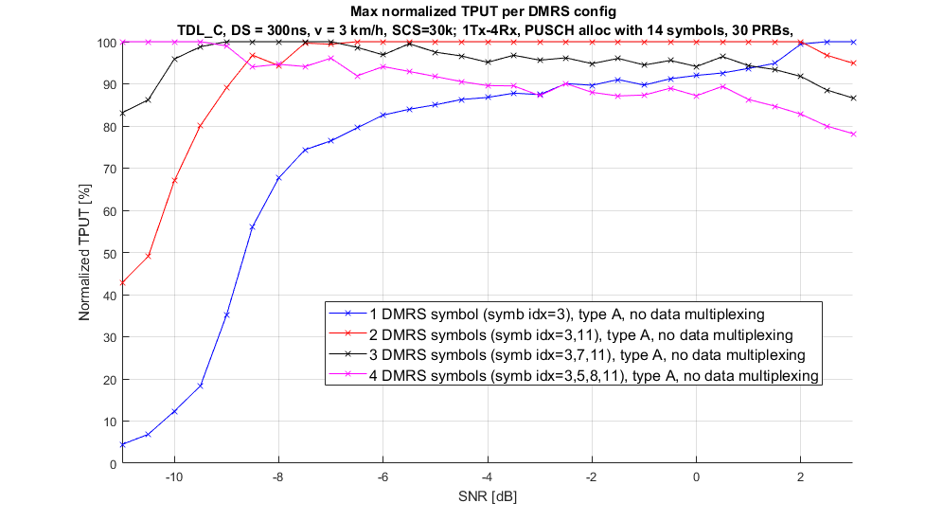
Figure 5 Performance of PUSCH with different DMRS configurations for cell edge scenario
Additional comparison for the same scenarios in Figure 5 but with fixed MCS is provided in Figure 6 and Figure 7 for MCS = 0 and MCS = 2, respectively.
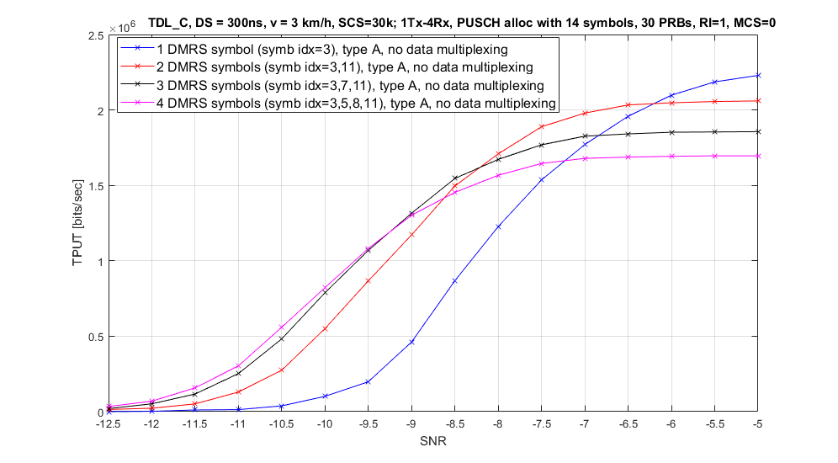
Figure 6 Performance of PUSCH with different DMRS configurations RI=1, MCS=0
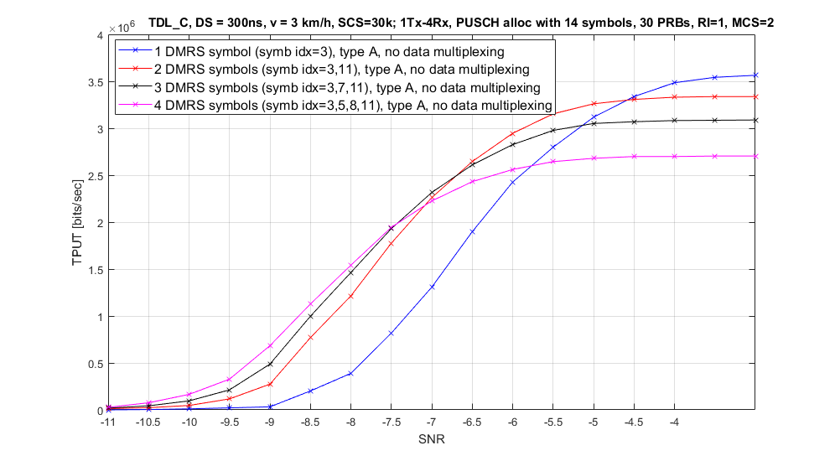
Figure 7 Performance of PUSCH with different DMRS configurations RI=1, MCS=2
As can be observed from the above results, usage of the most appropriate DMRS configuration has a potential to provide gain of up to 1.7dB per fixed MCS and tens of percent of TPUT increase at cell edge scenarios for PUSCH.
Proposal 3: Consider adaptive DMRS configuration for PUSCH to improve both coverage and link efficiency and introduce signaling mechanisms for dynamic DMRS configuration change.

2.4 Power domain based solutions
1. Sub-PRB transmission
Increasing the transmission power is a straightforward way to improve coverage performance. However, UEs in coverage limited scenarios have already transmitted the uplink signals with maximum transmission power. Five companies [4, ZTE][7, CTC][9, Intel][10, Sierra Wireless][12, Samsung][21, NTT DOCOMO] propose to study sub-PRB transmission with multiple slot aggregation, which can improve transmission PSD. [2, Nokia] also thinks sub-PRB transmission may be beneficial for coverage, in case of low data rate applications. [15, Spreadtrum] has concerns on sub-PRB transmission, and thinks very detailed and careful evaluations should be done to verify its effectiveness and weigh the worth and workload for introducing this new feature.

2. FDD high power UE
High power is introduced for UE in TDD mode and EN-DC mode, however, for FDD mode, high power mode is not defined yet. Based on observation of [1, HW], a large SNR gain is obtained by FDD higher power transmission as compared to original repetitions, e.g. 1 dB SNR gain at 10% BLER. Thus, [1, HW] proposes to study FDD higher power UE for PUSCH coverage enhancement.
Contribution [Huawei, HiSilicon, R1-2005258]
To evaluate the performance of FDD higher UE power transmission, we present a simplified simulation of a TDD-like pattern where the first 4 slots have twice the power of the baseline simulation, and the next 4 slots have zero power. This simple example gives approximately 1dB SNR gain at 10% BLER.
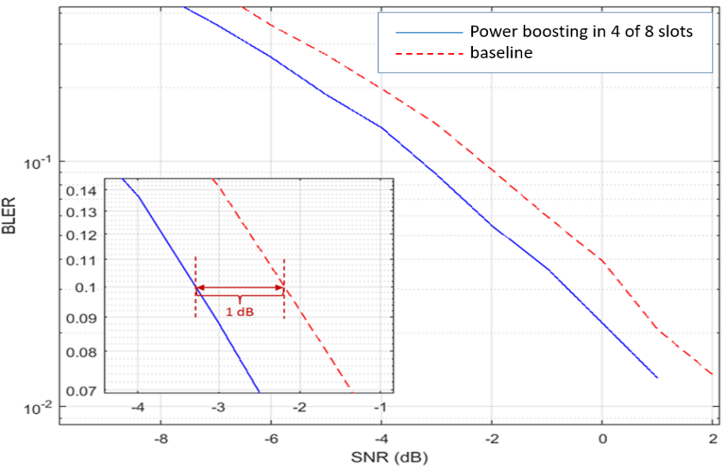
Figure 3.3-1 Simulation results of instant higher power transmission
Observation 4: A large SNR gain is obtained by FDD higher power transmission as compared to original repetitions, e.g. 1 dB SNR gain at 10% BLER.
In light of the above analysis, we have the following proposal:
Proposal 3: Study FDD higher power UE for PUSCH coverage enhancement

3. Waveform design to reduce MPR
[22/25, Qualcomm] proposes to study advanced waveform design techniques that allow reducing the MPR values for waveforms of all modulation orders. In particular, consider tone reservation principle for DFT-s-OFDM and CP-OFDM waveforms to further reduce PAPR.
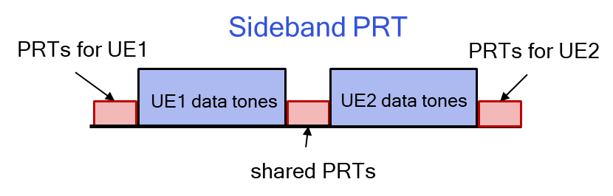

4. pi/2 BPSK based enhancements
[17, IITH] proposes pi/2 BPSK should be made mandatory and make pi/2 BPSK power boosting a function of the TDD frame structure, specifically the number of UL slots that are present in a given TDD frame structure.

2.5 Spatial domain based solutions
[11, OPPO] proposes to study spatial diversity for PUSCH. During PUSCH repetition, different PUSCH spatial filter parameters and different antenna ports can be applied for different PUSCH slots
[20, Ericsson] observes multiple layer transmission is especially beneficial in the non-coherent UEs that are those most used in real deployment, since multi-layer transmission provides more power in these UEs. Ericsson proposes to study multiple layer PUSCH transmission with DFT-S-OFDM. Ericsson also observes Open-loop Tx Diversity together with Msg3 repetition can improve Msg3 coverage through diversity gain and Tx chain power combining. Closed-loop Tx Diversity for Msg3 can benefit from coherent combining or antenna selection as well as Tx chain power combining. And proposes Study Msg3 coverage enhancement schemes, for example, repetition and multiple-antenna techniques.
[19, Sharp] Proposes to study STBC/SFBC, or time/frequency domain precoder cycling.

2.6 Others
[7, CTC] propose to study packet aggregation for PUSCH coverage enhancement. RAN can aggregate multiple RTP packets with one speech frame encapsulated in one RTP packet or the application can encapsulate multiple packets in one RTP packet. Due to the overhead reduction of packet aggregation, the coverage can be improved accordingly.

[20, Ericsson] observes SigComp can compress SIP packets at application layer before encryption is used. This feature should be considered for Voice coverage enhancement. It has better potential i.e. suitable for all scenarios regardless of whether packets are encrypted or unencrypted.

[5, Sony] proposes following specific techniques for FR2:
- Enhancements to improve spherical coverage / beam correspondence, including:
  - UE triggering of UL beam sweeping at low SNR
  - Increased number of UE panels [RAN4]
  - Power class with more stringent spherical coverage requirements [RAN4]
- Reflective arrays
- Polarization aspects of the UL and/or DL reference signals

3. Proposals

3.1 Proposals with high priority
Proposal 1:
- Study the performance and specification impacts on time domain based solutions for PUSCH enhancements, including
  - PUSCH repetition enhancement
    - Increase the nominal/actual number of PUSCH repetition
    - PUSCH repetition with non-consecutive slots/on the basis of available slots
    - OCC spreading based repetition
    - Symbol-level repetition
    - Enhancement on repetition Type B
    - CSI repetition on PUSCH
  - Multi-slot PUSCH/TBS scaling/TTI bundling
  - TB interleaving
  - RV repetition
  - Early termination of PUSCH repetitions

Companies are invited to provide views on the above proposal.
Companies | Views
SONY | Support proposal.
NTT DCOMO | We are fine with the FL proposal.
Qualcomm | We think this list is too long and needs to be shortened to only include techniques that have good coverage gain and are supported by multiple companies.  Several of the proposals being made for PUSCH repetitions do not necessary help a UE in cell-edge. From our point of view, we prefer to focus on enhancements such as TB size scaling/multi-slot PUSCH that provide consistent gains across a wide range of scenarios.
InterDigital | Agree with the proposal to treat Proposal 1 as one of the high priority topics. Regarding “Multi-slot PUSCH/TBS scaling/TTI bundling”, we propose to use terminologies which capture the proposals. Our proposal is to use “Multi-slot PUSCH: TBS scaling, transmission of coded TB segments over multiple slots, partial TBS retransmission” and “TTI bundling”. In our proposal, we have shown that partial TBS retransmission is needed when TBS is sent over multiple slots.
vivo | For PUSCH repetition enhancement, OCC spreading based repetition may result in negative effect on UE multiplexing, and symbol-level repetition seems to introduce more latency and receiver complexity, even gain is lower than RV based repetition transmission.  Enhancement on repetition type B, increase the nominal/actual number of PUSCH repetition are acceptable to us.  For multi-slot PUSCH/TBS scaling/TTI bundling, we think they can achieve some better coverage by using more time domain resource or jointly considered with cross PUSCH channel estimation.  For TB interleaving, it is beneficial to random error but not obviously to coverage capacity.  In TDD spectrum, it may lead to longer transmission delay. And the benefit is doubtful.  For RV repetition, fixed RV repetition pattern is not preferred, dynamic RV repetition based on certain implicit rule can be considered.  Early termination of PUSCH repetition does not directly impact the channel coverage, and the number of repetition configured should be decided by gNB considering to the worst case to guarantee a certain system performance.
Samsung | Due to the limited time in this SI, the list of high priority proposals is too extensive. Our preference is to prune the list as follows:  - PUSCH repetition enhancement  - Increase the nominal/actual number of PUSCH repetition  - Symbol-level repetition  - Enhancement on repetition Type B  - Multi-slot PUSCH/TBS scaling/TTI bundling
Panasonic | We are fine with the proposal and agree to treat time domain based solutions as high priority topics.
ZTE | We are generally fine with proposal except for symbol-level repetition for now. We are not sure whether this could bring performance improvement while as vivo mentioned it increases the latency and also receiver complexity.  In addition, we think most of the enhancements can also apply to repetition type A. So, we could remove repetition type B above or also adding repetition type A.
CATT | We are generally fine with the proposal as any potential solutions to improve PUSCH coverage can be further studied. Although we are negative to some of the solutions listed here, we are OK to keep them to see whether we can achieve a good trade-off between better coverage and the corresponding penalties in the future.  However, we are not OK with CSI repetition on PUSCH and early termination. As we commented in the online session, neither of them is helpful for the PUSCH coverage enhancement. For early termination, it may be helpful for the other UE’s coverage assuming that the released resources can be used for the other UE’s UL transmission. But it is very tricky as if coverage is a problem for the UE, gNB should guarantee the resources for the PUSCH transmission.  Based on the above comments, we proposed to remove the sub-bullet corresponding to ‘CSI repetition on PUSCH’ and ‘Early termination’.
Sharp | In our view, TB interleaving may not provide benefit when TB size is sufficiently small. For targeting 1 Mbps, TB size should be 1000 bits for FDD, and about 3500 bits for DDDSU, which leads 1 code block.
IITH, IITM, CEWIT, Reliance Jio, Tejas Networks | Support the proposal
OPPO | - OCC spreading based repetition  - Symbol-level repetition  - TB interleaving  We are not sure whether there is gains for the above 3 techniques, other proposals are fine for us.
Nokia/NSB | We would like to clarify the meaning of “study the performance and specification impacts” for this proposal and for the remaining proposals. From our understanding, this means that the listed solutions are going to be evaluated in the context of this SI. After the evaluation, there is another round of assessment/discussion on which solution(s) to be selected for the WI, if applicable. Could you please confirm the correctness of this understanding?  Secondly, for the completeness of the proposal, we propose to add “Study the link budget performance and specification impacts on ...” to the main bullet point of this proposal and also the remaining proposal, if applicable. Since LB and LLS have been agreed for EVM, we should keep the same method for the evaluation of solutions.  Thirdly, and more importantly, we find that the number of considered solutions is very large at this stage, and their nature extremely heterogeneous. This may lead to fragmentation of the study and scarce comparability of the results. In other words, if different solutions are studied and simulated only by small disjoint subsets of companies, agreeing on what do next is going to be very challenging, if even feasible at all. Given the importance that all companies seem to give to time domain based solutions, we wonder if we shouldn’t aim at rationalizing the effort companies will have to do, given the limited TUs we have left before the SI completion. For instance, we could agree on the nominal potential and importance of each solution and [preferred approach] reduce the number of considered solutions or [less preferred approach] assign soft priorities to the items listed in the proposal.  Building upon the third observation above, we have the following comments/questions on respective solutions:  - For “Increase the nominal/actual number of PUSCH repetitions” and “PUSCH repetition with non-consecutive slots/on the basis of available slots”, we think that these two solutions are somehow similar and aim to solve the same issue, which is the handling of cancellation due to collision with DL slots in TDD deployment. The former solves the issue by increasing the number of repetitions to compensate for the cancelled part, while the latter solves the issue in a more direct way. The two solutions just propose different ways of indication but rely on the same time diversity gain. In FDD deployment with available consecutive slots, we think that the current maximum numbers of repetitions for both types are sufficient.  - For “OCC spreading based repetition” and “Early termination of PUSCH repetitions”, as partially discussed in the online session, we have a concern on how to evaluate these solutions on LLS and LB calculation, if they just show benefit in system level. In the end, all the gains offered by any solution need to be fed into LB template to evaluate the enhancement in coverage.  - Again concerning “OCC spreading based repetition”, we understand that the goal is to increase the efficiency of resource utilization if more PUSCH repetitions are configured. A reference to UE multiplexing over PUCCH is made to substantiate this proposal. While the benefit of UE multiplexing over PUCCH is clear from operational perspective, the benefit of PUSCH multiplexing, as an isolated feature, is not clear, and so is its direct impact on the PUCH coverage. Hence, both the extent of this problem and its solution are not very clear to us.  - For “CSI repetition on PUSCH”, it’s unclear to us whether this is “CSI only” on PUSCH or not. Otherwise, why do we need to treat this solution separately from the PUSCH repetition enhancement?
NEC | Support the FL proposal. Considering the limited time, could move some bullet into medium priority.
Intel | We agree that solutions in time domain would be treated as higher priority.  We also share similar view as Nokia. It would be also good to clarify whether we would study all the solutions for PUSCH coverage enhancement, or the intention is to down-select some of the solutions during SI phase, e.g., considering the pros/cons of each solution and considering the majority support from different companies. This also applies for other proposals in the summary document.  We do have some concerns on some of the solutions in the proposal. Some of the solutions may not address the issues for PUSCH coverage enhancement. But we would provide more detailed comments once the intention is clear.
CMCC | Support the repetition kind enhancements.  But from our perspective, the uplink slots and symbols are limited in the 7D1S2U TDD configuration. We also think this is the same situation faced by other TDD operators. Then, the enhancements focusing on the limited uplink slots situation should be with higher priority.  And it should be noted that the repetition could enhance the coverage at the cost of data rate, since that the uplink time resources may be assumed fully used.
Ericsson | In our view, the list of detail enhancement solutions based on companies’ interest should be further discussed and narrow down based on technical analysis and simulation results. And the solutions should also be applied on real bottle necks that we found in the performance agenda item.  E.g. CSI on PUSCH and Msg3 PUSCH, can be bottlenecks. While for normal PUSCH due to power limitation in uplink, we need to prioritize those solutions that can provide more power for each transmission, given the number of repetitions for normal PUSCH is already up to 16 even if we may have TDD problems where some of the repetitions may overlap with downlink symbols/slots, so we do not see a need to optimize the scheduling of normal PUSCH or increase the number of PUSCH repetitions.  Thus, our view is to mainly consider Msg3 and CSI repetition in this proposal regarding time domain based solutions.
Apple | I think FL make a full list of the potential time domain based solutions. We are not so clear how to move forward with this full list. Is the intention to down select in this meeting or next meeting. At least from our side, below items may not provide the coverage gain, but we are open to discuss further.  - OCC spreading based repetition  - Symbol-level repetition  - TB interleaving  - RV repetition  - Early termination of PUSCH repetition
Huawei, Hisilicon | - Views on PUSCH repetition enhancement,  - For non-consecutive PUSCH repetition, the time delay tolerance should be considered  - For increasing PUSCH repetition numbers, current spec support maximum 16 repetitions, how to determine the larger repetition number should be evaluated  - For enhancement on repetition typeB, if PUSCH scheduling is across slot boundary, whether terminal devices in practical implementation can support this feature needs further discussion, for example, the inner scheduling and control process in terminal chips need a stable cycle (e.g. slots), if this cycle is blurred in PUSCH scheduling, the accurate scheduling and control within chips would be very difficult.  - For OCC spreading based repetition, the spectrum efficiency can be improved by CDM among multiple UE multiplexing.  - For multi-slot PUSCH across slot boundary, same views as that for enhancement on repetition type B. For partial TB retransmission for TBs transmission across multi-slots, whether Rx can identify  - For TB interleaving, how much gain can be achieved from simulation and interleaving method of resource mapping should be clarified  For early termination of PUSCH repetitions, potential gain can be obtained when large repetition numbers are supported. However, for uplink transmission, if gNB decode the TB correctly with less repetitions than configuration number, then gNB can dynamical change the configured repetition number in next scheduling, which can help release repetition resources.
WILUS | We are supportive of the FL proposal in principle. Due to the limited time budget, some of items should be prioritized in this SI. Longer PUSCH transmission in time domain (e.g., PUSCH repetition enhancement including increase number of repetitions and enhancement on repetition type-B, multi-slot PUSCH/TBS scaling/TTI bundling) can be prioritized because it may enhance coverage for power limited UE especially in cell-edge.

Proposal 2:
- Study the performance and specification impacts on frequency domain based solutions for PUSCH, including
  - Inter/intra-slot frequency hopping with more frequency offsets configured by RRC
  - Inter-slot frequency hopping with more frequency hopping positions
  - Intra-slot frequency hopping with more frequency hopping positions/ finer granularity
  - Inter-slot frequency hopping with inter-slot bundling to enable cross-slot channel estimation
  - Enhancements on frequency hopping for PUSCH repetition type B

Companies are invited to provide views on the above proposal.
Companies | Views
SONY | Support proposal.
NTT DCOMO | We are fine with the FL proposal.
Qualcomm | We are not in favor of increasing the number of frequency hops within a slot. Intra-slot frequency hopping incurs additional DMRS overhead that can potentially lead to a drop in overall throughput. We are also of the opinion that at least 2 DMRS symbols are needed per hop for a cell-edge UE for robust channel estimation.  In addition to this, frequency hopping gains are very closely tied to the underlying channel statistics, and unfortunately, our current gNB modeling assumptions put us in an unfavorable position to be evaluating such schemes, especially in the MMIMO context. Without appropriate simulation assumptions we should not be pursuing such enhancements.  Finally, we also have concerns on UE implementation as frequent hopping withing a single slot impacts UE tx chain design.
vivo | Our simulation results we observed that more frequency hopping positions for inter-slot hopping can obtain almost 1 dB additional performance gain. For intra-slot frequency hopping, the DMRS pattern may need to be adjusted with more frequency hops, and the overhead for DMRS may be increased.  Inter/intra-slot frequency hopping with more frequency offsets providing more flexibility to the network, may be beneficial to coverage enhancement. Inter/intra-slot frequency hopping with more frequency hopping positions and more frequency offsets seems to be better.
Samsung | OK to study the following from the list above:  ‐ Inter-slot frequency hopping with inter-slot bundling to enable cross-slot channel estimation  ‐ Enhancements on frequency hopping for PUSCH repetition type B  We note that a diversity order of 8 is enough to provide all diversity gains. With 4 gNB receiver antennas, which means that no other FH enhancements are needed except for basic inter-slot FH that allows for more accurate channel estimation (e.g. as in eMTC).  The sub-PRB transmission can be part of the frequency-domain enhancements since it is a frequency domain design although the benefits are coming from power gain. Thus, it is added to this proposal:  - Sub-PRB transmission
Panasonic | We agree to treat frequency domain based solutions as high priority topics. Although we are OK with the proposal, we agree with the Qualcomm’s first comment on increasing the number of frequency hops within a slot.
ZTE | Based on our simulation, we also find some performance gain by enabling both inter-slot and intra-slot FH to provide more FH positions. Thus, we are supportive of the second and third sub-bullet. For the first sub-bullet, it is just one way to achieve multiple FH positions, and could be put as a sub-sub-bullet of the second and third sub-bullet.
CATT | We are fine to study frequency domain solutions with high priority.  One comment on the third sub-bullet: why the finer granularity is only applied to intra-slot frequency hopping?
Sharp | We are OK with FL proposal.
IITH, IITM, CEWIT, Reliance Jio, Tejas Networks | Do not support increasing the number of frequency hops.
OPPO | We are fine to study frequency domain solutions with high priority.
Nokia/NSB | We would like to ask for clarification on “Enhancements on frequency hopping for PUSCH repetition type B”. Which enhancement is expected for this feature in Rel-17 exactly?  In Rel-16 URLLC work and study item, frequency hopping for PUSCH repetition type B has been extensively discussed and the final frequency hopping framework for PUSCH repetition type B is the result of a convergence among companies, given the result of the study. It is worth noting that reliability, i.e., support of lower operating SINR, is also one of the major KPIs for URLLC. Since this topic has been recently discussed as a new Rel-16 feature, we are not sure that discussing it again would be an efficient way of using the limited time resources we have for this SI. Other than that, we are fine with the proposal.
NEC | Support the FL proposal.
Intel | We are generally fine with the proposal. We suggest to combine some bullets to make it more concise as follows:  - Study the performance and specification impacts on frequency domain based solutions for PUSCH, including  - Inter/intra-slot frequency hopping with more frequency offsets/positions/finer granularity configured by RRC  - Inter-slot frequency hopping with more frequency hopping positions  - Intra-slot frequency hopping with more frequency hopping positions/ finer granularity  - Inter-slot frequency hopping with inter-slot bundling to enable cross-slot channel estimation  - Enhancements on frequency hopping for PUSCH repetition type B
CMCC | Support the study on the frequency hopping. But the impact to the other users’ transmission and the system efficiency should be limited, such as resource fragments caused by frequency hopping.
Ericsson | For normal PUSCH, we do not see a need to optimize the current frequency hopping schemes since normal PUSCH can already also be able to use other techniques to achieve frequency diversity gain, e.g. scheduling in retransmissions on different PRBs, scheduling with resource allocation type 0, or via interleaved VRB to PRB mapping so that a contiguous set of virtual resource blocks would be distributed in the frequency domain across multiple, widely separated physical resource blocks.  But for Msg3, probably repetition and frequency hopping can be considered together, we’re fine to study that.
Apple | In general, we are ok with the proposal, just have little concern on the intra-slot frequency hopping with more hopping positions, it could cause the resource fragmentation in a slot.
Huawei, Hisilicon | Above mentioned methods of more flexible frequency hopping to fully utilize the frequency domain diversity can be studied. However, compared to existing 2 frequency hopping positions, how much gain can be further obtained by increasing the frequency hopping positions from 2 to larger numbers can be studied.  The DMRS overhead due to more hopping needs to be considered especially for more hopping in one slot.
WILUS | We support enhancements on frequency hopping for PUSCH repetition type B.  For coverage bottleneck UE, channel estimation quality can be one of the most significant factors for coverage enhancement. And in case of PUSCH with long duration in the time domain with same PRBs, it seems important to make possibly obtain more coverage gain by using DMRS enhancement schemes (e.g., DMRS bundling). Thus, frequency domain based solutions for PUSCH should be considered based on clear coverage gain, not just simple hopping gain.

Proposal 3:
- Study the performance and specification impacts on DM-RS enhancements for PUSCH, including
  - DMRS bundling/cross-slot channel estimation/cross-repetition channel estimation
    - DM-RS can be placed in UL slot or special slot
  - DM-RS-less transmission
    - Lower DM-RS density
    - DM-RS sharing among multiple PUSCH transmission
  - Higher DM-RS density
  - Adaptive DM-RS configuration

Companies are invited to provide views on the above proposal.
Companies | Views
SONY | Support proposal.  Based on that the optimal DMRS configuration is different for different scenarios, we support the proposal of having Adaptive DM-RS configuration.
NTT DCOMO | We are fine with the FL proposal.
Qualcomm | We strongly believe channel estimation is an important aspect of PUSCH performance for a cell-edge UE. At low SNRs, multiple DMRS symbols to form reasonable channel estimates. In this context, it will be helpful to pursue enhancements that enable cross-slot channel estimation and ability to vary the DMRS configurations/patterns for a given PUSCH transmission.  These enhancements strongly motivate the need for a faster and more dynamic mechanism to adapt our DMRS/channel estimation strategies to changes in channel conditions for a cell-edge UE. The current RRC mechanisms are too slow and insufficient to address the needs of a cell-edge UE. DCI-based control of DMRS configurations is likely to help under such scenarios.
InterDigital | We are fine with Proposal 3 and agree to treat this as one of the high priority issues.
vivo | Joint channel estimation has obvious benefit on performance, especially at low speed. If the granularity of joint channel estimation in the time domain is configurable, the time domain granularity should also take the UE speed into consideration.  We support DMRS-less transmission due to lower DMRS density providing coding gain, and multiple PUSCH transmission or repetitions or slots can share their DMRS to compensate the accuracy loss caused by less DMRS, even achieve more accurate channel estimation to further enhance performance.
Samsung | OK to study some of the solutions above.  We would rephrase the proposal as follows:  - DMRS bundling/cross-slot channel estimation/cross-repetition channel estimation  Regarding adaptive DM-RS configuration or lower/higher DM-RS density beyond what is available in Rel-16, the impact on gNB complexity needs to also be considered together with any potential gains.
Panasonic | We are fine the proposal and agree to treat DM-RS enhancements as high priority topics.
ZTE | Support the proposal in general. Our simulation results show that joint channel estimation could provide clear performance gain (~1.8dB). As for detailed DMRS pattern, it could be further discussed.  One suggestion is to switch ‘Lower DM-RS density’ and ‘DM-RS-less transmission’, which seems the former includes the latter.
CATT | We are fine with the proposal to further exploit a better coverage.
Sharp | It is unclear to us what is meant by DMRS-less transmission.
IITH, IITM, CEWIT, Reliance Jio, Tejas Networks | Support the proposal
OPPO | Fine to study the above proposal
Nokia/NSB | As discussed in our contribution, from our perspective the available features of Rel-15 and Rel-16 should be reused as much as possible to enhance the coverage of PUSCH. When these features are used together, not only the benefit offered by all features can be combined but also the combination enables some room for further enhancement. Additionally, this approach has the advantage of requiring very low specification effort, if a solution is agreed on.  One example could be the combination of PUSCH repetition and intra-slot frequency hopping, the two essential techniques that can help enhancing PUSCH coverage as pointed out by most contributions and considered in proposals above as well. We observe that for PUSCH repetition type A, the DMRS positions are the same for all repeated slots. Conversely, when PUSCH repetition type A and intra-slot frequency hopping are both applied, the actual number of DMRS symbols per hop may or may not be the same, depending on the configured number of DMRS symbols. This leads to imbalance of the number of DMRS symbols among frequency hops for all repetitions, as shown in the following figure:  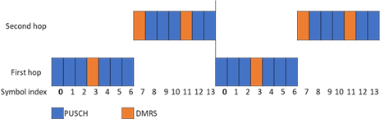  Furthermore, we note that the number of DMRS symbols allocated for each frequency hop is static over time. The combination of these two aspects may lead to deterministic channel estimation accuracy differences across hops. In this case, one frequency hop may be penalized and suffer when rapid channel fluctuations occur, or when noise/interference is stronger (this depends on the specific channel estimator implementation, UE position, cell layout and so on). This could be relevant, for instance, when a TB is segmented in multiple CBs and some of those are completely conveyed by only one hop. Therefore, repeating exactly the same DMRS allocation for every slot in PUSCH repetition type A could be sub-optimal. This problem would become even more relevant in case the number of repetitions or hops is increased, as per proposals above.  Thus, we propose to add the following sub-bullet to the proposal:  - DM-RS balancing among frequency hops when PUCSH repetition and frequency hopping are used in conjunction.  Other than that, we are fine with the rest of the proposal.
NEC | Support the FL proposal.
Intel | We are generally fine with the proposal. We suggest to remove “lower DMRS density” as follows:  - Study the performance and specification impacts on DM-RS enhancements for PUSCH, including  - DMRS bundling/cross-slot channel estimation/cross-repetition channel estimation  - DM-RS can be placed in UL slot or special slot  - DM-RS-less transmission  - Lower DM-RS density  - DM-RS sharing among multiple PUSCH transmission  - Higher DM-RS density  - Adaptive DM-RS configuration  Further, it is not clear to us how “DM-RS can be placed in UL slot or special slot” would work.
CMCC | We support Proposal 3 as one of the high priority issue
EURECOM | Agree to be studied with high priority. In particular optimization of DMRS density and intra-slot frequency hopping.
Ericsson | We’re fine to study cross slot channel estimation, but we expect that mechanisms providing more energy for normal PUSCH which is power limited compared to downlink channels are more promising.  We do not expect much gain from lowering the coding rate via reducing the number of DMRS resources or expect gains via increasing the DMRS density for normal PUSCH.
Apple | We are fine to study these methods to improve the channel estimation accuracy.
Huawei, Hisilicon | - DMRS bundling to enable more accurate channel estimation can improve uplink coverage. However, to enable joint channel estimation, limitations such as same precoding matrix, same transmit power, etc., should be considered  - DMRS sharing or lower DMRS density is suitable for static fading channels with low UE moving speed, which can fully utilize uplink resource  Higher or adaptive DMRS density configuration can be studied to match different fading channels
WILUS | We support the FL proposal.

3.2 Proposals with medium priority
Proposal 4:
- Study the performance and specification impacts on power domain based solutions for PUSCH enhancements, including
  - Sub-PRB transmission
  - FDD high power UE
  - Waveform design to reduce MPR
  - pi/2 BPSK based enhancements

Companies are invited to provide views on the above proposal.
Companies | Views
NTT DCOMO | We are fine with the FL proposal.
Qualcomm | We prefer to focus on techniques to reduce MPR/A-MPR values. RAN4 constraints significantly limit uplink power and we need RAN1 to take a close look at some of these issues.  WEnhancements that can benefit both VoNR and eMBB are to be prioritized. Enhancements that benefit both TDD and FDD are to be prioritized.  We are also concerned that power boosting can significantly impact UE tx design.
vivo | As discussed in the FR1 simulation assumptions for UL PUSCH, the optimal MCS index and number of PRBs combination depends on many factors, e.g. PSD, coding rate and wireless channel conditions, less PRB allocation does not necessary lead to better coverage, the performance gain is doubtful.  For FDD high power UE, it seems not necessary since we do not see coverage issue in FDD spectrum in our simulation.  For waveform with low MPR and pi/2 BPSK, the motivation is to achieve lower PAPR, but based on RAN4 MRP requirements, the MPR is 0dB for inner RB allocation for QPSK modulation order, the lower PAPR transmission can be achieved by proper network configuration/ scheduling, the inner band resources can be used for coverage limited UEs.
Samsung | Support only to study sub-PRB transmission, which is added to frequency domain based solutions in proposal 2.
Panasonic | We are fine with the proposal and agree to treat these solutions as medium priority.
ZTE | We suggest focusing on sub-PRB transmission. Similar to NB-IOT, sub-PRB can improve the coverage directly with sacrificing the date rates. This could apply for services like VoIP, which has a fixed packet size and very loose latency requirement, e.g. 320 bits within 50/100ms.
CATT | OK
Sharp | We are OK with FL proposal.
IITH, IITM, CEWIT, Reliance Jio, Tejas Networks | We support the proposal.  The low PAPR of pi/2 BPSK should be exploited to get additional coverage gains. Using QPSK in such coverage limited scenarios with same power levels as that of pi/2 BPSK will not exploit the low PAPR of the waveform.
OPPO | We suggest focusing on sub-PRB transmission.  FDD high power UE shall be firstly discussed in RAN4.
Nokia/NSB | We would like to ask for clarification on the difference between “Waveform design to reduce MPR” and “pi/2 BPSK based enhancements”. Whether they are the same or different and what would be the difference here.  Given the extremely large scope of this proposal, and similar to what we proposed for Proposal 1, we would also welcome a prioritization of the 4 bullets, if possible.
NEC | Support the FL proposal.
Intel | Our view is that sub-PRB can be considered as part of frequency domain enhancement for PUSCH.  For “FDD high power UE”, RAN4 would be a right place to study.  For “Waveform design to reduce MPR” and “pi/2 BPSK based enhancements”, it is not clear to us how/what we would study for these two solutions. Again, RAN4 may be a good place to study or NR already supports pi/2 BPSK for PUSCH.
CMCC | We are open to the sub-PRB transmission and waveform design to reduce MPR. But for the sub-PRB transmission, it should be clarified the usage scenario and the supported data rate, since the resources is very limited.
Ericsson | Simply decreasing the number of resources in frequency domain while keeping the TDRA not changed to us is to increase the capacity instead of improving the coverage, even if increasing time domain duration of a transmission, the performance gain compared to normal PUSCH repetition can hardly be seen.  For introducing the new UE power class in FDD, we need be careful since this is related to regulatory and UE implementation aspects.  Low PAPR study can be further studied, e.g. PI/2 BPSK, but we need to check the gain that we can achieve. Regarding new waveform, we do not see a need to study this at this stage as we also need to consider the complexity it introduces to NR system while the gain may also be doubtful.
Apple | For sub-PRB transmission, the gain is not from power domain, if single slot transmission, we the performance loss due to the higher coding rate. If multi-slot transmission, this can also be done in PRB level.  For FDD high power UE, it could have the regulatory issues, RAN4 could be the right place to define the UE transmission power.  For waveform design and pi/2 BPSK, we need more details to know what enhancement colud be done.
Huawei, Hisilicon | Higher power is a straightforward method to improve the coverage.  FDD higher power UE to enable better channel estimation gain with can improve uplink coverage

Proposal 5:
- Study the performance and specification impacts on spatial domain based solutions for PUSCH enhancements, including
  - Multiple layer PUSCH transmission with DFT-S-OFDM
  - Open-loop/closed loop Tx diversity

Companies are invited to provide views on the above proposal.
Companies | Views
InterDigital | We support the proposal from the FL.
vivo | For multiple layer PUSCH transmission, DFT-s-OFDM intuitively suits UL transmission better than CP-OFDM. We think there should be a sufficient evaluation about PAPR, coverage and capacity performance, based on multiple layer PUSCH transmission with DFT-S-OFDM.  For a cell edge UE, it is less likely to use multiple layer UL transmission, hence it should not be considered in this SI.  Transparent Tx diversity, which seems to no impact to current specification. If necessary, it can be up to UE implementation.
Samsung | No need to consider multi-layer transmission for coverage limited UEs.  TxD might be considered (low priority) in case of no FH in order to improve channel estimation while getting an 8-order of diversity.
Panasonic | We are fine with the proposal and agree to treat these solutions as medium priority.
ZTE | Share with vivo and Samsung above, no need to consider multi-layer transmission for coverage limited UEs.
Sharp | It is unclear to us why multi-layer transmission provides coverage enhancement.
OPPO | Share with vivo and Samsung above, no need to consider multi-layer transmission for coverage limited UEs.
Nokia/NSB | From our perspective spatial domain based solutions for PUSCH should be considered with low priority. Having said this, the practical advantage of having multiple layer transmission at the cell-edge is not very clear to us. Therefore, we are not sure that multiple layer PUSCH transmission with DFT-s-OFDM solution should be considered. Second bullet is ok.
NEC | We think it’s low priority.
Intel | It is not clear to us the benefit to introduce multi-layer transmission with DFT-s-OFDM waveform for PUSCH coverage enhancement. For cell edge UE, single layer PUSCH transmission is typically employed for better coverage.  We are fine to study “Open-loop/closed loop Tx diversity”
Ericsson | We can understand that there could be 2 arguments against multiple layer PUSCH with DFT-S-OFDM waveform.  One was that multiple-layer PUSCH transmission increases PAPR/CM. But as we observed, non-coherent and partially coherent UE’s PAPR or cubic metric (CM) of multiple layer PUSCH transmission is not higher than 1-layer PUSCH transmission by coherent UE.  Other argument could be that with low SNR there’s small chance of Rank 2+ PUSCH at cell edge, as DFT-S-OFDM is more favorable than CP-OFDM at cell edge due to its lower PAPR/CM.  But as indicated by the results shown in Figure 1 in our contribution, multiple layer transmission is especially beneficial in the non-coherent UEs that are those most used in real deployment, since multi-layer transmission provides more power in these UEs. Pure rank 1 transmission tends to be infrequent even for UEs in the poorest channel conditions when few gNB antennas are used. When massive MIMO gNBs are used, rank 1 is almost never selected.  Multiple layer transmission allows better performance for additional PA architectures so that TX power can be increased.  Regarding the TX diversity, the open-loop Tx Diversity for Msg3 can be combined with Msg3 repetition which was not supported yet, for example, precoder or beam cycling, or antenna hopping between Msg3 repetitions. Closed-loop Tx Diversity for Msg 3 is also possible if gNB has accurate channel state information. Moreover, multi-antenna transmission can provide on the order of 3 or 6 dB power by combining the transmit power of different TX chains.  So in our view these multiple antenna techniques are promising for PUSCH coverage enhancement.
Apple | We share the similar view as the majority, the benefits of multi-layer transmission are not clear for coverage limited UE.
Huawei, Hisilicon | Low priority. The scheme can be studied if time permits.

Proposal 6:
- Study the performance and specification impacts on following solutions for PUSCH enhancements, including
  - Packet aggregation
  - SigComp

Companies are invited to provide views on the above proposal.
Companies | Views
vivo | In our opinion, packet aggregation can be considered and it seems that the specification impact in RAN1 is limited.  SigComp is unclear.
Samsung | Deprioritize
Panasonic | We are fine with the proposal and agree to treat these solutions as medium priority.
OPPO | Deprioritize
NEC | If RAN1’s common understanding is that the solution has benefit, RAN2 could handle it.
Intel | We are not sure whether this should be studied in RAN1
CMCC | From RAN1’s perspective, the specification impact of packet aggregation and SigComp is not clear.
Ericsson | Not clear about the packet aggregation can improve or degrade the performance since it increased the packet size.  SigComp can compress SIP packets at application layer before encryption is used. This feature should be considered for Voice coverage enhancement. It has better potential i.e. suitable for all scenarios regardless of whether packets are encrypted or unencrypted.
Huawei, Hisilicon | The UDC, which is a part of LTE, should be also one candidate for the data and signaling compression in higher layers.

Proposal 7:
- Study the performance and specification impacts on following solutions for PUSCH enhancements for FR2, including
  - Enhancements to improve spherical coverage / beam correspondence
  - Reflective arrays
  - Polarization aspects of the UL and/or DL reference signals

Companies are invited to provide views on the above proposal.
Companies | Views
vivo | These solutions should be considered in other SI/WI, e.g. MIMO/Multiple TRP.
Samsung | No need to consider for coverage enhancements. They belong to MIMO general design.
Panasonic | We agree with vivo and Samsung.
CATT | Same views as above companies.
Sharp | We are OK with the proposal.
Nokia/NSB | No need to consider these solutions for coverage enhancements. They belong to MIMO general design.
Intel | We share similar view as other companies. We are not sure whether this should be studied in coverage enhancement.
Ericsson | Seem to be detailed MIMO aspects and may not be within the scope of this study item
Apple | We share the majorities’ view; it could be better to treat these solutions under MIMO WI.

Proposal 8:
- Capture the following updated structure in TR 38.830.
6.1 PUSCH coverage enhancements
6.1.1 Time-domain based solutions
6.1.2 Frequency-domain based solutions
6.1.3 DM-RS enhancements
6.1.4 Power-domain based solutions
6.1.5 Spatial-domain based solutions
6.1.6 Others

Companies are invited to provide views on the above proposal.
Companies | Views
NTT DCOMO | We are fine with the FL proposal.
Qualcomm | We are okay with the proposal
InterDigital | We support the proposal from the FL.
vivo | ok
Samsung | We support the proposal.
Panasonic | We are fine with the proposal.
ZTE | Support
CATT | We are fine with the proposal.
Sharp | We are OK with the proposal.
OPPO | We are fine with the proposal.
Nokia/NSB | Ok.
NEC | Ok
Intel | We are fine with the FL’s proposal.
Ericsson | We are fine to categorize the possible solutions according to the summary and discuss pros and cons at this meeting. But before we list the detailed solutions in the TR, we need to check the performance gains and complexity to determine the priority later according to the bottleneck we find in the performance evaluation agenda.
Apple | We are OK with the proposal.
Huawei, Hisilicon | Agree on moderator’s proposal
WILUS | We support the FL proposal.

4. Revised proposals

4.1 Revised proposals with high priority
Moderator’s summary
As commented by some companies, our intention is that the listed solutions are going to be evaluated. After evaluation, we can make recommendations for the follow-up WI.
The views on the potential solutions are summarized as follows:
7 companies point out the number of considered solutions seems a bit large and it is necessary to narrow the potential solutions, considering the majority support from different companies.
6 companies support proposal 1. 1 company supports proposal 1 except symbol-level repetition. 1 company supports proposal 1 except CSI repetition and early termination. 1 company supports proposal 1 except OCC spreading based repetition, symbol-level repetition and TB interleaving.
1 company supports the repetition kind enhancements. The enhancements focusing on the limited uplink slots situation should be with higher priority.
Views on each potential solution are listed below.
Potential solutions | Support/accept | Not support/Have concerns
- Increase the nominal/actual number of PUSCH repetition  - PUSCH repetition with non-consecutive slots/on the basis of available slots | Sony, DOCOMO, Panasonic, IITH, NEC, ZTE, CATT, OPPO, Samsung, WILUS, CMCC, CTC | Ericsson  Nokia (not support for FDD)
- OCC spreading based repetition | Sony, DOCOMO, Panasonic, IITH, NEC, ZTE, CATT, ZTE, CMCC | Vivo, OPPO, Apple  Nokia (not clear, how in LLS)
- Symbol-level repetition | Sony, DOCOMO, Panasonic, IITH, NEC, CATT, Samsung, CMCC | Vivo, ZTE, OPPO, Apple
- Enhancement on repetition Type B | Sony, DOCOMO, Panasonic, IITH, NEC, ZTE, CATT, OPPO, vivo, Samsung, WILUS, CTC, CMCC
- CSI repetition on PUSCH | Sony, DOCOMO, Panasonic, IITH, NEC, ZTE, OPPO, Ericsson, CMCC | CATT  Nokia (CSI only?)
- Multi-slot PUSCH/TBS scaling/TTI bundling | Sony, DOCOMO, Panasonic, IITH, NEC, ZTE, CATT, OPPO, Qualcomm, InterDigital, vivo, Samsung, WILUS, CTC
- TB interleaving | Sony, DOCOMO, Panasonic, IITH, NEC, ZTE, CATT, Sierra Wireless | Vivo, Sharp, OPPO, Apple
- RV repetition | Sony, DOCOMO, Panasonic, IITH, NEC, ZTE, CATT, OPPO, Sierra Wireless | Apple  Vivo: no fixed RV repetition
- Early termination of PUSCH repetitions | Sony, DOCOMO, Panasonic, IITH, NEC, ZTE, OPPO, CTC | Vivo, CATT, Apple  Nokia (how in LLS)

Revised proposal 1:
- Study the performance and specification impacts on time domain based solutions for PUSCH enhancements, including
  - Increase the nominal/actual number of PUSCH repetition for TDD
    - PUSCH repetition with non-consecutive slots/on the basis of available slots
  - Enhancement on PUSCH repetition Type B
  - Repetition for CSI only on PUSCH
  - Multi-slot PUSCH/TBS scaling/TTI bundling
  - FFS
    - OCC spreading based repetition
    - Symbol-level repetition
    - TB interleaving
    - RV repetition
    - Early termination of PUSCH repetitions

Companies are invited to provide views on the above proposal.
Companies | Views
Panasonic | Our preference is to add symbol-level repetition as the time-domain based solutions to be combined as “Multi-slot PUSCH/TBS scaling/TTI bundling/Symbol level repetition”.  Symbol-level repetition is one of the realization of multi-slot PUSCH/TBS scaling/TTI bundling, as the repeated symbols are mapped to multi-slots with the consideration of DMRS bundling. Since DMRS symbol is also repeated, it can also be related to DMRS bundling.  On the expressed concern on latency, the latency can be comparable to DMRS bundling.  On the expressed concern on the coverage gain, in symbol-level repetition, the same symbol is just repeated in consecutive symbols. The coverage gain is almost the same or even better than slot-level repetition as more number of symbols can be combined coherently without suffering the frequency error and channel variations.  On the expressed concern on the receiver complexity, since the required processing is only symbol combining of repeated symbols and other processing can be the same as legacy processing, the increase in complexity would not be much.  On UE multiplexing, the situation is similar with any repetition scheme.
InterDigital | We have one question for clarification. In “Multi-slot PUSCH/TBS scaling/TTI bundling”, does “Multi-slot PUSCH” or “TTI bundling” apply to processing of TB? If so, our proposal is to change it to “TB processing over Multi-slot PUSCH/TBS scaling/TB processing with TTI bundling”

Moderator’s summary
13 companies support proposal 2.
1 company thinks there is no need to optimize the current frequency hopping schemes for normal PUSCH
Views on each potential solution are listed below.
 | Support | Not support/Have concerns
Inter/intra-slot frequency hopping with more frequency offsets configured by RRC | Sony, DOCOMO, Panasonic, Nokia, NEC, Intel, Apple, Vivo, CATT, OPPO, CMCC, Huawei, CTC
Inter-slot frequency hopping with more frequency hopping positions | Sony, DOCOMO, Panasonic, ZTE, Nokia, NEC, Intel, Apple, Vivo, CATT, OPPO, CMCC, Huawei, CTC | IITH
Intra-slot frequency hopping with more frequency hopping positions/ finer granularity | Sony, DOCOMO, ZTE, Nokia, NEC, Intel, Vivo, CATT, OPPO, CMCC, Huawei, CTC | Qualcomm, Panasonic, IITH, Apple
Inter-slot frequency hopping with inter-slot bundling to enable cross-slot channel estimation | Sony, DOCOMO, Samsung, Panasonic, Nokia, NEC, Intel, Apple, CATT, OPPO, CMCC, Huawei, CTC
Enhancements on frequency hopping for PUSCH repetition type B | Sony, DOCOMO, Samsung, Panasonic, NEC, Intel, Apple, WILUS, CATT, OPPO, CMCC, Huawei | Nokia

Revised Proposal 2:
- Study the performance and specification impacts on frequency domain based solutions for PUSCH, including
  - Inter-slot frequency hopping
    - with more frequency offsets configured by RRC
    - with more frequency hopping positions.
  - Intra-slot frequency hopping
    - with more frequency offsets configured by RRC
    - FFS: with more frequency hopping positions.
  - Inter-slot frequency hopping with inter-slot bundling to enable cross-slot channel estimation
  - Enhancements on frequency hopping for PUSCH repetition type B

Companies are invited to provide views on the above proposal.
Companies | Views

Moderator’s summary
16 companies support proposal 3.
1 company propose to study DM-RS balancing among frequency hops when PUCSH repetition and frequency hopping are used in conjunction.

 | Support | Not support/Have concerns
DMRS bundling/cross-slot channel estimation/cross-repetition channel estimation | Sony, DOCOMO, Qualcomm, InterDigital, vivo, Panasonic, ZTE, CATT, IITH, OPPO, NEC, Intel, CMCC, Ericsson, Apple, WILUS, Nokia, CTC, EURECOM
DM-RS-less transmission | Sony, DOCOMO, InterDigital, vivo, Panasonic, CATT, IITH, OPPO, NEC, CMCC, Apple, WILUS, Huawei, Nokia, EURECOM | Ericsson
Higher DM-RS density | Sony, DOCOMO, InterDigital, Panasonic, CATT, IITH, OPPO, NEC, Intel, CMCC, Apple, WILUS, Huawei, Nokia, CTC, EURECOM | Ericsson
Adaptive DM-RS configuration | Sony, DOCOMO, Qualcomm, InterDigital, Panasonic, CATT, IITH, OPPO, NEC, Intel, CMCC, Apple, WILUS, Huawei, Nokia, EURECOM

Revised Proposal 3:
- Study the performance and specification impacts on DM-RS enhancements for PUSCH, including
  - DMRS bundling/cross-slot channel estimation/cross-repetition channel estimation
  - Lower DM-RS density
    - DM-RS sharing among multiple PUSCH transmission
  - Higher DM-RS density
  - Adaptive DM-RS configuration
  - FFS: DM-RS balancing among frequency hops when PUCSH repetition and frequency hopping are used in conjunction

Companies are invited to provide views on the above proposal.
Companies | Views

4.2 Revised proposal with medium priority
Moderator’s summary
Potential solutions | Support/Accept | Not support/Have concerns
Sub-PRB transmission | DOCOMO, Panasonic, CATT, Sharp, IITH, NEC, Samsung, ZTE, OPPO, Intel, CMCC | Qualcomm, vivo, Ericsson, Apple
FDD high power UE | DOCOMO, Panasonic, CATT, Sharp, IITH, NEC, Huawei | Qualcomm, vivo, Ericsson  OPPO, Intel Apple: study in RAN4
Waveform design to reduce MPR | DOCOMO, Panasonic, CATT, Sharp, IITH, NEC, Qualcomm, CMCC | Vivo, Intel, Ericsson, Apple
pi/2 BPSK based enhancements | DOCOMO, Panasonic, CATT, Sharp, IITH, NEC, Ericsson | Qualcomm, vivo, Apple  Intel: study in RAN4

Revised Proposal 4:
- Study the performance and specification impacts on following solutions for PUSCH enhancements with low priority
  - Sub-PRB transmission
  - Waveform design to reduce MPR
- Send LS to RAN4 to study on power domain based solutions for PUSCH enhancements, including
  - FDD high power UE
  - pi/2 BPSK based enhancements

Companies are invited to provide views on the above proposal.
Companies | Views

Moderator’s summary
Potential solutions | Support/Accept | Not support/Have concerns
Multiple layer PUSCH transmission with DFT-S-OFDM | Ericsson, InterDigital, Panasonic  NEC (low priority)  Huawei (Low priority) | Vivo, Samsung, ZTE, Sharp, OPPO, Nokia, Intel, Apple
Open-loop/closed loop Tx diversity | Ericsson, InterDigital, Panasonic  Samsung (low priority), Nokia (low priority), NEC (low priority), Huawei (Low priority) | Vivo: up to UE implementation

Revised Proposal 5:
- Multiple layer PUSCH transmission with DFT-S-OFDM is not considered for PUSCH enhancements in this study item.
- Study open-loop/closed loop Tx diversity for PUSCH enhancements with low priority.

Companies are invited to provide views on the above proposal.
Companies | Views

Moderator’s summary
Potential solutions | Support/Accept | Not support/Have concerns
Packet aggregation | Vivo, Panasonic, CTC | Ericsson  Samsung, OPPO: deprioritize  Intel, CMCC: RAN1 impact not clear  NEC: study in RAN2
SigComp | Ericsson, Panasonic | Vivo  Samsung, OPPO: deprioritize  Intel, CMCC: RAN1 impact not clear  NEC: study in RAN2
UDC | Huawei

Revised Proposal 6:
- RAN1 to deprioritize the study on following solutions for PUSCH enhancements
  - Packet aggregation
  - SigComp
  - UDC

Companies are invited to provide views on the above proposal.
Companies | Views

Moderator’s summary
Revised Proposal 7:
- Following solutions are not considered for PUSCH enhancements in this study item.
  - Enhancements to improve spherical coverage / beam correspondence
  - Reflective arrays
  - Polarization aspects of the UL and/or DL reference signals

Companies are invited to provide views on the above proposal.
Companies | Views

Moderator’s summary
It seems no concern on proposal 8.
Proposal 8:
- Capture the following updated structure in TR 38.830.
6.1 PUSCH coverage enhancements
6.1.1 Time-domain based solutions
6.1.2 Frequency-domain based solutions
6.1.3 DM-RS enhancements
6.1.4 Power-domain based solutions
6.1.5 Spatial-domain based solutions
6.1.6 Others

Companies are invited to provide views on the above proposal.
Companies | Views

5. Reference
- R1-2005258 Discussion on the potential coverage enhancement solutions for PUSCH Huawei, HiSilicon
- R1-2005299 Discussion on potential approaches and solutions for NR PUSCH coverage enhancement Nokia, Nokia Shanghai Bell
- R1-2005395 Discussion on Solutions for PUSCH coverage enhancement vivo
- R1-2005427 Discussion on potential techniques for PUSCH coverage enhancements ZTE
- R1-2005584 On PUSCH coverage enhancement techniques Sony
- R1-2005724 Discussion on potential techniques for PUSCH coverage enhancement CATT
- R1-2005732 Potential solutions for PUSCH coverage enhancements China Telecom
- R1-2005758 Discussion on PUSCH coverage enhancement NEC
- R1-2005889 Discussion on potential techniques for PUSCH coverage enhancement Intel Corporation
- R1-2005938 Potential techniques for PUSCH coverage enhancements Sierra Wireless
- R1-2006047 Consideration on PUSCH coverage enhancement OPPO
- R1-2006162 PUSCH coverage enhancement Samsung
- R1-2006226 Discussion on the PUSCH coverage enhancement CMCC
- R1-2006245 PUSCH coverage enhancement InterDigital, Inc.
- R1-2006253 Potential solutions for PUSCH coverage enhancement Spreadtrum Communications
- R1-2006348 Discussion on PUSCH coverage enhancements Panasonic Corporation
- R1-2006456 PUSCH coverage enhancements Indian Institute of Tech (H)
- R1-2006531 On potential techniques for PUSCH coverage enhancement Apple
- R1-2006579 PUSCH coverage enhancement Sharp
- R1-2006613 PUSCH coverage enhancement Ericsson
- R1-2006741 Potential techniques for PUSCH coverage enhancements NTT DOCOMO, INC.
- R1-2006820 Potential coverage enhancement techniques for PUSCH Qualcomm Incorporated
- R1-2006877 Discussion on potential techniques for coverage enhancement LG Electronics
- R1-2006892 Discussion on potential techniques for PUSCH coverage enhancement WILUS Inc.
- R1-2006977 Potential coverage enhancement techniques for PUSCH Qualcomm Incorporated

6. Appendix

[1] R1-2005258 Huawei, HiSilicon
Observation 1: By joint channel estimation across consecutive PUSCH transmissions, a large coverage gain can be achieved as compared to conventional single slot channel estimation, i.e., 1.4 dB and 2.1 dB SNR gains are obtained at 10% BLER for 2 and 3 slots joint channel estimation, respectively.
Observation 2: By finer granularity of (re)transmission, a better coverage performance could be obtained while the large DMRS overhead in each finer granularity (re)transmission would degrade the coverage performance.
Observation 3: PUSCH transmissions with finer granularity and shared DMRS among multiple PUSCH (re)transmissions can achieve an obvious SNR gain compared to the baseline (a scheduling granularity of 12OS) at 1Mbps target data rate, such as 1.4dB gain can be obtained by the finer granularity scheduling of 2OS.
Observation 4: A large SNR gain is obtained by FDD higher power transmission as compared to original repetitions, e.g. 1 dB SNR gain at 10% BLER.
Proposal 1: Joint channel estimation across consecutive PUSCH transmissions should be studied.
Proposal 2: Mechanism to reduce resource waste in HARQ (re)transmissions should be studied, such as PUSCH (re)transmissions with finer granularities and shared DMRS among multiple PUSCH retransmissions to reduce DMRS overhead.
Proposal 3: Study FDD higher power UE for PUSCH coverage enhancement

[2] R1-2005299 Nokia, Nokia Shanghai Bell
Observation 1. The coverage for data channel can be improved by using qam64-LowSE MCS index table (table 3), which enables lower code rate as compared to its 256QAM and 64QAM counterparts.
Observation 2. For a fixed number of PRBs, using the lowest possible MCS index, which still guarantees the target throughput, can extend the cell coverage.
Observation 3. The coverage of PUSCH can be enhanced by identifying the optimal combination of number of allocated PRBs and MCS index for PUSCH to meet the throughput target.
Observation 4. The potential advantage of introducing early termination of PUSCH repetition and/or more RVs is unclear and, if any at system-level, likely absent at link-level.
Observation 5. In TDD deployments, the coverage of PUSCH can be significantly enhanced by simply considering the frame structure that maximizes PUSCH coverage while ensuring that DL target throughput is met.
Observation 6. There is a tradeoff between the time domain diversity gain from PUSCH repetition and the low coding rate gain brought by the contiguous PUSCH transmission/TBS segmentation. The applicability of contiguous PUSCH transmission/TBS segmentation in TDD deployment is unclear.
Observation 7. Coverages of MSG1 and MSG3 are equally important in random access procedure. Hence, if coverage enhancement for MSG3 is studied, coverage enhancement for MSG1 must be studied as well.
Observation 8. Intra-slot frequency hopping can help to improve PUSCH coverage. However, the benefit of increasing number of frequency hops as well as the implementation complexity should be evaluated.
Observation 9. The benefit of having finer granularity in time domain for intra-slot PUSCH frequency hopping is unclear.
Observation 10. Introducing sub-PRB transmission may be beneficial for coverage, in case of low data rate applications.
Observation 11. Cross-slot channel estimation and DMRS-less PUSCH transmission require several constraints to be applicable in practice.
Observation 12. Repeating exactly the same DMRS symbol positions for every slot in PUSCH repetition type A could be sub-optimal in the context of intra-slot frequency hopping.
Proposal 1. The qam64-LowSE MCS index table (table 3) shall be considered for the study of coverage extension in Rel-17.
Proposal 2. The maximum coverage of PUSCH shall be evaluated for the combination of number of allocated PRBs and MCS index which yields the largest MPL value.
Proposal 3. The available features in NR Releases 15 and 16 should be considered when discussing possible solutions for NR coverage enhancement.
Proposal 4. Solutions that can directly enhance the link budget should be prioritized for the NR coverage enhancement study.

[3] R1-2005395 vivo
Observation 1: For inter-slot frequency hopping, frequency hopping on 4 different frequency locations can provide about 1dB performance gain compared with hopping on 2 frequency locations.
Observation 2: Joint channel estimation across multiple PUSCH transmission occasions cannot be performed in current transmission mechanism.
Observation 3: Joint channel estimation can bring about performance improvement for PUSCH transmission.
Observation 4: Joint channel estimation with DMRS-less PUSCH can achieve about 1dB performance gain compared with current PUSCH transmission without joint channel estimation and DMRS-less.
Proposal 1: Solutions for PUSCH enhancement are needed for coverage enhancement.
Proposal 2: More frequency locations for inter slot frequency hopping can be considered for coverage enhancement.
Proposal 3: Joint channel estimation can be considered for PUSCH coverage enhancement.
Proposal 4: DMRS-less for PUSCH transmission can be considered for coverage enhancement.
Proposal 5: MSG3 PUSCH repetition can be considered for coverage enhancement.

[4] R1-2005427 ZTE
Observation 1: DMRS sharing among PUSCH repetitions can provide 1.8dB gain in urban scenario.
Proposal 1: DMRS sharing among PUSCH repetitions can be considered.
  - Further study whether it is possible to enable DMRS sharing across repetitions and slot boundary.
  - Further study DRMS sharing pattern .
Observation 2: The CM of the proposed IFDMA scheme is about 0.2dB higher than DFT-s-OFDM, but about 1dB lower than traditional IFDMA.
Proposal 2: DMRS overhead reduction in the frequency domain can be considered.
Proposal 3: Enhancement to frequency hopping pattern can be considered for NR coverage enhancement.
- A more flexible frequency pattern for mitigating the inter-cell interference.
- A configurable time domain hopping interval for better channel estimation performance or DMRS sharing.
- A configurable number of hopping locations for better frequency diversity.
Proposal 4: OCC spreading based PUSCH can be considered for NR coverage enhancement.
Proposal 5: Early termination can be considered for NR coverage enhancement.
Proposal 6：PUSCH transmission with sub-PRB can be considered for coverage enhancement.

[5] R1-2005584 Sony
Proposal 1: For FR1, the following coverage enhancement techniques are considered:
- DMRS enhancements
- Frequency hopping enhancements
- Time interleaved transmissions
- Relaying, including sidelink relaying
Proposal 2: For FR2, the following coverage enhancement techniques are considered:
- DMRS enhancements
- Frequency hopping enhancements
- Time interleaved transmissions
- Relaying, including sidelink relaying
- Enhancements to improve spherical coverage / beam correspondence, including:
  - UE triggering of UL beam sweeping at low SNR
  - Increased number of UE panels [RAN4]
  - Power class with more stringent spherical coverage requirements [RAN4]
- Reflective arrays
- Polarization aspects of the UL and/or DL reference signals

[6] R1-2005724 CATT
Proposal 1: PUSCH repetition for Msg 3 and Msg A can be considered to enhance the coverage.
Proposal 2: Further enhancement on frequency hopping can be considered, e.g. more frequency hopping locations, frequency hopping mode optimization for PUSCH repetition type B and more flexible frequency hopping mode determination method for PUSCH repetition type B.
Proposal 3: Cross-slot/repetition channel estimation can be supported for PUSCH coverage enhancement without specification impacts.

[7] R1-2005732 China Telecom
Proposal 1: Increasing the number of repetition for PUSCH or spreading the repetitions of transmission within the delay budget can be considered to enhance the coverage performance of voice service.
Proposal 2: PUSCH repetition should be considered for Msg3.
Proposal 3: The repetition mechanism for PUSCH should be enhanced to overcome the cancellation of the repetition due to DL/UL collision for TDD.
Proposal 4: Early termination of PUSCH repetition can be considered.
Proposal 5: For frequency hopping, more frequency offsets can be configured by higher layer.
Proposal 6: For intra-slot frequency hopping and inter-slot frequency hopping, more frequency positions can be considered for the actual PUSCH transmission.
Proposal 7: Inter-bundle frequency hopping can be considered for PUSCH coverage enhancements.
Proposal 8: Sub-PRB transmission can be considered for PUSCH coverage enhancements.
Proposal 9: DM-RS enhancement can be considered for PUSCH coverage enhancements.
Proposal 10: Packet aggregation can be considered for PUSCH coverage enhancements.
Observation 1: The enhanced repetition mechanism can improve the performance of voice service for both O2I and O2O scenario, 3.2dB and 4dB gain with target 2% rBLER can be obtained respectively when 8 actual repetitions is considered.
Observation 2: The enhanced frequency hopping scheme can improve the coverage performance, 0.4dB gain with target 10% iBLER and 1.6dB gain with target 2% rBLER can be obtained for eMBB and VoIP respectively compared with conventional frequency hopping scheme.
Observation 3: The enhanced comb-like DMRS scheme can improve the coverage performance, about 0.5dB gain with target 10% iBLER for eMBB and about 0.5dB gain with target 2% rBLER for voice service can be obtained.
Observation 4: Full DMRS scheme can improve the coverage performance, about 0.5dB and 1.5 dB gain with target 10% iBLER can be obtained for eMBB for both urban and rural scenarios respectively.
Observation 5: Cross-slot channel estimation can improve the coverage performance, about 0.4dB and 0.8 dB gain with target 10% iBLER can be observed for TDD (DDDSUDDSUU) and FDD respectively.

[8] R1-2005758 NEC
Proposal 1: Cross channel estimation can improve the channel estimation accuracy which may increase the coverage. It’s beneficial to indicate the inferable state to UE to make cross channel estimation possible.
Proposal 2: It's beneficial to study providing more frequency hopping RB position to increase the coverage. Enhanced frequency hopping should also support cross channel estimation.
Proposal 3: It's beneficial to support autonomous repetition transmission of msg3 PUSCH by UE.

[9] R1-2005889 Intel Corporation
Observation 1
- ~2dB performance gain can be observed when doubling the repetition levels for PUSCH.
Observation 2
- When employing cross-slot channel estimation, substantial performance gain, i.e., ~0.9dB can be achieved for enhanced inter-slot frequency hopping pattern, compared to Rel-15 intra-slot and inter-slot frequency hopping pattern.
Observation 3
- ~1.5dB performance gain can be achieved when 4 frequency hops are employed for PUSCH repetition, compared to 2 frequency hops.
Observation 4
- For 8 repetitions with inter-slot frequency hopping, 4 DMRS symbols can achieve better link level performance than 2 DMRS symbols for PUSCH.
Observation 5
- For PUSCH with 8 repetitions and inter-slot frequency hopping, when employing cross-slot channel estimation algorithm, >1.7dB performance gain can be achieved compared to without cross-slot channel estimation.
- Advanced receiver needs to be considered when evaluating performance for different techniques for coverage enhancement.
Proposal 1
- It is desirable to increase the number of repetitions for PUSCH to further improve the coverage.
Proposal 2
- Enhanced inter-slot frequency hopping pattern can be considered for PUSCH coverage enhancement.
- For frequency hopping, number of hops can be increased to 4 to further improve PUSCH coverage.
Proposal 3
- RAN1 to further study PUSCH transmission with sub-PRB based resource allocation for coverage enhancement.
Proposal 4
- Multi-TRP/multi-beam based PUSCH transmission for coverage enhancement is studied under FeMIMO WI.
Proposal 5
- RAN1 to further study DMRS enhancement including higher DMRS density and DMRS-less scheme.
Proposal 6
- Msg3 repetition can be considered for coverage enhancement for 4-step RACH procedure.

[10] R1-2005938 Sierra Wireless
Proposal 1: For the eMBB use cases, there is no need to study increasing repetition for the PUSCH or PDSCH
Proposal 2: For voice use cases, the maximum number of repeats to study shall be 16 for the PDSCH and PUSCH.
Proposal 3:The maximum number of repeats to study for control channels shall be 16.
Proposal 4:Study RV repetition as a technique for coverage enhancement
Note 4: RV repetition is where the same RV is repeated for e.g. 4 slots before moving to the next RV. This helps the receiver perform timing and frequency tracking. For example, the UE can calculate a phase rotation between two slots using all data REs vs just using CRS.
Proposal 5:Study TB interleaving as a technique for coverage enhancement
Proposal 6: Study lower PAPR modulation schemes, such as Sub-PRB, as a technique for coverage enhancement for at least voice use cases
Proposal 7: Enhanced frequency hopping should be studied as a technique for coverage enhancement
Proposal 8:Techniques to improve channel estimation should be studied

[11] R1-2006047 OPPO
Observation 1: PUSCH slot aggregation would restrict flexible slots as uplink, which reduces the downlink transmission chances.
Proposal 1: Slot aggregation and dynamic PUSCH repetition can serve as the baseline for Rel-17 PUSCH coverage enhancement.
Proposal 2: Cross-slot estimation, DMRS-less and non-uniform DMRS can be considered for PUSCH repetition.
Proposal 3: During PUSCH repetition, different PUSCH spatial filter parameters and different antenna ports can be applied for different PUSCH slots

[12] R1-2006162 Samsung
Observation 1: Rel-16 PUSCH repetition type B may have loss of coding gain.
Proposal 1: Consider the actual repetition to be across the slot boundary or blank symbols.
Proposal 2: Consider the length of actual repetition could be larger than 14.
Observation 2: Additional flexibility to the PUSCH transmission with repetitions can be achieved by considering the total number of symbols over a number of slots for a PUSCH transmission with repetitions.
Proposal 3: Study mechanisms for the gNB to control the length of a PUSCH transmission with repetitions.
Proposal 4: Consider enhancements on channel estimation with TDRS bundling.
Proposal 5: Study enhancements on frequency hopping with TDRS bundling.
Proposal 6: Study TTI bundling together with smaller occupied BW for uplink transmission.

[13] R1-2006226 CMCC
Proposal 1: The increase of power spectrum density should be considered in the study.
Proposal 2: Utilizing the frequency selectivity should be considered in the study.
Proposal 3: The enhancement to the repletion and channel estimation should be considered in the study.
Proposal 4: Reducing the overheads and utilize more fragment resource should be considered to improve the data rate.

[14] R1-2006245 InterDigital, Inc.
Observation 1: The number of DMRS symbols placed in an uplink slot should be minimized without sacrificing channel estimation performance
Observation 2: DMRS symbol can be placed in a special slot which is placed before the uplink slot, allowing channel estimation across the slot boundary
Observation 3: Relying solely on repetitions to meet PUSCH coverage can have the following shortcomings:
1) A non-narrow band frequency allocation, thus reducing the TB’s power spectral density
2) An increase of latency required to transmit the TB/reach the required HARQ operating point
3) Increased cell load, which may come at the cost of other service types/users in the cell.
Proposal 1: Support placement of DMRS symbol in a special slot which is bundled with DMRS with adjacent uplink slot
Proposal 2: Support DMRS bundling in Repetition Type B which includes DMRS placement in a special slot
Proposal 3: Support TB scheduling over consecutive slots in the time domain without repetition
Proposal 4: Support TB encoding for transmission of coded TB segments mapped over multiple slots
Proposal 5: Support partial TB retransmission for TBs transmitted over a multi-slot PUSCH

[15] R1-2006253 Spreadtrum Communications
Proposal 1. The repetition number of dynamic scheduled PUSCH/configured grant PUSCH should be increased, e.g., 32, 64, etc.
Proposal 2.The supported PUSCH hoping number should be increased, e.g., 4, 8, etc.
Proposal 3. For DMRS-less transmission, both uniform and non-uniform time domain distribution for DMRS should be investigated.
Proposal 4. Before deciding to support sub-PRB allocation for PUSCH, very detailed and careful evaluations should be done to verify its effectiveness and weigh the worth and workload for introducing this new feature.

[16] R1-2006348 Panasonic Corporation
Proposal 1: To utilize/enhance the already specified repetition techniques, such as Rel.15 NR slot-level repetition and Rel.16 NR URLLC PUSCH repetition Type B, in poor channel conditions should be studied.
Observation 1: The repetition enhancement such that the number of repetitions is counted on the basis of available UL slots is useful if the resource usage of PDCCH needs to be reduced like PDCCH repetition.
Observation 2: In PUSCH repetition Type B, TBS determination based on actual repetition might be needed for low coding rate.
Proposal 2: Cross-slot/cross-repetition channel estimation should be studied.
Proposal 3: RAN1 asks to RAN4 in what condition phase continuity can be kept.
Observation 3: Adaptive DMRS transmission is beneficial especially for stationary scenario.
Proposal 4: Frequency hopping enhancement such as configurable time domain hopping interval should be studied in the combination with cross-slot/cross-repetition channel estimation.
Proposal 5: Symbol-level repetition should be studied.

[17] R1-2006456 Indian Institute of Tech (H)
Observation: 5G NR coverage enhancement should support additional [x] dB increase in MCL over rel-16 of 5G NR.
Observation: Coverage enhancement SI should support higher MCL which directly results in higher ISD compared to existing IMT-2020 evaluations.
Proposal: Identify [x] dB via system and link-level simulations.
Proposal: Study enhanced TBS calculations to support [x] dB increase in MCL by supporting transmissions over multiple UL slots.
Observation: UE with 26 dbm max Tx power provides a substantial increase in cell edge data rates.
Proposal: pi/2 BPSK should be made mandatory in 5G NR Rel-17 for FR1 bands.
Proposal: Make pi/2 BPSK power boosting a function of the TDD frame structure, specifically the number of UL slots that are present in a given TDD frame structure.

[18] R1-2006531 Apple
Proposal 1: time domain repetition, frequency hopping and DMRS enhancement can be considered for PUSCH coverage enhancement.
Proposal 2: msg3 PUSCH coverage enhancement can be considered.

[19] R1-2006579 Sharp
Proposal 1: Study channel estimation enhancement such as inter-slot joint channel estimation.
Proposal 2: Study and identify the gain of the frequency hopping with more than two hops.
Proposal 3: Study STBC/SFBC, or time/frequency domain precoder cycling.
Proposal 4: Study coverage enhancement for msg 3 PUSCH.

[20] R1-2006613 Ericsson
Observations:
- Non-coherent and partially coherent UE’s PAPR or cubic metric (CM) of multiple layer PUSCH transmission is not higher than 1-layer PUSCH transmission by coherent UE.
- Multiple layer PUSCH transmission with DFT-S-OFDM can improve PUSCH cell coverage.
- Multiple layer transmission is especially beneficial in the non-coherent UEs that are those most used in real deployment, since multi-layer transmission provides more power in these UEs.
  - Pure rank 1 transmission tends to be infrequent even for UEs in the poorest channel conditions when few gNB antennas are used.
  - When massive MIMO gNBs are used, rank 1 is almost never selected.
- Msg3 repetition can improve Msg3 coverage, reduce latency, and be a simpler mechanism to implement compared to Msg3 retransmission.
- Open-loop Tx Diversity together with Msg3 repetition can improve Msg3 coverage through diversity gain and Tx chain power combining.
- Closed-loop Tx Diversity for Msg3 can benefit from coherent combining or antenna selection as well as Tx chain power combining.
- CSI on PUSCH is one of the coverage bottlenecks and its coverage needs to be enhanced.
- Around 4 dB gain can be achieved with up to 8 repetitions of CSI (6+5 bits) on PUSCH for mid-band.
- SigComp can compress SIP packets at application layer before encryption is used. This feature should be considered for Voice coverage enhancement. It has better potential i.e. suitable for all scenarios regardless of whether packets are encrypted or unencrypted.
- Early CSI may also benefit the Voice Service. Having accurate CSI for a UE in poor coverage that wants to send a large UL SIP packet such as INVITE can allow the network to apply schemes such as beamforming, frequency selective scheduling, robust modulation and coding schemes, etc.
Proposals:
- Consider at least the following areas for UL coverage enhancement:
  - Improvements to low PAPR transmission
  - Multi-antenna techniques
  - Msg3 coverage enhancement
- Study multiple layer PUSCH transmission with DFT-S-OFDM
- Study Msg3 coverage enhancement schemes, for example, repetition and multiple-antenna techniques.
- Support CSI repetition on PUSCH with repetition Type A or Type B.
- Indicate to CT1 and SA4 that 2KB SIP message sizes may impact VoNR coverage or setup latency in arduous coverage scenarios and ask if SigComP functionality can be supported to reduce SIP message overhead.
- Ask CT1/SA4 what SIP message packet sizes and arrival rates can be expected.

[21] R1-2006741 NTT DOCOMO, INC.
Proposal 1: Extension of PUSCH repetition to support non-consecutive slots can be one of the potential techniques for PUSCH coverage enhancement.
Proposal 2: More efficient utilization of partial slot with next full slot for PUSCH can be one of the potential techniques for PUSCH coverage enhancement.
Proposal 3: High PSD (small number of PRBs) with high coding rate may have advantage for coverage performance, and additional PRB unit with smaller number of subcarriers (e.g. half PRB with 6 subcarriers) can be one of the potential techniques for PUSCH coverage enhancement.
Proposal 4: Frequency hopping with multiple frequency offsets can be one of the potential techniques for PUSCH coverage enhancement.
Proposal 5: Denser DM-RS mapping (e.g. 2 for DM-RS symbol duration, and pos3 for additional DM-RS symbol position) can be expected for enhancement of coverage performance.

[22] R1-2006820 Qualcomm Incorporated
Proposal 1: Techniques for UE transmit waveform design that allow further reduction in the MPR values for DFT-S-OFDM and CP-OFDM waveforms should be studied for coverage enhancement.
Proposal 2: Consider DMRS bundling technique for coverage enhancement in NR Rel-17.
Proposal 3: Consider adaptive DMRS configuration for PUSCH to improve both coverage and link efficiency and introduce signaling mechanisms for dynamic DMRS configuration change.
Proposal 4: Additional RS should be studied for improving channel estimation to extend PUSCH coverage.
Proposal 5: Consider TBS scaling and optimization across multiple slots for PUSCH coverage enhancement for eMBB and VoNR.
Proposal 6: Consider Msg3 PUSCH repetition as an enhancement technique to extend coverage of Msg3 in Rel-17.

[23] R1-2006877 LG Electronics
Proposal 1:
- Potential solutions for Rel-17 coverage enhancement should provide benefits over existing Rel-15/16 solutions for reliability enhancement.
Proposal 2:
- The adopted solutions for eMTC/NB-IoT can be considered as a references in developing potential solutions for Rel-17 coverage enhancement.
- Considering on characteristics of target environment (e.g., frequency range, mobile speed and deployment scenario) for requiring coverage enhancement in NR, the reference solutions should be adjusted appropriately for NR system.

[24] R1-2006892 WILUS Inc.
Observation 1: PUSCH coverage gain cannot be fully obtained with current PUSCH repetition mechanism.
Proposal 1: Enhanced PUSCH repetition to utilize available continuous uplink symbols as many as possible in time domain should be further studied for PUSCH coverage enhancement.
  - It can be considered to indicate different SLIV for PUSCH repetition for each slot on consecutive slots.
  - Slot boundary can be relaxed and a new slot unit for PUSCH repetition can be considered.
    - FFS: A PUSCH with more than 14 symbols or not.

