Invitation to 3GPP CT1#66/CT3#59/CT4#50
August 23 – 27, 2010 Xi'an, P. R. China

Dear Colleagues,

Huawei Technologies Co., LTD is pleased to invite you to the 3GPP CT1#66/CT3#59/CT4#50
meeting in Xi'an, P.R. China.

3GPPCT1#66 | OR | 23 - 27 Aug 2010 | Xi'an | CN
3GPPCT3#59 | OR | 23 - 27 Aug 2010 | Xi'an | CN
3GPPCT4#50 | OR | 23 - 27 Aug 2010 | Xi'an | CN

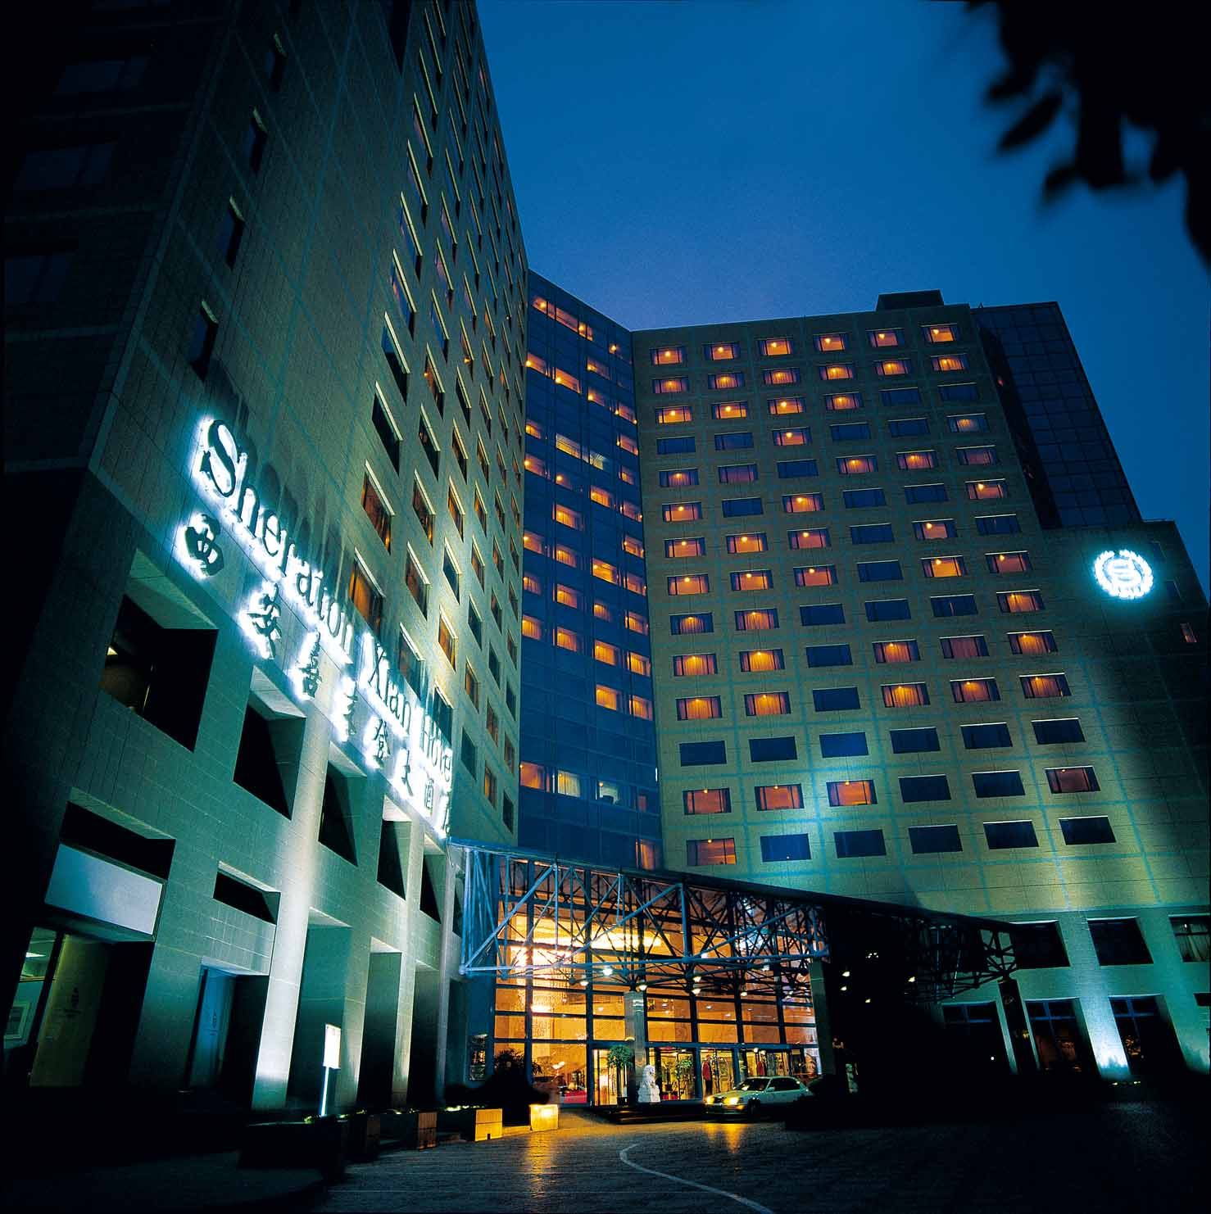

The meeting will be held at the Sheraton Xi'an Hotel. A block of rooms has been reserved at the hotel under the name 3GPP CT. The reduced single rate for the deluxe room is ￥900 CNY (~US$132) per night (full breakfast buffet, full lunch buffet during meeting days, service charge and taxes included, free broadband Internet access).Or ￥1050 CNY (~US$154) for double occupancy per night. The other choice is the SPG room, the reduced single rate is￥1000 CNY (~US$145) per night (full breakfast buffet, full lunch buffet during meeting days, service charge and taxes included, free broadband Internet access). Delegates are responsible for their own hotel reservations. Please send the reservation form (Appendix B) to the hotel by fax or email before

the cutoff date, 5 August 2010 (Note that reservation beyond this point may be considerably high and subject to availability).

In addition to hotel reservation, it is important to perform the online meeting registration at the following website: 3GPP Online Registration before 16 August 2010. This provides meeting organizers with important planning information.

For entering China, it is required to hold either tourism or business visa. Should you require a letter of invitation for your business visa application, please contact the host. Your email should attach the form in Appendix A filled with all necessary information and be sent out before 15 July 2010. For Chinese Embassy or Consulate information, please visit website http://www.fmprc.gov.cn/eng/.

There are some restaurants near to the hotel, and the general information is as follows:

Restaurants | Location | Phone No. | Price  (per person)
ZiJun Restaurant  紫钧茶餐厅 | No1,East of Feng Gao Street  沣镐东路1号甲字128号 | 029-68812669 | 50RMB
Wildness Camel Restaurant  野骆驼西餐厅 | No 320, East of Feng Gao Street  沣镐东路320号 | 029-84294770 | 70RMB
LaoXiang Coffee Restaurant  老象咖啡西餐厅 | No 102, East of Feng Gao Street  沣镐东路102号 | 029-81059229 | 70RMB
KFC | South of LaoDong Street  劳动南路 | / | 25RMB
Sheraton Food Street  喜来登食街 | Level of Sheraton Hotel  喜来登酒店一楼 | 029－84261888-1577 | 80RMB

Meeting directions and general information are provided in the following pages.

We are looking forward to seeing you in Xi'an, China.

Sincerely yours,

Ms. Qin Si
On behalf of Huawei Technologies Co., Ltd.

General Meeting Information

Meeting & Date:
3GPP CT1 #66 August 23 ~ 27, 2010
3GPP CT3 #59 August 23 ~ 27, 2010
3GPP CT4 #50 August 23 ~ 27, 2010

Location:
Xi’an, P. R. China

Contact from the host:
Ms. Qin Si
Tel: +86 755 28421324
Fax: +86 755 28421404
Email: qinsi@huawei.com

Ms. Lili Yang
Tel: +86 755 28422553
Fax: +86 755 28420413
Email: kadyyang@huawei.com

Hotel Information:
Sheraton Xian Hotel
Address: 262 Feng Hao East Road, Xi'an, Shaanxi, P.R China
Tel: + 86 29 8426 1888
Fax: + 86 29 8426 2983
Website: www.sheraton.com/xian

EDH requirements:
This will be a paperless meeting. Participants are requested to bring a wireless LAN card for their laptops. For your convenience, please be sure you have Oblique flat blades (inverted V-shape) with ground or Flat blade attachment plug to use in hotel guest room.
In meeting rooms, the host will provide power extensions with outlets fit for the power plug types illustrated in following picture.
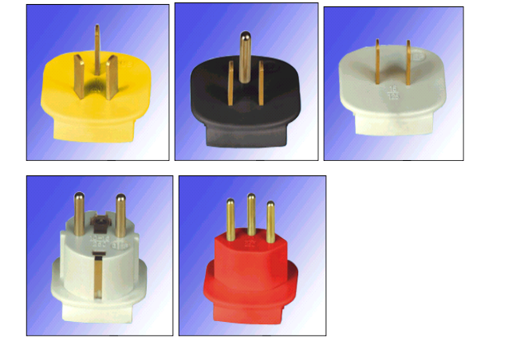
Reservation Information

The meeting will be held at the Sheraton Xian Hotel.

Cut-off Date: 5 August 2010.
Please make your reservation before the cut off date to insure the reduced group rate. Reservation beyond this point may be considerably high and subject to availability.

Check-in/Check-out Time:
Check in after 02:00 PM
Check out before 12:00 PM

Reservations:
Please fill out the form in Appendix B and return the completed form to the hotel by fax or email.

Cancellation Policy:
Please refer to Appendix B.

Please Note:
Huawei Technologies Co., Ltd is not responsible for reservation confirmations, cancelled or changed reservations, or no-shows. Please contact the hotel directly to make any changes.

Transportation Information

Sheraton Xian Hotel is near the breathtaking Xian City Wall, just 45 minutes away from Xian Xianyang International Airport and within easy reach of many top tourist attractions, leading multi-national business areas, shopping and entertainment.

- Xianyang Airport 24.14 km
- Xian Railway Station 6.0 km
- Terra Cotta Warriors Museum 45.0 km
- City Wall 3.0 km
- Big Wild Goose Pagoda 4.0 km
- The Bell Tower/Drum Tower 4.8 km
- Tang Paradise 15.0 km

Hotel Limousine ( Private Car Transfer)
- Fees are net, per car, per way.

- Toyota Camry (3 passenger, 2 luggage maximum) 330 CNY;
- Buick Van (5 passengers, 3 luggage maximum) 718 CNY;

- Mercedes Benz S350 (3 passengers, 2 luggage maximum) 880 CNY
  - Hours: 24 hours
  - Travel Time: 45 minutes
  - Contact: (86)(29) 84261888 ext1253; Reservation Required
- About: Transportation from Xianyang Airport can be arranged and through the hotel. To guarantee the service, please send email to reservation.xian@sheraton.com to confirm the arrangement, or call hotel directly.
At the airport, guest can locate hotel staff at the airport exit. Hotel staff will be holding a name board with guest name.

Airport:
It is about 45 minutes by car driving from Xi'an Xianyang International Airport to Sheraton Xi'an Hotel. Taxis are always available. The fare will be approximately ￥ 150 CNY (~US $ 22).

The information of Xi'an Xianyang International Airport could be found at http://en.wikipedia.org/wiki/Xi'an_Xianyang_International_Airport.

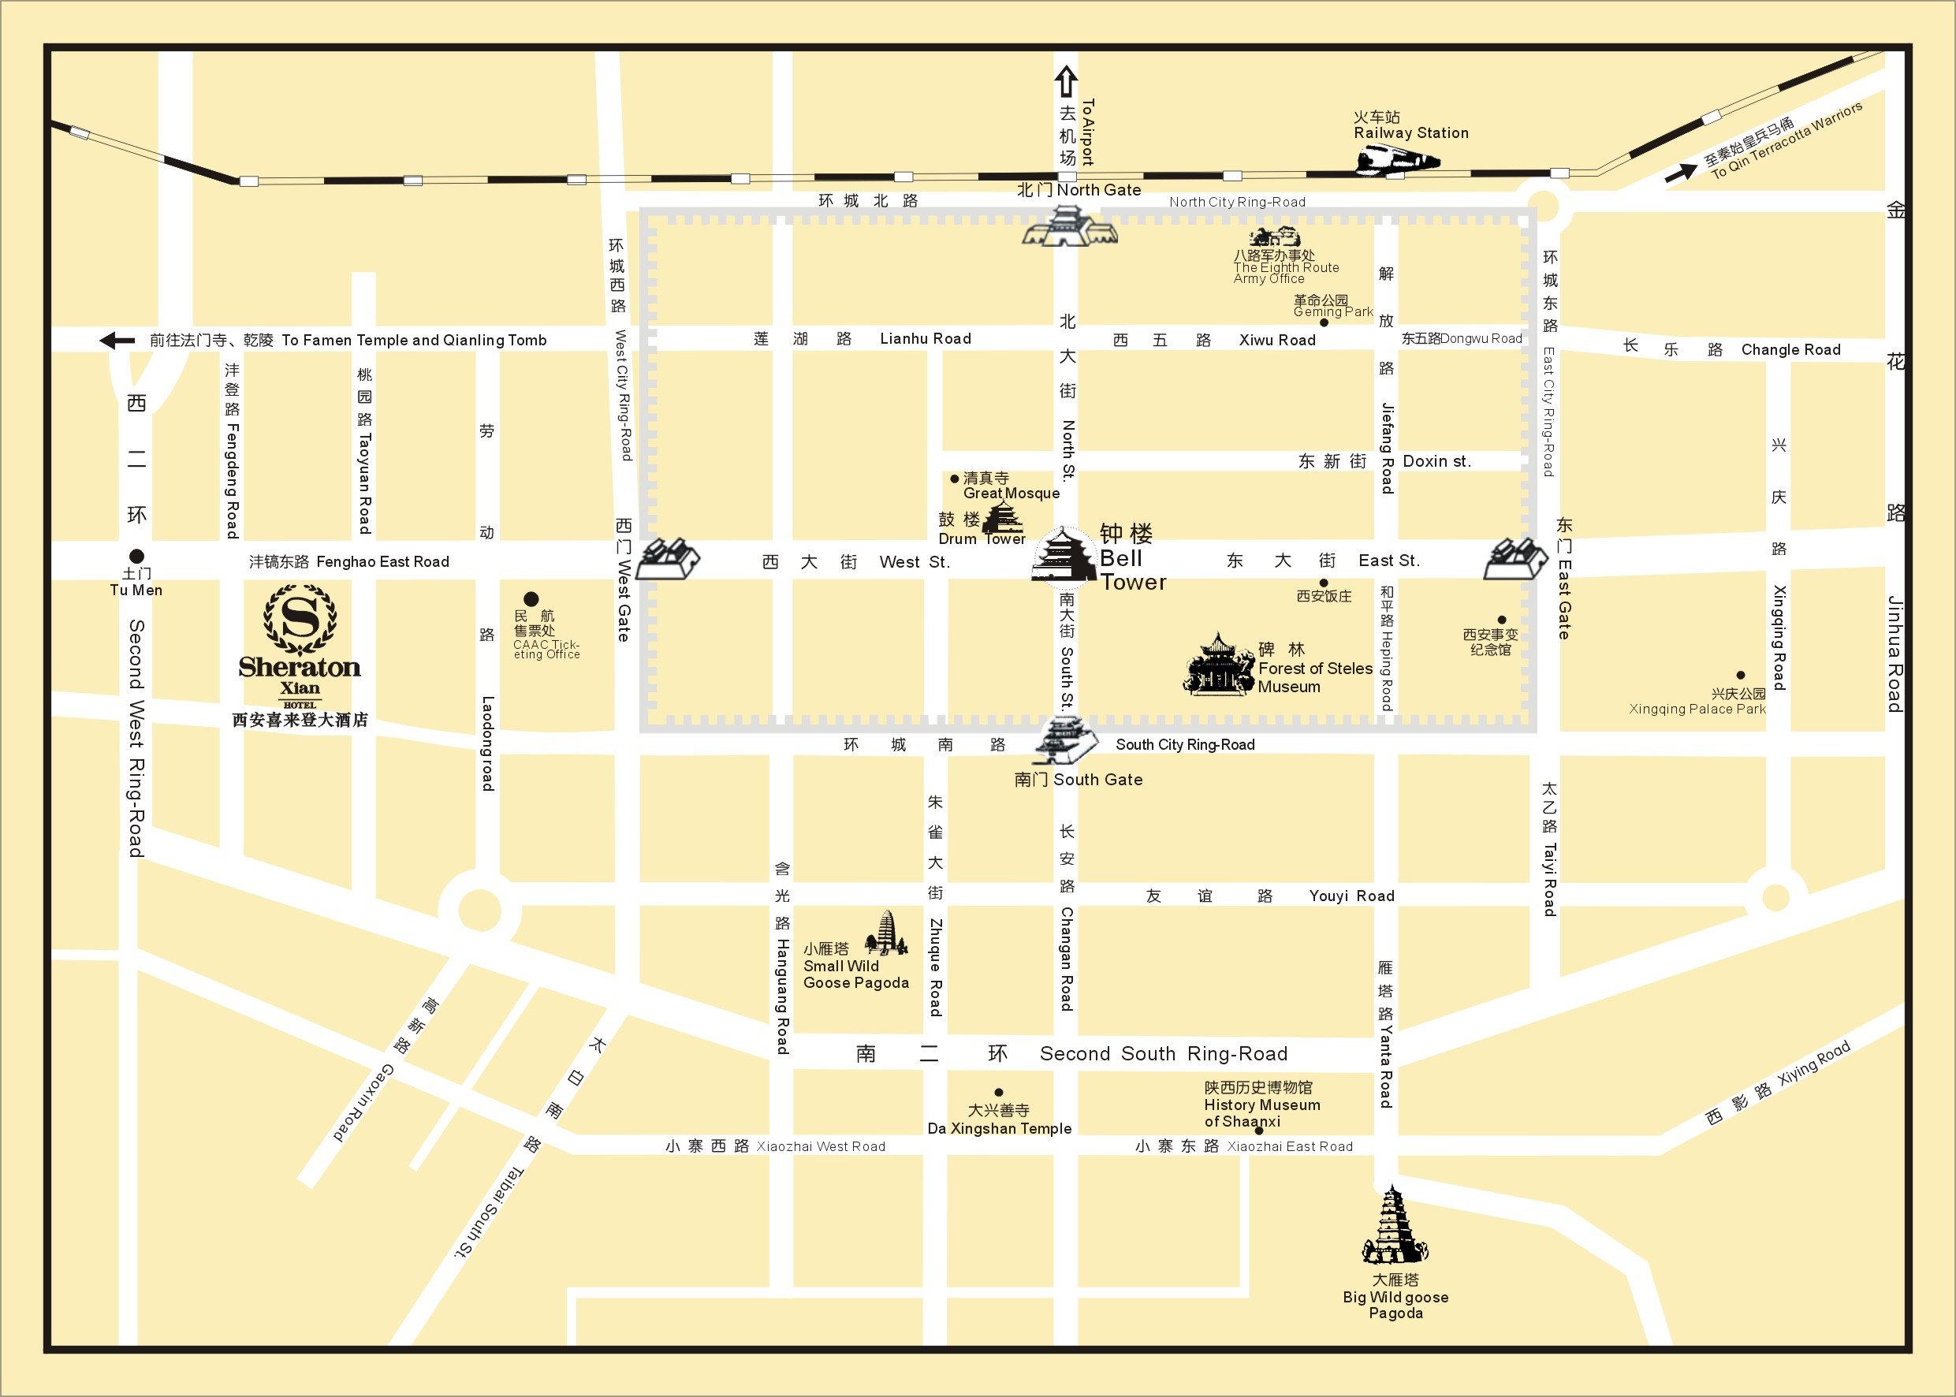

Please Note: Taxi drivers may not speak English, so make sure you have the name of your hotel or address written in Chinese. The following is the name, address and phone number of the Sheraton Xian Hotel in Chinese; please print it for your convenience:

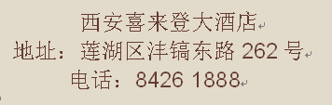

General Information for Stay in Xi'an

GSM/CDMA/3G Coverage:
There is GSM/CDMA coverage in Xi'an.
There is 3G (WCDMA/TD-SCDMA/CDMA 2000) coverage only in the centric area of Xi'an.

Currency:
Until May 31, 2010, 1 U.S. dollar was worth ￥ 6.83 CNY and 1 Euro is worth ￥ 8.40 CNY. Most foreign currencies are easily changed at banks or hotels.

Time Zone:
GMT +8 hours

Voltage:
Commercial power in China is 220V. Please be sure you have the correct adapter. Voltage converters will not be provided at the meeting.

About Xian

General Information
http://www.travelchinaguide.com/cityguides/xian.htm

Area Attractions
http://www.travelchinaguide.com/attraction/shaanxi/xian/

Weather & Clothing
http://www.travelchinaguide.com/climate/xian.htm

Shopping
http://www.travelchinaguide.com/cityguides/xian/shopping.htm

Please don’t hesitate to direct any questions regarding the logistical arrangements of this meeting to the Meeting Coordinators:

Ms. Qin Si

Have a great meeting and enjoy your stay in Xi'an!

Appendix A
3GPP CT1#66/CT3#59/CT4#50,
August 23 ~ 27, 2010
Xi'an, China

INVITATION LETTER REQUEST FORM

To enter China for the meetings indicated above, you may need a letter of invitation from the Chinese host, which you will need to present to the Chinese Embassy/Consulate in your area in order to obtain your visa. In order to obtain the invitation letter, please:

- fill out the form below;
- a copy of your passport (the name, date of birth, nationality, passport number, valid date of passport, etc. must be seen clearly; to ensure readability, a scanned photograph page is preferred.);
- a copy of previous Chinese visa and records if your entry is not the first time;
- Send all of the above to Ms. Qin Si before 15th July 2010.

Ms. Qin Si
Huawei Technologies Co., LTD
qinsi@huawei.com

Full name
Family name (Last name)
Given name (First name)
Gender (Male/Female)
Nationality
Date of Birth (dd/mm/yy)
Age (Western Count)
Passport number and issuing country:
Passport Valid until (dd/mm/yy)
Name of Company/Organization
Company/mailing address
Occupation and Job title
If the country in which you'll obtain your visa is different from your nationality, please indicate it here:
[ Country to obtain your visa]
Address(Home Country)
Postal Code
Telephone number
Fax number
Email address
In this case, it is Xi'an by default; if you want to visit other places than Xi'an, please indicate here.
Date of arrival at China
Date of departure from China
Name of meeting(e.g. CT1#66)

★ Documents applicant should provide:
1. The copy of foreigner's passport (the name, date of birth, nationality, passport number, valid date of passport, etc. must be seen clearly);
2. The copy of previous Chinese visa and records if foreigners whose entry is not the first time.

(Please do not forget to attach a copy of your passport photograph page before sending.)

Appendix B: 3GPP CT Hotel Reservation Form
3GPP CT1#66/CT3#59/CT4#50, August 23 to 27, 2010

The Sheraton Xian Hotel, Xi'an, has been chosen as the official hotel for 3GPP CT1#66/CT3#59/CT4#50, August 23 – 27,2010. Please complete this form and return to us by FAX (+ 86-29-8426 2983) or EMAIL (linda.xian@sheraton.com CC: tony.zhou@sheraton.com) on or before (Thursday, August 05, 2010).For any reservations received after the cut-off day (Thursday, August 05, 2010), both rooms and rates will be subject to hotel’s availability. The special group rate may be adjusted to our Best Available Rate should all rooms be sold out within the room block held between Hua Wei Technologies Co., Ltd and The Ritz-Carlton, Beijing.
(For the Reservation to be made, all fields marked by an asterisk “*” must be filled out.)

(Circle One) Mr./Ms./Mrs. Surnme*:__________________________First Name*:_____________________________
Name of accompanying person (if any) □Mr. □Ms. Surname*:_____________FirstName*:_________________
Company:_________________________________________________Title:___________________________________ Address:__________________________________________________________________________________________
Telephone*:_____________________________________Fax number*:______________________________________
E-mail*:________________________________________
Arrive on*: ____________________________ Flight/Time:________________________________________________
Depart on*:____________________________ Flight/Time:________________________________________________

-----------------------------------------------------------------------Room Rates extended to this particular function*:  The Deluxe Room (single) : RMB900 per room per night  **The above rates are inclusive of 15% service charge, applicable to single or double occupancy, and government taxes and fees  **Complimentary Breakfast is served daily  **Complimentary Internet Services inside the guestroom  **Complimentary full lunch buffet every day during meeting days  The Deluxe Room (double) : RMB1050 per room per night  **The above rates are inclusive of 15% service charge, applicable to single or double occupancy, and government taxes and fees  **Complimentary Breakfast is served daily  **Complimentary Internet Services inside the guestroom  **Complimentary full lunch buffet every day during meeting days  The SPG Room (single) : RMB1000 per room per night  **The above rates are inclusive of 15% service charge, applicable to single or double occupancy, and government taxes and fees  **Complimentary Breakfast is served daily  **Complimentary Internet Services inside the guestroom  **Complimentary full lunch buffet every day during meeting days  ---------------------------------------------------------------------  Preferred Room Category:  Bed Type Room Type  King-sized bed: Non-smoking room:  Two double beds: Smoking room: |  |  | -------------------------------------------------------------------------  CANCELLATION POLICY  - All bookings must be guaranteed by Credit Card. Any non-guaranteed booking room will be released 2 days prior to the day of your arrival without notice.  - 2 days prior to arrival, bookings cancelled after the charge for the first night accommodation will apply.  -----------------------------------------------------------------------  Please arrange Limousine service: (Please select)  Arrival limousine per car at Departure limousine per car at  RMB330 net (Toyota) RMB330 net (Toyota)  Arrival limousine per car at Departure limousine per car at  RMB780 net (Benz S350) RMB780 net (Benz S350)  The above price may be changed without prior notice  -----------------------------------------------------------------------  To guarantee your reservation, please submit this form before  Thursday, August 05, 2010 To:  Reservation Department  Group Coordinator  SHERATON XIAN HOTEL  262 Feng Hao East Road, Xi'an, Shaanxi 710077, P.R China  Tel: +86-29-8426 1888-1459  Simply Fax it to us at + 86-29-8426 2983  Or Reservation E-mail: linda.xian@sheraton.com CC: tony.zhou@sheraton.com  Your reservation will be confirmed ONLY when you receive a final confirmation message with confirmation number from the hotel.
Special Request:
Check In: 14:00 hr / Check Out: 12:00 hr

------------------------------------------------------------------------
I would like to guarantee my reservations by:
Credit Card Type*:

Credit Card Number*:

Expiry Date*:

Cardholder's Signature*
and Name*:

