3GPP TS 29.594 V16.4.0 (2020-12)
Technical Specification
3rd Generation Partnership Project;
Technical Specification Group Core Network and Terminals;
5G System; Spending Limit Control Service;
Stage 3
(Release 16)


The present document has been developed within the 3rd Generation Partnership Project (3GPP TM) and may be further elaborated for the purposes of 3GPP.
The present document has not been subject to any approval process by the 3GPP Organisational Partners and shall not be implemented.
This Specification is provided for future development work within 3GPP only. The Organisational Partners accept no liability for any use of this Specification.
Specifications and reports for implementation of the 3GPP TM system should be obtained via the 3GPP Organisational Partners' Publications Offices.

Keywords
3GPP
Postal address

3GPP support office address
650 Route des Lucioles - Sophia Antipolis
Valbonne - FRANCE
Tel.: +33 4 92 94 42 00 Fax: +33 4 93 65 47 16
Internet
http://www.3gpp.org
Copyright Notification
No part may be reproduced except as authorized by written permission.
The copyright and the foregoing restriction extend to reproduction in all media.

© 2020, 3GPP Organizational Partners (ARIB, ATIS, CCSA, ETSI, TSDSI, TTA, TTC).
All rights reserved.

UMTS™ is a Trade Mark of ETSI registered for the benefit of its members
3GPP™ is a Trade Mark of ETSI registered for the benefit of its Members and of the 3GPP Organizational Partners
LTE™ is a Trade Mark of ETSI registered for the benefit of its Members and of the 3GPP Organizational Partners
GSM® and the GSM logo are registered and owned by the GSM Association
Contents
Foreword 5
1 Scope 6
2 References 6
3 Definitions and abbreviations 7
3.1 Definitions 7
3.2 Abbreviations 7
4 Nchf_SpendingLimitControl Service 7
4.1 Service Description 7
4.1.1 Overview 7
4.1.2 Service Architecture 7
4.1.3 Network Functions 8
4.1.3.1 Charging Function (CHF) 8
4.1.3.2 NF Service Consumers 8
4.2 Service Operations 8
4.2.1 Introduction 8
4.2.2 Nchf_SpendingLimitControl_Subscribe service operation 9
4.2.2.1 General 9
4.2.2.2 Initial spending limit retrieval 9
4.2.2.3 Intermediate spending limit report retrieval 11
4.2.3 Nchf_SpendingLimitControl_Unsubscribe service operation 13
4.2.3.1 General 13
4.2.3.2 Unsubscribe from spending limit reporting 13
4.2.4 Nchf_SpendingLimitControl_Notify service operation 13
4.2.4.1 General 13
4.2.4.2 Spending limit report 14
4.2.4.3 Subscription termination request by CHF 15
5 Nchf_SpendingLimitControl Service API 16
5.1 Introduction 16
5.2 Usage of HTTP 16
5.2.1 General 16
5.2.2 HTTP standard headers 16
5.2.2.1 General 16
5.2.2.2 Content type 16
5.2.3 HTTP custom headers 17
5.2.3.1 General 17
5.3 Resources 17
5.3.1 Resource Structure 17
5.3.2 Resource: Spending Limit Retrieval Subscriptions (Collection) 17
5.3.2.1 Description 17
5.3.2.2 Resource definition 17
5.3.2.3 Resource Standard Methods 18
5.3.2.3.1 POST 18
5.3.2.4 Resource Custom Operations 18
5.3.3 Resource: Individual Spending Limit Retrieval Subscription (Document) 18
5.3.3.1 Description 18
5.3.3.2 Resource definition 19
5.3.3.3 Resource Standard Methods 19
5.3.3.3.1 PUT 19
5.3.3.3.2 DELETE 19
5.4 Custom Operations without associated resources 20
5.5 Notifications 20
5.5.1 General 20
5.5.2 Spending limit notification 20
5.5.2.1 Description 20
5.5.2.2 Target URI 20
5.5.2.3 Standard Methods 20
5.5.2.3.1 POST 20
5.5.3 Subscription Termination 21
5.5.3.1 Description 21
5.5.3.2 Target URI 21
5.5.3.3 Standard Methods 21
5.5.3.3.1 POST 21
5.6 Data Model 22
5.6.1 General 22
5.6.2 Structured data types 22
5.6.2.1 Introduction 22
5.6.2.2 Type SpendingLimitContext 23
5.6.2.3 Type SpendingLimitStatus 24
5.6.2.4 Type PolicyCounterInfo 25
5.6.2.5 Type PendingPolicyCounterStatus 25
5.6.2.6 Type SubscriptionTerminationInfo 25
5.6.3 Simple data types and enumerations 25
5.6.3.1 Introduction 25
5.6.3.2 Simple data types 25
5.6.3.3 Enumeration: TerminationCause 26
5.7 Error handling 26
5.7.1 General 26
5.7.2 Protocol Errors 26
5.7.3 Application Errors 26
5.8 Feature negotiation 26
5.9 Security 27
Annex A (normative): OpenAPI specification 28
A.1 General 28
A.2 Nchf_SpendingLimitControl Service API 28
Annex B (normative): 5GC and EPC interworking scenario support 32
B.1 Scope 32
B.2 Nchf_SpendingLimitControl Service 32
B.2.1 Service Description 32
B.2.1.1 Overview 32
B.2.1.2 Service Architecture 32
B.3 Service Operation 32
B.3.1 Introduction 32
B.3.2 Nchf_SpendingLimitControl_Subscribe Service Operation 32
B.3.3 Nchf_SpendingLimitControl_Unsubscribe Service Operation 33
B.3.4 Nchf_SpendingLimitControl_Notify Service Operation 33
Annex C (informative): Change history 34

Foreword
This Technical Specification has been produced by the 3rd Generation Partnership Project (3GPP).
The contents of the present document are subject to continuing work within the TSG and may change following formal TSG approval. Should the TSG modify the contents of the present document, it will be re-released by the TSG with an identifying change of release date and an increase in version number as follows:
Version x.y.z
where:
x the first digit:
1 presented to TSG for information;
2 presented to TSG for approval;
3 or greater indicates TSG approved document under change control.
y the second digit is incremented for all changes of substance, i.e. technical enhancements, corrections, updates, etc.
z the third digit is incremented when editorial only changes have been incorporated in the document.

1 Scope
The present specification provides the stage 3 definition of the Spending Limit Control Service of the 5G System.
The 5G System Architecture is defined in 3GPP TS 23.501 [2]. The stage 2 definition and related procedures for the Spending Limit Control Service are specified in 3GPP TS 23.502 [3] and 3GPP TS 23.503 [6].
The 5G System stage 3 call flows are provided in 3GPP TS 29.513 [12].
The Technical Realization of the Service Based Architecture and the Principles and Guidelines for Services Definition are specified in 3GPP TS 29.500 [4] and 3GPP TS 29.501 [5].
The Spending Limit Control Service is provided by the Charging Function (CHF) and enables the NF service consumer to retrieve policy counter status information. The internal CHF functionality for policy counter management provisioning is specified in 3GPP TS 32.240 [7].

2 References
The following documents contain provisions which, through reference in this text, constitute provisions of the present document.
- References are either specific (identified by date of publication, edition number, version number, etc.) or non-specific.
- For a specific reference, subsequent revisions do not apply.
- For a non-specific reference, the latest version applies. In the case of a reference to a 3GPP document (including a GSM document), a non-specific reference implicitly refers to the latest version of that document in the same Release as the present document.
[1] 3GPP TR 21.905: "Vocabulary for 3GPP Specifications".
[2] 3GPP TS 23.501: "System Architecture for the 5G System; Stage 2".
[3] 3GPP TS 23.502: "Procedures for the 5G System; Stage 2".
[4] 3GPP TS 29.500: "5G System; Technical Realization of Service Based Architecture; Stage 3".
[5] 3GPP TS 29.501: "5G System; Principles and Guidelines for Services Definition; Stage 3".
[6] 3GPP TS 23.503: "Policy and Charging Control Framework for the 5G System; Stage 2".
[7] 3GPP TS 32.240: "Charging architecture and principles; Stage 2".
[8] IETF RFC 7540: "Hypertext Transfer Protocol Version 2 (HTTP/2)".
[9] OpenAPI: "OpenAPI 3.0.0 Specification", https://github.com/OAI/OpenAPI-Specification/blob/master/versions/3.0.0.md.
[10] IETF RFC 8259: "The JavaScript Object Notation (JSON) Data Interchange Format".
[11] 3GPP TS 29.571: "5G System; Common Data Types for Service Based Interfaces".
[12] 3GPP TS 29.513: "5G System; Policy and Charging Control signalling flows and QoS parameter mapping; Stage 3".
[13] IETF RFC 7807: "Problem Details for HTTP APIs".
[14] 3GPP TS 33.501: "Security architecture and procedures for 5G system".
[15] IETF RFC 6749: "The OAuth 2.0 Authorization Framework".
[16] 3GPP TS 29.510: "5G System; Network Function Repository Services; Stage 3".
[17] 3GPP TR 21.900: "Technical Specification Group working methods".
[18] 3GPP TS 29.512: "5G System; Session Management Policy Control Service; Stage 3".

3 Definitions and abbreviations

3.1 Definitions
For the purposes of the present document, the terms and definitions given in 3GPP TR 21.905 [1] and the following apply. A term defined in the present document takes precedence over the definition of the same term, if any, in 3GPP TR 21.905 [1].
Nchf: Service-based interface exhibited by Charging Function.

3.2 Abbreviations
For the purposes of the present document, the abbreviations given in 3GPP TR 21.905 [1] and the following apply. An abbreviation defined in the present document takes precedence over the definition of the same abbreviation, if any, in 3GPP TR 21.905 [1].
CCS Converged Charging System
CHF Charging Function
CTS Charging Trigger Function
GPSI Generic Public Subscription Identifier
NF Network Function
NRF Network Repository Function
PCF Policy Control Function
SUPI Subscription Permanent Identifier

4 Nchf_SpendingLimitControl Service

4.1 Service Description

4.1.1 Overview
The Nchf_SpendingLimitControl service, as defined in 3GPP TS23.502 [3] and 3GPP TS23.503 [6], is provided by the Charging Function (CHF).
The Nchf_SpendingLimitControl service enables the NF service consumer (i.e. PCF) to retrieve policy counter status information and spending limit reporting per UE from the CHF.
If the spending limit reporting is no more required the Nchf_SpendingLimitControl service enables the NF service consumer to unsubscribe from the reporting.
Nchf_SpendingLimitControl Service applies to the cases where the PCF interacts with the CHF in the non-roaming scenario, and the H-PCF interacts with the H-CHF in the home-routed scenario.

4.1.2 Service Architecture
The Nchf_SpendingLimitControl service is provided by the CHF and consumed by the PCF, as shown in figure 4.1.2-1 for the SBI representation model and in figure 4.1.2-2 for the reference point representation model.
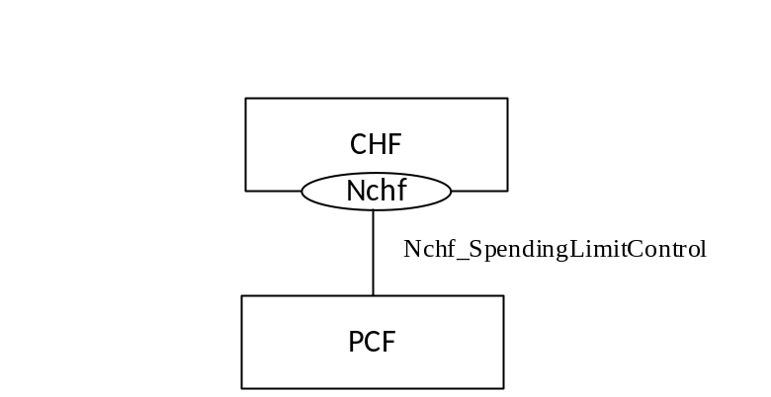
Figure 4.1.2-1: Nchf_SpendingLimitControl service architecture, SBI representation
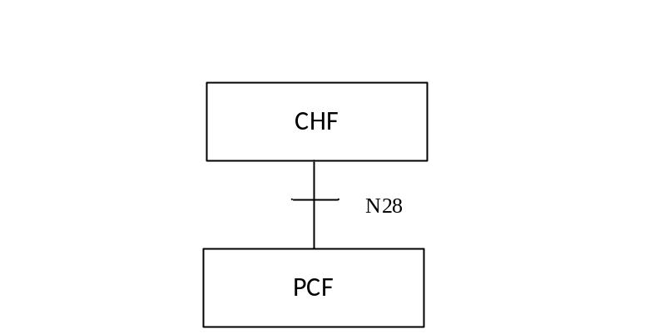
Figure 4.1.2-2: Nchf_SpendingLimitControl service architecture, reference point representation

4.1.3 Network Functions

4.1.3.1 Charging Function (CHF)
The Charging Function (CHF) is part of the Converged Charging System (CCS). The CHF provides the Nchf_SpendingLimitControl service and is specified in 3GPP TS 32.240 [7].

4.1.3.2 NF Service Consumers
The PCF is the known NF service consumer, as defined in 3GPP TS 23.502 [3]. The NF service consumer accesses policy counter status information relating to the subscriber spending from the CHF and uses the status of each relevant policy counter as input to its policy decision as required by the decision logic.

4.2 Service Operations

4.2.1 Introduction
The service operations defined for the Nchf_SpendingLimitControl service are shown in table 4.2.1-1.
Table 4.2.1-1: Nchf_SpendingLimitControl Service Operations
Service operation name | Description | Initiated by
Nchf_SpendingLimitControl_Subscribe | This service operation is used by an NF service consumer to subscribe to notification of changes in the status of the policy counters available and retrieval of the status of the policy counters for which subscription is accepted. | NF service consumer (PCF)
Nchf_SpendingLimitControl_Unsubscribe | This service operation is used by an NF service consumer to unsubscribe from notification of changes in the status of all policy counters. | NF service consumer (PCF)
Nchf_SpendingLimitControl_Notify | This service operation is used by the CHF to notify the NF service consumers about the change of the status of the subscribed policy counters. Alternatively, it can be used by the CHF to notify that the status for one or multiple subscribed policy counter will change in the future, indicating the time when this change shall be applied. Alternatively, it is also used to notify the NF service consumer of the removal of a subscriber from the CHF system for the purpose that the NF service consumer can terminate the subscriptions of all policy counters of the subscriber. | CHF

4.2.2 Nchf_SpendingLimitControl_Subscribe service operation

4.2.2.1 General
The Nchf_SpendingLimitControl_Subscribe service operation is used by the NF service consumer to subscribe to notification of changes in the status of the policy counters available and to retrieve the status of the policy counters for which the subscription is accepted. The following procedures are related to the subscribe service operation:
- initial spending limit retrieval; and
- intermediate spending limit report retrieval.

4.2.2.2 Initial spending limit retrieval
Figure 4.2.2.2-1 shows the scenario where the NF service consumer sends a request to the CHF to retrieve the status of policy counters available at the CHF and to subscribe to spending limit reporting (see also 3GPP TS 23.502 [3], figure 4.16.8.2.1).
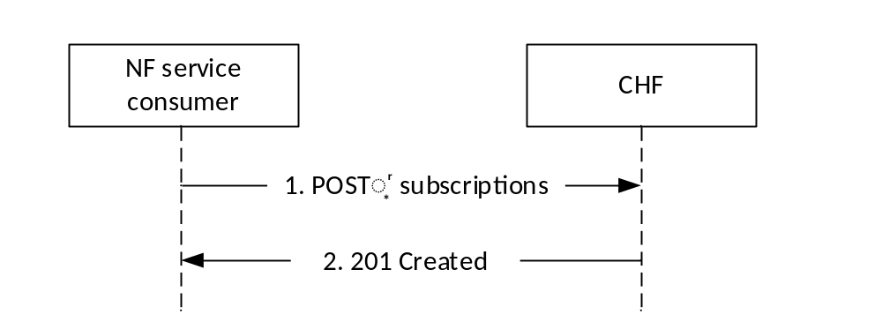
Figure 4.2.2.2-1: NF service consumer subscribes to retrieve policy counter status and spending limit reporting
The NF service consumer shall send an HTTP POST request to the resource "{apiRoot}/nchf-spendinglimitcontrol/v1/subscriptions" representing the "Spending Limit Retrieval Subscriptions", as shown in figure 4.2.2.2-1, step 1, to create a subscription for retrieval of the policy counter status and spending limit reporting.
The "SpendingLimitContext" data structure provided in the request body shall include:
- the Subscription Permanent Identifier (SUPI) encoded in the "supi" attribute;
- the notification correlation target address encoded in the "notifUri" attribute; and
- If the feature "NotificationCorrelation" is supported, a Notification Correlation Identifier assigned by the NF service consumer for the requested notifications encoded in the "notifId" attribute, if the "notifUri" does not encode within the provided URI the notification correlation Id.
NOTE: NF service consumer (i.e. PCF) ensures the combination of notifUri and notifId is unique per subscription in the whole network, including multiple network slices scenario.
The "SpendingLimitContext" data structure provided in the request body may include:
- the General Public Subscription Identifier (GPSI) encoded in the "gpsi" attribute;
- Event Filter information "list of policy counter identifier(s)" encoded in the "policyCounterIds" attribute. The "policyCounterIds" attribute shall contain the list of policy counter identifiers to be subscribed to. If the "policyCounterIds" attribute is omitted, the subscription is to all available policy counters; and
- when the feature "SubscriptionExpirationTimeControl" is supported by the NF service consumer, the NF service consumer may include an expiry time encoded in the "expiry" attribute, representing the time up to which the subscription is desired to be kept active. When the "expiry" attribute is omitted in the request, it represents the NF service consumer does not have any time constraint in the duration of the subscription.
If the CHF cannot successfully fulfil the received HTTP POST request due to an internal CHF error or due to the error in the HTTP POST request, the CHF shall send the HTTP error response as specified in subclause 5.7.
If the subscriber specified in the request is unknown to the CHF, the CHF shall indicate in an HTTP "400 Bad Request" response the cause for the rejection with the "cause" attribute set to "USER_UNKNOWN".
If the CHF has no available policy counters specified for the subscriber, the CHF shall indicate in an HTTP "400 Bad Request" response the cause for the rejection with the "cause" attribute set to "NO_AVAILABLE_POLICY_COUNTERS ".
If one or more policy counters specified in the request in the "policyCounterIds" attribute are unknown to the CHF, and the CHF is configured to reject request, the CHF shall indicate in an HTTP "400 Bad Request" response the cause for the rejection with the "cause" attribute set to "UNKNOWN_POLICY_COUNTERS" and the unknown policy counter identifiers within the "invalidParams" attribute.
Otherwise, upon the reception of an HTTP POST request the CHF shall:
- create a new subscription resource, which contains the list the policy counters included in the "policyCounterId" attribute, or if the "policyCounterId" attribute is omitted, all the policy counters of the subscriber;
- assign a subscriptionId; and
- store the subscription resource.
After the CHF created an "Individual Spending Limit Retrieval Subscription" resource, the CHF shall respond with "201 Created" response with a Location header field containing the URI of the created subscription resource and the message body containing a representation of the created subscription, as shown in figure 4.2.2.2-1, step 2.
The SpendingLimitStatus data structure provided in the response body shall include the status of the requested subscribed policy counters in the "statusInfos" map, where every PolicyCounterInfo entry shall contain:
- the policy counter identifier in the "policyCounterId" attribute; and
- the policy counter status in the "currentStatus" attribute.
When a requested policy counter identifier is known by the CHF, but it is not applicable to the subscriber (e.g. not provisioned), the CHF may include it in the "statusInfos" map, and set the "currentStatus" attribute to an operator configured policy counter status to indicate this to the NF service consumer.
When one or more policy counters specified in the request in the "policyCounterIds" attribute are unknown to the CHF, and the CHF is configured to accept the request, the CHF may include the unknown policy counters in the "statusInfos" map, and set the "currentStatus" attribute to an operator configured policy counter status to indicate this to the NF service consumer.
A PolicyCounterInfo data structure may include the list of the pending policy counter statuses and their activation times within the attribute "penPolCounterStatuses".

When the feature "SubscriptionExpirationTimeControl" is supported, the CHF may include the "expiry" attribute, representing the time up to which the subscription shall be kept active. If an expiry time was included in the subscription request, then the expiry time shall be returned in the response, and the value shall be less than or equal to the requested value. When the "expiry" attribute is omitted in the request and in the response, it represents neither the CHF or the NF service consumer have time constrains in the duration of the subscription and shall be kept active till the explicit subscription termination as described in subclause 4.2.3.2 and subclause 4.2.4.3.
NOTE 1: If the NF Service Consumer does not include a expiry time in the request, the CHF can include a expiry time in the response that represents the time after which the subscription becomes invalid.
NOTE 2: Once the subscription expires, if the NF service consumer wants to keep receiving notifications, it needs to create a new subscription in the CHF, as specified in this subclause.

4.2.2.3 Intermediate spending limit report retrieval
Figure 4.2.2.3-1 shows the scenario where the NF service consumer sends a request to the CHF to modify the existing subscription to the retrieval of spending limit reports (see also 3GPP TS 23.502 [3], figure 4.16.8.3.1). The NF service consumer can add or remove policy counters to retrieve the status of the counters.
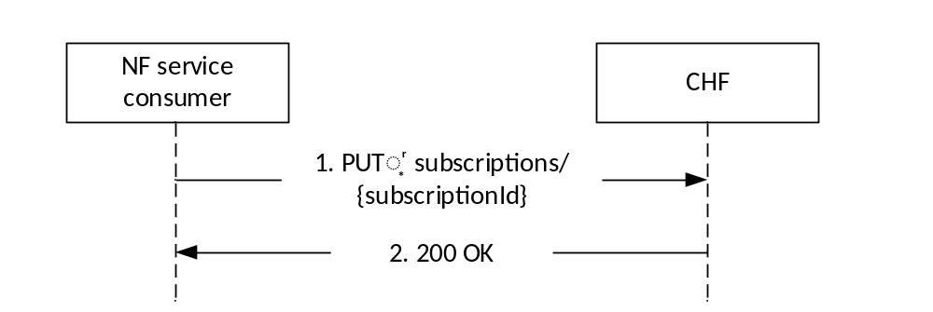
Figure 4.2.2.3-1: NF service consumer modifies the subscription to retrieve policy counter status and spending limit reporting
The NF service consumer shall send an HTTP PUT request to the resource "{apiRoot}/nchf-spendinglimitcontrol/v1/subscriptions/{subscriptionId}" representing an existing "Individual Spending Limit Subscription" resource, as shown in figure 4.2.2.3-1, step 1, to modify the subscription for retrieval of the policy counter status and spending limit reporting.
The "SpendingLimitContext" data structure provided in the request body:
- shall include the Subscription Permanent Identifier (SUPI) encoded in the "supi" attribute;
- shall include the notification correlation target address encoded in the "notifUri" attribute;
NOTE 1: If the notification correlation target address is not changed the previously provided notification correlation target address is included in the "notifUri" attribute.
- if the General Public Subscription Identifier (GPSI) was provided within the initial spending limit retrieval procedure, described in subclause 4.2.2.2, shall include the GPSI encoded in the "gpsi" attribute; and
- may include Event Filter information as a "list of policy counter identifier(s)" encoded in the "policyCounterIds" attribute. The "policyCounterIds" attribute shall contain the updated list of policy counter identifiers to be subscribed to. If the "policyCounterIds" attribute is omitted, the subscription is updated to all available policy counters; and
- when the feature "SubscriptionExpirationTimeControl" is supported, may include an expiry time encoded in the "expiry" attribute to update the duration of the subscription, representing the updated time up to which the subscription is desired to be kept active. When the "expiry" attribute is omitted in the request, the subscription shall be considered valid without an expiry time.
When the "policyCounterIds" attribute is present in the subscription request, this list of policy counters overrides a previously provisioned list.
After the CHF modified an "Individual Spending Limit Retrieval Subscription" resource, the CHF shall respond with "200 OK" response with the message body containing a representation of the modified subscription, as shown in figure 4.2.2.3-1, step 2.
The SpendingLimitStatus data structure provided in the response body, when the feature "SubscriptionExpirationTimeControl" is not supported, shall include the status of the requested subscribed policy counters in the "statusInfos" map, where every PolicyCounterInfo entry shall contain:
- the policy counter identifier in the "policyCounterId" attribute; and
- the policy counter status in the "currentStatus" attribute.
When a requested policy counter identifier is known by the CHF, but it is not applicable to the subscriber (e.g. not provisioned), the CHF may include it in the "statusInfos" map, and set the "currentStatus" attribute to an operator configured policy counter status to indicate this to the NF service consumer.
When one or more policy counters specified in the request in the "policyCounterIds" attribute are unknown to the CHF, and the CHF is configured to accept the request, the CHF may include the unknown policy counters in the "statusInfos" map, and set the "currentStatus" attribute to an operator configured policy counter status to indicate this to the NF service consumer.
A PolicyCounterInfo data structure may include the list of the pending policy counter statuses and their activation times within the attribute "penPolCounterStatuses".
When the feature "SubscriptionExpirationTimeControl" is supported, the CHF may include the "expiry" attribute, representing the time up to which the subscription shall be kept active. If an expiry time was included in the subscription update request, then the expiry time shall be returned in the response, and the value returned should be less than or equal to the value in the request. When the "expiry" attribute is omitted in the request and in the response, it represents that the previously agreed duration of the subscription remains valid.
NOTE 2: When the NF service consumer does not include a expiry time in the request, the CHF can include a expiry time in the response that represents an update of the previously provided duration of the subscription.
NOTE 3: Once the subscription expires, if the NF service consumer wants to keep receiving notifications, it needs to create a new subscription in the CHF, as specified in subclause 4.2.2.2.
If the HTTP PUT request is not accepted by the CHF, it shall indicate the appropriate cause for the rejection in the HTTP response code to the NF service consumer as specified in subclause 5.7.
If the CHF has no available policy counters specified for the subscriber, the CHF shall indicate in an HTTP "400 Bad Request" response the cause for the rejection with the "cause" attribute set to "NO_AVAILABLE_POLICY_COUNTERS ".
If one or more policy counters specified in the PUT request in the "policyCounterIds" attribute are unknown to the CHF, and the CHF is configured to reject request, the CHF shall indicate in an HTTP "400 Bad Request" response the cause for the rejection with the "cause" attribute set to "UNKNOWN_POLICY_COUNTERS" and the unknown policy counter identifiers within the "invalidParams" attribute. The PUT request shall not take effect, and the CHF shall maintain the Individual Spending Limit Retrieval resource.
NOTE 4: In order to avoid misbehaviors due to the policy counters status maintained in the CHF and the NF service consumer, the NF service consumer can terminate the subscription invoking the Nchf_SpendingLimitControl_Unsubscribe service operation in subclause 4.2.3.2.
NOTE 5: The NF service consumer can terminate the subscription invoking the Nchf_SpendingLimitControl_Unsubscribe service operation in subclause 4.2.3.2, or maintain subscription assuming that further available policy counters will be notified.

4.2.3 Nchf_SpendingLimitControl_Unsubscribe service operation

4.2.3.1 General
The Nchf_SpendingLimitControl_Unsubscribe service operation is used by the NF service consumer to cancel the subscription of status changes for all the policy counters available at the CHF. That means the complete cancellation of the spending limit reporting procedure.

4.2.3.2 Unsubscribe from spending limit reporting
Figure 4.2.3.2-1 shows the scenario where the NF service consumer sends a request to the CHF to unsubscribe from spending limit reporting (see also 3GPP TS 23.502 [3] figure 4.16.8.4.1).
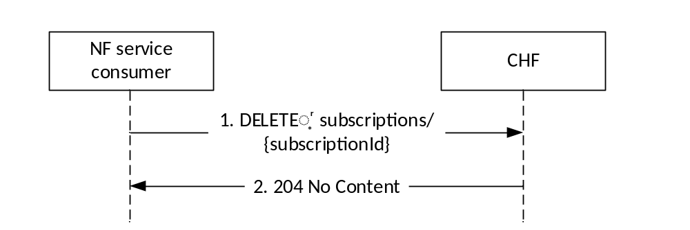
Figure 4.2.3.2-1: NF service consumer unsubscribes from spending limit reporting
The NF service consumer shall invoke the Nchf_SpendingLimitControl_Unsubscribe service operation to unsubscribe from the spending limit reporting (status change for all policy counters available is no more required). The NF service consumer shall send an HTTP DELETE request to the resource "{apiRoot}/nchf-spendinglimitcontrol/v1/subscriptions /{subscriptionId}", whereby the "{subscriptionId}" is the identification of the existing subscription to be deleted. Upon the reception of an HTTP DELETE request the CHF removes the corresponding subscription.
If the HTTP DELETE request is accepted by the CHF, it shall respond with "204 No Content" as shown in figure 4.2.3.2-1, step 2.
If the HTTP DELETE request is not accepted by the CHF (e.g. the HTTP DELETE request is for a non-existent subscription), it shall indicate the appropriate cause for the rejection in the HTTP response code to the NF service consumer.

4.2.4 Nchf_SpendingLimitControl_Notify service operation

4.2.4.1 General
The Nchf_SpendingLimitControl_Notify service operation is used by the CHF:
- to notify the change of the status of the subscribed policy counters available at the CHF for that subscriber; and/or
- to provide one or more pending statuses for a subscribed policy counter together with the time they shall be applied; and/or
- to request the termination of the subscription of status changes for all policy counters for a subscriber (e.g. the subscriber is removed from the CHF system).

4.2.4.2 Spending limit report
Figure 4.2.4.2-1 shows the scenario where the CHF sends a notification to the NF service consumer, when it detects that the status of a policy counter(s) has changed and the NF service consumer has subscribed to notifications of changes in the status of this policy counter(s). The CHF can also notify the NF service consumer that the status for one or multiple subscribed policy counter will change and indicate this by providing the time when this change shall be applied (see also 3GPP TS 23.502 [3], figure 4.16.8.5.1).
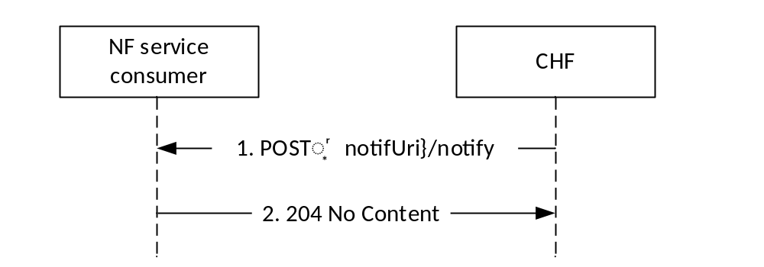
Figure 4.2.4.2-1: Spending limit reporting
The CHF shall send an HTTP POST request to the resource notification target address (notifUri) of the NF service consumer received in the subscription creation or modification, and shall append the "notify" segment path at the end of the URI, to indicate the NF service consumer the notification of a policy counter status change.
The SpendingLimitStatus data structure provided in the request body shall include:
- Subscriber Identity in the "supi" attribute;
- if the feature "NotificationCorrelation" is supported, the notification correlation ID in the "notifId" attribute if received in the SpendingLimitContext data structure provided in the creation of the subscription; and
- when the feature "SubscriptionExpirationTimeControl" is not supported, Policy counters status in the "statusInfos" map, where every PolicyCounterInfo entry shall include:
a. the "policyCounterId" attribute with the policy counter identifier; and
b. the "currentStatus" attribute with the new policy counter status when the notification is triggered by a change in the policy counter status, or the current policy counter status when the notification is triggered by a change in the pending policy counter status(es).
NOTE 1: When the feature "SubscriptionExpirationTimeControl" is supported, the CHF may include the update of the expiry time, and if at this time there is no change of policy counter status, the CHF may not include the "statusInfos" attribute.
When a policy counter identifier is no longer applicable to the subscriber (e.g. becomes not provisioned), but still exists in the Individual Spending Control Retrieval resource, the CHF may include it in the "statusInfos" map, and set the "currentStatus" attribute to an operator configured policy counter status to indicate this to the NF service consumer.
A PolicyCounterInfo data structure may include the list of pending policy counter statuses and their activation times within the attribute "penPolCounterStatuses.
When the feature "SubscriptionExpirationTimeControl" is supported, the CHF may include the "expiry" attribute, representing an update in the time up to which the subscription shall be kept active. When the "expiry" attribute is omitted, it represents that the previously agreed duration of the subscription remains valid.
NOTE 2: Once the subscription expires, if the NF Service Consumer wants to keep receiving notifications, it needs to create a new subscription in the CHF, as specified in subclause 4.2.2.2.
The CHF shall not send the policy counter status for the same policy counter until it received the response of the previous status report of the policy counter.
If the HTTP POST notification request message is accepted by the NF service consumer, it shall acknowledge the receipt of the event notification with a "204 No Content" response, as shown in figure 4.2.4.2-1, step 2.
If the HTTP POST request is not accepted and the information received is not considered by the NF service consumer, the NF service consumer shall indicate the appropriate cause for the rejection in the HTTP response code to the CHF.
If the NF service consumer receives an HTTP POST notification request message for an intermediate spending limit report transaction from the CHF in which no pending policy counter statuses and their activation times are included for a policy counter, i.e., the "penPolCounterStatuses" attribute is not included, the NF service consumer shall cancel all previously provided pending policy counter statuses and their activation times for this policy counter. If the NF service consumer receives an HTTP POST notification request message for an intermediate spending limit report transaction from the CHF containing pending policy counter statuses and their activation times for a previously provided policy counter, the NF service consumer shall replace the existing pending policy counter statuses and their activation times if any.
If the NF service consumer receives an HTTP POST request for spending limit report initiated by the CHF while it has an ongoing intermediate spending limit report retrieval transaction with the CHF, the NF service consumer shall update the policy counter information based on the HTTP POST request for spending limit report. When the corresponding response for the ongoing intermediate spending limit report retrieval transaction is eventually received, the NF service consumer shall only update policy counter information for counters that were not provided in the previously received HTTP POST request for spending limit report.

4.2.4.3 Subscription termination request by CHF
Figure 4.2.4.3-1 shows the scenario where the CHF sends a notification to the NF service consumer, when it requests the termination of the subscription of status changes for all policy counters for a subscriber.

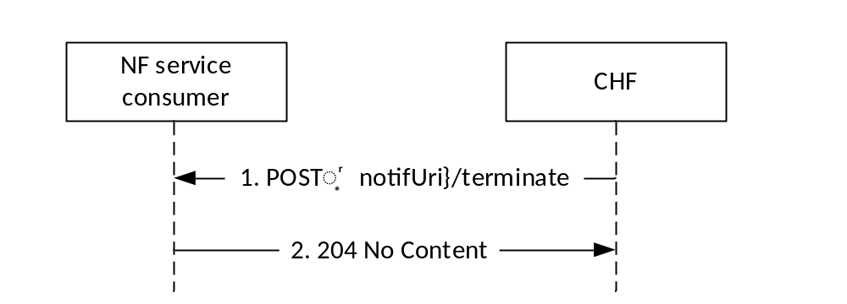
Figure 4.2.4.3-1: Subscription termination request by CHF
The CHF shall send an HTTP POST request to the resource notification target address (notifUri) of the NF service consumer received in the subscription creation or modification and shall append the "terminate" segment path at the end of the URI, to indicate the subscription termination and the removal of the Individual Spending Limit Retrieval Subscription resource to the NF service consumer.
The SubscriptionTerminationInfo data structure provided in the request body shall include the subscriber identification encoded in the "supi" attribute and may include subscription termination information in the "termCause" attribute.
When the termination request is because the subscriber identified by the SUPI has been removed from the CHF, the CHF shall set the "termCause" attribute to "REMOVED_SUBSCRIBER".
If the HTTP POST notification request message is accepted by the NF service consumer, it shall remove the subscription to notifications of all policy counters for a subscriber and shall acknowledge the receipt of the event notification with a "204 No Content" response, as shown in figure 4.2.4.3-1, step 2.
If the HTTP POST request is not accepted and the information received is not considered by the NF service consumer, the NF service consumer shall indicate the appropriate cause for the rejection in the HTTP response code to the CHF as specified in subclause 5.7.

5 Nchf_SpendingLimitControl Service API

5.1 Introduction
The Nchf_SpendingLimitControl service shall use the Nchf_SpendingLimitControl API.
The API URI of the Nchf_SpendingLimitControl API shall be:
{apiRoot}/<apiName>/<apiVersion>/
The request URIs used in HTTP requests from the NF service consumer towards the CHF shall have the Resource URI structure defined in subclause 4.4.1 of 3GPP TS 29.501 [5], i.e.:
{apiRoot}/<apiName>/<apiVersion>/<apiSpecificResourceUriPart>
with the following components:
- The {apiRoot} shall be set as described in 3GPP TS29.501 [5].
- The <apiName> shall be "nchf-spendinglimitcontrol".
- The <apiVersion> shall be "v1".
- The <apiSpecificResourceUriPart> shall be set as described in subclause 5.3.

5.2 Usage of HTTP

5.2.1 General
HTTP/2, IETF RFC 7540 [8], shall be used as specified in subclause 5.2 of 3GPP TS 29.500 [4].
HTTP/2 shall be transported as specified in subclause 5.3 of 3GPP TS 29.500 [4].
The OpenAPI [9] specification of HTTP messages and content bodies for the Nchf_SpendingLimitControl service is contained in Annex A.

5.2.2 HTTP standard headers

5.2.2.1 General
See subclause 5.2.2 of 3GPP TS 29.500 [4] for the usage of HTTP standard headers.

5.2.2.2 Content type
JSON, IETF RFC 8259 [10], shall be used as content type of the HTTP bodies specified in the present specification, as specified in subclause 5.4 of 3GPP TS 29.500 [4]. The use of the JSON format shall be signalled by the content type "application/json".
"Problem Details" JSON object shall be used to indicate additional details of the error in a HTTP response body and shall be signalled by the content type "application/problem+json", as defined in IETF RFC 7807 [13].

5.2.3 HTTP custom headers

5.2.3.1 General
The Nchf_SpendingLimitControl API shall support HTTP custom header fields specified in subclause 5.2.3.2 of 3GPP TS 29.500 [4].
In this Release of the specification, no specific custom headers are defined for the Nchf_SpendingLimitControl API.

5.3 Resources

5.3.1 Resource Structure
Figure 5.3.1-1 shows the resource structure of the Nchf_SpendingLimitControl API.
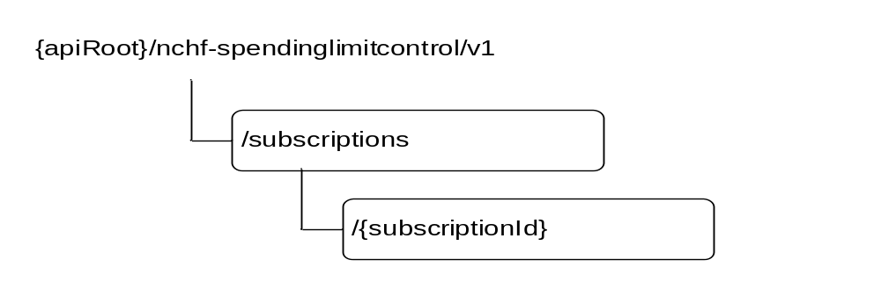
Figure 5.3.1-1: Resource URI structure of the Nchf_SpendingLimitControl API
Table 5.3.1-1 provides an overview of the resources and applicable HTTP methods.
Table 5.3.1-1: Resources and methods overview
Resource name | Resource URI | HTTP method or custom operation | Description
Spending Limit Retrieval Subscriptions | /subscriptions | POST | Creates a new individual spending limit retrieval subscription.
Individual Spending Limit Retrieval Subscription | /subscriptions/{subscriptionId} | PUT | Modifies an existing subscription (e.g. addition of additional policy counters).
Individual Spending Limit Retrieval Subscription | /subscriptions/{subscriptionId} | DELETE | Deletes an individual subscription.

5.3.2 Resource: Spending Limit Retrieval Subscriptions (Collection)

5.3.2.1 Description
This resource represents the collection of Nchf_SpendingLimitControl service subscriptions at a given CHF.

5.3.2.2 Resource definition
Resource URI: {apiRoot}/nchf-spendinglimitcontrol/v1/subscriptions
This resource shall support the resource URI variables defined in table 5.3.2.2-1.
Table 5.3.2.2-1: Resource URI variables for this resource
Name | Data type | Definition
apiRoot | string | See subclause 5.1

5.3.2.3 Resource Standard Methods

5.3.2.3.1 POST
This method shall support the URI query parameters specified in table 5.3.2.3.1-1.
Table 5.3.2.3.1-1: URI query parameters supported by the POST method on this resource
Name | Data type | P | Cardinality | Description
n/a

This method shall support the request data structures specified in table 5.3.2.3.1-2 and the response data structures and response codes specified in table 5.3.2.3.1-3.
Table 5.3.2.3.1-2: Data structures supported by the POST Request Body on this resource
Data type | P | Cardinality | Description
SpendingLimitContext | M | 1 | Contains the information for the creation of a new individual spending limit retrieval subscription.

Table 5.3.2.3.1-3: Data structures supported by the POST Response Body on this resource
Data type | P | Cardinality | Response codes | Description
SpendingLimitStatus | M | 1 | 201 Created | The spending limit subscription was created and spending limit reports are provided.
ProblemDetails | O | 0..1 | 400 Bad Request | (NOTE 2)
NOTE 1: In addition, the HTTP status codes which are specified as mandatory in table 5.2.7.1-1 of 3GPP TS 29.500 [4] for the POST method shall also apply.
NOTE 2: In addition to protocol and application errors which are specified in subclause 5.2.7.2 of 3GPP TS 29.500 [4], specific errors are described in subclause 5.7.

Table 5.3.2.3.1-4: Headers supported by the 201 Response Code on this resource
Name | Data type | P | Cardinality | Description
Location | string | M | 1 | Contains the URI of the newly created resource, according to the structure: {apiRoot}/nchf-spendinglimitcontrol/v1/subscriptions/{subscriptionId}

5.3.2.4 Resource Custom Operations
None.

5.3.3 Resource: Individual Spending Limit Retrieval Subscription (Document)

5.3.3.1 Description
This resource represents an individual Nchf_SpendingLimitControl service subscription at a given CHF.

5.3.3.2 Resource definition
Resource URI: {apiRoot}/nchf-spendinglimitcontrol/v1/subscriptions/{subscriptionId}
This resource shall support the resource URI variables defined in table 5.3.3.2-1.
Table 5.3.3.2-1: Resource URI variables for this resource
Name | Data type | Definition
apiRoot | string | See subclause 5.1
subscriptionId | string | Identifies a subscription to the CHF spending limit control retrieval service.

5.3.3.3 Resource Standard Methods

5.3.3.3.1 PUT
This method shall support the URI query parameters specified in table 5.3.3.3.1-1.
Table 5.3.3.3.1-1: URI query parameters supported by the PUT method on this resource
Name | Data type | P | Cardinality | Description
n/a

This method shall support the request data structures specified in table 5.3.3.3.1-2 and the response data structures and response codes specified in table 5.3.3.3.1-3.
Table 5.3.3.3.1-2: Data structures supported by the PUT Request Body on this resource
Data type | P | Cardinality | Description
SpendingLimitContext | M | 1 | Modifies the existing individual spending limit retrieval subscription.

Table 5.3.3.3.1-3: Data structures supported by the PUT Response Body on this resource
Data type | P | Cardinality | Response codes | Description
SpendingLimitStatus | M | 1 | 200 OK | Successful case: The individual spending limit subscription was modified and spending limit reports are provided.
ProblemDetails | O | 0..1 | 400 Bad Request | (NOTE 2)
NOTE 1: In addition, the HTTP status codes which are specified as mandatory in table 5.2.7.1-1 of 3GPP TS 29.500 [4] for the PUT method shall also apply.
NOTE 2: In addition to protocol and application errors which are specified in subclause 5.2.7.2 of 3GPP TS 29.500 [4], specific errors are described in subclause 5.7.

5.3.3.3.2 DELETE
This method shall support the URI query parameters specified in table 5.3.3.3.2-1.
Table 5.3.3.3.3-1: URI query parameters supported by the DELETE method on this resource
Name | Data type | P | Cardinality | Description
n/a

This method shall support the request data structures specified in table 5.3.3.3.2-2 and the response data structures and response codes specified in table 5.3.3.3.2-3.
Table 5.3.3.3.2-2: Data structures supported by the DELETE Request Body on this resource
Data type | P | Cardinality | Description
n/a

Table 5.3.3.3.2-3: Data structures supported by the DELETE Response Body on this resource
Data type | P | Cardinality | Response codes | Description
n/a |  |  | 204 No Content | Successful case: The individual spending limit subscription matching the subscriptionId was deleted.
NOTE: In addition, the HTTP status codes which are specified as mandatory in table 5.2.7.1-1 of 3GPP TS 29.500 [4] for the DELETE method shall also apply.

5.4 Custom Operations without associated resources
None.

5.5 Notifications

5.5.1 General
Notification shall comply with subclause 6.2 of 3GPP TS 29.500 [4] and subclause 4.6.2.3 of 3GPP TS 29.501 [5].
Table 5.5.1-1: Notifications overview
Notification | Callback URI | HTTP method or custom operation | Description (service operation)
Spending limit notification | {notifUri}/notify | notify (POST) | Counter Status changes notification.
Subscription Termination | {notifUri}/terminate | terminate (POST) | Indication of subscription termination.

5.5.2 Spending limit notification

5.5.2.1 Description
The spending limit notification is used by the CHF to notify the change of the status of the subscribed policy counters for a subscriber and/or to provide one or more pending statuses for a subscribed policy counter together with the time they shall be applied.

5.5.2.2 Target URI
The Callback URI {notifUri}/notify shall be used with the callback URI variables defined in table 5.5.2.2-1.
Table 5.5.2.2-1: Callback URI variables
Name | Data type | Definition
notifUri | Uri | The Notification Uri as assigned by the NF service consumer during the subscription service operation and described within the SpendingLimitContext data type (see table 5.6.2.2-1).

5.5.2.3 Standard Methods

5.5.2.3.1 POST
This method shall support the URI query parameters specified in table 5.5.2.3.1-1.
Table 5.5.2.3.1-1: URI query parameters supported by the POST method on this resource
Name | Data type | P | Cardinality | Description
n/a

This method shall support the request data structures specified in table 5.5.2.3.1-2 and the response data structures and response codes specified in table 5.5.2.3.1-3.
Table 5.5.2.3.1-2: Data structures supported by the POST Request Body on this resource
Data type | P | Cardinality | Description
SpendingLimitStatus | M | 1 | Provides information about the statuses of policy counters.

Table 5.5.2.3.1-3: Data structures supported by the POST Response Body on this resource
Data type | P | Cardinality | Response codes | Description
n/a |  |  | 204 No Content | The receipt of the notification is acknowledged.
NOTE: In addition, the HTTP status codes which are specified as mandatory in table 5.2.7.1-1 of 3GPP TS 29.500 [4] for the POST method shall also apply.

5.5.3 Subscription Termination

5.5.3.1 Description
The Subscription Termination request is used by the CHF to request the NF service consumer the termination of the subscription to policy counter status changes.

5.5.3.2 Target URI
The Callback URI {notifUri}/terminate shall be used with the callback URI variables defined in table 5.5.3.2-1.
Table 5.5.3.2-1: Callback URI variables
Name | Data type | Definition
notifUri | Uri | The Notification Uri as assigned by the NF service consumer during the subscription service operation and described within the SpendingLimitContext data type (see table 5.6.2.2-1).

5.5.3.3 Standard Methods

5.5.3.3.1 POST
This method shall support the URI query parameters specified in table 5.5.3.3.1-1.
Table 5.5.3.3.1-1: URI query parameters supported by the POST method on this resource
Name | Data type | P | Cardinality | Description
n/a

This method shall support the request data structures specified in table 5.5.3.3.1-2 and the response data structures and response codes specified in table 5.5.3.3.1-3.
Table 5.5.3.3.1-2: Data structures supported by the POST Request Body on this resource
Data type | P | Cardinality | Description
SubscriptionTerminationInfo | M | 1 | Provides information about the deletion of the resource.

Table 5.5.3.3.1-3: Data structures supported by the POST Response Body on this resource
Data type | P | Cardinality | Response codes | Description
n/a |  |  | 204 No Content | The receipt of the Notification is acknowledged.

HTTP response codes shall be supported as specified in subclause 5.2.7 of 3GPP TS 29.500 [4] and as defined in subclause 5.7.

5.6 Data Model

5.6.1 General
This subclause specifies the application data model supported by the API.
Table 5.6.1-1 specifies the data types defined for the Nchf_SpendingLimitControl service based interface protocol.
Table 5.6.1-1: Nchf_SpendingLimitControl specific Data Types
Data type | Section defined | Description | Applicability
SpendingLimitContext | 5.6.2.2 | Describes the subscription data structure required for an individual CHF spending limit subscription.
SpendingLimitStatus | 5.6.2.3 | Describes the data structure presenting the statuses of policy counters.
PolicyCounterInfo | 5.6.2.4 | Describes the data structure presenting the policy counter status.
PendingPolicyCounterStatus | 5.6.2.5 | Describes the data structure presenting the pending policy counter status.
PolicyCounterId | 5.6.3.2 | Identifies a policy counter.
SubscriptionTerminationInfo | 5.6.2.6 | Describes the data structure presenting the indication of the termination of the subscription.
TerminationCause | 5.6.3.3 | Represents the types of causes for requesting the termination of the subscription.

Table 5.6.1-2 specifies data types re-used by the Nchf_SpendingLimitControl service based interface protocol from other specifications, including a reference to their respective specifications and when needed, a short description of their use within the Nchf_SpendingLimitControl service based interface.
Table 5.6.1-2: Nchf_SpendingLimitControl re-used Data Types
Data type | Reference | Comments | Applicability
DateTime | 3GPP TS 29.571 [11] | String with format "date-time" as defined in OpenAPI Specification [9].
Uri | 3GPP TS 29.571 [11]
Supi | 3GPP TS 29.571 [11]
Gpsi | 3GPP TS 29.571 [11]
SupportedFeatures | 3GPP TS 29.571 [11] | Used to negotiate the applicability of the optional features defined in table 5.8-1.

5.6.2 Structured data types

5.6.2.1 Introduction
This subclause defines the structures to be used in resource representations.

5.6.2.2 Type SpendingLimitContext
Table 5.6.2.2-1: Definition of type SpendingLimitContext
Attribute name | Data type | P | Cardinality | Description | Applicability
supi | Supi | C | 0..1 | The Subscription Permanent Identifier (Supi) shall be present within the initial spending limit retrieval procedure (creation of a new individual subscription) and intermediate spending limit retrieval procedure (modification of an existing subscription).
gpsi | Gpsi | O | 0..1 | The Generic Public Subscription Identifier (Gpsi) shall contain either an External Id or an MSISDN. It may be present within the initial spending limit retrieval procedure (creation of a new individual subscription) and intermediate spending limit retrieval procedure (modification of an existing subscription).
policyCounterIds | array(PolicyCounterId) | O | 1..N | This is a list of policy counter identifier(s), which identifies policy counters maintained per subscriber within the CHF.
notifUri | Uri | C | 0..1 | This attribute identifies the recipient of spending limit notifications sent to the NF service consumer by the CHF. The notifUri shall be present within the initial spending limit retrieval procedure (creation of a new individual subscription and within the intermediate spending limit retrieval procedure (modification of an existing subscription).
notifId | string | C | 0..1 | Notification Correlation ID assigned by the NF service consumer. It shall be included if the NotificationCorrelation feature is supported, the notifUri does not encode the notification correlation Id, and the PCF(s) requires multiple subscriptions for the same SUPI, e.g. UE accesses multiple network slices. | NotificationCorrelation
expiry | DateTime | O | 0..1 | The expiry time may be included in a subscription request. When present, this IE shall represent the longest duration time after which the subscription shall become invalid. | SubscriptionExpirationTimeControl
supportedFeatures | SupportedFeatures | C | 0..1 | The list of supported features as described in subclause 5.8 shall be supplied by the NF service consumer in the POST request that request the creation of a spending limit report resource and intermediate spending limit retrieval procedure (modification of an existing subscription).

5.6.2.3 Type SpendingLimitStatus
Table 5.6.2.3-1: Definition of type SpendingLimitStatus
Attribute name | Data type | P | Cardinality | Description | Applicability
supi | Supi | O | 0..1 | The Subscription Permanent Identifier (Supi) shall be present within the callback notify service operation (notification of the status of subscribed policy counters).
notifId | string | C | 0..1 | Notification Correlation ID assigned by the NF service consumer. It shall be included if provided during the subscription within the SpendingLimitContext data type. | NotificationCorrelation
statusInfos | map(PolicyCounterInfo) | C | 1..N | Status of the requested policy counters. The key of the map is the attribute "policyCounterId".  It may be omitted when the feature SubscriptionExpirationTimeControl is supported and the CHF only requires to update the "expiry" attribute.
expiry | DateTime | C | 0..1 | This expiry time shall be included in a subscription response, if the expiry time was included in the request.  It may be included in a subscription response and notification request based on operator policies for the control in the CHF of the subscription duration. | SubscriptionExpirationTimeControl
supportedFeatures | SupportedFeatures | C | 0..1 | If the supportedFeatures is included in the request by the NF service consumer, it shall be supplied in the reply of the corresponding request by the CHF.

5.6.2.4 Type PolicyCounterInfo
Table 5.6.2.4-1: Definition of type PolicyCounterInfo
Attribute name | Data type | P | Cardinality | Description | Applicability
policyCounterId | PolicyCounterId | M | 1 | Identifies the requested policy counter.
currentStatus | string | M | 1 | Identifies the policy counter status applicable for a specific policy counter identified by the policyCounterId. The values (e.g. valid, invalid or any other status) are not specified. The interpretation and actions related to the defined values are out of scope of 3GPP.
penPolCounterStatuses | array(PendingPolicyCounterStatus) | O | 1..N | Provides the pending policy counter status.

5.6.2.5 Type PendingPolicyCounterStatus
Table 5.6.2.5-1: Definition of type PendingPolicyCounterStatus
Attribute name | Data type | P | Cardinality | Description | Applicability
policyCounterStatus | string | M | 1 | Identifies the policy counter status applicable for a specific policy counter identified by the PolicyCounterId. The values (e.g. valid, invalid or any other status) are not specified. The interpretation and actions related to the defined values are out of scope of 3GPP.
activationTime | DateTime | M | 1 | Indicates the time at which the pending policy counter status becomes the current status of a policy counter.

5.6.2.6 Type SubscriptionTerminationInfo
Table 5.6.2.6-1: Definition of type SubscriptionTerminationInfo
Attribute name | Data type | P | Cardinality | Description | Applicability
supi | Supi | M | 1 | Subscription Permanent Identifier.
termCause | TerminationCause | O | 0..1 | Indicates the cause for requesting the termination of the subscription to policy counter status changes.

5.6.3 Simple data types and enumerations

5.6.3.1 Introduction
This subclause defines simple data types and enumerations that can be referenced from data structures defined in the previous subclauses.

5.6.3.2 Simple data types
The simple data types defined in table 5.6.3.2-1 shall be supported.
Table 5.6.3.2-1: Simple data types
Type Name | Type Definition | Description | Applicability
PolicyCounterId | string | Identifies a policy counter.

5.6.3.3 Enumeration: TerminationCause
The enumeration "TerminationCause" represents the types of causes the CHF can report when requesting the termination of the subscription.
Table 5.6.3.3-1: Enumeration TerminationCause
Enumeration value | Description | Applicability
REMOVED_SUBSCRIBER | The subscriber identified by the SUPI has been removed from the CHF.

5.7 Error handling

5.7.1 General
HTTP error handling shall be supported as specified in subclause 5.2.4 of 3GPP TS 29.500 [4].
For the Nchf_SpendingLimitControl service API, HTTP error responses shall be supported as specified in subclause 4.8 of 3GPP TS 29.501 [5]. Protocol errors and application errors specified in table 5.2.7.2-1 of 3GPP TS 29.500 [4] shall be supported for an HTTP method if the corresponding HTTP status codes are specified as mandatory for that HTTP method in table 5.2.7.1-1 of 3GPP TS 29.500 [4]. In addition, the requirements in the following subclauses shall apply.

5.7.2 Protocol Errors
In this Release of the specification, there are no additional protocol errors applicable for the Nchf_SpendingLimitControl service API.

5.7.3 Application Errors
The application errors defined for the Nchf_SpendingLimitControl service API are listed in table 5.7.3-1. The CHF shall include in the HTTP status code a "ProblemDetails" data structure with the "cause" attribute indicating the application error as listed in table 5.7.3-1.
Table 5.7.3-1: Application errors
Application Error | HTTP status code | Description
USER_UNKNOWN | 400 Bad Request | The subscriber specified in the request is not known at the CHF and the subscription cannot be created.
NO_AVAILABLE_POLICY_COUNTERS | 400 Bad Request | There are no policy counters available for the subscriber at the CHF
UNKNOWN_POLICY_COUNTERS | 400 Bad Request | The policy counter identifiers in the request are not known at the CHF.

5.8 Feature negotiation
The optional features in table 5.8-1 are defined for the Nchf_SpendingLimitControl Service API. They shall be negotiated using the extensibility mechanism defined in subclause 6.6.2 of 3GPP TS 29.500 [4].
Table 5.8-1: Supported Features
Feature number | Feature Name | Description
1 | SubscriptionExpirationTimeControl | Indicates the support of a expiry time to control the time duration of the subscription to changes of policy counters status.
2 | NotifiationCorrelation | Indicates the support of the explicit indication of the notification correlation id

5.9 Security
As indicated in 3GPP TS 33.501 [14] and 3GPP TS 29.500 [4], the access to the Nchf_SpendingLimitControl API, based on local configuration, may be authorized by means of the OAuth2 protocol (see IETF RFC 6749 [15]), using the "Client Credentials" authorization grant, where the NRF (see 3GPP TS 29.510 [16]) plays the role of the authorization server.
If OAuth2 is used, an NF Service Consumer, prior to consuming services offered by the Nchf_SpendingLimitControl API, shall obtain a "token" from the authorization server, by invoking the Access Token Request service, as described in 3GPP TS 29.510 [16], subclause 5.4.2.2.
NOTE: When multiple NRFs are deployed in a network, the NRF used as authorization server is the same NRF that the NF Service Consumer used for discovering the Nchf_SpendingLimitControl service.
The Nchf_SpendingLimitControl API defines a single scope "nchf-spendinglimitcontrol" for OAuth2 authorization (as specified in 3GPP TS 33.501 [14]) for the entire API, and it does not define any additional scopes at resource or operation level.

Annex A (normative):
OpenAPI specification

A.1 General
The present Annex contains an OpenAPI [9] specification of HTTP messages and content bodies used by the Nchf_SpendingLimitControl Service API.
This Annex shall take precedence when being discrepant to other parts of the specification with respect to the encoding of information elements and methods within the API.
NOTE: The semantics and procedures, as well as conditions, e.g. for the applicability and allowed combinations of attributes or values, not expressed in the OpenAPI definitions but defined in other parts of the specification also apply.
Informative copies of the OpenAPI specification file contained in this 3GPP Technical Specification are available on a Git-based repository that uses the GitLab software version control system (see clause 5B of the 3GPP TR 21.900 [17] and subclause 5.3.1 of the 3GPP TS 29.501 [5] for further information).

A.2 Nchf_SpendingLimitControl Service API
openapi: 3.0.0
info:
version: 1.1.1
title: Nchf_SpendingLimitControl
description: |
Nchf Spending Limit Control Service.
© 2020, 3GPP Organizational Partners (ARIB, ATIS, CCSA, ETSI, TSDSI, TTA, TTC).
All rights reserved.
externalDocs:
description: 3GPP TS 29.594 V16.4.0; 5G System; Spending Limit Control Service.
url: 'http://www.3gpp.org/ftp/Specs/archive/29_series/29.594/'
servers:
- url: '{apiRoot}/nchf-spendinglimitcontrol/v1'
variables:
apiRoot:
default: https://example.com
description: apiRoot as defined in subclause subclause 4.4 of 3GPP TS 29.501
security:
- {}
- oAuth2ClientCredentials:
- nchf-spendinglimitcontrol
paths:
/subscriptions:
post:
requestBody:
required: true
content:
application/json:
schema:
$ref: '#/components/schemas/SpendingLimitContext'
responses:
'201':
description: Success
content:
application/json:
schema:
$ref: '#/components/schemas/SpendingLimitStatus'
headers:
Location:
description: 'Contains the URI of the created individual spending limit resource, according to the structure: {apiRoot}/nchf-spendinglimitcontrol/v1/subscriptions/{subscriptionId}'
required: true
schema:
type: string
'400':
$ref: 'TS29571_CommonData.yaml#/components/responses/400'
'401':
$ref: 'TS29571_CommonData.yaml#/components/responses/401'
'403':
$ref: 'TS29571_CommonData.yaml#/components/responses/403'
'404':
$ref: 'TS29571_CommonData.yaml#/components/responses/404'
'411':
$ref: 'TS29571_CommonData.yaml#/components/responses/411'
'413':
$ref: 'TS29571_CommonData.yaml#/components/responses/413'
'415':
$ref: 'TS29571_CommonData.yaml#/components/responses/415'
'429':
$ref: 'TS29571_CommonData.yaml#/components/responses/429'
'500':
$ref: 'TS29571_CommonData.yaml#/components/responses/500'
'503':
$ref: 'TS29571_CommonData.yaml#/components/responses/503'
default:
$ref: 'TS29571_CommonData.yaml#/components/responses/default'
callbacks:
statusNotification:
'{$request.body#/notifUri}/notify':
post:
requestBody:
required: true
content:
application/json:
schema:
$ref: '#/components/schemas/SpendingLimitStatus'
responses:
'204':
description: No Content, Notification was succesfull
'400':
$ref: 'TS29571_CommonData.yaml#/components/responses/400'
'401':
$ref: 'TS29571_CommonData.yaml#/components/responses/401'
'403':
$ref: 'TS29571_CommonData.yaml#/components/responses/403'
'404':
$ref: 'TS29571_CommonData.yaml#/components/responses/404'
'411':
$ref: 'TS29571_CommonData.yaml#/components/responses/411'
'413':
$ref: 'TS29571_CommonData.yaml#/components/responses/413'
'415':
$ref: 'TS29571_CommonData.yaml#/components/responses/415'
'429':
$ref: 'TS29571_CommonData.yaml#/components/responses/429'
'500':
$ref: 'TS29571_CommonData.yaml#/components/responses/500'
'503':
$ref: 'TS29571_CommonData.yaml#/components/responses/503'
default:
$ref: 'TS29571_CommonData.yaml#/components/responses/default'
subscriptionTermination:
'{$request.body#/notifUri}/terminate':
post:
requestBody:
required: true
content:
application/json:
schema:
$ref: '#/components/schemas/SubscriptionTerminationInfo'
responses:
'204':
description: No Content, Notification was succesfull
'400':
$ref: 'TS29571_CommonData.yaml#/components/responses/400'
'401':
$ref: 'TS29571_CommonData.yaml#/components/responses/401'
'403':
$ref: 'TS29571_CommonData.yaml#/components/responses/403'
'404':
$ref: 'TS29571_CommonData.yaml#/components/responses/404'
'411':
$ref: 'TS29571_CommonData.yaml#/components/responses/411'
'413':
$ref: 'TS29571_CommonData.yaml#/components/responses/413'
'415':
$ref: 'TS29571_CommonData.yaml#/components/responses/415'
'429':
$ref: 'TS29571_CommonData.yaml#/components/responses/429'
'500':
$ref: 'TS29571_CommonData.yaml#/components/responses/500'
'503':
$ref: 'TS29571_CommonData.yaml#/components/responses/503'
default:
$ref: 'TS29571_CommonData.yaml#/components/responses/default'
/subscriptions/{subscriptionId}:
parameters:
- in: path
name: subscriptionId
description: Identifies an individual spending limit retrieval subscription.
required: true
schema:
type: string
put:
requestBody:
required: true
content:
application/json:
schema:
$ref: '#/components/schemas/SpendingLimitContext'
responses:
'200':
description: OK. Resource was succesfully modified and representation is returned
content:
application/json:
schema:
$ref: '#/components/schemas/SpendingLimitStatus'
'400':
$ref: 'TS29571_CommonData.yaml#/components/responses/400'
'401':
$ref: 'TS29571_CommonData.yaml#/components/responses/401'
'403':
$ref: 'TS29571_CommonData.yaml#/components/responses/403'
'404':
$ref: 'TS29571_CommonData.yaml#/components/responses/404'
'411':
$ref: 'TS29571_CommonData.yaml#/components/responses/411'
'413':
$ref: 'TS29571_CommonData.yaml#/components/responses/413'
'415':
$ref: 'TS29571_CommonData.yaml#/components/responses/415'
'429':
$ref: 'TS29571_CommonData.yaml#/components/responses/429'
'500':
$ref: 'TS29571_CommonData.yaml#/components/responses/500'
'503':
$ref: 'TS29571_CommonData.yaml#/components/responses/503'
default:
$ref: 'TS29571_CommonData.yaml#/components/responses/default'
delete:
responses:
'204':
description: No Content. Resource was succesfully deleted
'400':
$ref: 'TS29571_CommonData.yaml#/components/responses/400'
'401':
$ref: 'TS29571_CommonData.yaml#/components/responses/401'
'403':
$ref: 'TS29571_CommonData.yaml#/components/responses/403'
'404':
$ref: 'TS29571_CommonData.yaml#/components/responses/404'
'429':
$ref: 'TS29571_CommonData.yaml#/components/responses/429'
'500':
$ref: 'TS29571_CommonData.yaml#/components/responses/500'
'503':
$ref: 'TS29571_CommonData.yaml#/components/responses/503'
default:
$ref: 'TS29571_CommonData.yaml#/components/responses/default'
components:
securitySchemes:
oAuth2ClientCredentials:
type: oauth2
flows:
clientCredentials:
tokenUrl: '{nrfApiRoot}/oauth2/token'
scopes:
nchf-spendinglimitcontrol: Access to the Nchf_SpendingLimitControl API
schemas:
SpendingLimitContext:
type: object
properties:
supi:
$ref: 'TS29571_CommonData.yaml#/components/schemas/Supi'
gpsi:
$ref: 'TS29571_CommonData.yaml#/components/schemas/Gpsi'
policyCounterIds:
type: array
items:
$ref: '#/components/schemas/PolicyCounterId'
minItems: 1
description: This is a list of policy counter identifier(s), which identifies policy counters maintained per subscriber within the CHF.
notifUri:
$ref: 'TS29571_CommonData.yaml#/components/schemas/Uri'
expiry:
$ref: 'TS29571_CommonData.yaml#/components/schemas/DateTime'
supportedFeatures:
$ref: 'TS29571_CommonData.yaml#/components/schemas/SupportedFeatures'
notifId:
type: string
SpendingLimitStatus:
type: object
properties:
supi:
$ref: 'TS29571_CommonData.yaml#/components/schemas/Supi'
notifId:
type: string
statusInfos:
type: object
additionalProperties:
$ref: '#/components/schemas/PolicyCounterInfo'
minProperties: 1
description: Status of the requested policy counters. The key of the map is the attribute "policyCounterId".
expiry:
$ref: 'TS29571_CommonData.yaml#/components/schemas/DateTime'
supportedFeatures:
$ref: 'TS29571_CommonData.yaml#/components/schemas/SupportedFeatures'
PolicyCounterInfo:
type: object
properties:
policyCounterId:
$ref: '#/components/schemas/PolicyCounterId'
currentStatus:
type: string
description: Identifies the policy counter status applicable for a specific policy counter identified by the policyCounterId. The values (e.g. valid, invalid or any other status) are not specified. The interpretation and actions related to the defined values are out of scope of 3GPP.
penPolCounterStatuses:
type: array
items:
$ref: '#/components/schemas/PendingPolicyCounterStatus'
minItems: 1
description: Provides the pending policy counter status.
required:
- policyCounterId
- currentStatus
PendingPolicyCounterStatus:
type: object
properties:
policyCounterStatus:
type: string
description: Identifies the policy counter status applicable for a specific policy counter identified by the policyCounterId. The values (e.g. valid, invalid or any other status) are not specified. The interpretation and actions related to the defined values are out of scope of 3GPP.
activationTime:
$ref: 'TS29571_CommonData.yaml#/components/schemas/DateTime'
required:
- policyCounterStatus
- activationTime
PolicyCounterId:
type: string
description: Identifies a policy counter.
SubscriptionTerminationInfo:
type: object
properties:
supi:
$ref: 'TS29571_CommonData.yaml#/components/schemas/Supi'
termCause:
$ref: '#/components/schemas/TerminationCause'
required:
- supi
TerminationCause:
anyOf:
- type: string
enum:
- REMOVED_SUBSCRIBER
- type: string

Annex B (normative):
5GC and EPC interworking scenario support

B.1 Scope
This annex defines procedures for the Nchf_SpendingLimitControl service for 5GC and EPC interworking scenarios specified in clause B.1 of 3GPP TS 29.512 [18].

B.2 Nchf_SpendingLimitControl Service

B.2.1 Service Description

B.2.1.1 Overview
The overview in subclause 4.1.1 applies.

B.2.1.2 Service Architecture
The architecture in subclause 4.1.2 applies.

B.3 Service Operation

B.3.1 Introduction
The service operations defined in subclause 4.2 shall be applicable.

B.3.2 Nchf_SpendingLimitControl_Subscribe Service Operation
Subclause 4.2.2.2 and subclause 4.2.2.3 are applied with the differences that the PCF shall include (if available) in SpendingLimitContext data structure:
- the IMSI of the user within the "supi" attribute;
- the MSISDN of the user within the "gpsi" attribute;

B.3.3 Nchf_SpendingLimitControl_Unsubscribe Service Operation
Subclause 4.2.3 applies.

B.3.4 Nchf_SpendingLimitControl_Notify Service Operation
Subclause 4.2.4 applies.

Annex C (informative):
Change history
Date | TSG # | TSG Doc. | CR | Rev | Cat | Subject/Comment | New
2018-04 |  |  |  |  |  | TS skeleton of Spending Limit Control Service specification | 0.0.0
2018-04 | CT3#96 |  |  |  |  | Inclusion of documents agreed in CT3#96: C3-182160, C3-182161, C3-182167, C3-182432, C3-182433, C3-182434, C3-182435, C3-182436, C3-182437, C3-182479 | 0.1.0
2018-05 | CT3#97 |  |  |  |  | Inclusion of documents agreed in CT3#97: C3-183138, C3-183288, C3-183538, C3-183539, C3-183541, C3-183543, C3-183544, C3-183545, C3-183546, C3-183547, C3-183548, C3-183550, C3-183552, C3-183780, C3-183782, C3-183830, C3-183831 | 0.2.0
2018-06 | CT#80 | CP-181026 |  |  |  | TS sent for approval to TSG | 1.0.0
2018-06 | CT#80 | CP-181026 |  |  |  | TS approved by plenary | 15.0.0
2018-09 | CT#81 | CP-182015 | 0001 | 1 | F | Removal of possibility of confusion related to 3GPP TS 29.513, custom headers, verbal forms and OpenAPI corrections | 15.1.0
2018-09 | CT#81 | CP-182221 | 0002 | 4 | F | Introduction of the simple data type "policyCounterId" | 15.1.0
2018-09 | CT#81 | CP-182098 | 0003 | 3 | F | Update and corrections of the data model | 15.1.0
2018-09 | CT#81 | CP-182015 | 0004 | 2 | F | Integration of error handling | 15.1.0
2018-09 | CT#81 | CP-182015 | 0007 | - | F | ED – Continuous reporting and policy counter status change | 15.1.0
2018-09 | CT#81 | CP-182099 | 0008 | 3 | F | Termination of the subscription of status changes for all policy counters by CHF | 15.1.0
2018-12 | CT#82 | CP-183205 | 0009 | - | F | Application of resource illustration rule | 15.2.0
2018-12 | CT#82 | CP-183205 | 0010 | - | F | Consolidation of the term "notificationUri" | 15.2.0
2018-12 | CT#82 | CP-183205 | 0011 | - | F | Clarification of "intermediate spending limit report retrieval" usage | 15.2.0
2018-12 | CT#82 | CP-183205 | 0012 | - | F | Correction of wrong reference for supi in OpenAPI doc | 15.2.0
2018-12 | CT#82 | CP-183205 | 0013 | - | F | Correction of the originator for application error responses | 15.2.0
2018-12 | CT#82 | CP-183205 | 0014 | 1 | F | Application of externalDocs field in OpenAPI doc | 15.2.0
2018-12 | CT#82 | CP-183205 | 0015 | 1 | F | Application of version pattern rule in OpenAPI doc | 15.2.0
2018-12 | CT#82 | CP-183205 | 0016 | 1 | F | Corrections to OpenAPI file | 15.2.0
2018-12 | CT#82 | CP-183205 | 0017 | - | F | Default value for apiRoot | 15.2.0
2018-12 | CT#82 | CP-183205 | 0018 | - | F | Cardinality | 15.2.0
2018-12 | CT#82 | CP-183205 | 0019 | 2 | F | Sending of GPSI (MSISDN) in Initial Spenidng Limit retrieval | 15.2.0
2018-12 | CT#82 | CP-183205 | 0020 | 1 | F | Update of content types | 15.2.0
2018-12 | CT#82 | CP-183205 | 0021 | 1 | F | Authorization of NF service access by OAuth 2.0 | 15.2.0
2018-12 | CT#82 | CP-183205 | 0022 | 1 | F | Introduction of status code 404 Not Found as mandatory status code and missing ones | 15.2.0
2018-12 | CT#82 | CP-183205 | 0023 | 1 | F | Location Header | 15.2.0
2018-12 | CT#82 | CP-183205 | 0024 | 2 | F | Correcting application error | 15.2.0
2019-03 | CT#83 | CP-190113 | 0025 | 1 | F | Correction of Resource URI | 15.3.0
2019-03 | CT#83 | CP-190113 | 0026 | 1 | F | Correction relating to the introduction of the General Public Subscription Identifier | 15.3.0
2019-03 | CT#83 | CP-190068 | 0027 | 2 | F | OpenAPI info version update | 15.3.0
2019-03 | CT#83 | CP-190067 | 0028 | - | F | Correction of wrong usage of key word "items" | 15.3.0
2019-06 | CT#84 | CP-191189 | 0030 | 3 | F | Precedence of OpenAPI file | 15.4.0
2019-06 | CT#84 | CP-191189 | 0031 | 1 | F | Copyright Note in YAML file | 15.4.0
2019-06 | CT#84 | CP-191189 | 0033 | - | F | OpenAPI version number update | 15.4.0
2019-06 | CT#84 | CP-191089 | 0032 | 1 | B | Race Condition handling | 16.0.0
2019-09 | CT#85 | CP-192151 | 0035 | - | A | NF service consumer pending policy counter handling | 16.1.0
2019-09 | CT#85 | CP-192156 | 0036 | 1 | B | Support of Expiry Time | 16.1.0
2019-09 | CT#85 | CP-192151 | 0038 | - | A | Correction to Subscription Termination service operation | 16.1.0
2019-09 | CT#85 | CP-192151 | 0040 | - | A | Correction to subscription creation/update response | 16.1.0
2019-09 | CT#85 | CP-192151 | 0042 | - | A | Corrections to subscription request descriptions | 16.1.0
2019-09 | CT#85 | CP-192151 | 0044 | - | A | Handling of unknown policy counters | 16.1.0
2019-09 | CT#85 | CP-192173 | 0045 | - | F | OpenAPI version update for TS 29.594 Rel-16 | 16.1.0
2020-06 | CT#88e | CP-201233 | 0046 | - | F | Description of "activationTime" attribute | 16.2.0
2020-06 | CT#88e | CP-201233 | 0047 | - | F | Miscellaneous corrections | 16.2.0
2020-06 | CT#88e | CP-201244 | 0048 | 1 | F | Storage of YAML files in ETSI Forge | 16.2.0
2020-06 | CT#88e | CP-201256 | 0049 | 1 | F | URI of the Nchf_SpendingLimitControl service | 16.2.0
2020-06 | CT#88e | CP-201244 | 0050 | 1 | F | Optionality of ProblemDetails | 16.2.0
2020-06 | CT#88e | CP-201244 | 0052 | 1 | F | Supported headers, Resource Data type | 16.2.0
2020-06 | CT#88e | CP-201255 | 0053 | - | F | Update of OpenAPI version and TS version in externalDocs field | 16.2.0
2020-09 | CT#89e | CP-202058 | 0056 | 1 | A | Correction to spending limit subscribe and unsubscribe procedures | 16.3.0
2020-09 | CT#89e | CP-202058 | 0058 | 1 | A | Nchf_SpendingLimitControl Service support of interworking | 16.3.0
2020-12 | CT#90e | CP-203139 | 0061 | 1 | F | Essential corrections and alignments | 16.4.0
2020-12 | CT#90e | CP-203139 | 0062 | 1 | F | Storage of YAML files in 3GPP Forge | 16.4.0
2020-12 | CT#90e | CP-203122 | 0064 | 1 | A | Correction to Intermediate spending limit report retrieval | 16.4.0
2020-12 | CT#90e | CP-203128 | 0065 | - | F | Correction to subscription's expiry time | 16.4.0
2020-12 | CT#90e | CP-203128 | 0066 | 1 | F | Correction to subscription create service operation | 16.4.0
2020-12 | CT#90e | CP-203152 | 0068 | - | F | Update of OpenAPI version and TS version in externalDocs field | 16.4.0

