3GPP TS 29.201 V12.4.0 (2016-03)
Technical Specification



The present document has been developed within the 3rd Generation Partnership Project (3GPP TM) and may be further elaborated for the purposes of 3GPP.
The present document has not been subject to any approval process by the 3GPP Organizational Partners and shall not be implemented.
This Specification is provided for future development work within 3GPP only. The Organizational Partners accept no liability for any use of this Specification.
Specifications and Reports for implementation of the 3GPP TM system should be obtained via the 3GPP Organizational Partners' Publications Offices.

3rd Generation Partnership Project;
Technical Specification Group Core Network and Terminals;
Representational State Transfer (REST) reference point between Application Function (AF) and
Protocol Converter (PC)
(Release 12)

Keywords
Representational, State, Transfer, Application, Protocol
3GPP
Postal address

3GPP support office address
650 Route des Lucioles - Sophia Antipolis
Valbonne - FRANCE
Tel.: +33 4 92 94 42 00 Fax: +33 4 93 65 47 16
Internet
http://www.3gpp.org
Copyright Notification
No part may be reproduced except as authorized by written permission.
The copyright and the foregoing restriction extend to reproduction in all media.

© 2015, 3GPP Organizational Partners (ARIB, ATIS, CCSA, ETSI, TSDSI, TTA, TTC).
All rights reserved.

UMTS™ is a Trade Mark of ETSI registered for the benefit of its members
3GPP™ is a Trade Mark of ETSI registered for the benefit of its Members and of the 3GPP Organizational Partners
LTE™ is a Trade Mark of ETSI registered for the benefit of its Members and of the 3GPP Organizational Partners
GSM® and the GSM logo are registered and owned by the GSM Association
Contents
Foreword 5
1 Scope 6
2 References 6
3 Definitions and abbreviations 7
3.1 Definitions 7
3.2 Abbreviations 7
4 Representational State Transfer (REST) reference point based on Protocol Converter (PC) architecture 8
4.1 Overview 8
4.2 Reference model 8
4.3 Functional elements 13
4.3.1 Application function 13
4.3.2 Protocol converter 13
4.4 Location of the PC within the PLMN 13
4.4.1 General 13
4.4.2 Protocol converter located in the PLMN but outside of the PCRF realm 14
4.4.3 Protocol converter located in the PCRF realm 14
4.5 PCC Procedures over the RESTful reference point 15
4.5.1 General 15
4.5.2 Initial Provisioning of Session Information 15
4.5.3 Modification of Session Information 16
4.5.4 AF Session Termination 17
4.5.5 Gate Related Procedures 17
4.5.6 Subscription to Notification of Signalling Path Status 17
4.5.7 Traffic Plane Events 17
5 Protocol 18
5.1 Introduction 18
5.2 Transport layer 18
5.3 Application delivery layer 18
5.3.1 Methods 19
5.3.2 Void 20
5.3.3 Resources and URI design 20
5.3.4 HTTP request/response dialogues 20
5.3.5 AF Session ID 22
5.4 Specific application communication 22
5.4.0 General 22
5.4.1 Content type XML 22
5.4.1.1 XML schema 22
5.4.1.2 Data types and mapping between XML elements 22
5.4.1.3 Mapping between Diameter AVPs and XML elements and groups 23
5.5 PC discovery 25
6 Routing 25
6.1 PC located in the PLMN but outside of the PCRF realm 25
6.2 PC located in the PCRF realm 25
7 Secure communication 26
Annex A (informative): Call Flows 27
A.1 General 27
A.2 AF session establishment 27
A.3 AF Session Modification Initiated by AF 27
A.4 AF Session Termination 28
A.5 Gate Related Procedures 28
A.6 Subscription to Notification of Signalling Path Status 29
A.7 Notification of Traffic Plane Events 29
A.7.1 Traffic plane event reporting 29
A.7.2 Service data flow deactivation when all service data flows are affected 30
A.7.3 IP-CAN Session Termination 31
Annex B (normative): XML Schema 33
B.1 XML elements and groups 33
B.2 Diameter message representation 36
Annex C (informative): Change history 40

Foreword
This Technical Specification has been produced by the 3rd Generation Partnership Project (3GPP).
The contents of the present document are subject to continuing work within the TSG and may change following formal TSG approval. Should the TSG modify the contents of the present document, it will be re-released by the TSG with an identifying change of release date and an increase in version number as follows:
Version x.y.z
where:
x the first digit:
1 presented to TSG for information;
2 presented to TSG for approval;
3 or greater indicates TSG approved document under change control.
y the second digit is incremented for all changes of substance, i.e. technical enhancements, corrections, updates, etc.
z the third digit is incremented when editorial only changes have been incorporated in the document.

1 Scope
The present document describes the Representational State Transfer (REST) reference point, which is used to exchange application level session information between the Protocol Converter (PC) and the Application Function (AF). REST shall be used as an architectural style as appropriate.

2 References
The following documents contain provisions which, through reference in this text, constitute provisions of the present document.
- References are either specific (identified by date of publication, edition number, version number, etc.) or non-specific.
- For a specific reference, subsequent revisions do not apply.
- For a non-specific reference, the latest version applies. In the case of a reference to a 3GPP document (including a GSM document), a non-specific reference implicitly refers to the latest version of that document in the same Release as the present document.
[1] 3GPP TR 21.905: "Vocabulary for 3GPP Specifications".
[2] 3GPP TR 29.817: "Study on XML based access of AF to the PCRF".
[3] 3GPP TS 29.213: "Policy and Charging Control signalling flows and Quality of Service (QoS) parameter mapping".
[4] 3GPP TS 29.214: "Policy and Charging Control over Rx reference point".
[5] 3GPP TS 23.203: "Policy and Charging Control architecture".
[6] 3GPP TS 23.335: "User Data Convergence (UDC); Technical realization and information flows; Stage 2".
[7] 3GPP TS 29.335: "User Data Convergence (UDC); User Data Repository Access Protocol over the Ud interface; Stage 3".
[8] IETF RFC 793: "Transmission Control Protocol".
[9] IETF RFC 2616: "Hypertext Transfer Protocol – HTTP/1.1".
[10] IETF RFC 3986: "Uniform Resource Identifier (URI): Generic Syntax".
[11] IETF RFC 1035: "Domain Names – Implementation and Specification".
[12] IETF RFC 2131: "Dynamic Host Configuration Protocol".
[13] 3GPP TS 33.310: "Network Domain Security (NDS); Authentication Framework (AF)".
[14] IETF RFC 2818: "HTTP Over TLS".
[15] IETF RFC 1786: "Uniform Resource Locators (URL)".
[16] IETF RFC 3588: "Diameter Base Protocol".

3 Definitions and abbreviations

3.1 Definitions
For the purposes of the present document, the terms and definitions given in 3GPP TR 21.905 [1] and the following apply. A term defined in the present document takes precedence over the definition of the same term, if any, in 3GPP TR 21.905 [1].
Application Function (AF): element offering application(s) that use IP bearer resources.
Protocol Converter (PC): element that converts the RESTful/XML based Rx reference point to the Diameter based Rx reference point.
Representation: is a view of a resource state, it is encoded in one or more transferable formats, such as XML, JSON, plain text or other formats.
RESTful HTTP: is an architectural style consisting of a coordinated set of architectural constraints applied to components, connectors, and data elements, within a distributed hypermedia system applied to the development of web services.
REST-Rx: term that is used to indicate the Rx interface based on RESTful HTTP between the AF and the PC.

3.2 Abbreviations
For the purposes of the present document, the abbreviations given in 3GPP TR 21.905 [1] and the following apply. An abbreviation defined in the present document takes precedence over the definition of the same abbreviation, if any, in 3GPP TR 21.905 [1].
AAA Authentication, Authorization, Accounting
AF Application Function
API Application Programming Interface
BBERF Bearer Binding and Event Reporting Function
DHCP Dynamic Host Configuration Protocol
DNS Domain Name System
DRA Diameter Routing Agent
HTTP HyperText Transfer Protocol
HTTPS Hypertext Transfer Protocol Secure
IP-CAN IP Connectivity Access Network
PC Protocol Converter
PCC Policy and Charging Control
PCEF Policy and Charging Enforcement Function
PCRF Policy and Charging Rules Function
PDN Packet Data Network
PLMN Public Land Mobile Network
QoS Quality of Service
REST Representational State Transfer
SPR Subscription Profile Repository
UDR User Data Repository
URI Uniform Resource Identifier
URL Uniform Resource Locator
UE User Equipment
XML Extensible Markup Language

4 Representational State Transfer (REST) reference point based on Protocol Converter (PC) architecture

4.1 Overview
The Representational State Transfer (REST) reference point resides between the AF and the Protocol Converter (PC). The PC converts application level information received from the AF to Diameter session information and communicates with the PCRF via the Diameter based Rx reference point (3GPP TS 29.214 [4]).

4.2 Reference model
The Rx reference point, which is based on Diameter, is defined between the PCRF and the AF (3GPP TS 29.214 [4]). If the AF supports RESTful HTTP and XML a Protocol Converter (PC) is needed. In this specification the interface between the AF and the PC is named REST-Rx. The REST-Rx interface shall be used in non-IMS scenarios only.
The PC converts the information, received over the REST-Rx interface, into information that can be used on the Diameter based Rx interface in order to get an access to the PCC architecture and vice versa. The PC manages RESTful resources, which are an integral part of the REST-Rx interface. As defined in the stage 2 specifications (3GPP TS 23.203 [5]), information from the AF is part of the input used by the PCRF for Policy and Charging Control (PCC) decisions. Signalling flows are specified in Annex A.
The relationships between the different functional entities involved for non-roaming scenario are depicted in figure 4.2.1 and 4.2.2.

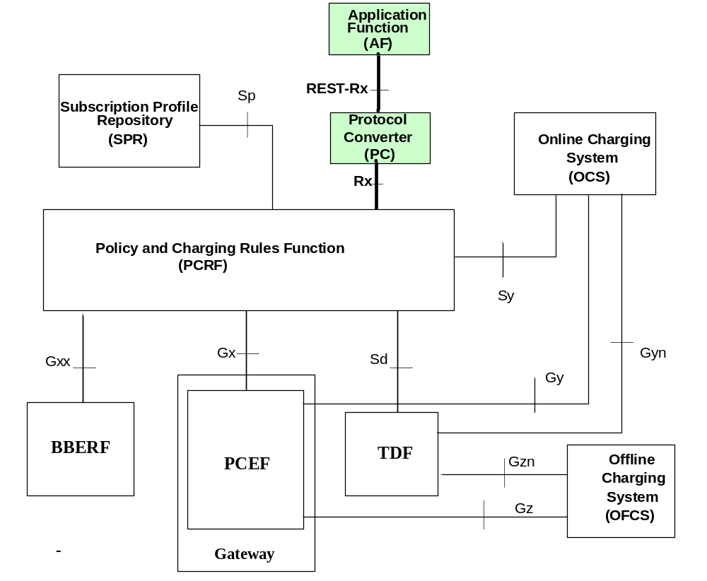
Figure 4.2.1: The PCC architecture with the PC for non-roaming scenario with SPR
With the UDC-based architecture, as defined in 3GPP TS 23.335 [6] and applied in 3GPP TS 23.203 [5], the UDR replaces the SPR and the Ud reference point provides access to the subscription data in the UDR. The Ud interface as defined in 3GPP TS 29.335 [7] is the interface between the PCRF and the UDR. When the UDC architecture is used, SPR and Sp, whenever mentioned in this document, are replaced by UDR and Ud.

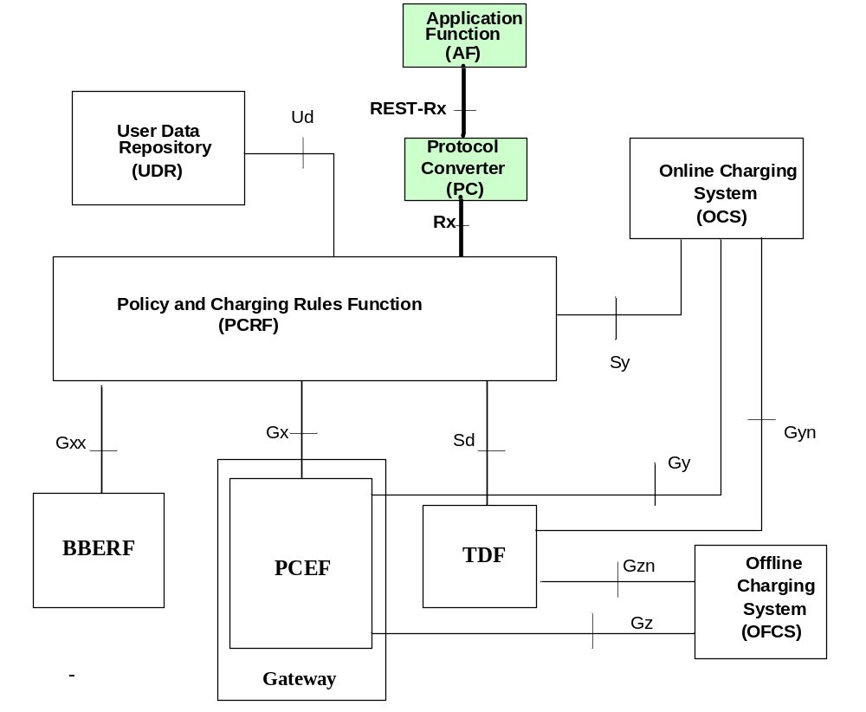
Figure 4.2.2: The PCC architecture with the PC for non-roaming scenario with UDR
The relationships between the different functional entities involved for home routed scenario are depicted in figure 4.2.3 and 4.2.4.

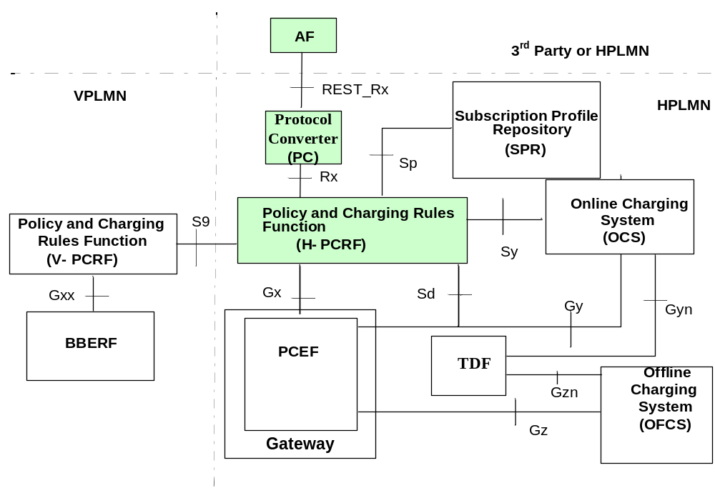
Figure 4.2.3: The PCC architecture with the PC for home routed scenario with SPR
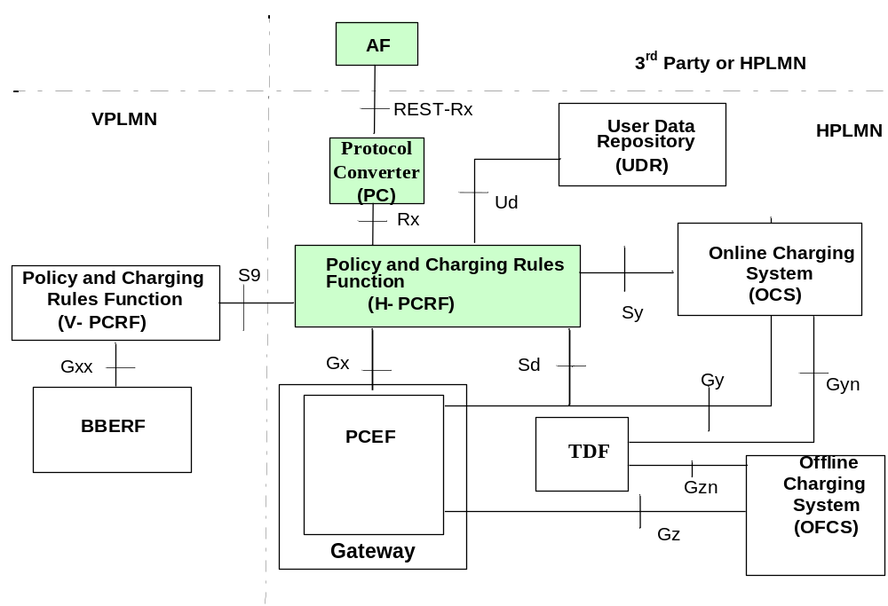
Figure 4.2.4: The PCC architecture with the PC for home routed scenario with UDR
The relationships between the different functional entities involved for local breakout scenario are depicted in figure 4.2.5 and 4.2.6.
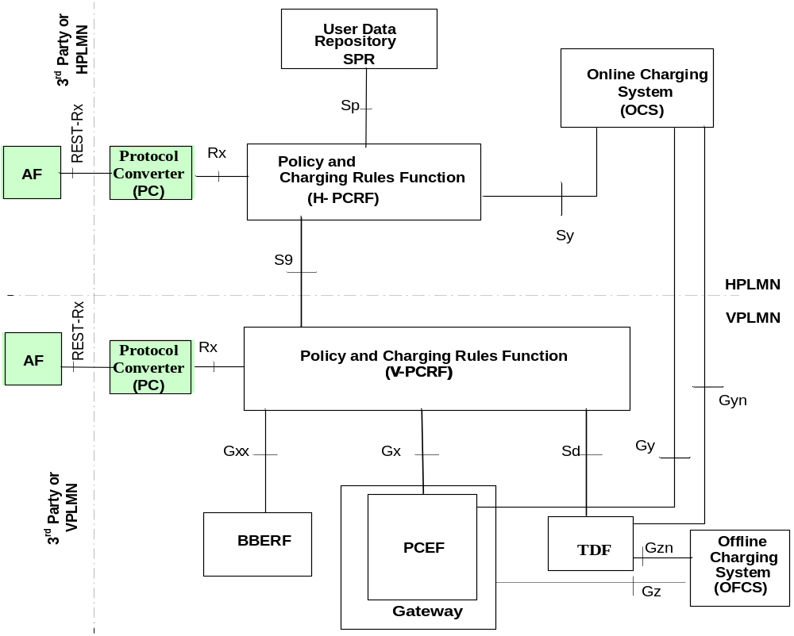
Figure 4.2.5: The PCC architecture with the PC for visited access scenario with SPR
With the UDC-based architecture, as defined in 3GPP TS 23.335 [6] and applied in 3GPP TS 23.203 [5], the UDR replaces SPR and the Ud reference point provides access to the subscription data in the UDR. The Ud interface as defined in 3GPP TS 29.335 [7] is the interface between the PCRF and the UDR. When the UDC architecture is used, SPR and Sp, whenever mentioned in this document, are replaced by UDR and Ud.

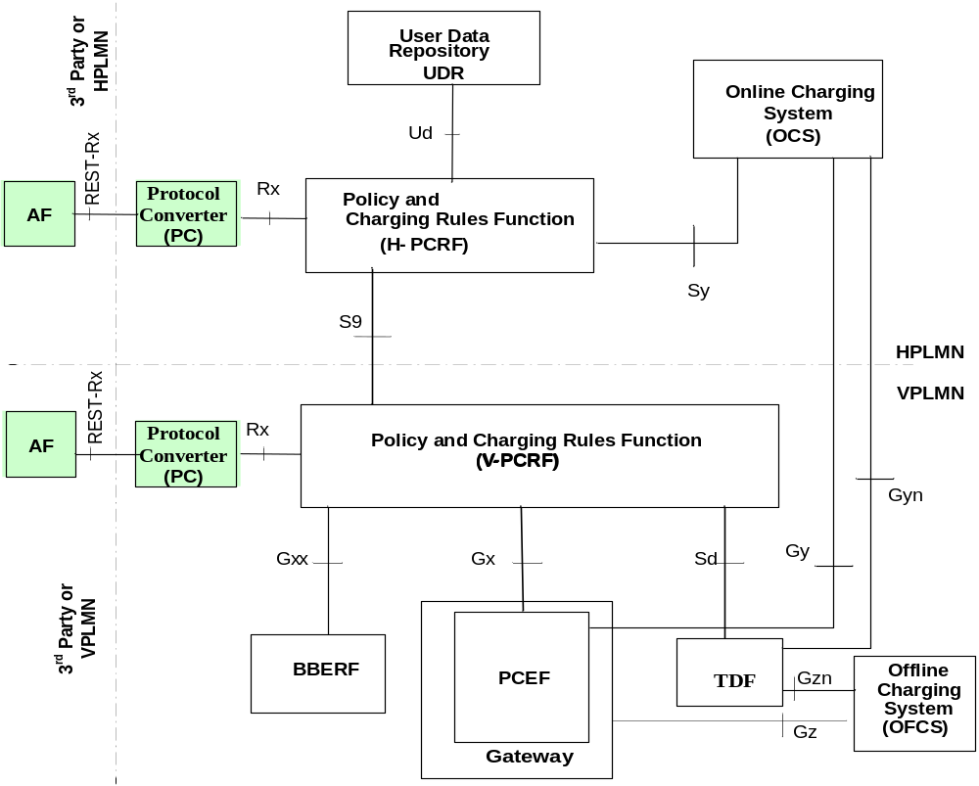
Figure 4.2.6: The PCC architecture with the PC for visited access scenario with UDR

4.3 Functional elements

4.3.1 Application function
The AF is an element offering applications that require the Policy and Charging Control of traffic plane resources (e.g. UMTS PS domain/GPRS domain resources). The AF shall use the Rx reference point to provide session information to the PCRF.
NOTE: The AFs may be deployed by the same operator offering the IP-CAN or may be provided by external third party service provider.

4.3.2 Protocol converter
If the AF only supports RESTful HTTP and XML a protocol converter is needed between the AF and the PCRF.
The Protocol converter (PC) is an element converting information carried over RESTful HTTP and XML to information carried over Diameter in order to get an access to the PCC architecture.

4.4 Location of the PC within the PLMN

4.4.1 General
The protocol converter can be located:
1) In the PLMN but outside of the PCRF realm;
2) In the PCRF realm.
There is only one logical protocol converter in both above cases.

4.4.2 Protocol converter located in the PLMN but outside of the PCRF realm
In this scenario the protocol converter is in the PLMN but outside of the PCRF realm, as shown in figure 4.4.2.1.

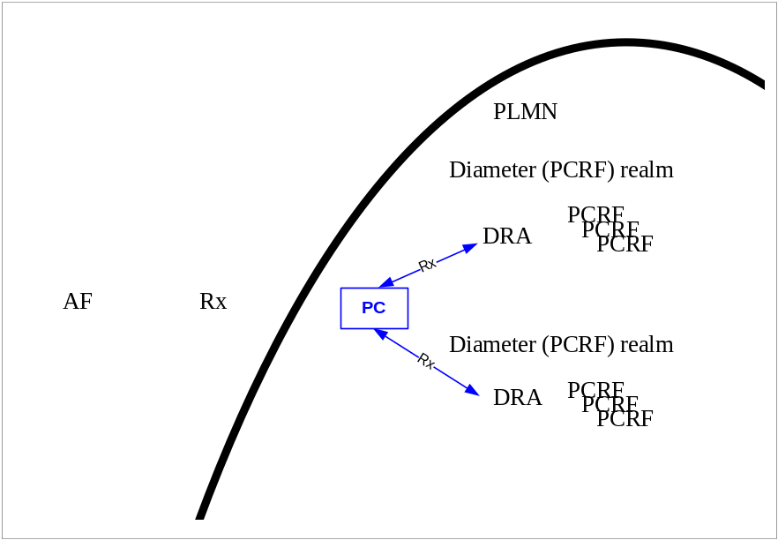
Figure 4.4.2.1: Protocol converter placed within PLMN but outside of the Diameter (PCRF) realm
NOTE: A DRA is needed if more than one PCRF is present in a Diameter (PCRF) realm.

4.4.3 Protocol converter located in the PCRF realm
In this scenario the protocol converter is in the PCRF realm, as shown in figure 4.4.3.1.

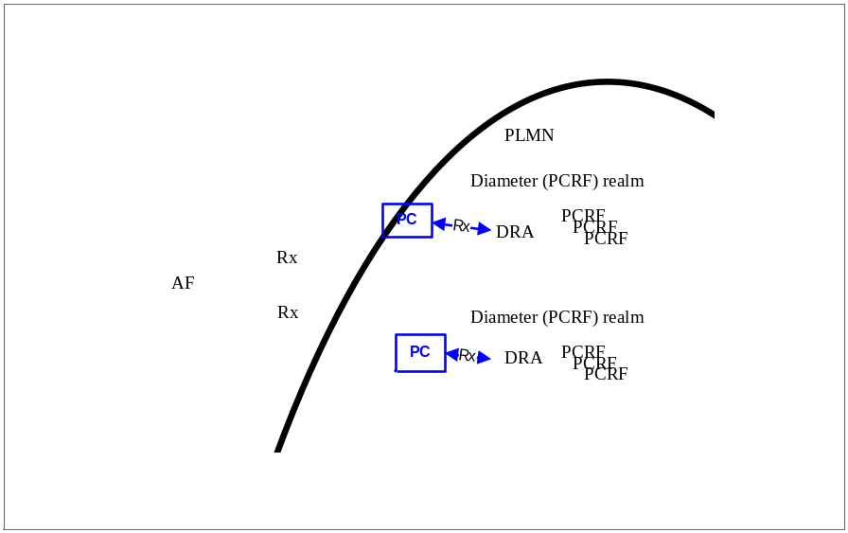
Figure 4.4.3.1: Protocol converter placed within the Diameter (PCRF) realm
NOTE: A DRA is needed if more than one PCRF is present in a Diameter (PCRF) realm.

4.5 PCC Procedures over the RESTful reference point

4.5.1 General
PCC procedures which can be operated at the REST-Rx interface are described in the following clauses.

4.5.2 Initial Provisioning of Session Information
When a new AF session is being established and media information for this AF session is available at the AF and the related media require PCC supervision, the AF shall open an RESTful Rx session with the PC for the AF session using an HTTP POST message that addresses the resource responsible for resource creation, unless an Rx session has already been established for the AF session. If the RESTful Rx session already exists for the AF session, the AF uses the existing RESTful Rx session and shall use the HTTP PUT message including the AF Session ID in the path element to address the existing resource. The AF shall provide the full IP address of the UE using either UEIP element or UEIPv6 element, and the corresponding Service Information within MCD group(s). The AF shall not include circuit-switched bearer related media in the service information sent to the PC. The AF shall indicate to the PC as part of the MCD element whether the media IP flow(s) should be enabled or disabled with the FlowStatus element.
The AF may include the AFAppId element into the AF session establishment representation in order to indicate the particular service that the AF session belongs to. This element can be provided at both AF session level, and media component description level. When provided at both levels, the AFAppId element provided within the MCD group will have precedence.
The AF may include the AFChargingId element into the AF session establishment representation for charging correlation purposes. The AF may also include the SpecificAction element to request notification for certain user plane events, e.g. bearer termination.
The AF may include the SvcURN element in order to indicate that the new AF session relates to emergency traffic.
The AF may include the MPSId element in order to indicate that the new AF session relates to an MPS session.
If the AF provides service information that has been fully negotiated, the AF may include the SvcInfoStatus element set to FINAL_SERVICE_INFORMATION as specified in 3GPP TS 29.214 [4].
The AF may additionally provide preliminary service information not fully negotiated yet at an earlier stage. To do so, the AF shall include the SvcInfoStatus element with the value set to PRELIMINARY SERVICE INFORMATION as specified in 3GPP TS 29.214 [4].
For sponsored data connectivity, the AF shall provide the application service provider identity and the sponsor identity to the PCRF via the PC by including the ASPId element and the SponsId element in the SpConnData group in the AF session establishment representation.
NOTE 1: The relationship between AF and sponsor is out of scope of this specification. A single AF can serve multiple sponsors.
To support the usage monitoring of sponsored data connectivity, the AF may also include the GSU group in the SpConnData group and the SpecificAction element set to the value USAGE_REPORT as specified in 3GPP TS 29.214 [4] to request notification when the usage threshold has been reached.
NOTE 2: If the AF is in the user plane, the AF can handle the usage monitoring and therefore it is not required to provide a usage threshold to the PCRF as part of the sponsored data connectivity information.
To allow the PCRF and PCEF to perform PCC rule authorization and bearer binding for the described service IP flows, the AF may supply both source and destination IP addresses and port numbers within the FlowDesc element, if such information is available.
The AF may specify the ResPrio element at request level in the AF session establishment representation in order to assign a priority to the AF session as well as specify the ResPrio element at the media component description level to assign a priority to the IP flow. The presence of the ResPrio in both levels does not constitute a conflict as they each represent different types of priority. Specifically the ResPrio at the AF session establishment representation level provides the relative priority for a session while the ResPrio at the media component description level provides the relative priority for an IP flow within a session. If the ResPrio element is not specified the requested priority is DEFAULT (0) as specified in 3GPP TS 29.214 [4].
The AF may request notifications of specific IP-CAN session events through the usage of the SpecificAction element in the AF session establishment representation. The HTTP POST message, which is used to establishment of a new session, shall include the notification URL in the representation.
The AF may include the ReqType element set to INITIAL_REQUEST as specified in 3GPP TS 29.214 [4].
When the PC receives the SuppFeatures element from the AF, it shall only include in the corresponding Diameter Supported-Features AVP sent to the PCRF the intersection of the AF advertised features and the features supported by the PC.
The behaviour when the AF does not receive the HTTP 201 CREATED response, or when it arrives after the internal timer waiting for it has expired, is out of scope of this specification and based on operator policy.

4.5.3 Modification of Session Information
The AF may modify the session information at any time (e.g. due to an AF session modification or internal AF trigger) by sending an HTTP PUT message to PC including the AF session ID as an URL address and the MCD group(s) with the updated Service Information in the HTTP body. The AF shall send an AF session modification request representation to the PCRF via the PC, only after the previous AF session modification request has been acknowledged.
If the AF provides service information that has been fully negotiated, the AF may include the SvcInfoStatus element set to FINAL_SERVICE_INFORMATION as specified in 3GPP TS 29.214 [4].
The AF may additionally provide preliminary service information not fully negotiated yet at an earlier stage. To do so, the AF shall include the SvcInfoStatus element with the value set to PRELIMINARY SERVICE INFORMATION as specified in 3GPP TS 29.214 [4].
The AF may include the ReqType element set to UPDATE_REQUEST as specified in 3GPP TS 29.214 [4] in the AF SESSION MODIFICATION REQUEST.
The AF may include the MPSId element in order to indicate that the modified AF session relates to an MPS session.
For sponsored data connectivity, the AF shall provide the application service provider identity and the sponsor identity to the PCRF via the PC by including the ASPId element and the SponsId element in the SpConnData group in the AF session modification representation.
To support the usage monitoring of sponsored data connectivity, the AF may also include the GSU group in the SpConnData group in the AF session modification representation.
NOTE: If the AF is in the user plane, the AF can handle the usage monitoring and therefore it is not required to provide a usage threshold to the PCRF via the PC as part of the sponsored data connectivity information.

4.5.4 AF Session Termination
When an AF session is terminated, the AF shall send an HTTP DELETE message including the AF Session ID as an URL address to the PC.
If the AF requires access network information at this step, the AF shall include the ReqAccInfo element within the AF session termination representation, indicating the required information.

4.5.5 Gate Related Procedures
Depending on the application, in the Service Information provision, the AF may instruct the PCRF via the PC by sending an HTTP PUT message when the IP flow(s) are to be enabled or disabled to pass through the IP-CAN. The AF does this by sending the gate status request message representation containing the MCD group(s) that contains the flow status information (in the FlowStatus element) for the flows to be enabled or disabled.
The behaviour when the AF does not receive the gate status response from the PC, or when it arrives after the internal timer waiting for it has expired, or when it arrives with an indication different than SUCCESS, are outside the scope of this specification and based on operator policy.

4.5.6 Subscription to Notification of Signalling Path Status
An AF may subscribe to notifications of the status of the AF signalling transmission path. To do so, the AF shall send an HTTP POST message to establish an AF session with the PC (as per sub-clause 5.3.4). The HTTP POST message shall provide a URL which shall be used as a notification URL by the PC. The AF shall provide the UE's IP address (using either the UEIP element or the UEIPv6 element) and the SpecificAction element requesting the subscription to "INDICATION_OF_LOSS_OF BEARER" and/or "INDICATION_OF_RELEASE_OF_BEARER" in the representation. The AF shall additionally provide an MCD group including a single MSC group with the FlowUsage element set to the value "AF_SIGNALLING" within the representation. The MCD group shall contain the MCN element set to "0".
If the AF Session is only used for subscription to Notification of Signalling Path Status, the AF may cancel the subscription to notifications of the status of the AF Signalling transmission path. In that case, the AF shall send an HTTP DELETE message to the PC, which shall be acknowledged with an HTTP 200 OK response.
NOTE: The Rx session created for the AF signalling can also be used when the AF requests notifications of IP-CAN type change and/or when the AF provisions AF Signalling Flow Information.

4.5.7 Traffic Plane Events
If the PC receives a Diameter RAR command for traffic plane events reporting as defined in clause 4.4.6 of 3GPP TS 29.214 [4], the PC includes the content translated from the RAR command as a representation into an HTTP PUT message to indicate to the AF the traffic plane events. After the PC receives the HTTP 200 OK response from the AF, the PC converts the representation of the response to a Diameter RAA command and sends the Diameter RAA command to the PCRF as specified in 3GPP TS 29.214 [4].
If the PC receives a Diameter ASR command for IP-CAN session termination as defined in clause 4.4.6.1 and 4.4.6.2 of 3GPP TS 29.214 [4], the PC includes the content translated from the ASR command as a representation into an HTTP PUT message to indicate to the AF the IP-CAN session termination. After the PC receives the HTTP response from the AF and the response includes a representation of an ASA, the PC converts the the representation of the response to a Diameter ASA command and sends the Diameter ASA command to the PCRF as specified in 3GPP TS 29.214 [4]. The AF initiates the session termination procedure as defined in clause 4.5.4.
NOTE: The definition of error cases are out of scope of the present specification.

5 Protocol

5.1 Introduction
The following layers of the protocol stack for the Rx reference point between AF and PC are described in sub-clauses:
- TCP [8] provides the communication service at the transport layer.
- An optional communication security layer can be added between the transport and the application delivery layer (see sub-clause 7).
- The application delivery layer provides the transport of the specific application communication data using HTTP [9].
- The specific application communication layer constitutes the transport of the XML documents. The XML schema describes the data structure, which is accepted by the Rx software applications.
Figure 5.1.1 illustrates the protocol stack of the RESTful Rx reference point.
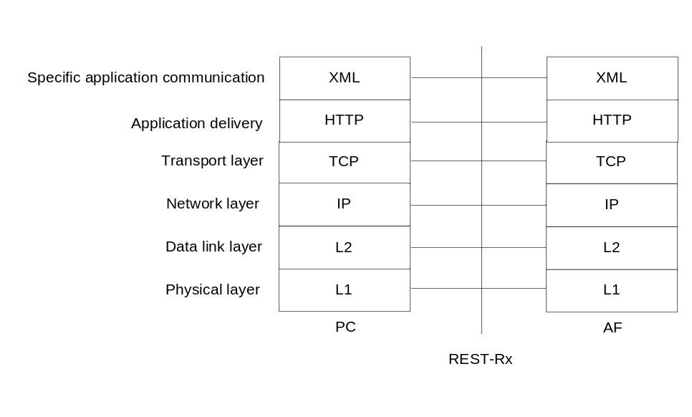
Figure 5.1.1: Protocol stack of the RESTful Rx reference point

5.2 Transport layer
HTTP is layered over TCP, which provides a reliable transport.
PC and the AF act as HTTP client and HTTP server both. As a result the PC and the AF establish a TCP connection for each direction. This permits bidirectional communication.
AF and PC shall use persistent connections. If the AF or PC has not already initiated a persistent TCP connection at the time sending an HTTP message, AF or PC shall initiate a TCP connection before sending the HTTP message; otherwise the AF or PC shall use the persistent connection.

5.3 Application delivery layer
The application delivery layer shall use RESTful HTTP.
The application delivery layer provides the following services:
- session establishment including creation of resources, which are addressable in the path element of an URL, and setup of notification URLs
- session modification, termination and gate related procedures by HTTP request/response dialogs
- subscription to notifications
- notification dialog by HTTP request/response messages
- transport of the specific application communication included in the HTTP message body
Creation of resources shall be a part of the AF session establishment. The AF session ID shall be assigned by the PC and shall be used to identify the session resource at the PC. This also sets-up the notification URL, which shall be used to address the resource for notifications from the PC to the AF.
NOTE: The AF session ID is allocated by the PC. In the session dialogue the AF session ID will be used to address a resource. If it is allocated by the PC, the client will be informed about the AF session ID within the HTTP response 201 Created. This means that the session related URI (see sub-clause 5.3.4 ...sessions/afsessionid) is dynamically discovered and not defined by the client.
The AF session ID is defined in clause 5.3.5.
The Rx application requires that the PC can notify the AF about traffic plane events. The AF normally acts as the HTTP client, but the requirement for notifications result in a reversal role of the client and server. Therefore, PC and AF may act as HTTP client and HTTP server both.
If the AF establishes an AF session (i.e. initiates the initial provisioning of session information), the AF shall send an HTTP POST message to the PC including all session information required. The AF shall include the URL, which shall be used by the PC when the PC will report traffic plane events corresponding to the AF session. The PC shall allocate a new AF session ID for the AF session and shall establish an Rx Diameter session with a new Rx Diameter session ID. The PC shall keep the mapping between the AF session ID and the URL and the mapping between the AF session ID and the Rx Diameter session ID. The PC shall send an HTTP 201 CREATED response to the AF including the allocated AF session ID once it receives a response from the PCRF.
If the AF modifies an AF session (i.e. initiates modification of session information), the AF shall send an HTTP PUT message, which includes the AF session ID as a path element of the URI. The PC shall send an HTTP 200 OK response to the AF after update of the corresponding Rx Diameter session.
If the AF terminates an AF session, the AF shall send an HTTP DELETE message including the AF session ID as a path element of the URI. The PC shall send an HTTP 200 OK response to the AF after termination of the corresponding Rx Diameter session.
If the AF initializes a gate related procedure, the AF shall send an HTTP PUT to the PC including all information required. The PC shall send an HTTP response to the AF after update of the corresponding Rx Diameter session.
If the AF subscribes to notifications of the status of the signalling transmission path, the AF shall send an HTTP POST to the PC including event information for the subscription. The subscription to notifications is performed as a separate session. The PC shall send an HTTP 201 CREATED response to the AF after update of the corresponding Rx Diameter session.
When the PC reports traffic plane events corresponding to the AF session, the PC shall send an HTTP PUT to the AF using the notification URL. The request includes the AF session ID as a path element of the notification URL. The AF may use the information for appropriate actions and will send an HTTP 200 OK response to the PC.
Every HTTP message contains the specific communication information required for this case in its body.
Annex A provides call flows for all procedures.

5.3.1 Methods
Methods indicate to the server what action has to be performed. Every HTTP request message has a method. The following HTTP methods can be used [9]:
- POST: Used to create a resource state. The URI defines the address responsible for the creation of the resource.
- PUT: Used to modify a resource state. The URI defines the resource which will be modified.
- DELETE: Used to delete a resource state.
Every HTTP request results in a response message that comes back with a status code and further information in its body, if required. The AF waits for this response before initiating a further request for the same AF session.

5.3.2 Void

5.3.3 Resources and URI design
REST claims that the session state is held by the client or it is transferred into a resource state by the server, in order to allow a stateless communication. The concept of the resource state avoids the transfer of the complete resource state to the client. Therefore, resources shall be an integral part of the REST-Rx interface. Resources are identifiable and have state representation.
NOTE 1: Stateless communication reduces the coupling of client and server. E.g., two requests that follow each other may not be processed by the same server instance.
NOTE 2: Resources may have one or more representations. JSON may be another representation (3GPP TR 29.817 [2]). It is possible to use different representations of resources for different requirements. In this release XML will be used as a representation only.
Resources shall be identified by URIs. The URI design shall be based on the structure defined in IETF RFC 3986 [10]:
scheme ":" hier-part [ "?" query ] [ "#" fragment ]
hier-part = "//" authority path-abempty
/ path-absolute
/ path-rootless
/ path-empty
The URI design for the REST-Rx interface shall be based on the characteristics and requirements of the reference point between AF and PC and shall have a hierarchical structure.
The scheme may be HTTP or HTTPS for the REST-Rx interface. Within a scheme the definition of names shall follow the rules of HTTP URIs. Host and port are the main parts of the authority. The path element identifies the resources. The URIs, which are allowed on the REST-Rx interface and build out of the obligatory parts, shall have the structure:
Scheme://Host/Mainapplication/Mainresources
The obligatory parts have the meaning:
- Scheme: The application delivery layer protocol HTTP or HTTPS.
- Host: This part of the URI represents the server address including the port.
- Main application: The application which shall be accessed by the request. This release shall only provide the Rx application.
NOTE 3: The main application level makes possible defining different applications as resources at the same entity. This release only provides the Rx application.
- Main resources: Sessions are the core concepts of the REST-Rx interface and can be defined as the main resources by URIs. Main resources may be split into sub-resources further (e.g. individual sessions may be identified by AF session IDs).
The URI addressing of the main resource sessions can look like:
- http://pcserver/rxapplication/sessions

5.3.4 HTTP request/response dialogues
The HTTP request/response dialogue may consist out of different dialogues providing the functionalities for session establishment, modification, termination, gate related procedures, subscription to notifications and notifications. These dialogues shall include the required content translated from the Diameter messages as defined in 3GPP TS 29.214 [4] and represented by the specific application communication language as defined in sub-clause 5.4. Sessions are addressed as resources in the path of the URI.
The HTTP request message, which is related to a session establishment procedure, shall use the POST method and shall include the notification URL in addition to the required content of an AAR message XML representation. The message addresses a resource, which is responsible for resource creation and session establishment, and has the general structure:
HTTP POST https://pcserver/rxapplication/sessions
<Settings>
<NotificationBaseURL>https://afresponsehost/path</NotificationBaseURL>
</Settings>
<AA-Request>
<xs:annotation>
<xs:documentation>========================</xs:documentation>
<xs:documentation>Rx specific information/xs:documentation>
<xs:documentation>========================</xs:documentation>
</xs:annotation>
</AA-Request>

This HTTP POST message instructs the PC to create a resource state with a notification URL and to establish an AF session between the PC and the PCRF. An AAA message, received by the PC, will result in a 201 Created response, which shall include the required content to be translated from the Diameter AAA answer message as a representation of the AAA message. The response message shall include one resource in the Location header field, which represents the AF session ID and will be used as a resource address by the AF.
The HTTP request message, which is related to a session with an AF session ID, shall have the general structure:
HTTP METHOD https://pcserver/rxapplication/sessions/afsessionid
<RxMessage> < !-- The actual element sent is the xml document is one of :
AA-Request, ST-Request, RA-Request or AS-Request -->
<xs:annotation>
<xs:documentation>=============================</xs:documentation>
<xs:documentation>Rx specific information/xs:documentation>
<xs:documentation>=============================</xs:documentation>
</xs:annotation>
</RxMessage>

It is answered by an HTTP response message that includes the correct content translated from a Diameter answer message as a representation as defined in Annex B.2. The HTTP response message shall have the general structure:
HTTP STATUS_CODE REASON_PHRASE
<RxMessage> < !-- The actual element sent is the xml document is one of :
AA-Answer, ST- Answer, RA-Request or AS-Request -->

<xs:annotation>
<xs:documentation>=============================</xs:documentation>
<xs:documentation>Rx specific answer messages </xs:documentation>
<xs:documentation>=============================</xs:documentation>
</xs:annotation>
</RxMessage>

The definition of sessions as resources makes it possible to use HTTP methods to retrieve information about the sessions and control their state.
Table 5.3.4.1: Rx methods and their result
Method | Result
POST .../sessions | Creates a resource for a session and initiates an AF session establishment procedure
PUT ...sessions/afsessionid | Modifies a session/resource state or initates a gate related procedure.  "afsessionid" is the AF session resource id that was previously created by the PC and returned in the Location header within the answer to the POST message.
PUT  ...<notificationbaseurl>/<afsessionid> | Notifies the AF about traffic plane events associated with an AF session.  The "notificationbaseurl" is set to the received NotificationBaseURL value in the original POST message that created the corresponding AF session resource.  The "afsessionid" is the AF session resource id that was previously created by the PC and returned in the Location header within the answer to the POST message.
DELETE ...sessions/<afsessionid> | Deletes a session/resource state.  The "afsessionid" is the AF session resource id that was previously created by the PC and returned within the answer to the POST message.

5.3.5 AF Session ID
The Diameter session between the PC and PCRF is mapped to a resource on the REST-Rx interface. The AF uses the AF session ID allocated by the PC, in the path element of an HTTP method to address the PC resource, which is used as an address for events corresponding to a particular activity. When the PC reports traffic plane events corresponding to the AF session, the PC adds the AF session ID as a path element to the notification URL.
The syntax of the Session ID defined for Diameter [16] can be mapped to the AF Session ID. The format of the AF session ID shall follow the implementation-specific syntax standardized for path elements of URLs [15]. The delimiter ";", which is used in the Diameter Session ID definition, need not be percent-encoded since there will be no conflict with a reserved character of the URI component.
NOTE: Characters in the reserved set are protected from normalization and are therefore safe to be used by scheme-specific and producer-specific algorithms for delimiting data subcomponents within a URI [15].

5.4 Specific application communication

5.4.0 General
Specific application communication represents the presentation of application data structures by transforming data into the form that the application accepts. It establishes the context between application-layer entities.
Note: This release only supports the content type XML.

5.4.1 Content type XML
The content type of the RESTful HTTP message shall be XML.

5.4.1.1 XML schema
The XML schema is given in annex B.

5.4.1.2 Data types and mapping between XML elements
The mapping between the Diameter value types or other parameter types used in this specification and the XML simple types is defined in table 5.4.1.2.1.
Table 5.4.1.2.1: Mapping between Diameter AVPs, other types and XML types
Diameter Value Type or other type | XML Simple Type | Remark
Enumerated | unsignedInt, integer | In XML enumerations constrain the value space to a specified set of values defined in 3GPP TS 29.214 [4]. Integer or unsignedInt is selected as the XML type.
IPFilterRule | string | The Diameter IPFilterRule is derived from OctetString. The IPFilterRule uses the ASCII charset.
OctetString | hexBinary | OctetStrings contain arbitrary data of variable length. They are used to process arrays of byte values. The data type is not limited to string values but can store any byte based data type (including binary data).
Time | unsignedLong | The time format is derived from the OctetString AVP Base Format. The string must contain four octets, in the same format as the first four bytes of the NTP timestamp format. The 64-bit timestamp format is used on the REST-Rx interface. It includes a 32-bit unsigned seconds field spanning 136 years and a 32-bit fraction field resolving 232 picoseconds.
Unsigned32 | unsignedInt
Unsigned64 | unsignedLong
UTF8String | string | The UTF8String is derived from the OctetString the base format.
Binary data | hexBinary | hexBinary represents arbitrary hex-encoded binary data.
Integer (used as enumeration indication) | unsignedInt | The unsigned integer can be used as enumeration value.

NOTE: AVPs which are defined in 3GPP TS 29.214 [4] but not defined in the XML schema (see Annex B.1) as representations of AVPs cannot be supported on the specific application communication layer of the REST-Rx interface respectively cannot be supported for the Diameter message representation (see Annex B.2).

5.4.1.3 Mapping between Diameter AVPs and XML elements and groups
The mapping between the Diameter AVP names and XML element and group names is defined in table 5.4.1.3.1.
Table 5.4.1.3.1: Mapping between Diameter AVPs and XML elements or groups
Diameter AVP (TS 29.214 [4]) | REST-Rx abbreviation | Type
3GPP-MS-TimeZone | MSTimeZone | Complex element
3GPP-SGSN-MCC-MNC | SgsnMccMnc | Complex element
3GPP-User-Location-Info | ULI | Complex element
Abort-Cause | AbortCause | Simple element
Acceptable-Service-Info | AcceptableSvcInfo | Group
Access-Network-Charging-Address | ANCAddr | Simple element
Access-Network-Charging-Identifier | ANCID | Group
Access-Network-Charging-Identifier-Value | ANCIDVal | Simple element
AF-Application-Identifier | AFAppId | Simple element
AF-Charging-Identifier | AFChargingId | Simple element
Application-Service-Provider-Identity | ASPId | Simple element
Called-Station-ID | APN | Simple element
CC-Input-Octets | CCIO | Simple element
CC-Output-Octets | CCOO | Simple element
CC-Total-Octets | CCTO | Simple element
Codec-Data | CodecData | Simple element
Experimental-Result | ExperiRes | Group
Experimental-Result-Code | ExperiResCode | Simple element
Feature-List | FeatList | Simple element
Feature-List-ID | FeatListId | Simple element
Final-Unit-Action | FinUnitAct | Simple element
Flow-Description | FlowDesc | Simple element
Flow-Number | FlowNum | Simple element
Flow-Status | FlowStatus | Simple element
Flow-Usage | FlowUsage | Simple element
Flows | Flows | Group
Framed-IP-Address | UEIP | Simple element
Framed-IPv6-Prefix | UEIPv6 | Simple element
Granted-Service-Unit | GSU | Group
IP-CAN-Type | IPCANType | Simple element
IP-Domain-ID | IPDomainId | Simple element
Max-Requested-Bandwidth-DL | MaxBwDL | Simple element
Max-Requested-Bandwidth-UL | MaxBwUL | Simple element
Media-Component-Number | MCN | Simple element
Media-Component-Description | MCD | Group
Media-Sub-Component | MSC | Group
Media-Type | MediaType | Simple element
Min-Requested-Bandwidth-DL | MinBWDL | Simple element
Min-Requested-Bandwidth-UL | MinBWUL | Simple element
MPS-Identifier | MPSId | Simple element
NetLoc-Access-Support | NETLocAccSupp | Simple element
Origin-State-ID | OrigStateId | Simple element
RAN-NAS-Release-Cause | RANNASRelCause | Complex element
RAT-Type | RATType | Simple element
Required-Access-Info | ReqAccInfo | Simple element
Reservation-Priority | ResPrio | Simple element
Result-Code | ResCode | Simple element
RR-Bandwidth | RRBw | Simple element
RS-Bandwidth | RSBw | Simple element
Rx-Request-Type | ReqType | Simple element
Service-Info-Status | SvcInfoStatus | Simple element
Service-URN | SvcURN | Simple element
Specific-Action | SpecificAction | Simple element
Sponsor-Identity | SponsId | Simple element
Sponsored-Connectivity-Data | SpConnData | Group
Subscription-ID | SubId | Group
Subscription-ID-Data | SubIdVal | Simple element
Subscription-ID-Type | SubIdType | Simple element
Supported-Features | SuppFeatures | Group
Termination-Cause | TermCause | Simple element
TWAN-Identifier | TWANId | Simple element
Used-Service-Unit | USU | Group
User-Location-Info-Time | ULITime | Simple element
Vendor-ID | VenID | Simple element

NOTE 1: Diameter AVPs which are listed in 3GPP TS 29.214 [4] but not listed in table 5.4.1.3.1 will not be supported on the specific application communication layer of the REST-Rx interface.
NOTE 2: When the Diameter message transports the Result Code AVP or an Experimental Result Code AVP, for example, the PC need not inspect these AVPs and need not map these AVPs to HTTP status codes. The AVPs shall be included into HTTP commands as representations and will be transported between the endpoints (PCRF and AF), which are responsible to take this information into account.

5.5 PC discovery
The Dynamic Host Configuration Protocol (DHCP) [12] and Domain Name System (DNS) [11] interfaces are typically not included in architecture diagrams or described as reference points. For the PC discovery, DHCP and DNS interactions can take place between the AF and the PC. If the AF does not have PC address information (i.e. provided by preconfiguration or other protocol configuration options), DHCP and DNS queries can be carried out before the creation of resources by the AF. The input parameters could be the UE IP address, User identity, IP domain Id and PDN Id.

6 Routing

6.1 PC located in the PLMN but outside of the PCRF realm
The AF may have following parameters: UE IP address (i.e. IPv4 or IPv6 address), PDN information, user identity and domain Identity.
The AF may use above parameters to construct the HTTP request URL to the protocol converter.
The above available parameters shall also be included in the AF session establishment requests to the protocol converter.
For the routing between the protocol converter and PCRF, if the PC can extract the realm information from the user identification and/or other information from the AF, the PC can send the Diameter message to the correct PCRF realm. Otherwise, if the PC can't extract the realm information from the user identification and/or other information from the AF, the PC may use pre-configured information to find the PCRF realm. The parameters provided by the PC may include the UE's IPv4 address, the UE's IPv6 address, PDN information, user identity and domain identity.
NOTE: The DRA procedure for the PC to find the PCRF is defined in clause 7.3.2 of 3GPP TS 29.213 [3].

6.2 PC located in the PCRF realm
The AF may have following parameters: UE IP address (i.e. IPv4 or IPv6 address), PDN information, user identity and domain Identity.
The AF may use above parameters to construct the HTTP request URL to the protocol converter.
The above available parameters shall also be included in the AF session establishment requests to the protocol converter.
For the routing between the protocol converter and PCRF, the protocol converter shall provide the PCRF or the DRA of the PCRF realm with the parameters translated from the HTTP request. The parameters provided by the PC may include the UE's IPv4 address, the UE's IPv6 address, PDN information, user identity and domain identity.
NOTE: The DRA procedure for the PC to find the PCRF is defined in clause 7.3.2 of 3GPP TS 29.213 [3].

7 Secure communication
3GPP TS 33.310 [13] provides a highly scalable entity authentication framework for 3GPP network nodes.
The unsecured HTTP protocol may be combined with TLS [14] in order to provide confidentiality and integrity protection. HTTP/TLS is differentiated from HTTP URIs by using the "HTTPS" scheme in place of the "HTTP" scheme. Mutual authentication shall be enabled in TLS for authenticating and allowing only an authorized 3rd party AF to access the PC
NOTE: In case a client knows the application level protocol (HTTP) and the format of the representation (XML), it is able to communicate with every resource around the world, for which a representation is retrievable in this format. Since HTTP and XML are extensively used in the internet community it is highly desirable to use the option for secure communication.

Annex A (informative):
Call Flows

A.1 General
This annex describes the procedures which use the two TCP connections to implement the interactions between the AF and the PC. The AF in the annex A.2, A.3, A.4, A.5 and A.6 uses one TCP connection initiated by the AF to send the HTTP request message and the PC in the annex A.7 uses one TCP connection initiated by the PC to send the HTTP request message.

A.2 AF session establishment
This sub-clause describes the signalling flow for the AF session establishment procedure through the PC.

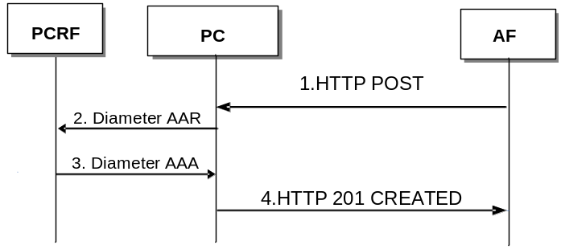
Figure A.2.1: Initial AF session request
1. The AF sends the HTTP POST to the PC to initiate the creation of a resource state, to inform the PC about the notification URL and to initiate an AF session establishment including the parameters defined in sub-clause 4.5.2.
2. The PC converts the request to a Diameter AAR command. The PC provides the Service Information to the PCRF by sending a Diameter AAR command as specified in 3GPP TS 29.214 [4] for a new Rx Diameter session.
3. The PCRF sends a Diameter AAA command to the PC as specified in 3GPP TS 29.214 [4].
4. The PC converts the required content of the Diameter AAA command and provides it in the HTTP 201 CREATED response to the AF including the parameters defined in sub-clause 4.5.2. The response message includes one resource in the Location header field, which represent the AF session ID.

A.3 AF Session Modification Initiated by AF
This sub-clause describes the signalling flow for the AF session modification procedure through PC.

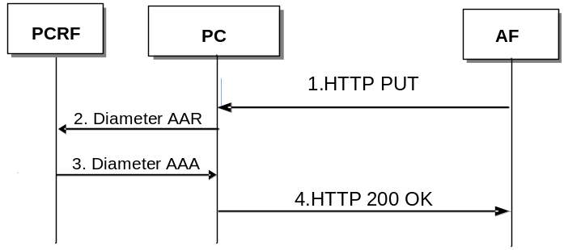
Figure A.3.1: AF session modification initiated by AF
1. The AF sends the HTTP PUT to the PC to initiate the AF session modification procedure including the parameters defined in sub-clause 4.5.3.
2. The PC converts the AF session modification request to a Diameter AAR command and sends the Diameter AAR command to the PCRF as specified in 3GPP TS 29.214 [4].
3. The PCRF sends a Diameter AAA command to the PC as specified in 3GPP TS 29.214 [4].
4. The PC converts the required content of the Diameter AAA command and provides it in the HTTP 200 OK to the AF including the parameters defined in sub-clause 4.5.3.

A.4 AF Session Termination
This sub-clause describes the signalling flow for the AF session termination procedures through PC.
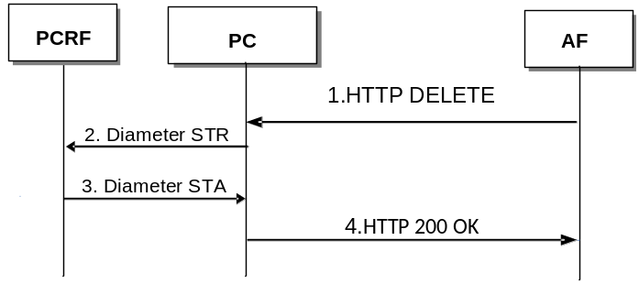
Figure A.4.1: AF session termination Procedures
1. The AF sends the HTTP DELETE to the PC to initiate the AF session termination procedure including the parameters defined in sub-clause 4.5.4.
2. The PC converts the AF session termination request to a Diameter STR command and sends the Diameter STR command to the PCRF as specified in 3GPP TS 29.214 [4].
3. The PCRF sends a Diameter STA command to the PC as specified in 3GPP TS 29.214 [4].
4. The PC converts the Diameter STA command and provides the HTTP 200 OK to the AF including the parameters defined in sub-clause 4.5.4.

A.5 Gate Related Procedures
This sub-clause describes the signalling flow for the gate related procedures through PC.
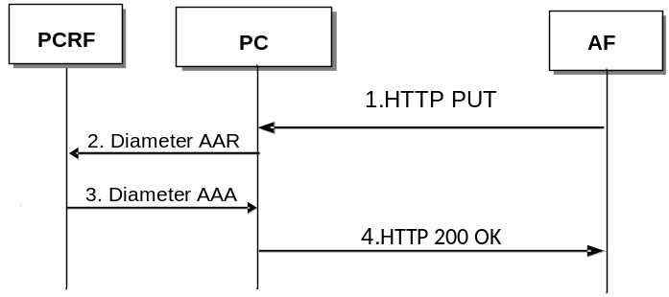
Figure A.5.1: Gate Related Procedures
1. The AF sends the HTTP PUT to the PC to indicate gate status including the parameters defined in sub-clause 4.5.5.
2. The PC converts the gate status request to Diameter AAR command and sends the Diameter AAR command to the PCRF as specified in 3GPP TS 29.214 [4].
3. The PCRF sends a Diameter AAA command to the PC as specified in 3GPP TS 29.214 [4].
4. The PC converts the Diameter AAA command and provides the HTTP 200 OK to the AF including the parameters defined in sub-clause 4.5.5.

A.6 Subscription to Notification of Signalling Path Status
This sub-clause describes the signalling flow for the subscription to notification of signalling path status through PC.
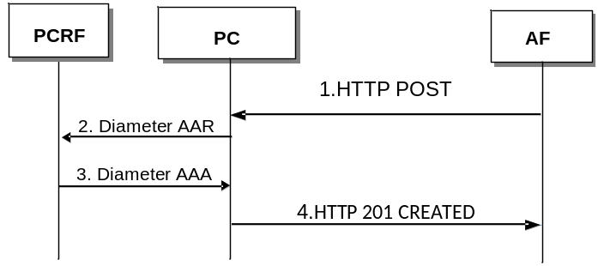
Figure A.6.1: Subscription to Notification of Signalling Path Status
1. The AF sends the HTTP POST to the PC to subscribe to notification of signalling path status including the parameters defined in sub-clause 4.5.6.
2. The PC converts the subscription request to Diameter AAR command and sends the Diameter AAR command to the PCRF as specified in 3GPP TS 29.214 [4].
3. The PCRF sends a Diameter AAA command to the PC as specified in 3GPP TS 29.214 [4].
4. The PC converts the Diameter AAA command and provides the HTTP 201 CREATED to the AF including the parameters defined in sub-clause 4.5.6.

A.7 Notification of Traffic Plane Events
This sub-clause describes the signalling flow for the notification of traffic plane events through the PC.

A.7.1 Traffic plane event reporting
This clause describes the signalling flow for traffic plane event reporting through the PC.

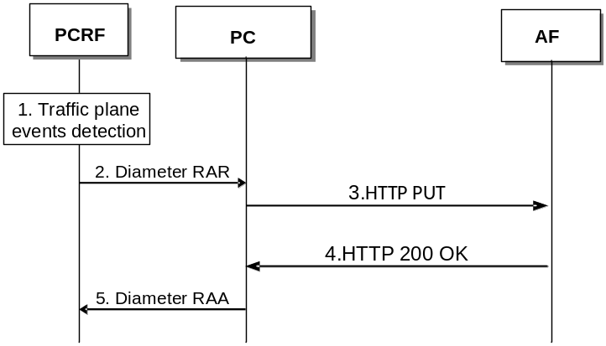
Figure A.7.1.1: Traffic plane events reporting
1. The PCRF detects the occurrence of the traffic plane events.
2. When the traffic plane events occur, the PCRF notifies the corresponding events to the PC via a Diameter RAR command as specified in 3GPP TS 29.214 [4].
3. The PC converts the Diameter RAR command to HTTP PUT to indicate the traffic plane events including the parameters defined in sub-clause 4.5.7.
4. The AF sends the HTTP 200 OK to the PC including the parameters defined in sub-clause 4.5.7.
5. The PC converts the HTTP 200 OK to Diameter RAA command and sends the Diameter RAA command to the PCRF as specified in 3GPP TS 29.214 [4].
NOTE: The signalling for traffic plane event reporting, when all service data flows within the AF session are affected, is described in clause A.7.2.

A.7.2 Service data flow deactivation when all service data flows are affected
This clause describes the signalling flow when all the service data flows within the AF session are affected through the PC.
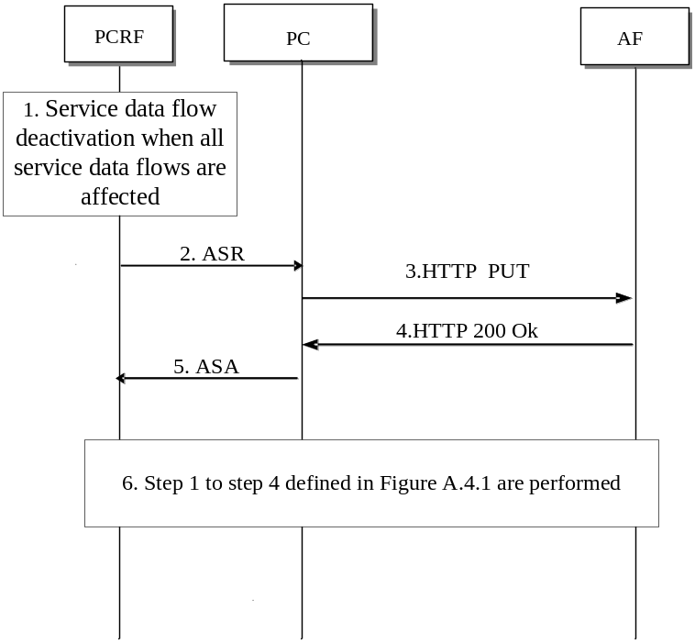

Figure A.7.2.1: Service data flow deactivation when all service data flows are affected
- The PCRF detects that all service data flows are terminated within the AF session.
- The PCRF sends the ASR command to the PC;
- The PC converts the Diameter ASR command to HTTP PUT including the parameters defined in clause 4.5.7.
- The AF sends the HTTP 200 OK to the PC including the parameters defined in clause 4.5.7.
- The PC converts the HTTP 200 OK to Diameter ASA command including the parameters defined in clause 4.5.7.
- Step 1 to step 4 defined in Figure A.4.1 are performed.

A.7.3 IP-CAN Session Termination
This clause describes the signalling flow for the IP-CAN session termination through the PC.
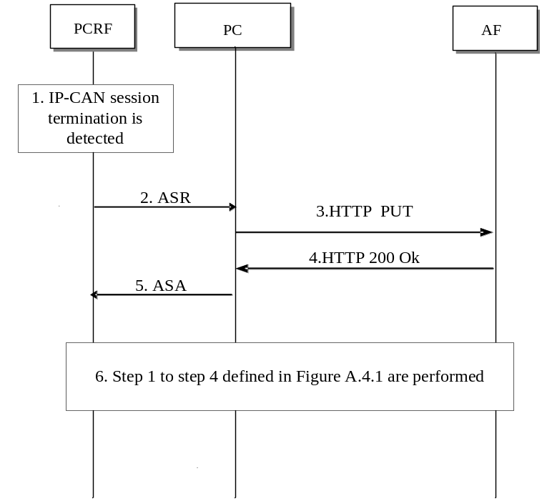

Figure A.7.3.1: IP-CAN Session Termination
- The PCRF detects the IP-CAN session is terminated and determines the AF session needs to be terminated.
- The PCRF sends the ASR command to the PC;
- The PC converts the Diameter ASR command to HTTP PUT to indicate the IP-CAN session termination including the parameters defined in clause 4.5.7.
- The AF sends the HTTP 200 OK to the PC including the parameters defined in clause 4.5.7.
- The PC converts the HTTP 200 OK to Diameter ASA command including the parameters defined in clause 4.5.7.
- Step 1 to step 4 defined in Figure A.4.1 are performed.

Annex B (normative):
XML Schema

B.1 XML elements and groups
This annex defines the XML structure of simple elements and groups, which shall be used as HTTP message content (see clause B.2). The structure is based on the AVP definition in 3GPP TS 29.214 [4].
<xs:annotation>
<xs:documentation>======================</xs:documentation>
<xs:documentation>Definition of Elements</xs:documentation>
<xs:documentation>======================</xs:documentation>
</xs:annotation>
<xs:element name="MSTimeZone" type="TypeMSTimeZone" />
<xs:element name="SgsnMccMnc" type="TypeSgsnMccMnc" />
<xs:element name="ULI" type="TypeULI" />
<xs:element name="AbortCause" type="xs:unsignedInt" />
<xs:element name="ANCAddr" type="xs:hexBinary" />
<xs:element name="ANCIDVal" type="xs:hexBinary" />
<xs:element name="VenID" type="xs:unsignedInt" />
<xs:element name="ExperiResCode" type="xs:unsignedInt" />
<xs:element name="IPCANType" type="xs:unsignedInt" />
<xs:element name="MPSId" type="xs:string" />
<xs:element name="NetLocAccSupp" type="xs:unsignedInt" />
<xs:element name="RANNASRelCause" type="TypeRANNASRelCause" />
<xs:element name="RATType" type="xs:unsignedInt" />
<xs:element name="ResCode" type="xs:unsignedInt" />
<xs:element name="TermCause" type="xs:unsignedInt" />
<xs:element name="TWANId" type="xs:hexBinary" />
<xs:element name="ULITime" type="xs:unsignedLong" />
<xs:element name="FinUnitAct" type="xs:unsignedInt" />
<xs:element name="IPDomainId" type="xs:string" />
<xs:element name="AFAppId" type="xs:string" />
<xs:element name="FlowNum" type="xs:unsignedInt" />
<xs:element name="FlowDesc" type="xs:string" />
<xs:element name="FlowStatus" type="xs:unsignedInt" />
<xs:element name="FlowUsage" type="xs:unsignedInt" />
<xs:element name="MaxBwUL" type="xs:unsignedInt" />
<xs:element name="MaxBwDL" type="xs:unsignedInt" />
<xs:element name="MinBwDL" type="xs:unsignedInt" />
<xs:element name="MinBwUL" type="xs:unsignedInt" />
<xs:element name="MediaType" type="xs:integer" />
<xs:element name="ResPrio" type="xs:unsignedInt" />
<xs:element name="RSBw" type="xs:unsignedInt" />
<xs:element name="RRBw" type="xs:unsignedInt" />
<xs:element name="SvcInfoStatus" type="xs:unsignedInt" />
<xs:element name="AFChargingId" type="xs:hexBinary" />
<xs:element name="SpecificAction" type="xs:unsignedInt" />
<xs:element name="MCN" type="xs:unsignedInt" />
<xs:element name="CodecData" type="xs:string" />
<xs:element name="SubIdType" type="xs:unsignedInt" />
<xs:element name="SubIdVal" type="xs:string" />
<xs:element name="FeatListId" type="xs:unsignedInt" />
<xs:element name="FeatList" type="xs:unsignedInt" />
<xs:element name="UEIP" type="xs:hexBinary" />
<xs:element name="UEIPv6" type="xs:hexBinary" />
<xs:element name="APN" type="xs:string" />
<xs:element name="SvcURN" type="xs:string" />
<xs:element name="SponsId" type="xs:string" />
<xs:element name="ASPId" type="xs:string" />
<xs:element name="CCTO" type="xs:unsignedLong" />
<xs:element name="CCIO" type="xs:unsignedLong" />
<xs:element name="CCOO" type="xs:unsignedLong" />
<xs:element name="ReqType" type="xs:unsignedInt" />
<xs:element name="ReqAccInfo" type="xs:unsignedInt" />
<xs:element name="OrigStateId" type="xs:unsignedInt" />
<xs:element name="Settings" type="TypeSettings" />
<xs:annotation>
<xs:documentation>===========================</xs:documentation>
<xs:documentation>Definition of Complex Types</xs:documentation>
<xs:documentation>===========================</xs:documentation>
</xs:annotation>
<xs:element name="TimeZoneOffset" type="xs:integer" />
<xs:element name="DST" type="xs:integer" />
<xs:element name="MCCdigits" type="xs:string" />
<xs:element name="MNCdigits" type="xs:string" />
<xs:element name="GeoLocType" type="xs:unsignedInt" />
<xs:element name="GeoLoc" type="xs:hexBinary" />
<xs:element name="ProtocolType" type="xs:unsignedInt" />
<xs:element name="CauseType" type="xs:unsignedInt" />
<xs:element name="CauseValue" type="xs:hexBinary" />
<xs:element name="NotificationBaseURL" type="xs:anyURI" />
<xs:complexType name="TypeMSTimeZone" >
<xs:sequence>
<xs:element ref="TimeZoneOffset" />
<xs:element ref="DST" />
<xs:any minOccurs="0"/>
</xs:sequence>
</xs:complexType>
<xs:complexType name="TypeSgsnMccMnc" >
<xs:sequence>
<xs:element ref="MCCdigits" />
<xs:element ref="MNCdigits" />
<xs:any minOccurs="0"/>
</xs:sequence>
</xs:complexType>
<xs:complexType name="TypeULI" >
<xs:sequence>
<xs:element ref="GeoLocType" />
<xs:element ref="GeoLoc" />
<xs:any minOccurs="0"/>
</xs:sequence>
</xs:complexType>
<xs:complexType name="TypeRANNASRelCause">
<xs:sequence>
<xs:element ref="ProtocolType" />
<xs:element ref="CauseType" />
<xs:element ref="CauseValue" />
<xs:any minOccurs="0"/>
</xs:sequence>
</xs:complexType>
<xs:complexType name="TypeSettings" >
<xs:sequence>
<xs:element ref="NotificationBaseURL" />
<xs:any minOccurs="0"/>
</xs:sequence>
</xs:complexType>
<xs:annotation>
<xs:documentation>====================</xs:documentation>
<xs:documentation>Definition of Groups</xs:documentation>
<xs:documentation>====================</xs:documentation>
</xs:annotation>
<xs:group name="ANCID">
<xs:sequence>
<xs:element ref="ANCIDVal" />
<xs:element minOccurs="0" maxOccurs="unbounded" name="Flows">
<xs:complexType>
<xs:group ref="Flows" />
</xs:complexType>
</xs:element>
<xs:any minOccurs="0"/>
</xs:sequence>
</xs:group>
<xs:group name="ExperiRes">
<xs:sequence>
<xs:element ref="VenID" />
<xs:element ref="ExperiResCode" />
<xs:any minOccurs="0"/>
</xs:sequence>
</xs:group>
<xs:group name="Flows">
<xs:sequence>
<xs:element ref="MCN" />
<xs:element minOccurs="0" maxOccurs="unbounded" ref="FlowNum" />
<xs:element minOccurs="0" ref="FinUnitAct" />
<xs:any minOccurs="0"/>
</xs:sequence>
</xs:group>
<xs:group name="MCD">
<xs:sequence>
<xs:element ref="MCN" />
<xs:element minOccurs="0" ref="AFAppId" />
<xs:element minOccurs="0" ref="MediaType" />
<xs:element minOccurs="0" ref="MaxBwDL" />
<xs:element minOccurs="0" ref="MaxBwUL" />
<xs:element minOccurs="0" ref="MinBwDL" />
<xs:element minOccurs="0" ref="MinBwUL" />
<xs:element minOccurs="0" ref="FlowStatus" />
<xs:element minOccurs="0" ref="ResPrio" />
<xs:element minOccurs="0" ref="RSBw" />
<xs:element minOccurs="0" ref="RRBw" />
<xs:element minOccurs="0" maxOccurs="2" ref="CodecData" />
<xs:element minOccurs="0" maxOccurs="unbounded" name="MSC">
<xs:complexType>
<xs:group ref="MSC" />
</xs:complexType>
</xs:element>
<xs:any minOccurs="0"/>
</xs:sequence>
</xs:group>
<xs:group name="MSC">
<xs:sequence>
<xs:element ref="FlowNum" />
<xs:element minOccurs="0" maxOccurs="2" ref="FlowDesc" />
<xs:element minOccurs="0" ref="FlowStatus" />
<xs:element minOccurs="0" ref="FlowUsage" />
<xs:element minOccurs="0" ref="MaxBwUL" />
<xs:element minOccurs="0" ref="MaxBwDL" />
<xs:any minOccurs="0"/>
</xs:sequence>
</xs:group>
<xs:group name="SubId">
<xs:sequence>
<xs:element ref="SubIdType" />
<xs:element ref="SubIdVal" />
<xs:any minOccurs="0"/>
</xs:sequence>
</xs:group>
<xs:group name="SuppFeatures">
<xs:sequence>
<xs:element ref="FeatListId" />
<xs:element ref="FeatList" />
<xs:any minOccurs="0"/>
</xs:sequence>
</xs:group>
<xs:group name="SpConnData">
<xs:sequence>
<xs:element minOccurs="0" ref="SponsId" />
<xs:element minOccurs="0" ref="ASPId" />
<xs:element minOccurs="0" name="GSU">
<xs:complexType>
<xs:group ref="GSU" />
</xs:complexType>
</xs:element>
<xs:element minOccurs="0" name="USU">
<xs:complexType>
<xs:group ref="USU" />
</xs:complexType>
</xs:element>
<xs:any minOccurs="0"/>
</xs:sequence>
</xs:group>
<xs:group name="GSU">
<xs:sequence>
<xs:element minOccurs="0" ref="CCTO" />
<xs:element minOccurs="0" ref="CCIO" />
<xs:element minOccurs="0" ref="CCOO" />
<xs:any minOccurs="0"/>
</xs:sequence>
</xs:group>
<xs:group name="USU">
<xs:sequence>
<xs:element minOccurs="0" ref="CCTO" />
<xs:element minOccurs="0" ref="CCIO" />
<xs:element minOccurs="0" ref="CCOO" />
<xs:any minOccurs="0"/>
</xs:sequence>
</xs:group>
<xs:group name="AcceptableSvcInfo">
<xs:sequence>
<xs:element minOccurs="0" maxOccurs="1" ref="MaxBwDL" />
<xs:element minOccurs="0" maxOccurs="1" ref="MaxBwUL" />
<xs:element minOccurs="0" maxOccurs="unbounded" name="MCD">
<xs:complexType>
<xs:group ref="MCD" />
</xs:complexType>
</xs:element>
<xs:any minOccurs="0"/>
</xs:sequence>
</xs:group>

B.2 Diameter message representation
This annex defines the XML structure of Diameter message representations, which shall be transported as content of HTTP methods. The structure is based on the message definition in 3GPP TS 29.214 [4] and the definition of the XML elements and groups (see clause B.1).
<xs:annotation>
<xs:documentation>=============================================</xs:documentation>
<xs:documentation>Definition of Diameter message representation</xs:documentation>
<xs:documentation>=============================================</xs:documentation>
</xs:annotation>
<xs:annotation>
<xs:documentation>=========================</xs:documentation>
<xs:documentation>AA-Request Representation</xs:documentation>
<xs:documentation>=========================</xs:documentation>
</xs:annotation>
<xs:element name="AA-Request">
<xs:complexType>
<xs:sequence>
<xs:element minOccurs="0" ref="IPDomainId" />
<xs:element minOccurs="0" ref="AFAppId" />
<xs:element minOccurs="0" maxOccurs="unbounded" name="MCD">
<xs:complexType>
<xs:group ref="MCD" />
</xs:complexType>
</xs:element>
<xs:element minOccurs="0" ref="SvcInfoStatus" />
<xs:element minOccurs="0" ref="AFChargingId" />
<xs:element minOccurs="0" maxOccurs="unbounded" ref="SpecificAction" />
<xs:element minOccurs="0" maxOccurs="unbounded" name="SubId">
<xs:complexType>
<xs:group ref="SubId" />
</xs:complexType>
</xs:element>
<xs:element minOccurs="0" maxOccurs="unbounded" name="SuppFeatures">
<xs:complexType>
<xs:group ref="SuppFeatures" />
</xs:complexType>
</xs:element>
<xs:element minOccurs="0" ref="ResPrio" />
<xs:element minOccurs="0" ref="UEIP" />
<xs:element minOccurs="0" ref="UEIPv6" />
<xs:element minOccurs="0" ref="APN" />
<xs:element minOccurs="0" ref="SvcURN" />
<xs:element minOccurs="0" name="SpConnData">
<xs:complexType>
<xs:group ref="SpConnData" />
</xs:complexType>
</xs:element>
<xs:element minOccurs="0" ref="MPSId" />
<xs:element minOccurs="0" ref="ReqType" />
<xs:element minOccurs="0" maxOccurs="unbounded" ref="ReqAccInfo" />
<xs:element minOccurs="0" ref="OrigStateId" />
</xs:sequence>
</xs:complexType>
</xs:element>
<xs:annotation>
<xs:documentation>========================</xs:documentation>
<xs:documentation>AA-Answer Representation</xs:documentation>
<xs:documentation>========================</xs:documentation>
</xs:annotation>
<xs:element name="AA-Answer">
<xs:complexType>
<xs:sequence>
<xs:element minOccurs="0" ref="ResCode" />
<xs:element minOccurs="0" name="ExperiRes">
<xs:complexType>
<xs:group ref="ExperiRes" />
</xs:complexType>
</xs:element>
<xs:element minOccurs="0" maxOccurs="unbounded" name="ANCID">
<xs:complexType>
<xs:group ref="ANCID" />
</xs:complexType>
</xs:element>
<xs:element minOccurs="0" name="AcceptableSvcInfo">
<xs:complexType>
<xs:group ref="AcceptableSvcInfo" />
</xs:complexType>
</xs:element>
<xs:element minOccurs="0" ref="AccceptableSvcInfo" />
<xs:element minOccurs="0" ref="IPCANType" />
<xs:element minOccurs="0" ref="NetLocAccSupp" />
<xs:element minOccurs="0" ref="RATType" />
<xs:element minOccurs="0" maxOccurs="unbounded" name="Flows">
<xs:complexType>
<xs:group ref="Flows" />
</xs:complexType>
</xs:element>
<xs:element minOccurs="0" maxOccurs="unbounded" name="SuppFeatures">
<xs:complexType>
<xs:group ref="SuppFeatures" />
</xs:complexType>
</xs:element>
<xs:any minOccurs="0"/>
</xs:sequence>
</xs:complexType>
</xs:element>
<xs:annotation>
<xs:documentation>=========================</xs:documentation>
<xs:documentation>RA-Request Representation</xs:documentation>
<xs:documentation>=========================</xs:documentation>
</xs:annotation>
<xs:element name="RA-Request">
<xs:complexType>
<xs:sequence>
<xs:element minOccurs="0" maxOccurs="unbounded" ref="SpecificAction" />
<xs:element minOccurs="0" maxOccurs="unbounded" name="ANCID">
<xs:complexType>
<xs:group ref="ANCID" />
</xs:complexType>
</xs:element>
<xs:element minOccurs="0" ref="ANCAddr" />
<xs:element minOccurs="0" maxOccurs="unbounded" name="Flows">
<xs:complexType>
<xs:group ref="Flows" />
</xs:complexType>
</xs:element>
<xs:element minOccurs="0" maxOccurs="unbounded" name="SubId">
<xs:complexType>
<xs:group ref="SubId" />
</xs:complexType>
</xs:element>
<xs:element minOccurs="0" ref="AbortCause" />
<xs:element minOccurs="0" ref="IPCANType" />
<xs:element minOccurs="0" ref="NetLocAccSupp" />
<xs:element minOccurs="0" ref="RATType" />
<xs:element minOccurs="0" name="SpConnData">
<xs:complexType>
<xs:group ref="SpConnData" />
</xs:complexType>
</xs:element>
<xs:element minOccurs="0" ref="ULI" />
<xs:element minOccurs="0" ref="ULITime" />
<xs:element minOccurs="0" ref="MSTimeZone" />
<xs:element minOccurs="0" maxOccurs="unbounded" ref="RANNASRelCause" />
<xs:element minOccurs="0" ref="SgsnMccMnc" />
<xs:element minOccurs="0" ref="TWANId" />
<xs:any minOccurs="0"/>
</xs:sequence>
</xs:complexType>
</xs:element>
<xs:annotation>
<xs:documentation>=========================</xs:documentation>
<xs:documentation>RA-Answer Representation</xs:documentation>
<xs:documentation>=========================</xs:documentation>
</xs:annotation>
<xs:element name="RA-Answer">
<xs:complexType>
<xs:sequence>
<xs:element minOccurs="0" ref="ResCode" />
<xs:element minOccurs="0" name="ExperiRes">
<xs:complexType>
<xs:group ref="ExperiRes" />
</xs:complexType>
</xs:element>
<xs:element minOccurs="0" maxOccurs="unbounded" name="MCD">
<xs:complexType>
<xs:group ref="MCD" />
</xs:complexType>
</xs:element>
<xs:element minOccurs="0" ref="SvcURN" />
<xs:any minOccurs="0"/>
</xs:sequence>
</xs:complexType>
</xs:element>
<xs:annotation>
<xs:documentation>=========================</xs:documentation>
<xs:documentation>ST-Request Representation</xs:documentation>
<xs:documentation>=========================</xs:documentation>
</xs:annotation>
<xs:element name="ST-Request">
<xs:complexType>
<xs:sequence>
<xs:element minOccurs="0" ref="TermCause" />
<xs:element minOccurs="0" maxOccurs="unbounded" ref="ReqAccInfo" />
<xs:any minOccurs="0"/>
</xs:sequence>
</xs:complexType>
</xs:element>
<xs:annotation>
<xs:documentation>========================</xs:documentation>
<xs:documentation>ST-Answer Representation</xs:documentation>
<xs:documentation>========================</xs:documentation>
</xs:annotation>
<xs:element name="ST-Answer">
<xs:complexType>
<xs:sequence>
<xs:element minOccurs="0" ref="ResCode" />
<xs:element minOccurs="0" name="SpConnData">
<xs:complexType>
<xs:group ref="SpConnData" />
</xs:complexType>
</xs:element>
<xs:element minOccurs="0" ref="ULI" />
<xs:element minOccurs="0" ref="ULITime" />
<xs:element minOccurs="0" ref="MSTimeZone" />
<xs:element minOccurs="0" maxOccurs="unbounded" ref="RANNASRelCause" />
<xs:element minOccurs="0" ref="SgsnMccMnc" />
<xs:element minOccurs="0" ref="TWANId" />
<xs:element minOccurs="0" ref="NetLocAccSupp" />
<xs:any minOccurs="0"/>
</xs:sequence>
</xs:complexType>
</xs:element>
<xs:annotation>
<xs:documentation>=========================</xs:documentation>
<xs:documentation>AS-Request Representation</xs:documentation>
<xs:documentation>=========================</xs:documentation>
</xs:annotation>
<xs:element name="AS-Request">
<xs:complexType>
<xs:sequence>
<xs:element ref="AbortCause" />
<xs:any minOccurs="0"/>
</xs:sequence>
</xs:complexType>
</xs:element>
<xs:annotation>
<xs:documentation>========================</xs:documentation>
<xs:documentation>AS-Answer Representation</xs:documentation>
<xs:documentation>========================</xs:documentation>
</xs:annotation>
<xs:element name="AS-Answer">
<xs:complexType>
<xs:sequence>
<xs:element minOccurs="0" ref="ResCode" />
<xs:any minOccurs="0"/>
</xs:sequence>
</xs:complexType>
</xs:element>

NOTE: Rx message content which is defined in 3GPP TS 29.214 [4] but not defined in this XML schema as representation of the message content cannot be supported on the specific application communication layer of the REST-Rx interface as HTTP message content.

Annex C (informative):
Change history
Change history
Date | TSG # | TSG Doc. | CR | Rev | Subject/Comment | Old | New
2014-09 | CT#65 | CP-140567 |  |  | Raised to v.12.0.0 following CT#65 approval | 2.0.0 | 12.0.0
2014-09 | CT#66 | CP-140906 | 0001 |  | Network Elements of Reference Model | 12.0.0 | 12.1.0
2014-09 | CT#66 | CP-140906 | 0004 | 1 | Removing of Unnecessary Editor's Note of 29.201 | 12.0.0 | 12.1.0
2014-09 | CT#66 | CP-140906 | 0005 | 1 | Removing of Application Delivery Layer Content Type | 12.0.0 | 12.1.0
2014-09 | CT#66 | CP-140906 | 0006 |  | Clarification of Content Type XML | 12.0.0 | 12.1.0
2014-09 | CT#66 | CP-140906 | 0007 |  | Allocation of the Rx Diameter Session ID in AF Establishment Procedure | 12.0.0 | 12.1.0
2014-09 | CT#66 | CP-140906 | 0008 |  | Stateless Communication of RESTful Rx | 12.0.0 | 12.1.0
2014-09 | CT#66 | CP-140906 | 0010 | 1 | Reference correction-Domain names | 12.0.0 | 12.1.0
2014-09 | CT#66 | CP-140906 | 0011 |  | Rest-Rx for non-IMS scenarious | 12.0.0 | 12.1.0
2014-09 | CT#66 | CP-140906 | 0012 | 2 | Clarification of PCC procedures over REST-Rx | 12.0.0 | 12.1.0
2014-09 | CT#66 | CP-140906 | 0013 | 4 | Traffic plane events and Rx method usage | 12.0.0 | 12.1.0
2014-09 | CT#66 | CP-140906 | 0014 | 3 | Verbal expressions in the protocol clause | 12.0.0 | 12.1.0
2014-09 | CT#66 | CP-140906 | 0015 | 4 | Definition of the AF Session ID | 12.0.0 | 12.1.0
2014-09 | CT#66 | CP-140906 | 0016 | 4 | Clarifications related to Annex A | 12.0.0 | 12.1.0
2014-09 | CT#66 | CP-140906 | 0017 | 5 | XML elements, groups and message representation | 12.0.0 | 12.1.0
2015-03 | CT#67 | CP-150110 | 0021 | 1 | Editorial correction and incorrect implementation of CRs | 12.1.0 | 12.2.0
2015-03 | CT#67 | CP-150110 | 0022 |  | AF session termination | 12.1.0 | 12.2.0
2015-03 | CT#67 | CP-150110 | 0024 | 3 | Correction to the session establishment and notification URIs | 12.1.0 | 12.2.0
2015-03 | CT#67 | CP-150110 | 0025 | 3 | Allowing for forward compatibility and miscellaneous corrections | 12.1.0 | 12.2.0
2015-09 | CT#69 | CP-150473 | 0027 | 2 | Introduction of the Acceptable-Service-Info AVP as an XML group | 12.2.0 | 12.3.0
2015-09 | CT#69 | CP-150473 | 0029 | 1 | Correction of XML elements, complex types, groups and message representations | 12.2.0 | 12.3.0

Change history
Date | TSG # | TSG Doc. | CR | Rev | Cat | Subject/Comment | New
2016-03 | CT#71 | CP-160103 | 0033 | 2 | F | Capability of REST-Rx | 12.4.0

