SA WG2 Meeting #172 S2-2509986r01
17 - 21 Nov, 2025, Dallas, USA
Source: China Mobile, ZTE
Title: Update for KI#2 Interim Agreements and Conclusions for UC1
Document for: Approval
Agenda Item: 20.3.1
Work Item / Release: FS_AIML_CN_Ph2 /Rel-20
Abstract of the contribution: This contribution proposes to update the interim agreements for AIML_CN KI#2.

Discussion
In TR 23.700-04 V0.3.1 (2025-09), some principles are agreed for KI#2. However, there are still several topics for further consideration depicted as 7.2.2 in TR 23.700-04.

The following topics are for further consideration for KI#2 for UC1:
- The need and details of type/identification of traffic pattern is FFS.
- Whether new UPF or SMF events are needed or not for NWDAF data collection.
- How to reduce the reporting load of input data sources and control plane signalling overhead? For example by configuring appropriate Analytics Filter Information, combining notification to NWDAF at UPF for multiple events, instructions from NWDAF to UPF for pre-processing in the UPF, etc.
- Consumer actions are FFS.
- For UC1, the input from AF, possibily via NEF, is FFS.
- For UC1, it is FFS whether mitigation actions applicable to any UE can be provisioned by the SMF into the UPF on N4 level, a new PFCP per Node procedure is defined.
NOTE : How UPF subscribes to the new analytics is FFS.

This proposal discusses these topics and concludes the aspects for KI #2 for UC1.

Proposal
It is proposed to adopt the following changes into TR 23.700-04.

*** First change ***

7 Interim agreements

7.1 Agreed Principles

7.1.2 Agreed Principles for KI#2
Editor's note: This clause will include the principles that are agreed as work progresses for the specific KI#Y. This may be populated directly or e.g. also when a topic in clause 7.2.2 gets resolved and a principle is agreed.

7.1.2.1 General
No impact on RAN and UE operation.
To reduce the reporting load of input data sources (e.g. UPF), the analytics consumer may include the Analytics Filter Information (as described in clause 6.1.3 of TS 23.288) for input data filtering to UPF.

7.1.2.2 Agreed Principles for Use Case #1
- The service consumer of the analytics service may be SMF, PCF, OAM, UPF, and AF. The consumer may take the output Analytics into account.
- To provide analytics to the consumers, the NWDAF may provide the output analytics, including the statistics and predictions of:
- Type of abnormal traffic, e.g. abnormal traffic due to DDoS, abnormal data packets patterns, unexpected traffic volume or burst.
- volume, rate or burst size of abnormal traffic,
- Identifiers/addresses of affected UPF(s), UE(s), PDU session(s),
- Identifiers/ information of the source, e.g. IP packet filter(s), IP Protocol (TCP, UDP, etc.), application ID, etc.
- To derive the output analytics, the following input data may be collected from the UPF or SMF, to support the NWDAF-based analytics:
- From UPF/SMF
- Information to identify the traffic pattern that can contain:
- Source of traffic (e.g. IP packet filter(s), IP Protocol (TCP, UDP, etc.), application ID, etc.)
- traffic flow filters
- identification of corresponding UEs
- Information of traffic characteristics.
- The SMF as consumer of NWDAF analytics may for instance take the following actions upon the detection of the abnormal traffic:
- UPF reselection to distribute the load across UPF instances (as defined in clause 6.3.3 of TS 23.501)
- Configuring UPF to block or shape abnormal traffic, to enforce bandwidth limitations

- UPF as consumer of NWDAF analytics may for instance take the following actions:
- Downlink traffic suppression (e.g., selective packet dropping or rate limitations)
- adjust packet processing resources,
- NOTE 1: UPF will only receive Analytics with reduced Output (i.e. type of abnormal traffic and traffic descriptor). UPF has operator-configured policies corresponding to the types of abnormal traffic, that can be activated for the received traffic descriptor. This does not apply on PDU-session level.The PCF as consumer of NWDAF analytics may for instance take the following actions:
- Policies creation or update and provisioning to SMF, e.g. executing traffic gating or shaping, enforcing bandwidth parameters (e.g. rate limiting to 5Mbps) or adjusting QoS parameters.- As stated in the architecture assumptions the UPF can detect abnormal traffic. When the abnormal traffic is detected the UPF can take actions to improve user plane performance using existing PDRs, and associated N4 rules such as QER or FAR, this is independent on the use of analytics.
NOTE 2: This can be done either by detection of abnormal traffic at UPF with reporting to SMF that results in related N4 rules or directly detection and enforcement of N4 rules at the UPF.

7.2.2 Topics for further consideration for KI#2
Editor's note: This clause will include the topics for further consideration as work progresses for the specific KI#2. Eventually this clause should only contain topics for further consideration that did not result in agreements (i.e. in agreed principle(s) in clause 7.1.2) and can either be then marked as not pursued or postponed to a future release.

*** Second change ***

8 Conclusions

Regarding KI #2, the following principles are concluded for UC1.
- The service consumer of the analytics service may be SMF, PCF, OAM, and UPF and AF. The consumer may take the output Analytics into account.
- To provide analytics to the consumers, the NWDAF may provide the output analytics, including the statistics and/or predictions of:
- Identification of the traffic/traffic flow (e.g. traffic flow filters).
- Whether the traffic flow(s) identified by the traffic flow filters or the traffic source is abnormal or not.
- Type of abnormal traffic, e.g. abnormal data packets patterns, (e.g. malformed, unexpected traffic volume, burst, etc.), malicious (e.g. DDoS) or suspicious.
. For abnormal data packet patterns a UP traffic pattern ID or application ID is provided in addition.
- volume, rate or burst size of abnormal traffic,
- Identifiers/addresses of affected UPF(s), UE(s), PDU session(s),
- Identifiers/ information of the traffic source, e.g. IP packet filter(s), IP Protocol (TCP, UDP, etc.), application ID, etc.
- Time window (e.g. start, duration) and UPF ID, interface when applicable.
- UP Traffic Pattern information containing pattern type (e.g. small‑packet burst, malformed, unknown, duplicate, fragmented packets, etc) and overload type (e.g. CPU/resource saturated, interface queue full/N6 congestion) when such data are available from analytics.

- To derive the output analytics, the following input data may be collected from the UPF or SMF, to support the NWDAF-based analytics (If individual UEs are targeted, the NWDAF subscribes at the SMF to obtain related information from the UPF):
- From UPF/SMF
- Information to identify the traffic pattern that can contain:
- Source of traffic (e.g. IP packet filter(s), IP Protocol (TCP, UDP, etc.), application ID, etc.)
- traffic flow filters(e.g. IP 5-tuple)
- QFI
- identifiers of corresponding UEs
- Information of traffic characteristics, including measured UL/DL data volumes, measured UL/DL data rates, and statistics.
- UP traffic pattern ID or application ID to identify the observed traffic pattern type.
- Information of UP pattern data elements if available from UPF, e.g. pattern type (including malformed, unknown, duplicate, fragmented), overload type, Top‑N fraud/offenders, and application traffic info (IP packet filter set) as labels.
- Anomaly info (e.g. abnormal packet info)
NOTE A: Existing UPF event exposure can be used or extended to collect usage/throughput/delay inputs (e.g. user‑data usage measures/trends, QoS monitoring, etc); per‑data‑flow reports commonly include flow descriptors and AppId when available. Additional UPF statistics (e.g. packet‑anomaly indicators, buffer/queue occupancy, per‑flow discard reasons, UPF resource load, etc) may be obtained via existing means or considered in normative phase. Details about applicable events and parameters for the subscription and reporting are to be determined in the normative phase.
NOTE B: For encrypted traffic flows (e.g. TLS, QUIC), the NWDAF may derive analytics based on observable metadata such as packet size distribution, inter-arrival time, and packet rate, which can be collected from UPF counters or OAM performance data, without inspecting any payload content.
- The event subscription can Target any UE or specific UEs and provides information about targeted UP pattern data and thresholds for the occurrence/volume/burst The UPF only reports when corresponding traffic patterns are detected.
NOTE X: Related UPF and SMF events will be determined in the normative phase. Whether the "User Data Usage Measures" event or another existing event is extended or new event(s) are defined will be determined in the normative phase

- The SMF as consumer of NWDAF analytics may determine the mitigation actions based on local operator policies for example :
- UPF reselection to distribute the load across UPF instances (as defined in clause 6.3.3 of TS 23.501and clause 4.3.5 of TS 23.502 [X])
- Configuring UPF to enforce the downlink traffic suppression (e.g., selective packet dropping or rate limitations) or shape abnormal traffic, to enforce bandwidth limitations

- The mitigation actions per observed traffic anomaly and associated traffic identification reported by NWDAF to SMF are provisioned into SMF. Then, the SMF provides them to the UPF, as stated in NOTE Z, these are not actions on PDU session level, as such a new PFCP per Node procedure is defined.
NOTE Y: It will be determined in the normative phase whether N4 session level configuration options are introduced.
- The UPF as consumer of NWDAF analytics may for instance take the following actions upon the detection of the abnormal traffic:
- Downlink traffic suppression (e.g., selective packet dropping or rate limitations) and optionally notify the action to SMF
- adjust packet processing resources,

NOTE Z: UPF will only receive Analytics with reduced Output (i.e. type of abnormal traffic and traffic descriptor). UPF has operator-configured policies corresponding to the types of abnormal traffic, that can be activated for the received traffic descriptor. This does not apply on PDU-session level.

- The PCF as consumer of NWDAF analytics may for instance take the following actions upon the detection of the abnormal traffic:
- Policies creation or update and provisioning to SMF, e.g. executing traffic gating or shaping, enforcing bandwidth parameters (e.g. rate limiting to 5Mbps) or adjusting QoS parameters.
- As stated in the architecture assumptions the UPF can detect abnormal traffic. When the abnormal traffic is detected the UPF can take actions to improve user plane performance using existing PDRs, and associated N4 rules such as QER or FAR, this is independent on the use of analytics.

- The reporting load of input data sources and control plane signalling overhead may be reduced via configuring appropriate Analytics Filter Information, combining notification to NWDAF at UPF for multiple events, instructions from NWDAF to UPF for pre-processing in the UPF, etc.
- The labels used for model training are collected from AF.

*** End of the changes ***

Three controversial points for further discussion are as follows:

1. Whether UPF can be the Analytics consumer and how UPF subscribe to the Analytics
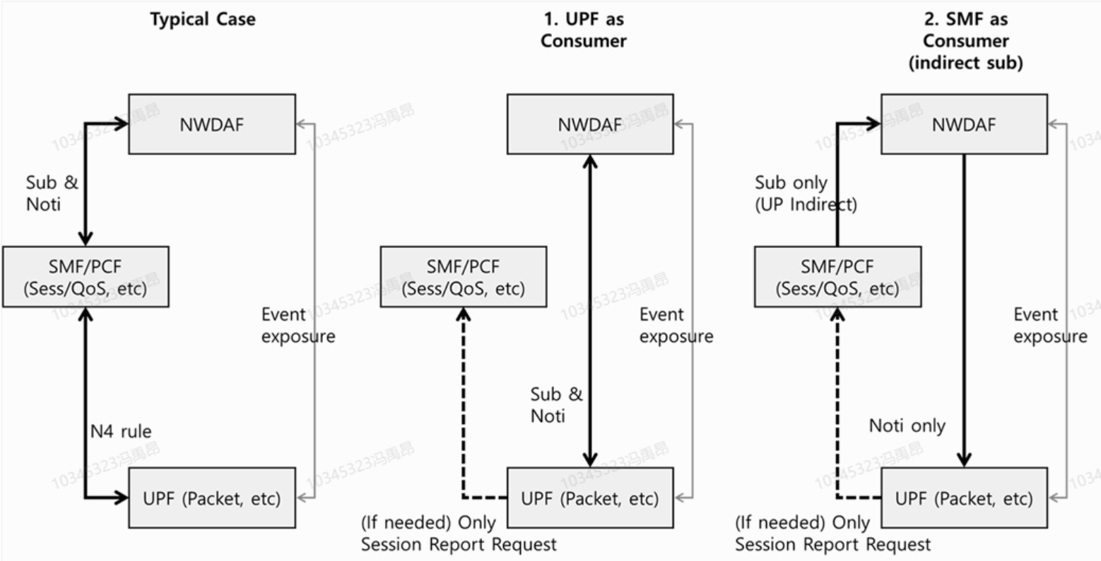

- When the UPF acts as a consumer, it performs operator‑configured local packet handling only (e.g. allow, deny, mirror, audit, shape, DLDR pacing, etc). Session/QoS state changes remain under SMF/PCF control. When the UPF acts as a NWDAF consumer, its analytics subscription scope is limited to per-UPF or per-interface level. (suggested by Joint paper from SK Telecom, AT&T, China Mobile, China Telecom, Deutsche Telekom, KDDI, Verizon, CATT, ETRI, ZTE, Samsung, Nokia S2-25010045)

- When the UPF is an analytics consumer, the UPF may subscribe to NWDAF directly. Then the NWDAF may send the analytics output to UPF, when the analytics output is available.
NOTE x: The service operations for UPF to subscribe or request analytics from NWDAF and the corresponding notify or response will be determined in normative phase. (suggested by Sumsang)

Alternatives for NOTE 1:

Agreed version from last meeting:
NOTE 1: UPF will only receive Analytics with reduced Output (i.e. type of abnormal traffic and traffic descriptor). UPF has operator-configured policies corresponding to the types of abnormal traffic, that can be activated for the received traffic descriptor. This does not apply on PDU-session level.

NOTE 1: UPF will only receive Analytics with reduced Output (i.e. type of abnormal traffic and traffic descriptor). UPF has operator-configured mitigation actions corresponding to the type of observed traffic anomalies reported by NWDAF and associated information for traffic identification. This does not apply on PDU-session level. (suggested by Ericsson)

NOTE 1: The UPF shall not subscribe for analytics requiring Session/QoS-flow, or application specific context, as such information resides with the SMF/PCF. Any analytics subscription or output at the UPF shall therefore be used only for local, non-Session/QoS behaviours (e.g. interface-level traffic statistics, anomaly trends, Top-N offenders, or overload indications, etc). (suggested by Joint paper from SK Telecom, AT&T, China Mobile, China Telecom, Deutsche Telekom, KDDI, Verizon, CATT, ETRI, ZTE, Samsung, Nokia S2-25010045)

Huawei’s S2-2501722 proposes to delete NOTE 1 and delete all descriptions of UPF as an Analytics consumer.

2. Whether UPF can obtain ML Model from NWDAF (suggested by Ericsson)
- The NWDAF may generate Analytics on abnormal user plane traffic using UPF input, this input includes the option that UPF performs inference using a local ML model, then report the inference results to NWDAF, the output of the local ML model at UPF are used as input of the ML model in the NWDAF.
NOTE 3: The local ML Model at UPF is an implementation option, how to train the ML Model or how to provision the ML Model is out of the scope of this study.

3. OAM/AF as Analytics consumer (suggested by Nokia)
- OAM as consumer of NWDAF analytics could configure SMF and/or UPF to block abnormal traffic or to increase capacity for legitimate traffic peaks.
- An AF as consumer of NWDAF analytics and data source could take action to correct abnormal traffic. For instance, in an enterprise network or IoT deployments, an (IOT) server to control abnormal traffic to/from (IoT) devices or to reconfigure some mis-configured devices.

